5 Anger Management Tricks That Make You Peaceful Again
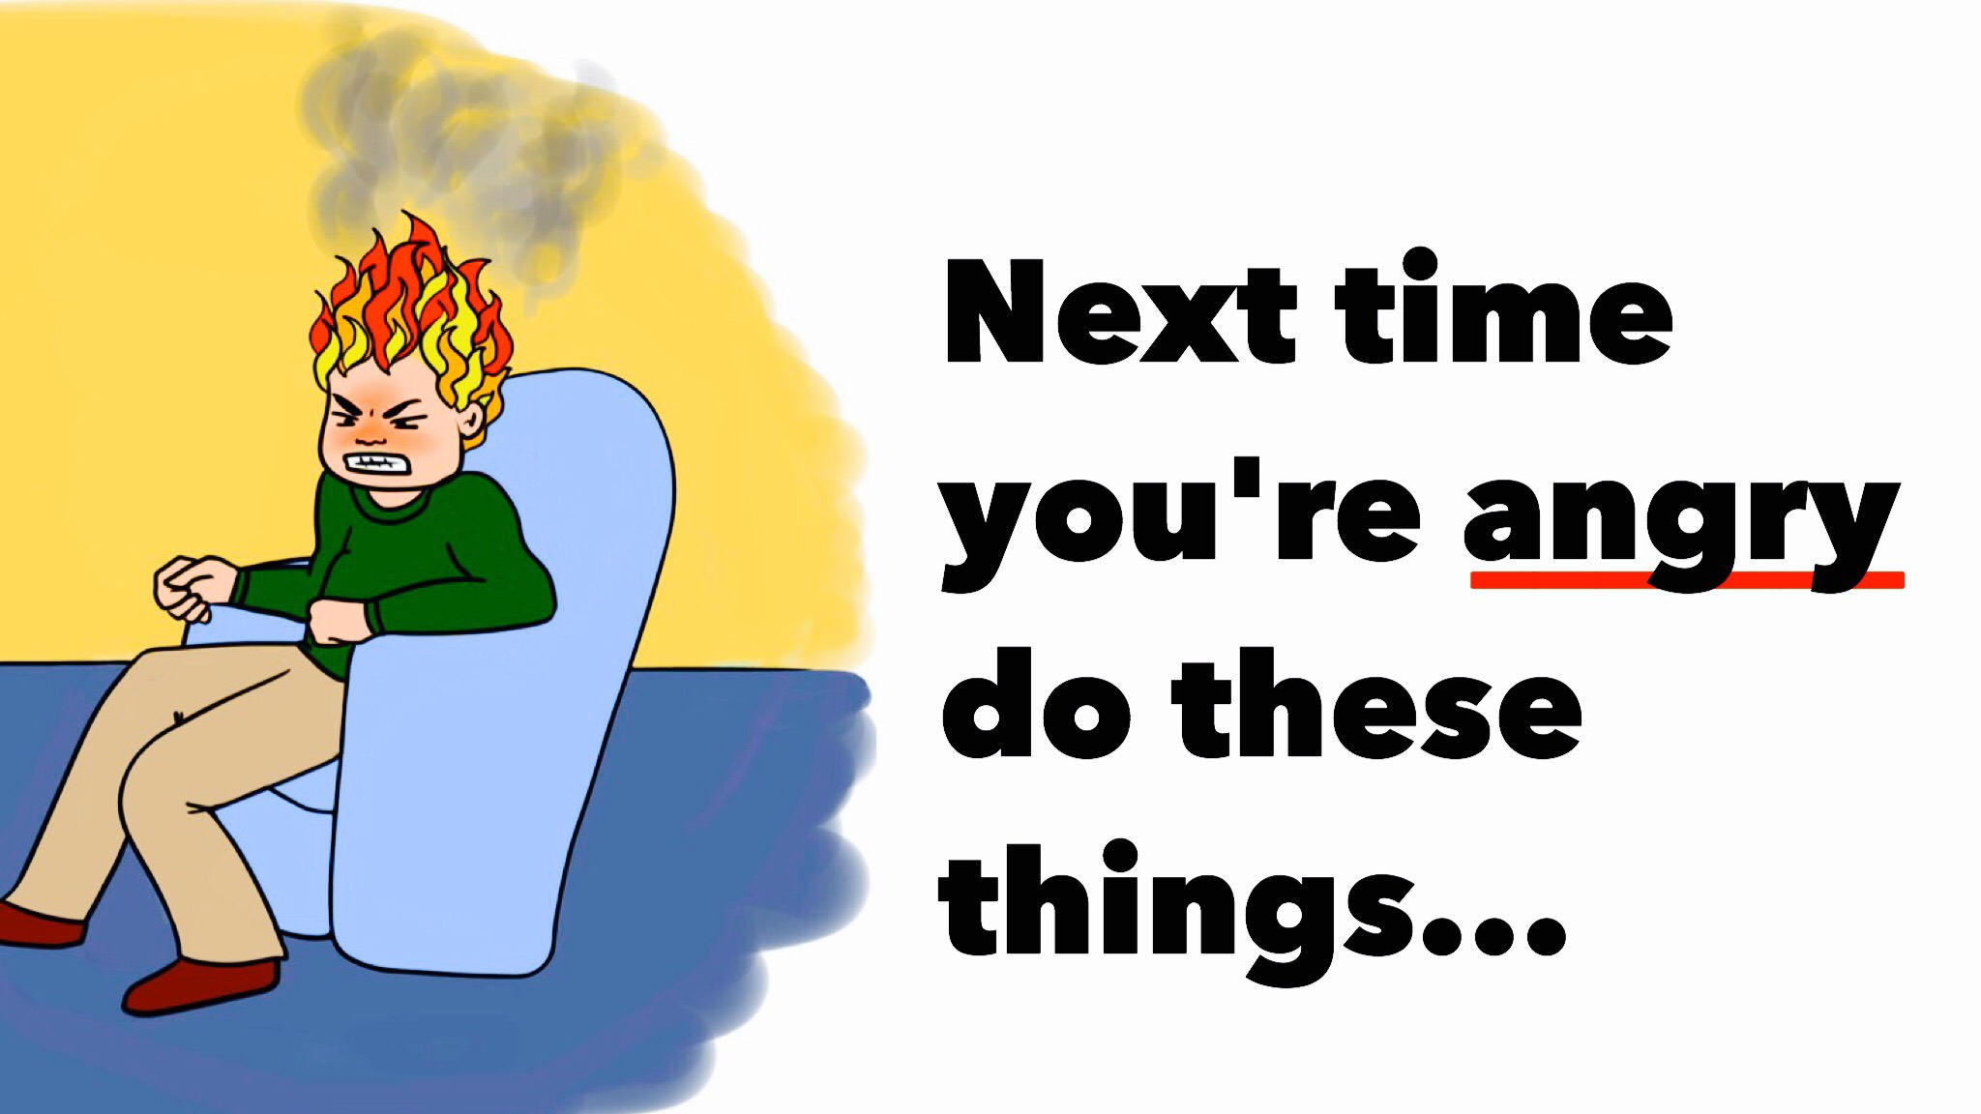
“Anger management is the process of learning to recognize signs that you’re becoming angry, and taking action to calm down and deal with the situation in a positive way. Anger management doesn’t try to keep you from feeling anger or encourage you to hold it in. Anger is a normal, healthy emotion when you know how to express it appropriately – anger management is about learning how to do this.” – The Mayo Clinic
While the above quote may be lengthy, it provides perhaps the most concise description of what constitutes “anger management.” It’s not the denial of anger, nor the attempt to suppress any feelings that may surface about the emotion. Anger management is about learning how to deal with anger. Many of us have either experienced recurrent bouts of uncontrollable anger or known someone close to us who has. Tragically, the end-result of elevated, irrepressible anger is too often emotionally and physically harmful. Many deaths at the hands of someone else have been attributed to “fits of rage” or something similar.
We all experience this surge of anger – to various degrees – from time to time. Perhaps it’s when someone cuts us off in traffic, when a family member instigates conflict, or when a co-worker refuses to work together amicably. In these and many other scenarios, the temptation to resort to anger is highly compelling. Should a strong surge of anger arise, it’s best to accept its presence and handle it. This brings us to the topic of this article: managing anger effectively.
Let’s get down to it.

Here are 5 anger management techniques that’ll help keep you at peace:

1. Identify a possible outlet
Rather than focusing on the thing that made you angry, make a conscious effort to resolve the issue. Is your child’s erratic behavior making you upset? Find something that will keep them occupied. Is your friend or family member doing something that pushes your buttons? Calm down and have a constructive dialogue or set some definite boundaries.
Remain consciously aware of the fact that unchecked anger resolves nothing. In fact, the result is often much worse. Breathe deeply, maintain some self-discipline, and think of a rational solution.

2. Forgive and (maybe) forget
Forgiveness is one of the most powerful antidotes to resentment. Allowing anger and other negative thoughts and feelings to distort and disrupt daily life ultimately leads to nothing more than bitterness, anger, and pessimism.
If you can forgive someone who brought about feelings of anger, you’ll both learn a valuable lesson. For you, the ability to forgive will reemphasize the truth that nobody can determine your state of mind. For the offender, the tolerance you exhibit may just be enough to remind them of the importance of remaining true to one’s word.
Should such a person repeatedly betray your sense of compassion, it’s probably time to reconsider the relationship. Depending upon the frequency of mistrust and the nature of the offense(s), prioritizing forgiving rather that forgetting may be the best (and healthiest) solution.

3. Improve your listening skills
Honing your listening skills may seem like an irrelevant solution, but hear us out. When we’re active listeners, we instantly improve the communication between the other person and us. This builds trust, and this trust can help mitigate potentially hostile thoughts and emotions.
Demonstrating to another that you’re truly listening accomplishes three things: (1) it shows that you care, (2) it shows that the other person’s thoughts and emotions matter, and (3) it establishes or reinforces feelings of empathy. Sometimes, a person that’s all worked up simply needs to be understood. Active listening accomplishes this need for understanding and much more.

4. Practice Relaxation
According to the American Psychological Association (APA), relaxation techniques “such as deep breathing and relaxing imagery can help calm down angry feelings.”
The APA provides some specific practices that may help:
– Breathe deeply from the diaphragm, as “chest breathing” will not promote relaxation.
– Repeat reassuring words, such as “take it easy,” “relax,” and “I’m in control” may help. It is recommended to practice deep breathing during this exercise.
– Using imagery, visualize something that provokes relaxation – either from experience or imagination.
– Nonstrenuous exercises (e.g. yoga, meditation, tai-chi) can assist with relaxing the muscles while promoting relaxation.

5. Cognitive restructuring
Angry people tend to swear, curse, or act erratically when confronted with a stressor. The problem here is obvious – such behavior fuels bitter notions and renders impossible any potential solution.
Cognitive restructuring involves nothing more than changing the way we think. The reason this method is so effective, as it pertains to anger management, is that thought processes are instantly dramatized and exaggerated when we’re angry.
Related article: 11 Quotes to Remember When You Feel Angry
Here’s a practical example. We’re waiting in line at our favorite coffee spot when the customer facing the cashier complains that their order is messed up. Understanding that resolving this problem will take time, a cynical monolog begins to surface in our minds. Instead of saying “This sucks,” “I’m going to be late,” recognize the situation and rationally replace them with something like “This situation is out of my control,” “I’ll remain calm, and they’ll eventually figure it out,” etc.
When we make the conscious attempt to rationalize such thoughts, a favorable outcome is much more likely.
More importantly, when we practice this – and other techniques described above – we invite peace and contentment, instead of anger and other negative states of mind.

