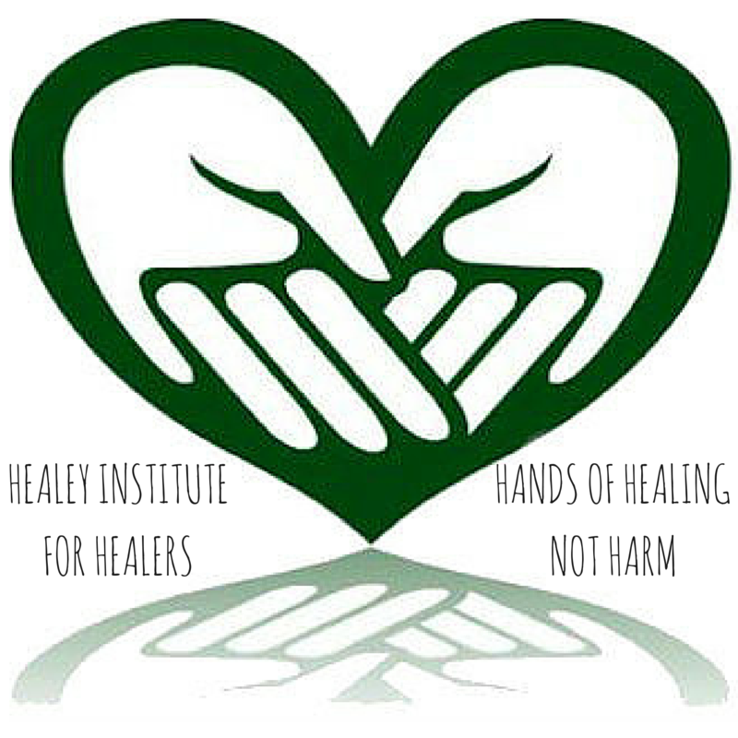
Healey Institute for Healers
- About
- ECourses & Classes
- Guidance & Holistic Counseling
- Services
- Contact
- Disclaimer


10+ Remedies for Radiation Exposure
17 January, 2014 by Derek J. Healey, posted in Holistic Health & Medicine, Personal Health & Healing
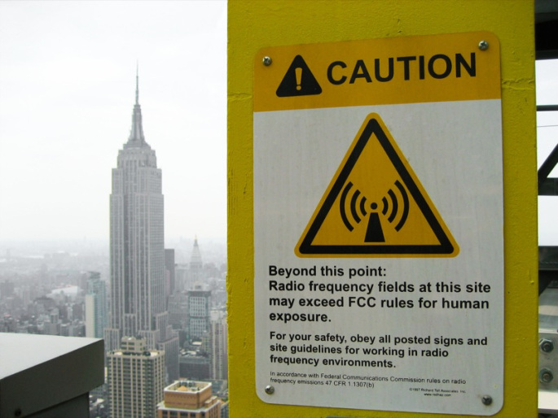
Earlier today, I wrote an article Return to Fukushima: Is Nuclear Power Worth All the Head & Heartache?
Now, almost three years later, we have much propagated information surrounding the health risks, especially since we now know that after years of denial, TEPCO admitted in the fall 2013 that contaminated groundwater is flowing into the Pacific at the volume of an Olympic-size swimming pool every week.
Back in March 2011, there was very little information in circulation other than that the plant had meltdown (several times) and that they were fixing it.
Many people decided to take things into their own hands, and reclaim their health. Many people fled, and are now still considered “nuclear refugees.” Others stocked up on potassium iodide and prussian blue. However, there were others who took prudent precautionary steps to protect themselves and loved ones from potential radioactive effects.
And, I don’t blame a single one.
We all know the threat of radiation contamination worldwide is not only possible, but is probable. Not only that, but we are exposed to mild levels of radiation everyday from space, at doctor’s appointments, cellphones and other electronics. Yet, we complicate matters worse with the hazards and dangers with nuclear power.
These nuclear reactors can damage not only our health as humans, but the health of land, air and sea, which is also ongoing, and steadily growing due to meltdowns much like Fukushima.
You can find out what the Signs & Symptoms of Radiation Sickness & Poisoning are here, but the basics are:
- Nausea and vomiting
- Diarrhea
- Headache
- Fever
- Dizziness
- Disorientation
- Weakness, Fatigue
- Hair loss
- Bloody vomit and stools
- Infections, open sores & poor wound healing
So, with all of that said, here is a list of 10+ Remedies for Radiation. This knowledge could just save your life one day.

#1. Reiki in Conjunction with Young Living Medicinal-Grade Therapeutic Essential Oil Blends
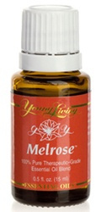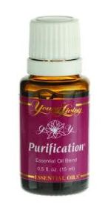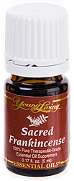
Combine the oils in pairs when diffusing (for example, Melrose with Sacred Frankincense or Sacred Frankincense with Purification). Melrose is a particularly powerful blend because it contains two melaleuca oils that may protect cells from radiation damage, according to Dr. Daniel Penoel in l’aromathÄ -rapie Exactement. Another sensible precaution is to wear an inexpensive dust mask saturated with the above oils while you are outside or traveling.
Melrose™ combats minor skin irritations with its powerful cleansing properties.
How to Use: Diffuse, inhale directly, or dilute with V-6 Vegetable Oil Complex to apply topically.
Essential Oils: Rosemary, Clove, Melaleuca (M. Alternifolia), Niaouli (Niaouli was used on Chernobyl victims.)
Retail Value: $23.36 US
Sacred Frankincense essential oil comes from the Boswellia sacra frankincense
tree. This oil is ideal for those who wish to take their spiritual journey and meditation
experiences to a higher level.
How to Use: Diffuse, inhale directly, apply topically, or take as a dietary supplement
Retail value: 5 mL: $55.59 US 15mL: $118.09 US
Purification®, the sweet, refreshing scent instantly deodorizes and neutralizes the air. This blend also contains citronella to deter insects and soothe minor bites.
How to Use: Diffuse, inhale directly, or apply topically.
Essential Oils: Lemongrass, Rosemary, Melaleuca (M. alternifolia), Myrtle, Citronella
Retail Value: $24.67 US

#2. Other Young Living Products to Protect Your Health, Home and Environment
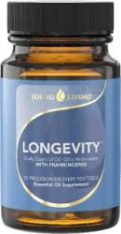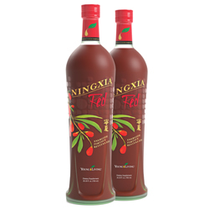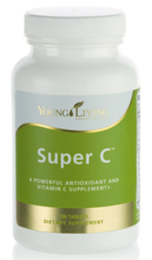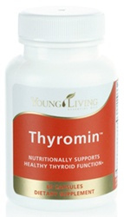
- Longevity 1-2 capsules twice daily – increases the oxygen and ATP cellular fuel for increasing cell life and immunity for tronger resistance against damage from environmental pollution
- Exodus II 1-2 capsules of oil daily to support the immune system
- Melrose 6-20 drops per capsule or in yogurt 1-3 times a day – formulated with 2 species of melaleuca (alternifolia and quinquenervia) that were found through research by Daniel Penoel, MD and Pierre Franchomme, PhD, to prevent cellular damage from environmental pollution and potential daily radiation exposure
- Mineral Essence 1 dropper-full per day – protects from mineral depletion as minerals work as a catalyst for enzyme conversion and vitamin absorption
- Super C 1-2 tablets daily – provides the body with 2,166 percent of the recommended dietary intake of the powerful antioxidant vitamin C and is enhanced with minerals, bioflavoinoids and pure organe, lemon and other essential oils; a natural antioxidant and free radical scavenger that supports the immune system and protects healthy cells
- Thyromin* 1 capsule three times a day – contains potassium iodide and kelp researched and proven to protect the thyroid from environmental radiation; other ingredients give support and nutrition to both the thyroid and adrenal galnds
- ICP 1-2 teaspoons in the morning – a good fiber blend that binds with toxins and helps with elimination, high in rutin from buckwheat which helps to protect against radiation and stimulates new bone marrow production
- JuvaPower 1-2 teaspoons at night – helps cleanse the colon
- Endoflex and Di-Gize 1-2 capsules daily – EndoFlex contains oils very specific to the thyroid while at the same time addressing the entire endocrine system; Geranium contains esters that protect the thyroid and supports the thyroid in being able to uptake iodine from food
- NingXia Red 4-6 oz daily – strengthens all body systems, high in antioxidants
- Detoxzyme 3-5 capsules at night – digests toxins while sleeping
- Allerzyme 1-2 capsules three times a day – digests non-nutritious substances that cause imbalance and irritation
- Essentialzyme 1 capsule three times a day – to keep general digestion continually working for better nutrient absorption and usability

#3. Other Protective Supplements
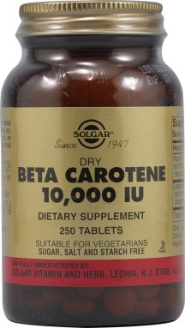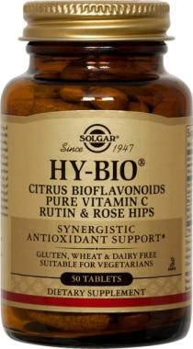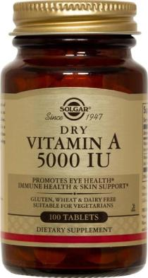
- Calcium/magnesium. The New England Journal of Medicine reported that calcium may prevent precancerous cells from becoming cancerous. It also protects against strontium 90 (similar structure to calcium) and other radioisotopes.
- Vitamin A or beta carotene. This vitamin manufactures antibodies, maintains and protects mucus membranes, and protects the thymus gland, the master gland of the immune system. It helps guard against tumor formation and cancer, as well as reverses aging process of the skin caused by ultraviolet light
- Coenzyme Q10. This substance protects against many chemicals and radiation, offering immense benefits to the immune system and retarding the aging process. Sufferers of heart problems, high blood pressure, angina, and obesity often find this substance to be helpful in managing symptoms. Natural levels decline with age; therefore, supplementation is needed.
- Vitamin C + bioflavinoids and rutin. A protective dose of between 500mg and 2,000 mg can counteract toxins and radiation.
- Vitamin E. Neutralizes harmful free radicals and protects delicate membranes.
- Zinc. Helps strengthen the T-cell-producing thymus gland. Aim for 50 to 100 mg daily, available from grains, nuts, seeds and legumes.
- Selenium. Selenium fights cancer and protects against carcinogens, by helping to produce a free radical scavenger called glutathione peroxidase.
- Proanthocyanadins (Grape seed extract/Pycnogenol). Considered to be one of the most powerful antioxidants or free radical scavengers, grape seed extract helps counteract stress, pollution and radiation
- DHEA. The most dominant hormone in the body, DHEA is considered the “Fountain of Youth” hormone because it can help extend life span. DHEA helps counteract the negative effects of stress, boosts the immune system, regulates blood cholesterol and lowers blood pressure. It rebalances the hormones in the body, especially during menopause, slows the production of free radicals, and inhibits the growth of cancers and carcinogens. A good food source of DHEA is wild yams.
- Melatonin. This valuable cancer-inhibiting hormone is often used to replenish the levels of melatonin, a hormone secreted by the pineal gland that affects the sleep cycle, fertility and the immune system. It’s often used to prevent and counteract jet lag and can rebalance the pineal gland after electric field exposure.

#4. Detox: Drink three liters of water daily


#5. Tea
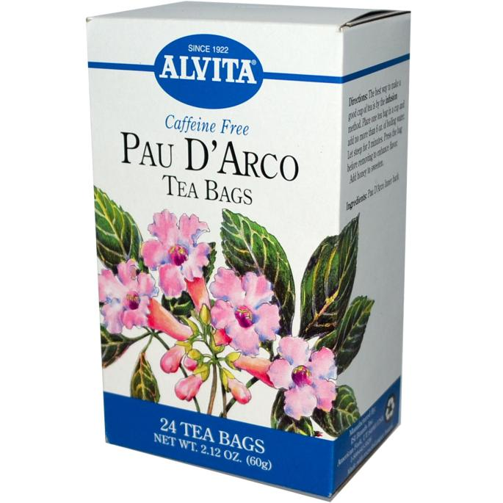
- Pau d’arco (also called ipe roxo, la pacho, taheebo, and bowstick tea). An herbal tea from the inner bark of two trees that grow in the warmer part of South America (Brazil, Argentina, Paraguay, Bolivia, etc.). Many South American doctors use a therapeutic tea from this herb to relieve pain and treat many conditions including leukemia and other forms of cancer, infections including yeast and other fungal conditions, skin rashes, and many other ailments. Dr. Theodoro Meyer of the Universidad Nacional of Tucuman, a province of the Argentine Andes, studied taheebo’s chemical composition and found a substance called xyloidin, an antibiotic capable of killing viruses. Dr. Prats Ruiz, M.D., of Concepcion, a city in Tucuman province, reported blood profiles of patients with leukemia before and after treatment with taheebo to document the efficacy of taheebo in treatment of certain cancers. Clinical details are provided by Professor Carlos Hugo Burgstaller in his book on the medicinal flora of Paraguay and Argentina, LA VUELTA A LOS VEGETALES (Buenos Aires, 1968).
- This tea was widely available in many health food stores until news of its anticancer claims became widespread. There is now an FDA effort to prohibit its sale in the United States. It has already been taken off the Canadian market to be “reclassified as an over-the-counter drug” because of the healing claims made for it. FDA approval of a drug for a specific use takes 8-12 years and costs about $56 million (1982 estimate).
- SAFFRON TEA. Contains colchicine, a substance that has been used in the treatment of leukemia. It also lowers uric acid (high in those who have a tendency towards gout and/or cardiovascular disease).
- THYME TEA. Often used as a remedy after x-rays. Just steep one tablespoon of thyme per pint of hot water for 20 minutes, then cool and strain.
- BLACK TEA. (CONTAINING TANNIN) AND HONEY. Used for radiation protection in China.

#6. Anti-Radiation Diet
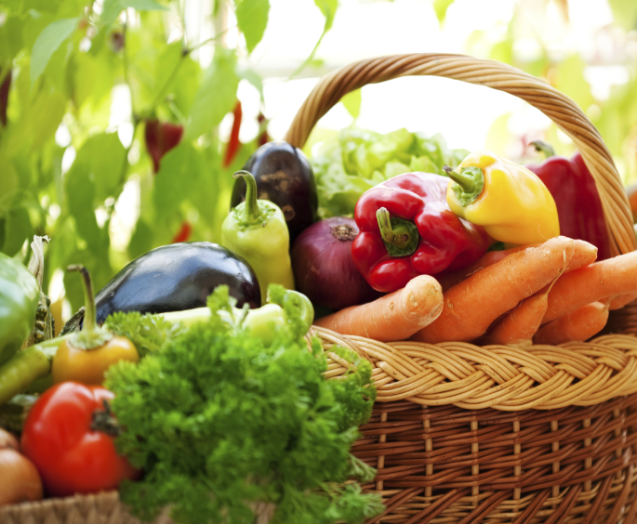
A balanced body can heal itself … but it needs your help. It’s important to pay close attention to the foods and dietary supplements you consume. Here’s why.
Diet and your body’s susceptibility to radiation are closely entwined. Radiation and pollutants destroy vitamins A, C, E, K several N vitamins, essential fatty acids, calcium and neuro-hormones. If your body lacks calcium. Potassium and other nutrients, it will more readily absorb the radioactive elements that are similar in structure to these nutrients.
Your best bet is to eat natural, fresh, organic (as much as possible) unprocessed foods, avoiding, white sugar, red meat, refined wheat, caffeine and homogenized milk.
- Chlorophyll-containing foods: barley grass and chlorella.
Chlorophyll closely resembles human blood and is used to cleanse, detoxify, purify and heal many conditions. It retards bacterial growth, detoxifies heavy metals from the body, increases wound healing, detoxifies the liver and other organs, deodorizes the body, removes putrefactive bacteria from the colon, aids healing of 11 types of skin diseases, relieves ulcers, gastritis, pancreatitis and other inflammatory conditions, helps heal gum diseases, and inhibits radiation and the metabolic activation of many carcinogens. Many studies have reported the protective effects of chlorophyll on irradiated animals.
There are pure chlorophyll supplements available if you don’t like to eat grass or algae. Better yet, try one of the following whole foods, all which are excellent sources of chlorophyll and other essential nutrients.
- Barley (wheat) grass is a totally balanced food. It contains all of the nutrients required for life; vitamins, minerals, enzymes and other proteins (amino acids), essential fatty acids and chlorophyll. Barley grass has thousands of living enzymes (a special protein). Enzymes are nature’s biological catalysts that initiate all the chemical transformations in the body. Over 3,000 enzymes have been identified. They are required for every transformation in the body – digestion, cell respiration, bodily movements, thinking processes, detoxification, cancer control, fat, protein and carbohydrate metabolism, etc.The normal daily amount of barley grass is 1-3 teaspoons (1 tsp = 2 grams). If you choose wheat grass (juice), start with one ounce daily and gradually increase to four or six ounces.
- Chlorella, a green freshwater micro-algae which has even more chlorophyll than barley (wheat) grass plus 55-65% protein with 19 amino acids including all the essential ones. It’s an excellent source of beta-carotene, vitamins B-l, B-2, B-3, B-6, B-12, pantothenic acid, folic acid, biotin, PABA, inositol and vitamin C. Vitamin B-12 is especially important for vegetarians who may be deficient in this vitamin. Chlorella has more B-12 than liver. It also contains important minerals – iron, phosphorus, magnesium, calcium, zinc, potassium, sulphur, iodine and trace amounts of manganese, sodium and chlorine.
Chlorella comes in a small pill form which may be more palatable to some people.
- Fermented (Lactic acid) vegetables and juices
Lactic acid fermented foods possess medicinal properties and can in the biological treatment of many conditions, including cancer, arthritis, multiple sclerosis, kidney and liver diseases, and digestive disorders. Sources include sauerkraut, beets, carrots, green and red pepper, beet tops, Swiss chard and celery.
- Cultured (fermented) milk products: yogurt, kefir, buttermilk, unprocessed cheese.
Longevity studies indicate that groups of people who use cultured milk products in their diet live longer. Real yogurt is made from fresh whole (unhomogenized) milk with billions of living friendly bacteria, a minimum of honey or fructose, and perhaps some real fruit.
Yogurt, kefir and other fermented milks contain an unidentified substance that lowers cholesterol. Yogurt is an excellent substitute for ice cream in milk shakes and smoothies. Use it on potatoes instead of sour cream. Make your own salad dressings with yogurt, honey, vinegar and spices.
These products also contain friendly bacteria, such as lactobacillus acidophilus and other strains perform valuable duties in your colon. These bacteria colonize the colon and evict unfriendly, dangerous bacteria and other organisms from your colon. These bacteria also synthesize germ-destroying antibodies in your colon.
- Cruciferous vegetables (cabbage, Brussels sprouts, broccoli, turnips, cabbage, spinach, cauliflower, and greens such as kale)
This family of vegetables contain substances that inhibit breast and colon cancer cell growth. Cabbage and other cruciferous vegetables also contain dithiolthiones, a non-toxic group of compounds that have antioxidant, anticancer and anti-radiation properties.
Sources include dark, leafy vegetables (broccoli, spinach, kale, Swiss chard, romaine, endive, chicory, escarole, watercress, collard, mustard and dandelion greens), dark yellow and orange vegetables (carrots, sweet potatoes, yams, pumpkins, winter squash) and fruits (cantaloupe, apricots, peaches, papayas and watermelon).
- High-fiber foods: whole grains, fruits and vegetables
Epidemiological data suggests that a high-fiber diet protects against large bowel cancer perhaps for several reasons. It dilutes bowel carcinogens, decreases colon transit time and changes the composition and metabolic activity of the fecal flora and certain carcinogenic substances in the colon. That’s why it’s healthier to eat whole grains containing the bran and the fiber, and whole fruits and vegetables instead of their processed, partitioned counterparts.
- Foods containing a natural Vitamin A
Such as lima beans, potatoes, yams, sweet potatoes, asparagus, tomatoes, onions and spinach), fruits (mango, grapes, avocado, pears, oranges plus the white under the peel and pulps, apples plus seeds and peeling, strawberries), all unsprouted seeds (especially sunflower, sesame and pumpkin), all nuts (especially almonds and cashews), leafy green vegetables, carob and teas from fruit blossoms and leaves (peach flowers, strawberry leaves, cherry flowers, apple blossoms), and all grasses, such as wheat and barley.
The vitamin A analog, abscisic acid, is found in large amounts in the grasses, seeds, nuts, legumes, mature leaves, and fruits listed above and in the apricot pit. The body makes abscisic acid in vivo (inside) from raw carrot juice and raw liver.
- Sesame seeds – raw, ground (tahini) or in capsules.
Sesame seed oil contains a substance called Complex T, the primary effect of which is to increase blood platelets – a must for fighting infection.
If you don’t like pills, just eat raw sesame seeds or tahini. In addition to Complex T, sesame seeds contain valuable essential fatty acids (EFAs) that are important workers in the immune system.
- Essential fatty acids, GLA and EPA
EFAs are essential for proper functioning of the immune system and protects against cancer. Food sources include flax seed oil, evening primrose oil and certain fish, particularly salmon.

#7. Bee and Flower Pollen
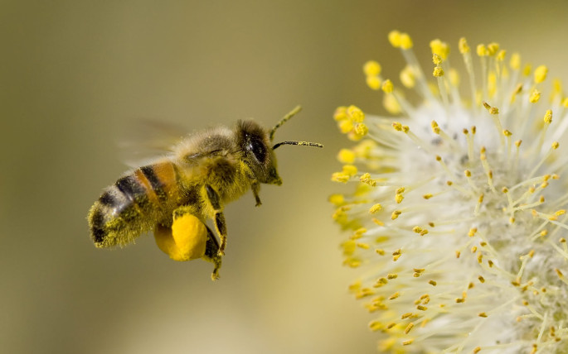
Pollen is an excellent food containing all essential amino acids, vitamins A, D, E, K, C, bioflavanoids, B-complex (especially pantothenic acid and B-3), and 27 minerals.
Research has proven pollen to be beneficial in treating several diseases. Dr. Emil Chauvin (French Academy of Science) discovered bee pollen was beneficial in treating anemia (increases red blood cells and hemoglobin), chronic prostatis, constipation, flatulence and colon infections, especially diarrhea.
Dr. Peter Hernuss at the University of Vienna’s Women’s Clinic conducted a study involving 25 women with inoperative uterine cancer. All received radiotherapy. The 15 who took 20 grams of bee pollen three times a day tolerated the radiation much better than the ten who took no bee pollen.

#8. Miso
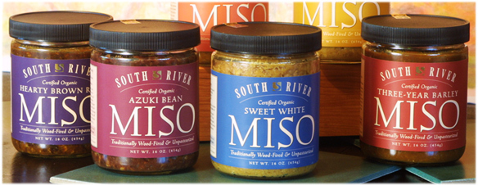
Made from naturally fermented soybeans, rice or barley, miso is a superior source of usable whole protein, aids digestion and assimilation, is low in fats, has a wonderful salty flavor, promotes health and helps neutralize environmental pollution including radiation. The reason for Miso’s protectiveness is not really known. It was observed that the Japanese who ate miso everyday did not die from radiation-induced cancer after the bombs at Hiroshima and Nagasaki. The observed effect of miso as a cancerostatic agent was further confirmed in a recent study in Japan.

#9. Sea vegetables Like Kelp and Dulse

Sodium alginate, a nonnutritious extract from Pacific kelp used to bind and detoxify heavy metals from the body (such as lead, mercury, cadmium, etc.), and agar, used as a thickening agent instead of gelatin or corn starch, will protect the human body from radiation effects. They also reduce absorption of strontium 90 by 50-80%.
Kelp and dulse, excellent natural sources of iodine, help protect against radioactive iodine, found mostly in milk. When the diet is adequately supplied with organic iodine (as in kelp), radioiodine is not as readily absorbed by the thyroid or the ovaries. Kelp contains 150,000 mcg of iodine per 100 grams (32 ounces). The RDA of iodine is 150-200 mcg. A reasonable daily dose of kelp would be 1-2 teaspoons of granules or 5-10 tablets. Other high iodine foods include: seafood, beef liver, pineapple, eggs and whole wheat.
Note: Taking kelp as a source of iodine is much safer than drinking iodine or eating potassium iodide, which can be especially dangerous for pregnant women and can cause allergic reactions. Iodine (inorganic) is toxic because of its tendency to combine with protein. That’s how it destroys bacteria (a protein). When you put iodine into your mouth, it combines with the protein there and in your stomach or wherever it goes. This causes irritation or worse. Also, sudden large doses of iodine in humans with a normal thyroid may reduce the synthesis of thyroid hormone.

#10. Limit Your Cellphone and Electronics Usage

Limit your cellphone usage, and for goodness sake remove any electronics from the bedroom.
As A World without Cancer explains, “Cellphones use radiofrequency waves, a form of electromagnetism that has been classified as ‘possibly carcinogenic to humans’ by the International Agency for Research on Cancer.” Whether cellphones cause brain cancer or not will likely take years of research, but it’s probably in your best interest to play it safe in the meantime.
Protect Yourself: Keep your phone away from your head by using speakerphone or texting instead of calling. You can also look for a phone with a lower specific absorption rate (SAR), which measures the level of radiofrequency energy it emits. Check cellphone SAR levels on CNET.

#11. Medical Prescriptions of Potassium iodide, Prussian blue, and DTPA
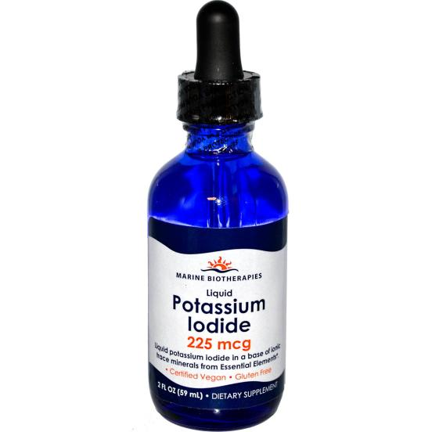
Some treatments may reduce damage to internal organs caused by radioactive particles. Medical personnel would use these treatments only if you’ve been exposed to a specific type of radiation. These treatments include the following:
- Potassium iodide. This is a nonradioactive form of iodine. Because iodine is essential for proper thyroid function, the thyroid becomes a “destination” for iodine in the body. If you have internal contamination with radioactive iodine (radioiodine), your thyroid will absorb radioiodine just as it would other forms of iodine. Treatment with potassium iodide may fill “vacancies” in the thyroid and prevent absorption of radioiodine. The radioiodine is eventually cleared from the body in urine. Potassium iodide isn’t a cure-all and is most effective if taken within a day of exposure.
- Prussian blue. This type of dye binds to particles of radioactive elements known as cesium and thallium. The radioactive particles are then excreted in feces. This treatment speeds up the elimination of the radioactive particles and reduces the amount of radiation cells may absorb.
- Diethylenetriamine pentaacetic acid (DTPA). This substance binds to metals. DTPA binds to particles of the radioactive elements plutonium, americium and curium. The radioactive particles pass out of the body in urine, thereby reducing the amount of radiation absorbed.
- A protein called granulocyte colony-stimulating factor, which promotes the growth of white blood cells, may counter the effect of radiation sickness on bone marrow. Treatment with this protein-based medication, which includes filgrastim (Neupogen) and pegfilgrastim (Neulasta), may increase white blood cell production and help prevent subsequent infections. If you have severe damage to bone marrow, you may also receive transfusions of red blood cells or blood platelets.
Related Articles
http://completehealthcircle.com/2013/11/12/how-to-cancer-proof-your-environment/
References
http://www.mayoclinic.org/diseases-conditions/radiation-sickness/basics/treatment/con-20022901
http://www.safespaceprotection.com/Healthy-Tips-Article/healthy-tips-anti-radiation-diet.aspx
Photos courtesy of Ernst Moeksis, Renewing Wellness, iHerb, Theta Foods, South River Miso, She Sells Seaweed, and Young Living.

