The Four Faces of Mars and a Night to Remember

Robert D. Morningstar
St. James Court
New York City

I am writing to confirm the veracity and authenticity of the work of the proponents of the theory of the Face on Mars as a coded message to humanity. I further propose to demonstrate a direct relationship between The Giza Pyramid Complex in Egypt and a particular region of the planet Mars defined by the area surrounding Olympus Mons, Tharsis Montes. and the western terminus of Valles Marineris.
The late Carl Sagan was fond of debunking theories like the Face on Mars with the coy quip:
"Extraordinary claims require extraordinary evidence".
Today, the evidence is in. In the following, I present extraordinary evidence which fulfills Sagan's requirements to the letter for the extraordinary claims of this writer, and those on whose shoulders he stands: Mark Carlotto, Vincent DiPietro, Gregory Molinaar, Vladimir Avinsky and Richard Hoagland.
From midnight on April 15th, 1998, the 86th anniversary of the loss of the Titanic, and continuing through today, I have embarked on one of the most awe-inspiring series of discoveries in my scientific life. As some may know, I have worked closely with Richard Hoagland of The Enterprise Mission (formerly The Mars Mission) since 1993 on sundry subject including Cydonia Mensae and what is popularly called "The Face on Mars" and "the Cydonia Complex".
I have been studying The Martin Enigma since 1992. I first met Richard Hoagland in 1993 through researcher Marc Whitford. Between 1995 and 1997, I worked for the old Mars Mission on everything from Lunar Anomalies and Hyperdimensional Physics to working out the bugs in several Enterprise Mission computers and troubleshooting technical failures and glitches. In 1995, Richard Hoagland offered me a position as a systems specialist and scientific consultant. Under his direction I helped Hoagland's Enterprise Mission navigate onto the Internet as Web Pilot (Richard liked to call me "The Helmsman"). I helped Hoagland in the construction of the Enterprise Mission website as technical consultant communicating construction and system design changes to Webmaster Keith Rowland who implemented them. I also archived the entire website on my computers to insure preservation of all valuable material.
Below is the map (MarsMap1.jpg) which I downloaded from JPL at 2:20 a.m. on the "Night of the Titanic", April 15th, 1998. I must record that I feel that the spirit of all those souls propelled me to this wonderful series of discoveries. I might not have stayed up had I not remembered that the Titanic had gone down during those hours 12-2:15 a.m. I thought to myself:
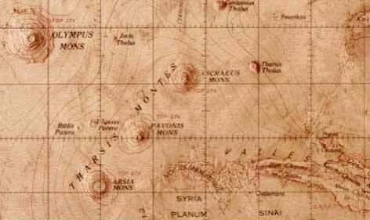
"Look at all the hoopla, cock and bull surrounding the Academy Awards and Cameron's 'King of the World' speech and here's the 86th anniversary and not a single commemoration, prayer, peep or sound bite anywhere in the media."
Staying up late, I meditated and thought about those poor lost souls in a cold and black ocean of darkness save for the light of stars. Sadly, I thought: "Very much like being in outer space without a space suit."
In checking my e-mail later, there was a notice about the new picture of The Face on Mars, presented and treated by NASA and the media like "just another rock". I logged onto the JPL Mars site and saw an icon for a complete map of Mars and went for it. I downloaded the map and instantly saw a unique relationship between Tharsis Montes and the alignment of the Pyramids of Giza and not for the first time Though I'd thought about it before (looking at small hand maps of Mars) I had dismissed it as simple coincidence. What relationship could there be between the two beside the other "coincidence" which writer Graham Hancock (Fingerprints of the Gods) is fond of pointing out..."The word 'Cairo' in Arabic means 'Mars'."
However, the full import of my observation didn't strike me until I checked a 19th century surveyor's map in Peter Tompkin's "Secrets of the Great Pyramid". History will show that Napoleon's engineers, Professors G. Piazzi Smith, Flinders Petrie and the Davisons were the first real "Mars Surveyors".
For the last few years I'd been working on the theory previously proposed by Freud and Velikovsky, that Akhenaton and Moses were one and the same person. After many years, I had come to the conclusion that the events of Exodus are not really missing from Egyptian history but rather they are embedded within Egyptian history but described in other terms.
Thus I had begun a few years ago a search for a series of similar events veiled by their description within another cultural context as "Egyptian History". The events would appear to historians as possibly similar but separate events. I had come to believe that the Biblical Exodus and Wilderness Trek corresponded in Egypt's history to the departure of Akhenaton from Thebes with his "ATON, THE ONE TRUE GOD," Nefertiti, his wife, royal family, court retinue, kitty cats and the whole "kaboodle" to the place called Amarna where he spent 18 years building "Akhetaton", the new royal capital of the One, True God of Light, Aton, physically manifesting as Sol. The 18 years in the wilderness of Tel el Amarna resulted in a civil war (which I equate with the rebellion of the Golden Calf Cult, during which sweet Old Moses "put three thousand men to the sword"). This event was costly and unseated Akhenaton and he disappeared without a trace. Well, almost without a trace. Moses also had to move with his "Yahweh (I AM)- The One True God", his wife, Zefera, his family, and his retinue to complete "40 years in the Wilderness". In my theory, 18 years were at Amarna (living under Akhenaton's "Laws for Living in Ma'at", i.e., "living in Truth", and 22 years wandering the Wildernesses of Sin and Sinai, i.e., escaping from Egypt, with Moses' One God-given laws, also for " living in truth", The Ten Commandments.
I have known and studied the Pyramids for 45 years. I first saw the Pyramids and the Sphinx in color and 3-D at age 5 through a rotating wheel 3-D binocular Viewer Master with 12 views of the complex. They made a deep impression on a young and curious mind. I'd stare at each picture for minutes, then hours on end and for days and days waiting for my parents to come home.
So it was that when a mountain peak to the west of the Giza Complex, "Al-Wadjit", was shown for a few seconds on the Discovery Channel 2 months ago, I registered it as a potentially important element in the Exodus-Amarna parallel theory which I was researching.
Could this be a candidate for the mountain of the Burning Bush? And why do we associate Moses' mountain which burns bushes with holiness, power, a (singular) wrathful deity, breathing fire and brimstone?
Yet, I was mystified that in my 40 years of viewing scores of film and TV documentaries and countless books and photos, NOT ONE had ever shown or noted the looming presence of "Al-Wadjit", as it was called and described as "holy mountain which looms over the Pyramids", far in the western background, apparently part of the Libyan Mountains. No documentary I'd seen had ever shown the Pyramids from an eastern vantage point looking to the west with the holy mountain visible between Cheops and Chephren. As I was looking for a local candidate for a "Mt. Nabor" or a "Mt. Sinai", I was compelled by the sight and I mentioned it to a colleague with similar views, Dr. William Theaux, who was likewise unaware of it's existence.
When I pulled out Tompkins' "Secrets" to align the Pyramids with Tharsis Montes, I saw the previously unnoticed truncated conical top ("vol-conical", one might say) of the holy mountain on the surveyor's map.
I was thunderstruck and suddenly remembered the "vol-conical structure" of 'Al-Wadjit" in the few seconds of video I had seen 2 months before, The mountain looks like Olympus Mons! I realized the correlation was more than coincidence,. It appears to have been landscaped, terraformed (maybe I should say "marsipanned") perhaps to remind the founding parents of Egypt's humanity of their lost homeland.
This discovery also may reveal why the Great Pyramid was intentionally designed to be truncated. This appears to have been done in order to represent one of four holy volcanic mountains on Mars, specifically Tharsis Montes and Olympus Mons and equally important, "unfinished business" on a cosmic scale.
In this context, Olympus Mons can be seen as the original Atlas-like holy mountain, a fire and brimstone breathing, wrathful deity, i.e., "the Most High God", who in violent paroxysms may have destroyed the original life on Mars in a series of cataclysmic eruptions which altered Mars' atmosphere radically, cracked the Valles Marineris and destroyed the Cydonia complex.
Robert Bauval's and Graham Hancock's elegant "Orion-Giza Thesis" notwithstanding, the Giza Complex appears to have been terraformed and landscaped to create a miniature representation of Tharsis Montes and Olympus Mons. It is accurate in the pancake terracing of "Al-Wadjit", the Holy Mountain to the west of Giza and with 2 drainage ditches leading to the Second Pyramid of Chephren and the Third Pyramid of Mycerinus suggestive of those seen in the Mars map leading from Olympus Mons to Pavonis Mons and Arsea Mons. Ascreaus Mons corresponds to The Great Pyramid. So it would appear that the Pyramids were placed at Giza just to be revered but rather to show the reverence of the Ancient Ones for Olympus Mons, the Holy of Holies of their homeland which may have been called Osiria.
I believe that I now understand why C.S. Lewis called the supreme spiritual hierarchies of Mars "Orisas" in his "Cosmic Trilogy" comprised of "Out of the Silent Planet", "Perilandra" and "That hideous Strength". It would seem that C.S. Lewis being a "Lewis" was privy to some of the most deeply held secrets of the supreme spiritual hierarchies of Earth which he chose to reveal at a time when the Earth stood on the brink of self-destruction to call humanity back to its roots and away from the precipice.
Finally, before I discuss and reveal the Four Faces of Mars, the geometric relationship of the southernmost or 3rd Pyramid (Mycerinus) to what were called "Remnants of The Stone Dyke" by Davison and Flinders Petrie (Pyramid specialists) correspond explicitly with that of Arsea Mons, southernmost of Tharsis Montes with a long promontory ridge along a deep, trench-like chasm coinciding with the western Terminus of Valles Marineris!
Consider this: The sun setting over "Al-Wadjit" with the 3 Pyramids in foreground would look much like Sol, the "Day Star" on Mars setting over Olympus Mons with Tharsis Montes in the foreground.
Home sweet home...longed for and remembered (i.e., re-membered, re-assembled, as in gathering all the "members" of the dead King(dom) Osiris, as Isis had done, to remember him forever. I pray that they are pleased by our discovery of their "cosmic cartouche" in the Faces on Mars.
Regarding the "Face on Mars" controversy, I have confirmed the authentic existence of the Face(s) on Mars. By using advanced computer graphic imaging techniques, I was able to rotate the angle of perspective to a nearly overhead view of The Face. I was able thus to extract from the raw photo NASA had just released not just the 2 faces originally discovered by DiPietro and Molinaar but four (4) Faces which are geometrically embedded (one might say "geometrically encrypted") within the one structure called "The Face" on the plains of the Cydonia.
All four faces are related intimately to the original and oldest Gods of Ancient Egypt and correspond with the descriptions in Ezekiel of that prophet's experience with four celestial beings who had the faces of a Man, A Lion, a Bull (ox), and an eagle (or hawk) upon their headdresses.
Ezekiel 1:10: "As for the likeness of their faces, they had the face of a man; and they four had the face of a lion on the right side; and they four had the face of an ox on the left side; and they four had also the face of an eagle. Thus were their faces."
Is it just coincidence that these same four archetypal symbols migrate almost seamlessly into Christianity as the symbols of the Four Evangelists: The Man, St. Matthew, The Lion of St. Mark, The Ox of St. Luke, and The Eagle of St. John. From the beginning to the end of Judeo-Christianity, these four symbols thread their way, weaving and holding both traditions together and tying them intimately to the proto-Egyptian Founders of Humanity. Yet, what is their meaning and function? In fact, they are the Heraldry of the One True God from the founding of humanity even unto the present. Consider the following excerpt from The Book of Revelations (4:6-7 & 5:10), literally The Word from The Eagle's Mouth, The Eagle being St. John the Beloved Disciple:
"And before the throne there was a sea of glass like unto crystal; and in the midst of the throne, were four beasts full of eyes before and behind. And the first beast was like a lion, and the second beast like a calf, and the third beast had the face as a man, and the fourth beast was like a flying eagle...And the four beasts said, Amen,"
Could the above passage be describing Cydonia Mensae? The Cydonian plains around the Face have at times reminded me of a "sea of glass", which is a good description of a desert plain which has been devastated by cosmic or nuclear blasts, evidence for which exists on Cydonia Mensae.
Attached are the most important pictures proving the validity of the theory of the Face on Mars as a "Martian Sphinx" (the term coined by Vladimir Avinsky) embodying in geometric symbols, what Richard Hoagland came to call "The Message of Cydonia." The file called "Figure-3.jpg" revealed the Face of Sekmet, Goddess of War, extracted by mirroring the right side of the Face (as we look at it) and making it symmetrical along the center line, right between the "nostrils". The image which emerges through mirroring "geometric decryption" is clearly that of a Lioness showing quite a fierce demeanor, the form of Sekmet, Goddess of War and "the raging sun."
Osiris and Horus the Falcon are self-evident and as explicit as two sides of the same coin, as they have always been represented, Progenitor and Redeemer.
This validates and confirms the work (and intuition) of Mark Carlotto, Vincent DiPietro, Gregory Molinaar, Vladimir Avinsky, and Richard Hoagland, the pioneers and champions of the Face on Mars Thesis. I am pleased to say to them all: "You have been right all the time and all the way from the Lion(ness) to Proto-Hominid. I am honored to lend my support to affirm the correctness and accuracy of your work in bringing this to the world's attention. I am also pleased to bring the image of Horus The Falcon to the fore in support of your original thesis of The Face and to confirm Avinsky's intuition of the Face on Mars as 'a Martian Sphinx'. It is all that and more. It is the cosmic cartouche of the King and the Redeemer, Osiris and Horus, the original founder of humanity and his son, who redeemed him and saved the world from destruction by Set and Typhon. I pray that he may do so once again and again and yet again...world without end."

Attached are the enhancements which prove authenticity of the Face(s) on Mars. Below is the whole menagerie of Four Faces of Mars contained within the single structure: The Ox, The Cat Goddess Sekmet, Osiris and Horus. I'm also including the original "Figure-1", the original NASA photo so that one can follow the geometric transformations which I performed to produce the Four Faces on Mars. The correct sequence is:
Figure-1. Face_Inverted.jpg (Original NASA release);
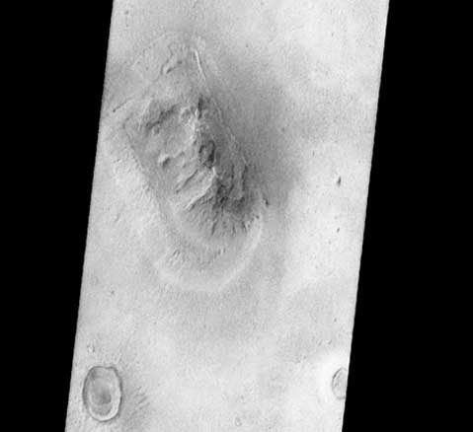
Figure-2. The Ox.jpg (or Apis Bull);
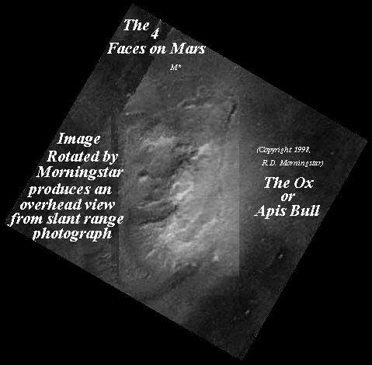
Figure-3. Sekmetcat.jpg (Lioness, Goddess of War);
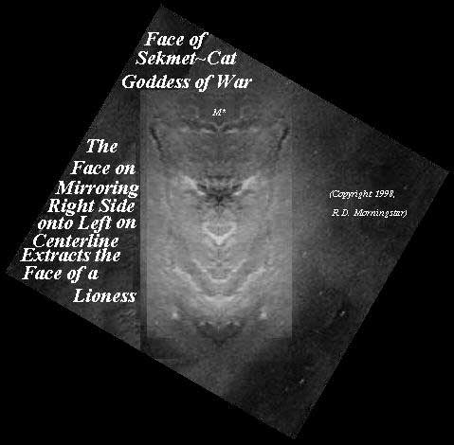
Figure-4. Osiris.jpg (The Dead Bearded King in Conical Crown);
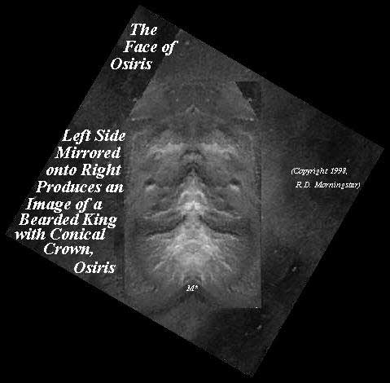
Figure-5. Horus.jpg (an unretouched 180 degree rotation of Osiris.jpg, # 4 above).
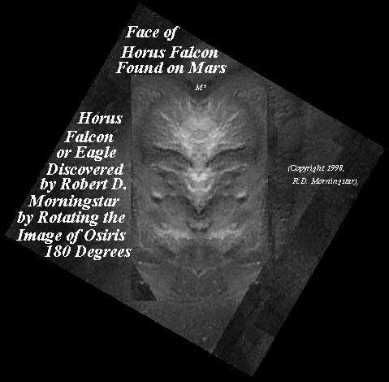
I consider this a true and self-evident, self-manifesting miracle.
"Olympus2.jpg" shows the relationship between Olympus Mons and Tharsis Montes region of Mars with "Al-Wadjit" and The Giza Complex. A detailed analysis will follow.

Olympus2.jpg..

THE Ultimate Key to the EARTH -MARS Connection:

Olympus Mons, Tharsis Montes, and the Pyramids of Giza
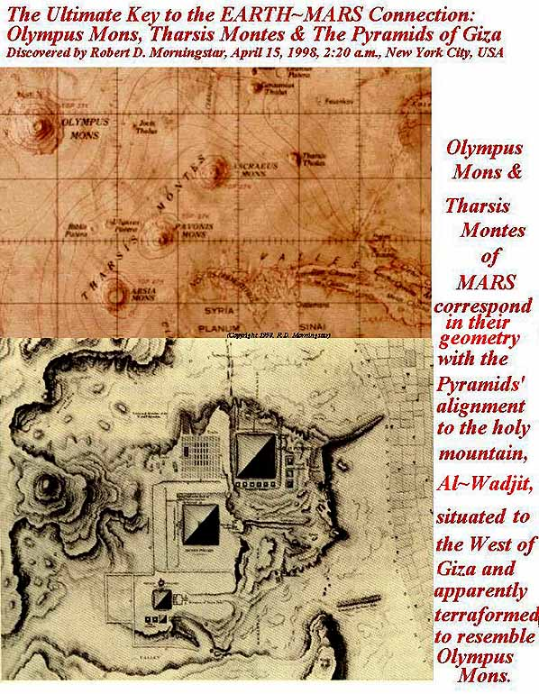
Enjoy and preserve the knowledge, spread the joyous word to others and the let us prepare to RETURN TO MARS.

With all reverence to the Holy One and with deep humility, I close with this prayer for Osiris/Horus, Isis/Sekmet, the co-founders of humanity:
"Destroyed is my badness; Annihilated is my evil.
Put away is the sin which was my own.
I wander on the path that I know,
In the direction of the Island of Justification.
I arrive in the land of the heavenly horizon;
I pass through the holy portal.
Oh Gods who come to meet me!
Stretch out your hands toward me!
I have become Heru, one among you.
I have restored the eye of the Horus,
Sun and son of Osiris
After it had been injured on the day of battle
By the two adversaries."

******* The Egyptian Book of the Dead
=============================================================================================================

