Stanley Kubrick Confesses To Faking The Moon Landings
Posted on December 10, 2015 by Sean Adl-Tabatabai in News, US // 19 Comments
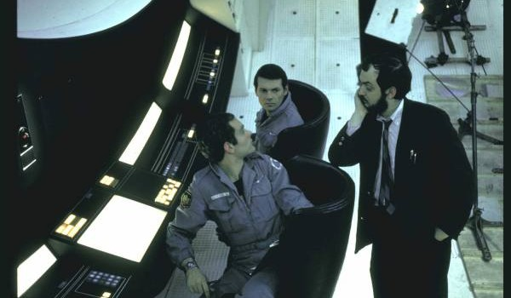
A stunning new video has emerged 15 years after Stanley Kubrick’s death in which Kubrick admits that the NASA moon landings were faked.
Filmmaker T. Patrick Murray interviewed Kubrick three days before his death in March 1999. He was forced to sign an 88-page NDA to keep the contents of the interview a secret for 15 years.
Below is a transcript from the interview with Stanley Kubrick, in which the 2001 Space Odyssey Director admits on camera that, “the moon landings ALL were faked , and that I was the person who filmed it.”
We have included a leaked rough cut of the film below the transcript as well as two unedited raw videos of the interview with Kubrick below that:
K: I’m so preoccupied. With my work, innovation, risk-taking, regrets…
T: Why are you giving this interview?
K: Because, it started to get to me after awhile. Well, this is difficult, because it is the first time I’ve talked about it. (sighs)
T: Sure, take all the time you need.
K: I’ve always been conflicted by it, but not consciously until years later. I was just blown away by the chance, the opportunity, the challenge of making this, this production, and I went into this like it was a regular film, like another regular film of mine, not thinking too much about uh the long term effects of what it would mean to society if it was ever discovered.
T: What are you talking about? I’m dying to know what you’re talking about.
K: Well, a confession of sorts. A movie I made, that nobody is aware of – even though they’ve seen it.
T: A movie you made, no one knows you made? Is that what you said?
K: That’s right. Is that intriguing? Do I have you intrigued?
K: I perpetrated a huge fraud on the American public, which I am now about to detail, involving the United States government and NASA, that the moon landings were faked, that the moon landings ALL were faked , and that I was the person who filmed it.
T: Ok. (laughs) What are you talking…You’re serious. Ok.
K: I’m serious. Dead serious.
K: Yes, it was fake.
T: Ok. Wait. Wait…
T: I don’t want this to be an R-rated film, but seriously, what the blank, but seriously…
T: I, I, I worked almost eight months to secure this once in a lifetime interview that almost no else could ever get, and instead of talking about his sixteen films that I’ve endured since I was a child…That we didn’t land on the moon, you’re saying?
K: No, we didn’t.
K: It was not real.
T: The moon landings were fake?
K: A, a, a.. fictional moon landing. A fantasy. It was not real.
K: Don’t you think it’s important for people to know the truth?
T: The moon landing in ’69, which was two years before my birth…
K: Is total fiction.
T: Total fiction.
T: Is that?…So, that’s the 15 year thing. So that’s makes sense now. That’s why I can’t release it for 15 years now, that makes total sense now.
T: Did we…we didn’t land on the moon you’re saying?
K: No, we didn’t.
T: Why are you telling me?
K: A, a, a, a massive fraud. An unparalleled fraud perpetrated against them. They SHOULD know.
K: Nixon want to uh, they were planning, yeah, he want to fake this, this moon landing…
T: Are you contending that people DON’T want to know the truth about the world, reality, the moon landings…?
K: The government, knowing this, takes advantage of it by perpetrating fraud after fraud after fraud.
T: How did you end up giving in? Being complicit with this fraud?
K: I didn’t want to do it.
T: This is NOT where I thought this interview was going!
K: With my help, with my, with my aid, and it is, it is bothering me.
T: I only have this certain amount of time with you. And I’ll talk about whatever you want, but…
T: You’re not…This isn’t some type of joke, or…
K: No. No, it’s not.
T: Or a film within a film thing…
K: Not joking. NOPE.
T: Okay.
K: The conspiracy theorists were right, on this occasion.
T: I don’t know what to ask you first.
K: I thought it was wrong, I just…I didn’t believe in perpetrating a fraud like that.
T: But you did.
K: It also undermined my artistic integrity to do that.
T: Ok, but you ended up saying yes. Why?
K: Well, yes, but because basically I was bribed. To put it bluntly, that’s what it was. It was just a plain fucking bribe.
T: Why are you telling me?
K:A, a, a, massive fraud. An unparalleled fraud perpetrated against them. They SHOULD know! Don’t you think it’s important for people to know the truth?
T: Why did they have to fake it? Why? Why would they ever need to do something like that? Why would the government ever want or need to do…
K: It’s no secret that NASA always wanted to fulfill this Kennedy prophecy.
T: Take it from the beginning…
T: I gotta be honest, this is where he (Kubrick) got me. I mean, when I actually put myself in his position, when I actually imagine that he was telling the truth, and that he was presented with this opportunity and if in the one in a billion chance that I lived his life and I was presented with the same opportunity, what would I do?
T: Yeah, he wanted his approval points up and he thought nothing could do it better than this.
T: What a conflict. I mean, gosh, I can’t imagine being presented with that opportunity. On one hand, I’d really would want to do it, but then I’d probably say I’m committing a crime, and lying…
T: It depends, but my guess would be…no, if you’re good, but you would do it.
K: Spielberg, (inaudible) Scorsese, even Woody Allen. There isn’t one of them who wouldn’t do this.
T: I gotta admit: I’d do it. I’d do it too.
T: But they dangled all this power and all this flattery on you, essentially?
K: Yeah, it got to me after awhile. You can listen to so much of that stuff before you start to believe it.
T: They just said you were the greatest and stuff?
K: Yeah, yeah – and I agreed with them.
K: Why are you telling the world? Why does the world need to know that the moon landings aren’t real and you faked them?
K: Which I consider to be my masterpiece.
T: And you can’t take credit, or even talk about…
K: Well, I am now..
T: Right, so you’ll be dead. In ten years, or 15…
K: Right, ten or 15 something like that.
T: So, you can’t talk to Roger Ebert about it. Does that frustrate you?
T: Why did they have to fake it? Why would they have to do that?
K: Because it is impossible to get there.
T: Ok, back up, back up, back up….

