Neil Armstrong: Freemason Or Not?
﻿﻿﻿I thought I'd repost this today. It's with a heavy heart we mark the passing of a true American hero. Neil Armstrong died today at the age of 82. He made history on July 29, 1969. He was literally, a man that went where no man had gone before . . . ﻿
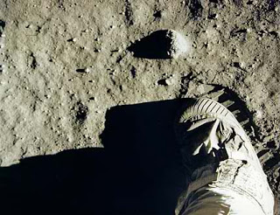
Neil Armstrong's footprint on the moon
﻿

"Mystery creates wonder and wonder is the basis of man's desire to understand."

~Neil Armstrong
As the first man to ever set foot on the moon, Neil Armstrong has become perhaps one of the most well-known NASA astronauts. Long before he was an astronaut, he was a pilot during the Korean War and flew seventy-eight combat missions.
Neil Armstrong was an early pioneer of high speed flight and was a test project pilot for many types of air experimental crafts--he flew over two hundred different types of air crafts which made him an excellent candidate when NASA began searching for qualified astronauts.
He is often included on lists of famous Freemason, however, Neil Armstrong, Jr. is not a Freemason. There's a little confusion with the name. His father, Neil Armstrong, Sr. was a very active member.
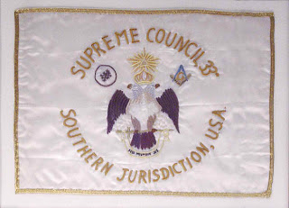
The eagle has landed . . .
The Scottish Rite Flag Buzz Aldrin took to the moon.

Not to say there weren't a lot Freemasons amongst NASA astronauts--members of the craft were well represented. Freemason astronauts include Buzz Aldrin, Leroy Gordon Cooper, Donn Eisle, John Glenn, Gus Grissom, James Irwin, Edgar Mitchell, Walter Schirra, Thomas Stafford, and Paul Weitz.
As a matter of fact, Buzz Aldrin took a personal item on the Apollo 11mission--a hand embroidered flag of the Scottish Rite Southern jurisdiction.
~TEC
Posted by Todd E. Creason
Email ThisBlogThis!Share to TwitterShare to FacebookShare to Pinterest
Labels: Freemason or Not?
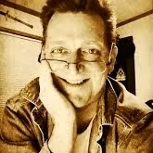
Todd E. Creason
is an author and novelist whose work includes the award-winning non-fiction historical series Famous American Freemasons and the novels One Last Shot (2011), A Shot After Midnight (2012) and Shot to Hell (2014).

3 comments:
AnonymousJuly 6, 2012 at 9:45 PM
nice posting.. thanks for sharing.
Reply
Steve CentersAugust 26, 2012 at 3:16 PM
Actually Neil's father's name was Stephen Koenig Armstrong and his mother Viola Louise (Engel) Armstrong.
His father was a member of my lodge in Ohio (Hamer Lodge No. 0167).
Neil never became a member of Hamer lodge and to my knowledge he never became a mason.

