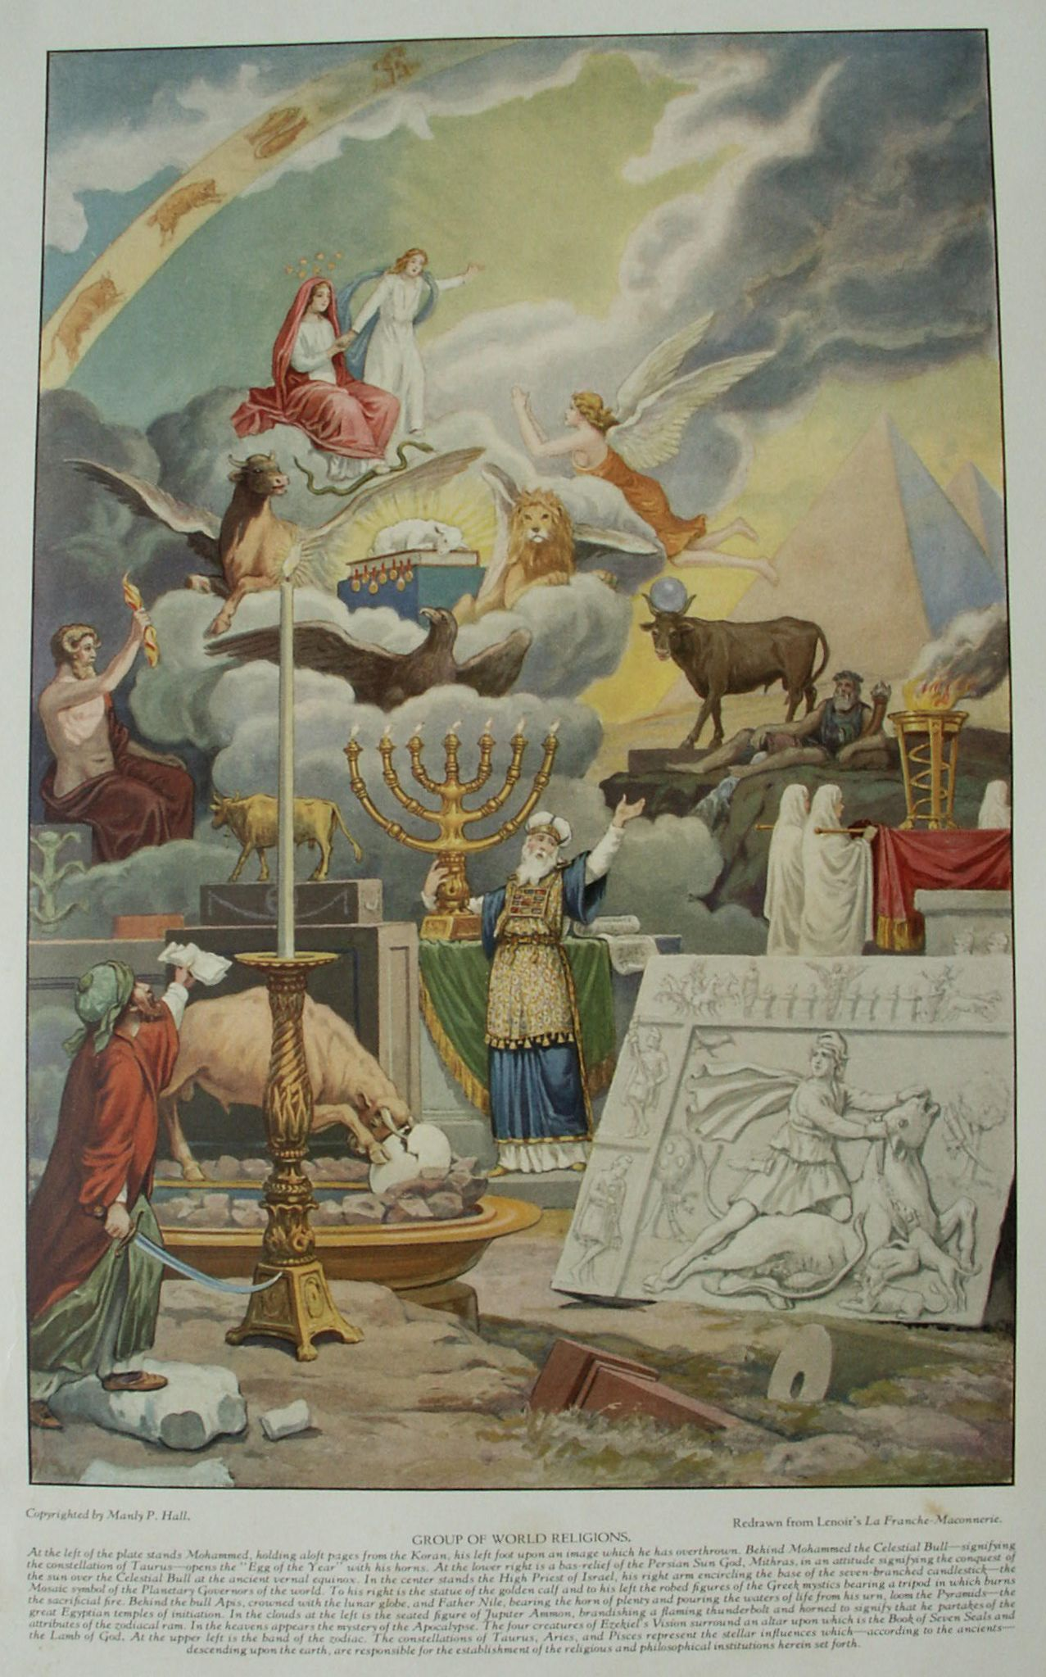

**Philosophy is the Science of Estimating Values**

**The Secret Teachings of All Ages - Manly P. Hall 1928**

**Introduction & Conclusion**

**Introduction**

PHILOSOPHY is the science of estimating values. The superiority of any state or substance over another is determined by philosophy. By assigning a position of primary importance to what remains when all that is secondary has been removed, philosophy thus becomes the true index of priority or emphasis in the realm of speculative thought. The mission of philosophy a priori is to establish the relation of manifested things to their invisible ultimate cause or nature.

"Philosophy," writes Sir William Hamilton, "has been defined [as]: The science of things divine and human, and of the causes in which they are contained [Cicero]; The science of effects by their causes [Hobbes]; The science of sufficient reasons [Leibnitz]; The science of things possible, inasmuch as they are possible [Wolf]; The science of things evidently deduced from first principles [Descartes]; The science of truths, sensible and abstract [de Condillac]; The application of reason to its legitimate objects [Tennemann]; The science of the relations of all knowledge to the necessary ends of human reason [Kant];The science of the original form of the ego or mental self [Krug]; The science of sciences [Fichte]; The science of the absolute [von Schelling]; The science of the absolute indifference of the ideal and real [von Schelling]--or, The identity of identity and non-identity [Hegel]." (See *Lectures on Metaphysics and Logic*.)

The six headings under which the disciplines of philosophy are commonly classified are: *metaphysics*, which deals with such abstract subjects as cosmology, theology, and the nature of being; *logic*, which deals with the laws governing rational thinking, or, as it has been called, "the doctrine of fallacies"; *ethics*, which is the science of morality, individual responsibility, and character--concerned chiefly with an effort to determine the nature of good; *psychology*, which is devoted to investigation and classification of those forms of phenomena referable to a mental origin; *epistemology*, which is the science concerned primarily with the nature of knowledge itself and the question of whether it may exist in an absolute form; and *æsthetics*, which is the science of the nature of and the reactions awakened by the beautiful, the harmonious, the elegant, and the noble.

Plato regarded philosophy as the greatest good ever imparted by Divinity to man. In the twentieth century, however, it has become a ponderous and complicated structure of arbitrary and irreconcilable notions--yet each substantiated by almost incontestible logic. The lofty theorems of the old Academy which Iamblichus likened to the nectar and ambrosia of the gods have been so adulterated by opinion--which Heraclitus declared to be a falling sickness of the mind--that the heavenly mead would now be quite unrecognizable to this great Neo-Platonist. Convincing evidence of the increasing superficiality of modern scientific and philosophic thought is its persistent drift towards materialism. When the great astronomer Laplace was asked by Napoleon why he had not mentioned God in his *Traité de la Mécanique Céleste*, the mathematician naively replied: "Sire, I had no need for that hypothesis!"

In his treatise on Atheism, Sir Francis Bacon tersely summarizes the situation thus: "A little philosophy inclineth man's mind to atheism; but depth in philosophy bringeth men's minds about to religion." The Metaphysics of Aristotle opens with these words: "All men naturally desire to know." To satisfy this common urge the unfolding human intellect has explored the extremities of imaginable space without and the extremities of imaginable self within, seeking to estimate the relationship between the one and the all; the effect and the cause; Nature and the groundwork of Nature; the mind and the source of the mind; the spirit and the substance of the spirit; the illusion and the reality.

An ancient philosopher once said: "He who has not even a knowledge of common things is a brute among men. He who has an accurate knowledge of human concerns alone is a man among brutes. But he who knows all that can be known by intellectual energy, is a God among men." Man's status in the natural world is determined, therefore, by the quality of his thinking. He whose mind is enslaved to his bestial instincts is philosophically not superior to the brute-, he whose rational faculties ponder human affairs is a man; and he whose intellect is elevated to the consideration of divine realities is already a demigod, for his being partakes of the luminosity with which his reason has brought him into proximity. In his encomium of "the science of sciences" Cicero is led to exclaim: "O philosophy, life's guide! O searcher--out of virtue and expeller of vices! What could we and every age of men have been without thee? Thou hast produced cities; thou hast called men scattered about into the social enjoyment of life."

In this age the word *philosophy* has little meaning unless accompanied by some other qualifying term. The body of philosophy has been broken up into numerous *isms* more or less antagonistic, which have become so concerned with the effort to disprove each other's fallacies that the sublimer issues of divine order and human destiny have suffered deplorable neglect. The ideal function of philosophy is to serve as the stabilizing influence in human thought. By virtue of its intrinsic nature it should prevent man from ever establishing unreasonable codes of life. Philosophers themselves, however, have frustrated the ends of philosophy by exceeding in their woolgathering those untrained minds whom they are supposed to lead in the straight and narrow path of rational thinking. To list and classify any but the more important of the now recognized schools of philosophy is beyond the space limitations of this volume. The vast area of speculation covered by philosophy will be appreciated best after a brief consideration of a few of the outstanding systems of philosophic discipline which have swayed the world of thought during the last twenty-six centuries. The Greek school of philosophy had its inception with the seven immortalized thinkers upon whom was first conferred the appellation of *Sophos*, "the wise." According to Diogenes Laertius, these were Thales, Solon, Chilon, Pittacus, Bias, Cleobulus, and Periander. Water was conceived by Thales to be the primal principle or element, upon which the earth floated like a ship, and earthquakes were the result of disturbances in this universal sea. Since Thales was an Ionian, the school perpetuating his tenets became known as the Ionic. He died in 546 B.C., and was succeeded by Anaximander, who in turn was followed by Anaximenes, Anaxagoras, and Archelaus, with whom the Ionic school ended. Anaximander, differing from his master Thales, declared measureless and indefinable infinity to be the principle from which all things were generated. Anaximenes asserted air to be the first element of the universe; that souls and even the Deity itself were composed of it.

Anaxagoras (whose doctrine savors of atomism) held God to be an infinite self-moving mind; that this divine infinite Mind, not inclosed in any body, is the efficient cause of all things; out of the infinite matter consisting of similar parts, everything being made according to its species by the divine mind, who when all things were at first confusedly mingled together, came and reduced them to order." Archelaus declared the principle of all things to be twofold: mind (which was incorporeal) and air (which was corporeal), the rarefaction and condensation of the latter resulting in fire and water respectively. The stars were conceived by Archelaus to be burning iron places. Heraclitus (who lived 536-470 B.C. and is sometimes included in the Ionic school) in his doctrine of change and eternal flux asserted fire to be the first element and also the state into which the world would ultimately be reabsorbed. The soul of the world he regarded as an exhalation from its humid parts, and he declared the ebb and flow of the sea to be caused by the sun.

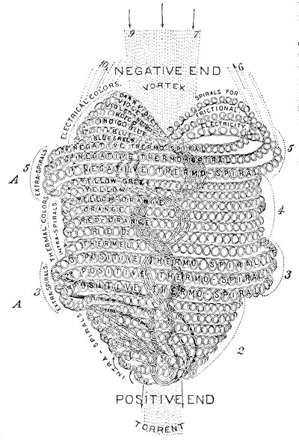  
BABBITT'S ATOM.

From Babbitt's *Principles of Light and Color*.

*Since the postulation of the atomic theory by Democritus, many efforts have been made to determine the structure of atoms and the method by which they unite to form various elements, Even science has not refrained from entering this field of speculation and presents for consideration most detailed and elaborate representations of these minute bodies. By far the most remarkable conception of the atom evolved during the last century is that produced by the genius of Dr. Edwin D. Babbitt and which is reproduced herewith. The diagram is self-explanatory. It must be borne in mind that this apparently massive structure is actually s minute as to defy analysis. Not only did Dr. Babbitt create this form of the atom but he also contrived a method whereby these particles could be grouped together in an orderly manner and thus result in the formation of molecular bodies.*

After Pythagoras of Samos, its founder, the *Italic* or *Pythagorean* school numbers among its most distinguished representatives Empedocles, Epicharmus, Archytas, Alcmæon, Hippasus, Philolaus, and Eudoxus. Pythagoras (580-500? B.C.) conceived mathematics to be the most sacred and exact of all the sciences, and demanded of all who came to him for study a familiarity with arithmetic, music, astronomy, and geometry. He laid special emphasis upon the *philosophic life* as a prerequisite to wisdom. Pythagoras was one of the first teachers to establish a community wherein all the members were of mutual assistance to one another in the common attainment of the higher sciences. He also introduced the discipline of retrospection as essential to the development of the spiritual mind. Pythagoreanism may be summarized as a system of metaphysical speculation concerning the relationships between numbers and the causal agencies of existence. This school also first expounded the theory of celestial harmonics or "the music of the spheres." John Reuchlin said of Pythagoras that he taught nothing to his disciples before the discipline of silence, silence being the first rudiment of contemplation. In his *Sophist*, Aristotle credits Empedocles with the discovery of rhetoric. Both Pythagoras and Empedocles accepted the theory of transmigration, the latter saying: "A boy I was, then did a maid become; a plant, bird, fish, and in the vast sea swum." Archytas is credited with invention of the screw and the crane. Pleasure he declared to be a pestilence because it was opposed to the temperance of the mind; he considered a man without deceit to be as rare as a fish without bones.

The *Eleatic* sect was founded by Xenophanes (570-480 B.C.), who was conspicuous for his attacks upon the cosmologic and theogonic fables of Homer and Hesiod. Xenophanes declared that God was "one and incorporeal, in substance and figure round, in no way resembling man; that He is all sight and all hearing, but breathes not; that He is all things, the mind and wisdom, not generate but eternal, impassible, immutable, and rational." Xenophanes believed that all existing things were eternal, that the world was without beginning or end, and that everything which was generated was subject to corruption. He lived to great age and is said to have buried his sons with his own hands. Parmenides studied under Xenophanes, but never entirely subscribed to his doctrines. Parmenides declared the senses to be uncertain and reason the only criterion of truth. He first asserted the earth to be round and also divided its surface into zones of hear and cold.

Melissus, who is included in the Eleatic school, held many opinions in common with Parmenides. He declared the universe to be immovable because, occupying all space, there was no place to which it could be moved. He further rejected the theory of a vacuum in space. Zeno of Elea also maintained that a vacuum could not exist. Rejecting the theory of motion, he asserted that there was but one God, who was an eternal, ungenerated Being. Like Xenophanes, he conceived Deity to be spherical in shape. Leucippus held the Universe to consist of two parts: one full and the other a vacuum. From the Infinite a host of minute fragmentary bodies descended into the vacuum, where, through continual agitation, they organized themselves into spheres of substance.

The great Democritus to a certain degree enlarged upon the atomic theory of Leucippus. Democritus declared the principles of all things to be twofold: atoms and vacuum. Both, he asserted, are infinite--atoms in number, vacuum in magnitude. Thus all bodies must be composed of atoms or vacuum. Atoms possessed two properties, form and size, both characterized by infinite variety. The soul Democritus also conceived to be atomic in structure and subject to dissolution with the body. The mind he believed to be composed of spiritual atoms. Aristotle intimates that Democritus obtained his atomic theory from the Pythagorean doctrine of the *Monad*. Among the Eleatics are also included Protagoras and Anaxarchus.

Socrates (469-399 B.C.), the founder of the *Socratic* sect, being fundamentally a Skeptic, did not force his opinions upon others, but through the medium of questionings caused each man to give expression to his own philosophy. According to Plutarch, Socrates conceived every place as appropriate for reaching in that the whole world was a school of virtue. He held that the soul existed before the body and, prior to immersion therein, was endowed with all knowledge; that when the soul entered into the material form it became stupefied, but that by discourses upon sensible objects it was caused to reawaken and to recover its original knowledge. On these premises was based his attempt to stimulate the soul-power through irony and inductive reasoning. It has been said of Socrates that the sole subject of his philosophy was man. He himself declared philosophy to be the way of true happiness and its purpose twofold: (1) to contemplate God, and (2) to abstract the soul from corporeal sense.

The principles of all things he conceived to be three in number: *God*, *matter*, and *ideas*. Of God he said: "What He is I know not; what He is not I know." Matter he defined as the subject of generation and corruption; idea, as an incorruptible substance--the intellect of God. Wisdom he considered the sum of the virtues. Among the prominent members of the Socratic sect were Xenophon, Æschines, Crito, Simon, Glauco, Simmias, and Cebes. Professor Zeller, the great authority on ancient philosophies, has recently declared the writings of Xenophon relating to Socrates to be forgeries. When *The Clouds of Aristophanes*, a comedy written to ridicule the theories of Socrates, was first presented, the great Skeptic himself attended the play. During the performance, which caricatured him seated in a basket high in the air studying the sun, Socrates rose calmly in his seat, the better to enable the Athenian spectators to compare his own unprepossessing features with the grotesque mask worn by the actor impersonating him.

The *Elean* sect was founded by Phædo of Elis, a youth of noble family, who was bought from slavery at the instigation of Socrates and who became his devoted disciple. Plato so highly admired Phædo's mentality that he named one of the most famous of his discourses The Phædo. Phædo was succeeded in his school by Plisthenes, who in turn was followed by Menedemus. Of the doctrines of the Elean sect little is known. Menedemus is presumed to have been inclined toward the teachings of Stilpo and the Megarian sect. When Menedemus' opinions were demanded, he answered that he was free, thus intimating that most men were enslaved to their opinions. Menedemus was apparently of a somewhat belligerent temperament and often returned from his lectures in a badly bruised condition. The most famous of his propositions is stated thus: That which is not the same is different from that with which it is not the same. This point being admitted, Menedemus continued: To benefit is not the same as good, therefore good does not benefit. After the time of Menedemus the Elean sect became known as the Eretrian. Its exponents denounced all negative propositions and all complex and abstruse theories, declaring that only affirmative and simple doctrines could be true.

The *Megarian* sect was founded by Euclid of Megara (not the celebrated mathematician), a great admirer of Socrates. The Athenians passed a law decreeing death to any citizen of Megara found in the city of Athens. Nothing daunted, Euclid donned woman's clothing and went at night to study with Socrates. After the cruel death of their teacher, the disciples of Socrates, fearing a similar fate, fled to Megara, where they were entertained with great honor by Euclid. The Megarian school accepted the Socratic doctrine that virtue is wisdom, adding to it the Eleatic concept that goodness is absolute unity and all change an illusion of the senses. Euclid maintained that good has no opposite and therefore evil does not exist. Being asked about the nature of the gods, he declared himself ignorant of their disposition save that they hated curious persons.

The Megarians are occasionally included among the dialectic philosophers. Euclid (who died 374? B.C.) was succeeded in his school by Eubulides, among whose disciples were Alexinus and Apollonius Cronus. Euphantus, who lived to great age and wrote many tragedies, was among the foremost followers of Eubulides. Diodorus is usually included in the Megarian school, having heard Eubulides lecture. According to legend, Diodorus died of grief because he could not answer instantly certain questions asked him by Stilpo, at one time master of the Megarian school. Diodorus held that nothing can be moved, since to be moved it must be taken out of the place in which it is and put into the place where it is not, which is impossible because all things must always be in the places where they are.

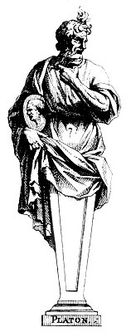  
PLATO.

From Thomasin's *Recuil des Figures, Groupes, Thermes, Fontaines, Vases et autres Ornaments*.

*Plato's real name was Aristocles. When his father brought him to study with Socrates, the great Skeptic declared that on the previous night he had dreamed of a white swan, which was an omen that his new disciple was to become one of the world's illumined. There is a tradition that the immortal Plato was sold as a slave by the King of Sicily.*

The *Cynics* were a sect founded by Antisthenes of Athens (444-365? B.C.), a disciple of Socrates. Their doctrine may be described as an extreme individualism which considers man as existing for himself alone and advocates surrounding him by inharmony, suffering, and direst need that be may thereby be driven to retire more completely into his own nature. The Cynics renounced all worldly possessions, living in the rudest shelters and subsisting upon the coarsest and simplest food. On the assumption that the gods wanted nothing, the Cynics affirmed that those whose needs were fewest consequently approached closest to the divinities. Being asked what he gained by a life of philosophy, Antisthenes replied that he had learned how to converse with himself.

Diogenes of Sinopis is remembered chiefly for the tub in the Metroum which for many years served him as a home. The people of Athens loved the beggar-philosopher, and when a youth in jest bored holes in the tub, the city presented Diogenes with a new one and punished the youth. Diogenes believed that nothing in life can be rightly accomplished without exercitation. He maintained that everything in the world belongs to the wise, a declaration which he proved by the following logic: "All things belong to the gods; the gods are friends to wise persons; all things are common amongst friends; therefore all things belong to the wise." Among the Cynics are Monimus, Onesicritus, Crates, Metrocles, Hipparchia (who married Crates), Menippus, and Menedemus.

The *Cyrenaic* sect, founded by Aristippus of Cyrene (435-356? B.C.), promulgated the doctrine of hedonism. Learning of the fame of Socrates, Aristippus journeyed to Athens and applied himself to the teachings of the great Skeptic. Socrates, pained by the voluptuous and mercenary tendencies of Aristippus, vainly labored to reform the young man. Aristippus has the distinction of being consistent in principle and practice, for he lived in perfect harmony with his philosophy that the quest of pleasure was the chief purpose of life. The doctrines of the Cyrenaics may be summarized thus: All that is actually known concerning any object or condition is the feeling which it awakens in man's own nature. In the sphere of ethics that which awakens the most pleasant feeling is consequently to be esteemed as the greatest good. Emotional reactions are classified as pleasant or gentle, harsh, and mean. The end of pleasant emotion is pleasure; the end of harsh emotion, grief; the end of mean emotion, nothing.

Through mental perversity some men do not desire pleasure. In reality, however, pleasure (especially of a physical nature) is the true end of existence and exceeds in every way mental and spiritual enjoyments. Pleasure, furthermore, is limited wholly to the moment; now is the only time. The past cannot be regarded without regret and the future cannot be faced without misgiving; therefore neither is conducive to pleasure. No man should grieve, for grief is the most serious of all diseases. Nature permits man to do anything he desires; he is limited only by his own laws and customs. A philosopher is one free from envy, love, and superstition, and whose days are one long round of pleasure. Indulgence was thus elevated by Aristippus to the chief position among the virtues. He further declared philosophers to differ markedly from other men in that they alone would not change the order of their lives if all the laws of men were abolished. Among prominent philosophers influenced by the Cyrenaic doctrines were Hegesias, Anniceris, Theodorus, and Bion.

The sect of the *Academic* philosophers instituted by Plato (427-347 B.C.) was divided into three major parts--the old, the middle, and the new Academy. Among the old Academics were Speusippus, Zenocrates, Poleman, Crates, and Crantor. Arcesilaus instituted the middle Academy and Carneades founded the new. Chief among the masters of Plato was Socrates. Plato traveled widely and was initiated by the Egyptians into the profundities of Hermetic philosophy. He also derived much from the doctrines of the Pythagoreans. Cicero describes the threefold constitution of Platonic philosophy as comprising ethics, physics, and dialectics. Plato defined good as threefold in character: good in the soul, expressed through the virtues; good in the body, expressed through the symmetry and endurance of the parts; and good in the external world, expressed through social position and companionship. In *The Book of Speusippus on Platonic Definitions*, that great Platonist thus defines God: "A being that lives immortally by means of Himself alone, sufficing for His own blessedness, the eternal Essence, cause of His own goodness. According to Plato, the *One* is the term most suitable for defining the Absolute, since the whole precedes the parts and diversity is dependent on unity, but unity not on diversity. The One, moreover, is before being, for *to be* is an attribute or condition of the One.

Platonic philosophy is based upon the postulation of three orders of being: that which moves unmoved, that which is self-moved, and that which is moved. That which is immovable but moves is anterior to that which is self-moved, which likewise is anterior to that which it moves. That in which motion is inherent cannot be separated from its motive power; it is therefore incapable of dissolution. Of such nature are the immortals. That which has motion imparted to it from another can be separated from the source of its an animating principle; it is therefore subject to dissolution. Of such nature are mortal beings. Superior to both the mortals and the immortals is that condition which continually moves yet itself is unmoved. To this constitution the power of abidance is inherent; it is therefore the Divine Permanence upon which all things are established. Being nobler even than self-motion, the unmoved Mover is the first of all dignities. The Platonic discipline was founded upon the theory that learning is really reminiscence, or the bringing into objectivity of knowledge formerly acquired by the soul in a previous state of existence. At the entrance of the Platonic school in the Academy were written the words: "Let none ignorant of geometry enter here."

After the death of Plato, his disciples separated into two groups. One, the *Academics*, continued to meet in the Academy where once he had presided; the other, the *Peripatetics*, removed to the Lyceum under the leadership of Aristotle (384-322 B.C.). Plato recognized Aristotle as his greatest disciple and, according to Philoponus, referred to him as "the mind of the school." If Aristotle were absent from the lectures, Plato would say: "The intellect is not here." Of the prodigious genius of Aristotle, Thomas Taylor writes in his introduction to *The Metaphysics*:

"When we consider that he was not only well acquainted with every science, as his works abundantly evince, but that he wrote on almost every subject which is comprehended in the circle of human knowledge, and this with matchless accuracy and skill, we know not which to admire most, the penetration or extent of his mind." Of the philosophy of Aristotle, the same author says: "The end of Aristotle's moral philosophy is perfection through the virtues, and the end of his contemplative philosophy an union with the one principle of all things."

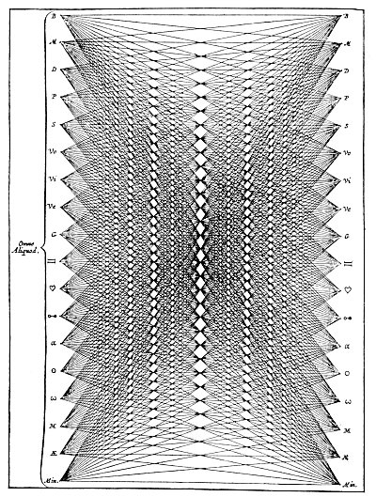  
THE PROBLEM OF DIVERSITY.

From Kircher's *Ars Magna Sciendi*.

*In the above diagram Kircher arranges eighteen objects in two vertical columns and then determines he number of arrangements in which they can be combined. By the same method Kircher further estimates that fifty objects may be arranged in 1,273,726,838,815,420,339,851,343,083,767,005,515,293,749,454,795,408,000,000,000,000 combinations. From this it will be evident that infinite diversity is possible, for the countless parts of the universe may be related to each other in an incalculable number of ways; and through the various combinations of these limitless subdivisions of being, infinite individuality and infinite variety must inevitably result. Thus it is further evident that life can never become monotonous or exhaust the possibilities of variety. Of the philosophy of Aristotle, the same author says: "The end of Aristotle's moral philosophy is perfection through the virtues, and the end of his contemplative philosophy an union with the one principle of all things."*

Aristotle conceived philosophy to be twofold: practical and theoretical. Practical philosophy embraced ethics and politics; theoretical philosophy, physics and logic. Metaphysics he considered to be the science concerning that substance which has the principle of motion and rest inherent to itself. To Aristotle the soul is that by which man first lives, feels, and understands. Hence to the soul he assigned three faculties: nutritive, sensitive, and intellective. He further considered the soul to be twofold--rational and irrational--and in some particulars elevated the sense perceptions above the mind. Aristotle defined wisdom as the science of first Causes. The four major divisions of his philosophy are dialectics, physics, ethics, and metaphysics. God is defined as the First Mover, the Best of beings, an immovable Substance, separate from sensible things, void of corporeal quantity, without parts and indivisible. Platonism is based upon *a priori* reasoning; Aristotelianism upon *a posteriori* reasoning. Aristotle taught his pupil, Alexander the Great, to feel that if he had not done a good deed he had not reigned that day. Among his followers were Theophrastus, Strato, Lyco, Aristo, Critolaus, and Diodorus.

Of *Skepticism* as propounded by Pyrrho of Elis (365-275 B.C.) and by Timon, Sextus Empiricus said that those who seek must find or deny they have found or can find, or persevere in the inquiry. Those who suppose they have found truth are called *Dogmatists*; those who think it incomprehensible are the *Academics*; those who still seek are the *Skeptics*. The attitude of Skepticism towards the knowable is summed up by Sextus Empiricus in the following words: "But the chief ground of Skepticism is that to every reason there is an opposite reason equivalent, which makes us forbear to dogmatize." The Skeptics were strongly opposed to the Dogmatists and were agnostic in that they held the accepted theories regarding Deity to be self-contradictory and undemonstrable. "How," asked the Skeptic, "can we have indubitate knowledge of God, knowing not His substance, form or place; for, while philosophers disagree irreconcilably on these points, their conclusions cannot be considered as undoubtedly true?" Since absolute knowledge was considered unattainable, the Skeptics declared the end of their discipline to be: "In opinionatives, indisturbance; in impulsives, moderation; and in disquietives, suspension."

The sect of the *Stoics* was founded by Zeno (340-265 B.C.), the Cittiean, who studied under Crates the Cynic, from which sect the Stoics had their origin. Zeno was succeeded by Cleanthes, Chrysippus, Zeno of Tarsis, Diogenes, Antipater, Panætius, and Posidonius. Most famous of the Roman Stoics are Epictetus and Marcus Aurelius. The Stoics were essentially pantheists, since they maintained that as there is nothing better than the world, the world is God. Zeno declared that the reason of the world is diffused throughout it as seed. Stoicism is a materialistic philosophy, enjoining voluntary resignation to natural law. Chrysippus maintained that good and evil being contrary, both are necessary since each sustains the other. The soul was regarded as a body distributed throughout the physical form and subject to dissolution with it. Though some of the Stoics held that wisdom prolonged the existence of the soul, actual immortality is not included in their tenets. The soul was said to be composed of eight parts: the five senses, the generative power, the vocal power, and an eighth, or hegemonic, part. Nature was defined as God mixed throughout the substance of the world. All things were looked upon as bodies either corporeal or incorporeal.

Meekness marked the attitude of the Stoic philosopher. While Diogenes was delivering a discourse against anger, one of his listeners spat contemptuously in his face. Receiving the insult with humility, the great Stoic was moved to retort: "I am not angry, but am in doubt whether I ought to be so or not!"

Epicurus of Samos (341-270 B.C.) was the founder of the *Epicurean* sect, which in many respects resembles the Cyrenaic but is higher in its ethical standards. The Epicureans also posited pleasure as the most desirable state, but conceived it to be a grave and dignified state achieved through renunciation of those mental and emotional inconstancies which are productive of pain and sorrow. Epicurus held that as the pains of the mind and soul are more grievous than those of the body, so the joys of the mind and soul exceed those of the body. The Cyrenaics asserted pleasure to be dependent upon action or motion; the Epicureans claimed rest or lack of action to be equally productive of pleasure. Epicurus accepted the philosophy of Democritus concerning the nature of atoms and based his physics upon this theory. The Epicurean philosophy may be summed up in four canons:

"(1) Sense is never deceived; and therefore every sensation and every perception of an appearance is true. (2) Opinion follows upon sense and is superadded to sensation, and capable of truth or falsehood, (3) All opinion attested, or not contradicted by the evidence of sense, is true. (4) An opinion contradicted, or not attested by the evidence of sense, is false." Among the Epicureans of note were Metrodorus of Lampsacus, Zeno of Sidon, and Phædrus.

*Eclecticism* may be defined as the practice of choosing apparently irreconcilable doctrines from antagonistic schools and constructing therefrom a composite philosophic system in harmony with the convictions of the eclectic himself. Eclecticism can scarcely be considered philosophically or logically sound, for as individual schools arrive at their conclusions by different methods of reasoning, so the philosophic product of fragments from these schools must necessarily be built upon the foundation of conflicting premises. Eclecticism, accordingly, has been designated the layman's cult. In the Roman Empire little thought was devoted to philosophic theory; consequently most of its thinkers were of the eclectic type. Cicero is the outstanding example of early Eclecticism, for his writings are a veritable potpourri of invaluable fragments from earlier schools of thought. Eclecticism appears to have had its inception at the moment when men first doubted the possibility of discovering ultimate truth. Observing all so-called knowledge to be mere opinion at best, the less studious furthermore concluded that the wiser course to pursue was to accept that which appeared to be the most reasonable of the teachings of any school or individual. From this practice, however, arose a pseudo-broadmindedness devoid of the element of preciseness found in true logic and philosophy.

The *Neo-Pythagorean* school flourished in Alexandria during the first century of the Christian Era. Only two names stand out in connection with it--Apollonius of Tyana and Moderatus of Gades. Neo-Pythagoreanism is a link between the older pagan philosophies and Neo-Platonism. Like the former, it contained many exact elements of thought derived from Pythagoras and Plato; like the latter, it emphasized metaphysical speculation and ascetic habits. A striking similarity has been observed by several authors between Neo-Pythagoreanism and the doctrines of the Essenes. Special emphasis was laid upon the mystery of numbers, and it is possible that the Neo-Pythagoreans had a far wider knowledge of the true teachings of Pythagoras than is available today. Even in the first century Pythagoras was regarded more as a god than a man, and the revival of his philosophy was resorted to apparently in the hope that his name would stimulate interest in the deeper systems of learning. But Greek philosophy had passed the zenith of its splendor; the mass of humanity was awakening to the importance of physical life and physical phenomena. The emphasis upon earthly affairs which began to assert itself later reached maturity of expression in twentieth century materialism and commercialism, even though Neo-Platonism was to intervene and many centuries pass before this emphasis took definite form.

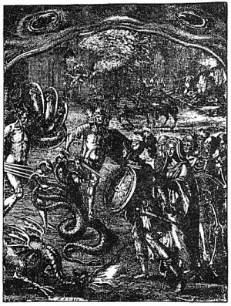  
ÆNEAS AT THE GATE OF HELL.

From Virgil's *Æneid*. (Dryden's translation.)

*Virgil describes part of the ritual of a Greek Mystery--possibly the Eleusinian--in his account of the descent of Æneas, to the gate of hell under the guidance of the Sibyl. Of that part of the ritual portrayed above the immortal poet writes:*

"Full in the midst of this infernal Road,  
An Elm displays her dusky Arms abroad;  
The God of Sleep there hides his heavy Head  
And empty Dreams on ev'ry Leaf are spread.  
Of various Forms, unnumber'd Specters more;  
Centaurs, and double Shapes, besiege the Door:  
Before the Passage horrid Hydra stands,  
And Briareus with all his hundred Hands:  
Gorgons, Geryon with his triple Frame;  
And vain Chimæra vomits empty Flame.  
The Chief unsheath'd his shining Steel, prepar'd,  
Tho seiz'd with sudden Fear, to force the Guard.  
Off'ring his brandish'd Weapon at their Face,  
Had not the Sibyl stop'd his eager Pace,  
And told him what those empty Phantoms were;  
Forms without Bodies, and impassive Air."

Although Ammonius Saccus was long believed to be the founder of *Neo-Platonism*, the school had its true beginning in Plotinus (A.D. 204-269?). Prominent among the Neo-Platonists of Alexandria, Syria, Rome, and Athens were Porphyry, Iamblichus, Sallustius, the Emperor Julian, Plutarch, and Proclus. Neo-Platonism was the supreme effort of decadent pagandom to publish and thus preserve for posterity its secret (or unwritten) doctrine. In its teachings ancient idealism found its most perfect expression. Neo-Platonism was concerned almost exclusively with the problems of higher metaphysics. It recognized the existence of a secret and all-important doctrine which from the time of the earliest civilizations had been concealed within the rituals, symbols, and allegories of religions and philosophies. To the mind unacquainted with its fundamental tenets, Neo-Platonism may appear to be a mass of speculations interspersed with extravagant flights of fancy. Such a viewpoint, however, ignores the institutions of the Mysteries--those secret schools into whose profundities of idealism nearly all of the first philosophers of antiquity were initiated.

When the physical body of pagan thought collapsed, an attempt was made to resurrect the form by instilling new life into it by the unveiling of its mystical truths. This effort apparently was barren of results. Despite the antagonism, however, between pristine Christianity and Neo-Platonism many basic tenets of the latter were accepted by the former and woven into the fabric of Patristic philosophy. Briefly described, Neo-Platonism is a philosophic code which conceives every physical or concrete body of doctrine to be merely the shell of a spiritual verity which may be discovered through meditation and certain exercises of a mystic nature. In comparison to the esoteric spiritual truths which they contain, the corporeal bodies of religion and philosophy were considered relatively of little value. Likewise, no emphasis was placed upon the material sciences.

The term *Patristic* is employed to designate the philosophy of the Fathers of the early Christian Church. Patristic philosophy is divided into two general epochs: ante-Nicene and post-Nicene. The ante-Nicene period in the main was devoted to attacks upon paganism and to apologies and defenses of Christianity. The entire structure of pagan philosophy was assailed and the dictates of faith elevated above those of reason. In some instances efforts were made to reconcile the evident truths of paganism with Christian revelation. Eminent among the ante-Nicene Fathers were St. Irenæus, Clement of Alexandria, and Justin Martyr. In the post-Nicene period more emphasis was placed upon the unfoldment of Christian philosophy along Platonic and Neo-Platonic lines, resulting in the appearance of many strange documents of a lengthy, rambling, and ambiguous nature, nearly all of which were philosophically unsound. The post-Nicene philosophers included Athanasius, Gregory of Nyssa, and Cyril of Alexandria. The Patristic school is notable for its emphasis upon the supremacy of man throughout the universe. Man was conceived to be a separate and divine creation--the crowning achievement of Deity and an exception to the suzerainty of natural law. To the Patristics it was inconceivable that there should ever exist another creature so noble, so fortunate, or so able as man, for whose sole benefit and edification all the kingdoms of Nature were primarily created.

Patristic philosophy culminated in *Augustinianism*, which may best be defined as Christian Platonism. Opposing the *Pelasgian* doctrine that man is the author of his own salvation, Augustinianism elevated the church and its dogmas to a position of absolute infallibility--a position which it successfully maintained until the Reformation. *Gnosticism*, a system of emanationism, interpreting Christianity in terms of Greek, Egyptian, and Persian metaphysics, appeared in the latter part of the first century of the Christian Era. Practically all the information extant regarding the Gnostics and their doctrines, stigmatized as heresy by the ante-Nicene Church Fathers, is derived from the accusations made against them, particularly from the writings of St. Irenæus. In the third century appeared *Manichæism*, a dualistic system of Persian origin, which taught that Good and Evil were forever contending for universal supremacy. In Manichæism, Christ is conceived to be the Principle of redeeming Good in contradistinction to the man Jesus, who was viewed as an evil personality.

The death of Boethius in the sixth century marked the close of the ancient Greek school of philosophy. The ninth century saw the rise of the new school of *Scholasticism*, which sought to reconcile philosophy with theology. Representative of the main divisions of the Scholastic school were the *Eclecticism* of John of Salisbury, the *Mysticism* of Bernard of Clairvaux and St. Bonaventura, the *Rationalism* of Peter Abelard, and the pantheistic *Mysticism* of *Meister Eckhart*. Among the Arabian Aristotelians were Avicenna and Averroes. The zenith of Scholasticism was reached with the advent of Albertus Magnus and his illustrious disciple, St. Thomas Aquinas. *Thomism* (the philosophy of St. Thomas Aquinas, sometimes referred to as the Christian Aristotle) sought to reconcile the various factions of the Scholastic school. Thomism was basically Aristotelian with the added concept that faith is a projection of reason.

*Scotism*, or the doctrine of *Voluntarism* promulgated by Joannes Duns Scotus, a Franciscan Scholastic, emphasized the power and efficacy of the individual will, as opposed to Thomism. The outstanding characteristic of Scholasticism was its frantic effort to cast all European thought in an Aristotelian mold. Eventually the Schoolmen descended to the level of mere wordmongers who picked the words of Aristotle so clean that nothing but the bones remained. It was this decadent school of meaningless verbiage against which Sir Francis Bacon directed his bitter shafts of irony and which he relegated to the potter's field of discarded notions.

The Baconian, or inductive, system of reasoning (whereby facts are arrived at by a process of observation and verified by experimentation) cleared the way for the schools of modern science. Bacon was followed by Thomas Hobbes (for some time his secretary), who held mathematics to be the only exact science and thought to be essentially a mathematical process. Hobbes declared matter to be the only reality, and scientific investigation to be limited to the study of bodies, the phenomena relative to their probable causes, and the consequences which flow from them under every variety of circumstance. Hobbes laid special stress upon the significance of words, declaring understanding to be the faculty of perceiving the relationship between words and the objects for which they stand.

Having broken away from the scholastic and theological schools, *Post-Reformation*, or modern, philosophy experienced a most prolific growth along many diverse lines. According to Humanism, man is the measure of all things; *Rationalism* makes the reasoning faculties the basis of all knowledge; *Political Philosophy* holds that man must comprehend his natural, social, and national privileges; Empiricism declares that alone to be true which is demonstrable by experiment or experience; *Moralism* emphasizes the necessity of right conduct as a fundamental philosophic tenet; *Idealism* asserts the realities of the universe to be superphysical--either mental or psychical; *Realism*, the reverse; and *Phenomenalism* restricts knowledge to facts or events which can be scientifically described or explained. The most recent developments in the field of philosophic thought are *Behaviorism* and *Neo-Realism*. The former estimates the intrinsic characteristics through an analysis of behavior; the latter may be summed up as the total extinction of idealism.

Baruch de Spinoza, the eminent Dutch philosopher, conceived God to be a substance absolutely self-existent and needing no other conception besides itself to render it complete and intelligible. The nature of this Being was held by Spinoza to be comprehensible only through its attributes, which are extension and thought: these combine to form an endless variety of *aspects* or *modes*. The mind of man is one of the modes of infinite thought; the body of man one of the modes of infinite extension. Through reason man is enabled to elevate himself above the illusionary world of the senses and find eternal repose in perfect union with the Divine Essence. Spinoza, it has been said, deprived God of all personality, making Deity synonymous with the universe.

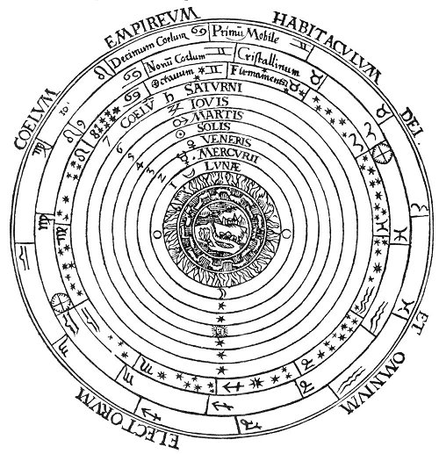  
THE PTOLEMAIC SCHEME OF THE UNIVERSE.

From an old print, courtesy of Carl Oscar Borg.

*In ridiculing the geocentric system of astronomy expounded by Claudius Ptolemy, modem astronomers have overlooked the philosophic key to the Ptolemaic system. The universe of Ptolemy is a diagrammatic representation of the relationships existing between the various divine and elemental parts of every creature, and is not concerned with astronomy as that science is now comprehended. In the above figure, special attention is called to the three circles of zodiacs surrounding the orbits of the planets. These zodiacs represent the threefold spiritual constitution of the universe. The orbits of the planets are the Governors of the World and the four elemental spheres in the center represent the physical constitution of both man and the universe, Ptolemy's scheme of the universe is simply a cross section of the universal aura, the planets and elements to which he refers having no relation to those recognized by modern astronomers.*

German philosophy had its inception with Gottfried Wilhelm von Leibnitz, whose theories are permeated with the qualities of optimism and idealism. Leibnitz's criteria of *sufficient reason* revealed to him the insufficiency of Descartes' theory of extension, and he therefore concluded that substance itself contained an inherent power in the form of an incalculable number of separate and all-sufficient units. Matter reduced to its ultimate particles ceases to exist as a substantial body, being resolved into a mass of immaterial ideas or metaphysical units of power, to which Leibnitz applied the term *monad*. Thus the universe is composed of an infinite number of separate monadic entities unfolding spontaneously through the objectification of innate active qualities. All things are conceived as consisting of single monads of varying magnitudes or of aggregations of these bodies, which may exist as physical, emotional, mental, or spiritual substances. God is the first and greatest Monad; the spirit of man is an awakened monad in contradistinction to the lower kingdoms whose governing monadic powers are in a semi-dormant state.

Though a product of the Leibnitzian-Wolfian school, Immanuel Kant, like Locke, dedicated himself to investigation of the powers and limits of human understanding. The result was his critical philosophy, embracing the critique of pure reason, the critique of practical reason, and the critique of judgment. Dr. W. J. Durant sums up Kant's philosophy in the concise statement that he rescued mind from matter. The mind Kant conceived to be the selector and coordinator of all perceptions, which in turn are the result of sensations grouping themselves about some external object. In the classification of sensations and ideas the mind employs certain categories: of sense, time and space; of understanding, quality, relation, modality, and causation; and the unity of apperception. Being subject to mathematical laws, time and space are considered absolute and sufficient bases for exact thinking. Kant's practical reason declared that while the nature of *noumenon* could never be comprehended by the reason, the fact of morality proves the existence of three necessary postulates: free will, immortality, and God. In the critique of judgment Kant demonstrates the union of the *noumenon* and the *phenomenon* in art and biological evolution. German *superintellectualism* is the outgrowth of an overemphasis of Kant's theory of the autocratic supremacy of the mind over sensation and thought. The philosophy of Johann Gottlieb Fichte was a projection of Kant's philosophy, wherein he attempted to unite Kant's practical reason with his pure reason. Fichte held that the known is merely the contents of the consciousness of the knower, and that nothing can exist to the knower until it becomes part of those contents. Nothing is actually real, therefore, except the facts of one's own mental experience.

Recognizing the necessity of certain objective realities, Friedrich Wilhelm Joseph von Schelling, who succeeded Fichte in the chair of philosophy at Jena, first employed the doctrine of identity as the groundwork for a complete system of philosophy. Whereas Fichte regarded self as the Absolute, von Schelling conceived infinite and eternal Mind to be the all-pervading Cause. Realization of the Absolute is made possible by intellectual intuition which, being a superior or spiritual sense, is able to dissociate itself from both subject and object. Kant's categories of space and time von Schelling conceived to be positive and negative respectively, and material existence the result of the reciprocal action of these two expressions. Von Schelling also held that the Absolute in its process of self-development proceeds according to a law or rhythm consisting of three movements. The first, a reflective movement, is the attempt of the Infinite to embody itself in the finite. The second, that of subsumption, is the attempt of the Absolute to return to the Infinite after involvement in the finite. The third, that of reason, is the neutral point wherein the two former movements are blended.

Georg Wilhelm Friedrich Hegel considered the intellectual intuition of von Schelling to be philosophically unsound and hence turned his attention to the establishment of a system of philosophy based upon pure logic. Of Hegel it has been said that he began with nothing and showed with logical precision how everything had proceeded from it in logical order. Hegel elevated logic to a position of supreme importance, in fact as a quality of the Absolute itself. God he conceived to be a process of unfolding which never attains to the condition of unfoldment. In like manner, thought is without either beginning or end. Hegel further believed that all things owe their existence to their opposites and that all opposites are actually identical. Thus the only existence is the relationship of opposites to each other, through whose combinations new elements are produced. As the Divine Mind is an eternal process of thought never accomplished, Hegel assails the very foundation of theism and his philosophy limits immortality to the everflowing Deity alone. Evolution is consequently the never-ending flow of Divine Consciousness out of itself; all creation, though continually moving, never arrives at any state other than that of ceaseless flow.

Johann Friedrich Herbart's philosophy was a realistic reaction from the idealism of Fichte and von Schelling. To Herbart the true basis of philosophy was the great mass of phenomena continually moving through the human mind. Examination of phenomena, however, demonstrates that a great part of it is unreal, at least incapable of supplying the mind with actual truth. To correct the false impressions caused by phenomena and discover reality, Herbart believed it necessary to resolve phenomena into separate elements, for reality exists in the elements and not in the whole. He stated that objects can be classified by three general terms: thing, matter, and mind; the first a unit of several properties, the second an existing object, the third a self-conscious being. All three notions give rise, however, to certain contradictions, with whose solution Herbart is primarily concerned. For example, consider matter. Though capable of filling space, if reduced to its ultimate state it consists of incomprehensibly minute units of divine energy occupying no physical space whatsoever.

The true subject of Arthur Schopenhauer's philosophy is the will; the object of his philosophy is the elevation of the mind to the point where it is capable of controlling the will. Schopenhauer likens the will to a strong blind man who carries on his shoulders the intellect, which is a weak lame man possessing the power of sight. The will is the tireless cause of manifestation and every part of Nature the product of will. The brain is the product of the will to know; the hand the product of the will to grasp. The entire intellectual and emotional constitutions of man are subservient to the will and are largely concerned with the effort to justify the dictates of the will. Thus the mind creates elaborate systems of thought simply to prove the necessity of the thing willed. Genius, however, represents the state wherein the intellect has gained supremacy over the will and the life is ruled by reason and not by impulse. The strength of Christianity, said Schopenhauer, lay in its pessimism and conquest of individual will. His own religious viewpoints resembled closely the Buddhistic. To him Nirvana represented the subjugation of will. Life--the manifestation of the blind will to live--he viewed as a misfortune, claiming that the true philosopher was one who, recognizing the wisdom of death, resisted the inherent urge to reproduce his kind.

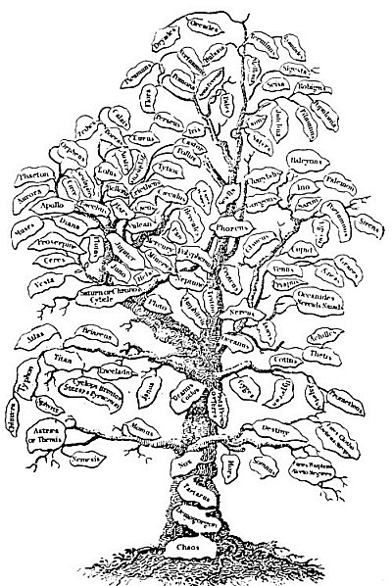  
THE TREE OF CLASSICAL MYTHOLOGY.

From Hort's *The New Pantheon*.

*Before a proper appreciation of the deeper scientific aspects of Greek mythology is possible, it is necessary to organize the Greek pantheon and arrange its gods, goddesses, and various superhuman hierarchies in concatenated order. Proclus, the great Neo-Platonist, in his commentaries on the theology of Plato, gives an invaluable key to the sequence of the various deities in relation to the First Cause and the inferior powers emanating from themselves. When thus arranged, the divine hierarchies may be likened to the branches of a great tree. The roots of this tree are firmly imbedded in Unknowable Being. The trunk and larger branches of the tree symbolize the superior gods; the twigs and leaves, the innumerable existences dependent upon the first and unchanging Power.*

Of Friedrich Wilhelm Nietzsche it has been said that his peculiar contribution to the cause of human hope was the glad tidings that God had died of pity! The outstanding features of Nietzsche's philosophy are his doctrine of eternal recurrence and the extreme emphasis placed by him upon the *will to power*--a projection of Schopenhauer's will to live. Nietzsche believed the purpose of existence to be the production of a type of all-powerful individual, designated by him the superman. This superman was the product of careful culturing, for if not separated forcibly from the mass and consecrated to the production of power, the individual would sink back to the level of the deadly mediocre. Love, Nietzsche said, should be sacrificed to the production of the superman and those only should marry who are best fitted to produce this outstanding type. Nietzsche also believed in the rule of the aristocracy, both blood and breeding being essential to the establishment of this superior type. Nietzsche's doctrine did not liberate the masses; it rather placed over them supermen for whom their inferior brothers and sisters should be perfectly reconciled to die. Ethically and politically, the superman was a law unto himself. To those who understand the true meaning of power to be virtue, self-control, and truth, the ideality behind Nietzsche's theory is apparent. To the superficial, however, it is a philosophy heartless and calculating, concerned solely with the survival of the fittest.

Of the other German schools of philosophic thought, limitations of space preclude detailed mention. The more recent developments of the German school are *Freudianism* and *Relativism* (often called the Einstein theory). The former is a system of psychoanalysis through psychopathic and neurological phenomena; the latter attacks the accuracy of mechanical principles dependent upon the present theory of velocity.

René Descartes stands at the head of the French school of philosophy and shares with Sir Francis Bacon the honor of founding the systems of modern science and philosophy. As Bacon based his conclusions upon observation of external things, so Descartes founded his metaphysical philosophy upon observation of internal things. *Cartesianism* (the philosophy of Descartes) first eliminates all things and then replaces as fundamental those premises without which existence is impossible. Descartes defined an idea as that which fills the mind when we conceive a thing. The truth of an idea must be determined by the criteria of clarity and distinctness. Hence Descartes, held that a clear and distinct idea must be true. Descartes has the distinction also of evolving his own philosophy without recourse to authority. Consequently his conclusions are built up from the simplest of premises and grow in complexity as the structure of his philosophy takes form.

The *Positive* philosophy of Auguste Comte is based upon the theory that the human intellect develops through three stages of thought. The first and lowest stage is theological; the second, metaphysical; and the third and highest, positive. Thus theology and metaphysics are the feeble intellectual efforts of humanity's child-mind and positivism is the mental expression of the adult intellect. In his *Cours de Philosophie positive*, Comte writes:

"In the final, the positive state, the mind has given over the vain search after Absolute notions, the origin and destination of the universe, and the causes of phenomena, and applies itself to the study of their laws,--that is, their invariable relations of succession and resemblance. Reasoning and observation, duly combined, are the means of this knowledge." Comte's theory is described as an "enormous system of materialism." According to Comte, it was formerly said that the heavens declare the glory of God, but now they only recount the glory of Newton and Laplace.

Among the French schools of philosophy are *Traditionalism* (often applied to Christianity), which esteems tradition as the proper foundation for philosophy; the *Sociological* school, which regards humanity as one vast social organism; the *Encyclopedists*, whose efforts to classify knowledge according to the Baconian system revolutionized European thought; *Voltairism*, which assailed the divine origin of the Christian faith and adopted an attitude of extreme skepticism toward all matters pertaining to theology; and *Neo-Criticism*, a French revision of the doctrines of Immanuel Kant.

Henri Bergson, the intuitionalist, undoubtedly the greatest living French philosopher, presents a theory of mystic anti-intellectualism founded upon the premise of creative evolution, His rapid rise to popularity is due to his appeal to the finer sentiments in human nature, which rebel against the hopelessness and helplessness of materialistic science and realistic philosophy. Bergson sees God as life continually struggling against the limitations of matter. He even conceives the possible victory of life over matter, and in time the annihilation of death.

Applying the Baconian method to the mind, John Locke, the great English philosopher, declared that everything which passes through the mind is a legitimate object of mental philosophy, and that these mental phenomena are as real and valid as the objects of any other science. In his investigations of the origin of phenomena Locke departed from the Baconian requirement that it was first necessary to make a natural history of facts. The mind was regarded by Locke to be blank until experience is inscribed upon it. Thus the mind is built up of received impressions plus reflection. The soul Locke believed to be incapable of apprehension of Deity, and man's realization or cognition of God to be merely an inference of the reasoning faculty. David Hume was the most enthusiastic and also the most powerful of the disciples of Locke.

Attacking Locke's sensationalism, Bishop George Berkeley substituted for it a philosophy founded on Locke's fundamental premises but which he developed as a system of idealism. Berkeley held that ideas are the real objects of knowledge. He declared it impossible to adduce proof that sensations are occasioned by material objects; he also attempted to prove that matter has no existence. Berkeleianism holds that the universe is permeated and governed by mind. Thus the belief in the existence of material objects is merely a mental condition, and the objects themselves may well be fabrications of the mind. At the same time Berkeley considered it worse than insanity to question the accuracy of the perceptions; for if the power of the perceptive faculties be questioned man is reduced to a creature incapable of knowing, estimating, or realizing anything whatsoever.

In the *Associationalism* of Hartley and Hume was advanced the theory that the association of ideas is the fundamental principle of psychology and the explanation for all mental phenomena. Hartley held that if a sensation be repeated several times there is a tendency towards its spontaneous repetition, which may be awakened by association with some other idea even though the object causing the original reaction be absent. The *Utilitarianism* of Jeremy Bentham, Archdeacon Paley, and James and John Stuart Mill declares that to be the greatest good which is the most useful to the greatest number. John Stuart Mill believed that if it is possible through sensation to secure knowledge of the *properties* of things, it is also possible through a higher state of the mind--that is, intuition or reason--to gain a knowledge of the true substance of things.

*Darwinism* is the doctrine of natural selection and physical evolution. It has been said of Charles Robert Darwin that he determined to banish spirit altogether from the universe and make the infinite and omnipresent Mind itself synonymous with the all-pervading powers of an impersonal Nature. *Agnosticism* and *Neo-Hegelianism* are also noteworthy products of this period of philosophic thought. The former is the belief that the nature of ultimates is unknowable; the latter an English and American revival of Hegel's idealism.

Dr. W. J. Durant declares that Herbert Spencer's Great Work, *First Principles*, made him almost at once the most famous philosopher of his time. *Spencerianism* is a philosophic positivism which describes evolution as an ever-increasing complexity with equilibrium as its highest possible state. According to Spencer, life is a continuous process from homogeneity to heterogeneity and back from heterogeneity to homogeneity. Life also involves the continual adjustment of internal relations to external relations. Most famous of all Spencer's aphorisms is his definition of Deity: "God is infinite intelligence, infinitely diversified through infinite time and infinite space, manifesting through an infinitude of ever-evolving individualities." The universality of the law of evolution was emphasized by Spencer, who applied it not only to the form but also to the intelligence behind the form. In every manifestation of being he recognized the fundamental tendency of unfoldment from simplicity to complexity, observing that when the point of equilibrium is reached it is always followed by the process of dissolution. According to Spencer, however, disintegration took place only that reintegration might follow upon a higher level of being.

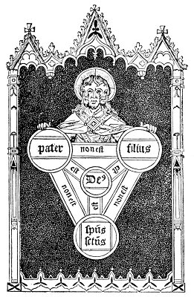  
A CHRISTIAN TRINITY.

From Hone's *Ancient Mysteries Described*.

*In an effort to set forth in an appropriate figure the Christian doctrine of the Trinity, it was necessary to devise an image in which the three persons--Father, Son, and Holy Ghost--were separate and yet one. In different parts of Europe may be seen figures similar to the above, wherein three faces are united in one head. This is a legitimate method of for to those able to realize the sacred significance of the threefold head a great mystery is revealed. However, in the presence of such applications of symbology in Christian art, it is scarcely proper to consider the philosophers of other faiths as benighted if, like the Hindus, they have a three-faced Brahma, or, like the Romans, a two-faced Janus.*

The chief position in the Italian school of philosophy should be awarded to Giordano Bruno, who, after enthusiastically accepting Copernicus' theory that the sun is the center of the solar system, declared the sun to be a star and all the stars to be suns. In Bruno's time the earth was regarded as the center of all creation. Consequently when he thus relegated the world and man to an obscure corner in space the effect was cataclysmic. For the heresy of affirming a multiplicity of universes and conceiving Cosmos to be so vast that no single creed could fill it, Bruno paid the forfeit of his life.

*Vicoism* is a philosophy based upon the conclusions of Giovanni Battista Vico, who held that God controls His world not miraculously but through natural law. The laws by which men rule themselves, Vico declared, issue from a spiritual source within mankind which is *en rapport* with the law of the Deity. Hence material law is of divine origin and reflects the dictates of the Spiritual Father. The philosophy of *Ontologism* developed by Vincenzo Gioberti (generally considered more as a theologian than a philosopher) posits God as the only being and the origin of all knowledge, knowledge being identical with Deity itself. God is consequently called Being; all other manifestations are existences. Truth is to be discovered through reflection upon this mystery.

The most important of modern Italian philosophers is Benedetto Croce, a Hegelian idealist. Croce conceives ideas to be the only reality. He is anti-theological in his viewpoints, does not believe in the immortality of the soul, and seeks to substitute ethics and aesthetics for religion. Among other branches of Italian philosophy should be mentioned *Sensism* (Sensationalism), which posits the sense perceptions as the sole channels for the reception of knowledge; *Criticism*, or the philosophy of accurate judgment; and *Neo-Scholasticism*, which is a revival of Thomism encouraged by the Roman Catholic Church.

The two outstanding schools of American philosophy are *Transcendentalism* and *Pragmatism*. Transcendentalism, exemplified in the writings of Ralph Waldo Emerson, emphasizes the power of the transcendental over the physical. Many of Emerson's writings show pronounced Oriental influence, particularly his essays on the Oversoul and the Law of Compensation. The theory of Pragmatism, while not original with Professor William James, owes its widespread popularity as a philosophic tenet to his efforts. Pragmatism may be defined as the doctrine that the meaning and nature of things are to be discovered from consideration of their consequences. The true, according to James, "is only an expedient in the way of our thinking, just as 'the right' is only an expedient in the way of our behaving." (See his *Pragmatism*.) John Dewey, the *Instrumentalist*, who applies the experimental attitude to all the aims of life, should be considered a commentator of James. To Dewey, growth and change are limitless and no ultimates are postulated. The long residence in America of George Santayana warrants the listing of this great Spaniard among the ranks of American philosophers. Defending himself with the shield of skepticism alike from the illusions of the senses and the cumulative errors of the ages, Santayana seeks to lead mankind into a more apprehending state denominated by him *the life of reason*.

(In addition to the authorities already quoted, in the preparation of the foregoing abstract of the main branches of philosophic thought the present writer has had recourse to Stanley's *History of Philosophy*; Morell's *An Historical and Critical View of the Speculative Philosophy of Europe in the Nineteenth Century*; Singer's *Modern Thinkers and Present Problems*; Rand's *Modern Classical Philosophers*; Windelband's *History of Philosophy*; Perry's *Present Philosophical Tendencies*; Hamilton's *Lectures on Metaphysics and Logic*; and Durant's *The Story of Philosophy*.)

Having thus traced the more or less sequential development of philosophic speculation from Thales to James and Bergson, it is now in order to direct the reader's attention to the elements leading to and the circumstances attendant upon the genesis of philosophic thinking. Although the Hellenes proved themselves peculiarly responsive to the disciplines of philosophy, this science of sciences should not be considered indigenous to them. "Although some of the Grecians," writes Thomas Stanley, "have challenged to their nation the original of philosophy, yet the more learned of them have acknowledged it [to be] derived from the East." The magnificent institutions of Hindu, Chaldean, and Egyptian learning must be recognized as the actual source of Greek wisdom. The last was patterned after the shadow cast by the sanctuaries of Ellora, Ur, and Memphis upon the thought substance of a primitive people. Thales, Pythagoras, and Plato in their philosophic wanderings contacted many distant cults and brought back the lore of Egypt and the inscrutable Orient.

From indisputable facts such as these it is evident that philosophy emerged from the religious Mysteries of antiquity, not being separated from religion until after the decay of the Mysteries. Hence he who would fathom the depths of philosophic thought must familiarize himself with the teachings of those initiated priests designated as the first custodians of divine revelation. The Mysteries claimed to be the guardians of a transcendental knowledge so profound as to be incomprehensible save to the most exalted intellect and so potent as to be revealed with safety only to those in whom personal ambition was dead and who had consecrated their lives to the unselfish service of humanity. Both the dignity of these sacred institutions and the validity of their claim to possession of Universal Wisdom are attested by the most illustrious philosophers of antiquity, who were themselves initiated into the profundities of the secret doctrine and who bore witness to its efficacy.

The question may legitimately be propounded: If these ancient mystical institutions were of such "great pith and moment," why is so little information now available concerning them and the arcana they claimed to possess? The answer is simple enough: The Mysteries were secret societies, binding their initiates to inviolable secrecy, and avenging with death the betrayal of their sacred trusts. Although these schools were the true inspiration of the various doctrines promulgated by the ancient philosophers, the fountainhead of those doctrines was never revealed to the profane. Furthermore, in the lapse of time the teachings became so inextricably linked with the names of their disseminators that the actual but recondite source--the Mysteries--came to be wholly ignored.

Symbolism is the language of the Mysteries; in fact it is the language not only of mysticism and philosophy but of all Nature, for every law and power active in universal procedure is manifested to the limited sense perceptions of man through the medium of symbol. Every form existing in the diversified sphere of being is symbolic of the divine activity by which it is produced. By symbols men have ever sought to communicate to each other those thoughts which transcend the limitations of language. Rejecting man-conceived dialects as inadequate and unworthy to perpetuate divine ideas, the Mysteries thus chose symbolism as a far more ingenious and ideal method of preserving their transcendental knowledge. In a single figure a symbol may both reveal and conceal, for to the wise the subject of the symbol is obvious, while to the ignorant the figure remains inscrutable. Hence, he who seeks to unveil the secret doctrine of antiquity must search for that doctrine not upon the open pages of books which might fall into the hands of the unworthy but in the place where it was originally concealed.

Far-sighted were the initiates of antiquity. They realized that nations come and go, that empires rise and fall, and that the golden ages of art, science, and idealism are succeeded by the dark ages of superstition. With the needs of posterity foremost in mind, the sages of old went to inconceivable extremes to make certain that their knowledge should be preserved. They engraved it upon the face of mountains and concealed it within the measurements of colossal images, each of which was a geometric marvel. Their knowledge of chemistry and mathematics they hid within mythologies which the ignorant would perpetuate, or in the spans and arches of their temples which time has not entirely obliterated. They wrote in characters that neither the vandalism of men nor the ruthlessness of the elements could completely efface, Today men gaze with awe and reverence upon the mighty Memnons standing alone on the sands of Egypt, or upon the strange terraced pyramids of Palanque. Mute testimonies these are of the lost arts and sciences of antiquity; and concealed this wisdom must remain until this race has learned to read the universal language--SYMBOLISM.

The book to which this is the introduction is dedicated to the proposition that concealed within the emblematic figures, allegories, and rituals of the ancients is a secret doctrine concerning the inner mysteries of life, which doctrine has been preserved *in toto* among a small band of initiated minds since the beginning of the world. Departing, these illumined philosophers left their formulæ that others, too, might attain to understanding. But, lest these secret processes fall into uncultured hands and be perverted, the Great Arcanum was always concealed in symbol or allegory; and those who can today discover its lost keys may open with them a treasure house of philosophic, scientific, and religious truths.

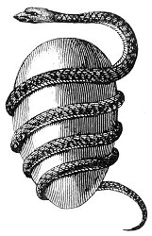  
THE ORPHIC EGG.

From Bryant's *An Analysis of Ancient Mythology*.

*The ancient symbol of the Orphic Mysteries was the serpent-entwined egg, which signified Cosmos as encircled by the fiery Creative Spirit. The egg also represents the soul of the philosopher; the serpent, the Mysteries. At the time of initiation the shell is broke. and man emerges from the embryonic state of physical existence wherein he had remained through the fetal period of philosophic regeneration.*

=================================================================================================================================================

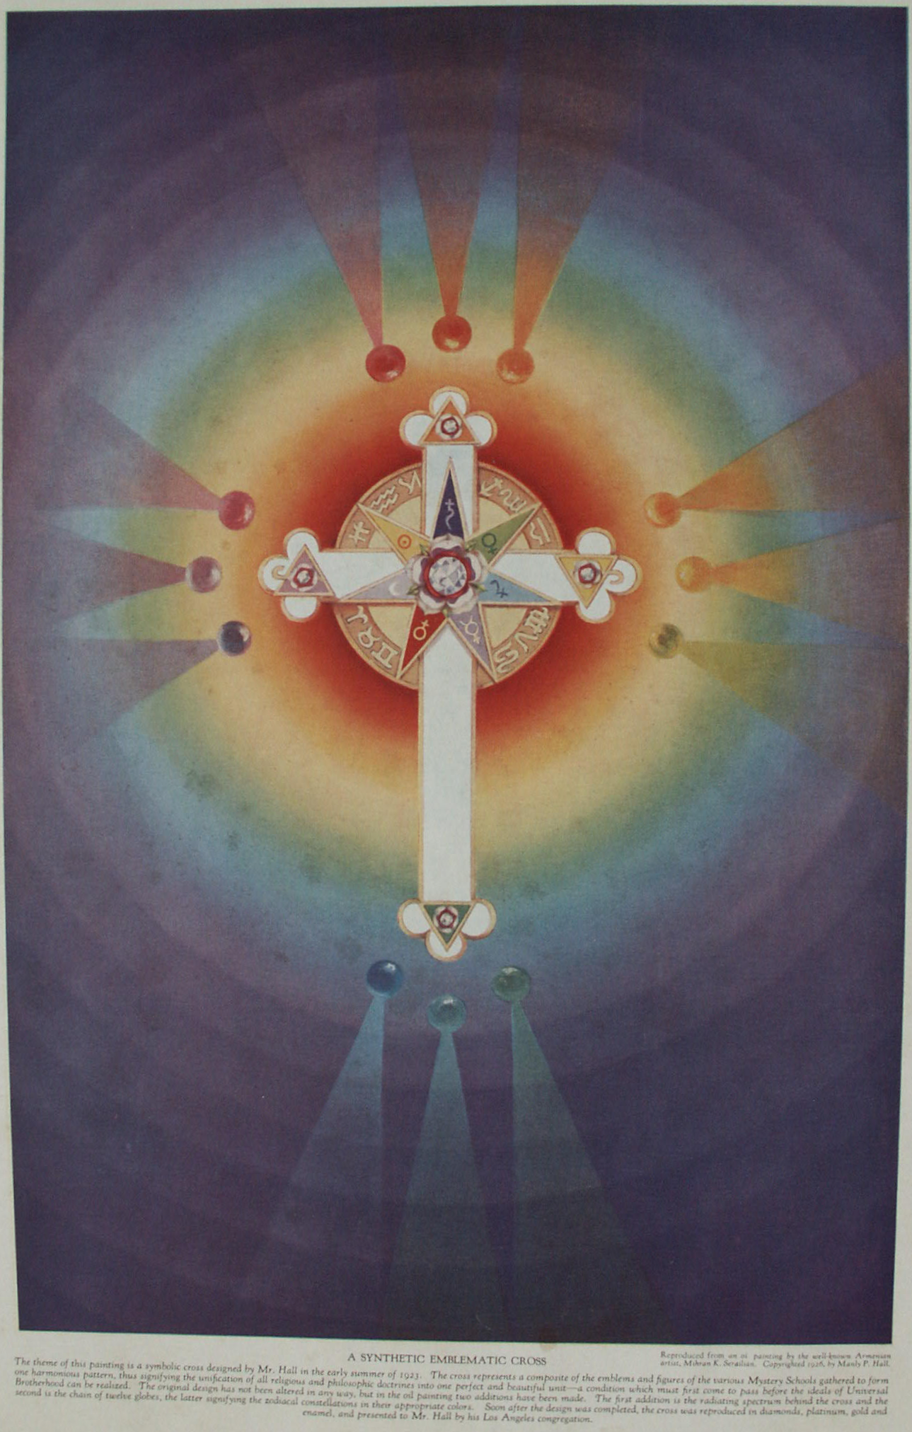

**Conclusion**

PHILIP, King of Macedon, ambitious to obtain the teacher who would be most capable of imparting the higher branches of learning to his fourteen-year-old son, Alexander, and wishing the prince to have for his mentor the most famous and learned of the great philosophers, decided to communicate with Aristotle. He dispatched the following letter to the Greek sage: "PHILIP TO ARISTOTLE, HEALTH: Know that I have a son. I render the gods many thanks; *not so much for his birth, as that he was born in your time*, for I hope that being educated and instructed by you, he will become worthy of us both and the kingdom which he shall inherit." Accepting Philip's invitation, Aristotle journeyed to Macedon in the fourth year of the 108th Olympiad, and remained for eight years as the tutor of Alexander. The young prince's affection for his instructor became as great as that which he felt for his father. He said that his father had given him *being*, but that Aristotle had given him *well-being*.

The basic principles of the Ancient Wisdom were imparted to Alexander the Great by Aristotle, and at the philosopher's feet the Macedonian youth came to realize the transcendency of Greek learning as it was personified in Plato's immortal disciple. Elevated by his illumined teacher to the threshold of the philosophic sphere, he beheld the world of the sages--the world that fate and the limitations of his own soul decreed he should not conquer.

Aristotle in his leisure hours edited and annotated the *Iliad* of Horner and presented the finished volume to Alexander. This book the young conqueror so highly prized that he carried it with him on all his campaigns. At the time of his triumph over Darius, discovering among the spoils a magnificent, gem-studded casket of unguents, he dumped its contents upon the ground, declaring that at last he had found a case worthy of Aristotle's edition of the *Iliad*!

While on his Asiatic campaign, Alexander learned that Aristotle had published one of his most prized discourses, an occurrence which deeply grieved the young king. So to Aristotle, Conqueror of the Unknown, Alexander, Conqueror of the Known, sent this reproachful and pathetic and admission of the insufficiency of worldly pomp and power: "ALEXANDER TO ARISTOTLE, HEALTH: You were wrong in publishing those branches of science hitherto not to be acquired except from oral instruction. In what shall I excel others if the more profound knowledge I gained from you be communicated to all? *For my part I had rather surpass the majority of mankind in the sublimer branches of learning, than in extent of power and dominion*. Farewell." The receipt of this amazing letter caused no ripple in the placid life of Aristotle, who replied that although the discourse had been communicated to the multitudes, none who had not heard him deliver the lecture (who lacked spiritual comprehension) could understand its true import.

A few short years and Alexander the Great went the way of all flesh, and with his body crumbled the structure of empire erected upon his personality. One year later Aristotle also passed into that greater world concerning whose mysteries he had so often discoursed with his disciples in the Lyceum. But, as Aristotle excelled Alexander in life, so he excelled him in death; for though his body moldered in an obscure tomb, the great philosopher continued to live in his intellectual achievements. Age after age paid him grateful tribute, generation after generation pondered over his theorems until by the sheer transcendency of his rational faculties Aristotle--"the master of those who know," as Dante has called him--became the actual conqueror of the very world which Alexander had sought to subdue with the sword.

Thus it is demonstrated that to capture a man it is not sufficient to enslave his body--it is necessary to enlist his reason; that to free a man it is not enough to strike the shackles from his limbs--his mind must be liberated from bondage to his own ignorance. Physical conquest must ever fail, for, generating hatred and dissension, it spurs the mind to the avenging of an outraged body; but all men are bound whether willingly or unwillingly to obey that intellect in which they recognize qualities and virtues superior to their own.

That the philosophic culture of ancient Greece, Egypt, and India excelled that of the modern, world must be admitted by all, even by the most confirmed of modernists. The golden era of Greek æsthetics, intellectualism, and ethics has never since been equaled. The true philosopher belongs to the most noble order of men: the nation or race which is blessed by possession of illumined thinkers is fortunate indeed, and its name shall be remembered for their sake. In the famous Pythagorean school at Crotona, philosophy was regarded as indispensable to the life of man. He who did not comprehend the dignity of the reasoning power could not properly be said to live. Therefore, when through innate perverseness a member either voluntarily withdrew or was forcibly ejected from the philosophic fraternity, a headstone was set up for him in the community graveyard; for he who had forsaken intellectual and ethical pursuits to reenter the material sphere with its illusions of sense and false ambition was regarded as one dead to the sphere of Reality. The life represented by the thraldom of the senses the Pythagoreans conceived to be spiritual death, while they regarded death to the sense-world as spiritual life.

Philosophy bestows life in that it reveals the dignity and purpose of living. Materiality bestows death in that it benumbs or clouds those faculties of the human soul which should be responsive to the enlivening impulses of creative thought and ennobling virtue. How inferior to these standards of remote days are the laws by which men live in the twentieth century! Today man, a sublime creature with infinite capacity for self-improvement, in an effort to be true to false standards, turns from his birthright of understanding--without realizing the consequences--and plunges into the maelstrom of material illusion. The precious span of his earthly years he devotes to the pathetically futile effort to establish himself as an enduring power in a realm of unenduring things. Gradually the memory of his life as a spiritual being vanishes from his objective mind and he focuses all his partly awakened faculties upon the seething beehive of industry which he has come to consider the sole actuality. From the lofty heights of his Selfhood he slowly sinks into the gloomy depths of ephemerality. He falls to the level of the beast, and in brutish fashion mumbles the problems arising from his all too insufficient knowledge of the Divine Plan. Here in the lurid turmoil of a great industrial, political, commercial inferno, men writhe in self-inflicted agony and, reaching out into the swirling mists, strive to clutch and hold the grotesque phantoms of success and power.

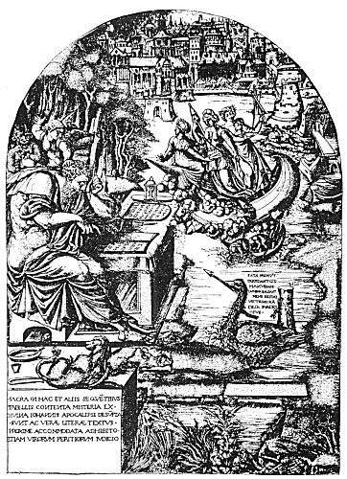  
JOHN AND THE VISION OF THE APOCALYPSE.

From an engraving by Jean Duvet.

*Jean Duvet of Langres (who was born in 1485 and presumably died sometime after 1561, the year in which his illustrations to the Apocalypse were printed in book form) was the oldest and greatest of French Renaissance engravers. Little is known concerning Duvet beyond the fact that he was the goldsmith to the King of France. His engravings for the Book of Revelation, executed after he had passed his seventieth year, were his masterpiece. (For further information regarding this obscure master, consult article by William M. Ivins, Jr., in The Arts, May, 1926.) The face of John is an actual portrait of Duvet. This plate, like many others cut by Duvet, is rich in philosophical symbolism.*

Ignorant of the cause of life, ignorant of the purpose of life, ignorant of what lies beyond the mystery of death, yet possessing within himself the answer to it all, man is willing to sacrifice the beautiful, the true, and the good within and without upon the blood-stained altar of worldly ambition. The world of philosophy--that beautiful garden of thought wherein the sages dwell in the bond of fraternity--fades from view. In its place rises an empire of stone, steel, smoke, and hate-a world in which millions of creatures potentially human scurry to and fro in the desperate effort to exist and at the same time maintain the vast institution which they have erected and which, like some mighty, juggernaut, is rumbling inevitably towards an unknown end. In this physical empire, which man erects in the vain belief that he can outshine the kingdom of the celestials, everything is changed to stone, Fascinated by the glitter of gain, man gazes at the Medusa-like face of greed and stands petrified.

In this commercial age science is concerned solely with the classification of physical knowledge and investigation of the temporal and illusionary parts of Nature. Its so-called practical discoveries bind man but more tightly with the bonds of physical limitation, Religion, too, has become materialistic: the beauty and dignity of faith is measured by huge piles of masonry, by tracts of real estate, or by the balance sheet. Philosophy which connects heaven and earth like a mighty ladder, up the rungs of which the illumined of all ages have climbed into the living presence of Reality--even philosophy has become a prosaic and heterogeneous mass of conflicting notions. Its beauty, its dignity, its transcendency are no more. Like other branches of human thought, it has been made materialistic--"practical"--and its activities so directionalized that they may also contribute their part to the erection of this modern world of stone and steel.

In the ranks of the so-called learned there is rising up a new order of thinkers, which may best be termed the *School of the Worldly Wise Men*. After arriving at the astounding conclusion that they are the intellectual salt of the earth, these gentlemen of letters have appointed themselves the final judges of all knowledge, both human and divine. This group affirms that all mystics must have been epileptic and most of the saints neurotic! It declares God to be a fabrication of primitive superstition; the universe to be intended for no particular purpose; immortality to be a figment of the imagination; and an outstanding individuality to be but a fortuitous combination of cells! Pythagoras is asserted to have suffered from a "bean complex"; Socrates was a notorious inebriate; St. Paul was subject to fits; Paracelsus was an infamous quack, the Comte di Cagliostro a mountebank, and the Comte de St.-Germain the outstanding crook of history!

What do the lofty concepts of the world's illumined saviors and sages have in common with these stunted, distorted products of the "realism" of this century? All over the world men and women ground down by the soulless cultural systems of today are crying out for the return of the banished age of beauty and enlightenment--for something *practical* in the highest sense of the word. A few are beginning to realize that so-called civilization in its present form is at the vanishing point; that coldness, heartlessness, commercialism, and material efficiency are *im*practical, and only that which offers opportunity for the expression of love and ideality is truly worth while. All the world is seeking happiness, but knows not in what direction to search. Men must learn that happiness crowns the soul's quest for understanding. Only through the realization of infinite goodness and infinite accomplishment can the peace of the inner Self be assured. In spite of man's geocentricism, there is something in the human mind that is reaching out to philosophy--not to this or that philosophic code, but simply to philosophy in the broadest and fullest sense.

The great philosophic institutions of the past must rise again, for these alone can tend the veil which divides the world of causes from that of effects. Only the Mysteries--those sacred Colleges of Wisdom--can reveal to struggling humanity that greater and more glorious universe which is the true home of the spiritual being called man. Modern philosophy has failed in that it has come to regard thinking as simply an *intellectual* process. Materialistic thought is as hopeless a code of life as commercialism itself. *The power to think true* is the savior of humanity. The mythological and historical Redeemers of every age were all personifications of that power. He who has a little more rationality than his neighbor is a little better than his neighbor. He who functions on a higher plane of rationality than the rest of the world is termed the greatest thinker. He who functions on a lower plane is regarded as a barbarian. Thus comparative rational development is the true gauge of the individual's evolutionary status.

Briefly stated, the true purpose of ancient philosophy was to discover a method whereby development of the rational nature could be accelerated instead of awaiting the slower processes of Nature, This supreme source of power, this attainment of knowledge, this unfolding of the god within, is concealed under the epigrammatic statement of the *philosophic life*. This was the key to the Great Work, the mystery of the Philosopher's Stone, for it meant that alchemical transmutation had been accomplished. Thus ancient philosophy was primarily the living of a life; secondarily, an intellectual method. He alone can become a philosopher in the highest sense who *lives the philosophic life*. What man lives he comes to *know*. Consequently, a great philosopher is one whose threefold life--physical, mental, and spiritual--is wholly devoted to and completely permeated by his rationality.

Man's physical, emotional, and mental natures provide environments of reciprocal benefit or detriment to each other. Since the physical nature is the immediate environment of the mental, only that mind is capable of rational thinking which is enthroned in a harmonious and highly refined material constitution. Hence *right action*, *right feeling*, and *right thinking* are prerequisites of *right knowing*, and the attainment of philosophic power is possible only to such as have harmonized their thinking with their living. The wise have therefore declared that none can attain to the highest in the science of knowing until first he has attained to the highest in the science of living. *Philosophic power is the natural outgrowth of the philosophic life*. Just as an intense physical existence emphasizes the importance of physical things, or just as the monastic metaphysical asceticism establishes the desirability of the ecstatic state, so complete philosophic absorption ushers the consciousness of the thinker into the most elevated and noble of all spheres--the pure philosophic, or rational, world.

In a civilization primarily concerned with the accomplishment of the extremes of temporal activity, the philosopher represents an equilibrating intellect capable of estimating and guiding the cultural growth. The establishment of the *philosophic rhythm* in the nature of an individual ordinarily requires from fifteen to twenty years. During that entire period the disciples of old were constantly subjected to the most severe discipline. Every activity of life was gradually disengaged from other interests and focalized upon the reasoning part. In the ancient world there was another and most vital factor which entered into the production of rational intellects and which is entirely beyond the comprehension of modern thinkers: namely, *initiation* into the philosophic Mysteries. A man who had demonstrated his peculiar mental and spiritual fitness was accepted into the *body of the learned* and to him was revealed that priceless heritage of arcane lore preserved from generation to generation. This heritage of philosophic truth is the matchless treasure of all ages, and each disciple admitted into these *brotherhoods of the wise* made, in turn, his individual contribution to this store of classified knowledge.

The one hope of the world is philosophy, for all the sorrows of modern life result from the lack of a proper philosophic code. Those who sense even in part the dignity of life cannot but realize the shallowness apparent in the activities of this age. Well has it been said that no individual can succeed until he has developed his philosophy of life. Neither can a race or nation attain true greatness until it has formulated an adequate philosophy and has dedicated its existence to a policy consistent with that philosophy. During the World War, when so-called civilization hurled one half of itself against the other in a frenzy of hate, men ruthlessly destroyed something more precious even than human life: they obliterated those records of human thought by which life can be intelligently directionalized. Truly did Mohammed declare the ink of philosophers to be more precious than the blood of martyrs. Priceless documents, invaluable records of achievement, knowledge founded on ages of patient observation and experimentation by the elect of the earth--all were destroyed with scarcely a qualm of regret. What was knowledge, what was truth, beauty, love, idealism, philosophy, or religion when compared to man's desire to control an infinitesimal spot in the fields of Cosmos for an inestimably minute fragment of time? Merely to satisfy some whim or urge of ambition man would uproot the universe, though well he knows that in a few short years he must depart, leaving all that he has seized to posterity as an old cause for fresh contention.

War--the irrefutable evidence of irrationality--still smolders in the hearts of men; it cannot die until human selfishness is overcome. Armed with multifarious inventions and destructive agencies, civilization will continue its fratricidal strife through future ages, But upon the mind of man there is dawning a great fear--the fear that eventually civilization will destroy itself in one great cataclysmic struggle. Then must be reenacted the eternal drama of reconstruction. Out of the ruins of the civilization which died when its idealism died, some primitive people yet in the womb of destiny must build a new world. Foreseeing the needs of that day, the philosophers of the ages have desired that into the structure of this new world shall be incorporated the truest and finest of all that has gone before. It is a divine law that the sum of previous accomplishment shall be the foundation of each new order of things. The great philosophic treasures of humanity must be preserved. That which is superficial may he allowed to perish; that which is fundamental and essential must remain, regardless of cost.

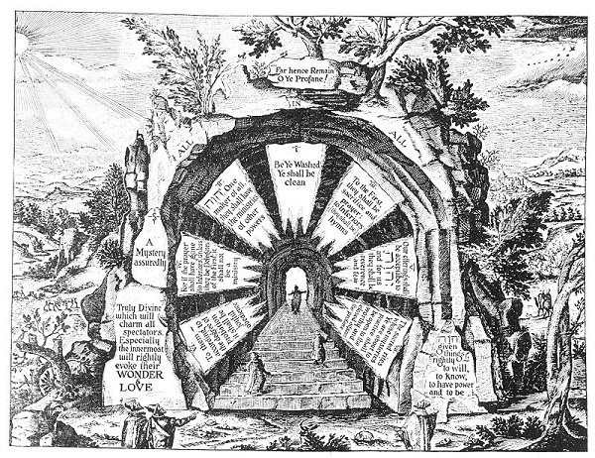  
THE ENTRANCE TO THE HOUSE OF THE MYSTERIES.

From Khunrath's *Amphitheatrum Sapientiæ*, etc.

*This symbolic figure, representing the way to everlasting life, is described by Khunrath in substance as follows: "This is the Portal of the amphitheatre of the only true and eternal Wisdom--a narrow one, indeed, but sufficiently august, and consecrated to Jehovah. To this portal ascent is made by a mystic, indisputably prologetic, flight of steps, set before it as shown in the picture. It consists of seven theosophic, or, rather, philosophic steps of the Doctrine of the Faithful Sons. After ascending the steps, the path is along the way of God the Father, either directly by inspiration or by various mediate means. According to the seven oracular laws shining at the portal, those who are inspired divinely have the power to enter and with the eyes of the body and of the mind, of seeing, contemplating and investigating in a Christiano-Kabalistic, divino-magical, physico-chemical manner, the nature of the Wisdom: Goodness, and Power of the Creator; to the end that they die not sophistically but live theosophically, and that the orthodox philosophers so created may with sincere philosophy expound the works of the Lord, and worthily praise God who has thus blessed these friend, of God." The above figure and description constitute one of the most remarkable expositions ever made of the appearance of the Wise Man's House and the way by which it must be entered.*

Two fundamental forms of ignorance were recognized by the Platonists: *simple* ignorance and *complex* ignorance. Simple ignorance is merely lack of knowledge and is common to all creatures existing posterior to the First Cause, which alone has perfection of knowledge. Simple ignorance is an ever-active agent, urging the soul onward to the acquisition of knowledge. From this virginal state of unawareness grows the desire to become aware with its resultant improvement in the mental condition. The human intellect is ever surrounded by forms of existence beyond the estimation of its partly developed faculties. In this realm of objects not understood is a never-failing source of mental stimuli. Thus wisdom eventually results from the effort to cope rationally with the problem of the unknown.

In the last analysis, the Ultimate Cause alone can be denominated wise; in simpler words, only God is good. Socrates declared knowledge, virtue, and utility to be one with the innate nature of good. Knowledge is a condition of *knowing*; virtue a condition of *being*; utility a condition of *doing*. Considering wisdom as synonymous with mental completeness, it is evident that such a state can exist only in the Whole, for that which is less than the Whole cannot possess the fullness of the All. No part of creation is complete; hence each part is imperfect to the extent that it falls short of entirety. Where incompleteness is, it also follows that ignorance must be coexistent; for every part, while capable of knowing its own Self, cannot become aware of the Self in the other parts. Philosophically considered, growth from the standpoint of human evolution is a process proceeding from heterogeneity to homogeneity. In time, therefore, the isolated consciousness of the individual fragments is reunited to become the complete consciousness of the Whole. Then, and then only, is the condition of *all-knowing* an absolute reality.

Thus all creatures are relatively ignorant yet relatively wise; comparatively nothing yet comparatively all. The microscope reveals to man his significance; the telescope, his insignificance. Through the eternities of existence man is gradually increasing in both wisdom and understanding; his ever-expanding consciousness is including more of the external within the area of itself. Even in man's present state of imperfection it is dawning upon his realization that he can never be truly happy until he is perfect, and that of all the faculties contributing to his self-perfection none is equal in importance to the rational intellect. Through the labyrinth of diversity only the illumined mind can, and must, lead the soul into the perfect light of unity.

In addition to the simple ignorance which is the most potent factor in mental growth there exists another, which is of a far more dangerous and subtle type. This second form, called *twofold* or *complex* ignorance, may be briefly defined as *ignorance of ignorance*. Worshiping the sun, moon, and stars, and offering sacrifices to the winds, the primitive savage sought with crude fetishes to propitiate his unknown gods. He dwelt in a world filled with wonders which he did not understand. Now great cities stand where once roamed the Crookboned men. Humanity no longer regards itself as primitive or aboriginal. The spirit of wonder and awe has been succeeded by one of sophistication. Today man worships his own accomplishments, and either relegates the immensities of time and space to the background of his consciousness or disregards them entirely.

The twentieth century makes a fetish of civilization and is overwhelmed by its own fabrications; its gods are of its own fashioning. Humanity has forgotten how infinitesimal, how impermanent and how ignorant it actually is. Ptolemy has been ridiculed for conceiving the earth to be the center of the universe, yet modern civilization is seemingly founded upon the hypothesis that the planet earth is the most permanent and important of all the heavenly spheres, and that the gods from their starry thrones are fascinated by the monumental and epochal events taking place upon this spherical ant-hill in Chaos.

From age to age men ceaselessly toil to build cities that they may rule over them with pomp and power--as though a fillet of gold or ten million vassals could elevate man above the dignity of his own thoughts and make the glitter of his scepter visible to the distant stars. As this tiny planet rolls along its orbit in space, it carries with it some two billion human beings who live and die oblivious to that immeasurable existence lying beyond the lump on which they dwell. Measured by the infinities of time and space, what are the captains of industry or the lords of finance? If one of these plutocrats should rise until he ruled the earth itself, what would he be but a petty despot seated on a grain of Cosmic dust?

Philosophy reveals to man his kinship with the All. It shows him that he is a brother to the suns which dot the firmament; it lifts him from a taxpayer on a whirling atom to a citizen of Cosmos. It teaches him that while physically bound to earth (of which his blood and bones are part), there is nevertheless within him a spiritual power, a diviner Self, through which he is one with the symphony of the Whole. Ignorance of ignorance, then, is that self-satisfied state of unawareness in which man, knowing nothing outside the limited area of his physical senses, bumptiously declares there is nothing more to know! He who knows no life save the physical is merely ignorant; but he who declares physical life to be all-important and elevates it to the position of supreme reality--such a one is ignorant of his own ignorance.

If the Infinite had not desired man to become wise, He would not have bestowed upon him the faculty of knowing. If He had not intended man to become virtuous, He would not have sown within the human heart the seeds of virtue. If He had predestined man to be limited to his narrow physical life, He would not have equipped him with perceptions and sensibilities capable of grasping, in part at least, the immensity of the outer universe. The criers of philosophy call all men to a comradeship of the spirit: to a fraternity of thought: to a convocation of Selves. Philosophy invites man out of the vainness of selfishness; out of the sorrow of ignorance and the despair of worldliness; out of the travesty of ambition and the cruel clutches of greed; out of the red hell of hate and the cold tomb of dead idealism.

Philosophy would lead all men into the broad, calm vistas of truth, for the world of philosophy is a land of peace where those finer qualities pent up within each human soul are given opportunity for expression. Here men are taught the wonders of the blades of grass; each stick and stone is endowed with speech and tells the secret of its being. All life, bathed in the radiance of understanding, becomes a wonderful and beautiful reality. From the four corners of creation swells a mighty anthem of rejoicing, for here in the light of philosophy is revealed the purpose of existence; the wisdom and goodness permeating the Whole become evident to even man's imperfect intellect. Here the yearning heart of humanity finds that companionship which draws forth from the innermost recesses of the soul that great store of good which lies there like precious metal in some deep hidden vein.

Following the path pointed out by the wise, the seeker after truth ultimately attains to the summit of wisdom's mount, and gazing down, beholds the panorama of life spread out before him. The cities of the plains are but tiny specks and the horizon on every hand is obscured by the gray haze of the Unknown. Then the soul realizes that wisdom lies in breadth of vision; that it increases in comparison to the vista. Then as man's thoughts lift him heavenward, streets are lost in cities, cities in nations, nations in continents, continents in the earth, the earth in space, and space in an infinite eternity, until at last but two things remain: the Self and the goodness of God.

While man's physical body resides with him and mingles with the heedless throng, it is difficult to conceive of man as actually inhabiting a world of his own-a world which he has discovered by lifting himself into communion with the profundities of his own internal nature. Man may live two lives. One is a struggle from the womb to the tomb. Its span is measured by man's own creation--time. Well may it be called the unheeding life. The other life is from realization to infinity. It begins with understanding, its duration is forever, and upon the plane of eternity it is consummated. This is called the philosophic life. Philosophers are nor born nor do they die; for once having achieved the realization of immortality, they are immortal. Having once communed with Self, they realize that within there is an immortal foundation that will not pass away. Upon this living, vibrant base--Self--they erect a civilization which will endure after the sun, the moon, and the stars have ceased to be. The fool lives but for today; the philosopher lives forever.

When once the rational consciousness of man rolls away the stone and comes forth from its sepulcher, it dies no more; for to this second or philosophic birth there is no dissolution. By this should not be inferred physical immortality, but rather that the philosopher has learned that his physical body is no more his true Self than the physical earth is his true world. In the realization that he and his body are dissimilar--that though the form must perish the life will not fail--he achieves conscious immortality. This was the immortality to which Socrates referred when he said: "Anytus and Melitus may indeed put me to death, but they cannot injure me." To the wise, physical existence is but the outer room of the hall of life. Swinging open the doors of this antechamber, the illumined pass into the greater and more perfect existence. The ignorant dwell in a world bounded by time and space. To those, however, who grasp the import and dignity of Being, these are but phantom shapes, illusions of the senses-arbitrary limits imposed by man's ignorance upon the duration of Deity. The philosopher lives and thrills with the realization of this duration, for to him this infinite period has been designed by the All-Wise Cause as the time of all accomplishment.

Man is not the insignificant creature that he appears to be; his physical body is not the true measure of his real self. The invisible nature of man is as vast as his comprehension and as measureless as his thoughts. The fingers of his mind reach out and grasp the stars; his spirit mingles with the throbbing life of Cosmos itself. He who has attained to the state of understanding thereby has so increased his capacity to know that he gradually incorporates within himself the various elements of the universe. The unknown is merely that which is yet to be included within the consciousness of the seeker. Philosophy assists man to develop the sense of appreciation; for as it reveals the glory and the sufficiency of knowledge, it also unfolds those latent powers and faculties whereby man is enabled to master the secrets of the seven spheres.

From the world of physical pursuits the initiates of old called their disciples into the life of the mind and the spirit. Throughout the ages, the Mysteries have stood at the threshold of Reality--that hypothetical spot between *noumenon* and *phenomenon*, the Substance and the shadow. The gates of the Mysteries stand ever ajar and those who will may pass through into the spacious domicile of spirit. The world of philosophy lies neither to the right nor to the left, neither above nor below. Like a subtle essence permeating all space and all substance, it is everywhere; it penetrates the innermost and the outermost parts of all being. In every man and woman these two spheres are connected by a gate which leads from the not-self and its concerns to the Self and its realizations. In the mystic this gate is the heart, and through spiritualization of his emotions he contacts that more elevated plane which, once felt and known, becomes the sum of the worth-while. In the philosopher, reason is the gate between the outer and the inner worlds, the illumined mind bridging the chasm between the corporeal and the incorporeal. Thus godhood is born within the one who sees, and from the concerns of men he rises to the concerns of gods.

In this era of "practical" things men ridicule even the existence of God. They scoff at goodness while they ponder with befuddled minds the phantasmagoria of materiality. They have forgotten the path which leads beyond the stars. The great mystical institutions of antiquity which invited man to enter into his divine inheritance have crumbled, and institutions of human scheming now stand where once the ancient houses of learning rose a mystery of fluted columns and polished marble. The white-robed sages who gave to the world its ideals of culture and beauty have gathered their robes about them and departed from the sight of men. Nevertheless, this little earth is bathed as of old in the sunlight of its Providential Generator. Wide-eyed babes still face the mysteries of physical existence. Men continue to laugh and cry, to love and hate; Some still dream of a nobler world, a fuller life, a more perfect realization. In both the heart and mind of man the gates which lead from mortality to immortality are still ajar. Virtue, love, and idealism are yet the regenerators of humanity. God continues to love and guide the destinies of His creation. The path still winds upward to accomplishment. The soul of man has not been deprived of its wings; they are merely folded under its garment of flesh. Philosophy is ever that magic power which, sundering the vessel of clay, releases the soul from its bondage to habit and perversion. Still as of old, the soul released can spread its wings and soar to the very source of itself.

The criers of the Mysteries speak again, bidding all men welcome to the House of Light. The great institution of materiality has failed. The false civilization built by man has turned, and like the monster of Frankenstein, is destroying its creator. Religion wanders aimlessly in the maze of theological speculation. Science batters itself impotently against the barriers of the unknown. Only transcendental philosophy knows the path. Only the illumined reason can carry the understanding part of man upward to the light. Only philosophy can teach man to be born well, to live well, to die well, and in perfect measure be born again. Into this band of the elect--those who have chosen the life of knowledge, of virtue, and of utility--the philosophers of the ages invite YOU.

===================================================================================================================================================

End