Saudi Arabian Women's Conference... With Not A Female In Sight
https://us-mg5.mail.yahoo.com/neo/launch?.rand=962atl7ge55hd#7894381664
By Sara C. Nelson | 25 July 2013
Huffington Post UK
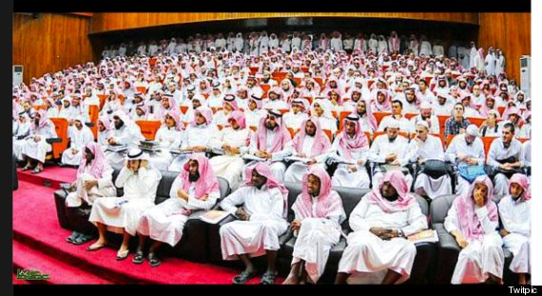
The conference on the subject of ‘women in society’ was notable for its lack of women.

An image of a conference in Saudi Arabia on the topic of “women in society” – with not a single female present – has gone viral.
The picture features row upon row of men in traditional headscarves and white thobes. A single Westerner in a flannel shirt is the only person breaking up an otherwise uniform sea of what appear to be Arab men.
We traced the picture back to Beladalorb.com, which says it was published in Saudi newspaper Okaz last year.
The conference was reportedly held at the University of Qassim and was apparently attended by representatives of 15 countries.
Much is being made of absurdity and hypocrisy of the image, but when you consider Saudi Arabia is a country where women are not permitted to drive, it seems less so.
Religious police in the Gulf Kingdom which is governed by Sharia Law only recently lifted a ban on females riding motorbikes and bicycles – as long as they wear the full-length veil and are accompanied by a male relative.
It is illegal for Saudi women to travel abroad without male accompaniment. They may only do so if their guardian agrees by signing a document know as a ‘yellow sheet’ at an airport or border crossing.
In November 2012 it emerged women were being electronically monitored with authorities using SMS to track them and inform their husbands of their whereabouts.
And it was only in 2011 that women were given the right to vote and run for office in municipal elections in 2015.
================================================================================================================================

