Barbara G. Walker 1930- Wikipedia Dec 1 2015
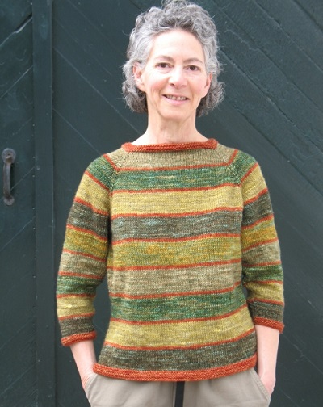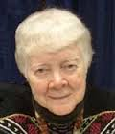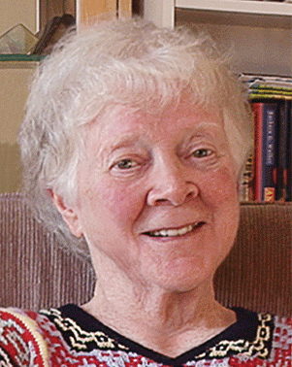
Barbara G. Walker (born July 2, 1930, in Philadelphia, Pennsylvania) is a U.S. author and feminist. She is an influential knitting expert and the author of several classic encyclopedic knitting references, despite "not taking to it at all" when she first learned in college.^{[1]} ^{[2]} Other topics she has written about are religion, cultural anthropology, spirituality, and mythology from the viewpoint of Pre-Indo-European neolithic matriarchies.

Contents
- 1 Books
  - 1.1 Knitting
  - 1.2 Feminism and skepticism
- 2 Personal life
- 3 Bibliography
- 4 Other works
- 5 See also
- 6 References
- 7 External links

Books

Knitting
In the 1960s and 1970s, she authored several volumes of knitting references which have become landmarks for their comprehensiveness and clarity.^{[3]} Her Knitting Treasury series documents over a thousand different knitting stitches. Other books considered mosaic knitting, for producing multicolored designs while knitting only one color per row, and constructing knitted garments from the top down rather than the usual bottom-up method used in Western knitting tradition. Her legacy continues with the reprinting of most of her knitting books, starting in the mid-1990s, as well as the publication of new contributions to knitting literature.

Feminism and skepticism
She writes about both the problems with mainstream religion and how these have contributed to patriarchal societies and sexism.^{[4][2]} In The Skeptical Feminist: Discovering the Virgin, Mother, and Crone, she writes about her belief that there is no god. However, she believes that people, and women in particular, can use the image of the goddess in their day-to-day lives. She often uses the imagery of the Mother Goddess to discuss neolithic matriarchies. Her book Woman's Rituals: A Sourcebook is an attempt to show how she puts her "meditation techniques" into practice, and is meant as a guide for other women to do the same thing.

Personal life
She studied journalism at the University of Pennsylvania and then worked for the Washington Star in Washington, D.C. While serving on a local hotline helping battered women and pregnant teens in the mid-1970s, her earlier interest in feminism became heightened. She continued a personal study of comparative religions and feminist issues after she graduated ^{[2]} which led to her writing The Woman's Encyclopedia of Myths and Secrets (1983). ^{[4]}
Walker describes herself as an atheist. The American Humanist Association named her "Humanist Heroine" in 1993, and in 1995 she received the "Women Making Herstory" award from the New Jersey NOW.^{[4]}

Bibliography
- A Treasury of Knitting Patterns (1968) ISBN 0-942018-16-8 (reprint edition 1998)
- A Second Treasury of Knitting Patterns (1970)
- The Craft of Lace Knitting (1971) ISBN 0-684-12503-X
- The Craft of Cable-Stitch Knitting (1971) ISBN 0-684-12500-5
- Knitting from the Top (1972) ISBN 0-942018-09-5 (reprint edition)
- The Craft of Multicolor Knitting (1973) ISBN 0-684-13405-5
- Sampler Knitting (1973) ISBN 0-684-13263-X (reprinted in A Fourth Treasury of Knitting Patterns (2000))
- Barbara Walker's Learn-to-Knit Afghan Book (1974) ISBN 0-942018-13-3 (reprint edition 1997)
- Mosaic Knitting (1976) ISBN 0-684-14243-0 (revised in 1997)
- The Woman's Encyclopedia of Myths and Secrets (1983) ISBN 0-06-250925-X
- A Second Treasury of Knitting Patterns (1985) ISBN 0-942018-17-6 (reprint edition 1998)
- The Secrets of the Tarot: Origins, History, and Symbolism (1984) ISBN 0-06-250927-6
- Charted Knitting Designs: A Third Treasury of Knitting Patterns (1986) ISBN 0-942018-18-4 (reprint edition 1998)
- The I Ching of the Goddess (1986) ISBN 0-06-250924-1
- The Skeptical Feminist: Discovering the Virgin, Mother, and Crone (1987) ISBN 0-06-250932-2
- The Woman's Dictionary of Symbols and Sacred Objects (1988), Castle Books, ISBN 0-06-250923-3
- The Crone: Woman of Age, Wisdom, and Power (1988) ISBN 0-06-250934-9
- The Book of Sacred Stones: Fact and Fallacy in the Crystal World (1989, with Werner P. Brodde) ISBN 0-06-250921-7
- Women's Rituals: A Sourcebook (1990) ISBN 0-06-250939-X
- Amazon: A Novel (1992) ISBN 0-06-250975-6
- Feminist Fairy Tales (1996) ISBN 0-06-251320-6
- Restoring the Goddess: Equal Rites for Modern Women (2000) ISBN 1-57392-786-4
- A Fourth Treasury of Knitting Patterns (2000) ISBN 0-942018-20-6 (includes Sampler Knitting (1973))
- The Essential Handbook of Women's Spirituality and Ritual (2001) ISBN 1-931412-64-2
- Mosaic Knitting, Revised (2006) ISBN 0-942018-15-X
- Man Made God: A Collection of Essays (2010) ISBN 0-9799631-4-1
- Belief and Unbelief (2014) ISBN 9780931779565

Other works
- Barbara Walker Tarot Deck (Misc. Supplies) (1986) ISBN 1-931412-72-3
- I Ching of the Goddess: Divination Kit (Boxed Set with Cards) (2001) ISBN 1-931412-72-3
- Women And Religion: Sexism In The Christian Tradition (1997) - speech

See also
- Feminism
- Knitting
- Prehistoric religion
- Skepticism

References

• "Knitting's Old Guard Speaks Out" Vogue Knitting 2007 Fall
• • Druchunas, Donna (January 11, 2009). "Barbara G. Walker, The Skeptical Feminist". skepchic.org. Retrieved 29 April 2015.
• • Gardner, Kay; Shayne, Ann (2006). Mason-Dixon Knitting: The Curious Knitter's Guide. Potter Craft. p. 115. ISBN 0-307-23605-6.
• "Humanist Profile: Barbara G. Walker". NOW NJ. National Organization for Women of New Jersey (NOW-NJ). January 16, 2005. Retrieved 29 April 2015.
================================================================

