The Brazen Table of Bembo & Hieroglyphics

http://penelope.uchicago.edu/oddnotes/bembo.html
The Bembine Isiac table, a brass, silver and enamel table almost certainly the work of an Egyptianizing Roman sculptor, was stolen at the sack of Rome in 1527. It came into the possession of the Renaissance scholar Pietro Bembo. After various vicissitudes and travels, it came to rest in Turin's Museo Egizio, where it is today. (See L'Egitto Due (in Italian) for a brief history.)

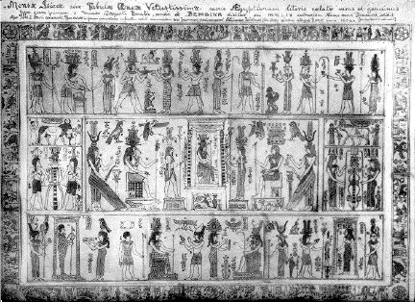
The Isiac table of Bembo; from a web page that has, alas, disappeared

An article in Notes & Queries (4th s. ii 40, 328 (October 3, 1868)) may help to shed some light on its history:
The celebrated altar-piece of Isis, which after so many vicissitudes is preserved in the Museum of Turin, has been the object of attention and investigation to various learned men, and the hieroglyphics by which it is covered have been minutely and variously engraved in their several works. For Æneas Vico of Parma, who, I think, was the first who gave his attention to the subject, it was engraved in full size.... Pignorius was the next, in his curious work: —
"Vetustissimæ Tabulæ Æneæ Hieroglyphicis, hoc est sacris Ægyptiorum litteris cælatæ, accurata explicatio," &c. 4to. Venetiis, 1605."
This I have not seen, my own copy being the second edition of the same work, with a different title, which I transcribe: —
"Characteres Ægyptii, hoc est Sacrorum quibus Ægyptii utuntur, simulachrorum, accurata delineatio et explicatio, qua antiquissimarum superstitionum origines, progressiones, ritusque, ad Barbaram, Græcam, et Romanam historiam illustrandam, enarruntur, et multa scriptorum veterum loca explicantur atque emendantur. Autore Laurentio Pignorio Patavino. Accessit ab eodem, Auctarium, in quo ex antiquis Sigillis Gemmisque selectiora quædam ejus generis, et veterum hereticorum amuleta exhibentur. Omnia in æs pulcherrime incisa, et in lucem emissa per Joannem Theodorum, et Joannem Israelem De Bry, fratres germanos. 4to. Francofurti, M.DC.VIII."
Besides the engravings interspersed in the text, this volume has fifteen pages of engrave hieroglyphical representations, and forty-three leaves of explanatory letterpress. The theory of Pignorius, who sees in the mystic figures merely the representation of the ceremonies of a sacrifice after the Ægyptian rite, is advocated with equal brevity and learning, and is held to be the most simple and probable. His little work reached yet a third edition, in which the title again underwent a change. It now appeared as —
Mensa Isiaca, quâ Sacrorum apud Ægyptios ratio ac simulacra subjectis tabulis æneis simul exhibentur et explicantur. 4to. Amsterdam, 1669."
Of this the Rev. Hartwell Horne says that it is "The best edition of a most curious work. Pignorius is allowed to have succeeded best in deciphering the meaning of the mystic table of Isis." (Introd. to Bibliog., p. 460.)
... Mr Horne appears not to have been aware of the [earliest edition] of 1605, as he erroneously states the first to have appeared at Frankfort. I believe, however, that so far as regards the text, the one is a reprint of the other.
The subject of the Isiac table is further discussed by Kircher, in his Œdipus Ægyptiacus (Romæ, 1652-4, 4 vols., folio), by Montfaucon, Yablonski, and Caylus, in whose several works engraved representations will also be found. Warburton considered it the most modern monument of ancient Egypt, and Champollion regarded it as the work of an artist who had no esoteric acquaintance with the mystic rites of the goddess. Since the expression of this opinion, the Isiac tablet has lost much of the interest with which it was formerly regarded.
I have also before me —
"The New Pantheon; or, Fabulous History of the Heathen Gods, Goddesses, Heroes, &c., explained in manner entirely new, &c., by Samuel Boyse, A.M. The fifth edition, by William Cooke, A.M., &c. 8vo. Salisbury, 1777."
Here are given three plates identical with the engravings of De Bry in the work of Pignorius. The explanation which accompanies these plates is prefaced by the statement, that
"These three following plates — viz. of Isis, Osiris, and Orus, were taken originally from the Bembine or Isiac table in the Bodleian. This table or altar-piece is of brass, full of hieroglyphics inlaid in silver and enamel, which constitute an epitome of the whole Egyptian theology. It has been described, copied, and elaborately explained by the learned Jesuit, Athanasius Kircher, in his Œdipus Ægyptiacus, vol. iii. p. 80 et seq. Romæ, 1654-7. Hor. Apoll."
Here there appears to be something which, to me at least, requires explanation. The table preserved at Turin is the "Bembine," so called from its having been purchased by Cardinal Bembo from a locksmith who had bought it at the sack of Rome in 1525 [sic]. There can hardly be two Bembine Isiac Tables, with similar inscriptions. Is then the Bodleian table a copy of that at Turin?
WILLIAM BATES, Birmingham

This page is maintained at the University of Chicago by James Eason, who welcomes comments, criticism, and suggestions.
Bembo, Pietro (1470 - 1547) http://www.xrefer.com/entry/251676
Italian scholar, poet, and humanist
Born at Venice, he was educated by Augurello, Barbaro, and Donato. He met Politian in 1491 and in the same year travelled to Messina to learn Greek from Constantine Lascaris. In 1493 he returned to Venice and edited Lascaris's Greek grammar for Manutius, who also issued Bembo's editions of Petrarch (1501) and Dante (1502). Gli Asolani (1505), dialogues on love dedicated to Lucrezia Borgia, brought Bembo to Urbino where he is depicted as the advocate of platonic love in Castiglione's Courtier. In 1513 in Rome Bembo published De imitatione, which championed Ciceronianism and led to his appointment as secretary (1513-21) to Pope Leo X, after which he went to Padua. In 1530 he published Rime, a collection of his Italian poetry, and was nominated historian and librarian of the Venetian republic. In 1539 he became a cardinal and moved back to Rome, where he died.
Bembo was an important member of the sceptical group which flourished around Leo X, and was patron of the free-thinking Pomponazzi. He was also an important figure in the revival of interest in vernacular poetry, starting a vogue for imitations of Petrarch. He showed a much greater sensitivity to form than did those humanists who concentrated on classical literature; his Prose della volgar lingua (1525), the first critical history of Italian literature since Dante, used Petrarch and Boccaccio as models for a vernacular which would be natural as well as artistic. See also Bembine Table.
Bembine Table
An inscribed bronze table-top made in Rome in the first century ad and excavated in the 1520s from the ruins of the temple of Isis (hence its other name of "Isiac Table"). In 1527 it came into the possession of Cardinal Bembo. Its hieroglyphs made it an intriguing object to Renaissance scholars (see Egyptian studies). An accurate engraving of it was made by Enea Vico (1559) and it was published in 1605 by Lorenzo Pignorio in his Vetustissimae tabulae aenaea sacris Aegyptiorum simulachris coelatae accurata explicatio (An accurate account of a most ancient bronze tablet engraved with sacred symbols of the Egyptians).

http://216.239.51.100/search?q=cache:DYoxkHiuseYC:www.vermontel.com/~vtsophia/wis2.htm+bembine&hl=en
At the age of fourth-nine, Plato was initiated on the alter of the Bembine tablet of Isis in the great pyramid of Cheops. After death on the wooden tao cross, three days buried in the granite sarcophagus, he was raised to the glory of Osiris in the rising sun. Is it strange he would say that fire is a pyramid?

The Deck of Cards

Manly Hall, The Secret Teachings of All the Ages

. . . the modern deck [of cards] is of profound symbolic importance, for its arrangement is apparently in accord with the divisions of the year. The two colors, red and black, represent the two grand divisions of the year -- that during which the sun is north of the equator and that during which it is south of the equator. The four suits represent the seasons, the ages of the ancient Greeks, and the Yugas of the Hindus. The twelve court cards are the signs of the zodiac arranged in triads of a Father, a Power, and a Mind according to the upper section of the Bembine Table. The ten pip cards of each suit represent the Sephirothic trees existing in each of the four worlds (the suits). The 13 cards of each suit are the 13 lunar months in each year, and the 52 cards of the deck are the 52 weeks in the year. Counting the numbers of pips and reckoning the jacks, queens, and kings as 11, 12, and 13 respectively, the sum for the 52 cards is 364. If the joker be considered as one point, the result is 365, or the number of days in a year.

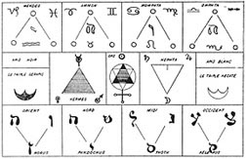
Levi’s Key To The Bembine Table
From Levi’s History of Magic.
http://prs.org/books/book310.htm
"The Isiac Tablet, writes Levi, is a Key to the Ancient Book of Thoth, which has survived to some extent the lapse of centuries and is pictured to us in the still comparatively ancient set of Tarocchi Cards.
To him the Book of Thoth was a résumé of the esoteric learning of the Egyptians, after the decadence of their civilization, this lore became crystallized in an hieroglyphic form as the Tarot; this Tarot having become partially or entirely forgotten or misunderstood, is pictured symbols fell into the hands of the sham diviners, and of the providers of the public amusement by games of Cards. The modern Tarot, or Tarocchi pack of cards consists of 78 cards of which 22 form a special group of trumps, of pictorial design: the remaining 56 are composed of four suits of 10 numerals and four court cards, King, Queen, Knight and Knave or Valet; the suits are Swords (Militaryism), Cups (Sacerdocy), Clubs or Wands (Agriculture), and Shekels or Coins (Commerce), answering respectively to our Spades, Hearts, Clubs and Diamonds. Our purpose is with the 22 trumps, these form the special characteristic of the pack and are the lineal descendants of the Hieroglyphics of the Tarot. These 22 correspond to the letters of the Hebrew and other sacred alphabets, which fall naturally into three classes of a Trio of Mothers, and Heptad of doubles, and a duodecad of simple letters. They are also considered as a triad of Heptads and one apart, a system of Initiation and an Uninitiate."
(See Westcott’s The Isiac Tablet.) MPH
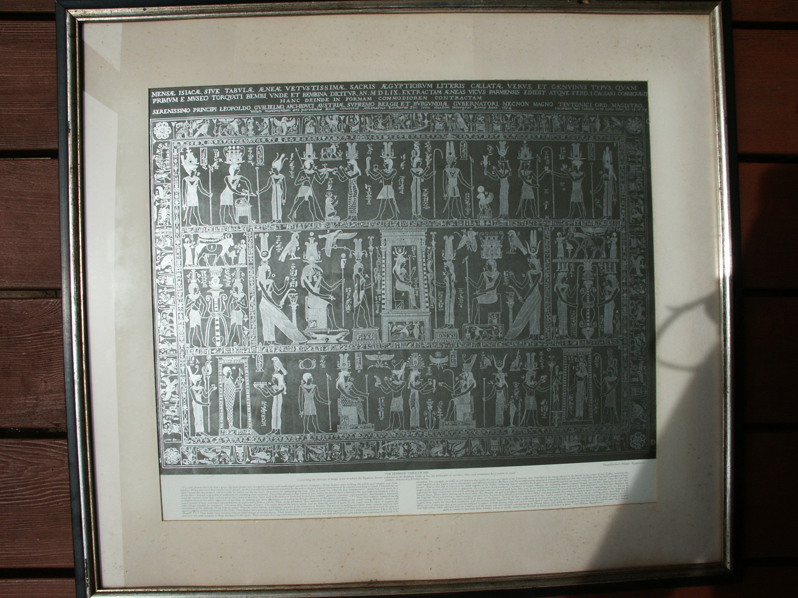

========================================================================================================================================
END

