John Muir 1838 –1914
http://en.wikipedia.org/wiki/John_Muir
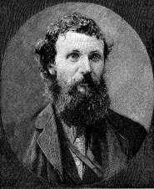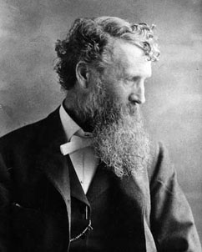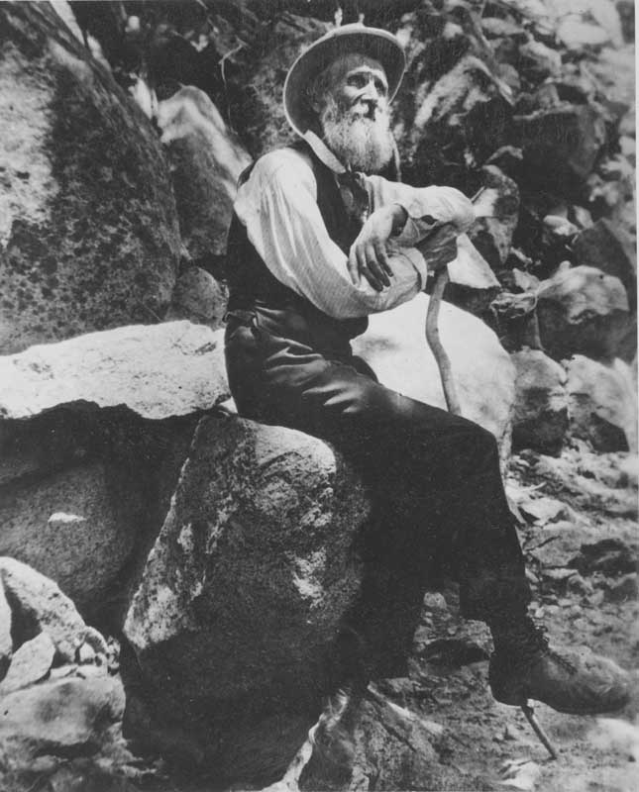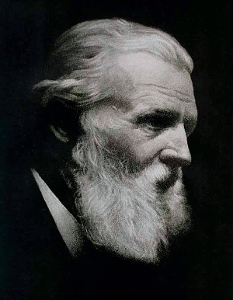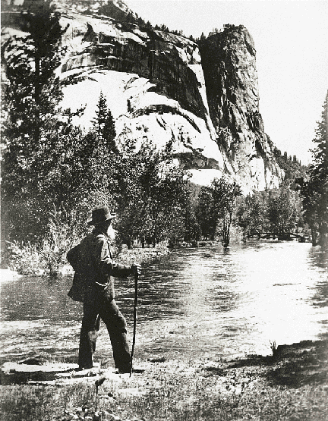
--------------------------------------------------------------------------------------------------------------------------------------------------------------------------------------------------------------------------------------------------

John Muir (April 21, 1838 – December 24, 1914) was one of the earliest modern preservationists. His letters, essays, and books telling of his adventures in nature, especially in the Sierra Nevada Mountains of California, were read by millions and are still popular today. His direct activism helped to save the Yosemite Valley and other wilderness areas. The Sierra Club, which he founded, is now one of the most important conservation organizations in the United States. But more than that his vision of nature's value for its own sake and for its spiritual, not just practical, benefits to humankind helped to change the way we look at the natural world.

Contents
- 1 Biography
- 2 Muir's travels in the Northwest
- 3 From studying to protecting
  - 3.1 Honours
- 4 Quotes
- 5 Reference
  - 5.1 Primary sources
  - 5.2 Secondary sources
- 6 See also
  - 6.1 Other books
- 7 External links

Biography
Muir was born in Dunbar, East Lothian, Scotland to Daniel Muir and Ann Gilrye. He was the third of eight children being preceded by Margaret and Sarah and followed by David, Daniel, Ann and Mary (twins) and the American born Joanna. In his autobiography, he described his two main boyhood pursuits, fighting (either by re-enacting romantic battles of Scottish history or just scrapping on the playground) and hunting for birds nests (ostensibly to one-up his fellows as they compared notes on who knew where the most were located). Such pursuits would later prove formative to Muir's adult character.
Muir emigrated to the United States in 1849, when his family started a farm in rural Marquette County, Wisconsin. He attended the University of Wisconsin for several years. It was there, under a towering black locust tree beside North Hall, that Muir took his first botany lesson. A fellow student plucked a flower from the tree and used it to explain how the grand locust is a member of the pea family, related to the straggling pea plant. Fifty years later, the naturalist Muir described the day in his autobiography. "This fine lesson charmed me and sent me flying to the woods and meadows in wild enthusiasm," Muir wrote. But instead of graduating from a school built by the hand of man, Muir opted to enroll in the "university of the wilderness" and thus walked a thousand miles from Indiana to Florida after spending most of the years 1866 and 1867 working as an industrial engineer in Indianapolis, where a factory accident almost cost him his eyesight. He had planned to continue on to South America, but was stricken by malaria and went to California instead.
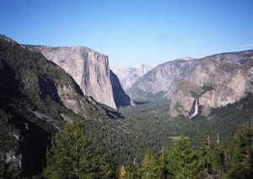
Yosemite Valley from Inspiration Point
Arriving in San Francisco in March 1868, Muir immediately left for a place he had only read about called Yosemite. After seeing Yosemite Valley for the first time he was captivated, and wrote, "No temple made with hands can compare with Yosemite," and "[Yosemite is] the grandest of all special temples of Nature."
After his initial eight-day visit, he returned to the Sierra foothills and became a ferry operator, sheepherder and bronco buster. In May 1869 a rancher named Pat Delaney offered Muir a summer job in the mountains to accompany and watch over Delaney's sheep and sheepherder. Muir enthusiastically accepted the offer and spent that summer with the sheep in the Yosemite area. That summer Muir climbed Cathedral Peak, Mount Dana and hiked the old Indian trail down Bloody Canyon to Mono Lake. During this time he started to develop his theories about how the area developed and how its ecosystem functioned.
Now more enthusiastic about the area than before, Muir secured a job operating a sawmill in the Yosemite Valley under the supervision of innkeeper James Hutchings. A natural born inventor, Muir designed a water-powered mill to cut wind-felled trees and he built a small cabin for himself along Yosemite Creek.
Pursuit of his love of science, especially geology, often occupied his free time and he soon became convinced that glaciers had sculpted many of the features of the valley and surrounding area. This notion was in stark contradiction to the accepted theory of the day, promulgated by Josiah Whitney (head of the California Geological Survey), which attributed the formation of the valley to a catastrophic earthquake. As Muir's ideas spread, Whitney would try to discr Muir by branding him as an amateur and even an ignoramus. The premier geologist of the day, Louis Agassiz, however, saw merit in Muir's ideas, and lauded him as "the first man who has any adequate conception of glacial action."
In 1871 Muir discovered an active alpine glacier below Merced Peak, which further helped his theories to gain acceptance. He was also a highly productive writer and had many of his accounts and papers published as far away as New York. Also that year, one of Muir's heroes, Ralph Waldo Emerson, arrived in Yosemite and sought Muir out. Muir's former professor at the University of Wisconsin, Ezra Carr, and Carr's wife Jeanne encouraged Muir to publish his ideas. They also introduced Muir to notables such as Emerson, as well as many leading scientists such as Louis Agassiz, John Tyndall, John Torrey, Clinton Hart Merriam, and Joseph LeConte.
A large earthquake centered near Lone Pine, California in Owens Valley (see 1872 Lone Pine earthquake) was felt very strongly in Yosemite Valley in March 1872. The quake woke Muir in the early morning and he ran out of his cabin without fear exclaiming, "A noble earthquake!" Other valley settlers, who still adhered to Whitney's ideas, feared that the quake was a prelude to a cataclysmic deepening of the valley. Muir had no such fear and promptly made a moonlit survey of new talus piles created by earthquake-triggered rockslides. This event led more people to believe in Muir's ideas about the formation of the valley.
In addition to his geologic studies, Muir also investigated the living Yosemite area. He made two field studies along the western flank of the Sierra of the distribution and ecology of isolated groves of Giant Sequoia in 1873 and 1874. In fact, in 1876 the American Association for the Advancement of Science published a paper Muir wrote about the trees' ecology and distribution.
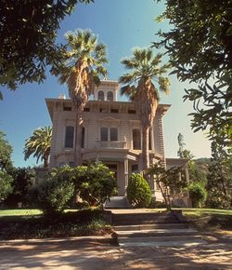
The Muirs' home in Martinez, California.
In 1880 Muir married Louisa Wanda Strentzel, whose parents owned a large ranch and fruit orchards in Martinez, California, a small town northeast of San Francisco. For the next ten years he devoted himself to managing the family ranch which became very successful. (When he died he left an estate of $250,000. Their house and part of the ranch are now a National Historical Site.) During this time two daughters were born, Wanda and Helen.

[] Muir's travels in the Northwest
In 1888 after seven years of managing the Strentzel ranch Muir described himself as "all nerve-shaken and lean as a crow - loaded with care, work and worry." Accompanied by botanist Charles Parry, Muir left on a journey to the Pacific Northwest and Alaska. The trip marked a turning point in Muir's life. Muir began writing again. He became his old self, climbing Mt Rainier, writing "Ascent of Mount Rainier".

[] From studying to protecting
Muir threw himself into his new role with great vigor. He envisioned Yosemite area and the Sierras as pristine lands without domesticated animals and free of people, including Native Americans. He saw the greatest threat to the Yosemite area and the Sierras to be livestock, especially domestic sheep (calling them "hooved locusts"). In "My First Summer in the Sierra" he writes about his encounter with the Indians describing his impression; "A strangely dirty and irregular life these dark-eyed dark-haired, half-happy savages lead in this clean wilderness." In June 1889, the influential associate or of Century magazine, Robert Underwood Johnson, camped with Muir in Tuolumne Meadows and saw firsthand the damage a large flock of sheep had done to the grassland. Johnson agreed to publish any article Muir wrote on the subject of excluding livestock from the Sierra high country. He also agreed to use his influence to introduce a bill to Congress that would make the Yosemite area into a national park, modeled after Yellowstone National Park.
A bill essentially following recommendations that Muir put forward in two Century articles ("The Treasure of the Yosemite" and "Features of the Proposed National Park", both published in 1890), was passed by Congress on September 30, 1890. To the dismay of Muir, however, the bill left Yosemite Valley in state control. With this partial victory under his belt, Muir helped form an environmental organization called the Sierra Club on May 28, 1892 and was elected as its first president (a position he held until his death 22 years later). In 1894 his first book, The Mountains of California, was published.
In July of 1896 Muir became good friends with another leader in the conservation movement, Gifford Pinchot. That friendship was ended late in the summer of 1897 when Pinchot released a statement to a Seattle newspaper supporting sheep grazing in forest reserves. Muir confronted Pinchot and demanded an explanation. When Pinchot reiterated his position Muir told him "I don't want any thing more to do with you." This philosophical divide soon expanded and split the conservationist movement into two camps: the preservationists, led by Muir, and Pinchot's camp, who co-opted the term "conservationist." Muir was deeply opposed to commercializing nature. The two men debated their positions in popular magazines as Outlook, Harper's Weekly, Atlantic Monthly, World's Work, and Century. Muir argued for the preservation of resources for their spiritual and uplifting values; Pinchot saw conservation as a means of intelligently managing the nation's resources. Both men opposed reckless exploitation of natural resources, including clear-cutting of forests.
In 1899, Muir accompanied railroad executive E. H. Harriman and other esteemed scientists on Harriman's famous exploratory voyage along the Alaska coast aboard the luxuriously refitted 250-foot steamer called the George W. Elder. He would later rely on his friendship with Harriman to apply political pressure on Congress to pass conservation legislation.
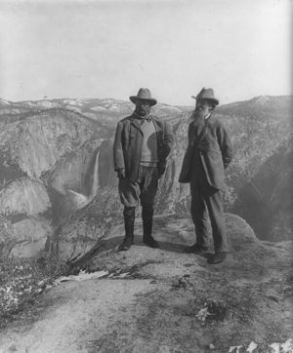
Roosevelt and Muir
In 1903 President Theodore Roosevelt accompanied Muir on a visit to the park. Muir joined Roosevelt in Oakland, California for the train trip to Raymond. The presidential entourage then traveled by stagecoach into the park. While traveling to the park, Muir told the president about state mismanagement of the valley and rampant exploitation of the valley's resources. Even before they entered the park, he was able to convince Roosevelt that the best way to protect the valley was through federal control and management.
After entering the park and seeing the magnificent splendor of the valley, the president asked Muir to show him the real Yosemite. Muir and Roosevelt set off largely by themselves and camped a few ranges into the backcountry. While circling around a fire, the duo talked late into the night, slept in the brisk open air and were dusted by a fresh snowfall in the morning - a night Roosevelt never would forget.
Muir then increased efforts by the Sierra Club to consolidate park management and was rewarded in 1905 when Congress transferred the Mariposa Grove and Yosemite Valley into the park.
Pressure then started to mount to dam the Tuolumne River for use as a water reservoir for San Francisco. The damming of Hetch Hetchy Valley was passionately opposed by Muir who called Hetch Hetchy a "second Yosemite." Muir, the Sierra Club and Robert Underwood Johnson fought against inundating the valley and Muir even wrote Roosevelt pleading for him to scuttle the project. After years of national debate that polarized the nation, Roosevelt's successor, Woodrow Wilson signed the dam bill into law on December 19, 1913. Muir felt a great loss from the destruction of the valley, his last major battle.
John Muir died in Los Angeles on December 24, 1914 after a brief visit to his daughter Wanda. Some, such as Steve Roper, a California climber, say he died of a "broken heart". [1]

[] Honours
The John Muir Trail, the John Muir Wilderness, the Muir Woods National Monument, John Muir High School, John Muir College (a residential college of the University of California, San Diego), and John Muir Country Park in Dunbar are named in his honour, as is the asteroid 128523 Johnmuir. An image of John Muir, with the California Condor and Half Dome, appears on the California state quarter which was released in 2005.

[] Quotes
"Most people are on the world, not in it; have no conscious sympathy or relationship to anything about them, undiffused, separate, and rigidly alone like marbles of polished stone, touching but separate." John Muir Information Guide - On People and the Wilderness
"Why should man value himself as more than a small part of the one great unit of creation? And what creature of all that the Lord has taken the pains to make is not essential to the completeness of that unit - the cosmos? The universe would be incomplete without man; but it would also be incomplete without the smallest transmicroscopic creature that dwells beyond our conceitful eyes and knowledge." A Thousand Mile Walk to the Gulf

[] Reference

[] Primary sources
- Muir, John (1997). John Muir: Nature Writings: The Story of My Boyhood and Youth; My First Summer in the Sierra; The Mountains of California; Stickeen; Essays. Library of America. ISBN 1-883011-24-8.

[] Secondary sources
- Ehrlich, Gretel (2000). John Muir: Nature's Visionary. National Geographic. ISBN 0-7922-7954-9.
- Meyer, John M. (1997). "Gifford Pinchot, John Muir, and the Boundaries of Politics in American Thought". Polity 30 (2): 267-284. ISSN 0032-3497.
- Miller, Char (2001). Gifford Pinchot and the Making of Modern Environmentalism. Island Press. ISBN 1-55963-822-2.
- Smith, Michael B. (June 1998). "The Value of a Tree: Public Debates of John Muir and Gifford Pinchot". The Historian 60 (4): 757-778. ISSN 0018-2370.
- Turner, Fredrick (1985). Rediscovering America, John Muir in His Time and Ours. Viking Press. ISBN 0-87156-704-0.
- Williams, Dennis (2002). God's Wilds: John Muir's Vision of Nature. Texas A&M University Press. ISBN 1-58544-143-0.
- Wolfe, Linnie Marsh (1945). Son of the Wilderness: The Life of John Muir. University of Wisconsin Press. ISBN 0-299-18634-2.
- Wuerthner, George (1994). Yosemite: A Visitor's Companion. Stackpole Books, 25-37. ISBN 0-8117-2598-7.

[] See also

[] Other books
- Sachs, Aaron (2006). The Humboldt Current: Nineteenth-Century Exploration and the Roots of American Envionmentalism. Viking Press. ISBN 0-670-03775-3. Muir is one of four people the author focuses on who were influenced by Alexander von Humboldt.

[] External links
Wikiquote has a collection of quotations related to:
John Muir
Wikisource has original works written by or about:
John Muir

- Works by John Muir at Project Gutenberg
- John Muir Writings. Complete text online of Muir's books
- Manuscript letters, 1861-1914 put online by the Wisconsin Historical Society
- John Muir Exhibit by the Sierra Club
- John Muir Global Network
- John Muir National Historic Site from National Park Service
- Dunbar's John Muir Association Scotland
- John Muir Birthplace Trust Scotland
- John Muir Trust Scotland
- John Muir In Indianapolis Historical Marker
- John Muir Project Protecting Federal Public Forest Lands

