**[Jeb Bush - The Early Years](http://chiptatum.com/index.php/articles/50-jeb-bush-the-early-years)**

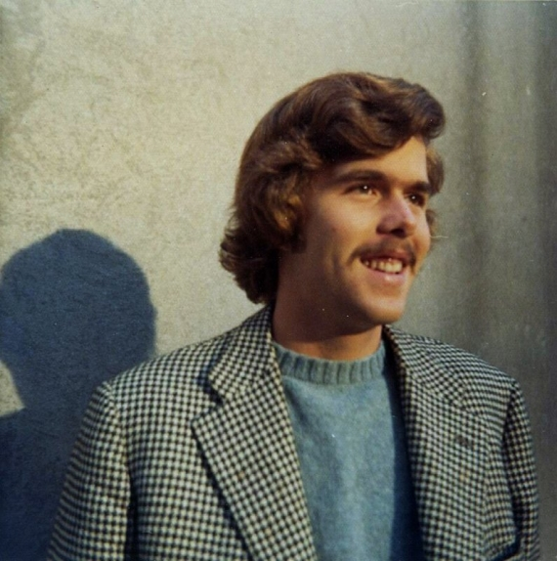

User Rating: 0 / 5

Star inactiveStar inactiveStar inactiveStar inactiveStar inactive

**Jeb Bush's CIA "NOC" work in Venezuela**

**by Wayne Madsen**

Former Florida Governor and 2016 presidential hopeful Jeb Bush may have thought he could pass himself off as "Hispanic" when he ticked off that ethnic option on his 2009 voter registration form but he was not able to easily pass himself off as a "banker" in Venezuela in the late 1970s.  
  
One of the last things then-Central Intelligence Agency director George H. W. Bush did for his son Jeb, whose actual name is John Ellis Bush from which the "Jeb" is derived as an acronym, is to have him hired by the international division of the Texas Commerce Bank as a CIA "non-official cover" officer or "NOC." Texas Commerce Bank was an optimal cover for CIA activities. The bank was founded by the family of James Baker. All the elder Bush had to do was to call his close friend Baker to have his son hired by the bank's international division, the usual branch where CIA NOCs were placed within banks and investment firms. Other banks used by the CIA for NOC embeds included Bank of America, Chase Manhattan Bank, and Manufacturers Hanover.  
  
Texas Commerce Bank, bought by Chemical Bank in 1987 and which is now part of J.P Morgan Chase, had the right pedigree to enable it to work closely with the CIA. In 1977, its board members included Lady Bird Johnson and the recently-defeated President Gerald Ford. In the 1980s, Kenneth Lay, who founded the CIA-connected Enron, became a board member of Texas Commerce Bank. Howard Hughes's CIA-linked Summa Corporation used Texas Commerce Bank to purchase a number of properties on the Las Vegas strip.  
  
In 1977, a short time after his father left the CIA as director, Jeb, fluent in Spanish as a result of his time as an exchange student in Guadalajara, was sent, along with his Mexican wife Columba, to Caracas, Venezuela to work as a "branch manager" and "vice president" at the young age of 24. But Jeb was no ordinary "branch manager." He was, officially, Texas Commerce Bank's top point man in the Venezuelan capital and, unofficially, the CIA's main financial liaison to the Venezuelan oil industry and the Colombian narcotics cartels. Jeb would regularly report to his CIA "official cover" counterpart attached to the U.S. embassy in Caracas as a State Department "diplomat."  
  
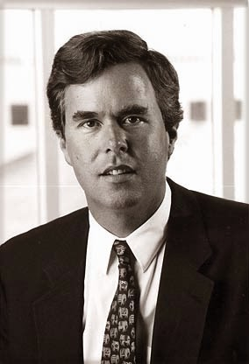   
*Jeb as a CIA "NOC" in Caracas for Texas Commerce Bank, owned by James Baker*  
  
Jeb helped lay the groundwork for the future Reagan-Bush administration's 1980s covert war against Nicaragua and leftist guerrillas in El Salvador by establishing banking and money laundering links between the CIA and the Medellin and Cali drug cartels. Jeb's friends in the Colombian cartels, particularly Medellin cartel boss Pablo Escobar, would helped finance the Nicaraguan contras in return for CIA-supplied weapons. While in Venezuela, Jeb cleverly managed to hide the Colombian cartel's drug revenues as oil industry revenues of "front" companies. Texas Commerce Bank was the bank of choice for Latin American drug cartels. It was later discovered to have stashed $7 million in drug profits for the Gulf cartel of Mexico.  
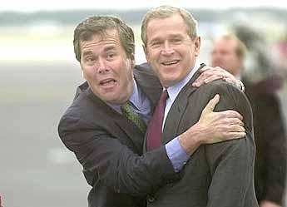  
*Jeb ready to continue the CIA's lock on the White House*  
  
Baker sold Texas Commerce Bank's Houston skyscraper to the head of the National Commercial Bank of Saudi Arabia, Sheikh Khalid bin Mahfouz, in 1985. Bin Mahfouz was later identified as a key member of Saudi Arabia's support network for the 9/11 terrorist attacks against the United States, which is noted in the still-classified 28 pages of U.S. Senate Intelligence Committee Report on 9/11 intelligence failures. Bin Mahfouz, who lived in the River Oaks section of Houston near George H. W. Bush, died suddenly in 2009 at the age of 59. Bin Mahfouz, who was also an Irish citizen, threatened with confiscatory lawsuits any publication that reported his links to 9/11 and his family ties to Osama bin Laden.  
  
Jeb had no problems with the Venezuelan government in providing financial support for the Colombian cartels. For much of Jeb's stay in Venezuela, the extremely corrupt Carlos Andres Perez, known as "CAP," was president. His extravagant spending using Venezuela's revenue from the recently-nationalized oil industry earned his government the nickname of "Saudi Venezuela." Although CAP nationalized the oil industry and created the *Petroleos de Venezuela* (PdVSA) state-owned oil firm, he also was generous to American firms bidding for work with PdVSA. One of them was Bechtel Corporation, the firm of future Reagan-Bush cabinet members George P. Shultz and Caspar Weinberger. With a number of Bechtel employees in Venezuela, Jeb was not the only CIA "NOC" present in the country. But, he was the most influential.  
  
During CAP's second term as president from 1989 to 1993, a young army officer named Hugo Chavez attempted to overthrow the corrupt CAP in a coup. Many of Venezuela's elite who Jeb befriended during his days as Langley's main NOC in Caracas later became involved with repeated CIA attempts to overthrow Chavez and his successor, Nicolas Maduro. Today, they and their progeny live in the Miami-Dade area, particularly in Doral, nicknamed "Doralzuela," and are among Jeb's strongest and most deep-pocketed political supporters.  
  
In 1989, CAP crushed popular protests against his government by killing as many as 3000 protesters. The massacre is known as the "Caracazo" massacre. After leaving office the second time, Andres Perez was convicted of corruption and sentenced to 28 months in prison.  
  
After leaving Venezuela in 1980 to help with his father's presidential and vice presidential campaigns, Jeb hooked up with Cuban-American Miami businessman Armando Codina, who had his own connections with CIA-supported anti-Castro Cuban exiles in south Florida. It was Codina who helped Jeb make millions of dollars in the real estate business and eventually help launch him on his political career that took him to the Governor's Mansion in Tallahassee. Jeb, as a principal of the Codina Group, was able to arrange the sale of high-priced condos and mansions in the Miami area to his elite friends in Venezuela, with Jeb receiving handsome sales commissions.  
  
One of Jeb's close Miami associates was Cuban terrorist Orlando Bosch. Bosch was a key figure in the CIA's Operation Condor, which was an alliance of Latin American military dictatorships that targeted leftist leaders for assassination across international borders. Bosch helped carry out the October 1976 bombing of Cubana Airlines flight 455, which was en route from Barbados to Jamaica. All 73 passengers and crew were killed in the attack, including children and the Cuban fencing team.  
  
The Cubana bombing plot was discussed at a 1976 meeting in Washington between Bosch; another Cuban terrorist, Luis Posada Carriles; and Michael Townley of the CIA. Jeb's father, the CIA director, was fully aware of the plot, as well as another plot to kill former Chilean Foreign Minister Orlando Letelier. Letelier and Roni Moffitt, his American associate, were killed when their car exploded on Sheridan Circle in front of the Irish embassy in Washington on September 21, 1976, a few weeks before the Cubana airliner was blown out of the sky off Barbados.  
  
Codina, Bosch, and Posada Carriles were all part of Jeb's inner circle of friends, which also included Cuban businessman Camilo Padreda, a former spy for Cuban dictator Fulgencio Batista, and Hernandez Cartaya, both later indicted for systematically embezzling funds from the Jefferson Savings and Loan of McAllen, Texas. Padreda and Cartaya were also identified as CIA agents who helped skim funds from Jefferson and other S&Ls to fund the Nicaraguan contras. Jeb's work for the CIA in Caracas in 1977 came a few months after the CIA's worst terrorism spree in history, which also happened to coincide with George H. W. Bush's single year as CIA director.  
  
After his father became Vice President, Jeb served as the liaison for the Nicaraguan contras and he arranged meetings between them and their supporters and the White House point man for covert assistance to the Nicaraguan rebels, one Marine Corps Lieutenant Colonel by the name of Oliver North. Another one of Jeb's Cuban cronies, Miguel Recarey, owner of Miami-based International Medical Center, an HMO, was awash in ill-gotten Medicare funds. Recarey and his brother, who had close ties to the CIA, were also funded by Florida Mafia boss Santo Trafficante, Jr., a co-conspirator in several CIA plots to assassinate Fidel Castro and a suspected co-plotter in the assassination of President John F. Kennedy.  
  
A Jeb Bush presidency would maintain the CIA's lock on the White House. Barack Obama's and his family's CIA connections are a historical fact. George W. Bush ensured the CIA's control over the presidency for eight years and before him, Bill Clinton, who had his own links to the CIA's contra-cocaine network through Mena, Arkansas, has seen his Clinton Foundation benefit from a $1 million contribution from one of Jeb's old Cuban-Venezuelan friends, Gustavo Cisneros, the multi-billionaire "Berlusconi of Venezuela." Cisneros, now exiled in the Dominican Republic, was involved in the CIA's 2002 abortive coup against Chavez