Christopher Columbus 1451-1506
http://en.wikipedia.org/wiki/Christopher_Columbus
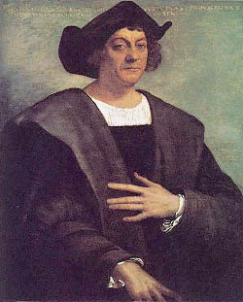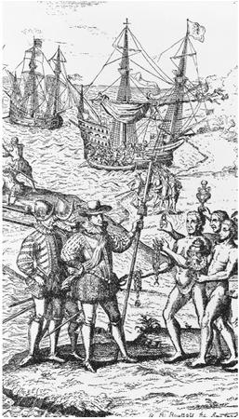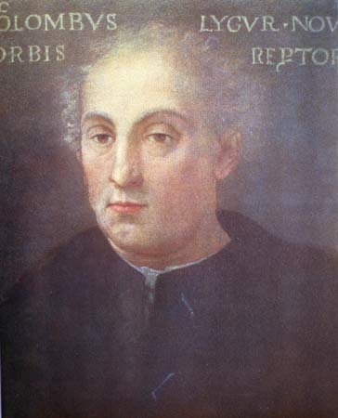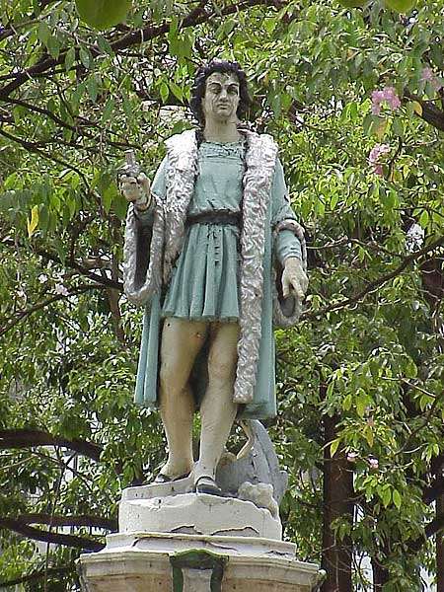

Christopher Columbus (1451? – May 20, 1506) was a navigator and maritime explorer cred as the discoverer of the Americas. Although it is generally accepted that he was Italian, Columbus is also associated with Spain because he was sponsored by the Catholic Monarchs and eventually became an admiral for the Crown of Castile. The name Christopher Columbus is a Latinization of the Spanish Don Cristobal Colón.
Columbus' voyages across the Atlantic Ocean began a European effort at exploration and colonization of the American continent. While history places great significance on his first voyage of 1492, he did not actually reach the mainland until his third voyage in 1498. Likewise, he was not the earliest European explorer to reach the Americas, as there are accounts of European transatlantic contact prior to 1492. Nevertheless, Columbus' voyage came at a critical time of growing national imperialism and economic competition between developing nation states seeking wealth from the establishment of trade routes and colonies. Therefore, the period before 1492 is known as Pre-Columbian.
The anniversary of the 1492 voyage (vd. Columbus Day) is celebrated throughout the Americas and in Spain and Italy. However, as the legacy of the European colonization of the Americas is generally viewed in a more negative light today than in the past, Columbus has become a divisive figure.

Contents
[hide]
- 1 Life
  - 1.1 Nationality
  - 1.2 Early life
  - 1.3 Physical appearance
- 2 Background to voyages
  - 2.1 Navigational theories
  - 2.2 Campaign for funding
- 3 Voyages
  - 3.1 First voyage
  - 3.2 Second voyage
  - 3.3 Third voyage
  - 3.4 Fourth voyage
- 4 Governorship and arrest
- 5 Later life
- 6 Legacy
  - 6.1 19th century
  - 6.2 Modern day
- 7 Notes
- 8 References
- 9 See also
- 10 External links

[] Life
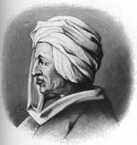
No authentic contemporary portrait of Columbus has ever been found; this late 19th-century engraving is one of many conjectural images

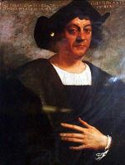
Christopher Columbus, conjectural image by Sebastiano del Piombo in the Gallery of Illustrious Men (Corridoio Vasariano), Uffizi, Florence.

Nationality
Main article: Origin theories of Christopher Columbus
The identity of Columbus is still not certain. It is most widely accepted that he was of Italian ancestry. More specifically he is believed to have been from the Republic of Genoa, in Italy,^{[1]} although it has been surmised he could have been from Catalonia, Spain, and Portugal where the greatest navigators of his time lived.^{[2]} Certainly there were ties between Spain and the Italian nation-states; King Ferdinand II of Aragon was also the King of Sicily. Some theories suggest that he was actually Basque; the Basques are one of the most ancient mariner communities of Middle Ages Europe. Clues to Columbus' origin such as learned languages and DNA samples have been studied, but no definitive answer has yet been revealed.^{[3]}

[] Early life
According to generally recognized theory, Columbus was born between August and October 1451 in Genoa. His father was Domenico Colombo, a middle-class wool weaver working between Genoa and Savona. Susanna Fontanarossa was his mother and Bartolomeo was his brother. Bartolomeo worked in a cartography workshop in Lisbon for at least part of his adulthood.^{[1]} While information about Columbus' early years is scarce, he probably received an incomplete education. He spoke a Genoese dialect.^{[citation needed]} In one of his writings, Columbus claims to have gone to the sea at the age of 10. In the early 1470s, he was in the service of René I of Anjou in a Genoese ship hired to support his unfortunate attempt to conquer the Kingdom of Naples. Later he allegedly made a trip to Chios, in the Aegean Sea. In May 1476, he took part in an armed convoy sent by Genoa to carry a valuable cargo to northern Europe. On August 13, 1476, the convoy was intercepted by Portuguese ships near the Genoa coast. Columbus was wounded in the battle that ensued, but managed to land at the small town of Lagos.

[] Physical appearance
Although an abundance of artwork involving Christopher Columbus exists, no authentic contemporary portrait of the man has been found. Over the years, artists who reconstruct his appearance do so from written descriptions. These writings describe him as having reddish hair, which turned to white early in his life, as well as being a lighter skinned person with too much sun exposure turning his face red. Despite the clear description of red hair or white hair, textbooks use the image on the right so often that it has become the face of Columbus in popular culture.

[] Background to voyages

[] Navigational theories
Europe had long enjoyed a safe passage to China and India— sources of valued goods such as silk, spices and opiates— under the hegemony of the Mongol Empire (the Pax Mongolica, or "Mongol peace"). With the Fall of Constantinople to the Muslims in 1453, the land route to Asia was no longer an easy route. Portuguese sailors took to traveling south around Africa to get to Asia. Columbus had a different idea. By the 1480s, he had developed a plan to travel to the Indies, then construed roughly as all of south and east Asia, by sailing directly west across the "Ocean Sea," i.e., the Atlantic. Following Washington Irving's myth-filled 1828 biography of Columbus, it became common supposed knowledge that Columbus had difficulty obtaining support for his plan because Europeans believed that the earth was flat.^{[4]} In fact, few people at the time of Columbus’s voyage, and virtually no sailors or navigators, believed this. Most agreed that the earth was a sphere. This had been the general opinion of ancient Greek science, and continued as the standard opinion (for example of Bede in The Reckoning of Time) until Isidore of Seville misread the classical authors and stated the earth was flat, inventing the T and O map concept. This view was very influential, but never wholly accepted. Knowledge of the Earth's spherical nature was not limited to scientists: for instance, Dante's Divine Comedy is based on a spherical Earth. Columbus put forth arguments that were based on the circumference of the sphere. Most scholars accepted Ptolemy's claim that the terrestrial landmass (for Europeans of the time, comprising Eurasia and Africa) occupied 180 degrees of the terrestrial sphere, leaving 180 degrees of water. Columbus, however, believed the calculations of Marinus of Tyre that the landmass occupied 225 degrees, leaving only 135 degrees of water. Moreover, Columbus believed that one degree represented a shorter distance on the earth's surface than was commonly held. Finally, he read maps as if the distances were calculated in Italian miles (1,238 meters). Accepting the length of a degree to be 56⅔ miles, from the writings of Alfraganus, he therefore calculated the circumference of the Earth as 25,255 kilometers at most, and the distance from the Canary Islands to Japan as 3,000 Italian miles (3,700 km) which is 2300 statute miles. Columbus did not realize that Al-Farghani used the much longer Arabic mile of about 1,830 meters. The problem facing Columbus was that experts did not accept his estimate of the distance to the Indies. The true circumference of the Earth is about 40,000 kilometers (25,000 statute miles), and the distance from the Canary Islands to Japan is 19,600 kilometers (12,200 statue miles). No ship in the 15th century could carry enough food to sail from the Canary Islands to Japan. Most European sailors and navigators concluded, correctly, that sailors undertaking a westward voyage from Europe to Asia non-stop would die of starvation or thirst long before reaching their destination. Spain however, only recently unified through the marriage of Ferdinand and Isabella, was desperate for a competitive edge over other European countries in trade with the East Indies. Columbus promised them that edge. Columbus' calculations were inaccurate concerning the circumference of the Earth and the distance from the Canary Islands to Japan. However, almost all Europeans were mistaken in thinking the aquatic expanse between Europe and Asia was uninterrupted. Although Columbus died believing he had opened up a direct nautical route to Asia, in fact he had established a nautical route between Europe and the Americas. The route to America, rather than to Japan, gave Spain a competitive edge in developing a mercantile empire.

[] Campaign for funding
In 1485, Columbus presented his plans to John II, King of Portugal. He proposed the king equip three sturdy ships and grant Columbus one year's time to sail out into the Atlantic, search for a western route to Orient, and then return home. Columbus also requested he be made "Great Admiral of the Ocean", created governor of any and all lands he discovered, and given one-tenth of all revenue from those lands discovered. The king submitted the proposal to his experts, who rejected it. It was their considered opinion that Columbus' proposed route of 2,400 miles was, in fact, far too short.^{[5]} In 1488 Columbus appealed to the court of Portugal once again, and once again John invited him to an audience. It too was to come to nothing, for not long afterwards came the arrival of Portugal's native son Bartholomeu Dias from a successful rounding of the Horn of Africa. Portugal was no longer interested in trailblazing a western route to the East. From Portugal Columbus, weary but determined, traveled once more to both Genoa and Venice; from neither was he given any encouragement. Previously he had his brother sound out Henry VII of England, to see if the British monarch might not be more amiable to Columbus' proposal. After much carefully considered hesitation Henry's invitation came, but it came too late. Columbus had already committed himself to Spain. He had sought an audience from the monarchs Ferdinand II of Aragon and Isabella I of Castile, who had united the largest kingdoms of Spain by marrying and were ruling together. On May 01, 1486, permission having been granted, Columbus laid his plans before Queen Isabella, who, in turn, referred it to a committee. After the passing of much time, these savants of Spain, like their counterparts in Portugal, reported back that Columbus had judged the distance to Asia too short, much too short. They pronounced the idea impractical, and advised their Royal Highness' to pass on the proposed venture. However, to keep Columbus from taking his ideas elsewhere,and perhaps to keep their options open, the King and Queen of Spain gave him an annual annuity of 12,000 maravedis ($87,000?) and furnished him with a letter ordering all Spanish cities and towns to provide him food and lodging at no cost.^{[6]} After continually lobbying at the Spanish court, he finally had success in 1492. Ferdinand and Isabella had just conquered Granada, the last Muslim stronghold on the Iberian peninsula, and they received Columbus in Córdoba, in the Alcázar castle. Isabella turned Columbus down on the advice of her confessor, and he was leaving town in despair, when Ferdinand intervened. Isabella then sent a royal guard to fetch him and Ferdinand later rightfully claimed cr for being "the principal cause why those islands were discovered". King Ferdinand is referred to as "losing his patience" in this issue, but this cannot be proven. About half of the financing was to come from private Italian investors, whom Columbus had ready lined up. Financially broke after the Granada campaign, the monarchs left it to the royal treasurer to shift funds among various royal accounts on behalf of the enterprise. Columbus was to be made "Admiral of the Seas" and would receive a portion of all profits. The terms were unusually generous, but as his own son later wrote, the monarchs did not really expect him to return. According to the contract that Columbus made with King Ferdinand and Queen Isabella, if Columbus discovered any new islands or mainland, he would receive many high rewards. In terms of power, he would be given the rank of Admiral of the Ocean Sea (Atlantic Ocean) and appointed Viceroy and Governor of all the new lands. He has the right to nominate three persons, from whom the sovereigns would choose one, for any office in the new lands. He would be entitled to 10 percent of all the revenues from the new lands in perpetuity; this part was denied to him in the contract, although it was one of his demands. Finally, he would also have the option of buying one-eighth interest in any commercial venture with the new lands and receive one-eighth of the profits. Columbus was later arrested in 1500 and supplanted from these posts. After his death Columbus's sons Diego and Ferdinand took legal action to enforce their father's contract. Many of the smears against Columbus were initiated by the Spanish crown during these lengthy court cases, known as the pleitos colombinos. The family had some success in their first litigation, as a judgment of 1511 confirmed Diego's position as Viceroy, but reduced his powers. Diego resumed litigation in 1512, which lasted until 1536, and further disputes continued until 1790.^{[7]}

[] Voyages
Main article: Voyages of Christopher Columbus

[] First voyage
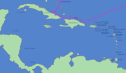

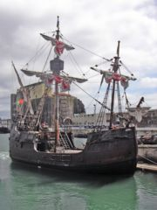
A ship replica of the Santa Maria

On the evening of August 3, 1492, Columbus departed from Palos with three ships; one larger "carrack", the Santa Maria -nicknamed the Gallega (the Gallician), and two smaller "caravels", the Pinta (the Painted) and Santa Clara, nicknamed the Niña (the Girl). (The ships were never officially named).^{[citation needed]} The ships were property of Juan de la Cosa and the Pinzón brothers (Martin Alonzo and Vicente Yáñez), but the monarchs forced the Palos inhabitants to contribute to the expion. Columbus first sailed to the Canary Islands, which was owned by Castile, where he restocked the provisions and made repairs, and on September 6, he started what turned out to be a five-week voyage across the ocean. Land was sighted at 2 a.m. on October 12, 1492, by a sailor named Rodrigo de Triana (also known as Juan Rodriguez Bermejo) aboard Pinta.^{[8]} Columbus called the island (in what is now The Bahamas) San Salvador, although the natives called it Guanahani. Exactly which island in the Bahamas this corresponds to is an unresolved topic; prime candidates are Samana Cay, Plana Cays, or San Salvador Island (named San Salvador in 1925 in the belief that it was Columbus' San Salvador). The indigenous people he encountered, the Lucayan, Taíno or Arawak, were peaceful and friendly. Columbus also explored the northeast coast of Cuba (landed on October 28) and the northern coast of Hispaniola, by December 5. Here, the Santa Maria ran aground on Christmas morning 1492 and had to be abandoned. He was received by the native cacique Guacanagari, who gave him permission to leave some of his men behind. Columbus founded the settlement La Navidad and left 39 men. Columbus headed for Spain, but another storm forced him into Lisbon. He anchored next to the King's harbour patrol ship on March 4, 1493 in Portugal. After spending more than one week in Portugal, he set sail for Spain. Word of his finding new lands rapidly spread throughout Europe. He reached Spain on March 15.

[] Second voyage
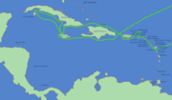

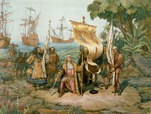
A depiction of Columbus claiming possession of the New World in a chromolithograph made by the Prang Education Company in 1893.

Columbus left Cádiz, Spain, on September 24, 1493 to find new territories, with 17 ships carrying supplies, and about 1,200 men to peacefully colonize the region. On October 13, the ships left the Canary Islands as they had on the first voyage, following a more southerly course. On November 3, 1493, Columbus sighted a rugged island that he named Dominica; later that day, he landed at Marie-Galante, which he named Santa Maria la Galante. After sailing past Les Saintes (Todos los Santos), he arrived at Guadaloupe (Santa Maria de Guadalupe), which he explored between November 4 and November 10, 1493. The exact course of his voyage through the Lesser Antilles is debated, but it seems likely that he turned north, sighting and naming several islands including Montserrat (Santa Maria de Monstserrate), Antigua (Santa Maria la Antigua), Redondo (Santa Maria la Redonda), Nevis (Santa María de las Nieves), Saint Kitts (San Jorge), Sint Eustatius (Santa Anastasia), Saba (San Cristobal), Saint Martin (San Martin), and Saint Croix (Santa Cruz). He also sighted the island chain of the Virgin Islands, which he named Santa Ursula y las Once Mil Virgines, and named the islands of Virgin Gorda, Tortola, and Peter Island (San Pedro). He continued to the Greater Antilles, and landed at Puerto Rico (San Juan Bautista) on November 19, 1493. The first skirmish between Americans and Europeans since the Vikings^{[9]} took place when his men rescued two boys who had just been castrated by their captors. On November 22, Columbus returned to Hispaniola, establishing a new settlement at Isabella – on the north coast – where gold had first been found. However, it proved a poor location and the settlement was short-lived. He left Hispaniola on April 24, 1494, arrived at Cuba (naming it Juana) on April 30, and reached Jamaica on May 5. He explored the south coast of Cuba, which he believed to be a peninsula rather than an island, and several nearby islands including the Isle of Youth (La Evangelista), before returning to Hispaniola on August 20 and then finally returning to Spain.

[] Third voyage
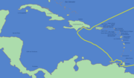

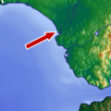
Location of city of Sanlúcar de Barrameda, the starting point for Columbus' third journey.

On May 30, 1498, Columbus left with six ships from Sanlúcar, Spain, for his third trip to the New World. He was accompanied by the young Bartolomé de Las Casas, who would later provide partial transcripts of Columbus' logs. Columbus led the fleet to the Portuguese island of Porto Santo, his wife's native land. He then sailed to Madeira and spent some time there with the Portuguese captain João Gonçalves da Camara before sailing to the Canary Islands and Cape Verde. Columbus landed on the south coast of the island of Trinidad on July 31. From August 4 through August 12, he explored the Gulf of Paria which separates Trinidad from Venezuela. He explored the mainland of South America, including the Orinoco River. He also sailed to the islands of Chacachacare and Margarita Island and sighted and named Tobago (Bella Forma) and Grenada (Concepcion). He described the new lands as belonging to a previously unknown new continent, but he pictured it hanging from China, bulging out to make the earth pear-shaped. Columbus returned to Hispaniola on August 19 to find that many of the Spanish settlers of the new colony were discontented, having been misled by Columbus about the supposedly bountiful riches of the new world. Columbus repeatedly had to deal with rebellious settlers and natives. He had some of his crew hanged for disobeying him. A number of returning settlers and sailors lobbied against Columbus at the Spanish court, accusing him and his brothers of gross mismanagement. On his return he was arrested for a period (see Governorship and arrest section below).

[] Fourth voyage
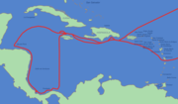

Columbus made a fourth voyage nominally in search of the Strait of Malacca to the Indian Ocean. Accompanied by his brother Bartolomeo and his 13-year-old son Fernando, he left Cádiz, Spain on May 11, 1502, with the ships Capitana, Gallega, Vizcaína and Santiago de Palos. He sailed to Arzila on the Moroccan coast to rescue the Portuguese soldiers who he heard were under siege by the Moors. On June 15, they landed at Carbet on the island of Martinique (Martinica). A hurricane was brewing, so he continued on, hoping to find shelter on Hispaniola. He arrived at Santo Domingo on June 29, but was denied port, and the new governor refused to listen to his storm prediction. Instead, while Columbus's ships sheltered at the mouth of the Jaina River, the first Spanish treasure fleet sailed into the hurricane. Columbus' ships survived with only minor damage, but twenty-nine of the thirty ships in the governor's fleet were lost to the storm. In addition to the ships, 500 lives (including Nicolaus Bobadilla's) and an immense cargo of gold were surrendered to the sea. After a brief stop at Jamaica, Columbus sailed to Central America, arriving at Guanaja (Isla de Pinos) in the Bay Islands off the coast of Honduras on July 30. Here Bartolomeo found native merchants and a large canoe, which was described as "long as a galley" and was filled with cargo. On August 14, he landed on the American mainland at Puerto Castilla, near Trujillo, Honduras. He spent two months exploring the coasts of Honduras, Nicaragua, and Costa Rica, before arriving in Almirante Bay, Panama on October 16. On December 05, 1502 Columbus and his crew found themselves in a storm unlike any they had ever experienced. In his journal Columbus writes,
For nine days I was as one lost, without hope of life. Eyes never beheld the sea so angry, so high, so covered with foam. The wind not only prevented our progress, but offered no opportunity to run behind any headland for shelter; hence we were forced to keep out in this bloody ocean, seething like a pot on a hot fire. Never did the sky look more terrible; for one whole day and night it blazed like a furnace, and the lightening broke with such violence that each time I wondered if it had carried off my spars and sails; the flashes came with such fury and frightfullness that we all thought that the ship would be blasted. All this time the water never ceased to fall from the sky; I do not say it rained, for it was like another deluge. The men were so worn out that they longed for death to end their dreadful suffering.^{[10]}
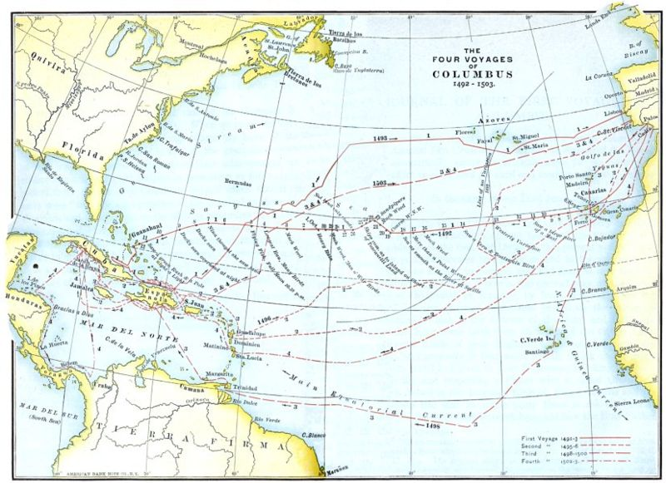
The Four Voyages of Columbus 1492–1503

In Panama, he learned from the natives of gold and a strait to another ocean. After much exploration, he established a garrison at the mouth of Rio Belen in January 1503. On April 6, one of the ships became stranded in the river. At the same time, the garrison was attacked, and the other ships were damaged. He left for Hispaniola on April 16, but sustained more damage in a storm off the coast of Cuba. Unable to travel any farther, the ships were beached in St. Ann's Bay, Jamaica, on June 25, 1503. Columbus and his men were stranded on Jamaica for a year. Two Spaniards, with native paddlers, were sent by canoe to get help from Hispaniola. In the meantime, in a desperate effort to induce the natives to continue provisioning him and his hungry men, he successfully intimidated the natives by correctly predicting a lunar eclipse,^{[11]} using astronomic tables made by Rabbi Abraham Zacuto who was working for the king of Portugal. Help finally arrived on June 29, 1504, and Columbus and his men arrived in Sanlúcar, Spain on November 7.

[] Governorship and arrest
During his time as governor and viceroy, Columbus ruled his domain tyrannically, or so claimed disgruntled Spaniards who chafed being under the rule of an Italian. Tired, discouraged, disgusted, his mind clouded by fatigue and worry, his body wracked by arthritis and his eyes by ophthalmia, Columbus knew he was in over his head. So in October, 1499 he sent two ships back to Spain, asking the Court of Spain to appoint a royal commissioner to help him govern. As a result of this, Francisco de Bobadilla, a member of the Order of Calatrava, was appointed; however, his authority went far beyond what Columbus had either asked or intended. Bobadilla was given total control as Governor, from 1500 until his death in 1502, over everything and everyone, including Columbus. Arriving in Santo Domingo while Columbus was away, Bobadilla was immediately peppered with complaints about all three of the Columbus brothers: Christopher, Bartolomé, and Diego. Consuelo Varela, a Spanish historian, states: "Even those who loved him [Columbus] had to admit the atrocities that had taken place."^{[12][13]} As a result of these testimonies, the startled Christopher Columbus, upon his return, and without being allowed a word in his own defense, was clapped in irons with manacles on his arms and chains on his feet, and cast into prison to await return to Spain. He was now some 53 years old. On October 01, 1500 Columbus and his two brothers, likewise in chains, were sent back to Spain. Once in Cádiz, a grieving Columbus wrote to a friend at court:
It is now seventeen years since I came to serve these princes with the Enterprise of the Indies. They made me pass eight of them in discussion, and at the end rejected it as a thing of jest. Never the less I persisted therein...Over there I have placed under their sovereignty more land then there is in Africa and Europe, and more than 1,700 islands...In seven years I, by the divine will, made that conquest. At a time when I was entitled to expect rewards and retirement, I was incontinently arrested and sent home loaded with chains...The accusation was brought out of malice on the basis of charges made by civilians who had revolted and wished to take possession on the land....
I beg your graces, with the zeal of faithful Christians in whom thir Highneses have confidence, to read all my papers, and to consider how I, who came from so far to serve these princes...now at the end of my days have been despoiled of my honor and my property without cause, wherein is neither justice nor mercy.^{[14]}
For six weeks Columbus and his brothers lingered in jail before the busy King Ferdinand ordered their release. Not long thereafter the king and queen summoned the Columbus brothers to their presence at the Alhambra palace in Granada. There the royal couple heard the brothers' pleas; restored their freedom and their wealth; and, after much persuasion, agreed to fund Columbus' fourth voyage. But as to Christopher Columbus' role as governor, that door was firmly shut. From that point forward Don Nicolás de Ovando was to be the new governor of the west Indies.

[] Later life
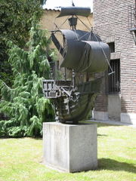
A statue of the Santa Maria, Columbus' flagship in his first voyage. The statue is at the House of Columbus in Valladolid, Spain, the city where Columbus died.

While Columbus had always given the conversion of non-believers as one reason for his explorations, he grew increasingly religious in his later years. He claimed to hear divine voices, lobbied for a new crusade to capture Jerusalem, often wore Franciscan habit, and described his explorations to the "paradise" as part of God's plan which would soon result in the Last Judgement and the end of the world. In his later years, Columbus demanded that the Spanish Crown give him 10% of all profits made in the new lands, pursuant to earlier agreements. Because he had been relieved of his duties as governor, the crown did not feel bound by these contracts, and his demands were rejected. After his death his family later sued for part of the profits from trade with America in the pliegos colombinos.

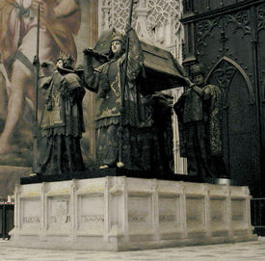
Columbus' tomb in the cathedral of Seville. It is borne by four statues of kings representing the Kingdoms of Castile, Leon, Aragon, and Navarre

On May 20, 1506, Columbus died in Valladolid, fairly wealthy from the gold his men had accumulated in Hispaniola. He was still convinced that his journeys had been along the east coast of Asia. Following his death, his body underwent excarnation—the flesh was removed so that only his bones remained. Even after his death, his travels continued: first interred in Valladolid and then at the monastery of La Cartuja in Seville, by the will of his son Diego, who had been governor of Hispaniola, his remains were transferred to Santo Domingo in 1542. In 1795, the French took over, and his remains were removed to Havana. After Cuba became independent following the Spanish-American War in 1898, his remains were moved back to the Cathedral of Seville, where they were placed on an elaborate catafalque. However, a lead box bearing an inscription identifying "Don Christopher Columbus" and containing fragments of bone and a bullet was discovered at Santo Domingo in 1877. To lay to rest claims that the wrong relics were moved to Havana and that Columbus is still buried in the cathedral of Santo Domingo, DNA samples were taken in June 2003 (History Today August 2003). Results announced in May 2006 show that at least some of Columbus' remains rest in Seville, but authorities in Santo Domingo have not allowed the exhuming of the body.^{[15]}

[] Legacy
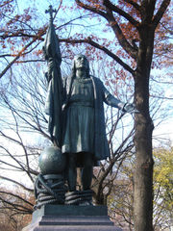
Bronze statue at Central Park, New York City by Jerónimo Suñol, 1894

Columbus is often viewed as a hero in the United States because of his pivotal role in U.S. history. He has had a cultural significance beyond his actual achievements and actions as an individual, becoming a symbol and figure of legend. Numerous stories about Columbus have cast him as an archetypal figure for both good and for evil. While other discoverers and immigrants had come to the new world of the Americas before Columbus and it had already been "discovered" many times, Columbus's impact and significance in history has more to do with his time and its effects. His journey came when technical developments in sailing techniques and communication made it possible to report his voyages easily throughout western Europe. In this way Europe was reacquainted with the Americas, and this was followed by many more voyages seeking wealth and expansion.

[] 19th century
The nascent countries of the New World, particularly the newly independent United States, seemed to need a historical narrative to give them roots. This narrative was supplied in part by Washington Irving in 1828 with The Life and Voyages of Christopher Columbus, which may be the true source of much of the associations held about the explorer. Hero worship of Columbus perhaps reached a zenith around 1892 when the 400th anniversary of his first arrival in the Americas occurred. Monuments to Columbus like the Columbian Exposition in Chicago were erected throughout the United States and Latin America extolling him. Numerous cities, towns, and streets were named after him, including the capital cities of two U.S. states (Columbus, Ohio and Columbia, South Carolina). The story that Columbus thought the world was round while his contemporaries believed in a flat earth was often repeated despite the fact that the real issue was the size of the Earth not if it was round or not^{[16]} (In fact even Aristotle a key Classical figure in the Church doctrine of the day argued the Earth was a globe)^{[17]} This tale was used to show that Columbus was enlightened and forward looking. Columbus' apparent defiance of convention in sailing west to get to the far east was hailed as a model of "American"-style can-do inventiveness. The admiration of Columbus was particularly embraced by some members of the Italian American, Hispanic, and Catholic communities. These groups point to Columbus as one of their own to show that Merranean Catholics could and did make great contributions to the U.S. The modern vilification of Columbus is seen by his supporters as being politically motivated.

[] Modern day
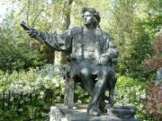
A bronze statue of Columbus sits among the flowers and trees of Belgrave Square, London.

Culpability is sometimes placed on contemporary governments and their citizens for ongoing acts of genocide against Native Americans during the time of Christopher Columbus. Columbus myths and celebrations are generally a positive affair, making less room for this concept in history books. Ward Churchill, an associate professor of Native American Studies at the University of Colorado and a leader of the American Indian Movement, has argued that
Very high on the list of those expressions of non-indigenous sensibility which contribute to the perpetuation of genocidal policies against Indians are the annual Columbus Day celebration, events in which it is baldly asserted that the process, events, and circumstances described above are, at best, either acceptable or unimportant. More often, the sentiments expressed by the participants are, quite frankly, that the fate of Native America embodied in Columbus and the Columbian legacy is a matter to be openly and enthusiastically applauded as an unrivaled "boon to all mankind." Undeniably, the situation of American Indians will not—in fact cannot—change for the better so long as such attitudes are deemed socially acceptable by the mainstream populace. Hence, such celebrations as Columbus Day must be stopped.^{[18]}
Columbus' colonization of the Americas, and the subsequent effects on the native peoples, were dramatised in the 1992 feature film 1492: Conquest of Paradise to commemorate the 500th anniversary of his landing in the Americas. In 2003, Venezuelan President Hugo Chavez urged Latin Americans to not celebrate the Columbus Day holiday. Chavez blamed Columbus for leading the way in the mass genocide of the Native Americans.^{[19]}

[] Notes
- ^ ª ^{b} Encyclopedia Britannica, 1993 ed., Vol. 16, pp. 605ff / Morison, Christopher Columbus, 1955 ed., pp. 14ff
- ^ Columbus: Secrets from the Grave, Discovery Channel documentary, about a possible Catalan origin.
- ^ Abend, Lisa, Geoff Pingree. "Who really sailed the ocean blue in 1492?", The Christian Science Monitor, 2006-10-17. Retrieved on 2006-10-17.
- ^ Boller, Paul F (1996). Not So!:Popular Myths about America from Columbus to Clinton. ISBN 0-19-510972-4.
- ^ Morison,Samuel Eliot, Admiral of the Ocean Sea: The Life of Christopher Columbus Boston, 1942
- ^ Durant, Will "The Story of Civilization" vol. vi, "The Reformation". Chapter XIII, page 260.
- ^ Mark McDonald, "Ferdinand Columbus, Renaissance Collector",2005,British Museum Press,ISBN 978-0-7141-2644-9
- ^ Clements R. Markham, ed. (2001). The Journal of Christopher Columbus (during His First Voyage, 1492-93). ISBN 1-4021-9501-X.
- ^ Jr, William D. Phillips & Carla Rahn Phillips (1993). The Worlds of Christopher Columbus. ISBN 0-521-44652-X.
- ^ Morison, Samuel Eliot,Admiral of the Ocean: The Life of Christopher Columbus page 617, Boston 1942
- ^ Miles, Kathy (2005). Christopher Columbus and the Lunar Eclipse. StarrySkies.com. Retrieved on 2006-10-11.
- ^ Giles Tremlett. "Lost document reveals Columbus as tyrant of the Caribbean", The Guardian, 2006-08-07. Retrieved on 2006-10-10. (in english)
- ^ Bobadilla's 48 page report — derived from the testimonies of 23 people who had seen or heard about the treatment meted out by Columbus and his brothers —had originally been lost for centuries, but was rediscovered in 2005 in the Spanish archives in Valladolid. It proved to contain an account of Columbus' 7 year reign as the first Governor of the Indies.
- ^ Morison, Samuel Eliot "Admiral of the Ocean Sea: A Life of Christopher Columbus" page 576, Boston, 1942
- ^ Lorenzi, Rossella. "DNA Suggests Columbus Remains in Spain", Discovery News, October 6, 2004. Retrieved on 2006-10-11. (in English)
- ^ Round Earth and Christopher Columbus
- ^ Aristotle and the round Earth
- ^ Churchill, 1994
- ^ Columbus 'sparked a genocide'. BBC News (October 12, 2003). Retrieved on 2006-10-21.

[] References
- Churchill, Ward (1994). “Bringing the Law Back Home: Application of the Genocide Convention in the United States”, in Indians Are Us? Culture and Genocide in Native North America. Monroe, ME: Common Courage Press. ISBN 1-56751-020-5.
- Cohen, J.M. (1969) The Four Voyages of Christopher Columbus: Being His Own Log-Book, Letters and Dispatches with Connecting Narrative Drawn from the Life of the Admiral by His Son Hernando Colon and Others. London UK: Penguin Classics.
- Cook, Sherburn and Woodrow Borah (1971) Essays in Population History, Volume I. Berkeley CA: University of California Press
- Crosby, A. W. (1987) The Columbian Voyages: the Columbian Exchange, and their Historians. Washington, DC: American Historical Association.
- Friedman, Thomas (2005) The World Is Flat: A Brief History of the Twenty-first Century. New York: Farrar Straus Giroux.
- Hart, Michael H. (1992) The 100. Seacaucus NJ: Carol Publishing Group.
- Keen, Benjamin (1978) The Life of the Admiral Christopher Columbus by his Son Ferdinand, Westport CT: Greenwood Press.
- Nelson, Diane M. (1999) A Finger in the Wound: Body Politics in Quincentennial Guatemala. Berkeley CA: University of California Press.
- Morison, S. E. (1942) Admiral of the Ocean Sea: A Life of Christopher Columbus. Boston: Little, Brown and Company.
- Phillips, W. D. and C. R. Phillips (1992) The Worlds of Christopher Columbus. Cambridge UK: Cambridge University Press.
- Turner, Jack (2004) Spice: The History of a Temptation. New York: Random House.
- Wilford, John Noble and Ashbel Green (1991) The Mysterious History of Columbus: An Exploration of the Man, the Myth, the Legacy. New York: Knopf Press.

[] See also
- 1492: Conquest of Paradise, a 1992 biopic film by Ridley Scott
- Bartolomeo Columbus
- Columbus Day
- Fernando Colón
- Guanahani (a discussion of candidates for site of first landing)
- Knights of Columbus
- List of places named for Christopher Columbus
- Paolo dal Pozzo Toscanelli
- Pre-Columbian trans-oceanic contact
- Spanish colonization of the Americas

[] External links
- Columbus Navigation
- Reconstructed portrait of Christopher Columbus in a contemporary style.
- Works by Christopher Columbus at Project Gutenberg
- The Eclipse That Saved Columbus Science News 7 October 2006
- Christopher Columbus and the Indians By Howard Zinn, from A People's History of the United States.
- The Catalan Columbus — attempts to prove the Catalan origin of Cristòfor Colom.
- Short Biography on Christopher Columbus
Persondata
NAME | Columbus, Christopher
ALTERNATIVE NAMES | Cristoforo Colombo, Cristóbal Colón
SHORT DESCRIPTION | navigator and an admiral for the Crown of Castile
DATE OF BIRTH | c. 1451
PLACE OF BIRTH | Genoa
DATE OF DEATH | May 20, 1506
PLACE OF DEATH | Valladolid, Spain
Retrieved from "http://en.wikipedia.org/wiki/Christopher_Columbus"

=====================================================================================================================================
END

