The Hollow Earth Theory

http://www.tlonh.com/the_hollow_earth_theory.asp#complete_shell

The Hollow Earth Theory has been around for a long time. While the first concepts were crude, this 'crazy' idea has slowly developed into a viable alternative to the solid Earth model. In light from today's technology, many of our findings point towards a hollow structure as the only method to explain resultant data.
Lets have a look at the main hollow Earth models and see how the theory has developed:
The Concentric Spheres Hollow Earth Model
The Polar Holes Hollow Earth Model
The Inverted Earth Hollow Earth Model
The Complete Shell Hollow Earth Model

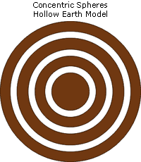
The Concentric Spheres Hollow Earth Model:
Perhaps the earliest hollow Earth concept was proposed by Edmond Halley in 1962. His ideas were developed while tyring to understand the Earth's magnetic field. In order to explain the complex movements of the field, Halley concluded that there must be at least 4 concentric shells each with their own magnetic properties. The movement of each shell relitive to the others allowed distinctive areas of the field to wander around the globe.
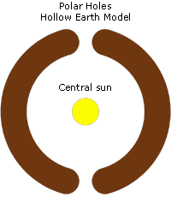
The Polar Holes Hollow Earth Model:
The most famous hollow Earth model includes huge polar holes between 2000 and 4000 kilometres across that open to the interior of the planet. Many hollow Earth investigators have gone looking for these holes but nothing has ever been found. Today's satellite technology has proven that such holes are a total myth. In the centre of the planet a central sun provides light and heat to the world within.
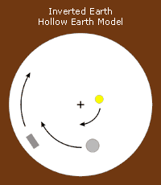
The Inverted Earth Hollow Earth Model:
This little known concept is the most bizarre of hollow Earth ideas. It works on the principle that we are actually living inside a hollow planet right now and the centre of the planet is a point infinitely far away. All the other planets, the moon, satellites and the sun revolve around this central point.
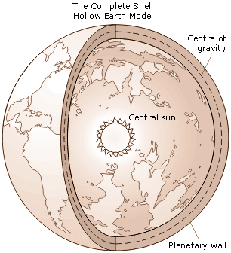
The Complete Shell Hollow Earth Model:
Developed by us, this is the most advanced hollow Earth model today. Based on a combination of the hollow Earth and expanding Earth theories, it provides an alternate explanation for the drifting continents phenomenon thus making the tired Plate Tectonics theory obsolete.
Based on our current understanding of gravity The Land of No Horizon shows how the accumulation of matter during the planet forming process naturally produces a planet structured differently to what is currently theorised. It is also shown how a planet hollows out and expands under it's own gravitational power.
The hollow planet structure can explain many mysteries that have plagued us for centuries such as unusual Impact crater characteristics on terrestrial planets, the mysterious Red Spot on Jupiter and seismic wave data from earthquakes here on Earth. Understanding outgassing and atmosphere formation on a hollow planet model helps us explain past mysteries such as the great flood on Earth and the Floods on Mars.
An expanding Earth provides the driving force behind the drifting continents, mountain building and earthquakes and is also accountable for changing the value of gravity over time. In the past when the Earth was smaller centrifugal force from a much faster speed of rotation reduced the affects of gravity in equatorial regions. This reduction of gravity is what allowed the great dinosaurs and all past life to grow to much larger sizes.

