Hollow Earth, Review

www.crystalinks.com/agartha.html

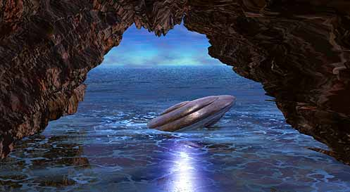
Underground civilizations link with the 'Hollow Earth Theory'. There are supposedly races that exist in subterranean cities beneath planet Earth. Very often, these dwellers of the world beneath are more technologically advanced than we on the surface. Some believe that UFOs are not from other planets, but are manufactured by strange beings in the interior of the Earth.
In the late 17th century, British astronomer Edmund Halley proposed that Earth consists of four concentric spheres and "also suggested that the interior of the Earth was populated with life and lit by a luminous atmosphere. He thought the aurora borealis, or northern lights, was caused by the escape of this gas through a thin crust at the poles."
In the early 19th century, an eccentric veteran of the war of 1812 John Symmes promoted the idea of interior concentric spheres so widely that the alleged opening to the inner world was named "Symmes Hole."
Jules Verne wrote Journey to the Center of the Earth in 1864 and Edgar Rice Burroughs (1875-1950), the creator of Martian adventures and Tarzan of the Apes, also wrote novels set in the hollow earth. Legends often ignite the imagination of fiction writers and fiction often ignites the imagination of the pseudoscientist.
In 1869, Cyrus Reed Teed, an herbalist and self-proclaimed alchemist, had a vision of a woman who told him that we are living on the inside of the hollow Earth. For nearly forty years, Teed promoted his idea in pamphlets and speeches. He even founded a cult called the Koreshans (Koresh is the Hebrew equivalent of Cyrus).
In 1906, William Reed published The Phantom of the Poles in which he claimed that nobody had found the north or south poles because they don't exist. Instead, the poles are entrances to the hollow Earth.
In 1913, Marshall B. Gardner privately published Journey to the Earth's Interior in which he rejected the notion of concentric spheres but swore that inside the hollow earth was a sun 600 miles in diameter. Gardner, too, claimed that there were huge holes a thousand mile wide at the poles.
In the 1940s, Ray Palmer, co-founder of FATE, Flying Saucers from Other Worlds, Search, The Hidden World, and many other pulp publications, teamed up with Richard Shaver to create the Shaver Mystery, a legend of a world of hollow earth people and an advanced civilization. Shaver even claimed to have dwelled with the inner Earth people.
According to Richard Toronto, the FBI blamed Palmer and Shaver for concocting "flying saucer hysteria" in 1947, making them the true founding fathers of modern UFOlogy.

ADMIRAL BYRD
In 1964, Raymond W. Bernard, an esotericist and leader of the Rosicrucians published The Hollow Earth - The Greatest Geographical Discovery in History Made by Admiral Richard E. Byrd in the Mysterious Land Beyond the Poles - The True Origin of the Flying Saucers.
Admiral Richard E. Byrd of the United States Navy flew to the North Pole in 1926 and over the South Pole in 1929.
In his diary, he tells of entering the hollow interior of the earth, along with others and traveling 17 miles over mountains, lakes, rivers, green vegetation, and animal life. He tells of seeing tremendous animals --resembling the mammoths of antiquity moving --through the brush. He eventually found cities and a thriving civilization. The external temperature was 74 degress F.
His airplane was greeted by flying machines of a type he had never seen before. They escorted him to a safe landing area where he was graciously greeted by emissaries from Agartha. After resting, he and his crew, were taken to meet the king and queen of Agartha. They told him that he had been allowed to enter Agartha because of his high moral and ethical character. They went on to say that they worried about the safety of planet due to he bombs and other testing done above the surface by goverments. After the visit Byrd and his crew were guided back to the surface of the planet.
In January of 1956 Admiral Byrd led an expedition to the South Pole. On that expedition he and his crew penetrated down 2,300 miles into the center of the earth. Admiral Byrd stated that the North and South Poles are only two of many openings into the center of the Earth. He wrote about seeing a sun below the Earth.
- The Hollow Earth - Dr. Raymond Bernard tells stories about people who have entered the inner earth and what has happened to them. It mentions a photograph published in 1960 in the Globe and Mail in Toronto, Canada which shows a beautiful valley with lush hills. An aviator claimed that he had taken the picture while flying into the North Pole.
Bernard also authored Flying Saucers from the Earth's Interior. His real name was Walter Seigmeister. In his Letters from Nowhere, Bernard claims to have been in contact with great mystics in secret ashrams and with Grand Lamas in Tibet. He was, in short, another Gurdjieff. Dr. Bernard "died of pneumonia on September 10, 1965, while searching the tunnel openings to the interior of the Earth, in South America." Bernard seems to have accepted every legend ever associated with the hollow Earth idea, including the notions that the Eskimos originated within the Earth and an advanced civilization dwells within even now, revving up their UFOs for occasional forays into thin air. Bernard even accepts without question Shaver's claim that he learned the secret of relativity before Einstein from the Hollow Earth people.
Admiral Byrd actually referred to Antarctica as "The Land of Everlasting Mystery". He once wrote: "I'd like to see that land beyond the (North) Pole. That area beyond the Pole is the Center of the Great Unknown."

CHANNELING
Diane Robbins has seen the light and claims that ADAMA receives telepathic messages from Telos, a city beneath Mt. Shasta in northern California, which are channeled by Lailel and provide all kinds of wonderful messages about perpetual peace and prosperity. Her book is called The Call Goes Out from the Subterranean City of Telos.

NAZI LINK
The belief in a hollow Earth had some adherents in Nazi Germany. There is even a legend which says that Hitler and his chief advisers escaped the last days of the Third Reich by going through the opening at the South Pole.
Some of Hitler's top advisors - perhaps even Hitler himself - believed that the Earth was hollow; and there was at least one expedition by the Nazi military to exploit that belief for strategic advantage during the war.
As with all such stories, it's often difficult to sort out facts, exaggerations, and outright fabrications. But it's anintriguing tale, and one that requires a little background.
The "inverted Earth" theory, claims that we - our civilization - actually exists on the inside of the globe. We are held fast to the ground not by gravity, but by centrifugal force as the Earth rotates. The stars, so goes the theory, are twinkling chunks of ice suspended high in the air, and the illusion of day and night is caused by a rotating central sun that is half brilliant, half dark. Cyrus Teed, an alchemist from Utica, N.Y., was one of the first people to popularize this idea. So obsessed was he with the idea that he founded a religion based on it, changed his name to Koresh, and established a commune for Koreshanity in Chicago in 1888. In Germany, independently of the Koreshans, another group also was founded that adhered to the inverted Earth idea, and it was this concept that was accepted by some segments of the Nazi hierarchy.
The scenario told at the beginning of this article accepts one hollow Earth theory, while the facts seem to show that some Nazis actually believed in the other.
Hitler's Nazis were convinced that they were destined to rule the world, and they came to this warped conclusion through the acceptance of many occult beliefs and practices, including astrology, the prophecies of Nostradamus, and the hollow/inverted Earth theory.
Because they suspected that our surface is on the interior of a concave Earth, Hitler sent an expedition, including Dr. Heinz Fischer and powerful telescopic cameras, to the Baltic island of Rugen to spy on the British fleet. Fischer did so not by aiming his cameras across the waters, but by pointing them up to peer across the atmosphere to the Atlantic Ocean. The expedition was a failure, of course. Fischer's cameras saw nothing but sky, and the British fleet remained safe.
There's the legend... that Hitler and many of his Nazi minions escaped Germany in the closing days of World War II and fled to Antarctica where at the South Pole they had discovered an entrance to the Earth's interior. According to the Hollow Earth Research Society in Ontario, Canada, they are still there. After the war, the organization claims, the Allies discovered that more than 2,000 scientists from Germany and Italy had vanished, along with almost a million people, to the land beyond the South Pole. This story gets more complicated with Nazi-designed UFOs, Nazi collaboration with the people who live in the center of the Earth, and the explanation for "Aryan-looking" UFO pilots.

I know there are ancient tunnel systems and buried cities beneath the surface of the planet in which many people chose to dwell, but that is not related to entire civilizations with advanced cultures.
The civilizations we think of as beneath the surface - co-exist with our 3D electromagnetic energy grid program. We move our conscious awareness in and out of those parallel realities so they appear to be physical.
Beneath the surface is a metaphor for - existing in lower frequency. The 'inner sun concept' is a metaphor for our inner light - connection to source - our soul.

AGARTHA
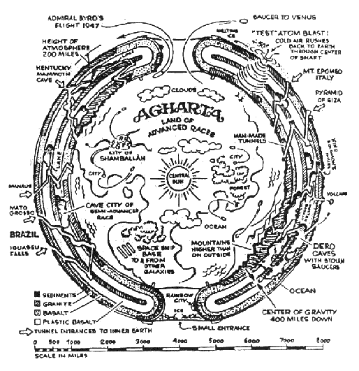
There is supposedly a civilization of people living in the center of the Earth in a place called Agartha.
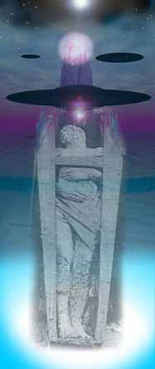
Agartha is one of the most common names cited for the society of underground dwellers is Agharta (or Agartha) with its capital city of Shambala.

The source for this information, apparently, is The Smoky God, the "biography" of a Norwegian sailor named Olaf Jansen.
According to Agartha - Secrets of the Subterranean Cities, the story, written by Willis Emerson, explains how Jansen's sloop sailed through an entrance to the Earth's interior at the North Pole. For two years he lived with the inhabitants of the Agharta network of colonies who, Emerson writes, were a full 12 feet tall and whose world was lit by a "smoky" central sun. Shamballa the Lesser, one of the colonies, was also the seat of government for the network. While Shamballa the Lesser is an inner continent, its satellite colonies are smaller enclosed ecosystems located just beneath the Earth' s crust or discreetly within mountains."
The many cataclysms and wars taking place on the surface drove these people underground, according to Secrets: "Consider the lengthy Atlantean-Lemurian war and the power of thermonuclear weaponry that eventually sank and destroyed these two highly advanced civilizations. The Sahara, the Gobi, the Australian Outback and the deserts of the U.S. are but a few examples of the devastation that resulted. The sub-cities were created as refuges for the people and as safe havens for sacred records, teachings and technologies that were cherished by these ancient cultures."
The Entrances. to Agartha: There are allegedly several entrances to the Kingdom of Agharta throughout the world
• Kentucky Mommoth Cave, in south-central Kentucky, US.
• Mount Shasta, California, US - the Agharthean city of Telos allegedly exists within and beneath this mountain.
• Manaus,Brazil
• Mato Grosso, Brazil- the city of Posid supposedly lies beneath this plain.
• IguaÁ™Falls, border or Brazil and Argentina.
• Mount Epomeo, Italy
• Himalayan Mountains, Tibet - the entrance to the underground city of Shonshe is allegedly guarded by Hindu monks.
• Mongolia - the underground city of Shingwa allegedly exists beneath the border of Mongolia and China
• Rama, India - beneath this surface city is a long lost subterranean city, they say, also named Rama.
• Pyramid of Giza, Egypt
• King Solomon's Mines.
• Dero Caves
• North and South Poles

BUDDHIST THEORY
It is believed to be a race of supermen and superwomen who occasionally come to the surface to oversee the development of the human race. It is also believed that this subterranean world has millions of inhabitants and many cities, its capital being Shambala.
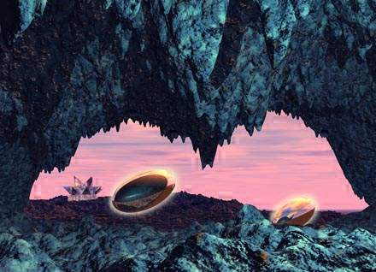
Ancient philosophy states that Agartha was first colonized thousands of years ago when a holy man lead a tribe to the underground. The people have scientific knowledge and expertice far beyond that of the people who live on the surface of the planet.

INDIA
The Ramayana one of the most famous texts of India, tells the story of the great avatar, Rama. It describes Rama as "an emissary from Agartha" who arrived on an air vehicle.
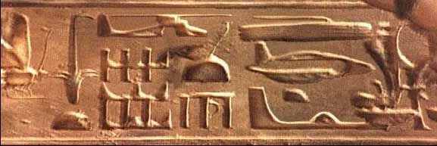
In India there is an ancient belief, still held by some, in a subterranean race of serpent people who dwell in the cities Patala and Bhogavati. According to the legend, they wage war on the kingdom of Agharta. "The Nagas," according to "The Deep Dwellers," "are described as a very advanced race or species, with a highly-developed technology. They also harbor a disdain for human beings, whom they are said to abduct, torture, interbreed with and even to eat."
The Entrances. While the entrance to Bhogavati is somewhere in the Himalayas, believers assert that Patala can be entered through the Well of Sheshna in Benares, India. Says William Michael Mott in "The Deep Dwellers": "According to herpetologist and author Sherman A. Minton, as stated in his book Venomous Reptiles, this entrance is very real, with forty steps which descend into a circular depression, to terminate at a closed stone door which is covered in bas-relief cobras.
In Tibet, there is a major mystical shrine also called 'Patala,' which is said by the people there to sit atop an ancient cavern and tunnel system, which reaches throughout the Asian continent and possibly beyond. The Nagas also have an affinity with water, and the entrances to their underground palaces are often said to be hidden at the bottom of wells, deep lakes and rivers."
The Old Ones - The Beings. In an article entitled "The Hollow Earth: Myth or Reality" for Atlantis Rising, Brad Steiger writes of the legends of "the Old Ones," an ancient race that populated the surface world millions of years ago and then moved underground. "The Old Ones, an immensely intelligent and scientifically advanced race," Steiger writes, "have chosen to structure their own environment under the surface of the planet and manufacture all their necessities.
The Old Ones are hominid, extremely long-lived, and pre-date Homo sapiens by more than a million years. The Old Ones generally remain aloof from the surface peoples, but from time to time, they have been known to offer constructive criticism; and it has been said, they often kidnap human children to tutor and rear as their own."
The Elder Race - The Beings. One of the most controversial tales of inner Earth dwellers is the so-called "Shaver Mystery." In 1945, Amazing Stories magazine under the editorship of Ray Palmer ran a story told by Richard Shaver, who claimed he had recently been the guest of what remained of an underground civilization. Although few really believed the story, any many suspect that Shaver may actually have been psychotic, Shaver always averred that his story was true.
He contended that the Elder Race, or Titans, came to this planet from another solar system in our prehistoric past. After a while of living on the surface, they realized our sun was causing them to age prematurely, so they escaped underground, building huge subterranean complexes in which to live. Eventually, they decided to seek a new home on a new planet, evacuating the Earth and leaving behind their underground cities populated by mutated beings: the evil Dero - detrimental robots - and the good Tero - integrated robots. It was these beings that Shaver claimed to have met.
The Entrance. Despite the enormous popularity of the Shaver Mystery in Amazing Stories - Palmer milked it for all it was worth, and then some - the location of the entrance to this underground world was never divulged.

QUETZALCOATL

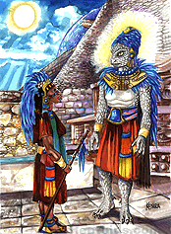
Quetzalcoatl was the god connected to the Aztecs and Toltecs.
Legend has it that he vanished on a flying saucer
for eight days when he visited the inner worlds.

