**William James Durant 1885 – 1981**

[**http://en.wikipedia.org/wiki/Will_Durant**](http://en.wikipedia.org/wiki/Will_Durant)

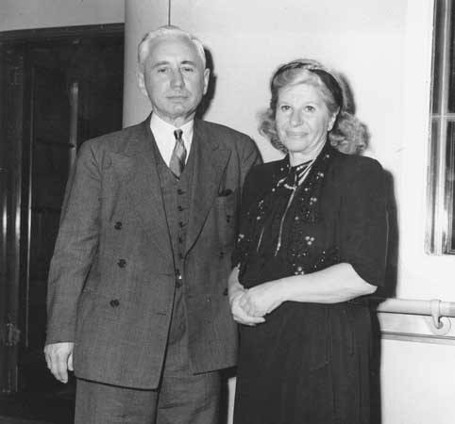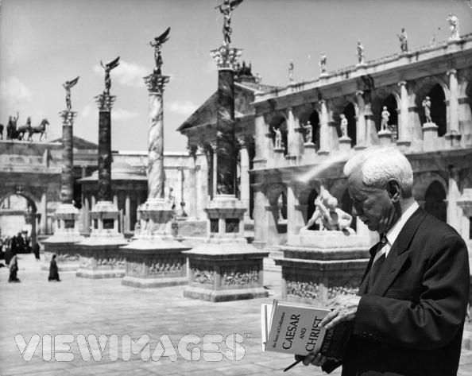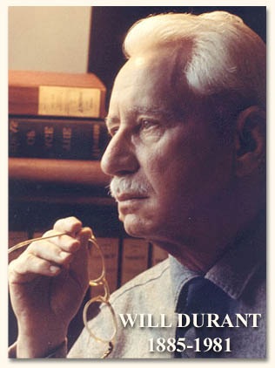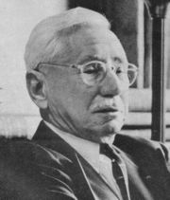

**William James Durant** ([November 5](http://en.wikipedia.org/wiki/November_5), [1885](http://en.wikipedia.org/wiki/1885)–[November 7](http://en.wikipedia.org/wiki/November_7), [1981](http://en.wikipedia.org/wiki/1981)) was an [American](http://en.wikipedia.org/wiki/United_States) [philosopher](http://en.wikipedia.org/wiki/Philosopher), [historian](http://en.wikipedia.org/wiki/Historian), and [writer](http://en.wikipedia.org/wiki/Writer). He is best known for writing, with his wife, [Ariel Durant](http://en.wikipedia.org/wiki/Ariel_Durant), [*The Story of Civilization*](http://en.wikipedia.org/wiki/The_Story_of_Civilization), an 11-volume work written between 1935 and 1975.

The Durants were awarded the [Pulitzer Prize](http://en.wikipedia.org/wiki/Pulitzer_Prize) for literature (1967) and the [Presidential Medal of Freedom](http://en.wikipedia.org/wiki/Presidential_Medal_of_Freedom) (1977).

|  |
| --- |
| **Contents**[1 Life and works](http://en.wikipedia.org/wiki/Will_Durant#Life_and_works)   * [2 Selected books](http://en.wikipedia.org/wiki/Will_Durant#Selected_books)   + [2.1 The Story of Civilization](http://en.wikipedia.org/wiki/Will_Durant#The_Story_of_Civilization) * [3 References](http://en.wikipedia.org/wiki/Will_Durant#References) * [4 External links](http://en.wikipedia.org/wiki/Will_Durant#External_links) |

**Life and works**

Durant was born in [North Adams](http://en.wikipedia.org/wiki/North_Adams%2C_Massachusetts), [Massachusetts](http://en.wikipedia.org/wiki/Massachusetts) of [French-Canadian](http://en.wikipedia.org/wiki/French-Canadian) parents Joseph Durant and Mary Allard, who had been part of the [Quebec emigration](http://en.wikipedia.org/wiki/Quebec_emigration) to the [United States](http://en.wikipedia.org/wiki/United_States). He fought for equal wages, [women's suffrage](http://en.wikipedia.org/wiki/Women%27s_suffrage) and fairer working conditions for the American labor force. Durant not only wrote on many topics but also put his ideas into effect. Durant, it has been said widely, attempted to bring philosophy to the common man. He authored [*The Story of Philosophy*](http://en.wikipedia.org/wiki/The_Story_of_Philosophy), [*The Mansions of Philosophy*](http://en.wikipedia.org/w/index.php?title=The_Mansions_of_Philosophy&action=edit&redlink=1), and, with the help of his wife, [Ariel](http://en.wikipedia.org/wiki/Ariel_Durant), wrote [*The Story of Civilization*](http://en.wikipedia.org/wiki/The_Story_of_Civilization). He also wrote magazine articles.

He was trying to improve understanding of viewpoints of human beings and to have others forgive foibles and human waywardness. He chided the comfortable insularity of what is now known as [Eurocentrism](http://en.wikipedia.org/wiki/Eurocentrism), by pointing out in *Our Oriental Heritage* that Europe was only a "a jagged promontory of Asia." He complained of "the provincialism of our traditional histories which began with Greece and summed up Asia in a line" and said they showed "a possibly fatal error of perspective and intelligence."

In [1900](http://en.wikipedia.org/wiki/1900), Will was educated by the [Jesuits](http://en.wikipedia.org/wiki/Jesuits) in St. Peter's Preparatory School and, later, [Saint Peter's College](http://en.wikipedia.org/wiki/Saint_Peter%27s_College%2C_New_Jersey) in [Jersey City, New Jersey](http://en.wikipedia.org/wiki/Jersey_City%2C_New_Jersey). In [1905](http://en.wikipedia.org/wiki/1905), he became a [Socialist](http://en.wikipedia.org/wiki/Socialist). He graduated in [1907](http://en.wikipedia.org/wiki/1907). He worked as a [reporter](http://en.wikipedia.org/wiki/Reporter) for [Arthur Brisbane](http://en.wikipedia.org/wiki/Arthur_Brisbane)'s [*New York Evening Journal*](http://en.wikipedia.org/w/index.php?title=New_York_Evening_Journal&action=edit&redlink=1) for ten dollars a week. At the *Evening Journal*, he wrote several articles on [sexual criminals](http://en.wikipedia.org/wiki/Sexual_crime).

Following this, in [1907](http://en.wikipedia.org/wiki/1907), he began teaching [Latin](http://en.wikipedia.org/wiki/Latin), [French](http://en.wikipedia.org/wiki/French_language), [English](http://en.wikipedia.org/wiki/English_language) and [geometry](http://en.wikipedia.org/wiki/Geometry) at [Seton Hall University](http://en.wikipedia.org/wiki/Seton_Hall_University), [South Orange, New Jersey](http://en.wikipedia.org/wiki/South_Orange%2C_New_Jersey). Durant was also made [librarian](http://en.wikipedia.org/wiki/Librarian) at the college.

In [1911](http://en.wikipedia.org/wiki/1911) he left the Seminary. He became the teacher and chief pupil of the [Ferrer Modern School](http://en.wikipedia.org/wiki/Ferrer_Modern_School), an experiment in [libertarian](http://en.wikipedia.org/wiki/Libertarian) education. [Alden Freeman](http://en.wikipedia.org/w/index.php?title=Alden_Freeman&action=edit&redlink=1), a supporter of the Ferrer Modern School, sponsored him for a tour of [Europe](http://en.wikipedia.org/wiki/Europe). At the Modern School, he fell in love with and married a pupil, thirteen years his junior, Chaya (Ida) Kaufman, whom he later nicknamed "Ariel". The Durants had one daughter, Ethel, and adopted a son, Louis. [Ariel](http://en.wikipedia.org/wiki/Ariel_Durant) would contribute materially to all the volumes of [*The Story of Civilization*](http://en.wikipedia.org/wiki/The_Story_of_Civilization) but was given title page credit starting only with Volume VII, *The Age of Reason Begins.*

In [1913](http://en.wikipedia.org/wiki/1913), he resigned his post as teacher. To support themselves, he began lecturing in a Presbyterian church for five- and ten-dollar fees; the material for these lectures became the starting point for *The Story of Civilization*. Freeman paid his tuition for the graduate school of [Columbia University](http://en.wikipedia.org/wiki/Columbia_University).

In [1917](http://en.wikipedia.org/wiki/1917), working on a doctorate in philosophy, Will Durant wrote his first book, *Philosophy and the Social Problem*. He discussed the idea that philosophy had not grown because it avoided the actual problems of society. He received his doctorate in [1917](http://en.wikipedia.org/wiki/1917). He was also an instructor at [Columbia University](http://en.wikipedia.org/wiki/Columbia_University).

[*The Story of Philosophy*](http://en.wikipedia.org/wiki/The_Story_of_Philosophy) originated as a series of [Little Blue Books](http://en.wikipedia.org/wiki/Little_Blue_Books) (educational pamphlets aimed at workers) and was so popular it was republished in [1926](http://en.wikipedia.org/wiki/1926) by [Simon & Schuster](http://en.wikipedia.org/wiki/Simon_%26_Schuster) as a hardcover book[[1]](http://ktwu.wuacc.edu/journeys/scripts/412b.html) and became a bestseller, giving the Durants the financial independence that would allow them to travel the world several times and spend four decades writing *The Story of Civilization.* He retired from teaching and began work on the eleven volume *Story of Civilization*. Will drafted a civil rights "Declaration of Interdependence" in the early [1940s](http://en.wikipedia.org/wiki/1940s), nearly a full decade before the Brown decision (see [Brown v. Board of Education](http://en.wikipedia.org/wiki/Brown_v._Board_of_Education)) ignited the [Civil Rights Movement](http://en.wikipedia.org/wiki/American_Civil_Rights_Movement_%281955-1968%29). This Declaration was introduced into the [Congressional Record](http://en.wikipedia.org/wiki/Congressional_Record) on [October 1](http://en.wikipedia.org/wiki/October_1), [1945](http://en.wikipedia.org/wiki/1945).

The Durants strove throughout *The Story of Civilization* to create what they called "integral history." They opposed this to the "specialization" of history, an anticipatory rejection of what some have called the "cult of the expert." Their goal was to write a "biography" of a civilization, in this case, the West, including not just the usual wars, politics and biography of greatness and villainy, but also the culture, art, philosophy, religion, and the rise of mass communication. Much of *The Story* considers the living conditions of everyday people throughout the twenty-five hundred years their "story" of the West covers. They also bring an unabashedly moral framework to their accounts, constantly stressing the repetition of the "dominance of strong over the weak, the clever over the simple." *The Story of Civilization* is the most successful historiographical series in history. It has been said that the series "put Simon and Schuster on the map" as a publishing house.

For *Rousseau and Revolution,* (1967), the 10th volume of *The Story of Civilization*, they were awarded the [Pulitzer Prize](http://en.wikipedia.org/wiki/Pulitzer_Prize) for literature; later followed the highest award granted by the United States government to civilians, the [Presidential Medal of Freedom](http://en.wikipedia.org/wiki/Presidential_Medal_of_Freedom) by [President Ford](http://en.wikipedia.org/wiki/Gerald_Ford) in 1977.

They followed *Rousseau and Revolution* with a slender volume of observations called [The Lessons of History](http://en.wikipedia.org/wiki/The_Lessons_of_History); which was both synopsis of the series as well as analysis. Though they had intended to carry the work into the 20th century, they simply ran out of time and had expected the 10th volume to be their last. However, they went on to published a final volume, their 11th, *The Age of Napoleon* in 1975. They also left behind notes for a twelfth volume, *The Age of Darwin*, and an outline for a thirteenth, *The Age of Einstein*, which would have taken *The Story of Civilization* through to 1945.

Two posthumous works by Durant have been published in the last several years, *The Greatest Minds and Ideas of All Time* (2002) and *Heroes of History: A Brief History of Civilization from Ancient Times to the Dawn of the Modern Age* (2001).

The Durants also shared a love story as remarkable as their scholarship; they detail this in *Dual Autobiography.* They died within two weeks of each other in 1981 (she on October 25 and he on November 7). Though their daughter, Ethel, and grandchildren strove to keep the death of his Ariel from the ailing Will, he learned of it on the evening news, and he himself died at the age of 96. He was buried beside his wife in [Westwood Village Memorial Park Cemetery](http://en.wikipedia.org/wiki/Westwood_Village_Memorial_Park_Cemetery) in [Los Angeles](http://en.wikipedia.org/wiki/Los_Angeles%2C_California).

**Selected books**

See a full bibliography at Will Durant Online [[2]](http://www.willdurant.com/bibliography.htm).

* Durant, Will (1926). *The Story of Philosophy*. New York: Simon and Schuster.
* Durant, Will (1927). *Transition*. New York: Simon and Schuster.
* Durant, Will (1929) *The Mansions of Philosophy*. New York: Simon and Schuster. Later with slight revisions re-published as *The Pleasures of Philosophy*
* Durant, Will (1930) *The Case for India*. New York: Simon and Schuster.
* Durant, Will (1931) *Adventures in Genius*. New York: Simon and Schuster.
* Durant, Will (1953) *The Pleasures of Philosophy*. New York: Simon and Schuster.
* Durant, Will & Durant, Ariel (1968). [*The Lessons of History*](http://en.wikipedia.org/wiki/The_Lessons_of_History). New York: Simon and Schuster.
* Durant, Will & Durant, Ariel (1970). *Interpretations of Life*. New York: Simon and Schuster.
* Durant, Will & Durant, Ariel (1977). *A Dual Autobiography*. New York: Simon and Schuster.
* Durant, Will (2001). *Heroes of History: A Brief History of Civilization from Ancient Times to the Dawn of the Modern Age*. New York: Simon and Schuster. Actually copyrighted by John Little and the Estate of Will Durant.

**The Story of Civilization**

* Durant, Will (1935). *Our Oriental Heritage*. New York: Simon and Schuster.
* Durant, Will (1939). *The Life of Greece*. New York: Simon and Schuster.
* Durant, Will (1944). *Caesar and Christ*. New York: Simon and Schuster.
* Durant, Will (1950). *The Age of Faith*. New York: Simon and Schuster.
* Durant, Will (1953). *The Renaissance*. New York: Simon and Schuster.
* Durant, Will (1957). *The Reformation*. New York: Simon and Schuster.
* Durant, Will, & Durant, Ariel (1961). *The Age of Reason Begins*. New York: Simon and Schuster.
* Durant, Will, & Durant, Ariel (1963). *The Age of Louis XIV*. New York: Simon and Schuster.
* Durant, Will, & Durant, Ariel (1965). *The Age of Voltaire*. New York: Simon and Schuster.
* Durant, Will, & Durant, Ariel (1967). *Rousseau and Revolution*. New York: Simon and Schuster.
* Durant, Will, & Durant, Ariel (1975). *The Age of Napoleon*. New York: Simon and Schuster.

**References**

* Will Durant, *Transition: A Sentimental Story of One Mind and One Era*, Garden City NY : Garden City Pub. Company, 1927.
* "Durant, Will; and Durant, Ariel." Encyclopædia Britannica from Encyclopædia Britannica Premium Service. [[3]](http://www.britannica.com/eb/article?tocId=9031558) (Accessed May 14, 2005)
* *Cat Angels*, [Jeff Rovin](http://en.wikipedia.org/wiki/Jeff_Rovin), Harper Paperbacks, [ISBN 0-06-100972-5](http://en.wikipedia.org/wiki/Special:BookSources/0061009725)

**External links**

* [Will Durant Foundation](http://www.willdurant.com/)
* [Will Durant's List of: Best 100 Books for an Education](http://www.cloudcraft.com/knowledge/)

===================================================================================================================================================