Northern Tibet Exploration
Archaeological Discoveries
of the
Changthang Circuit Expedition 1999
by John Vincent Bellezza
www.asianart.com

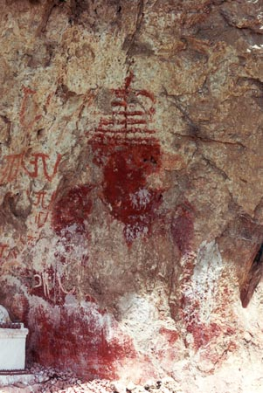
- Giant pictographic stupa

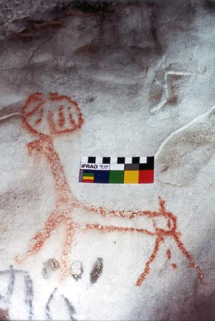
2. Deer pictograph

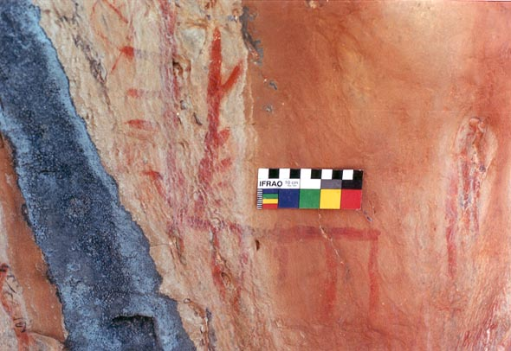
3. Deer pictograph, depicted with exaggeratedly long antlers
all text & images © John Vincent Bellezza

by John Vincent Bellezza
About the Author
Born in New York City, John Vincent Bellezza has been exploring Tibet and the Great Western Himalaya since 1983. He has made numerous pilgrimages and mounted a series of expeditions which have taken him to many corners of the Highest mountains and plateau in the world. An inveterate explorer, John to date has trekked more than 20,000 kilometers and he has clocked a huge number of miles in motor vehicles. From his first journeys in the region, he was struck by the great environmental and cultural changes which are taking place and he realized that it was imperative to document as much as possible before vital aspects of our human heritage were lost forever. John observes that vanishing cultures are not unlike endangered species in that they both represent unique pieces of existence with tremendous survival and spiritual value which immeasurably enrich the world in which we live.
In the 1980s, John collected ethnographic data on various tribes of the Himalaya filling 20 volumes of journals. In the 1990s, building on his excellent cultural and linguistic base, he decided to specialize in pre-Buddhist Tibetan culture, a field of which little was still known. By traveling to northern Tibet, John was able to befriend nomads who were pleased to show him what remained of their ancient cultural traditions. The harshness of the climate and prevailing social realities however, proved a formidable challenge and John was forced to endure many hardships including a lack of food, ferocious dogs and torrential rivers.
As a pioneer in unlocking the secrets of ancient Tibet, John pursued an interdisciplinary approach undertaking the archaeological, ethnographic and textual studies pertinent to his chosen field. The fruits of his intensive endeavor resulted in the publication of numerous articles and two scholarly books (the second of which is soon to be published; see his bibliography). His ground breaking work has resulted in the documentation of over 150 pre-Buddhist archaeological sites (including ruins, rock art, tombs and megaliths), and the collection of a wide range of anthropological and literary sources of information concerning archaic traditions in Tibet. John holds the view that there is still much to explore and discover on our planet and vociferously refutes those who believe that there is nothing new under the sun. He says that inspired by a salutary vision harnessed to determination and hard work, there are no limits to what we can achieve individually or collectively.
Now that we have entered the 21st century, John is intent on extending the scope of his research and drawing in new expertise from a variety of fields. He thus welcomes the comments and advise of interested readers. He believes that by making the exploration of pre-Buddhist Tibet an international effort this endeavor will in its own modest way foster global links of friendship and understanding, the keys to our very survival. It is with this lofty vision that John sustains his difficult and demanding work.
You can contact John at: jbellezza@hotmail.com

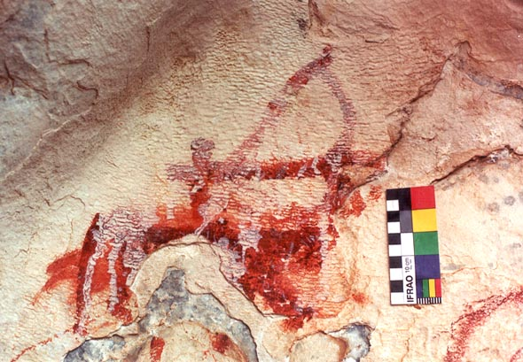
4. Mounted figure with bow and arrow
Thanks to the generous financial support of the Spalding Trust, England, (as well as an earlier grant from the Shang Shung Institute, USA and Italy) I returned to northern and western Tibet in April of 1999, on what I call the Changthang Circuit Expedition. This expedition lasted until November and totaled 161 days in the field. Having so much time was most useful and I was able to meet or exceed all my research objectives. I also wish to express my gratitude to the provincial, prefectural, county, and township officals of the the Tibet Autonomous Region for their support and expertise.
Background
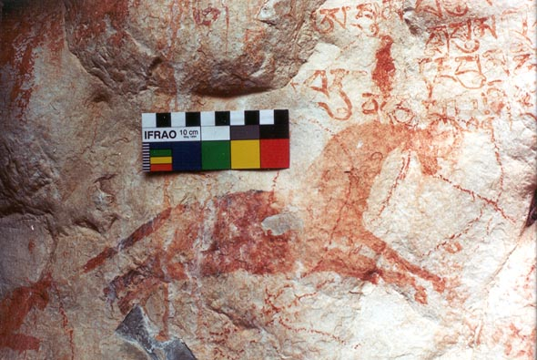
5. Horse, part of a Bon mantra is also visible in the image

For over one decade, I have been actively involved in the exploration of the Byang-thang region of Tibet in conjunction with my research into pre-Buddhist culture and archaeology (see bibliography). While Tibet is synonymous with Buddhist learning and culture, its civilization extends much further back into antiquity than the Buddhist period. My findings demonstrate that Tibet supported a sophisticated culture long before the dawn of the Buddhist era in the 7th century. This earlier civilization was closely connected to the early Bon religion, an amorphous indigenous belief system which seems to have been enriched by various traditions coming from adjoining countries. The Bon religion, now heavily assimilated to Buddhism, is still very much in practice in Tibet and adjacent countries.

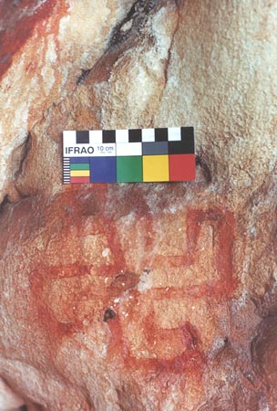
6. Bon g.yung-drung
The investigation of pre-Buddhist culture is very much in its infancy and there is still a great deal of work to do. I am hopeful that in the next decades we will obtain answers to pressing questions related to this study such as the chronology of archaeological sites, the nature of cultural borrowing and influences in early times, and the true extent of pre-Buddhist civilization.
Of particular interest is the pre-Buddhist Zhang Zhung civilization which was based in northern and western Tibet as late as the 8th century. The literature of the Bon religion is replete with references and allusions to Zhang Zhung which, according to these sources, was large and powerful. One of the main objectives of my research is to establish the historicity of this kingdom and its role in the development of Tibetan civilization.
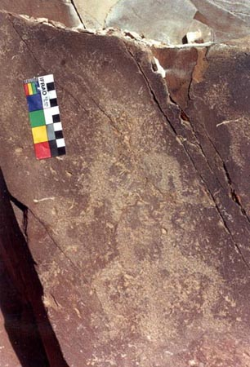
7. Petroglyph depicting squatting figure with object between its legs,
My research into early Tibetan civilization is comprised of three major disciplines: textual studies, ethnography and archaeology. I am involved in the collection (mostly in photographic form) and translation of texts and manuscripts which shed light on pre-Buddhist practices. Among the most important of these are gsol-kha, scriptures written in praise of indigenous deities such as the mountain gods and lake goddesses.
Most importantly, I am engaged with interviewing senior members of the older generation. These cultural luminaries are becoming very rare in a land which is fast becoming a cultural desert. They preserve much cultural lore and knowledge that in many instances is not being transmitted to the younger generation. This means that once they pass away the heritage of Tibet and by extension, the rest of the world, will be much impoverished.
I will continue to examine ethnographic and textual materials in my various publications: however, in this report we will focus on archaeology.
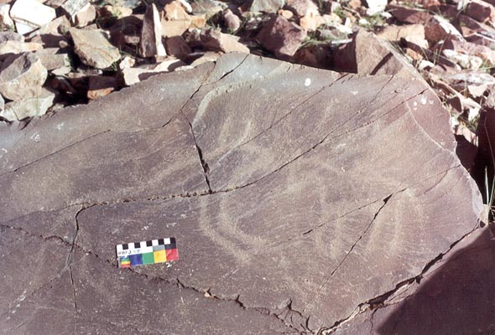
8. Petroglyph belonging to earliest tier of Tibetan rock art depicting a yak and either a horse or onager
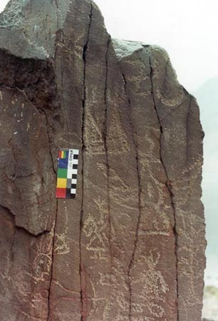
9. Petrogylphic panel depicting Zhang Zhung type motifs
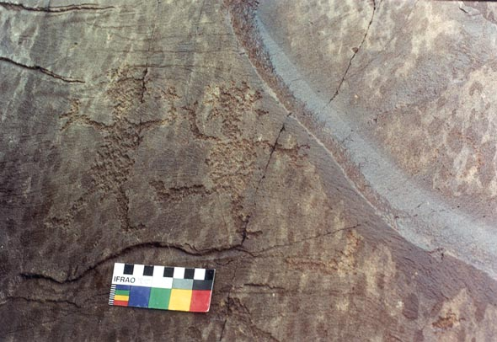
10. Petroglyph portraying figures which appear to be dancing
Materials Compiled on the Changthang Circuit Expedition
1) Five volumes of notebooks primarily in Tibetan
2) My journal entries in English totaling around 400 finely written pages
3) 89 rolls of film (which provided more than 2000 usable photographs)
4) Specimens of the parent rocks used in the construction of archaeological sites
5) Several organic specimens
6) Copies of Tibetan texts and manuscripts
7) Maps
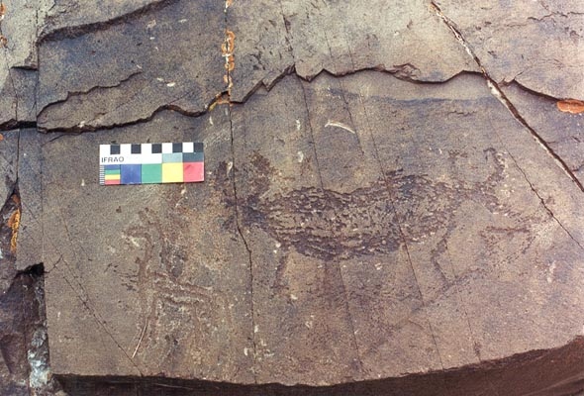
11. Two-headed yak petrogylph
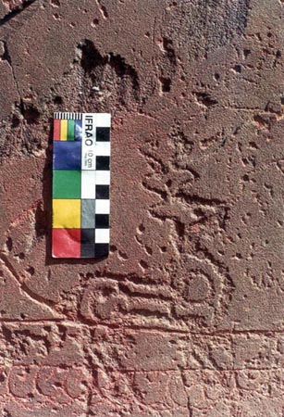
12. Ungulate in a style found throughout Inner Asia
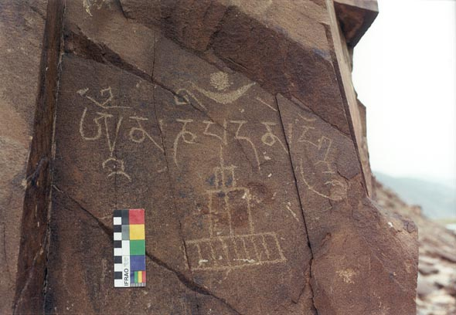
13. Ma-ni mantra and early style stupa carving
Pre-Buddhist Archaeological Sites Documented on the Changthang Circuit Expedition
During the expedition I was able to document around 100 pre-Buddhist sites. On top of the work I have already done over the last decade (where I surveyed around 50 other pre-Buddhist sites), I believe I now have sufficient data to outline the typology and preferred location patterns of pre-Buddhist archaeological sites. There are still many ancient sites to be discovered but it now seems as though we have a representative selection encompassing most regions of the Byang-thang.
The types of pre-Buddhist archaeological sites found on the Byang-thang can be classed as follows:
1) Petroglyphs and Pictographs
2) Hilltop forts, palaces and other structures
3) Structures, mostly religious, integrating caves and escarpments in their construction
4) Free-standing religious edifices
5) The remains of sedentary villages
6) Cist-type graves, both square and round in form
7) Graves with cubic-shaped superstructures built on summits
8) Isolated pillars
9) Stelae built within a quadrangular perimeter
10) Monolithic arrays usually with accompanying structures
11) Other remains such as mountain top walls and earth works
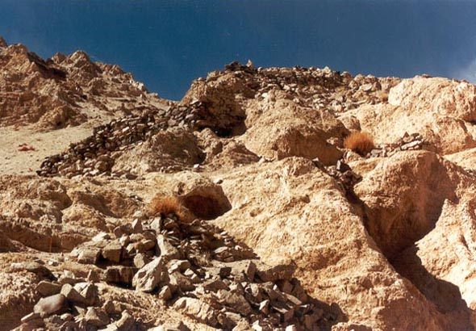
14. Part of a Mon mkhar
A word on what constitutes the pre-Buddhist period is in order: I use the word pre-Buddhist to denote cultural phenomena and physical evidence which have their origin in the period before Buddhism came to dominate Tibet and which in content display distinctively non-Buddhist characteristics. The first diffusion of Buddhism began in the early seventh century, in the reign of King Srong-btsan sGam-po. Buddhism however, did not come to dominate the religious sentiments of Tibet until the ninth or tenth centuries. It seems likely therefore that pre-Buddhist edifices and art could have been produced as late as 1000. In certain situations, as in very remote areas where pre-Buddhist cults continued to exist, the pre-Buddhist cultural context can be extended as late as 1250. On the other end of the chronological spectrum are pre-Buddhist sites of deep antiquity dating to the early Metal Age and earlier. For an assessment of pre-Buddhist chronology see my book Divine Dyads: Ancient Civilization in Tibet.
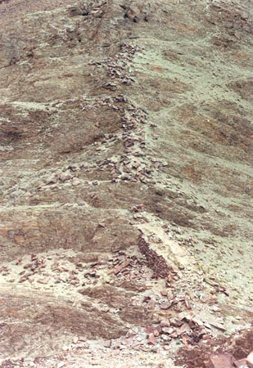
15. A section of the ramparts of a Mon mkhar,
As this point in the investigation there is little archaeometric data to rely on. I hope with the publication of my findings the situation will change and the archaeological community will find the interest and resources to explore some of these sites. Much will depend on academia forging mutually beneficial relations with the government of the People’s Republic of China and local Tibetan communities.
I attribute archaeological sites to the pre-Buddhist period on the basis of the following criteria:
1) Sites mentioned in Bon literature as belonging to the Zhang Zhung period (pre-Buddhist kingdom centered in north and west Tibet)
2) Ruins ascribed by elders as belonging to the ancient Bon po, Mon pa, Zhang Zhung kingdom, or in certain instances, to the Gling Ge-sar epic
3) Monuments exhibiting distinctly non-Buddhist morphological features
4) Art and artifacts which display archaic non-Buddhist characteristics
5) Cross-cultural comparisons with archaeological sites in adjoining countries
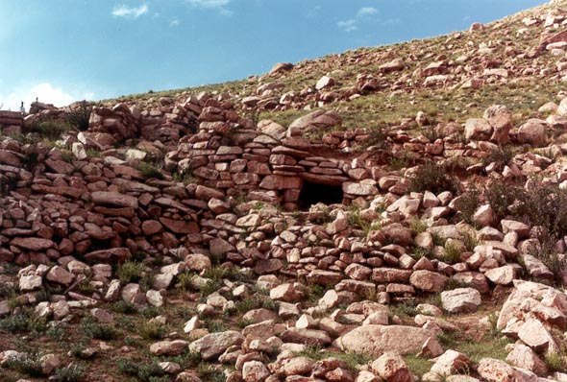
16. A portion of a Zhang Zhung era religious edifice
My survey was confined to picture taking, interviews and map making. At no time did I disturb the ground or in any other way affect the integrity of the sites. I am well aware that once archaeological sites are put on the map they are vulnerable to the attacks of the unsavory. As a first priority, it is imperative that this heritage be conserved for future generations. Secondly, once those interested are aware of this heritage, measures will be taken to carry the investigation to the next stage; the scientific excavation of selected sites. Until such steps are taken a huge gap will exist in our knowledge of Eurasian archaeology.
Rock Art

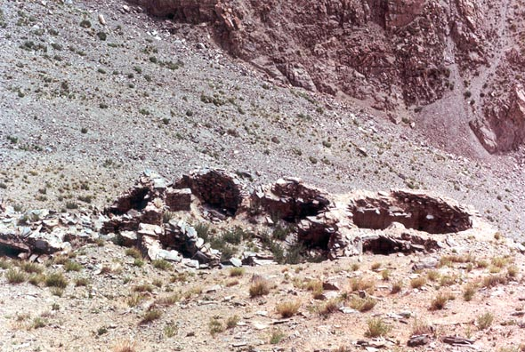
17. Zhang Zhung religious edifice, note the rounded walls
Among the archaeological sites I surveyed on the Changthang Circuit Expedition are those that contain rock art. I have documented the rock paintings at gNam-mtsho in four scholarly works and still recently, I found examples I was unaware of. Among the most notable is what may be the largest pictograph to come to light in Tibet (see image no.1). It is a red ochre stupa (mchod-rten) painted in an archaic style measuring approximately five meters in height and two meters in width. On the basis of style, I believe this stupa was painted no later than 1300. There are also four smaller companion stupas which are very difficult to discern unless the light is right.
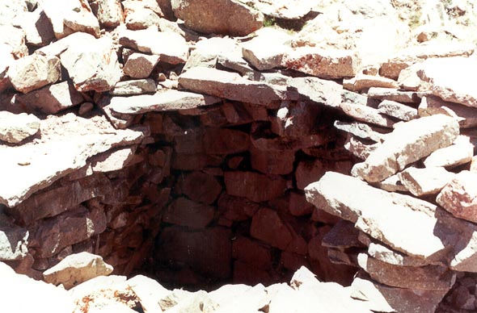
18. A portion of an ancient habitation, note the stone roof braces
The most common subjects in gNam mtsho rock paintings are animals, not surprising when you consider that livestock still form the linchpin of the economy. The deer, an animal with archaic religious associations figures prominently in pictographs. Paintings of deer were produced from the early Metal Age (perhaps even in the Neolithic) until relatively recently and come in many styles and forms (see images 2 and 3) (the color calibration scale in this and other rock art images is used by the International Federation of Rock Art Organisations). The horse also figures prominently in rock paintings, an animal with an extremely high status in the northern steppes of Tibet. Most compositions featuring the horse do so in conjunction with mounted hunters and warriors (see image no. 4). There are however, examples of horses without riders such as the example shown here which is painted in close proximity to a Bon mantra (see image no. 5).
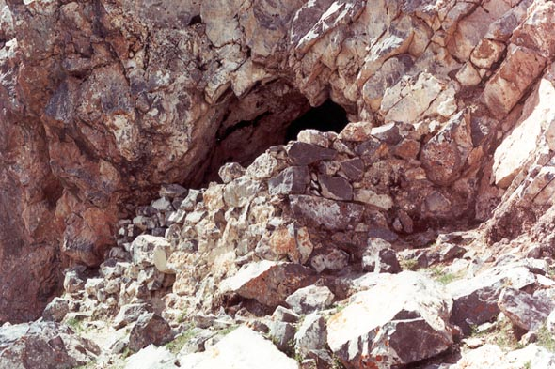
19. One of the ancient hermitages at Gyer-ru mtsho
In extreme northwestern Tibet, I came across a petroglyphic site which to my knowledge has not previously been documented. It is a very important site in that it includes carvings produced over millennia. The earliest petrogylphs may well date to the Neolithic, beginning a tradition which lasted until relatively recent times. As one might expect from such a site, the petroglyphs exhibit great diversity in terms of content and the techniques used to carve them. Among them is a figure similar to those in north Asia sometimes likened to cosmic birthing goddesses and dated to the Bronze Age (see image no. 7).
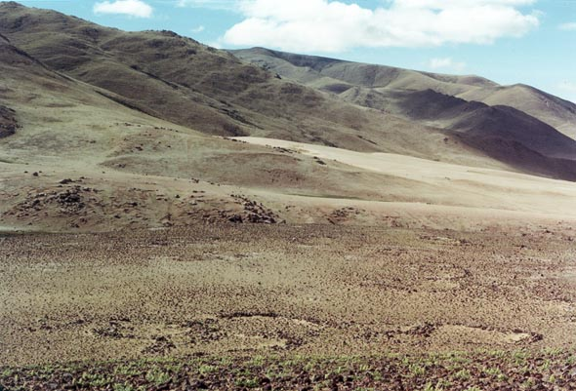
20. Round Mon-pa grave complex, nearly 20 are visible in the image
The earliest variety of petroglyphs feature animals which in design parallel those found in south Siberia and Mongolia and dated to the Neolithic or Bronze Age (see image no. 8). The two animals represented here appear to be a yak and either a horse or onager.
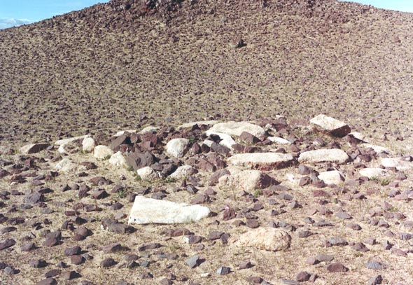
21. Square Mon-pa grave
Of great interest are petroglyphs exhibiting cultural motifs associated with the pre-Buddhist Zhang Zhung kingdom (see image no. 9). While an Iron Age date is indicated for these types of petroglyphs, it cannot be ruled out that in some instances they were made as late as 1250. The motifs present include the g.yung-drung, crescent moon, raptor with outstretched wings, tree and two anthropomorphs with headdresses consisting of three prominent lines reminiscent of horns or feathers. Bon texts (such as Sources for a History of Bon) record that Zhang Zhung adepts had such embellishments. Another motif depicted on this panel is a pair of primitive mchod-rten with triple-pointed finales (bya-ru bya-gri) such as the ones Bon-po believe were produced in Zhang Zhung times.
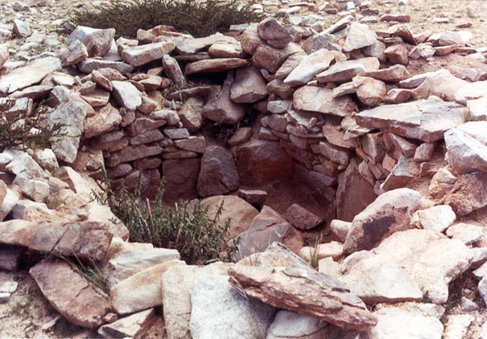
22. Interior of Mon grave
One of the most primitive techniques used to create petroglyphs consists of pecking at the rock with stone or metal tools to create the images. This type of petrogylph is well represented in the site I surveyed (images 10 and 11) and could potentially be as old as the close of the New Stone Age (Aeneolithic). In one of these examples, two anthropomorphs mimic each other’s arm movements giving the impression that they are dancing. Crown-like objects on the tops of their heads are reminiscent of feathers or horns, both of which were used in pre-Buddhist times to adorn the head. In the other composition - produced through pecking - an unusual two-headed yak is portrayed.
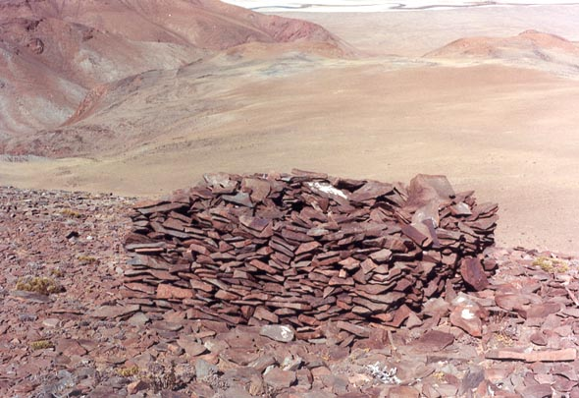
23. Mountain top Mon-pa grave
Ungulates with long sinuous antlers and curvilinear designs in the body like the one shown here are found at various sites in western Tibet (image no. 12). These types of design elements also occur in the petroglyphs of ungulates in Mongolia and south Siberia (as well as Ladakh and Spiti in India, and Baltistan in Pakistan) and are dated to the Bronze Age and Iron Age. Early historical carvings are also in evidence in the site I surveyed (image no. 13). The ma-ni mantra inscription and mchod-rten shown here are of the same type found in Ladakh and Baltistan and which are generally believed to date from Tibet’s imperial period (seventh to mid-ninth centuries).
Archaeological Monuments
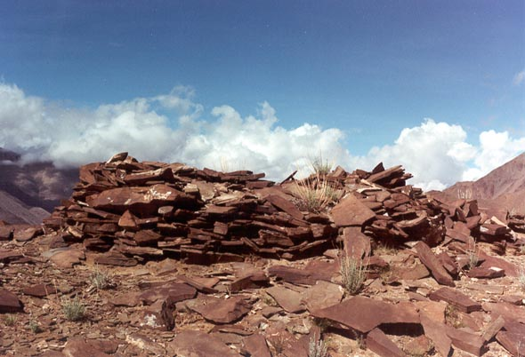
24. Mountain top Mon-pa grave
In western Tibet there are a number of hilltop ruins connected by the local residents to the Mon-pa. These are called Mon rdzong or Mon mkhar (A.H. Francke first described the genre at the turn-of-the-century in Ladakh and Professor G. Tucci did likewise, in the middle of the century in Rong-chung). On the expedition I surveyed around one dozen Mon mkhar. The Mon-pa were a semi-legendary prehistoric people probably of non-Tibetan origin. The forts they supposedly left exhibit diverse styles of construction (see images 14 and 15). I have several reasons to believe that some of the structures attributed to the Mon-pa were in actuality constructed in the Zhang Zhung period. One reason is that among the Buddhists of mNga’-ris province pre-Buddhist remains are routinely attributed to the Mon-pa with little or no awareness of the significance of Zhang Zhung.
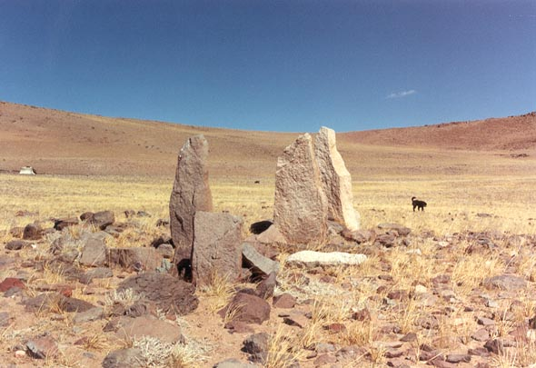
25. Pillars in quadrangular enclosure
Among the most interested monumental remains are those attributed to Zhang Zhung and which are said to have functioned as religious centers (see images 16 and 17). I had the good fortune of being able to document more than one dozen of these types of structures. In some cases, as in Nyi-ma and gNam-ru counties, Bon literature corroborates the oral accounts attributing these structures to the pre-Buddhist period. The Zhang Zhung religious centers (sad mkhar) are built in a very different fashion from their Buddhist successors. The rooms are small (four to nine square meters) and are often oval-shaped. Most notably, these are all stone constructions with stone rafters, arches and roof slabs (where these features are still intact). In what appear to be the remains of ancient villages a similar type of construction was used whereby structures have all stone roofs (see image 18). I discovered several groups of ruins which appear to have been centers of habitation.
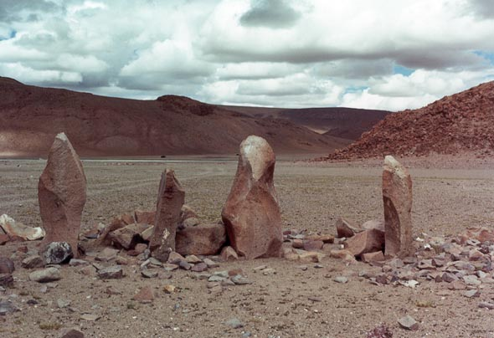
26. Pillars in quadrangular enclosure
According to the oral history of the shepherds of the Byang-thang (’brog-pa), the dwellers of Zhang Zhung constructed a network of religious edifices integrated into caves and escarpments. The vestiges of one of these cave hermitages are found at Gyer-ru mtsho in dPal-mgon county. I had noted this site and a little of its history in Divine Dyads but it was not until the present expedition that I had an opportunity to visit it. According to the Bon-po elders of the region, the remains of walls, terraces and other structures found on the southwestern side of the headland of Gyer-ru mtsho (Gyer-ru mtsho do) belong to the Zhang Zhung period (see image 19). While I presently lack the scientific capability to verify these claims, it is clear from Bon religious tradition that Gyer-ru mtsho was indeed the site of activity in the time of Zhang Zhung.
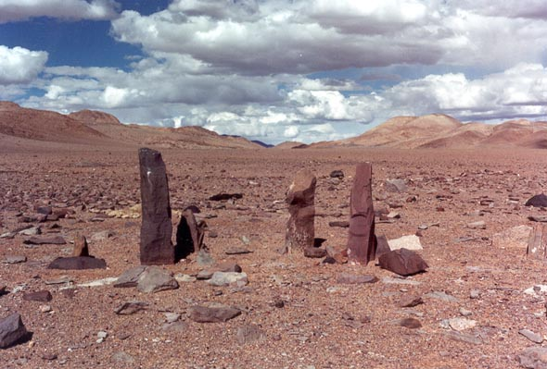
27. Pillars in quadrangular enclosure
It is now apparent that gravesites lay scattered all over northern Tibet. They often form clusters of up to twenty structures and can either be oval or square in shape (see images 20 and 21). They average three or four meters across. On the expedition I documented about one dozen of these sites. These graves are almost without exception attributed to the Mon-pa. In some instances, I found graves which had been opened revealing the burial chamber inside (see image 22).
Another type of structure attributed by local Tibetans as being the graves of Mon-pa (Mon dur) are found on mountain and ridge tops (see images 23 and 24). I have found five sites of this typology. These consist of superstructures two or three meters square with a central chamber built above ground level. These chambers are usually less then one metre square and therefore, could only have accommodated an adult corpse which had been dismembered or reburied. While I cannot confirm the oral history associated with these sites it is clear from Tibetan historical sources that burials were a feature of pre-Buddhist culture. Gravesites, including large burial complexes, have previously been found throughout Tibet. There are preliminary indications that some of these graves might be related to those found in Mongolia and south Siberia.
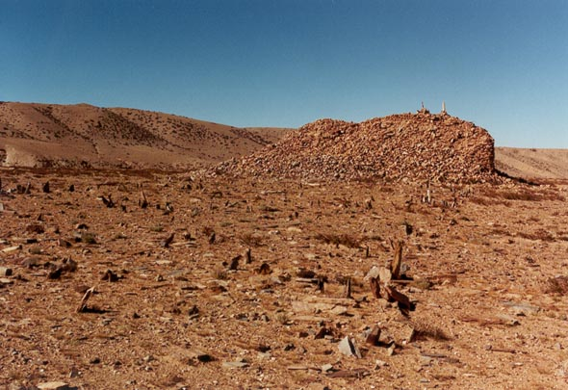
28. Monolithic array with adjoining structure
fig. 28 (back to text)
Another type of archaeological monument proving to be relatively common are pillars situated on the west side of stone enclosures (see images 25, 26 and 27). I have found around two dozen examples of this type of monument. They are frequently attributed by shepherds to the Tibetan epic hero, Gling Ge-sar and are said to be where he hitched his divine horse or alternatively, to the beginning of creation. The pillars protrude up to 1.8 meters from the ground and are frequently found in rows of three to ten standing stones. When there are multiple pillars they are sometimes made of stones of contrasting colors. The enclosing structures might have originally been taller but now without exception, they have been reduced to ground level. These perimeters are square or rectangular in shape and vary in size but typically are around eight meters by eight meters. At this point in the investigation, the function of these monuments is not known but we might speculate based on our knowledge of Tibetan menhirs that they were constituent parts of tribal ancestral worship. This type of monument must have been a fundamental part of pre-Buddhist society, for otherwise it would not have such wide currency.
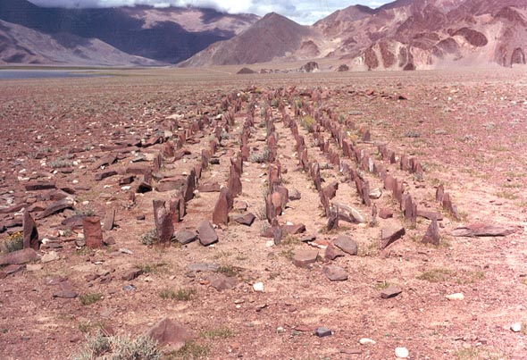
29. Monolithic array
One of the most captivating pre-Buddhist monuments in western Tibet consists of rows of standing stones arrayed in quadrangular complexes (see photos 28, 29, 30). This year, I discovered six of these sites which, in local culture, are frequently attributed to the Mon-pa or Gling Ge-sar of the Tibetan epic. The menhirs are often found in association with other types of structures.
The standing stones vary in height from 25 centimeters to 1.5 meters and can number many hundreds in a single complex. The stones appear to have been aligned in neat rows oriented to the cardinal directions. They are now often inclined, heavily worn and covered in lichen, indications of their substantial age. The menhirs appear to be constructed from both raw and dressed stones depending on their size and the particular site. The adjoining structures are usually leveled but in certain instances above ground ruins have survived. The ruins usually consist of long narrow edifices up to four meters in height. The walls of these structures are extremely thick and exhibit a high degree of stone working skill. There is some indication, in the way of local accounts, that they may have functioned as graves.
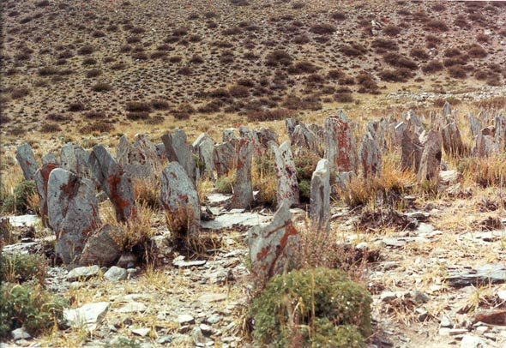
30. A portion of a monolithic array
The most significant archaeological site of this type (which I refer to as monolithic arrays) is called Yu Kham-bu. It is comprised of six large complexes each with a concourse of standing stones lying adjacent to long structures. Without exception, the fields of menhirs lay on the east side of the buildings. The buildings range in length from 20 to 60 meters. The outer walls of these edifices are upwards of two meters thick. There also appear to be inner walls of considerable thickness. The width of the buildings averages around ten meters and therefore, at least on the ground level, they had very small inner spaces as compared to their exterior dimensions. The crumbling walls of the edifice I call Tower Complex still exceed three or four meters in height but potentially may have been much taller (see image 31). This is suggested by their massive construction and fine masonry. Horizontal courses of large and small blocks alternate with courses of stones laid diagonally to produce a herring bone pattern. The Sui Annals note that the Sum-pa of Tibet built towers in northern Tibet.
Conclusion
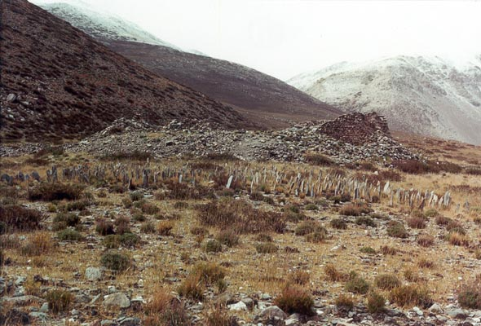
31. Yu Kham-bu Tower Complex
As I have mentioned, there is much research and exploration to do but at least we are making some headway. I believe that it is essential that Tibetans reclaim their ancient heritage as they are much more than mere hybrids of Indian and Chinese civilization. Tibet possesses a past every bit as profound and unique as any of the other great cultures of antiquity.
I would very much welcome input from interested parties: jbellezza@hotmail.com
Bibliography of Works Relating to Tibetan Archaeology by John Vincent Bellezza
2001. Antiquities of Northern Tibet: Pre-Buddhist Archaeological Discoveries on the High Plateau. Adroit Publishers, Delhi.
2000. “Pre-Buddhist Archaeological Sites in Northern Tibet: An Introductory: Report on the Types of Monuments and Related Literary and Oral Historical Sources" in Kailash, vol. 17, no. 1. Kathmandu.
2000. “Bon Rock Paintings at gNam mtsho: Glimpses of the Ancient Religion of Northern Tibet” in Rock Art Research, vol. 17, no. 1. Melbourne.
2000. “Gods Hunting and Society: Animals in the Ancient Cave Paintings of Celestial Lake in Northern Tibet” in East and West. Rome
1999. “Archaeological Mysteries at Tibet’s Sacred Mountain Nyenchen Thanglha” in Himal. Vol. 12, no.12: Kathmandu
1999. “High Country Culture” in Discovering Archaeology, vol. 1, no. 3, May/June. El Paso.
1999. “A Preliminary Archaeological Survey of Da rog mtsho” in The Tibet Journal, vol. 24, no. 1. Library of Tibetan Works and Archives: Dharamsala.
1998. “Thogchags: Talismans of Tibet” in Arts of Asia, vol. 28, no. 3, May/June. Hong Kong.
1997. Divine Dyads: Ancient Civilization in Tibet. Library of Tibetan Works and Archives. Dharamsala.
1997. “Notes on Three Series of Unusual Symbols Discovered on the Byang thang”. in East and West, vol. 47, nos. 1-4, IsIAO: Rome.
1996. “A Preliminary Archaeological Survey of gNam mtsho and Dang ra g.yu mtsho” in The Tibet Journal, vol. 21, no. 2. The Library of Tibetan Works and Archives. Dharamsala.
1995. “Doring Revisited” in Himal, vol. 8, May/June. Kathmandu.
1994. “Thog lcags” in The Tibet Journal, vol. 19, no. 1. Library of Tibetan Works and Archives. Dharamsala.
1993. “Ouest for the Four Fountains of Tibet” in Himal, vol. 6, Jan./Feb. Kathmandu.

