Robert M. Schoch

http://en.wikipedia.org/wiki/Robert_M._Schoch

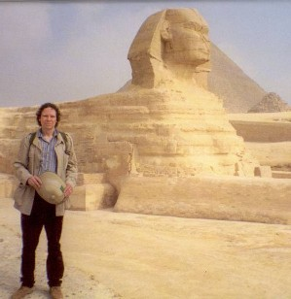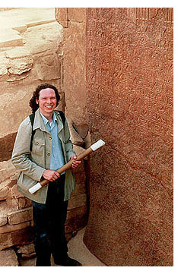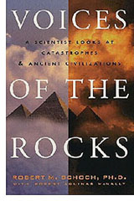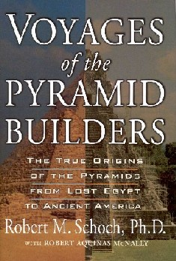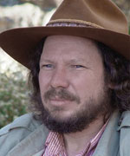

Robert M. Schoch is an American geologist and academic with a special interest in pyramid monuments around the world. He received his Ph.D. in geology and geophysics from Yale in 1983, and as of 2000 is a tenured professor of general studies at Boston University. He is one of few geologists to espouse the theory that the Egyptian Sphinx is much older than conventionally thought and that some kind of catastrophe has wiped out other evidence of a significantly older civilization. In 1991, Schoch redated the famous monument to 7000–5000 BC, based on his assertion that its erosion was due mainly to the effects of water, rather than wind and sand. Mainstream Egyptologists reject his analysis.
Schoch's other theories include the belief that possibly all pyramids — in Egypt, Mesoamerica and elsewhere — represent a much older global culture. He is also known for his research on the Yonaguni underwater "monuments," to which he dived in 1997; his analysis of the formations is that they are of natural origin.
In 2003, Schoch lent his name to a genus of extinct mammals, Schochia, of which Schochia sullivani is the genoholotype.[1]
In 2006, Schoch investigated the so-called Bosnian pyramid excavations, at the invitation of the locals. He concluded "absolutely no evidence of pyramids per se or of a great ancient civilization in the Visoko region." [2]

Published works
- Voices of the Rocks: A Scientist Looks at Catastrophes and Ancient Civilizations, 1999. ISBN 0-609-60369-8
- Voyages of the Pyramid Builders: The True Origins of the Pyramids from Lost Egypt to Ancient America, 2003. ISBN 1-58542-320-3.
- Pyramid Quest: Secrets of the Great Pyramid and the Dawn of Civilization, 2005. ISBN 1-58542-405-6.
- Environmental Science: Systems and Solutions, with Michael McKinney, 2003. ISBN 0-7637-0918-2.

External links
- Robert Schoch's homepage at Boston University's College of General Studies
- His first website (out of date)
- Schoch's new website, in conjunction with Colette Dowell

===================================================================================================================================
END

http://www.cpakonline.com/presenters

Robert M. Schoch

Biography
Robert M. Schoch is well-known for his research on the Great Sphinx as well as his studies of the underwater structure off the coast of Yonaguni Island, Japan. Currently a tenured faculty member at Boston University’s College of General Studies, Schoch completed his graduate work at Yale University, earning a Ph.D. (1983) in geology and geophysics. Since 1990 Robert Schoch has been researching the age of the Great Sphinx, in conjunction with John Anthony West, and based on his geological studies, he has determined that the Sphinx’s origins go back to pre-dynastic times. Schoch discusses the Sphinx and other topics in his book Voices of the Rocks.
Dr. Schoch has also published two new books, Voyages of the Pyramid Builders: The True Origins of the Pyramids from Lost Egypt to Ancient America (Tarcher/Putnam, 2003) and Pyramid Quest: Secrets of the Great Pyramid and the Dawn of Civilization (Tarcher/Penguin, 2005). Schoch has lectured widely on paleontology, stratigraphy and the age of the Great Sphinx. He is the author of numerous papers, reviews, abstracts and several books besides the two mentioned above (including the textbook Environmental Science: Systems and Solutions). In recognition of Schoch’s paleontological contributions, in 1993 the new genus Schochia, an extinct group of fossil mammals, was named in his honor.
Topic
He will explore the very ancient beginnings of Egyptian civilization (going back much further in the past than has been generally acknowledged), and the high knowledge of those early people. He will also discuss the more general concept of cycles among ancient peoples, and the interplay between large-scale cycles (for instance, precession) and smaller-scale cycles (for instance, caused by periodic encounters with comets). Such cyclical phenomena had a profound effect on the very fabric of ancient civilizations, and continue to have meaning today.
---------------------------------------------------------------------------------------------------------------------------------------------------------------------------------------------------------

