Mythology
http://en.wikipedia.org/wiki/Mythology
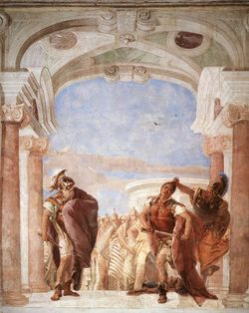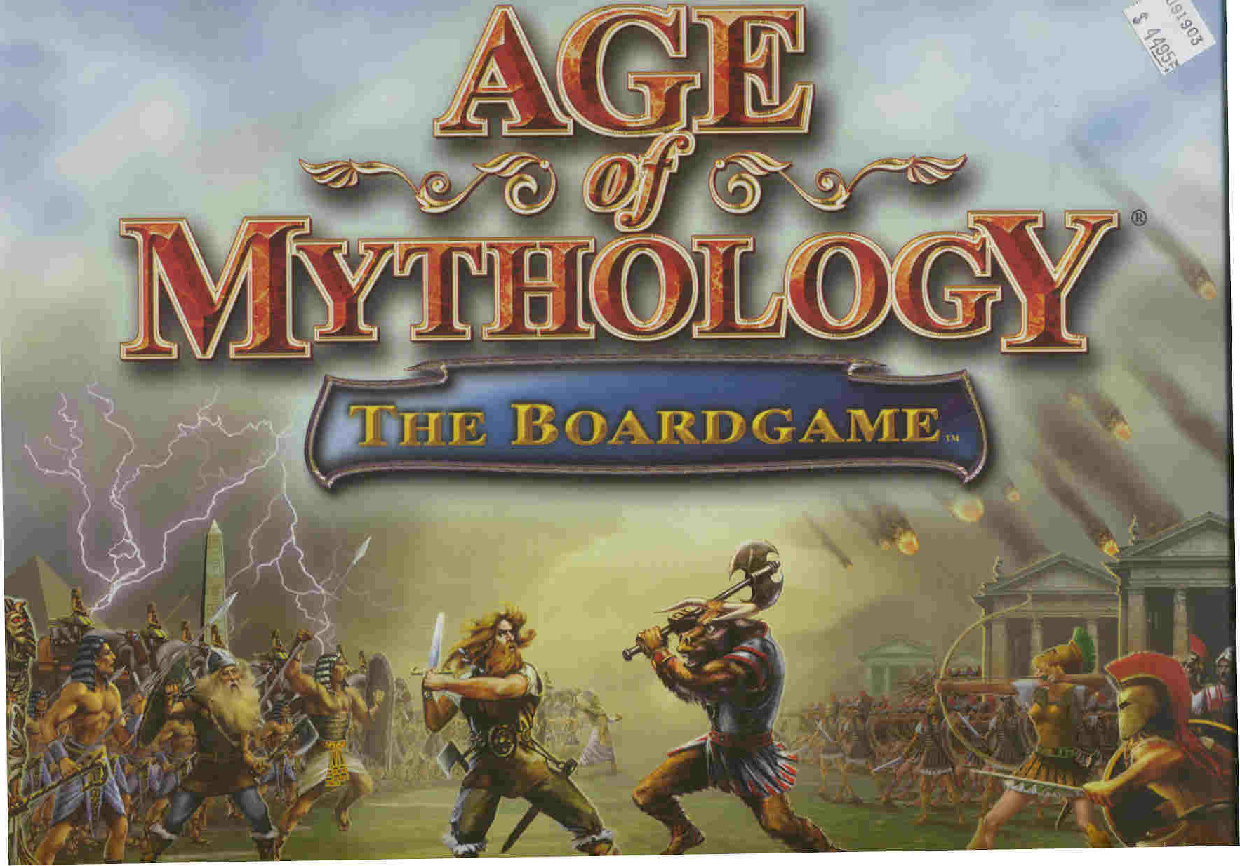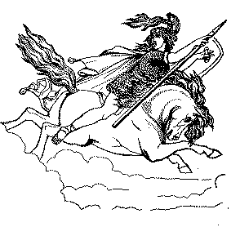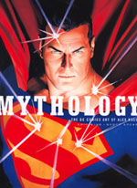

The word mythology (Greek: μυθολογία, from μυθος mythos, a story or legend, and λογος logos, an account or speech) literally means the (oral) retelling of myths – stories that a particular culture believes to be true and that use supernatural events or characters to explain the nature of the universe and humanity. In modern usage, mythology is either the body of myths from a particular culture or religion (as in Greek mythology, Egyptian mythology or Norse mythology) or the branch of knowledge dealing with the collection, study and interpretation of myths.
In common usage, myth means a falsehood — a story which many believe to be based on fact but which is not true. However, the field of mythology does not use this definition.

[] Definition
Myths are narratives about divine or heroic beings, arranged in a coherent system, passed down traditionally, and linked to the spiritual or religious life of a community, endorsed by rulers or priests. Once this link to the spiritual leadership of society is broken, they lose their mythological qualities and become folktales or fairy tales.^{[1]}
In folkloristics, which is concerned with the study of both secular and sacred narratives, a myth also derives some of its power from being believed and deeply held as true. In the study of folklore, all sacred traditions have myths, and there is nothing pejorative or dismissive intended in the use of the term, as there often is in common usage.
Myths are often intended to explain the universal and local beginnings ("creation myths" and "founding myths"), natural phenomena, inexplicable cultural conventions, and anything else for which no simple explanation presents itself. This broader truth runs deeper than the advent of critical history which may, or may not, exist as in an authoritative written form which becomes "the story" (Preliterate oral traditions may vanish as the written word becomes "the story" and the literate become "the authority"). However, as Lucien Lévy-Bruhl puts it, "The primitive mentality is a condition of the human mind, and not a stage in its historical development."^{[2]} Most often the term refers specifically to ancient tales from very old cultures, such as Greek mythology or Roman mythology. Some myths descended originally as part of an oral tradition and were only later written down, and many of them exist in multiple versions.
According to F. W. J. Schelling in the eighth chapter of Introduction to Philosophy and Mythology, "Mythological representations have been neither invented nor freely accepted. The products of a process independent of thought and will, they were, for the consciousness which underwent them, of an irrefutable and incontestable reality. Peoples and individuals are only the instruments of this process, which goes beyond their horizon and which they serve without understanding."

[] Religion and mythology
Main article: Religion and mythology
Mythology figures prominently in most religions. Common usage of myth, the word may indicate a fiction or half-truth (nearly all dictionaries include this definition), myth does not imply that a story is either objectively false or true, it rather refers to a spiritual, psychological or symbolical notion of truth unrelated to materialist or objectivist notions. While many adherents of modern dominant religions regard the events surrounding the origin and development of their faith as literal historic accounts, there are many followers who instead regard them as figurative representations of their belief systems. Most of the new age religions, such as the Neopagans, have no problem characterizing their religious texts as mythical.
The word mythology is used to refer to stories that, while they may or may not be strictly factual, reveal fundamental truths and insights about human nature, often through the use of archetypes. Also, the stories discussed express the viewpoints and beliefs of the country, time period, culture, and/or religion which gave birth to them. One can speak of a Hindu mythology, a Christian mythology, or an Islamic mythology, in which one describes the mythic elements within these faiths without speaking to the veracity of the faith's tenets or claims about its history.

[] Classifications
Ritual myths explain the performance of certain religious practices or patterns and associated with temples or centers of worship. Origin myths describe the beginnings of a custom, name or object. Cult myths are often seen as explanations for elaborate festivals that magnify the power of the deity. Prestige myths are usually associated with a divinely chosen hero, city, or people. Eschatological myths are stories which describe catastrophic ends to the present world order of the writers. These extend beyond any potential historical scope, and thus can only be described in mythic terms. Apocalyptic literature such as the New Testament Book of Revelation is an example of a set of eschatological myths. Social myths reinforce or defend current social values or practices. Myths may fit in more than one category.

[] Related concepts
Myths are not the same as fables, legends, folktales, fairy tales, anecdotes or fiction, but the concepts may overlap. Notably, during Romanticism, folktales and fairy tales were perceived as eroded fragments of earlier mythology (famously by the Brothers Grimm and Elias Lönnrot). Mythological themes are also very often consciously employed in literature, beginning with Homer. The resulting work may expressly refer to a mythological background without itself being part of a body of myths (Cupid and Psyche). The medieval romance in particular plays with this process of turning myth into literature. Euhemerism refers to the process of rationalization of myths, putting themes formerly imbued with mythological qualities into pragmatic contexts, for example following a cultural or religious paradigm shift (notably the re-interpretation of pagan mythology following Christianization). Conversely, historical and literary material may acquire mythological qualities over time, for example the Matter of Britain and the Matter of France, based on historical events of the 5th and 8th centuries, respectively, were first made into epic poetry and became partly mythological over the following centuries. "Conscious generation" of mythology has been termed mythopoeia by J. R. R. Tolkien^{[3]}, and was notoriously also suggested by Nazi ideologist Alfred Rosenberg.

[] Formation of myths
Robert Graves said of Greek myth: "True myth may be defined as the reduction to narrative shorthand of ritual mime performed on public festivals, and in many cases recorded pictorially." (The Greek Myths, Introduction). Graves was deeply influenced by Sir James George Frazer's mythography The Golden Bough, and he would have agreed that myths are generated by many cultural needs.
Myths authorize the cultural institutions of a tribe, a city, or a nation by connecting them with universal truths. Myths justify the current occupation of a territory by a people, for instance.
All cultures have developed over time their own myths, consisting of narratives of their history, their religions, and their heroes. The great power of the symbolic meaning of these stories for the culture is a major reason why they survive as long as they do, sometimes for thousands of years. Mâche distinguishes between "myth, in the sense of this primary psychic image, with some kind of mytho-logy, or a system of words trying with varying success to ensure a certain coherence between these images^{[4]}.
A collection of myths is called a mythos, e.g. 'the Roman mythos.' A collection of those is called a mythoi, e.g. 'the Greek and Roman mythoi.' One notable type is the creation myth, which describes how that culture believes the universe was created. Another is the Trickster myth, which concerns itself with the pranks or tricks played by gods or heroes.
Joseph Campbell is one of the more famous modern authors on myths and the history of spirituality. His book The Hero with a Thousand Faces (1948) outlined the basic ideas he would continue to elaborate on until his death in 1987.

[] Myths as depictions of historical events
As discussed above, the status of a story as myth is unrelated to whether it is based on historical events. Myths that are based on a historical nucleus over time become imbued with symbolic meaning, transformed, shifted in time or place, or even reversed.
One way of conceptualizing this process is to view 'myths' as lying at the far end of a continuum ranging from a 'dispassionate account' to 'legendary occurrence' to 'mythical status'. As an event progresses towards the mythical end of this continuum, what people think, feel and say about the event takes on progressively greater historical significance while the facts become less important. By the time one reaches the mythical end of the spectrum the story has taken on a life of its own and the facts of the original event have become almost irrelevant. A classical example of this process is the Trojan War, a topic firmly within the scope of Greek mythology. The extent of a historical basis in the Trojan cycle is disputed, see historicity of the Iliad.
This method or technique of interpreting myths as accounts of actual events, euhemerist exegesis, dates from antiquity and can be traced back (from Spencer) to Evhémère's Histoire sacrée (300 BCE) which describes the inhabitants of the island of Panchaia, Everything-Good, in the Indian Ocean as normal people deified by popular naivety. As Roland Barthes affirms, "Myth is a word chosen by history. It could not come from the nature of things". ^{[5]}
This process occurs in part because the events described become detached from their original context and new context is substituted, often through analogy with current or recent events. Some Greek myths originated in Classical times to provide explanations for inexplicable features of local cult practices, to account for the local epithet of one of the Olympian gods, to interpret depictions of half-remembered figures, events, or account for the deities' attributes or entheogens, even to make sense of ancient icons, much as myths are invented to "explain" heraldic charges, the origins of which has become arcane with the passing of time. Conversely, descriptions of recent events are re-emphasised to make them seem to be analogous with the commonly known story. This technique has been used by some religious conservatives in America with text from the Bible, notably referencing the many prophecies in the Book of Daniel and the Book of Revelation especially. It was also used during the Russian Communist-era in propaganda about political situations with misleading references to class struggles. Until World War II the fitness of the Emperor of Japan was linked to his mythical descent from the Shinto sun goddess, Amaterasu.
Mâche argues that euhemerist exegesis, "was applied to capture and seize by force of reason qualities of thought, which eluded it on every side."^{[6]} This process, he argues, often leads to interpretation of myths as "disguised propaganda in the service of powerful individuals," and that the purpose of myths in this view is to allow the "social order" to establish "its permanence on the illusion of a natural order." He argues against this interpretation, saying that "what puts an end to this caricature of certain speeches from May 1968 is, among other things, precisely the fact that roles are not distributed once and for all in myths, as would be the case if they were a variant of the idea of an 'opium of the people.'"
Contra Barthes Mâche argues that, "myth therefore seems to choose history, rather than be chosen by it" ^{[7]}, "beyond words and stories, myth seems more like a psychic content from which words, gestures, and musics radiate. History only chooses for it more or less becoming clothes. And these contents surge forth all the more vigorously from the nature of things when reason tries to repress them. Whatever the roles and commentaries with which such and such a socio-historic movement decks out the mythic image, the latter lives a largely autonomous life which continually fascinates humanity. To denounce archaism only makes sense as a function of a 'progressive' ideology, which itself begins to show a certain archaism and an obvious naivety."^{[8]}

[] Other theories
Middleton argues that, "For Lévi-Strauss, myth is a structured system of signifiers, whose internal networks of relationships are used to 'map' the structure of other sets of relationships; the 'content' is infinitely variable and relatively unimportant."^{[9]}
In their book Hamlet's Mill, Giorgio De Santillana and Hertha Von Dechend suggest that myth is a "technical language" describing cosmic events, ^{[10]} They write:
"One should pay attention to the cosmological information contained in ancient myth, information of chaos, struggle and violence. [..] Plato knew .. that the language of myth is, in principle, as ruthlessly generalizing as up-to-date "tech talk". .. There is no other technique, apparently, than myth, which succeeds in telling structure [..] The main merit of this language has turned out to be its built-in ambiguity. Myth can be used as a vehicle for handing down solid knowledge independently from the degree of insight of the people who do the actual telling of stories, fables, etc"
Catastrophists ^{[11]} such as Immanuel Velikovsky believe that myths are derived from the oral histories of ancient cultures that witnessed cosmic catastrophes. In his book Worlds in Collision, he writes:
"The historical-cosmological story of this book is based on the evidence of historical texts of many peoples around the globe, on classical literature, [..] to establish (1) that there were physical upheavals of a global character in historical times; (2) that these catastrophes were caused by extraterrestrial agents; and (3) that these agents can be identified.".^{[12]}
The catastrophic interpretation of myth, forms only a small minority within the field of mythology.

[] Modern mythology
Film and book series like Star Wars and Tarzan sometimes have strong mythological aspects that sometimes develop into deep and intricate philosophical systems. These items are not mythology, but contain mythic themes that, for some people, meet similar psychological needs. An example is that developed by J. R. R. Tolkien in The Silmarillion and The Lord of the Rings. Fans will sometimes incorrectly refer to a complex fictional world such as that of the Star Trek series as a mythology.
Fiction, however, does not reach the level of actual mythology until people believe that it really happened. For example, some people believe that fiction author Clive Barker's movie Candyman was based upon a true story, and new stories have grown up around the figure. The same can be said for the Blair Witch and many other stories.
The word is also used to refer to common, rarely questioned contemporary value systems, especially when seen as ideological or socially constructed, as in "the mythology of love". In the 1950s French structuralist thinker Roland Barthes published a series of semiotic analyses of such modern myths and the process of their creation, collected in his book Mythologies.

[] Myths by region

[] Africa
Akamba mythology - Akan mythology - Alur mythology - Ashanti mythology - Baluba mythology - Bambara mythology - Bambuti mythology - Banyarwanda mythology - Basari mythology - Baule mythology - Bavenda mythology - Bazambi mythology - Baziba mythology - Bushongo mythology - Dahomey mythology (Fon) - Dinka mythology - Efik mythology - Egyptian mythology (Pre-Islam) - Ekoi mythology - Fan mythology - Fens mythology - Fjort mythology - Herero mythology - Ibibio mythology - Igbo mythology - Isoko mythology - Kamba mythology - Kavirondo mythology - Khoikhoi mythology - Kurumba mythology - Lozi mythology - Lotuko mythology - Lugbara mythology - Lunda mythology - Makoni mythology - Masai mythology - Mongo mythology - Mundang mythology - Ngbandi mythology - Nupe mythology - Nyamwezi mythology - Oromo mythology - Ovambo mythology - Pygmy mythology - San mythology - Serer mythology - Shona mythology - Shongo mythology - Songhai mythology - Sotho mythology - Tonga mythology - Tumbuka mythology - Xhosa mythology - Yoruba mythology - Zulu mythology

[] Asia (non-Middle East)
Ayyavazhi mythology - Buddhist mythology - Bön mythology (pre-Buddhist Tibetan mythology) - Chinese mythology - Hindu mythology - Hmong mythology - Japanese mythology - Korean mythology- Persian mythology - Philippine mythology - Turkic mythology- Vietnamese mythology

[] Australia and Oceania
Australian Aboriginal mythology - Hawaiian mythology - Maori mythology - Melanesian mythology - Micronesian mythology - Papuan mythology - Polynesian mythology - Rapa Nui mythology

[] Europe
Albanian mythology - Anglo-Saxon mythology - Basque mythology - Catalan mythology - Celtic mythology - Corsican mythology - Christian mythology - Chuvash mythology - Cretan mythology - Dutch mythology - English mythology - Etruscan mythology - Estonian mythology - French mythology - Germanic mythology - Greek mythology - Hungarian mythology - Finnish mythology - Irish mythology - Latvian mythology - Lithuanian mythology - Lusitanian mythology - Norse mythology - Roma (Gypsy) mythology - Roman mythology - Romanian mythology - Sardinian mythology - Scottish mythology - Slavic mythology - Spanish mythology - Swiss mythology - Tatar mythology - Turkish mythology

[] Middle East
Arabian mythology (pre-Islamic) - Islamic mythology - Biblical mythology - Christian mythology - Jewish mythology - Persian mythology - Mesopotamian mythology (Babylonian, Sumerian, Assrian) - Yazidi

[] North America
Abenaki mythology - Algonquin mythology - American folklore (non-Native American) - Blackfoot mythology - Chippewa mythology - Chickasaw mythology - Choctaw mythology - Creek mythology - Crow mythology - Haida mythology - Ho-Chunk mythology - Hopi mythology - Inuit mythology - Iroquois mythology - Huron mythology - Kwakiutl mythology - Lakota mythology - Leni Lenape mythology - Miwok mythology - Navaho mythology - Nootka mythology - Ohlone mythology - Pawnee mythology - Pomo mythology - Salish mythology - Seneca mythology - Tsimshian mythology - Ute mythology - Zuni mythology

[] South America and Mesoamerica
Aztec mythology - Chilota mythology - Inca mythology - Guaraní mythology - Haitian mythology - Maya mythology - Mapuche mythology - Olmec mythology - Toltec mythology

[] Mythological archetypes
- Culture hero
- Death deity
- Earth Mother
- First man or woman
- Hero
- Life-death-rebirth deity
- Lunar deity
- Psychopomp
- Sky father
- Solar deity
- Trickster
- Underworld

[] Books on mythology
- Mythologies by Roland Barthes
- Bulfinch's Mythology by Thomas Bulfinch
- The Golden Bough by James George Frazer
- The Hero with a Thousand Faces and other titles by Joseph Campbell
- Mythology by h Hamilton

[] See also
- Comparative mythology
- Folklore
- National myth
- Artificial mythology
- Legendary creature
- Mytheme
- Monomyth
- Mythical place
- Origin belief

[] Myth and religion
- Mythological and eschatological Biblical interpretation

[] Lists
- List of deities
- List of legends and myths
- List of mythical objects
- List of species in folklore and mythology
- List of species in folklore and mythology by type

[] Notes
- ^ Simpson & Roud (2000). Dictionary of English Folklore, 254.
- ^ Mâche (1992). Music, Myth and Nature, or The Dolphins of Arion, 8.
- ^ Tolkien (1997). The Monsters and the Critics. HarperCollins; New Ed ion.
- ^ Mâche (1992). Music, Myth and Nature, or The Dolphins of Arion, 20.
- ^ Mâche (1992). Music, Myth and Nature, or The Dolphins of Arion, 20.
- ^ Mâche (1992). Music, Myth and Nature, or The Dolphins of Arion, 10.
- ^ Mâche (1992). Music, Myth and Nature, or The Dolphins of Arion, 21.
- ^ Mâche (1992). Music, Myth and Nature, or The Dolphins of Arion, 20.
- ^ Middleton (1990). Music, Myth and Nature, or The Dolphins of Arion, 222.
- ^ Santillana & Dechend (1990). Hamlet's Mill: An Essay Investigating the Origins of Human Knowledge And Its Transmission Through Myth, 222.
- ^ Researchers include Dwardu Cardona (author of God Star ISBN 1-4120-8308-7), Ev Cochrane (The Many Faces of Venus ISBN 0-9656229-0-9), Alfred de Grazia (Quantaevolution series), David Talbott and (Saturn Myth ISBN 0-385-113376-5), and authors at Catastrophism! Man, Myth and Mayhem in Ancient History and the Sciences
- ^ Immanuel Velikovsky (1950). Worlds in Collision.

[] References
- Kees W. Bolle, The Freedom of Man in Myth. Vanderbilt University Press, 1968.
- Caillois, Roger (1972). Le mythe et l'homme. Gallimard.
- Joseph Campbell, The Hero with a Thousand Faces. Princeton University Press, 1949.
- Mircea Eliade. Cosmos and History: The Myth of the Eternal Return. Princeton University Press, 1954.
- Louis Herbert Gray [ed.], The Mythology of All Races, in 12 vols., 1916.
- h Hamilton. Mythology (1998)
- Lucien Lévy-Bruhl
  - Mental Functions in Primitive Societies (1910)
  - Primitive Mentality (1922)
  - The Soul of the Primitive (1928)
  - The Supernatural and the Nature of the Primitive Mind (1931)
  - Primitive Mythology (1935)
  - The Mystic Experience and Primitive Symbolism (1938)
- Charles H. Long, Alpha: The Myths of Creation. George Braziller, 1963.
- Barry B. Powell, "Classical Myth," 5th ion, Prentice-Hall.
- Santillana and Von Dechend (1969, 1992 re-issue). "Hamlet's Mill: An Essay Investigating the Origins of Human Knowledge And Its Transmission Through Myth", Harvard University Press. ISBN 0-87923-215-3.
- Friedrich Wilhelm Joseph von Schelling
  - Introduction to the Philosophy of Mythology, 1856.
  - Philosophy of Mythology, 1857.
  - Philosophy of Revelation, 1858.

[] External links
- Myths and Myth-Makers Old Tales and Superstitions Interpreted by comparative mythology by John Fiske
- Godchecker Easy-to-use searchable encyclopedia of gods and goddesses from around the world; currently has over 2,500 gods listed, including many obscure deities.
- www.mythologyweb.com Information about myths, legends and folklore, as well as a message board.
- Timeless Myths
======================================================================================================================================
END

