The Complete List of Long-Lasting Survival Foods - Nadia Tamara 2020

https://crisisequipped.com/long-lasting-survival-foods/

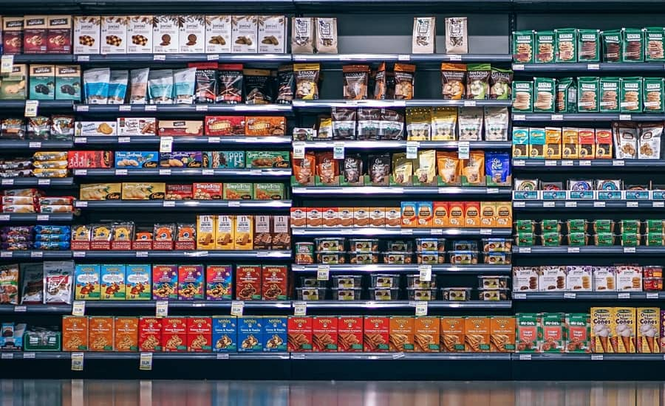

In a prosperous country like the United States, it’s difficult to imagine what “lack” looks like. Walk into any Costco, Walmart or local store and you’ll notice the shelves are practically overflowing with stuff…all kinds of stuff! Oftentimes multiple brands offer different varieties of the same type of item. It’s overwhelming, honestly, especially if you’ve seen scarcity in countries who have never experienced such abundance.
Can you envision going to the grocery store and finding aisles and aisles of empty shelves? Venezuela at this moment is facing a major nationwide crisis. A couple of its many problems include the lack of food provisions and huge inflation prices. A recent report determined the average person has lost 24 lbs over the last year and about 90% of the population currently lives in poverty. This statistic is inconceivable considering Venezuela was one of the richest countries in South America not too long ago.
The depletion of food and provisions is a recurring thing in history and has been experienced around the world too many times. During WW2, there was a major lack of food all across Europe. During the Great Depression in the United States, people had to count every penny, nickel and dime to see whether or not they could afford to eat. Countries in extreme poverty deal with this constantly whether they’re involved in a war or not.
Although our country parades abundance in every store front, it doesn’t mean that we are exempt from a food shortage at some point in our future. In fact, there is a pattern of food shortages and inflation during every major natural disaster. This is a prime example of stores charging outrageous prices for otherwise cheap items during Hurricane Harvey.
If you’ve observed the news, you may have noticed that shopping around the time that evacuation orders are set in place is almost as bad as shopping during Black Friday. It's crazy to say the least.
Considering the instability of world economies, it’s important to be prepared for whatever may come. Water and food are our lifelines and we must have plenty of provisions to cover our future needs, not just tomorrow’s. Having long-term food stored at home will also benefit us in short and long-term emergencies.
Don’t wait for your local grocery store to look like this:

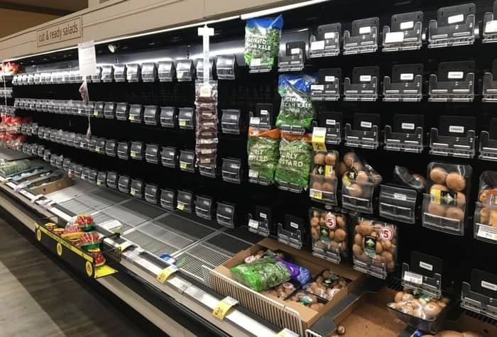

If you stockpile food for the next few years you will certainly save yourself from the stress that most other people will have. When there are food shortages you probably won’t be in starvation mode and will be able to live a better life despite the events happening in the world. If you agree thus far, I’m sure you’ll also agree that it’s wise to stockpile food that will last the longest time on the shelf. I definitely recommend rotating food as you eat it and purchasing food in bulk when possible.
Ok let’s get to the list!
By the way, some of the items listed below are not “food” items per se because they can’t be eaten on their own but they are fundamental for either enhancing the flavor, consistency, and/or nutritional properties of meals and are therefore worth mentioning.

Get the survival food list

You will receive the download link in your inbox.

I agree to receive email updates and promotions.

By submitting your name and email, you are agreeing to our Privacy Policy. We will never send you spam or sell your email.

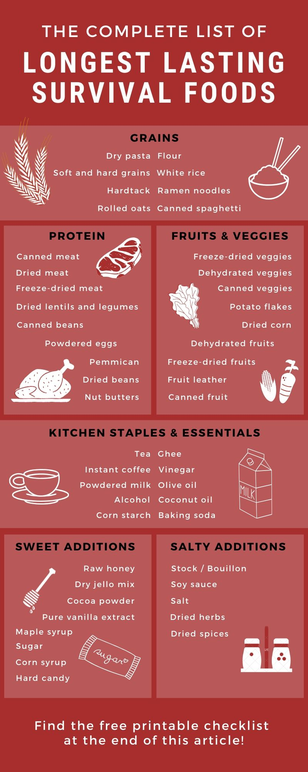

Want to take this list to the grocery store? Find the printable version at the bottom of this post.

Survival foods that have the longest shelf life

These are the 48 foods that last a very long time-- some of them never expire! They are ideal for long term storage, therefore you should definitely consider stockpiling them for survival!

1. SOFT GRAINS
Soft grains, such as barley, quinoa, rye and grits, can last up to 8 years if their package is sealed with oxygen absorbers. If possible, purchase these from a supplier who sells long-term food storage because their packaging and sealing process is designed to preserve whole wheat grains longer than the packages you often find at the store.

2. HARD GRAINS
Hard grains such as, buckwheat, hard red wheat, soft white wheat and millet, can last around 10 to 12 years when stored properly. For a maximum shelf life, the sealed package must have an oxygen absorber. Purchase these in bulk from a supplier who sells long-term food storage, if possible.

3. ROLLED OATS
Oatmeal containers from the store will last up to 24 months, according to the package, if stored at room temperature. So long that there is no moisture or oxygen present, they can last up to 30 years. It might help to store your oats with an oxygen absorber. You can tell if they went bad if they develop a rancid flavor or smell. Oatmeal is also an option provided by many food storage companies and are guaranteed to last long-term.



4. WHITE RICE
White rice can last up to 20 years if stored in ideal conditions. Brown rice is much healthier than white, but it does not last as long as white, wild, basmati or jasmine rice. Make sure it’s stored with an oxygen absorber and no moisture is present.



5. HARDTACK
Hardtack is otherwise known as the bread that lasts forever. This used to be a food staple for soldiers during the Civil War. Although most soldiers hated it during that time, it was something to keep them going during times when food was a mere commodity. You can’t purchase them at stores anymore but hardtack is easy to make. It only requires two (or three) ingredients: water, flour and if you want, salt. Want to make some at home? Try out this recipe!

6. FLOUR
Unground flour can last up to 25 years. After it’s ground, however, the shelf life decreases dramatically. It’s recommended to grind it as you need it. Always keep flour in a sealed bag with an oxygen absorber for a maximum shelf life.

7. DRY PASTA
Pasta can last up to 30 years when no moisture or oxygen is present. The pasta you find at the store can last up to 2 years past it’s “best by” date in its original packaging. If it’s sealed with oxygen absorbers it can last much longer. I recommend purchasing pasta from a supplier of long-lasting food.

8. RAMEN NOODLES
Ramen is not the healthiest meal to sustain you during difficult times, but it’s easy to prepare and will last a couple years in its original packaging if stored under the right conditions.

9. CANNED SPAGHETTI
Canned spaghetti can easily last up to 2 years and perhaps longer if it’s kept in ideal conditions. Make sure no botulism is present when opening.

10. DRIED BEANS
Dried beans that are sealed with oxygen absorbers can last up to 5 years. I would recommend you don’t store them any longer than that. If you do, they’ll still be safe to eat but they will take too long to cook and become more difficult to chew. [Don’t store pinto beans and split peas for more than 3 years. Overtime they will get very hard and even if you boil them for hours, they won’t be soft enough, making them also harder to digest.]



11. CANNED BEANS
Canned beans can likely stay good for up to 6 years if stored under the best conditions, possibly longer. As always with cans, check for signs of botulism prior to eating since botulism can be deadly.

12. DRIED LENTILS AND LEGUMES
Just like dried beans, the maximum shelf life for lentils and legumes is anywhere between 4 and 5 years. After that, they may take too long to cook and still be too hard to eat.

13. DEHYDRATED FRUIT
The trick with dehydrating food is to make sure all the moisture is removed from it. Once you’re ready to store it, add an oxygen absorber. Properly dehydrated fruit, such as raisins, apricots, and apples, can last up to 30 years. I recommend you make your own at home. The dehydrated fruit from the grocery store will not last nearly as long since the fruit is not completely dehydrated and sometimes moisture is re-absorbed during its packaging process. Check your fruit periodically to make sure there are no signs of spoilage. Another good option is to purchase fruit from long-term storage food companies. Their dehydration process guarantees a shelf life of up to 15 years. Check our store for some of the best options in dehydrated fruit storage!



14. DEHYDRATED VEGGIES
The shelf life of veggies can vary, depending on the moisture content of each vegetable. Just like dehydrated fruits, if you purchase dehydrated vegetables at the grocery store their shelf life might be considerably less than if they’re properly done at home. In my opinion, it’s better to make and package your own if you know how. Carrots, for instance, can last up to 20 years if dehydrated and stored in ideal conditions. If you want a 15 year shelf life guarantee on your veggies but don’t want to make your own, look no further than our store. We offer several options that are family favorites!



15. DRIED CORN
Freeze-dried corn has a shelf life of up to 15 years so long that it’s free from moisture. Popcorn can last indefinitely if it stays free from moisture.



16. POTATO FLAKES
Potato flakes can last up to 30 years. It may even last longer if kept sealed in a dry container and stored in a cool, dark location. These potato flakes are guaranteed to last you up to 15 years.



17. DRIED MEAT
Meat jerky that you buy at the store can last approximately 2 years unopened. Keep in mind that the leaner the meat is, the longer its shelf life. Fat will make the jerky get rancid quicker. Making your own might be a better choice for those who want to have control over its curing process, the preservatives used (or lack of) and the amount of time given to allow it to dry. It must be kept free from oxygen and away from sunlight. Use oxygen absorbers if you’re making your own. This is a good place to start if you’re planning to give homemade jerky a try!

18. FREEZE-DRIED MEAT
Professionally packaged freeze-dried meats guarantee a shelf life of up to 15 years when stored in ideal locations. Of course the package has to remain unopened. This is a great option for those who want to have several packages on-hand.



19. CANNED MEAT
Spam, canned chicken, corn beef, canned ham, and tuna can last from 2 to 5 years after the can’s printed date, so long that it’s stored in ideal conditions. Always check for signs of botulism in cans prior to eating, as botulism can be deadly. When purchasing canned meat for storage, it’s best to read the labels first and choose the meats whose ingredients are just meat and salt.

20. PEMMICAN
Pemmican is also known as the ultimate survival superfood because it can last fifty or more years if made and stored correctly. Pemmican is a blend of powdered lean meats mixed with berry powder and animal fat. It’s perhaps not the tastiest survival food, but it’s a good dose of protein for emergencies. Want to make your own? Try this recipe!

21. POWDERED WHOLE EGGS
Powdered eggs are an egg-cellent shelf stable option. This is a product you’ll most likely have to buy from a professional long-term food company but it guarantees you a shelf life of up to 15 years. Egg-cited yet? Ok, no more egg jokes! 🙂

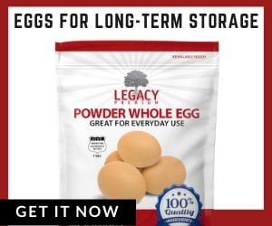

22. PEANUT BUTTER
Powdered peanut butter boasts a 15 year shelf life but if you prefer the kind that comes in a jar, it’ll stay good for up to 2 years if kept in ideal conditions.



23. COCONUT OIL
Unopened extra virgin coconut oil can last from 2 to 5 years so long that the container is stored in a cool, dark place. Opened jars of coconut oil will last a few months after being opened. If there are yellow spots in the oil or it smells rancid, you’ll know it's no longer good to eat.

24. OLIVE OIL
Olive oil can last up to 2 years if the bottle is unopened and stored in ideal conditions. The bottle must remain in a dark place to maintain a longer shelf life. Olive oil will taste rancid once it has gone bad.

25. GHEE
Ghee is clarified butter. When butter is boiled for a long time, all the moisture evaporates and the remaining liquids are fat (ghee) and milk solids. Ghee can last up to 2 years unopened and unrefrigerated if it’s stored in a dark and cool place. If left in the freezer, it will stay fresh indefinitely.

26. MAPLE SYRUP
Unopened pure maple syrup stored in a glass jar can be kept indefinitely. If opened, leave it in the fridge or freeze it. Keyword here is “pure” maple syrup. Aunt Jemima Maple Syrup is not only a cheap version but also fake (read the ingredients- maple syrup is not one of them). No surprise there but the point is to never settle for anything less than the real thing!

27. CORN SYRUP
Corn syrup has an indefinite shelf life. It doesn’t matter if the jar’s seal is opened or unopened, just make sure it’s stored in a dark place at room temperature. Also, keep the lid on tight always.

28. SUGAR
White, brown, cane, and powdered sugar can be stored indefinitely if it’s kept hermetically sealed. Adding a moisture absorber to the package and re-sealing it can help maximize its freshness. Make sure that bugs (ants especially!) don’t invade your sugar.

29. RAW HONEY
Raw honey can be kept indefinitely. Water will spoil it so make sure to keep it free from moisture. It’s possible that it will crystalize at some point, but don’t let that scare you! To un-crystalize it, just place the honey jar in a bath of warm water (without allowing the water to get inside the honey) and in time it will get back to its original state. You can also take crystalized honey by the spoonful and dissolve it right into tea or other hot drinks.

30. HARD CANDY
Most hard candies will last between 1 to 2 years but they can last indefinitely if stored in a dark location and dry climate. The drier the atmosphere its stored in, the longer the shelf life.

31. DRY JELLO MIX
An unopened box of dry jello mix, or unflavored gelatin, will last indefinitely in the pantry. Just make sure no moisture is present.

32. CORN STARCH
Unopened corn starch can be kept indefinitely when stored in a cool and dark place. It may lose some of its thickening properties over the years.

33. SOY SAUCE
An unopened jar of soy sauce can last indefinitely. Once opened, it will last between 2 to 3 years.

34. VINEGAR
White and Apple Cider Vinegar will last indefinitely. ACV has many nutritional and cleaning properties, so its uses go way beyond the typical salad condiment. Make sure you keep ACV or white vinegar in your long-term food storage pantry.

35. ALCOHOL
Unopened bottles of hard liquor can be stored indefinitely. Wine will age overtime and can turn into vinegar. To prevent this, keep unopened bottles of wine for a maximum of 2 years, unless you know the exact shelf life of the wine. Each type of wine (merlot, sauvignon, etc) has a different shelf life. Store wine in a dark, cool cellar with the bottle at an angle so that the cork always stays wet. Some high quality wines can keep for hundreds of years so if that’s what you want, make sure to do your research and be ready to pay a lot of money for it.

36. PURE VANILLA EXTRACT
Due to its alcohol content, 100% pure vanilla extract can last indefinitely in a cool and dark place. The key word here is “pure” since the artificial extract will not have nearly the same nutritional properties nor an indefinite shelf life. This is one of those products that it’s worth spending the extra money for the real thing.

37. SALT
Salt will store indefinitely without losing quality. White table salt is highly processed so I recommend you to store pink Himalayan salt or sea salt. Make sure to keep the salt free from moisture.

38. STOCK / BOUILLON
Bouillon, in its powdered form, can be stored for up to 10 years but its shelf life can be significantly increased if the cubes (or loose powder) are sealed in a mylar bag with an oxygen and moisture absorber.

39. DRIED HERBS AND SPICES
Dried herbs can last between 1 to 3 years, depending on how they’re stored. Spices can last up to 4 years if unopened and stored in a cool, dark place.

40. BAKING SODA
Baking soda can be stored indefinitely. It’s important to keep it dry and free from moisture. If you fear that your baking soda has gone bad, don’t throw it out. Instead, use it as a home cleaning product. In fact, these are 50 ways in which you can use baking soda. Don’t be shy to buy it in large quantities!

41. INSTANT / FREEZE-DRIED COFFEE
Instant and freeze-dried coffee can last up to 25 years on the pantry shelf, but will last indefinitely if stored in the freezer.



42. POWDERED MILK
Powdered milk can last up to 25 years if properly stored. Make sure it’s completely sealed and stored in a dry, cool place where no moisture becomes present. Adding a moisture absorber to the package might enhance its shelf life. If the powdered milk becomes yellow or begins to smell rancid, consider that your warning that it has gone bad.



43. RAW CACAO / COCOA POWDER
Raw cacao can last between 2 to 3 years. Pure cocoa powder can last up to 2 years or more. The quality, flavor and nutritional properties may decrease over time, especially if it has been opened for more than two years. Make sure to store it in a cool and dark place.

44. TEA
Tea, whether in a bag or in its loose-leaf form, can last for up to 2 years (as claimed by most tea producing companies). All you risk in consuming tea past its expiration date is quality. You won’t get sick from drinking expired tea. Make sure to watch our for bugs and store it in an airtight container for maximum shelf life.

45. MRE’s (MEALS READY TO EAT)
The shelf life of MRE’s really depends on the manufacturer. One of the leading companies in MRE’s is Mountain House. They guarantee their meals to last up to 30 years. You’ll find other companies, like Backpacker’s Pantry, whose product shelf lives are between 5 to 10 years. Each company offers a different variety of meals so you have a lot of freedom to choose what meals are right for you.



46. FREEZE-DRIED MEALS
Emergency food companies pride themselves in making meals that last up to 25 years. They are great options to have because they provide you peace of mind without having to worry about expiration dates and having to rotate your supply constantly.

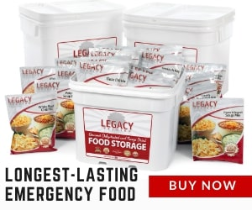

47. LONG-LASTING SNACKS AND BARS
Nutrient Survival has gotten one step ahead of most emergency food companies by adding a line of nutritionally-dense snacks! Not only are they tasty, but more importantly they provide a great source of vitamins, minerals, and fiber that your body needs to survive. Try their long-lasting bars and cookies here.



48. CANNED FOOD
The general recommended storage for canned food is between 1 to 3 years. Considering your storage location is ideal, they could probably last up to 6 years or more. Some people claim that cans can last indefinitely, and while they might be right, the nutritional value will deteriorate regardless after the first couple years. No matter how long you store your cans for, always check for signs of botulism. If your can is badly dented, corroded, or has been exposed to extreme temperatures, then they may be unsafe to eat. Always inspect cans for signs of botulism, since botulism can be deadly. Read more about canned food safety here!

How does food processing change the shelf life of food?

There are many different methods to preserve food. Food can be cured, pickled, pasteurized, dehydrated, freeze-dried, and heat processed. Food is processed so it can have a longer shelf life while maintaining its nutritional value over a period of months or years. The packaging that is used to seal the product also has a lot to do with its shelf life. For long-term food storage, packages are often flushed out with nitrogen to remove any oxygen that is present and then an oxygen absorber is also added. Some of these packages are guaranteed to last in cool and dark locations for up to 30 years or more.



What causes faster food spoilage?

There are many variables that can alter the shelf life of any given food product. The main factors are oxygen, light, heat, humidity, bacteria (including mold), and insects or rodents.

How to store food for maximum shelf life?

The best advice I have heard for food preservations is to create an environment that is inhospitable to bacteria by removing the presence of oxygen and moisture. There are products that it’s nearly impossible to do this because they’re very water dense. Most likely, the shelf life of those products will be significantly less than a product which contains less moisture.
Some products can have a longer shelf life if they’re stored in the refrigerator or freezer but they risk losing flavor or nutritional value.
The simplest way to extend the life of your food is to keep it away from light, heat, moisture and oxygen. Typically this is in a pantry or basement where temperatures remain stable year-long. It’s recommended that shelf stable food be stored in the home rather than the garage because the garage typically has greater temperature fluctuations.
One more tip is to rotate your food as you eat it. By rotating your food, you can make sure you’re eating what expires first while maintaining a stocked pantry that can last you for several years.
If you want to prepare your own dehydrated fruits, vegetables and other treats, look into purchasing Mylar bags and oxygen absorbers. These two things will increase your food’s shelf life significantly if properly sealed. If you’re in doubt about how many oxygen absorbers to use, remember that it never hurts to add an extra oxygen absorber.

