Latin American High Weirdness: The Cults Part I
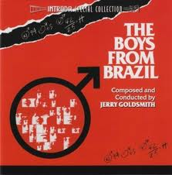

Since the end of the second World War Latin America has become something of a playground for the Cryptocracy. Cults, medical experiments, UFOs, drugs, Nazi war criminals, and the like have been in abundance in this region of the world in an especially bizarre fashion for over a half century. The isolation of many parts of Latin America coupled with its close proximity to the United States are a big reason for this. I also suspect that its potent mixture of religious practices make it an especially fertile region for PSYOPs.
The 'New World', being in relative isolation from the Old, maintained some very ancient religions practices up to the time of the arrival of the Spanish. Even then ancient native American rituals, such as those involving entheogens, continued to be practiced amongst isolated tribes up to modern times. Into this stew was then added African folk traditions courtesy of the trans-Atlantic slave trade in addition to Catholic mysticism and European occultism. Some nations are even more diverse -Brazil features the largest Japanese population outside of Japan, for instance. Naturally, their religious practices followed.
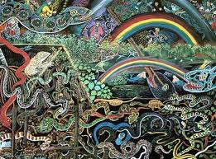
It was into this stew that the sorcerers of the US intelligence community and their allies in Europe (including former Nazis) boldly entered in the wake of World War II. For instance, our old friend Andrija Puharich, when he wasn't busy developing chemical and ELF weapons for the US Military or contacting the Nine for some very artistocratical families, managed to make several pilgrimages to Latin America in the 1950s and 60s. During the first, in 1956, Puharich was accompanied by the Dutch psychic Peter Hurkos and the enigmatic inventor, paranormal enthusiast, and possible US intelligence asset Arthur Young (much more on Puharich and Young can be found here and here). Hurkos described the visit as an archaeological project but many believe that these men were in fact searching for the mushroom cults that had inspired some R. Gordon Wasson'stheories on the role of the magic mushroom in religion. Puharich himself would go on to author a book on the magic mushroom called The Sacred Mushroom a few years later.
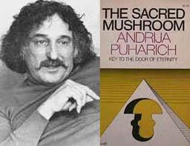
In 1962 Puharich was back in Latin America, this time Brazil, investigating the claims of the 'psychic surgeon' Arigo. Also in Brazil in 1962 was the notorious Nazi war criminal Joseph 'the Angel of Death' Mengele, the 'medical doctor' of Auschwitz, living in a farm house 93 miles from Sao Paulo. There were many other Nazis living in South America at the time, as it was one of the main destinations of the infamous ratlines. Mengele had been living in Argentina previously, near Adolf Eichmann, until the former Holocaust organizer was arrested in 1960. Other Nazis were much more fortunate, such as Klaus Barbie, the 'Butcher of Lyon', who was able to establish himself in Bolivia as a US intelligence asset, a Lt. Col in the Bolivian Intelligence apparatus, gun runner, and eventual drug lord.
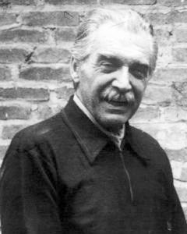
Mengele

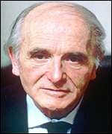
Barbie
Even a branch of the notorious UMMO hoax would pop up in Argentina in the late 1970s, operating out of a facility specializing in cancer cures brought about by a 'highly sophisticated electronic equipment.' Curiously, researchers such as Jacques Vallee have argued that the UMMO hoax, which was mainly perpetuated in Spain and France, was based upon a short story called "Tlon, Uqbar, Orbis Tertius" by the legendary Argentine writer Jorge Luis Borges, which was written around 1940. Regardless, the legacy of UFOs in South America is certainly the most bizarre I've encountered in modern accounts. For a sample of this high strangeness, check out this old post I wrote on entheogens.
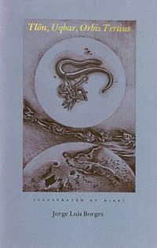
While all of this was going on another curiosity began to appear in certain spots in Latin America beginning in the early 1960s: Self-sustaining communities, usually comprised of Americans or Europeans, often described as 'Utopian' or 'Agricultural' experiments, with bizarre 'religious' agendas. What's more, many of these communities had a knack for appearing in countries that were considered essential in the Cold War struggle between the USA and the USSR.
By the far the most famous of these communities was Jonestown of Guyana, South America. I shall delve much more deeply into Jonestown in a little bit, but would like to mention a few other such communities that never gained the notoriety of Jonestown for lack of 'revoltionary suicide,' as the media hailed it. One such community was Hilltown,also of Guyana, and closely linked to Jonestown. Guyana was a country, in part due to its close proximity to Brazil, that would become a key piece of the CIA's Cold War agenda in South America.
"It was then that British Guiana saw the first stirrings for independence. A Marxist dentist, Dr. Cheddi Jagan, an East Indian educated in America, founded the People's Progressive party, which quickly assumed power under colonial rule. Jagan was assisted in the drive by a brilliant British-educated Afro-Guyanese barrister named Linden Forbes Burnham. Within several years, however, Burnham broke with Jagan to form his won party, the People's National Congress.
"With the Cold War and the Cuban revolution to the north, the United States was absolutely determined not to let another 'domino' fall in the Caribbean. So it entered the power struggle in obscure Guiana. Burnham had a more opportunistic side than the more doctrinaire Jagan, whose pro-Soviet sympathies were no secret. When the Central Intelligence Agency injected $1 million into labor unions to finance street disturbances, enough internal instability was created that Forbes Burnham toppled Jagan in 1964.
"Two years later, Burnham announced independence, and two years after that, in 1968, his party swept the elections. Burnham became prime minister. On February 23, 1970, the country became known as the Cooperative Republic of Guyana. To the surprise of the CIA, Burnham moved his country on a socialist path, flirting with Castro, the Soviets, the East Germans, and North Koreans, and nationalizing most of the country's resources, including sugar, rice and bauxite, of which it is the world's fourth largest producer..."
(Raven, Tim Reiterman, pgs. 272-273)
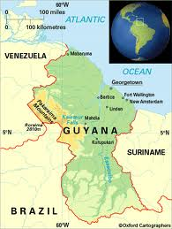
Journalist Reiterman, in his biography of Jim Jones, attempts to portray Guyana prime minister Forbes Burnham as someone who betrayed the CIA. This may well have been the case, but Burnham would go on to forge strange alliances with American 'holy men' on dubious missions that would become essential to his regime staying in power. Of course one of these 'holy men' was Jones, the other one David Hill, founder of the after mentioned Hilltown community. Of this fellow, Reiterman writes:
"...One was Rabbi Edward Washington [an allias used by Hill -Recluse], an ex-convict from Cleveland, Ohio, who managed to persuade several hundred Afro-Guyanese that blacks were the original Jews. His House of Israel became a political enforcement arm of the Burnham regime. The organization broadcast a weekly radio show on the governemnt-owned radio station in Georgetown, a sure sign of official favor. Another group that would get a weekly radio show was Peoples Temple."
(ibid, pg. 273)
Ah, but there was so much more to the good Rabbi Washington/Hill.
"Inside Guyana itself, approximately 25 miles to the south of Mathew's Bridge, is a community called Hilltown, named after religious leader Rabbi Hill. Hill has used the names Abraham Israel and Rabbi Emmanuel Washington. Hilltown, set up about the same time as Jonestown, followed the departure of David Hill, who was known in Cleveland, a fugitive of the US. courts. Hill rules with an 'iron fist' over some 8,000 Black people from Guyana and America who believe they are the Lost Tribe of Israel and the real Hebrews of Biblical prophecy. Used as strong-arm troops, and 'internal mercenaries' to insure Burnham's election, as were Jonestown members, the Hilltown people were allowed to clear the Jonestown site of shoes and unused weapons, both in short supply in Guyana. Hill says his followers would gladly kill themselves at his command but he would survive, since, unlike Jones, he is 'in control.'
(Secret and Suppressed, John Judge, pgs. 141-142)
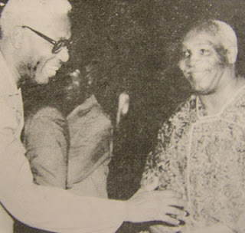
Hill, on the right
The House of Israel eventually fell out of favor in Guyana, but not before over a decade of terror was inflicted on the nation:
"During the 1970s and 1980s, a religious group known as the House of Israel became an informal part of the PNC's security apparatus and engaged in actions such as strikebreaking, progovernment demonstrations, political intimidation, and murder. The House of Israel was led by an ardent PNC supporter, David Hill, locally known as Rabbi Washington. Hill was an American fugitive wanted for blackmail, larceny, and tax evasion. Despite its name, the House of Israel was neither Israeli nor Jewish-oriented. It was, instead, a black supremacist cult claiming that Afro-Guyanese were the original Hebrews. Cult adherents further believed that modern-day Jews were, in fact, descendants of other non-Jewish biblical peoples and were in Israel illegally. Serving as a paramilitary force for the PNC, the House of Israel had 8,000 members, including a 300-member guard force known as the 'royal cadets.'
"A 1979 incident illustrates the House of Israel's close relationship with the Burnham administration. A member of the cult, Bilal Ato, murdered a reporter working for an opposition newspaper on July 14, 1979. The reporter had been taking photographs of an antigovernment demonstration when he was stabbed to death. Although the entire incident was filmed by other journalists, the government took three years to bring the case to trial. A former state prosecutor defended Ato. The judge reduced Ato's charge to manslaughter and sentenced him to eight years in prison.
"Later in 1979, as well as during the early and mid-1980s, the government used the House of Israel to break strikes and to disrupt public meetings of any group that the government felt might oppose its policies. Observers claimed that House of Israel members were accompanied by police and sometimes wore police uniforms during these incidents. In 1985 House of Israel members allegedly prevented delegates from entering the annual general meeting of the Guyana Council of Churches in Georgetown.
"When President Hugh Desmond Hoyte took power in 1985, the House of Israel fell out of government favor. In July 1986, Rabbi Washington and other key House of Israel leaders were arrested and charged with murder. Washington pleaded guilty to manslaughter and received a fifteen-year sentence."
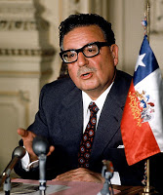
Allende
Clearly the House of Israel was instrumental in sustaining the Burnham regime. In Chile, a similar Utopian community would be called in service under the notorious Pinochet regime after the first democratically elected Marxist president of Latin America, Salvador Allende, was removed and assassinated during a military coup in the early 1970s. This community, which would become a close alley of the Pinochet regime, was known as Colonia Dignidad. Like Jonestown, it was described as an an agricultural experiment and headed by a controversial minister.
"Paul Schafer was one of the founders of the Colony of Righteousness and was, and is, its only leader. Schafer jumped bail in Germany in 1961 on charges of child sexual abuse, but that did not stop him from taking a group of families with him when he fled to Chile, arriving there in 1962 at the age of forty with around sixty 'blonde, blue-eyed settlers'... including some children who were brought there under false pretenses, taken from their families back in Germany. His flock came from the town of Siegburg, across the Rhine from Bonn, where Schafer claimed to be a psychologist, and where he ran a youth home where the sexual-abuse charges originated. Schafer, also the leader of a Baptist sect (a sect which evidently condones sexual intercourse between adults and children among other peculiarities), bought an old ranch called El Lavadero about 250 miles south of Santiago in the Parral region and quickly converted it into a self-sufficient, model community known as Colonia Dignidad, the 'Colony of Righteousness' or 'Dignity Colony.'
"The population of the Colony eventually grew to about 350, composed of 250 adults and 100 children. According to reports in the Chilean and German press, the sexes are rigorously separated and sexual intercourse is forbidden (except, one gathers, at the discretion of Schafer). And, since sex is prohibited, the only way the Colony has been able to increase its population has been by 'importing' children from Germany. German authorities have been investigating charges that from thirty to forty children reported missing from Bonn and Cologne areas have wound up at the Colony. Thus, charges of both child abuse and international child abduction have been leveled at this remote cult community by eyewitnesses, escapees, and responsible members of the West German and Chilean governments. The parallels between Colonia Dignidad and the stories told by 'satanic cult survivors' however, are even stronger.
"Spanish is not spoken: instead, only German, and, oddly, English are used. Old-fashioned, 1940s-era clothing is worn and fourteen-hour workdays are the norm. No television, radio, or newspapers are allowed in the Colony. There is, however, a shortwave unit on the premises which is used to communicate with an office the Colony maintains in Santiago...
"The Colony established a free clinic on its premises: free, that is, on specific days of the week to members of the local population. They also have their own factory for processing meat, power plant... and their own airfield. By 1985, they had even opened their own roadside restaurant on the Pan American Highway.
"Accounts of the size of the Colony vary from news report to news report. Everything from 12,000 acres to 37,000 acres has been offered, and accounts of its operations also include mine, a lumber mill, and a gravel factory. The author believes it is safe to say that the Colony has grown considerably over the years and that estimates of a 37,000-acre settlement might not be far from the mark, considering the other purposes to which the Colony was put both during and after the Allende regime."
(Unholy Alliance, Peter Levenda, pgs. 313-314)
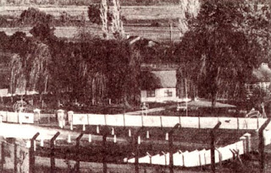
the Colony
Even before the military coup that toppled the Allende regime, strange allegations were surfacing concerning the Colony (aside from child abductions and sexual abuse, of course).
"...in 1966, the first of many accusations against Schafer and the Colony surfaced when Wolfgang Muller escaped the 'watchdogs, electronic alarms and six-foot barbed wire fences to describe life inside the Colony. Muller -who had been brought over from Germany as a member of the original Sieburg group when he was sixteen -claimed that he had been forced into slave labor at the Colony, was beaten, and had been sexually abused by Schafer in Germany when he was twelve years old. One of Muller's more interesting claims -especially in light of later events -is his insistence that Schafer had given him 'memory-altering drugs' when Muller attempted to rebel or to reveal the details of his abuse at Schafer's hands. He also complained of electroshock treatments being administered by camp doctors (shades of Barbie at Montluc Prison). After his escape, he wound up at the West German embassy in Santiago and now lives in that country under an assumed name, still afraid for his life."
(ibid, pg. 315)
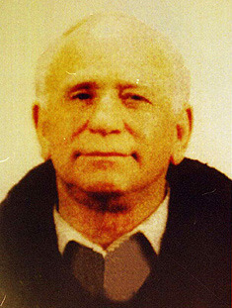
Schafer
Child abuse, memory altering drugs, electroshock treatments -it was into this fertile environment some of the Pincochet regime's more unfortunate political prisoners found themselves. The primary liaison between Colonia Dignidad and the Pincochet regime was an American CIA agent named Michael Townley who also served as a member of the Chilean secret police in addition to helping plan the military coup that ousted Allende.
"By the spring of 1973, however, rumors of an impending military coup were rampant in the capital. Among the conspirators creating discord both in the city and in the countryside was a young American, Michael Vernon Townley. Townley was a member of Patria y Libertad and an associate of other right-wing terror groups. A right-wing fanatic himself who carried out assignments for a variety of masters, Townley also contributed to the development of the interrogation program at Colonia Dignidad.
"Working directly for, and reporting to, the generals, Townley was given the rank of major in the Chilean Army and together with Colonel Pedro Espinosa and the Chilean Secret Police (DINA), liaised with Patria y Libertad to create a climate of terror in the country conductive to a military coup...
"With the coup, however, the Colony got a chance to put its electroshock and narcotics 'therapies' to the test. Townley and DINA agents had the run of the Colony, both at Parral and at the Colony office in Santiago. While DINA maintained contact with its agents all over the world through the Colony's radio link, Townley helped design the specially equipped interrogation cells. These were tiny, soundproofed rooms built underground where 'poltical prisoners' were taken not only for actual; interrogation of a political or military nature, but also for the purpose of developing new methods of torture.
"At first, each prisoner was questioned closely to obtain sufficient information concerning his or her personality in order to develop an appropriate torture and interrogation scheme. This individualized approach is already well known to the intelligence professionals the author has come into contact over the years. The ostensible goal is to enable the interrogator to so finely tune the torture procedure that the victim surrenders his or her will more completely, more expeditiously. In practice, however, and with such a 'scientifically' adjusted scheme of programmed sadism, there is tremendous room for an interrogator who is so inclined to subject the victim to unimaginable suffering over a long and sustained period of time. That this is what, in fact, took place at the Colony is beyond doubt..."
(ibid, pgs. 317-320)
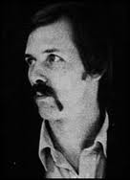
Townley
According to a UN report Levenda sites, detainees of the Colony had their heads covered with leather hoods, and were then taken to these underground cells were they were subjected to a bombardment of electronic equipment including loudspeakers and microphones in addition to electric shocks. The Colony's interrogation techniques have shades of both Gitmo and 1984 in addition to the CIA's own experiments in its various MK-ULTRA projects.
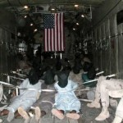
Gitmo
Over course, it won't come as a surprise to learn that Paul Schafer was a former Nazi who maintained ties with some of the more notorious war criminals in hiding in South America. Josef Mengele it widely believed to have been a guest of the Colony, for instance. Certainly his 'expertise' and first-hand experience in 'enhanaced' interrogation methods would have been much appreciated there. Mengele and Michael Townley would have surely had some interesting conversations.
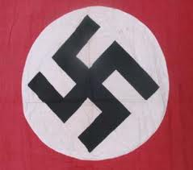
Paul Schafer was finally forced out of Chile in 1997 as charges of child molestation were finally brought against him. In 2005 he was arrested in Argentina and extradited to Chile where he was given a 20 year prison sentence. Shortly after Schafer's arrest, the Colony was raided which led to the discovery of a massive cache of weapons that included machine guns, rocket launchers and even a tank. As of 2005 the Colony had been taken over by Chilean officials.
While its certainly lovely that Schafer and the Colony were finally brought down, researchers have asserted that Colonia Dignidad was but one such camp in South America. Another rumored campsite supposedly existed at Pisagua, Chile. It is now acknowledged that there was some kind of prison camp at this location. The similarities between Colonia Dignidad and Hilltown are also striking. Both communities, which featured fanatical followers from foreign countries driven by doctrines of racial superiority, were incorporated into the security apparatuses of the two nations they became involved in. The major differences seem to be that Hilltown, with over 8000 residents, was more of an overt paramilitary force while Colonia Dignidad was geared more toward 'intelligence' work.
And that brings us to Jonestown. Is it possible that Jonestown was always intended as a site not unlike Colonia Dignidad? As unlikely as this may sound to some, there are several remarkable similarities to Jonestown and Colonia Dignidad, as we shall soon see. Further, there are equally curious US intelligence ties to both sites.
All this shall be examined in the next installment.
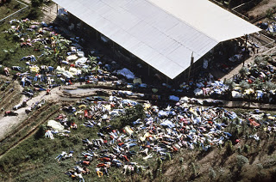
Posted by Recluse at 9:55 AM
Email ThisBlogThis!Share to TwitterShare to FacebookShare to Pinterest
Labels: CIA, Cults, DMT, Edgewood Arsenal, Entheogens, Hidden History, High Weirdness, Mexico,Mind Control, MK-ULTRA, Nazi, Occult, UFOs

