U.S. Treasury Plan If Economic Collapse: "Force Majeure," Paratroopers to Fed Res. Banks, "De-Monetize" U.S. Dollar

Nation NewsDesk 18 June 2021 Hits: 15393
https://halturnerradioshow.com/index.php/en/news-page/news-nation/u-s-treasury-plan-if-economic-collapse-force-majeure-paratroopers-to-fed-res-banks-de-monetize-u-s-dollar

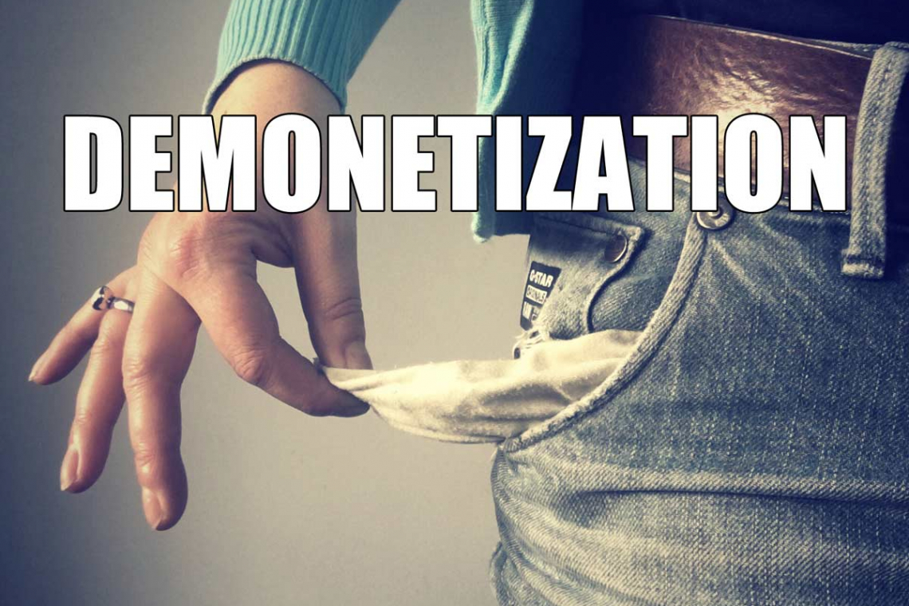
Did you know the United States of America actually has a PLAN in the event they can no longer service their debt? They do! Adopted it back in the early 2000's. Meet the "6900 Protocols."
With all the hoopla taking place nowadays, our national government being completely ILLEGITIMATE via a fraudulent and stolen election, and hyper-inflation creeping just around the corner, it might be worth a minute or two to learn what our "trusted public servants" have planned . . . for us . . . . after THEY have Bankrupted the nation.
Protocols For Economic
Collapse In America
By Al Martin
2-23-2008
And this is how the U.S. Treasury would handle an economic collapse. It's called the 6900 series of protocols. It would start with the Secretary of the Treasury declaring a force majeure, preventing the United States of America from servicing its debt.
This, of course, would immediately be interpreted by the marketplaces as a de facto repudiation of U.S. debt.
They even know precisely WHAT TIME they would make such a declaration: 11:38 AM eastern U.S. Time. That's because by 11:38 AM ET, markets in Asia and Europe will be closed, leaving only US markets operating for a few more hours.
A few seconds after that announcement was made, all United States markets, both equities debt and commodities i.e., stock, bonds, commodities, that have trading limits or permissible daily limits would all be limit-offered with pools. Limit-offered means that there are more sellers at the limit i.e., limit down, than there are buyers.
So-called 'pools' would immediately begin to form, probably a thousand contracts every few minutes. 'Limit-offered with pools' - this is trader language. Pools to sell 2,000 lots, 3,000 lots. That means, the number of sellers over and above the available buyers at the limit- offered price. That would begin to build.
By 1:00, the news would begin to sink in because it would take awhile before panic selling would arise from the public. This news is being released at lunch hour.
Most of the American people initially would not even understand the horror of the news. You would see professional selling first, and as that professional selling intensified over the afternoon, the SEC, the CFTC, NASDAQ, and various market regulatory authorities would begin to institute certain emergency market protocols. This would be the installation of the so-called 'declaration of fast market conditions,' for instance; the declaration of 'no more stop orders,' the declaration of 'fill at any price,' etc. in a desperate bid to maintain liquidity.
That first day, the Dow Jones Industrial Average and related indices on a percentage basis would lose about 20%-30% of their value by the close of business that day. The real impact would come overnight when the American people found out what this was all about when it was explained to them.
The SEC and various regulatory entities have anticipated the market's decline, hour by hour and they will be closely watching every move (down) the markets make. It is widely expected that "circuit breakers" will be triggered within an hour, then triggered again, until the market suspends trading for the rest of that day.
When Japan's markets open the next day - we will call this "Day 2" - what would happen is almost instant collapse. At 7:30 a.m. EDT, the Tokyo markets would open, and no price would be affixed for probably three or four hours into the session due to the avalanche of selling.
Once prices were established, the government of Japan would close all of its financial markets.
Europe would not even open. All European governments would close all capital exchanges.
When the U.S. goes down, everything around the world in matters financial, goes with us.
On that second day, here in the US, Army Forces would be dropped in via parachute to the cities where the twelve Federal Reserve district banks are located.
The reason they would be brought in by parachute is there won't be enough time to do this via driving. Those troops would HAVE to be in-place around the twelve federal reserve banks, to protect the plexi-glass pallets of currency in their vault stacked to the ceiling and whatever gold is also inside.
The origin of these U.S. Treasury protocols comes from the Department of Defense (DoD). The DoD has contingency plans for a variety of scenarios. Those scenarios would include, obviously, military collapse, World War III, and its aftermath. What we're talking about now is aftermath -- how the aftermath of the U.S. being unable to service its debt, would be handled.
One does not necessarily know how the events would transpire that would cause the collapse, whether it's military collapse or economic collapse. In World War III, it would become obvious -- when the mushroom clouds started to appear over cities.
Economic collapse scenarios were always premised on the basis of a US declaration of force majeure on debt service. It's a very extensive scenario.
The scenarios are all together, i.e., military, economic, political and social, complete destabilization leading to collapse.
Then they break down individual scenarios. In the economic collapse scenario, the starting point would be the United States Treasury declaring a force majeure on debt service, which is de facto repudiation, and that's how it would be interpreted by the world's capital marketplaces. Then the scenario goes on from there.
The US Treasury would obviously declare a force majeure after the European markets had closed. In other words, they had gone out for the day, which means 11:38 a.m. EDT, our time. They'd wait until the European markets closed, and the US markets had been open for a couple of hours. That's when they'd determine how to begin the process of unwinding or controlling the collapse to the best extent possible, mainly because they know that the greatest hedge pressure would be people seeking to use other markets to hedge their long exposure in the United States and that the US would be the biggest seller in all the rest of the world's markets.
Therefore you would want to declare the force majeure when the rest of the world's markets closed. (catch'em off guard! I like it-its just so American.) The declaration of force majeure would be precipitated by the declaration that the United States is no longer able to service its debt. That's pretty simple.
Who makes that decision? The Treasury Department. The President does not make that decision. The Secretary of the Treasury does. He has that authority.
You might ask -- wouldn't he have his arm twisted not to do that? The answer is that if there isn't any money left to service the debt, it doesn't make any difference what the current regime might want to do.
The day of reckoning is now coming. What has happened in the interim, from 2001 to present, is dynamic, global economic deterioration. The economic deterioration visited upon the United States by rampant deficit spending enacted by Congress is not a localized event. It is, in fact, global. We have a planet now that is sinking into a sea of red ink.
Back around the year 2008, the United States was consuming about 80% of the entire world's savings to finance its debt. At some point after 2008, the US began to need MORE than the entire world had to lend. Enter the U.S. Federal Reserve, monetizing debt by entering digits into a computer account. PRESTO! Money created out of thin air to buy Treasury Bonds!
Bringing this problem to a head is the issue of the central banks of Germany, Japan, and Saudi Arabia; they are no longer the powerhouses they used to be. Their reserves have now been substantially depleted. They can, therefore, no longer hide the fact that they own a certain number, likely in the trillions of dollars, of U.S. Treasury debt that isn't being serviced, because they can't hide it through bookkeeping tricks anymore; because their reserves are so depleted.
This is why not too long ago, someone put the arm on Great Britain and demanded payment in Gold Bullion. It was all very hush hush, but readers of the Hal Turner Radio Show web site did get the information quickly.
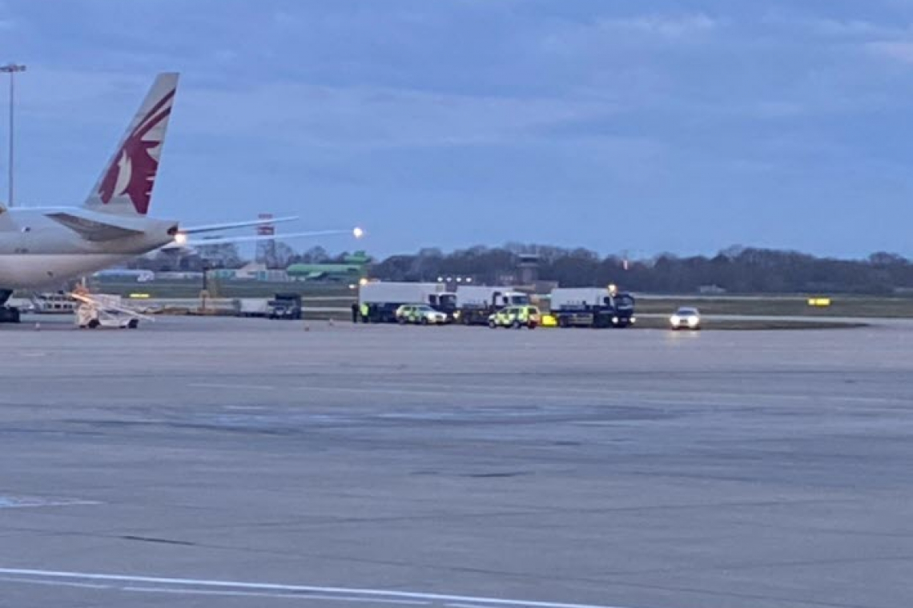
Very serious amounts of Gold/Silver Bullion and cash money was abruptly removed from the United Kingdom on 13 April 2021, and shipped to Doha, Qatar without explanation.
Authorities in London did a rolling road block along the motorway to allow the tremendous shipment of bullion and cash to get through! Three (3) armored bullion trucks, 4 unmarked police cruisers, 6 marked police cars and a police helicopter was following in the sky. (Story HERE)
Someone is putting demands on western banks because they see the US money is in gigantic trouble. Someone is saying to the US "You've got to start servicing this debt because we, and foreign central banks, are in nations - European and Asian - whose reserves are now nearly exhausted. We no longer trust you to pay the debt, we want Gold. Now."
Foreign Central banks can no longer make it appear that the U.S. debt is being serviced because those foreign central banks own reserves are so substantively depleted. Therefore the US and the west in general, are being told they must begin to cover this debt. If the US cannot, or will not, then, at some point, people in banking around the world will have to publicly admit in order to save their own necks -- that THEY were the end buyers of a lot of stealth debt, a lot of debt that the U.S. Treasury issued illegally and has never serviced. That would then expose the whole cabal.
The process of unraveling has already begun because of ever-spiraling budget deficits. The U.S., even in its overt policies (now they're overt political, economic, social and military policies) is generating a $2 TRILLION-plus deficit per year. There isn't enough money on the entire planet to lend such amounts to the US.
Because foreign central banks are so depleted from buying other US debt, they can't refinance the stealth debt by issuing more stealth debt anymore. Nor can they bleed money out of the system like they could in the 1980s. There is no mechanism that they can use anymore to hide expansion of debt that could be used to service said stealth debt, and they are, frankly, running out of assets that they can steal from the American people.
So the proverbial day of reckoning is coming.
Back in 2008, David Walker, US Comptroller General and chief of the GAO has said that the United States would no longer be able to service its debt beyond 2009. Yet here we are, now, in 2021. How could that be? Well, as stated earlier, the federal reserve is monetizing US debt. The fed is entering digits into an account on their computer system, then using that account to "buy" U.S. Treasury Notes. Money out of thin air.
What does that mean? The key is in what Walker meant when he says the debt can no longer be serviced. It simply meant the United States would no longer be able to pay even the interest on its debts because it needs more than the planet has available to lend to them.
Therefore, if the planet can no longer generate any more liquidity to lend to the United States, one of three things have to happen:
A) There has to be a sudden and dramatic reduction in federal spending. There are only two places that can come from. There would have to be an immediate slashing of defense spending probably by 65-75% OR; there would have to be an immediate cut in all social programs: Welfare, Food Stamps, Social Security and all the rest.
B) The other option, 6900 B, is a dramatic increase in the rate of federal income taxation from the current nominal rate of 28% to 65%-85%, which is what the Treasury Department estimated would be required post-2009 to provide the U.S. Treasury with sufficient revenues to continue to service debt, OR;
C) The third option, 6900 C, becomes the declaration of a force majeure on credit service of U.S. Treasury debt by the United States Treasury, which is tantamount to, and would be accurately construed as, de facto debt repudiation by the United States of America.
When that day comes, in other words, when the U.S. Treasury declares a force majeure on debt, it wouldn't be broadcast on mainstream media. There's no sense because the American people don't even understand what it means. The announcement would actually be put on the Federal Reserve wire system, which would, of course, immediately be picked up by all media outlets anyway.
The United States would, in order to accommodate global electronic trading, attempt to open the market on the second day, which they would do, regardless of price, just to maintain some liquidity. At the end of Day Two, the Dow Jones and related indices, would have lost two thirds of their value, and prices would be set accordingly.
On Day Three, the New York Stock Exchange, the SEC and other related agencies would recommend to the United States Treasury and the Federal Reserve that all markets be closed. That would be on the morning of Day Three.
At Eleven AM EDT, the Federal Reserve would then order all domestic banks closed.
At 9:00 PM EDT on Day Three, the President of the United States would declare a state of martial law. All financial transactions would come to an end. The Treasury would act to formally de-monetize the U.S. dollar and declare it worthless.
This would be totally unprecedented. In the past, collapses have been temporary and have been brought back up. But what we're talking about now is the end.
These protocols that I'm referring to aren't even all that secret. They were publicly available all through the Clinton era. These are Treasury protocols that were instituted mostly in the late 1970s when the Treasury and Federal Reserve began to feel that it was important to have an emergency-collapse protocol in place.
What precipitated the timing of this was the inflationary spiral of the mid-late 1970s, during Richard Nixon /Gerald Ford terms up to that point. The U.S. Treasury and the Federal Reserve were both concerned that this inflationary spiral, which was occurring not only domestically but globally, might lead to a global, uncontrollable hyper-inflation that the Federal Reserve or major central banks could not stop by traditional means, i.e., by raising interest rates and contracting money supply.
There was also the recognition, of course, that global central reserve bank bullion inventories had been so depleted over the previous 30 years that any re-institution of a species currency, even on a temporary basis, and even within a regional or individual nation-state basis, was no longer possible.
This is an analogy. In a military scenario, it's like the President of the United States pushing the final red button -- the commit button. The Treasury Secretary of the United States has a similar mechanism. It's called the yellow button, the commit button. The Secretary of Defense has the same system. This is what happens. Computer programs start to institute these protocols.
Imagine the complexity of trying the manage all this. I think it's going to happen all simultaneously. There are hundreds of different agencies involved, both domestically and internationally.
In order to maintain liquidity for as long as possible, it has to be extremely well-coordinated, and there must be existing collapse protocols that can be used.
The reason I was familiar with them was because I used to see the U.S. Treasury 6900 Series Collapse Protocol, 6903, 6904 there'll be A, B, and so on which keyed in to the Department of Defense to be incorporated within the Department of Defense's own World War III scenario and various types of military/ political/ social instability/ war/ pestilence, chaos, etc. scenarios.
All federal agencies had individual collapse protocols that ultimately got coordinated through the Department of Defense. Obviously, the Department of Defense would be the ultimate coordinator because it would need to have special forces available, on a stand-by basis, ready, that could quickly parachute into areas all over the country, into the cities particularly, to secure federal properties and assets.
And that's literally how it would begin. By the end of the third day, it would be all over -- a state of martial law. We're not talking about war, now; this is just economic collapse.
There's no military implication here, no political, no social implication or policy directive thereunto. This is strictly economic collapse.
By the end of Day Three, effectively, all banks in the world will be shut down, all paper currencies will become valueless. Martial law would be declared.
There would be no continuing transactions, at least for a period of time, of commodities. All providers of fuels and foods would be shut down automatically.
They have this planned in extremely great detail too. For instance, the U.S. Department of Defense Special 117th Assault Unit would parachute in to seize control of the cattle yards in Oklahoma City. This is how well it's planned. In other words, economic collapse would automatically involve expansive military action and control.
By the end of the third day, when you no longer have a domestic medium of exchange, you have to have secured food and fuel stocks. You've got to have troops that have secured distribution points where there is food and fuel stocks, warehouses, tanks, etc. Otherwise people are just going to go get them, and the people have to know that if they try to go break into that store and steal that loaf of bread, they're going to be shot.
Protocols for environmental disasters are called 'scaling-circle scenarios.' 'Scaling circles' is a Department of Defense euphemism. It's also used in FEMA, OEM and other emergency management services.
In environmental catastrophes, which are going to become national or global, it's got to start someplace. It's going to start in one very small, specific area. Therefore what happens is that the immediate force containment is the greatest in the first circle, to try to contain the spread of the disaster and keep it within that circle-not allowing it into circle 2.
The environmental problem, to whatever extent it's possible, before it spreads, will be neutralized or mitigated, in order to keep that catastrophe within that circle, or, if it is likely that it is to escape that circle, to attack whatever it is in such a fashion as to mitigate its strength and its ability to contaminate or otherwise affect other areas.
In the case of earthquakes, for instance, affecting the west coast, beginning at Mt. Rainier and moving southward -- that's a different type of scenario. That does not include as much Department of Defense involvement. It includes separate protocols, wherein mostly FEMA and OEM act as the senior coordinating agencies between municipal, county and state disaster and containment, which is called Disaster and Containment Units. Federal troops would only be brought in for the purposes of maintaining control.
In a military or economic collapse situation, National Guard units would provide any spare help they could in combating whatever the problem is. Federal troops would be used in order to have the specific authority simply to shoot anyone.
There are plans for all sorts of scenarios. The economic-disaster scenario is the one I always found the most intriguing because it is the one that is least understood by the American people.
Military control would be necessary when lines begin to form at the banks, people trying to access their money. But that wasn't even anticipated as a big problem. Lines would form at the banks, but it was not even envisioned until sometime on Day Three because the American people wouldn't get it. It would be announced that the stock markets are down 2000 or 3000 points, and since we've always been taught they'll come back, the people would still be buying stocks.
You could count on everybody remaining in ignorance all the way down because the American people have never been taught Economics 101. The American people wouldn't realize the full extent of it until the markets were closed on the third day, or until the time when they went down to cash a check and the bank was closed with soldiers out in front. Then they would go down and see the gas station's closed. They see the local supermarket has been shuttered, and there's federal troops in front of it. Then they might begin to catch on.
And remember -- it's not just federal troops. In emergency-collapse protocols, even before the declaration of a formal state of emergency or a state of martial law, the local military authorities within any given county or jurisdiction have the ability to essentially militarize anyone, that is, any civilian. This would be more than just deputizing civilians. It's federal. In other words, they would have the ability to militarize and give military authority to a civilian force. This would include not only police and the sheriffs and state police, but all local law enforcement that exists below the state level would be immediately militarized. They wouldn't take just anybody like they did in Iraq. It would be like the military when they call for volunteers.
In other words, this is how it would unfold over three days, but, in fact, very few Americans would know what to do about it or how to take any precautions. They wouldn't have a clue because they don't understand enough about economics to know what is happening. So that's what it is -- Economic Armageddon.
In conclusion, since there is very little the people of the United States can do to protect themselves. We're not going to make any suggestions of how to protect yourselves because there's very little you can do.
We could tell you to go out and buy gold coins and bury them in the coffee can in the back yard and go to your nearest survivalist store, but, frankly, that's useless. In the last analysis, it's a lot of hype. There is very little the average US citizen could do.
Here's an interesting and humorous aside. A couple of years ago, Hormel Foods, which makes Spam, announced that in the last six months there have been record sales of Spam in the United States the survivalists' food of choice. After all, they pride themselves on the fact, as the spokesman for Hormel said, "It is the only food product you can buy with an expiration that's 50 years."
When everything goes to hell, when all that man has created has turned to dust again, the final legacy is going to be Spam. It will be the last surviving item -- when the anthropologists of 20 thousand years from now are digging sites and they see these enormous mountains of unopened cans of Spam-still unspoiled and ready to eat. They'll have monuments to the past, out of Spam.
(-Spam is the true definition of DEAD FOOD-it never goes bad)
Furthermore, on Washington Journal they were talking about how FEMA has recommended to the Office of Homeland Security to have increased restrictions regarding citizen hoarding of long-term food and fuel supplies. That's pretty sinister too.
What they're talking about is the purchase of long-term so-called stores of survival food. FEMA was talking about some sort of restriction preventing people from accumulating food stores; putting it simply, that's what it means. The second point was to increase restrictions that already exist.
FEMA was recommending even tighter restrictions on citizens building their own private property underground storage tanks for the purposes of long-term storage of fuel. The real intent of this is is threefold: a) to restrict citizens' ability to hoard food; b) restrict citizens' ability to hoard long-term storage of fuel; c) the forced identification of citizens to reveal food and fuel stocks they may be hoarding.
And that, in my opinion, is the real essence. The government wanted this kept secret - having the FEMA supply restrictions angle put into the equation, because they knew how people would interpret it.
They have tried to use environmental legislation to restrict people's ability to build fuel storage facilities on their own property -- to get around what the true intent of that was.
But the bigger picture is that if you start to limit citizens' ability to hoard fuel and food and shake them up by potential forced identification of gold holdings or forced redemption.
In other words, what you don't want is citizens who have the ability to store a lot of food and fuel and to own gold because they would be able to resist state control in the future.
The feds need to have every citizen on a rationing card to control the civilian population. You can't have citizens out there hoarding food and fuel because then people can say to government, "I ain't taking a rationing card, baby, with my national ID card. I don't have to. You can't control me through food and fuel and worthless paper currency."
I used to make fun of these people. But now, things have come full circle on this debate. The pattern is becoming increasingly clear. So is the future.
In fact, I would believe that those of the survivalist mentality (the food, fuel, the gold coins in the coffee can in the back yard) . . . people who think that way will be ultimately vindicated.
People should quit making fun of them because they would be vindicated - even though they were all burned out, twenty-dollared to death, buying books and tapes, and discredited by mainstream media.
It may sound like a hollow victory, but it won't be a hollow victory for them - them that's got the Spam...
Attribution and Conclusion
The majority of this article was written long ago, in 2008, by a guy named Al Martin. It was forwarded to me by a visitor to this web site.
I tweaked the numbers to make them more current, and added the info about the federal reserve monetizing the debt so as to afford an answer to anyone wondering how, if this was all slated to collapse in 2009, we're still here?
It brings many frightening realities to the forefront because these days, what's taking place in matters financial with our federal government, is absolutely off the rails. They're not just spending a little more than they take in via taxes, their spending almost DOUBLE what they take in in taxes.
Let me ask you, how much is the currency of a Bankrupt nation actually worth?
The very simple takeaway from this article is this: Have Emergency Food, Water, Medicine, and other supplies to tie you over for a few months, minimum.
If/When you hear the phrase "FORCE MAJEURE" - you will have only HOURS to get to the supermarket, buy as much food as you can with whatever cash or credit you have left, and haul ass home to pack and head to your bugout location, then move out fast.
Bear in mind too, the banks will get word of this before the rest of us. They may cut off all credit cards before the public is event TOLD of a force majeure. That would mean you could only buy more food with cash. Got enough cash at home to do that?
Once it all goes to hell, and money (as we know it) is "de-monetized" everyone is fucked; except the people who put their cash into something ELSE which is not cash. No, I don't mean gold or silver because government will try to get their filthy hands on all of that. Something with intrinsic value (it has its value within itself). Things like land/real estate, precious gems, food supplies, fuel. Anything that will be useful to you and holds its value in itself.
But for God's sake, don't just sit around and do nothing. Prepare because when this hits, it will strike like a lightning bolt out of the blue.
The masses who are asses have no idea such a thing CAN EVEN HAPPEN, never mind happen to them. When stores all have to close because there is no longer any monetary means of commerce, what do you think the savages in the cities are going to do? Maybe "Yo man, gimme all yo shit, Cracka, befo I bust a cap in yo ass"
Yes, it will be that simple. So bug out before the savages figure out what's going on because the cities and urban areas will descend into violent chaos very VERY fast.
Then remember, under our system of Government, it is CONGRESS that holds the purse strings. No President can borrow or spend a single cent, unless CONGRESS authorized it. All that debt which is collapsing our country, wrecking our currency, was done to you by CONGRESS. So if you see any of those scumbags on the street, you'll know what to do.

