Victims of Zion

This page is dedicated to the hundreds of people who have put their lives, reputation and freedom on the line to bring truth to the world.

www.zundelsite.org\english\debate\victims\index.html

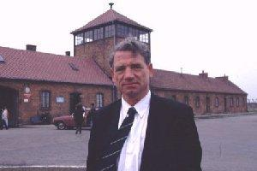
Dr. Fredrick Toben - latest victim!
Though German in origin, Dr. Fredrick Toben was raised in Australia as an Australian citizen, and speaks both English and German. Becoming interested in exonerating the German people from the anti-German racism of the Holocaust legend, he at first edited a revisionist journal called Truth Missions, which was later renamed Adelaide Institute Newsletter. He then broadened out to establish Australia's revisionist website, Adelaide Institute. He has personally visited the site of Auschwitz and burrowed under the ruins of the alleged gas chamber, being unable to find the four holes in the roof which were supposedly used to throw in gas pellets. He conducted regular dialogue with Exterminationists, and did not expect to be arrested when he visited Prosecutor Klein in Mannheim, Germany, for a private discussion on the Holocaust laws in Germany, which make it mandatory to accept the entire Holocaust story.
Nevertheless, he was arrested by Klein and police chief Mohr in Mannheim, Germany, in April, 1999, and was awaiting trial for being a "holocaust denier" for seven months. He then was tried and sentenced to ten months imprisonment, but released from prison while awaiting his appeal. He left Germany and did not return for his appeal trial.

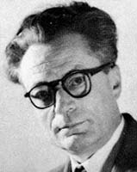
Paul Rassinier

Barred from entering Germany for trying to give testimony for the defense in political trials.

Background and contribution:

Born in 1906, Rassinier, a school teacher, is seen as the Father of modern European Revisionism. A French resistance fighter and friend of the Jews, he was imprisoned by the Germans for his illegal activities in Buchenwald and Camp Dora where he worked in the underground rocket factories. He was elected after the war as a member of the French National Assembly for the Socialist Party. Rassinier nonetheless wrote groundbreaking Revisionist books.

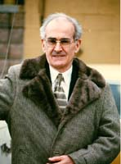
Dr. Robert Faurisson

At least 10 times physically assaulted by Holocaust Enforcers; on several occasions nearly killed. Jaws broken. Teeth knocked out. Hospitalized for weeks. Persecuted mercilessly in endless legal battles.

Background and contribution:

Known as the "Dean of the world-wide Revisionist movement" and principal teacher of Ernst Zündel, Dr. Faurisson first discovered the technical and architectural drawings of the Auschwitz morgues, the crematories and other installations. He was also the first to insist that only a U.S. gas chamber expert could unravel the technical impossibility of the Auschwitz homicidal gassing story - as falsely told to the public for over half a century. Zündel mentor, advisor and trial witness in the 1984 preliminary hearings and in the 1985 and 1988 Great Holocaust Trials. Slated as expert witness for the 1991 Munich trial of Ernst Zündel. (The prosecution dropped the Anne Frank Diary part of the charge in mid-trial after they learned that Dr. Faurisson was going to testify to that point.)

"Someone who has provoked the Jewish community for years should expect this sort of thing [a vicious, near-fatal beating]."

- Nazi-hunter Serge Klarsfeld on the savage attack against Professor Faurisson

Questioned Holocaust, historian badly beaten Toronto Globe and Mail | Monday, Sept. 18, 1989, p. A5 www.zundelsite.org\english\debate\faurisson_beaten.html

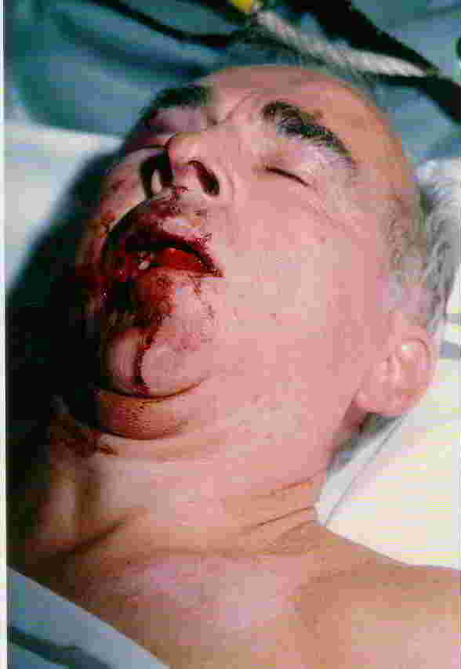

Reuter
CLERMONT-FERRAND, France

A leading French revisionist historian who denies that millions of Jews were killed in the Holocaust was recovering from surgery yesterday after a savage beating.

Robert Faurisson, 60, suffered a broken jaw and ribs and severe head injuries in the attack by three youths while he was walking his dog in the town of Vichy.

A hospital spokesman in Clermont-Ferrand, the central French city where he was transferred for surgery, said Mr. Faurisson's condition was stable.

"He was conscious, but he couldn't speak," said a fire fighter who gave Mr. Faurisson first aid. "His jaw was smashed. They destroyed his face."

A previously unknown group, The Sons of the Memory of the Jews, took responsibility for the attack, saying those who deny the Holocaust should "beware."

Veteran Nazi-hunters Serge and Beate Klarsfeld said they were not surprised by the attack. "Someone who has provoked the Jewish community for years should expect this sort of thing [a vicious, near-fatal beating]," Serge Klarsfeld said. <end>

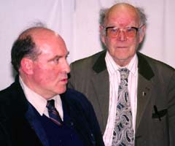
Thies Christophersen

Forced to flee from country to country. Hounded to death after numerous acid attacks, arson, and attempts on his life and property.

Background and contribution:

As a German agrarian expert, Christophersen was stationed at Auschwitz in the critical period 1943-44. As a German expert, he had access to the entire camp. He took valuable photographs at the time. He was the first Revisionist eyewitness to come forward stating categorically that there were no gas chambers for killing humans in Auschwitz. He wrote the famous booklet, "Die Auschwitz-Lüge", (The Auschwitz Lie) translated into many languages. Zündel witness in the 1985 and 1988 Great Holocaust Trials.

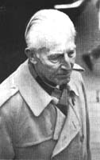
Judge Wilhelm Stäglich

Was tried and convicted in post-war German courts. Had his doctorate stripped from him and his pension cut for speaking out.

Background and contribution:

Judge Stäglich, stationed during WWII in the Auschwitz area with an anti-aircraft unit, published a groundbreaking book "Der Auschwitz Mythos" (The Auschwitz Myth) - seized, forbidden and destroyed by West German court order.

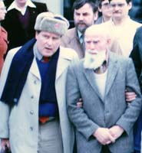
Joseph Burg (Ginzburg)

Persecuted and beaten by Holocaust Enforcers of Jewish Defense League type thugs. Denied burial in the Munich Jewish cemetery. (Ernst Zündel and Otto Ernst Remer gave the eulogies.)

Background and contribution:

Author of many books ("Schuld und Schicksal", "Zionazi", "Das Tagebuch der Anne Frank", "Auschwitz in alle Ewigkeit" etc.) as well as many pamphlets and two documentary interviews with Ernst Zündel. Chief Jewish advisor, mentor and Zündel witness in the 1988 Great Holocaust Trial.

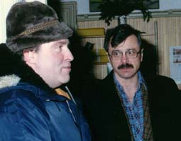
Professor Arthur Butz

Vilified and persecuted for almost three decades.

Background and contribution:

An American electrical engineer and university professor, Butz wrote the "Bible" of modern Revisionism titled "The Hoax of the 20th Century". This book, which deals with most details of Holocaust lore from "shrunken heads" to "Jewish soap" and "gassing" claims, more than any other influenced Ernst Zundel in his Revisionist research.

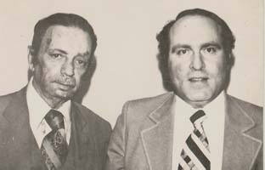
Haviv Schieber

Driven to attempted suicide

Background and contribution:

A Polish Jew and former mayor of Ber Sheeba in Israel, Schieber taught Ernst Zündel much about Israeli reality. He was an Israeli Revisionist, wanting to revise Israel's attitudes, institutions and borders. He fled Israel to find safety in the USA, was denied political asylum at first, and tried to take his life by slashing his wrists at Washington, D.C. airport on the day of his deportation. He was finally allowed refuge from Israeli persecution in the US in the early 1970s.

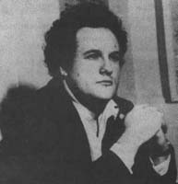
Francois Duprat

Killed for distributing the French language version of "Did Six Million Really Die?"

Background and contribution:

A French writer, historian and educator, Duprat had introduced the booklet "Did Six Million Really Die?" in France by publishing the first French translation. He also published "The Mystery of the Gas Chamber." He was only 38 years old when his car was blown up by a bomb and he was assassinated on March 18, 1978. His wife, who was with him in the car, lost the use of her legs in this terrorist act. Two Jewish groups took credit for the assassination - the "Jewish Remembrance Commando" and another group who identified itself as ". . . Jewish Revolutionary Group." The assassins were never found.

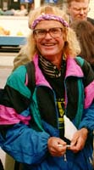
Ditlieb Felderer

Charged, tried, convicted and jailed in Sweden. Vilified in the press. Forced to live in exile.

Background and contribution:

Felderer, at one time a prominent Jehovah's Witness, is known as an early researcher into the physical evidence in every major concentration camp in then Communist Eastern Europe. Felderer took over 30,000 photographs of every conceivable detail in the camps. He discovered that there was a swimming pool for the inmates in Auschwitz, modern hospital facilities, including a gynecological section, as well as an orchestra, live theatre, well-stocked library, and sculpting classes. He discovered the musical score of the "Auschwitz Waltz" in the secret archives accessible only with special permission. He found that an intimate role was played by Jehovah Witnesses in the camps, who cooperated with the SS-Administration, and he exposed the lie of the 60,000 Jehovah's Witnesses killed. (On his initiative and insistence, the inflated number was reduced to 203) [Trial Transcript Vol. 18, 4226 to 4229; 4645]. For his Revisionist work, Felderer was excommunicated - that is, drummed out of the Jehovah Witnesses' sect. He has been persecuted by the Holocaust Enforcers ever since. Felderer is known for his weird sense of humor and outlandish, offensive cartoons. He believes that deliberate Holocaust liars and history falsifiers should not have their sensibilities spared. This idiosyncrasy of Felderers is being exploited by Holocaust propagandists in counter-attacks against him. Zündel advisor and witness in the 1985 and 1988 Great Holocaust Trials.

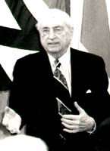
Professor Austin App

Persecuted for his courageous and tireless truth campaign for two generations on behalf of German-Americans.

Background and contribution:

A German-American community leader and author of many booklets and tracts - among them "The Six Million Swindle," "Action on a War Crime," "The Bombing Atrocity of Dresden," "Ravaging the women of Conquered Europe," and many others - Professor App was an early guide of Ernst Zündel.

Ernst Zündel

Three documented assassination attempts by fire and pipe bombs. Endless legal harassment leading to repeated jailings and bankrupting of his graphic arts business.

Background and contribution:

Nicknamed the "Revisionist Dynamo" or the "Revisionist Renaissance Man" for his untiring Revisionist Truth Campaign and his comprehensive grasp of complex political issues, Zündel - more than any other Revisionist on earth - caused the Holocaust Hoax to become a mainstream topic of discussion. Extensive chronological biography on the Zundelsite.

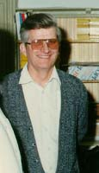
Jim Keegstra

Lost his job and his reputation was destroyed. Prevented an arson attempt against him. Was convicted to a $3,000 fine after 10 years of costly litigation. Was financially ruined by his ordeal.

Background and contribution:

A Canadian school teacher of Dutch background, Keegstra taught both sides of the Holocaust and other questions of history. He was charged under Canada's infamous "Hate Laws", and was tried and convicted. He appealed - and was re-tried and re-convicted. Three times, his case went to the Supreme Court. He ultimately lost. Zündel witness in the 1985 Great Holocaust Trial.

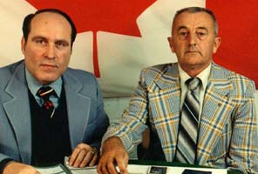
Frank Walus

Attacked seven times by Jewish assailants; nearly killed in an acid attack. Lost his US citizenship and his home to pay for his defense.

Background and contribution:

A Polish German-American auto worker, Walus was targeted and accused falsely by Simon Wiesenthal to be a "Nazi War Criminal." Vilified by the US media in a vicious campaign as the "Butcher of Kielce", Walus fought bravely against his tormentors of the Office of Special Investigations, also known as the US "Nazi Hunters". He ultimately won his case against them in a costly appeals process but died after several massive heart attacks - a bitter, financially ruined man. He refused to be buried on US soil because he felt the country had betrayed and failed him. Zündel witness in the 1985 Great Holocaust Trial.

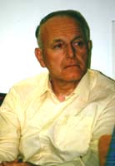
Emil Lachout

Mercilessly hounded by Austrian authorities and the Austrian lapdog media for over a decade. Forced to undergo a humiliating psychiatric assessment.

Background and contribution:

An Austrian school teacher, former military police man and Boy Scout leader, Lachout's name is associated with the famous Müller-Lachout document. He ultimately won his case in the European Court of Human Rights. Austria must pay him compensation but hasn't done yet - so far. Never a man to do things by halves, Lachout is demanding an apology from the Austrian State. Zündel witness in the 1988 Great Holocaust Trial.

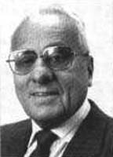
Henri Roques

Had his doctorate revoked.

Background and contribution:

Henri Rocques is a French author and researcher who exposed the Myth of Pope Pius XII's complicity in the Holocaust. His doctoral thesis made world-wide headlines in 1986 when, for the first time in the nearly eight-century history of French universities, a duly awarded doctorate was quickly revoked on French government's orders, after an outry by the Leftist-Jewish media in France. In a tightly argued dissertation, Rocques came to the stunning conclusion that the allegations of mass gassings of Jews made by SS officer Kurt Gerstein were groundless, and that the supposed Roman-Catholic coverup of this "slaughter" are false. He further concluded that postwar academics deliberately falsified key parts of the already tortured Gerstein testimony. His dissertation was eventually published by the Institute for Historical Review in book form under the title "The Confessions of Kurt Gerstein."

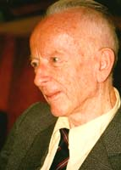
Tjiudar Rudolph

Imprisoned in Germany for lengthy stints for "doubting the Holocaust", even though he was in his mid-eighties at the time.

Background and contribution:

A former German Security Service member, fluent in five languages including Yiddish and Polish, Rudolph was involved with organizing Red Cross inspection tours of Auschwitz and other camps during the war. He wrote numerous Revisionist articles. He accompanied Fred Leuchter as translator to Auschwitz and Maidanek in 1988. He was charged and convicted for publishing a newsletter disputing the "Six Million" story. Zündel witness in the 1985 and 1988 Great Holocaust Trials.

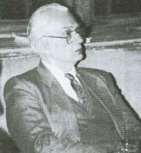
Udo Walendy

Convicted and imprisoned in Germany for 15 months, even though already in his seventies and in poor health with a serious heart condition.

Background and contribution:

A prolific German researcher, writer and publisher of numerous books and a series of popular booklets called "Historische Tatsachen"- ("Historical Truths") including the German version of "Did Six Million Really Die?" and the German language version of the Leuchter Report #1 - Walendy was dragged before the courts numerous times. His home and offices were frequently raided by the police. Business files, books, printing plates and computers were confiscated. Zündel advisor and witness in the 1985 and 1988 Great Holocaust Trials.

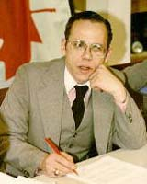
Fred Leuchter

Arrested and jailed in Germany. Financially ruined.

Background and contribution:

An American execution expert, Leuchter designed and maintained gas chambers for several US penal institutions. He was sent by Ernst Zündel to investigate Auschwitz, Majdanek, Dachau, Hartheim and other alleged "Nazi Death Camps" and "gassing facilities." Author of the devastating series of Leuchter Reports. (I, II, III, IV) and many articles and videotaped presentations that resulted from these investigations, Leuchter was blacklisted in the US and hounded by the Holocaust Promotion Lobby and the world's lapdog media. He was arrested and jailed in Germany for giving an anti-Holocaust lecture for Günther Deckert, a well-known political party leader. Allowed out on bail, Leuchter returned to the US. and chose not to go back to Germany to stand trial. Nonetheless, he lost his livelihood as a result. Sensational Zündel witness in the Great Holocaust Trial in 1988. Leuchter, although present in the courtroom in Munich, was not allowed to testify about his research findings in Auschwitz for Ernst Zündel in the German (Munich) Trial in 1991.

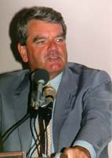
David Irving

Convicted, jailed, fined, deported and barred from numerous countries - and hounded world-wide by Holocaust Enforcers.

Background and contribution:

A prolific British author of approximately 36 books and recognized authority on Hitler and World War II, Irving pretty much believed and accepted the standard Holocaust version - until he read the Leuchter Report. He agreed to testify as the last witness for the defense in the 1988 Zündel Trial. His appearance was a sensation! In the following years, he went on widely publicized and acclaimed Canada- and America-wide lecture tours. He traveled as a speaker through several European countries, with headlines and controversy dogging his every step. He drew packed houses and infuriated the Holocaust Lobby, which reacted with vicious smear campaigns and managed to have Irving arrested and convicted in Munich, Germany, for "defaming the dead." This conviction caused Irving to be ultimately banned from Canada, Australia, Italy, New Zealand and South Africa. He was deported in handcuffs from Niagara Falls, Ontario, after a farcical Immigration hearing, during which he was held and treated in jail like some common criminal - for weeks! He has been hounded by the Holocaust Enforcers ever since. A combative man, Irving has lately gone on counter-attacks and is suing the British Board of Jewish Deputies and American Jewish Holocaust Promoter, Deborah Lipstadt and her publishers. Zündel witness in the 1988 Great Holocaust Trial.

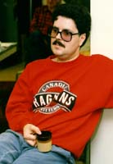
Ivan Lagace

Became the target of several Royal Canadian Mounted Police raids. Resigned from his job as crematory director after receiving endless threats by anonymous callers and from thugs claiming to be the Jewish Defense League.

Background and contribution:

A crematory expert from Calgary, Alberta, who had been responsible for the disposing of 10,000 bodies in his career, Lagace finally sorted out - publicly and in open court - all the fanciful lies about the Germans supposedly "cremating multiple corpses in single corpse retorts" in Auschwitz, Birkenau and elsewhere. Lagace's testimony put an end to the wild claims by so-called "death camp survivors" about ". . . cremating bodies in five minutes" etc. His testimony - together with Fred Leuchter's findings as well as the lab results presented by Dr. James Roth of Alpha Laboratories from the soil and rock samples Leuchter had brought from Auschwitz to the USA - spelled the death knell of fanciful "survivor" claims. Lagace was raided by the Royal Canadian Mounted Police in his crematory office where he was making notes and keeping photographs taken for future court cases hidden in a container for human ashes. Zündel witness in the Great Holocaust Trial of 1988.

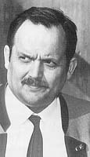
Gerd Honsik

Convicted, fined and driven into exile.

Background and contribution:

Honsik, an Austrian writer and poet, wrote several devastating books - one exposing Simon Wiesenthal, one titled "Freispruch für Hitler" and a third "33 Witnesses against the Gas Chamber Lie." He was convicted in Austria and Germany to fines in excess of DM 50,000 and forced to go into exile in Spain where he now lives, Gerd Honsik writes a monthly Revisionist newsletter in tabloid format titled "Halt!" ("Stop!") - meaning "Stop the hatred and lies!"

Walter Lüftl

President of Austrian Chamber of Engineers relieved from his elected post after questioning Gas Chambers story on enginering grounds

Background and contribution:

Lüftl was elected to represent 4000 austrian Architects and Construction engineers and was for years a court approved expert witness in cases involving engineering matters. Simon Wiesenthal and his friends in the media agitated, till the highly respected head of his own engineering firm was dismissed from his post. He had circulated privately what has since been published as the Lüftl Report in which he questions the Gassing story on technical grounds.

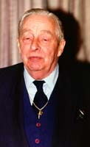
Imre Finta

Victimized by the media and financially totally ruined by civil law suits mismanaged by his first lawyers. Criminally charged and prosecuted as a "war criminal" in Canada.

Background and contribution:

A retired Hungarian police captain, Finta was accused by Sabina Citron and others for allegedly persecuting Jews in Hungary during the war. After lengthy legal battles, he was ultimately acquitted by unanimous jury verdict when Ernst Zündel's attorneys, Doug Christie and Barbara Kulaszka, took over his defense and won his victory in court. The jurors obviously did not believe the many Israeli and Jewish eye-witnesses!

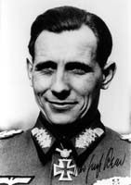
Otto Ernst Remer

Tried and convicted to more than one year imprisonment, even though he was over 80 years old and in ill health.

Background and contribution:

A German war hero who successfully thwarted the military putsch by German traitors against Hitler in Berlin on 20 July 1944, Remer seized the political opportunity brought about by the revelations of the Leuchter Report. He made the findings known to millions of people by privately publishing "Die Remer Depesche", a mass circulation tabloid style newspaper. The German vassal regime came down hard on the old soldier. He was tried and convicted to prison. He went into exile in Spain, wheelchair-bound, where he died. His widow now has to fight for her pension. She refuses to return his ashes to Germany until such time when her husband's remains can be returned under honorable circumstances.

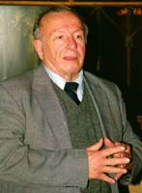
Jerome Brentar

His reputation tarnished and his company boycotted, Brentar lost his livelihood for saving a man from the noose.

Background and contribution:

This Croation-American trained social worker and Christian activist has helped every falsely accused "war criminal" - from Frank Walus to Dr. Arthur Rudolf to Mr. Bartesch. He was of immense help to John Demjanjuk. Due to the tireless work of this saintly man, Walus and Demjanjuk won their cases in the end. Brentar spent almost $500,000 of his own funds to help pay for the lawyers' fees, translators, flights, hotel accommodations, meals, and witness fees. He lost his once thriving Travel Agency because of the vicious publicity engendered, and now lives at the edge of poverty in forced retirement on his social security pension. Zündel researcher, advisor and witness in the 1985 Great Holocaust Trial.

John Demjanjuk

Extradited, charged, tried, convicted and sentenced to death by hanging. Spent many years in prison.

Background and contribution:

Demjanjuk was a Ukrainian autoworker and former camp guard whose grotesque case saw him extradited to Israel from the USA for trial. Convicted to death by hanging, but ultimately released by the Israeli Supreme Court, who obviously did not believe what must have been the perjured or false testimony of Israeli eye-witnesses, Demjanjuk was saved from the noose because Jerry Brentar worked day and night to search and find exonerating documents, eye witnesses and handwriting experts to save Demjanjuk's life. America has returned his passport and must pay him his pension for all the years of his imprisonment. Hopefully, part of that money will go Jerry Brentar to recover his outlays.

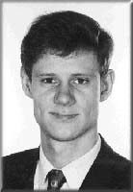
Germar Rudolf

Accused, tried and convicted in Germany. Career and doctorate dissertation ruined. Driven into exile.

Background and contribution:

This brilliant, German-trained chemist re-examined Auschwitz, Birkenau and other installations and buildings, testing rocks, soil and other physical samples for traces of Zyklon B. Following the pioneering work of Fred Leuchter, he put the final nail into the coffin of the Auschwitz story. Even though he did scientific work and was utterly apolitical, Rudolf's home and office were raided, computers seized etc. He was charged and tried in Germany for not believing in the standard Auschwitz story. As a scientist, he found the "gassing" claims to be scientifically untenable and, therefore, absurd. A modern day Galileo, Rudolf was found guilty and convicted because he refused to renounce scientific facts and his own scientific tests and findings. He was facing jail when he went into exile with his young wife and two babies. He now edits and publishes devastating refutations of the Allied Propaganda claims in a German-language journal. The Holocaust Enforcers are dogging his steps, and he faces endless hassles and trials, should the "German" vassal authorities ever get a hold of him. Zündel expert witness in chemistry in the Munich trial in 1991 - disallowed by the judge at the request of the prosecution.

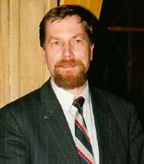
Attorney Jürgen Rieger

Attacked and beaten. Car blown up. Professional reputation and career ruined.

Background and contribution:

Long-time Zündel attorney in Germany, Rieger has been a defender of German patriots since his law school days. He has drawn the ire of the Holocaust Enforcers by winning the 1981 Zündel case in Stuttgart against the false claim that Zündel had published "hate literature", and winning several cases against the German vassal regime who had confiscated Zündel's postal bank account, unfreezing DM 30,000 in the process. He also managed to regain for Zündel his confiscated German passport - after a six-year legal battle. Rieger was attacked and beaten unconscious in broad daylight after leaving a Hamburg courthouse and had to be airlifted, near death, by helicopter to the trauma unit of the hospital of Hamburg University, where he lay unconscious for days. The assailants escaped after their assassination attempt. German police later caught one Turkish "guest worker" who was tried - and let go! The other culprits were never found.

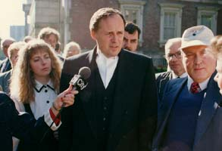
Attorney Doug Christie

Targeted professionally on numerous occasions with spurious charges of "unprofessional conduct" lodged with law societies in Canada.

Background and contribution:

Undoubtedly the finest constitutional and civil rights lawyer of his generation in Canada, Christie is known for his exceptional defenses of Ernst Zündel, Jim Keegstra, Malcolm Ross, Imre Finta and many other persecuted dissidents in Canada - and even the octogenarian, aristocratic Lady Birdwood in England. Under constant threat by busybodies in various law societies, usually the target of Jewish Holocaust Lobbyist complaints, Christie has frequently been intimidated during the Zündel trials by judges who threatened him with contempt of court when he called their arbitrary decisions into question. He is hated by all enemies of freedom, by many groveling politicians and the intellectual prostitutes in the Canadian media establishment. Christie has headed the Zündel legal defense team for over 15 years.

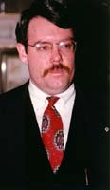
Attorney Kirk Lyons

Viciously character-assassinated by the media and "Jewish defense" organizations after defending the rights of US patriots.

Background and contribution:

An American civil rights lawyer of note, skill and courage and defender of many patriots, especially the "Dead of Waco," Lyons has represented people like Fred Leuchter in controversial cases, and has lately been targeted by the conservative "Spotlight" for "special media treatment" because he won a large suit against a law firm which had mismanaged a case involving one of his clients, the former Populist Party of the USA and Don Wassal. Character assassins are still trying to falsely link Lyons to the Oklahoma City bombing via a client of his, Andy Strasmeir, son of a famous German political operative and advisor to Helmut Kohl. Lyons has also defended patriots in the famous "Fort Smith Sedition Trial" and has since been vilified by the ADL.

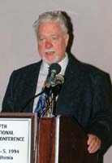
Bradley Smith

Viciously character-assassinated and kicked off his web server.

Background and contribution:

A Libertarian, former bookstore owner, bullfighter, writer and broadcaster, Smith runs the wildly successful "Campus Project", placing ads in college and university student papers and asking for an open debate on the Holocaust. He is the owner of the popular CODOH website, known to be one of the top mainstream Revisionist websites on the Net, running head-to-head with Greg Raven's new Institute for Historical Review website now under construction. The Holocaust Lobby is relentless in its attacks against Bradley Smith, who speaks fluent Spanish and has moved to Mexico to cut costs. Zündel defense witness in the 1985 Great Holocaust Trial.

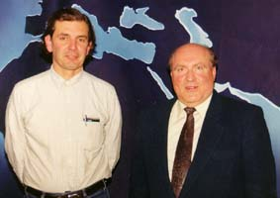
Michael Hoffman II

Viciously character-assassinated.

Background and contribution:

Hoffman is a former Associated Press reporter and author of the first book on Ernst Zündel's 1985 Trial, a biography that has undergone many printings. He is an indefatigable Revisionist researcher. He publishes a monthly newsletter titled Revisionist History, and is the author and publisher of numerous books and booklets. A noted, talented speaker and producer of Revisionist videos, Hoffman is also one of Revisionists' most skilled and passionate writers. He has drawn the Holocaust Lobby's ire for his grass roots street level activism and manly courage.

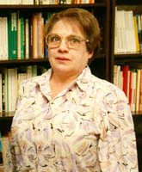
Ingrid Weckert

Tried, convicted and fined.

Background and contribution:

One of the best-known German historical researchers and writers, Weckert is best known for her book on the events leading up to Kristallnacht - a book called "Feuerzeichen" (Flashpoint). She has been subjected to police raids, during one of which Ernst Zündel was arrested in her apartment in Munich. A former tourist guide for travel agencies, she reads and speaks Hebrew. She knew Menachim Begin and other Jewish leaders personally and frequently visited Israel. In 1998, she was tried, convicted and fined DM 3,500 for writing a Revisionist article. She now lives at the edge of poverty from a small pension.

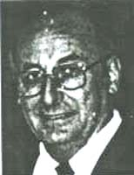
Erhard Kemper

Legally harassed. Endlessly hounded.

Background and contribution:

Kemper is a German agrarian engineer and gifted, politically astute freelance writer who has been arrested, tried and convicted for his revisionist writings in Germany dozens of times. He is unbroken in spirit, in spite of the constant legal harassment and failing health as a result of his persecution. He has been completely impoverished and his health has been ruined, but he bravely soldiers on.

Günther Deckert

Currently imprisoned in Bruchsal, Germany. Faces up to eight years incarceration.

Background and contribution:

A German educator, party leader, writer, public speaker and publicist, Deckert won fame for being tried and convicted after he simultaneously translated an English-language lecture by Fred Leuchter in Germany into German. He was at first acquitted by a German judge who found him to be an upright and decent patriot, then recharged and convicted by a different judge after an artificially created international media uproar. Now German prosecutors keep piling court case after court case on Deckert while he is in jail. He bravely keeps fighting on.

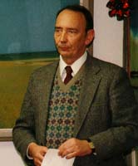
Hans Schmidt

Arrested, tried and jailed in Germany, even though he was a US citizen.

Background and contribution:

German-American author and publisher of a German- as well as an English-language newsletter (GANPAC Brief and USA-Berichte), Schmidt was arrested in 1995 for having written about a "Jew- and Freemason infested" oligarchy and media ruling today's Germany. He spent 5 months in prison for four words. Released on bail and in ill health, Schmidt returned to the USA where he wrote a book about his experience in Germany, titled "Jailed in Democratic Germany." He has been a thorn in the side of the German vassal authorities for many years.

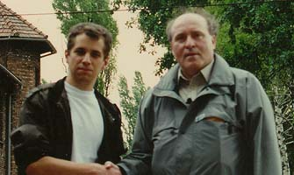
David Cole

Became a victim of the JDL. Was physically beaten. Had his life threatened on the Internet by the Jewish Defense League.

Background and contribution:

This young Jewish Revisionist filmmaker came to the defense of Ernst Zündel when Zündel needed defending. Subsequently, Zündel and Cole made a film in Auschwitz, with David Cole pointing out all the things wrong with that theme park of hate against Germans. Later yet, Cole came to Canada to lecture to large audiences on his Revisionist findings in Auschwitz, together with David Irving. He also appeared with Zündel in Munich, Germany, spreading Revisionism right under the watchful eyes of the German political police. In a vicious letter posted on the Internet, the Jewish Defense League threatened Cole's life. Emotionally fragile and torn between his conscience and family loyalties as well as filial devotion, he could not withstand the pressure and recanted with an abject apology to his tribesmen and tormentors. Every serious Revisionist understands that this act of recantation was coerced and may have bought David his very survival.

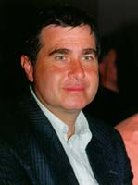
Jürgen Graf

Charged, tried and convicted in Switzerland. Fired for the second time from his teaching post.

Background and contribution:

A Swiss school teacher and language genius, Graf speaks almost one dozen languages fluently and understands many more, some of them the most exotic ones such as Russian, Japanese, Thai as well as Malay and Filipino dialects. Author of several books, among them "Der Holocaust auf dem Prüfstand" (The Holocaust on Trial), he went recently to Russia where he researched Russian archives for months. The Swiss government charged, tried and convicted Graf in 1998 to 15 months in jail under the new anti-Revisionist law adopted by the Swiss in 1994. His German-born, 80-year-old publisher was likewise convicted to 1 year in prison.

Siegfried Verbeke

Currently on trial in Holland under immense police pressure in Belgium. Endured numerous police raids and business boycotts.

Background and contribution:

The most dynamic Revisionist in Belgium and maybe all of Europe, Verbeke published numerous books, booklets, magazines and tracts for European Revisionists. Verbeke is now himself on trial, together with Dr. Faurisson - accused of cutting into the financial profits of the Anne Frank Foundation because of their books and texts critical of the Anne Frank Diary. Both are currently appealing a Dutch verdict. Verbeke seems undeterred by numerous police raids. Europe-wide, he carries on with a vigorous mass circulation, grassroots-based Revisionist Truth-in-History campaign in several European languages.

Carlos Porter

Charged, tried in absentia, and convicted in Germany.

Background and contribution:

An American ex-patriate, skilled linguist and translator living in Belgium and author of numerous books - "Not Guilty at Nuremberg", "Made in Russia: The Holocaust" subtitled "The German Defenses Case" - Porter was charged by the Germans in 1997. He refused to attend the trial, was tried in absentia and convicted. He responded with a defiant, blistering Emile Zola-like excoriating written counterattack to the judge in his case, and presently is waiting to be arrested and taken to Germany to serve his sentence there.

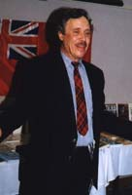
Malcolm Ross

Fired from his teaching post for politically incorrect writings.

Background and contribution:

A Canadian school teacher and author, Ross was for years a thorn in the eyes of the Holocaust Lobby because of his writings. It took years to fire him under some flimsy excuse because he never taught his version of history in class. Charged and re-charged, he repeatedly won in appeal courts. After years of litigation, the Supreme Court in a unanimous ruling found Malcolm Ross guilty in the end, and he was sentenced to a fine. Today, he is the unemployed father of two children.

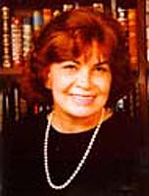
Ingrid Rimland

Vilified by the ADL as an "Extremist." Had her new trilogy "Lebensraum!" seized by the hundreds and banned in Canada as "hate material."

Background and contribution:

A relative newcomer to Revisionism, Ingrid Rimland is best known for her novels dealing with World War II that bring to life and explain the underlying reasons of the Third Reich's struggle against Communism. Canada Customs confiscated and banned the titles, even though there was not enough time to have these massive, well-researched books read, much less professionally content-evaluated. Rimland has had global mainstream media coverage as the defender of the controversy-dogged Zundelsite - which seems to be the reason her name as been smeared as an "Extremist" in a 1997 ADL smear publication.

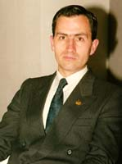
Pedro Varela

Grotesquely charged with "genocide" - for selling books.

Background and contribution:

Spanish bookseller and well-known, long-time leader of the Spanish youth group "Cedade", Varela is currently before the Spanish courts for "genocide" for selling historical, Revisionist and National Socialist books. Jewish Lobbyists have asked for a 24 year prison term for Varela.

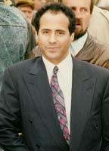
Ahmed Rami

Tried, convicted and imprisoned in Sweden.

Background and contribution:

Rami is a former Moroccan military officer living in exile in Sweden, where he used to run "Radio Islam", a radio program that was closed down due to Holocaust Lobby pressure. He was tried and convicted in Sweden for his Revisionist views and served a nine month prison term. Now he runs a much-visited, multilingual website famous the world over, which has come under repeated attack by French and Swedish Jewish sources. He won several court skirmishes, and for the moment seems to hold his own.

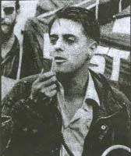
Nick Griffin

Charged, tried, convicted and fined in England.

Background and contribution:

Famous for his recent court case over pictures and words published in the magazine "The Rune", Griffin, a well-known British political activist, was charged, tried and convicted as a sacrificial lamb on the altar of Tony Blair's election promises - to be "tougher on Revisionists and racists." Two US black separatist leaders spoke out as witnesses for Griffin, but he was convicted nonetheless to a steep fine of L3,000. (The expert witness for the defense was none other than Dr. Robert Faurisson who helped out once again when help was needed.) Griffin is reported to be unbowed.

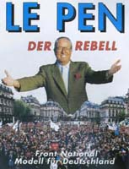
Jean Marie Le Pen

Charged, convicted and under political sanctions in France.

Background and contribution:

The flamboyant French leader of the "Front National", the largest and most promising nationalist political party in Europe, "belittled" the Holocaust and called it "a mere detail, a footnote in the history of WWII" - apparently using the phrase on three different occasions! He was recently convicted in a French court under the Communist-inspired Gayssot Law. He was given a steep fine and forbidden to run in elections for the next two years. Le Pen is undeterred, even though politically victimized for years by the French political establishment and a disgustingly hypocritical, largely Jewish-dominated French media.

Roger Garaudy

Charged, tried and convicted in France.

Background and contribution:

A former French Communist leader, philosopher and recent convert to Revisionism and Islam, Garaudy was charged, tried and convicted for writing a semi-Revisionist book titled "The Founding Myths of Israeli Politics," in which he had quoted extensively from material by Dr. Faurisson (without attribution) and by Barbara Kulaszka's book "Did Six Million Really Die?" (with attribution). He was condemned to a $50,000 fine. His trial was a farce and his performance in court disappointing. However, as a result, he seems to have kicked loose an avalanche of Revisionist thought and activities in the Moslem world, much to the chagrin of Israel - a country that more and more considers Revisionism its Number One problem.

Abbe Pierre

Victim of fierce world-wide media vilification.

Background and contribution:

Considered a male "Mother Theresa" for his altruistic dedication to the poor of France, this famous pro-Marxist French cleric endorsed Roger Garaudy's Revisionist book - and was almost crucified by a vitriolic media reaction. The Holocaust Enforcers made a huge mistake picking on this man. He fired back salvo after salvo - much to everyone's surprise. He fought bravely for a man well into his eighties, but in the end fled into a monastery in Italy - from where he apologized under pressure from his church.

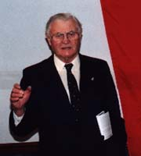
Doug Collins

Harassed and vilified by the BC Human Rights Commisson. Financially penalized.

Background and contribution:

Doug Collins was a British soldier in World War II. He was captured and escaped several times. He worked in an intelligence capacity with the British Control Commission in occupied Germany after the war. He emigrated to Canada in the 1950s and worked for several Canadian newspapers. He drew the ire of the Holocaust Enforcers after he testified for Ernst Zündel in the 1985 Great Holocaust Trial. He declared that as a journalist, he saw nothing wrong with the booklet "Did Six Million Really Die?" and that he found no "hate" in that 30,000 word essay. An award-winning journalist and TV commentator and the author of several books, Collins was hauled before a quasi-court by Holocaust Enforcers when he wrote a column about "Swindler's List" and commented on the preponderance of Jews in Hollywood. He and his paper had to defend themselves before the British Columbia Human Rights Commission, which, in the end, ruled in his favor, after his paper spent more than $200,000 and Collins spent $50,000 of his own money. Barely had he won the case when he was re-charged - for the same column, along with three others!

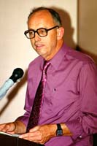
Dr. Robert Countess

Vilified by the Canadian Human Rights Tribunal and the intervenor lawyers in the most recent Political Show Trial case of Ernst Zündel.

Background and contribution:

The American Revisionist, former army chaplain, lecturer, writer and globe-trotting good-will ambassador, Dr. Robert Countess, was targeted for a special smear- and vilification campaign by Jewish intervenors at the Zündel CHRT Inquisition in Toronto in June 1998. He was sneeringly denied expert witness status, even though he was completely familiar with all the major works discussed and had been in touch with most authors, even in person, dealing with the Holocaust topic - pro and con. Dr. Countess left the "People's Republic of Canada", as he called it, for the safety and constitutionally governed and protected USA, from where he vowed to carry on the struggle for freedom of speech with still greater vigor.

And many, many more...!

