**Adolf Hitler; the Greatest Story NEVER Told by** [Dennis Wise](http://www.imdb.com/name/nm6284048?ref_=tt_ov_dr) 2013

http://thegreateststorynevertold.tv/

**The Untold Story of Adolf Hitler**

Adolf Hitler, born in Braunau, one man who will change the history of the world forever. It follows his childhood to the death of his mother and his broken ambition to become an artist, then further to his entry into politics. His service in the army, accolades, his writing Mein Kampf, politics and most importantly Germany's revival are well explained followed by WW2. It also covers the effect on Germany's after the WW2 defeat up until the fall of the Berlin Wall. Probably the most detailed documentary ever covering over 100 years of history.

This documentary does a great job in balancing the narrative of World War 2. The film portrays the rise of Hitler, the National Socialists and the lead-up to WW2 from the German perspective. It could thus be said to be biased in favour of the National Socialists, but not more so than the average Western mainstream documentary whitewashes the Allies' war effort.  
  
This is certainly the best and most informative WW2 documentary I've seen, which is all the more fascinating given the low-budget production.  
  
This documentary ought to be compulsory viewing in all public schools worldwide. If it were, the US would never get away with invading small counties in the Middle East on false pretenses.  
  
A must see!

**=================================================================================**

## Part 1 Adolf Hitlers Childhood

[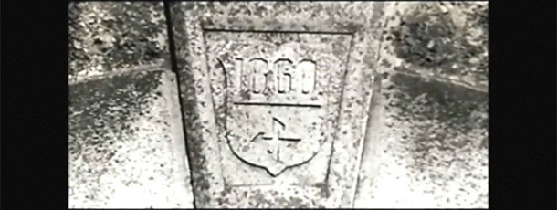](http://thegreateststorynevertold.tv/wp-content/uploads/2013/09/TGSNT-P1.jpg)

**Part 1  Adolf Hitler’s Childhood**

From his birth and early life, throughout his WW1 exploits and into his early political career.

Little is said of Hitler’s earlier years before World War 1 so here it is. He was born in a small village in Austria  on the borders of  Austria and Germany. He was a chorister as a child in the local church and wanted to become a great artist or architect. He followed his dream to Vienna and applied to enrol at the fine arts college there. After being refused entry twice he became a drifter. He became interested in the National Socialist Party in the early years and was keen to fight the Communists trying to take over Germany in the early 1900’s before WW1.

World War I was nearing and he applied to the German Kaiser to join his Private Guard. He then was rewarded for bravery, commissioned to the rank of Corporal and won numerous other medals of valour.

After the War he decided to try to overthrow the Government which was full of Communists. His coup was almost successful but he was over confident and was arrested and was tried for treason which he pleaded guilty to. Treason held the death penalty but he plead his case in the courts and was sentenced to 5 years jail.

In jail he then wrote Mein Kampf, which became a worldwide best-seller far after the War, even though it was banned in most countries. He came out of jail even more popular than before and decided to then go into politics properly.

Many people ask how such a Man could rise to power. To understand this you need to know what happened. To understand World War I you need to go further back in history.

Adolf Hitler was in hospital recovering from a gassing in the trenches when World War I ended. He heard the Kaiser had abdicated and then the Treaty of Versailles. Hitler was ‘born’ that very moment in time. If you want to know his motivations, look up the Treaty of Versailles.

Please note corrections:

*Adolf Hitler was the 55th party member and not the seventh.

**The grave of his parents no longer have a monument headstone as it has been removed by officials since this documentary was made.

* **[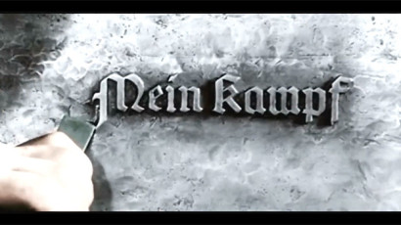](http://thegreateststorynevertold.tv/wp-content/uploads/2013/09/TGSNT-P2.jpg)**
* **Part 2 The Early Years**
* Hitler goes to prison whilst Germany descends into poverty. The NSDAP rise to power, The Nuremberg Rallies and Germany prospers again
* **[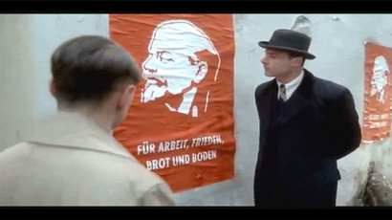](http://thegreateststorynevertold.tv/wp-content/uploads/2013/09/TGSNT-P3.jpg)**
* **Part 3 Origins** of the NSDAP.
* History of the swastika including The Anschluss, more on Hitler’s relationship with Eva Braun, and The Sudeten Conflict.

**Part 3 Origins**

**Part 3 Origins of the NSDAP swastika including The Anschluss, more on ...**

* **[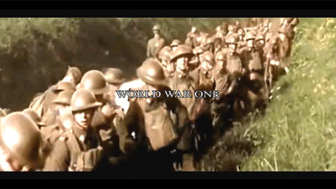](http://thegreateststorynevertold.tv/wp-content/uploads/2013/09/TGSNT-P4.jpg)**

[**View Details**](http://thegreateststorynevertold.tv/portfolio/part-4-cultural-clash/)

**Part 4 Cultural Clash**

**Part 4 Cultural Clash with Germany and the Jews with Crystal Night and...**

* **[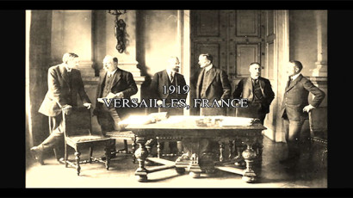](http://thegreateststorynevertold.tv/wp-content/uploads/2013/09/TGSNT-P5.jpg)**

[**View Details**](http://thegreateststorynevertold.tv/portfolio/part-5-war-declared/)

**Part 5 War Declared**

**Part 5 War Declared and the truth behind WW1 and the Treaty of Versail...**

* **[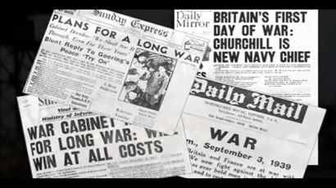](http://thegreateststorynevertold.tv/wp-content/uploads/2013/09/TGSNT-P6.jpg)**

[**View Details**](http://thegreateststorynevertold.tv/portfolio/part-6-battle-of-britain/)

**Part 6 Battle of Britain**

**Part 6 Battle of Britain and England and France declaring War because ...**

* **[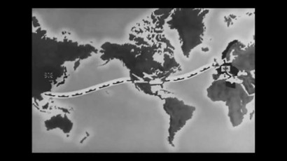](http://thegreateststorynevertold.tv/wp-content/uploads/2013/09/TGSNT-P7.jpg)**

[**View Details**](http://thegreateststorynevertold.tv/portfolio/part-7-stalin/)

**Part 7 Stalin**

**Part 7 Stalin and the Allies mountain of War Crimes, the America Racis...**

* **[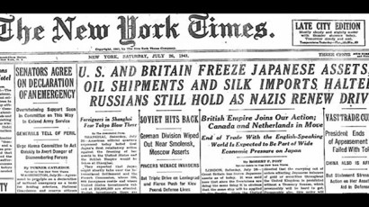](http://thegreateststorynevertold.tv/wp-content/uploads/2013/09/TGSNT-P8.jpg)**

[**View Details**](http://thegreateststorynevertold.tv/portfolio/part-8-pearl-harbor/)

**Part 8 Pearl Harbor**

**Part 8 Pearl Harbor and the Japanese Conflict, War in Europe and the d...**

* **[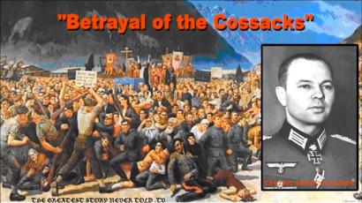](http://thegreateststorynevertold.tv/wp-content/uploads/2013/09/Pannwitz.jpg)**

[**View Details**](http://thegreateststorynevertold.tv/portfolio/part-9-betrayal-of-the-cossacks/)

**Part 9 Betrayal of the Cossacks**

**Part 9 Betrayal of the Cossacks after the bloodiest part of WW2 and mo...**

* **[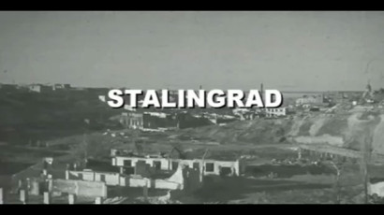](http://thegreateststorynevertold.tv/wp-content/uploads/2013/09/TGSNT-P10.jpg)**

[**View Details**](http://thegreateststorynevertold.tv/portfolio/part-10-stalingrad/)

**Part 10 Stalingrad**

**Part 10 Stalingrad and the onslaught of German Forces East with Japan ...**

* **[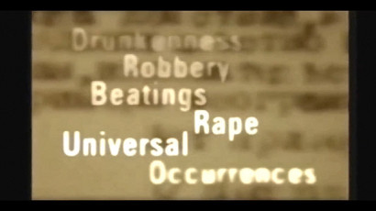](http://thegreateststorynevertold.tv/wp-content/uploads/2013/09/TGSNT-P11.jpg)**

[**View Details**](http://thegreateststorynevertold.tv/portfolio/part-11-the-red-terror/)

**Part 11 The Red Terror**

**Part 11 The Red Terror and the Partisans as the Wermacht retreat Westw...**

* **[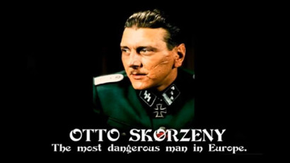](http://thegreateststorynevertold.tv/wp-content/uploads/2013/09/TGSNT-P12.jpg)**

[**View Details**](http://thegreateststorynevertold.tv/portfolio/part-12-mussolini/)

**Part 12 Mussolini**

**Part 12 Mussolini: BREAKING MUSSOLINI OUT the daring Prison Break by t...**

* **[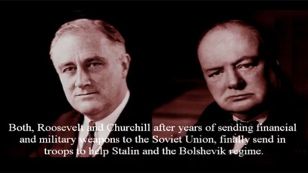](http://thegreateststorynevertold.tv/wp-content/uploads/2013/09/TGSNT-P13.jpg)**

[**View Details**](http://thegreateststorynevertold.tv/portfolio/part-13-roosevelt-and-churchill/)

**Part 13 Roosevelt and Churchill**

**Part 13 Roosevelt and Churchill. This episode shows their hidden web o...**

* **[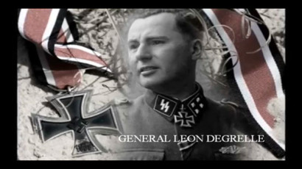](http://thegreateststorynevertold.tv/wp-content/uploads/2013/09/TGSNT-P14.jpg)**

[**View Details**](http://thegreateststorynevertold.tv/portfolio/part-14-general-leon-degrelle/)

**Part 14 General Leon DeGrelle**

**Part 14 General Leon DeGrelle, the most famous of the Waffen SS. ̶...**

* **[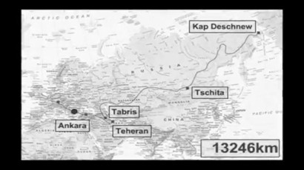](http://thegreateststorynevertold.tv/wp-content/uploads/2013/09/TGSNT-P15.jpg)**

[**View Details**](http://thegreateststorynevertold.tv/portfolio/part-15-battle-of-the-bulge/)

**Part 15 Battle of the Bulge**

**Part 15 Battle of the Bulge, which nearly turned the War on it’s...**

* **[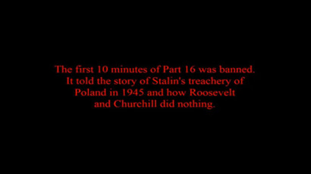](http://thegreateststorynevertold.tv/wp-content/uploads/2013/09/TGSNT-P16.jpg)**

[**View Details**](http://thegreateststorynevertold.tv/portfolio/part-16-treachery/)

**Part 16 Treachery**

**Part 16 The Treachery and the Bombing of Civilians by the Americans an...**

* **[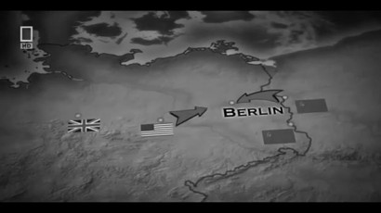](http://thegreateststorynevertold.tv/wp-content/uploads/2013/09/TGSNT-P17.jpg)**

[**View Details**](http://thegreateststorynevertold.tv/portfolio/part-17-battle-of-berlin/)

**Part 17 Battle of Berlin**

**Part 17 Battle of Berlin and The death of Adolf Hitler; The Russians a...**

* **[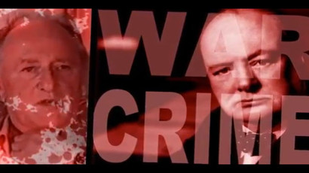](http://thegreateststorynevertold.tv/wp-content/uploads/2013/09/TGSNT-P18.jpg)**

[**View Details**](http://thegreateststorynevertold.tv/portfolio/part-18-germany-defeated/)

**Part 18 Germany Defeated**

**Part 18 Germany Defeated. The horrific deaths of Joseph & Magda G...**

* **[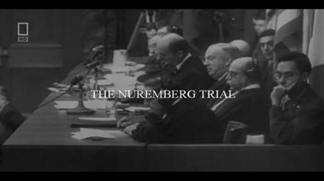](http://thegreateststorynevertold.tv/wp-content/uploads/2013/09/TGSNT-P19.jpg)**

[**View Details**](http://thegreateststorynevertold.tv/portfolio/part-19-nuremberg-trials/)

**Part 19 Nuremberg Trials**

**Part 19 Nuremberg Trials and the De-Nazification and ethnic cleansing ...**

* **[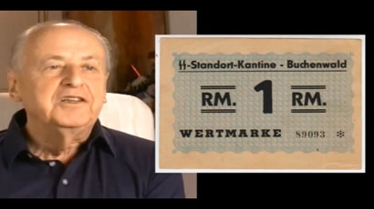](http://thegreateststorynevertold.tv/wp-content/uploads/2013/09/TGSNT-P20.jpg)**

[**View Details**](http://thegreateststorynevertold.tv/portfolio/part-20-confessions-by-torture/)

**Part 20 Confessions by Torture**

**Part 20 Confessions by Torture in the London Cage a series of nine cag...**

* **[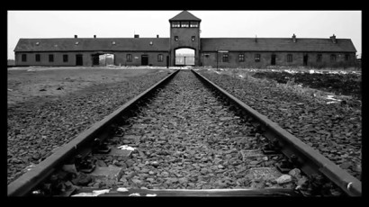](http://thegreateststorynevertold.tv/wp-content/uploads/2013/09/TGSNT-P21.jpg)**

[**View Details**](http://thegreateststorynevertold.tv/portfolio/part-21-the-leuchter-findings/)

**Part 21 The Leuchter Findings**

**Part 21 The Leuchter Findings: David Cole revisionist, The History of ...**

* **[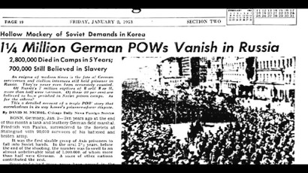](http://thegreateststorynevertold.tv/wp-content/uploads/2013/09/TGSNT-P22.jpg)**

[**View Details**](http://thegreateststorynevertold.tv/portfolio/part-22-ocean-of-death/)

**Part 22 Ocean of Death**

**Part 22 Ocean of Death: Plunder of German technology, Defeat brings R...**

* **[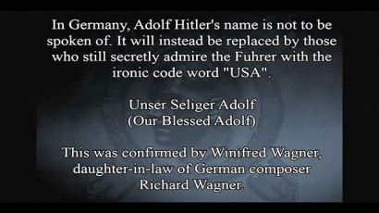](http://thegreateststorynevertold.tv/wp-content/uploads/2013/09/TGSNT-P23.jpg)**

[**View Details**](http://thegreateststorynevertold.tv/portfolio/part-23-the-berlin-wall/)

**Part 23 The Berlin Wall**

**Part 23 The Berlin Wall: Return of the German POW’s, The Rise a...**

* **[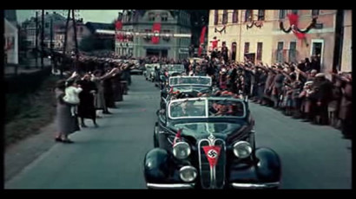](http://thegreateststorynevertold.tv/wp-content/uploads/2013/09/TGSNT-P24.jpg)**

[**View Details**](http://thegreateststorynevertold.tv/portfolio/part-24-what-if-germany-had-won/)

**Part 24 What If Germany Had Won?**

**Part 24 What If Germany Had Won? Hitler’s economic miracle ̵...**

* **[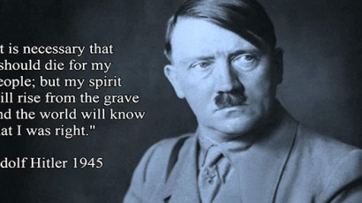](http://thegreateststorynevertold.tv/wp-content/uploads/2013/11/Dennis-Wise-Deanna-Spingola.jpg)**

[**View Details**](http://thegreateststorynevertold.tv/portfolio/part-25-defeated-wrong-enemy/)

**Part 25 We Defeated The Wrong Enemy**

**Part 25 We Defeated The Wrong Enemy: Operation Thunder, fighting to sa...**

* **[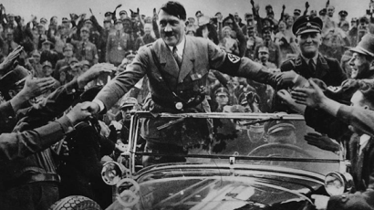](http://thegreateststorynevertold.tv/wp-content/uploads/2013/11/Adolf-Hitler-Car-e1436324066559.png)**

[**View Details**](http://thegreateststorynevertold.tv/portfolio/part-26-credits-thanks/)

**Part 26 Credits & Thanks**

**Part 26 Credits & Thanks: Video list of all sources and links tha...**

* **[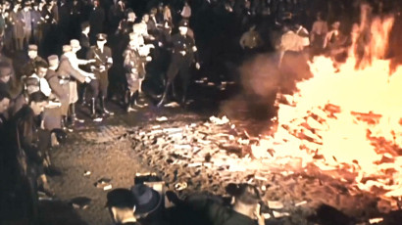](http://thegreateststorynevertold.tv/wp-content/uploads/2013/09/BookBurningBerlin1-1024x495.jpg)**

[**View Details**](http://thegreateststorynevertold.tv/portfolio/part-27-babylon-hitler-bonus/)

**Part 27 Babylon Before Hitler – Bonus**

**Part 27 Babylon Before Hitler – Bonus. Adolf Hitler was a man of...**