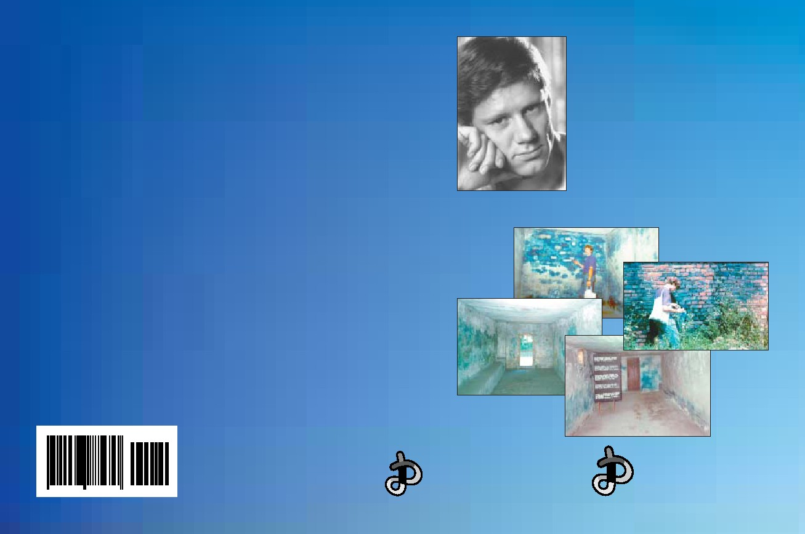
“I am extraordinarily impressed. To my knowledge, you are the ﬁrst expert in Germany
Germar Rudolf
who has addressed this particular topic in a scholarly impeccable and well-founded way.
Germar Rudolf • The Rudolf Report
It is not for me to attribute an ice-breaker function to your expert report. It is easy to see
which political-historical effects will originate from it, though its entire dimension cannot
The
yet be estimated.”
Prof. Dr. Hellmut Diwald, Historian, January 22, 1992
“I read it with great interest. […] My impression is, however, that this expert report is an
Rudolf
important contribution to a very important question which, since the ‘Leuchter Report,’
needs to be answered urgently. […] One can only very much hope that the well-known
tactics of hushing up is not applied to your expert report, but that critical responses and
comments will be made.”
Report
Prof. Dr. Ernst Nolte, Historian, January 28, 1992
“For me, the signiﬁcance of receiving your report rests on the fact that it substantially
contributes to our stock of knowledge. With many of my collegues active in the ﬁeld of
contemporary history, I am overjoyed and thankful for you having initiated this research
activity. Of course, I am even more delighted regarding the results of your accurate scien-
Expert Report on Chemical and Technical Aspects
tiﬁc investigation.”
Prof. Dr. Werner Georg Haverbeck, Historian, January 31, 1992
of the ‘Gas Chambers’ of Auschwitz
“I calmly read your report! It gives me hope to realize that a representative of the younger
generation courageously sets out, with scientiﬁc thoroughness, noticeable great expertise,
and corresponding investigative curiosity, to get to the bottom of a controversial question
that is of worldwide signiﬁcance! The result is clear and unequivocal! True facts cannot
be suppressed forever! I wish that your work will make the breakthrough!”
Prof. Emil Schlee, Historian, April 1, 1992
“[…] I sincerely hope that all statements about this topic would obviously be based on long
and intensive work such as yours. Most of it is certainly unveriﬁable for the layman, but
the photographs are already quite informative. […]”
Prof. Dr. Ernst Nolte, Historian, January 6, 1993
“Rudolf is a young scientist who tried to prove in an excellently layed-out work with
tables, graphics, and so on, that the gas chambers were technically impossible. […] These
scientiﬁc analyses are perfect.”
Hans Westra, Anne-Frank-Foundation, BRT 1 TV (Belgium), Panorama, April 27, 1995
“All in all, he relies on literature which was written long before this report was com-
pleted, and the report must be described as scientiﬁcally acceptable.”
Prof. Dr. Henri Ramuz, Chemist, interrogated as expert witness about the Rudolf Report
by the Swiss Court at Châtel-St.-Denis, May 18, 1997
HOLOCAUST Handbooks Series
Volume Two
Theses & Dissertations Press
PO Box 257768
Chicago, IL 60625, USA
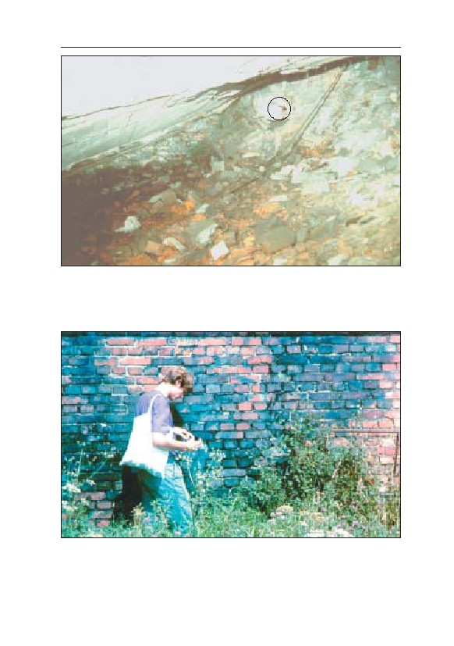
COLOR IMAGES
Color Image 1: Inside of the ruins of morgue 1 (‘gas chamber’) of crema-
torium II. The arrow points to the photograph taking location (see chapter
8.3.3.). Note: Not the slightest trace of blue discoloration can be found on
the walls.
Color pictures 1-4: © Karl Philipp
Color Image 2: Exterior southwest wall of the Zyklon B disinfestation wing of
BW 5b in the Auschwitz-Birkenau camp: a deep blue discoloration, caused
by cyanide compounds which penetrated the entire wall over the decades
since WWII and formed the blue pigment with iron compounds contained in
cement and bricks. This pigment is unaffected by 55 years of weathering.
I
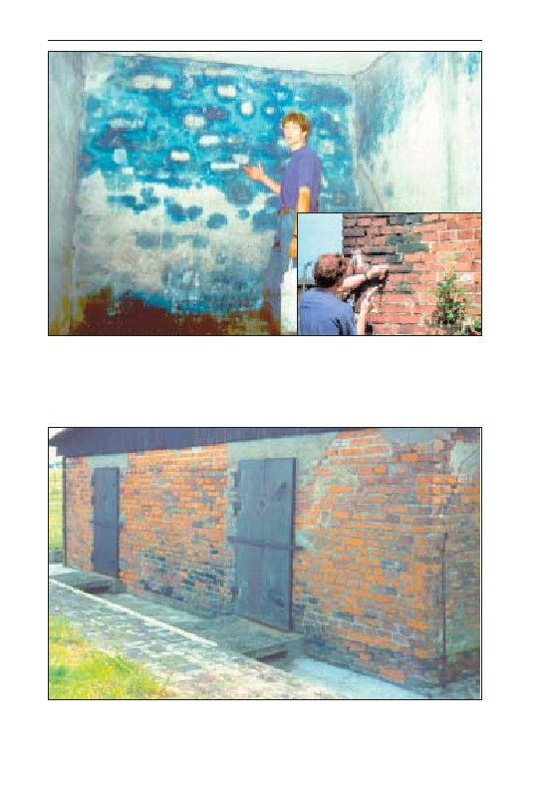
GERMAR RUDOLF · THE RUDOLF REPORT
Color Image 3: Northwest room of the Zyklon B disinfestation wing of BW
5a in the Auschwitz-Birkenau camp. The external walls (background and to
the right) show an intensive blue discoloration caused by the application of
Zyklon B (HCN). The internal wall to the left was added later and is therefore
free of cyanide residues. Color Image 4 (inset): Exterior of a wall of the
same part of BW 5a. Cyanide penetrated the wall and caused blue stains.
Color Image 5: Blue discoloration of the exterior wall of disinfestation instal-
lation barrack 41 in Majdanek camp (Bad und Desinfektion I), caused by the
application of Zyklon B. © C. Mattogno
II
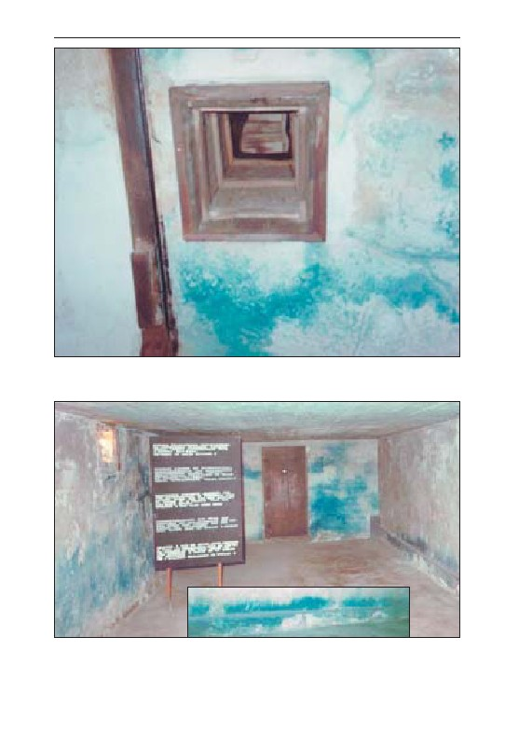
COLOR IMAGES
Color Image 6: Blue discoloration of the ceiling of the large Zyklon B disin-
festation chamber, barrack 41 in Majdanek camp (Bad und Desinfektion I),
caused by the application of Zyklon B. © C. Mattogno
Color Image 7: Blue discoloration of the interior of the walls of chamber III,
disinfestation installation barrack 41 (Bad und Desinfektion I) in Majdanek
camp, caused by the application of Zyklon B. Color Image 8 (inset): East
wall of this chamber. © C. Mattogno
III
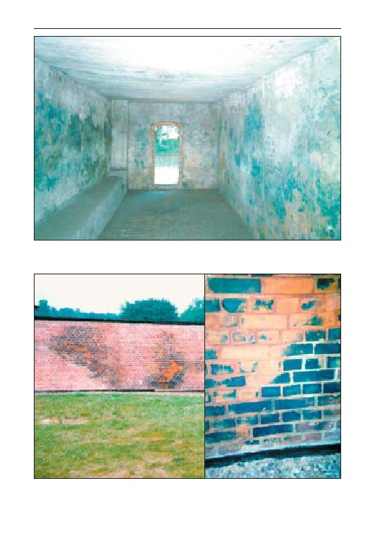
GERMAR RUDOLF · THE RUDOLF REPORT
Color Image 9: Blue discoloration of the interior walls of the Zyklon B disin-
festation installation in the Stutthof camp. © C. Mattogno
Color Image 10 (left): Blue discoloration of the east exterior wall of the
Zyklon B disinfestation installation in the Stutthof camp. Color Image 11
(right): section enlargement. © C. Mattogno
IV
THE RUDOLF REPORT
Expert Report on Chemical and Technical Aspects
of the ‘Gas Chambers’ of Auschwitz
Dedicated to the unknown thousands of Germans
now suffering political persecution in their own country
All readers are reminded that all income from sales of this book
and similar publications is intended for revisionists, who are, for the
most part, subject to governmental terror and have frequently been fi-
nancially ruined as a result of that terror. Persons wishing to support
revisionism are kindly requested to refrain from illegal copying, and to
buy and distribute the book in the proper manner.
The Publishers

Germar Rudolf
Certified Chemist
THE
RUDOLF
REPORT
Expert Report on
Chemical and
Technical Aspects
of the ‘Gas Chambers’
of Auschwitz
HOLOCAUST Handbooks Series, vol. 2:
Germar Rudolf:
The Rudolf Report.
Expert Report on Chemical and Technical Aspects
of the ‘Gas Chambers’ of Auschwitz.
Translated by Carlos Porter, Michael Humphrey,
James Damon, and the author.
Theses & Dissertations Press, Imprint of Castle Hill Publishers,
Chicago (Illinois), March 2003.
Paperback: ISBN 0-9679856-5-X
Hardcover: ISBN 0-9679856-6-8
ISSN 1529-7748
First German edition:
Rüdiger Kammerer, Armin Solms (ed.):
Das Rudolf Gutachten.
Gutachten über die Bildung und Nachweisbarkeit von
Cyanidverbindungen in den “Gaskammern” von Auschwitz.
Cromwell Press, London, July 1993 (ISBN 1-898419-00-0)
Second German edition:
Germar Rudolf:
Das Rudolf Gutachten.
Gutachten über die “Gaskammern” von Auschwitz
Castle Hill Publishers, Hastings, April 2001 (ISBN 1-902619-03-X)
Distribution Australia/Asia: Peace Books, PO Box 3300,
Norwood, 5067, Australia
Distribution Rest of World: Castle Hill Publishers
UK: PO Box 118, Hastings TN34 3ZQ
USA: PO Box 257768, Chicago, IL 60625
Set in Times New Roman
Table of Contents
Page
1. Prelude............................................................................................ 11
1.1. Slow Death in U.S. Gas Chambers .......................................... 11
1.2. Hydrogen Cyanide—a Dangerous Poison................................ 15
1.3. The Acid that Causes Blue Stains ............................................ 20
2. The Coup........................................................................................ 23
2.1. Fred Leuchter on Auschwitz and Majdanek............................. 23
2.2. Damage Control ....................................................................... 26
3. The Origins .................................................................................... 29
3.1. On the Problem ........................................................................ 32
3.2. On Politics................................................................................ 36
4. A Brief History of Forensic Examinations of Auschwitz ........... 39
4.1. Introduction .............................................................................. 39
4.2. The Moral Obligation of Forensic Examination ...................... 39
4.3. A Definition of Forensic Science ............................................. 41
4.4. Forensic Science and Auschwitz.............................................. 42
4.4.1. Forensics in the Courts........................................................... 42
4.4.1.1. The 1946 Cracow Auschwitz Trial ...................................... 42
4.4.1.2. The 1964-1966 Frankfurt Auschwitz Trial .......................... 44
4.4.1.3. The 1972 Vienna Auschwitz Trial....................................... 45
4.4.2. Forensics Outside the Courts.................................................. 46
4.4.2.1. In Search of Mass Graves .................................................... 46
4.4.2.2. Faurisson and the Consequences ......................................... 46
5. Auschwitz ....................................................................................... 49
5.1. Introduction .............................................................................. 49
5.1.1. “Opera During the Holocaust................................................ 49
5.1.2. On the History of the Camp ................................................... 51
5.2. Epidemics and the Defense Against them................................ 59
5.2.1. Danger of Epidemics.............................................................. 59
5.2.2. Epidemic Control with Zyklon B ........................................... 60
5.2.3. Epidemic Control in Auschwitz ............................................. 65
5

GERMAR RUDOLF · THE RUDOLF REPORT
5.2.3.1. Terminology Used and Responsibilities...............................65
5.2.3.2. Procedures Used ...................................................................67
5.2.3.3. Results ..................................................................................68
5.2.3.4. Basic Policy Decisions .........................................................69
5.2.3.5. The Army Medical Officer...................................................70
5.2.3.6. Short-Wave Delousing Facility ............................................73
5.2.4. Disinfestation Installations BW 5a und 5b .............................73
5.3. ‘Gas Chamber’ in the Auschwitz I Main Camp ....................... 78
5.4. ‘Gas Chambers’ in Birkenau Camp.......................................... 88
5.4.1. Crematoria II and III...............................................................88
5.4.1.1. Starting Situation..................................................................88
5.4.1.2. The Obsessive Search for “Criminal Traces” ......................94
5.4.1.2.1. New Cellars Stairways .......................................................95
5.4.1.2.2. Gassing Cellar, Undressing Room, and Showers ...............96
5.4.1.2.3. “Gas-tight Doors” for Crematorium II .............................103
5.4.1.2.4. Ventilation Installations....................................................107
5.4.1.2.5. Pre-heated Morgues..........................................................108
5.4.1.2.6. “Cremation with Simultaneous Special Treatment” .........109
5.4.1.2.7. “Gas Testers” and “Indicator Devices for HCN
Residues” ...........................................................................111
5.4.1.2.8. Zyklon B Introduction Holes and Columns ......................113
5.4.1.2.9. Conclusions ......................................................................133
5.4.2. Crematoria IV and V ............................................................135
5.4.3. Farmhouses 1 and 2 ..............................................................139
5.4.4. The Drainage System in Birkenau....................................... 141
5.4.4.1. Background: Eyewitness Accounts ...................................141
5.4.4.2. The Ground Water Table in Birkenau ...............................141
5.4.4.3. Open-Air Incineration in Pits.............................................143
5.5. Construction Conclusions....................................................... 145
6. Formation and Stability of Iron Blue ........................................ 151
6.1. Introduction ............................................................................ 151
6.2. Instances of Damages to Buildings ........................................ 152
6.3. Properties of Hydrogen Cyanide, HCN.................................. 155
6.4. Composition of Iron Blue....................................................... 158
6.4.1. Overview ..............................................................................158
6.4.2. Excursus ...............................................................................158
6.5. Formation of Iron Blue........................................................... 159
6

TABLE OF CONTENTS
6.5.1. Overview .............................................................................. 159
6.5.2. Water Content ...................................................................... 161
6.5.2.1. Overview ........................................................................... 161
6.5.2.2. Excursus............................................................................. 161
6.5.3. Reactivity of Trivalent Iron.................................................. 163
6.5.3.1. Overview ........................................................................... 163
6.5.3.2. Excursus............................................................................. 163
6.5.4. Temperature ......................................................................... 164
6.5.4.1. Overview ........................................................................... 164
6.5.4.2. Excursus............................................................................. 167
6.5.5. pH Value .............................................................................. 168
6.6. Stability of Iron Blue.............................................................. 170
6.6.1. pH Sensitivity....................................................................... 170
6.6.2. Solubility .............................................................................. 171
6.6.2.1. Overview ........................................................................... 171
6.6.2.2. Excursus............................................................................. 172
6.6.3. Excursus: Competing Ligands ............................................. 175
6.6.4. Effects of Light .................................................................... 176
6.6.4.1. Overview ........................................................................... 176
6.6.4.2. Excursus............................................................................. 176
6.6.5. Long-Term Test ................................................................... 177
6.7. Influence of Various Building Materials................................ 180
6.7.1. Brick..................................................................................... 180
6.7.1.1. Overview ........................................................................... 180
6.7.1.2. Excursus............................................................................. 181
6.7.2. Cement Mortar and Concrete ............................................... 181
6.7.2.1. Overview ........................................................................... 181
6.7.2.2. Excursus............................................................................. 182
6.7.3. Lime Mortar ......................................................................... 185
6.7.4. Effects upon the Formation of Iron Blue.............................. 185
7. Zyklon B for the Killing of Human Beings ............................... 191
7.1. Toxicological Effect of HCN ................................................. 191
7.2. Evaporation Characteristics of Zyklon B ............................... 194
7.3. The Gassing of Human Beings............................................... 196
7.3.1. Eyewitness Testimonies ....................................................... 196
7.3.1.1. Boundary Conditions ......................................................... 196
7
GERMAR RUDOLF · THE RUDOLF REPORT
7.3.1.2. Eyewitness Fantasies..........................................................199
7.3.1.3. Quantities of Poison Gas ....................................................208
7.3.1.3.1. Overview ..........................................................................208
7.3.1.3.2. Excursus 1: Poisoning or Suffocation?.............................211
7.3.1.3.3. Excursus 2: HCN Loss due to Adsorption........................216
7.3.2. Critique of the Eyewitness Descriptions...............................218
7.3.2.1. Theatre of the Absurd.........................................................218
7.3.2.1.1. Necessity of Co-Operation ...............................................218
7.3.2.1.2. Failure to Separate the Sexes............................................219
7.3.2.1.3. Towel and Soap ................................................................220
7.3.2.2. Speed of Ventilation of the ‘Gas Chambers’......................220
7.3.2.2.1. Introduction ......................................................................220
7.3.2.2.2. Excursus ...........................................................................220
7.3.2.2.3. Ventilation of the Morgues of Crematorium II & III........223
7.3.2.3. Simulation Calculations .....................................................227
7.3.2.4. Excursus: Capacity of Protective Filters ............................230
7.3.3. Evaluation of Eyewitnesses ..................................................233
7.3.4. An Expert on Cyanide Speaks Out .......................................238
7.3.5. Why Precisely Zyklon B?.....................................................241
8. Evaluation of Chemical Analyses............................................... 245
8.1. Test Sample Taking and Description ..................................... 245
8.2. Analytical Methods ................................................................ 246
8.3. Evaluation of Analytical Results ............................................ 247
8.3.1. F.A. Leuchter/Alpha Analytic Laboratories .........................247
8.3.2. Institute for Forensic Research, Cracow...............................250
8.3.3. G. Rudolf/Fresenius Institute................................................252
8.3.3.1. Samples 1-4: Crematorium II, Morgue 1............................253
8.3.3.2. Samples 5 to 8 and 23, 24: Inmate Barracks ......................258
8.3.3.3. Samples 9 to 22: Disinfestation Building ...........................258
8.3.3.4. Samples 25-30: Tests..........................................................265
8.3.4. John C. Ball ..........................................................................268
8.4. Discussion of the Analysis Results ........................................ 269
8.4.1. Blue Wall Paint?...................................................................269
8.4.2. False Method of Analysis .....................................................270
8.4.3. The Memory Hole ................................................................273
8.4.4. The Moon is Made of Pizza..................................................276
8.4.5. Anticipated Values ...............................................................279
8
TABLE OF CONTENTS
8.4.6. Limits of the Chemical Method............................................ 283
9. Conclusions .................................................................................. 287
10. Acknowledgements.................................................................... 293
11. Hunting Germar Rudolf ........................................................... 297
11.1. What Makes Revisionists? ................................................... 297
11.2. The Naiveté of a Young Revisionist .................................... 316
11.3. Flaws of a State Under the Rule of Law .............................. 330
11.4. Rudolf’s Thought ‘Crimes’ .................................................. 345
11.5. The Media and the Case of Germar Rudolf ......................... 383
11.6. Outlawed in the Federal Republic of Germany.................... 404
11.7. Biographical Notes on the Author........................................ 421
12. Bibliography .............................................................................. 423
12.1. Monographs.......................................................................... 423
12.2. Periodical Articles ................................................................ 428
12.3. Archival Documents............................................................. 434
12.4. Internet Documents .............................................................. 434
12.5. Courts Files, Governmental Documents .............................. 436
12.6. Video, Audio, and Unpublished Documents........................ 437
13. Lists............................................................................................. 439
13.1. List of Tables........................................................................ 439
13.2. List of Illustrations ............................................................... 440
13.3. List of Graphs....................................................................... 444
13.4. List of Abbreviations............................................................ 445
14. Index ........................................................................................... 447
9

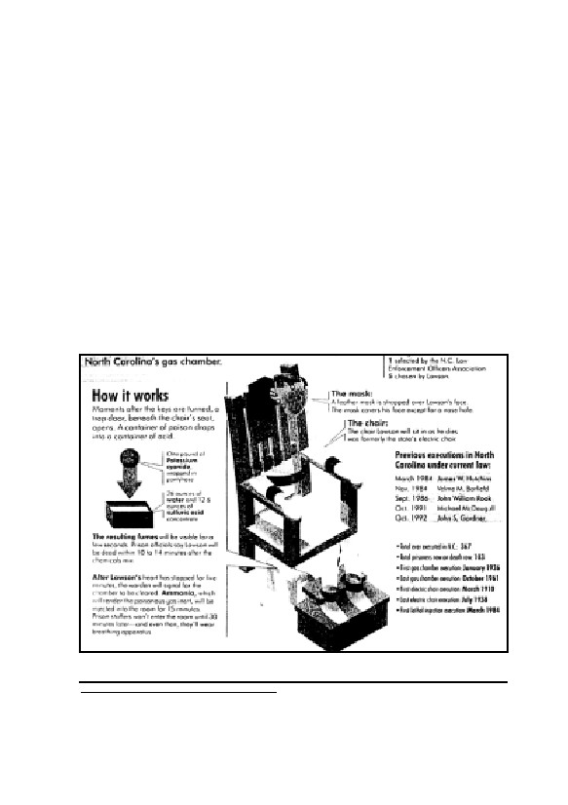
1. Prelude
1.1. Slow Death in U.S. Gas Chambers
On June 15, 1994, dramatic events unfolded during the execution
of capital punishment. David Lawson, sentenced to death for a capital
felony, was scheduled to be killed by hydrogen cyanide in the gas
chamber located in the state prison of Raleigh, North Carolina—but
the prisoner refused to assist his executioners.1 Lawson repeatedly held
his breath for as long as possible and took only short breaths in be-
tween.2 Lawson exhibited enormous willpower, calling out to both
executioners and witnesses throughout his execution:
Fig. 1: Schematic drawing of the
US execution gas chamber in North Carolina:4
1
A detailed description of this execution can be found at: Bill Krueger, “Lawson’s Final Mo-
ments”, The News & Observer, Raleigh, North Carolina, June 19, 1994, p. A1.
2
Newsweek, November 8, 1993, p. 75; The New York Times, October 6, 1994, p. A20; ibid.,
11

GERMAR RUDOLF · THE RUDOLF REPORT
“I am human.”
At first his cry was clearly audible but as the minutes went by he
became less and less understandable and finally, more than ten minutes
into the execution, there was just a mutter. He was declared dead only
after eighteen minutes. The witnesses to the execution were horrified.
The warden of the prison who had also supervised the execution was
so shaken that he resigned. Because of this execution fiasco, execu-
tions with poison gas have been abandoned for a short period of time
in the USA and replaced with lethal injections.
In early March 1999, however, this horror had already been for-
gotten. This time, the victim was a German national. Despite interven-
tion by the German government, Walter LaGrand was executed in the
state prison at Florence, Arizona. LaGrand’s death struggle against
lethal cyanide gas lasted eighteen minutes. Thirty witnesses peered
through a bulletproof window as the confessed, convicted murderer
died horribly behind an armor-reinforced door.3
It is now clear to the experts, and especially to those still waiting
on death row, that a quick and painless execution by gas requires the
cooperation of the intended victim. Prisoners about to be gassed were
usually encouraged to inhale deeply as soon as the cyanide was re-
leased in order to make their deaths come easily. However, if an in-
tended victim was uncooperative, the execution could easily become a
fiasco. By simply refusing to take the deep breaths needed to quickly
ingest a lethal dose of cyanide, the agony could last for more than
eighteen minutes, even under ideal conditions. Publications in the
United States reveal that executions lasting from 10 to 14 minutes are
the rule, rather than the exception. Amnesty International calls them
“botched executions”.4-7
June 16, 1994, p. A23.
3
Bettina Freitag, “Henker warten nicht”, New Yorker Staats-Zeitung, March 13-19, 1999, p. 3.
4
The News & Observer, Raleigh (NC), June 11, 1994, p. 14A (according to the prison warden,
normally 10-14 min.).
5
C.T. Duffy, 88 Men and 2 Women, Doubleday, New York 1962, p. 101 (13-15 min.); C.T.
Duffy was warden of San Quentin Prison for almost 12 years, during which time he ordered
the execution of 88 men and 2 women, many of them executed in the local gas chamber.
6
Stephen Trombley, The Execution Protocol, Crown Publishers, New York 1992, p. 13 (ap-
proximately 10 minutes or more.); Amnesty International, Botched Executions, Fact Sheet
December 1996, distributed by Amnesty International USA, 322 Eighth Avenue, New York,
NY 10001-4808 (more than 7 min).
7
These paragraphs are based on an article by Conrad Grieb, “The Self-assisted Holocaust
Hoax” (available online only: http://www.codoh.com/gcgv/gcgvself.html); Ger.: “Der
12

1. PRELUDE
The method used in American execution gas chambers was intro-
duced in 1924, and has since been improved to technical perfection.
The expense to kill just one single person is tremendously high, since
neither the witnesses, nor the prison personnel or the environment may
be endangered by the poison gas released for such an execution. Re-
inforced-glass windows, massive, heavy, hermetically-sealed steel
doors, powerful ventilation systems with a device to burn the evacu-
ated poisonous gases, and a chemical treatment of the chamber interior
to neutralize all remaining traces of the poison make this execution
method the most a cumbersome of all.8
During the last two decades of the 20th century, the only technical
expert in the United States able to build and maintain this equipment
was Frederick A. Leuchter Jr., sometimes referred to in the media as
“Mr. Death”,9 since his profession was the design, construction and
maintenance of various kinds of execution devices.10
A feature article in The Atlantic Monthly (Feb. 1990), for example,
factually described Leuchter as
“the nation’s only commercial supplier of execution equipment. […]
A trained and accomplished engineer, he is versed in all types of execu-
tion equipment. He makes lethal-injection machines, gas chambers, and
gallows, as well as electrocution systems […]”
Similarly, a lengthy New York Times article (October 13, 1990),
complete with a front-page photo of Leuchter, called him
“The nation’s leading adviser on capital punishment.”
In his book about “America’s Capital Punishment Industry”, Ste-
selbstassistierte Holocaust-Schwindel”, Vierteljahreshefte für freie Geschichtsforschung, 1(1)
(1997), pp. 6ff. (online: www.vho.org/VffG/1997/1/Grieb1.html) (subsequently abbreviated as
VffG).
8
Re. the technical proceedings cf.: F. A. Leuchter, The Third Leuchter Report, Samisdat Pub-
lishers Ltd., Toronto 1989 (online:
www.zundelsite.org/english/leuchter/report3/leuchter3.toc.html).
9
Such is the title of a documentary movie directed by Errol Morris about Fred Leuchter, shown
at the Sundance Film Festivals in Park City (Utah, USA) in late January 1999: “Mr. Death:
The Rise and Fall of Fred A. Leuchter, Jr.” There are actually several versions of this movie,
the one offered as a VHS video for retail being massively reworked.
10
The following paragraphs were taken from Mark Weber, “Probing Look at ‘Capital Punish-
ment Industry’ Affirms Expertise of Auschwitz Investigator Leuchter”, The Journal of Histori-
cal Review 17(2) (1998), pp. 34ff. (subsequently abbreviated as JHR); Ger.: “Ein prüfender
Blick in Amerikas ‘Todesstrafen-Industrie’ bestätigt das Leuchter-Gutachten”, VffG, 2(3)
(1998), pp. 226ff. (online: www.vho.org/VffG/1998/3/Buecher3.html)
13

GERMAR RUDOLF · THE RUDOLF REPORT
phen Trombley confirms that Leuchter is, in fact,11
“America’s first and foremost supplier of execution hardware. His
products include electric chairs, gas chambers, gallows, and lethal injec-
tion machines. He offers design, construction, installation, staff training
and maintenance.”
Killing someone in a gas chamber is very dangerous for those who
carry out the execution, above all because the body of the dead pris-
oner is saturated with lethal gas. After the execution, explains
Leuchter:12
“You go in. The inmate has to be completely washed down with
chlorine bleach or with ammonia. The poison exudes right out through
his skin. And if you gave the body to an undertaker, you’d kill the under-
taker. You’ve got to go in, you’ve got to completely wash the body.”
Bill Armontrout, warden of the Missouri State Penitentiary in Jef-
ferson City, confirms the danger:13
“One of the things that cyanide gas does, it goes in the pores of
your skin. You hose the body down, see. You have to use rubber gloves,
and you hose the body down to decontaminate it before you do anything
[else]”
In Leuchter’s opinion, gas chamber use should be discontinued,
not just because of the cruelty of this method of execution, but because
of his beliefs relating to gas chambers as such:14
“They’re dangerous. They’re dangerous to the people who have to
use them, and they’re dangerous for the witnesses. They ought to take all
of them and cut them in half with a chain saw and get rid of them.”
With a career built on the motto “Capital punishment, not capital
torture”, Leuchter takes pride in his work. He is glad to be able to en-
sure that condemned prisoners die painlessly, that the personnel who
carry out executions are not endangered, and that taxpayer dollars are
saved.
11
Stephen Trombley, op. cit. (note 6), p. 8.
12
Ibid., p. 98.
13
Ibid., p. 102
14
Ibid., p. 13.
14
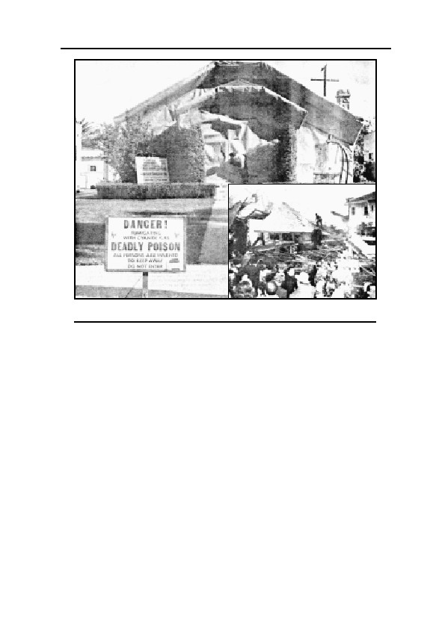
1. PRELUDE
Fig. 2: How to get rid of termites: Larger photo: Before. Smaller
photo: After.
1.2. Hydrogen Cyanide—a Dangerous Poison
Hydrogen cyanide, is not, of course, utilized solely for the purpose
of executions in American gas chambers, but for much more construc-
tive purposes as well. Since approximately the end of WWI, hydrogen
cyanide, or HCN, has been used to exterminate vermin such as bed-
bugs, lice, corn weevils, termites, cockroaches, and other pests. It is, of
course, important to be extremely cautious while applying hydrogen
cyanide in order to avoid disaster, because it is in many ways a highly
dangerous poison.
The residents of a house in Los Angeles, California, had to learn
this in a quite painful way shortly before Christmas 1947. They had
hired the Guarantee Fumigation Company to destroy the termites
which threatened to eat up the wooden structure. The pest controllers,
however, were apparently not very competent, because when using a
container of pressurized HCN to fill the house, which had been
wrapped up like a Christmas present, they exceeded safe limits and
15

GERMAR RUDOLF · THE RUDOLF REPORT
pumped in too much gas. (Fig. 2).15 Due to unknown reasons, the mix-
ture of air and HCN, which can be highly explosive under certain cir-
cumstances, ignited during the fumigation. The resulting explosion
destroyed the entire dwelling.16
However, hydrogen cyanide has yet another insidious characteris-
tic: it is highly mobile. This mobility is highly welcome when it comes
to killing vermin: Wherever fleas and bugs try to hide, the gas will still
reach them! Unfortunately, hydrogen cyanide does not restrict itself to
attack vermin. Rather, it indiscriminately seeps into the smallest cracks
and even penetrates porous substances such as felt sealing materials
and thin walls, thereby leaking into areas where it is not welcome. The
failure on the part of disinfestors to ensure that all places to be fumi-
gated are adequately sealed off have been described in toxicological
literature:17
“Example: J.M., a 21 year old female home decorator, was work-
ing in the cellar of the house, the second floor of which was being treated
for vermin with cyanide gas. Due to insufficient sealing during fumiga-
tion, the gas penetrated the corridors, where it poisoned the disinfestor,
and reached the cellar through air shafts. Mrs. M. suddenly experienced
an intense itching sensation in her throat followed by headache and diz-
ziness. Her two fellow workers noticed the same symptoms and they all
left the cellar. After half an hour, Mrs. M. returned to the cellar where-
upon she suddenly collapsed and fell unconscious. Mrs. M. was taken to
a hospital together with the unconscious exterminator. Mrs. M. recov-
ered and was released. The exterminator, by contrast, was pronounced
dead on arrival.”
But the dangers of this type of poison gas are not merely restricted
to persons in the same house in which fumigation is taking place.
Large quantities of gas may penetrate the open air and endanger the
entire neighborhood, as shown by an accident in the fall of 1995 in a
Croatian holiday resort:18
15
A gassing requires 1-2% by volume, while an explosion requires 6% by volume or more; see,
in this regard, chapter 6.3.
16
“How to get rid of termites”, Life, Dec. 22, 1947, p. 31; see also Liberty Bell, 12/1994, pp. 36f.
17
S. Moeschlin, Klinik und Therapie der Vergiftung, Georg Thieme Verlag, Stuttgart 1986, p.
300.
18
dpa, “Dilettantische Kammerjäger”, Kreiszeitung, Böblinger Bote, Nov. 16, 1995, p. 7. Re-
search has failed to determine which toxic gas was involved. Since hydrogen cyanide is one of
the most poisonous and most rapidly diffusing of all gases used in disinfestation, the reported
damage would have been at least as great if caused by hydrogen cyanide, even if hydrogen
cyanide was not in fact involved in this accident. A number of additional examples are de-
16

1. PRELUDE
“That failed profoundly. Three local residents suffering from symp-
toms of poisoning and a number of surviving woodworms were the re-
sults of the botched action against vermin in a church in the Croatian
holiday resort Lovran, close to Rijeka. The exterminator’s clumsy work
necessitated the evacuation of several hundred residents of the locality.
The exterminators tried to treat the Church of the Holy Juraj for
woodworm during the night, using the highly toxic gas. But since they
failed to seal off the church appropriately, the gas seeped into surround-
ing houses in which people were already asleep. ‘Fortunately, the people
woke up immediately because of sudden attacks of nausea—that’s what
saved them from certain death,’ wrote the newspaper, ‘Vecernji List’.
Three residents nevertheless suffered severe intoxication. The mayor de-
cided to evacuate the center of the town. The exterminators were ar-
rested. The woodworms survived. dpa”
But that is still not all: on top of this, hydrogen cyanide is also a
tenacious poison. It adheres wherever it is utilized, especially in a
moist environment. Deadly cyanide gas continues to evaporate slowly
from moist objects for hours and days, involving a permanent envi-
ronmental hazard where sufficient ventilation cannot be assured. This
is emphasized by an especially dramatic and simultaneously macabre
accident in the United States in the fall of 1998:
Oct. 10, 1998
Suicide fumes sicken
nine Iowa students
GRINNELL, Iowa (CPX) A student at Grinnell College
committed suicide by swallowing so much potassium cyanide
that the fumes from his body sickened nine people.
Two college staff members, three students and four para-
medics were weakened and nauseated by the fumes after en-
countering the student’s body Monday. They were treated and
scribed by K. Naumann: “Die Blausäurevergiftung bei der Schädlingsbekämpfung”,
Zeitschrift für hygienische Zoologie und Schädlingsbekämpfung, 1941, pp. 36-45.
17

GERMAR RUDOLF · THE RUDOLF REPORT
released from a local hospital.
Carl T. Grimm, 20, a sophomore from Placentia, Calif.,
swallowed a crystalline form of potassium cyanide, which pre-
vents oxygen from entering cells. He immediately asked his
roommate to call for help but not before the chemical reacted
with water in his body and began to produce cyanide gas, a
spokesman for the college said.
Grimm’s residence hall at the private liberal arts college
located about 50 miles east of Des Moines was evacuated be-
cause of the fumes. Grinnell Regional Medical Center, where
Grimm’s body was taken, also had to be aired out.
College officials are still trying to determine how Grimm
got the potassium cyanide and why he wanted to kill himself. [19]
Another case, which occurred somewhat differently, nevertheless
led to an accident which was no less tragic. Salts of cyanide, which
release cyanide gas in the presence of moisture, are used for the
separation of gold and silver during the processing of precious metals.
In the case in question, a company was engaged in the processing of
the cyanide-rich residues of such chemical reactions contained in large
tanks, which is not without risk. The employer directed the workers,
who were not equipped with gas masks or protective clothing, to go
into the tanks which were still releasing cyanide gas. The conse-
quences were tragic.
Department of Justice National News Release
MONDAY, MAY 10, 1999
On May 7, the jury in Pocatello, ID, found that Allan Elias
ordered employees of Evergreen Resources, a fertilizer manu-
facturing company he owned, to enter and clean out a 25,000-
gallon storage tank containing cyanide without taking required
precautions to protect his employees. Occupational Safety and
Health Administration inspectors repeatedly had warned Elias
19
www.mankato.msus.edu/depts/reporter/reparchive/10_15_98/campuscope.html
18

1. PRELUDE
about the dangers of cyanide and explained the precautions he
must take before sending his employees into the tank, such as
testing for hazardous materials and giving workers protective
gear.
Scott Dominguez, an Evergreen Resources employee, was
overcome by hydrogen cyanide gas while cleaning the tank and
sustained permanent brain damage as a result of cyanide poi-
soning.[…]
Over a period of two days in August 1996, Elias directed
his employees—wearing only jeans and T-shirts—to enter an
11-foot-high, 36-foot-long storage tank and clean out cyanide
waste from a mining operation he owned. Elias did not first test
the material inside the tank for its toxicity, nor did he deter-
mine the amount of toxic gases present. After the first day of
working inside the tank, several employees met with Elias and
told him that working in the tank was giving them sore throats,
which is an early symptom of exposure to hydrogen cyanide
gas.
The employees asked Elias to test the air in the tank for
toxic gases and bring them protective gear—which is required
by OSHA and which was available to the defendant free of
charge in this case. Elias did not provide the protective gear,
and he ordered the employees to go back into the tank, falsely
assuring them that he would get them the equipment they
sought. Later that morning, Dominguez collapsed inside the
tank. And he could not be rescued for nearly an hour because
Elias also had not given employees the required rescue equip-
ment.[20]
Even this example fails to convey the full scope of the insidious
nature of cyanide gas, since it does not just kill by means of inhalation;
even a gas mask may prove insufficient, especially if a person is sweat-
ing heavily. Hydrogen cyanide is dissolved most readily on moist sur-
20
www.osha.gov/media/oshnews/may99/national-19990510.html; see also The Plain Dealer,
Dec. 19, 1999, p. 30A; Nation—The Orange County Register, Jan. 9, 2000, News 11; Allan
Elias was sentenced to 17 years imprisonment on April 28, 2000, APBnews.com, April 29,
2000, www.apbnews.com/safetycenter/business/2000/04/29/safetycrime0429_01.html and
…/safetycrime0429_doc.html: The cyanide-contaminated sludge in the tank also contained
phosphoric acid, resulting in the release of cyanide gas.
19
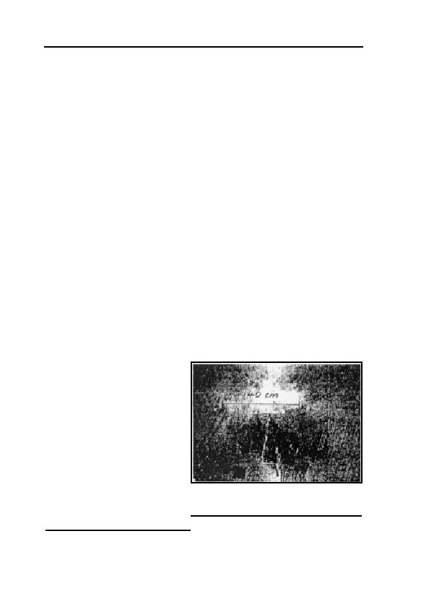
GERMAR RUDOLF · THE RUDOLF REPORT
faces, and it easily penetrates the skin. This was proven by a dramatic
accident in 1995 in a cave in the French city of Montérolier:21
“The death of nine persons on June 21, 1995, in the cave of
Montérolier (Seine-Maritime) was said to have been caused by the re-
lease of cyanide gas originating from the poison gas used during First
World War, the so-called Vincennite. This was announced Wednesday by
former Professor of Physical Chemistry, Louis Soulié. […] At a press
conference in Buchy, he said that ‘neither the children nor the firemen
rushing to the rescue—one of whom wore a gas mask—died of carbon
monoxide poisoning.’
[…] ‘Even six days after their deaths, a cyanide concentration twice
as high as the fatal dose was still observed in the victims’ blood.’
According to the professor’s remarks, the three children lit a fire in
the cave and threw a Vincennite bomb found in the cave into the fire. The
bomb exploded. The gas caused the deaths of three children, four fire-
men, the father of one of the children and an amateur spelunker.
According to Prof. Soulié, the deaths of the firemen looking for the
children in the cave, including the fireman wearing a gas mask, were due
to the fact that hydrogen cyanide dissolves in the sweat and penetrates
the body through the skin, where it causes poisoning.”
1.3. The Acid that Causes Blue Stains
Great excitement was
caused by a strange occur-
rence in a Protestant church at
Wiesenfeld, Lower Bavaria,
Germany, in the spring and
summer of 1977. The congre-
gation had renovated the dete-
riorating church at great ex-
pense during the previous
year, but now they faced a
disaster. Huge blue stains
Fig. 3: Inky blue stains on the plaster
of a church fumigated with hydrogen
were found to have formed in
cyanide.
all parts of the plastered inte-
21
“Un expert évoque la présence de gaz mortel dans la grotte”, Le Quotidien de la Réunion,
June 25, 1998.
20
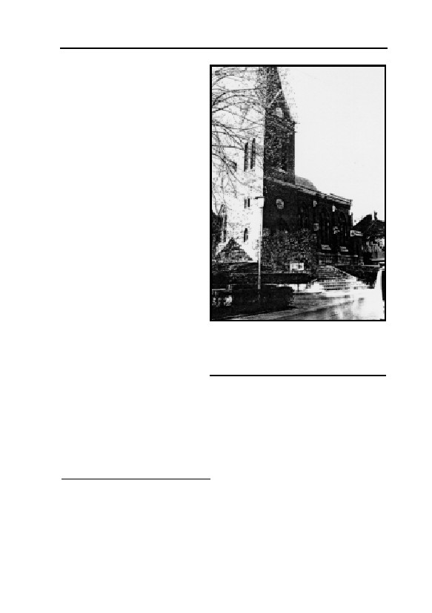
1. PRELUDE
rior of the church. The experts
having renovated the church
were now called in for consul-
tation, and found themselves
confronted by a riddle which
was only solved by a chemical
analysis of the stained por-
tions of the walls. The entire
interior surface of the church
was impregnated by Iron
Blue. No explanation could be
found for this in the literature.
It nevertheless proved possi-
ble to reconstruct the se-
quence of events.
A few weeks after the re-
plastering of the church with a
water-resistant cement mortar,
the entire church had been
fumigated with Zyklon B (hy-
drogen cyanide) to extermi-
Fig. 4: In August 1976, the Protestant
church at D-96484 Meeder-Wiesenfeld
nate woodworm in the choir
was fumigated with Zyklon B.
stalls. The hydrogen cyanide,
Subsequently, blue-colored stains
released by the Zyklon B, did appeared all over the plaster (see Fig. 3).
not just kill woodworm: it
also reacted chemically with the plaster. The hydrogen cyanide con-
tained in the Zyklon reacted with the iron oxides contained in quanti-
ties of 1-2% in all plasters, thus forming Iron Blue, a highly stable
compound well-know for centuries.22
Reports of blue pigmentation of walls resulting from fumigation
with hydrogen cyanide for the destruction of vermin in areas with
22
G. Zimmermann (ed.), Bauschäden Sammlung, volume 4, Forum-Verlag, Stuttgart 1981, pp.
120f., relating to the case of building damage occurring in August 1976 in the Protestant
church at D-96484 Meeder-Wiesenfeld. We wish to thank Mr. W. Lüftl, Vienna, for discover-
ing this information, as well as Mr. K. Fischer, Hochstadt am Main, who was held liable for
damages as responsible architect, and who supplied me with further details. Reproduced from:
E. Gauss (alias Germar Rudolf), “Wood Preservation through Fumigation with Hydrogen
Cyanide: Blue Discoloration of Lime- and Cement-Based Interior Plaster”, in: E. Gauss (ed.),
Dissecting the Holocaust, Theses & Dissertations Press, Capshaw, AL, 2000, pp. 555-559
(online: www.vho.org/GB/Books/dth/fndwood.html).
21

GERMAR RUDOLF · THE RUDOLF REPORT
moist, ferrous plaster are well-known in technical literature, as shown
by a recent survey.23 The necessary prerequisite for this reaction ap-
pears to be that the fumigated plaster must be new and must exhibit
high humidity. In other cases, there was also damage to the structure
and interior installations, but no blue stains, perhaps because the plas-
ter was old and had already set.24
23
E. Emmerling, in: M. Petzet (ed.), Holzschädlingsbekämpfung durch Begasung, Arbeitshefte
des Bayerischen Landesamtes für Denkmalpflege (Working Notebooks of the Bavarian State
Office for Monument Maintenance), vol. 75, Lipp-Verlag, Munich 1995, pp. 43-56. Whether
the examples cited in the paper may perhaps refer to the above mentioned case only in a
roundabout way, must remain open for the time being. Carl Hermann Christmann reports the
case of a farm building belonging to an 18th century monastery; the farm building was sold to
a farmer following secularization, and the farmer then used it as a barn. Approximately 20
years ago, an investor converted the beautiful Baroque building into a luxury holiday restau-
rant. The existing interior plaster was repaired and painted white. After some time, blue stains
appeared in the white paint; the stains were identified by a consulting expert as Iron Blue. The
expert assumed that the former owner must have fumigated the building with hydrogen cya-
nide between 1920 and 1940, which then caused the stains 40-50 years later. Personal com-
munication from C.H. Christmann according to his recollection on July 13, 1999; Mr. Christ-
mann was unfortunately unable to find the source of the information. I would be extremely
grateful for any references to passages in the literature in relation to this case.
24
In one case, the fumigation of a church freshly painted with iron-free lime paint led to dark
stains caused by the polymerization of hydrogen cyanide: D. Grosser, E. Roßmann,
“Blausäuregas als bekämpfendes Holzschutzmittel für Kunstobjekte”, Holz als Roh- und
Werkstoff, 32 (1974), pp. 108-114.
22

2. The Coup
2.1. Fred Leuchter on Auschwitz and Majdanek
On February 3, 1988, Fred Leuchter received an unexpected visi-
tor at his home in Boston, Massachusetts. A professor of French,
Greek, Latin, as well as critic of testimonies, texts and documents from
the University of Lyon II—Dr. Robert Faurisson—had an unusual as-
signment in mind: He wanted to persuade Leuchter, in his capacity as
an expert in execution technology, to prepare a professional opinion to
be used in a criminal trial then taking place in Toronto, Canada.25 More
precisely, Dr. Faurisson wanted to convince Leuchter to determine
whether or not the generally alleged mass exterminations with hydro-
gen cyanide gas in the concentration camps of the Third Reich were
technically possible. Until that time, Leuchter had never questioned the
existence of German homicidal gas chambers. When Prof. Faurisson
showed him some mostly technical documents, however, Leuchter be-
gan to have doubts about the technical feasibility of the alleged homi-
cidal gassings and agreed to come to Toronto to view additional docu-
mentation.
After this meeting and on the assignment of defense counsel, he
then traveled to Poland with his wife who was also his secretary, his
draftsman, a video cameraman and a translator, to make a technical
examination of the concentration camps at Auschwitz, Auschwitz-
Birkenau and Majdanek for the above trial. He returned to the United
States and wrote a 192-page report (incl. appendices). He also brought
32 test samples taken from the masonry in the crematoria at Auschwitz
and Birkenau, the locations where the alleged gassings are said to have
taken place, as well as from a delousing gas chamber. The background
of these samples is as follows:
25
Re. background and course of the criminal proceedings cf.: R. Lenski, The Holocaust on Trial,
Reporter Press, Decatur, Alabama 1990, abridged transcript of the trial against Ernst Zündel in
Toronto 1988; Ger.: Der Holocaust vor Gericht, Samisdat Publishers Ltd., Toronto 1996
(online: www.zundelsite.org/german/lenski/lenskitoc.html); a lengthy compilation of the en-
tire trial: Barbara Kulaszka (ed.), Did Six Million Really Die? Report on the Evidence in the
Canadian “False News” Trial of Ernst Zündel—1988, Samisdat Publishers Ltd., Toronto
1992 (online: www.zundelsite.org/english/dsmrd/dsmrdtoc.html).
23
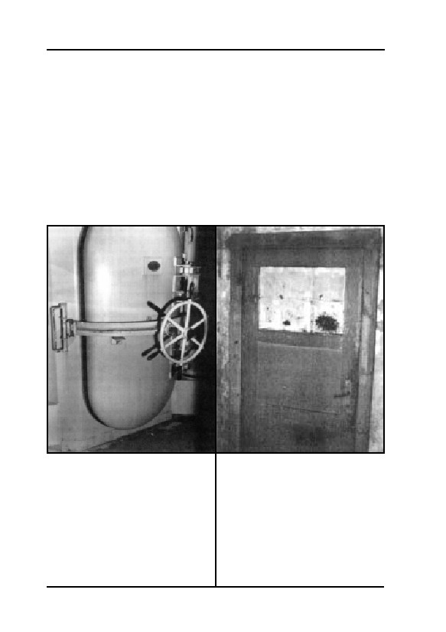
GERMAR RUDOLF · THE RUDOLF REPORT
Almost all the concentration camps of the Third Reich contained
facilities for the disinfestation of lice carried by inmate clothing. Vari-
ous methods were used to accomplish this objective: hot air, hot steam,
several different poison gases, and towards the end of the war even
microwaves. Delousing was urgently needed in particular because lice
carry epidemic typhus, a disease with a history of repeated outbreaks in
eastern and central Europe. Epidemic typhus appeared again during
WWII where it claimed hundreds of thousands of victims, not only in
the concentration camps and prisoner-of-war camps, but among sol-
diers at the front. Since WWI, the most effective and the most widely
used means for the extermination of lice and other pests, was hydrogen
cyanide, marketed under the trade-name Zyklon B.
Fig. 5: Single door to an execution
Fig. 6: One of three doors from an
gas chamber for one single person
alleged National Socialist gas
per gassing procedure (Baltimore,
chamber for the execution of
USA, 1954, technology from the
hundreds of persons simultaneously,
1930s). The execution of a single
using Zyklon B (hydrogen cyanide)
person with hydrogen cyanide is
(crematorium I, Auschwitz, Poland,
inevitably far more complicated and
early 1940s). This door is neither of
dangerous to the environment than
sturdy construction, nor is it air-tight
the fumigation of clothing (even in a
(note the keyhole). It is partly glazed
DEGESCH circulation chamber).
and opens inwards i.e., into the room,
where corpses were allegedly piling
up.
24
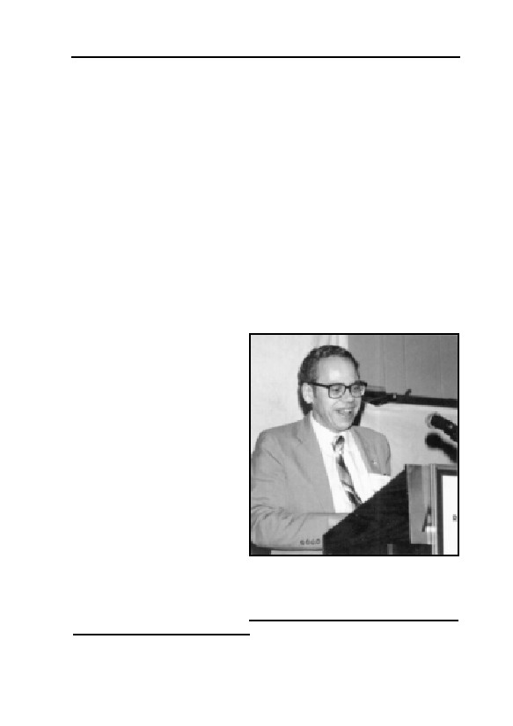
2. THE COUP
It has been known for decades that the walls within the buildings
in which Zyklon B is proved to have been used to delouse inmate
clothing exhibit massive, blotchy, bluish discoloration. This blue dis-
coloration is due to a chemical substance known as Iron Blue which,
under the right conditions, is formed in a chemical reaction by hydro-
gen cyanide with certain components of masonry. This substance can
still be observed in surviving delousing facilities today. It is obviously
a very stable compound. Professor Faurisson was the first person to
point out that this blue discoloration is absent from the supposed homi-
cidal gas chambers at Auschwitz. Faurisson’s idea was to analyze
samples from the masonry in the alleged homicidal gas chambers for
traces of poison gas or its compounds (cyanides) and compare them
with samples taken from the delousing chambers. Fred Leuchter fol-
lowed this suggestion when doing his on-site investigations in Ausch-
witz in 1988.
On April 20 and 21, 1988, Leuchter took the stand as an expert
witness in the courtroom in Toronto. He reported about his research
and developed his conclu-
sions. The atmosphere in the
courtroom was tense. Leu-
chter’s testimony was straight-
forward and at the same time
sensational: According to
Leuchter, there had never
been any possibility of mass
extermination of human be-
ings by gassing in Auschwitz,
nor in Birkenau, nor in Ma-
jdanek:26
“It is the best engineer-
ing opinion of this author
that the alleged gas cham-
Fig. 7: Frederick A. Leuchter, the
bers at the inspected sites
world’s first, and possibly only, cyanide
could not have then been, or
gas chamber expert, during a talk at
now, be utilized or seriously
the conference of the Institute for
Historical Review in 1992
considered to function as
26
F. A. Leuchter, An Engineering Report on the alleged Execution Gas Chambers at Auschwitz,
Birkenau and Majdanek, Poland, Samisdat Publishers Ltd., Toronto 1988, 195 pp.; Ger.: Der
erste Leuchter Report, ibid., 1988 (online: ihr.org/books/leuchter/leuchter.toc.html).
25

GERMAR RUDOLF · THE RUDOLF REPORT
execution gas chambers.”
Shortly before Leuchter, another witness was questioned: Bill Ar-
montrout, Warden of the Maximum Security Prison in Jefferson City,
Missouri. It was Armontrout who, on request of defense attorney
Barbara Kulaszka, pointed out that no one in the United States under-
stood the operation of gas chambers better than Fred A. Leuchter.
Armontrout himself confirmed in Court the great difficulties involved
in killing people with poison gas, as Robert Faurisson had done before
him.
Following Leuchter, Prof. James Roth, director of a chemical
laboratory in Massachusetts, also took the witness stand to describe the
results of his analysis of the 32 masonry samples, the origins of which
had been unknown to him: All samples taken from the gas chambers
supposedly used for mass human extermination exhibited either no or
only negligible traces of cyanide, while the sample from the delousing
chambers taken for use as control purposes exhibited enormously high
cyanide concentrations.27
Leuchter’s report and subsequent testimony shook the foundations
of Holocaust history, the story of the ‘Nazi gas chambers’. Considering
the tens of thousands of copies of this “Leuchter Report” that have
been distributed in all major languages all over the world and the many
speeches Leuchter held, the impact of the work of this one man was
enormous.
2.2. Damage Control
Alarmed by this development, the ‘Never Forgive, Never Forget’
brigade wasted no time in taking counter-measures. Self-styled ‘Nazi
hunter’ Beate Klarsfeld announced that Fred Leuchter “has to under-
stand that in denying the Holocaust, he cannot remain unpunished.”28
Jewish organizations launched a vicious smear campaign to de-
stroy not only his reputation, but his ability to make a living. Leading
the charge was Shelly Shapiro and her group, “Holocaust Survivors
27
Partially derived from Prof. Faurisson’s description in: “Zum Zündel-Prozeß in Toronto, Teil
2. Vorgeschichte—Ablauf—Folgen”, Deutschland in Geschichte und Gegenwart 36(4) (1988),
pp. 4-10 (online: http://www.vho.org/D/DGG/Faurisson36_4.html) (hereafter abbreviated as
DGG).
28
This paragraph is again quoted acc. to Mark Weber, who gives no reference for this alleged
quote of Beate Klarsfeld in his article op. cit. (note 10),.
26

2. THE COUP
and Friends in Pursuit of Justice”. Calling Leuchter a fraud and impos-
tor, this group claimed, despite better knowledge, that he lacked quali-
fications as an execution equipment specialist and had asserted the
possession of professional qualifications which he had never earned.29
Although these accusations were entirely unfounded and failed to
survive any legal verification, the ‘get Leuchter’ campaign, with the
co-operation of mainstream journalists and editors, was successful.
Leuchter’s contracts with state authorities for the manufacture, installa-
tion, and servicing of execution hardware were cancelled. He was fi-
nancially forced out of his home in Massachusetts and had to find pri-
vate work elsewhere. No American has suffered more for his defiance
of the Holocaust lobby.
29
Cf. JHR, 12(4) (1992), pp. 421-492 (online:
www.vho.org/GB/Journals/JHR/12/index.html#4).
27

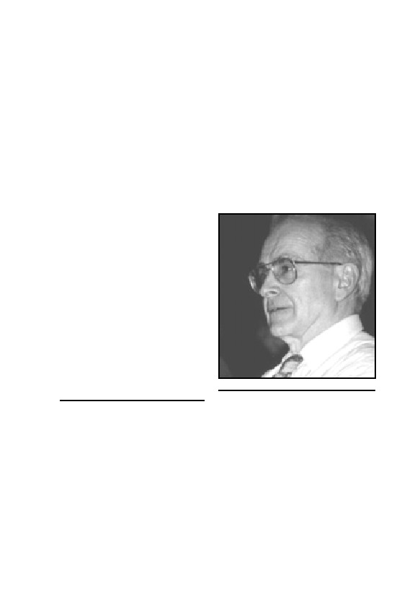
3. The Origins
Before the publication of the Leuchter Report, discussion relating
to the reliability of eyewitness testimony of National Socialist mass
murder was confined to groups describing themselves as ‘revisionists’,
usually termed ‘Neo-Nazis’ or ‘right-wing extremists’ by the media.
But in fact, the labels used by the media were wide off the mark, as can
be seen in the case of four of the most well-known revisionists: Paul
Rassinier, French Socialist and former member of the French Resis-
tance, who was an inmate of the concentration camps Buchenwald and
Dora-Mittelbau;30 German Jew, Josef Ginsburg, who suffered from
anti-Jewish measures taken dur-
ing WWII by other countries as
well as Germany.31 The two most
notable revisionists, Professors
Arthur R. Butz, USA,32 and re-
tired Prof. Robert Faurisson, of
France, can certainly not be ac-
cused of being political extrem-
ists, and nobody ever seriously
tried to do this.33
The discussion on the tech-
nical problems of the National
Socialist mass-murder of the
Jews was begun in the late 1970s
Fig. 8: Prof. Dr. Robert Faurisson
30
Cf. his four most-important works: Die Lüge des Odysseus, K.-H. Priester, Wiesbaden 1959;
Was nun, Odysseus?, ibid. 1960; Das Drama der Juden Europas, H. Pfeiffer, Hannover 1965;
Was ist Wahrheit?, Druffel, Leoni 81982; Engl.: Debunking the Genocide Myth, The Noontide
Press, Los Angeles, 1978 (online: abbc.com/aaargh/engl/PRdebunk1.html).
31
Cf. his most import works: Schuld und Schicksal, Damm-Verlag, Munich 1962 (online:
www.vho.org/D/sus); Sündenböcke, Verlag G. Fischer, Munich 1967; NS-Verbrechen—
Prozesse des schlechten Gewissens, ibid. 1968; Verschwörung des Verschweigens, Ederer,
Munich 1979; Majdanek in alle Ewigkeit?, ibid. 1979 (online: www.vho.org/D/miae); Zi-
onazi-Zensur in der BRD, ibid. 1980.
32
Cf. The Hoax of the Twentieth Century, Institute for Historical Review, Newport Beach, Cali-
fornia, 71985 (online: www.vho.org/GB/Books/thottc); “Context and perspective in the ‘Holo-
caust’ controversy”, JHR, 3(4) (1982), pp. 371-405. (online:
www.vho.org/GB/Journals/JHR/3/4/Butz371-405.html).
33
Cf. Mémoire en défense, La Vieille Taupe, Paris 1980; Serge Thion (ed.), Vérité historique ou
vérité politique?; La Vielle Taupe, Paris 1980 (online: abbc.com/aaargh/fran/histo/SF1.html);
R. Faurisson, Écrits révisionnistes, 4 vols., published by author, Vichy 1999.
29

GERMAR RUDOLF · THE RUDOLF REPORT
by Robert Faurisson, then Professor of French, Greek and Latin, and an
analyst of documents, texts, and witness statements at the University of
Lyon II. He began to question the standard historical version of the
Holocaust after he had made numerous critical studies concerning wit-
ness testimony and on documents that supposedly supported the claims
of mass-murder. In 1978 for the first time, he advanced the argument
that “there had not been one single gas chamber under Adolf Hitler”.34
Later he supported this claim with physical, chemical, topographic,
architectural, documentary, and historical arguments. He described the
existence of the homicidal gas chambers as “radically impossible”.35
At the end of 1979, the largest French daily newspaper, Le Monde, de-
cided to publish Professor Faurisson’s provocative thesis, so he was
given the opportunity to summarize it in an article.36 The establishment
historians reaction was characteristic37 and is best illustrated by a pas-
sage from a declaration signed by Pierre Vidal Naquet and 33 other
researchers:38
“One may not ask how such a mass-murder [of Jews] was possible.
It was technically possible, because it happened. This is the obligatory
starting-point of every historical investigation of this subject. We simply
want to call into memory this truth: There is no debate over the existence
of the gas chambers, and there must not be one.”
Such a dogmatic explanation is equivalent to a capitulation, which
was well understood. Hence, they reconsidered their standpoint and
went back to the drawing board.
Over the years that followed, establishment historians took up the
questions raised by Robert Faurisson and others, at least to some ex-
34
Cf. in addition to arguments in the works in note 33 also R. Faurisson, “Es gab keine Gas-
kammern”, Deutscher Arbeitskreis Witten, Witten 1978.
35
R. Faurisson, “Le camere a gas non sono mai esistite”, Storia illustrata, 261 (1979), pp. 15-35
(online: abbc.com/aaargh/fran/archFaur/RF7908xx2.html); Engl.: “The Gas Chambers: Truth
or Lie?” The Journal of Historical Review, 2(4) (1981), pp. 319-373 (online:
www.vho.org/GB/Journals/JHR/2/4/Faurisson319-373.html); cf. Faurisson, “The Mechanics
of Gassing”, JHR, 1(1) (1980) pp. 23ff. (online:
abbc.com/aaargh/engl/FaurisArch/RF80spring.html); Faurisson, “The Gas Chambers of
Auschwitz Appear to be Physically Inconceivable”, ibid., 2(4) (1981), pp. 311ff. (online:
www.vho.org/GB/Journals/JHR/2/4/Faurisson312-317.html)
36
“‘Le problème des chambres à gaz’ ou ‘la rumeur d’Auschwitz’”, Le Monde, Dec. 29, 1978,
p. 8; see also “The ‘problem of the gas chambers’”, JHR, 1(2) (1980), pp. 103-114 (online:
ihr.org/jhr/v01/v01p103_Faurisson.html).
37
Cf. the documentation on numerous articles and letters in R. Faurisson, Mémoire…, op. cit.
(note 33), pp. 71-101.
38
Le Monde, Feb 21, 1979.
30

3. THE ORIGINS
tent, although they doggedly refused to permit him, or any one else
who even remotely voiced similar thoughts, to participate in any aca-
demic activities. In the early 1980s, two large Holocaust conferences
were held in the cities of Paris39 and Stuttgart.40 One of the more im-
portant reasons for these conferences certainly were the works of Fau-
risson, Butz, and others.41
In 1983, as a counter-measure against the ongoing successes of re-
visionists, a compilation was published, principally the work of French
and German establishment historians.42 While this book ridiculed and
insulted revisionists and cast political aspersions against them, and at
the same time was intended to refute their claims, it does neither ad-
dress any particular revisionist argument, nor are any revisionist publi-
cations quoted or authors named, so that it is impossible to the reader
of this book to verify the polemic accusations made against the revi-
sionists. This book also repeats the mistake often emphasized by revi-
sionists: quotations from ‘eye-witness’ testimony and passages from
documents were taken out of context and pasted uncritically into a pre-
determined historical schema.
The publication of the Leuchter Report at the end of the 1980s
gave a significant boost to revisionism. From that time onward, there
has been an unending stream of publications.43 The number of persons
39
At the Sorbonne from Jun 29.—July 2., 1982, entitled “Le national-socialisme et les Juifs”; cf.
Ecole des hautes études en sciences socials (ed.), L’Allemagne nazie et le génocide juif, Gal-
limard/Le Seuil, Paris 1985; on December 11-13, 1987, there was a second Colloquium held
at the Sorbonne, cf. R. Faurisson, Écrits révisionnistes, op. cit. (note 33), vol. 2, pp. 733-750
(online: abbc.com/aaargh/fran/archFaur/RF871210.html).
40
For a transcript of the conference, cf.: Jäckel, E., J. Rohwer, Der Mord an den Juden im
Zweiten Weltkrieg, Deutsche Verlags-Anstalt, Stuttgart 1985.
41
Most importantly, Wilhelm Stäglich’s Der Auschwitz-Mythos, published in 1979, (Grabert,
Tübingen, online: www.vho.org/D/dam; Engl.: The Auschwitz Myth, Institute for Historical
Review, Torrance, CA, 1986) as well as Walter N. Sanning’s papers and book on Jewish
population statistics: “Die europäischen Juden. Eine technische Studie zur zahlenmäßigen
Entwicklung im Zweiten Weltkrieg, Teil 1-4”, DGG 28(1-4) (1980), pp. 12-15; 17-21; 17-21;
25-31; Sanning, Die Auflösung des osteuropäischen Judentums, Grabert, Tübingen 1983
(online: www.vho.org/D/DGG/Sanning28_1.html and www.vho.org/D/da); English: The Dis-
solution of Eastern European Jewry, Institute for Historical Review, Torrance, CA, 1983.
42
E. Kogon, H. Langbein, A. Rückerl et al. (eds.), Nationalsozialistische Massentötungen durch
Giftgas, S. Fischer Verlag, Frankfurt 1983; Engl.: Nazi Mass Murder, Yale University Press,
New Haven 1993; French: Henry Rollet, Les chambres à gaz secret d’Etat, Les Editions de
Minuit, Paris 1984.
43
The most important: J. Ball, Air Photo Evidence, Auschwitz, Treblinka, Majdanek, Sobibor,
Bergen Belsen, Belzec, Babi Yar, Katyn Forest, Ball Resource Service Ltd., Delta, B.C., Can-
ada 1992 (permanently updated and enhanced online: www.air-photo.com); Ernst Gauss (alias
G. Rudolf), Vorlesungen über Zeitgeschichte, Grabert, Tübingen 1993 (online:
31

GERMAR RUDOLF · THE RUDOLF REPORT
involved in ‘revisionism’ increases steadily; although in France and in
German-speaking countries, this development has been curtailed by the
enactment of laws threatening heavy penalties.44
3.1. On the Problem
A fact-oriented discussion of the technical arguments brought into
the public by the Leuchter Report was started in France by an attempt
www.vho.org/D/vuez); Gauss. (ed.), Grundlagen zur Zeitgeschichte, ibid. 1994 (online: co-
doh.com/inter/intgrundex.html); Engl.: Dissecting the Holocaust, note 22; Jürgen Graf, Der
Holocaust auf dem Prüfstand, Guideon Burg, Basel 1992 (online:
www.zundelsite.org/german/graf/Prueftoc.html); Graf, Der Holocaust-Schwindel, ibid. 1993;
Graf, Auschwitz. Tätergeständnisse und Augenzeugen des Holocaust, Verlag Neue Visionen,
Würenlos 1994 (online: www.vho.org/D/atuadh); Graf, Todesursache Zeitgeschichtsfor-
schung, ibid. 1995 (online: www.zundelsite.org/ezundel/german/graf/Graf_TOC.html); Graf
and Carlo Mattogno, KL Majdanek, Castle Hill Publishers, Hastings 1998 (online:
www.vho.org/D/Majdanek/MR.html); Graf, Mattogno, Das KL Stutthof, Castle Hill Publish-
ers, Hastings 1999 (online: www.vho.org/D/Stutthof); Jürgen Graf, Riese auf tönernen Füßen,
ibid. 1999 (online: www.vho.org/D/Riese); Engl: The Giant With Feet of Clay, Theses & Dis-
sertations Press, Capshaw, AL, 2001 (online: www.vho.org/GB/Books/Giant); Gerd Honsik,
Freispruch für Hitler, Burgenländischer Kulturverband, Vienna 1988 (online:
www.vho.org/D/ffh); Honsik, Schelm und Scheusal, Bright Rainbow, Madrid n.d. [1994];
Rüdiger Kammerer, Armin Solms (ed.), Das Rudolf-Gutachten, Cromwell, London 1993 (on-
line: www.vho.org/D/rga); Carlo Mattogno, La soluzione finale. Problemi e polemiche,
Edizioni di Ar, Padua 1991; Auschwitz. La prima gasazione, Edizioni di Ar, Padua 1992; Mat-
togno, Auschwitz: The End of a Legend, Institute for Historical Review, Costa Mesa 1994
(online: www.vho.org/GB/Books/anf/Mattogno.html); Herbert Verbeke (ed.), Auschwitz:
Nackte Fakten, Vrij Historisch Onderzoek, Berchem 1995 (online: www.vho.org/D/anf). Be-
fore the Leuchter Report, there were really only three revisionist periodicals (JHR, Annales
d’Histoire Révisionniste, Historische Tatsache, online cf.
www.vho.org/Archive.html#Journals), there are now eight—apart from various information
services and newsletters: JHR (PO Box 2739, Newport Beach, CA 92659, USA; online:
ihr.org/jhr), VffG (PO Box 118, Hastings TN34 3ZQ, UK; online: www.vho.org/VffG), The
Barnes Review (130 Third Street SE, Washington, D.C. 20003, USA; online:
www.barnesreview.org), Révision (11 rue d’Alembert, F-92130 Issy-les-Moulineaux), L’Autre
Histoire (BP 3, F-35134 Coësme), Revisionist History (PO Box 849, Coeur d’Alene, Idaho
83816, USA; online: hoffman-info.com), Akribea (45/3 route de Vourles, F-69230 Saint-
Genis-Laval; online: www.vho.org/F/j/Akribeia), Le Révisionniste (VHO, BP 46, B-2600
Berchem 1, Belgium); The Revisionist (PO Box 257768, Chicago, IL 60625, online:
www.vho.org/tr).
44
The Fabius-Gayssot Law was passed in France in 1990, rendering punishable the ‘denial of
the facts’ of the National Socialist war crimes ‘ascertained’ at the Nuremburg Trials of 1946
convened by the Allied powers. In 1993, Austria followed suit (sec. 3h Criminal Law); in
1994, Germany (sec. 130 Criminal Code, new version), in 1995, Switzerland (sec. 216bis
Criminal Code) and in 1996, Spain enacted similar laws. A similar law passed in Belgium in
1997 has not yet been enforced. Poland adopted a similar law in 2000, Hungary is currently
preparing to introduce one. Canada and Australia have created ‘Human Rights Commissions’
which persecute revisionists although there is no legal framework for this.
32

3. THE ORIGINS
at refutation by the pharmacist Jean-Claude Pressac in the periodical
Jour Juif.45 His work could hardly qualify as an expert discussion in
view of the absence of any references to his sources and any exact sci-
entific argumentation. Though he did point out several deficiencies in
the Leuchter Report, he made several errors himself in chemical and
engineering questions due to his lack of expertise.46
The first response from Germany came from the Institut für Zeit-
geschichte (IfZ, Institute for Contemporary History).47 It was based on
Pressac’s work and was hardly useful due to the lack of technical ex-
pertise in the same.48
A little later, a contribution on the Leuchter Report appeared in an
anthology on the Third Reich, authored by retired social worker
Werner Wegner, who had no qualifications in chemistry or civil engi-
neering either.49 Instead of seeking the advice of qualified people on
these matters, he drew his own conclusions—to his own massive em-
barrassment.50 One may question why Dr. Rainer Zitelmann, the re-
sponsible editor of this anthology, included this ridiculous piece in his
otherwise well-researched compilation.51
At the end of 1991, chemist Dr. J. Bailer critiqued the Leuchter
Report in a little booklet published in Austria.52 This work is notable
45
J.-C. Pressac, Jour J, December 12, 1988, pp. I-X. See also the related discussion in the un-
dated translation, without references; see also Pressac in: S. Shapiro (Ed.), Truth Prevails:
Demolishing Holocaust Denial: The End of the Leuchter Report, Beate Klarsfeld Foundation,
New York 1990.
46
On this cf. W. Schuster, “Technische Unmöglichkeiten bei Pressac”, DGG, 39(2) (1991), pp.
9-13 (online: vho.org./D/DGG/Schuster39_2); also Paul Grubach, “The Leuchter Report Vin-
dicated: A Response to Jean-Claude Pressac’s Critique”, JHR, 12(2) (1992), pp. 248ff. (on-
line: codoh.com/gcgv/gc426v12.html)
47
H. Auerbach, Institut für Zeitgeschichte, letter to Bundesprüfstelle, Munich, Oct. 10, 1989;
Auerbach, November 1989 (no day given), both published in U. Walendy, Historische Tatsa-
che no. 42, Verlag für Volkstum und Zeitgeschichtsforschung, Vlotho 1990, pp. 32 and 34.
48
In this regard, see my technical appraisal, reprinted in Henri Roques, Günter Annthon, Der
Fall Günter Deckert, DAGD/Germania Verlag, Weinheim 1995, pp. 431-435 (online:
www.vho.org/D/Deckert/C2.html).
49
W. Wegner, “Keine Massenvergasungen in Auschwitz? Zur Kritik des Leuchter-Gutachtens”,
in U. Backes, E. Jesse, R. Zitelmann (ed.), Die Schatten der Vergangenheit, Propyläen, Frank-
furt 1990, pp. 450-476 (online: www.vho.org/D/dsdv/Wegner.html, with interpolated critique
by the present writer).
50
On this cf. W. Häberle, “Zu Wegners Kritik am Leuchter-Gutachten”, DGG, 39(2) (1991), pp.
13-17 (online: www.vho.org/D/DGG/Haeberle39_2.html).
51
In a personal communication to me, he confessed that he had been forced to include the paper
to avoid opposition to his book due to the fact that the other papers were ‘revisionist’ in tone.
52
J. Bailer, “Der Leuchter-Bericht aus der Sicht eines Chemikers”, in: Amoklauf gegen die
Wirklichkeit, Dokumentationszentrum des österreichischen Widerstandes, Bundesministerium
33

GERMAR RUDOLF · THE RUDOLF REPORT
for largely ignoring the witness testimony on the procedures suppos-
edly used during the gassings at Auschwitz and for the author’s lack of
understanding of the process by which hydrogen cyanide reacts with
masonry. Despite criticism directed at his study,53 Bailer repeated his
unsustainable objections in a later publication, without responding to
his critics.54
At approximately the same time as Bailer’s first publication, G.
Wellers also published a study of the Leuchter Report. Wellers’ posi-
tion was superficial, and is characterized by lack of technical and sci-
entific knowledge.55
Finally, the Auschwitz State Museum itself ordered an expert re-
port to be compiled. The Institute for Forensic Research, Toxicology
Division, of Cracow, Poland, named after Prof. Dr. Jan Sehn, prepared
this report under Prof. Dr. J. Markiewicz on September 24, 1990,
which confined itself to the analysis of masonry samples.56 The report
concluded that the reason why Leuchter’s samples from the homicidal
gas chambers were mostly negative with respect to traces of cyanide
was because the cyanide compounds had been exposed for more than
40 years to weathering, which these compounds allegedly could not
have withstood. Three of these authors from the Jan Sehn Institute later
published additional findings,57 which were, however, based on a veri-
fiably incorrect analytical method—as was the first series of analy-
für Unterricht und Kultur (eds.), Vienna 1991, pp. 47-52. With respect to the cyanide content
of human hair: Expert Opinion of the Cracow Institute, 1945, on the cyanide content of human
hair, hair pins and a ventilation lid, B. Bailer-Galanda, ibid., pp. 36-40; the original is in the
custody of the Auschwitz State Museum.
53
Cf. E. Gauss (alias G. Rudolf), Vorlesungen…, op. cit. (note 43), pp. 290-293; Gauss,
“Chemische Wissenschaft zur Gaskammerfrage”, DGG, 41(2) (1993), pp. 16-24 (online:
vho.org./D/DGG/Gauss41_2).
54
J. Bailer, in B. Bailer-Galanda, W. Benz, W. Neugebauer (ed.), Wahrheit und Auschwitzlüge,
Deuticke, Vienna 1995, pp. 112-118; cf. my critique “Zur Kritik an ‘Wahrheit und Ausch-
witzlüge’”, in Herbert Verbeke (ed.), Kardinalfragen zur Zeitgeschichte, Vrij Historisch On-
derzoek, Berchem, 1996, pp. 91-108 (online: www.vho.org/D/Kardinal/Wahrheit.html); Engl.:
“Critique of Truth and the Auschwitz-Lie” (online: www.vho.org/GB/Books/cq/critique.html).
55
G. Wellers, “Der Leuchter-Bericht über die Gaskammern von Auschwitz”, Dachauer Hefte,
7(7) (November 1991), pp. 230-241.
56
J. Markiewicz, W. Gubala, J. Labedz, B. Trzcinska, Expert Opinion, Prof. Dr. Jan Sehn Insti-
tute for Forensic Reserach, department for toxicology, Cracow, Sept. 24, 1990; partially pub-
lished, e.g. in: “An official Polish report on the Auschwitz ‘gas chambers’”, JHR, 11(2)
(1991), pp. 207-216 (online: www.vho.org/GB/Journals/JHR/11/2/IHR207-216.html)
57
J. Markiewicz, W. Gubala, J. Labedz, Z Zagadnien Nauk Sadowych, Z XXX (1994) pp. 17-27
(online: www2.ca.nizkor.org/ftp.cgi/orgs/polish/institute-for-forensic-research/post-
leuchter.report).
34

3. THE ORIGINS
ses—so that their results were flawed.58 Correspondence with the au-
thors failed to elucidate the reasons for the deliberate use of an incor-
rect method.59
In 1997 in France, distribution of the French edition of the present
report produced two notable reactions, only one of which addressed
factual arguments,60 but which nevertheless failed to discuss the tech-
nical problems in a scientific manner.61 The Chemical Department of
the French Academy of Sciences chose not to make a comment pub-
licly on factual arguments, but rather to resort to polemic phraseology
and personal attacks.62
In 1998, in the United States, in answer to the present report, a pa-
per appeared on the Internet, consisting partly of discussion of techni-
cal issues and partly of political name-calling.63 In related correspon-
dence,64 however, the author of the paper avoided any discussion of the
central issues.65
In 1999, cultural historian Prof. Robert Jan van Pelt produced an
expert report on Auschwitz for the defense in the libel case of British
58
G. Rudolf, “Leuchter-Gegengutachten: Ein Wissenschaftlicher Betrug?”, in DGG 43(1)
(1995) pp. 22-26 (online: www.vho.org/D/Kardinal/Leuchter.html); Engl.: “Counter-Leuchter
Expert Report: Scientific Trickery?” (online: www.vho.org/GB/Books/cq/leuchter.html );
summarized in Rudolf, “A Fraudulent Attempt to Refute Mr. Death”, online:
www.vho.org/GB/c/GR/Fraudulent.html.
59
G. Rudolf and J. Markiewicz, W. Gubala, J. Labedz, “Briefwechsel”, in: Sleipnir, 1(3) (1995)
pp. 29-33; reprinted in Herbert Verbeke (ed.), op. cit. (note 54), pp. 86-90 (online Engl.: as
note 58).
60
B. Clair, “Revisionistische Gutachten”, VffG, 1(2) (1997), pp. 102-104 (online:
www.vho.org/VffG/1997/2/Clair2.html).
61
G. Rudolf, “Zur Kritik am Rudolf Gutachten”, ibid., pp. 104-108 (online:
www.vho.org/VffG/1997/2/RudGut2.html).
62
La Vielle Taupe/Pierre Guillaume, “Rudolf Gutachten: ‘psychopathologisch und gefährlich’.
Über die Psychopathologie einer Erklärung”, VffG, 1(4) (1997), pp. 224f. (online:
www.vho.org/VffG/1997/4/Guillaume4.html).
63
Richard J. Green, “The Chemistry of Auschwitz”, May 10, 1998, online: holocaust-
history.org/auschwitz/chemistry/, and “Leuchter, Rudolf and the Iron Blues”, March 25, 1998,
online: holocaust-history.org/auschwitz/chemistry/blue/, with considerable proselytizing ‘anti-
fascist’ bias.
64
A detailed description of the deficiencies of the paper appeared in “Das Rudolf Gutachten in
der Kritik, Teil 2”, VffG 3(1) (1999), pp. 77-82 (online:
www.vho.org/VffG/1999/1/RudDas3.html); Engl.: “Some considerations about the ‘Gas
Chambers’ of Auschwitz and Birkenau”, online: www.vho.org/GB/c/GR/Green.html.
65
Richard J. Green, Jamie McCarthy, “Chemistry is Not the Science”, May 2, 1999, online:
holocaust-history.org/auschwitz/chemistry/not-the-science/. About 50% of the article consists
of political accusations and vilification. For a response, see G. Rudolf, “Character Assassins”,
online: www.vho.org/GB/c/GR/CharacterAssassins.html.
35

GERMAR RUDOLF · THE RUDOLF REPORT
Historian David Irving against American writer Deborah Lipstadt.66
This report represents a retreat to the argumentative situation before
Jean-Claude Pressac’s first book, published in 1989,67 ignoring almost
all arguments brought forward by revisionists since that year.68 In
2002, however, Prof. van Pelt published a summary of the evidence
presented at said trial and his interpretation of it.69 This book is the first
in English to intensively discuss various revisionist arguments, for
which he mainly relies on the works of J.-C. Pressac.70 It is a pity,
though, that the cultural historian van Pelt tries to address many
chemical, toxicological, engineering and architectural questions for
which he simply lacks both expertise and experience.
Most of the above-mentioned attempted refutations of the
Leuchter Report, and subsequent discussion with other revisionists, are
marred by personal insinuations about the motivations of persons mak-
ing use of revisionist arguments, or by polemical excursions, neither of
which contribute to the scientific discussion.
3.2. On Politics
The question of whether or not systematic mass-killings of Jews in
homicidal gas chambers specifically constructed for the purpose of
accomplishing their extermination took place under the National So-
cialist regime is apparently viewed as a political issue. Whether or not
a moral appraisal of the National Socialist regime depends on the exis-
tence or non-existence of gas chambers is disputable. A political
evaluation of the Third Reich is not significantly dependent upon this
66
Pelt Report, introduced in evidence during the libel case before the Queen’s Bench Division,
Royal Courts of Justice, Strand, London, David John Cawdell Irving vs. (1) Penguin Books
Limited, (2) Deborah E. Lipstadt, ref. 1996 I. No. 113.
67
Jean-Claude Pressac, Auschwitz: Technique and operation of the gas chambers, Beate-
Klarsfeld-Foundation, New York 1989.
68
Cf. G. Rudolf, “Gutachter und Urteilsschelte”, VffG 4(1) (2000), pp. 33-50 (online:
www.vho.org/VffG/2000/1/Rudolf33-50.html); more exhaustively, in English, online:
www.vho.org/GB/c/GR/RudolfOnVanPelt.html and …/CritiqueGray.html.
69
Robert J. van Pelt, The Case for Auschwitz. Evidence from the Irving Trial, Indiana University
Press, Bloomington/Indianapolis 2002; cf. Robert H. Countess, “Van Pelts Plädoyer gegen
den gesunden Menschenverstand”, VffG, 6(3) 2002), pp. 349-354; Paul Grubach, “Greuel-
propaganda des Ersten Weltkriegs und der Holocaust”, ibid., pp. 354-359 (online:
www.vho.org/VffG/2002/3/Countess349-354.html and …/Grubach354-359.html).
70
When he addresses chemical questions, he also refers to some degree to the work of R. Green,
op.cit. (notes 63, 65).
36
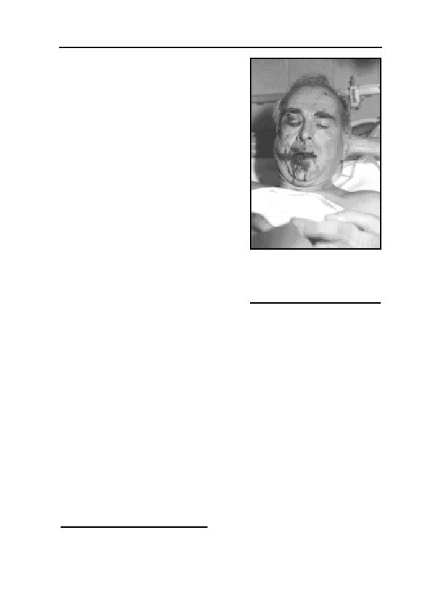
3. THE ORIGINS
moral evaluation. Since the present dis-
cussion contains neither a moral, nor
political, evaluation of a long-dead re-
gime, I shall make no moral or political
statements. Personally, I am inclined to
judge a politician, or political system,
on the basis of what he, or it, was able
to leave behind for their respective
population—everything else follows.
That must suffice at this point.
To everyone who has ever sus-
pected that revisionists are motivated by
a desire to whitewash National Social-
ism, or restore the acceptability of right-
wing political systems, or assist in a
Fig. 9: People who run out
breakthrough of Nationalism, I would
of arguments turn to
like to say the following:
violence. Prof. Faurisson
While researching, our highest goal
after an attack by Jewish
must at all times be to discover how
thugs, Sept. 16, 1989.71
historical events actually occurred—as
the 19th century German historian Leopold Ranke maintained. Histori-
ans should not place research in the service of making criminal accusa-
tions against, for example, Genghis Khan and the Mongol hordes, nor
to whitewash any of their wrong-doings. Anybody insisting that re-
search be barred from exonerating Genghis Khan of criminal accusa-
tions would be the object of ridicule and would be subject to the suspi-
cion that he was, in fact, acting out of political motives. If this were not
so, why would anyone insist that our historical view of Genghis Khan
forever be defined solely by Khan’s victims and enemies?
The same reasoning applies to Hitler and the Third Reich. Both
revisionists and their adversaries are entitled to their political views.
The accusation that revisionists are only interested in exonerating Na-
tional Socialism and that such an effort is reprehensible or even crimi-
nal, is a boomerang: This accusation implies that it is deemed unac-
ceptable to partially exonerate National Socialism historically, and by
71
The Globe and Mail, Sept. 18, 1989, Le Monde, Sept. 19, 1989, Sunday Telegraph, Sept. 24,
1989; see also “Revisionist Historian Suffers Savage Beating” (co-
doh.com/thoughtcrimes/8909FAUR.HTML).
37
GERMAR RUDOLF · THE RUDOLF REPORT
so doing, always also morally. But by declaring any hypothetical exon-
eration based on possible facts as unacceptable, one admits openly not
to be interested in the quest for the truth, but in incriminating National
Socialism historically and morally under any circumstances and at all
costs. And the motivation behind this can only be political. Hence,
those accusing revisionists of misusing their research for political ends
have themselves been proven guilty of exactly this offense. It is there-
fore not necessarily the revisionists who are guided by political mo-
tives—though quite a few of them certainly are—but with absolute
certainty all those who accuse others of attempting to somehow his-
torically exonerate a political system which has long since disappeared.
As a consequence, our research must never be concerned with the
possible ‘moral’ spin-off effects of our findings in relation to politi-
cians or regimes of the past, but solely with the facts. Anyone who ar-
gues the opposite does not understand scientific research and should
not presume to condemn others on the basis of authentic research.
38
4. A Brief History of Forensic Examina-
tions of Auschwitz
4.1. Introduction
In late spring 1993, the Max-Planck-Institute for Solid State Re-
search in Stuttgart issued an internal memorandum informing its em-
ployees that a doctoral candidate there—the author of this book—had
been dismissed because of private research he had done on Auschwitz.
The institute explained that in view of the horror of the National So-
cialists’ crimes against the Jews, it was morally repugnant to discuss
the specific manner, in which the victims had been killed, or to try to
determine the precise number of the dead. That one of the world’s
leading scientific research institutes stated to its personnel that to de-
termine accurate quantities is not only unethical, but reprehensible, and
cause for dismissal, is not without its own irony. However, many peo-
ple are deeply moved by the question whether or not the monstrous
crime alleged should be subject to careful scrutiny by means of thor-
ough forensic analysis. The following attempts to answer this question
and offers a brief overview on forensic examinations of the purported
crimes scenes at Auschwitz which have been conducted thus far.
4.2. The Moral Obligation of Forensic Examination
Does it really matter how many Jews lost their lives in the German
sphere of influence during the Second World War? Is it so important,
after so many years, to attempt painstakingly to investigate just how
they died? After all, it is surely morally correct that even one victim is
one too many; and nobody seriously denies that many Jews died.
To affirm these things, however, is not to raise a valid objection—
moral or otherwise—to the scientific investigation of a crime held to
be unique and unparalleled in the history of mankind. Even a crime
that is alleged to be uniquely reprehensible must be open to a proce-
dure that is standard for any other crime: namely, that it can be—must
be—subject to a detailed material investigation. Further: whoever pos-
39

GERMAR RUDOLF · THE RUDOLF REPORT
tulates that a crime, alleged or actual, is unique must be prepared for a
uniquely thorough investigation of the alleged crime before its unique-
ness is accepted as fact.
If, on the other hand, someone sought to shield so allegedly unpar-
alleled a crime from investigation by erecting a taboo of moral outrage,
the creators of that taboo would, at least morally, themselves commit a
singular offense: imputing unparalleled guilt, beyond any critique and
defense, in this case to an entire people, the Germans.
To demonstrate just what kind of double standard is being applied
to ‘the Holocaust’ (generally defined as the purposeful annihilation,
chiefly by gassing, of millions of Jews by the National Socialists), let
us note the international reaction to several recent examples of mass
murder or ‘crimes against humanity.’
In 1949, a trial started in southwest France which caused as much
attention in France as did the Nuremberg War Crimes Trial: Mdm.
Marie Besnard was accused of having murdered twelve people with
arsenic. During this extraordinary court battle, 15 experts on medical,
chemical, geological and analytical forensic experts made exhaustive
analyses and long-lasting, extensive experiments with the aim to verify
whether the arsenic traces found in the buried victims stemmed from
poison or are the result of yet unknown concentration processes in bur-
ied corpses. Finally, after twelve years of research and arguing of the
fifteen experts, of which eight were professors and one even a Nobel
Price laureate, Mdm. Besnard was acquitted due to lack of evidence.72
After the collapse of the Soviet Union in 1991, numerous mass
graves, containing altogether hundreds of thousands of bodies of vic-
tims of the Soviets, were discovered, excavated, and investigated. Not
only was the number of victims determined, but in many cases the spe-
cific cause of death as well. In the same regions where many of these
mass graves were found, one million Jews are said to have been shot
by the Einsatzgruppen: yet no such grave has ever been reported
found, let alone dug and investigated, in the more than half a century
during which these areas have been controlled by the USSR and its
successor states.
During the conflict in Kosovo in 1999, rumors about mass killings
by Serbs spread around the world. After the fighting was over, an in-
72
Michael D. Kelleher, C. L. Kelleher, Murder Most Rare: The Female Serial Killer, Praeger,
Westport, Conn., 1998.
40

4. A BRIEF HISTORY OF FORENSIC EXAMINATIONS OF AUSCHWITZ
ternational forensic commission arrived in Kosovo, searching, excavat-
ing, and forensically investigating mass graves. These graves proved to
be not only fewer than the Serbs’ Albanian opponents had alleged, but
to contain small fractions of the number of victims claimed.
Did the Allies attempt, during the Second World War and in the
years immediately following, to find and to investigate mass graves of
persons said to have been victims of the Germans? So far as is known,
only once: at Katyn. But the findings of the Soviet forensic commis-
sion, which blamed the mass murder of several thousand Polish offi-
cers buried there on the Germans, are today generally considered a fab-
rication. The report of the international forensic commission invited by
the Germans in 1943, on the other hand, which found that the Soviets
had carried out this mass murder, is today considered accurate even by
the Russian government.73
4.3. A Definition of Forensic Science
Forensic science is generally regarded as a supporting science of
criminology. Its aim is to collect and to identify physical remnants of a
crime, and from these to draw conclusions about the victim(s), the per-
petrator(s), the weapon(s), time and location of the crime as well as
how it was committed, if at all. This science is relatively new and en-
tered the court rooms only in 1902, when fingerprint evidence was ac-
cepted, in an English court, for the first time. The 1998 CD-ROM En-
cyclopedia Britannica writes about forensic science:
“A broad range of scientific techniques is available to law enforce-
ment agencies attempting to identify suspects or to establish beyond
doubt the connection between a suspect and the crime in question. Ex-
amples include the analysis of bloodstains and traces of other body fluids
(such as semen or spittle) that may indicate some of the characteristics of
the offender. Fibres can be analyzed by microscopy or chemical analysis
to show, for instance, that fibres found on the victim or at the scene of the
crime are similar to those in the clothing of the suspect. Hair samples,
and particularly skin cells attached to hair roots, can be compared
chemically and genetically to those of the suspect. Many inorganic sub-
stances, such as glass, paper, and paint, can yield considerable informa-
tion under microscopic or chemical analysis. Examination of a document
73
Cf. F. Kadell, Die Katyn Lüge, Herbig, Munich 1991.
41
GERMAR RUDOLF · THE RUDOLF REPORT
in question may reveal it to be a forgery, on the evidence that the paper
on which it is written was manufactured by a technique not available at
the time to which it allegedly dates. The refractive index of even small
particles of glass may be measured to show that a given item or fragment
of glass was part of a particular batch manufactured at a particular time
and place.”
Hence, forensic research is exactly what revisionists, starting with
Robert Faurisson, have called the search for material evidence. The
revisionists’ demand for such material evidence is entirely consistent
with the normal practice of modern law enforcement. Also, as is gen-
erally acknowledged, forensic evidence is more conclusive than eye-
witness testimony or documentary evidence.
Even though forensic methods have hardly been applied with re-
gards to Auschwitz, there are a few examples which I shall discuss
briefly in the following chapter.
4.4. Forensic Science and Auschwitz
4.4.1. Forensics in the Courts
4.4.1.1. The 1946 Cracow Auschwitz Trial
The 1946 Cracow Auschwitz Trial. In 1945, the Jan Sehn Institute
for Forensic Research (Instytut Ekspertyz Sadowych) prepared a report
on a forensic investigation of Auschwitz that was submitted in evi-
dence in the 1946 Auschwitz trial in Cracow, Poland.74 This expert
report should be treated with caution, because forensic examinations
and judicial procedures under the Communists have been anything but
trustworthy, and in 1945, Poland was a Stalinist satellite. One need
only point to the example of Katyn, the Soviet account of which was
fully endorsed by Poland’s Communist regime.73
The Cracow forensic investigators took hair, presumably cut from
inmates, and hair clasps from bags found by the Soviets in Auschwitz.
Tested for cyanide residues, both hair and clasps showed positive re-
sults. Additionally, a zinc-plated metal cover was tested for cyanide
and found to have a positive result as well. The Cracow Institute
claims that this metal cover once shielded the exhaust duct of a sup-
74
Published in German, op. cit. (note 52), pp. 36-40; the original is in the Auschwitz State Mu-
seum.
42

4. A BRIEF HISTORY OF FORENSIC EXAMINATIONS OF AUSCHWITZ
posed homicidal gas chamber at Birkenau.
The tests conducted by the institute were qualitative, not quantita-
tive, analyses. In other words, they could only determine whether or
not cyanide was present, not how much of it was there. As to whether
or not homicidal gassing with hydrogen cyanide took place in Ausch-
witz, these analyses are worthless, for three reasons:
1. There is no way of determining the origin and history of the hair
and hair clasps obtained from bags in Auschwitz. Assuming that
the analytic results are correct, from a chemical point of view the
following can be noted: A positive test for cyanide in human hair
proves only that the hair has been exposed to HCN (hydrogen
cyanide). But that result does not suffice to establish that the per-
sons from whom the hair came were killed by cyanide. It is a good
deal more likely that the hair had already been cut when it was ex-
posed to the gas: in German as well as in Allied camps, it was
standard to cut off prisoners’ hair for hygienic reasons. When hair
over a certain length was later reused,75 it had to be deloused be-
forehand (often with Zyklon B, the active ingredient of which is
hydrogen cyanide). Hence, positive cyanide results from loose hair
do not prove human gassings.
2. We face a similar problem with the zinc-plated covers allegedly
used to cover the ventilation ducts of the supposed gas chambers:
their exact origin and history is unknown. It would have been much
preferable for the Cracow Institute to have analyzed samples from
the walls of the alleged gas chambers instead of obtaining samples
from pieces of metal:
a. Whereas the origin and history of these metal covers was uncer-
tain, the origin and (at least partly) the history of the walls of the
morgues allegedly used as gas chambers was known.
b. In contrast to cement and concrete, zinc-plated metal covers
prevent the formation of stable iron cyanide compounds.76 The
developing zinc cyanide compounds are relatively unstable and
must be expected to vanish in a short period of time.77
75
Letter from the SS-Wirtschafts- und Verwaltungshauptamt, Oranienburg, to concentration
camp commanders, August 6, 1942, IMT Document 511-USSR, cited in: Der Prozeß gegen
die Hauptkriegsverbrecher vor dem Internationalen Militärgerichtshof (Nuremberg, 1949),
pp. 553f. The letter ordered the recycling of prisoners’ hair twenty centimeters or more in
length.
76
Zinc prevents the formation of rust, which is required to form long-term stable iron cyanides.
77
Like earth alkaline cyanides, zinc cyanides are slowly decomposed by humidity.
43

GERMAR RUDOLF · THE RUDOLF REPORT
c. The tendency of porous wall material in moist underground
rooms to accumulate and to bind hydrogen cyanide, physically
as well as chemically, is hundreds of times higher than that of
sheet metal.78
d. As a matter of fact, the letter accompanying the samples sent to
the Cracow Institute actually mentions that a mortar sample al-
legedly taken from a so-called gas chamber is enclosed as well
and should also be tested for cyanide. However, for unknown
reasons, the Cracow Institute did not mention this mortar sample
in its report, perhaps because it did not show any positive result.
3. It is unknown where those zinc-plated metal covers are today. It is
furthermore impossible to identify them, since the Cracow report
does not include a description or photo of them. Therefore, this
analysis cannot be reproduced.
4.4.1.2. The 1964-1966 Frankfurt Auschwitz Trial
Several expert reports were prepared during the Frankfurt Ausch-
witz trial, the best known being those of the Munich Institut für Zeit-
geschichte (Institute for Contemporary History).79 However, none of
these reports was forensic in nature. They addressed legal, historical,
or psychological topics. Throughout this mammoth trial, the court, the
prosecution,80 and the defense81 never suggested that material traces of
the alleged crime be secured and investigated. The prosecution had at
its disposal numerous statements by eyewitnesses and confessions by
perpetrators, and it considered this material entirely sufficient to estab-
78
For this, see chapter 6.7.
79
H. Buchheim et al., Anatomie des SS-Staates, Walter, Freiburg 1964.
80
Throughout his writings, Adalbert Rückerl, one of the most prominent German prosecutors in
‘Holocaust cases’, dispenses with any mention of material evidence. Instead, he declares
documentary evidence the best and most important form of evidence, even in the absence of
material evidence for the authenticity and correctness of the documents themselves (in J. We-
ber, P. Steinbach (eds.), Vergangenheitsbewältigung durch Strafverfahren?, Olzog, Munich
1984, p. 77). Rückerl reports that it is practically impossible to find a suspect guilty solely on
documentary evidence, so that, especially given the increasing time span separating alleged
crimes from trial, it is almost always necessary to fall back on eyewitness testimony, even
though its unreliability is clear, particularly in trials of so-called ‘National Socialist violent
crimes’ (A. Rückerl, NS-Verbrechen vor Gericht, C. F. Müller, Heidelberg 1984, p. 249;
Rückerl, Nationalsozialistische Vernichtungslager im Spiegel deutscher Strafprozesse, dtv,
Munich 1978, p. 34; Rückerl, NS-Prozesse, C. F. Müller, Karlsruhe 1972, pp. 27, 29, 31).
81
Such total naiveté, combined with legal incompetence, on behalf of the defense is best exem-
plified in Hans Laternser, Die andere Seite im Auschwitzprozeß 1963/65, Seewald, Stuttgart
1966.
44

4. A BRIEF HISTORY OF FORENSIC EXAMINATIONS OF AUSCHWITZ
lish beyond reasonable doubt the existence of a program to exterminate
Jews in Auschwitz and elsewhere during the Third Reich.82 The abun-
dance of such evidence has since been used to argue that the lack of
documentary and material evidence was irrelevant.83 That no material
evidence was presented during the Frankfurt Auschwitz Trial was
freely conceded by the court in its ruling:83
“The court lacked almost all possibilities of discovery available in a
normal murder trial to create a true picture of the actual event at the
time of the murder. It lacked the bodies of the victims, autopsy records,
expert reports on the cause of death and the time of death; it lacked any
trace of the murderers, murder weapons, etc. An examination of the eye-
witness testimony was only possible in rare cases. Where the slightest
doubt existed or the possibility of a confusion could not be excluded with
certainty, the court did not evaluate the testimony of witnesses […]”
4.4.1.3. The 1972 Vienna Auschwitz Trial
Between January 18 and March 10, 1972, two architects responsi-
ble for the design and construction of the crematoria in Auschwitz-
Birkenau, Walter Dejaco and Fritz Ertl, were put on trial in Vienna,
Austria.84 During the trial, an expert report on the possible interpreta-
tion of the blueprints of the alleged gas chambers of the Auschwitz and
Birkenau crematoria was presented to the court. The report concluded
that the rooms in question could not have been gas chambers, nor
could they have been converted into gas chambers.85 Thanks to this
first methodologically sound expert report on Auschwitz, the defen-
dants were acquitted.
82
One of the most prominent German advocates of this thesis is Professor Ernst Nolte in his
book Streitpunkte, Propyläen, Berlin 1993, pp. 290, 293, 297.
83
Ref. 50/4 Ks 2/63; cf. I. Sagel-Grande, H. H. Fuchs, C. F. Rüter (eds.), Justiz und NS-
Verbrechen, vol. 21, University Press, Amsterdam 1979, p. 434.
84
Ref. 20 Vr 6575/72 (Hv56/72), Jan. 18-March 10, 1972; this reference number is different
from the one Robert Van Pelt quotes in his report: The Pelt Report, op. cit. (note 66), p. 135 n.
59: 20 Vr 3806/64 and 27 C Vr 3806/64).
85
Personal communication from the expert, who must, for the time being, remain anonymous
for fear of persecution and prosecution. See Michael Gärtner, “Vor 25 Jahren: Ein anderer
Auschwitzprozess,” VffG, 1(1) (1997), pp. 24f. (online:
www.vho.org/VffG/1997/1/Gaertner1.html)
45
GERMAR RUDOLF · THE RUDOLF REPORT
4.4.2. Forensics Outside the Courts
4.4.2.1. In Search of Mass Graves
In 1966, the Auschwitz State Museum commissioned the Polish
company Hydrokop to drill into the soil of the Auschwitz-Birkenau
camp and to analyze the samples. It is not known whether this research
was done in the context of the Frankfurt Auschwitz trial. The results,
however, vanished into the museum’s archives: they have never been
released, which by itself is revealing enough. Years later, however,
several pages from this report were photocopied and sent to the Ger-
man revisionist publisher Udo Walendy, who published them with
commentary in an issue of his periodical.86 Traces of bones and hair
allegedly found at several places might indicate mass graves. The few
pages published by Walendy, however, do not reveal whether these
findings led to an excavation or a subsequent forensic study of the
traces. It is not even evident whether the bone and hair samples col-
lected are human or animal remains.
4.4.2.2. Faurisson and the Consequences
As a result of Prof. Faurisson’s activities as described in chapter
3., forensic research on Auschwitz boomed since 1988. Each time a
researcher came to a conclusion contradicting the widely held views,
he was socially ostracized and persecuted, like Prof. Faurisson, Fred
Leuchter, and Germar Rudolf, but when the results confirmed the
reigning paradigms, the researchers were darlings of the media and
politicians, like Jean-Claude Pressac, the researchers from the Jan-
Sehn-Institute in Cracow, and more recently Prof. Robert van Pelt.69
It must therefore be stated that forensic research on Auschwitz is
not at all reprehensible, as stated by the Max-Planck-Institute in Stutt-
gart. Such research was always done, more or less intensively. What is
often considered to be reprehensible, however, is a research result that
is unwanted by the public. This is an unfortunate bias, because science
can prosper only where any result is openly and freely published and
discussed without researchers fearing punitive measures.
The present book is an attempt to give the reader an update about
the results of the ongoing forensic research on the two major camps of
86
Udo Walendy, Historische Tatsachen, no. 60, Verlag für Volkstum und Zeitgeschichtsfor-
schung, Vlotho 1993, pp. 7-10.
46

4. A BRIEF HISTORY OF FORENSIC EXAMINATIONS OF AUSCHWITZ
Auschwitz, the Stammlager or main camp close to the town of Ausch-
witz itself, and the Birkenau camp some 3 km to the northwest of the
town. May it not lead to more persecution and ostracism of its author
than he already has experienced.87
87
For this, see the appendix at the end of this book.
47

5. Auschwitz
5.1. Introduction
5.1.1. “Opera During the Holocaust
We are all familiar with the name Auschwitz. Most people could
identify Auschwitz as a ‘death camp’ for the Jews. Many people might
be capable of recalling that it was located in Poland. Many would be
uncertain of details, but would be at least familiar with the name. In
any case, it is a part of modern culture.
Auschwitz is usually depicted as the place of incessant, methodical
and centrally-planned extermination of the Jews (not the Jewish race,
as there is none.)
There are many accounts and descriptions about the total horror,
the pervasive atmosphere of suffering and the impending assembly line
of death. Could such a place possibly have had a swimming pool for
the prisoners? Could it have been equipped with a social-educational
centre, organized discussion groups, concerts, theatre, a children’s
choir, opera performances—all run by, and for, the internees? Impos-
sible! That wouldn’t fit in with the image with which we are all famil-
iar.
Anyone prepared to search books, papers, and videos presenting
the non-establishment evidence and opinions—material which, signifi-
cantly, is never available in mainstream book shops—will become fa-
miliar with this information.
The swimming pool has appeared in published reproductions of
various wartime aerial photographs. Of course, these photos could be
fakes; but the prisoner’s pool— now seen close-up– appears in a video
filmed in modern-day Auschwitz. This video includes a rather surpris-
ing interview with the head tour guide and the director of the modern-
day camp, Dr. Franciszek Piper. The film was made by David Cole.
Mr. Cole is an American Jew. Perhaps the video is a forgery. But
if the other facilities did, in fact, exist, then the swimming pool is quite
plausible.
For evidence of the reality of the other facilities, let’s turn to no
less a source than the Jerusalem Post (domestic edition), January, 25,
49
GERMAR RUDOLF · THE RUDOLF REPORT
1995, (Features), page 7.
This present writer has the original copy, it was sent to him from
Israel. One half-page article is entitled ‘Amidst the Killing, Children
Sang of Brotherly Love’. ‘In 1943, 10-year-old Daniel K. arrived in
Auschwitz. Now a university professor, he looks back at a different
face of the death camp’, runs the introduction. Professor K. writes:
‘The Chorale from [Beethoven’s Ninth Symphony] was… performed by
a Jewish children’s choir at Auschwitz-Birkenau in 1943… I was a
member of that choir… I… remember my first engagement with cul-
ture, with history, and with music—in the camp…’
‘In March 1944, I was severely ill with diphtheria and was sent to
the camp hospital barracks. My mother had asked to be transferred to
stay with me in the hospital. [Response not stated]… Nurses, doctors,
and patients survived…’
Why nurses, doctors, even hospitals, for people who were sent
there to be killed? Why was the boy fed, clothed, and housed for be-
tween two and three years? Daniel K continues:
‘One of the youth leaders of our group… asked to establish an
education centre for children. He was given permission, and in a short
time the education centre became a spiritual and social centre for the
family camp. [The family camp!] It was the soul of the camp.
‘Musical and theatrical performances, including a children’s op-
era, were held at the centre. There were discussions of various ideolo-
gies—Zionism, Socialism, Czech nationalism… There was a conductor
named Imre… (who) organized the children’s choir. Rehearsals were
held in a huge lavatory barracks where the acoustics were good…
‘(In) the fall 1944… huge masses of inmates fit for labour were
being sent to Germany.’ (End quote.)
Ah, so ‘huge masses’ of them were kept fit to work! I have deliber-
ately ignored the many usual references to extermination, gas ovens,
and so on; they are available ad nauseam all around us.
My purpose is to bring to attention the admitted existence of these
leisure facilities. Their existence can no longer be doubted. Their exis-
tence throws a new and thought-provoking light on those familiar sto-
ries we all know: Could it be that Auschwitz was not quite the type of
place usually described?”
The above article by Dan McSweeney was published on May 1,
1997, in the Australian newspaper Killoy Sentinel (New South Wales).
50
5. AUSCHWITZ
David Cole’s eye-opening video, described in the article, can still be
purchased today.88 The leisure facilities described in the article above
are in no way as unknown to the usual literature as represented here.
Rather, the literature of concentration camp experiences and the secon-
dary literature dealing with the same subject is saturated with similar
references to stays in hospital, expensive health care treatments of se-
riously ill ‘unfit’ persons, dental clinics, kindergartens, concerts, sports
events (Birkenau had its own soccer field), access to the city of
Auschwitz, etc.). These descriptions are, of course, not the dominant
theme. They are mentioned in passing, alongside the well-known hor-
ror stories and atrocities. It is only when one deliberately looks for
such things and compiles them that one becomes aware of what a para-
doxical image these contemporary witnesses of Auschwitz actually
portray—and not just of Auschwitz, by any means. That should be suf-
ficient ‘food for thought’ for any of us. A consistent analysis of the
eyewitness accounts which have, in the meantime, multiplied to sheer
infinity, from this point of view, remains to be compiled. Who dares to
perform this thankless task?
5.1.2. On the History of the Camp
Although the name of Auschwitz, a town in Polish Upper Silesia,
is utilized as a synonym for the alleged National Socialist crime of an
assembly-line extermination of Jews—frequently described as
‘unique’—thus far, worldwide, there has never been any balanced de-
scription of this concentration camp. Generally, only three books, from
the thousands on the subject, are worth selecting for discussion here.
Danuta Czech’s Kalendarium, a work of post-war Polish-Commu-
nist propaganda, resembles a sort of catalogue of chronological listing
of actual and invented individual events, without any attempt to draw
up a theoretically definitive and critical view of the existing material
on the history of the camp.89
Jean-Claude Pressac’s works concentrate almost exclusively on
88
“David Cole Interviews Dr. Franciszek Piper, Director, Auschwitz State Museum” , VHS
Video, distributed by CODOH, P.O. Box 439016, San Diego, CA 92143, USA (online: co-
doh.com/cole.ra (includes audio)); for the abridged text-only version, see: David Cole, “A
Jewish Revisionist’s Visit to Auschwitz”, JHR 13(2) (1993), pp. 11-13 (online: co-
doh.com/gcgv/gcgvcole.html (excerpt))
89
Kalendarium der Ereignisse im Konzentrationslager Auschwitz-Birkenau 1939-1945, Rowohlt
Verlag GmbH, Reinbek bei Hamburg, 1989.
51

GERMAR RUDOLF · THE RUDOLF REPORT
only five buildings in the camp, the crematoria,67,90 but due to his lack
of technical and architectural expertise, nevertheless fails miserably in
his self-appointed task of explaining the technique and manner of func-
tioning of these buildings.91
Robert van Pelt and Deborah Dwork, in their history of the city of
Auschwitz, deal only superficially with the subject of the concentration
camp,92 and van Pelt’s more recent book is perhaps a bit too narrowly
focused on homicidal gassings and does not really go beyond what
Pressac already presented.69
Books available on bookstore shelves are—for the most part—a
compendium of eyewitness reports, scattered amongst serious attempts
at documentation and literary pretensions.93
Only in the very early 1990s, i.e., since the collapse of the Com-
munist regime in Eastern Europe, did the files of those agencies of the
Third Reich become available to us which allow a reliable history of
Auschwitz camp to be written. The files of the Zentralbauleitung der
Waffen SS und Polizei Auschwitz (Central Construction Office of the
90
J.-C. Pressac, Les crématoires d’Auschwitz. La machinerie du meurtre de masse, CNSR, Paris
1993; German: Die Krematorien von Auschwitz. Die Technik des Massenmordes, Piper, Mu-
nich 1994; if not mentioned otherwise, back references to this footnote refer to the French
original.
91
For a criticism of Pressac’s first book, see R. Faurisson, JHR, 11(1) (1991), pp. 25ff.; ibid.,
11(2) (1991), pp. 133ff. (online French.: www.vho.org/F/j/RHR/3/Faurisson65-154.html); F.
A. Leuchter, The Fourth Leuchter Report, Samisdat Publishers Ltd., Toronto 1991 (online:
www.zundelsite.org/english/leuchter/report4/leuchter4.toc.html); for critique of Pressac’s sec-
ond book see: Herbert Verbeke (ed.), op. cit. (note 43); for a criticism of the principles under-
lying Pressac’s methodology, see G. Rudolf, “Gutachten über die Frage der Wissen-
schaftlichkeit der Bücher Auschwitz: Technique and operation of the gas chambers und Les
Crématoires d’Auschwitz, la Machinerie du meurtre de masse von Jean-Claude Pressac”, in:
W. Schlesiger, Der Fall Rudolf, Cromwell, London 1994 (Engl. online:
www.vho.org/GB/Books/trc/index.html#expert-report); Pressac has since been the target of
massive, quite unscientific, attacks from Jewish quarters as well; see also Rivarol, March 22,
1996, p. 8 (online: abbc.com/aaargh/fran/archFaur/RF960322.html); ibid., April 12, 1996, p.
4; see also Pierre Guillaume’s criticism, De la misère intellectuelle en milieu universitaire,
B.p. 9805, 75224 Paris cedex 05, 1995 (online:
abbc.com/aaargh/fran/archVT/vt9309xx1.html).
92
Robert van Pelt, Deborah Dwork, Auschwitz: 1270 to the Present, Yale University Press, New
Haven and London 1996; see also Carlo Mattogno’s criticism “Architektonische Stümpereien
zweier Plagiatoren”, VffG, 4(1) (2000), pp. 25-33 (online:
www.vho.org/VffG/2000/1/Mattogno25-33.html; Engl.: “Auschwitz 1270 to the Present” (on-
line: http://www.codoh.com/granata/irving-eng.html).
93
See, in this regard, Norman G. Finkelstein’s condemnation in Norman G. Finkelstein, Ruth
Bettina Birn, A Nation on Trial: The Goldhagen Thesis and Historical Truth, Metropolitan
Books, New York 1998; see also Richard Widmann’s criticism, “Holocaust-Literatur versus
Holocaust-Wissenschaft”, VffG 2(4) (1998), pp. 311ff. (online:
www.vho.org/VffG/1998/4/Buecher4.html).
52

5. AUSCHWITZ
Waffen SS and Police at Auschwitz),94 which are located in Moscow,
the files of the Kriegsarchiv der Waffen SS (War Archive of the Waf-
fen SS) in the Military-Historical Archives in Prague, and the files of
Auschwitz concentration camp, which are located at the Auschwitz
Museum, are especially important in this regard. Since there are more
than one hundred thousand documents in these archives, it will be nec-
essary to wait for several years for the appearance of a seriously docu-
mented work on the topic. It must be considered certain that such re-
search, which is only just beginning, will lead to a further massive re-
vision of our image of Auschwitz concentration camp.
In the absence of better documentation, in the following—as far as
the brief survey of the history of Auschwitz is concerned—I will rely
upon the statements of Jean-Claude Pressac,67,90 where his statements
are undisputed, since Pressac is continued to be praised as the expert
regarding the technique of Auschwitz.95
The installations of the Auschwitz I camp, also known as the
Stammlager (main camp) and located on the outskirts of the city of
Auschwitz, originally formed part of the barracks of the Austrian-
Hungarian Monarchy (later Poland), and were transformed into a con-
centration camp after the German invasion of Poland in September
1939. Camp II, located in the vicinity of the city of Birkenau (known
as Auschwitz-Birkenau), was rebuilt after the start of the Russian cam-
paign, officially as a Waffen SS prisoner of war camp for the reception
of Russian POWs. Both camps belonged to the same complex, with
over 30 additional smaller camps in Upper Silesia, intended to supply
manpower, etc., for the chemical works recently built by the Germans
on a large scale at Auschwitz, in particular the BUNA works of the
German industrial giant I.G. Farbenindustrie AG for coal refining (liq-
uefaction and gasification plants for artificial rubber and fuel produc-
tion), located close to the settlement Monowitz east of Auschwitz, see
Fig. 10. Birkenau camp was used, among other things, for the recep-
tion of unfit prisoners. The intended camp capacity of 200,000 to
300,000 inmates, according to the final planning situation, was unique
among the concentration camps of the Third Reich. This capacity was
94
Tsentr Chranenija Istoriko-dokumental’nich Kollektsii (hereafter TCIDK); see also the docu-
ments in the Gosudarstwenny Archiv Rossiskoy Federatsii.
95
Cf. Manfred Köhler, “Pressac und die deutsche Öffentlichkeit”, in: Herbert Verbeke, op. cit.
(note. 43), pp. 19-30 (online: www.vho.org/D/anf/Koehler.html); Engl.: “Pressac and the
German Public”, online: www.vho.org/GB/Books/anf/Koehler.html
53
GERMAR RUDOLF · THE RUDOLF REPORT
however never even approximately achieved.
The cramming together of large number of people in the most re-
stricted areas of the camp, the sanitary infrastructure of which was just
being developed, caused serious health problems in all camps of the
Third Reich. Both inmates and hundreds of civilians working in the
camps could introduce all sorts of parasitic insects into the camp, in
particular lice and fleas. Lice are the chief carriers of epidemic typhus
which was a widespread disease in Eastern Europe. Therefore, the
camps were equipped with hygienic installations, including extensive
disinfestation installations, in which the clothing and personal effects
of newly arriving inmates were disinfested, for instance with the insec-
ticide Zyklon B (a porous carrier material soaked with liquid hydrogen
cyanide), a product frequently used for this purpose. The inmates
themselves were given a haircut96 and were made to shower thor-
oughly. Since the camp was at times insufficiently equipped with dis-
infestation installations and materials, also aided by the carelessness
during disinfestation on the part of civilians working in the camp, ty-
phus epidemics broke out repeatedly killing large numbers of inmates
as well as guards.
Due to the high mortality rate, these camps were equipped with
cremation facilities. After a devastating typhus epidemic during the
summer of 1942, during which more than 300 people died per day in
peak times, plans were made to build four cremation facilities at Birk-
enau in the hope of being able to cope with the amount of corpses. Of
these four crematoria, however, two were severely damaged shortly
after they were put into operation. Since it turned out that the capacity
of the four Birkenau crematoria was much higher than needed, the two
damaged crematoria were not repaired but were allowed to remain idle.
The main camp in Auschwitz possessed only one crematorium installa-
tion which was put out of operation with the opening of the installa-
tions at Birkenau.
Historians today usually assume that the above mentioned crema-
tion installations were not only used for the purpose initially planned,
i.e., the incineration of inmates having died of natural causes, but were
later misused for the mass extermination of the Jews, among others.
According to these historians, the term “arbeitsunfähig” (unfit for la-
96
In the Third Reich, hair cut to a certain length is alleged to have been collected for industrial
purposes, after previous delousing, see note 75.
54
5. AUSCHWITZ
bor), used in relation to prisoners, was equivalent in meaning to ‘unde-
serving of life’. This implies that any arriving inmates who were un-
able to work were killed immediately. For this purpose, human beings
are said to have been killed (‘gassed’), after a few structural modifica-
tions, in a few rooms in the particular cremation installations, using
Zyklon B—actually intended for vermin control. Allegedly, the victims
were then burnt, some of them in the cremation ovens and some in
open ditches.
According to eyewitness accounts, a homicidal gas chamber is
supposed to have existed in the crematorium of Auschwitz I; this loca-
tion still exists today, intact, but has been the object of serious manipu-
lation, as we shall see. Additional homicidal gas chambers are said to
have existed in the Birkenau camp, Auschwitz II, located approxi-
mately three kilometers away. These gas chambers were allegedly lo-
cated in the four crematoria of that camp, as well as in two farmhouses
outside the actual camp itself, modified for homicidal gassing pur-
poses.
Of the installations used for disinfestation in the Birkenau camp
using Zyklon B, only buildings 5a and b (BW 5a/b) in construction sec-
tions 1a/b (Bauabschnitt 1a/b) remain intact. In these buildings, one
wing each is said to have been temporarily used for the disinfestation
of personal effects with hydrogen cyanide. The following is an archi-
tectural and structural description of the individual structures of the
Auschwitz main camp and Birkenau, Figs. 11 and 12.
55
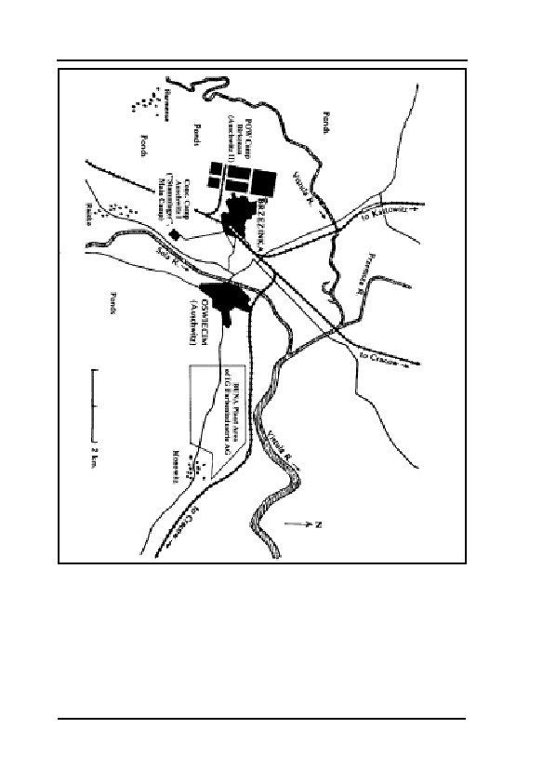
Fig. 10: Map of the
surrounding vicinity of
Auschwitz during the
GERMAR RUDOLF · THE RUDOLF REPORT
Second World War. The
boundary lines of the
terrain of the IG
Farbenindustrie factories
were entered later, and are
only an approximate
indication of the factory
terrain. The terrain of
Birkenau concentration
camp corresponds to the
planning situation of 1945,
which was, in fact, never
56
completed.
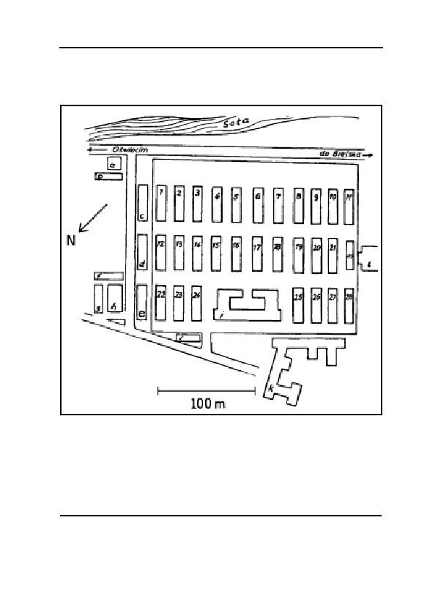
5. AUSCHWITZ
Fig. 11: Map of Auschwitz I/Main Camp (concentration camp), according to
the information brochure of the Auschwitz State Museum in 1991.
Block 1—28:
inmate barracks
a:
commandant’s house
h: crematorium I with ‘gas chamber’
b:
main guard station
i: guard station near camp entrance gate
c:
camp commandant’s office
(block leader room)
d:
administration building
j: camp kitchen
e:
SS hospital
k: inmate registration building
f,g:
political division
l: camp warehouse, theatre building
m: new laundry
57
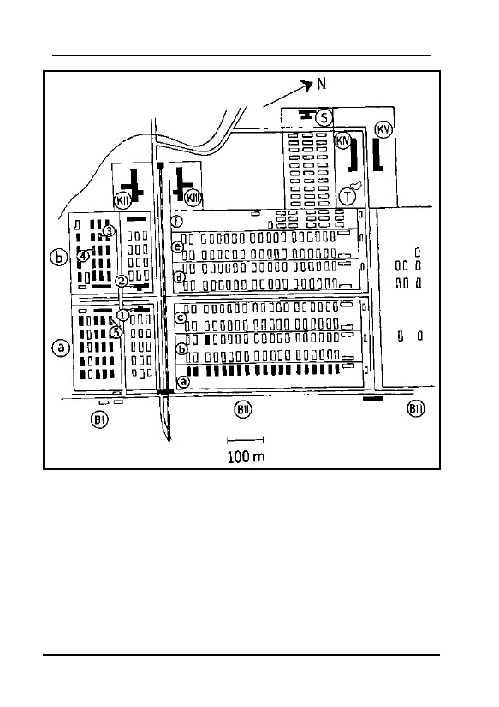
GERMAR RUDOLF · THE RUDOLF REPORT
Fig. 12: Map of POW camp Auschwitz II/Birkenau, approximately 2 km north-
west of the main camp, construction situation as of the end of 1944. The shaded
buildings still exist, some of them, however, only in the form of ruins or
foundations (crematoria II-V), the rest having been torn down by Polish civilians
for building materials after the war. According to the information brochure of the
Auschwitz State Museum, 1991.
BI-III:
building sector I to III
K IV:
crematorium IV with ‘gas chamber’
BIa/b:
women’s camp
K V:
crematorium V with ‘gas chamber’
BIIa:
quarantine camp
S:
‘Zentralsauna’, hot-air/steam disinfestation
BIIb:
family camp
T:
pond
BIIc:
Hungarian camp
1:
building sector 5a—Zyklon B disinfestation
BIId:
men’s camp
2:
building sector 5b—Zyklon B disinfestation
BIIe:
gypsy camp
3:
inmate barracks no. 13
BIIf:
inmate hospital
4:
inmate barracks no. 20
K II:
crematorium II with ‘gas chamber’
5:
inmate barracks no. 3
K III:
crematorium III with ‘gas chamber’
58

5. AUSCHWITZ
5.2. Epidemics and the Defense Against them
5.2.1. Danger of Epidemics97
Before the era of modern warfare, it has always been taken for
granted that during a war epidemic disease caused more deaths among
the soldiers and civilians than the use of weapons. It took the atomic
bomb, deployed in a ruthless and criminal manner by the United States
against unarmed people and in contravention of international law, to
change this assumption.
The epidemic most feared in World War I at the eastern front was
typhus.98 Typhus epidemics claimed uncounted thousands of lives
among German soldiers at the Russian front and could be prevented
from spreading into German territory after the end of the war only by
the most rigorous of measures. Since that time, the danger of epidem-
ics has been taken seriously by medical and military offices and per-
sonnel.99
For example, the German encyclopedia Der große Brockhaus, vol.
VI of the 1930 Leipzig edition, contains a comprehensive article on
epidemic typhus. This acute infectious disease is spread only by the
body louse:100
“The disease is caused by Rickettsia prowazeki (discovered in 1910
by Ricketts and in 1913 by Prowazek), a micro-organism found in the in-
testines and salivary glands of infected lice. […]
Epidemic typhus occurs chiefly where unfavorable social and sani-
tary conditions prevail: in dank overcrowded living quarters, hospitals,
97
The following remarks are largely based on H.J. Nowak’s study, “Shortwave Delousing Fa-
cilities in Auschwitz”, in: E. Gauss (ed.), op. cit. (note 43), pp. 312-324 (online:
www.vho.org/GB/Books/dth/fndNowak.html).
98
Epidemic Typhus, which is also called European, Classic, or Louse-Borne Typhus, or Jail
Fever, is a louse-borne disease caused by bacteria belonging to the Rickettsia group. Whereas
Typhus is the term used in English to refer to all diseases caused by various Rickettsia bacte-
ria, the German term is “Fleckfieber”, which, in English, is used only for one type of typhus,
the so-called Rocky Montain Spotted Fever that is transferred by ticks; see
http://www.merck.com/pubs/mmanual/section13/chapter159/159a.htm
99
O. von Schjerning, Handbuch der Ärztlichen Erfahrungen im Weltkrieg 1914/1918, volume
VII Hygiene, J. A. Barth Verlag, Leipzig 1922, in particular, pp. 266ff: “Sanierungsanstalten
an der Reichsgrenze”.
100
The Brockhaus Encyclopedia refers to the article by A. Schittenhelm, “Flecktyphus” in Hand-
buch der Inneren Medizin, 2nd ed., 1925.
59

GERMAR RUDOLF · THE RUDOLF REPORT
prisons, emigration ships, caused by crop failures and price increases,
thus also known as starvation, hospital, prison, ship or war typhus. Ty-
phus is endemic in Russia, the Balkans, northern Africa, Asia Minor,
and Mexico. According to Tarrassevich, 25-30 million people suffered
from epidemic typhus in Russia in 1918-1921, which amounts to 20-23%
of the population. […]
Successful control and prevention of epidemic typhus consists of en-
forcing all measures available to destroy the body louse.”
The experiences of German physicians during WWII were no dif-
ferent.101,102 The topic of epidemics can be found in countless publica-
tions. Practical experiments were also conducted which increased the
knowledge about fighting the causes of this disease.
Professor Dr. F. Konrich was completely justified in stating, in his
publication “About sanitation facilities of German POW camps”103 that
epidemics such as those in question “[…] had long been extinct here
[in Germany].” However, it also becomes quite understandable why all
of the offices and institutions involved over-reacted when epidemic
typhus broke out in the Auschwitz concentration camp in early July
1942.104 The outbreak was traced to the civilian laborers brought in to
work in the camp, rather than to inmates deported to Auschwitz. Also,
due to drastic measures taken to isolate and eradicate this epidemic, its
spreading to the camp’s nearby civilian population could be prevented.
5.2.2. Epidemic Control with Zyklon B
One of the most efficient methods to fight lice and thereby to con-
tain and eliminate typhus—but also to kill other vermin like grain bee-
tles, bugs, cockroaches, termites, mice, rats and many more—is their
poisoning with highly volatile hydrogen cyanide.
Liquid hydrogen cyanide has a short shelf life and is extremely
dangerous with incorrect handling. At the end of the First World War,
hydrogen cyanide was introduced onto the market in an easier to han-
101
R. Wohlrab, “Flecktyphusbekämpfung im Generalgouvernement”, Münchner Medizinische
Wochenschrift, 89(22) (1942), pp. 483-488.
102
W. Hagen, “Krieg, Hunger und Pestilenz in Warschau 1939-1943”, Gesundheitswesen und
Desinfektion, 65(8) (1973), pp. 115-127; ibid., 65(9) (1973), pp. 129-143.
103
Friedrich Konrich, “Über die Sanierungsanstalten der deutschen Kriegsgefangenenlager”,
Gesundheits-Ingenieur, July 19, 1941, pp. 399-404.
104
Cf. Wilhelm Stromberger, “Was war die ‘Sonderbehandlung’ in Auschwitz?”, Deutschland in
Geschichte und Gegenwart, 44(2) (1996), pp. 24f. (online:
www.vho.org/D/DGG/Strom44_2.html).
60

5. AUSCHWITZ
dle and safer form: porous materials soaked with hydrogen cyanide
with the addition of a stabilizer and an irritant warning material, in-
tended to warn people of low concentrations of hydrogen cyanide,
which in lower concentrations has only a slight odor and that many
people cannot even smell at all. This product, called Zyklon B, was
then packed in tin cans, which can only be opened with a special tool.
The number of patents filed for the additives to Zyklon B shows that
there was no simple, clear solution to the problems relating to the
stabilizers and irritant warning materials.105 Legally, there was a great
difference between the stabilizer for Zyklon B and the irritant warning
material. A stabilizer for Zyklon B was required by German law,106
while an irritant warning material, by contrast, was not legally re-
quired.107
Zyklon B was licensed and produced by the DEGESCH108 corpo-
ration residing in Frankfurt.109 Until the end of the Second World War,
it played an extraordinarily important role in the struggle against insect
pests and rodents110,111 in food warehouses, large-scale means of trans-
105
See also, in this regard, Wolfgang Lambrecht, Otto Karl, Das Handelsprodukt Zyklon B, soon
to be published on the internet at www.vho.org/D/Beitraege/Zyklon.html.
106
Deutsche Reichsbahn Eisenbahnverkehrsordnung (EVO, German Reich railway regulations),
annex C to §54 EVO, Vorschriften über die nur bedingt zur Beförderung zugelassenen Ge-
genstände vom 1. Okt. 1938 (Regulations on Objects Permissible for Restricted Transport
Only, dated 1 October 1938), p. 50:
“Die Blausäure muß durch einen von der Chemisch-Technischen Reichsanstalt nach Art
und Menge anerkannten Zusatz, der zugleich ein Warnstoff sein kann, beständig gemacht
sein.” (The hydrogen cyanide must be stablized by an additive, which may also be an irri-
tant, in the manner and quantity recognized by the Chemical-Technical Reichs Founda-
tion.)
107
L. Gaßner, “Die gesetzlichen Bestimmungen der Anwendung hochgiftiger gasförmiger Stoffe
zur Schädlingsbekämpfung in Deutschland” (The legal provisions relating to the use of highly
poisonous gaseous materials for pest control in Germany) in Karl Greimer, Handbuch des
praktischen Desinfektors, Th. Steinkopf, Dresden 1937, pp. 185f. The fact that Auschwitz
concentration camp received Zyklon B without an irritant is therefore not so unusual as some-
times represented in the literature, i.e., as a ‘criminal trace’. The well-known exceptional regu-
lations for the Waffen SS are no exception; they merely referred to the applicable Reichs regu-
lations and implementation provisions regulating the use of Zyklon B; see Deutsches Reich,
“Anwendung von hochgiftigen Stoffen zur Schädlingsbekämpfung durch die Waffen-SS”,
Rund-Erlaß des Reichsministers für Ernährung und Landwirtschaft vom April 3, 1941, quoted
acc. to Zeitschrift für hygienische Zoologie und Schädlingsbekämpfung, 33 (1941), p. 126.
108
Deutsche Gesellschaft für Schädlingsbekämpung (German Society for Pest Control), a sub-
sidiary of the I.G. Farbenindustrie AG.
109
On the history of the firm, mixed with Holocaust story telling, see Jürgen Kalthoff, Martin
Werber, Die Händler des Zyklon B, VSA-Verlag, Hamburg 1998; much more factual and
technically correct is the work by Wolfgang Lambrecht, Otto Karl, op. cit. (note 105).
110
O. Hecht, “Blausäuredurchgasungen zur Schädlingsbekämpfung”, Die Naturwissenschaften,
16(2) (1928), pp. 17-23.
61
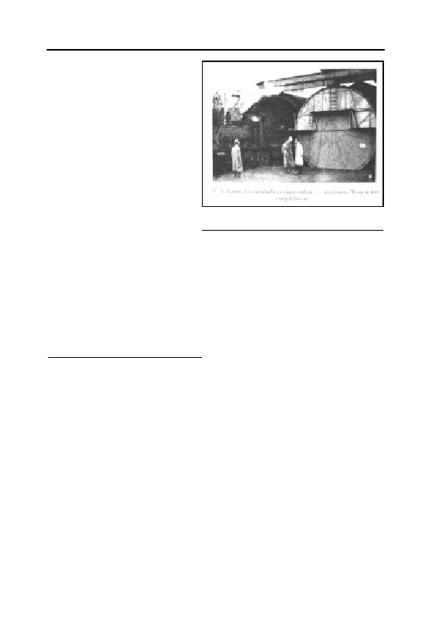
GERMAR RUDOLF · THE RUDOLF REPORT
port like trains, ships, both in
Europe and in America.112 For
example, Dr. G. Peters reports
in his work Blausäure zur
Schädlingsbekämpfung (Hy-
drogen Cyanide for Pest Con-
trol)113 about the fumigation
of ships with hydrogen cya-
nide, which happened in the
United States as early as 1910,
and about tunnel facilities, in
Fig. 13: A lice-ridden train enters a
which entire railway trains
railway gassing tunnel in Budapest.112
could be driven into in order
to be disinfested (see Fig. 13). The use of Zyklon B in public build-
ings, barracks, prisoner of war camps, concentration camps was also
featured in the literature of that time.114-117 Of course, there were sev-
eral other gaseous pest control agents in addition to Zyklon B.118,119
Zyklon B continued to play an important role even after the war, until
it was largely replaced by DDT and its successors.120,121
A large number of publications are available from both the war-
time and pre-war periods, to which reference is made.113,114,117,122-126
111
G. Peters, W. Ganter, “Zur Frage der Abtötung des Kornkäfers mit Blausäure”, Zeitschrift für
angewandte Entomologie, 21(4) (1935), pp. 547-559.
112
G. Peters, “Eine moderne Eisenbahn-Entwesungsanlage”, Anzeiger für Schädlingskunde,
14(8) (1938) pp. 98f.; cf. F.P. Berg, op. cit. (note. 131).
113
Gerhard Peters, Blausäure zur Schädlingsbekämpfung, Ferdinand Enke Verlag, Stuttgart 1933.
114
Walter Dötzer, “Entkeimung, Entseuchung und Entwesung”, in J. Mrugowsky (ed.), Arbeit-
sanweisungen für Klinik und Laboratorium des Hygiene-Instituts der Waffen-SS, 2nd ed., Ur-
ban & Schwarzenberg, Berlin and Vienna 1943.
115
F.E. Haag, Lagerhygiene, Taschenbuch des Truppenarztes, vol. VI, F. Lehmanns Verlag,
Munich 1943.
116
F. Puntigam, “Die Durchgangslager der Arbeitseinsatzverwaltung als Einrichtungen der
Gesundheitsvorsorge”, Gesundheits-Ingenieur, 67(2) (1944), pp. 47-56.
117
For a more recent treatment of the topic, see: F.P. Berg, op. cit. (note. 131).
118
G. Peters, Die hochwirksamen Gase und Dämpfe in der Schädlingsbekämpfung, F. Enke Ver-
lag, Stuttgart 1942.
119
DEGESCH, Acht Vorträge aus dem Arbeitsgebiet der DEGESCH, 1942, p. 47; Document NI-
9098 from the Nuremberg Trials, table of properties of the gaseous insecticide/pest control
product used by DEGESCH.
120
H. Kruse, Leitfaden für die Ausbildung in der Desinfektion und Schädlingsbekämpfung, Mus-
ter-Schmidt, Göttingen 1948.
121
H. Kliewe, Leitfaden der Entseuchung und Entwesung, F. Enke Verlag, Stuttgart 1951.
122
F. Puntigam, H. Breymesser, E. Bernfus, Blausäuregaskammern zur Fleckfieberabwehr, Son-
derveröffentlichung des Reichsarbeitsblattes, Berlin 1943.
62

5. AUSCHWITZ
There are also guidelines on the fumigation of property and rooms,
describing the procedures in detail, both before and afterwards.127,128
These do not considerably differ from the regulations in application
today.129 Based upon this, the following is a brief discussion of the
technology and method of procedure employed.
Initially, for the disinfestation of personal effects, ordinary rooms
(10 to 30 m2 surface area) were temporarily modified, by making the
windows and doors as gas-tight as possible by means of felt sealant
material and paper strips, while providing for proper heating and venti-
lation of the rooms. Workers wearing gas masks spread Zyklon B
evenly on the floor of the room containing the property to be disin-
fested. This procedure was similar to what was then the regular fumi-
gation of ordinary rooms for the destruction of vermin. Such converted
rooms may be seen even today in the main camp of Auschwitz I. The
use of temporarily sealed rooms for fumigation purposes is not without
risk since the sealing is never perfect.
Later, special gas-tight installations without windows were built,
equipped with efficient heating and ventilation systems, and later also
with circulating air systems for a more rapid circulation of the gas in-
side the room (so-called “DEGESCH-Kreislaufverfahren,” DEGESCH
circulation procedure, see Fig. 14). Cans of Zyklon B were opened by
means of an exterior mechanism, so that the workers were no longer
exposed to danger. The bottom of the can was automatically punctured
and the preparation fell into a basket, into which a fan blew hot-air,
thus quickly evaporating the hydrogen cyanide and carrying the fumes
123
G. Peters, “Gefahrlose Anwendung der hochgiftigen Blausäure in Entlausungskammern”,
Arbeitsschutz, 5(III) (1942), pp. 167f.
124
F. Puntigam, “Raumlösungen von Entlausungsanlagen”, Gesundheits-Ingenieur, 67(6) (1944),
pp. 139-180.
125
E. Wüstinger, “Vermehrter Einsatz von Blausäure-Entlausungskammern”, Gesundheits-
Ingenieur, 67(7) (1944), p. 179.
126
A more recent summary of this topic was prepared by Friedrich P. Berg, “The German De-
lousing Chambers”, JHR, 7(1) (1986), pp. 73-94 (online: codoh.com/gcgv/gcdelouse.html);
cf. also Berg, op. cit. (note 131).
127
Entseuchungs- und Entwesungsvorschrift für die Wehrmacht, H. Dv. 194, M. Dv. Nr. 277, L.
Dv. 416, Reichsdruckerei, Berlin 1939.
128
Richtlinien für die Anwendung von Blausäure (Zyklon) zur Ungeziefervertilgung (Entwesung),
Gesundheitsanstalt des Protektorats Böhmen und Mähren, Prag o.J.; Dokument NI-9912(1) at
the International Military Tribunal, reproduced by Herbert Verbeke (ed.), op. cit. (note 43),
pp. 94-99.
129
Technische Regeln für Gefahrstoffe, TRGS 512, Begasungen, BArbBl. no. 10/1989, p. 72, in:
Robert Kühn, Karl Birett, Merkblätter Gefährlicher Arbeitsstoffe, ecomed, Landsberg 1990.
63
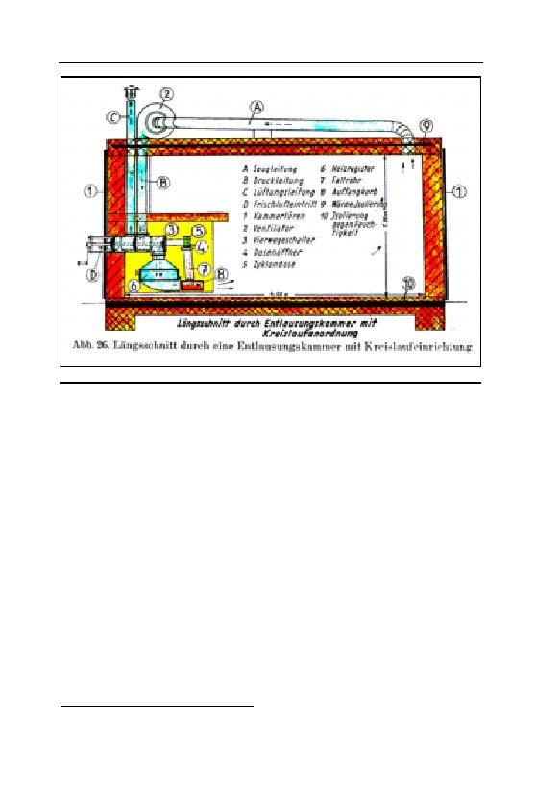
GERMAR RUDOLF · THE RUDOLF REPORT
Fig. 14: DEGESCH delousing chamber with circulation feature.130
away. These installations, with the so-called circulation procedure,
were relatively small in size, a few m3, to economize on the highly-
expensive vermin destruction product.
These professional installations were often part of an entire hygi-
enic complex. As a rule, this building complex was organized ap-
proximately as follows in terms of purpose (see Fig. 15):103
– Undressing room, ‘dirty side’. People to be deloused removed
their soiled clothing and handed them over for disinfestation/dis-
infection.
– Shower. Prisoners washed themselves after undressing, plus some-
times other procedures, such as haircuts, medical examinations,
including a sauna.
– Dressing room, ‘clean side’. Their own cleaned and sanitized
clothing was given back to the prisoners or substitute clothing was
issued to them since the cleaning may have lasted many hours.
– Disinfestation/Disinfection room. An area to clean and process the
clothing combined with a laundry.
130
Ludwig Gaßner, “Verkehrshygiene und Schädlingsbekämpfung”, Gesundheits-Ingenieur,
66(15) (1943), S. 174ff.; cf. F.P. Berg, op. cit. (note 131).
64
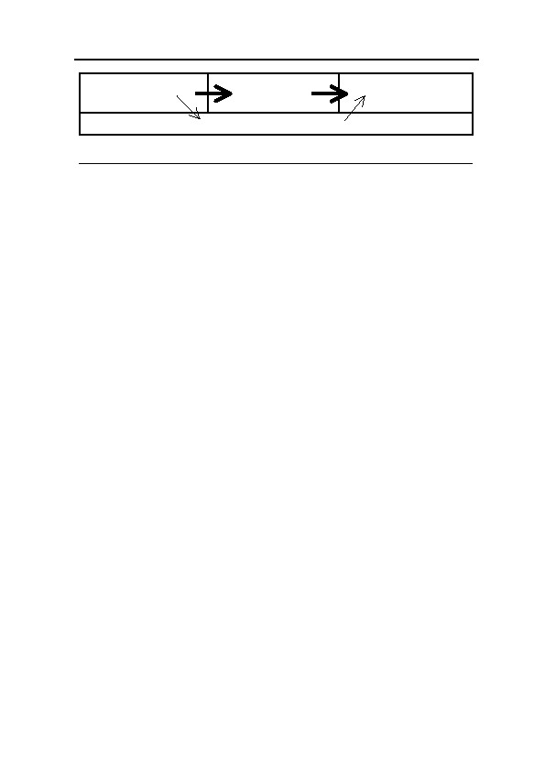
5. AUSCHWITZ
Undressing room
Shower/
Dressing room
‘Dirty Side’
Sauna
‘Clean Side’
Disinfestation/Disinfection/Laundry
Fig. 15: Schematic organization of a hygiene complex
Clothing pathway;
Inmate pathway
It was not uncommon for a crematorium to be installed in the
same building complex, as may still be seen at Dachau concentration
camp today (near Munich), in which the new hygienic installation pos-
sesses a series of DEGESCH circulating air installations for the disin-
festation of clothing, with an undressing and redressing room to the
right and left of the inmate showers, as well as a crematorium. (The
room described as a “gas chamber” at Dachau today is actually the
inmate shower, which is indispensable in the above schema, and which
has been intentionally mislabeled by the Museum.)
The applicable concentrations during the disinfestation of clothing
might be very different according to the type of vermin and exterior
conditions, and usually ranged from 5 to 30 g of hydrogen cyanide per
m3 of air. The application time varied just as greatly, from under two
hours up to ten hours and more. In the more modern installations with
heating (higher than 25°C) and circulating air/ventilation installations,
good results could be attained with concentrations of 20 g per m3, al-
ready after 1 to 2 hours. Disinfestation in ordinary rooms, on the other
hand, could last up to 24 hours or more.
5.2.3. Epidemic Control in Auschwitz
5.2.3.1. Terminology Used and Responsibilities
We shall use the technical terms established in the 1939 German
Army Regulations (Heeresdienstvorschrift 194),127 since these deter-
mined how the personnel, i.e., the physicians and those who disin-
fected the camps, were to proceed:
“Disinfection
Disinfection means […]: destroying the disease-(epidemic-)causing
agents on objects, in rooms, in excretions and on the bodies of infectious
persons.
65
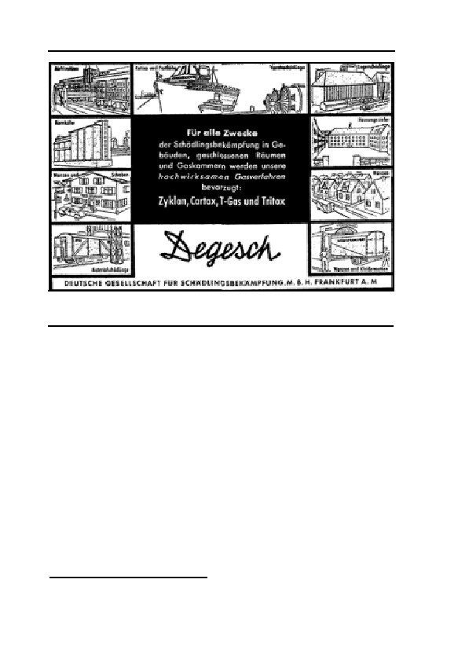
GERMAR RUDOLF · THE RUDOLF REPORT
Fig. 16: Typical advertisement of the firm DEGESCH about the broad
variety of applications of gassing methods offered: Flour mills, ships, stores,
grain storages, houses, railroad cars, trucks.131
Disinfestation
Disinfestation means: ridding rooms, objects and people of vermin
(small life forms) that can transmit pathogens, cause economic damage
or annoy man.”
The regulation quoted lists all known physical and chemical means
of disinfection and disinfestation. Similarly, a “work guideline” was re-
leased in 1943 by the Sanitation Institute of the Waffen-SS: “Ent-
keimung, Entseuchung und Entwesung”114 (Sterilization, Disinfection
and Disinfestation).
The authority in charge of sanitation in the Waffen-SS as well as
in the concentration camps was the “Hygieneinstitut der Waffen-SS”132
(Sanitation Institute of the Waffen-SS), established in 1942 in Berlin,
which set up a branch office in 1943 in Rajsko near Auschwitz, with its
“Hygienisch–bakteriologischen Untersuchungsstelle Südost d. W-SS”
(Sanitary and Bacteriological Testing Station Southeast of Waffen-SS).
The files from this testing station have survived (151 volumes dating
from 1943 to 1945).133
131
Der praktische Desinfektor, Heft 2, Verlag Erich Deleiter, Berlin 1941, inside cover; cf. F.P.
Berg, “Typhus and the Jews”, JHR, 8(4) (1988), pp. 433-481 (online:
66

5. AUSCHWITZ
The garrison physician (army medical officer) and the medical
personnel were in charge of implementing all sanitary measures. This
physician—and this was the case at Auschwitz as well—was to be
consulted as subject expert in all relevant matters of construction plan-
ning and other things. Where hydrogen cyanide was to be used, re-
quirements called for specially trained expert personnel. In Auschwitz,
this role was filled by the “disinfectors”.
5.2.3.2. Procedures Used
Generally, four procedures were used at Auschwitz for disinfesta-
tion and disinfection:
– hot air
– hot steam
– hydrogen cyanide
– microwaves
Data on the disinfestation and disinfection installations in opera-
tion in Auschwitz camp may be taken from a listing dated January 9,
1943: “Hygienische Einrichtungen im KL und KGL Auschwitz”134
(Sanitary Facilities in the POW and Concentration Camp Auschwitz)
directed to the Amtsgruppenchef C (Berlin), and an “Aufstellung über
die im KL. und KGL. Auschwitz eingebauten Entwesungsanlagen
Bäder und Desinfektionsapparate”135 (List of Disinfestation Facilities,
Baths and Disinfection Systems Installed in the POW and Concentra-
tion Camp Auschwitz), dated July 30, 1943.
The following capacities, taken from the last-mentioned docu-
ment, relate to a 24-hour a day operation period.
a) In the concentration camp (protective custody camp):
Block 1: One hot air disinfestation installation, manufactured
by the Klein corporation for 1,800 people and ap-
proximately 3,600 blankets since the fall of 1940.
Block 3: One hydrogen cyanide gas disinfestation installation
www.vho.org/GB/Journals/JHR/8/4/Berg433-481.html).
132
TCIDK 502-1-26-117.
133
Heinz Bobrach et al., Inventar archivalischer Quellen des NS-Staates, K. G. Saur, Munich
1995, volumes 3/1, 1991. So far, we are aware of approximately 110,000 laboratory examina-
tions. Many probative and highly informative facsimiles are to be found in Hefte von Ausch-
witz, nos. 1 through 19, special editions, Auschwitz State Museum Publishers, Auschwitz Mu-
seum, since 1959.
134
TCIDK 502-1-332-46/46a.
135
TCIDK 502-1-332-9/10.
67
GERMAR RUDOLF · THE RUDOLF REPORT
(i.e., Zyklon B), for 1,400 people and approximately
20,000 pieces of laundry.136
Block 26: One hot air installation for 2,000 people.
Disinfestation building at Deutsche Ausrüstungs-Werke (Ger-
man Equipment Works, i.e., Canada I): 1 hydrogen
cyanide gas disinfestation installation (BW 28) for
approximately 30,000 pieces of laundry, blankets, etc.
(in operation since the summer of 1942).
Civilian worker disinfestation barracks: One hot air disinfesta-
tion installation, manufactured by the Hochheim cor-
poration, with a daily capacity for 2,000 people, with
large shower bath installation and disinfection appara-
tus, permanently installed.
b) In the POW camp (K.G.L., Birkenau):
BW 5a in B Ia: One disinfestation apparatus (manufactured by
Werner) and one hot air apparatus (manufac-
tured by Hochheim) in operation since Novem-
ber 1942 for 2, 000 people.
One chamber for hydrogen cyanide fumigation
has been built for 8,000 blankets and has been
in operation since the fall of 1942.
BW 5b in B Ib: Installation as in BW 5a.
All the facilities listed therein were subject to modifications. The
number of sanitary facilities increased with the number of inmates, as
the two aforementioned documents already show. Pressac mentions 25
chambers operated with Zyklon B, without providing a verifiable
source.137
5.2.3.3. Results
The results could only be compiled if one knew the number of per-
sons disinfested by means of the installation. These numbers have thus
far remained unclear. Although Danuta Czech claims in her book89 that
such documents on large time periods are available in the Auschwitz
archive, we have so far been unable to examine them. As of the present
writing, it is still impossible to make a reliable statement as to whether
136
According to Pressac, in operation since 1941/42, op. cit. (note 67), p. 25.
137
Ibid., p. 550.
68

5. AUSCHWITZ
or not the existing disinfestation installations were consistently reliable
for the indicated number of persons. Pressac, in the conclusions to his
second book,138 indicates the peak of the first epidemic between “7./11.
September” 1942 with “375 deaths per day”, which clearly indicates that
the capacity of the facilities available did not suffice.
5.2.3.4. Basic Policy Decisions
Two policy decisions made by the SS-Hauptamt Haushalt und
Bauten (SS Main Office Budget and Construction) in the Reich Ad-
ministration of the SS and its successor no doubt also influenced the
measures taken in the camp. The first decision of June 5, 1940,139
stated that HCN would no longer be used, and replaced instead with a
hot-air method. The reason for this was probably that the use of HCN
in makeshift delousing chambers was not reliable and had caused many
accidents and was thus deemed too dangerous. The second decision,
issued on March 11, 1942,140 21 months later, seems to have reversed
that first decision by calling for the “[…] conversion of all delousing
facilities to operation with HCN”, in which regard it was noted:
“Deviations therefrom—delousing by means of hot air or hot
steam—is only permissible insofar as they involve temporary installa-
tions, in which the necessary safety for the handling of HCN is not as-
sured.”
A further letter from the Office C VI of February 11, 1943,141 to
the Commandant again expressly states, probably with reference to the
letter of June 5, 1940: “[…] as per the prohibition against the use of
HCN for disinfestation […]”. This means that all efforts were to be
made to convert all facilities to be operated with the only really reliable
method available—HCN—but that the use of HCN was allowed only
where and if the necessary safety and reliability of the method was as-
sured, i.e., makeshift delousing chambers were not allowed to be oper-
ated with HCN.
Men in positions of authority, accustomed to decision-making, and
faced with a dangerous epidemic capable of spreading to the civilian
population with incalculable consequences, will always take suitable
138
J.-C. Pressac, op. cit. (note 90), p. 157
139
TCIDK 502-1-333-145
140
TCIDK 502-1-336-94
141
TCIDK 502-1-332-37
69

GERMAR RUDOLF · THE RUDOLF REPORT
measures and act accordingly. Hydrogen cyanide (= Zyklon B) was the
most reliable disinfestation agent of its time (for details, please see
“Blausäure als Entlausungsmittel in Begasungskammern”,142 or “Ent-
lausung mit Zyklon-Blausäure in Kreislauf-Begasungskammern”.143
The only problem was in finding a safe location for such facilities,
perhaps outside the actual camp (see chapter 5.4.3.).
5.2.3.5. The Army Medical Officer
On September 9, 1942, Dr. E. Wirths was stationed in Auschwitz
as garrison physician. From the records we may say that he performed
his duties correctly; in this context, reference is made, in particular, to
his massive criticism of the highest echelons.
As time went by, the number of inmates increased steadily, and
unfortunately there were more than just one epidemic. We shall there-
fore briefly summarize, by means of examples, the conclusions
reached by this physician and the steps he took in consequence.
On December 4, 1942, Dr. Wirths reported to headquarters about a
discussion held in the administrative council of Bielitz District. The
subject was epidemic typhus. A considerable number and range of per-
sons had participated in the discussion, including the medical officer,
the Wehrmacht, and representatives of the government. This illustrates
how seriously the epidemic was taken to be:144
“He reports that at present three large disinfestation, shower, and
sauna facilities could be put into operation, specifically two facilities for
the inmates and one for the members of the SS troops. The capacity of
these facilities is some 3,000 to 4,000 persons per 24 hours. Zyklon B
disinfestation has been discontinued entirely, since it has been found that
success is not 100% certain with this procedure.”
Buildings BW5a and 5b were intended for the inmates. The capac-
ity of these disinfestation facilities was probably adequate for the num-
ber of inmates at this time. One must consider, however, that at this
same time the structural shell for another 19 DEGESCH circulation
142
Gerhard Peters and W. Rasch, “Die Blausäure als Entlausungsmittel in Begasungskammern”,
Der praktische Desinfektor, September 1941, pp. 93-96.
143
Gerhard Peters, Emit Wüstinger, “Entlausung mit Zyklon-Blausäure in Kreislauf-
Begasungskammern. Sach-Entlausung in Blausäure-Kammern”, Zeitschrift für hygienische
Zoologie und Schädlingsbekämpfung, issue 10/11 (1940), special printing. TCIDK 502-1-332-
86/90; it arrived at the Auschwitz construction office on July 3, 1941.
144
TCIDK 502-1-332-117/119
70

5. AUSCHWITZ
fumigation chambers was being completed in Building BW160 of the
Main Camp (Admissions building). Another paragraph of the above
letter states that the garrison physician of Kattowitz had provided the
loan of two mobile boiler installations.
On April 18, 1943, Wirths reports to the Commandant, with warn-
ing reference to the sewer system in Birkenau, and concludes that “[…]
great danger of epidemics is inevitable.”145
On May 7, 1943, in a discussion with the chief of Amtsgruppe C,
SS Brigadier General and Major General of the Waffen-SS engineer
Dr. Kammler, and others, the garrison physician set out in chapter “II.
Bauten in Zuständigkeit des Standortarztes” (II. Buildings Under the
Charge of the Garrison Physician):146
“[…] that the continued health of the inmates for the major tasks is
not guaranteed, due to the poor toilet conditions, an inadequate sewer
system, the lack of hospital barracks, and separate latrines for the sick,
and the lack of washing, bathing, and disinfestation facilities.”
Dr. Wirths clearly pointed out the inadequacies and also how to
rectify them.
At this point we must warn the reader, who may perhaps not be
sufficiently aware of the historical context, not to jump to false conclu-
sions. The reader may well lack an understanding of all the problems
that were involved in obtaining materials as well as all the other neces-
sities required to build these facilities in wartime. Figuratively speak-
ing, a written permission was required to purchase every brick.
We must also point out that, in those days in eastern Europe, a
sewer system of any kind at all was exemplary to start with, and that
this is all the more true for sewage treatment facilities, which were
built for both camps at great expenditure in resources and according to
high technical standards.
The above quoted document continues:
“The Brigadier General acknowledges the foremost urgency of these
matters and promises to do everything possible to ensure rectification of
the shortcomings. He is somewhat surprised, however, that the medical
side presents him with reports giving a very favorable account of the
sanitary and hygienic conditions on the one hand; while he is then im-
mediately confronted with reports to the exact opposite effect on the
145
TCIDK 502-1-332-219
146
TCIDK 502-1-233-33/38
71
GERMAR RUDOLF · THE RUDOLF REPORT
other hand. The Chief of the Zentralbauleitung is hereby instructed to pre-
sent suggestions for rectification by May 15, 1943.” (Emphasis added.)
It began with the toilet facilities, with regards to which he en-
forced changes that he considered necessary. For example: lids on the
toilets, because otherwise “[…] a great danger of epidemics is inevita-
ble.”147 These lids were ordered by the Head of Department C of the
WVHA (Wirtschafts-Verwaltungshauptamt, Economic Administrative
Main Office) on May 10, 1943.148 It ended with roofing matters related
to the gypsy kindergarten:149
“For the damaged roofs of kindergarten blocks 29 and 31 in the
Gypsy Camp I request 100 rolls of roofing felt (very urgent.)”
In between, on May 28, 1943,150 he selected six circulating air de-
lousing facilities which—as was noted down in handwriting—were
ordered on May 29, 1943, by the Building Administration’s expert on
heating matters, Jährling. Then there is an account of a water quality
test on June 1, 1943,151 etc. This extensive correspondence resulted in
separate subject files in the filing system of the Zentralbauleitung,
such as “Sanitary Conditions”.152
The physician’s field of work was great and varied and deserved
its own monograph. He was even responsible for ensuring that the in-
mates’ kitchen personnel were frequently examined—including labora-
tory tests of their stool, etc. That Dr. Wirths truly saw to absolutely
everything is obvious from the documents.
The garrison physician’s reminders and admonitions increased
over time. On balance, one must conclude that, just as today, while
there were opportunists and careerists in those days, there were also—
as our example shows—SS-men with backbone and a sense of duty,
professional ethics and the courage to stand up for their beliefs.
At the end of the comments section of the Memorandum of May 9,
1943, we find:
“As stop-gap measure until that time, the Brigadier General pro-
vides the loan of a new short-wave delousing platoon.” (Emph. added.)
147
TCIDK 502-1-322-219
148
TCIDK 502-1-322-31
149
Taken from a letter of March 23, 1944 to the Zentralbauleitung (Central Construction Office)
in Auschwitz, TCIDK 502-1-332-175.
150
TCIDK 502-1-332-28
151
TCIDK 502-1-332-212
152
TCIDK 502-1-149-135
72
5. AUSCHWITZ
5.2.3.6. Short-Wave Delousing Facility
Perhaps one of the most fascinating aspects of Auschwitz concen-
tration camp is the installation of a stationary short-wave installation,
the world’s first technological predecessor to the microwave ovens in
common use today. This technology was invented by Siemens in the
late 1930s and developed to mass-production readiness during the war.
This was a by-product of the powerful radio tubes built for the televi-
sion transmission of the Berlin Olympics in 1936, the energy-rich radio
waves which killed the insects in the vicinity of the antenna. The de-
velopment took place with financial assistance from the Wehrmacht,
which hoped to achieve a perceptible improvement in the struggle
against the epidemics raging in the east. Since the inmates assigned to
the armaments industries in the concentration camps were particularly
valuable towards the end of the war, the Reich leadership decided not
to put the first installation into operation at the front for the disinfesta-
tion of soldiers’ clothing, but rather, in the largest Labor complex in
the Reich, in Auschwitz. Due to Allied bombing attacks, however,
there was a one-year delay in the completion of this installation, which
probably cost the lives of tens of thousands of inmates. The Auschwitz
camp administration had anticipated its installation as early as 1943
and had therefore postponed other delousing projects. This facility, put
into operation during the summer of 1944, proved in fact to be of revo-
lutionary effectiveness, both quick and cheap: personal effects were
moistened and placed on one end of a conveyor belt and emerged at
the other end a few minutes later, completely free of vermin and ster-
ile.153
5.2.4. Disinfestation Installations BW 5a und 5b
The only buildings remaining intact in Auschwitz-Birkenau today,
possessing a wing for the disinfestation of personal effects with Zyklon
B, are buildings (Bauwerk, BW) 5a and 5b in building sections B1a
and B1b, respectively. Both buildings were planned as mirror images
of each other. The west (resp. east) wing of these buildings were used,
153
See also, in this regard, H.-J. Nowak, op. cit. (note 97); H. Lamker, “Die Kurzwellen-
Entlausungsanlagen in Auschwitz, Teil 2”, VffG 2(4) (1998), pp. 261-272 (online:
…/1998/4/Lamker4.html); an English summary appeared by Mark Weber, “High Frequency
Delousing Facilities at Auschwitz”, JHR, 18(3) (1999), p. 4. (www.ihr.org/JHR/v18/v18n3p-
4_Weber.html)
73
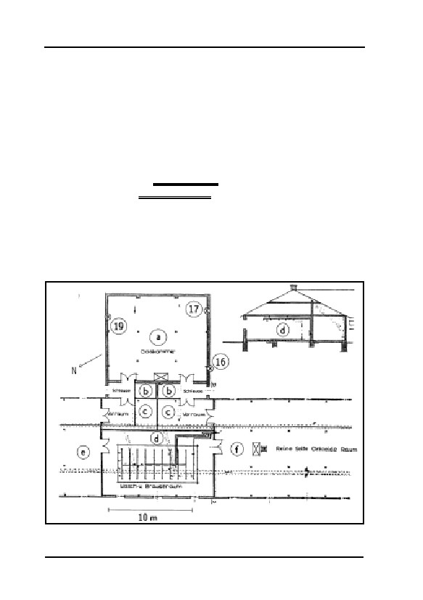
GERMAR RUDOLF · THE RUDOLF REPORT
at least temporarily, for disinfestation with Zyklon B. These rooms
were expressly labeled “Gaskammer” (gas chamber) in the building
plans, see Fig. 17.
This is no triviality: rather, it is important proof that the term
‘gas chamber’, at that time, referred exclusively to installations for
the disinfestation of personal effects, both by architects during the
planning of such buildings, and by disinfestation experts. The title
of one of the most important contemporary publications on the
subject of cyanide disinfestation by F. Puntigam, H. Breymesser,
E. Bernfus: BlausäureGASKAMMERN [sic!!!] zur Fleckfieberabwehr
[hydrogen cyanide GAS CHAMBERS for the prevention of epidemic
typhus], or the term used in an advertisement of the firm
DEGESCH: “gas chambers”, see Fig. 16, p. 66. This was simply the
ordinary designation for rooms used for the disinfestation of per-
sonal effects.
Therefore, we must always assume, in the absence of proof to
the contrary, that use of the word ‘gas chamber’ in a German
a: Delousing
wing
b: Sluice
c: Vestibule
d: Washroom and shower
e: Dirty side, undressing room
f: Clean side, Ankleideraum
16,17,19: Sample taking locations
Fig. 17: Ground plan of the HCN disinfestation wing of building 5a before
building alterations (mirror image) and BW 5b today. BW 5b Sample taking
locations drawn in.154
74
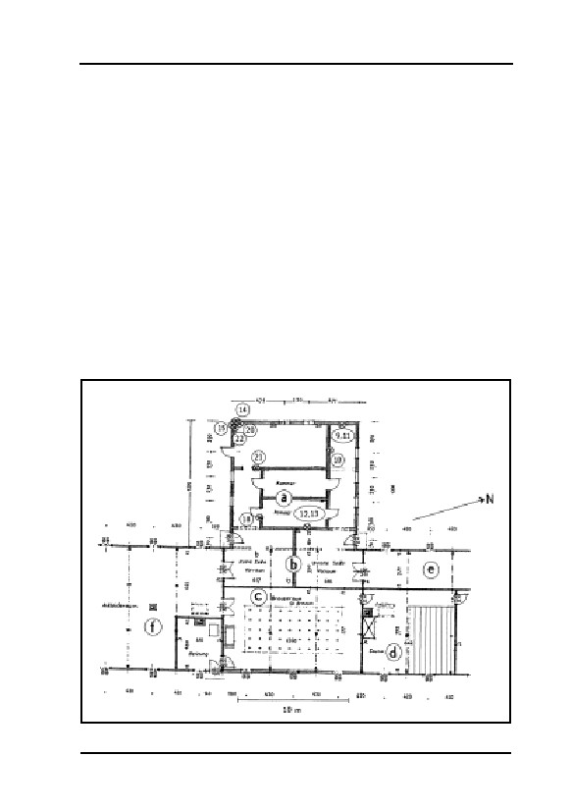
5. AUSCHWITZ
document from this period refers to a room for the disinfestation
of personal effects!
For this reason, in the following, the term gas chamber will be
placed in single quotation marks at all times (‘gas chamber’), when-
ever the word refers to chambers for the execution of human beings.
There are two reasons for this:
1. The German technical term Gaskammer originally pointed ex-
clusively to disinfestation chambers operated with toxic gas. To
apply the same term to chambers intended for the execution of
human beings is an incorrect use of the term at that time.
2. Simply for the purpose of avoiding confusion as to the meaning
of the word ‘gas chamber’ in each case, a distinction must be
made in writing.
Fig. 17 shows the ground plan of the two disinfestation gas cham-
bers of building 5a and 5b approximately in their original condition.
The chamber in building 5a was transformed in the summer of 1943
a: Hot air delousing chambers
b: Vestibules
d: Sauna
c: Shower room
e: Undressing room
f: Dressing room
9-15,
18,
20-22:
Sample taking locations
Fig. 18: Ground plan of the hot air disinfestation wing of building 5a after
building alterations in 1943. BW 5a sample taking locations drawn in.154
75
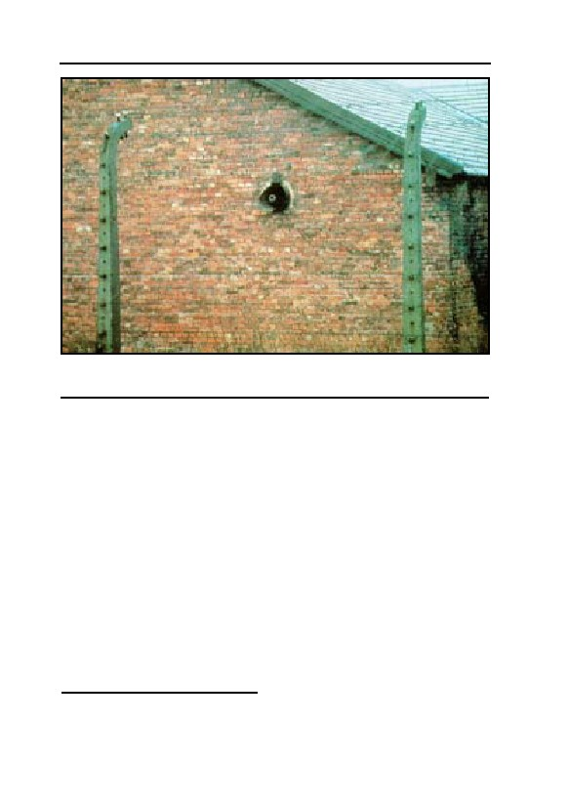
GERMAR RUDOLF · THE RUDOLF REPORT
Fig. 19: Ventilation outlets from the disinfestation wing of building BW 5b,
without equipment today. The ends of the water pipes are visible inside; see
also Fig. 20.
and received two small hot air chambers, visible in Fig. 18.154 The
buildings have ordinary brick walls and a concrete foundation built
level with the ground, plastered and whitewashed on the interior with
chalk-based mortar. The room in building 5b has no separate ceiling,
the roof’s framework is covered from underneath with boards of an
unknown material (perhaps Heraclite). Originally without windows,
like building BW 5b today, the disinfestation wing of BW 5a was
equipped, during the building alterations, with windows firmly walled
in which cannot be opened.
In the gable wall of the disinfestation room in BW 5b are two cir-
cular openings, approximately 50 cm in diameter, corresponding to the
former ventilation exhaust and air intake channels, Fig. 19. The roof
has three ventilation chimneys; there must have been three ovens in
this room during the time of operation.155 The double doors, opening
inwards and drawn onto the plans, have been replaced with single
doors, also opening inwards. For the time being, one can only specu-
154
J.-C. Pressac, op. cit. (note 67), pp. 55-58, Plans of Buildings 5a/b, pp. 59f. exterior photos.
Building alteration plan no. 2540 for conversion to hot air delousing installation, dated July 5,
1943.
155
Ibid., p. 53.
76

5. AUSCHWITZ
late on any equipment of the disinfestation chambers.
The room has a surface area of approximately 130 m2, is open to
the framework of the roof, and therefore has a volume of at least 400
m3. However, the space above 2 m in height must probably be consi-
dered to have been unusable dead space, resulting in the waste of huge
amounts of HCN/Zyklon B, since a quantity of Zyklon B of at least 4
to 5 kg (10 g per m3) cyanide content was necessary for just one gas-
sing,156 regardless of whether the room contained only a few personal
effects or whether the available area was filled. For example, with 100
fumigation cycles per year (one every 3 or 4 days) approximately 0.8
tons of Zyklon B would have been consumed by this installation alone
and by building 5a, corresponding to 10% of the entire Zyklon B de-
liveries to Auschwitz in 1942, with a total delivery of 7.5 tons.157
When one considers that there were other HCN disinfestation in-
stallations in Birkenau in addition to this one; that the deliveries to
Birkenau camp also supplied the related labor camps (more than 30 in
number); and the fact that inmate barracks were also occasionally fu-
migated with this insecticide,158 it will be seen that the quantities of
Zyklon B delivered to Auschwitz camp can actually be explained by
normal delousing activities.
The annual delivery quantities were too low to ensure successful
disinfestation of all personal effects and buildings in all camps in the
Auschwitz complex, since typhus epidemics were never entirely elimi-
nated.
How frequently the delousing chambers of BW 5a and 5b were ac-
tually used for HCN disinfestation has to remain open for the time be-
ing, since no documentation about this has been found yet, and also
because the document cited above states that the use of Zyklon B had
to be abandoned as early as December 1942 (at least in unsafe installa-
156
The gross mass given on the label of a Zyklon B can always refered to the net HCN content of
the can, i.e., excluding the mass of the carrier material. That means for instance that a 1 kg
Zyklon B can consisted of 1 kg HCN plus some 2 kg of carrier material, i.e., a 1 kg can had a
total mass of some 3 kg.
157
Office of Chief of Counsel for War Crimes, British Military Tribunal, Case against B. Tesch
et al., here, the sworn statement of A. Zaun, Hamburg Oct. 24, 1945, Document No. NI-11
396; quoted according to U. Walendy, Auschwitz im IG-Farben-Prozeß, Verlag für Volkstum
und Zeitgeschichtsforschung, Vlotho 1981, p. 62.
158
See also the Höß order relating to the avoidance of accidental poisoning during the disinfesta-
tion of barracks, reproduced by J.-C. Pressac, op. cit. (note 67), p. 201. For each barracks with
a volume of approximately 40m×12m×3.5m > 1,500 m3, this means a requirement of 15 kg
Zyklon B; the 100 barracks in Birkenau camp alone would require 1.5 tons!
77
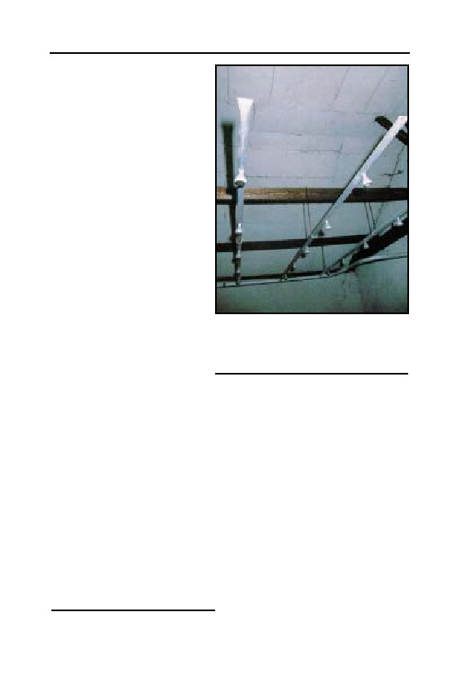
GERMAR RUDOLF · THE RUDOLF REPORT
tions), i.e., just a few weeks
after this installation was put
into operation (see p. 70).
A remarkable feature of
this room in building BW 5b
is the intricate construction of
the water pipes, laid in the
hooks fastened to the diagonal
roof girders, visible in Fig. 20.
A few of the pipe endings are
equipped with shower heads.
The water pipes have no con-
nection. Paradoxically, they
end in the above mentioned
ventilation outlets, and can
only have been installed after
the removal of the ventilators
installed there. There are, of
Fig. 20: Water pipe system with
course, shower rooms in these shower heads in the disinfestation wing
buildings, but in a very differ-
of building BW 5b. These water pipes
have no connection; they terminate in
ent location (see Fig. 17). The
the ventilation outlets. See Fig. 19.
shower installations once in
existence there, however, have been entirely dismantled. Since the
doors to these rooms are open, any visitor may examine this peculiar
construction. The original German drawings and documents of this
building do not indicate that these pipes were installed during the
German occupation, which means that they were probably installed
after the war for an unknown reason.
5.3. ‘Gas Chamber’ in the Auschwitz I Main Camp
According to Pressac, no material or documentary evidence of the
‘gas chamber’ in the crematorium in the main camp exists, but there
are many eyewitness accounts:159
“As evidence to establish the reality of homicidal gassings there
remain only the testimonies of participants,[…]”
159
J.-C. Pressac, op. cit. (note 67), p. 123.
78
5. AUSCHWITZ
These accounts, according to Pressac, are characterized by many
contradictions, technical impossibilities, and general incredibility. He
observes a “general tendency to exaggerate”, and explains the gross
errors and technical impossibilities in the eyewitness accounts and
writings of camp commandant Höß by stating:
“He was present, without seeing.”
That is, Pressac alleges that Höß had no idea of the methods, risks
and dangers involved in the handling of Zyklon B. But this is in con-
tradiction to an order issued by commandant Höß calling for caution
during the fumigation of barracks with Zyklon B158—caution which
had become necessary in view of several cases of poisoning. This spe-
cial order of the commandant warning of accidents involving Zyklon B
gas, an order which was distributed throughout the camp, indicates a
duty of care with regards to those inmates who were, allegedly and
nevertheless, doomed to die from the effects of that same gas sooner or
later. We will have occasion to speak of Höß’s testimony at a later
time.
Pressac, moreover, explains the form and basic tone of the testi-
mony of SS man Pery Broad as incorrect because this testimony is
soaked in Polish patriotism, to say nothing of the transparent Polish
hatred against SS men, although Broad was an SS man himself and had
no links to Poland, and because Pressac found out that this ‘testimony’
has been slightly reworked by the Poles, the original of which is miss-
ing. In other words, this ‘document’, obviously patched together by the
Poles, is quite worthless insofar as a critical examination of its source
is concerned. Nevertheless, Pressac considers the basic testimonies
with regards to homicidal gassings to be correct.160
The ‘gas chamber’ in the main camp is a room in a ground level
building, which replaced a former kitchen building of the former
Austro-Hungarian barracks located at the same spot.161 The floor and
ceiling of crematorium I are of reinforced concrete while the exterior
walls are of brick masonry, insulated on the exterior by a coating of
tar. Except for the access ways, the building is practically underground
due to the fact that dirt has been piled up against the walls. The interior
walls are plastered and whitewashed.
160
Ibid., pp. 126-128.
161
Ibid., p. 129.
79
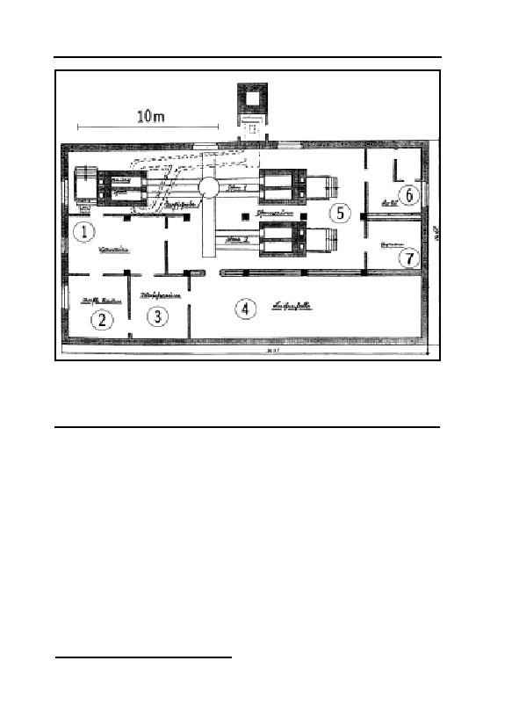
GERMAR RUDOLF · THE RUDOLF REPORT
Fig. 21: Ground plan of crematorium I in Auschwitz I/main camp in its
original condition. The morgue was later alleged to have been used as a
162
‘gas chamber’.
1: Vestibule; 2: Laying-out room; 3: Wash room; 4: Morgue;
5: Oven room; 6: Coke; 7: Urns
Fig. 21 shows the building plan of the building at the beginning of
the war, planned and constructed as a normal crematorium, with a
morgue.162 This also explains the piles of dirt, which were intended to
ensure an even, cool temperature. For the same reason, the partition
between the morgue and the oven room is double-walled with a heat-
insulating air-barrier in between.
As far as I know, no documents exist concerning the installation of
a ventilation system into this morgue, though it appears inconceivable
to operate a morgue without windows, exterior doors, and any kind of
forced ventilation.
The morgue was later alleged to have been ‘converted’ into a ‘gas
chamber’. Three to four hatches are later said to have been pierced
through the roof for the introduction of the Zyklon B for homicidal
162
Ibid., pp. 151/153.
80
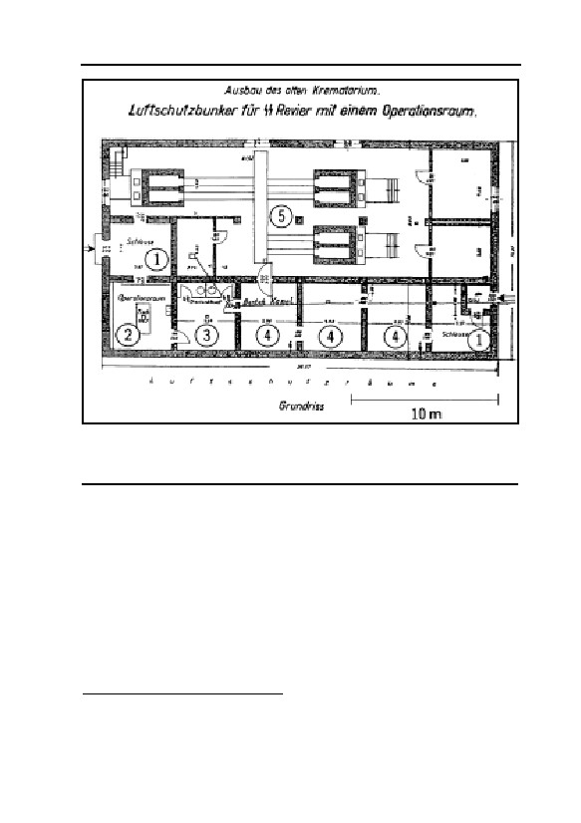
5. AUSCHWITZ
Fig. 22: Ground plan of crematorium I Auschwitz I Main Camp after
conversion to air raid shelter, 1944.166
1: Sluice; 2: Operating room; 3: Former washroom, now air raid shelter with
toilet; 4: Air raid shelter; 5: Former oven room.
gassings, as well as two hatches for the incorporation of heavy ventila-
tors.163 The head of the Auschwitz Museum, Franciszek Piper, how-
ever is of the opinion that:164
“In the case of Crema I there were no ventilators. The doors were
opened and the gas was allowed to ventilate by convection.”
Pressac reproduces a photo of the roof of the crematorium, taken
by the Soviets shortly after the liberation, in which three dark spots on
the roofing felt are alleged to be troughs of former Zyklon B introduc-
tion holes, allegedly now covered up.163,165 The photograph reproduced
in his book is, however, too poor in quality to permit anything to be
163
Ibid., pp. 131f.
164
D.D. Desjardin, “My Visit to Auschwitz-Birkenau, May 30-31, 1996”, Interview mit F. Piper,
online: codoh.com/newrevoices/nddd/ndddausch.html.
165
J.-C. Pressac, op. cit. (note 67), p. 149; photograph of the roof of crematorium I immediately
after the liberation.
81
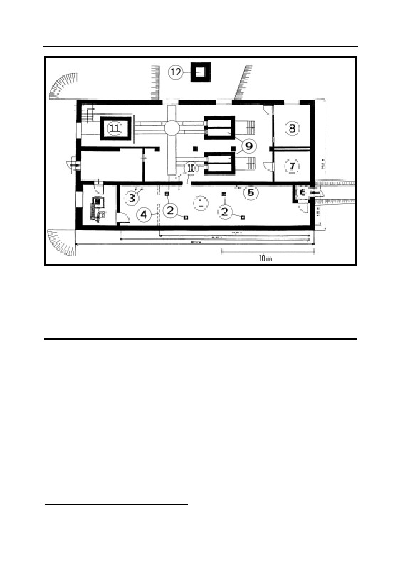
GERMAR RUDOLF · THE RUDOLF REPORT
Fig. 23: Ground plan of crematorium I in Auschwitz I/Main Camp today,
after subsequent fakery.168
1: ‘Gas chamber’; 2: Fake Zyklon B introduction holes; 3: Toilet drains; 4:
former partition morgue-washroom; 5: Ventilation chimney from air raid
shelter; 6: Air raid chute, today referred to as victim entryway; 7: Urns, 8:
Coke; 9: Reconstructed ovens; 10: Newly pierced entry to oven room;
painted: old entryway; 11: Remains of the old oven; 12: Fake chimney.
seen with clarity, much less permitting any conclusion as to the con-
struction or engineering. Pressac’s speculation must therefore be
viewed as groundless.
In the autumn of 1944, the crematorium was converted into an air
raid shelter. The building alterations, especially the replacement of the
thin partition by thick walls, can be seen in Fig. 22.166 The alleged
Zyklon B introduction holes as well as the ventilation holes are alleged
to have been sealed at that time—assuming that they ever existed.
The building work undertaken for this conversion is described in a
document into the smallest detail.167 There is no mention of any filling in
of any old existing holes pierced in the roof but rather of the incorpora-
tion of gas-tight windows and doors as well as the piercing of new holes:
166
Ibid., p. 156.
167
“Herstellung der für die Beheitzungsöfen, sowie für die Ent- und Belüftung erforderlichen
Mauerdurchbrüche und Schläuche”, letter from the Auschwitz Air Raid Warden, Aug. 26,
1944, TCIDK 502-1-401.
82
5. AUSCHWITZ
“Installation of gas-tight doors, window shutters, and windows,
Manufacture of the openings in the masonry necessary for the heat-
ing ovens, as well as for the ventilation outlets and intakes and pipes.”
This is a strong indication that before this time there were neither
gas-tight doors and windows nor any other openings for ventilation
installations or for any other purpose (Zyklon introduction holes); oth-
erwise such old openings would have been used for this purpose, or
their filling would have been mentioned.
Direct access to the air raid shelters, which evolved from the mul-
tiple division of the morgue/‘gas chamber’, was possible through a
newly added entrance with sluice, which today is represented as the
entryway taken by the victims, although the ‘gas chamber’ had no en-
trance in that location—as a matter of fact, it had no direct entrance
from the outside at all.163 Toilets were likewise built into the former
washroom at this time.
Fig. 23 shows the ground plan of the crematorium in its present
condition.168 According to Pressac, the access from the morgue/‘gas
chamber’ to the present cremation room was newly placed after the
war—not quite at the original location. The partitions in the air-raid
shelter, including the wall to the washroom, which was, however,
never part of the morgue (the later ‘gas chamber’), were torn down.
Accordingly, the irritated visitor sees two discharge pipes from two
toilets inside the alleged ‘gas chamber’. According to Pressac, who
gives no source for this statement, the roof was newly covered with
tarpaper during which the traces of the Zyklon B holes and ventilation
holes of the ‘gas chamber’ were allegedly covered over. The renewed
incorporation of four staggered Zyklon B introduction stacks by the
Polish Museum after the war is therefore not alleged to have taken
place in the same location. This argument, on Pressac’s part, must
cause astonishment, since from the inside, the roof/ceiling is of unplas-
tered bare concrete. It should have been quite possible to determine the
location of the original openings—now allegedly sealed—from the
interior and it would also have been quite possible to make openings in
the same place.
As confirmed to visitors by the Museum administration upon in-
quiry, the two chimney openings in the cremation room, as well as the
168
J.-C. Pressac, op. cit. (note 67), p. 159.
83

GERMAR RUDOLF · THE RUDOLF REPORT
chimney itself, which is without any functional connection outside the
building, were built after the war as a “reconstruction for Museum
purposes” on the location of the alleged original installations.169
The French journalist and well-known anti-revisionist, Eric Co-
nan, writes:170
“Another delicate subject: What to do with the falsifications left
behind by the communist administration? In the 50s and 60s, several
buildings which had disappeared or had been misappropriated were re-
built with gross errors and displayed as authentic. Some, which were
‘too new’, have been closed for the public. Not to mention the delousing
gas chambers which were sometimes presented as homicidal gas cham-
bers. Those aberrations have helped the deniers a lot, which took the es-
sence for their legends out of it. The example of the Crematory I is typi-
cal. In its morgue, the first gas chamber was installed. It operated for a
short period of time in early 1942. The blocking of this area, which was
essential for the gassings, disturbed the operation of the camp. End of
April 1942, it was therefore decided to move the deadly gassings to Birk-
enau, were it was conducted on an industrial scale mainly with Jewish
victims. The Crematory I was subsequently converted into an air raid
shelter with a surgery room. In 1948, when the Museum was created,
Crematory I was reconstructed in a supposed original state. Everything
in it is false:[171] the dimensions of the gas chamber, the locations of the
doors, the openings for pouring in Zyklon B, the ovens, rebuilt according
to the recollections of some survivors, the height of the chimney. At the
end of the 70s, Robert Faurisson exploited those falsifications all the
better because at that time the Museum officials balked at admitting
169
Ibid., p. 133; see also the confirmation of changes in the partial recreation of the installation in
the letter from the Auschwitz State Museum to Joel P. Hayward, ref. I-8523/26/2120/ 91,
dated May 7, 1991; B. Bailer-Galanda, Informationen der Gesellschaft für politische Aufk-
lärung, Innsbruck, June 1991, no. 29, p. 1, relating to Leuchter’s statement relating to crema-
torium I: “Er verwechselt museale Rekonstruktionen der Gaskammern, die dem Betrachter
einen Eindruck der damaligen Geschehnisse vermitteln sollen, mit real funktionierenden
Gaskammern.”(He confuses a museum reconstruction of the gas chambers, intended to pro-
vide the observer with the impression of the events at that time, with authentically functioning
gas chambers.); Letter from Dr. Scheel, Bonn, German Foreign Office, Jan. 8, 1979, ref. 214-
E-Stuparek: “Auch mir ist bekannt, daß es im Lager Auschwitz keine Gaskammern gegeben
hat. Die Gaskammern befanden sich im ca. 3 km davon entfernten KZ Auschwitz-Birkenau.” (I
know as well that there were no gas chambers in Auschwitz camp. The gas chambers were lo-
cated in the Auschwitz-Birkenau camp, located approximately 3 km away.)
170
“Auschwitz: la mémoire du mal”, L’Express, 19.-25. January 1995; see also, in this regard,
Robert Faurisson’s remarks: “Sur Auschwitz, lentement, la vérité reprend ses droits” (The
truth about Auschwitz is slowing reclaiming its rights), Feb. 4, 1995 (online:
abbc.com/aaargh/fran/archFaur/RF950204.html).
171
In the original: “Tout y est faux: […]”
84

5. AUSCHWITZ
them.[172] An American revisionist[88] has shot a video in the gas chamber,
still presented as authentic: one may see him questioning the visitors
with his ‘revelations’. […] For the moment, things remain as they are,
and the visitors are not told anything. This is too complicated. One shall
see later what to do.” (Emphases added.)
According to the inflection: they were lying, they are lying, they
will be lying…
In view of this unrealistic ‘reconstructions’ carried out after the
war, the Jewish-American professor of architecture Robert van Pelt,
who actually is only a professor for cultural history, in co-operation
with the Jewish-Canadian Holocaust historian Deborah Dwork, arrives
at the following, no less unequivocal conclusions:173
“The architecture designed to enact the metamorphosis from
Mensch to Untermensch was intact when the Soviets liberated the camp
in 1945. All traces of it were removed subsequently. The guidebook for
sale in the bookstore does not mention the building [crematorium I] at
all. Perhaps the men and women who created the museum could not rec-
oncile its implications with their ideology of a resistance: an ideology
that denied total victimization. Perhaps it was simply a question of re-
sources and the need for tourist services. Whether for doctrinal or prac-
tical reasons, the destruction of the original arrangement within the pre-
sent visitor reception center is a postwar obfuscation and a loss.
There have been additions to the camp the Russians found in 1945
as well as deletions, and the suppression of the prisoner reception site is
matched by the reconstruction of crematorium I just outside the north-
east perimeter of the present museum camp. With its chimney and its gas
chamber, the crematorium functions as the solemn conclusion for tours
through the camp. Visitors are not told that the crematorium they see is
largely a postwar reconstruction.
When Auschwitz was transformed into a museum after the war, the
decision was taken to concentrate the history of the whole complex into
one of its component parts. The infamous crematoria where the mass
murders had taken place lay in ruins in Birkenau, two miles away. The
committee felt that a crematorium was required at the end of the memo-
rial journey, and crematorium I was reconstructed to speak for the his-
tory of the incinerators at Birkenau. This program usurpation was rather
detailed. A chimney, the ultimate symbol of Birkenau, was re-created;
172
See Serge Thion (ed.), op. cit. (note 33), pp. 316f.; R. Faurisson, “The Gas Chambers…”, op.
cit. (note 35), p. 335.
173
Op. cit. (note 92), pp. 363f.
85

GERMAR RUDOLF · THE RUDOLF REPORT
Figs. 24 and 25: Symptoms of decay visible on the interior ceiling of the
morgue of crematorium I in Auschwitz Main Camp. After more than 50
years, the rusting of the steel reinforcement rods near the surface has
begun cracking the concrete. The provisional attempts of the Museum
administration to plaster these holes (right) will prove useless.
four hatched openings in the roof, as if for pouring Zyklon B into the gas
chamber below, were installed, and two of the three furnaces were re-
built using original parts. There are no signs to explain these restitu-
tions, they were not marked at the time, and the guides remain silent
about it when they take visitors through this building that is presumed by
the tourist to be the place where it happened.”
This argument of the “usurpation” is packed with dynamite, be-
cause it suggests that the events alleged to have taken place in cremato-
rium I, events described by eyewitnesses Rudolf Höß, Pery Broad and
a few others actually never took place at this location. But this under-
mines the credibility of all other eyewitnesses from the very outset,
including those from Birkenau. We wonder if the authors are aware of
this?
It may at least be stated without fear of contradiction that the ceil-
ing, exterior walls and pillars as well as the foundation of the building
are in their original condition. If Zyklon B introduction stacks and ven-
tilation openings had existed in the reinforced concrete roof, breaks in
the reinforced concrete structure would be visible from the interior in
the corresponding places, since these cannot have been made to disap-
pear without leaving visible traces. In addition to today’s Zyklon B
introduction stacks there are, however, no indications of any former
openings in the roof. The holes allegedly made in another location
therefore never existed!
The openings in the concrete visible today are neither plastered,
nor have the remains of the cut steel reinforcement rods been removed
in a professional manner. The holes have been planked with wood and
86
5. AUSCHWITZ
sealed with tar. Such poor workmanship reflects neither the care re-
quired in handling a poisonous gas, nor standard German craftsman-
ship.
If the SS had put these holes in the concrete during the war, one
must assume that they would have taken care to evenly distributed
these holes in the ceiling of the original(!) morgue in order to ensure an
even distribution of the Zyklon B inside the room. The stacks today,
however, are only evenly distributed in the ceiling of this room if one
considers the washing room, which was only incorporated after the
war(!), as an integral part of the morgue (‘gas chamber’.) (See Figs. 21
and 23). Thus, the arrangement of today’s introduction holes only
make sense if they were created especially for its present status as a
falsely dimensioned “reconstruction for Museum purposes” (B. Bailer-
Galanda)169 after the war. This by itself is strong circumstantial evi-
dence that those holes were chiseled in after the interior walls of the
former air raid shelter—one too many of them—had been torn down
by the Soviets or the Poles. This is also supported by the fact that it has
been generally assumed until the present day—without contradiction
by any side—that the introduction holes visible today were indeed cre-
ated after the war without recourse to the alleged remains of old,
walled-up holes.174
The flat roof of the crematorium, like all flat roofs, is not water-
tight. Due to decades of erosion by rain water and the steel reinforce-
ment rods, lying near the surface, rusting over time and splitting the
concrete,175 the interior of the room exhibits clear signs of decay; see
Figs. 24f. The Museum administration has, of course, attempted to
plaster these places, but the plaster is immediately destroyed by the
crumbling of rust from the steel reinforcement rods. Janitors from the
Museum are compelled to sweep away falling pieces of crumbling
mortar and concrete. It would be entirely incorrect to explain these
signs of deterioration as the remains of former introduction holes
174
See, in this regard, the interview with D. Cole, op. cit. (note 88).
175
Steel reinforcement rods in concrete are only practicable when the iron is deeply embedded in
the concrete and therefore protected for decades against corrosion by the very durable alkaline
environment of the concrete, since concrete is only slowly carbonated by the carbon dioxide
(CO2) in the environment, resulting in a neutralization of its pH value. The reinforcement rods
in the ceiling of the morgue in question lie directly on the surface, where the pH value would
fall very quickly (i.e., would become less alkaline), particularly when rain water containing
CO2 penetrated the concrete; see the crack in Fig. 25 which would quickly allow the entry of
rain water.
87
GERMAR RUDOLF · THE RUDOLF REPORT
through the roof. Such a claim is refuted by four facts:
1. The steel reinforcement rods would have had to have been re-
moved during the opening of any holes.
2. A border between the old concrete of the ceiling and the filling
material added later would also be visible. The corrosion locations
all indicate a homogenous structure of the concrete.
3. These locations would have to be evenly distributed over the ceil-
ing of the original morgue.
4. These locations would have to exhibit an even, regular form
(round, square or rectangular).
Based on all these arguments, it can be concluded with certainty
that at the time of the alleged use of this rooms as a ‘gas chamber’,
there were no openings for the introduction of Zyklon B. There is no
indication of a former device to ventilate the room either. Furthermore,
there was no direct access to the ‘gas chamber’ from the outside. The
victims would have had to enter through the corpse room (laying out
room), or through the oven room. They would, therefore, have had to
file past the corpses of their already-murdered companions in misery—
truly a macabre spectacle. There could be no successful deception of
the victims and camouflage nor could there be any hope of willing co-
operation or acquiescence on the part of the inmates under such cir-
cumstances. Or, to put the lack of direct access doors to the ‘gas cham-
ber’ in Robert Faurisson’s words:
“No doors, no destruction.”
5.4. ‘Gas Chambers’ in Birkenau Camp
5.4.1. Crematoria II and III
5.4.1.1. Starting Situation
These crematoria are entirely comparable in size, equipment, and
manner of construction to other similar installations built in the Third
Reich at that time, as well as with those built today.176 In this connec-
176
The present writer has before him a sketch of the ground plan of the crematorium, built in
1939, in the Sachsenhausen concentration camp, which is similar in design and dimensions
with crematoria II and III at Auschwitz, yet no mass murders are alleged to have occurred at
Sachsenhausen. Reference should also be made to the construction design of modern cremato-
ria: H.-K. Boehlke, Friedhofsbauten, Callwey Verlag, Munich 1974, in particular, the crema-
torium diagram on p. 117, including a doctor’s office; E. Neufert, Bauentwurfslehre, Ullstein
88

5. AUSCHWITZ
tion, reference is made to the trial of the builder of the cremation in-
stallations in Birkenau camp. In 1972, the court acquitted the two de-
fendants, master builder W. Dejaco and master builder F. Ertl, since
suspicion of aiding and abetting in mass murder could not be corrobo-
rated.177 An expert report drawn up during this trial on the surviving
plans and documents on the construction of the crematoria led to the
conclusion that these buildings could not have been used or modified
so as to serve as instruments of mass murder.85 In an eyewitness state-
ment made recently, one of the master builders at Auschwitz, Walter
Schreiber, stated as follows on the planning of these crematoria:178
Question: In which positions were you active?
Answer: As supervising engineer, I inspected the Huta Corpora-
tion and dealt with the Zentralbauleitung of the SS. I also au-
dited the invoices of our firm.
Q.: Did you enter the camp? How did that happen?
A.: Yes. One could walk everywhere without hindrance on the
streets of the camp and was only stopped by the guards upon
entering and leaving the camp.
Q.: Did you see or hear anything about killings or mistreatment of
inmates?
A.: No. But lines of inmates in a relatively poor general condition
could be seen on the streets of the camp.
Q.: What did the Corporation build?
A.: Among other things, crematoria II and III with the large
morgues.
Q.: The prevalent opinion is that these large morgues were gas
chambers for mass killings.
A.: Nothing of the sort could be deduced from the plans made
available to us. The detailed plans and provisional invoices
drawn up by us refer to these rooms as ordinary cellars.
Q.: Do you know anything about introduction hatches in the rein-
forced concrete ceilings?
A.: No, nothing more from memory. But since these cellars were
Fachverlag, Frankfurt 1962, pp. 423f.
177
Proceedings against master builders W. Dejaco and F. Ertl (note 84).
178
Schreiber was the Supervising Engineer at the Kattowitz agency of the Huta corporation,
which built the crematoria at Birkenau. See also Werner Rademacher, “In memoriam Dipl.-
Ing. Dr. techn. Walter Schreiber”, VffG 4(1) (2000), pp. 104f. (online:
www.vho.org/VffG/2000/1/Rademacher104f.html). He died in 1999.
89
GERMAR RUDOLF · THE RUDOLF REPORT
also intended to serve the auxiliary purpose of air raid shelters,
introduction holes would have been counter-productive. I would
certainly have expressed an objection to such an arrangement.
Q.: Why were such large cellars built, when the water table in
Birkenau was so extremely high?
A.: I don’t know. Originally, however, above-ground morgues were
to be built. The construction of the cellars caused great prob-
lems in retention and sealing.
Q.: Would it be conceivable that you were deceived and that the SS
nevertheless had gas chambers to be built by your firm without
your knowledge?
A.: Anyone who knows anything about what happens on a building
site knows that that is impossible.
Q.: Do you know any gas chambers?
A.: Naturally. Everyone in the east knew about disinfection cham-
bers. We also built disinfection chambers, which look quite dif-
ferent. We built such installations and knew what they looked
like, even after the necessary installations. As a building firm,
we often had work to do after installation of the machinery...
Q.: When did you learn that your firm was supposed to have built
gas chambers for industrial mass killing?
A.: Only after the end of the war.
Q.: Weren’t you quite amazed about it?
A.: Yes! After the war I made contact with my former boss in Ger-
many and asked him about it.
Q.: What did you learn?
A.: He also only learned about it after the war, but he assured me
that the Huta Corporation certainly did not build the cellars in
question as gas chambers.
Q.: Would building alterations be conceivable after the withdrawal
of the Huta Corporation?
A.: Conceivable, sure, but I would rule that out on the basis of time
factors. After all, they would have needed corporations again,
the SS couldn’t do that on their own, even with inmates. Based
on the technical requirements for the operation of a gas cham-
ber, which only became known to me later, the building erected
by us would have been entirely unsuited for the purpose in re-
gard to the necessary machinery and practicable operation.
Q.: Why didn’t you publish that?
90
5. AUSCHWITZ
A.: After the war, first, I had other problems. And now it is no
longer permitted.
Q.: Have you been interrogated as a witness in this matter?
A.: No Allied, German, or Austrian agency has ever taken an inter-
est in my knowledge of the construction of crematoria II and III,
I or my other activity in the former general government. I was
never interrogated in this matter, although my services for the
Huta Corporation were known. I mentioned them in all my later
CVs and recruitment applications. Since knowledge of the facts
is dangerous, however, I never felt any urge to disseminate it.
But now, when the lies are getting increasingly bolder and con-
temporary witnesses like myself are slowly but surely dying off,
I am glad that someone is willing to listen and set down the way
it really was. I have serious heart trouble and can die at any
moment, it’s time now.
Prof. van Pelt has stated as follows on crematorium II:179
“Auschwitz is like the Holy of Holies. I’ve prepared for years to go
there. And to have a fool [Leuchter] come in, coming completely unpre-
pared, it’s sacrilege! Somebody who walks into the Holy of Holies and
doesn’t give a damn.” [00:44:30]
“Crematorium II is the most [word indistinct: notorious?] of Ausch-
witz. In the twenty-five hundred square feet of this one room more people
lost their lives than in any other place on this planet. Five hundred thou-
sand people were killed. If you would draw a map of human suffering, if
you create a geography of atrocities, this would be the absolute center.”
[01:00:00]
“If the Holocaust revisionists would be shown to be right we would
lose our sense about the Second World War, we would lose our sense
about what democracy was. The Second World War was a moral war; it
was a war between good and evil. And so if we take the core of this war,
which is in fact Auschwitz, out of the picture, then everything else be-
comes unintelligible to us. We collectively end up in a madhouse.”
[01:23:30]
We will not allow ourselves to be distracted by the notion that
Prof. van Pelt considers internment in a madhouse the only alternative
179
Van Pelt’s testimony in Errol Morris’ documentary movie Mr Death, op. cit. (note 9), time
given in [min:sec:frame].
91
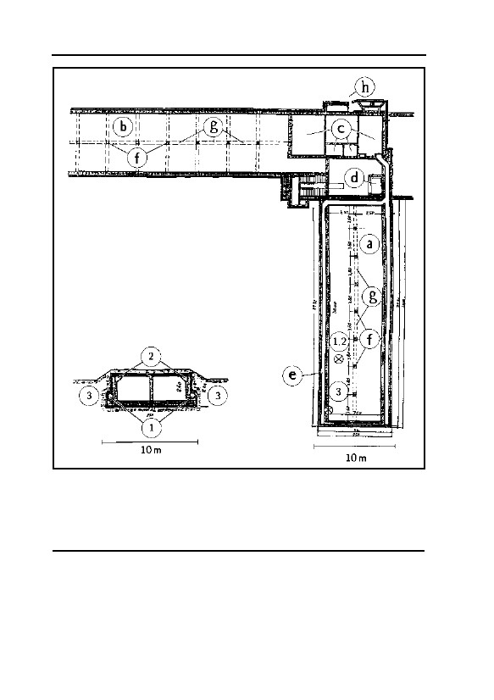
GERMAR RUDOLF · THE RUDOLF REPORT
Fig. 26: Ground plan of morgue 1 (alleged
‘gas chamber’) of Crematoria II and III (mir-
ror symmetrical) in Auschwitz II/ Birkenau
180
camp.
a: Morgue 1/ ‘gas chamber’, 30×7×2,41 m
b: Morgue II/Undressing room, 49,5×7,9×2,3 m
c: rooms resulting from partition of of former morgue 3
d: Corpse lift to the oven room on ground floor
e: Ventilation outlet channel
f: Concrete pillars
g: Concrete beam
h: Cellar entrace built later
1-3: Sample taking locations of Samples 1-3
Fig. 27: Cross-section of morgue 1 (alleged ‘gas
chamber’) of crematoria II and III (mirror
symmetrical) in Auschwitz II/Birkenau camp.180
1: Ventilation outlet
2: Ventilation inlet
3: soil
to believe in the Holocaust. Van Pelt’s testimony does, however, em-
phasize the importance of crematorium II (and crematorium III, built
as a mirror image of crematorium II, although allegedly not used quite
so intensively), which will be discussed in the following.
A special, separate morgue with better ventilation was then used,
as is usual today, as a laying out room for the victims of possible epi-
92
5. AUSCHWITZ
demics. This cellar is designated as an “Infektionsleichenkeller” (infec-
tion corpse morgue) in the technical literature. Fig. 26 is the ground
plan of morgue 1 (alleged ‘gas chamber’) of crematorium II, which
was designed mirror symmetrically to crematorium III. Fig. 27 shows
the cross section through morgue 1.180 As may be seen from the cross-
section, these morgues, for the most part, are located below ground.
The long and slender type of construction, the underground location, as
well as the lack of contact with the cremation rooms result in an even,
cool temperature in these areas. This corresponds to their having been
planned as morgues, which is how they are designated in the building
plans.
The planning of such large cellars is not astonishing, furthermore,
when one considers that several hundred corpses a day had arrived dur-
ing the worst periods of the epidemics raging in Auschwitz, and that
these corpses had to be stored somewhere. The compelling interpreta-
tion of the non-criminal planning of these rooms as harmless morgues
is shared even by Pressac.
The documentation reproduced by Pressac shows that this installa-
tion was derived from an earlier 1941 plan for a new crematorium in
the main camp.181 The access street to the crematoria in Birkenau was
located on the side of the chimney wing (see Fig. 29). The original
plan for the main camp, however, provided for an access street on the
other side of the building. Moreover, the high water table of the terrain
in Birkenau did not permit location of the morgue quite under
ground.182 The cellars were therefore raised so as not to swim on top of
the ground water. Together with the layer of earth on top of the cellars,
these were insurmountable for vehicles and carts. Direct access to the
cellars from the outside was therefore blocked. For this reason, an ad-
ditional flight of stairs was incorporated to the offices of morgue 3 as
well as a flight of stairs at the end of morgue 2 (see Fig. 29).
Possibly as a result of the dramatically altered military situation
after the German defeat of Stalingrad in the winter of 1942-43, all con-
struction plans were reduced in costs and required manpower wherever
180
J.-C. Pressac, op. cit. (note 67), pp. 319-329. Plans for crematoria II and III.
181
Ibid., p. 183, on the non-criminal planning of crematoria II and III, see, in particular, p. 264.
182
See also Michael Gärtner, Werner Rademacher, “Grundwasser im Gelände des KGL Birkenau
(Auschwitz)”, VffG 2(1) (1998), pp. 2-12 (online: www.vho.org/VffG/1998/1/GaeRad1.html);
Engl.: “Ground Water in the Area of the POW camp Birkenau”, The Revisionist, 1(1) (2003),
pp. 3-12 (www.vho.org/tr/2003/1/GaertnerRademacher3-12.html).
93
GERMAR RUDOLF · THE RUDOLF REPORT
possible. Hence, the new stairways did not have corpse chutes as the
old stairway. Several other cost-reducing changes were made on cre-
matorium III.183 Defects in the quality of the cheap material used for
crematoria IV and V must have led to their early breakdown (see next
chapter).
The original basement stairways with corpse chutes of crematoria
II and III had already been finished by then, although they could only
be accessed with difficulty. That these stairs were built at all, indicates
an over-hasty transmission of the old plans for the main camp to the
new situation in Birkenau.
The walls of the morgue consist of double brick masonry with a
layer of tar in between for insulation.183 The interior walls are plastered
with a hard, cement-rich material, the ceiling and support pillars of
reinforced concrete show the marks of wooden planking and are there-
fore not plastered. The roof, made of reinforced concrete, is isolated by
a layer of tar, which is protected from environmental and mechanical
damage by a rather thin layer of cement covering it. The layers of tar
both on top of the roof as well as between the two brick walls was in-
dispensable as a water barrier due to the high ground water in the
swampy region of Birkenau. Both morgues had several drains.
5.4.1.2. The Obsessive Search for “Criminal Traces”
Jean-Claude Pressac was the first researcher to dig through the
mountains of documentation at the Auschwitz Museum and later
through the documentation of the Zentralbauleitung stored in Moscow.
He was also the first one to create the now-widely used term “criminal
trace”. Based on the total absence of documents proving the erection
of homicidal ‘gas chambers’, Pressac resorted to a semantic trick by
attributing a criminal significance to harmless documents, which were
said to constitute a clue that something was not quite right about the
crematoria at Auschwitz. Based on the progress in research, however,
all these ‘criminal traces’ compiled by Pressac and others and accom-
panied by sometimes fantastic cerebral acrobatics have collapsed. The
most notable of them are listed and briefly refuted in the following.
183
J.-C. Pressac, op. cit. (note 67), p. 187, costs and survey of construction design of crematoria
II and III.
94
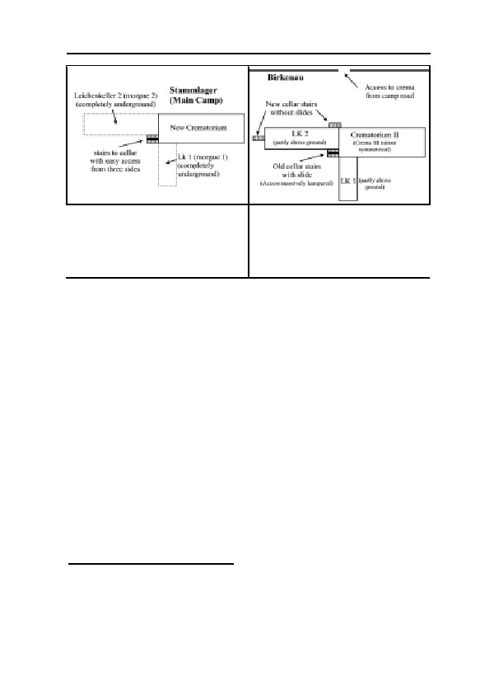
5. AUSCHWITZ
Fig. 28: Schematic location of the
Fig. 29: Schematic location of
new crematorium as originally
crematorium II, altered plan. To
planned for the Auschwitz main
adjust it to the higher location of the
camp.
morgue and the access in Birkenau
from the other side (mirroring
crematorium III).
5.4.1.2.1. New Cellars Stairways
Fact 1: Additional access ways via stairways from the outside
were later incorporated into the cellars of crematoria II and III.
Incorrect additional allegation: The corpse chute at the old, origi-
nal stairway entrance was demolished.184
Incorrect conclusion: The construction of new stairways without
corpse chutes with the simultaneous demolition in the original stairway
access way could mean only one thing: no more corpses were to go
sliding into the cellars but rather people who were still able to walk
down a few steps. Hence they had to be alive while entering, and were
killed after they had entered the building.185
Correct conclusion: The new stairways were necessary based on
the alteration in the plans, see the chapter above. This is supported by
the heading of the plan for the new stairways: “Change of cellar access
to street side”.186 The corpse chute, furthermore, was not even demol-
ished. In fact, it appears in all following plans as shown by Carlo Mat-
togno:187
184
Judgment of Judge Gray, D. Irving vs. D.E. Lipstadt, op. cit. (note 66), §7.61, 13.76, 13.84.
185
On Gray, see preceding footnote; J.-C. Pressac, op. cit. (note 67), pp. 213, 218.
186
J.-C. Pressac, op. cit. (note 67), pp. 183f., 302f.; with regards to the original plans by Walter
Dejaco, see J.-C. Pressac, op. cit. (note 90), Document 9.
187
The following list was taken from Carlo Mattogno’s “Architektonische Stümpereien…”, op.
cit. (note 92), p. 29.
95
GERMAR RUDOLF · THE RUDOLF REPORT
“– Plan 2136 of the Zentralbauleitung of 22 February 1943 for
crematorium III;188
– Plan 2197 of the Zentralbauleitung of 18 March 1943 for crema-
torium II;189
– Plan 109/15 of the firm Huta of 24 September 1943 for cremato-
ria II and III;190
– Plan 109/16A of the firm Huta of 9 October 1943 for crematoria
II and III.191
Moreover, the ‘chute’ is mentioned as existing in ordinances 200
and 204 of the Zentralbauleitung to the Häftlingsschlosserei of 18 March
1943 respecting crematorium II.192“
Furthermore, crematoria II and III were undoubtedly used during
their entire period of operation for the temporary storage of the bodies
of persons having died of ‘natural’ causes (epidemics, exhaustion, age,
etc.), awaiting cremation, which amounted at least to thousands of bod-
ies. If it were true that stairways without chutes could only be used by
living persons still capable of climbing stairs on their own, then one
might be permitted to ask: how did the corpses of persons having died
of ‘natural causes’ get into the morgue (or wherever they were stored)?
Did they walk by themselves? Of course not. They were carried, and
sometimes certainly even a few steps up and down—and not only in-
side the crematorium. Was it therefore impossible to get corpses into a
building not having a chute? Certainly not. Would missing chutes
therefore prove that only living people could enter? Of course not. So
why did the SS not build a new corpse chute by the new stairway?
Perhaps simply because the costs of the crematorium were running out
of control due to the constant changes in plans, and because it was de-
sired or necessary to keep the costs down? Would that not be a much
simpler and more logical explanation?
5.4.1.2.2. Gassing Cellar, Undressing Room, and Showers
Fact 1: There are documents of SS Zentralbauleitung which men-
tion an “Auskleidekeller” (undressing room) in crematorium II.193
188
J.-C. Pressac, op. cit. (note 67), p. 305.
189
Ibid., p. 307.
190
Ibid., p. 327.
191
Ibid., p. 328.
192
The Trial of Höß, volume 11a, p. 88.
193
J.-C. Pressac, op. cit. (note 67), pp. 433ff.
96
5. AUSCHWITZ
Fact 2: There is a document which mentions a “Vergasungskeller”
(gassing cellar,) in crematorium II.194
Fact 3: There is a document which lists “14 Brausen” (14
showers) for crematorium III.195
Fact 4: Pieces of wooden planking left in the underside of the ceil-
ing of morgue 1 in crematorium II are visible even today.196
Incorrect conclusion: Morgue 1 of crematoria II & III was built as
homicidal ‘gas chamber’, equipped with “false” shower heads, which
were fastened to the pieces of wood left in the concrete and used to
deceive the victims; morgue 2 was used as the undressing room for the
victims.197
Correct conclusion: It is not known which room is being referred
to by means of the term “Vergasungskeller” in the above mentioned
document. Since there were still no proper means to drill holes in con-
crete ceilings and no neat plastic rawl plugs in the 1940s, there was
only one way to fasten installations to bare concrete walls: conical
pieces of wood were cast in the concrete onto which the electrical
lines, water pipes, and other installations were screwed tightly. The
existence of such pieces of wood in the ceiling of morgue 1 does not
prove that shower heads were fastened there. It is more probable that
lamps or electrical lines were fastened there. Nor is there any proof
that the “showers” mentioned in the document were “false”, as stated
by Pressac. In actual fact, the Zentralbauleitung temporarily
considered expanding the Birkenau crematoria into hygiene centers
equipped with disinfestation installations, inmate showers and un-
dressing rooms but nevertheless later abandoned these plans. Carlo
Mattogno has produced extensive documentation in support of this
argument:198 in an ‘Aufstellung’ (itemization) by the Topf company dated
“Now
13 April, 1943, concerning requested metals to be used in the construc-
tion of certain machinery for crematorium II at Auschwitz, the following
194
Ibid., p. 432.
195
Ibid., p. 430.
196
Ibid., p. 488.
197
See also four Pressac footnotes above; see also Gray, judgment, op. cit. (note 66), §13.69,
13.82.
198
C. Mattogno, “Leichenkeller von Birkenau: Luftschutzräume oder Entwesungskammern?”
VffG 4(2) (2000), pp. 152-158 (online: www.vho.org/VffG/2000/2/Mattogno152-158.html);
Engl.: “Morgue Cellars of Birkenau: Gas Shelters or Disinfesting Chambers?” (online:
http://www.codoh.com/granata/leichen.html).
97

GERMAR RUDOLF · THE RUDOLF REPORT
piece of information appears:[199]
‘2 Topf disinfestation heaters for crematorium II in the prisoner
of war camp Auschwitz.’
On 14 May, Bischoff sent Topf the following ‘urgent telegram’:[200]
‘On Monday bring the overdue warm water project for ap-
proximately 100 showers. Installation of water heater or boiler in
the still under construction trash incinerator crematorium III or flue
for the purpose of utilizing the high emission temperature. Contin-
gently higher walling of the oven for the purpose of accommodating
a large reserve container is possible. It is being requested to send
along the appropriate designs with Herrn Prüfer on Monday, May
17.’
On June 5, 1942, Topf sent Drawing D60446 to the Zentralbaulei-
tung ‘regarding the installation of the boilers in the rubbish incinerator’.
This project involved the installations intended for crematorium II.[201]
In an undated ‘questionnaire’ apparently written in June 1943 re-
garding the Birkenau crematoria, in answer to the question, ‘Are the ex-
haust gases utilized?’, the head of the Zentralbauleitung, Bischoff, re-
sponded: ‘planned but not carried out’, and in response to the following
question: ‘If yes, to what purpose?’, Bischoff answered: ‘for bath facili-
ties in crematorium II and III’.[202]
Finally, there is an invoice from the firm VEDAG Vereinigte Dach-
pappen-Fabriken Aktiengesellschaft (United Roofing-Felt Factories, In-
corporated) dated July 28, 1943, with the subject ‘Auschwitz-
crematorium’ referring to ‘completed sealing work for the disinfestation
facility’ (emphasis added) which was carried out between May 21 and
July 16, 1943, cf. Fig. 30.[203]
Before drawing any conclusions, a few explanations are required.
While both Topf disinfestation heaters were then installed in the Zentral-
sauna, the document cited above refers them to crematorium II. The pro-
ject for the installation of 100 showers in crematorium III (and in crema-
torium II) could not have been for the prisoners of the ‘Sonderkom-
mando’ of the crematoria, since only 50 showers were installed in the
shower room of the Zentralsauna, which had been designed for the in-
199
Archiwum Panstwowego Muzeum w Oswiecimiu (hereafter APMO), BW 30/34, p. 47.
200
APMO, BW 30/34, p. 40.
201
TCIDK, 502-1-336 (page number illegible).
202
TCIDK, 502-1-312, p. 8.
203
TCIDK, 502-1-316, p. 431, “Zweitschrift” in 502-1-323, p. 137.
98
5. AUSCHWITZ
mates of the entire camp;[204] therefore it is clear that the ‘bath facilities
in crematorium II and III’ in the ‘questionnaire’ quoted above, were in-
tended for the prisoners of the entire camp as well. This means that it
was planned to convert the crematoria II and III into hygienic centers.
The purpose of such centers was to cleanse the inmates and their
clothing, i.e., to free them from dirt and disease-carrying parasites. But
this necessarily included a disinfection or disinfestation installation. The
expansion of the crematoria was not however completed because work
had already begun in the meantime on the central sauna which was bet-
ter suited for this purpose. The documents cited here nevertheless prove
a temporary intent on the part of the Zentralbauleitung to perform cre-
mation, inmate cleaning and the disinfestation of clothing in the same
building.
Now I think that it is not irrelevant to note here that in this project
the water heating system for the showers was connected to the garbage
incinerator and not to the crematorium oven, as for example in the five-
muffle oven of the Lublin KL. In my opinion, the reason for that decision
was the fact that the crematorium ovens did not ensure a continuity of
use to be able to provide sufficient hot water throughout the entire day;
in other words, the crematorium ovens were not used enough to ensure
efficient operation of the water heating system.
That the VEDAG-Invoice[203] indeed refers to the hot-air disinfesting
chambers installed in the Zentralsauna, is definitely proven by a VEDAG
single invoice which has the same date and the same contents as the first
invoice noted above, but it refers to the ‘BW 32 = disinfestation facility’,
that is to say, precisely in the Zentralsauna. [cf. Fig. 31,205] But for what
reason does the invoice have as its subject: ‘Auschwitz-crematorium’?
This heading has an obvious relationship to the aforesaid Topf ‘itemiza-
tion’ of April 13, 1943, concerning ‘2 Topf disinfestation heaters for
Crema II’ which were then installed in the Zentralsauna. In any case, the
two documents establish the correlation crematorium–disinfestation and
portray the expression of a plan or at least of a Zentralbauleitung inten-
tion to combine cremation and disinfestation within the same edifice.”
Since, as shown in chapter 5.2.2., the installation of hygiene cen-
ters with showers, disinfestation, undressing and dressing rooms and
adjacent crematoria is not at all unusual, the “traces” adduced by Pres-
sac and van Pelt may be seen to have been incorrectly interpreted.
204
Inventory of the delivery negotiations relating to the “Desinfektions- und Entwesunsanlage”
(Zentralsauna) of 22. January 1944. TCIDK, 502-1-335, p. 3.
205
TCIDK, 502-1-316, S. 430.
99
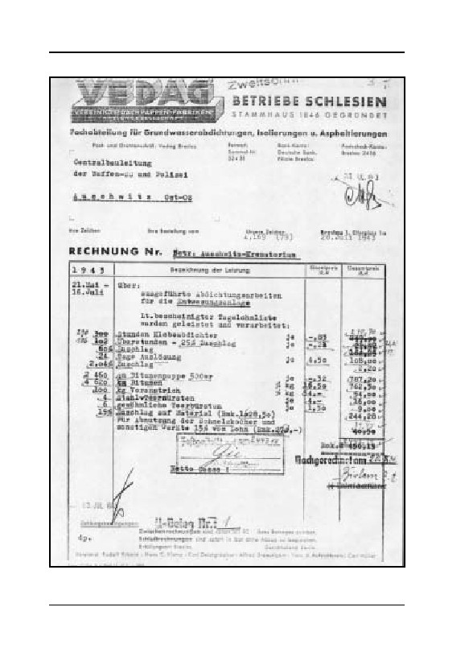
GERMAR RUDOLF · THE RUDOLF REPORT
Fig. 30: “Re.: Auschwitz crematorium […] Caulking work performed for the
disinfestation installation”
TCIDK, 502-1-316, p. 431, “Zweitschrift” in 502-1-323, p. 137.
100
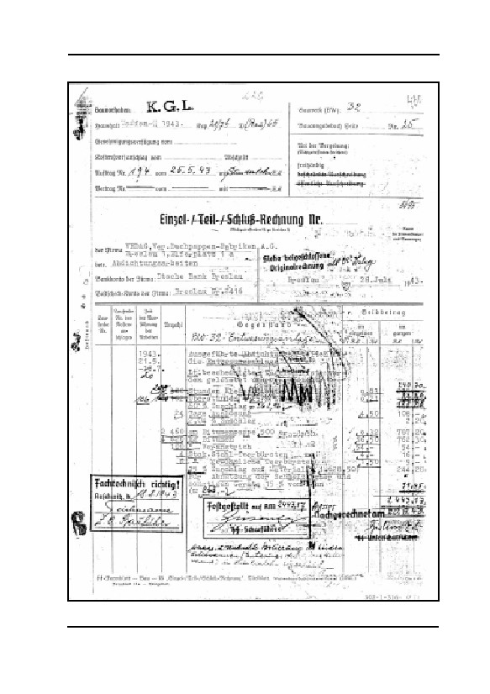
5. AUSCHWITZ
Fig. 31: “Re: BW: 32 = Disinfestation installation […] Caulking work
performed for the disinfestation installation” TCIDK, 502-1-316, p. 430.
101
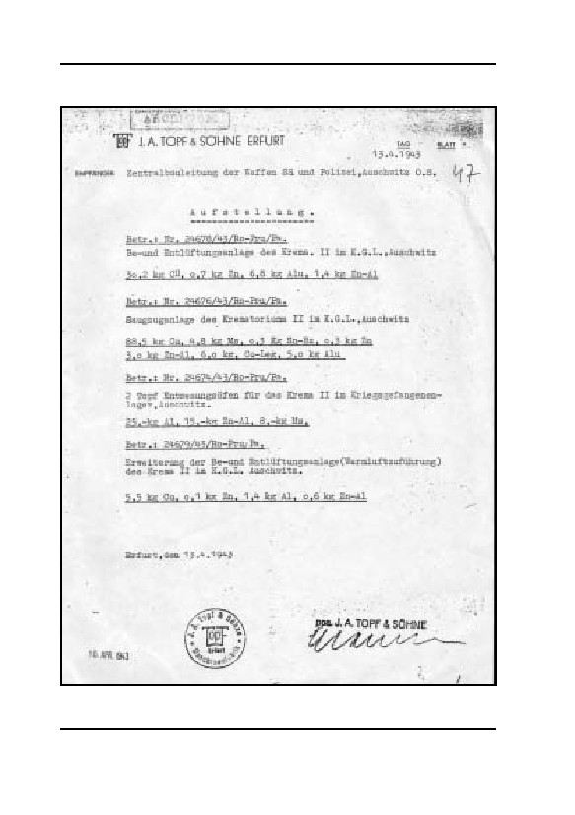
GERMAR RUDOLF · THE RUDOLF REPORT
Fig. 32: “2 Topf disinfestation ovens for crematorium II in the Prisoner of
War Camp, Auschwitz.” Archiwum Panstwowego Muzeum w Oswiecimiu,
BW 30/34, p. 47.
102
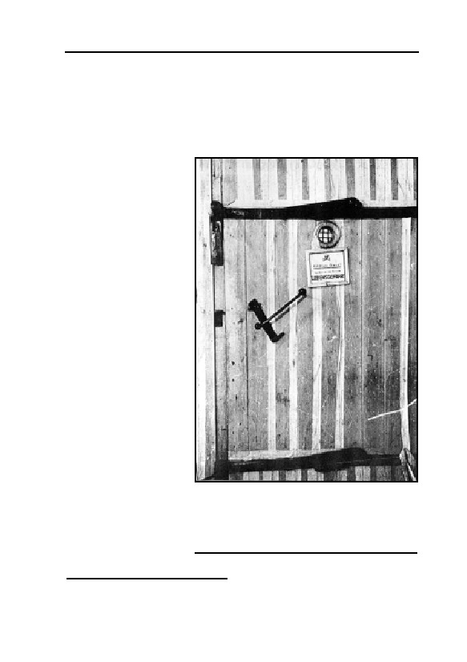
5. AUSCHWITZ
5.4.1.2.3. “Gas-tight Doors” for Crematorium II
Fact 1: Morgue 1 in crematorium II was equipped with gas-tight
doors with a peephole.206
Fact 2: An initially planned double door opening to the inside of
morgue 1 was replaced
by a double door open-
ing to the outside.207
Incorrect conclu-
sion 1: Morgue 1 in
crematorium II was
converted into a homi-
cidal ‘gas chamber’,
equipped with gas-tight
doors.208
Incorrect conclu-
sion 2: Doors opening
to the inside of morgue
1 would have been
blocked by gassing vic-
tims piling up in front
of it so that the doors
could not have been
opened. Realizing this,
the SS changed the
doors to open to the
outside.
Correct
conclu-
sions 1: Even if a peep-
Fig. 33: Wooden disinfestation chamber door
hole was not entirely
at Auschwitz, rendered provisionally gas-tight
necessary for a disin-
with peephole and metal protection grid. This
festation chamber, it
is what the gas-tight doors for the homicidal
‘gas chambers’ are supposed to have looked
has nevertheless been
like. Note the extremely flimsy lock.
proved that the disin-
206
J.-C. Pressac, op. cit. (note 67), pp. 434-436.
207
Ibid., pp. 285, 302.
208
See also Pressac footnote above; see also Gray, judgment, op. cit. (note 66), §13.84.
103
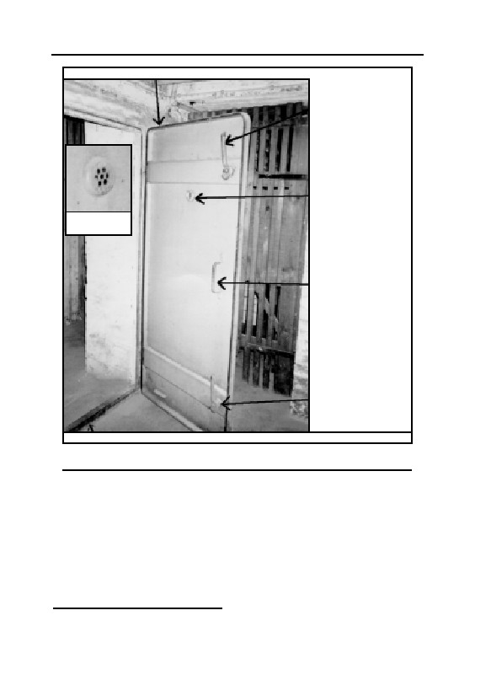
GERMAR RUDOLF · THE RUDOLF REPORT
Gas caulking
Upper door bolt
Outer peephole, with
protective grid
Peephole from
the outside
Door handle
Lower door bolt
Reinforced frames (steel in concrete)
Fig. 34: German air-raid shelter door from 1939 in the cellar of a private
house in Karlsruhe © Photo: R. Faurisson, 1991
festation chamber doors installed in Auschwitz were also equipped
with exactly such peepholes, as shown in the photograph reproduced
here (Fig. 33).209 One document indicates that gas-tight doors measur-
ing 100 cm × 192 cm were ordered for morgue 1 (the ‘gas chamber’)
of crematoria II and III.210
On the delivery plan, i.e., the final plan for crematorium II, the
size of the doors is nevertheless drawn in as 190 cm × 200 cm, as on
all previous plans, so that these gas-tight doors would not have fit-
209
J.-C. Pressac, op. cit. (note 67), p. 49.
210
Ibid., p. 436. In the inventory list on p. 430, a handwritten entry mentioning a gas-tight door
only appears in crematorium II.
104
5. AUSCHWITZ
ted.211 Based on the ruins, it must be possible even today, to establish
whether the door was possibly walled in to make it narrower and
whether there are any traces of door frames. Excavations would be
necessary to determine this.
The engineers Nowak and Rademacher have shown that the ‘gas-
tight’ doors manufactured at Auschwitz by inmates from wooden
planks could not have been gas-tight in a technical sense, the planks
did not close hermetically, the fittings were simply fastened through
the wood by means of bolts, and the seals consisted of felt strips.212
One has to consider that a hypothetical homicidal ‘gas chamber’
door would have to open outwards—a door opening inwards would be
blocked by inmate bodies lying in front of the door. Such doors would
require an especially stable arrangement as the locks and hinges would
have to be capable of resisting the pressure of hundreds of panicking
people. The pressure exerted by such masses of people becomes appar-
ent when one recalls the photographs of panicky spectators at foot-
ball/soccer matches. Separating fences and partitions between individ-
ual spectator blocks are commonly trampled down like mere blades of
grass in such situations. In any case, a simple wooden door, rendered
provisionally gas-tight, as has been found in Auschwitz, a photograph
of which is reproduced by Pressac in his book (see Fig. 33),213 could
never have resisted such pressure.
The camp administration could actually have ordered solid, tech-
nically gas-tight steel doors (air-raid shelter doors, Fig. 34) since they
were offered such doors but it can be proven that they did not order
them. One must assume that they had no serious need for them.212
In this context, a comparison of the flimsy wooden doors as found
in Auschwitz (used for delousing purposes only) with technically gas
tight, massive iron doors as used for executions in U.S. homicidal gas
chambers is revealing, compare Fig. 33 with Fig. 5 (page 24).
The installation of a door with felt seals in crematorium II may
have been temporarily considered either in connection with the tempo-
rarily considered expansion into a hygiene center or because it was
211
Ibid., pp. 227, 311, 312.
212
H.J. Nowak, W. Rademacher, “‘Gasdichte’ Türen in Auschwitz”, VffG 2(4) (1998), pp. 248-
261 (online: www.vho.org/VffG/1998/4/NowRad4.html); Engl.: “‘Gas-Tight’ Doors in Au-
schwitz”, in: E. Gauss (ed.), op. cit. (note 43), pp. 324-336 (online:
www.vho.org/GB/Books/dth/fndNowak.html).
213
J.-C. Pressac, op. cit. (note 67), pp. 46-49, 425-428, 486, 500.
105

GERMAR RUDOLF · THE RUDOLF REPORT
desired to use the only solid reinforced concrete cellar in Birkenau
camp as an air-raid shelter, as remarked by senior engineer Schreiber.
This cellar was actually used as an air-raid shelter for inmates as sug-
gested by a few eyewitness testimonies.214 This would also explain
other more minor ‘traces’ which cannot be discussed here. Samuel
Crowell has shown in several articles the extent to which the SS actu-
ally built air-raid shelter installations not only for themselves but also
for the camp inmates.215
Correct conclusions 2: The change in orientation of the doors was
probably caused by the design of this morgue’s ventilation system.
Since the air inlet of this system had a higher resistance than the outlet
(see next chapter), a considerable subpressure was caused in morgue 1,
constantly sucking air in from the rest of the building. This is a desired
effect for a morgue where many corpses had to be stored, so that un-
pleasant smells would not reach other parts of the building. A double
door opening to the side with a lower pressure (inside morgue 1)
would open automatically, whereas a door opening to the side of
higher pressure closes automatically.
214
Miklos Nyiszli’s book Auschwitz: A Doctor’s Eyewitness Account, Arcade Publishing, New
York 1993, alleges, on p. 128, that the inmates took refuge in the gas chamber during air raids.
Martin Gilbert’s Auschwitz and the Allies (Henry Holt & Co., New York 1981), p. 309, con-
tains the testimony of a female survivor, according to which she, together with many other
female arriving inmates, was led to a darkened room to remain there during an air raid. What
is most interesting about this testimony is the description of the manner in which some of the
women became hysterical during the air raid and believed that they were inhaling poison gas.
Another conclusion which could be drawn from this testimony is that the SS were concerned
with protecting their inmates from air raids, and that there must have existed several such air
raid shelters at Birkenau, which must have been gas-tight, that however remained entirely un-
noticed and unstudied (from: S. Crowell, “Technik und Arbeitsweise deutscher Gasschutz-
bunker im Zweiten Weltkrieg”, VffG 1(4) (1997), p. 242, fn. 4 online:
www.vho.org/VffG/1997/4/Crowell4.html; Engl.: “Technique and Operation of German Anti-
Gas Shelters in WWII: A Refutation of J.C. Pressac’s Criminal Traces”, online:
www.codoh.com/incon/inconpressac.html). Another survivor reports that the inmates were
regularly led into an air raid shelter during Allied air raids in 1944: Colin Rushton, Spectator
in Hell. A British Soldier’s Extraordinary Story, Pharaoh Press, Springhill (Berkshire) 1998.
215
Samuel Crowell, ibid.; see also “Defending Against the Allied Bombing Campaign: Air Raid
Shelters and Gas Protection in Germany, 1939-1945”, online:
www.codoh.com/incon/inconabr.html; “The Gas Chamber of Sherlock Holmes: An Attempt at
a Literary Analysis of the Holocaust Gassing Claim”, online:
www.codoh.com/incon/inconshr123.html; “New Documents on Air Raid Shelters at Auschwitz
Camp”, online: www.fpp.co.uk/Auschwitz/documents/LSKeller/MoscowDocs.html; “Com-
ments on Mattogno’s critique of the bomb shelter thesis”, online:
www.codoh.com/incon/inconscrmtgno.html; “Bombenschutzeinrichtungen in Birkenau: Eine
Neubewertung”, VffG 4(3&4) (2000), pp. 284-330; Engl. “Bomb Shelters in Birkenau: A Re-
appraisal”, online: www.codoh.com/incon/inconbsinbirk.html.
106

5. AUSCHWITZ
5.4.1.2.4. Ventilation Installations
Fact: All rooms in crematoria II and III were equipped with effi-
cient ventilation installations.216
Incorrect conclusion: Morgues 1 of crematoria II and III were
converted into homicidal ‘gas chambers’ equipped with installations
for the intended purpose of evacuating poison gases.217
Correct conclusion: It is in fact inconceivable that a large morgue
without windows and with only one door filled with innumerable bod-
ies of the victims of epidemic disease would not be equipped with a
ventilation installation. The efficiency of the ventilation, however,
proves that these installations were designed for typical morgues.218
The efficiency of the blowers may be seen from the invoices sent to the
Zentralbauleitung by the Topf corporation after installation of the sys-
tems.219 According to the invoices, both morgues #1, i.e., the alleged
‘gas chambers’ (in the invoice designated as the “B-room”), were each
equipped with a 4,800 m3/h intake and outlet blower,220 while for the
“L-room” (the so-called “undressing room”) only one outlet blower
was installed, with a capacity of 10,000 m3/h.221
216
The ventilation ducts of morgue 1 are visible in the plans published by J.-C. Pressac, op. cit.
(note 67), pp. 224, 289; chapter on the ventilation installations of crematoria II and III: ibid.,
pp. 355ff.; engine power of the ventilation installations for all rooms in crematoria II and III:
ibid., p. 374 and 377; size of the ventilation outlets: ibid., p. 234; Fig. of an outlet cover in the
ventilation outlets.
217
For Pressac see footnote above; a similar opinion has been expressed by Van Pelt, Pelt Report,
op. cit. (note 66), p. 208, as well as by Judge Gray in the Irving vs. Lipstadt trial, op. cit. (note
66), §7.62.
218
See also, in this regard, Carlo Mattogno, “Auschwitz. das Ende einer Legende”, in: Herbert
Verbeke (ed.), op. cit. (note 43, also the English version), pp. 134f. (online: Ger.:
www.vho.org/D/anf/Mattogno.html; Engl.: www.vho.org/GB/Books/anf/Mattogno.html). The
following remarks are closely patterned after Mattogno; for further details, see Mattogno.
219
Invoice no. 729 dated May 27, 1943. APMO, D-Z/Bau, nr. inw. 1967, pp. 246f.; ibid., 231f.:
invoice no. 171 dated 22. February 1943 for crematorium II.
220
The engines had a nominal output of 2 HP (approximately 1.5 KW). The output data relate to
a back-pressure of 40 mm water column. The increment calculations for estimating the venti-
lation shaft resistances in crematoria II & III according to engineering handbooks have shown
that the back pressure to be expected would probably have been higher (in the region of 50-60
mm water columns), due, particularly, to the primitive lids with many small holes covering the
ventilation slit. Two blowers were probably used for this reason. Personal communication
from Hans Lamker, a certified engineer.
221
J.-C. Pressac gives the output of these blowers at 8,000 m³/h, but without proving it (together
with Robert van Pelt in: Yisrael Gutman, Michael Berenbaum (ed.), Anatomy of the Auschwitz
Death Camp, Indiana University Press, Bloomington 1994, pp. 210, 232). Perhaps he simply
crudely added the output of the two blowers together, which is impermissible, since the blow-
ers did not work in parallel, but rather, in series (behind each other).
107
GERMAR RUDOLF · THE RUDOLF REPORT
When considering the volume of the two morgues (morgue 1÷504
m ; morgue 2÷900 m3), the results for the alleged, planned ‘gas cham-
3
bers’ (4,800/504 =) are approximately 9.5 air exchanges per hour and
for the undressing room (10,000/900 =) approximately 11 air ex-
changes per hour. Does anybody seriously believe that, at the end of
May 1943, i.e., two months after the beginning of the alleged mass
murders, it was assumed that the ‘gas chambers’ would need less venti-
lation than the undressing rooms, or even less than the dissecting
rooms, laying out rooms and wash rooms, the ventilation efficiency of
which were even greater—approximately 131/3 air exchanges per hour?
Wilhem Heepke’s classic work on the construction of crematoria
states that a morgue requires a minimum of 5 air exchanges per hour
and 10 during intensive use.222 Thus it is clear that the ventilation in-
stallations provided for the morgues were designed, in terms of orders
of magnitude, for morgues in intensive use or for morgues containing
the bodies of epidemic disease victims. For comparison: Zyklon B dis-
infestation chambers with circulating air systems were equipped with
72 air exchanges per hour.223 Furthermore, it should be mentioned that
the original plans for a new crematorium in the main camp from
1941—a time when even Pressac admits that the SS had no criminal
intentions—provided for 17(!) air exchanges per hour for the dissect-
ing room(!) and the morgues.224 This exchange rate is considerably
higher than what was later realized for all rooms of crematoria II and
III, including the alleged ‘gas chambers’. Thus, on the way from bene-
ficial planning to (allegedly sinister) construction, the air exchange
rates had been drastically reduced (probably in order to reduce costs).
Does anybody seriously believe, the SS would have lowered the venti-
lation capacity when changing the designation of a morgue from a
beneficial use to a homicidal ‘gas chamber’, instead of increasing it?
This is thus the final refutation of any argument on the alleged criminal
characteristics of the ventilation installations in these crematoria.
5.4.1.2.5. Pre-heated Morgues
Fact: The morgues of crematoria II and III were never heated, al-
though a heating system was temporarily considered; water pipes in
222
W. Heepke, Die Leichenverbrennungs-Anstalten, C. Marhold, Halle 1905, p. 104.
223
Gerhard Peters, Emil Wüstiger “Sach-Entlausung in Blausäure-Kammern”, Zeitschrift für
hygienische Zoologie und Schädlingsbekämpfung, 10/11 (1940), pp. 191-196, here p. 195.
224
J.-C. Pressac, Les crématoires d’Auschwitz, op. cit. (note 90) p. 18.
108

5. AUSCHWITZ
morgue 1 were removed.225
Incorrect conclusion: Morgues need no heating for normal opera-
tional functioning. Crematoria II and III were converted into homicidal
‘gas chambers’, (intended to be) equipped with a heating system so
that ‘the gas would work more rapidly’. It was necessary to eliminate
the plumbing system in the morgue because panic-stricken inmates
would have damaged the pipes.226
Correct conclusion: According to expert literature, morgues do in-
deed need some kind of heating equipment, because corpses must be
protected from the effects of frost and freezing temperatures in win-
ter.227 Hence, under normal operation, morgues would have been
equipped with heating devices, but the initial plans to equip the
morgues in Auschwitz with heaters were cancelled,228 rendering the
argument irrelevant. Regarding the removal of the water pipes, a ‘non-
criminal’ explanation follows logically: Since no heating was ever in-
stalled in these morgues, there was a danger that the water pipes would
have burst in freezing temperatures due to the lack of any heating. In
order to prevent burst pipes and a subsequent flooding of the morgues,
the pipes had to be removed.
5.4.1.2.6. “Cremation with Simultaneous Special Treatment”
Fact: With regards to the “Electrical supply and installation of the
concentration camp and prisoner of war camp” the documentary note
(“Aktenvermerk”) of the Auschwitz Zentralbauleitung of January 29,
1943, states:229
“This putting into operation [of crematorium II] can however only
extend to restricted use of the available machines (in which case crema-
tion with simultaneous special treatment [original: “Sonderbehandlung”]
will be made possible) since the [electrical] supply leading to the crema-
225
Pre-heating: J.-C. Pressac, op. cit. (note 67), pp. 221, 223. Demolition of the water pipes:
ibid., p. 286; for further details in this discussion, which is just as fruitless, since they are
based on the “criminal traces” dreamed up by Pressac, see also, generally, H. Verbeke, op. cit.
(note 43).
226
See also the above footnotes referring to Pressac, in particular, relating to the water pipes; a
similar opinion expressed by Van Pelt, Pelt Report, op. cit. (note 66), p. 296, as well as by
Judge Gray in the Irving vs. Lipstadt trial, op. cit. (note 66), §7.68.
227
E. Neufert, op. cit. (note 176).
228
J.-C. Pressac, op. cit. (note 67), p. 230. The waste heat of the forced draught blowers was to be
used, but since these burned out and were removed, the entire pre-heating project for morgue
1 was cancelled.
229
TCIDK 502-1-26-21, Jan. 29, 1943.
109
GERMAR RUDOLF · THE RUDOLF REPORT
torium is too weak for its output consumption.”
Incorrect conclusion: Since the “special treatment” mentioned ap-
parently required electricity and because the homicidal ‘gas chamber’
possessed an electrical ventilation, R.J. van Pelt concludes that “Son-
derbehandlung” referred to homicidal gassings, which was made pos-
sible by operating the ventilation despite a reduced power supply.230
Correct conclusion: First, it is not apparent from this document
whether or not electricity is required for “special treatment”. Further-
more, on January 29, 1943, the ventilation installation for the morgue
had not yet even been delivered, let alone installed and put into opera-
tion. Commencement of construction was not anticipated before Feb-
ruary 10.231 Installation was only charged to the account on February
22, 1943.232 Therefore, the “available machines” on January 1, 1943,
in no way included the morgue ventilation installations. Actually, the
concept “special treatment” in this connection has no ‘criminal’ sig-
nificance at all, as W. Stromberger104 and recently C. Mattogno have
pointed out:233
“By considering the historical context—a typhus epidemic increase
so dangerous in 1942 as to induce […] Major General of the Waffen SS
Glücks to command on February 8, 1943, the complete quarantine of the
camp[234]—the meaning of the term ‘special treatment’ in the memoran-
dum of January 29, 1943, could only be an extension of its hygienic-
sanitary meaning which emerges from other documents.235 That is, from
the hygienic-sanitary point of view, the ‘existing machines’ would have
guaranteed proper cremation with limited capacity.
This is confirmed by a document going back a few weeks. On Janu-
ary 13, 1943, Bischoff wrote a letter to the firm Deutsche Ausrüs-
tungswerke in Auschwitz with the subject ‘Fulfillment of carpentry jobs
for the building planning room.’ In this document, Bischoff complained
about the delay in receiving doors ‘for crematorium I in the KGL’, ex-
230
Robert van Pelt, Deborah Dwork, op. cit. (note 92), p. 330.
231
Memorandum from Kirschnek dated 29 January 1943. APMO, BW 30/34, p. 105.
232
Topf, invoice no. 171 dated 22. February 1943 relating to the installation for the ventilation of
crematorium II. TCIDK, 502-1-327, pp. 25-25a. See also C. Mattogno, op. cit. (note 218), pp.
136-139.
233
See also C. Mattogno, “Architektonische Stümpereien…”, op. cit. (note 92), p. 31.
234
APMO, Standort-Befehl, D-AuI-1, p. 46.
235
For this, see Carlo Mattogno, „Sonderbehandlung“ ad Auschwitz. Genesi e Significato, Edizi-
oni di Ar, Padua 2001.
110
5. AUSCHWITZ
plaining in detail:236
‘Above all, the ordered doors of Bftgb. No. 17010/42/Ky/Pa of
order letter dated 26.10.42 for crematorium I of the concentration
camp is urgently needed for carrying out special measures.’
The expression ‘carrying out special measures’ had no criminal sig-
nificance at all. On the contrary, it denoted the construction of hygienic-
sanitary installations, including the hospital for the prisoners (Häftlings-
lazarett) projected for the BIII sector of Birkenau. Therefore, if the cre-
matorium was made for ‘carrying out special measures,’ it means that it
was a part of these installations and its hygienic-sanitary function was
exclusively the cremation of dead bodies of deceased camp prisoners.”
5.4.1.2.7. “Gas Testers” and “Indicator Devices for HCN Resi-
dues”
Fact 1: There is a telegram of February 26, 1943, by means of
which heating technician Jährling of the Topf & Söhne oven construc-
tion firm orders “10 Gas testers” for crematorium II.
Fact 2: There is a letter from the Topf corporation of March 2,
1943, which, referring to the above telegram, mentions “Anzeigegeräte
für Blausäure-Reste” (indicator devices for HCN residues).
Incorrect conclusion: The SS ordered the indicator devices in or-
der to verify whether the ventilation of the ‘gas chamber’ was success-
ful after completion of mass murder with hydrogen cyanide in crema-
torium II.237
Correct conclusion: According to the technical literature, “Gas
testers” are flue gas analyzers intended to determine the exhaust gas
composition of oven gases.238 Such devices were standard equipment
in crematoria. That the above mentioned order referred to such devices
is clear from the fact that they were ordered by a heating technician
from an oven construction firm. The letter in reply from the Topf cor-
poration dated March 2, 1943, stating that one must first find out who
marketed these devices, has been revealed on several occasions to be
an absurdity:239
236
APMO, BW 30/34, p. 78.
237
See the two footnotes above, with relation to Pressac; van Pelt, Pelt Report, op. cit. (note 66),
pp. 200, 254.
238
Akademischer Verein Hütte (ed.), Hütte, Ernst und Sohn, Berlin 271942, p. 1087
239
Werner Rademacher, “The Case of Walter Lüftl”, in Ernst Gauss (ed.), op. cit. (note 22), pp.
78ff. (online: www.vho.org/D/gzz/3.html); C. Mattogno, “Die ‘Gasprüfer’ von Auschwitz”,
111
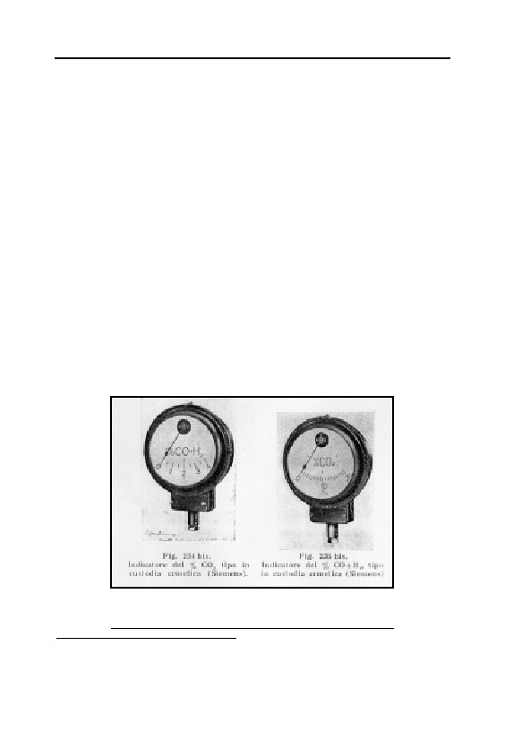
GERMAR RUDOLF · THE RUDOLF REPORT
– According to contemporary literature, devices for the detection of
HCN residues were called “Blausäurerestnachweisgeräte” (HCN
residue detection devices) or “Gasrestnachweisgeräte für Zyklon”
(Gas residue detection devices for Zyklon).128 Since the Topf &
Söhne corporation according to the letter had already received in-
formation on the possibility of procurement of such devices from
three firms, the correct name of these devices must in the mean-
time have penetrated even to Topf & Söhne.
– Furthermore, these detection devices are based on a wet chemical
method which possessed no “indicator” and could not, therefore,
be designated as indicator devices. On the other hand, the gas test-
ers mentioned in the telegram had a physico-chemical sensor con-
nected to a dial (see Fig. 35).
– According to contemporary prescriptions, testing with HCN resi-
due testing devices was obligatory in every disinfestation action
using hydrogen cyanide in order to test whether the ventilation of
a fumigated room had been successful before it could be entered
without a gas mask. Since disinfestation had been performed on a
large scale in Birkenau since 1941, it is absolutely incredible that
no one should have concerned himself with the possibility of or-
Fig. 35: Photograph of two indicator devices from the
Siemens corporation for the CO2 and/or CO+H2- gas
content in %. Component of a gas tester.240
VffG 2(1) (1998), pp. 13-22 (online: www.vho.org/VffG/1998/1/Mattogno1.html).
240
Alberto Cantagalli, Nozioni teorico-pratiche per i conduttori di caldaie e generatori di va-
pore, G. Lavagnolo Editore, Turin 1940, p. 308; taken from C. Mattogno, op. cit. (note 239),
112
5. AUSCHWITZ
dering such devices before early 1943!
– Since the creation of Birkenau camp in 1941, the SS garrison doc-
tor for Auschwitz camp was responsible, among other things, for
the ordering, administration, and use of Zyklon B and all materials
for its handling (disinfestation installations, gas masks, HCN resi-
due detection devices, etc.). He therefore had three years experi-
ence in this business. Why then should the Zentralbauleitung,
which was not competent in this matter, in addition to being unau-
thorized, have issued the order for the procurement of HCN resi-
due detection devices in 1943?
– In addition to crematorium ovens, the Topf corporation also pro-
duced hot air disinfestation ovens, as well as silo fumigation in-
stallations which were, however, not operated with HCN.241 Why
then should the heating technician Jährling, a civilian engineer,
order devices of which he had no knowledge from a firm which
obviously did not even know the supplier of the devices when the
health service of Auschwitz camp had already been regularly sup-
plied with these devices by the Tesch und Stabenow corporations
for two years and therefore knew the supplier? There was very
probably a supply of them in storage at the camp.
It is therefore the conviction of W. Rademacher, C. Mattogno, and
myself that this reply from the Topf corporation is a forgery, in which
a word such as “Anzeigegeräte für Rauchgasanalyse” was perhaps
replaced by the word “Anzeigegeräte für Blausäure-Reste” (Indica-
tor Device for Smoke Analysis by Indicator Device for HCN Resi-
dues).
5.4.1.2.8. Zyklon B Introduction Holes and Columns
Fact 1: There are eyewitness testimonies claiming that there were
three or four square holes measuring 70 cm in the roofs of both
morgues 1 of crematoria II and III.. According to some witnesses, col-
umns fabricated of mesh metal ran from the floor of the morgues
through the holes in the ceiling and protruded over the roof. Zyklon B
is alleged to have been thrown into these columns for the purpose of
p. 19.
241
Hydrogen cyanide would form poisonous residues with moist food. The gases Areginal and
Cartox were used; see also G. Kunike, Das ABC der Vorrats- und Hausschädlinge und ihre
Bekämpfung, Theodor Weicher, Berlin 1941, pp. 53f.
113
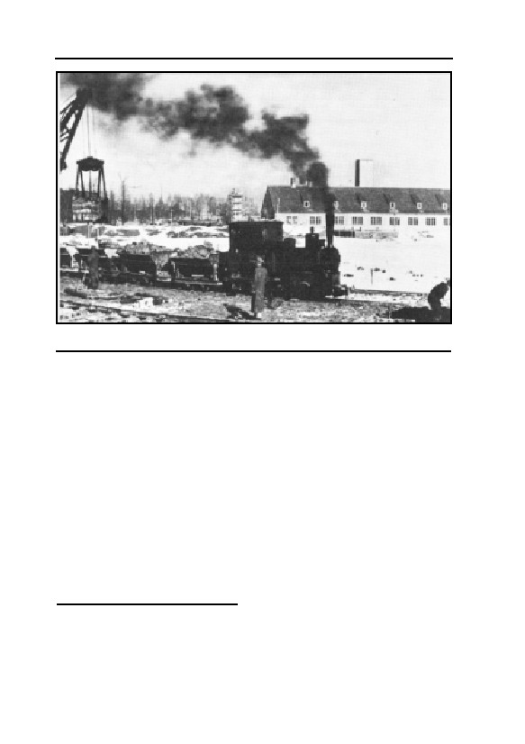
GERMAR RUDOLF · THE RUDOLF REPORT
Fig. 36: Photograph of crematorium II of Birkenau taken in February
1943.244
mass killings.242
Fact 2: There are two photographs showing objects on the roof
(see further below).
Fact 3: There is a document mentioning “Drahtnetzeinschubvor-
richtungen” (wire mesh push-in devices).
Incorrect conclusion: The eyewitnesses are right.
Correct conclusion: Pressac reproduced a photo of crematorium II
showing square objects located on the roof of morgue 1 (the fourth
object obviously lies behind the cellar).243 The same photograph also
appears in Danuta Czech’s book.244 It was taken in early February
1943, see Fig. 36, the decisive detail of which being magnified in Fig.
37. If these objects are really Zyklon B introduction holes, as Pressac
believes, then one must assume that the objects are:
a) of equal size
b) regularly aligned
242
Henryk Tauber: J.-C. Pressac, op. cit. (note 67) p. 484; Filip Müller, Sonderbehandlung,
Steinhausen, Munich 1979, p. 95; Charles Sigismund Bendel: E. Kogon et al., op. cit. (note
42), p. 227; Michal Kula: E. Kogon et al., op. cit. (note 42), p. 231; for a summary and cri-
tique of these and other witness accounts on these alleged openings and introduction devices,
see G. Rudolf, op. cit. (note 68), pp. 34-37.
243
Op. cit. (note 67), crematorium II, p. 340, taken ca. between Feb. 9 and 11, 1943.
244
D. Czech, op. cit. (note 89), p. 454.
114
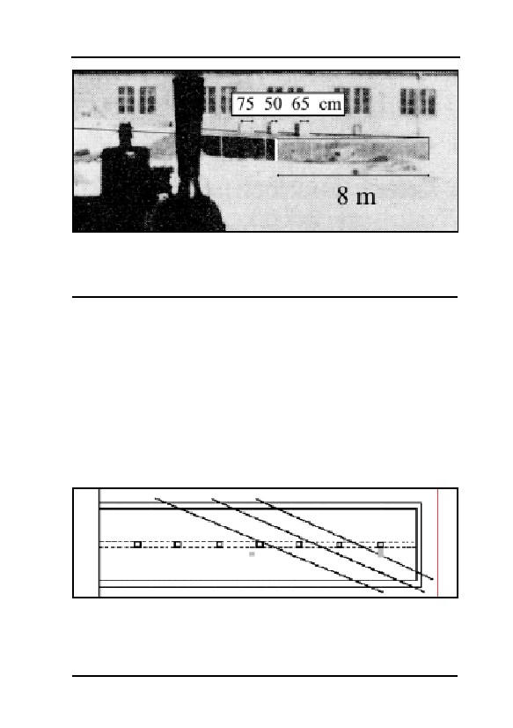
5. AUSCHWITZ
Fig. 37: Magnification of detail from Fig. 36 with outlines of the morgue and
scale of measurements drawn in. The width of the three objects in Fig. 36
shows strong variation between ca. 50 and 75 cm. Furthermore, it is notable
that the shady side of the first object, seen from the left, is considerably
weaker than those of the others.
c) regularly distributed along the roof
d) nearly the same color and
e) casting approximately the same shadows.
Fig. 37 points out the outlines of the cellar, indicating its width as
well as the approximate width of the three objects. Despite the medio-
cre resolution of the photograph, it may be concluded that these objects
are of unequal width, not evenly distributed over the roof, but stand, on
the contrary, close together. It also seems peculiar that the shady side
of the first object seen from the left, compared with those of the other
two objects, is remarkably light in color. Fig. 38 shows the alignment
of perspective, viewed from above, on which these objects can possi-
Fig. 38: Schematic drawing of a view onto morgue 1 of crematorium II.
Longitudinally painted: the concrete longitudinal beam with the 7 supporting
pillars. Drawn in as intersecting lines: base-lines, upon which the middle of
the three objects located on the roof must have been located.245 Obviously,
they were not evenly distributed along the roof. Grey rectangle: actual
location of the two openings in existence today.
115
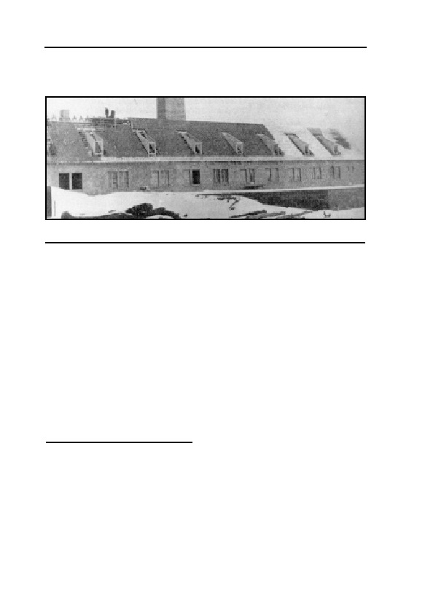
GERMAR RUDOLF · THE RUDOLF REPORT
bly be located.245 As none of the requirements set forth above is met,
the argument that these objects are above-roof parts of Zyklon B intro-
duction stacks must be abandoned.
Fig. 39: Photograph of crematorium II from Jan. 20, 1943, similar in
perspective as Fig. 36, but without objects on the roof of morgue 1.
It should be mentioned in passing that these objects are not to be
seen in other photographs of the morgue, see Fig. 39 taken on January
20, 1943,246 as well as another photograph reproduced by Pressac and
taken in the summer of 1943.247 It will therefore be necessary to find
another explanation for the objects in the photograph taken in February
1943, such as, for example, that some sort of objects had been placed
on the roof—perhaps in the course of constructing the building, under-
takings which were obviously still underway—or horribile dictu, but
less likely, that the picture has been retouched at a later date.
Fig. 40 shows an enlargement of an Allied air photo of Birkenau
camp taken on August 25, 1944.248 Darkened areas (arrow) are clearly
visible on the lateral wing, the roof of morgue 1 (‘the gas chamber’) of
crematorium II. A stereoscopic evaluation of this air photo shows that
these darkened areas on Fig. 40 cannot have possessed any height.249
245
Taken from Jean-Marie Boisdefeu, La controvers sur l’extermination des Juifs par les Alle-
mands, volume 1, Vrij Historisch Onderzoek, Berchem 1994, p. 168.
246
From D. Czech, op. cit. (note 89), p. 398, and J.-C. Pressac, op. cit. (note 67), p. 335.
247
J.-C. Pressac, op. cit. (note 67), p. 341. Pressac, of course, alleges the existence of Zyklon B
introduction apertures; in actual fact, however, nothing of the sort is to be seen.
248
Alliied aerial photographs, National Archives Air Photo Library, Washington, D.C., RG 373
Can F 5367, exp. 3185, published by CIA employees D.A. Brugioni and R.G. Poirier, Le
Monde Juif, no. 97, January-March 1980, p. 2, allegedly on their own, private, responsibility.
249
R. Lenski, op. cit. (note 25), pp. 356ff., testimony of aerial photographical appraiser Kenneth
R. Wilson, pp. 8 927-8 941e of the trial transcript; see also B. Kulaszka (ed.), op. cit. (note
25), pp. 353f. According to Wilson, the spots on the photos dated Sept. 13, 1944, cannot be
seen.
116
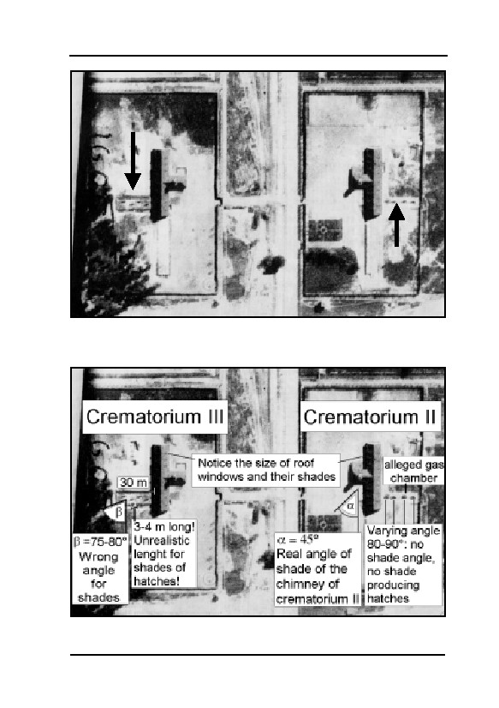
5. AUSCHWITZ
Fig. 40: Enlargement of Allied air photo RG 373 Can F 5367, exp. 3185 of
Birkenau camp, taken on August 25, 1944. An interesting feature is the dark
spots on morgue 1 (‘gas chambers’) of both crematoria (arrow), of which it
is known today that there are no introduction stacks for Zyklon B.
Fig. 41: Schematic drawing of the air photo in Fig. 40. It is immediately
apparent that the spots on the roofs of morgues 1 cannot be introduction
stacks: too large, too irregular, wrong direction for ‘shadows’.
117
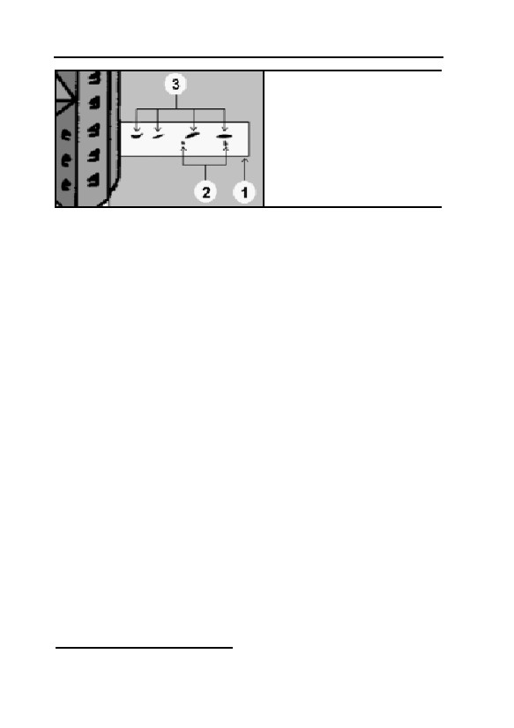
GERMAR RUDOLF · THE RUDOLF REPORT
Fig. 42: Schematic drawing of the
location and size of the spots (3)
on the roof of morgue 1 (the ‘gas
chamber’) of crematorium II (1)
visible on the air photos, as well
as the location (2) of the only
250
holes to be found today.
If the Zyklon B introduction stacks really possessed the dimen-
sions of 70 cm (21/3 ft) on each side as described by the eyewitnesses,
this cannot be reconciled with the spots on the air photo, which are
approximately 2 to 3 m2 in area (20-23 ft2). It must be noted that the
chimneys of the inmate barracks as well as the large crematorium
chimneys are rich in contrast, symmetrical, and straight. The spots on
morgue 1 of both crematoria, by contrast, form an angle of approxi-
mately 75-80° (crematorium III) or 80-90° (crematorium II, irregular)
to the arrangement of the main wing of crematorium II (see schematic
drawing Fig. 41). If these spots were objects of any kind, they would
have to exhibit the same alignment as the shadows of the crematorium
chimney of crematorium II, the chimney of an inmate barracks, and
other sharply conspicuous parts of the picture. The actual shadows, in
contrast to the spots above, form a 45° angle to the main direction of
crematoria II and III (see Fig. 41).
We know that the crematorium chimney of crematorium II was
15 m high.180 It throws a shadow on the picture which is five times as
long as the spots on the roof of morgue 1 (‘gas chamber’) of cremato-
rium III (length of shadow of chimney: 20 m, that is, the angle of the
sun was approximately 37°, length of the spots on morgue 1 (‘gas
chamber’) of crematorium III: approximately 4 m). This means simply
that the alleged Zyklon B introduction stack must have projected 3 m
above the roof of morgue 1 (‘gas chambers’) of crematorium III in or-
der to cast such long shadows, which may be ruled out as impossible.
Absence of spatial height, irregular shape, incorrect size (length
and width), and wrong, irregular direction of the spots therefore prove
definitively that these spots are not the shadows of any objects, nor can
250
Figure 42 was taken from the Air Photo Evidence website (air-photo.com/altered/altered.html)
with John C. Ball’s kind permission.
118
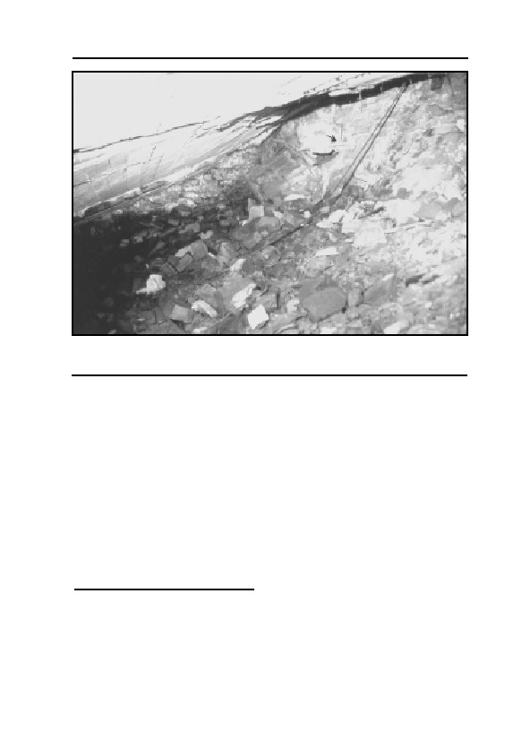
5. AUSCHWITZ
Fig. 43: Interior photograph taken from the ruins of morgue 1 (‘gas
chamber’) of crematorium II. The arrow points to the photograph taking
location (see chapter 8.3.3.).
they be the legendary Zyklon B introduction stacks. The irregular,
vague nature of these spots, as well as the fact that they are missing on
at least one air photo,251 gives rise to the conclusion that they are the
retouching of a forger, added at a later time. An expert study prepared
in late 1992 by John Clive Ball, a professional air photo interpreter in
Canada, has since proven that the air photos were faked while they
were in the possession of the CIA– surprise, surprise!252
As a result of the long-lasting wrong interpretation of these spots
on this air photo, the otherwise unfounded allegation was made that the
alleged Zyklon B introduction stacks were aligned linearly on the mid-
dle of the roof in case of morgue 1 (‘gas chamber’) of crematorium II,
and aligned alternating to the left and to the right of the middle of the
251
J. Ball, op. cit. (note 43), p. 48, morgue 1 of crematorium II, photograph dated 13 September
1944, RG 373 Can B 8413, exp. 6V2.
252
The manipulations on this picture are overly plentiful, such as, for example, an interpolated
drawing of a group of inmates allegedly marching over the roof of a barracks! See also J.C.
Ball, ibid., p. 42; Ball, “Air Photo Evidence” in: Ernst Gauss (ed.), op. cit. (note 22), pp. 271-
284 (online: www.vho.org/GB/Books/dth/fndaerial.html). On the alleged original photo-
graphs, it may furthermore be seen that the spots on morgues 1 of both crematoria (II + III) are
pointing in different directions; ibid. private communication by J.C. Ball.
119
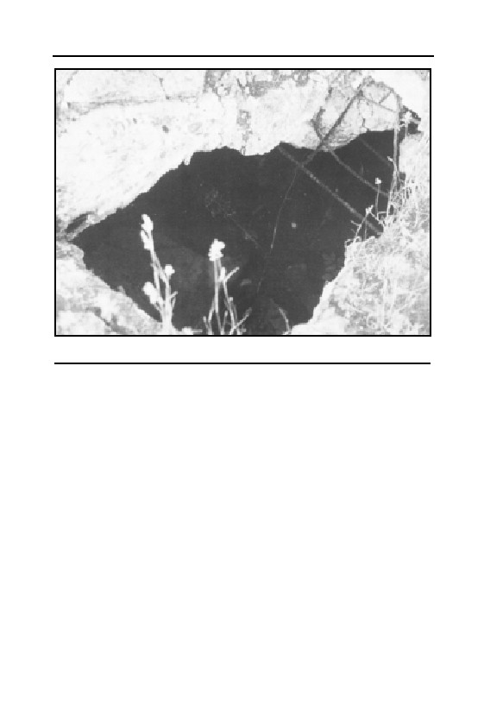
GERMAR RUDOLF · THE RUDOLF REPORT
Fig. 44: Alleged Zyklon B introduction hole in the ceiling of morgue 1 (‘gas
chamber’) of crematorium II, entry to the still passable part of the cellar.
roof in case of morgue 1 of crematorium III, according to the location
of the spots on this air photo. The alternating alignment, however,
would contradict the argument that the Zyklon B introduction columns
were aligned behind the concrete support pillars in order to conceal
them so that the entering victims would not become suspicious. As a
matter of fact, no introduction column could have been hidden behind
a concrete pillar, because this would have necessitated the opening of a
hole not only through the reinforced concrete roof, but also through the
massive longitudinal support beam, see Fig. 26, which would have
compromised the stability of the entire morgue. Hence, an alignment to
the left and/or right of the support pillars would have been unavoid-
able.
After the building was destroyed towards the end of the war—by
whom does not matter—one occasionally encounters the attitude that
the remaining ruins are fakes, and that the original installations have
disappeared without a trace. This would mean that the Poles rebuilt the
crematoria true to the original for many millions of Zlotys after the
war, only in order to blow them up. A grotesque idea. Thus the author
of the present book was rejected as an expert witness by a court on De-
120
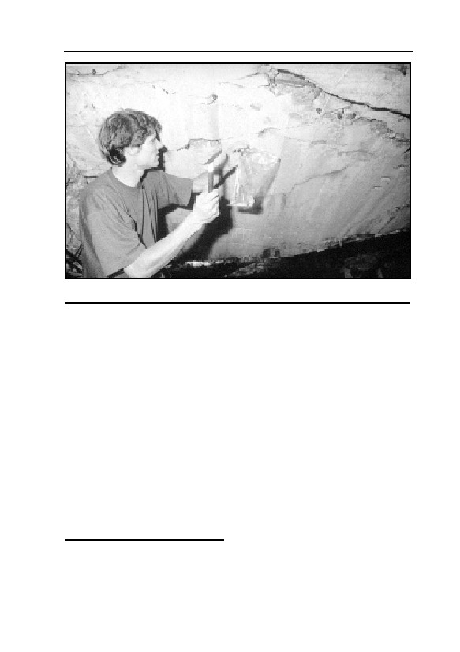
5. AUSCHWITZ
Fig. 45: Ceiling of morgue 1 (‘gas chamber’) of crematorium II. Sample
taking location of samples 1 and 2.
cember 6, 1991, and May 5, 1992, on the grounds that his research on
the ‘gas chambers’ was fully irrelevant since, as it was allegedly well
known, the structures in Auschwitz were only fakes, the authentic ‘gas
chambers’ having disappeared without a trace.253
Such allegations are, of course, absurd, and only testify to the
technical incompetence of the judges entrusted with these matters. It is
a shame that such individuals are given the power to decide the fate of
others in these disputes.254
The roofs of morgue 1 (‘gas chambers’) of both crematoria today
are broken in pieces and have collapsed, but the ceiling of morgue 1
(‘gas chamber’) of crematorium II is still relatively intact. The next to
the last of the seven pillars of morgue 1 (‘gas chamber’) of cremato-
rium II, seen from the south, still bears a piece of the ceiling. There,
one can still climb down into the interior of the cellar through a hole in
the ceiling (Fig. 44, p. 120) (see also Figs. 43 and 45), in which the
ground water stands on the floor even in summer during a fairly
253
County Court Munich, ref. 451 Cs 112 Js 3326/90 and ref. 432 Cs 113 Js 3619/90.
254
See, in this regard, the letter from the semi-official German Institut für Zeitgeschichte, in
which, with relation to the Auschwitz State Museum, the reconstruction of the installations in
crematorium I is described and the condition of the original ruins of the crematoria in Birke-
nau are briefly mentioned: H. Auerbach, Institut für Zeitgeschichte, Munich, letter dated
March 20, 1992.
121
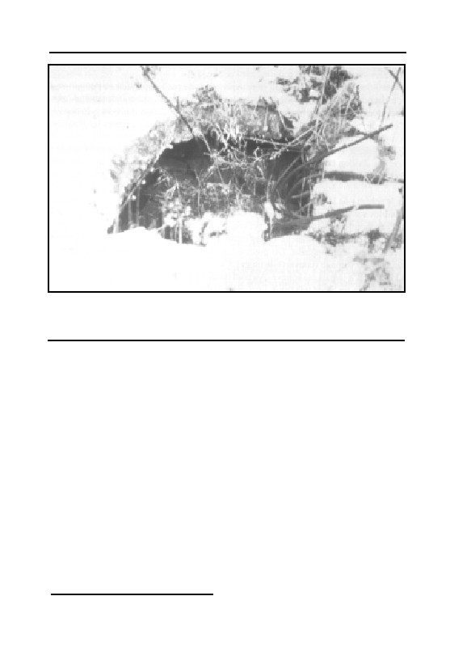
GERMAR RUDOLF · THE RUDOLF REPORT
Fig. 46: Alleged Zyklon B introduction hole in the roof of morgue 1 (‘gas
chamber’) of crematorium II in December 1991. It is clearly visible that it was
not cleared from the steel reinforcement rods. These were simply bent
backwards.
lengthy dry season. Large parts of the masonry work and concrete ceil-
ing accessible there are in original condition, protected from wind and
weather. There are no visible signs of erosion or corrosion. In his book,
Pressac shows illustrations of the circular, intact ventilation pipe open-
ings through the ceiling of morgue 2 of crematorium II as well as
through the concrete ceiling of the oven room of crematorium III.255
Figs. 49-53 (p. 126) show the five openings in the ceiling of the
oven room of crematorium III as of December 1991. They were used
to withdraw radiant heat from the crematorium ovens. The ceiling col-
lapsed during the demolition of the oven room and most of the five
holes were partially destroyed during the process.
If the Zyklon B introduction holes described by eyewitnesses
really existed, with the wire mesh columns installed inside them, then
what else is to be expected?
1. According to eyewitness Henryk Tauber, the victims would
have demolished all the equipment in this room:256
255
J.-C. Pressac, op. cit. (note 67), pp. 365f.
256
Ibid., pp. 483f.; Pelt Report, op. cit. (note 66), p. 106.
122
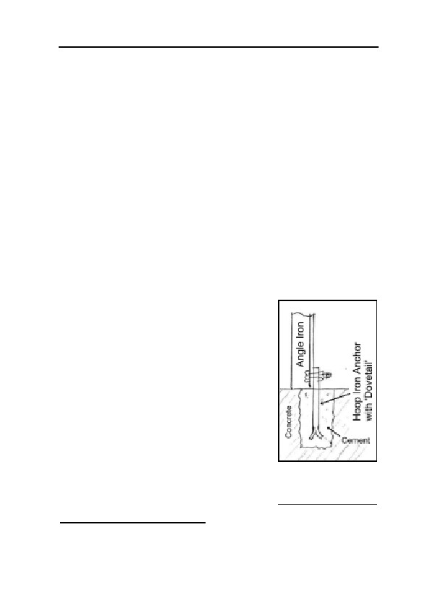
5. AUSCHWITZ
“The people going to be gassed and those in the gas chamber dam-
aged the electrical installations, tearing the cables out and damaging the
ventilation equipment.”
2. Several hundred people, locked into a cellar with a very small
surface area, anticipating death, would panic and attempt to escape,
damaging everything that stood in their way. So what would the vic-
tims locked into the cellar have done to the wire mesh columns de-
scribed by the eyewitnesses? If these columns actually existed, their
outer framework would have to have been of solid steel, but certainly
not of fragile wire mesh construction.
3. These columns would, in addition, have had to have been sol-
idly anchored in the concrete ceiling, the floor, and the concrete pillars.
But since solid anchoring dowels did not yet exist at that time, hoop
irons would have been cast into the concrete during the construction of
the cellar, spread out to a ‘dovetail’ inside the concrete.257 If carried
out after completion of the building, holes would have been chiseled
into the concrete, and the hoop irons would have been cast in cement
filling these holes, see Fig. 47. In both cases, a removal of such cast-in
hoop irons would have been impossible. All
one could do is cut them off with a saw or a
welding torch.258 Hence, if any introduction
device was ever installed in these morgues,
traces of such hoop irons must still be present.
4. Furthermore, the steel reinforcement
rods in the reinforced concrete would have to
run wreath-like around the hole, and would be
capable of verification by means of induction
devices, even today.
5. Since, in addition, the morgues’ roofs
were covered with a layer of soil approxi-
mately one half meter thick, the entire con-
struction would have to be protected against
Fig. 47: Hoop iron
the intrusion of soil and rain water, and in so
with dovetail, cast
doing it would have been indispensable to
in cement in a hole
raise the edges of the holes above the surface
in concrete.
257
I am grateful to Carl Hermann Christmann, a certified building engineer, for this information.
258
I am grateful to R. Faßbender, a certified building engineer, for this information, who also
provided the drawings.
123
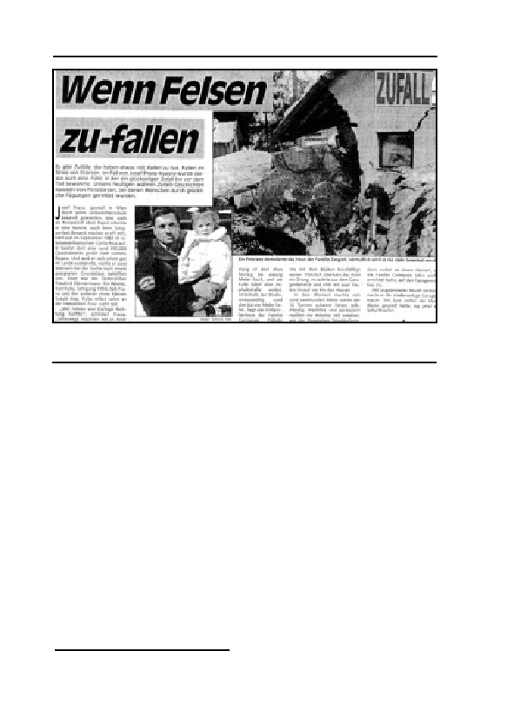
GERMAR RUDOLF · THE RUDOLF REPORT
Fig. 48: Notch (fatigue) effect resulting at inserted openings from the
application of force. The only crack running through the wall proceeds,
naturally enough, from the corner of the window.260
of the roof like miniature chimneys.
Nothing of the kind can be found on the roof of morgue 1 of cre-
matorium II which has remained largely intact. The only two holes
which can be found today of anything approaching the diameter in-
volved were obviously crudely pierced at a later time, as may been
seen in Figs. 46 and 44 (p. 120). Even Pressac admits that these are the
only holes visible today.259 Nevertheless his richly illustrated book in-
cludes not one clear photograph of the two existing holes.
All other smaller breakthroughs, cracks, and openings in the roofs
of morgues 1 (‘gas chamber’) of crematoria II and III visible today are
breaks in the reinforced concrete effected at a later time with the iron
reinforcing rods sticking out. Nowhere does one find cleanly poured
concrete edges or rough, chiseled out edges with some remaining plas-
ter work; there are no remains of ascending concrete or brick/mortar
stacks; no steel reinforcement rods running other than would be ex-
pected for an ordinary flat roof without holes; and there are no traces
of any hoop irons, dovetails, or any other means of anchoring any de-
vice to the morgue’s floor, ceiling, or concrete pillars.
259
J.-C. Pressac, op. cit. (note 67), p. 354.
124

5. AUSCHWITZ
If any of these holes were used as Zyklon B introduction holes,
they would have to have been broken through following completion of
the roof, i.e., shortly before the commencement of the alleged mass
murders.261 Such holes with no plasterwork to polish off their rough
edges, however, could neither have been sealed against escaping poi-
son gas, nor against intruding soil and water, nor would it have been
possible to safely install any panic-proof introduction devices in them.
Using such crude holes would truly be an incredibly stupid piece of
bungling.
But there is more. In the opening shown in Fig. 46 the reinforce-
ment rods were only separated and bent back. They possess their full
length even today. One could bend them back again and weld them
back together with their stumps, which are also visible to the left of the
photograph (covered with snow).262 Nor is there any trace of rein-
forcement rods running in a wreath-like pattern around the hole. This
hole, therefore, can never have been used as an introduction hole; it
was never finished. And what makes matters worse: this is still the
‘best’ of all holes and cracks in this roof in existence today. All others
are even more irregular and filled with reinforcement rods.
No apparatus, using the technology available at that time, could be
anchored in such crudely pierced, unplastered holes, from which the
reinforcement rods were not even removed; therefore, no gas introduc-
tion device could ever have been firmly installed, let alone sealed from
the exterior. This means that the entire environment including the sup-
posed perpetrators would have been endangered by the gas streaming
out of the opening. The supposed victims could furthermore only have
been prevented by force from escaping through these holes, or even
throwing the Zyklon B back out through the hole, since these holes
were obviously incapable of closing.
We might even go much further in this direction: we can tell from
260
Kurier, Aug. 30, 1992, p. 20: “Wenn Felsen fallen”.
261
The ceiling was finished towards the winter of 1942/43, while the mass exterminations alleg-
edly began in March 1943; see also J.-C. Pressac, op. cit. (note 67), pp. 338f.
262
Please do not attempt to bend them back again! More recent photographs show that individu-
als have obviously broken off two of the three reinforcement rods during similar such at-
tempts. One of these persons who unintentionally broke off one rod was Dr. Fredrick Töben in
February 1997, as he advised me personally after his visit to Auschwitz. Another rod was bro-
ken off later by unknown person(s), see. Carlo Mattogno, “Keine Löcher, keine Gaskam-
mer(n)” VffG 6(3) (2002), pp. 284-304 (online: www.vho.org/VffG/2002/3/Mattogno284-
304.html).
125
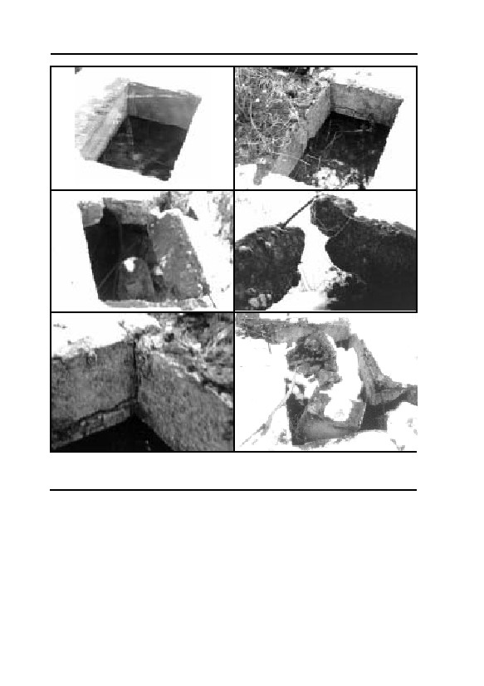
GERMAR RUDOLF · THE RUDOLF REPORT
2
1
3
3
4
5
Figs. 49-53: The five properly constructed ventilation holes in the ceiling of
the oven room to the upper story, crematorium III; condition: December
1991. Note the cracks caused by the explosion.
the concrete when at least one of the two large holes was pierced. An
opening pierced through the concrete in the roof of either morgue 1
(‘gas chamber’) in consideration at a later time would inevitably have
had the consequence, when the building was blown up, that the breaks
and fissures caused to the roof by the explosion would have run
preferentially through these holes.
The reason for this is that explosions exert extraordinarily great
forces, and that the formation of cracks is favored by any weakness in
the structure, since the tension peaks attain very high values in the vi-
cinity of acute angles (notch effect, see Fig. 48). Such holes, in particu-
126
5. AUSCHWITZ
lar, which would already have damaged the structure of the concrete
due to their incorporation following completion of the structure, repre-
sent not only points of likely fracture, but points of inevitable fracture.
This is made more obvious by Figs. 49-53 (p. 126). Although the ex-
plosion pressure in the oven room, on an even level with the ground,
could turn aside in all directions, and the roof remains relatively intact
to the attic, three of the five oven room ventilation holes, cleanly cast
and reinforced in the concrete roof, were completely destroyed. In the
case of two of the other holes, clearly visible cracks formed at the cor-
ners, visible in the photos reproduced by Pressac.255
In the morgues of crematoria II and III, the explosion pressure
could only turn upwards, causing their roofs to be much more seriously
damaged than the roof of the oven room. The alleged Zyklon B intro-
duction holes in the roof of morgue 1(‘gas chamber’) of crematorium
II however are conspicuous for having remained relatively intact; in
the case of the hole in Fig. 46 all the cracks and fissures run around
this hole! On the spot, one furthermore recognizes the arbitrary ar-
rangement of this hole in a location at which the roof of the morgue is
undamaged. This alone proves with building engineering certainty that
this hole was broken through after the destruction of the roof!
The chisel marks on the edge of the hole in Fig. 44 are so similar
to those in Fig. 46 that it must be assumed that both holes have the
same history.263
There were therefore no holes in the ceilings of these rooms
through which the poison gas preparation could be introduced by
means of wire mesh pillars” or otherwise, as described by eyewit-
nesses.
Prof. van Pelt remarked accurately in this regard:264
“Today, these four small holes that connected the wire-mesh col-
umns and the chimneys [on the roof of morgue 1, crematorium II] cannot
be observed in the ruined remains of the concrete slab. Yet does this
mean they were never there?”
An interesting question, which the professor of architectural his-
tory answers as follows:
263
Carlo Mattogno, op. cit. (note 262), has shown that the size of this hole actually increased
over the years, probably because the Auschwitz Museum wants to give it a more regular, rec-
tangular shape.
264
Pelt Report, op. cit. (note 66), p. 295.
127
GERMAR RUDOLF · THE RUDOLF REPORT
“While there is no certainty in this particular matter, it would have
been logical to attach at the location where the columns had been some
framework at the bottom of the gas chamber ceiling, and pour some con-
crete in the holes, and thus restore the slab.”
Van Pelt’s claim that the camp administration could have filled the
holes in the ceiling with concrete in the fall of 1944 in order to restore
the ceiling, is without proof. But at least Prof. van Pelt believes that the
SS administration acted logically, in that they allegedly attempted to
wipe away all trace of their alleged crime. But does van Pelt really be-
lieve that it would have made more sense to fill up the holes with con-
crete instead of removing the entire roof of the ‘gas chamber’, as was
done with the roofs of morgues 2, the “undressing room”? An Allied
air photo taken on December 21, 1944, shows that the roof of the other
morgue, which is not alleged to have been used to commit any mur-
ders, was completely removed.265 Obviously the whole matter makes
no sense. To believe van Pelt, we must believe, that the SS arbitrarily
created architectural relics to confuse later tourists and Holocaust re-
searchers instead of destroying the roof entirely, as in the case of the
undressing room. This seems too absurd to be taken seriously.
But if van Pelt had the most rudimentary knowledge of architec-
ture, he would know that it is impossible to remove holes measuring 70
× 70 cm (that is almost half a square meter!) from a concrete roof
without leaving clearly visible traces. Actually, however, there are no
traces of openings in the roof later closed with concrete.
In addition, concrete patches filled in later would have flown out
of these holes like corks out of a shaken champagne bottle during an
explosion, thus making the holes just as visible as they were before.
On closer inspection, Prof. van Pelts allegation turns out to be not only
demonstrably wrong, but utterly absurd.
But at least Prof. van Pelt agrees with the revisionists that there are
no remains of these alleged holes. In remarking that there are no such
traces, van Pelt has in fact proven that there were never any holes in
the ceiling of this room, and, consequently, no Zyklon B introduction
holes of any nature whatever, and, consequently, no introduction of
any poisonous substances whatever in the manner described by the
‘eyewitnesses’. He has proven that his ‘eyewitnesses’ were lying. He
265
Dino A. Brugioni, Robert G. Poirier, op. cit. (note 248), p. 15; see also G. Rudolf, op. cit.
(note 68), p. 39. I am grateful to Fritz P. Berg for this argument.
128
5. AUSCHWITZ
has proven that there is no proof for the mass murders in Auschwitz.
Actually, he has proven that there is no proof for the Holocaust. “No
holes, no ‘Holocaust’” (Robert Faurisson). It is beautiful to see the
great Professor of Architecture Robert Jan van Pelt in the year 2000
come to the same conclusion as myself in the year 1991, when I inves-
tigated the ceiling of the alleged ‘gas chamber’ of crematorium II of
Birkenau. Only our conclusions are somewhat divergent.
At this point, I would like to introduce a witness who contacted
David Irving by e-mail after conclusion of Mr. Irving’s legal proceed-
ings against Deborah Lipstadt in May 2000. He is an engineer named
Barford; his colleagues are assisting in the conservation and restoration
of the camp for the Auschwitz Museum administration. He informed
David Irving that, during his trial, investigations were made in com-
plete secrecy at Auschwitz with regards to the mystery of the holes,
and then remarked:
“[W]hat happened to their [the Auschwitz Museum’s] tests on the
roof of Crema II mentioned in the attachment. Did they find the Zyklon B
holes or not? Did they report those results to Lipstadt’s lawyers, and
when! […]
As you can guess, despite my belief that you and the Revisionists are
wrong, and despite spending half an hour examining the collapsed roof
of the underground gas chamber of crematorium II from different angles,
I found no evidence of the four holes that the eye-witnesses say were
there […].
Secondly several areas of the slabs are covered in small rubble from
an outer layer of concrete which was fractured by the blast. Now I would
have expected these fragments to have fallen through the holes, if they
were there, into the void beneath. […]
I remain puzzled by the lack of physical evidence for these holes.”
In early 2000, Charles D. Provan distributed a paper claiming he
had located the missing holes in the roof of morgue 1 of crematorium
II.266 What Provan did, however, was simply to declare those cracks as
‘holes’, which were caused by the concrete support pillars piercing
through the collapsing roof and cracks caused by the roof bending over
the longitudinal beam. All holes described by Provan are full of rein-
266
“No Holes? No Holocaust? A Study of the Holes in the Roof of Leichenkeller 1 of Kremato-
rium II at Birkenau” published by author in early 2000; online:
http://www.revisingrevisionism.com.
129
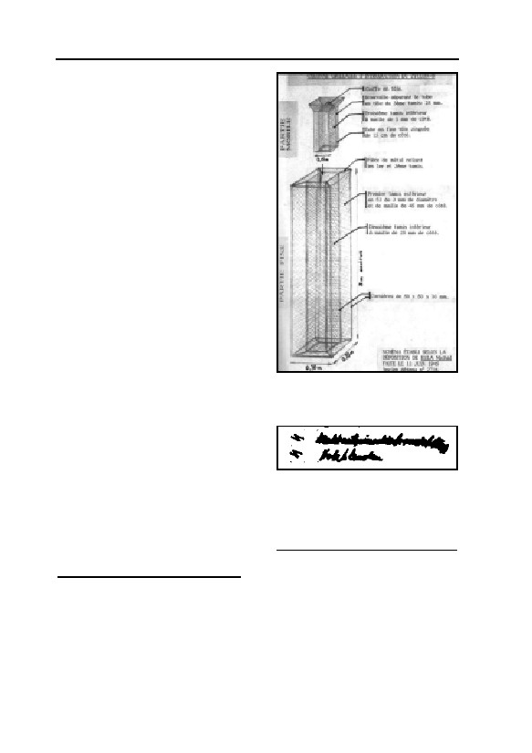
GERMAR RUDOLF · THE RUDOLF REPORT
forcement bars, they lack regular
shape, have no straight edges and
corners (as is to be expected for
regular, planned-in holes), no traces
of plaster (as is to be expected if
holes were chiseled in later), no
traces of chimney extensions to lead
these stacks through the soil, no
traces of anchoring devices (rawl
plugs, hoop irons, dovetails…). In
his schematic drawing of the roof,
Provan even possesses the boldness
to display these cracks as holes with
regular shapes.267 C. Mattogno has
pointed out in detail how unfounded
and distorted Provan’s claims really
are.268
Finally, I want to focus on those
legendary “Zyklon B introduction
Fig. 54: J.-C. Pressac’s drawing
columns” for which Michal Kula is
of the legendary “Zyklon B
the most frequently quoted ‘eye wit-
introduction columns” as
ness’. He gives a detailed descrip-
described by Michal Kula.270
tion of these columns which he
claimed he had built.269 J.-C. Pres-
sac270 (see Fig. 54) and Prof. van
Fig. 55: Handwritten entries in an
Pelt271 have prepared drawings of
inventory list of crematorium II for
these columns based on Kula’s de-
morgue 2. The lower one reads
scription. Firstly, there neither exists
“Holzblenden” (wooden blinds).
material nor documentary evidence
Can anybody guess what the up-
195
that these columns existed.268 All we
per one means?
267
Ibid., p. 36.
268
Carlo Mattogno, op. cit. (note 262).
269
Höß trial, vol. 2, pp. 99-100.
270
J.-C. Pressac, op. cit. (note 67), p. 487; on p. 287, Pressac shows a rather primitive drawing
with French inscriptions, probably prepared by a former French inmate on request of the So-
viet investigation commission right after the war.
271
R. van Pelt, op. cit. (note 69), pp. 194, 208; caveat emptor: Though van Pelt’s translation of
Kula’s testimony is erroneous, and though the data supplied in Kula’s testimony is rather
meager, van Pelt uses it to make five different, very detailed drawings—some of it necessarily
based on van Pelt’s fantasy, and the rest based on Kula’s fantasy.
130

5. AUSCHWITZ
actually have in this regard is a handwritten entry in an inventory list
for crematorium II,195 of which some people claim it means “4 Draht-
netzeinschubvorrichtungen”, which, literally translated means some-
thing like ‘wire mesh push-in device’. I have reproduced this handwrit-
ten entry in Fig. 55. The following points deserve to be taken notice of:
– this entry is basically illegible and could also mean something
else;
– it is unknown, by whom and when this handwritten entry was
made;
– this entry is made for morgue no. 2, the alleged undressing cellar,
not(!) for morgue 1, the alleged ‘gas chamber’;
– if Kula’s introduction columns would be included in this inventory
list, they would appear with an appropriate name describing the
whole thing, not just a ‘push-in device,’ which could only be the
inner part of Kula’s device;
– in German, schub describes horizontal (pushing) movements,272
whereas for vertically lowering an object, the word laß is used,
i.e., Einlaßvorrichtung instead of Einschubvorrichtung.
Whatever this handwritten entry really refers to, one thing is clear:
it does not support Kula’s claim of the existence of complex Zyklon B
introduction devices(!) in morgue 1(!) of the crematoria II and III.
Furthermore, M. Kula’s credibility as a witness must be consid-
ered very low, since he claims for example that he saw how corpses of
gassing victims were carried away:
“I saw then that they [the corpses] were greenish. The nurses told
me that the corpses were cracked, and the skin came off.”
As will be shown in chapter 7., victims of Zyklon B gassings
aren’t greenish (they are pinkish-reddish), and there is no reason for
the corpses to crack and for their skin to come off. This is nothing but
atrocity propaganda.
But let us assume for a moment, the SS would have faced the
problem of introducing HCN into the morgues 1 of crematoria II and
III after their roofs had been finished. I offer two options to solve the
problem, and every reader might pick the solution that seems more
likely:
a) Pierce (2×4=) eight holes through the reinforced concrete roofs – a
272
E.g., a cabinet’s drawer is a Schublade.
131
GERMAR RUDOLF · THE RUDOLF REPORT
laborious and expensive task, leading to massive, irreparable dam-
age to the roofs’ layer of tar and upper cement layer; add (2×4=)
eight brick or concrete chimneys of at least 1 m height to lead the
holes through the layer of soil on top of the roofs, and attempting
to repair the damage done to the roof by the violent hole piercing
process – another laborious, material consuming, and expensive
task; design and construct (2×4) eight wire mash columns 3 m
high, consisting of three parts: a panic-proof, outer column made
of massive steel, a middle wire mesh column (with no purpose at
all but to hinder the HCN from spreading out), and a removable
inner wire mesh column, another laborious, material as well as
time consuming, and expensive task; finding a way to anchor
these eight devices panic-proof in the concrete floor, ceiling and
pillars, another laborious and expensive task; all these works had
to be planned, approved, tested, and material had to be allotted,
leaving a thick and long ‘paper trail’ of documents (which, by the
way, doesn’t exist); but finally, all one would possess at the end
would be a primitive device allowing for the simple introduction
of Zyklon B by pouring it into the inner column; one had to sit and
wait for a long time until a lethal amount of HCN had evaporated
from the Zyklon B carrier and had spread into the morgue, or al-
ternatively, one had to apply an excessive amount of Zyklon B to
ensure high evaporation rates for quick execution success, and re-
move and destroy the Zyklon B after the gassing, though only a
fraction of the HCN had been released by then.273
But there was a second, much simpler option:
b) Installing a simple basket – to hold Zyklon B – in the air intake
shaft of morgue 1 right after the easily accessible intake ventilator,
which then would blow the HCN vapors right into the ‘gas cham-
ber’, similar to the DEGESCH circulation procedure; thus reduc-
ing the gassing time and the amount of Zyklon B required to a
fraction compared to any scenario where Zyklon B is simply kept
closely together on heaps without any moving air.274
273
For evaporation rates of Zyklon B, see chapter 7.2. and 7.3.1.3.
274
The brick-built air intake duct was easily accessible from the attic, where the fans were in-
stalled, and the ground floor; see J.-C. Pressac, op. cit. (note 67), pp. 276, 291, 329, 369. The
use of the air intake fan to introduce HCN would have lead to some HCN losses through the
air exhaust chimney already during the gassing, thus endangering anybody close to those cre-
matoria, but certainly not more than would have been the case when all the HCN had to be
removed after the end of a hypothetical gassing, so this would not be an argument against this
132
5. AUSCHWITZ
Also, one could have drastically increased the evaporation rate of
the Zyklon B in this basket even further, hence accelerating the
execution procedure. All that would have been required was to al-
ter an idea the Topf engineers had in early March 1943. When fac-
ing cooling problems of the cremation furnaces’ forced draught
blowers, the Topf engineers suggested to use the excess heat pro-
duced by these engines to pre-heat the morgue. The only construc-
tional change needed for this was to redirect this excess heat into
the morgue’s air intake duct.275 Though the forced draught blowers
overheated and were damaged shortly thereafter,228 it would have
been easy to construct a short air duct from the furnace chimney to
the air intake duct of morgue 1 instead. In this way, warm air com-
ing from the crematory ovens would have been redirected over the
Zyklon B basket into morgue 1, supplying this room with warm
air enriched with HCN.
I assume the point I am making is clear: there were all sorts of
cheaper and less complicated solutions available than suggested by
Michal Kula. His solution is simply impracticable and is an insult to
every engineer’s and architect’s intelligence—naturally bearing in
mind the fact that the ruins of crematorium II clearly prove that no
such columns were ever installed anyway.
5.4.1.2.9. Conclusions
Pressac’s “criminal traces” have been refuted on structural engi-
neering grounds. So, too, have all the ‘eyewitnesses’, who have been
discredited without exception. The alleged homicidal ‘gas chambers’
are therefore refuted upon the grounds of building engineering. Or, in
Robert Faurisson’s words:
“No Holes, No ‘Holocaust’”
In summary, the arguments relating to the introduction columns
may be listed as follows:
technique. Also, such a loss of HCN is minimal compared to the loss following Kula’s sce-
nario. For more on this, see chapter 7.3.1.3.
275
See chapter 5.4.1.2.5.
133

GERMAR RUDOLF · THE RUDOLF REPORT
Table 1: Arguments relating to the Zyklon B introduction columns
ALLEGATION
FACT
Zyklon B introduction
An analysis of this air photo proves that the spots
stacks are visible on
visible have no spatial height, have an irregular shape,
morgue 1 (‘gas cham-
an incorrect size (much too long and wide), and ir-
ber’) crematoria II and
regular directions different from real shadows; these
III on an air photo.
spots can therefore neither be shadows of any objects,
nor can they be the legendary Zyklon B introduction
stacks.
The filling stacks are
These three objects are only visible on one photo-
visible on a ground
graph; on others they are missing. They stand closely
photo of crematorium II.
together, have different dimensions and irregular
alignment. Introduction stacks would have the same
size, a regular alignment and evenly distributed over
the roof. The objects do not accord with the holes
actually found, either in location or in number.
For planned introduction
The only two holes deserving this name clearly show
holes, cleanly cast and
chisel marks; the concrete structure was destroyed at a
reinforced holes with
later time; there are no smooth, cast concrete edges
concrete/brick stacks
and surfaces, no stack-like elevation to prevent the
protruding over the layer
entry of rain water and soil into the hole. All other
of soil laying on this roof
cracks and openings are highly irregular, filled with
would have to be ex-
reinforcements rods, and obviously caused by the
pected.
collapsing roof being pierced by pillars and bent over
the longitudinal beam.
For holes chiseled in, the
In all cases the reinforcement rods still project into
reinforcement rods
the holes; in one case, these were only cut through
would have to be re-
and bent back. The edges of all holes and cracks were
moved, the edges pol-
not plastered; the tar insulation is openly visible; there
ished off, and a protrud-
is no trace of any stacks added. The ‘best’ of these
ing stack built. Such
holes is in an area unaffected by the explosion that
holes would be severely
blew up this morgue, proving that this hole was chis-
damaged by an explo-
eled in after the war.
sion.
The installation of intro- No trace of such fixtures can be found anywhere,
duction devices running hence no such devices were ever installed.
from the ceiling to the
floor requires panic-
proof fixtures, like mas-
sive rawl-plugs and hoop
irons with dovetails
134
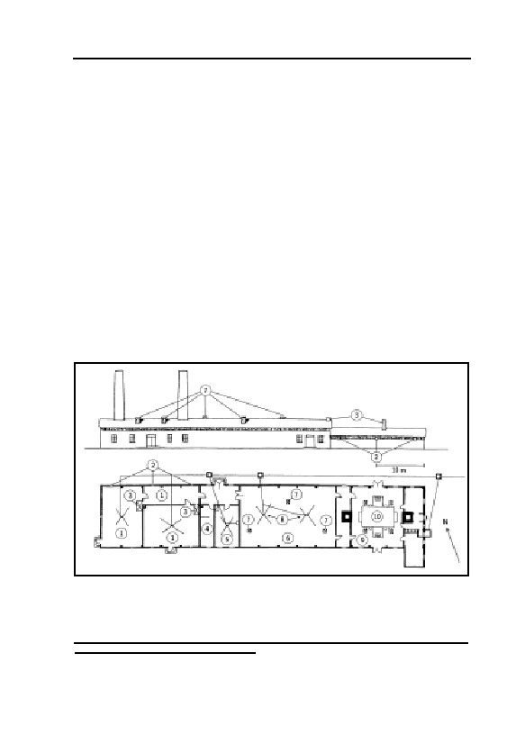
5. AUSCHWITZ
5.4.2. Crematoria IV and V
Figure 56 shows the ground plan of crematorium IV and mirror-
symmetrically that of crematorium V.276 Based on cost considerations,
these buildings, planned and begun later, were constructed in a simpler
manner than crematoria II and III. Due to low quality materials, the
crematorium ovens of both crematoria broke down shortly after the
putting into operation of the installation. They were not repaired due to
crematorium over-capacity. There are few documents as well as con-
tradictory and, to some extent, incredible eyewitness testimonies relat-
ing to these installations, which, according to Pressac, must be consid-
ered the least well-known:277
“[…] the least known of the instruments of extermination […] a
comparison of such testimonies reveals inconsistencies.”
These crematoria were planned starting in the summer of 1942,
built until early 1943. According to Pressac, in addition to the two
western rooms, which bear no designation in the plans, the vestibules
are also supposed to have been used as homicidal ‘gas chambers’. All
Northside
Fig. 56: North lateral view (above) and ground plan (below) of crematorium
IV and/or V (mirror image) in Auschwitz II/Birkenau camp.276
1: Alleged ‘gas chambers’; 2: Alleged Zyklon B introduction hatches; 3:
Heating ovens; 4: Coke room; 5: Doctor’s office; 6: Morgue; 7: Ventilation
chimneys; 8: Gullies; 9: Oven room; 10: Crematorium ovens
276
Plan received from R. Faurisson. The same plan is found in J.-C. Pressac, op. cit. (note 67), p.
401, but of very poor quality.
135
GERMAR RUDOLF · THE RUDOLF REPORT
these rooms allegedly possessed gas-tight hatches with wooden shut-
ters approximately 1.50 m from the floor and measuring 30×40 cm, in
the exterior walls, for the introduction of Zyklon B,278 which are later
supposed to have been widened to 40×50 cm.279
Both rooms had heating furnaces that needed to be fired from the
vestibule, which, according to Pressac, was allegedly also used as a
‘gas chamber’ (for the heating, see Fig. 56). No ventilation installation
is known to have existed. Pressac assumes ventilation by natural con-
vection.279 Franciszek Piper, Director of the Auschwitz Museum
agrees:164
“There were plans for mechanical ventilation of the Zyklon B, but
these were not put into effect. Evacuation of the gas was instead achieved
by convection, that is, by merely opening the doors.”
Pressac alleges the later incorporation of a door in the corridor for
natural ventilation support, but without proving it.280 Since it would
hardly have been any more expensive for the SS to provide for me-
chanical ventilation in these rooms, and since this solution would have
been considerably more effective, Pressac’s argument of the installa-
tion of a door for ventilation can be rejected as unrealistic. It is also
obvious that the morgue and oven room possessed ventilation chim-
neys. The rooms which purportedly served as ‘gas chambers,’ how-
ever, are the only rooms which, apart from the coke room and doctor’s
office,281 possessed no ventilation chimney!
According to an older Pressac publication,282 these ‘gas chambers’
were not planned and built as such either, which he bases, among other
things, on the fact that the absence of a ventilation installation would
have led to a need to evacuate the entire building for many hours dur-
ing a gassing.283 It is, in fact, inconceivable for a gas chamber not to
277
J.-C. Pressac, op. cit. (note 67), pp. 379ff., chapter on crematoria IV and V.
278
Ibid., p. 384. For an illustration of the gas-tight door and hatches, see pp. 46-49, 425-428, 486,
500.
279
Ibid., p. 386.
280
Pressac points to a photo of crematorium IV, ibid., p. 417, as proof of his hypothesis. But
since the photograph was taken from the south side while the corridor lies on the north side of
the building, the door shown in the plan is the access, drawn on the plan, to one of the undes-
ignated rooms. If he means to refer to crematorium V, hidden in the forest in the background,
then it is impossible to claim seriously that anything can be recognized on this photo.
281
A doctor’s office in crematoria, by the way, is quite normal, even today; see also E. Neufert,
op. cit. (note 176).
282
J.-C. Pressac, Le Monde Juif, no. 107, Juli-September 1982, pp. 91-131.
283
Pressacs argues this way in his new book as well, op. cit. (note 90), pp. 67, 89.
136
5. AUSCHWITZ
possess a ventilation system, regardless of the purpose for which it was
designed.
In his new book, Pressac leaves these arguments unchanged.284
Since the mass extermination of the Jews was supposed to have been
already fully underway—particularly, in farmhouses I and II—when
crematoria IV and V were being planned, it is, of course, absurd to be-
lieve that these installations could have been incorrectly designed and
built. Today, therefore, Pressac assumes a “criminal planning” of the
crematoria.285 Proof of such criminality is alleged to have been sup-
plied by various documents, mentioning the “installation of gas-tight
[sic] windows”, “pouring concrete floor in gas chamber”, and re-
peated mentions of gas-tight doors in various connections.286
As already shown in the chapter on the disinfestation of personal
effects, the German word “Gaskammer” (gas chamber) was the desig-
nation commonly used at that time for the disinfestation of personal
effects. The combination of crematoria and disinfestation installations
in one and the same building was very common practice at that time.287
Indications have since been found leading to the inference that it was
initially planned to use the rooms referred to in some documents as
“gas chambers” for disinfestation purposes. One factor in favor of this
hypothesis, for example, is that the ovens for the heating of these
rooms had to be heated from the hallway, and that the lamps planned
for installation in these rooms had be to explosion-proof, and installed
in a recess.288
In the case of crematoria IV and V, one must assume that the
rooms in question here were intended for disinfestation purposes, but
never completed for this purpose, let alone used. In any case, there is
no evidence that ventilation systems absolutely necessary for the use of
HCN were ever installed.289 The reason for this may lie in the fact that
284
J.-C. Pressac, op. cit. (note 67), p. 386.
285
Ibid., p. 447.
286
Ibid., pp. 406, 442-455.
287
For a prominent example, one need only consider Dachau concentration camp, the cremato-
rium building of which contained a series of DEGESCH circulation delousing chambers, see
p. 65.
288
A point which suggests that a fundamental danger of explosion must be reckoned with during
fumigations with hydrogen cyanide; see also chapter 6.3.
289
J.-C. Pressac, op. cit. (note 90), pp. 89f., alleges, in this regard, that a ventilation installation
was built into crematorium IV only in late May 1944, but his remarks are untenable in this re-
gard; see also Germar Rudolf, “Some Technical and Chemical Considerations about the ‘Gas
Chambers’ of Auschwitz and Birkenau”, in: Ernst Gauss (ed.), op. cit. (note 22), pp. 347f.
137
GERMAR RUDOLF · THE RUDOLF REPORT
starting in early 1943, the Germans were working on the completion of
a large hygienic complex with a large hot air disinfestation installation
(the so-called ‘Zentralsauna’) in the immediate vicinity of these cre-
matoria, and were also anticipating the early use of microwave disin-
festation installations as promised by Berlin (see chapter 5.2.3.6.).
W. Rademacher has remarked that Pressac personally quotes a
document by means of which “210 Gas door anchorings” were or-
dered in Auschwitz. This document indicates that the term gas-tight
(“gasdicht”) does not necessarily constitute a reference to execution of
disinfestation chambers, since it has never been claimed that there was
a need for roughly one hundred doors for homicidal ‘gas chambers’ at
Auschwitz.290 It is entirely possible that all doors and windows were
designated as ‘gas tight’ if they were equipped with felt insulation and
were, therefore, sealed off against air currents, a characteristic not at all
common in windows for inmate barracks in a concentration camp.291
Pressac himself provides yet another item of proof that the term
‘gas chamber’ has no criminal significance in Auschwitz documents.
One document states: “1 key for gas chamber”. Since all ‘gas tight’
doors found at Auschwitz, as well as all surviving photographs of such
doors, show that these doors had no locks, this document must refer to
a door for another type of room, such as a room for the storage of Zyk-
lon B, which truly required storage under lock and key.292
The walls of crematoria IV and V, which were built entirely above
ground, were of simple brick masonry. After they were blown up, both
buildings were demolished to their foundation walls and concrete
foundations. The foundation wall of crematorium V, which is ap-
proximately 1 m high, is supposed to have been rebuilt.293 The founda-
tion wall of crematorium IV, which is approximately 50 cm high, is
also supposed to have been rebuilt out of other rubble at a later time.56
Even these ruins can still speak to us, even if, in this case, only the
concrete foundations are authentic, since everything else is probably
not authentic. Another technical precondition for the use of the rooms
alleged to have been homicidal ‘gas chambers’ would be that it would
(online: www.vho.org/GB/Books/dth/fndgcger.html).
290
W. Rademacher, op. cit. (note 239), p. 80; J.-C. Pressac, op. cit. (note 67), p. 451.
291
At least the windows of those inmate barracks still accessible today in Birkenau have been
installed in a very sloppy way, so that the wind blows intensely through the gaps. It is, how-
ever, questionable whether these barracks are authentic or were rebuilt after the war.
292
J.-C. Pressac, op. cit. (note 67), p. 456.
293
Ibid., p. 390.
138
5. AUSCHWITZ
have to have been rendered impossible for the victims on the inside to
get anywhere near the introduction hatches, since otherwise they could
have simply pushed the SS man off the ladder while he was throwing
the Zyklon B into the chamber; they could then have attempted to es-
cape. A U-shaped, solid steel grid construction anchored in the floor
and in the masonry of the walls with steel hoop anchors spread out into
dovetails would have been necessary to keep the victims on the inside
at arm’s length from the hatches. The concrete floors of these rooms
surviving today, however, make it clear that nothing of the sort was
ever anchored in the floor.
5.4.3. Farmhouses 1 and 2
According to eyewitness accounts, there are supposed to have
been two farmhouses (sometimes referred to as bunkers 1 and 2), lo-
cated west-north west of the Birkenau camp, which were converted
into homicidal ‘gas chambers’. Their location and construction are not,
however, exactly described. Pressac mentions contradictory eyewitness
reports in this regard.294 Relating to the testimony of P. Broad, for ex-
ample, he writes.: “[…] not exploitable […], since it has been rewrit-
ten by and for the Poles […]”, and: “It is impossible to make a synthe-
sis of all these accounts”. Höß’s report relating to the characteristics
and location of these buildings is only superficial.295 According to re-
marks in the judgment to the Frankfurt Auschwitz trial,296 the homi-
cidal mass gassings are supposed to have taken place in a manner simi-
lar to those in the chambers of crematoria IV and V, described above.
This procedure is clarified by the testimony of Richard Böck,297 and, to
a certain extent, by Milton Buki,298 Rudolf Höß, Szlama Dragon, Mau-
rice Benroubi, Moshe Maurice Garbarz, Johann Paul Kremer (at the
Frankfurt Auschwitz trial), and André Lettich.299
Pressac has published a photograph of what are alleged to be the
294
Ibid., pp. 161ff.
295
R. Höß, in: M. Broszat (ed.), Kommandant in Auschwitz, Deutsche Verlags-Anstalt, Stuttgart
1958.
296
Judgment of the so-called Frankfurt Auschwitz Trial, ref. 50/4 Ks 2/63, p. 99; see note 83.
297
Interrogation of the eyewitness R. Böck during pre-trial investigations for the so-called Frank-
furt Auschwitz Trial: Staatsanwaltschaft beim LG Frankfurt (Main), Strafsache beim Schwur-
gericht Frankfurt (Main) gegen Baer und Andere wegen Mordes, ref. 4 Js 444/59, sheets
6878ff. Quoted: sheet 6881f.
298
J.-C. Pressac, op. cit. (note 67), p. 163.
299
See also J. Graf, Auschwitz. Tätergeständnisse und Augenzeugen, op. cit. (note 43).
139

GERMAR RUDOLF · THE RUDOLF REPORT
remains of the foundation walls of farmhouse 2.300 According to analy-
ses of Allied air photographs, there was only temporarily a building in
the vicinity of the location ascribed to farmhouse 2; there is no trace of
farmhouse 1.252,301 The extermination of the Hungarian Jews is sup-
posed to have been underway when the air photos were taken, with
many thousands of victims per day and strongly smoking cremations in
large open ditches precisely in the area analyzed.302 There is no trace of
large cremation ditches, large fires giving off copious smoke, or large
stockpiles of fuel. Only on air photos made during the winter of
1944/1945, a few mass graves can be seen west of crematorium III—
probably for the victims of the chaotic circumstances in the camp after
the Germans started to shut down and dismantle the equipment in fall
of 1944 during their withdrawal.303
Recently discovered documents prove that one of these farm-
houses actually existed—and was used for disinfestation. The SS, in
particular, was prohibited from carrying on the disinfestation of per-
sonal effects with Zyklon B inside the camp whenever there was a
safety risk. The conversion of a farmhouse, which was located outside
the camp, and whose utilization as provisional HCN disinfestation in-
stallations would not have involved any safety risk for the camp itself,
could have resulted from this difficult situation. Several documents are
now available which refer to an “existing building” outside of con-
struction section B III, in which a bath installation and sauna were to
be installed.304
In late 2001, several European newspapers reported that an Italian
scholar had discovered the ‘bunker 1’ in Birkenau.305 As C. Mattogno
has shown, however, this is nothing but a hoax. The farmhouse alleg-
edly identified as the old bunker is at a totally different location than
the alleged bunker 1 supposedly was, and it was never anything else
but a farmhouse.306
300
J.-C. Pressac, op. cit. (note 67), p. 176.
301
Pfeiffer, Hansa Luftbild GmbH, aerial photographic analysis of Allied photograph dated Aug.
25, 1944 (note 248), letter dated July 17, 1991; J. Konieczny, The Soviets, But Not the West-
ern Allies, Should Have Bombed the Auschwitz Camp, Polish Historical Society, unpublished
paper.
302
J.-C. Pressac, op. cit. (note 67), p. 253.
303
See J.C. Ball, in E. Gauss, op. cit. (note 252), p. 283.
304
TCIDK 502-1-24-77, Nov. 30, 1942; 502-1-24-33, Dec. 3, 1942; 502-1-332-46a, Jan. 9, 1943;
502-1-26-66, April 9, 1943; 502-1-238-10, Sept. 30, 1943.
305
Le Monde, Nov. 20, 2001; Bild, Nov. 20, 2001; Corriere della Sera, Nov. 21, 2001, p. 35.
306
C. Mattogno, “Die ‘Entdeckung’ des ‘Bunkers 1’ von Birkenau: alte und neue Betrügereien”,
140
5. AUSCHWITZ
5.4.4. The Drainage System in Birkenau
5.4.4.1. Background: Eyewitness Accounts
J.-C. Pressac quotes various eyewitnesses claiming that due to the
restricted capacity of the Auschwitz crematoria, a large portion of the
bodies of the victims of homicidal mass gassing were cremated in
open-air pits. These pits were allegedly located north of crematorium
V as well as close to the farmhouses (bunkers) 1 and 2. The size of
these pits is described as roughly 20-60 m long, 3-7 m wide, and 1.5 to
3 m deep.307
5.4.4.2. The Ground Water Table in Birkenau
In his expert report, Fredrick Leuchter pointed out that due to the
high ground water table he found in Birkenau in 1988, it would have
been impossible to dig deep pits and to light and maintain a fire in
them.26 The reason for the high ground water table is that the Birkenau
camp lies in the immediate vicinity of the confluence of the Sola river
into the Vistula river. A few hundred meters away from the camp one
finds today swampy meadows.
Leuchter, however, did not investigate the important question of
whether the ground water table was similarly high in 1942-1944, when
the events attested to by the witnesses took place. It has been pointed
out that the Birkenau camp had a sophisticated grid work of drainage
canals which lowered the ground water table.308 This drainage system
is still functioning fairly well to this day. Whereas the ground water
table around the camp is basically right at the surface, it is today low-
ered to 60 to 70 cm under the surface within the camp, obvious, for
example, from Figure 57. The photo was taken on August 15, 1991,
during a long period of drought. It shows a construction trench in front
of the Zentralsauna located in the western part of the camp.
But how effective was this drainage system in 1942-1944, and
most importantly, how effective was it in the area north of cremato-
rium V and in the vicinity of the alleged farmhouses, which were lo-
VffG 6(2) (2002), pp. 139-145 (online: www.vho.org/VffG/2002/2/Mattogno139-145.html);
Engl. see the presentation of Russ Granata, “The ‘Discovery’ of ‘Bunker 1’ of Birkenau”,
www.vho.org/~granata/Discovery.html
307
J.-C. Pressac, op. cit. (note 67), p. 162-164, 171, 177
308
J.-C. Pressac, op. cit. (note 67), p. 209, drainage plan POW camp Birkenau.
141
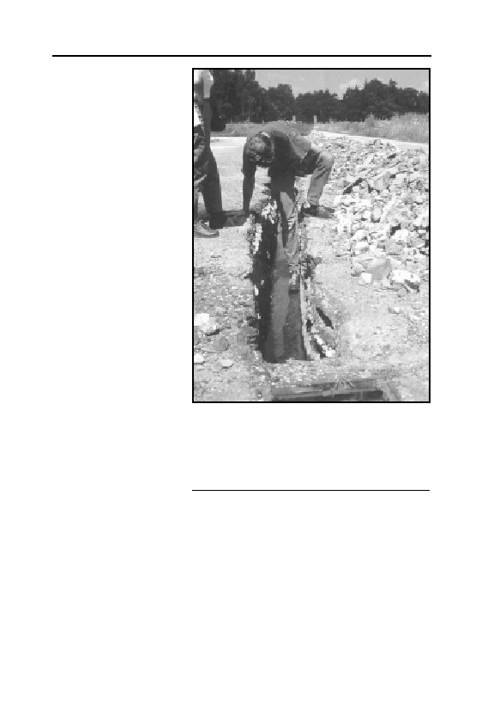
GERMAR RUDOLF · THE RUDOLF REPORT
cated outside of the
camp’s drainage sys-
tem?
There are two
pieces of circumstantial
evidence indicating that
the water table was not
much different then
than it is today. The
first evidence is the
well known small pond
in the vicinity of crema-
torium IV, which is
supposed to have ex-
isted the same way dur-
ing the war. If the
drainage system had
lowered the water table
by several meters, the
pond next to cremato-
rium IV, contrary to
many witness state-
ments, would have
Fig. 57: Then and today—the unchanged
ground water state in the Birkenau camp, here
dried up. This proves
in midsummer 1991, in a construction trench
the unchanged water
in front of the Zentralsauna, approximately 70
table from then until
cm. Incinerations of corpses in pits many
now. The second evi-
meters deep, in accordance with witness
dence is the subterra-
testimony, were not possible.
nean location of the morgues of crematoriums II and III, as well as
some of the building sections of the Zentralsauna. They all were con-
structed by insulating the buildings’ basements from intruding water
with a waterproof layer of tar, which indicates that there was a need to
protect against such water in the first place. Also, since the drainage
ditches in the camp are only 1 to 1.5 meters deep, they could not have
lowered the water table to less than one meter. This maximum value,
though, can only be achieved in the immediate vicinity of the ditches.
In complementary studies, Michael Gärtner and Werner Rade-
142
5. AUSCHWITZ
macher on the one hand182 and Carlo Mattogno on the other hand309
have shown, with a vast amount of contemporary German documents
dealing with the camp authorities’ problems caused by the high water
table, that between the end of 1941 and middle of 1944, the water table
in Birkenau in general and outside the camp perimeter in particular
was very high, coming close or even reaching the surface and turning
the entire area into a swampy region. All three authors showed that
construction on buildings with basements was possible only by perma-
nently pumping off ground water, and Mattogno even found docu-
ments expressively forbidding the digging of pits for outhouse latrines,
because this would contaminate the drinking water of the entire
Auschwitz region. Mass incinerations of corpses in deep pits, of
course, would have contaminated the drinking water as well, hence
would never have been permitted.
5.4.4.3. Open-Air Incineration in Pits
In general, it is of course possible to burn corpses in open-air pits,
though it certainly takes more time and fuel than any cremation in a
crematorium, and it also leaves many more traces due to incomplete
combustion. In 1999, Dr. Myroslaw Dragan conducted an experimental
incineration of an 80 lb. deer in a pit roughly 1 m deep, 70 cm wide,
and 1.2 m long. This incineration with a relatively small amount of
wood lasted some 4-5 hours and was almost completely successful.310
Dr. Dragan found out that for open-air incinerations, small, narrow
holes are advantageous over large, wide holes or, even worse, crema-
tions on ground level, since the soil walls of a pit act like the walls of a
crematorium oven, storing and reflecting a great deal of the heat pro-
duced by the fire—provided that the soil has a considerable amount of
clay stabilizing the wall of the pit, and, of course, that no ground water
flows into the pit and extinguishes the fire.
The situation in Birkenau, however, was drastically different from
that. Not only did the witnesses claim that those pits were very wide,
309
“‘Verbrennungsgruben’ und Grundwasserstand in Birkenau”, VffG 6(4) (2002), pp. 421-424
(online: www.vho.org/VffG/2002/4/Mattogno421-424.html); Engl.: “‘Incineration Pits’ and
Ground Water Level in Birkenau”, The Revisionist, 1(1) (2003), pp. 13-16 (online:
www.vho.org/tr/2003/1/Mattogno13-16.html).
310
Only small pieces of the skull were left over which were located in a corner of the pit. Com-
munications of Dr. M. Dragan, whom I helped to investigate the carcass’ remains in June
1999.
143
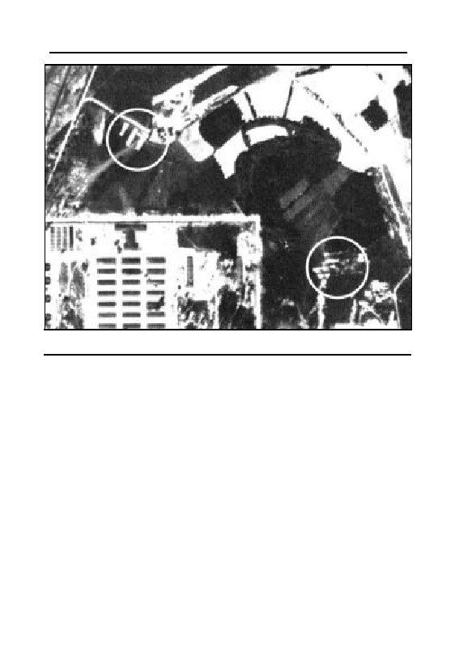
GERMAR RUDOLF · THE RUDOLF REPORT
Fig. 58: White circles: possible sites of old mass graves of typhus victims in
Auschwitz.
but as Gärtner, Rademacher, and Carlo Mattogno have shown, the ex-
tremely high ground water table in the areas around the alleged loca-
tion of those cremation pits was so high that it would have been impos-
sible to dig such deep pits, arrange hundreds of corpses and fuel in
them, and maintain a fire for many hours without these pits quickly
filling with water. These findings show clearly that the attested burning
of corpses in pits many meters deep was impossible under such condi-
tions, since these pits would have filled up with ground water rather
quickly.
It is known that in Birkenau the corpses which had accumulated
during the typhus epidemic of the summer of 1942 were first buried in
mass graves. Due to the danger of the contamination of the ground wa-
ter, however, they had to be exhumed in the spring of 1943. Since the
new cremation facilities still were not capable of functioning at that
time, it is possible that at least a portion of the corpses were burned on
funeral pyres. For this purpose, as a rule, one removes the turf and the
upper layer of topsoil in order to preserve them from damage and to
absorb the ashes of the wood and the corpses. But holes many meters
144
5. AUSCHWITZ
deep are not dug.
Indeed, one can unearth in excavations west of the Birkenau camp
ashes and bone splinters (whether from humans or cattle remains open)
to the depth of several decimeters, intensively mixed with all kinds of
refuse (glass and porcelain shards, slag, bits of iron, etc.). Apparently
this place served as a rubbish heap for the camp under German admini-
stration and/or after the war under Polish administration.
In his detailed study of aerial photos of the Birkenau camp made
by the allied surveillance planes, J.C. Ball has revealed that at no point
in time in the summer and autumn of 1944 in the camp or in its envi-
rons were large incineration pits—and fuel stockpiles necessary for
that—to be seen, let alone flames and smoke, as they are repeatedly
attested to.311 He did, however, locate the places were mass graves had
existed (see Fig. 58).303
5.5. Construction Conclusions
Even the most primitive temporary disinfestation installations—
whether in the initial period of the life of Auschwitz camp or else-
where—were always equipped with a ventilation and heating system,
the last being, of course, useful but not absolutely necessary. But no
room possessing no ventilation system need even be seriously consid-
ered as a room for fumigation with poisonous gases, whether for lice or
human beings. Homicidal ‘gas chambers’ must furthermore be
equipped, apart from the entry doors, with an opening for the introduc-
tion of the poison gas material from the outside; this is not absolutely
necessary for disinfestation installations, but is nevertheless useful. It
must be concluded, therefore, that no installation possessing neither a
poison gas introduction device from the outside, nor any possibility of
ventilation, can be taken seriously as a homicidal ‘gas chamber’. If one
considers the rooms discussed above in a summary manner, the results
are shown in Table 2.
Not taken into consideration in the above, among other things, is
the fact that hypothetical homicidal ‘gas chambers’ would have to be
escape-proof, that their equipment had to be panic-proof, that their
ventilation would have to be efficient enough for homicidal purposes,
311
J.C. Ball, op. cit. (note 43).
145

GERMAR RUDOLF · THE RUDOLF REPORT
Table 2: Equipment and suitability of actual or alleged ‘gas chambers’
Equipment/
Suitability as Suitability as
Poison gas
Suitability
Heating Ventilation disinfestation
execution
introduction
Building
chamber
chamber
Disinfestation cham-
if with means of
yes
introduction
bers
Crematorium I
×
×
hardly/perhaps
no
Crematoria II and III
×
×
perhaps
no
Crematoria IV and V
×
hardly
hardly
Farmhouses I and II
×/
×/
hardly/perhaps
no
= present or possible;
= possibly present; × = not present
which, in view of the above, was not the case, and finally that the
evacuation of the poison gas into the environment after the execution
required special measures in order to avoid that people close to the ‘gas
chambers’—both inside the building as well as in its vicinity—get hurt
or even killed.
Although the literature is generally unanimous as to the equipment
of the rooms in crematoria IV and V, the information is, to a certain
extent, speculative, due to the lack of documents and material evi-
dence. The same is true for the information relating to the farmhouses,
on which there are practically no documents available.
Fortunately, it is precisely the one ‘gas chamber’ in which the
largest number of people was allegedly killed by poison gas during the
Third Reich which has remained almost entirely intact: morgue 1 of
crematorium II. Contrary to all eyewitness testimony, this cellar, dur-
ing the period of its operation, possessed no Zyklon B introduction
holes in the roof. It is only logical and consequent to transfer these
conclusions also to the mirror-symmetrically built, but otherwise iden-
tical crematorium III, even though we do not possess any physical evi-
dence for this due to the almost complete destruction of the roof of its
morgue 1. If this is so, those rooms cannot have been used as locations
for mass homicide using poison gas, as alleged by witnesses.
When one considers the technical circumstances prevailing in and
around Auschwitz, in the broadest sense, one becomes aware of the
absurdity of the entire claim of homicidal mass gassings. The camp
management was fully aware of the methods and technical precondi-
tions for Zyklon B disinfestation, and was even informed as to the lat-
est developments in the related technology.143 But instead of using
these methods, it allegedly had recourse, for mass gassing purposes, to
extremely crude methods, particularly where bunkers I and II, and,
146
5. AUSCHWITZ
later, crematoria IV and V, were concerned:
Allegedly, hundreds or thousands of people were killed with
highly poisonous gas in rooms,
– which had walls and ceilings made of a material absorbing huge
amounts of the poison gas and letting it penetrate;
– which did not have escape-proof doors and windows;
– which did not have panic-proof equipment;
– which did not have technically gas tight doors and shutters;
– which had no provision to quickly release and distribute the poi-
son gas;
– which had no effective device to ventilate or otherwise render
ineffective the poison gas after the end of the execution.
At the same time, the most modern disinfestation installations
were being built all over German-occupied Europe,
– which had walls and ceilings covered with gastight coatings;
– which were equipped with escape-proof doors and had no win-
dows;
– which had technically gas tight doors;
– which had devices to quickly release and distribute the poison
gas;
– which had effective devices to ventilate or otherwise render
ineffective the poison gas after the end of the gassing procedure.
There were never any perceptible delivery problems for these in-
stallations. In the Auschwitz main camp, the latest technology for dis-
infestation using HCN was even incorporated (cf. chapter 5.2.3.5.),
while the Zentralsauna at Birkenau was even equipped with the most
modern hot air disinfestation technology! And to top it all: the Ger-
mans even invented the microwave technology, which is so well-
known today, to kill lice! They erected these installations, which were
still very expensive at that time, in Auschwitz camp, to save inmate
lives! And we are supposed to believe that the Germans were incapable
of installing adequate technical equipment for Zyklon B gassings in at
least one of their alleged homicidal ‘gas chambers’! Can anything be
more insulting to the human mind?
So much for the claim that homicidal ‘gas chambers’ existed at
Auschwitz. We have also proven that the largest room, the one alleg-
edly most-often used as a homicidal ‘gas chamber’, could not have
been used for that purpose as stated by alleged eyewitnesses. Together
with the untruthful witnesses to a homicidal ‘gas chamber’ in the Main
147

GERMAR RUDOLF · THE RUDOLF REPORT
Camp (see chapter 5.3.), and in view of the fact that there is no docu-
mentary indication of a criminal use of these rooms, we must conclude
that there is no credible proof, and no “criminal trace”, in support of
the claimed existence of homicidal ‘gas chambers’ in Auschwitz.
Considering these facts, it can not really come as a surprise that fi-
nally even the mainstream historians and media are taking notice of
them: In May 2002, Fritjof Meyer, a senior editor at Germany’s larg-
est, left-wing weekly magazine Der Spiegel, stated in an article that
documents and witness statements regarding the alleged gas chambers
in the crematoria II and III of Birkenau
“rather indicate that attempts were made in March and April of
1943 to use the mortuary cellars for mass murder in the early summer of
1943. Apparently, the tests were not successful […] The actually commit-
ted genocide probably took place mainly in the two converted farm-
houses outside of the camp.”312
In other words: there is a tendency to abandon those locations
which Prof. Dr. R. van Pelt called “the absolute center” in the “geo-
graphy of atrocities” (see page 91), or even the Birkenau crematoria
altogether, since, according to Meyer the genocide is now supposed to
have taken place mainly in those ominous farmhouses or bunkers of
which we possess hardly any documentary evidence.
Following Meyer, the final destruction of the corpses of the
alleged victims of mass murder is now supposed to have happened
almost exclusively by means of open-air incinerations in deep pits.
However, all claims made regarding the alleged open-air incineration
of corpses in deep pits are obviously untrue because no traces of such
incinerations can be found on contemporary air-photos, and because
the high water table in Birkenau would have prevented the
maintenance of fires in deep pits.
Those readers who take no interest in the chemical problems relat-
ing to the alleged ‘gas chambers’ in Auschwitz may skip the following
chapter 6. Prior to a solution to the problem of how the poisonous
preparation was introduced into the presumed ‘gas chambers’, further
speculation as to the manner and method of the murders, and their pos-
312
F. Meyer, “Die Zahl der Opfer von Auschwitz”, Osteuropa, 52(5) (2002), pp. 631-641, here p.
632; for critical reviews of these artciles, see Germar Rudolf, “Cautious Mainstream Revision-
ism”, The Revisionist, 1(1) (2003), pp. 23-30 (online: www.vho.org/tr/2003/Rudolf23-
30.html); Carlo Mattogno, “Auschwitz. The new Revisions by Fritjof Meyer”, The Revisionist,
1(1) (2003), pp. 30-37 (online: www.vho.org/tr/2003/Mattogno30-37.html).
148
5. AUSCHWITZ
sible chemical traces, remains a mere academic exercise, with no basis
in reality. Our study of Auschwitz could, therefore, conclude here.
However, because the chemical questions involved attracted so
much attention, caused the hottest controversies, and stirred the most
intensive debates, detailed remarks are nevertheless in order, below,
about the chemical questions, raised by Faurisson and Leuchter, relat-
ing to the formation of residues (Iron Blue) caused by the reactivity of
hydrogen cyanide.
149


6. Formation and Stability of Iron Blue
6.1. Introduction
Hundreds of thousands of people are claimed to have been killed
in the alleged Auschwitz ‘gas chambers’ by hydrogen cyanide in the
form of the product Zyklon B®. The question which now arises is the
following: could this poisonous gas leave chemical traces, which could
perhaps be detected in these alleged chemical slaughterhouses?
If hydrogen cyanide (HCN), the reactive compound in Zyklon B,
were only bound to the walls by adsorption (adhesion),313 there would
not be any detectable residues today anymore, due to the volatility of
hydrogen cyanide (boiling point: 25.7°C); all the hydrogen cyanide
involved would long since have evaporated.
But if one assumes that the hydrogen cyanide, during fumigation,
would combine with certain materials in the masonry to create other,
considerably more stable compounds, then one might anticipate the
possible existence of chemical residues even today.
The reaction products of interest to us in this respect are the salts
of hydrogen cyanide, called cyanides,314 in particular, the iron cyanide
group, formed by a compound of iron and cyanide. Iron occurs univer-
sally in nature. It is iron which gives brick its red color, sand its ochre
color, and clay its color ranging from yellowish to reddish-brown.
More precisely, we are speaking of iron oxide, popularly known as
‘rust’. Basically, all walls consist of at least 1% rust, as a result of
sand, gravel, clay, and cement, of which the wall is constructed.
The iron cyanides have long been known for their extraordinary
stability, one of them having achieved particular fame as one of the
most commonly used blue pigments during the last three centuries:
313
Absorption and Adsorption are not the same! Absorption is the incorporation (sometimes even
consumption) of a matter into a medium (light is absorbed/consumed by a pigment, gas is ab-
sorbed/dissolves into a liquid), whereas Adsorption is the adhesion of matter onto a—usually
solid—surface (dust on furniture, steam on windscreen, vapours on any solid surface...);
Adsorption is further subdivided in chemisorption, in which the matter is bound to a surface
by chemical bonds, and physisorption, in which the bonding is only a physical effect. The
transition between both is fluent.
314
For simplicity’s sake, ‘cyanide’ is frequently understood to mean only the anionic part of the
cyanide salts, the cyanide ion, CN–.
151
GERMAR RUDOLF · THE RUDOLF REPORT
Iron Blue, also often referred to as Prussian Blue.315
6.2. Instances of Damages to Buildings
Chapter 1.3. contained a discussion of an instance of damage to a
church which occurred in 1976 in Bavaria, Germany. In the many hun-
dreds of thousands of fumigations which have been carried out since
1920, there cannot, as a rule, have been any complications, otherwise
the procedure would have been very rapidly abandoned. The case in
question was, therefore, an exception. But what exactly was it that
made this church an exception?
Different scenery. 1939-1945. In the camps of the Third Reich,
hundreds of thousands of people—Jews, political prisoners, criminals,
‘anti-socials,’ and prisoners of war—were crammed together. To stem
the raging epidemics, attempts were made, not always with great suc-
cess, to kill the carriers of disease, particularly head lice. This was
done in particular with hydrogen cyanide, Zyklon B. This was some-
times done in chambers professionally designed for such purposes,
sometimes ordinary rooms were equipped for such purposes in an aux-
iliary manner, and provisionally used for disinfestation. Many of the
camps in the Third Reich were leveled at the end of the war or after-
wards; in other camps the existing buildings were torn down and the
buildings materials used for the reconstruction of the ruined cities. A
few buildings, however, remain intact today. The interiors of these
buildings look as in Fig. 59-66 (see also the color picture section in the
middle of this book).
From the remarks of a Polish research team having conducted in-
vestigations on behalf of the Auschwitz Museum, we also know that
the disinfestation chamber in the Auschwitz main camp is colored a
spotty blue.56,57 To my knowledge, only the Zyklon B disinfestation
chambers of Dachau camp (DEGESCH circulation chambers) exhibit
no blue pigmentation, because the walls were professionally coated
with a paint impermeable to gas and water.
315
Iron Blue is the ISO designation (ISO 2495) for iron cyanide blue pigments of various compo-
sition, which are also known as Berlin Blue, Turnbull’s Blue, Prussian Blue, Vossen Blue®,
Milori Blue, Paris Blue, French Blue, China Blue, Bronze Blue, Steel Blue, Ink Blue, among
others.
152
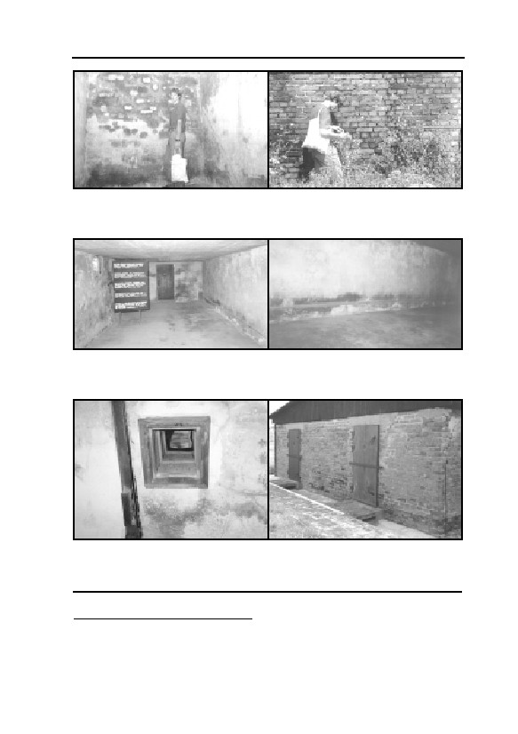
6. FORMATION AND STABILITY OF IRON BLUE
Fig. 59: Interior northwest room in
Fig. 60: Exterior southwest wall of
the Zyklon B disinfestation wing of
the Zyklon B disinfestation wing of
BW 5a in the Birkenau camp.
BW 5b in the Birkenau camp.
(© Karl Philipp)
(© Karl Philipp)
Fig. 61: Zyklon B disinfestation
Fig. 62: Zyklon B disinfestation
installation, chamber III, of barrack
installation, east wall of chamber III
41 in Majdanek camp.
of barrack 41 in Majdanek camp.
(© C. Mattogno316)
(© C. Mattogno316)
Fig. 63: Large Zyklon B disinfestation Fig. 64: Zyklon B disinfestation instal-
chamber, ceiling, barrack 41 in Ma-
lation, chambers II and III (exterior
jdanek camp. (© C. Mattogno )
wall), of barrack 41 in Majdanek
316
camp. (© Carlo Mattogno317)
316
Taken from the book by Jürgen Graf, Carlo Mattogno, KL Majdanek, op. cit. (note 43), photos
XIII, XIV, XIX (online: www.vho.org/D/Majdanek/MR.html); see also the photo in Michael
Berenbaum, The World Must Know, Little, Brown & Co., Boston 1993, p. 138.
317
Taken from the book by Ernst Gauss (Ed., alias G. Rudolf), Dissecting the Holocaust, op. cit.
(note 22), color page, with kind permission by Carlo Mattogno.
153
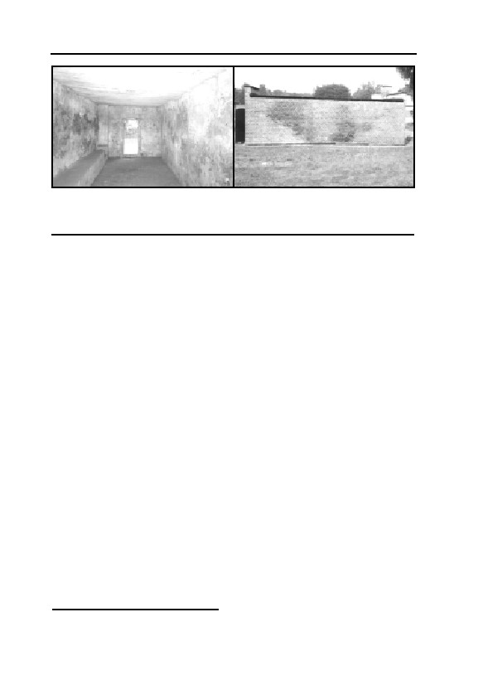
GERMAR RUDOLF · THE RUDOLF REPORT
Fig. 65: Zyklon B disinfestation
Fig. 66: Zyklon B disinfestation
chamber in Stutthof camp, interior
chamber in Stutthof camp, east
view taken from the south door.
side, exterior. (© Carlo Mattogno318)
(© Carlo Mattogno318)
It seems therefore that a blue pigmentation of masonry is no ex-
ception, but rather a rule, particularly where unprotected masonry is
repeatedly exposed to hydrogen cyanide over long periods. The large-
scale, long-term use of hydrogen cyanide for vermin control in disin-
festation chambers only began, in practice, with the onset of the Sec-
ond World War. And with the dissolution of the National Socialist
prisoner camps, the confiscation of the corporation having manufac-
tured and marketed Zyklon B (the I.G. Farbenindustrie AG), and the
invention of DDT at the end of World War II, this large-scale use of
hydrogen cyanide ended just as abruptly. No one cared about any ‘in-
stances of building damage’ having occurred in the former National
Socialist disinfestation chambers in this period. The question never
arose in the literature… until Frederick A. Leuchter came along.
The following is an attempt to demonstrate the manner in which
these blue pigments, referred to as Iron Blue, came to be formed in the
masonry during fumigation with HCN, and the conditions favorable to
their formation.
There have been many publications on this chemical compound in
the last five decades, which were perused and will be summarized in
the following in relation to our topic. In so doing, attention was di-
rected at:
1) the circumstances which lead to the formation of Iron Blue, and
2) the long-term stability of Iron Blue under the existing circum-
stances.
318
Taken from the book by Carlo Mattogno, Jürgen Graf, Das KL Stutthof, op. cit. (note 43),
photos 13 & 14 (online: www.vho.org/D/Stutthof).
154
6. FORMATION AND STABILITY OF IRON BLUE
When writing the initial versions of this expert report intended to
be presented at German courts of law, I was extremely anxious not to
make any errors, because I knew that the topic was extremely contro-
versial. As a consequence, I over-examined several chemical aspects
involved, some of which can be understood only by chemical experts.
Others aspects are not really necessary for an understanding of the core
issue. In order to have a complete English version of my expert report,
I nevertheless decided to include all the material I accumulated over
the years. Those sections, however, which are considered of marginal
interest or of interest to experts only, I have given headlines always
starting with “Excursus”. For some readers it might be advisable to
skip these chapters. They will most likely not miss anything.319
But first a short description of the starting substance, hydrogen
cyanide.
6.3. Properties of Hydrogen Cyanide, HCN
Hydrogen cyanide, a colorless liquid, is similar, in many of its
physical properties, to water.320 This similarity also explains the limit-
less solubility of HCN in water and its strong tendency towards
absorption (dissolution) in water. The equilibrium concentration321 of
hydrogen cyanide in water is investigated in more detail in chapter
6.5.3.
The opinion is often expressed that, because gaseous hydrogen
cyanide is approximately 5% lighter than air, it must separate from air
and rise. Hydrogen cyanide gas is, however, only slightly lighter than
air and does not separate, because of the thermal movement of every
gas particle. To clarify this, reference must be made to the principal
components of air: The main component of air, nitrogen, 78% by vol-
ume, is 8% heavier than hydrogen cyanide gas. If a separation took
place between hydrogen cyanide gas and nitrogen, it would all the
more occur between the two main components of air, since oxygen
(21% of air by volume) is 15% heavier than nitrogen. This would have
319
I also want to point out that I did not include all this academic, self-serving ivory tower chatter
in order to impress people. I was simply advised by many friends, supporters, and adversaries
to include all my material since back-references to my German original is no help to most
English language speakers, of whom only a tiny fraction can read German.
320
High polarity, low molecular mass, possibility of formation of hydrogen bonds.
321
Concentration is the number of parts per volume.
155

GERMAR RUDOLF · THE RUDOLF REPORT
Table 3: Physical Properties of HCN322
27.026 g mol-1
Molecular weight
Boiling point (1 atm)
25.7°C
Melting point
-13.24°C
Specific density of the gas at 31°C (air = 1)
0.947
6-41 Vol.%323
Explosion limits in air
as a result that all the oxygen of the earth’s atmosphere would settle in
the lower fifth of the atmosphere, as a consequence of which the entire
surface of the earth would get oxidized, i.e., burn. This obviously does
not happen. Thus, a spontaneous separation of hydrogen cyanide gas
would never take place in air.
The 5% lesser density of pure hydrogen cyanide gas compared to
air (this corresponds to a density difference of 35°C warm air as com-
pared to 20°C warm air) can however very well lead to a density con-
vection, when pure gaseous hydrogen cyanide is released in a location
with the same temperature as the ambient air. The gas would then rise
slowly, but gradually mix with the ambient air. But to conclude from
this that hydrogen cyanide vapors always rise, would be an incorrect
conclusion. At 15°C, for example, on physicochemical grounds, no
concentrations higher than 65% of hydrogen cyanide can occur in air
(see Graph 1); the density of such a mixture lies only approximately
3% below that of air. Furthermore, a great deal of energy is withdrawn
from the ambient air by the evaporating hydrogen cyanide. Conse-
quently, the ambient temperature sinks until exactly as much energy is
transported to the liquid (adsorbed) HCN as needed for the decelerated
evaporation at the corresponding lower temperature. It is therefore
theoretically possible for hydrogen cyanide vapors containing little
HCN, but which are cold, to be denser, that is, heavier than the ambi-
ent air.
Graph 1 shows the equilibrium percentage of hydrogen cyanide in
air as a function of temperature. Even at 0°C, the percentage still lies at
322
W. Braker, A.L. Mossman, Matheson Gas Data Book, Matheson Gas Products, East Ruther-
ford 1971, p. 301. I have left out some of the less interesting dimensions in this connection:
heat capacity (20.9°C): 2.625 J g-1 K-1 (Water=4.187 J g-1 K-1); dielectricity constant (20°C):
114 (Water=78.5); evaporation heat: 28 kJ mol-1; evaporation entropy: 190 J mol-1 K-1; spon-
taneous combustion temperature: 538°C; flash point: -17.8°C; regarding dielectricity con-
stants, see: R.C. Weast (ed.), Handbook of Chemistry and Physics, 66th Ed., CRC Press, Boca
Raton, Florida 1986, E 40. However, under normal conditions (1 atm, 25°C), hydrogen cya-
nide is not a gas.
323
1 vol.% is 10,000 ppm (for HCN, roughly 12 g/m³)
156
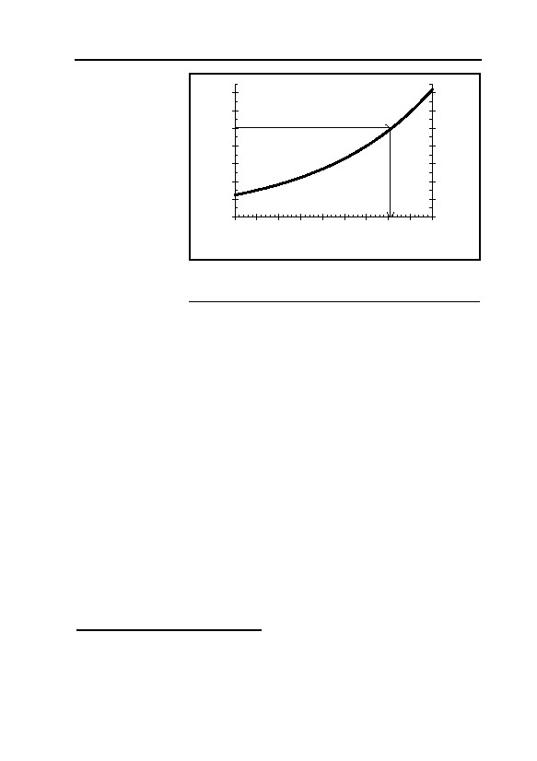
6. FORMATION AND STABILITY OF IRON BLUE
approximately
1.4
140
36% by volume.
vapor pressure HCN [atm]
vapor pressure HCN [%]
1.2
120
Condensation of
HCN on sur-
1
100
rounding objects
0.8
80
would occur only
0.6
60
if the percentage
0.4
40
rose over the
0.2
20
boiling temperature
equilibrium per-
0
0
centage (the so-
-10 -5
0
5
10 15 20 25 30 35
called dew point).
Temperature [°C]
Since in all cases
Graph 1: Vapor pressure of hydrogen cyanide in
here under con-
percentage of air pressure as a function of
sideration, a ma-
temperature.
ximum concentra-
tion of 10% HCN in air would only be reached for a short period of
time close to the source of HCN (the Zyklon B carrier), no condensa-
tion of HCN on walls can be expected. An exception is, however, the
so-called capillary condensation, which can occur in finely porous ma-
terials such as cement mortar.324
Hydrogen cyanide forms explosive mixtures with air in the range
of 6 to 41% by volume. With strong initial ignition, its explosive ef-
fects can be compared with nitro-glycerin.325 In the applications under
discussion here, a proportion of 6% by volume and more can be
reached in the immediate vicinity of the source, which suffices for lo-
cal blow ups at the most. Hence, only inappropriately high concentra-
tions can lead to explosive mixtures, as shown by a corresponding ac-
cident in 1947.16 With correct application quantities and concentra-
tions, the technical literature indicates that there is practically no dan-
ger of explosion.326
324
The lowered vapor pressure caused by adsorption effects in a narrow hollow space leads to
early condensation.
325
The usual explosive in dynamite. Cf. Wilhelm Foerst (ed.), Ullmanns Encyklopädie der tech-
nischen Chemie, vol. 5, Urban und Schwarzenberg, Munich 31954, p. 629.
326
Willibald Schütz, “Explosionsgefährlichkeit gasförmiger Entwesungsmittel”, Reichsarbeits-
blatt, Teil III (Arbeitsschutz no. 6), no. 17/18 (1943), pp. 198-207, here p. 201.
157

GERMAR RUDOLF · THE RUDOLF REPORT
6.4. Composition of Iron Blue
6.4.1. Overview
The stoichiometric composition of an ideal Iron Blue crystal is:
Fe4[Fe(CN)6]3
It is characteristic that the iron in this compound is present in two
different oxidation states: Fe2+ (here in square brackets) and Fe3+ (here
on the outer left). The interaction between these two different iron ions
also gives rise to the blue color of this compound (Charge-Transfer-
Complex). The actual composition can be quite variable, depending on
the stoichiometry on formation and the presence of impurities, in
which case the color varies between dark blue and greenish-blue tones.
6.4.2. Excursus
It was with support of the Mösbauer spectroscopy327 that a long-
lasting argument could be decided:328,329 Turnbull’s Blue,
Fe3[Fe(CN)6]2, is actually the same as Berlin Blue, Fe4[Fe(CN)6]3, even
if the summation formulas suggest they are different. As a matter of
fact, the summation formula of Berlin Blue is closest to the reality: In
the ideal Iron Blue crystal, 16 molecules of coordination water are in-
cluded:
Fe4[Fe(CN)6]3 · x H2O (x=14 to 16)
Today it is known that the ‘soluble’ Iron Blue which frequently is
referred to in older literature, is mainly a substance with the composi-
tion MeFeIII[FeII(CN6)] · x H2O, where Me is the counter ion to the op-
posite cyanoferrate, [Fe(CN)6]3-/4-, mostly potassium (K+) or ammo-
nium (NH4+).
According to Buser,329 ‘soluble’ Iron Blue is formed mainly dur-
ing quick formation and precipitation of the pigments, leading to the
inclusion of large amounts of water and potassium or ammonium ions
Impulseless resonance absorption of γ−θυαντσ (gamma radiation) from a radioactive isotope,
327
here Cobalt: 57Co 57Fe + γ (main quant: 122 keV; quant used for spectroscopy has a differ-
ent energy)
328
E. Fluck, W. Kerler, W. Neuwirth, Z. anorg. allg. Chem. 333 (1964), pp. 235-247; J.F. Dun-
can, J. Chem. Soc. 1963, pp. 1120-1125.
329
H.J. Buser, D. Schwarzenbach, W. Peter, A. Ludi, Inorg. Chem. 16 (1977), pp. 2704-2710.
Iron Blue single crystals of high purity and homogeneity were obtained by slow oxidation of a
solution of Fe[FeII(CN)6] in concentrated (!) HClaq. in air. If in the presence of molar amounts
of Kalium only some 2% inclusions were observed.
158

6. FORMATION AND STABILITY OF IRON BLUE
in the extremely voluminous precipitate. The resulting crystal is there-
fore very faulty and more appropriately called a polymer.330 By filtra-
tion, drying and intensive grinding, however, this very inhomogene-
ous, polluted Iron Blue can be transformed into a pigment which is
only hardly colloidal dispersible.331 This ‘soluble’ Iron Blue is not
soluble in the original sense of the word, but can more easily be col-
loidally dispersed than the ‘insoluble’ Iron Blue, which is very impor-
tant for its application as a pigment.332,333
However, these colloids are very instable and precipitate easily
when salts are added.334 According to Buser,329 even in presence of
high concentrations of potassium ions, almost pure ‘insoluble’ Iron
Blue can be obtained, if the formation process is proceeding slowly
enough. In case of deeper interest about the structure one might consult
the following literature.329,335
6.5. Formation of Iron Blue
6.5.1. Overview
We are only concerned, in this connection, with how Iron Blue
arises from hydrogen cyanide and iron compounds in building materi-
als. In building materials, the iron is generally present in trivalent form
(Fe3+), in the form of ‘rust’.
330
Originally, this term was used only in organic chemistry for chainlike connected, sometimes
also branched attachments of equal segments.
331
Dispersion (lat.: dispersere, distribute) are distribution of two different phases within each
other. They are called colloids (gr.: gluelike) if the particles are between 10-8 and 10-7 m small.
Such a mixture in liquids scatters the light (Tyndall effect), is thus not clear. But due to elec-
trostatic repulsion (equally charged particles), colloids do not tend to coagulate and precipi-
tate.
Suspension: (lat.: to float) are coarsely dispersed system with particle sizes bigger than 10-6 m.
332
R.E. Kirk, D.F. Othmer, Encyclopedia of Chemical Technology, Vol. 13, 3. ed., Wiley &
Sons, New York 1979, pp. 765-771; J.A. Sistino, in: Peter A. Lewis (ed.), Pigment Handbook,
Vol. 1, Wiley and Sons, New York 1974, pp. 401-407; A.F. Holleman, N. Wiberg, Lehrbuch
der Anorganischen Chemie, de Gruyter, Berlin 1001985, p. 1143
333
H. Ferch, H. Schäfer, Schriftenreihe Pigmente Nr. 77, Degussa AG, Frankfurt 1990.
334
K.A. Hofmann, Anorganische Chemie, Vieweg, Braunschweig 211973, p. 677; B.N. Gosh,
K.C. Ray, Trans. Far. Soc. 53 (1957), pp. 1659-1661; E.F. Zhel’vis, Y.M. Glazman, Ukrain-
skii Khim. Zh. 35 (1969), pp. 766ff.; East European Sci. Abs. 5 (1969), pp. 84f.
335
M.B. Robin, Inorg. Chem. 1 (1962), pp. 337-342; Gmelins Handbuch der Anorganischen
Chemie, 59 (Fe), B4, Verlag Chemie, Weinheim 1932, pp. 670-732; R.E. Wilde, S.N. Ghosh,
B.J. Marshall, Inorg. Chem. 9 (1970), pp. 2512-2516; R.S. Saxena, J. Ind. Chem. Soc. 28
(1951), pp. 703-709; A.K. Bhattacharya, J. Ind. Chem. Soc. 28 (1951), pp. 221-224.
159

GERMAR RUDOLF · THE RUDOLF REPORT
For the formation of Iron Blue, therefore, a part of this iron must
be reduced to bivalent form (Fe2+). The subsequent combination of
these different iron ions with CN– to Iron Blue occurs spontaneously
and completely.336 The most probable mechanism337 is one in which
the cyanide ion itself acts as a reducing agent. The starting point in so
doing is an Fe3+ ion, largely surrounded (complexed) by CN– ions:
[Fe(CN)4-6](1-3)-. A slightly alkaline environment is favorable to the fi-
nal reduction of the iron(III)-ion to iron(II).338
The pigment formation in the case under consideration here is then
organized in 5 steps:
a) Ad-/absorption of hydrogen cyanide (HCN);313
b) Ionic splitting (electrolytic dissociation)339 of hydrogen cyanide
in water to the cyanide ion, which alone can form complexes
336
F. Krleza, M. Avlijas, G. Dokovic, Glap. Hem. Tehnol. Bosne Hercegovine, 23-24 (1977, Vol.
Date 1976), pp. 7-13.
337
Photolytic decomposition of the [FeIII(CN)6]3– by means of UV radiation is also conceivable as
an alternative. Since the interior walls of the rooms in question are not exposed to any UV ra-
dition, this mechanism is ignored here. See also G. Stochel, Z. Stasicka, Polyhedron 4(11)
(1985), pp. 1887-1890; T. Ozeki, K. Matsumoto, S. Hikime, Anal. Chem. 56 (14) (1984), pp.
2819-2822; L. Moggi, F. Bolletta, V. Balzani, F. Scandola, J. Inorg. Nucl. Chem. 28 (1966),
pp. 2589-2598.
338
pH value of 9-10 according to M.A. Alich, D.T. Haworth, M.F. Johnson, J. Inorg. Nucl.
Chem. 29 (1967), pp. 1637-1642. Spectroscopic studies of the reaction of hexa-
cyanoferrate(III) in water and ethanol. 3.3×10-4 M Fe(NO3)3 were exposed with a cyanide ex-
cess of likewise 3.3×10-4 mol l-1. With pH values of approximately 10, all the Fe2[Fe(CN)6]
was converted into Iron Blue within 48 hours. Cyanate, the anticipated product of the oxida-
tion of the CN–, could not, however, be proven. Perhaps this is further oxidized directly into
CO2. If this mechanism is assumed, the result, purely stoichiometrically, is that an alkaline
environment must be favorable. This finding is supported by the known fact that hexacyan-
oferrate(III) is a strong oxidation agent in alkaline medium and is even able to oxidize triva-
lent chrome to hexavalent, therefore, that is, CN– ions must have oxidized very quickly: J.C.
Bailar, Comprehensive Inorganic Chemistry, Vol. 3, Pergamon Press, Oxford 1973, p. 1047.
An overly alkaline environment would, however, disturb the complexing of the Fe3+- ion by
cyanide, which is then displaced by OH– (Fe(OH)3 then occurs as a by-product) and/or the lat-
ter can hardly be displaced from the iron.
The driving force in the reduction of the Fe3+ is the considerably more favorable energetical
situation of the hexacyanoferrate(II) as compared to hexacyanoferrate(III); see, in this regard,
R.M. Izatt, G.D. Watt, C.H. Bartholomew, J.J. Christensen, Inorg. Chem. 9 (1970), pp.
2019ff. Calorimetric measurements relating to the formation enthalpies of Iron Blue from re-
spective educts (in brackets) were as follows:
∆Η(Φε2+ + [Fe(CN)6]3-)= -66.128 kJ mol-1; ∆Η(Φε3+ + [Fe(CN)6]4-)= 2.197 kJ mol-1.
For this reason, a direct reduction of uncomplexed Fe3+, i.e., not surrounded by cyanide, has
an energy disadvantage and is therefore negligible.
339
Dissociation: is the splitting of a compound, in this case into two differently charged ions
(heterolytic) in aqueous medium (electrolysis):
HCN + H2O CN– + H3O+
160
6. FORMATION AND STABILITY OF IRON BLUE
with iron;
c) Complexing of trivalent iron (Fe3+) to the complex iron(III)-cya-
nide,340 that is, the displacement of oxygen and/or OH– ions in
rust by cyanide ions;
b) Reduction of iron(III)-cyanide to iron(II)-cyanide;
e) Precipitation of iron(II)-cyanide with trivalent iron as Iron Blue.
The velocity of formation of the pigment can be influenced by
various factors, which will be considered:
1. Water content of the reaction medium;
2. Reactivity of the iron;
3. Temperature;
4. Acid content.
6.5.2. Water Content
6.5.2.1. Overview
The formation of cyanide through absorption and subsequent dis-
sociation of hydrogen cyanide in water is the necessary precondition
for a reaction with iron compounds, since the hydrogen cyanide itself
exhibits only a low reactivity. All reactions listed in chapter 6.5.1. un-
der a)-e) occur almost exclusively in water. Water furthermore ensures
that the reaction partners—all salts capable of being dissolved in wa-
ter—come together in the first place. Finally, the moisture contained in
the building material also acts as a hydrogen cyanide trap, since hydro-
gen cyanide dissolves eagerly in water. A relatively high water content
in the masonry will therefore considerably increase the speed of reac-
tion.
6.5.2.2. Excursus
The reason for the low reactivity of HCN compared to the free
cyanide ion is because HCN is less nulceophilic than the free ion.341
Aside from the dissociation of hydrogen cyanide in water, the process
340
Correct: hexacyanoferrate(III).
341
nucleophilic (gr.: core/nucleus loving) is the tendency of a particle to react with positively
charged particles. For this, at least a partial negative charge of the nucleophilic particle is re-
quired. In this case, cyanide is, due to its negative charge (CN–), much more nucleophilic to-
wards the positively charge iron (Fe3+) than the formally uncharged (though polar) hydrogen
cyanide.
161
GERMAR RUDOLF · THE RUDOLF REPORT
of chemisorption313 on solid surfaces deserves being mentioned, where
the hydrogen cyanide releases its proton (H+) to an alkaline oxide and
is itself attached to a metal ion.
Absorption and dissociation of the superbly soluble hydrogen cya-
nide (see chapter 6.5.4.) is clearly superior to chemisorption. Further-
more, the aqueous solution (as solvent) is indispensable for the com-
plex formation and redox reactions of the cyanide with Fe3+. Addition-
ally, the aqueous medium makes the reacting agents mobile, which do
not always form at the same location. And finally, the moisture con-
tained in the solid material works as a trap for hydrogen cyanide, be-
cause it intensely binds the hydrogen cyanide. Or the other way
around: the drier a solid material is, the easier hydrogen cyanide,
which was ad-/absorbed before, will be released back into the envi-
ronment. Therefore, a relatively high water content of the solid mate-
rial will accelerate the reaction.
Experiments with reactions of hydrogen cyanide (some 4 g per m³
in air, 15°C, 75% rel. humidity) with mixtures of Fe(OH)2-Fe(OH)3
attached to wet paper strips showed that a blue discoloration occurred
after 30 min at a pH value342 of 2 to 3, since at such low values almost
no hydrogen cyanide dissociates to the reactive cyanide (see chapter
6.5.5.). At pH values of 7 to 9, a visible blue discoloration occurred
after a few minutes of inserting the sample. At higher pH values, this
time span grew again, because the initially absorbed hydrogen cyanide
had to lower the pH value first, before it could form the pigment (see
chapter 6.6.1., pH Sensitivity).
These experiments show clearly that undissociated, gaseous HCN
or HCN dissolved as gas shows no reactivity. An addition of small
amounts of KCN to an aqueous sulfuric acid solution of Fe2+/Fe3+,
however, results in the immediate precipitation of the pigment. The
cyanide obviously reacts faster with the iron salts than it is protonated
by sulfuric acid, i.e., converted into hydrogen cyanide.
342
pH (pondus hydrogenii) is a measure for the acid content of aqueous solutions (negative,
decadic logarithm of H3O+ concentration: -lg10(c(H3O+))): pH < 7: acid
pH = 7: neutral
pH > 7: alkaline
162

6. FORMATION AND STABILITY OF IRON BLUE
6.5.3. Reactivity of Trivalent Iron
6.5.3.1. Overview
The solubility of trivalent iron diminishes rapidly with increasing
alkalinity (rising pH value). Even in a pH neutral environment, almost
all iron is bound as rust.343 The reaction between iron compounds and
cyanide resulting in the formation of the intermediate product iron(III)-
cyanide, [Fe(CN)6]3–, is therefore largely a reaction on the solid-liquid
interface, that is, between the iron adhering to the solid body and the
cyanide ion in solution. This reaction occurs considerably more slowly
than the same reaction in an aqueous solution. The fastest possible re-
action requires a large surface area on the solid-fluid phase boundary,
that is, a large, interior, microscopically rough surface and a fine,
highly porous solid body, since in such cases, a lot of the iron com-
pounds lie on the surface and are therefore less solidly bound and can
quickly combine with cyanide.
In an increasingly alkaline environment, only decreasingly small
amounts of ‘rust’ can slowly be converted into iron(II)-cyanide, but
cannot react with iron(III)-ions to form Iron Blue.
6.5.3.2. Excursus
Even in an alkaline environment, it must be expected that rust, in
the presence of perceptible cyanide concentrations, will be quite slowly
transformed into iron(III)-cyanide and finally into iron(II)-cyanide.344
The last step required for the formation of Iron Blue, however, the
combination of iron(II)-cyanide with iron(III), will not occur due to the
lack of dissolved iron(III)-ions. In a strongly alkaline environment, an
increasing concentration of iron(II)-cyanide, which is chemically sta-
ble, can slowly accumulate. It remains in a stand-by position, waiting
for the pH value to drop.
Iron salts generally tend to incorporate water, and Iron Blue is no
exception to this. A higher water content in the solid body results in
Fe2O(3-x)(OH)2x · x H2O
343
⇀
344
Naturally, the equilibrium of the reaction Fe(OH)3 + 6 CN– ↽ [Fe(CN)6]3- + 3 OH– under
such conditions is strongly on the left hand side. However, this does not mean, as is well
known, that a minute quantity of iron(III)-cyanide will not be formed. The latter, however, is
withdrawn from the equilibrium in alkaline medium in the presence of excess cyanide, by be-
ing reduced by the latter to iron(II)-cyanide, which is considerably more stable in alkaline me-
dium than iron(III)-cyanide; for further details, see also chapter 6.6.1.
163

GERMAR RUDOLF · THE RUDOLF REPORT
increased water accumulation in rust, too. The rust expands, so to
speak, and thus becomes more reactive towards competing ligands345
like cyanide. Freshly precipitated, extremely moist and non-homo-
genous iron hydroxide precipitations possess extreme reactivity, and
together with hydrogen cyanide, as shown in chapter 6.5.2.2., they
form the pigment in visible quantities in minutes.
For the formation of colloidally dispersible Iron Blue, the quick
formation in aqueous solution with high concentrations of the agents is
required (see chapter 6.4.2.), since this leads to heterogeneous crystal-
lites (tiny crystals) with many inclusions (ions, solvent molecules) and
a high degree of disorder. These crystallites have only a small tendency
to coagulate.
The slow interface reaction on the phase-boundary layer liquid-
solid with quite low concentrations of the reacting agents will suppress
the formation of colloidally dispersible Iron Blue. The process de-
scribed here, occurring in walls exposed to hydrogen cyanide, strongly
resembles the formation of monocrystals as described by Buser,329
since in this case also, one reagent (Fe2+) had to be formed through
slow reduction by excess cyanide. Thus, except from the inhomogene-
ous material, the conditions here under consideration are suitable for a
slow crystal growth of insoluble Iron Blue without large amounts of
inclusions and formation of crystal defects.
6.5.4. Temperature
6.5.4.1. Overview
The environmental temperature influences larger magnitudes in
quite a different manner:
A) Accumulation of hydrogen cyanide in the moisture of the ma-
sonry;
B) Water content of the solid body;
C) Velocity of reaction.
A: Graph 2 shows the maximum solubility of HCN in water at
various temperatures with a hydrogen cyanide content of 1 mol% in
345
In complex chemistry, ligands refer to in most cases negatively charged particles (anions)
surrounding in most cases a positively charged central particle (cation, in general a metal ion).
In this case, the central atom iron (Fe2+/3+) is surrounded by the ligand cyanide (CN–).
164

6. FORMATION AND STABILITY OF IRON BLUE
air,346 which corre-
0.25
sponds to approxi-
0.2
c(HCN) [mol/l]
mately 13 g hydrogen
0.15
cyanide per m3 air.347 It
increases, as with any
0.1
gas, with decreasing
0.05
temperature and lies
0
between 0.065 mol per l
0
5
10
15
20
25
30
Temperature [°C]
at 30°C and 0.2 mol per
l at 0°C.
Graph 2: Saturation concentration of
These high concen-
hydrogen cyanide in water as a function of
temperature at 1 mol% HCN in the air (partial
trations prove the ex-
pressure348 of p(HCN)=0.01, e.g., 10 mbar
treme solubility of hy-
HCN at 1,000 mbar total pressure).
drogen cyanide in wa-
ter.320 It decreases by approximately half every 20°C. It is therefore
approximately 10,000 times more soluble in water than oxygen (O2)
and approximately 250 times more soluble than carbon dioxide (CO2).
The latter is not without importance, since the opinion is sometimes
expressed in the literature that the carbon dioxide content of air could
have an influence on the amount of hydrogen cyanide soluble in wa-
ter.57 But since hydrogen cyanide is considerably more soluble in water
than CO2, and since CO2, furthermore, is hardly converted into car-
bonic acid in water at all, this influence may be disregarded.349
B: The moisture content of masonry is very strongly dependent on
the relative humidity of air and the temperature. Since the tendency of
water to evaporate (water vapor pressure) increases with rising tem-
346
mol is a standard amount of particles: 1 mol = 6.023 × 1023 particles, according to the defini-
tion, the number of atoms contained in 12 g Carbon.
347
Landolt-Börnstein, Eigenschaften der Materie in ihren Aggregatzuständen, part 2, volume b,
Lösungsmittelgleichgewichte I, Springer, Berlin 1962, pp. 1-158.
348
The partial pressure of a gas is it fraction of the total gas content.
349
The influence is supposed to be based on the fact that carbonic acid (H2CO3, pKA= 6.37) dis-
places the cyanide ion (CN–) from the equilibrium: 1. CO2 + H2O ⇌ H2CO3; 2. CN– + H2CO3
⇀ HCN + HCO– . Since, however, CO2 is only soluble in water with difficulty and since, in
↽
3
⇀
addition, the equilibrium of the reaction CO2 + H2O ↽ H2CO3 (carbonic acid) lies almost
completely on the left side, the concentration of carbonic acid in the moisture of masonry it-
self is several orders of magnitude lower than that of the hydrogen cyanide, even if the content
of carbon dioxide in the room under consideration, exposed to hydrogen cyanide, is similar to
the hydrogen cyanide content. HCO– (pKA=10.25), finally, is a weaker acid than HCN
3
(pKA=9.31) and would therefore be displaced by the latter: HCN + HCO– ⇀ CN– + CO2 +
3↽
H2O. Therefore, even a higher carbon dioxide content in air can hardly influence the absorp-
tion of hydrogen cyanide in masonry.
165
GERMAR RUDOLF · THE RUDOLF REPORT
perature, and since, as a rule, the relative humidity of the air decreases,
and since both lead to a drop in the water content, any increase in the
temperature has a cumulative effect. Drops in water content by a power
of ten at temperature increases of 10°C have been proven in the tem-
perature ranges of 10-30°C under consideration (see chapter 6.7.).
C: Only an acceleration in the slowest of the five steps described
in chapter 6.5.1. can be responsible for a change in the velocity of the
entire reaction. In neutral or alkaline medium, this is the displacement
of the oxygen or OH–-ion in rust by the cyanide ion (point c). Although
the iron(III)-cyanide [Fe(CN)6]3– itself is stable in a moderately alka-
line medium350—that is, the iron(III)-cyanide is more stable than the
rust—the displacement of the OH–-ions in rust is inhibited by the cya-
nide, since the rust is not dissolved in water. An increase in tempera-
ture by 20°C usually doubles the velocity of reaction, if the other pa-
rameters remain unchanged.
This is, however, not so in extreme cases, since, as shown above,
the velocity of reaction is very strongly negatively influenced by the
massively decreased water content at higher temperatures (see above):
decreased mobility of the reaction partner, decreased reactivity of iron,
increased evaporation of ad-/absorbed hydrogen cyanide etc. (see
chapters 6.5.2. and 6.5.3.). A strong reduction in pigment formation
must therefore be expected at increased temperatures.
A decisively higher water content of the solid material and the
considerably better absorption and solubility properties of hydrogen
cyanide in water are the reasons for the tendency of solid materials to
accumulate more cyanides with lower temperatures. An increase in the
reactivity of iron oxide (rust) in the solid body with relation to hydro-
gen cyanide with a higher water content of the solid material at lower
temperatures must be anticipated, as well as with a general increase in
the reactivity of all agents. A cooler, and thus moister, solid material is
therefore better suited to the formation of Iron Blue than a warm, dry
body.351
350
See also J.C. Bailar’s remarks on the massive reduction force of Fe(CN)6]3- in the alkaline
environment, op. cit. (note 338).
351
In the immediate vicinity and beyond the freezing point of water, however, the reactivity
drops of course.
166
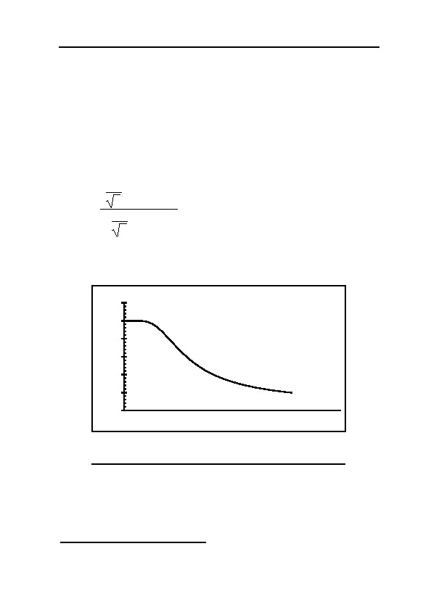
6. FORMATION AND STABILITY OF IRON BLUE
6.5.4.2. Excursus
There are two more steps in the observed reaction which could,
theoretically, have an influence on the reaction under consideration:
A) Adsorption on the solid material;
B) Dissociation of hydrogen cyanide.
A: The adsorption of hydrogen cyanide on solid surfaces de-
creases with rising temperature, according to Langmuire (see Graph
3).352
K
· p · e-∆H/RT
T
Θ=
(1)
K
· p · e-∆H/RT
1-
T
Θ
∆Η = adsorption enthalpy (negative)
= Degree of adsorption
K
= variable
R = universal gas constant
T
= temperature
e = Euler’s number (2.71828...)
p
= gas pressure
120
100
degree of coverage [%]
80
60
40
20
0
temperature
Graph 3: Degree of coverage of the surface of a solid
material with an adsorbed gas as a function of temperature
(schematic)
The intensity of the decrease of the equilibrium degree of adsorp-
tion (coverage) with rising temperature as well as the point of ap-
proximate saturation, however, are unknown for the problem at hand.
But since, as discussed before, all reactions under consideration require
aqueous solutions anyway, adsorptions on solid, i.e., dry surfaces are
352
J. Oudar, Physics and Chemistry of Surfaces, Blackie & Son, Glasgow 1975, pp. 26ff.
167
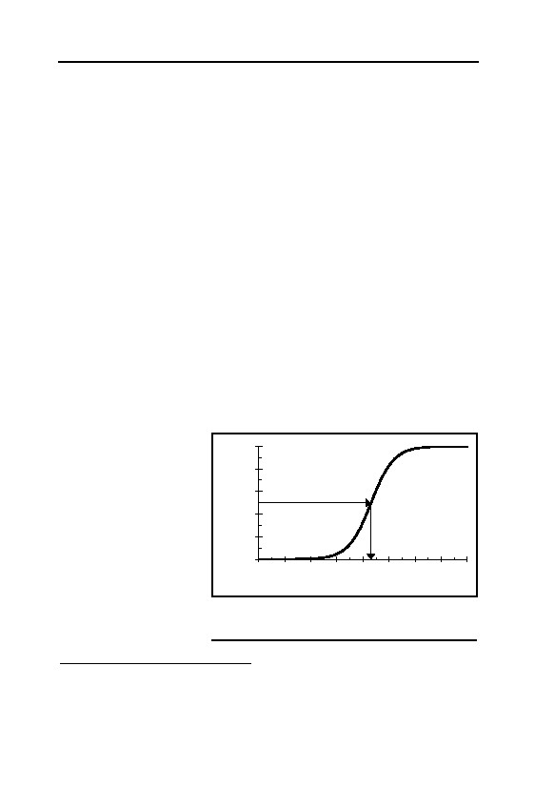
GERMAR RUDOLF · THE RUDOLF REPORT
of no importance to our investigation.
B: According to the literature, the dissociation behavior of acids as
a function of temperature is not unanimous.353 Although there is a ten-
dency of increasing protolysis354 with rising temperature, this tendency
turns upside down at higher temperatures for some acids, others show
generally falling values. Since the changes are generally in the range of
low percentages only, and because speed of protolysis is generally very
high, hence never a restricting factor, this can be neglected here.
6.5.5. pH Value
The pH value (acidity) influences the formation in various ways.
In chapter 6.5.1., reference has already been made to the higher reduc-
tion power of cyanide and iron(III)-cyanide in alkaline environment.
The pH value also influences the reactivity of iron compounds in the
solid body (chapter 6.5.3.).
As remarked above, dissolved hydrogen cyanide hardly exhibits
reactivity. The formation of cyanide ions by absorption and dissocia-
tion of hydrogen cyanide only starts in sufficient degree at neutral pH
values and above, see Graph 4.355 The data leading to Graph 4, together
with the data that enabled us to plot Graph 2 (saturation concentration
of HCN as a function
of temperature), leads
100
to a graph revealing the
80
dissociation degree
relationship
between
of HCN [%]
60
temperature, pH value
50% at pH 9.31 = pKA of HCN
–
(acid content), and CN
40
saturation concentra-
20
tion, see Graph 5 (at a
0
concentration of 1
5
6
7
8
9
10
11
12
13
mol% HCN in air,
pH-value
which is approximately
Graph 4: Degree of disassociation of
1% by weight, the hydrogen cyanide as a function of the pH value
usual
disinfestation
at room temperature.
353
R.C. Weast (ed.), op. cit., (note 322), p. D 163.
354
Protolysis is the splitting of acids (HAc) into their corresponding acid anion (base, Ac–) and
proton (H+, or with water to H3O+):
HAc + H2O Ac– + H3O+
HCN + H2O CN– + H3O+..
here
355
pKA values of HCN: 9.31; R.C. Weast (ed.), op. cit. (note 353).
168
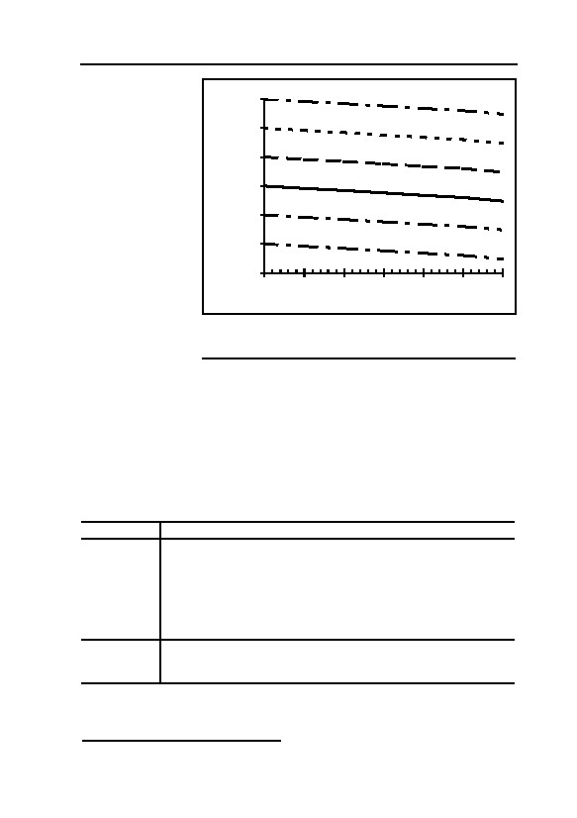
6. FORMATION AND STABILITY OF IRON BLUE
concentration).356
1
At neutral pH
pH = 10
values, equilib-
0.1
pH = 9
rium concentra-
tions of CN– are
c(CN-)sat. [mol/l]
0.01
pH = 8
within the range
0.001
of 3×10–4 to
pH = 7
–3
1×10 mol per
0.0001
pH = 6
liter, depending
on the tempera-
0.00001
pH = 5
ture. An increase
0.000001
in the pH value
0
5
10
15
20
25
30
by one point re-
Temperature [°C]
sults in a ten-fold
Graph 5: Cyanide equilibrium concentration in water
increase in the
as a function of the temperature and pH value at
cyanide equilib-
1mol-% HCN in the air.
rium concentra-
tion. The actual cyanide concentration in masonry is determined by the
velocity of absorption of the gas, adsorption effects within the solid
material, and possible reactions of the cyanide.
The result of all these factors is that slightly alkaline pH values are
favorable to the formation of the pigment.
The individual parameters and their influence on the formation of
Iron Blue are summarized in the following table:
Table 4: Formation of Iron Blue
Parameter Effect
con- Increase in water content results in the following: increased absorp-
Water
tion of hydrogen cyanide; long-term retention of ad-/absorbed hydro-
tent
gen cyanide; increased mobility of reaction partners; increased reac-
tivity of iron oxide; water is the basic precondition for disassociation
and redox reactions; generally positive influence with increasing
water content. The water content is dependent above all upon the
temperature.
Reactivity of Factor determining reaction velocity, apart from the type of material
and pH value (see below), positively influenced by increasing water
the iron
content.
356
Valid for ideal solutions.
169

GERMAR RUDOLF · THE RUDOLF REPORT
Parameter Effect
Temperature Increased ad-/absorption of hydrogen cyanide as well as—under oth-
erwise identical conditions—decreased velocity of individual reac-
tions with falling temperature; strong increase on water content, and
therefore a strongly positive net influence upon all other factors with
a falling temperature.
Increased iron reactivity with falling pH, as well as a massive reduc-
pH value
tion in cyanide accumulation and redox reactivity of iron(III)-
cyanide; compromise between iron reactivity and cyanide forma-
tion/Fe3+ reduction: A weakly alkaline pH value is favorable to
absorption of hydrogen cyanide and accumulation of cyanide as well
as for the reduction in iron(III)-cyanide, which determines the veloc-
ity of the reaction. Although more strongly alkaline media can accu-
mulate iron(II)-cyanide over longer periods of time, no Iron Blue can
form under such circumstances.
6.6. Stability of Iron Blue
6.6.1. pH Sensitivity
Iron Blue is an extremely acid-resistant, but base-decomposing
pigment.357 Hydrogen cyanide is only released by warm, diluted sulfu-
ric acid, while hydrochloric acid, by contrast, has no effect.358 In a
clearly alkaline environment, i.e., in the presence of high concentra-
tions of OH– ions, these displace the cyanide ion from the iron(III)-ion.
Fe(OH)3 is then precipitated (‘rust sludge’), and the Iron Blue is de-
stroyed.359
357
The hexacyanoferrate acids are very strong acids: J. Jordan, G.J. Ewing, Inorg. Chem. 1
(1962), pp. 587-591. The findings of analyses of disassociation constants show, for hexacyan-
oferrate(III): K1 >KIII>KIII>0.1; hexacyanoferrate(II): K1 >K2 >0.1; K3 =6×10-3; K4 =6.7×10-5.
III
II
II
II
II
2
3
Thus, hexacyanoferrate(III) is still almost completely disassociated at pH=1, hexacyanofer-
rate(II) doubly, from pH=3 triply, from pH=5 complete.
358
G.-O. Müller, Lehrbuch der angewandten Chemie, vol. I, Hirzel, Leipzig 1986, p. 108; the
pigment is, however, reversibly soluble in concentrated hydrochloric acid, i.e., the pigment is
not decomposed, but merely physically brought into solution; there is therefore no release of
hydrogen cyanide; see also H.J. Buser et al., op. cit. (note 329); see also chapter 8.2.: analyti-
cal method for total cyanide content according to DIN: the pigment is destroyed by boiling
HClaq.. Iron Blue suspensions (see note 331) have an acid pH value of approximately 4. At this
slightly acid eigen pH, as is formed, for example, by acid rain in surface waters, Iron Blue is
at its most stable: H. Ferch, H. Schäfer, op. cit. (note 333). In technical applications, the alka-
line resistance is increase by adding nickel, cf. R.E. Kirk, D.F. Othmer, op. cit. (note 332);
J.A. Sistino, op. cit. (note 332); E. Elsermann, Deutsche Farben-Z. 5 (1951), pp. 419ff.; R.
Beck, Deutsche Farben-Z. 6 (1952), p. 231.
359
Iron(III)-hydroxide is even less soluble in this range than Iron Blue; on the solubility of
Fe(OH)3 see chapter 6.6.3.; to be exact, Iron Blue is not totally destroyed at a high pH; rather,
170

6. FORMATION AND STABILITY OF IRON BLUE
The literature contains authenticated cases of studies with iron at
pH values of 9 and 10, in which it is still stable.360 The pH range
around 10 to 11 can be considered the critical limit for the stability of
Iron Blue. Based on the alkaline behavior of fresh mortar and concrete
(in this regard, see also chapter 6.7.2), Iron Blue is only used to paint
these surfaces to a limited extent.361
6.6.2. Solubility
6.6.2.1. Overview
Iron Blue is considered one of the least soluble cyanide com-
pounds, which is the precondition for its widely-varied application as a
pigment.362 The literature flatly refers to Iron Blue as “insoluble”.363
Concrete, reliable values on the solubility of Iron Blue are not re-
corded in the scientific literature. Based on comparative calculations
between the known solubility of Fe(OH)3 on the one hand, and the
limit value of the pH stability of Iron Blue on the other hand (pH 10),
the approximate solubility of Iron Blue in water can, however, be cal-
culated (see chapter 6.6.2.2.). It amounts to approximately 10-24 g Iron
Blue per liter of water, this means that 0.000000000000000000000001
g Iron Blue dissolve in 1,000 g of water.
In addition to a compound’s solubility in water, its condition
(crudely or finely crystalline, superficially adherent or adsorbed by
capillary effects) as well as, in particular, the condition and quantity of
the Fe3+ is, initially, merely withdrawn; the base-resistant [Fe(CN)6]4- remains intact; see note
344.
360
See the studies by M.A. Alich et al., op. cit. (note 338).
361
J.A. Sistino, op. cit. (note 332); H. Beakes, Paint Ind. Mag. 69(11) (1954), pp. 33f. Mixtures
of Iron Blue and phtalocyanine blue generally find application, since both, alone, lack suffi-
cient long-term stability; Degussa describes the lime fastness of Iron Blue as “not good” (H.
Ferch, H. Schäfer, op. cit. (note 333)); however, Degussa is referring to its fastness on still un-
carbonated, alkaline plasters and concretes: H. Winkler, Degussa AG, letter to this author,
June 18, 1991. My own experiments with the dissolution of fresh Iron Blue precipitations re-
sulted in a limit value of pH 10-11 for the stability of Iron Blue.
362
This property is used in Russian industry, for example, for the passivation of steel pipes
against aggressive waste waters, since CN– contained in waste waters coats the interior of
pipes with an insoluble protective layer of Iron Blue: N.G. Chen, J. Appl. Chem. USSR,
74(1)(1974), pp. 139-142. But it should be noted that this borders on criminal negligence,
since toxic cyanides simply do not belong in waste waters.
363
DIN Safety Data Sheet VOSSEN-Blau®, in: Schriftenreihe Pigmente Nr. 50, Degussa AG,
Frankfurt 1985; see also H. Ferch, H. Schäfer, op. cit. (note 333). Last but not least, pigments,
by definition, are coloring agents practically insoluble in dissolvents and binding agents (DIN
55,943 and 55,945).
171

GERMAR RUDOLF · THE RUDOLF REPORT
the water supplied are decisive in determining the actual velocity of
dissolution of a substance. Iron Blue formed in masonry will be pre-
sent in a finely crystalline form and adsorbed by capillary effects, in
which case the former favors dissolution, while the latter is extremely
detrimental to dissolution. Water almost or entirely saturated with
iron(III)-ions is no longer capable of dissolving further iron. Further-
more, water permeation through finely porous solid material like ma-
sonry is extremely low even at high water tables; the iron saturation
concentration is quickly attained, which, in addition, as remarked
above, is generated by the slightly more soluble iron oxides of the solid
body rather than by the Iron Blue having once arisen. It is furthermore
very well known that mortar and concrete permeated with paints prac-
tically cannot be rendered colorless.364 It cannot, therefore, be antici-
pated that the Iron Blue content once having arisen in walls can be per-
ceptibly reduced by dissolution in water. Water running down the exte-
rior surfaces is considerably more aggressive, exerting, in particular, an
erosive effect, i.e., damaging the masonry as such.
6.6.2.2. Excursus
Tananaev et al. 365 examined the solubility of metal hexacyanofer-
rate(II) and discovered a solubility product366 of 3 · 10-41 (pKS =40.5) for
the solubility product of Iron Blue, without mentioning the unit used.
Assuming they used the summation formula of Fe4[Fe(CN)6]3
(unit being mol7 l-7), one attains a solubility of 0.5 mg per liter water.
Thus, it would be 14 times less soluble than the nearly insoluble cal-
cium carbonate (CaCO3, 7.1 mg per liter water, KS = 4.95 · 10-10 mol2l-
2 367
). Later publications support these findings,336 although attention
must be paid to deviations in the stoichiometry (composition) of Iron
Blue with impurities, leading to an increased solubility.
Tananaev et al. precipitated the complex metal cyanoferrate from
364
See also, in this regard, the remarks of a company dealing in colored cements and concretes:
Davis Colors, 3700 East Olympics Blvd., Los Angeles, CA 90023,
www.coloredconcrete.com/davis/Tech/03470.html.
365
I.V. Tananaev, M.A. Glushkova, G.B. Seifer, J. Inorg. Chem. USSR, 1 (1956), pp. 72ff.
366
The solubility product of a compound is defined as the product of the entire ionic concentra-
tion of the totally dissociated compound: Fe4[Fe(CN)6]3 → 4 Fe3+ + 3 [Fe(CN)6]4-;
KL(Fe4[Fe(CN)6]3) = c(Fe3+)·c(Fe3+)·c(Fe3+)·c(Fe3+)·c([Fe(CN)6]4-)·c([Fe(CN)6]4-)·c([Fe(CN)6]4-)
= c4(Fe3+)·c3([Fe(CN)6]4-).
The pKS value correlates to the negative decimal logarithm of the product of solubility.
367
R.C. Weast (ed.), op. cit., (note 322), p. B 222.
172

6. FORMATION AND STABILITY OF IRON BLUE
an appropriate metal salt solution with Li4[Fe(CN)6], probably acquir-
ing a high rate of inclusions (lithium, water) as well. Thus, in spite of
the four hour-long accumulation of the precipitation, the filtrate would
certainly still have contained colloidally dispersed Iron Blue. Since
they finally determined the amount of free Fe3+ in the filtrate by pre-
cipitating it with ammonia as Fe(OH)3, they will undoubtedly also
have precipitated the Fe3+ of the colloidally dispersed Iron Blue, as
ammonia raises the pH value so much that Iron Blue is no longer stable
(see chapter 6.6.1.).
Therefore, they did not determine the solubility of Iron Blue, but
the measure of stability of the dispersion of fresh precipitations of the
pigment.
The solubility product of Pb2[Fe(CN)6] given by Krleza et al. ,336
which they used as a reference to determine the solubility products, is
much lower than the one used by Tananaev et al.. If applied to Tanan-
aev’s calculations, this produces a solubility of Iron Blue of only 0.05
mg per liter. Krleza et al., however, find similar results for the solubil-
ity of most of the metal cyanides analyzed, including Iron Blue. Since
conventional methods of analysis, such as gravimetry and titration,
tend to be unreliable when facing minute traces, one must but wonder
about these similar results.
However, one can escape this dilemma by thoughtful reasoning.
It is safe to say that Iron Blue is stable at a pH value of 7, i.e., in a
neutral aqueous medium, so we take this as a minimum value. As men-
tioned earlier, a pH value of about 10 can be considered the upper limit
of stability for Iron Blue, so we take this as maximum value for the
following calculations. At pH=7, and even more so at pH=10, the free
iron concentration is extremely low, since Fe(OH)3 is nearly insoluble
(see Table 5).
At pH 7 and 10, respectively, a saturated Fe(OH)3 solution has the
following free Fe3+ concentration:
KL(Fe(OH)3)
c(Fe3+) =
(2)
c3(OH-)
2.67×10-39 mol4l-4
pH=7: = 10-21 mol3l-3 = 2.67×10-18 mol l-1
(3)
2.67×10-39 mol4l-4
pH=10: = 10-12 mol3l-3 = 2.67×10-27 mol l-1
(4)
173
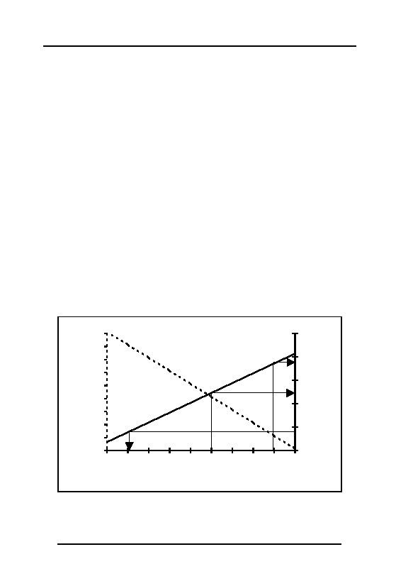
GERMAR RUDOLF · THE RUDOLF REPORT
Should the free Fe3+ concentration surpass this value due to a bet-
ter solubility of Iron Blue, then Fe3+ would precipitate as hydroxide
and would be increasingly removed from the pigment, thereby destroy-
ing it in the end. Since this does not happen at pH=7 at all, and pH=10
can be considered the point where it just starts to happen, the concen-
tration of the Fe3+ ion in a saturated Iron Blue solution must lie well
below 10-18 mol/liter, i.e., in the area of 10-27 mol/liter. Thus, the solu-
bility of Iron Blue must also have a value around 10-27 mol per liter
(actually: ¼ of the free Fe3+ concentration, KS less than 4.1 · 10-187 mol7
l-7, pKS larger than 186.6) which, at a mol mass of 1,110 g mol-1
((Fe4[Fe(CN)6]3 · 14 H2O) would correlate to 10-24 g.
With this, the complex iron pigment does indeed deserve to be
called insoluble, as only one part of dissolved Iron Blue can statisti-
cally be found in 100,000,000,000,000,000,000,000,000,000 parts of
water (1029). The actual solubility would therefore be less by a factor
of 1020 as determined by Tananaev et al., which would come pretty
close to values calculated for other so-called ‘insoluble’ compounds,
like mercury sulfide (HgS). However, one must consider that the
chemistry of Fe3+ in aqueous solutions doesn’t justify the terms ‘dis-
solved’ or ‘precipitated’, since a multitude of complexes do exist in the
1E-03
250
1E-06
200
1E-09
max.
pKs(Iron Blue)
c(Fe³+) [mol/l]
1E-12
150
1E-15
Rudolf
1E-18
min.
100
1E-21
1E-24
Tananaev
50
1E-27
1E-30
0
2
3
4
5
6
7
8
9
10
11
pH value
Graph 6: Free Fe³+ concentration as a function of pH value and the
resulting minimal pKS value of Iron Blue, depending on its stability at
the corresponding pH value. pKS value acc. to Tananaev et al. : 40.5;
according to reflections made here: greater than 123, smaller than
186.
174

6. FORMATION AND STABILITY OF IRON BLUE
broad pH-spectrum, partly as polymer hydroxo-aquo-complexes (com-
pare chapter 6.5.3.).
Graph 6 shows the correlation between the pH value of the free
3+
Fe -concentration in a hypothetical saturated solution of Iron Blue and
the respectively resulting minimal pKS values possible for Iron Blue,
which it must possess, should stability prevail at the given pH-reading.
Tananaev’s pKS value given, it is obvious that the pigment would re-
main stable only up to pH 3. Accordingly, it would dissociate itself by
its eigen pH value of 4 (see chapter 6.6.1., note 358), which is formed
in its own dispersion. Thus the magnitude of error in the results of
Tananaev et al. and Krleza et al. is apparent.
These reflections show that iron, bound as hydroxides or oxides in
solid materials, tends to dissolve in a neutral medium more readily than
Iron Blue, since its equilibrium concentration must be higher than that
of Iron Blue.
6.6.3. Excursus: Competing Ligands
As shown, OH–-ions may, due to the low solubility of Fe(OH)3,
noticeably precipitate the Fe3+ of Iron Blue in pH media above 9 to 10.
The residual hexacyanoferrate(II), on the other hand, would only de-
compose in strongly alkaline media, because Fe(OH)2 is simply more
soluble (compare Table 5).369
Tartrate370 has, in contrast to oxalate, hardly any effects so that
Table 5: Dissociation constants and solubility products
of iron compounds
Compound
Constant
Source
4.1 · 10-187 mol7 l-7
KS(Fe4[Fe(CN)6]3)
KD(6)([Fe(CN)6]4-)
10-24 mol l-1
368
KD(6)([Fe(CN)6]3-)
10-31 mol l-1
368
4.79×10-17 mol3 l-3
367
KS(Fe(OH)2)
2.67×10-39 mol4 l-4
367
KS(Fe(OH)3)
3.13×10-11 mol2 l-2
367
KS(FeCO3)
368
C. Wilson, Wilson & Wilson’s Comprehensive Inorganic Chemistry, Vol. 1B, Elsevier, Am-
sterdam 1960, p. 162.
369
In absence of free cyanide ions, the pH stability limit of hexacyanoferrate(II) (total dissocia-
tion) is at 11.8, but already very small amounts of free cyanide (10-10 mol l-1) push the limit up
to pH=13.
370
Tartrate, corresponding base of tartaric acid. The mixed potassium-sodium-salt is the famous
tartrate (potassium bitartrate), which crystallizes on the cork of wine bottles (Seignette salt).
175
GERMAR RUDOLF · THE RUDOLF REPORT
Fe3+ can be quantitatively removed from sour wine with [Fe(CN)6]4-, a
usual procedure to remove iron ions from wine.371 Concentrated alkali
carbonate solutions will precipitate the Fe2+ of Iron Blue as FeCO3, so
that they destroy the entire pigment by precipitating Fe3+ as Fe(OH)3
(due to alkalinity) and the hexacyanoferrate(II) salt [Fe(CN)6]4-.372 Cal-
cium carbonate solutions, however, would not be sufficient due to their
marginal saturation solubility. Besides that, Kohn examined the sup-
portive effect of most of the organic ligands to disperse Iron Blue.373
Thus, apart from OH– (alkaline medium), there are no other lig-
ands to be considered competing in the formation or dissolution of Iron
Blue in the cases here under consideration.
6.6.4. Effects of Light
6.6.4.1. Overview
Iron Blue itself is generally considered a light-resistant pigment,
which is only slowly decomposed by the effects of UV radiation.374
Thus, there are even patents utilizing Iron Blue as a UV-absorbing
pigment, which is only meaningful with sufficient resistance to UV
radiation.375 Since the walls of interest to us here are protected from
UV radiation and because UV radiation can only exert a superficial
effect on the walls, while the Iron Blue would form and remain within
the walls, a possible process of decomposition by UV radiation can
have no influence upon our investigation.
6.6.4.2. Excursus
Certain wave lengths of ultraviolet radiation may set free CN– from
hexacyanoferrate(II) and -(III), the preliminary stages of Iron Blue. As
far as hexacyanoferrate(III) is concerned, this leads to the formation of
371
C. Lapp, C. Wehrer, P. Laugel, Analusis, 13 (4) (1985), pp. 185-190.
372
G.-O. Müller, op. cit. (note 358).
373
M. Kohn, Anal. Chim. Acta 3 (1949), pp. 558ff.; ibid., 5 (1951), pp. 525-528; ibid., 11 (1954),
pp. 18-27.
374
See also Winnacker-Küchler, Chemische Technologie, volume 2, Carl Hanser Verlag, Munich
1982, p. 197; H. Ferch, H. Schäfer, op. cit. (note 333); Wilhelm Foerst (ed.), Ullmanns Encyk-
lopädie der technischen Chemie, volume 13, Urban und Schwarzenberg, Munich 31962, p.
794; ibid., volume 18, Verlag Chemie, Weinheim 1979, pp. 623ff.; H. Watanabe, J. Jap. Soc.
Col. Mat., 34 (1961), pp. 5-8; L. Müller-Focken, Farbe und Lack, 84 (1987), pp. 489-492.
375
H. Tada, M. Kunio, H. Kawahara, Jpn. Kokai Tokkyo Koho, 1990, 3 p. Source only available
as abstract.
176

6. FORMATION AND STABILITY OF IRON BLUE
Iron Blue.337 As far as hexacyanoferrate(II) is concerned, quantum effi-
ciencies376 of 0.1 to 0.4 are reported for wave lengths of 365 nm.377
Lately, it has been discussed whether complex cyanides can be
removed from industrial waste waters by ultraviolet radiation. The un-
bound cyanide will be oxidized and destroyed by hydroxyl radicals
originating from the parallelly occurring photolysis of water.378 How-
ever, results are not unequivocal.379
As for Iron Blue, one knows of the bleaching effect under strong,
perpetual sun radiation and the ensuing re-darkening during the
night.380 Here also, the liberation of CN– is responsible, which reduces
parts of the Fe3+ ions to Fe2+ ions. The latter process, however, will
reverse during the night under the influence of oxygen and moisture.
The Iron Blue concentration will eventually be reduced by the loss of
the released CN–, either by evaporation of hydrogen cyanide, by wash-
ing out as CN–, or by oxidation through Fe3+/atmospheric oxygen or
from hydroxyl radicals from the natural photolysis of water. The latter
process is minute and can therefore be omitted. At any rate, most of the
cyanide released by photolysis will again be complex bound to iron.
6.6.5. Long-Term Test
The best long-term test available to us consists of disinfestation
buildings BW 5a and 5b in Birkenau, which have defied the wind and
weather of the strongly corrosive climate in the industrial region of
Upper Silesia for over 50 years, and which are still colored blue, both
inside and out, exhibiting a high cyanide content. These findings are
also supported by two other long-term tests.
The color durability of Iron Blue, in addition to other pigments,
376
Quantum efficiency is that part of the absorbed light quants which leads to photo reactions
under scrutiny, here from 10 to 40%.
377
L. Moggi, et al., op. cit. (note 337); V. Carassiti, V. Balzani, Ann. Chim. 50 (1960), pp. 782-
789.
378
Photolysis of water leads to the splitting of water into uncharged parts with unpaired electrons
(formation of radicals through homolytic splitting (homolysis); see also dissociation, note
339):
2 H2O + hν H3O· + OH·
(hν = photo quant)
hydroxyl radical
379
M.D. Gurol, J.H. Woodman, Hazard. Ind. Waste 21 (1989), pp. 282-290; S.A. Zaidi, J. Carey,
in: Proceedings of the Conference on Cyanide and the Environment, Colorado State Univer-
sity, 1984, pp. 363-377.
380
Deutsche Chemische Gesellschaft (ed.), Gmelins Handbuch, op. cit. (note 335); Ullmanns
Encyklopädie, op. cit. (note 374); L. Müller-Focken, op. cit. (note 374).
177
GERMAR RUDOLF · THE RUDOLF REPORT
was tested during an environmental resistance test lasting 21 years in
the industrial district of Slough, west of London.381 In so doing, pieces
of aluminium sheet metal were alternatively dipped in an iron(III)-
cyanide and then in an iron(III)-salt solution,382 by which the resulting
pigment was adsorbed on the aluminium sheet metal. The test sheets
were then exposed to the environment on the roof of a building in a
vertical 45° angle facing south-west.
During the 21 years lasting test, in which eight Iron Blue samples
were tested among other pigments, the Iron Blue, in particular, fol-
lowed by iron ochre (Fe2O3, rust), exhibited only minimal alterations
after this period of time. One sample of Iron Blue and iron ochre was
removed only after 10 to 11 years in each case.383 All other samples
still exhibited an intense blue color. Half of the seven remaining Iron
Blue samples received the value 4 out of a maximum of 5 points for
the best retention of quality, on the grey scale used there in the deter-
mination of color changes. Only minor alterations were detected.
The exhibits were therefore exposed to the environmental condi-
tions of a strongly industrialized area, with full effects of precipitation,
direct sunshine, and wind erosion for more than 21 years. Under in-
tense summer sunshine and in the absence of wind, the temperature of
the dark-blue colored aluminium metal sheets rose steeply (Iron Blue is
only stable up to approximately 140°C.384). Snow, frost, hail, storms,
and the finest, driving acid drizzle had obviously just as little an effect
on the pigment as the UV radiation of direct sunlight. What is remark-
able is that in determining the degree of destruction of the pigment no
unexposed samples were used since these had been lost over the 21-
year period; rather, places on the surface of the exhibits which had
been relatively well protected from direct environmental influences by
the frames and by rubber rings on the screw joints were used as control
samples. These exhibited almost no alterations.
In comparison to the environmental conditions which are of inter-
381
J.M. Kape, E.C. Mills, Tranp. Inst. Met. Finish., 35 (1958), pp. 353-384; ibid., 59 (1981), pp.
35-39.
382
K4[Fe(CN)6]3 or Fe(NO3)3.
383
The literature does not, however, mention this Iron Blue sample as “Prussian Blue”, like the
others, since it was, at that time, considered to be of another type, i.e., “Turnbull’s Blue” or
“ferrous ferricyanide”.
384
Compare Ferch, H. Schäfer, op. cit. (note 333); S. Barbezat, J. Réch. Cent. Nat. Réch. Sci. 4
(1952), pp. 184ff.; E. Gratzfeld, Färg och Lack, 3 (1957), pp. 85-108; E. Herrmann, Farbe
und Lack, 64 (1958), pp. 130-135.
178
6. FORMATION AND STABILITY OF IRON BLUE
est here, this long-term test involved considerably more severe condi-
tions, since in this case, the externally formed Iron Blue was only su-
perficially adsorbed upon the aluminium sheets. The pigment neverthe-
less resisted extremely well.
Another event proves the extraordinary long-term stability of Iron
Blue. For many decades at the end of the 19th and the early decades of
the 20th century, Iron Blue was a by-product in the generation of city
gas, because the hydrogen cyanide contained in coke gas had to be
eliminated for security reasons by washing it with iron hydroxide prior
to introduction into the city gas network. Iron Blue is the end product
of this washing process. City gas works frequently disposed of this
product by distributing some of it over their factory terrain with the
intend to kill weeds—in vain, though, since Iron Blue has no effect as
an herbicide. Today, the grounds of former German city gas works still
contain high quantities of Iron Blue, many decades after the works
were put out of operation. It was neither decomposed, nor dissolved or
washed away by rain water, since it is insoluble. In particular, terrain
with a high Iron Blue content is not considered polluted, since it is
physiologically unobjectionable due to its stability.385
In summary, it may be stated that Iron Blue having formed in the
interior of a wall as a component of the wall itself, possesses a longevity
comparable to the iron oxide from which it has formed. This means sim-
ply that Iron Blue possesses a degree of stability which is comparable to
that of the masonry itself: the Iron Blue will remain contained in the wall
for as long as the wall itself remains in existence.386
Once perceptible quantities of cyanide have accumulated within a
wall, therefore, and once conditions permit the conversion of the cyanide
into Iron Blue, no perceptible reduction in the Iron Blue content can be
anticipated, even after fifty years or more.
A typical example of the manner in which the media deal with these
facts is a press report issued by the German Press Agency (Deutsche
Presseagentur, dpa) on March 29, 1994, and which was then published
in many German newspapers and even broadcast on radio. The report
385
D. Maier, K. Czurda, G. Gudehus, Das Gas- und Wasserfach, in: Gas • Erdgas, 130 (1989),
pp. 474-484.
386
An interesting study has been conducted in this connection about the reduction of soluble
components in concrete standing in water, providing support to the statements made here: not
even the concentration of alkali ions, which are the most soluble components of concrete, was
massively reduced: H.A. El-Sayed, Cement and Concrete Research, 11 (1981), pp. 351-362.
179
GERMAR RUDOLF · THE RUDOLF REPORT
flatly claimed that, according to unnamed experts:
“Cyanide compounds decompose very quickly. In the ground, this
occurs even after six to eight weeks; in masonry, these compounds could
only be preserved under ‘absolute conditions of conservation including
complete exclusion of air and bacteria.”387
Inquiries with the dpa press office in Stuttgart which published
the report revealed that the writer responsible for the report, Albert
Meinecke, had simply invented this expert opinion.388 This obvious
lie continues to be further disseminated, even by German government
agencies such as, for example, the Bavarian Ministry of the Interior.389
6.7. Influence of Various Building Materials
6.7.1. Brick
6.7.1.1. Overview
Bricks are well-known to acquire their hardness and stability dur-
ing their baking process. This causes an intensive binding of the com-
ponents in bricks (sintering). One result of this is that the reactivity of
the iron oxide occurring in bricks (2 to 4%) is strongly reduced, so that
a perceptible inclination to form iron cyanide is hardly to be antici-
pated. The immediate surface of bricks slightly attacked by atmos-
pheric influences (weathering) nevertheless constitutes an exception to
this rule, so that the superficially adherent iron oxide is available for
conversion into Iron Blue.
387
German daily newspapers, for instance: Süddeutsche Zeitung, Stuttgarter Zeitung, Südwest-
presse-Verbund (March 29, 1994), taz, Frankfurter Rundschau (March 30, 1994).
388
See also W. Schlesiger, op. cit. (note 91), pp. 21-24; G. Rudolf, “Über die frei erfundene
Expertenmeinung der ‘dpa’”, DGG 42(2) (1994), pp. 25f. (online:
www.vho.org/D/DGG/Rudolf42_2.html); Engl. in the appendix to this book, chapter 11.5.
389
See the Bavarian State Ministry for the Interior, Verfassungsschutzbericht 1997, Munich
1998, p. 64. A corresponding reference to the factual incorrectness of the remarks made in this
regard by the Arbeitskreis Zeitgeschichte und Politik (in a letter by president Hans-Jürgen
Witzsch, dated Oct. 8, 1998, Fürth) was countered by the Ministry as follows: “Your efforts to
deny and/or relativize the crimes of the National Socialists have been known to the security
authorities for years. […] We see no occasion for a discussion of gas chambers.” The letter,
from Dr. Weber of the Bavarian State Ministry of the Interior dated Oct. 13, 1998, ref. IF1-
1335.31-1, probably established a new world record for stupidty.
180
6. FORMATION AND STABILITY OF IRON BLUE
6.7.1.2. Excursus
The chemical composition of bricks varies massively due to the
different sorts of mar and loam used as initial material. The content of
clay (included in this are 20 to 60% Kaolinite, consisting roughly of
47% SiO2, 40% Al2O3, 13% H2O) may lie between 20 and 70%, the
rest being carbonate, finest sand and iron oxides.390 According to my
own analyses, the latter content may vary between 2 and 4%.
The porosity values of bricks lie between 20 and 30 vol.%,391 ac-
cording to other sources up to 50%.392 According to my own mercury
penetration tests, the pore size of bricks lies heavily concentrated
around 1 µm.393
Due to the decreased specific surface (0.5 to 1 m² per g, BET,394
own tests), the reactivity of the iron oxide is strongly reduced. How-
ever, partly dissolved iron at brick surfaces immediately exposed to
weathering can be set free for reactions in bigger amounts.
The normal free, i.e., not chemically bound water content of bricks
in dry rooms (20°C) is in the area of one volume percent, but it can rise
up to 4% at a relative humidity of over 90%.395
6.7.2. Cement Mortar and Concrete
6.7.2.1. Overview
The rust content (Fe2O3) of Portland cement, of particular interest
to us here, the cement most frequently used for concrete and cement
mortars, is usually between 1 and 5%.396 The sand added to the mortar
can also exhibit a high iron content (up to 4%). As mentioned in chap-
ter 6.5.3., a large surface area at the solid-liquid phase limit (iron ox-
ide-cyanide solution) is favorable to the formation of Iron Blue. This is
extraordinarily large in cement and concrete mortars (microscopic inte-
390
O. Hähnle, Baustoff-Lexikon, Deutsche Verlagsanstalt, Stuttgart 1961, p. 384.
391
Landolt-Börnstein, Zahlen und Funktionen aus Physik, Chemie, Astronomie, Technik, volume
IV Technik, part 4b Wärmetechnik, Springer, Berlin 61972, pp. 433-452.
392
S. Röbert (ed.), Systematische Baustofflehre, volume 1, VEB Verlag für Bauwesen, Berlin
4
1983, p. 120.
393
These mercury penetration tests were performed at the research institute of the VARTA Bat-
terie AG in Kelkheim, Germany, in late 1991.
394
Method to determine the specific surface with nitrogen adsorption following Brunauer, Em-
met, Teller.
395
K. Wesche, Baustoffe für tragende Bauteile, volume 1, Bauverlag, Wiesbaden 1977, p. 37.
396
W.H. Duda, Cement-Data-Book, Bauverlag, Wiesbaden 1976, pp. 4ff., as well as my own
analysis.
181
GERMAR RUDOLF · THE RUDOLF REPORT
rior surfaces of approximately 200 m2 per gram).397
Fresh concrete and cement mortars—which are identical from a
chemical point of view—are relatively strongly alkaline (pH approxi-
mately 12.5). It later falls, however, due to the binding of carbon diox-
ide from the air. Depending on the special chemistry of the cement
mortar, this process proceeds very slowly in the depth of the material.
According to the composition of the cement mortar, this may last from
a few months to many decades, until the pH value of such a mortar or
concrete becomes neutral, even in the deepest layers.396-398 This chemi-
cal behavior explains the entire secret of the stability of reinforced
concrete, which prevents the embedded steel from rusting further in the
environment within the concrete, which remains alkaline for lengthy
periods of time.399
The water content of concrete and cement mortars depends on the
temperature and relative humidity of the air and fluctuates between 1%
and less at 20°C and 60% relative humidity up to 10% in air saturated
with humidity.395 In case of permanently high humidity, penetrating
wetness from outside, a huge part of the pore system can be filled with
water.400
Poorly insulated rooms built underground always have cool and
humid walls due to their great exchange surface area with the ground:
partly because of their absorption of humidity from the ground, and
partly because of the condensation of humidity in the air on the cool
walls when the temperature falls below the dew point. The water content
of these walls therefore lies around 10%, i.e., a factor of approximately
10 or more above that of dry walls of heated rooms built above ground.
6.7.2.2. Excursus
The chemical composition of Portland cement, the most frequently
used cement for concrete and water mortar, can be seen in Table 6.
397
W. Czernin, Zementchemie für Bauingenieure, Bauverlag, Wiesbaden 1977, pp. 49f.
398
N.V. Waubke, Transportphänomene in Betonporen, Dissertation, Braunschweig 1966.
399
In the strongly alkaline environment, iron is passivated by a passive layer of Fe(OH)3. ‘Botch
work’ on building sites, i.e., rusting reinforcement rods and cracking concrete after only a few
years or decades, due to overly low pH value in the vicinity of the embedded reinforcement
rods, is caused by a) an incorrect composition of the concrete (too little cement—it’s cheaper
this way—and/or too much or too little water—incompetence), or b) by installing the rein-
forcement rods too close to the surface of the concrete, where the pH value falls strongly after
a few years or decades; see notes 396f.
400
K. Wesche, Baustoffe für tragende Bauteile, volume 2, Bauverlag, Wiesbaden 1981, pp. 51f.
182
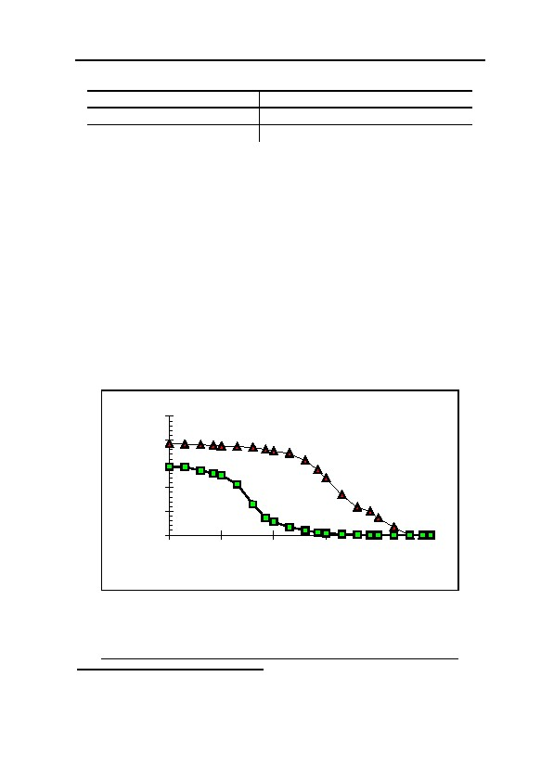
6. FORMATION AND STABILITY OF IRON BLUE
Table 6: Composition of Portland cement402
K2O: 0.2 to 0.6 %
Al2O3 : 5 to 10 %
Na2O: 0.5 to 3 %
SiO2 : 20 %
CaO : 60 %
Fe2O3: < 5 %
The specific surface of the cement powder is in the order of 3,000
2
cm per g. Concrete and cement mortar get their stability by hydration
of the cement compounds calcium oxide CaO (burnt lime), silicium
dioxide SiO2 (Quartz), iron and aluminium oxide Fe2O3/Al2O3 to
mixed, microfibrous calcium alumosilicate-hydrates with a chemically
bound water content of some 25 mass %.401 It then has a specific sur-
face of up to 200 m2 per g when measured with water adsorption,
which is an extremely high value. Other methods (e.g. BET-measuring
with nitrogen) yield a value of only 1/3 of this or less.397 The porosity of
mortar and concrete heavily depends on the amount of water added
during preparation and lies at a minimum of 27% according to the lit-
erature,400 in which case the volume of the microcapillary pores be-
tween the silicate fibers is included as well, which cannot be deter-
mined with mercury penetration measurings.
Aside from the absolute porosity, the pore size distribution is deci-
accumulated relative pore
25
20
volume [%]
lime mortar
15
10
concrete
5
0
0.001
0.01
0.1
1
10
100
pore radius [µm]
Graph 7: Accumulated pore volume distribution of concrete,
according to “Forschungs- und Materialprüfungsanstalt, Abteilung
1: Baustoffe” (Research and Material Testing Agency, Department
1: Building Materials), Stuttgart, and of wall mortar, own analysis.
In each case determined by Hg penetration.
401
Verein Deutscher Zementwerke, Zement Taschenbuch 1972/73, Bauverlag, Wiesbaden 1972,
pp. 19ff.
402
W.H. Duda, op. cit. (note 396).
183

GERMAR RUDOLF · THE RUDOLF REPORT
sive for the reactivity towards gases. If the main pore volume is formed
by micropores, then the gas diffusion into the material is more inhib-
ited than if the main pore volume is formed by larger pores. Graph 7
shows the accumulated pore volume distribution of concrete and one
wall mortar (exact composition unknown, since taken from an old wall,
but according to its brittle consistency probably a lime mortar).
Having a similar total pore volume like the wall mortar (here only
14% due to the test method), the concrete’s largest portion of pore vol-
ume lies between a pore radius of 0.01 and 0.1 µm, whereas the wall
mortar’s largest portion lies between 0.1 und 10 µm. Hence, if com-
pared with the wall mortar, the gas diffusion into the concrete will be
disadvantaged. In general, the average pore size of cement building
materials changes to larger values when increasing the content of sand
and lime.
Fresh concrete is relatively strongly alkaline, caused by the high
content of calcium hydroxide, which, however, gets bound as calcium
alumosilicates rather quickly. However, depending on the type of ce-
ment, a certain amount of it is released as time goes by. The pH value
of non-carbonated concrete is around 12.5. It later falls, however, due
to the binding of carbon dioxide from the air.
The speed of carbonation into the depth of the concrete depends
strongly on the consistency and porosity of the material and follows a
square root relation:403
D=c· t
(5)
d = depth of carbonation
c = constant
t = time
In water tight concretes, it takes many years for the limit of car-
bonation to advance only a few centimeters due to the inhibition of
diffusion in this highly compact material.
In the area of carbonation, the pH value decreases to roughly 7,
the equilibrium value of saturated calcium carbonate solutions. But if
the wall is wet, this results in a proton exchange and therefore no sharp
pH border is formed. If a large portion of the air pores (size in the or-
der of a tenth of a millimeter) flooded with water poor in carbon diox-
ide, the carbonation advances more slowly, because compared to the
403
W. Czernin, op. cit. (note 397); Verein Deutscher Zementwerke, op. cit. (note 401); N.V.
Waubke, op. cit. (note 398).
184
6. FORMATION AND STABILITY OF IRON BLUE
gaseous phase, diffusion in aqueous phases is much slower, by some
orders of magnitude. In case of waters rich in carbon dioxide, however,
this can accelerate the carbonation.
6.7.3. Lime Mortar
The iron content of lime mortars is based, in particular, on the ad-
mixed sand (up to 4 % Fe2O3). Lime mortar is manufactured using only
burnt lime (CaO), sand, and water and acquires its solidity through the
binding of slaked lime (Ca(OH)2) with atmospheric carbon dioxide to
lime (CaCO3). This procedure takes only days or weeks (depending on
the thickness of the particular layers), due to the cruder porous system
which facilitates the diffusion of gas. For fresh lime mortar, an extreme
high water content can be damaging, as the carbon dioxide necessary
for the binding process can no longer penetrate into the wall.
The final ph value of this material lies within the neutral range.
Since this medium no longer provides sufficient protection for steel
reinforcement rods and offers only slight environmental resistance, it is
usually used for the plastering of interior walls and for interior brick
walls only, in the latter case often mixed with cement. 400 The specific
surface of lime mortar lies considerably beneath that of cement mortar
(up to one order of magnitude).404 The water content is similar to ce-
ment mortar.
6.7.4. Effects upon the Formation of Iron Blue
The first step in the formation of Iron Blue in masonry is the ab-
sorption of gaseous hydrogen cyanide. A cool (10°C ) wall in a cellar
with atmospheric humidity near the saturation point, due to its higher
water content (by a factor of at least 10), has an increased ability (by a
factor of 10) to absorb hydrogen cyanide compared to warm walls in a
heated room built above ground with lower atmospheric humidity
(20°C, 50% rel.).
The second step in the formation of Iron Blue is the ionic split
(disassociation) of the hydrogen cyanide, that is, its conversion into
simple cyanide.405 This procedure requires an alkaline environment,
404
The reason: no formation of very finely crystalline alumosilicate with higher surface area.
405
In masonry, this largely corresponds to the neutralization of the hydrogen cyanide by calcium
hydroxide Ca(OH)2 into calcium cyanide Ca(CN)2.
185
GERMAR RUDOLF · THE RUDOLF REPORT
which, in lime mortars, lasts only for a few days or weeks, but which
are present for months or years in cement mortar and concrete.
The next step is the formation of iron(III)-cyanide, a process that
hardly occurs in a strongly alkaline environment and which occurs
slowly in slightly alkaline environments. In the neutral range, this reac-
tion is once again slowed down because the cyanide converts into non-
reactive, volatile hydrogen cyanide by the humidity in the wall. The
environment around the carbonation limit of concrete and mortar
(which is slightly alkaline), can therefore be addressed as the area in
which iron(III)-cyanide can form easily. In a strongly alkaline area of
the masonry, it only arrives at this prior stage of Iron Blue formation
through the slow detour of the reduction of slight traces of iron(III)-
cyanide to iron(II)-cyanide. A large surface area, as found in cement
mortars and concrete, is especially favorable to the solid-liquid inter-
face reaction between solid rust and cyanide in a liquid solution. These
generally have the advantage of retaining an alkaline medium for
longer periods of time, so that the cyanide accumulated in the masonry
is not lost and has enough time to react with rust. Once again, a high
water content, which broadens the range of moderately alkaline acid
values, is advantageous.406 The reduction of a part of the iron(III)-ions
to iron(II)-ions finally, the next to last step in Iron Blue formation, re-
quires a moderately alkaline acid value, but also occurs in the strongly
alkaline range. A distinction can be made between three areas of dif-
ferent reactivity in masonry:
1. Larger quantities of cyanide ions can accumulate in the non-
carbonated portion, due to the alkaline medium, further favored by
the increased absorption of hydrogen cyanide by the still-humid
material. The cyanide is only bound as iron(III)-cyanide to a slight
extent. This is converted quite rapidly into the more stable
iron(II)-cyanide due to its strong oxidation behavior in the alkaline
medium. An accumulation of iron(III)-cyanide will therefore take
place over a longer time period.
2. In the zone of carbonation, the tendency to accumulate cyanide is
reduced, since the disassociation equilibrium lies increasingly on
the side of the hydrogen cyanide. The oxidation strength of the
iron(III)-cyanide is also diminished. On the other hand, the pig-
406
Very humid mortars and concretes, due to proton diffusion, exhibit no sharp carbonation, i.e.,
pH limit.
186

6. FORMATION AND STABILITY OF IRON BLUE
ment itself now becomes stable, so that increased quantities of
iron(II)-cyanide will be converted into Iron Blue, intimately mixed
with the lime which is now also forming in this area, with the now
somewhat more easily soluble iron(III)-ion at the carbonation
limit.407
3. In the pH-neutral, carbonated part of the masonry, the formation is
considerably dependent on the available cyanide concentration,
which is strongly reduced there. Already formed iron(II)-cyanide
is gradually converted into Iron Blue in the presence of humidity.
Table 7 shows the adsorption values of hydrogen cyanide in vari-
ous building materials.409 They confirm the assumption of considerably
higher reactivity of cements compared to brick, as well as the greater
tendency of fresh cement compared to older and generally more humid
building materials toward accumulation of hydrogen cyanide. The hy-
drogen cyanide accumulation in concrete masonry, the age of which is
unfortunately not indicated, is astonishingly high. Since by definition
there is no consid-
erable difference Table 7: Absorption of hydrogen cyanide by
between the com- various building materials under the effect of 2%
409
position of cement HCN by volume over 24 hours.
HCN [mg m–2]
mortar and con- MATERIAL
crete, it is fur- Terracotta........................................................................ 55.2
thermore not clear Brick ............................................................................... 73.0
how the differing Lime sandstone, naturally humid..............................22,740.0
analytical results Lime sandstone, briefly dried .....................................4,360.0
Lime sandstone, dried approx. ½ year at 20°C ..........2,941.0
are to be inter-
Concrete block, dried for 3 days .................................8,148.0
preted. These data
Lime mortar blocks, a few days old*..........................4,800.0
are therefore not Cement mortar blocks, a few days old*.........................540.0
without their diffi- Cement mortar blocks, a month old* .............................140.0
culties.410 But at Cement blocks, pure, a few days old* ........................1,550.0
least the tendency * 2.5 to 3.3% HCN by volume.408 The vol. % data, according to the authors,
of humid masonry representup to 50% or less, through adsorption practice, however, are only
theoretical nominal values, which, in
reached
onto walls and fumigation
to absorb higher materials.
407
From the CO2 in the air and the Ca(OH)2 in the mortar.
408
F. Puntigam, et al., op. cit. (note 122), pp. 35ff.
409
L. Schwarz, W. Deckert, Z. Hygiene und Infektionskrankheiten, 107 (1927), pp. 798-813;
ibid., 109 (1929), pp. 201-212.
410
The method cannot establish any possible chemical binding of hydrogen cyanide, since only
that fraction of hydrogen cyanide was measured which evaporated from the samples.
187

GERMAR RUDOLF · THE RUDOLF REPORT
quantities of hydrogen cyanide is confirmed (compare lime sandstone:
factor 8 at equal temperature and relative atmospheric humidity, but
different prior history). W.A. Uglow showed in a detailed series of
tests that concrete absorbs approximately four to six times as much
hydrogen cyanide as lime mortar. He also found a strong tendency of
humid building materials towards increased adsorption of hydrogen
cyanide. He also noted a dark blue pigmentation running through the
entire concrete sample and did not therefore exclude the possibility of
a chemical reaction of the hydrogen cyanide with the material.411
The durability of very high concentrations of hydrogen cyanide
over longer periods of time even in dry, chemically bound cement may
be seen from Graph 8. Concentrations do not fall below ¼ of the initial
values even after three days. With daily fumigation lasting several
hours, this resulted, in this example, in average HCN concentration in
the wall swinging around approximately 100 to 200 mg hydrogen cya-
nide per m2 of masonry.
The measurement values in Graph 8 were approximated by a func-
tion consisting of two terms:
c(t)= 100.e–(t/0.3) + 100.e–(t/4).
(6)
c(t) = HCN concentration at time t
t = time in days
The first term in the above can be interpreted as desorption from
the surface material with a τ412 of 0.3 days. The second term describes
a slower desorption of hydrogen cyanide with a τ of four days, perhaps
caused by the much slower diffusion through the pore water of the
samples. Larger errors relating to the drop in concentration described
here will be made over longer periods of time because the release of
hydrogen cyanide is increasingly inhibited by physical and chemical
effects (forming of stable compounds).
An analogous function is assumed by the absorption of hydrogen
cyanide:
c(t)= 100.(2-e–(t/0.3)-e–(t/4)).
(7)
411
W.A. Uglow, Z. Hygiene und Infektionskrankheiten, 108 (1928), pp. 108-123.
τ is the time after which the value has fallen to the 1/e-multiple (0.368…) of the initial value.
412
188
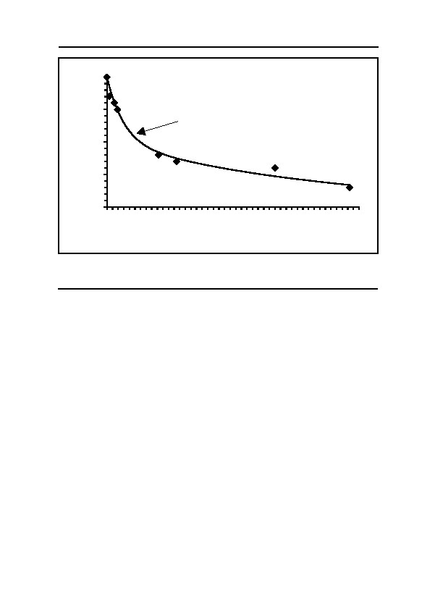
6. FORMATION AND STABILITY OF IRON BLUE
200
c(HCN) = 100 × e-t/0.3 + 100 × e-t/4
150
c(HCN) [mg/m²]
100
50
0
0
0.5
1
1.5
2
2.5
3
3.5
4
4.5
time [days]
Graph 8: Drop in the hydrogen cyanide concentration in old, dry, cement
409
blocks, after 24-hour fumigation with 2.5% HCN by volume (see footnote
in Table 7, S. 187).
This is only a correct description of the process when the concen-
tration of hydrogen cyanide in air in the room remains constant. The
function then reaches its maximum saturation after approximately 20
days. In order to allow for such an approximation, one must reduce the
gassing time involved in such a way as to equal real conditions with
variable concentrations. In case of a series of consecutive gassings and
airings of masonry, a quasi-constant concentration will be reached after
20 cycles as well.
189


7. Zyklon B for the Killing
of Human Beings
7.1. Toxicological Effect of HCN
The effect of hydrogen cyanide is based on the fact that it para-
lyzes the respiration of every individual cell in the body. Oxygen can
no longer be transported from the blood through the cell walls into the
cells.413 As the vital cell functions are thereby starved of oxygen, the
animal or human being suffocates.
Insects and, in particular, insect eggs, are considerably less sensi-
tive to hydrogen cyanide than warm-blooded animals. On the one
hand, this is due to their greater resistance (slower metabolism). On the
other hand, this is due to the fact that lethal concentrations of the gas
must penetrate every crack and fissure, no matter how tiny. Every hem
and seam of all the garment in the property to be fumigated must be
filled with the poison in order to kill, for example, every concealed
louse. Warm-blooded animals, by contrast, are rapidly exposed to high
concentrations of the gas, not only because of their size, but above all
due to their breathing through lungs.
Lethal doses of cyanide can be ingested orally, inhaled, or ab-
sorbed through the skin. Oral poisoning (for example, with potassium
cyanide KCN) is very painful due to muscular convulsions caused by
cell suffocation. Even though victims of poisoning by inhalation of
high concentrations of hydrogen cyanide become more rapidly uncon-
scious than with oral ingestion, painful convulsions caused by muscu-
lar suffocation appear in these cases as well. For this reason, execution
by use of hydrogen cyanide gas, as performed in some U.S. states, has
recently been a topic of much controversy; see chapter 1. A dose of 1
mg cyanide per kg body weight is generally considered lethal. Non-
lethal doses of cyanide are quickly decomposed and excreted by the
body.414
413
Reversible attachment of the cyanide onto the Fe3+ of the cell-specific enzyme of respiration,
cytochromoxidase, thereby interrupting the supply of oxygen to the cells, rendering impossi-
ble the processes of respiration which are essential for the life of the cell.
414
Binding onto sulfur (to form rhodanide).
191

GERMAR RUDOLF · THE RUDOLF REPORT
The bright red coloration of the blood and bruised spots, caused by
over-saturation of the blood with oxygen, since the blood can no longer
give off its oxygen to the cells, are generally considered, among other
things, symptomatic of hydrogen cyanide poisoning in fatal cases.17,415-
417
Testimonies describing a blue or green coloration of the victims are
therefore false.418
Absorption through the skin is especially likely when the skin has
become moist, for example, as a result of sweating at work. It is gener-
ally advised to avoid sweating during the handling of hydrogen cya-
nide. In this regard, concentrations from 6,000 ppm419 (0.6 % by vol-
ume) constitute a health hazard, while 10,000 ppm (1% by volume)
can cause death in just a few minutes.420
Table 8 shows the effects of various concentrations of hydrogen
cyanide, found in the literature.421
Table 8: Effect of various concentrations of hydrogen cyanide
in air upon human beings
2 to 5 ppm:
Perceptible odor
10 ppm:
Maximum permissible work site concentration, acc. to German law
20 to 40 ppm:
Slight symptoms after a few hours
45 to 54 ppm:
Tolerable for ½ to 1 hour without significant or delayed effect
100 to 200 ppm:
Lethal within ½ to 1 hour
300 ppm:
Rapidly fatal
F. Flury and F. Zernik indicate that 200 ppm can be fatal within
five to ten minutes, while 270 ppm are immediately fatal.420 These are
not, of course, the results of experiments on human beings, but rather
extrapolations, in which lower risk thresholds have been determined on
415
W. Wirth, C. Gloxhuber, Toxikologie, Georg Thieme Verlag, Stuttgart 1985, pp. 159f.
416
W. Forth, D. Henschler, W. Rummel, Allgemeine und spezielle Pharmakologie und Toxikolo-
gie, Wissenschaftsverlag, Mannheim 1987, pp. 751f.
417
H.-H. Wellhöner, Allgemeine und systematische Pharmakologie und Toxikologie, Springer
Verlag, Berlin 1988, pp. 445f.
418
This is why Michal Kula’s statement about the color of gassing victims—“I saw then that they
were greenish”, proves that he never saw what he claims he did, see p. 131.
419
ppm stands for ‘parts per million’; here, 1 ppm HCN corresponds to 1 ml HCN per m3
(1,000,000 ml) of air.
420
F. Flury, F. Zernik, Schädliche Gase, Dämpfe, Nebel, Rauch- und Staubarten, Berlin 1931, p.
405; see also M. Daunderer, Klinische Toxikologie, 30th suppl. delivery 10/87, ecomed,
Landsberg 1987, pp. 4ff.; considering the age of the first source as well as the vast amount of
literature quoted in chapter 5.2.2., Pressac’s claim on page 147 of his first book (note 67) that
the lethal dose was not known is completely false. It was also already a known fact in those
days that HCN could be absorbed via the skin.
421
DuPont, Hydrogen Cyanide, Wilmington, Delaware 7/83, pp. 5f.
192
7. ZYKLON B FOR THE KILLING OF HUMAN BEINGS
the grounds of safety. This will be demonstrated in the following. To
kill an average person with a body weight of 100 kg, the victim must
therefore ingest approximately 100 mg hydrogen cyanide (1 mg per
kilo body weight). The respiration of a human being at rest amounts to
approximately 15 liters of air per minute.422 With a hydrogen cyanide
content of 0.02% (approximately 0.24 mg per liter) the victim must
inhale approximately 416 liters of air before ingesting the fatal quantity
of hydrogen cyanide. At 15 liters per minute, this will take about half
an hour. A very strong person can survive even this period of time. By
contrast, a sensitive person weighing 50 kg breathing at an accelerated
rate as a result of physical effort or excitement will inhale 40 liters per
minute, ingesting a fatal dose of 208 liters of air in five minutes. It is
obvious from these calculations, that the data in safety instructions are
always intended to protect smaller, weaker people from accidents un-
der the most unfavorable circumstances. The data given in the litera-
ture as “immediately” or “rapidly fatal” doses are furthermore so in-
definite as to be unable to satisfy our purposes. In addition, they only
refer to the time when a victim has ingested a fatal dose, but not when
death occurs, which can sometimes take a very long time.423
The threshold values will be different if we require even the
strongest individual, out of all conceivable individual victims, to die in
just a few minutes.424 The concentrations necessary for this purpose
will, by its very nature of the thing, be several times higher than the
values indicated above. They could only be determined by a series of
experiments, which is naturally impossible with human beings. The
only data available to us are those gathered during executions with hy-
drogen cyanide carried out in the United States. Leuchter speaks of
concentrations of hydrogen cyanide used in executions in the USA in
the order of magnitude of 3,200 ppm. In these cases, death occurs after
4 to 10 minutes, depending on the physical constitution of the vic-
tim.425 Press reports from the USA indicate that executions lasting
from 10 to 17 minutes are the rule rather than the exception (see chap-
ter 1.1.).
In relation to the quantities used, the US execution gas chamber in
422
Robert F. Schmidt, Biomaschine Mensch, Piper, Munich 1979, p. 124.
423
M. Daunderer, op. cit. (note 420), p. 15.
424
Among toxicologists known as the lethal dose for 100% of all victims, LD100.
425
F. A. Leuchter, Boston, FAX to H. Herrmann dated April, 20, 1992, as well as private
communication from Mr. Leuchter.
193
GERMAR RUDOLF · THE RUDOLF REPORT
Raleigh (North Carolina), for example, is said to use 454 g KCN in
half concentrated sulfuric acid, leading to instant formation of hydro-
gen cyanide vapor, which is even visible for a short period to the wit-
nesses in the witness room and which reaches the victim in seconds.1
As a matter of pure calculation, this generates approximately 180 g of
hydrogen cyanide, corresponding to 150 liters of gas. However, since a
considerable part of it remains dissolved in the half concentrated sulfu-
ric acid (approximately 50%, see chapter 8.3.3.4.), we assume in the
following that approximately 90 g or 75 liters hydrogen cyanide are
released as gas. In North Carolina, this gas arises immediately beneath
the victim, so that the victim must be exposed, immediately after the
beginning of the execution process, to a concentration which probably
exceeds 10% by volume for a short period, but then falls steadily as a
result of diffusion of the hydrogen cyanide throughout the chamber.426
At a normal respiration volume of approximately 15 to 20 liter per
minute and assuming an average concentration during the execution of
only 0.75% by volume, approximately 1.35 to 1.8 grams of HCN will
be ingested in 10 minutes (150-200 liters of inhaled air), which corre-
sponds to ten to twenty times the fatal dose. In the following calcula-
tions, we will assume a ten-fold overdose only, in order to kill all the
people in the chamber, with certainty, in ten minutes.
7.2. Evaporation Characteristics of Zyklon B
Zyklon B does not release its poison gas instantaneously, but
rather over an extended period of time. Since this period of time can be
decisive for the evaluation both of eyewitness accounts as well as of
chemical analyses, it will be investigated more thoroughly in this chap-
ter.
R. Irmscher of DEGESCH reported in a paper written in 1942 that,
at that time, the use of cardboard discs and gypsum (Ercco) were the
most commonly used carrier material.427 The gypsum version was
426
Assuming a volume of 10 m3 in the chamber, 75 Liter HCN corresponds to 0.75% by volume,
i.e., somewhat more than double the end values taken by Leuchter.
427
R. Irmscher, “Nochmals: ‘Die Einsatzfähigkeit der Blausäure bei tiefen Temperaturen’”,
Zeitschrift für hygienische Zoologie und Schädlingsbekämpfung, 1942, pp. 35f.; on the history
of the development of Zyklon B, see Wolfgang Lambrecht, “Zyklon B—eine Ergänzung”,
VffG 1(1) (1997), pp. 2-5 (online: www.vho.org/VffG/1997/1/Lambrecht1.html) as well as W.
Lambrecht, O. Karl, op. cit. (note 105).
194
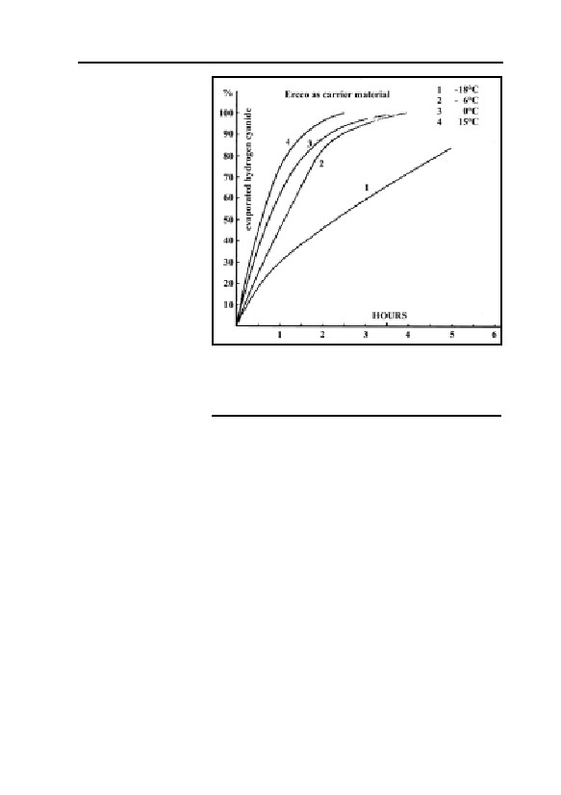
7. ZYKLON B FOR THE KILLING OF HUMAN BEINGS
used—even accord-
ing to eyewitness
testimony—in the
concentration
camps.
The evapora-
tion characteristics
of this product at
various
tempera-
tures, low relative
humidity of the air,
and a fine distribu-
tion of the carrier
material are repro-
duced in Graph 9 as
given by Irmscher.
Graph 9: Evaporation rate of hydrogen cyanide
The evaporation is
from the Ercco carrier material (gypsum with some
“seriously delayed”
starch) at various temperatures and fine
at high atmospheric
distribution, according to R. Irmscher/DEGESCH
humidity, because
1942.427
the evaporating hy-
drogen cyanide withdraws considerable quantities of energy from the
liquid HCN, the carrier material, and the ambient air. As a conse-
quence, the temperature of the product and the ambient air drops. If the
temperature of the air reaches the dew point, atmospheric humidity
condenses out of the air onto the carrier material, which binds the hy-
drogen cyanide and slows down the evaporation process.
For later references, we want to keep in mind that, at 15°C and in
the presence of lower atmospheric humidity, approximately 10% of the
hydrogen cyanide used at Auschwitz have left the carrier material dur-
ing the first five minutes, and approximately 50% after half an hour. In
cool cellar areas with a relative humidity of approximately 100%, the
evaporation times would have been “seriously delayed”.
The question of how Zyklon B would have behaved if spread on
the floor in a room filled with human beings, is somewhat more diffi-
cult. The radiant heat of the bodies would have a slightly accelerating
effect upon the evaporation by increasing the temperature in the vicin-
ity of the floor. Further acceleration of evaporation may occur due to a
possible reduction in size of the carrier granules as a result of being
195
GERMAR RUDOLF · THE RUDOLF REPORT
trampled upon or crushed by falling human bodies, as well as direct
bodily contact.
The relative atmospheric humidity in the cellars of crematoria II
and III, which must certainly have approached 100%, would have “se-
riously delayed” evaporation,428 as well as the possible fluid secretions
caused by panic on the part of victims lying on the floor, which could
very well have occurred as soon as the door was closed, that is, prior to
release of the Zyklon B. Under such conditions, a serious delay in the
discharge of the hydrogen cyanide from the carrier material would
have to be anticipated.
If assuming that Zyklon B introduction devices were installed in
some of the Auschwitz ‘gas chambers’ as attested to by Michal
Kula,429 such a device would have had the following effects: a) the
Zyklon B granules would not have been spread out, but rather would
have been kept together by the inner wire mesh, reducing the evapora-
tion rate considerably; b) all three wire mesh columns would have
drastically reduced any air convection within them, reducing both
evaporation rate as well as the speed with which the gas spreads out
into the chamber; c) due to high humidity in the air and the lack of air
convection, moisture would have condensed intensively on the Zyklon
B carrier, reducing the evaporation rate of HCN “seriously.”
The present study regarding homicidal mass gassings will be
based on the conservative assumption that the Zyklon B would at best
have behave in the manner described by Irmscher at 15°C (see above).
7.3. The Gassing of Human Beings
7.3.1. Eyewitness Testimonies
7.3.1.1. Boundary Conditions
This chapter will examine a few related eyewitness testimonies for
a determination of the chemical, physical, and technical boundary con-
ditions of the alleged homicidal gassings. A complete and detailed
analysis of the many eyewitness testimonies in the individual trials and
428
Unheated cellar rooms by their very nature, have very high relative atmospheric humidity. As
a result of the large numbers of human beings crammed into the cellar, the atmospheric hu-
midity would certainly approach 100%, resulting in the condensation of water on cold objects.
429
See chapter 5.4.1.2.8., p. 130, for this.
196

7. ZYKLON B FOR THE KILLING OF HUMAN BEINGS
in the literature would be too voluminous to include here.430 The fol-
lowing survey is therefore not complete.
For a clarification of the evidence problems, an extract from the
judgment of the Frankfurt Auschwitz Trial may be quoted here:83
“The court lacked almost all possibilities of discovery available in a
normal murder trial to create a true picture of the actual event at the
time of the murder. It lacked the bodies of the victims, autopsy records,
expert reports on the cause of death and the time of death; it lacked any
trace of the murderers, murder weapons, etc. An examination of the eye-
witness testimony was only possible in rare cases. Where the slightest
doubt existed or the possibility of a confusion could not be excluded with
certainty, the court did not evaluate the testimony of witnesses […]
The general findings […] are based on […] the credible testimony
of witnesses […] Böck, in addition to the written notes of the first camp
commandant Höß.”
In the opinion of the court, many of the witness testimonies pos-
sessed insufficient credibility. But it nevertheless succeeded in obtain-
ing testimonies from a few allegedly credible witnesses that sounded
sufficiently credible to the court.
Before we analyze some of these testimonies more closely, a few
remarks are necessary about the circumstances and the atmosphere in
which these testimonies and confessions of alleged victims and perpe-
trators came about in the first couple of years after the end of World
War II. It was in those years that the story of the conveyor-belt like
extermination of human beings in Auschwitz and elsewhere was ele-
vated to ‘common knowledge.’ Challenging this story led to a severe
increase in legal penalty for any defendant, as it still does to this day in
many countries in Europe.
According to reports by Bernard Clarke, who arrested Höß at that
time, Höß was tortured after his arrest.431 In his autobiography, Höß
also reports this and mentioned similar procedures during his Polish
430
See, in this regard, the excellent analysis of J. Graf, Auschwitz. Tätergeständnisse und Augen-
zeugen, op. cit. (note 43).
431
R. Butler, Legions of Death, Arrows Books Ltd., London 1986, pp. 236f.; see: R. Faurisson,
“Comment les Britanniques ont obtenu les aveux de Rudolf Hoess”, Annales d’Histoire Révi-
sionniste 1 (1987) pp. 137-152 (online: aaargh.vho.org/fran/archFaur/1986-
1990/RF8703xx1.html); Engl.: “How the British obtained the confessions of Rudolf Hoess”,
JHR, 7(4) (1986), pp. 389 ff. (online: www.vho.org/GB/Journals/JHR/7/4/Faurisson389-
403.html); D. Irving, Nuremberg. The Last Battle, Focal Point, London 1996, pp. 241-246.
197

GERMAR RUDOLF · THE RUDOLF REPORT
imprisonment.295 According to a report by a US Senator drawn up at
that time, mistreatment of German prisoners by Allied personnel was a
frequent occurrence:432
– Burning of the skin;
– Beds of the nails destroyed by ramming matches under the nails;
– Torn-out fingernails;
– Broken teeth;
– Broken jaws;
– Crushed testicles;
– All kinds of wounding by beating with truncheons, brass knuckles,
and kicks;
– Confinement while naked in cold, damp, and dark rooms;
– Imprisonment for days in hot rooms without water;
– Mock trials;
– Mock judgments;
– Mock executions;
– Mock priests, and many other methods.
A few voices were raised at that time in the USA clearly stating
that the Nuremberg Tribunal was a case of revenge, not justice.433
These voices spoke of:
– Forced testimony under the threat of punishment;
– Compelled production of all documents to the prosecution;
– Refusal to provide documents or examination of documents for
the defense;
– Travel and currency prohibitions against the defense.
A glance at the London Agreement, which established the legal
framework for the Nuremberg Trials, reveals two remarkable articles,
which are clearly incompatible with the procedures of a state under the
432
Reference is made here to the mock trials held at Dachau by the Americans; see the speech by
Senator J. McCarthy, sent to Dachau as an observer on behalf of the U.S. Senate, Congres-
sional Record-Senate No. 134, Sept. 26, 1949, pp. 10397ff., reproduced in full in R. Tiemann,
Der Malmedy-Prozeß, Munin, Osnabrück 1990, pp. 269ff.; see also F. Oscar, Über Galgen
wächst kein Gras, Erasmus-Verlag, Braunschweig 1950, pp. 38ff.; R. Aschenauer, Macht
gegen Recht, Arbeitsgemeinschaft für Recht und Wirtschaft, Munich 1952, pp. 13ff.; Freda
Utley, Kostspielige Rache, H.H. Nölke-Verlag, Hamburg 71952, esp. pp. 216ff.; Engl.: Freda
Utley, The High Cost of Vengeance, Regnery, Chicago 1949.
433
See, in this regard in particular, the article in: New York Times, Feb. 23, 25, 29; March 6; July
30; Oct. 7, 1948; Jan. 7, March 2, 5; May 5, 1949; Chicago Daily Tribune, Feb. 23-26, 28, 29,
1948; March 12; Sept. 13, 1949; Our Sunday Visitor, USA, June 14, 1959, 15; Daily News,
Washington, Jan. 9, 1949; Sunday Pictorial, Great Britain, Jan. 23, 1949.
198

7. ZYKLON B FOR THE KILLING OF HUMAN BEINGS
rule of law. Article 19 states:434
“The Tribunal shall not be bound by technical rules of evidence. It
shall adopt and apply to the greatest possible extent expeditious and non-
technical procedure, and shall admit any evidence which it deems to
have probative value.”
while Article 21 states:
“The Tribunal shall not require proof of facts of common knowl-
edge but shall take judicial notice thereof [...]”
For a correct evaluation of Holocaust testimony of the witnesses
and the confessions of the defendants, it is essential to pay attention to
the boundary conditions under which the so-called NSG trials were
held435 and continue to be held.436
7.3.1.2. Eyewitness Fantasies
What is the credibility of the eyewitness testimonies as to content?
Reference should be made at this point to a few detailed works on this
problem.437 The following is a closer examination of three of the more
frequently quoted eyewitnesses: Rudolf Höß, former camp comman-
dant at Auschwitz, Richard Böck, a camp SS man of subordinate rank,
as well as Henryk Tauber, former inmate and member of the “Sonder-
kommando” in crematorium II in Birkenau.
The Höß statements may be consulted in the Broszat edition and
read as follows:295
“Maintaining the fire at the ditches, pouring the collected fat [over
the burning bodies …] They ate and smoked while dragging corpses
[…]” (p. 126)
“The bodies were doused first with oil residues, and later with
methanol […] He also attempted to destroy the bodies with explo-
sives,[…]” (p. 157ff.)
434
Reprinted in its entirety in T. Taylor, The Anatomy of the Nuremberg Trials, Little, Boston
1992, pp. 645ff.; probably the best analysis of the trial itself was written by Alexander von
Knieriem, Nürnberg. Rechtliche und menschliche Probleme, Klett, Stuttgart 1953.
435
NSG = National-Sozialistische Gewaltverbrechen; National Socialist violent crimes.
436
See, in this regard, Manfred Köhler (alias G. Rudolf), “The Value of Testimony and Confes-
sions Concerning the Holocaust”, in: E. Gauss (ed.), op. cit. (note 22), pp. 85-131 (online:
www.vho.org/GB/Books/dth/fndvalue.html).
437
E. Kern, Meineid gegen Deutschland, Schütz, Pr. Oldendorf, 21971; E. Gauss, Vorlesungen…,
op. cit. (note 43); Jürgen Graf, Auschwitz… , op. cit. (note 43); also: M. Köhler, op. cit. (note
436).
199
GERMAR RUDOLF · THE RUDOLF REPORT
“Half an hour after the introduction of the gas, the door was opened
and the ventilation installation was turned on. Removal of the bodies be-
gan immediately […]” (p. 166.)
and elsewhere:438
“[…]
Q
But was not it [sic] quite dangerous work for these inmates to go into
these chambers and work among the bodies and among the gas
fumes?
A
No.
Q
Did they carry gas masks?
A
They had some, but they did not need them, as nothing ever happened.
[…]”
Anyone who has ever grilled meat knows that fat cannot be
scooped up from burning flesh. Fat ignites at approximately 184°C.439
It is therefore the first thing that burns on a corpse located in a fire.
Hence, it is impossible to collect the easily combustible fat during the
incineration of a corpse. After all, the bodies were burnt—not grilled.
The incineration of corpses in the open air with combustible fluids
is impracticable because fluids have the property of flowing down or
away and/or evaporating. When corpses, which consist of more than
60% water, are burnt, this must take place with the expenditure of quite
large quantities of fuel and great heat. In particular, open oil or meth-
ane combustion would be insufficient.
The alleged attempt to destroy bodies by means of explosives re-
quires no further comment. In reading such testimonies, one must in-
evitably wonder as to Höß’s mental condition in writing them, as well
as that of anyone who takes such claims seriously. Unfortunately, such
testimonies are the rule rather than the exception.440
Entering the ‘gas chamber’ without a protective filter, eating and
smoking in the ‘gas chamber’, as well as the commencement of the
corpse dragging operation immediately after the opening of the doors,
would only be conceivable if there were no longer any dangerous
438
Henry Friedländer, The Holocaust, Vol. 12: “The ‘finale solution’ in the extermination camps
and the aftermath”, Garland, New York 1982, p. 113, Testimony of R. Höß, taken at Nurem-
berg, April 2, 1946.
439
J.H. Perry, Chemical Engineer’s Handbook, Wilmington Delaware 1949, p. 1584.
440
For a more detailed study in this regard, see Arnulf Neumaier, “The Treblinka-Holocaust”, in
E. Gauss (ed.), op. cit. (note 22), pp. 467-495 (online:
www.vho.org/GB/Books/dth/fndtreb.html).
200
7. ZYKLON B FOR THE KILLING OF HUMAN BEINGS
quantity of gas in the chamber. The question of whether this was pos-
sible will be the subject of chapter 7.3.2.2.
It is interesting to note that M. Broszat deleted the last pages of
Rudolf Höß’s testimony from his edition, since they contain “com-
pletely erroneous data on the numerical strength of these Jews”, as
Broszat himself stated in a footnote. In these pages, Höß speaks of
three million Jews in Hungary, four million in Romania, two million in
Bulgaria. The actual figures were lower by a factor of approximately
ten.441 In addition, the same pages contain the following, which is also
incredible:442
“Although well-cared for and plentifully provided with bonus pay-
ments, one often saw them [the Jewish Sonderkommandos] dragging
corpses with one hand, and holding and gnawing on something to eat
with the other hand.
Even during the horrid work of digging up and burning the mass
graves, they did not allow themselves to be disturbed while eating. Even
the burning of their closest relatives could not shake them. […]”
This is really a bit hard to digest.
Another commonly quoted witness is Henryk Tauber. Tauber was,
according to his own testimony, a member of the inmate Sonderkom-
mando of crematorium II during the war. J.-C. Pressac writes that this
eyewitness testimony is the best in relation to the crematoria, which he
considers to be 95% reliable. This testimony contains the following:443
“During the incineration of such [not emaciated] corpses, we used
the coke only to light the fire of the furnace initially, for fatty corpses
burned of their own accord thanks to the combustion of the body fat. On
occasion, when coke was in short supply, we would put some straw and
wood in the ash bins under the muffles, and once the fat of the corpse be-
gan to burn the other corpses would catch light themselves. […]
Later on, as cremations succeeded one another, the furnaces burned
441
Intensive statistical studies in this regard were undertaken by W.N. Sanning, op. cit. (note 41);
W. Benz, Dimension des Völkermords, Oldenbourg, Munich 1991; see also G. Rudolf, “Holo-
caust Victims: A Statistical Analysis · W. Benz and W. N. Sanning – A Comparison”, in: E.
Gauss (ed.), op. cit. (note 22), pp. 183-216 (online:
www.vho.org/GB/Books/dth/fndstats.html).
442
J. Bezwinska, KL Auschwitz in den Augen der SS, Verlag des Staatlichen Auschwitz-
Museums, Auschwitz 1973, pp. 135f.
443
Interrogation of Henryk Tauber dated May 25, 1945, annex 18, volume 11 of the Höß trial,
quoted acc. to J.-C. Pressac, op. cit. (note 67), pp. 489f.; this testimony is not untypical; see
also A. Neumaier, op. cit. (note 440).
201

GERMAR RUDOLF · THE RUDOLF REPORT
thanks to the embers produced by the combustion of the corpses. So, dur-
ing the incineration of fat bodies, the fires were generally extinguished.
[…]
Another time, the SS chased a prisoner who was not working fast
enough into a pit near the crematorium that was full of boiling human
fat. At that time [summer 1944], the corpses were incinerated in open-air
pits, from which the fat flowed into a separate reservoir, dug in the
ground. This fat was poured over the corpses to accelerate their combus-
tion. […]”
Tauber’s claims as to self-igniting, self-combustible corpses are
completely absurd, and in contradiction to all the laws of physical and
technical sciences.444 He also confuses grilling with burning with rela-
tion to the allegedly boiling fat from the corpses. What is more, fat
cannot boil at all. It simply begins to ignite at temperatures of ap-
proximately 180-190°C.
Tauber also proves himself a liar in the technical details related by
him. The combustion gases in a crematorium oven stream from the
combustion chamber445 through the cremation chamber containing the
corpse (muffle), through the ash chamber into the flue, which conducts
the exhaust gases to the chimney.446 If a fire had been ignited in the ash
chamber to burn the bodies located above, this would have reversed the
flow of gas: fresh air would have been sucked in through the chimney,
while the exhaust gases would have flowed through the muffle into the
combustion chamber, from which they would have found their way out
into the oven room. Starting the fire in the ash chamber, as described
by Tauber, would have been disastrous.
On top of this, Tauber also claims that the Sonderkommandos
shoved extraordinarily many corpses into each oven (up to eight) when
they heard Allied planes approaching. Tauber claims that by so doing,
huge flames would have come out of the crematorium’s chimney,
which they hoped would make the Allied bomber pilots aware of them.
But as is common knowledge and has been pointed out many times, no
444
On the energy requirements in general and in the crematoria of Auschwitz in particular, see C.
Mattogno and F. Deana, “The Crematoria Ovens of Auschwitz and Birkenau”, in: E. Gauss
(ed.), op. cit. (note 22), pp. 373-412 (online: www.vho.org/GB/Books/dth/fndcrema.html).
445
This is the so-called coke gas generator, where coke is burned with reduced oxygen supply,
producing a combustible mixture of CO and H2 (and some CO2 and H2O), which burned in the
muffle under addition of air.
446
J.-C. Pressac, op. cit. (note 67), pp. 93ff., chapter on the design and functioning of cremato-
rium ovens built in the German concentration camps at that time.
202
7. ZYKLON B FOR THE KILLING OF HUMAN BEINGS
flames ever come out of crematorium chimneys. It is also impossible to
push eight corpses in an cremation muffle whose door is just two feet
wide and high.447 And apart from that, before Tauber and his co-
inmates would have been able to push eight corpses into each oven and
get a huge blaze going, any plane they claim to have heard approach-
ing would have long flown far, far away. Such testimonies are, to use
Pressac’s words, nothing but downright lies and pure invention.448
Now to the testimony of the witness Richard Böck as quoted dur-
ing the Frankfurt tribunal:297
“One day, it was during the winter of 1942/43, H. asked me,
whether I wanted to drive with him to a gassing action. […]
The transport train, which had already arrived, stood on the free
stretch of track. […]
They were all loaded, and driven to a former farmhouse. […]
After the entire transport—there must have been approximately
1,000 people—was in the building, the door was closed. Finally, an SS
man came, I believe it was a Rottenführer, to our ambulance and got out
a gas canister. He then went to a ladder with this gas canister. […] At
the same time, I noticed that he had a gas mask on while climbing the
ladder. […] he shook […] the contents of the canister into the opening.
[…] When he had closed the little door again, an indescribable crying
began in the chamber. […] That lasted approximately 8-10 minutes, and
then all was silent. A short time afterwards, the door was opened by in-
mates and one could see a bluish cloud floating over a gigantic pile of
corpses. […] At any rate, I was surprised that the inmate commando
which was assigned to remove the bodies, entered the chamber without
gas masks, although this blue vapor floated over the corpses, from which
I assumed that it was a gas. […]”
In winter of 1942/1943, no crematorium was operable in Birkenau
(the first became operable in spring 1943). For this reason, the alleged
victims of homicidal mass gassings in a farmhouse as attested to by
Böck are supposed to have been cremated in open-air pits close to this
farmhouse.
In view of our previous study of the subject, we can establish:
• According to professional air photo analyses of the decisive loca-
447
On cremation technology, see C. Mattogno and F. Deana, op. cit. (note 444).
448
Ibid., pp. 469ff., on several claims made by the witnesses C.S. Bendel, M. Nyiszli, and H.
Tauber.
203
GERMAR RUDOLF · THE RUDOLF REPORT
tions, there were no large cremation ditches, no fuel stockpile, no
development of smoke or flames.449 Accordingly, the scenario of
destruction is obviously false in this regard.
• One thousand people occupy a surface area of at least 200 m2. Ac-
cording to eyewitness testimonies, the farmhouses had only half
this much surface area, at the most.450
• Chapter 7.1.: Hydrogen cyanide is a colorless, invisible gas.
Therefore, no “blue vapor floating over the corpses” could be
seen. This passage is a sign of pure fantasy, obviously suggested
by the German name of HCN, “Blausäure” (blue acid), which
only relates, however, to the formation of the pigment Iron Blue.
• Chapter 7.2.: Since the events described are alleged to have taken
place in winter, the rapidity of the procedure is incredible, since
Zyklon B only releases gas slowly at frost temperatures.
• The described entry into chambers with a high concentration of
toxic gas without a protective filter is impossible; such a manner
of procedure would obviously sooner or later be fatal.
German public prosecutor Willy Dreßen had the following to say
about Böck’s testimony:451
“Dear Mr. […],
I enclose a copy of the eyewitness testimonies of former members of
the SS on the gassing of inmates at Auschwitz […] for your information.
They are only a selection—there are numerous other such testimonies. In
contrast to yourself, I am of the opinion that these eyewitness testimonies
relating to the fact of the occurrence of gassings of human beings, are
entirely suitable to refute the denial of this fact.
Faithfully, (Dreßen), Public Prosecutor”
And yet again: “Dear Mr. […],
[…] Furthermore, the testimony of B ö c k is only one of numerous
similar statements […]
Faithfully, (Dreßen), Public Prosecutor”
449
See also J.C. Ball, op. cit. (note 43).
450
J.-C. Pressac, op. cit. (note 67), pp. 161ff.
451
Letter from public prosecutor Willy Dreßen, Zentrale Stelle der Landesjustizverwaltung Ba-
den-Württemberg, Ludwigsburg, ref. 110 AR 916/89, July 26, 1989, and Oct. 11, 1989, re-
spectively; see also the book by Ernst Klee, Willy Dreßen, Schöne Zeiten, S. Fischer, Frank-
furt 1988: Engl.: The Good Old Days, Free Press, New York 1991.
204
7. ZYKLON B FOR THE KILLING OF HUMAN BEINGS
Böck’s testimony was one of the few which the Frankfurt tribunal
considered credible after careful examination, that is, the inconsisten-
cies would not be so easily recognized by the layman, in contrast to the
many other testimonies. And yet it is entirely incredible.
Pressac himself becomes very critical in quite a few of his pas-
sages relating to the reliability and credibility of eyewitness testimo-
nies;452 yet it is upon these eyewitness testimonies that all the descrip-
tions of the ‘gas chamber’ killings are based. He lists the untruths, im-
possibilities, and exaggerations of the witnesses and explains how they
presumably materialized. Finally, in an interview, he said:453
“No, no. One cannot write serious history based only upon eyewit-
ness testimonies.”
At the same time, however, he bases all of his remarks on the al-
leged existence of homicidal ‘gas chambers’ exclusively on these eye-
witness testimonies! And elsewhere, he states, with a naiveté which
can hardly be surpassed:454
“Witnesses never lie, but they can be mistaken.”
Pressac seems to be the only person of the establishment who
takes notice of the progress of revisionist research. He knows that tra-
ditional historiography of the Holocaust is reduced to absurdity by the
facts revealed by this research. Consequently, he keeps changing his
attitude when making public statements. The most vehement attack of
the media darling Pressac on the dominating historiography occurred
during an interview published as an appendix to a PhD thesis analyzing
the history of Holocaust revisionism in France. In it, Pressac described
the established historiography of the Holocaust as “rotten” and
stated:455
“Can we alter the course? It is too late. A general correction is fac-
tually and humanely impossible [...]. New documents will unavoidably
turn up and will overthrow the official certainties more and more. The
current view of the world of the [National Socialist] camps, though tri-
452
J.-C. Pressac, op. cit. (note 67), pp. 124-128, 162, 174, 176f., 181, 229, 239, 379f., 459-502.
For additional eyewitness testimonies, see also note 442 and E. Kogon et al., op. cit. (note 42),
pp. 194-239.
453
Focus no. 17/1994, pp. 118, 120.
454
Die Woche, Oct. 7, 1993, p. 8
455
In: Valérie Igounet, Histoire du négationnisme en France, Editions du Seuil, Paris 2000, p.
652. I thank R. Faurisson, who made me aware of this interview.
205
GERMAR RUDOLF · THE RUDOLF REPORT
umphant, is doomed. What of it can be salvaged? Only little.”
In his first and so far most comprehensive book, Pressac is com-
pelled to correct the statements of witnesses in many cases in order to
eliminate errors and, in his opinion, technical impossibilities. But when
so doing, he never reveals the basis upon which he undertakes these
corrections. In actual fact, he merely replaces the capriciousness of
‘eyewitnesses’ with his own. Thus, the numbers of victims per gassing
procedure, as estimated by Pressac, for example, are considerably
lower than those estimated in the eyewitness statements, which often
speak of several thousand victims per gassing operation per day for
crematoria II and III. One thousand people could only have been made
to enter a cellar with a surface area of 210 m2 under the maintenance of
extraordinary discipline accompanied by a readiness to co-operate(!)
on the part of the victims (see chapter 7.3.2.1.1.). The numbers of peo-
ple reported in places by witnesses, on the other hand (2,000 and
more456) could not have been contained by morgue 1. To arrive at the
number of victims of Auschwitz-Birkenau, as spread by sensationalist
media and literature until the late 1980s—four million—one is in fact
compelled to resort to technically impossible figures of ‘gas chamber’
occupancy, as the witnesses do. At the moment, the official estimates
range from approximately 1 to 1½ million victims,457 though in his
second book, Pressac downgraded the ‘gas chamber’ victims to
630,000458 and later even further down to 470,000-550,000,459 and in
an article published in a small German periodical in early 2002, a
German mainstream journalist attempted to reduce the death toll of the
Auschwitz ‘gas chambers’ down to as little as 356,000.460 But as long
as this revolutionary development is not accepted by most scholars, we
will stick to the number of one million ‘gas chamber’ victims for all
further considerations.
456
2,000 according to R. Höß (H. Friedländer, op. cit. (note 438), S. 112), as well as C.S. Bendel,
3,000 according to M. Niyszli, see note 448.
457
On the correction to the number of victims in 1990, see also Werner Rademacher, “Die Wand-
lungen der Totenzahl von Auschwitz”, VffG 3(3) (1999), pp. 256-267 (online:
www.vho.org/VffG/1999/3/Rademacher256-267.html); Robert Faurisson: “Wieviele Tote gab
es in Auschwitz?” VffG 3(3) (1999), pp. 268-272 (online:
www.vho.org/VffG/1999/3/Faurisson268-272.html).
458
J.-C. Pressac, Les crématoires d’Auschwitz, op. cit. (note 90), p. 147.
459
J.-C. Pressac, Die Krematorien von Auschwitz, op. cit. (note 90), p. 202.
460
F. Meyer, op. cit. (note 312). For an overview of the wide range and development of claims
about the Auschwitz death toll, see Robert Faurisson, “How many deaths at Auschwitz?”, The
Revisionist, 1(1) (2003), pp. 17-23 (www.vho.org/tr/2003/Faurisson17-23.html).
206
7. ZYKLON B FOR THE KILLING OF HUMAN BEINGS
The following is a description of the homicidal gassing procedures
for the individual installations, if one were to assume that one million
human beings were actually gassed:
Crematorium I:
Blocking the crematorium environs to third par-
ties; 500-700 victims undressing in open air (what
a spectacle for all other inmates!); entry into ‘gas
chamber’ (morgue) near oven room; on their way
to the ‘gas chamber,’ victims march past piles of
corpses of earlier victims; introduction of Zyklon
B through pillars with utilization of gas masks af-
ter closure of doors; turning on of ventilators (if
available) and opening of doors after death of vic-
tims (approximately five min.); evacuation of
chambers without gas masks; removal and crema-
tion of victims.461 According to Pressac only a few
gassings, with a total of only 10,000 victims.462
Crematoria II/III: Entry of 800 to 1,200 victims into western en-
trance stairway into crematorium II; undressing in
undressing cellar; travel through stairwell into
morgue 1 (‘gas chamber’); introduction of Zyklon
B through pillars with utilization of gas masks;
turning on ventilators after death of victims (ap-
proximately five min.); opening of doors after ap-
proximately 20 minutes; hosing down of corpses,
soiled with blood, vomit, and excrement; removal
of bodies without utilization of gas masks; cutting
of hair and removal of gold teeth while bodies are
still in cellar; transport with lift (payload 1.5 tons)
to ground floor; there, transport through water-
filled channels to ovens; cremation.302 Approxi-
mately 400,000 victims for crematorium II,
350,000 for crematorium III according to Pres-
sac.463
Crematorium IV/V: Undressing of a few hundred victims in open air
(again: what a spectacle for all other inmates!),
461
J.-C. Pressac, op. cit. (note 67), p. 125.
462
Ibid., pp. 131f.
463
Ibid., p. 187.
207

GERMAR RUDOLF · THE RUDOLF REPORT
otherwise in morgue, some of them next to
corpses of last gassing victims awaiting crema-
tion; entry into ‘gas chambers’ past coal room and
doctor’s office; evacuation of the entire building;
introduction of Zyklon B through hatches from a
ladder after closure of door(s); opening of doors
after 15 to 20 minutes; removal of corpses to
morgue or to cremation ditches behind cremato-
rium V by the Sonderkommando, some of them
wearing gas masks, some not. According to Pres-
sac, the number of victims can only be estimated
with
difficulty,
probably
approximately
464
100,000.
A similar scenario applies to farm-
houses I and II (see chapter 5.4.3.).
7.3.1.3. Quantities of Poison Gas
7.3.1.3.1. Overview
Opinions differ as to the concentration of poison gas alleged to
have been used in the presumed executions (see next chapter). The
only indirect source available to us are the alleged execution times re-
ported by the eyewitnesses, which in turn permit a crude estimate of
the concentrations used. These reported execution times all allege a
gassing time of only a few minutes.465
464
Ibid., pp. 384-390.
465
With relation to the killing times, see in, for example: Schwurgericht Hagen, verdict from July
24, 1970, ref. 11 Ks 1/70, p. 97 (5 min.); Final Trial Brief of the Prosecution, quoted acc. to U.
Walendy, Auschwitz im IG-Farben-Prozeß, op. cit. (note 157), pp. 47-50 (3 to 15 minutes in
extreme cases); E. Kogon et al., op. cit. (note 42), ubiquitous (immediately up to 10 min.,
more rarely, up to 20 min.); J. Buszko (ed.), Auschwitz, Nazi Extermination Camp, Interpress
Publishers, Warschau 21985, in cooperation with the Auschwitz State Museum, pp. 114 + 118
(a few minutes); H.G. Adler, H. Langbein, E. Lingens-Reiner (ed.), Auschwitz, Europäische
Verlagsanstalt, Cologne 31984, pp. 66, 80 + 200 (a few minutes, up to 10 minutes); Ham-
burger Institut für Sozialforschung (ed.), Die Auschwitz-Hefte, vol. 1, Beltz Verlag, Weinheim
1987, pp. 261ff. +294 (instantly, up to 10 min.); C. Vaillant-Couturier, in: Der Prozeß gegen
die Hauptkriegsverbrecher vor dem Internationalen Miltärgerichtshof Nürnberg (IMT), vol.
VI, p. 242 (5 to 7 min.); M. Nyiszli in: G. Schoenberner (ed.), Wir haben es gesehen, Fourier,
Wiesbaden 1981, p. 250 (5 min.); C.P. Bendel in: H. Langbein, Menschen in Auschwitz, Eu-
ropaverlag, Vienna 1987, p. 221 (end of screaming of victims after 2 min.); P. Broad in: B.
Naumann, Auschwitz, Athenäum, Frankfurt/Main 1968, p. 217 (4 min.), opening of doors after
10-15 minutes: A. Rückerl, NS-Verbrechen vor Gericht, C.F. Müller, Heidelberg, 21984, pp.
58f.; K. Hölbinger in: H. Langbein, Der Auschwitz-Prozeß, Europäische Verlagsanstalt,
Frankfurt/Main 1965, p. 73 (1 min.): R. Böck, ibid., p. 74 (screaming victims for 10 minutes
following closure of doors, followed by opening of doors, cf. note 297); H. Stark, ibid., p. 439
208

7. ZYKLON B FOR THE KILLING OF HUMAN BEINGS
Assuming an execution time approximately corresponding to those
in US execution gas chambers (ten minutes and more at 3,200 ppm
HCN, see chapter 7.1.), a concentration of at least 3,000 ppm (3.6g/m3)
would have had to have reached even the remotest corner of the cham-
ber after only half this time (five minutes). With a free volume of 430
m3 in morgue 1 of crematoria II and III,466 this corresponds to a quan-
tity of hydrogen cyanide of approximately 1.5 kg released and spread
out after five minutes. Since the carrier material only releases ap-
proximately 10% of its hydrogen cyanide content after five minutes
(see chapter 7.2.), at least ten times that amount would have been re-
quired in order to kill in only a few minutes, i.e., this would mean the
utilization of at least 15 kg of Zyklon B.467 This, of course, only ap-
plies on the condition that the hydrogen cyanide released reached the
victims immediately, which cannot be expected in large, overcrowded
(screaming victims for 10-15 minutes); F. Müller, ibid., p. 463 (8-10 min.); E. Pyš, ibid., p.
748 (ventilators switched on after only a few minutes); K. Lill, ibid., p. 750 (a scream a few
seconds after the introduction of Zyklon B, pall of thick smoke exiting the chimney a few
minutes later); transcript of the expert opinion of Prof. Dr. G. Jagschitz, 3rd-5th hearing days of
criminal proceedings against Gerd Honsik, April 4., April 30, May 4, 1992, ref. 20e Vr 14184
and Hv 5720/90, District Court Vienna, p. 443 (2-3 min); Dokument 3868-PS, IMT volume
33, pp. 275ff., quoted according to L. Rosenthal, “Endlösung der Judenfrage”, Massenmord
oder “Gaskammerlüge”?, Verlag Darmstädter Blätter, Darmstadt 1979 (2 to 15 minutes in
exceptional cases); R. Höß, op. cit. (note 295: 30 minutes for the entire procedure, including
ventilation); Hans Münch, in G. Rudolf, “Auschwitz-Kronzeuge Dr. Hans Münch im Ge-
spräch”, VffG, 1(3) (1997), pp. 139-190 (2 to 5 min. in winter) (online:
www.vho.org/VffG/1997/3/RudMue3.html); Salmen Lewenthal, Hefte von Auschwitz, Son-
derheft 1, Handschriften von Mitgliedern des Sonderkommandos, Verlag Staatliches Museum
Auschwitz, 1972, p. 155 (sudden silence); Dov Paisikovic, in: Léon Poliakov, Auschwitz,
René Julliard, 1964, pp. 159ff. (3-4 minute), Franke-Gricksch Report, in: J.-C. Pressac, op. cit.
(note 67), p. 238 (one minute to kill the victims, another until the doors were opened); Rudolf
Vrba alias Walter Rosenberg, Alfred Wetzler, ref. M 20/153, Yad Vashem (acc. to War Refu-
gee Board, “German Extermination Camps—Auschwitz and Birkenau”, in David S. Wyman
(ed.), America and the Holocaust, volume 12, Garland, New York/London 1990, p. 20 (eve-
ryone in the room was dead after three minutes); Jerzy Tabeau, in: The Extermination Camps
of Auschwitz (Oswiecim) and Birkenau in Upper Silesia (10 minutes, quoted according to En-
rique Aynat, Los protocolos de Auschwitz. i Una fuente historica? Verlag Garcia Hispan, Ali-
cante 1990); André Lettich, Trente-quatre mois dans les Camps de Concentration, Imprimerie
Union Coopérative, Tours, 1946 (a few moments). Janda Weiss, in David E. Hackett, (ed.),
The Buchenwald Report, Beck, Munich 1997, p. 394 (3 min.). If longer killing times appear in
the eyewitness testimonies, they refer, not to crematoria II and III, but, rather, to crematoria
IV/V, bunkers 1-2, or crematorium I in the Main Camp. The killings in crematoria II and III
are therefore alleged to have been committed very quickly.
466
504 m3 empty volume of the cellar minus 75 m3 occupied by 1,000 persons.
467
At least because the initial evaporation of the hydrogen cyanide would have led to an immedi-
ate condensation of the environmental humidity onto the carrier, more or less interrupting the
further evaporation of hydrogen cyanide; see also chapter 7.2.
209
GERMAR RUDOLF · THE RUDOLF REPORT
cellars. It must therefore be considered established that quantities of at
least 20 kg of Zyklon B per gassing (ten 2 kg cans or twenty 1 kg cans)
would probably have had to have been used for the gassing procedures
described.
Let us state that the scenarios described by the witnesses would
require a quick increase in the concentration of hydrogen cyanide eve-
rywhere in the chamber. At the same time, logically, there cannot have
been a simultaneous drop in the hydrogen cyanide in the chamber—
such as through the respiration of the victims. Such a loss in hydrogen
cyanide would have had to have been overcompensated for through an
even more rapid evaporation of fresh hydrogen cyanide, because the
hydrogen cyanide concentration would have had to increase for rapid
executions. After the end of respiration due to increasing numbers of
dead victims, who died in a matter of minutes, this most important
cause of a loss in hydrogen cyanide would have ceased to exist as a
factor. But since Zyklon B continues to give off large amounts of hy-
drogen cyanide for many more minutes, it must be assumed that the
hydrogen cyanide content in such chambers would continue to increase
constantly, and very rapidly, during the first quarter hour at least. Since
deadly concentrations (3,200 ppm) would have had to have been
reached even in the remotest corner of the chamber even after a few
minutes, this means that the hydrogen cyanide concentration inside the
chamber after approximately one quarter hour would have exceeded
10,000 ppm and would have continued to rise thereafter—slowly, of
course, but nevertheless constantly at all times.
To assume that the respiration of the victims locked in the cham-
bers would have been capable of perceptibly reducing the concentra-
tion of hydrogen cyanide in the air is therefore entirely in contradiction
to the eyewitness statements.468 In particular, this would have to as-
sume that the victims, confined in the chamber, could have acted as
quasi-living filters for the greater proportion of the time during which
the Zyklon B was releasing hydrogen cyanide (at least one hour). But
one thousand people locked in a hermetically sealed cellar would have
died in an hour from lack of oxygen alone.
These considerations show that a concentration of hydrogen cya-
468
Such is, for example, the hypothesis brought forth by G. Wellers, op. cit. (note 55), which is
similarly incorrect in its findings, due to the incorrect hypothesis that lower quantities of Zyk-
lon B were used: J. Bailer, op. cit. (note 52); W. Wegner, op. cit. (note 49).
210
7. ZYKLON B FOR THE KILLING OF HUMAN BEINGS
nide in morgue 1 of crematoria II and III during the alleged gassings
would have had an effect on the masonry which would have been at
least as great as that occurring during disinfestation. High rates of hy-
drogen cyanide absorption would have to be expected during these pe-
riods, particularly on the cool and moist masonry of cellars in cremato-
ria II and III. The duration of the gassing period would have depended
above all on the subsequent ventilation, which will be examined below.
7.3.1.3.2. Excursus 1: Poisoning or Suffocation?
Because eyewitness statements about the amount of Zyklon B are
rare, and since humans are more sensitive to HCN than insects (see
chapter 7.1.), some scholars opine that only small amounts of Zyklon
B were used for the alleged mass murders in Auschwitz, for example J.
Bailer,54 W. Wegner,49 and G. Wellers,55 who assume an applied con-
centration of 1 g per m3 (0.083 Vol.%) or less.
The few witnesses statements we have, however, claim that sev-
eral kilograms of Zyklon B were used.469 In his book, Pressac fre-
quently refers to a HCN concentration of 12 g per m3 or 1 vol.% used
for executions.470 He backs this up with many witness accounts, ac-
cording to which four to six 1-kg cans of Zyklon B were allegedly
poured into the ‘gas chambers’ (morgues) of crematorium II and III,
which indeed corresponds to a concentration of 1 vol.%.302
Pressac, on the other hand, assumes that 95 to 98% of the entire
Zyklon B delivered to the camp were used for the original purpose, i.e.,
for delousing clothes and rooms,471 for which he relies on statements
from the Nuremberg tribunal.472 Pressac justifies this with the fact that,
in relation to other concentration camps, where doubtlessly no exter-
469
J. Buszko (ed.), op. cit. (note 465), p. 118: 6 to 12 kg; Léon Poliakov, Harvest of Hate,
Greenwood Press, Westport, Conn., 1971, p. 205: 5-7 kg; an analysis of the eyewitness state-
ments has been undertaken by D. D. Desjardin: “Kenneth Stern’s Critique of The Leuchter
Report: A Critical Analysis”, online: codoh.com/newrevoices/nddd/ndddstern.html. The
analysis does not, however, take account of the slow release of hydrogen cyanide by the car-
rier material. See also Desjardin’s interview with F. Piper, op. cit. (note 164), where Piper
talks about 6 kg per 1,400 victims.
470
J.-C. Pressac, op. cit., p. 18.
471
J.-C. Pressac, op. cit., pp. 15 and 188.
472
Office of Chief of Counsel for War Crimes, British Military Tribunal, trial against B. Tesch et
al., Hamburg March 1-8, 1946, Document No. NI-12 207, quoted acc. to: U. Walendy, op. cit.
(note 157), p. 83. Note: No staff member of the former Zyklon B producers was ever con-
victed, because there was no evidence linking them to a crime: Degussa AG (ed.), Im Zeichen
von Sonne und Mond, Degussa AG, Frankfurt/Main 1993, pp. 148f.
211
GERMAR RUDOLF · THE RUDOLF REPORT
mination took place, the Auschwitz camp did not receive higher
amounts of Zyklon B deliveries, if seen in relation to the number of
inmates and in relation to the material delousing facilities that doubt-
lessly operated there.
The supply figures of the Auschwitz camp can be found in the
protocols of the International Military Tribunal Nuremberg. In total,
they reached some 19,000 kg during the years 1942 and 1943.157 The
total supplied amount during the entire existence of the camp from late
1940 to early 1945 will hardly have exceeded 40 tons. According to
Pressac’s statement that not 2-5% of this was used for killings, 800 to
2,000 kg of the total delivery was used for extermination of humans.
But when dividing up this amount of Zyklon B for one million
people allegedly killed with it, with 1,000 victims per gassing—the
‘gas chambers’ (morgues I) of crematorium II and III could hardly
hold 1,000 persons per execution—only roughly 0.8 to 2 kg HCN was
available for each gassing. With the morgues’ free volume of roughly
430 m3,466 and after all hydrogen cyanide had evaporated from the car-
rier (after more than an hour), 800 to 2,000 g of hydrogen cyanide
would result in a theoretical end concentration of 1.86 to 4.65 g per m3,
which means that the concentration during the first five or ten minutes
was much lower.
If, on the other hand, one million victims were killed according to
the eyewitness statements, i.e., with high concentrations in a few min-
utes, those 1,000 gassing would have required 1,000×20 kg = 20 tons
of Zyklon B, or at least 50% of the entire Zyklon B delivery to the
camp.
This shows an obvious inconsistency in Pressac’s statements. One
cannot have both high concentrations during homicidal gassings and a
low percentage of the entire Zyklon B delivery to Auschwitz used for
these gassings.
Let us now have a closer look at the theory endorsed by J. Bailer,54
W. Wegner,49 and G. Wellers,55 that only a small amount of HCN was
used for the killings. In such a case, the concentration reduction due to
the respiration of the victims is no longer a negligible quantity.
Per capita, the respiration of HCN is the higher, the higher the ap-
plied concentration is. The reason for this is that although the victim
incorporates lethal amounts of hydrogen cyanide in short periods of
time in case of high concentrations, their organism’s reaction is de-
layed. During this delay, the victim incorporates more overdoses of
212
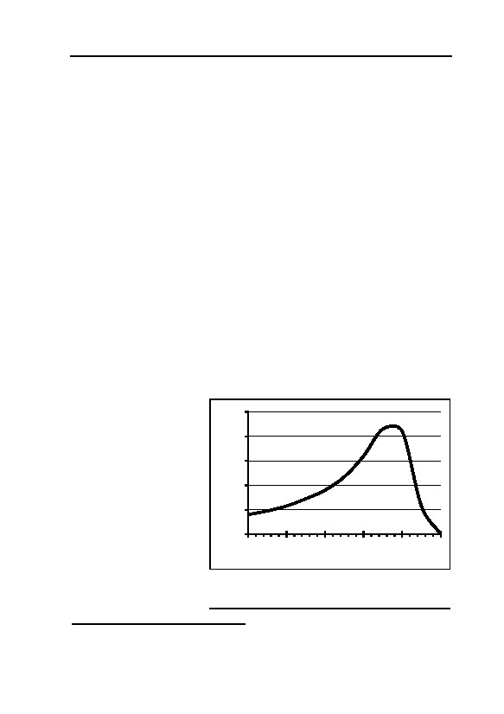
7. ZYKLON B FOR THE KILLING OF HUMAN BEINGS
hydrogen cyanide.
Graph 10 shows the behavior of the breathing volume per minute
of persons dying of suffocation or poisoning (biochemical suffoca-
tions). Respiratory arrest occurs at the end of this period of time (at 5).
Death occurs only several minutes after respiratory arrest. If one as-
sumes a time period of 5 minutes until respiratory arrest, the assumed
breathing volume during each single minute is: 1.: 20 l; 2.: 30 l; 3.: 50
l; 4.: 80 l; 5.: 30 l.422 In total, this yields a breathing volume of ca.
210 l. Furthermore, we assume that the function is independent of the
length of time until respiratory arrest. This means that the double
amount of air is inhaled if the time period would be doubled.
Regarding morgue 1 (‘gas chamber’) of crematorium II, we have
the following data: Volume: 504 m3; volume of 1,000 persons: ca. 75
m3; resulting free air volume: ca. 430 m3. First, the oxygen content in
the room may be studied. In Table 9, the total inhaled volume of 1,000
victims is given in m3 and multiples of the free air volume as a func-
tion of time. The average oxygen content is reduced by 20-30% per
inhalation. This results in the remaining oxygen content in the chamber
as given in the last two columns. Oxygen contents below 6% are le-
thal.473 So, even without adding any toxic gas, we have to reckon with
the victims being suffocated in an airtight chamber already after some
45-60 minutes.
If one increases the
100
number of locked-up
breathing volume [l/min]
80
persons, this process is
accelerated
accord-
60
ingly. However, if there
were Zyklon B holes in
40
the morgues I of cre-
20
matorium II and III
during wartime, con-
0
trary to the results
0
1
2
3
4
5
t [arbitrary unit]
achieved before, these
rooms could not be
Graph 10: Schematic representation of the
breathing volume behavior relative to time in
sealed off in an air tight
case of suffocation/poisoning.
473
Y. Henderson, H.W. Haggard, Noxious Gases, Reinhold Publishing, New York 1943, pp.
144f.; J.S. Haldane, J.G. Priestley, Respiration, Yale University Press, New Haven 1935, pp.
223f.
213
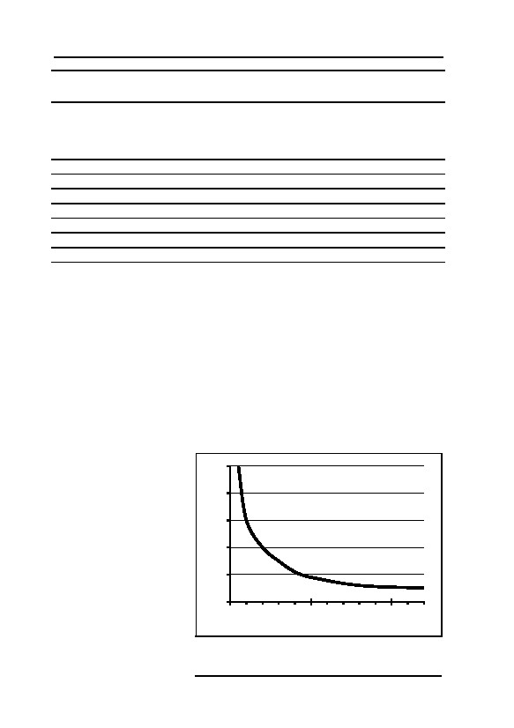
GERMAR RUDOLF · THE RUDOLF REPORT
Table 9: Reduction of O2 content
in air-tight morgue 1 as a function of time
Reduction of Reduction of
Time until res- Inhaled volume
in free volumes
O2
O2
piratory arrest of 1,000 vic-
of the room content (30% content (20%
[min]
tims [m³]
per Inhalation) per inhalation)
5
210
0.5
17.9
18.9
10
420
1
15
16.8
20
840
2
10.5
13.4
30
1,260
3
7.4
10.8
45
1,890
4.5
4.2 (lethal)
7.8
60
2,520
6
5.5 (lethal)
120
5,040
12
manner. Also, small amounts of air would have seeped into the interior
through the ventilation shafts.
Due to the extremely high capability of the lungs to absorb HCN,
the human lung acts like a perfect filter which absorbs all hydrogen
cyanide out of the air. Taking the experiences of US execution ‘gas
chamber’ as a base, death occurs after some 10 minutes at the earliest
in case of an application of ca. 4 g HCN per m3. In assuming a total
inhaled volume of ca. 210 l, this corresponds to an incorporated
amount of HCN of ca. 800 mg, which is a tenfold overdose of the le-
thal dose (80 mg/person). In the following, it is assumed that an execu-
tion lasting several hours, no overdoses of HCN are incorporated. Us-
ing these benchmark
figures, a relation be-
10
tween
incorporated
8
overdose and execution
time results as shown
overdose
6
in Graph 11.
The HCN content
4
in the air of a room
decreases similarly by
2
breathing as by ventila-
0
tion (exponential be-
0
50
100
havior, see chapter
time until resporatory arrest [min]
7.3.2.2.2.). If the vic-
Graph 11: Incorporated amount of HCN as
tims have inhaled the
function of time until respiratory arrest in
entire room volume
overdoses of lethal dose (ca. 80 mg).
214

7. ZYKLON B FOR THE KILLING OF HUMAN BEINGS
Table 10: Amount of hydrogen cyanide as a function of execution
time
(lethal dose = 80 mg/person = 80 g/1,000 persons)
Time until
Inhaled
released
Portion of
Applied HCNinhaled/
respiratory
Over- Amount
amount of
released
Zyklon B HCNapplied
arrest
dose
of
HCN from
HCN [%]
(15°C) [g]
[%]
[min]
HCN [g]
carrier [g]
5
10
800
40
2,030
28,600
3
10
6
480
63
760
5,000
10
20
4
320
86
370
1,230
26
30
3
240
95
252
625
38
45
2
160
99
161
320
50
60
1.5
120
100
120
200
60
120
1
80
100
80
100
80
once, the HCN content will be reduced to ca. 37% of the initial value.
As a function of time passed until respiratory arrest occurs, Table 10
shows, how much HCN was incorporated by the victims in total (col-
umn 3), which portion of the total content of HCN in the air this is
(column 4), how much HCN had been released in total (column 5), and
how much Zyklon B at a carrier temperature of 15°C had to have been
applied to release that much HCN as is required in this period of time.
The last column shows the ratio of the inhaled amount of HCN and the
applied amount. In so doing, it was assumed that the HCN concentra-
tion was available to every victim right from the start. In reality, the
applied amount of hydrogen cyanide had to be a bit higher than as-
sumed here (delay due to release and distribution of hydrogen cya-
nide).
According to testimonies, the execution times until all victims
were dead were shorter than 10 minutes.465 When considering the de-
lays caused by the release of the gas and its distribution, as well as the
fact that death occurs only several minutes after respiratory arrest, the
first two lines of Table 10, corresponding to execution times of ca. 10
and 15 minutes, respectively, are at the upper limit of witness accounts.
This means that an execution within a few moments or minutes would
have required enormous amounts of Zyklon B. Such witness accounts
are therefore unrealistic. Furthermore, it must be assumed that, with
the execution times attested to, only a fraction of the applied (<10%)
and at the execution time released amount of hydrogen cyanide
(<60%) actually could have been incorporated by the victims. The rest
215
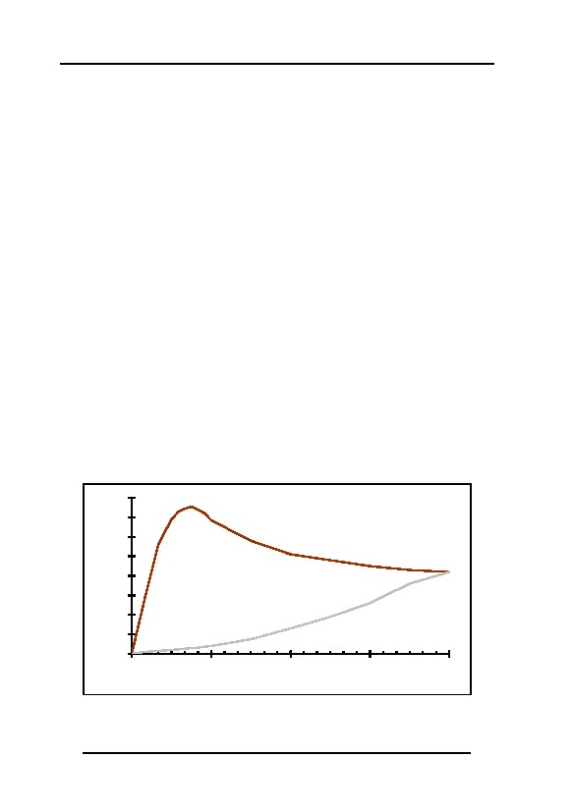
GERMAR RUDOLF · THE RUDOLF REPORT
was available to react with the walls, among other things. Therefore,
one has to reckon with high adsorption rates of hydrogen cyanide es-
pecially at the cool and wet walls of the cellars of crematorium II and
III, contrary to Weller’s hypothesis, according to which this is not sup-
posed to happen.55 According to his opinion, the little amounts of hy-
drogen cyanide applied were supposedly inhaled entirely. This contra-
dicts the witness accounts of the quick ‘gas chamber’ death which re-
quired large amounts of hydrogen cyanide.
Finally, the application of small amounts of hydrogen cyanide of
an end concentration of only 1g/m³, i.e., the use of only some 400 g
Zyklon B per gassing, would have been senseless, if the facilities were
indeed air-tight, which would have been imperative for their use as a
mass ‘gas chamber’. This is, because the victims would have died in a
similar period of time due to lack of oxygen anyway (cf. Table 9).
7.3.1.3.3. Excursus 2: HCN Loss due to Adsorption
It is worth taking a look into the HCN losses caused during disin-
festations due to adsorption on walls and clothes, as well as due to
leaks. Puntigam et al.122 describe the hydrogen cyanide concentration
behavior at different locations of a delousing chamber with and with-
out air circulation (“Kreislaufverfahren”). Puntigam neither gives
measures and loading of the chamber, nor the type of carrier material
and its distribution, nor the temperature. Since the different measuring
0.8
0.7
0.6
with circulating air system
c(HCN) [Vol.-%]
0.5
0.4
0.3
without circulating air system
0.2
0.1
0
0
60
120
180
240
time [min]
Graph 12: Hydrogen cyanide concentration behavior in delousing
chamber with and without circulating air systems, measuring points
always in center of room (intern. correspondence of DEGESCH;
values at various points differed greatly).122
216
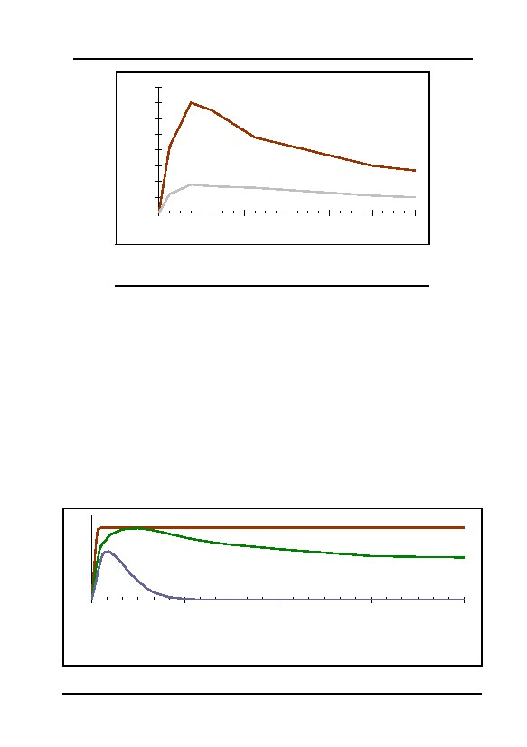
7. ZYKLON B FOR THE KILLING OF HUMAN BEINGS
0.8
0.7
0.6
empty chamber
c(HCN) [Vol.-%]
0.5
0.4
0.3
chamber filled with clothes
0.2
0.1
0
0
4
8
12
16
20
24
time [h]
Graph 13: Hydrogen cyanide concentration behavior in
disinfestation chamber with and without clothes
at room temperature.409
points show different concentrations peaks, this indicates a non-even
distribution of the products in the chamber. For the sake of clarity, only
the concentration behavior in the center of the room is reproduced in
Graph 12.
The loss of hydrogen cyanide as a function of temperature in a dis-
infestation chamber can be seen in Graph 14. The higher losses at
lower temperatures is caused by a higher moisture content in the
gassed material and in the walls of the observed room.123
According to the already quoted publication by Schwarz et al.,409
their measurements were made in the range of room temperature. Al-
though the interesting part of Graph 13 is only poorly resolved, it is
nevertheless clear that under these circumstances the maximum con-
centration is reached as late as 4 to 5 hours after the start. In these
c(HCN) [Vol.-%]
0
60
time [h]
120
180
240
Upper curve: Ideal concentration behavior without Adsorption losses.
Center curve: Normal concentration behavior in a w a r m chamber.
Lower curve: Normal concentration behavior in a c o l d chamber.
Graph 14: Relation between hydrogen cyanide adsorption on clothing and
temperature in a delousing chamber with circulating air system (schematic).123
217
GERMAR RUDOLF · THE RUDOLF REPORT
years, circulating air systems did not yet exists, so that only the natural
air convection was responsible for distributing the gas. Remarkable is
the strong concentration reduction due to adsorption on the load, here
lifeless material to be deloused. Due to the slow increase towards the
maximum concentration, it must be assumed that Puntigam’s values
without circulating air system (Graph 12, lower curve) were achieved
at similar temperatures.
In case of hypothetical homicidal gassings, the sweat produced by
the frightened, crowded people and their HCN absorption through skin
and lungs will cause similar losses, and in case of the underground
morgues of crematorium II and III, additional losses will occur due to
the cold and moist walls.
In order to kill all victims quickly, as attested to by the ‘eyewit-
nesses’, such losses would have to be compensated by introducing
even more HCN than calculated before (chapter 7.3.1.3.1. and
7.3.1.3.3.) in order to quickly reach and maintain high HCN concentra-
tions everywhere in the ‘gas chamber.’
7.3.2. Critique of the Eyewitness Descriptions
7.3.2.1. Theatre of the Absurd
First, a few critical remarks on three topics of eyewitness statements
relating to homicidal mass gassings should be made at this point.
7.3.2.1.1. Necessity of Co-Operation
Just imagine the following scene: 1,000 people of both sexes plus
children enter the undressing room with a surface area of 390 m2
(4,200 ft²). Each one would therefore have a area of only 60 cm × 60
cm (2×2 ft) in which to undress. Experience shows that people do not
pack themselves tightly to the very edge of an enclosed area, unless, of
course, they are quite willing to do so.474 In order to get people to do
this, the procedure must be rehearsed; they must be aware of what is
happening and what steps they must follow—and they must be willing
to co-operate.
Alternatively, few people could be made to undress at a time, but
this assumes that the people who have already undressed are in the ‘gas
474
Just think of street cars or buses, where everyone remains near the door, even though there is
plenty of room at the rear.
218
7. ZYKLON B FOR THE KILLING OF HUMAN BEINGS
chamber’ and waiting patiently for the next arrival of naked inmates.
Once inside the ‘gas chamber’, the same problem occurs again. Here
each individual has only an area of 45 cm × 45 cm (1.5×1.5 ft) in
which to stand. The people must press themselves tightly together; the
first people entering the room must proceed to the end of the room in a
disciplined manner and line up against the wall. The next lot will form
the line directly in front, and so on, until the entire chamber is full,
which must have taken approximately half an hour, even with perfect
choreography.
How did they get these 1,000 people to pack themselves tightly
together, as one can expect it from soldiers who have exercised this for
weeks on a parade ground? The only solution is that this must have
been exercised just as intensively and disciplined as soldiers do it. And
of course, at some point in this alleged scenario, people had to realize
that they were not gathering for a shower, thus resulting in panic and
lack of orderly cooperation with their murderers’ procedures.
7.3.2.1.2. Failure to Separate the Sexes
All eyewitness accounts known to the author are unanimous in
claiming that the victims were not separated by sex before being sent
into the ‘gas chambers’. The eyewitness accounts of the failure to sepa-
rate the sexes are incredible for the following four reasons:
1. This procedure is in contradiction to the procedures followed
during disinfestation, where, according to the same witnesses, the
sexes were carefully separated.475
2. Since there were always two alleged ‘gas chambers’ of each
type available in Birkenau (in crematorium II and III, or IV and V,
or bunker I and II), there is no apparent reason why the victims
could not have been separated by sex.
3. The claims were repeatedly made that the victims were made
to believe that they were going to shower or undergo disinfestation.
These procedures would have necessarily separated the populace on
the basis of sex, if only because of the need for deception.
4. Particularly in the 1940s of last century, large numbers of
people could only have been made to disrobe completely with others
475
See, for example, the pictures taken by the SS before and after delousing new arriving in-
mates, neatly separated by sex, as published in the Serge Klarsfeld (ed.), The Auschwitz Al-
bum. Lilly Jacob’s Album, New York 1980.
219
GERMAR RUDOLF · THE RUDOLF REPORT
of the opposite sex if they had been threatened with force and vio-
lence. But this would have nullified all the other measures of con-
cealment.
7.3.2.1.3. Towel and Soap
According to a few eyewitnesses, the victims were handed towels
and bars of soap to make them believe that they were going to take a
shower.476 (Who, by the way, would go with a towel under a shower?)
This statement becomes incredible given the chaos in the ‘gas cham-
ber’: 1,000 corpses, 1,000 towels, and 1,000 bars of soap, plus vomit,
urine, and blood from 1,000 victims! How was it possible to recycle
those 1,000 bars of soap? How did they clean 1,000 towels? Did they
waste 1,000 towels and 1,000 soap bars for every gassing? It can there-
fore be concluded that such accounts are untrue, and witnesses testify-
ing about it are not trustworthy.477
7.3.2.2. Speed of Ventilation of the ‘Gas Chambers’
7.3.2.2.1. Introduction
An imaginary experiment may perhaps assist in clarifying a
somewhat complicated mathematical relationship: you have a bucket
filled to the brim with sea water in front of you. You now take a sec-
ond bucket filled with fresh water and pour it very carefully into the
first bucket, allowing the excess flow over the edge. Now the question:
when you have emptied the second bucket of fresh water into the first,
containing sea water, what is the composition of the water in the first
bucket? Pure fresh water? Of course not. It will be a mixture of salt
and fresh water.
7.3.2.2.2. Excursus
In mathematics, the equation related to this problem is called a
linear, homogenous differential equation.
In general, the following time behavior applies for the concentra-
tion change of a substance i with time, dci/dt, in case of air exchange,
476
Cf. the testimony of André Lettich, Thêse Fac. Med., Trent-quatre mois dans les camp de
concentration, Ed. Tours, impr. dl’Union cooperative, Paris 1946; quoted acc. to E. Kogon et
al. op. cit. (note 42), p. 210.
477
See also, in this regard, the detailed analysis of the testimony of SS Man Dr. Hans W. Münch:
G. Rudolf, “Auschwitz-Kronzeuge…”, op. cit. (note 465).
220

7. ZYKLON B FOR THE KILLING OF HUMAN BEINGS
provided that the newly added gas (free of i) is ideally mixed with the
old gas:
dci
dt = −α · ci(t)
(8)
i.e., that the concentration change of substance i is proportional to
the
concentration
ci(t)
at
time
t.
The modification of the equation yields:
⌠ 1 dci = ⌠−α · dt
(9)
⌡
⌡ci(t)
After integration over dc and dt, resp., this yields:
ln(ci(t)) = a' − a · t
(10)
or
ci(t) = a"· e−ατ.
(11)
For t = 0, e−ατ = 1 and thus
a" = ci(t=0) = co
(12)
with co as initial concentration (when the ventilation is started).
This leads to:
ci(t) = co· e−ατ.
(13)
From equation (8) results the initial concentration change
dci(t=0)/dt:
dci(t=0)
dt = –a · co
(14)
Hence, we get for the constant a:
dci(t=0)
–a = (dt · c )
(15)
0
In case of a sufficiently low exchange volume dv per time interval
dt, the ratio of total volume V to the exchange volume dv can be intro-
duced as initial concentration change (in case of infinitesimal transition
→
(dt
0)
this
is
mathematically
correct).
1
For example, if the air exchange per time unit is /1,000 of the total, the
1
concentration
change
per
time
unit
is
/1,000,
too.
221

GERMAR RUDOLF · THE RUDOLF REPORT
This turns (15) into
dv
–a = (dt · dV)
(16)
V·dt
After the time t = dv , the complete volume is exchange one time.
Therefore, a is the reciprocal of the air exchange time:
1
a = exchange time.
(17)
After a single air exchange, the concentration is:
ci(t) = co· e−1 ≈ 0.37 · co .
(18)
For the 1/x-value period (time period in which the concentration
drops to 1/x) the following applies accordingly:
ln(1/x)
1
t /x = –a .
(19)
Example: If it is required to lower the value down to 1% of the ini-
tial value (12 g per m3, 1 Vol.%, down to 120 mg hydrogen cyanide per
m3, 0.01 Vol.%), i.e., down to 1/100 of the initial value, this results to:
ln(1/100)
1
t /100 = –a ≈ 4.6 × air exchange time.
(20)
The half-value period is:
0.693
t½ ≈ –a .
(21)
Therefore, the concentration has dropped down to half after
roughly 2/3 of a complete air exchange. This is true, if the fresh and
the old air are mixed perfectly. However, this is not necessarily the
case, as there are two other possible scenarios:
1. Exchange of old gas only (linear, laminar flow along the entire
cross-section of the room): air exchange time roughly identical
with ventilation time: Technically not given in the facilities under
consideration.
2. Exchange of mainly fresh gas (exhaust close to intake), areas of
old gas partly not involved: ventilation time is a multiple of what
222
7. ZYKLON B FOR THE KILLING OF HUMAN BEINGS
is described above. In our case, this is certainly given for the areas
between the corpses, since here almost no mixing of the gases
takes place. Additionally, the unfavorable location of the air in-
takes to the exhausts leads to a partial exchange of fresh gas (air
short circuit). This increases the ventilation time by a factor two to
four or more.
The following chapter will determine, which scenario was given in
the alleged ‘gas chambers’.
7.3.2.2.3. Ventilation of the Morgues of Crematorium II and III
As shown above, when fresh air and stale air mix together, the
concentration of the latter falls to only approximately 37% of the initial
value after one complete air exchange, and to approximately 14% after
a second exchange.
Data are only available on the ventilation installations in cremato-
ria II and III, so that at this point we have to ignore all other ‘gas
chambers’ in this regard.478 In chapter 5.4.1.2.4., the ventilation capac-
ity of morgues 1 of crematoria II and III was shown to have been 4,800
m3 per hour. With a volume of free air in the morgue 1 of 430 m3, the
volume of the room would be exchanged once in approximately 5-6
minutes.466
For morgues 1 of crematoria II and III under consideration at this
point, however, a further problem arises. In particular, the ventilation
intake has been installed only approximately 2 m away from the ventila-
tion outlet in the same wall. The distance to the ventilation outlet on the
opposite wall, however, is 7.3 m, i.e., 3.5 times as far. The result, in
these cellars, is a ‘ventilation short circuit’, especially if we assume that
the victims of the alleged mass extermination are all tightly crammed
together, especially in the middle of the room, which would further
lengthen the fresh air pathway from one side of the cellar to the other.
The air blown into the ventilation intake openings would therefore, for
the most part, be immediately sucked out through the ventilation outlet
openings located nearby.479 Therefore, it must be expected that the actual
ventilation time would be greatly increased in comparison to a perfect
mixing of fresh air and stale air as a result of this poor design.
478
Crematorium I is deliberately left out of the discussion, since the mass murders allegedly
committed there have, in the meantime, after all, been generally questioned.
479
A reasonable regulation would have been to install the ventilation inlets on one side of the
room, and the ventilation outlets on the other side.
223
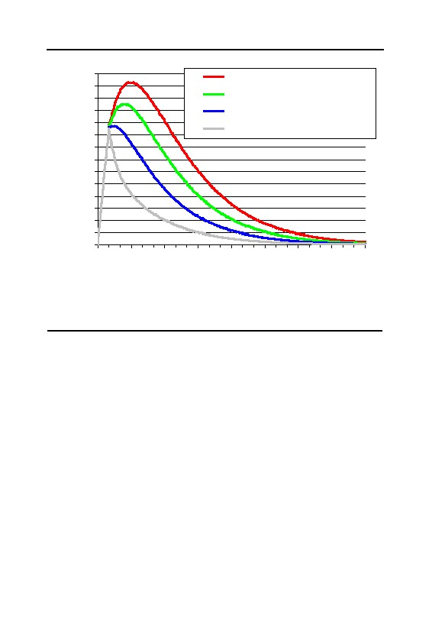
GERMAR RUDOLF · THE RUDOLF REPORT
14
one air exchange each 96 min.
13
one air exchange each 24 min.
12
11
one air exchange each 12 min.
10
c(HCN) [g/m³]
one air exchange each 6 min.
9
8
7
6
5
4
3
2
1
0
0
30
60
90
120
150
180
210
240
t [min]
Graph 15: Simulation of the concentration of hydrogen cyanide in a
hypothetical homicidal ‘gas chamber’ of the type of morgue 1 of
crematorium II in Auschwitz-Birkenau, see text.
In addition, the following problem would also arise: the Zyklon B
granules, which in the meantime would certainly have become moist,
would lie trapped underneath the bodies in at least some places. To
understand how this would effect the ventilation, we have carried out a
simulation calculation based on the following assumption:
1. At 15°C, the moist Zyklon B releases hydrogen cyanide in the dry
environment in the manner described by R. Irmscher (see chapter
7.2.).
2. Reaching an average concentration of hydrogen cyanide through-
out the entire chamber of approximately 5-6 g/m³ after 5 minutes
and/or approximately 10-12 g/m³ after 10 minutes (0.5 or 1 Vol.-
%)—necessary for the rapid killing of all victims according to the
eyewitnesses—requires the use of approximately 20 kg of Zyklon
B (see chapter 7.3.1.3.).
3. The ventilation is turned on after 10 minutes, reducing the concen-
tration of hydrogen cyanide according to the well-known formula
(see chapter 7.3.2.2.2.)
The results may be taken from the Graph 15 for four air exchanges
224
7. ZYKLON B FOR THE KILLING OF HUMAN BEINGS
differing in efficiency: one air exchange every 6, 12, 24 and 96 min-
utes.480 A few average values are listed in Table 11, taken from the in-
dividual scenarios. The value for 5g/m3 indicates, when the HCN con-
centration falls below a value at which it is possible to enter the cham-
ber with a gas mask, but without protective garment and without per-
forming physical work. The value for 2g/m3 should lie in the vicinity
of a value permitting light physical work with a gas mask, but without
protective garment. The value for 0.1g/m3 indicates when the HCN
concentration falls below a concentration permitting entry of the
chamber without a gas mask and without any health hazard. The col-
umn with the heading “∫c(t) dt/10g/m3” finally corresponds to a tenth of
the surface area under the particular curve. The value corresponds to
the duration of a hypothetical gassing of a chamber with a constant
10g/m3 HCN, when the hydrogen cyanide suddenly rises at the begin-
ning of this period of time and then suddenly disappears at the end of
this period. These values can now be used for simulation calculations;
see next chapter.
The 6 min/air exchange applies in the absence of a short circuit of
the air in the chamber. The 12 min/air exchange corresponds to this
necessary correction. Both cases assume an empty chamber. In fact,
the ventilation of the intermediate area between the hundreds of bodies
480
For those who wish to see it written out:
a. Equation for release of HCN from the carrier material (in fractions):
A(t) = e–t/a
– in which t = time after the initial release of HCN in minutes
– in which a = 43.5/minutes (so as to attain the velocity and low atmospheric humidity
at 15°C alleged by Irmscher, note 427)
b. Equation for the reduction of the HCN content through ventilation:
B(t) = e–t/b
– in which b = necessary time for a single air exchange of the room in question.
c. Equation for the actual HCN content:
i. For the first 10 minutes (no ventilation, only release of HCN):
C1(t)=(1-A(t))×D
– in which D = e/f
– in which e = mass of Zyklon B introduced in grams)
– in which f = volume of the chambers = 430 m³ (net volume, without the volume
taken up by the victims)
– e has been selected so as to attain a concentration of approximately 10g/m³ after 10
minutes. For the sake of simplicity, I have used 20 kg = 20,000 g .
ii. Differential equation for the actual HCN content for times after 10 minutes, i.e., with
ventilation, iteratively resolved into one minute steps:
C2(t+1)=C2(t)×e–1/b+(A(t))-A(t+1))×D
– in which (A(t))-A(t+1))×D is the quantity of HCN evaporating from the carrier
with each new minute.
225

GERMAR RUDOLF · THE RUDOLF REPORT
Table 11: Some values of the ventilation efficiency of a
hypothetical homicidal ‘gas chamber’, with Zyklon B remaining in the
chamber, see text. Data in minutes.
Air exchange duration t (5g/m3)
t (2g/m3)
t (0.1g/m3)
∫c(t) dt/10g/m3
6
24
61
192
35
12
56
97
228
63
24
81
123
254
90
96
100
144
278
118
allegedly lying around on the floor, and the Zyklon B trapped under-
neath, will further slow the procedure to a considerable extent, so that,
in relation to a hazard-free entry of the chamber, the truth will rather
lie somewhere between cases two and four or beyond them.
It may be considered established that under no circumstances
could these cellars be entered without a gas mask in less than 3-4 hours
after the beginning of the gassing. Hard physical work with gas masks,
but without protective clothes, i.e., the alleged removal of the bodies,
would not have been possible in less than 11/2 to 2 hours.
If assuming the existence of Zyklon B introduction devices which
allowed the removal of Zyklon after the end of the gassing, the result-
ing data would, of course, look dramatically different, see Table 12.
Under such circumstances, it might have been possible to enter the ‘gas
chamber’ with a gas mask for hard labor already after 30 to 45 min-
utes, and without a gas mask within one to two hours. This would then
lie at least within the range of some less extravagant eyewitness ac-
counts. That explains also, why Pressac and van Pelt insist on the exis-
tence of these introduction columns, contrary to all physical evidence
and despite the lack of any documentary proof and reliable witness
testimony. Without those introduction columns, however, the scenarios
described by eyewitnesses regarding a swift removal of the corpses
from the ‘gas chamber’ after the gassing are simply impossible.
These are, of course, only calculated guesses; if one were to ask
Table 12: Some values of the ventilation efficiency of a
hypothetical homicidal ‘gas chamber’, with Zyklon B removed from
chamber, see text. Data in minutes.
Air exchange duration t (5g/m3)
t (2g/m3)
t (0.1g/m3)
∫c(t) dt/10g/m3
6
14
20
37
11
12
18
29
65
16
24
22
38
92
22
96
26
47
119
28
226
7. ZYKLON B FOR THE KILLING OF HUMAN BEINGS
me whether I would rely upon these values and enter such a ‘gas
chamber’ without a gas mask, I would reply that I preferred to insist
upon the performance of a traditional chemical test beforehand. The
simple reason for this is that all reliable calculation would be rendered
impossible by the Zyklon B trapped beneath the bodies, as well as by
the wet bodies moistened with hydrogen cyanide.
The rooms in crematoria IV and V which purportedly served as
‘gas chambers,’ like farmhouses I and II, allegedly had no ventilation
installation and only slight ventilation possibilities by means of a few
doors. The use of a room without efficient ventilation installations for
mass murder at a time and in a place, where even dissecting rooms,
wash rooms, and laying-out rooms could be and were equipped with
ventilation installations, and where many ventilation fans were supply-
ing lots of fresh air in disinfestation rooms right next door, is so absurd
that any rational human being ought to refuse to take such stories seri-
ously.
7.3.2.3. Simulation Calculations
The following are the results a series of simulation calculations for
the determination of the relative saturation of the masonry with hydro-
gen cyanide based on the assumption that similar concentrations of
hydrogen cyanide are used in all cases. In so doing, a distinction is
made between two sets of circumstances:
1. Disinfestation chamber. The constant concentration assumed for
the calculation amounts to 10 g/m³. A constant concentration cannot,
however, be assumed, particularly for the existing epidemic disinfesta-
tion installations BW 5a und 5b existing in Birkenau, since great quan-
tities of hydrogen cyanide would escape through the non-airtight roof
on the one hand, and since both the masonry and the clothing would
have absorbed considerable quantities of hydrogen cyanide over time
(see chapter 7.3.1.3.3.). We therefore assume two models, as follows:
a) one gassing daily with a constant concentration over 6 hours, and b)
one gassing daily with 12 hours of constant concentration.481 This
481
In order to keep the HCN concentration in those make-shift delousing chambers of BW 5a and
BW 5b constant over 12 hours, this would have required the application of an initial concen-
tration at least twice or thrice as high as 10 g/m², but this would have been impossible due to
lack of sufficient Zyklon B. The quantities of Zyklon B necessary for such use would have
corresponded to 24 to 30 kg per day, or approximately 9 to 11 tons per year, which is roughly
the total quantity delivered to the camp, leaving no HCN for homicidal gassings. Hence, this
227
GERMAR RUDOLF · THE RUDOLF REPORT
would mean that the chamber was used around the clock, i.e., more or
less 24 hours a day, seven days a week, which must be viewed as the
extreme upper value.
2. Homicidal ‘gas chamber.’ Here as well, our calculation assumes
a constant concentration of 10 g/m³. I have selected two different gas-
sing times here: 1/20 day (72 min) and 1/100 of a day (14.4 min). The
first value corresponds to the average constant exposure time of ‘gas
chamber’ walls to HCN if assuming no Zyklon B introduction columns
and a fairly good ventilation after the gassing (see 5th column in Table
11), the second value corresponds to the same scenario, but this time
with Zyklon B columns and a close to perfect ventilation after the gas-
sing (see 5th column in Table 12).
In former editions of this expert report, I have used the equations
determined in chapter 6.7.4. to calculate the relative saturation of ma-
sonry cyclically exposed to hydrogen cyanide. However, after using
several approaches on exactly how to do it, which lead to sometimes
quite different results,482 I decided to refer to this equation only in or-
der to establish the time it takes for masonry to reach its maximum
saturation or a quasi-constant concentration (20 days and 20 daily cy-
cles, respectively). In this edition, the quasi-stationary concentration in
masonry were calculated iteratively using Fick’s law of diffusion.483
One wall model used was considered to be insulated at one end
that corresponds to the situation as given in morgues 1 of crematoria II
and III, which were built of two layers of brick wall with a insulating
layer of tar in between.484 The other wall model had no such insulation,
i.e., it lost HCN on its ‘outside,’ leading to an average concentration
within the entire wall which is roughly half as high as in the insulated
case. This was the situation as it was given in the Zyklon B disinfesta-
tion rooms of BW 5a and BW 5b.
Table 13 shows the results of these calculations. Whereas the av-
scenario is unrealistic for our purposes, because our scenario requires homicidal gassings; see
also chapter 7.3.1.3.
482
The equations determined in chapter 6.7.4. consist of two terms, which can be handled indi-
vidually or both together, and it is not at all clear, which time value is to be used when switch-
ing over from gassing to airing, which all influences the result.
483
I am not going to explain basic statistical laws of diffusion here. This law is so commonly
known that anybody interested in it might look it up in any physics book. Maybe the iterative
steps I used where a bit too big, so there is an error margin in my calculations, but if so, it af-
fects all series, so it should not make a difference regarding my comparisons.
484
See chapter 5.4.1.1. and footnote 183. Though tar is not gas-tight, it still prevents most of the
water and HCN to penetrate it.
228

7. ZYKLON B FOR THE KILLING OF HUMAN BEINGS
Table 13: Quasi-stationary concentrations of HCN in masonry in per-
cent of saturation, as a function of daily exposure time to HCN
time
insulated not insulated, aver-
not insulated, on sur-
age
face
14.4 min
1.6%
0.8%
1.6%
72 min
4.2%
7.8%
7.9%
6h
30.9%
16.2%
30.6%
12 h
56.1%
29.8%
56.2%
erage concentration profiles of the insulated wall model is constant, it
is linearly decreasing in the non-insulated walls from the inside out.
The maximum average values close to the inner, HCN-exposed surface
are quite comparable to the respective constant average concentrations
in the insulated cases.
I have emphasized the values of particular interest: In case of
homicidal gassings in the morgues 1 of crematoria II and III (without
Zyklon B introduction columns), the walls will reach a quasi-stationary
concentration of 8% of their saturation concentration. In case of disin-
festation chambers, the value given for 6 hours of exposure to a con-
stant HCN concentration—corresponding to a round-the-clock opera-
tion—leads to ca. 16% for the average value of the entire wall, and
some 30% for the surface.
The values under consideration here are percent values of the satu-
ration concentration of a wall, i.e., relative values. The cases of the
disinfestation and homicidal ‘gas chamber’ are only correctly compa-
rable when one considers the absolute hydrogen cyanide concentra-
tions in the masonry. If, for example, one considers that, in particular,
the interior walls of the disinfestation chambers intended for personal
effects were warm, dry walls, while the alleged homicidal ‘gas cham-
bers’ in crematoria II and III were cool and very moist, then, with
equal gassing concentrations, one must multiply the relative concentra-
tions of the homicidal ‘gas chamber’ by the factor of the increased hy-
drogen cyanide absorption capability of cool, moist walls. If one as-
sumes the value of 8 determined in this regard on page 187, then the
absolute average hydrogen cyanide content of the homicidal ‘gas
chamber’ would be a value lying around 64% of the saturation concen-
tration of a warm, dry wall in a disinfestation chamber, i.e., four times
higher than the average hydrogen cyanide content of the disinfestation
chamber wall (ca. 16%), and more than twice as high as its maximum
content at the surface (ca. 30%). Even when assuming the existence of
229

GERMAR RUDOLF · THE RUDOLF REPORT
Zyklon B introduction columns and a close to perfect success of the
subsequent ventilation, the moist and cool homicidal ‘gas chamber’
walls would still have accumulated HCN corresponding to 13% of the
average saturation of dry disinfestation walls, which is close to what
would accumulate in those disinfestation walls (16%).
As a result of the high moisture content of those underground
morgues, one can see that even with such short gassing times, the walls
of a homicidal ‘gas chamber’ accumulate a hydrogen cyanide content
which would be quite comparable to that of a disinfestation chamber.
Much less hydrogen cyanide in the quasi-stationary condition of the
hypothetical homicidal ‘gas chambers’ could only be expected, if one
were to assume absurdly short, but technically unfeasible gassing
times, the application of very little Zyklon B, or only very few gas-
sings at all.
7.3.2.4. Excursus: Capacity of Protective Filters
Filter devices to protect against hazardous and/or lethal gases and
vapors are divided a) into types according to the kind of gas to be fil-
tered and b) into classes according to their capacity. Filters of class 3
with a large capacity are stored externally, usually in a container to be
carried at one’s side, since they are too heavy to be carried on the
mask. They are connected to the mask with a hose. Filters of class 2
are screwed into the mask and form the majority of all used filter types.
Filters of class 1 are plug-in filters.
The service life of gas filters depends on:
• Type and concentration of the harmful compound;
• Air demand of the carrier, as a function of the intensity of work
performed and the personal constitution;
Table 14: Maximally admissible concentration of
harmful compound for protection filters485
Gas filter class
Maximally admissible concentration of
harmful compound
1,000 ml m–3 (ppm)
1
0.1 Vol.%;
5,000 ml m–3 (ppm)
2
0.5 Vol.%;
10,000 ml m–3 (ppm)
3
1.0 Vol.%;
Short-term excess up to twice of the table value is permissible
485
Hauptverband der gewerblichen Berufsgenossenschaften, Atemschutz-Merkblatt, Carl
Heymanns Verlag, Cologne Oct. 1981.
230

7. ZYKLON B FOR THE KILLING OF HUMAN BEINGS
• Humidity and temperature of the air.
Needless to say that the Deutsche Institut für Normung (DIN,
German Institute for Standardization) has determined the minimum
values of break-through times of filters under standard testing condi-
tions. These conditions are:
• 20°C;
• 70 % relative humidity of air;
• 30 liters flow-through of air per minute.
In Table 15 the values of different filter types are given with their
respective harmful gas.
Hydrogen cyanide filters used by the allies during that time be-
longed to class 3 with filters to be carried externally. The service life of
such filters at hard physical labor and 0.05 vol.% of hydrogen cyanide
is given with 3 to 5 hours. At a concentration of over 1 vol.%, the gas
quickly breaks through even these devices.487
R. Queisner wrote a report about his experiences with German fil-
ter devices used during the Second World War for delousing proce-
dures with hydrogen cyanide.488 The filter inserts “J” and “G” used at
that time were especially developed for being applied in air containing
hydrogen cyanide and had a service life of 30 min. with a peak load of
Table 15: Minimum break through times for filters
according to DIN 3181 part 1 in minutes486
break through
class 1 test
class 2 test
class 3 test
type test gas
criterion (ppm) concentration concentration concentration
A
CCl4
10
80
40
60
B
Cl2
1
20
20
30
H2S
10
40
40
60
HCN
10*
25
25
35
E
SO2
5
20
20
30
K
NH3
25
50
40
60
* relating to HCN + (CN)2
486
DIN 3181 part 1, draft, Atemfilter für Atemschutzgeräte. Gas- und Kombinationsfilter der
Gasfilter-Typen A,B,E und K. Sicherheitstechnische Anforderungen, Prüfung, Kennzeichnung,
Beuth Verlag GmbH, Berlin, May 1987.
487
War Department, Hydrocyanic-Acid-Gas Mask, US Government Printing Office, Washington
1932; War Department, Technical Manual No. 3-205, US Government Printing Office, Wash-
ington 1941.
488
R. Queisner, “Erfahrungen mit Filtereinsätzen und Gasmasken für hochgiftige Gase zur
Schädlingsbekämpfung”, Zeitschrift für hygienische Zoologie und Schädlingsbekämpfung,
1943, pp. 190-194.
231

GERMAR RUDOLF · THE RUDOLF REPORT
1 vol.%. Since the mask carrier is only exposed to small amounts of
hydrogen cyanide during delousing activities (during distribution of
the product and at the end of the gassing, the hydrogen cyanide con-
centration is rather low), experience showed that it is possible to use
the mask several hours.
According to Schmidt,422 relaxed humans inhale some 14 liters of
air per minute. This can increase up to 50 to 60 liters per minute in
case of heavy physical work, in extreme cases even up to 100 to 120
liters.
If, according to Pressac and in agreement with the witness ac-
counts, a concentration of 1 vol.% was used during the gassings, the
inmates of the special commands (‘Sonderkommandos’), who carried
away the corpses out of the ‘gas chambers’ of the crematorium IV and
V as well as out of the farmhouses I/II, which did not have a ventila-
tion system, had to wear gas masks. Equipped with gas filters of class
2 and doing heavy physical work, they would have been exposed to a
high concentration of toxic gas. Since hydrogen cyanide is particularly
well absorbed through sweat-wet skin, this would certainly have led to
signs of poisoning.
The minimum break-through times of corresponding modern gas
filters of class 2, type B (for hydrogen cyanide) lies at 25 min. for 0.5
vol.% at an air flow-through of 30 liters per min. In case of a suffi-
ciently hard physical labor, this time will be quickly cut to half or a
quarter. Therefore, a modern filter of class 2 can offer only several
minutes of safety under the circumstances under consideration. Breath-
ing would have been seriously hindered by these filters (max. 5.6 mbar
pressure difference at 95 l per min. according to the current DIN),
hence the working speed would have been slow and the demand for
resting times and forced pauses due to gas poisonings would have been
huge. Since they were especially designed for hydrogen cyanide, the
filters of that time had a higher capacity, and consequently their dura-
bility might have been correspondingly higher, which, in turn, in-
creased their service time.
Pressac writes489 that a hydrogen cyanide concentration of 1 vol.%
is not tolerable even with filter mask, and that an exposure time of up
to one minute is granted only in emergency cases, and this without any
heavy physical work!
489
J.-C. Pressac, op. cit., (note 67), p. 16.
232
7. ZYKLON B FOR THE KILLING OF HUMAN BEINGS
Finally, a poisoning through the sweat-wet skin would have been
avoidable under these circumstances only if the workers would have
worked with protective garments in the ‘gas chamber’, which was not
reported by any witness and which would have reduced the working
performance even more. The accounts of some witnesses regarding the
applied concentrations and the quick clearing of the chamber after the
execution without protective garments and masks, on which even Pres-
sac relies, exclude each other and thus can certainly not be correct.
It should not be forgotten here that hydrogen cyanide is a contact
poison. Transporting corpses, on whose skin huge, possible lethal
amounts of hydrogen cyanide are absorbed, had required that the spe-
cial commands dealing with these corpses had to wear protective
clothes. Finally, when considering the applied concentrations attested
to, the guards, like the special commands, would have risked their
health. This is true for all ‘gas chambers’.
7.3.3. Evaluation of Eyewitnesses
It is possible to provide a satisfactory answer to the problem of the
Zyklon B introduction holes in the roofs of morgue 1 (the ‘gas cham-
bers’) of crematoria II and III through the interpretation of air photos
and structural considerations. One must therefore conclude that the
holes and cracks visible today were only put in during or after the de-
struction of the building during the winter of 1944-45. This means that
the poison gas could not have been introduced into the alleged ‘gas
chambers’ in the manner described by the eyewitnesses.
The rapidity of the executions as described by the eyewitnesses, in
their extreme values (“a few moments”, “a few minutes”, “two min-
utes”, etc.) cannot, once again, be attained with Zyklon B under the
given technical conditions, and can only be attained through the use of
very high quantities of Zyklon B.
Entering the ‘gas chambers’ without protective measures, the per-
formance of heavy physical work in the chambers, sometimes with a
naked torso, while eating and smoking, along with testimony relating to
large quantities of toxic gas, reveals the perjury of these eyewitnesses.490
Equally false are the statements relating to the duration of ventila-
tion of morgue 1 (the ‘gas chamber’) of crematoria II and III, since the
490
There are, of course, witnesses who allege that gas masks were worn. Protective garment,
however, is never mentioned.
233
GERMAR RUDOLF · THE RUDOLF REPORT
ventilation would be greatly influenced by various factors (hindrance
of circulation by the bodies, the short circuit in the ventilation path-
way, the release of hydrogen cyanide by Zyklon B). In fact, safe entry
into the ‘gas chamber’ without protective measures can hardly have
been possible in less than three to four hours. Finally, heavy physical
work could only have been conceivable before the expiration of at least
another one and a half hours, even with gas masks.
The eyewitness testimonies relating to the alleged cremation of the
bodies, finally, are riddled with fantasy: cremation in deep ditches;
cremation with liquid fuels; entirely without—or with ridiculously lit-
tle—fuel; the destruction of corpses with explosives; the collection of
human fat. These have nothing in common with technical reality or
possibility, and are largely refuted by the Allied aerial photographic
evidence: no huge ditches, no smoke, no fire, no fuel storage areas.
The illogical and ridiculous— in Pressac’s words—gassing sce-
narios in the ‘gas chambers’ of crematoria IV and V as well as the
comparable ones in farmhouses I and II, would have been extremely
dangerous for the Sonderkommandos (see chapter 5.4.2. and 5.4.3.).
Yet these ‘gas chambers’ must have been planned and built as instru-
ments of mass murder,491 if mass gassings were already underway
elsewhere in the camp during their period of construction. All of this
must compel people accustomed to thinking in terms of technology
and the natural sciences to conclude that the Germans must have de-
cided to choose absolutely the most expensive, laborious, most dan-
gerous and difficult way possible in which to kill people en masse.
It would have been logical, for propaganda purposes, to have de-
scribed the installations such as the disinfestation chambers intended
for personal effects located in buildings 5a and 5b as homicidal ‘gas
chambers’. But this was never attempted, nor are there any eyewitness
testimonies as to such a utilization of these premises. Furthermore, the
doors drawn in the plans of the disinfestation chambers of buildings
5b—as well as the doors located there today—open inwards, which
would have rendered it impossible to remove bodies lying in front of
the doors after the mass gassings. These rooms were, therefore, cer-
tainly never used as homicidal ‘gas chambers’. It is nevertheless possi-
ble that an attempt was made to represent the disinfestation chamber in
491
J.-C. Pressac, op. cit. (note 67), p. 447
234
7. ZYKLON B FOR THE KILLING OF HUMAN BEINGS
building 5b as a (fake) homicidal ‘gas chamber’. The water pipes visi-
ble there hang freely in space inside the room, without any connection;
only a few of them are equipped with shower heads, while they termi-
nate in the ventilation openings in the exterior wall, i.e., they were in-
stalled after the removal of the disinfestation devices (ovens, ventila-
tors, and so on), very probably after the German withdrawal (see Fig.
20). Remarkably, all pipes and fittings have been removed from the
real shower room in the same wing (see Fig. 17). In case this is not an
attempted falsification, it is still possible that this wing was clumsily
converted into a shower room after the end of the war, when Birkenau
was used as prisoner camp for Germans. But this is not likely, since
this building had proper showers already, so why dismantle them first,
and then construct a makeshift shower in a room unsuitable for it?
Brief mention should be made at this point of the widespread no-
tion that the toxic gas streamed into the alleged homicidal ‘gas cham-
ber’ through shower heads, especially as there are even a few such
eyewitness statements. Zyklon B consists of the active ingredient, hy-
drogen cyanide, adsorbed on a solid carrier material (gypsum) and only
released gradually. Since it was neither a liquid nor a gas under pres-
sure, the hydrogen cyanide from this product could never have traveled
through narrow water pipes and shower heads. Possible showers, or
fake shower heads, could therefore only have been used to deceive the
victims; they could never have been used for the introduction of this
poison gas. There is general unanimity as to this point, no matter what
else might be in dispute.
235

GERMAR RUDOLF · THE RUDOLF REPORT
Table 16: Evaluation of eyewitnesses
EYEWITNESS CLAIM
EVALUATION
Death of all victims
If high concentrations of hydrogen cyanide are used, as in
after 0 (instantane-
American execution chambers, death occurs in a period of 10
ously) to 15 minutes. minutes or even later. During the process, the victim is there-
fore exposed to a high overdose concentration of hydrogen
cyanide. Technically this is not possible with Zyklon B, since
the Zyklon B carrier base releases the gas slowly (50% in 30
to 90 minutes, according to the temperature and relative hu-
midity). The distribution of the gas throughout the chamber
from a few sources of hydrogen cyanide only, and the absorp-
tion of the gas by the moist walls and the nearby victims
would further delay the process. Killing all the victims in a
few (less than five) minutes would be impossible. Even during
the use of very large quantities of Zyklon B (much more than
10g per m3).
Opening of the doors The ventilation system, if it existed, did not have the perform-
to the ‘gas chamber’ ance to clear the chambers in the time frame attested to. As-
after the execution
suming that the victims died quickly from the high concentra-
(and sometimes a
tions of toxic gas, then the workers in the Sonderkommando
short ventilation time) would also have been killed by the gas. Working without gas
and immediate com- masks equipped with a filter is totally inconceivable; at high
mencement of trans- concentrations of poison gas, even these are very unsafe.
port of the bodies
Heavy respiratory devices must be worn at concentrations of
without gas masks
over 0.5 Vol.%, which would render the removal of the bodies
and protective cloth- much more difficult. Contamination through the skin must be
ing.
expected during heavy work, involving perspiration, and due
to the high concentrations of hydrogen cyanide on the skin of
the victims. At the same time, such concentrations are suffi-
cient to put a stop to the workers’ ability to work (dizziness,
nausea, etc.). Protective clothing is therefore required.
Blue vapor over the
Hydrogen cyanide is a colorless liquid and/or an invisible gas.
victims.
The name “Blausäure” (blue acid) is due to the reaction of
hydrogen cyanide with iron, forming the iron-blue pigment.
There cannot, therefore, have been any blue vapor.
Bluish/greenish col- Hydrogen cyanide blocks the oxygen supply to the cells. The
oration of the skin of blood can no longer give off oxygen to the cells. Saturation of
the victims.
the blood with oxygen therefore occurs; the skin of the victim
therefore has a reddish, not bluish, appearance, especially on
the mucous membranes and during post-mortem lividity. On
the other hand, if the victims had slowly suffocated, this could
explain bluish coloration of skin.
Attempted destruction Totally unsuited and dangerous.
of the bodies by
means of explosives.
236

7. ZYKLON B FOR THE KILLING OF HUMAN BEINGS
EYEWITNESS CLAIM
EVALUATION
Cremation of bodies
This testimony is quite absurd. Cadavers never burn due to
in crematorium ovens
their own fat content alone. Additional fuel is always required.
without fuel.
Commencement of
The unheated morgues 1 of crematoria II and III, filled with
body transport from
bodies, would have been incompletely ventilated in 15 to 20
the chamber of
minutes using the allegedly built-in ventilation installation.
crematoria II and III
Hydrogen cyanide released for hours from the Zyklon B dis-
20 minutes after com-
tributed among the bodies, release of hydrogen cyanide ab-
mencement of
sorbed by the skin and walls and the absence of air exchanges
ventilation, without
between the bodies would have led to ventilation times
gas masks.
amounting to several hours, before the cellar could have been
entered without gas masks equipped with filters.
Cremation of the
Due to the high water table in Birkenau in 1942-1994, deep
corpses in pits 1.5 to
pits would have quickly filled with water. The maintenance of
3 meters deep.
fires in such pits was not possible.
Cremation of the
The complete cremation of corpses requires a high tempera-
corpses with metha-
ture. Liquid fuels always burn only near and on the corpse, so
nol and/or old oil.
that the heat is lost upwards; in addition, they trickle down
into the subsoil in open air. Methanol evaporates very easily
and therefore has a very low flame temperature. Experiments
with cremations in the open air show that corpses can be car-
bonized on the outside, but not however entirely cremated
with these fuels.
Pouring escaping
This is an entirely absurd testimony. If anything burns in the
human fat over the
flesh at all, it is the fat. Since the bodies would have been
bodies.
lying in the fire, the fat cannot possibly have been collected
outside the fire by means of channels.
Flames shooting out
Coke fires are very short-flamed and develop only little
of heavily smoking
smoke, and this smoke usually burns within the muffle. Even
crematorium chim-
carbonized, burning corpses do not generate any flame and do
neys.
smoke only slightly if the muffle is working inefficiently.
That flames could penetrate through a 10 meter long flue and
a 15 ft high chimney to the outside, is technically impossible.
Even the fire’s reflections disappear in the flue.
237

GERMAR RUDOLF · THE RUDOLF REPORT
7.3.4. An Expert on Cyanide Speaks Out
Nantes, the 2nd Nov. 1997
“Gérard Roubeix
51 Av. de la Coquetterie
to M. Michel Adam
44000 Nantes
c/o ANEC
PO Box 21
44530 St. Gildas-des-Bois
Sir,
Having learned about the odious persecution of which you are a
victim in the name of ‘freedom of expression’, let me express all of my
sympathy and my total solidarity to you.
I have spent 20 years of my career as an engineer in the hydrogen
cyanide industry in the service of the groups Pechiney-Ugine-
Kuhlmann and Charbonnages de France. In particular, I have been
the director of the St. Avold plant, which in 1970, with its production
of 40 tons of cyanides per day, was the most important plant world-
wide; theoretically, this production would have allowed the lethal poi-
soning of 500 million human beings on a single day. This shows how I
am aware of the problems regarding the handling of HCN. Well, I af-
firm that all the ‘testimonies’ I have read or heard of concerning these
gas chambers, in which 2 to 3,000 people were crammed, are nothing
but total fantasy.
I congratulate you for your admirable battle against the hoax. The
truth is on its way.
[signed Roubeix]
P.S: You may use this testimony, if necessary.”
Michel Adam was a teacher of history and geography in the West
of France. At the beginning of July 1997, as a former lady deportee to
the concentration camp of Ravensbrück was giving a conference at his
school telling about her ‘memories,’ he opposed the lady several times
by using solid revisionist arguments. Michel Adam was immediately
suspended and, after one year of troubles of all sorts, he was dismissed
238
7. ZYKLON B FOR THE KILLING OF HUMAN BEINGS
by French Minister for the Arts Claude Allègre on account of the three
following official reasons:
– showing his revisionist views in front of his pupils;
– disturbing a meeting of his pupils with a former deportee;
– showing doubts about the credibility of a deportee’s testimony.
Already in 1998, Gérard Roubeix wrote a similar letter which has
been published elsewhere.492 He died in 2001.
ANEC stands for Association normande pour l'éveil du citoyen,
(Norman Association for the Warning of Citizens), which was an asso-
ciation created by the Normandy teacher Vincent Reynouard, who, just
as Michel Adams before him, lost his job because of his revisionist
views and was sentenced to fines and a three months prison term.493
ANEC published 36 issues of the revisionist periodical Nouvelle Vi-
sion.
492
Annales d’Histoire Révisionniste 7 (1989), pp. 212f.
493
Cf. Vincent Reynouard, “Deutsch-Französische Völker-Freundschaft”, VffG, 4(3&4) (2000),
pp. 410-415 (online: www.vho.org/VffG/2000/3/Reynouard410-415.html)
239
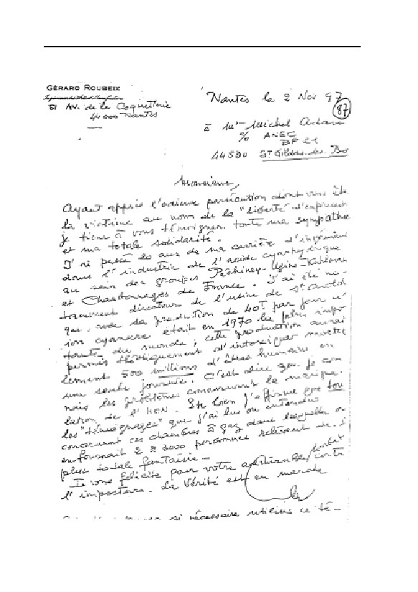
GERMAR RUDOLF · THE RUDOLF REPORT
240
7. ZYKLON B FOR THE KILLING OF HUMAN BEINGS
7.3.5. Why Precisely Zyklon B?
One might naturally wonder why the SS are supposed to have de-
cided to use Zyklon B as an instrument of mass murder. The Soviets, at
any rate, killed countless millions of human beings either simply by
shooting them in the back of the neck or allowing them to die in camps
under miserable conditions. Surely it would have been simpler to leave
the people deported to Auschwitz to their fate; they would have per-
ished from hunger and epidemics within a very short time anyway.
That is how the Americans murdered approximately 1 million German
civilian internees after the end of the Second World War.494 Instead,
the SS at Auschwitz spent almost one billion dollars, in today’s values,
to bring the epidemics raging there under control, incurring huge ex-
penditures on medical facilities, to cure the internees from the typhus
epidemics, which were very often fatal.495 This alone speaks volumes
about the credibility of the conventional wisdom.
The academic question, therefore, of whether or not some other
poison gas would have been better suited for the mass murders instead
of hydrogen cyanide in the form of Zyklon B cannot, in the last analy-
sis, be answered, since there are no scientifically documented experi-
mental values for mass murder by poison gas.
Theoretically, one could, at that time, have chosen between nitro-
gen (N2), carbon dioxide (CO2), carbon monoxide (CO), phosgene
(COCl2), chlorine (Cl2), hydrogen cyanide (HCN), nerve gases such as
Tabun and Sarin, Diesel engine exhaust, internal combustion engine
exhaust, producer gas, coke or city gas, process gas, and, possibly, still
other, entirely different, instruments of mass murder, suitable even un-
der completely different circumstances (shooting in the back of the
neck, hunger, epidemics). But if one really wished to take the trouble
to commit mass killings with poison gas, it is most probable that one
would have used carbon monoxide, which is definitely lethal to human
494
James Bacques, Other Losses, Stoddart, Toronto 1989; Bacque, Crimes and Mercies, Little,
Brown & Co., Toronto 1996.
495
Hans Jürgen Nowak, op. cit. (note 97), pp. 323f.; Manfred Gerner, Michael Gärtner, Hans
Jürgen Nowak, “Die Kosten von Auschwitz” VffG, 6(2) (2002), pp. 146-158; (online:
www.vho.org/VffG/2002/2/GernerGaertnerNowak146-158.html); on the medical care, see the
unpublished studies by the late C. Jordan on the G. Weise case; see also ibid., “The German
Justice System: A Case Study”, in E. Gauss (ed.), op. cit. (note 22), pp. 147-181 (online:
www.vho.org/GB/Books/dth/fndpoljust.html).
241
GERMAR RUDOLF · THE RUDOLF REPORT
beings above 0.1%, for the following reasons:
1. The poison gas CO was available in limitless quantities and in le-
thal concentrations at giveaway prices, substantially cheaper than
Zyklon B, on almost every street corner in the Third Reich:
a) Internal combustion engines easily attain a CO content of 7% by
volume, so that it would have been suitable for mass murder.
Nevertheless only a very small minority of eyewitnesses speak
of the use of internal combustion engines in only one German
concentration camp (Sobibor).496
b) Producer gas generators generate a gaseous mixture with a pro-
portion of CO of up to 35% by volume, using only wood or
coke, air and water. These generators were installed in hundreds
of thousands of vehicles all over German-occupied Europe dur-
ing the Second World War, since it was necessary to convert to
alternate fuels due to the Allied oil blockade. As F.P. Berg has
shown, every member of the German Reich Government was
familiar with these extraordinarily economical and easily oper-
ated installations with their quickly lethal toxic gas, especially
the transport experts, whose duty it was to gradually replace all
Diesel and internal combustion engines with generator gas in-
stallations. These were, in some cases, exactly the same people
who were entrusted with the deportation and allegedly with the
killing of Jews—such as Adolf Eichmann, for example.496 But it
has never been claimed that these installations were used for
purposes of homicide.
c) Toxic city gas with a CO portion of up to 30% by volume was
available in every major city for a ridiculously low price. Con-
sideration would obviously have been given to committing mur-
der with it.
d) Process gas: The German corporate giant I.G. Farbenindustrie
AG had already built a coal gasification/liquidification plant
only a few kilometers away from Auschwitz concentration camp
in the early 1940s. Here, by means of various conversion proc-
esses, coal was converted into chemical end products, from
which oils, fats, fuels, and synthetic rubbers could be processed.
The first step in this process is the generation of process gas,
496
See Friedrich P. Berg, “The Diesel Gas Chambers: Ideal for Torture—Absurd for Murder”,
in: Ernst Gauss (ed.), op. cit. (note 22), pp. 435-465 (online:
www.vho.org/GB/Books/dth/fndieselgc.html).
242
7. ZYKLON B FOR THE KILLING OF HUMAN BEINGS
which has a similar composition to coke gas or city gas. The
I.G. Farbenindustrie AG factory had a concentration camp in its
immediate vicinity by the name of Monowitz, which was con-
nected to the extensive system of more than 30 different
Auschwitz concentration camps more than 30 kilometers in Up-
per Silesia and Western Poland. If the SS had looked for a sim-
pler way to kill millions of Jews, the center of extermination
certainly would have been built in the vicinity of Monowitz,
with a direct process gas pipeline from the I.G. Farbenindustrie
AG factory.
2. It would not have been necessary to order and store CO and pay
attention to the use-by date, as was necessary in the case of Zyk-
lon B; carbon monoxide would have been available at all times, as
soon as the economical installations were completed.
3. The handling of CO would have been considerably simpler for the
executioners. Almost the only thing to pay attention to would have
been the opening and closing of the CO valve. The handling of
Zyklon B, on the other hand, would have demanded a remarkable
number of safety precautions on the part of the executioners. The
wearing of gas masks, and, when possible, additional protective
clothing (gloves), the careful opening of the cans with a suitable
tool, the careful introduction of the carrier through the openings,
the careful disposal of the Zyklon B residues.
4. CO can be introduced simply and quickly through pressure pipes
or through a blower, while Zyklon B, on the other hand, releases
its toxic fumes only slowly.
5. In the case of CO, there would not have been so many problems
with ventilating the air in the mass execution areas as with hydro-
gen cyanide/Zyklon B, since the introduction of CO could be
stopped simply by closing a valve, and because CO does not ad-
here to surfaces and is almost insoluble in water—in extreme con-
trast to hydrogen cyanide.
6. Zyklon B was scarce and expensive, and was needed everywhere
to combat epidemics such as typhus, including in the army and
German-allied armed forces, so that any avoidable squandering of
it for other purposes would have been avoided—even, and espe-
cially, at Auschwitz, where typhus threatened not only the lives of
the inmates, but also the guards and civilians entering the camp or
who lived in the vicinity. In plain English, this means that the ty-
phus epidemic in Auschwitz concentration camp threatened the
extremely important production of the war industries located in
243

GERMAR RUDOLF · THE RUDOLF REPORT
Upper Silesia, the second-greatest industrial region in Germany
after the Ruhr at that time. The struggle against epidemics, for
which Zyklon B was undoubtedly needed, was therefore of the
greatest importance, in larger quantities than the manufacturer,
DEGESCH, was able to deliver at that time.
Naturally, CO would not necessarily speed up the execution pro-
cedure in comparison to hydrogen cyanide, but it would have been
safer, more easily available nearby, less complicated, and cheaper.497
Certainly,
“the bottleneck in the extermination process […would have been]
the incineration of the bodies, not the gassing itself. [An appropriate
equipment provided,] A thousand people could be killed in a matter of
minutes, or an hour or two at most, counting the entire operation from
arrival at the camp to the final ventilation of the gas chamber.
Yet to burn the bodies of those thousand people […would have
taken] quite a long while.”498
As C. Mattogno and F. Deana have shown, the cremation installa-
tions at Auschwitz were never able to cremate the bodies of the dead
from the various epidemics and other unhygienic conditions of
Auschwitz camp which occurred anyway, not to mention the bodies
allegedly occurring as the result of mass murders,444 this is a further
proof that there was never a program of mass homicide at Auschwitz.
497
If for no other reason because, according to the establishment literature, CO was also already
used in connection with the euthanasia action.
498
According to a part of the answer from “Nizkor”
(www2.ca.nizkor.org/features/qar/qar29.html) to question no. 2: “Why did they use this in-
stead of a gas more suitable for mass extermination?”
(www.zundelsite.org/english/debate/debatetoc.html) of a flyer distributed by the Institute for
Historical Review: 66 Questions and Answers on the Holocaust, IHR, Costa Mesa, undated.
244
8. EVALUATION OF CHEMICAL ANALYSES
8. Evaluation of Chemical Analyses
8.1. Test Sample Taking and Description
As far as I am aware, test samples from buildings at Auschwitz
have been analyzed by four persons or groups so far.499
1. Fred A. Leuchter, Consulting Engineers, Boston, MA, on be-
half of the defense of E. Zündel, Toronto. F.A. Leuchter marked the
locations where he took samples from crematoria in maps of these
buildings drawn by himself and reproduced in his expert report. Only
Leuchter’s samples taken from morgue 1 (‘gas chamber’) of cremato-
rium II are reproduced in the sketch below (Fig. 67). There is also a
video establishing Leuchter’s sample taking locations.500 J.-C. Pressac
has subjected the sample taking to criticism.45 Leuchter failed to indi-
cate a more exact specification of the sample material; the designation
is “brick” in all cases. The sample taking was done without regard for
depth. From the traces left by Leuchter in the corresponding places in
the masonry, one must calculate sample taking depths of up to 3 cm
and more.
2. Prof. Dr. Jan Markiewicz, Jan Sehn Institute for Forensic Re-
search, Toxicology Department, Cracow, on behalf of the Auschwitz
State Museum. J. Markiewicz provides more exact data on the sample
taking locations, the type of material, and the depth taken in a sample
taking records. The control samples were taken from a disinfestation
chamber in the Auschwitz main camp, the interior walls of which, ac-
cording to the report, were painted during the war, so that only a pale
blue tint is visible in places. This is not, therefore, unaltered masonry
material; thus, in case the samples were taken from the upper layer of
the wall only, one has to expect lower results in comparison to an un-
treated wall.56,57
3. Dipl.-Chem. Germar Rudolf, Stuttgart, Germany, on behalf of
499
C. Mattogno (Rome) has also taken samples from some of the installations (‘gas chambers’) at
Birkenau and has had them analyzed; the findings concur with those of F.A. Leuchter and G.
Rudolf. C. Mattogno, letter to the author, Rome, May 26, 1992.
500
The video documentation on Leuchter’s investigations at Auschwitz can be ordered from:
Samisdat Publishers Ltd., 206 Carlton Street, Toronto Canada, M5A 2L1 (E-mail: ezun-
del@cts.com).
245
GERMAR RUDOLF · THE RUDOLF REPORT
the defense of the late Major General O. E. Remer. The samples were
taken in the presence of witnesses by hammer and chisel and immedi-
ately sealed in a plastic bag. The subsequent numbering of the bags
was recorded by hand, including the measured sample taking location
and type of sample. Table 19 shows buildings, sample taking locations
and depths, as well as a brief description of the wall material. The ex-
act locations are shown in the sketch of the corresponding buildings in
chapter 5 of this book.
4. John C. Ball, Ball Resource Services Ltd., Delta, BC, Canada.
John C. Ball has not given any details about where exactly he took his
samples, nor what kind of material it was. According to his own de-
scription, at least the samples from the delousing rooms of BW 5a and
BW 5b consist of a mixture of material taken at various places of these
rooms, both inside and outside. Hence, the same might be true for his
other samples. For this reason, we will only briefly list Ball’s analyses
results here without going into too many details about how they are to
be interpreted.
8.2. Analytical Methods
The analyses were performed in each case respectively by:
1. Prof. Dr. J. Roth, Alpha Analytic Laboratories, Ashland, Mas-
sachusetts. For the cyanide analysis, this laboratory used a procedure
carried out analogously to the German standard (see 3.).501 Control
analyses were prepared for some test samples near the detectable
threshold of 1 mg cyanide per kg test material. The results fluctuated
up to 40%.
2. Jan Sehn Institute for Forensic Research, Toxicology Depart-
ment, Cracow, Poland, under Jan Markiewicz. The Polish Scientist
used the micro-diffusion chamber procedure, which does not permit
the detection of Iron Blue.502 The detection threshold for other cya-
nides lies at 10 µg per kg sample material.
3. Fresenius Institute, Taunusstein, Hessen, Germany, with no
501
The iron content was also determined by means of ICP spectrometer. The values lay between
6 and 7.5 g per kg.
502
In this procedure, the sample is to semi-concentrated sulfuric acid for 24 hours. The gases
released are only collected by means of diffusion in a KOH collector.
246
8. EVALUATION OF CHEMICAL ANALYSES
knowledge of the origins of the samples. Proof of the presence of cya-
nide was produced in conformity with DIN 38 405, section D 13. The
detection threshold lies nominally in the range from 0.5 to 0.1 mg per
kg.503 All values below 0.5 mg per kg are uncertain, and are commonly
marked as “not proven”. Control analyses were performed by the Insti-
tut für Umweltanalytik Stuttgart, IUS (Institute for Environmental
Analytics) (Table 20).
4. Unknown. However, the results indicate that the method used
was similar to the one used by Leuchter/Roth and Rudolf/Fresenius.
8.3. Evaluation of Analytical Results
8.3.1. F.A. Leuchter/Alpha Analytic Laboratories
All of Leuchter’s positive findings from the alleged homicidal ‘gas
chamber’ lie in the vicinity of the ‘official’ detection threshold (1 mg
per kg) and must be expected to exhibit very high fluctuations. Control
sample no. 32 is from the disinfestation wing of Building 5a (which
Leuchter calls “disinfestation chamber 1”). The foundations of crema-
toria IV and V are alleged to have been rebuilt from the rubble of other
buildings (see chapter 5.4.2). Thus, the analyses of samples originating
from these walls are nevertheless interesting, due to their positive find-
ings in places.
That the analytical values of samples from areas protected from
environmental influences are just as low as results from exposed loca-
tions, or not detectable at all, led Leuchter to the conclusion that the
environmental influences could not have considerably reduced the
cyanide content of the exposed buildings,504 which would be in accor-
dance with the findings in chapter 6.6. According to Leuchter, low
cyanide traces may have resulted from an isolated fumigation of the
morgues for pest control, since interior disinfestations were carried out
in many camp buildings at that time. The positive result (1.3 mg per
kg) of Sample 28, which Leuchter took from the partition of the former
washroom to the dissecting room of crematorium I, a wall which never
503
Driving out the hydrogen cyanide by boiling the sample for one hour in aqueous HCl in a
slightly reductive medium (SnCl2), Driving out in the continuous stream of air, collection in
the aqueous KOH collector. Finally, photometric or titrimetric testing depending on the con-
centration in each case. Proof of iron was achieved here by the ICP spectrometer.
504
F.A. Leuchter, press release, Boston, 13. February 1990.
247
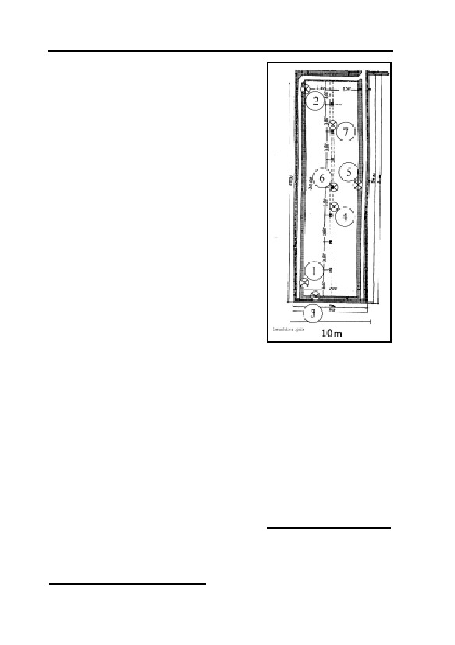
GERMAR RUDOLF · THE RUDOLF REPORT
formed part of the alleged ‘gas chamber’
and moreover was probably newly erected
during the conversion to an air raid shelter,
is remarkable. This result, approximately as
high as the rest of the samples (including
those from the foundation walls of cremato-
rium IV and V, built of unknown material)
may largely be explained by three factors:
1. Cyanide traces of this minimal order of
magnitude may be present anywhere,
which is, however, improbable.
2. This air raid shelter, like all rooms in
Auschwitz-Birkenau, was occasionally
fumigated with Zyklon B for disinfes-
tation purposes.
3. Analytical values in this order of mag-
nitude (near the detectable threshold)
are not reproducible and therefore can-
not be interpreted due to the limited ef-
ficiency of the method. They are
equivalent to zero values. In view of
Fig. 67: Sketch of
the results to be discussed below, this
morgue 1 (‘gas
reason appears the most probable.
chamber’) of
crematorium II in
According to Bailer, the high cyanide
Birkenau with test
content of the control samples taken by
sample taking locations
Leuchter in the disinfestation wing is to be
26
by F.A. Leuchter:
attributed either to an artifact, an error in
• Samples 1,2,3,5 from
the sample taking, or an analytical error. He
Masonry;
understands an artifact to mean that the wall • Sample 4 from the ceil-
of the disinfestation wing was painted with
ing;
blue paint, precisely, an Iron Blue paint, at • Sample 6 from the pil-
an earlier time. Bailer further expresses the
lars;
opinion that no Iron Blue could form in the • Sample 7 from the de-
masonry material due to the alkaline envi-
bris on the ground.
ronment. In addition, the high cyanide con-
tent of 1,050 mg per kg is said to mean that the walls consist 0.1% of
pigment, which in his opinion could not possibly be true.505
505
J. Bailer, op. cit. (note 52); similar to ibid., in B. Bailer-Galanda, et al. (ed.), op. cit. (note 54),
248

8. EVALUATION OF CHEMICAL ANALYSES
Table 17: Cyanide concentrations in the masonry of
‘gas chambers’/disinfestation chambers
According to F.A. Leuchter/Alpha Analytic Laboratories, Ashland,
Massachusetts, USA
CN-[mg per kg]
Test sample no. Sample taking location
1-7
Crematorium II, morgue 1
0.0
8
Crematorium III, morgue 1
1.9
9
Crematorium III, morgue 1
6.7
10,11
Crematorium III, morgue 1
0.0
12
Door sealing
0.0
13,14
Crematorium IV
0.0
15
Crematorium IV
2.3
16
Crematorium IV
1.4
17-19
Crematorium IV
0.0
20
Crematorium IV
1.4
21
Crematorium V
4.4
22
Crematorium V
1.7
23,24
Crematorium V
0.0
25
Crematorium I, morgue
3.8
26
Crematorium I, morgue
1.3
27
Crematorium I, morgue
1.4
28
Crematorium I, wash room
1.3
29
Crematorium I, morgue
7.9
30
Crematorium I, morgue
1.1
31
Crematorium I, morgue
0.0
32
Disinfestation chamber 1
1,050.0
The morgue of crematorium I and morgue 1 of crematorium II are alleged to have been
homicidal ‘gas chambers’.
As shown in chapter 6.5., the environment is only alkaline in the
non-carbonated masonry. It was also established that an alkaline envi-
ronment even supports the accumulation of cyanide and certain other
steps in the reaction towards the formation of Iron Blue. If one as-
sumes, as an extreme case, a complete conversion of all iron com-
pounds contained in the masonry into pigment (1 to 2% iron content),
the values found by Leuchter are even rather low. Whether the walls of
the disinfestation wing were painted blue, i.e., whether a high cyanide
content can only be found on the upper, i.e., the paint layer of the wall,
will be discussed at a later time.
Pressac opines that the low cyanide traces in the masonry of the
crematoria are the final proof of the existence of the ‘gas chambers,’
since they are still detectable today after what was, in his opinion, a
pp. 112-118
249
GERMAR RUDOLF · THE RUDOLF REPORT
short exposition time and low reactivity of hydrogen cyanide on cool
masonry and despite corrosion and erosion.506 He furthermore ex-
presses the opinion that warm walls would be necessary for the forma-
tion of the pigment.507 Just how unrealistic this opinion really is, has
already been shown: Firstly, the pigment formed is durable (chapter
6.6.); secondly, cool and moist walls have a higher reactivity to pig-
ment formation than dry and warm walls (chapter 6.5.); thirdly,
Leuchter’s Sample no. 28 proves that the cyanide traces are not caused
by homicidal gassings.
8.3.2. Institute for Forensic Research, Cracow
The analytical values shown in Table 18 were never published by
the Jan Sehn Institute. They only became public knowledge due to an
act of indiscretion. The results appear to suggest that the alleged ‘gas
chambers’ exhibit either no cyanide residues at all or values which are
clearly lower than those found in samples taken from the disinfestation
chambers. The scientist responsible, Prof. Markiewicz, writes about the
chemistry involved:56
“Hydrogen cyanide is a weak acid, which has the result that its salts
decompose slightly in the presence of stronger acids. One of these
stronger acids is carbonic acid, which arises from the reaction between
carbon dioxide and water. [Even] stronger acids, such as, for example,
sulfuric acid, decompose cyanide even more easily. Complex compounds
with cyanide ions with heavy metals are more durable. Among such
compounds is the already mentioned ‘Prussian Blue’ [=Iron Blue], but
even this decomposes slowly in an acid environment.
One could hardly expect, therefore, that building materials (plaster,
brick) exposed to environmental influences (precipitation, acid oxides,
especially sulfuric and nitric monoxide) would contain derivative com-
pounds of cyanides after a period of 45 years.”
This contradicts the facts established above, and so to repeat:
a) Carbon dioxide is only slightly soluble in water and hardly forms
carbonic acid in water at all, and therefore the cyanide salts cannot
“decompose” (see chapter 6.5.4.1. and note 349; actually, the wa-
ter is responsible for the decomposition);
b) Iron Blue (Prussian Blue) is extraordinarily stable in acids and is
506
Op. cit.(note 45); ibid., op. cit. (note 67), p. 133.
507
J.-C. Pressac, op. cit. (note 67), p. 53.
250

8. EVALUATION OF CHEMICAL ANALYSES
Table 18: Cyanide concentrations in the masonry of ‘gas
chambers’/ disinfestation chambers
According to the Jan Sehn Institute for Forensic Research, Department for
Toxicology, Cracow, Poland, data in mg per kg
CN–
Sample taking location and -depth Material
No. Building
1 Disinfestation
Room 4, around the ventilator
Plaster
0.068
Block 3
opening, 2 mm
2 Disinfestation
Room 4, next to doors to Room 3, Plaster
0.036
Block 3
2 mm
7 Disinfestation
Room 3, below window, opposite, Plaster
0.076
Block 3
2 mm
8 Disinfestation
Door opening between Room
Plaster
0.140
Block 3
2 and 1, 2 mm upper left
9 Disinfestation
Like Nr. 8, lower left
Plaster
0.404
Block 3
10 Disinfestation
Room 1, Ventilator opening, 2 mm Plaster
0.528
Block 3
11 Disinfestation
Like 10, light blue
Plaster
0.588
Block 3
15 Crematorium II, Concrete support columns
Plaster (?) 0.024
morgue 1
4 additional samples from crematorium II, 1 from crematorium I, 1 from crematorium V, in each case
an alleged ‘gas chamber’, and 2 control samples contained demonstrable traces of CN–.
not destroyed by the influences of weathering, even over decades
(chapter 6.6.).
In a private exchange of correspondence with Werner Wegner,
Prof. Markiewicz displayed his ignorance once again:508
“VIII. Water activates many chemical processes. The chambers
were certainly moist. What kind of influence this exerts upon the binding
of HCN by cement (wall plaster)—is unknown to us. […]
IX. The blue stains on the exterior walls of Building 5a are not eas-
ily explained. Above all, we must examine whether or not it is actual Ber-
lin Blue [=Iron Blue…]”
In a later study, these authors published additional analysis results
of samples taken later, using the same analytic method. According to
these analyses, the cyanide concentration of samples taken in a disinfe-
station chamber and in alleged homicidal ‘gas chambers’ were in the
range of 0.0 to 0.8 and 0.0 to 0.6 mg/kg, respectively. This study also
508
Letter from the Prof. Dr. Jan Sehn Institute for Forensic Expert Opinions, Department for
Forensic Toxicology, Cracow, to W. Wegner, undated (winter 91/92), (illegible signature) un-
published.
251
GERMAR RUDOLF · THE RUDOLF REPORT
discussed the selection of the analytical method.57 This was said to
have been selected because the authors could not imagine how blue
iron cyanide compounds could form in the masonry:
“It is hard to imagine the chemical reactions and physicochemical
processes that could have led to the formation of Prussian blue in that
place.”
They furthermore assume, together with J. Bailer,52,54 that the blue
pigmentation of the disinfestation chamber walls could be due to a coat
of paint. To exclude this pigmentation from the analysis, they decided
to apply a method which is insensitive to iron cyanides.
An exchange of correspondence with myself in 1995 once again
revealed the general incompetence with which the Polish researchers
approached this set of problems.58,59
A more detailed discussion of the Polish findings appears in chap-
ter 8.4.2.
8.3.3. G. Rudolf/Fresenius Institute
Only a few samples were taken from the alleged homicidal ‘gas
chambers.’ Care was taken to ensure that samples were only taken
from material not exposed to weathering. Only a few places in morgue
1 (the alleged ‘gas chamber’) in crematorium II at Birkenau, where a
pillar supports the roof even today and has therefore visibly protected
both the underside of the roof and parts of the wall from all influence
of weathering, exemplified by the deposition of spider webs many
years old and the absence of any trace of lime precipitation on the con-
crete or mortar, which would be caused by rain water.
Many samples have already been taken from the alleged ‘gas
chambers’ by the Cracow team and Leuchter, all with at least nearly
negative results. Since it was above all a matter of clarifying the ques-
tion of which circumstances favor the formation of pigment and since
clearly positive findings were not to be expected according to the
analyses performed in the alleged ‘gas chambers’ thus far, the sample
gathering took place chiefly in the disinfestation chambers of Build-
ings 5a and 5b in construction section Ia and/or Ib. It is known that
their walls not only contain large quantities of pigment, but that their age
also corresponds approximately to that of the crematoria on the same
location, which cannot be said of the buildings in the main camp. The
age can, but need not, have an influence on the chemistry of the wall
252
8. EVALUATION OF CHEMICAL ANALYSES
materials. Furthermore, these buildings are not so much in the spotlight
of the museum activity as those in the main camp, and therefore rather
permit hope of an absence of subsequent building alterations.
Finally, samples were taken from a few inmate barracks to exam-
ine Leuchter’s argument that low cyanide traces could also result from
a few fumigations for pest control. The numbering of the barracks cor-
responds to those found on the barracks today.509 See also, in this re-
gard, Fig. 12.
8.3.3.1. Samples 1-4: Crematorium II, Morgue 1
On the taking of samples 1 to 3, see Figure 26 (page 92). An ex-
tremely high concentration of cyanide on the surface of the material
must generally be expected. To investigate this, sample 1 contains,
principally, concrete prongs from the ceiling/underside of the roof
(caused by wooden planking), that is, the most exposed part of the
concrete, as well as material from the uppermost layer of concrete, 1 to
2 cm thick, including a piece up to a depth of approximately 3 mm.
Sample 2 contains concrete to a depth of 5 mm, taken from the
place at which the piece extending inward up to a depth of 3 mm was
obtained in sample 1.
Separation between material from the topmost layer (Sample 1)
and lower layers (Sample 2) was not entirely possible due to the ex-
treme hardness of the concrete.
Sample 3 is a harder plaster, obviously rich in cement, extending
to the first row of bricks.
Sample 4 originates from the plaster of the concrete beam in the
chimney wing (rubbish incineration) of crematorium II. It is only inter-
esting as a blind sample in addition to the others.
The results lie in the same order of magnitude as Leuchter’s posi-
tive findings from other alleged ‘gas chambers’, although Leuchter had
no positive results in samples from morgue 1 (‘gas chamber’) of cre-
matorium II. The difference between Samples 1 and 2 may indicate
that a depth profile is actually prevalent in the concrete. Table 20
shows a list of control analyses. Sample 3 mentioned above with a low
positive result of 6.7 mg/kg now has a value below the detectable
threshold (0.5 mg per kg). This confirms the statement made in chapter
8.2. that values near the detectable threshold are not reproducible.
509
J.-C. Pressac, op. cit. (note 67), p. 514, plan of Birkenau camp with barracks numbering.
253

Table 19: Cyanide concentrations in masonry of ‘gas chambers’ / delousing chambers
According to G. Rudolf/Institut Fresenius, Taunusstein, Hessen, Germany
254
Concentration values in mg per kg; %Fe: Portion of total iron content converted to Iron Blue, assuming that all detected
cyanide was present as Iron Blue.
–
No Building
Sampling location and depth
Material
c[CN ]
c[Fe]
%Fe
1 Crema II
Morgue 1, ceiling, between 2. and 3. supporting pillar from the Concrete
7.2 13,000
-
south, removal of material from a broad area, concrete drips
incl. a small piece of deeper material, 0-3 mm.
2 Crema II
as 1, 1-5 mm.
Concrete
0.6 20,000
-
3 Crema II
Inner side of western wall of morgue 1, 0-1,5 cm, see Figure
Plaster
6.7 10,000
-
43 (page 119).
4 Crema II
Inner side of the northern wall of the chimney wing, garbage
Plaster
0.1 11,000
-
GERMAR RUDOLF · THE RUDOLF REPORT
5 B1b Barrack 20 Wall separating berth, underneath the crossing beam of one
Plaster
0.6
9,400
-
nd
bed in the large room, 2 row of berths from the entrance,
3
first berth to the right (separating wall), ca. 5 · 5 · 5 cm big.
6 B1b Barrack 20 Separate room in the west, interior wall, mortar between Mortar
<0.1
4,400
-
bricks, 0-1 cm.
7 B1b Barrack 20 as 6, at the entrance directly to the right, 0-1 cm.
Plaster
0.3 19,000
-
8 B1b Barrack 13 as 5, behind beam rest.
Plaster
2.7 11,000
-
9 B1a BW 5a
Inside of external wall (West), 120 cm from northern wall, 155
Plaster
11,000.0 12,000
75
cm from the floor, 0-2 mm.
10 B1a BW 5a
Internal wall (south), 240 cm from western wall, 170 cm from
Plaster
3.6 10,000
-
the floor, 0-2 mm.
11 B1a BW 5a
as 9, 1-10 mm.
Plaster
2,640.0
6,000
36
12 B1a BW 5a
Eastern wall (inside), 170 cm from northern wall, 170 cm from
Plaster
2,900.0
8,500
28
floor, (eastern hot air chamber), 0-2 mm.
13 B1a BW 5a
as 12, 2-10 mm.
Plaster
3,000.0
9,000
27
14 B1a BW 5a
Outside western wall, 40 cm from southern wall, 160 cm from
Brick
1,035.0 25,000
3.5
the ground, 0-5 mm.

Table 19 continued: Analyses results Rudolf/Fresenius
–
No Building
Sampling location and depth
Material
%Fe
c[CN ]
c[Fe]
15a B1a BW 5a
Outside southern wall, 40 cm from western wall, 210 cm from the
Mortar
1,560.0 10,000
13
ground, 0-3 mm.
15b B1a BW 5a
as a, > 0-5 mm, with pigment layer removed.
Brick
56.0
n.b.
-
15c B1a BW 5a
as b, removed pigment layer, < 1 mm.
Brick
2,400.0
n.b.
-
16 B1b BW 5b
Outside southern wall, 2 m from entrance door, 1 m from the ground,
Brick
10,000.0 47,000
17
0-7 mm.
17 B1b BW 5b
Inside southern wall, 130 cm from eastern wall, 130 cm from the floor,
Plaster
13,500.0 15,000
74
4-10 mm .
18 B1a BW 5a
Floor area of door post of hot air delousing chamber, eastern cham-
Wood
7,150.0
n.b.
-
ber, pointing to the main wing, 0-5 mm.
19a B1b BW 5b
Inside northern wall, 230 cm from eastern wall, 90 cm from the floor,
Plaster
1,860.0
4,300
35
0-4 mm.
19b B1b BW 5b
as 19a, 4-8 mm.
Plaster
3,880.0
9,500
33
20 B1a BW 5a
Inside exterior wall (west), 40 cm from southern wall, 210 cm from the Plaster
7,850.0 11,000
59
floor, 0-3 mm.
21 B1a BW 5a
Interior wall (east) from western wall, 30 cm from door, 190 cm from
Mortar
0.3 18,000
-
the floor, 10-50 mm.
22 B1a BW 5a
Inside of exterior wall (south), 40 cm from western wall 155 cm from
Plaster
4,530.0 11,000
34
the floor, 3-10 mm.
23 B1a Barrack 3
Special room northwest, inside exterior wall (north), 0-5 mm.
Plaster
0.3
8,100
-
24 B1a Barrack 3
Main room inside exterior wall, (north), 0-5 mm.
Mortar
0.1 13,000
-
25 Experiment
Untreated brick, 0-5 mm.
Brick
9.6 35,000*
-
26 Experiment
16 h in 0.3 vol.% HCN, 0-5 mm, see text.
Brick
0.1 35,000*
-
27 Experiment
Cement Mortar
109**
8,800* 1,0
24 ¾ h in 2 vol.% HCN, +1 g H2O, 20 mm, 100 g.
28 Experiment
Cement Mortar
94**
8,800* 0,9
as 27, without added H2O, 108 g.
29 Experiment
as 28, 94 g.
Lime Mortar
53**
4,500* 1,0
255
8. EVALUATION OF CHEMICAL ANALYSES
30 Experiment
Lime Mortar
58**
4,500* 1,1
as 28, + 2g H2O, 96 g.
–
CN values between 0.1 and 0.5 mg/kg are considered uncertain (NN); n.d.=not determined; *=own analyses; **= Institut für Umweltanalytik, Stuttgart (IUS).
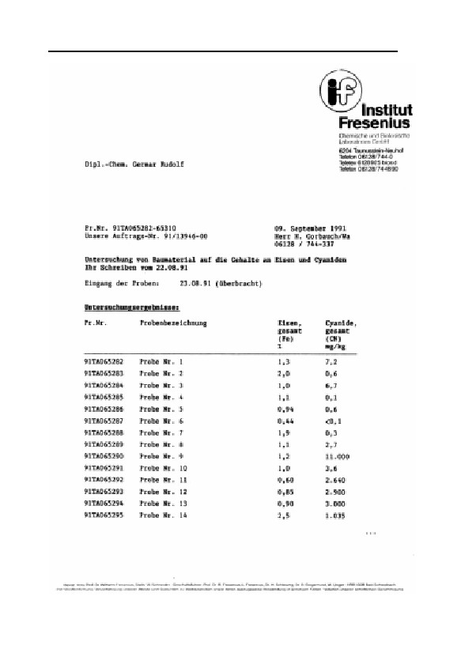
GERMAR RUDOLF · THE RUDOLF REPORT
256
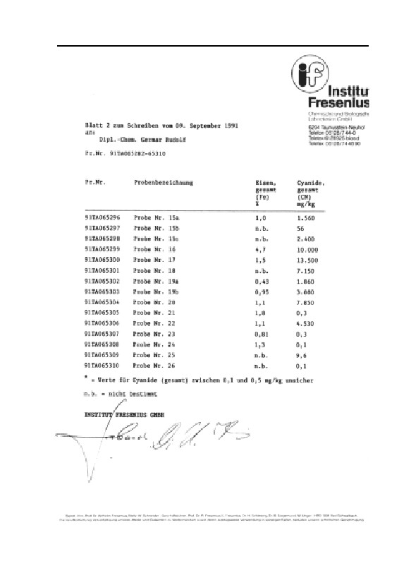
8. EVALUATION OF CHEMICAL ANALYSES
257

GERMAR RUDOLF · THE RUDOLF REPORT
Table 20: Analysis results from the Institut Fresenius
and the Institut für Umweltanalytik, Stuttgart (IUS)
In both cases the cyanide demonstration took place according to
–
DIN 38405/D13. Data in mg CN per kg.
Sample Sample taking location
Fresenius
IUS
3
Morgue 1 (‘gas chamber’), cre-
6.7
< NG
matorium II, wall plaster 0-1.5 cm
8
1b barracks 13, partition wall of
2.7
< NG
berth, 3-5 cm
11
B1a, building 5a, interior side of
2,640.0
1,430*
exterior wall (west), 1-10 mm
25
Untreated brick
9.6
9.6
26
3 additional samples of fumigated
-
<NG*
brick
* This sample was examined according to DIN 35 405/D14. Here in con-
trast to D13 no cadmium salt was added. Nothing is known as to the effects
on the results. Demonstrable threshold (NG) in each case 0.5 mg per kg.
8.3.3.2. Samples 5 to 8 and 23, 24: Inmate Barracks
Samples 5 and 8 are from a large lump of plaster a few centimeters
thick taken from the large room of the respective barracks (see Table
19, p. 254). A depth profile was not drawn up; the values must there-
fore be viewed as average values. Samples 6 and 7 are from the special
room located at the west end of these barracks. Samples 23 and 24 are
from the exterior wall of the large room of a third barrack.
Quantities of cyanide on the order of magnitude of those found by
Leuchter in the alleged ‘gas chambers’ can apparently also be found in
the wall material of the inmate barracks. This is indicated by the results
of Sample 8. All others are also positive, but notably lower. In this
case as well, the control analysis (Table 20, p. 258) failed to yield re-
producible results.
8.3.3.3. Samples 9 to 22: Disinfestation Building
With regards to the sample taking locations of the individual sam-
ples, see Figs. 17f. Judging from the consistency, the material used to
build the brick walls of buildings 5a and 5b is a mortar rich in sand but
extremely poor in cement (extremely crumbly), covered with a lime
mortar plaster.
Building 5a: What is remarkable about the outside of the exterior
walls of the disinfestation chamber of BW 5a is that, in places, it ex-
258
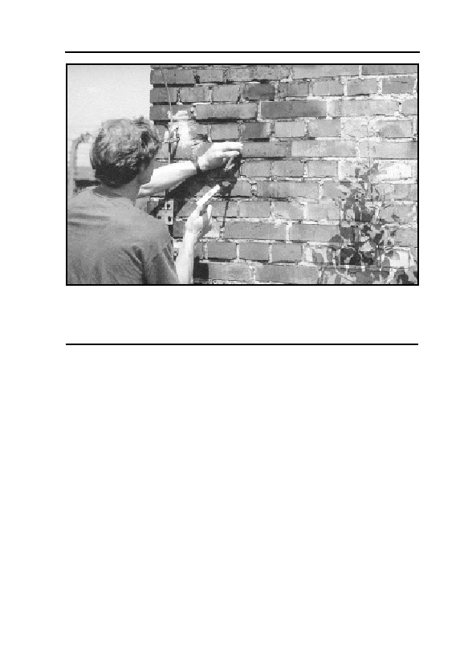
8. EVALUATION OF CHEMICAL ANALYSES
Fig. 68: The outside of the external wall of hydrogen cyanide delousing
wing of building 5a in August 1991. Small amounts of cyanide which
diffused through the walls are discoloring them at places still today. 50
years of the most detrimental environmental influences did not change this
fact.
hibits blue bricks and mortar joints (see 68, above). Sample 14 is a
loose fragment of brick which is clearly dark blue at all points facing
outwards and therefore exposed to weathering. Sample 15a is mortar
from the south wall, only the topmost layer of which was blue to a
depth of approximately 1 mm. The cyanide value at this point must
have been above the average value of the first approximately 3 mm.
Sample 15b is a fragment of brick, the blue layer of which was sepa-
rated with a spatula (Sample 15c). The mass of the remaining fragment
amounted to approximately twenty times the layer scratched off; only
slight cyanide concentrations are detectable here. The average concen-
tration here must have been around 120 mg/kg. On the brick as well,
the pigment has only formed in perceptible quantities on the outermost
side, that which is exposed to weathering (in this regard, see the exte-
rior wall of the disinfestation chamber in Stutthof concentration camp,
Fig. 65).
Very important is the confirmation of the fact that the pigment ac-
tually possesses an enormous environmental resistance, since Samples
14 to 15c were exposed to intensive sunshine, wind, rain, etc. for more
259
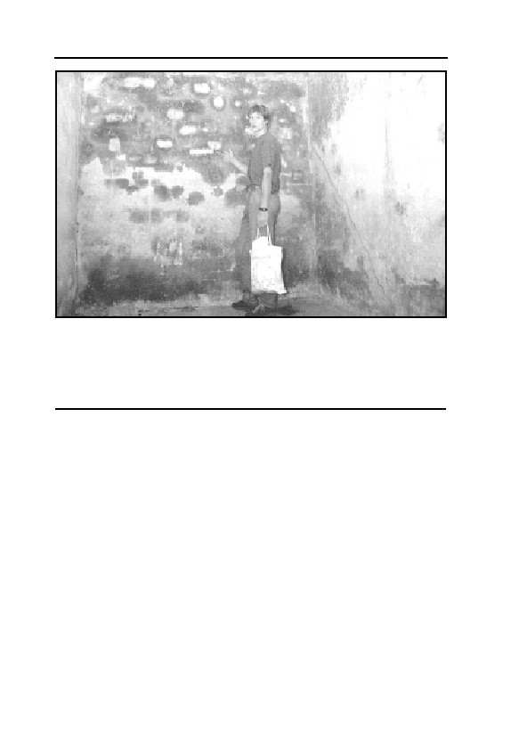
GERMAR RUDOLF · THE RUDOLF REPORT
Fig. 69: Picture of a room located in the northwest of the disinfestation wing
of building 5a (see Figure 18). The exterior walls are located in the
background and to the right, showing intensive blue discolorations caused
by iron Blue. Taking locations of samples 9 and 11 are visible. On the left in
the picture is the interior wall, erected during the conversion to a hot air
disinfestation chamber. Sample 10, with a slightly positive cyanide content,
was taken from this wall.
than 40 years. But how did the pigment arise in such high concentra-
tions at this precise location, although the outside of the exterior walls
were not exposed to any direct fumigation? The low quantities of cya-
nide which diffused through the masonry are apparently sufficient to
enable the formation of pigment on the outside of the wall, which was
moist, especially during rainy weather, and its iron compounds were
certainly massively activated by environmental influences.
The inside of the exterior walls of the disinfestation wing of Build-
ing 5a are almost completely blue, even dark blue (see Fig. 69, below).
Interestingly, the pattern of the brick structure located below the plas-
ter has made an imprint on the intensity of Iron Blue formation in the
upper layer of the plaster. Such a phenomenon is similar to, e.g., the
well known condensation of excessive atmospheric humidity on cool
walls (for example, in large groups of sweating human beings, such as
at rock concerts, in discotheques, or, generally, in poorly heated
rooms), which also leads to the formation of patterns exhibiting the
260
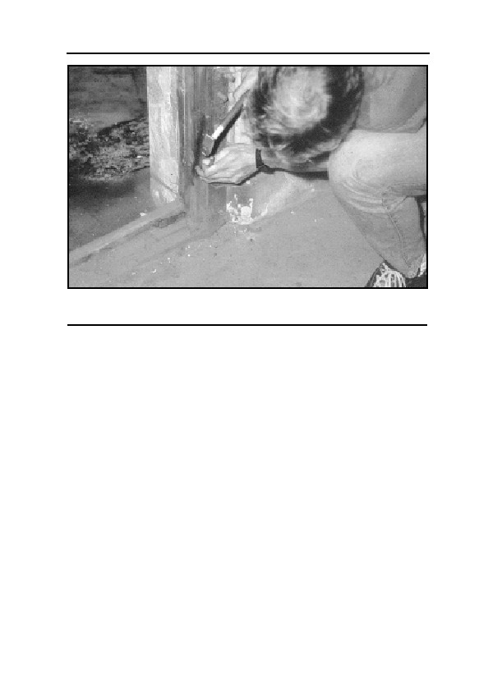
8. EVALUATION OF CHEMICAL ANALYSES
Fig. 70: Picture of the door frame in disinfestation wing of building 5a. the
lower, rusty hinge has developed Iron Blue under the influence of hydrogen
cyanide. Sample taking location of sample no. 18.
underlying brick structure of such walls. Differently-baked bricks have
a different tendency towards accumulation through condensation due
to their differing heat conductivity. Differing reactivity to the forma-
tion of cyanides due to differing moisture contents and temperatures
may therefore be the cause of this effect, but also differing transport
capacities for migrating cyanide salts due to differing moisture con-
tents.
Underneath the first layer of wall plaster, only approximately 1
mm thick, the material appears, by contrast, pale blue, just like the en-
tire east wall of the wing, which is an interior wall of the original disin-
festation chamber and whose discoloration is much less intensive
(samples 12 and 13).
The interior walls of the same room, which were incorporated at a
later time, i.e., those belonging to the hot air disinfestation chamber
(see Fig. 18), exhibit, as expected, no trace of blue.
The results of samples 9 and 11, and 20 and 22, resp., confirm the
first impression. The topmost layer of plaster on the inside of the exte-
rior walls has a very high cyanide concentration; underneath, the con-
centration decreases. The high cyanide concentration of Sample 11
could not, however, be exactly reproduced. The results of the control
analysis lies at only 54% of the first value. The slightly different ana-
261
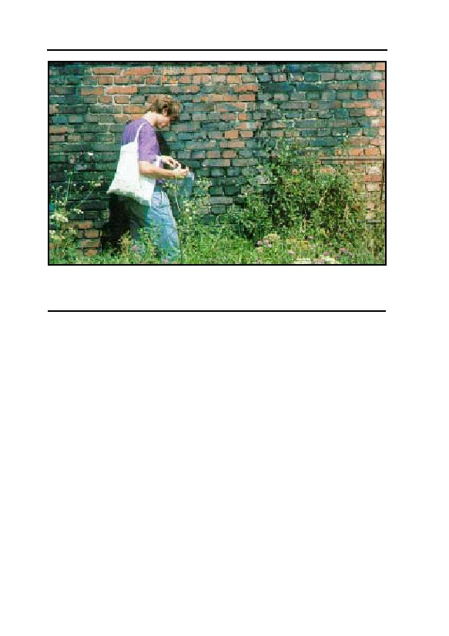
GERMAR RUDOLF · THE RUDOLF REPORT
Fig. 71: In contrast to building 5a (see Fig. 68), the disinfestation wing of
building 5b was used as a hydrogen cyanide delousing chamber for a
longer period of time. Subsequently, the outside of its walls are covered
with blue spots, unimpressed by 50 years of weathering here as well.
lytical procedure may be responsible for (see footnote in Table 20).
In pure Iron Blue, 1 g of cyanide contains approximately 0.82 g
iron. The iron analysis, assuming that the cyanide is present completely
in the form of Iron Blue, shows that, in Sample 9, approximately ¾ of
all iron was converted to pigment. If one considers that not all iron can
be reached by the hydrogen cyanide, then one can speak of a near-
saturation of the upper layer of material with the pigment. The drop in
the concentration from the topmost layer to the lower layers is ex-
plained, for one thing, by the linear gradient which must be expected in
not isolated walls (see chapter 7.3.2.3.). Furthermore, as with the blue
pigmentation of the exterior of the walls, the effect of accumulation of
cyanides on the surface through evaporation of water carrying soluble
cyanide compounds must be considered, even though this effect was
certainly smaller on inside walls than on outside walls due to lack of
air exchange in these rooms after the war (high relative humidity of the
air, no wind), and due to the lack of sun activity in the room equipped
with windows facing northwards only, see in Fig. 69.
Samples 12 and 13 correspond to Samples 9 and 11, taken from
the interior wall only, from the east wall, near one of the hot air cham-
bers. The surface concentration is considerably lower than on the in-
262
8. EVALUATION OF CHEMICAL ANALYSES
side of the exterior walls, there is no recognizable concentration pro-
file. The reason for this may be that the dry walls allow the hydrogen
cyanide to diffuse more easily into the masonry, while the hydrogen
cyanide more readily reacts superficially on the moist exterior walls. It
is more probable, however, that no migration of soluble cyanide salts
to the surface took place in the interior wall due to dryness. These
samples are also interesting insofar as they prove that high quantities
of cyanide compounds, highly-resistant for long periods of time, can
form on warm and dry interior walls. Due to the high ground water
table in Birkenau, as well as due to the lack of an effective heat insula-
tion, the exterior walls must be expected to have been quite cool and
moist even when the interior was heated, particularly during the cool
seasons.
The samples from the walls added during the conversion to hot air
disinfestation should exhibit no cyanide residues. Accordingly, sample
no. 10 from the interior wall incorporated at a later time exhibits only a
very low cyanide concentration near the detectable threshold. Sample
21 was taken from the mortar between the bricks of the wall installed
later, at a depth of 1 cm to 5 cm into the masonry. There is a crack in
the masonry of the interior wall at this location. The analysis shows
minimal but hardly interpretable traces of cyanide below the detectable
threshold in this interior wall as well. This finding may indicate disin-
festation of these rooms after the conversion to hot disinfestation, if the
slight quantities have not in any case lost all probative value, like the
control analysis of the other samples have shown.
Sample 18, finally, was taken from the door frame which was only
incorporated after the conversion to hot air disinfestation. Below the
lower hinge, the wood exhibits a visibly blue pigmentation (see Fig.
70, p. 261). The pigment was able to form here due to the moisture in
the floor, in connection with the rusting iron. This is assuming that the
rooms were either charged with hydrogen cyanide after the conversion
of the installation or that the floor of the installation continued to give
off cyanide over longer periods of time. In the first case, the cyanide
traces in the walls added later (Samples 10 and 21) could actually be
explained by fumigation of the rooms. However, during the conversion
of this wing to a hot air disinfestation facility, this gas-tight door may
have been removed from the access way to this wing and re-used here,
so that the cyanide would result from earlier fumigations. The analyti-
cal results should only be conditionally considered as qualitative, since
263
GERMAR RUDOLF · THE RUDOLF REPORT
organic material can be a disturbing factor during analysis. In any case,
the high reactivity of moist iron oxide mixtures (rust) is confirmed.
Building 5b: The exterior walls of disinfestation wing BW 5b are
not only blue in places, as in the case of BW 5a, but rather, almost
completely so, even below the ground (see Fig. 71, below). An excep-
tion here is the east wall, which hardly exhibits any blue pigmentation
(see Fig. 19, p. 76). The analysis of a fragment of brick from the south
side (Sample 16) therefore shows an extremely high value. Here, the
pigment extends further into the masonry. Here as well, weathering has
had no visible or measurable effect on the pigment concentration. Ap-
proximately 17% of the iron in the fragment of brick has been trans-
formed into pigment, despite the only slight concentration in cyanides
able to reach the exterior of the masonry wall here as well. The con-
spicuous difference between Building BW 5b and 5a, which is only
blue in places, is explained by the longer period of use of the 5b wing
as a Zyklon B disinfestation chamber. The reason for the perceptibly
lesser blue pigmentation of the east side of the exterior wall of this
wing can be explained by the lesser influence of weathering on this
side (east winds are mostly accompanied by dry weather in eastern
Europe).
When examining the interior of this wing, one is surprised by the
walls which are mostly white. Pale green stains are visible only in a
few places. The analysis of the green-colored plaster underneath the
upper layer, Sample 17, however, shows the highest value found any-
where, despite the thick layer of plaster consisting of a compact, very
hard material, 3 to 4 mm thick. With relation to the transformation of
the iron, what was said of the upper layer of plaster in BW 5a only, is
true here: near saturation. The color of the material, here only greenish,
is apparently not directly meaningful with regards to the cyanide con-
centration. Because even in the presence of maximum values, the pro-
portion of pigment in the plaster only amounts to 1.5 %, the intense
blue color in places on the surface of the inside of exterior walls of BW
5a cannot moreover be explained in this manner. Rather, the dark blue
colors result from a still higher concentration of pigment in the upper-
most layers in the micro-meter range of magnitude caused by the ac-
cumulation processes of migrating, soluble cyanide salts as described
above.
That these accumulation processes did not occur on the surface of
the inside of Building 5b may be explained by the different type of ma-
264
8. EVALUATION OF CHEMICAL ANALYSES
terial and its preparation. The hard, iron-poor interior plaster of lime
mortar adheres very poorly to the wall and is already falling off in
some places. The contact between plaster and wall is so poor in places,
that when one knocks on the wall, one hears that there is a hollow
space beneath. Such weak contact between wall and plaster, however,
prevents moisture in the wall from diffusing through to the surface
plaster and carrying soluble cyanide compounds (for example, iron(II)-
cyanide) with it.
Sample 19 was divided in two, since the upper layer of plaster in
this room is visibly different from the layer lying beneath: The first 4
mm of plaster consists of a white, brittle, hard material (sand-poor lime
plaster), while the layer underneath consists of an ochre-colored, sand-
rich lime plaster. The separation was not completely successful; parts
of the sand-rich mortar remain in Sample 19a. The analysis for iron,
which might possibly have been even lower in the presence of com-
plete separation, confirms the assumption that the upper layer is an
iron-poor lime plaster. This explains the deficient formation of blue
spots of pigment on the surface of the plaster in this room, since there
is too little iron available for the formation of pigment. Nevertheless,
even the upper layer of plaster exhibits quite high cyanide values. This
shows that the layer of plaster was not applied after termination of the
disinfestation actions.
8.3.3.4. Samples 25-30: Tests
For an evaluation of the reactivity of hydrogen cyanide with build-
ing materials, a series of tests was undertaken; during the first series,
only brick was fumigated with hydrogen cyanide, generated from a
defined quantity of KCN+H2SO4 in a gas-tight container. Over the
course of the tests, it became apparent by means of sensitive differen-
tial pressure measurements that only a part of the hydrogen cyanide
added to 16% sulfuric acid was released as gas. Hydrogen cyanide is
so easily soluble, even in this acid, that only a portion of it is actually
released into the gas room. The actual quantity of gas in the reaction
container therefore lay far below the mathematically calculated 3.7%
by volume, while the pressure measurements consequently lay around
2 % by volume.
On the construction of a reaction container from a glass cylinder,
sealed above and below by PVC plates with gas qualities and O-rings,
265
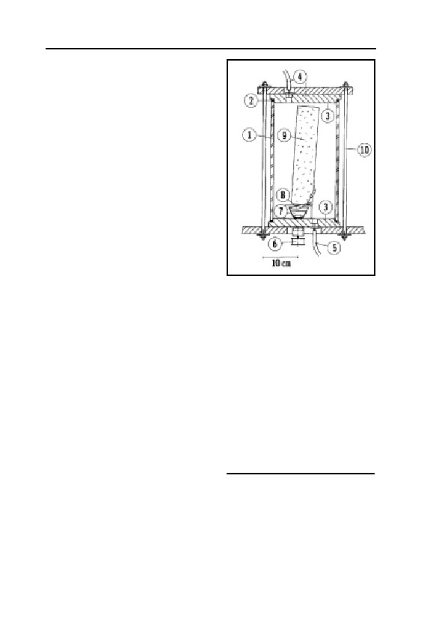
GERMAR RUDOLF · THE RUDOLF REPORT
see Fig. 72. 16% H2SO4 was placed
in a crucible, KCN was added by
means of a magnetic lever mecha-
nism with the container sealed. The
mixing was performed by means of
a magnetic stirrer.
The samples listed in Table 21
were analyzed. The following pa-
rameters were kept constant:
• 11°C air and sample tempera-
ture;
• 90% relative atmospheric humid-
ity;
• Storage of the samples for ap-
proximately five weeks under
these conditions prior to initia-
tion of the tests;
Fig. 72: Construction drawing of
• Sealing of the samples on all
the experimental container for
the fumigation of material
sides, except for one frontal sur-
samples with hydrogen cyanide.
face, with paraffin 52/54 (thus
1: Glass cylinder
fumigation on one side only)
2: O-sealing ring
• Fumigation with 2% by volume
3: PVC lid and floor plate
4: Gas outlet and pressure
hydrogen cyanide;
gauge
• 24.75 hours fumigation time;
5: Gas ventilation outlet
• Storage of the samples after fu-
6: Magnet mixer motor
migation at room temperature
7: Porcelain dish with 16 Vol.%
H2SO4 and magnet mixer
and low atmospheric humidity
8: Spoon with KCN fixed axle,
for 71 days.
capable of tipping over mag-
Exceptions from these condi-
net from exterior
tions are listed in the right column
9: Sample material (here brick)
of Table 21 (p. 267). Following
10: Bolts
fumigation, the topmost layers of
the sealed surfaces of samples 27 to 30 were removed, and hence the
sealing layer of paraffin. The additionally moistened samples 27 and
30 made themselves perceptible by an intense odor of hydrogen cya-
nide during storage at room temperature, in contrast to samples 28 and
29 which were only moist by nature. The odor of hydrogen cyanide
disappeared suddenly upon additional moistening. In the case of the
266

8. EVALUATION OF CHEMICAL ANALYSES
Table 21: Test sample preparation and fumigation
Nr. Material
Conditions
25/26 Brick from demolished building from 16 h fumigation with 0.3 Vol.%,
Bavaria; only sample 26 was fumi-
Storage after fumigation for 120
gated!
days at room temperature. No
sealing with paraffin
27 Cement mortar: 1 part sand, 1 part Portland cement, addition of 1 g
½ part lime. Sample measurements: 55×60×20 mm,
water
3
100 g (ca. 1.5 g/cm )
28 Cement mortar: 1 part sand, 1 part Portland cement,
½ part chalk. Sample measurements: 55×60×20 mm,
3
108 g (approx.. 1.6 g/cm )
29 Lime mortar: 2 ½ parts sand, 1 part lime. Sample
3
measurements: 55×60×20 mm, 94 g (ca. 1.4 g/cm )
30 Lime mortar: 2 ½ parts sand, 1 part lime. Sample
addition of 2 g
measurements: 52×58×20 mm, 96 g
water
3
(ca. 1.6 g/cm )
cement mortar sample, the odor was no longer perceptible after a
week, while in the case of the lime mortar sample, it was no longer
perceptible after two weeks. Storage of the samples for more than two
months at room temperature therefore perceptibly reduced the hydro-
gen cyanide content, while the drying of the samples strongly hindered
the conversion to iron cyanide.
The analytical results relating to the brick samples (Table 19, p.
254, Sample no. 25 and 26) are surprising for their values, which ap-
pear paradoxical: the fumigated sample, in contrast to the unfumigated
sample, exhibited no traces of cyanide. The value of the unfumigated
sample could be exactly reproduced (Table 20). Further analyses of the
fumigated brick likewise resulted in no demonstrable cyanide concen-
trations. These findings prove that cyanide values up to 10 mg per kg
have only very limited probative value, since these can be attributed to
traces which occur everywhere.510
The interpretation of the analytical results of samples 27 to 30 re-
sulted in the following data:
• In total, 30 mg of cyanide were found in the samples during the
analysis. Since 300 mg cyanide were used during this test, 10% of
510
It is also conceivable that the unfumigated samples were contaminated during preparation for
analysis, perhaps through an improperly cleaned ball mill, in which samples with a high cya-
nide content had previously been crushed. The reason for the good reproducibility may be that
there is hardly any carbonate in brick, since it acts as a disturbance ion.
267

GERMAR RUDOLF · THE RUDOLF REPORT
this quantity was found durably bound to the samples.
• The cement mortar samples, in contrast to the lime mortar samples,
exhibit a higher cyanide concentration by a factor of two. The higher
iron content of the cement mortar samples may be the reason for
this, since the cyanide content increases proportionally to the iron
content (see the last column of Table 19). In addition, hydrogen
cyanide adsorption was certainly favored by the higher inner surface
area of the cement mortar as compared to lime mortar.
• The increased hydrogen cyanide absorption caused by the addition
of moisture was only slightly perceptible in the analytical results,
since the samples were all very moist anyway, and because the ma-
terial dried out during the final storage phase and therefore the hy-
drogen cyanide was only able to bind partially.
• Blue pigmentation of the samples was not to be expected, since even
if all the bound cyanide were present in the form of Iron Blue, only
0.005-0.01% of the total material would consist of the blue pigment,
which would cause hardly any perceptible coloration to the naked
eye. An accumulation of cyanides on the surface of the sample, fi-
nally, could not occur due to the absence of water in diffusion. In
addition, the dry storage of the samples probably blocked the con-
version process.
8.3.4. John C. Ball
All samples taken from alleged homicidal ‘gas chambers’ are
around or well under the detection threshold and must therefore be
considered zero. Ball’s samples from the delousing wings of buildings
5a and 5b do represent a fairly good average of my own and confirm
my results.
Table 22: Cyanide concentrations in the masonry of ‘gas
chambers’/disinfestation chambers according to John C. Ball511
c(CN–) [mg/kg]
No.
Location
1
Delousing Room B1b BW 5b, inside and outside
3,170.0
2
Delousing Room B1b BW 5a, inside and outside
2,780.0
3
Crematorium II, morgue 1 ('gas chamber')
0.4
4
Crematorium III, morgue 1 ('gas chamber')
1.2
5
White Farm House, remnants of foundation
0.07
6
Crematorium V, remnants of foundation wall
0.1
511
John Clive Ball, The Ball Report, Ball Resource Services Ltd., Delta, BC, Canada, 1993.
268
8. EVALUATION OF CHEMICAL ANALYSES
8.4. Discussion of the Analysis Results
8.4.1. Blue Wall Paint?
The hypothesis expressed by J. Bailer,52,54 that blue paint could be
responsible for the high cyanide values in the disinfestation chambers,
does not correspond to the facts:
1. Iron Blue is not sold as wall paint at all, since it lacks suffi-
ciently high lime fastness (see chapter 6.6.1.).
2. If this argument were correct, it would be remarkable that the
SS, of all the rooms in the Third Reich, would apply blue paint only to
their disinfestation chambers where no one could admire it; and,
strangely, always the same blue. All other rooms were whitewashed.
Were the SS practitioners of ‘blue magic’?
3. The disinfestation chambers themselves already had a coat of
lime paint. Why would they cover this coat of lime paint with another
paint which, in addition, is not even lime fast? They would therefore
have had to wait until the lime paint and plaster had set before one
could paint the walls. And then it would have been by no means certain
that the paint would not furthermore have become stained as a result of
chemical reactions.
4. A coat of paint on the interior of the room would not explain the
patchy pattern of the blue stains on the interior of the exterior walls of
the disinfestation wing of Building 5a.
5. Neither would a coat of paint on the interior of the room explain
the absence of blue coloration on the interior walls added to the disin-
festation wing at a later time. Or are the SS supposed to have painted
only certain walls, and then, not evenly, with paint brushes, but, per-
haps, soiling the wall statistically by throwing and spattering?
6. Bailer’s argument is refuted by the fact that none of the colored
walls shows any pattern of brush marks, and no identifiable coat of
paint, since wall paint consists not only of pigment, but also of a not
inconsiderable proportion of binding agents and other chemicals. The
blue pigment is, however, simply one component of the lime paint and
plaster.
7. Bailer’s argument furthermore fails to explain how the artistic
skills of the painters could have succeeded in imitating the brick struc-
ture lying beneath the plaster. Or did they not only practice ‘blue
magic,’ but were equipped with X-ray eyes as well?
269
GERMAR RUDOLF · THE RUDOLF REPORT
8. Bailer’s argument does not explain the only pale blue tint of the
interior south walls of the original disinfestation wing of Building 5a.
9. Neither does Bailer’s argument explain the high cyanide con-
centration in the superficially white, iron-poor material of the walls of
the disinfestation wing of Building 5b. Or is it his opinion that these
rooms were, perhaps, painted with an ‘iron white,’ a paint color that
does not even exist?
10. Bailer’s argument furthermore fails to explain the still higher
cyanide concentration of deeper, greenish-bluish coats of material in
the walls of the disinfestation wing of Building 5b; or does he perhaps
intend to argue that the SS even applied iron-blue paint to wall plaster
and wall mortar where no one could ever admire it? There, it would in
addition have certainly have been decomposed into its component parts
due to the alkaline pH value of fresh mortar and would have lost its
color at least temporarily.
11. Finally, Bailer’s argument cannot explain why even the exte-
rior walls of the disinfestation rooms, exposed to weathering, have a
notable cyanide content and are discolored with blue stains. Or did the
SS employ the technique of statistically throwing and splashing paint
about here as well, paying particular attention to the structure of the
brick, resisting at all times the temptation to apply the coats of paint
which are so typical of ordinary painting, simply because blotchy blue-
stained brick is so sexy? Or was the Iron Blue applied to the bricks
upon manufacture, resisting the baking process of the brick in a magi-
cal fashion known only to the blue-magic SS?
The Polish scientists, as indicated above, adopted Bailer’s argu-
ment and therefore preferred simply not to prove the presence of Iron
Blue at all. Honni soit qui mal y pense… (a rogue who thinks evil
about it)
8.4.2. False Method of Analysis
Many people, both experts and laymen, rely good-naturedly upon
the findings of the Jan Sehn Institute for Forensic Research in Cracow,
i.e., the study published in 1994 by Prof. Markiewicz and colleagues.
These Polish scientists, however, tested their samples with analytical
methods that were unable to detect stable iron cyanide compounds.
They did this because they could not imagine how such stable iron
cyanide compounds could form. It is, of course, no shame to fail to
270
8. EVALUATION OF CHEMICAL ANALYSES
understand something initially. Anyone, however, who makes a claim
to scientific reliability must, before making statements upon the sub-
ject, at least attempt to investigate and understand. But not so the Pol-
ish scientists. They assert their lack of understanding as a justification
for their failure to act. Has anyone ever heard that failure to understand
a phenomenon was any reason for scientists not to study it? To the Pol-
ish scientists, this was obviously the case. It would only be permissible
to exclude Iron Blue from the study if it were possible to exclude, with
practical certainty, that the effects of hydrogen cyanide on masonry
could result in the formation of iron cyanide, and, consequently, Iron
Blue, and if there were at least some indication that these rooms had
been painted with Iron Blue. The Polish scientists completely ne-
glected to do this. And even worse: they did not even attempt to refute
my arguments on the formation of stable iron cyanide compounds
which I published in early 1993.512 They were familiar with this publi-
cation, because they quoted it, but not, for example, in order to discuss
my arguments, but simply to condemn it flatly as an example of the
allegedly diabolical deeds of the ‘deniers’ and the ‘whitewashers’ of
Hitler, who Prof. Markiewicz and his colleagues intended to refute—so
their own words. This should suffice to show that the Polish actions
were ideologically motivated, to a high degree. If they had been neutral
scientists, they would have applied the correct and interpretable
method of analysis and would have discussed my publications in a
scholarly manner instead of worrying about Hitler’s dirty laundry.
Prof. Markiewicz and his colleagues did not even attempt to find
any explanation for the high iron cyanide concentration in the walls of
the disinfestation chambers and their blotchy-blue surfaces.
Although they had sought out an analytical method able to pro-
duce the results desired by them, the results of their first series of tests
were obviously so disturbing that they decided to suppress them and
never published them. These data only became public knowledge
through an act of indiscretion in 1991 (see chapter 8.3.2.).513
The Polish scientists therefore rejected the undesired results of
512
E. Gauss, Vorlesungen…, op. cit. (note 43), pp. 163-170; 290-294.
513
The first series of studies, undertaken by J. Markiewicz, W. Gubala, J. Labedz, and B. Trzcin-
ska, were never published by the authors of the studies. Only the revisionists have published
their findings, after the article was smuggled out of the Jan Sehn Institute by unknown persons
in 1991; see also note 56; for further remarks on this example of ‘political science’, see G.
Rudolf, op. cit. (note 58).
271

GERMAR RUDOLF · THE RUDOLF REPORT
Table 23: Orders of magnitude of analytical results
of various samples, in mg CN–/kg
Author: Markiewicz et al. Leuchter
Rudolf
Ball
Cyanide without
———— Total cyanide ————
Results from:
iron cyanide
delousing chambers:
0-0.8
1,025 1,000-13,000 2,780-3,170
‘gas chambers’:
0-0.6
0-8
0-7
0-1.2
their first series of tests and took even more samples, until they finally
produced the results that fitted in with their preconception: this time,
both the samples from the disinfestation chamber and the alleged ‘gas
chambers’ showed cyanide residues on the same order of magnitude.57
But even Prof. Markiewicz and his colleagues, during the test fu-
migations performed by them, at least confirmed that moist cement
mortar (as was used in the morgues of crematoria II and III) absorbs at
least ten times more hydrogen cyanide than dry lime mortar (as used in
the disinfestation chambers), as I had assumed for my calculations in
this work.
Table 24 shows the analysis results of Prof. Markiewicz and his
colleagues compared to those of Fred Leuchter, John C. Ball, and
mine.
I will spare myself further analysis since analysis results obtained
in a methodically incorrect manner cannot be corrected even by correct
interpretation. Any attempt at interpretation is therefore a waste of
time.514
Even a direct comparison with my arguments and the open expres-
sion of suspected fraud could not move Prof. Markiewicz and his col-
leagues to justify or correct their unscientific manner of behavior.58,59
The director of this group, Dr. Jan Markiewicz, who is not a chemist,
but rather, a “Technical Testing Specialist”, died in 1997. Both the
other authors have remained silent.
One can after all understand that these Polish authors made their
careers in Communist Poland, and, as Polish patriots, can under no
circumstances permit the undermining of ‘Auschwitz’ as a moral justi-
fication for the Polish ethnic cleansing of the East Prussians, East
Pomeranians, and Silesians after the end of World War Two, as a result
514
A word on the HCN-CO2 mixture used by the Poles for their fumigation experiments. In their
view, CO2 has a negative influence on the adsorption of HCN in the masonry. Their own test
results are, however, in contradiction to this view; they are also incorrect in assuming that CO2
could have a negative influence on the absorption of HCN; see also note 349, p. 165.
272
8. EVALUATION OF CHEMICAL ANALYSES
of which some three million Germans lost their lives, as well as it be-
ing the greatest land robbery of modern history. Many Poles fear in
their hearts that the post-war state of Poland stands and falls with
Auschwitz. This may explain Prof. Markiewicz’s and his colleagues’
scientific contortions, but it fails to be a justification for them. Even the
possible circumstance that the scientists assigned to the topic were not
and are not chemists and that their laboratory was perhaps not
equipped up to Western standards, cannot explain this, since an analy-
sis of the total cyanide concentration is not expensive in terms of labo-
ratory equipment and the chemistry involved is anything but compli-
cated.
The manner with which the Polish scientists approached the prob-
lem, however, gives rise to serious suspicion that this was an attempt at
scientific fraud, a suspicion which is also supported by the fact that
they were unable to justify their incorrect methods of measurement
except through their incompetence and ignorance.
The conclusions to be drawn from the above is clear: the only
‘scientific’ attempt to refute Fredrick A. Leuchter’s sensational argu-
ment proves, upon closer examination, to be one of the greatest scien-
tific falsifications of the 20th century.
How desperate must one really be, if it is believed necessary to
stoop to such methods in an attempt to defend the established version
of the Holocaust, i.e., the alleged systematic extermination of the Jews
in homicidal ‘gas chambers’?
8.4.3. The Memory Hole
At the end of chapter 6.6.5., I already referred to the bold lies of
Albert Meinecke from the German press agency dpa regarding the al-
leged short life term of hydrogen cyanide in masonry. A new corny
joke was recently added to this debate by Prof. James Roth from the
Alpha Analytic Laboratories, Ashland, Massachusetts. I discuss this
event here because Prof. Roth’s allegations were widely publicized by
the international media in connection with the libel case of British his-
torian David Irving against Deborah E. Lipstadt.515
For his documentary movie Mr. Death on Fredrick A. Leuchter,
Errol Morris also interviewed Prof. Dr. James Roth. In 1988, Roth’s
515
This claim played a role in the verdict which should not be underestimated, cf. judgment
Gray, op. cit. (note 66), §13.79; cf. note 68.
273
GERMAR RUDOLF · THE RUDOLF REPORT
laboratory had analyzed the masonry samples from the alleged ‘gas
chambers’ taken by Leuchter in Auschwitz for their cyanide content.
During the trial against Ernst Zündel in Toronto that same year, for
which the Leuchter report had been produced, Prof. Dr. Roth himself
was interrogated as an expert witness. Ten years later, Errol Morris
interviewed Roth about this event. During this interview, Prof. Roth
did all he possibly could to distance himself from the possible conse-
quences of the analyses performed by his company. His interview
gained importance only due to the fact that the Dutch architectural His-
torian Prof. Robert van Pelt quoted Roth in his 1999 expert report pre-
pared for the Irving trial. In it, van Pelt wrote about Roth’s statements
in Morris’ movie:516
“Roth explained that cyanide will react on the surface of brick or
plaster, penetrating the material not more than 10 microns, or 0.01 mm,
or one tenth the thickness of a human hair […]. In other words, if one
wants to analyze the cyanide concentration in a brick sample, one should
take a representative sample of the surface, 10 microns thick, and no
more.”
It can be shown that Prof. Dr. James Roth is wrong for the follow-
ing reasons:
1. It is a fact that the walls of the disinfestation chambers in Ausch-
witz, Birkenau, Stutthof, and Majdanek are saturated with cyanide
compounds, and this not only superficially, but into the depth of
the masonry, as I have proved by taking samples from different
depths of the wall, compare in this regard especially my samples
no. 11, 13, 17, 19b, and 23 in Table 19. They prove that hydrogen
cyanide can rather easily reach deep layers of plaster and mortar.
But even the other samples taken from the surface prove that Prof.
Roth’s allegation is wrong: Provided that most of the cyanide de-
tectable today is present in the form of iron cyanide (Iron Blue and
other cyanoferrates), as Prof. Roth assumes himself, his thesis
would mean that 10% to 75% of the iron content of these samples
are located in the upper 10 micrometer of my samples (0.010 mm),
i.e., they are located in less then 1% of the entire sample mass, and
the rest of the sample would have been massively deprived of iron.
How this migration of a major portion of iron to a thin surface
layer would have happened is inexplicable to me.
516
Pelt Report, op. cit. (note 66), p. 307.
274
8. EVALUATION OF CHEMICAL ANALYSES
2. Furthermore, expert literature is detailed in that
a. hydrogen cyanide is a extremely mobile chemical compound
with physical properties comparable to water,322
b. which can quite easily penetrate through thick, porous layers
like walls.409
3. In addition, it is generally known that cement and lime mortar are
highly porous materials, comparable for instance with sponges.517
In such materials, there does not exist something like a defined
layer of 0.01 mm beyond which hydrogen cyanide could not dif-
fuse, as there can also be no reason, why water could not penetrate
a sponge deeper than a millimeter. Steam, for example, which be-
haves physically comparable to hydrogen cyanide, can very easily
penetrate walls.
4. Finally, the massive discolorations of the outside walls of the dis-
infestation chambers in Birkenau and Stutthof, as shown in this
expert report, are clearly visible and conclusive evidence for the
fact how easily hydrogen cyanide and its soluble derivatives can
penetrate such walls.
As a professor of analytical chemistry, Prof. Roth must know this,
so one can only wonder why he spreads such outrageous nonsense.
That Prof. Roth is indeed a competent chemist can be seen from what
he said during his testimony under oath as an expert witness during the
above mentioned Zündel trial:518
“In porous materials such as brick or mortar, the Prussian blue
[recte: hydrogen cyanide] could go fairly deep as long as the surface
stayed open, but as the Prussian blue formed, it was possible that it
would seal the porous material and stop the penetration.”
517
DIN 4108, part 3 to 5, deals with diffusion of steam into building materials. The most impor-
tant coefficient for building materials is the so-called coefficient of diffusion resistance; this is
a dimensionless number indicating, how much longer the diffusion of steam takes to penetrate
a layer of certain materials compared to the time it takes to diffuse through the same layer of
still air. This coefficient is valid not only for water vapor, but also for gaseous hydrogen cya-
nide as well as for any other gas. In the list of 100 different building materials compiled in
DIN 4108 part 4, one can find lime and cement mortar with diffusion resistances from 15 to
35, in which case the resistance grows with increasing cement content, for gypsum plaster, the
coefficient is 10, for brick walls 5 to 10, for glass wool mats it is 1. That means, if a gas dif-
fuses through a layer of still air with a speed of 1 cm per second, it does take 15 to 35 seconds
to diffuse through a 1 cm thick layer of lime or cement mortar and 5 to 10 seconds to diffuse
just as deep into a brick wall. (I am grateful to Mr. C.H. Christmann for this reference.) In this
regard, compare also the analysis about the porosity of masonry, graph 7, p. 183.
518
B. Kulaszka (ed.), op. cit. (note 25), p. 363 (protocol p. 33-9291).
275
GERMAR RUDOLF · THE RUDOLF REPORT
Prof. Roth might have felt obligated to attack Leuchter in order to
avoid becoming himself a target of certain lobby groups who already
managed to destroy Leuchter’s career. That would explain why the
truth temporarily dropped into a hole in Prof. Roth’s memory while
being interview by Errol Morris. It is also revealing that Prof. Roth
mentioned during this interview, if he had known where Leuchter’s
samples originated from, his analytical results would have been differ-
ent. Does that mean that Prof. Roth manipulates his result according to
whether or not he likes the origin of certain samples? Such an attitude
is exactly the reason why one should never tell an ‘independent’ labo-
ratory about the origin of the samples to be analyzed, simply because
‘independence’ is a very flexible term when it comes to controversial
topics. What Prof. Dr. Roth has demonstrated here is only his lack of
professional honesty.
8.4.4. The Moon is Made of Pizza
Another strange story is that of Richard Green, a PhD Chemist
with quite similar educational background as I have.63-65 The layman
would expect two experts, with similar educational background, to
come to similar conclusions in questions relating to their expert
knowledge. But this is only partly the case. The reason for this is that
Dr. Green ignores many facts that are either supported by documentary
evidence—like the performance of the ventilation installed in cremato-
ria II and III, or the speed of executions in U.S. execution chambers—
or by expert literature—like the higher tendency of cold, moist walls to
adsorb HCN, and the longer lasting alkalinity of cement mortar com-
pared to lime mortar.
However, Dr. Green makes some concessions which are important
to note:
a) He agrees that basically all witnesses attest to very short execu-
tion times, indicating a rather high concentration of HCN used.
b) He also agrees “that Rudolf is correct or nearly correct regard-
ing the formation of blue staining in the delousing chambers.”
What he does challenge, though, is the possibility of formation of
any noticeable quantities of Iron Blue in the homicidal ‘gas chambers.’
One of his flawed and deficient arguments to support his thesis is that
in his view, no noticeable amounts of cyanide could have accumulated
in the walls of the morgues (‘gas chambers’). According to Dr. Green,
276
8. EVALUATION OF CHEMICAL ANALYSES
one major factor for this is supposed to be the fact that masonry has a
neutral pH value which does not allow the protolysis of hydrogen cya-
nide and thus the formation of cyanide salts. But if that were true, how
come huge amounts of cyanides did accumulate in the walls of the dis-
infestation chambers?
My argument in this regard is that particularly cement plasters and
concretes, as used in morgues 1 of crematoria II and III, are noticeably
alkaline for many weeks, months, or even years, which I documented
thoroughly with expert literature on the chemistry of building materials
(see chapter 6.7.2.). Hence, I concluded that these walls would have
been very much inclined to accumulate cyanide salts and to form Iron
Blue, even more so than the lime plaster of the disinfestation cham-
bers, which in turn provoked the following answer by Dr. Green:
“[In 1993] The IFRC [Institute for Forensic Research, Cracow], on
the other hand measured the pH [of mortar samples from the alleged gas
chambers] to be between 6 and 7 [i.e. neutral].”
Dr. Green obviously did not consult any literature on the chemis-
try of building materials, as he quotes none. He solely relies on the
findings of the Cracow institute. In order to make the reader see how
flawed Dr. Green’s way of arguing is, let me say it in a parable:
By referring to a couple of Italian expert pizza baking instructions,
I showed that a pizza, when taken out of the oven, is hot or warm for
quite a while (one hour). Now, Dr. Green comes along claiming that I
am wrong because a Polish friend of his has just now measured the
temperature of a pizza which was baked a week ago, and which has
been lying around somewhere since. And the Polish scientists found
out that this pizza is indeed cold right now. Surprise, surprise!
Of course, samples taken from the surface of walls erected 50
years ago or more are now pH neutral! Even this I have proved by
showing how the front of neutralization slowly migrates into concrete
and mortar (see chapter 6.7.2.2.). But what does the pH value of sam-
ples taken 50 years after the erection of these building prove regarding
their pH value shortly after they were built? Dr. Green’s way of argu-
ing is childish to the highest degree.
When it comes to intellectual honesty, Dr. Green reveals some
other very strange behavioral patterns, one of which I want to address
here.
Dr. Green agrees with me that the Iron Blue found in delousing
277
GERMAR RUDOLF · THE RUDOLF REPORT
chambers is the result of gassings with hydrogen cyanide. Hence he
disagrees with the opinion of Markiewicz and others that this Iron Blue
has its origin for different reasons, like residual paint. Consequently,
Dr. Green should refuse the approach of the Cracow team to exclude
Iron Blue from the analysis, because this would most likely exclude the
major parts of the cyanide residues formed by gassings with HCN in
general (not just in case of delousing chambers). Subsequently, Dr.
Green should furthermore criticize Markiewicz for having chosen a
method of analysis which must lead to faulty and misleading result, as
I did. Additionally and more generally, he should say that the Polish
scientists neither tried to understand what they claimed not to have un-
derstood, nor discussed the attempts to understand as made by others,
which were known to them. No matter which results the Polish scien-
tists produced and what their scientific opinion might have been: their
behavior is extremely unscientific, as the most important task of a
scientist is to try to understand what has not been understood so
far, and to discuss the attempts of others to make understandable.
The Polish scientists did just the opposite: they decided to ignore and
exclude what they did not understand. Finally, in their article as well as
in a letter to me, the Polish scientists themselves stated that the purpose
of their paper was to refute the “Holocaust Deniers” and to prevent
Hitler and National Socialism from being whitewashed, i.e., their pur-
pose was not to find out the truth! Thus, by their own confession, they
used unscientific methods in order to produce desired results for the
purpose of achieving certain political goals.
Let me quote Prof. A.R. Butz in this connection, who stated an-
other appropriate metaphor to emphasize the degree of intellectual dis-
honesty revealed by Markiewicz and his colleagues:519
“The argument [of Markiewicz et al. for excluding Iron Blue from
their analyses], to the extent that it was intelligible enough to be summa-
rized at all, was that they did not understand how the iron-cyanide com-
pounds got to be there, so they decided to ignore them in reaching their
conclusions. I don’t understand how the moon got there, so I will ignore
all effects associated with it, such as tides. I hope I don’t drown.”
And the amazing thing about Dr. Green is that he—and with him
Prof. van Pelt, who relies on Green69—does not only defend Prof.
519
Arthur R. Butz, “Historical Past vs. Political Present”, JHR , 19(6) (2000), pp. 12ff. (online:
www.ihr.org/jhr/v19/v19n6p12_Butz.html).
278
8. EVALUATION OF CHEMICAL ANALYSES
Markiewicz’s behavior in every regard, but he attacks me for my cri-
tique against the Polish scientists, while omitting all the reasons I gave
for doing so. To crown this, Dr. Green even defends the fact that Prof.
Markiewicz never even bothered to address any of my critique, even
though addressing critiques is paramount for scientists. Dr. Green ar-
gues:
“Rudolf complains that Markiewicz et al. have not responded to his
queries. Why should they do so? What credibility does Rudolf have, that
demands they answer his every objection no matter how ill-founded?”
However, since Dr. Green agrees that the Iron Blue detectable in
disinfestation walls is the result of gassings with Zyklon B, he himself
has indirectly admitted that all my objections against Markiewicz’s
method of analysis are well-founded, i.e., just the opposite of “ill-
founded”.
And why does Dr. Green think I bear no credibility demanding a
discussion of any of my arguments? Not because I lack scientific quali-
fications. No, he thinks I am an abomination because of my views, and
because I have been subject to social persecution and political prosecu-
tion, leading to the total destruction of my social existence, my reputa-
tion, and finally my freedom. Dr. Green even resorts to calling me a
“liar,” “obfuscator,” and “hater” because of my different well-founded
opinions.
The scheme is as follows: first, people like Dr. Green attempt to
do everything to destroy my reputation by name-calling, persecution,
and prosecution, and when they succeed, they claim that there is no
need to discuss anything with me anymore, since I do not have any
reputation and credibility anyway. This way they can nicely ignore any
argument refuting their flawed thesis. And they have the chutzpah to
call themselves righteous scientists and to call me a pseudo-scientific
liar and obfuscator of the truth.
Dr. Green unconditionally defends the scientific frauds from the
Cracow institute, and both get away with it, because in the eyes of the
public, both have the ‘politically correct’ ‘scientific’ opinion about
Auschwitz. Birds of the same feather flock together.
8.4.5. Anticipated Values
The only case of the formation of Iron Blue through fumigation
with hydrogen cyanide, which is fairly well documented, is the case of
279
GERMAR RUDOLF · THE RUDOLF REPORT
damage to a church in Lower Bavaria as cited above.22 Even today,
buildings are fumigated with hydrogen cyanide, yet Iron Blue is rarely
formed. The reason for this, however, is quite obvious. Fumigation
with hydrogen cyanide is used to kill vermin, such as woodworm, meal
moths, corn beetles, or lice. However, a massive case of vermin infes-
tation requiring the use of hydrogen cyanide occurs, in practice, only in
buildings which have already been in use for relatively long periods of
time, i.e., many years. It is therefore to be expected that the interior
plaster of such buildings has long since become thoroughly carbonized.
Furthermore, the rooms to be fumigated are, as a rule, heated in order
to enhance the effectiveness of the hydrogen cyanide (faster evapora-
tion, slower adsorption losses, stimulated metabolism of vermin).
Since it is not to be expected, according to the findings presented here,
that a perceptible accumulation of cyanides, let alone the formation of
Iron Blue, would occur after only one fumigation in warm, dry, and
chemically set wall materials, one cannot be surprised that such build-
ing damage is the exception rather than the rule.
The damage to the building in Bavaria is a typical exception here,
since the unheated church, notorious for its humid walls, had been
plastered with cement mortar, which is known to remain alkaline for
many months, only a few weeks before. These are exactly the condi-
tions which in my view were favorable to the formation of Iron Blue.
With increasing setting of the cement plaster over the course of
months, the pH value of the masonry in the church finally dropped, so
that the final reaction led to the formation of Iron Blue, which is stable
for long periods of time. This final reaction of the adsorbed cyanide
into Iron Blue was only completed after approximately two years. The
prior stage of this reaction, the formation of considerably paler iron
cyanides, could already have been completed or well progressed prior
to this.520
A comparison with the probable conditions of the disinfestation
chambers and alleged homicidal ‘gas chambers’ of the Third Reich is
quite informative (see Table 24). The following assumes that both in-
stallations (tacitly assuming the existence of the homicidal ‘gas cham-
bers’) were put into use more or less immediately after their construc-
520
Incidentally, all the plaster in the church had be to knocked off the walls and replaced, since
there was no other way to get rid of the Iron Blue. Communication from Konrad Fischer, head
architect during the renovation of the church at that time.
280

8. EVALUATION OF CHEMICAL ANALYSES
Table 24: Comparison between cases of building damage, morgue and
disinfestation chamber
LOCATION
PLASTERING OF
CREMATORIUM II/III
DISINFESTATION
PROPERTY
MORGUE 1
BW 5A/B
CHURCH
Iron Content
> 1 Weight.-%
1-2 Weight -%
0.5-5 Weight.-%
Type of plaster
Lime + Cement
Cement (+lime?)
Lime
Alkalinity
Medium-term high
Medium-to-long-term
Short-term high
high
Moisture
Moderately high (hy-
High (unheated cellar
Moderate (exterior wall)
drophobic plaster, cool,
below ground water
to low (interior room)
moist church)
(heated room)
table, condensing
sweat*)
Time elapsed
A few weeks
Between a few weeks
(a few weeks?)
and three months*
between plastering
and fumigation
Allegedly ≥ 400*, in
Number of fumi-
1
Probably < 400, in each
gations
case many hours
each case at least one
hour
Proof of cyanide
Clear
Negative
Clear (0.1-1 weight-%)
* = assuming the correctness of the alleged mass gassing scenarios
tion, i.e., at a time when the concrete, mortar, and plaster was still not
entirely set. In addition, they were in near-constant use for one to two
years.
That the entire plaster job on the wall of the church referred to
above turned blue even after only one fumigation is explained by the
especially (un)favorable circumstances. The alleged ‘gas chambers’ of
crematoria II and III in Birkenau show a striking similarity to this case.
These cool and moist cellar rooms were only completed shortly before
they were put into service and are then said to have been exposed to
hydrogen cyanide on a constant basis in contrast to the church men-
tioned above, which was only fumigated once.
Finally, the interesting question of which analytical values were
really to be expected, if the reported mass gassings with Zyklon B
really occurred in the ‘gas chambers’ at Auschwitz, must now be ex-
amined.
First, consideration will be restricted to the morgues 1 of cremato-
ria II and III, since sufficient data are only available for these buildings
and because it is only here that meaningful samples can be taken, since
it is certain that the material is in its original condition.
As a comparative value, let us take two of the samples taken by
myself from the interior wall of Building 5a: Samples no. 12 and 13,
with a total cyanide concentration of 2,900 and 3,000 mg/kg, respec-
281
GERMAR RUDOLF · THE RUDOLF REPORT
tively.
The following is a list of individual properties which exert an in-
fluence upon the formation of Iron Blue.
1. Properties, which were approximately the same in both installations:
– the (alleged) operating time (approximately 1 year)521
– the (alleged) frequency of use (a few hundred times),522 even if a
document quoted in chapter 5.2.3.5. states that shortly after the
putting into operation of these hydrogen cyanide disinfestation
chambers, a decision was made to stop using them, see. p. 70. It
may therefore well be that the cyanide residues to be found in
these disinfestation chambers today result from considerably
fewer fumigations.
– the (necessary) application concentration.523
– both installations were (allegedly) put into operation more or less
immediately after completion.524
2. Properties that were advantageous to the formation of Iron Blue in
the disinfestation chamber:
– the duration of the fumigation times led, in the disinfestation
chamber, to a concentration of cyanide in the masonry between
16% and 30% of saturation; in the case of the homicidal ‘gas
chambers’, however, only to values of between 1.6% and 8%
could be reached (factor 2-19).525
3. Properties which were advantageous to the formation of Iron Blue in
the homicidal ‘gas chambers’:
– the morgues possessed cool, moist walls, which have a higher ten-
521
With regards to the homicidal ‘gas chambers’, the period between March 1943 and the fall of
1944 is ‘attested to’. Building 5a was completed in the fall of 1942 (TCIDK, 502-1-214; acc.
to 502-1-22-19, it was completed already by June 20, 1942), but converted to operate with hot
air in the summer of 1943 (J.-C. Pressac, op. cit.. (note 67), pp. 55-58; acc. to TCIDK, 502-1-
24, equipment of BW 5a and 5b with hot air disinfestation facility started on Nov. 1, 1942).
522
For the homicidal ‘gas chambers’, this follows from the alleged victim totals of several hun-
dred thousand victims per chamber; for the delousing installations, this follows from the
maximum number of days available in ¾ of a year (approximately 270 days).
523
See also chapters 7.1. and 7.3.1.3.
524
Crematorium II was completed in February/March, after which the gassings are alleged to
have begun in mid-March or the end of March. With relation to the delousing installations, we
have no data, but one may assume that the building was used as soon as it was completed,
even if it must be expected that the delousing chambers could not be used for a while, since,
for delousing, it was necessary first to install all the equipment after completion of the build-
ing, i.e., undressing rooms, showers, saunas, heating, etc. The same applies, of course, to the
crematoria/morgues.
525
See also chapters 7.3.2.2.f.
282

8. EVALUATION OF CHEMICAL ANALYSES
dency, higher by a factor of 8, to adsorb hydrocyanic than the
warm, dry interior walls of the disinfestation chamber under con-
sideration (factor 8).526
– Ceilings and walls of the morgue consisted of cement mortar
and/or concrete, which, due to their longer-lasting alkaline proper-
ties and due to their greater specific inner surface area, are able to
adsorb and bind hydrogen cyanide for a longer time and more
strongly than the cement-poor mortar and plaster of the disinfesta-
tion wing under consideration. Quantification in this regard is dif-
ficult, but a factor in excess of two must be anticipated (factor
2).527
According to these considerations, the factors indicating that
rather more iron cyanide would have had to form in the homicidal ‘gas
chambers’ than on the interior walls of the disinfestation chamber in
question (2 8×2 ≈ 0.4-8) weigh more heavily. In actual fact, however,
to 19
the homicidal ‘gas chambers’ contain such low cyanide concentrations
that they are neither capable of reproducible detection nor of adequate
interpretation, but in any case at least some 150 to 10,000 times lower
than those detectable in the walls of the disinfestation chambers.
Or in plain English: When analyzing wall samples from the al-
leged ‘gas chambers’ of crematoria II and III, we ought to expect re-
sults which are in the same order of magnitude as the results of sam-
ples taken from the walls of the delousing chambers of BW 5a and 5b.
What we do find in those ‘gas chamber’ samples, however, is practi-
cally nothing.
8.4.6. Limits of the Chemical Method
The most recent development in the official school of thought
tends to modify the marginal conditions for the homicidal mass gas-
sings, even when this stands in shattering contradiction to the state-
ments of eyewitnesses or the technical data.
Whereas it was still the rule, until a few years ago, for the eyewit-
ness testimonies to allege daily, or even continuous, gassings,528 today
it is occasionally assumed, as a result of the drastic reduction in the
526
See also chapters 6.5.1., 6.5.3., 6.7.2.f.
527
See also chapters 6.5.2., 6.7.2.f.
528
According, for example to the testimony of M. Buki in the Frankfurt Auschwitz Trial; see H.
Langbein, Der Auschwitz-Prozeß, op. cit. (note 465), p. 96.
283
GERMAR RUDOLF · THE RUDOLF REPORT
number of victims to a maximum of 630,000,458 470,000 to 550,000,459
or even 356,000 gassing victims,460 that there were considerably fewer
homicidal gassings per ‘gas chamber’ than hitherto believed.
There is furthermore a tendency towards a strong reduction in the
alleged quantity of hydrogen cyanide utilized as compared, for exam-
ple, to the quantities alleged by the eyewitnesses.49,54,55
There is much unfounded fantasizing as to the existence of any
ominous Zyklon B introduction devices, which would have permitted
the toxic gas to be released through holes in the ceiling into the cham-
ber—holes which, unfortunately, did not and do not exist—and to be
removed again following conclusion of the gassings.529
Furthermore, the opinion is occasionally expressed that the homi-
cidal ‘gas chamber’ was sprayed with a water hose after every gassing.
This assertion forgets that it would have lasted many hours until the
‘gas chamber’ could have been cleared of bodies (they had to be cre-
mated, which is time-consuming, after all) that the hydrogen cyanide
does not merely sit on the surface of the wall, but rather, due to its ex-
tremely high diffusion capacity, penetrates deeply into the wall within
a few hours, and that a water hose would be of no assistance in this
regard, quite apart from the fact that such an action would have had the
effect of causing the consequently extremely damp walls to adsorb
even more hydrogen cyanide during the next hypothetical gassing. In
addition, the samples taken from the ceiling, which was certainly not
hosed down, likewise show no reproducible cyanide concentrations.
Yet there are also physical-chemical boundary conditions which
can influence the analytical results. It is, for example, not inconceiv-
able that, for whatever reason remaining unknown until the present
time, the masonry of the alleged ‘gas chambers’ was not, or more
slightly, inclined to the formation of Iron Blue, or that possible resi-
dues were destroyed for unknown reasons.
The assumptions made in relation to the boundary conditions relat-
ing to hypothetical homicidal gassings were naturally subject to par-
ticular reserves, since no empirical data were available in this regard.
Thus the question of how quickly the hydrogen cyanide contained in
Zyklon B could diffuse in hypothetical ‘gas chambers’ and how
529
Pressac (note 67) and van Pelt (note 69) are true masters in the composition of such inven-
tions. The court historians either fail to notice or deliberately ingore the fact that these fairy
tales are not based upon documents or physical reality.
284
8. EVALUATION OF CHEMICAL ANALYSES
quickly it could have resulted in death for all the victims, cannot be
answered with absolute certainty. The assumptions made here are, of
course, generally well-founded, but are not infallible.
All of the above makes prediction with certainty of the quantities
of cyanide which one might have expected to find in the masonry of
the alleged ‘gas chambers’ impossible. The anticipated cyanide values
indicated above and the subsequently following, summarized conclu-
sions are therefore only the well-founded conclusions of an expert;
under no circumstances do they constitute dogmatic truth. An exten-
sive series of tests, for which neither the time, nor the equipment, nor
the money are available to me, would have been necessary under the
most varied conditions for a better prediction of the expected values. In
view of the importance of the topic, it would perhaps have been proper,
after 55 years, for some renowned institute to begin with such investi-
gations at long last.
Matters are different, however, when coming to conclusions based
upon architectural and engineering questions. Because the structural
fabric of some of the buildings under discussion has remained in its
original condition, and due to the extensive documentation available
about them, we are able to arrive at concrete statements, especially re-
garding the absence of alleged Zyklon B introduction holes in cremato-
ria I, II, and III.
285

9. Conclusions
Even according to the statements of pharmacist J.-C. Pressac, who,
in the late 80s and early 90s, was promoted as the technical Holo-
caust expert, eyewitness testimonies relating to the engineering of
the installations and their capacity are, almost without exception,
untenable. But even the corrections to the testimonies considered by
Pressac to be necessary do not go far enough to make them credi-
ble. In particular, the testimonies relating to the duration of execu-
tions in the ‘gas chambers’ (morgue 1) of crematoria II and III, as
well as the ventilation times after the executions go completely
awry. This is because of the over-estimation of the evaporation rate
of hydrogen cyanide from the carrier of Zyklon B, as well as the in-
correct concept of the effectiveness of the ventilation of the rooms.
If the eyewitness testimonies relating to the quantities of Zyklon B
used, and at least approximately relating to the rapidity of the exe-
cution procedure are to be accepted, then they are incompatible
with testimonies, sometimes of the same witnesses, that the victims’
corpses were removed from the ‘gas chambers’ immediately after
the executions and without gas masks and protective garments. This
is particularly true for those alleged ‘gas chambers’ without ventila-
tion installations (crematoria IV and V and farmhouses I and II),
since working in poorly ventilated ‘gas chambers’ with high con-
centrations of poison gas is impossible without gas masks. The ex-
treme danger to the sweating workers of the Sonderkommando,
who are supposed to have worked without protective garments,
makes the witnesses untrustworthy. The eyewitness accounts are
therefore completely contradictory, illogical, contrary to the laws of
nature, and therefore incredible. The witnesses engage in particular
contortions when it comes to the cremations (amount and kind of
fuel used, speed of cremation, development of flames and smoke),
which furthermore fail to accord with the analyses of aerial photog-
raphy.
The alleged installations for the mass murder of human beings are,
in Pressac’s judgment, impractical for their purpose, but were, on
the contrary, illogically constructed in parts, so that they would not
have been suitable as instruments of mass extermination. Once one
287
GERMAR RUDOLF · THE RUDOLF REPORT
considers the actual technical requirements, the impression remains
of the total inadequacy of the installations in question—which were
deficient to the point of uselessness—in gross contradiction to the
technically advanced disinfestation chambers in the immediate vi-
cinity. The facts set forth here with relation to Zyklon B introduc-
tion pillars in the ceilings of the ‘gas chambers’ (morgue 1) of cre-
matoria I to III strengthen the suspicion of a subsequent manipula-
tion almost to a certainty. These installations would have been even
less suitable than crematoria IV and V. It would have been impos-
sible to introduce the gas into them.
Due to the proven, enormous environmental resistance of Iron Blue
pigment, the slight cyanide traces in alleged homicidal ‘gas cham-
bers’, which are demonstrable in places, but are not reproducible,
cannot be explained on the basis of remaining residues of a disinte-
gration process, since even on the weathered exterior side of the
disinfestation wing large quantities of cyanide can be found even
today. Towards the end of the operating period of the installations,
therefore, the cyanide content must have been present in the same
order of magnitude as it is today, as well as in the areas which were
never exposed to weathering. But the cyanide values of protected
areas in the alleged homicidal ‘gas chambers’ are just as low as in
places exposed to weathering. Weathering has, therefore, not actu-
ally diminished these slight traces. The low cyanide values cannot
be explained by fumigation of the premises for vermin, as postu-
lated by Leuchter, since such fumigation would probably have left
greater quantities of cyanide in the moist cellars of crematoria II
and III. The cyanide values of the alleged homicidal ‘gas chambers’
lie in the same order of magnitude as the results, among others, of
the samples taken by myself from parts of other buildings (hot air
disinfestation Building 5a, inmates barracks, the washroom of cre-
matorium I). These values, however, lie so near the detectable
threshold that no clear significance can be attributed to them, most
importantly due to their lack of reproducibility. From the above,
one can safely conclude that no cyanide residues capable of inter-
pretation can be found in the walls of the alleged homicidal ‘gas
chambers’.
It was further possible to show that, under the conditions of the
mass gassings as reported by eyewitnesses in the alleged ‘gas
chambers’ of crematorium II to V, cyanide residues would have
288
9. CONCLUSIONS
been found in similar quantities, coloring the walls blue, as they can
be found in the disinfestation wings of building 5a/b. Since no sig-
nificant quantities of cyanide were found in the alleged homicidal
‘gas chamber’, one must conclude that these installations were ex-
posed to similar conditions as the above mentioned other installa-
tions (hot air disinfestation, inmate barracks, washroom of cremato-
rium I), i.e., that they most likely were never exposed to any hydro-
gen cyanide.
Final Conclusions
A. On chemistry
A: The investigation of the formation and stability of cyanide
traces in masonry of the indicated structures as well as interpretation of
the analytic results of samples of building material from these struc-
tures in Auschwitz show:
1. Cyanide reacting in masonry to produce Iron Blue is stable over
periods of many centuries. It disintegrates on the same time scale
as the masonry itself. Therefore, traces of cyanide should be de-
tectable today in almost undiminished concentrations, regardless
of the effects of weather. The outer walls of the delousing cham-
bers BW 5a/b in Birkenau, which are deep blue and contain high
concentrations of cyanide, are evidence of this.
2. Under the physically possible conditions of the mass-gassing of
humans with hydrogen cyanide, traces of cyanide must be found
in the same range of concentration in the rooms in question as they
are found in the disinfestation structures, and the resulting blue
discoloration of the walls should likewise be present.
3. In the walls of the supposed ‘gas chambers’ the concentrations of
cyanide remnants are no higher than in any other building taken at
random.
Conclusion to A:
On physical-chemical grounds, the mass gassings with hydro-
gen cyanide (Zyklon B) in the supposed ‘gas chambers’ of Ausch-
witz claimed by witnesses did not take place.
289

GERMAR RUDOLF · THE RUDOLF REPORT
B: On building technology
The investigation of the events of alleged mass gassings in the in-
dicated rooms claimed by witnesses, from a technical and practical
standpoint, including physical-chemical analysis, showed:
1. The extensive documentation on the Auschwitz camp does not
contain a single reference to execution ‘gas chambers’; rather it re-
futes such suspicions.
2. The supposed main gas chambers of Auschwitz, the morgue hall
of the crematorium in the main camp and the morgue cellars I
(‘gas chambers’) of crematories II and III, did not have any means
for the introduction of poison gas mixtures. Holes in the roofs
visible today were made after the war, and all other cracks are the
result of the building’s destruction at the end of the war.
3. The release of lethal quantities of hydrogen cyanide from the Zyk-
lon B carrier requires many multiples of the time asserted; the ac-
tual duration runs to several hours.
4. To provide the necessary ventilation for the supposed ‘gas cham-
bers’ of crematories II and III would have taken many hours, con-
trary to all witness testimony.
5. It would have been impossible to provide an effective ventilation
of the supposed ‘gas chambers’ of crematories IV or V or of farm-
houses I and II. The corpses could not have been removed from
the rooms and carried away by the Sonderkommando without pro-
tective garments and the use of gas masks with special filters.
Conclusion to B:
The procedures of mass-gassing as attested to by witnesses
during their interrogation before various courts of law, as cited in
judicial rulings, and as described in scientific and literary publica-
tions, in any building of Auschwitz whatever, are inconsistent with
documentary evidence, technical necessities, and natural scientific
law.
Germar Rudolf, Certified Chemist, in exile, on September 13,
2002.
290
9. CONCLUSIONS
DECLARATION
The author of this report can refer only to the existing eyewitness
testimonies and documents, which alone are the basis for the wide-
spread historical viewpoint in the matters dealt with here.
If the conviction should nevertheless become prevalent that the
eyewitnesses erred in their corresponding testimonies, then an expert
can only confirm that there is no longer any basis upon which to draw
up an expert opinion, and, in the opinion of this author, there will no
longer be any basis upon which court judgments, a method of histori-
ography established by criminal law, or criminal prosecution of certain
statements could be based.
291

10. Acknowledgements
Not everybody who was directly or indirectly involved in creating
this expert report or who expressed their support, can be thanked here.
Also on behalf of those who cannot be mentioned, I am expressing my
gratitude to the following individuals and institutions for their support:
to the Forschungs- und Materialprüfungsanstalt (Research and
Material Testing Agency) Baden-Württemberg, Otto Graf Institut,
Department 1: Building Materials, Stuttgart, for informative dis-
cussions and their permission to use their rich literature;
to the Forschungsinstitut für Pigmente und Lacke e.V. (Research
Institute for Pigments and Varnishes), Stuttgart, for permission to
use their library;
to the research center of the VARTA Batterie AG, Kelkheim, for
performing mercury penetration tests of building materials;
to the Bundesarchiv-Militärarchiv (Federal Archive-Military Ar-
chive) in Freiburg for their information about Soviet tank engines
during World War two;
to the Degussa AG for sending information material on Iron Blue
(trade name Vossen-Blau®);
to the Detia Freyberg GmbH and ARED GmbH for their informa-
tion on Zyklon B;
to the Institut Fresenius, Taunusstein, for giving me insights into
their working and analysis methods and for their informative dis-
cussions about analytic problems;
to the Institut für Umweltanalytik (Institute for Environmental
Analytics), Stuttgart, for their co-operation with the control and
experimental analyses;
to retired Major General Otto Ernst Remer, whose martial public
statements were the reasons why this expert report became neces-
sary in the first place;
to Mr. Karl Philipp, whose initiative on behalf of O.E. Remer and
whose logistic support enabled me to prepare this report;
to Mr. Prof. Dr. Robert Faurisson for critically reading the first
manuscript in late 1991, and for supplying me with an abundance
of documentary material;
to Dipl.-Ing. Winfried Zwerenz for offering me his rooms and
293
GERMAR RUDOLF · THE RUDOLF REPORT
equipment to conduct experiments and for his sub-expert state-
ments regarding ventilation and cremation techniques;
to the certified engineers Dipl.-Ing. Gerhard Förster, Ing. Emil
Lachout, Dipl.-Ing. Arnulf Neumaier, Dipl.-Ing. Michael Gärtner,
Dipl.-Ing. Harald Reich, Dipl.-Ing. Carl Hermann Christmann,
Dipl.-Ing. R. Faßbender, and Dipl.-Ing. Konrad Fischer for their
various support and research contributions;
in particular to Dipl.-Ing. Baurat h.c. Walter Lüftl for all kinds of
comments and suggestions on various questions of engineering;
to Dr. Horst Leipprand and Otto Karl for their indispensable re-
search on the properties of Zyklon B;
to John C. Ball for his broader investigations of Allied air photos
of Auschwitz;
to Carlo Mattogno for his extremely detailed and productive cri-
tique and for his excellent archival studies which he allowed me to
use and quote extensively;
to Friedrich Paul Berg for his very valuable research on executions
with hydrogen cyanide in the USA;
to Werner Wegner, and Jan Markiewicz for their friendly
correspondence in this matter;
to Dr. Myroslaw Dragan for his productive critique regarding the
ingestion of hydrogen cyanide by the victims and his instructive
cremation experiments;
to Charles D. Provan for his fruitful, though unfortunately still
unpublished, critique regarding the Zyklon B introduction holes;
to attorneys at law Hajo Herrmann, Dr. Günther Herzogenrath-
Amelung, Dr. Klaus Göbel, Jürgen Rieger and Dr. Herbert Schal-
ler for their support in legal matters;
to Dr. Heinz Knödler, Linda M. Faith, Andrew Fuetterer, and Dr.
Fredrick Töben for proofreading various versions of this report;
to Carlos Porter, Michael Humphrey, and James M. Damon for
various contributions to get this work translated from German into
English;
to the historians Dr. Rainer Zitelmann, Prof. Dr. Werner Georg
Haverbeck, Prof. Dr. Hellmuth Diwald and Prof. Dr. Emil Schlee,
Prof. Dr. Robert Hepp, Prof. Dr. Ernst Nolte, Dr. Walter Post, and
Dr. Joachim Hoffmann for their encouragement;
to my good friends Elda and Robert H. Countess, PhD, who were
there for me when I became a refugee and needed friends, who
294
10. ACKNOWLEDGEMENTS
helped me to build up this fine publishing house Theses & Disser-
tations Press, and particularly to Bob who discussed many details
with me and did the final proofreading (blame any typos on him
☺);
to the Zentralrat der Juden in Deutschland (Central Council of
Jews in Germany), who, by their highly inappropriate intervention,
encouraged my dismissal from finishing my doctoral dissertation,
from the prospect of pursuing a post-doctoral degree, and from all
duties of a professional career, so that I can dedicate 24 hours a
day to revisionism;
to the University of Stuttgart and the Max-Planck-Institute for
Solid State Research in Stuttgart, who successfully prevented that
I waste my life in the ivory towers of science by denying me my
PhD degree and dismissing me without notice;
to the District Court Stuttgart, the County Court Tübingen, the
County Court Böblingen, the County Court Weinheim, the County
Court Berlin-Tiergarten, the County Court Munich, as well as the
Bundesprüfstelle für jugendgefährdende Medien (German Federal
Review Office for Youth-Endangering Media) for trying to drown
me in uncounted criminal prosecutions, which had as a conse-
quence that I can now follow my revisionist publishing activities
in exile, undisturbed by the terror of the German authorities;
and finally to the German and British media for their uncounted
inflammatory articles and footages against me, forcing me into in-
ner emigration and giving me even more time to dedicate for revi-
sionism.
295


11. Hunting Germar Rudolf
11.1. What Makes Revisionists?
Bavarian Nostalgia
During the early 1980s, in my last three years at high school, I de-
veloped a passion for everything Bavarian: the soccer team Bayern
München, Lederhosen, the dialect, and, of course, the Bavarian Party,
the CSU,530 which exists in Bavaria only. I also became a fan of Franz-
Josef Strauß, who for many decades was chairman of this party and
became kind of a symbol for everything Bavarian. I surely would have
joined the CSU, also because of its strong conservative views, but un-
fortunately this party was open only to those residing in Bavaria, where
I never lived.
At that time, I also joined the youth organization of Germany’s
semi-conservative party CDU,531 but was active only a short time, be-
cause when my university studies took me to Bonn in 1983, I aban-
doned all political commitments for the time being.
When I started to study chemistry at University of Bonn in the fall
of 1983, Bonn, then capital of West Germany, was a hotbed of anti-
government demonstrations mainly by leftist students. The German
federal government, lead by CDU and CSU, had agreed to the station-
ing of Pershing middle range nuclear weapons in Germany by the US.
Armed Forces and also planned a census of the German population.
Both infuriated the German left, who was strongly opposed to any for-
eign military presence in Germany and to any governmental intrusion
into the privacy of German citizens.532 I, on the other hand, took the
position held by the German Federal government led by CDU/CSU,
530
Christlich Soziale Union, Christian Social Union.
531
Christlich Demokratische Union, Christian Democratic Union. They actually refused to be
called conservative, and rightly so, since only a minority of their members has conservative
views, the majority having quite liberal views. The CDU has no section in Bavaria, where the
CSU plays its role, though the Bavarian CSU is more conservative than the ‘Prussian’ CDU.
532
Today, the German government consists of those who demonstrated against such politics in
the 70s and 80s, and as was to be expected, they do even worse in politics: They wage war in
Serbia and Afghanistan, and they are increasingly dismantling the Germans’ civil rights.
297
GERMAR RUDOLF · THE RUDOLF REPORT
arguing for the census and for the stationing of U.S. nuclear weapons
to deter the Soviets.
However, my involvement was abruptly curbed when CSU chair-
man Strauß engineered a one billion Deutschmark loan to communist
East Germany, a deal that contradicted everything Strauß stood for, in
particular, the principle that one should never do business with the to-
talitarian powers of the East, unless some reciprocal benefit was forth-
coming. The reciprocal benefit here, however, was only imaginary in
that East Germany’s communist government promised to remove the
‘robot’ machine guns on the inner-German border, which automati-
cally killed or maimed every German trying to pass from totalitarian
East Germany to ‘Golden’ West Germany. Subsequently, these atro-
cious weapons were indeed removed, but this was accompanied by the
construction of a second border fence further inland. As a result, the
inner-German border became even more impenetrable. Hence, Strauß’
deal did not lead to any humane relief for the East Germans, but in-
stead stabilized East Germany’s economy, thus delaying its—as we
know today—unavoidable final collapse for a few more years. From
today’s perspective, my criticism at the time was entirely justified. But
at that time, it was the opinion of a separate minority only, a minority
subject to ridicule—it was a ‘peculiar view’.
First jail experience
In October 1983, I had joined a Catholic student fraternity,
founded in Königsberg (East Prussia) in the late 1800s, but relocated to
Bonn after WWII. At the end of WWII, almost the entire German
population of East Prussia either fled or was murdered and expelled by
the invading Soviets who divided this old German province in two
parts, annexed the northern part and gave the southern part to Poland.
In 1984, a ‘brother’ of this fraternity persuaded me to accompany him
on a trip to Czechoslovakia in February of that same year. This frater-
nity brother was a student of Catholic theology and had adopted the
cause of the suppressed Catholic Church in the then still Stalinist
Czechoslovakia. Also, he had acquaintances there, and his parents
were from the Sudetenland, a once purely German border region of
Czechia, from where most Sudeten-Germans had been expelled or
murdered after WWII by the Czechs. This fraternity brother of mine
believed and fought for the rights both of the small Sudeten-German
298
11. HUNTING GERMAR RUDOLF
minority still living in Czechoslovakia and for the expelled Sudeten-
Germans, most of whom had resettled in Bavaria and Austria after
WWII.
With the knowledge and support of the Catholic Church, we at-
tempted to smuggle theological and political books, as well as a photo-
copier, to a Catholic congregation in Prague. Our political literature
included, for example, a Czech edition of George Orwell’s 1984,
which was forbidden in the then Czechoslovakian Socialist Soviet Re-
public. Although the books arrived at their destination, the photocopier
was discovered at the border and my fraternity brother, another person
traveling with us and myself were immediately confined to prison at
Pilsen in the west of Czechoslovakia. After two weeks of nervous wait-
ing, without any contact to the outside world, during which I was inter-
rogated twice, I was told I could leave. My fraternity brother, however,
was later sentenced to a year’s imprisonment. He was forced to remain
in jail for ten months until Christmas time 1984, when German Foreign
Minister Hans-Dietrich Genscher intervened and managed to get him
released early.
Justice, not brute force
For many others, this experience might possibly have convinced
them to leave controversial topics well enough alone. For me, it was
the opposite. Because when I find that I have been the victim of injus-
tice, my reaction is to fight until amends are made.
It was at this time that I became familiar with the dark side of the
Communist dictatorship. I swore to myself in prison, once I was set
free, I would combat the evil of Communism.
During the following year and a half, I became more involved
with those who had been the victim of expulsions: firstly, because my
father had been expelled from the east German province Silesia, to-
gether with millions of German compatriots (after WWII, Silesia was
annexed by Poland and is now its southwestern part); secondly, proba-
bly as a result of memories of the fraternity brother mentioned above;
and thirdly, from a conviction that the expulsion and persecution of
East Germans by the communist dictatorships of Czechoslovakia,
Yugoslavia, Poland, and the USSR was one of the greatest crimes in
history, a crime which ought never be forgotten, trivialized or mini-
mized, approved or justified. Parallels with the arguments invariably
299
GERMAR RUDOLF · THE RUDOLF REPORT
made in regards to the persecution of the Jews inevitably come to
mind.
First political thoughts
The year 1985 was marked by two events:
First, the so-called Engelhard533 Law was discussed and finally
enacted, according to which the offense to dispute, diminish, or justify
the crimes of the National Socialist regime, or any other tyrannical re-
gime, will be prosecuted automatically, without anybody needing to
file a complaint. The original intention of those who started this dis-
cussion—the leftist Social-Democrats—was to make it easier for the
legal system to prosecute ‘Holocaust deniers’, without the necessity of
a complaint by some Jewish individual or organization. Certain seg-
ments of Germany’s semi-conservative party—especially those lobby-
ing for the German expellees—demanded that this law should also ap-
ply to anyone minimizing or justifying the crimes of other dictator-
ships, for example, those who minimized or justified the criminal post-
war expulsion of Germans from east Germany and eastern Europe.
In this discussion, I vigorously took sides on the wing of the con-
servatives often disparagingly referred to as the ‘steel helmet fraction’.
By then, I had frequently experienced that those working and arguing
on behalf of the German expellees are confronted with the argument
that the Germans in general and the German expellees in particular
have no right to insist on their claims, even if they were supported by
international law.
After all, since Germany under Hitler had wanted war and started
war, and since so much guilt had accumulated as a result of the ‘exter-
mination’ or ‘intended extermination’ of the Jews and Slavs, any sub-
sequent crimes committed against Germans by the peoples of Eastern
Europe must be viewed as mere recompense. One had to take this view
for the sake of a peaceful life. But by so doing, crimes, when commit-
ted against Germans by non-Germans, are considered to constitute a
counterbalance to German crimes against other nationals, and are thus
accepted as ‘fair punishment’. This is common practice, it is a matter
of good conduct in Germany to see it this way. But you will be sorry,
should it ever enter your mind to turn this argument around and com-
pare and counterbalance German crimes, actual or alleged, with those
533
Named after the then German Secretary of Justice.
300
11. HUNTING GERMAR RUDOLF
of other nationalities. This is, of course, verboten! In fact, continual
reminders of German crimes, whether true or not, were and are still
used to suppress any memory of crimes committed against my own
people, the Germans, or to discuss justified claims resulting from the
allied crimes.
No doubts about the indisputable
Certainly, it would have been possible to try and dispute these
German crimes, actual or alleged, as a means of overcoming the obsta-
cles of discussing the crimes committed against Germans. But this
course of action was not open to me, since I could neither argue nor act
against my strongly held convictions. I was a firm believer in the stan-
dard historical account of the extermination of the Jews. This approach
was therefore closed to me—it did not even occur to me as a theoreti-
cal possibility. The only available way was to take the position that
two wrongs do not make a right, and no good could ever come of a
wrong. This applies to the National Socialist persecution of the Jews as
well as to the expulsion of the Germans.
Tackling the Zeitgeist
The second significant event of 1985 was my joining a political
party called Republikaner (not to be confused with the US Republi-
cans). I made contact with this party through my involvement with the
youth branch of an organization of Silesian Germans. At that time,
these Republikaner were relatively unknown and their members were
thought of as conservative patriots, but not as a right-wing radicals. I
discovered that this party had originated from a split with Bavaria’s
conservative party CSU. The reason for some members of the CSU to
leave this party and form their own was dissatisfaction with the media-
tion of the billion deutschmark loan to communist East Germany by
CSU chairman Franz-Josef Strauß, as already mentioned. The party ap-
peared to me as a kind of nation-wide CSU—minus the fear and trem-
bling in the face of the Eastern bloc, and minus the marked patronage of
offices and blatant corruption which was noticeable already then.
At first, I thought that this was just the party I had long been look-
ing for, at least with respect to German national politics. However,
their handling of the subject of immigrants repelled me, because as a
Catholic I was very sensitive to programs or ideas that appeared to be
301
GERMAR RUDOLF · THE RUDOLF REPORT
motivated by hostility to foreigners.
An anti-fascist climb-down
The year 1986 was again marked by two events:
First, I came to realize that the Republikaner, at least in the Bonn-
Siegburg districts, were mostly a collection of hard-core right-wingers
who had been expelled from East Germany after WWII. At the only
membership meeting that I attended, it was obvious to me that they
could not find anything more important to talk about than the question
of whether and to what extent West Prussia was German, and whether
territorial claims to it could be asserted. This complete withdrawal
from political reality accompanied by a failure to recognize that which
was politically necessary at the time the world was debating the reun-
ion of West and East Germany, contributed to my decision to leave the
Party.
The most compelling reason for my decision was a recognition
that the party included more than a few former members of the right-
wing radical party NPD,534 with whom I wanted no contact. After a
membership of half a year, I left the party in early or middle 1986.
The second event that I wish to discuss here took place in January
1986, at a convention to celebrate the 115th anniversary of the founding
of the German Reich in 1871, organized by the student fraternity Ver-
ein Deutscher Studenten (VDSt, Association of German Students), and
held in Frankfurt. It was at this convention that I first learned that the
VDSt Frankfurt was a nationalistically oriented student organization.
And it was after this celebration that I had a long argument with a stu-
dent member of this organization who claimed to be a member of the
nationalist party NPD. The subject of our argument was the extermina-
tion of the Jews. He maintained that the established description did not
fit the facts, and that there were not, in reality, six million victims, but
three million at most. I was appalled by this manner of argument, and
will explain why.
Repulsive numbers juggling
First, there was the natural repugnance aroused by a line of argu-
ment which tended merely to diminish a few numbers, although the
534
Nationaldemokratische Partei Deutschlands, National Democratic Party of Germany.
302
11. HUNTING GERMAR RUDOLF
issue is not really the actual numbers, but the intention behind the
deed. My belief at that time was that Hitler had planned to exterminate
the Jews, and had done whatever had been necessary to accomplish
this goal. The actual ‘how’ and ‘how many’ were of secondary impor-
tance.
From the student’s style of argument, it was clear that he had
strong political motives for his way of thinking. He spoke of the use of
the ‘Auschwitz bludgeon’ against the political right, and in particular,
against his party. His mixture of political objectives and scientific ar-
gumentation made me skeptical. I could not take his arguments at face
value, because I was unable to trust him. I silently reproached him for
his political involvement, believing that he was no longer willing or
able to distinguish between truth and falsehood, between the justified
and the unjustified.
I have forgotten his exact arguments and conclusions. Perhaps I do
him an injustice, but I still retain a bitter taste of his unbending, politi-
cally-motivated way of thinking. It is possible that this is merely an
impression I had, because at the time, I thought of all NPD members as
extremists with dishonest intentions. It is therefore possible that it
wasn’t the NPD member who had a distorted view of things, but
rather, that I saw him distortedly by my own prejudices. That question
will never be answered.
Politics prevents doubt
What can one say today about that event? Although I had dealt
with this Holocaust ‘denier’ and was well aware of the reality of the
political misuse of the ‘Auschwitz bludgeon’ against the political right
or right-wing oriented people, this did not lead to my doubting the
truth of the usual historical version of the National Socialist persecu-
tion of the Jews. The reason was that I could not, and cannot, take seri-
ously any position maintained for obviously political reasons.
In the years that followed, I devoted myself chiefly to my studies;
in 1986, I had entered the demanding graduate phase of my studies
with subsequent preparation for the Diplom examination.535 During this
period, I abandoned all political activity and withdrew from my work
with German refugee organizations and with my student fraternity.
This was due not only to my academic work load, but also because I
535
Regarding its difficulty, the German Diplom is almost an equivalent to an Anglo-Saxon PhD.
303
GERMAR RUDOLF · THE RUDOLF REPORT
had had my fill of nonsense and no longer cared about activities which
were partially unrealistic and mostly useless.
Turks into the ‘gas chamber’?
The pressure let up in the year 1989, as I had just completed my
Diplom examinations and therefore enjoyed some free time for differ-
ent intellectual pursuits. The same year was also marked by two sig-
nificant events.
The first event was the elections for the Berlin Chamber of Depu-
ties, during which the Republikaner gained their famous (or infamous)
entry into the city’s parliament. Like most people, I was completely
surprised by this outcome, since I had lost almost all contact with this
party. But, in contrast to most other people, I had some idea of what
the Republikaner were, and were not. The horrifying media witch-hunt
against this party immediately following the electoral success infuri-
ated me. Characteristic of this witch-hunt was the question posed by a
journalist on election eve to Bernhard Andres, then party chairman in
Berlin, as to whether the Republikaner wished to do to the Turks what
Hitler had done to the Jews. That was when things turned sour. It was
clear to me in the flash of a moment’s insight that I would rejoin the
Republikaner out of pure defiance and democratic solidarity, even if I
was displeased by some things about this party. One could take or
leave a few isolated party positions as one wished. As long as the party
was in compliance with the German constitution, it was entitled to
treatment on the basis of equality.
Of course, nothing that has happened since then bears any resem-
blance to democracy. Party meetings were regularly harassed or pro-
hibited, although Germans were guaranteed the freedom of assembly
as a ‘basic right’. The print and electronic news media were instructed
to report nothing but negative information about this party, a fact not in
conformity with the standards of ethics and the legal duty of the pub-
licly-funded news media to report the news with objectivity.
The establishment parties placed the Republikaner beyond the pale
of democracy and constitutional politics. It was therefore those estab-
lishment parties who had violated the constitutional right of the Repub-
likaner to equal treatment, as well as to the freedoms of expression and
assembly.
304
11. HUNTING GERMAR RUDOLF
Professional disbarment due to loyalty to the constitution
One of my close friends, a long-time member of Germany’s semi-
conservative party CDU, had recently completed his studies in civil
administration and was assigned to the city government of a large city
in Saxony during his period of practical training. He then received or-
ders from his supervisor, a CDU member, to prohibit the planned re-
gional party convention of the Republikaner. Since it was his specific
duty as a civil servant to respect the provisions of the German constitu-
tion, he refused to obey these orders on the grounds that the Repub-
likaner were a legally constituted party, the unconstitutionality or un-
democratic nature of which has remained unproven. Therefore, in ac-
cordance with the principle of equal treatment for political parties, as
well as with the rights of free assembly and a respect for the duty of
democratic parties to hold regular meetings of their members, their
party convention could not lawfully be prohibited.
The consequence of this disobedience was that my friend was told
that he would not be able to complete his period of practical training.
To avoid forced termination during this period, my friend agreed to a
termination agreement to become effective subsequent to this training.
His concomitant attempt to fight the agreement in the Labor Court
naturally failed. In Germany, those who defend the constitution are
dumped on the street, while those who continually violate the constitu-
tion enjoy offices and power while the media cheer them on.
‘Reprehensible’ German unity
I need to discuss another reason for my rejoining the Republikaner
in 1989. My belief that one should hold fast to the unity of the German
Fatherland has never changed. The left-wing German party SPD536 had
abandoned the goal of reunification in the mid-70s, while the left-wing
radical GRÜNE (Greens) had always supported the division of Ger-
many into two independent states. The small liberal party FDP537 fol-
lowed in the mid-80s in their support for two independent German
states, and towards the end of the 80s, even within the semi-
conservative CDU calls to put off the German reunification forever
became louder and louder. In this connection (I believe it was in 1987),
536
Sozialdemokratische Partei Deutschlands, Socialdemocratic Party of Germany.
537
Freie Demokratische Partei, Free Democratic Party.
305
GERMAR RUDOLF · THE RUDOLF REPORT
I remember the commentary of Dr. Helmut Kohl, then leader of the
CDU and German chancellor, on a position paper of a certain CDU
Member of Parliament, Bernhard Friedmann, concerning German re-
unification, which Dr. Kohl described as “blooming nonsense”. After
the political sea-change of 1983, when the semi-conservative/liberal
CDU/FDP coalition replaced that of the socialist/liberal SPD/FDP
government of the decade before, the new government dissolved all
governmental departments in charge of administrative preparations for
a German reunification. The left wing of the CDU, under Rita Süss-
muth, Heiner Geißler and Norbert Blüm, campaigned openly for dual
statehood. In the summer of 1989, the Federal Council of the CDU
youth organization Junge Union (Young Union) took the initiative to
recommend the deletion of the political goal of German reunification
from the party program of the CDU– just a few months before the Ber-
lin Wall fell and Germany actually was reunified!
Now that Germany is reunited, a devastating judgment must be
passed upon all the established political parties with regards to their
political competence. From the standpoint of the present, the Repub-
likaner were the only party, of those involved at the time, with a cor-
rect estimation of the historical and political forces, even if they were
subsequently booted out by the turncoats of reunification. I was in the
party because all the other parties had abandoned, or were about to
abandon in an absolutely unconstitutional manner, the principle of re-
unification, a principle laid down in the preamble to the German con-
stitution.
It is significant also that my membership in the Republikaner,
which ended in the summer of 1991, was later used by the District
Court Stuttgart as an indicator of my political mania— in full knowl-
edge of what I have just described. Nowadays, support for the mainte-
nance of constitutional political principles is deemed reprehensible, if
not outright illegal. Further comments are superfluous.
Ready to go into a new era…
The young people that streamed into the Republikaner party at that
time wanted to do something for German reunification, since this was
impossible in almost any other political party. Former members of the
CDU, the SPD and the FDP joined, as well as people from right-wing
splinter parties and many people who had never been in any party at
306
11. HUNTING GERMAR RUDOLF
all. It was a motley group resulting in an unholy chaos. But among us
students in Frankfurt, where I completed work for my diploma thesis
and later performed my compulsory military service,538 this plate of
mixed vegetables was intellectually very fruitful. In the newly founded
Republikaner university organization, we had one former member of
the liberal party FDP, one from the socialist party SPD, one from the
conservative ecologist party ÖDP,539 three from the semi-conservative
CDU, and many who were active for the first time. During this time,
we were flooded with new ideas and discussed controversial issues as
never before.
In this Frankfurt period, which ended in late 1990, I read nearly
200 books, mostly during my ‘loafer-service’ in the Bundeswehr: I
read right-wing and left-wing books, books from the middle-of-the-
road, and books without any political viewpoint. It was one of the best
times I have ever experienced. It was like preparing for an intellectual
break-out.
…but instead into the offside
Our interest in involvement with the Republikaner party disap-
peared due to the fact that it was extremely anti-academic, both in its
ranks and leadership. We had to let ourselves be mocked and called
greenhorns and academic egg-heads by other members, and the work
of our high-school organization was torpedoed by the Republikaner
leadership which led to our resignation. From 1990 onwards, the Re-
publikaner party has concerned itself mostly with internal conflicts;
since every initiative for constructive work was received with mali-
cious criticism, I resigned in the summer of 1991, about nine months
after my relocation to Stuttgart in order to start my PhD studies.
A concentration camp inmate…
Now back to the question of how I became a revisionist. Certainly
in the beginning of my second involvement with the Republikaner, I
was repeatedly confronted with the use of the ‘Auschwitz bludgeon’
used against both ‘my’ party and myself. I have mentioned above the
scandalous question of the journalist after the Berlin election, a ques-
tion which was used continually to suggest that the Republikaner—
538
In Germany, military service is compulsory for all men physically fit to do so.
539
Ökologisch Demokratische Partei, Ecological Democratic Party.
307
GERMAR RUDOLF · THE RUDOLF REPORT
after they had seized power—intended to ‘gas’ the Turkish immigrants
residing in Germany. Wouldn’t it have been easy to have introduced
the idea of disputing the Holocaust at such a time?
I had a chance to do this in the spring of 1989, when one of my
friends, who had left the ‘liberal’ FDP shortly before to join the Repub-
likaner, addressed the Holocaust issue in one of our discussions. He
recommended that I read the book Was ist Wahrheit, (What is Truth)
by the socialist Frenchman, Professor Paul Rassinier.30 This may be
regarded as the first fully revisionist book ever published. It deals with
the supposed extermination of the Jews from the point of view of a
former member of the French Resistance who had been incarcerated by
the Germans in several concentration camps during WWII.
The remarkable thing about the book is its author. Since he was in-
terned in several concentration camps as a member of the Resistance
and was a pronounced left-winger—before and after WWII, he was a
French member of parliament for the leftist socialists—he could not be
accused of wanting to whitewash anything or of having any kind of
political agenda. Written in a factual and balanced style, the book was
easy to read; we discussed it, and that was all. I felt no need to devote
myself further to the subject, either through the examination of further
revisionist or establishment literature or through undertaking my own
investigations. If there had ever been a political reason for an involve-
ment with Holocaust revisionism, it would have been when I was
throwing myself intensively into debating on behalf of the Repub-
likaner.
…a neutral Swiss…
The cause of my interest in the Holocaust problem, beginning in
the fall of 1989, came from quite another source, one that was only
secondarily political and which had nothing to do with the Repub-
likaner. In the fall of 1989, I bought the book Der Nasenring. Im
Dickicht der Vergangenheitsbewältigung (The Nose Ring—In the
Thicket of Coming to Terms with the Past) by the Swiss political sci-
entist Dr. Armin Mohler.540 I had already received an earlier edition of
this book as a gift from my mother in the mid-1980s. This earlier edi-
tion was the result of an assignment given to Mohler by a semi-official
institute of West Germany. Mohler was asked to study how and when
540
Heitz & Höffkes, Essen 1989.
308
11. HUNTING GERMAR RUDOLF
German attempts to come to terms with their past—originally a purely
moral impetus—had become a weapon in day-to-day political discus-
sion and intrigues.
That ‘coming to terms with the past’ could lend itself to misuse for
dirty schemes is obvious. From my own experience, I can think of
three notable cases, where prominent German figures were driven out
of office and their reputation destroyed by political and media smear
campaigns. In such cases, the media and/or competing colleagues ei-
ther use (allegedly) ‘brown spots’ in the CV of the attacked individu-
als’ WWII history, or they distort and/or instrumentalize ‘politically
incorrect’ statements certain individuals made in public or private
about Germany’s WWII past.541 Whatever the CV or the statements
about the past of the victims of these campaigns are; the treatment
which they receive by colleagues and the media must arouse the suspi-
cion that the German past is being used today as a weapon of political
intrigue against undesirables in one’s own political party, in other par-
ties, or in general against any unwelcome professional competitor.
The question of how true the historical picture is that hides behind
the ‘coming to terms with the past’ Mohler handled only peripherally
in this early edition of his book. His new book, which I read in the fall
of 1989, goes into this question very thoroughly and thereby naturally
brings up the question of the validity of historical revisionism—
something which first became clear to me while reading the book.
That I got hold of this book was due not so much to its contents,
which I previously knew nothing about, but more to my interest in the
analyses of a Swiss political scientist, someone writing from what I
considered to be a neutral position.
…and an apolitical American…
This Swiss author also reported about a study on the alleged ‘gas
chambers’ at the Auschwitz concentration camp. This study, so Moh-
ler, had been prepared by an American expert for execution technolo-
gies, who had come to the conclusion that there had never been any
gassings with poison gas in Auschwitz. One of his main arguments
was the absence of traces of the poison gas supposedly used in the
walls of those locations identified as homicidal ‘gas chambers’. Since
this was a quite intriguing argument, I decided to order a copy of this
541
The names of those persons are: Hans Filbinger, Philipp Jenninger, and Werner Höfer.
309
GERMAR RUDOLF · THE RUDOLF REPORT
study, for which Dr. Mohler even provided an address in his book.
Thus were the factors brought together that I needed to compel me to
get to the bottom of the problem: the report of an author I held to be
politically neutral of a study by an apolitical non-partisan American on
a discipline in which I had recently completed my diploma examina-
tion: Chemistry.
…enabled me to doubt
At that point, I was ready to put to the test my hitherto held opin-
ion on the correctness of the established Holocaust dogma, because I
had been presented with arguments from politically neutral persons
that I could examine by means of my technical skill.
In late summer 1989, I received an English copy of the so-called
Leuchter Report, which I have just mentioned, and I read and trans-
lated it into German immediately, but the report did not convince me
entirely, because it was inexact at points and contained sloppy errors,
as I described extensively in a letter to the editor published in the small
right-wing monthly newspaper Junge Freiheit in 1990. But the
Leuchter Report had embedded the thorn of doubt in my heart. I must
now explain what that meant, since therein lies the real reason for my
involvement.
Would only morons doubt?
It is generally known that none of the world’s religions reproaches
its adherents for doubting the faith. Religion teaches us that to doubt is
human, and therefore acceptable. One who doubts is not guilty as a
result.
After reading the Leuchter Report, I began to doubt whether the
historically accepted view of the events of the Holocaust was correct. I
nevertheless felt guilty, because in western societies we are imbued
with our mother’s milk that the history of the Holocaust is the purest
truth, and those who doubt or deny this are evil or insane: extremists,
National Socialists, Jew-haters, ethnic persecutors, weak-minded, mo-
rons, idiots, fruitcakes, cranks, crooks, anti-Semites, and so forth.
Yet, through a purely chemical argument, the thorn of doubt had
been deeply embedded and I could only get rid of it by plucking it out
or trying to forget it. I doubted, and felt guilty for doubting; yet I knew
that it is not right to feel guilty for doubting.
310
11. HUNTING GERMAR RUDOLF
From pole star to shooting star
Religions expect their adherents to believe in certain dogmas, but
they do not demand doubters to feel guilty. At least the same must ap-
ply to science, where doubters should not be expected to feel guilty
either. Here I was confronted with chemical-historical questions, and
ideally speaking, science knows no dogmas, knows no compulsion to
obedience, and no punishments for those who contradict the prevalent
paradigm.
I therefore asked myself, why do western societies guard the
Holocaust dogma closer than any religion does its own dogmas? The
reason is certainly that western societies, and in particular German so-
ciety, regards the Holocaust as one of their moral foundations. This I
have explained elsewhere, in the book Dissecting the Holocaust.542 The
German elites almost uniformly maintain that the health and wealth of
the German Republic depends on the observance of current description
of the Holocaust. In the German Republic, we are raised with the con-
viction that the Holocaust is the moral pole star of our world-view,
with respect to which everything else must be oriented.
That was my own unconscious belief until I began to question the
standard historical version of the Holocaust. When these doubts sur-
faced, I was confronted with the possibility that the pole star might
turn out to be only a meteor, that everything which had been held as
fundamental truth may in reality be false.
Motivations
Here then are the reasons I have dedicated myself to revisionism:
1. Because of my upbringing, I felt bad merely for doubting. I knew
something was wrong with a society when it instills guilt-feelings
in its members simply because they dissent. The Holocaust is the
one area, and almost the only area, where one is admonished to
accept facts blindly; not to think critically. We are taught to ques-
tion practically everything else, even that which is kept in high re-
gard, such as the reality of God, or sexual intimacy. We are
primed to be docile subjects and kept fearful of any transgressions
with respect to the Holocaust. That angered me then and it angers
me still.
542
2nd edition, Theses & Dissertations Press, Chicago, IL, 2003, pp. 49-53.
311
GERMAR RUDOLF · THE RUDOLF REPORT
2. Because of my doubts, my entire outlook on life became unstable.
I was no longer certain what was correct or incorrect, who lied and
who told the truth. The eternal conflict of good and evil was re-
vived in me. The question where the truth could be found concern-
ing the Holocaust was so important, that I knew I could only re-
cover my peace of mind by finding out for myself, personally,
where the truth lay. I wanted to rid myself of uncertainty one way
or the other.
3. There is no scientific area in which those who hold dissident opin-
ions are persecuted more mercilessly by the ‘ruling order’ than
that of revisionism. That is probably why most people don’t want
to touch it, and most avoid it by convincing themselves that the
subject is not relevant to current problems. But for me, this draco-
nian persecution is the best proof there is that this is a crucial sub-
ject, because the powers that be regard it as most important that
nobody touches this taboo. Comprehensive and critical research in
this area is therefore very important for scientific, political and so-
cial reasons.543
4. The treatment of revisionism and its proponents in areas of sci-
ence, journalism, politics and law is a scandal worldwide—it de-
mands redress.
Almost stopped…
Up to the beginning of my PhD studies in the fall of 1990, I had
read only two books on the subject: Wilhelm Stäglich’s Der Auschwitz
Mythos41 and the book by Kogon and others entitled Nationalsozial-
istische Massentötungen durch Giftgas.42
After reading these books I collected information on the so-called
Zündel trial in order to find out what arguments had been made there. I
had discovered in winter 1989/1990 that Zündel, who had commis-
sioned the Leuchter Report, was an admirer of Adolf Hitler. This reve-
lation had the equivalent effect of a kick in the stomach, because now I
had to deal with the possibility that the Leuchter Report was not the
independent report of an apolitical American technician, but merely the
instrument of a German-Canadian Neo-Nazi. But such considerations
could not remove the points made by Leuchter and therefore could not
543
See also my paper “Wissenschaft und ethische Verantwortung”, in Andreas Molau (ed.), Op-
position für Deutschland, Druffel-Verlag, Berg am Starnberger See 1995, pp. 260-288.
312
11. HUNTING GERMAR RUDOLF
remove my doubts about the historical picture.
In other words, I fully realized that a fact-oriented argument re-
mains a fact-oriented argument—and needs to be treated as such by the
examining scientist—even if it came from somebody who stated them
for political reasons.
…but then getting into gears
I began my own research into this area at the beginning of 1991, at
first out of pure personal curiosity regarding the question whether the
pigment Iron Blue that developed in the walls of the buildings, where
gassings with hydrogen cyanide from Zyklon B allegedly had taken
place, were sufficiently stable to still be there today. After that had
been proved, I concentrated on the question if, when, how, and under
what circumstances this pigment could develop in walls of different
compositions.
A revisionist had read my letter to the editor of Junge Freiheit in
1990, mentioned above, and after a phone conversation, he sent me a
list of addresses of persons and organizations—almost all of them un-
known to me.
After I had sent out my first research results in spring 1991 to this
list, I was contacted by one person on that list, a friend of ret. Major
General Otto Ernst Remer, a retired Wehrmacht officer. At that time,
Remer was engaged in publishing political pamphlets, some of which
made quite blunt revisionist statements, which had led to several
criminal prosecutions against him. Because of this, his friend and the
Düsseldorf lawyer Hajo Herrmann, a well-known former Luftwaffe
fighter pilot who was now Remer’s defense attorney, were looking for
an expert to support Remer’s revisionist claims.
At that time, it even appeared to be possible for me to work jointly
with the Institut für Zeitgeschichte (Institute for Contemporary His-
tory), an official German left-wing historical institute, whose address
was on that list as well. However, they never responded to my letters,
apparently because they were not interested in the technical-scientific
side of the problem.
In summer 1991, I decided to leave the Republikaner party. I have
already given the reasons for my decision. An additional and decisive
motivation was that I did not want my involvement with revisionism to
be interpreted politically because of my membership of a party or that
313
GERMAR RUDOLF · THE RUDOLF REPORT
my scientific activity in this controversial area would conflict with the
political goals or principles of any party.
Sheer horror…
I should mention another reason that may be helpful toward un-
derstanding my involvement. Until my first trip to Auschwitz-
Birkenau, I had had no exact idea of the condition of the camp’s for-
mer crematoria, in which the alleged ‘gas chambers’ were located, so I
had no idea whether it would actually be useful to undertake technical
or chemical research. Before my first trip, I had thoroughly prepared
myself as to what I might expect with respect to the material remains
at, for example, ‘gas chambers’, if the generally accepted reports of the
mass gassings in Birkenau were correct. It was clear to me, for exam-
ple, if one was to believe the eye-witnesses, that the roofs of the
morgues of crematoria II and III should show three or four holes
through which Zyklon B was to have been thrown into the room.
On August 16, 1991, as I stood on the roof of morgue 1 of crema-
toria II at Birkenau, which was usually designated as the ‘gas chamber’
where the most mass-murders of the Third Reich were said to have
taken place, a roof which was in various stages of collapse and yet still
held together and partially rested on supporting columns; a roof in
which I could find neither breath nor trace of these holes, so that I
asked myself whether I lived in a world of madmen. I found myself
horribly duped by a judiciary which had never thought it necessary to
make any special technical examinations of the alleged crime scene. I
had been lied to by all the politicians of the world who to date had
failed to assemble even the most minuscule investigation commission.
I had been deceived by the innumerable ‘Holocaust historians’ who to
date had not deemed it necessary to make any investigation of the
camps of Auschwitz or elsewhere, examinations which paleontologists
and historians of antiquity have undertaken on the sites of ruins and
other remains of ancient settlements. And I felt betrayed by the natural
scientists and engineers world-over who swallowed any and every
story whatsoever from the ‘eye-witnesses’ without so much as a mur-
mur that the material remains, the supposed crime scenes, and the eye-
witness testimony itself should be subjected to some rudimentary scru-
tiny.
314
11. HUNTING GERMAR RUDOLF
…leads to the collapse of a world-view
On this 16th of August, 1991, my world-view collapsed and I
swore to do whatever necessary to advance clarification to this com-
plex of questions. I will only abandon my position when my doubts are
confirmed or rejected through convincing scientific arguments in a fair
scientific discourse. Use of force will never change this position. On
the contrary: it fortifies my conviction that I am right, because only he
who lacks arguments must use force. And since I have been chased all
over the world ever since by all sorts of government with brute force, I
now know that I must be right.
The Eros of Cognition
In time, a further motivation was added to those mentioned above,
namely what I call the ‘Eros of Cognition.’ Whoever calls himself a
scientist and has not experienced this, is not, in my opinion, a real sci-
entist. The excitement of taking part in decisive scientific research and
discoveries, to push things forward which one knows are new and even
revolutionary, the consciousness of standing at the forefront and help-
ing direct ‘whither the ship of discovery goest’– those are things that
one must know first-hand, in order to understand what is ‘Eros of cog-
nition’.
315
GERMAR RUDOLF · THE RUDOLF REPORT
11.2. The Naiveté of a Young Revisionist
A Fleeting Acquaintance
In February 1991, I attended a seminar in Bad Kissingen put on by
a Sudeten-German youth organization—I was not a member but had
been invited. Toward the end of the seminar, I got to know another
participant of about my age. He suggested that before we departed we
pay a visit to Wehrmacht Generalmajor Otto Ernst Remer, who lived in
that town.
Remer, I was told, was the person who had suppressed the Putsch
of July 20, 1944, against Hitler, and I was told he held fast to his views
of that time. Our intended visit would be a little bit like a visit to a mu-
seum containing a living political fossil. I was curious, so I agreed and
off we went.
To a young man from a bourgeois home who had been fed a
steady diet of anti-fascism, the living room of General and Frau Remer
was creepy—Hitler busts, military decorations and all kinds of propa-
ganda hand-outs caused a shiver to run down my back. We were given
a tour of the house by Frau Remer and then treated to a showing of a
video-film that portrayed the events of July 20, 1944, from Remer’s
viewpoint. Thus ‘enlightened’, after an hour we left for home.544
Freedom to Witness
In summer 1991, when I was requested by Remer’s attorney to
prepare an expert opinion on the ‘gas chambers’ of Auschwitz for a
544
Moreover, the Remer couple could remember as little from this chance meeting as from the
two subsequent occasions on which I met them, when I appeared as an unknown, unimportant
person among a crowd. (Summer 1991: On the return from my first Auschwitz trip, I accom-
panied Karl Philipp on a brief visit during a reception on Remer’s 80th birthday. Philipp was
Remer’s friend who had initially contacted me, who had driven me to Auschwitz and helped
me there, and who later helped me with all kinds of technical and infrastructural/logistical
support. Autumn 1992: Dinner of the defense team during the trial against Remer, after the
court had refused to accept me as an expert witness.) The Remers came to know me person-
ally only in January 1995, when the Stuttgart District Court went to Spain to interrogate the
Remer couple as part of the trial against me on account of the commentary that Remer had
added to the report without asking me. Even then in Spain they needed to ask who I was. They
got to know me fairly well only after I had fled to Spain in early 1996, where I resided for four
months some 50 miles west of Remer’s residence in exile.
316
11. HUNTING GERMAR RUDOLF
criminal trial against his client, I well knew the client for whom I
would be acting. It was clear to me that there was a danger that
Remer’s political opinions and activities could rub off on ‘his expert
witness’, if the witness came to a ‘politically incorrect’ conclusion.
Why I nevertheless decided to proceed is as follows.
In a state under the rule of law, a witness, including an expert wit-
ness, can not be punished for what he says before the court or for what
he presents in writing to the court, in good conscience and to his best
understanding.
Also, in civil law an expert witness is only liable if it can be
proven that he violated the rules and accepted practices of his profes-
sion in producing his report and in so doing caused someone bodily or
mental harm.
Therefore, when an expert witness through painstaking effort
evaluates all available sources and interprets them in a technically
sound manner, in good conscience and to his best understanding, then
even if the conclusions of the expert report were wrong he could not be
made liable for any gross negligence.
Consequently, he could defend himself at law against any civil
disadvantages that resulted from the presentation of a possibly politi-
cally incorrect expert report because a witness—here an expert wit-
ness—may not be made to suffer for having testified in good con-
science and to his best understanding.
Though I could see there were storms threatening to come my
way, I looked on them placidly since I believed that having the law on
my side gave me the upper hand.
May one publish expert opinions?
It was intended from the beginning that the expert report arising
from this request of Remer’s attorney would be published. It is unusual
to publish expert reports from judicial proceedings, but it does happen
when the subject is of public interest. Expert reports drawn up for sev-
eral trials against supposed National Socialist war criminals, for exam-
ple, were later made available to a wide public for educational pur-
poses. The Frankfurt Auschwitz Trial is a prime example of this. The
expert reports produced during this trial by scientists at the Institut für
Zeitgeschichte were later published as a collection.545
545
H. Buchheim et.al., Anatomie des SS-Staates, Walter, Freiburg 1964.
317
GERMAR RUDOLF · THE RUDOLF REPORT
My report was ready for publication in spring 1992. The original
document prepared for the court was enlarged by numerous substantial
additions and the layout was improved. In summer 1992, the German
publishing houses Ullstein-Langen Müller and von Hase & Köhler
showed active interest in the project. Dr. Fleißner, head of the Ullstein-
Langen Müller publishers, quickly got cold feet due to the controver-
sial nature of the theme, despite initial agreement, but von Hase &
Köhler wasted no time presenting me with a signed contract. The prob-
lem with this contract was that it did not contain any specification as to
when the book should appear. This meant publication could have been
put off indefinitely while my hands were tied by my contractual agree-
ment. When I pressed them to fix this they lost interest.
Waiting for the Doctor
Social and legal repression was a hint that the theme was a hot
one, even when it was handled in a dry, scientific manner. On the ad-
vice of various people, I decided to postpone the publication of the
document by a politically right-leaning publisher until after I had re-
ceived my PhD degree.
In the European right-wing scene, the appearance of my report
was awaited with increasing impatience throughout 1992; it was ex-
pected that my report would contribute decisively to a breakthrough of
historical revisionism.
Various people began to prepare openly for the coming publica-
tion. I regarded these activities with mixed feelings and often needed to
point out that my doctorate would not be properly completed until
many months hence.
At the beginning of 1992, I reckoned that I could be in possession
of the much-desired degree in the fall. Because of the workload of my
doctoral supervisor Prof. von Schnering, however, I extended this pe-
riod several times. I ended waiting five more months to February,
1993, until Prof. von Schnering began to proofread my dissertation.
Various Distributions Activities
I came into conflict with German-Canadian revisionist Ernst
Zündel in this time, because in summer 1992, without my knowledge,
he gave out copies of the report as prepared for the court in February,
1992. In November, again without my knowledge, he went so far as to
318
11. HUNTING GERMAR RUDOLF
translate this outdated version of my report into English. Later he let it
be known that he would like to be reimbursed for his translation costs
to the amount of $10,000.
I had a more pleasant experience with an attorney in Austria, Dr.
Herbert Schaller. In February, 1993, he asked me if he could have 100
copies of the report to distribute discreetly in Austrian high society. Up
to that point, I had made a total of 50 copies of the report by photocop-
ier and glued in color photos by hand, which was an enormous labor. I
told the attorney that since my doctoral supervisor had begun to work
on my dissertation, I had no time to make 100 copies for him. How-
ever, I agreed that he could make copies from the copy he had and
could distribute those—on the condition that he do so as discreetly as I
myself had done already without accompanying commentary and
without public propaganda.
As far as I know, Dr. Schaller did make and distribute 100 copies
in February or March, 1993. To this day, there has been no public re-
port of his action.
Remer Acts
As fate would have it, the Austrian attorney Dr. Schaller was also
one of Otto Ernst Remer’s defense attorneys. Remer must have heard
about the distribution of my report in Austria. Shortly thereafter, I was
informed by one of Remer’s friends, and without Remer’s knowledge,
as I found out later, concerning Remer’s intention to do in Germany
what his lawyer had done in Austria. According to what I was told,
Remer intended to do exactly as the Austrian had done. But because
Germany is more than ten times larger than Austria, Remer and his
friends intended to do their distribution activity more professionally by
having my expert report printed instead of photocopied. Though I
knew this could put my PhD degree in jeopardy, I saw no reason to
intervene. Naively I thought that Remer would stick to the rules the
Austrian had followed, which were perhaps too natural to me to be
pointed out specifically: the report must remain unaltered, no addi-
tional text, no public propaganda is to be made. As we shall see, these
rules were not considered natural by Remer and his friends.
319

GERMAR RUDOLF · THE RUDOLF REPORT
The Bull in the China Shop
In March, 1993, with a furious publicity campaign, Remer an-
nounced as a measure of self-defense that he was going to publish and
distribute that piece of exculpatory evidence that he was not permitted
to present to the court, because the Holocaust is assumed to be self-
evident.546 Thereby Remer broke the first unconditional rule for the
protection of my doctoral title, namely that there be no accompanying
public propaganda. Thinking that this writing would only circulate in
Remer’s circle of supporters, I paid little attention. When I received a
phone call from a journalist of a west German radio station, informing
me that some of those advertising sheets had surfaced at the University
of Cologne, the situation changed. Soon the management of the Fre-
senius Institute was on the telephone asking me what was in the re-
port—the Fresenius Institute had analyzed the masonry samples from
Auschwitz for me. They hinted that they might consider joining me in
taking legal action against Remer. An hour later the Institute’s attorney
was threatening me with legal action. Remer had become a bull in the
china shop.
Between a Rock and a Rock
My situation was precarious. At the request of an attorney, I had
prepared an expert opinion to be used in the defense of his client. The
conclusion of the report was potentially capable of reducing the culpa-
bility of said client with respect to the criminality of some of his fac-
tual assertions. I intended to publish the report a few months after
completing my doctoral work anyway. Now the client took the step of
publishing the report at a time that was uncomfortably early and, what
was worse and unexpected, with an unhealthy press campaign. Should
I now take him to court after having helped him in court? Should I take
him to court for doing what I intended to do myself in a few months,
though with a smaller or different press campaign?547 After all, I had
546
Chapter 244 of the German Criminal Code provides that the court may reject evidence on the
grounds of ‘common knowledge’ or complete unsuitability. This happens mostly in ‘Holo-
caust’ cases, and, indeed, without examination of the submitted evidence, to determine
whether it is actually unsuitable or whether it may be able to defeat ‘common knowledge’,
which it might do if it were superior to evidence previously submitted. In trials against revi-
sionists and also against supposed ‘National Socialist criminals,’ exculpatory evidence is de
facto verboten, a classic indication of a show trial.
547
My hesitation in taking legal measures against Remer was later used by the court as an indica-
320
11. HUNTING GERMAR RUDOLF
been informed in advance and did not intervene then. The only thing
that had changed were Remer’s public relation activities.
The Industrious Additions
As if Remer’s industrious publicity campaign were not enough, in
April 1993, as my expert report was handed out for the first time, I
learned that a one-page foreword and a five-page appendix consisting
of a description of Remer’s criminal trial had been added to my re-
port.548 I was not the least bit interested in whether or not the added
commentary was criminally relevant. I only glanced at the forward and
took no notice of the trial description added after the end of my report.
I was aggravated in that Remer had expanded and thus altered the text
without authorization. Never mind what was in the commentary—it
did not have my approval and that was aggravating enough. But now
that this report of mine had been printed, what could I do about it? I
thought that it was obvious that I could not be held responsible for
something whose addition to my report I had had no knowledge of, not
to mention that I had neither given my agreement to it nor had partici-
pated in its preparation. So why should I care whether the content of
Remer’s commentary was criminal? As a matter of fact, I basically
ignored Remer’s comments. So it happened that I perused Remer’s
commentary for the first time at the end of 1994, fully one and three
quarters of a year afterward, after my own criminal indictment because
of that commentary.
The Hot Potato
In any case, in early 1993, I was concerned only about my doc-
toral work. This also was due to a passage in Remer’s appendix, which
my doctoral supervisor held under my nose shortly after he—as all
professors of chemistry in Germany—had received his copy. In the
above-mentioned report on Remer’s criminal trial, I had been men-
tioned in connection with the Max-Planck-Institute for Solid State Re-
search in Stuttgart. Though I was preparing my PhD thesis in theoreti-
cal crystallography at this institute, my research about the ‘gas cham-
bers’ of Auschwitz and my subsequent activities as an expert witness
tion of my complicity with him.
548
See chapter 11.4.1. for the text Remer had added. Reprinted in German in: Herbert Verbeke
(ed.), op. cit. (note 54), pp. 109-115 (online: www.vho.org/D/Kardinal/Remer.html).
321
GERMAR RUDOLF · THE RUDOLF REPORT
had nothing to do with this governmental research institute. It was my
private activity. However, the fact that I was referred to in Remer’s
appendix as an “expert from the Max-Planck-Institute” had the conse-
quence that the German news media and scientific, legal, and political
circles unleashed a storm over the Max-Planck-Institute and demanded
to have my head. At the insistence of the Institute, I consulted an attor-
ney specializing in copyright law. He, however, made it clear to me
that no ‘serious’ attorney would touch such a hot potato, both from
conviction and for the sake of his reputation. Also, it was not clear
whether I had any ground of action against Remer, since the copyright
had probably gone to him because he had ordered and paid for the re-
port as I had admitted.549
The question of the copyright to the report has never been cleared
up. The Remers always held the position that they have the copyright
to the report because they paid for it, and that they can do with it as
they please. There was a contractual agreement set to paper, but unfor-
tunately I lost my copy as a result of house searches and changes of
abode, and the Remers could not find their copy after their flight to
Spain, so that the actual contents of the document cannot be deter-
mined. I remember only that I was promised to be reimbursed for ex-
penses that I incurred through the production of the report, and that in
turn I was supposed to publish my expert report, but no time limit was
given for that. The copyright was not discussed.
Also, the Remers have silently accepted that since June 1993,
without consulting them, I have on my own determined where, when,
and how my report is to appear in each of several languages—German,
English, French and Dutch.
Thousands of Dollars—for Nothing
Left out in the rain, as it were, in mid-April 1993, I tried to divert
Herr Remer. At the start of May, I finally succeeded in persuading him
to curtail his distribution activities because of the reprisals I was ex-
periencing.
Aside from any legal aspect of Remer’s commentary, I would like
to make a few observations. First, Remer’s remarks were composed in
a style that would insult any average anti-fascist citizen—and that
would be about 95% of the population. One could well assume for that
549
I was only paid expenses.
322
11. HUNTING GERMAR RUDOLF
reason alone that most recipients of this version of the report would
toss it into the wastebasket unread.
Not only that, but Remer had done something that would cause
nearly all his recipients who possessed a spark of pride to consign the
piece to the fire. In his foreword on the inside front cover, he attacked
our leading politicians, media people, and jurists with the words,
“These Liars need to be driven from their spoils fortresses”.
At the same time, Remer sent this version of my report to exactly
these leading politicians, media people, and jurists, and apparently be-
lieved he could achieve some success thereby. It is certain that to send
a piece of writing to someone in which he is criticized and threatened
is a useless exercise. Remer’s defense action must have cost him thou-
sands of Dollars—all for nothing.
In the Talons of Justice
After I had stopped Remer’s defense action, the legal process ran
its course. It was my thinking that no one could touch me for some-
thing I had not done. But the State’s Attorney had to investigate, since
many of those to whom Remer had sent his copies had filed criminal
complaints against him and against me: the German Society of Chem-
ists, many State Attorneys and Chief State Attorneys, Judges and
Presidents of District Courts and Federal Courts, left-wing party repre-
sentatives from various parliaments, professors of various disciplines
from universities throughout Germany, and on and on and on. Not to
mention that there were continual inquiries from Tel Aviv that persist
even today.
Strangely, the State Attorneys were active only against me. They
made inquiries about Remer, but saw no need to search his house. With
respect to Remer, they were satisfied to push papers around. With re-
spect to me, over the following years they searched my house three
times and took away everything that was not nailed down. Apparently,
German justice did not consider Remer to be dangerous. The Remer
problem, they probably thought, would solve itself biologically. My
case, however, they decided, needed extra effort.
The End of Illusions
The trial, which lasted from the end of 1994 to the middle of 1995,
destroyed what remained of my illusions about the rule of law in Ger-
323
GERMAR RUDOLF · THE RUDOLF REPORT
many. I have described this in chapter 11.3. “Flaws of the State Under
the Rule of Law”.550 On January 19, 1996, the Federal General State
Attorney determined that I was to spend 14 months behind bars, not for
my report but for Remer’s commentary. The Federal Supreme Court
concurred with this sentence in a decision on March 7, 1996 (Ref. 1
StR 18/96). On Remer’s commentary, the District Court of Stuttgart
stated in passing sentence (Ref. 17 KLs 83/94, S. 115):
“Although the foreword and afterward did not explicitly accuse the
Jews of fabricating the descriptions of the Holocaust for political and
material benefits, in the view of the court the Remer version of the Report
had the purpose of suggesting this and thereby arousing hostility toward
the Jews. This follows from the fact that the reader, believing the claims
of the Report to be correct and influenced by the tendentious comments
and rhetoric, would come to the conclusion that the surviving Jews as the
most important witnesses of events, surviving relatives as directly af-
fected and Jewish researchers must have intentionally concocted false
reports on the Holocaust.”
According to the court, then, Remer’s remarks were not punish-
able by themselves; only together with my report a reader so inclined
could ‘read between the lines’ and would supposedly be led to hostility
toward the Jews, and that is morally indefensible because it must be
clear to everyone that one ought to be ‘a friend of the Jews’.
Therefore, not only was I punished for a crime I had not commit-
ted, but for one which no one had committed.
This would have made some sense, at least, if Remer had foregone
his commentary and I had been sentenced for my report and not for
somebody else’s commentary, but that was not the case.
In Exile
On May 7, 1996, the criminal trial against me and others for the
publication of the book Grundlagen zur Zeitgeschichte551 (for this, see
chapter 11.4.2.) began before the County Court of Tübingen. The sen-
tence that could be imposed by such a court was one to four years im-
prisonment. Since I had already been sentenced to 14 months of im-
prisonment without probation, the sentence for me this time would
550
Published in German in Herbert Verbeke (ed.), op. cit. (note 54), pp. 59-63 (online:
www.vho.org/D/Kardinal/Webfehler.html).
551
See the English translation Dissecting the Holocaust, op. cit. (note 22).
324
11. HUNTING GERMAR RUDOLF
probably not be less than two years—also without probation. Also, the
public prosecutor of Tübingen was answerable to the General Prosecu-
tor’s Office in Stuttgart, and who knows to whom they are answerable.
From the beginning, the following dicta overshadowed the trial:
“The moral foundation of this Republic is at stake.”552
“All democracies have a basis, a cornerstone. For France it is
1789, for Germany it is Auschwitz.”553
In its sentence, the Tübingen County Court decided the book
Grundlagen zur Zeitgeschichte should be withdrawn from circulation,
effectively annihilated and that the author and publisher should be pun-
ished. This, after prominent German historians had submitted to the
court expert opinions to the effect that the book held to scientific stan-
dards and that therefore the authors, editor, publisher, sellers, printer
and purchasers were owed the right of freedom of science and the right
of freedom of expression (see chapter 11.4.2.).554 It did not help:
“The Non-Jew Must Burn!”
Since I was the editor of the book, Grundlagen zur Zeitgeschichte,
a warrant for my arrest was issued and I fled the country. In view of all
this I hope one may forgive and understand my reasons that I took my
family and went into exile. A busy young father had better things to do
than breathe jail-house air.555
Hindsight is Insight
Today, nine years after these events, I know that it is precisely the
serious, scientific revisionist work that the establishment considers
threatening, since one cannot fight a professionally written work with
cat-calls and jeers. Unlike shallow pamphlets, it must be taken seri-
ously. Patrick Bahners stated the establishment view in the highly re-
spected German daily Frankfurter Allgemeine Zeitung:556
“The state protects the freedom of science. It recognizes the scien-
552
Die Zeit, Dec. 31, 1993, p. 51.
553
German Federal Foreign Minister Joschka Fischer in Süddeutschen Zeitung, acc. to Rheinis-
cher Merkur, April 16, 1999.
554
Ref. 4 Ls 15 Js 1535/95.
555
Unfortunately, my wife took my two children and left my in January 1999, initiating divorce
proceedings in early 2000.
556
“Objektive Selbstzerstörung”, Frankfurter Allgemeine Zeitung, August 15, 1994, p. 21.
325
GERMAR RUDOLF · THE RUDOLF REPORT
tist not by the result, but by correct form. [...] But it can be seen that the
intention to agitate can be recognized not only by errors of form that
separate beer hall talk from scientific undertaking. On the contrary agi-
tation that is perfect in form is the most perfidious. [...] But for those who
survived Auschwitz it can hardly be a slighting insult when an expert us-
ing phony reasoning tells him there never was a mortal danger.
Also the state is mocked here. If Deckert’s [a German revisionist]
‘Views about the Holocaust’ were correct, the Federal Republic was
founded on a lie. Every Presidential address, every minute of silence,
every history book would be a lie. When he denies the murder of Jews, he
repudiates the legitimacy of the Federal Republic.”
However, Bahners proceeds from false premises.
First, Bahners does not make clear how an intention to agitate can
be recognized, if not by errors of form. It is stated in the German con-
stitution that science is free without restriction. Decisions of the Ger-
man Federal Constitutional Court have stated that science is defined by
formal rules alone and not by content. These decisions are in agree-
ment with fundamental theoretical works on the nature of scientific
knowledge. If Bahners thinks differently, he is anti-constitutional, anti-
scientific, and anti-human rights.
Secondly, there are no experts who assert that the survivors of
Auschwitz were “never in mortal danger”. Bahners warms up the cal-
culated lie that revisionists would present Auschwitz as a vacation re-
sort without danger to life or limb and generally characterize the Na-
tional Socialist persecution of the Jews as harmless to the Jews. Either
Bahners doesn’t know what he’s talking about—in which case he
should stay away from the keyboard—or he himself is agitating against
others with different opinions, in which case the Frankfurter Allge-
meine Zeitung should not allow Bahners to soil its reputation.
Thirdly, Bahners’ conception that the legitimacy of the Federal
Republic of Germany is based on the unconditional recognition of the
established version of the National Socialist persecution and extermi-
nation of the Jews is absurd and utterly false. If the Federal Republic of
Germany were actually founded on this historical detail, it would be a
dire weakness, because every state that bases its existence on a version
of history enforced under pains and penalties must sooner or later
come to grief.
Certainly, the formal foundations of the legitimacy of the German
Republic are very different—human rights, civil right, acceptance by
326
11. HUNTING GERMAR RUDOLF
the people of the state, international recognition, political, historical
and cultural identity and continuity with preceding German states—
and there is no need to accept the harsh judgment of Bahners and some
of his colleagues.
Pseudo-legal Contortions
However, it was recently made clear by the Ministry of Justice of
Baden-Württemberg that in future, Germany’s judicial system will
adopt Bahners’ viewpoint that revisionist works of a scientific nature
constitute incitement to hatred and must therefore be burned. In its an-
swer to a question relating to the seizure of scientific revisionist books
of Grabert Verlag it stated:557
“Legal intervention is not constitutionally excluded even when it is
clear that the case involves a work of science or research. Article 5,
Para. 3, Cl. 1 of the Fundamental Law contains no expressed prohibition
of limits. In constitutional law it is recognized that even freedoms that
are granted without expressed conditions have limits. Such limits might
come from the fundamental rights of third parties or from other constitu-
tionally-protected goods. In these cases there must be a comparison of
the competing claims of the equally constitutionally-protected interests
with the purpose of optimizing these claims. There must be a particular
examination of the case making use of the method of proportionality.
(Decisions of the Federal Constitutional Court (BVerfGE) 67, 213, 228;
77, 240, 253; 81, 278, 292ff.; 83, 130, 143) When these constitutional re-
quirements are met, in special cases use of appropriate measures is con-
sistent with freedom of science or of research”
The assertion of the Minister of Justice that even a scientific work
can be seized when the fundamental rights of others are involved is
completely false, and the decisions of the German Federal Constitu-
tional Court cited here are misleading. It is true that no fundamental
right can be guaranteed unconditionally and when there is a conflict
with other fundamental rights that an optimal compromise of interests
must be found by means of the principle of proportionality. However,
this limitation of fundamental rights pertaining to the freedom of sci-
ence can never extend to the determination of what theses may be stud-
557
Dr. Ulrich Goll, ref. 4104—III/185, Sept. 23, 1996; cf. IDN, “‘Appell der 500’ vor Landtag”,
DGG 44(4) (1996), pp. 9f. (online: www.vho.org/D/DGG/ IDN44_4.html); VHO, “Zur Wis-
senschaftsfreiheit in Deutschland”, VffG 1(1) (1997), pp. 34-37 (online:
www.vho.org/VffG/1997/1/ VHOWiss1.html).
327
GERMAR RUDOLF · THE RUDOLF REPORT
ied and to which conclusions one may come.
Only the means by which research is conducted is subject to limi-
tations, since research may not employ methods that compromise the
rights of others—such as experiments on humans or endangering the
environment. If it is forbidden to science to formulate new theses or to
attempt to refute existing theories, however controversial these at-
tempts and their conclusions might be, or if it is forbidden to science to
use certain arguments or to come to certain conclusions, or to publish
scientific conclusions in order to subject them to indispensable public
scrutiny and scientific criticism, then one throws the fundamental right
to freedom of scientific research out the window entirely, because the
critical examination of standing theories and paradigms through seri-
ous attempts to refute them, and the publication thereof, is the heart of
science, or even of human knowledge in general.558
The Consequences
The declaration of the Ministry of Justice given above is clearly
unconstitutional and one may hope that the German Federal Constitu-
tional Court will say so at some point in the case of Grundlagen zur
Zeitgeschichte. Of course, it is not likely to do so under present condi-
tions, since in a similar case of Federal book-burning in the early
1980s, the German Federal Constitutional Court itself made a state-
ment in the sense of the Ministry of Justice’s statement above.559
Therefore one cannot avoid the conclusion that the present situa-
tion in Germany is as follows:
1. With respect to the core of the Holocaust claim—gas chambers,
the National Socialist’s intention to annihilate the Jews, and the
carrying out such a program—there can be only one predeter-
mined conclusion under penalty of law.
2. The most important condition to the free pursuit of science would
then be suspended, that which states: Every thesis must be sub-
jected to the strictest attempts at refutation and must be refutable
in theory and in practice. Neither may any conclusion of scientific
research be prescribed nor proscribed (cf. Article 3(3) of German
558
Cf. Karl R. Popper, Objektive Erkenntnis, Hoffmann & Campe, Hamburg 41984.
559
On Wilhelm Stäglich, op. cit. (note 41): German Federal Constitutional Court, ref., ref. 1 BvR
408f./83, reprinted in Wigbert Grabert, Geschichtsbetrachtung als Wagnis, Grabert, Tübingen
1984, pp. 287ff.
328
11. HUNTING GERMAR RUDOLF
Basic Law).
3. The fundamental dignity of humans that sets us apart from animals
lies in the fact that we do not take our sensual impressions as be-
ing identical to objective reality, but that we doubt and can resolve
our doubts through intellectual activity—research. This factor of
human dignity is suspended in Germany in this particular field.
(cf. Article 1, of German Basic Law).
It remains an open question what one is to do with Article 20(4) of
the German Basic Law which states:
“All Germans have the right of resistance to anyone who attempts
to overthrow this provision if no other means avail.”
329
GERMAR RUDOLF · THE RUDOLF REPORT
11.3. Flaws of a State Under the Rule of Law
Introduction
Where politics and the Zeitgeist exert heavy pressure on justice,
one must expect that unjust judgments will be handed down on pur-
pose. For this there is no need either for a state with a constitution
which is openly contrary to the rule of law or a condition similar to
civil war.1 With respect to normal prosecutions of criminals, the legal
procedures of nations observing the rule of law and those not observ-
ing the rule of law are similar. Only in politically motivated prosecu-
tions will it show whether or not judges follow the rule of law, that is,
whether they can be forced by trial procedures not to deviate from
them. For some time there has been a discussion as to how far the
character of the Federal Republic of Germany as a nation observing the
rule of law has been endangered by certain phenomena of the Zeitgeist.
One case in particular caused severe accusations from many sides
of the German society so that the political distortions within the Ger-
man legal system have indeed reached such a degree that even legal
experts are seriously troubled: In 1991, Günter Deckert, then leader of
the German nationalistic party NPD (Nationaldemokratische Partei
Deutschlands), organized a convention where Fred. A. Leuchter, a U.S.
expert for execution technologies, lectured about his technical and
chemical research regarding the alleged ‘gas chambers’ of Auschwitz.
Deckert translated his speech for the audience into German. He was
subsequently prosecuted for this and eventually sentenced to 12
months on probation. Following a huge media-outcry and massive in-
tervention of national as well as international politicians, Deckert was
put on trial again—at a different court with different judges—and sen-
tenced to two years without probation. His first judge Dr. Rainer Orlet
was threatened to be prosecuted for violating the law—his sentence
was considered to have been too mild—but was eventually only forced
to retire.560 Deckert’s publication about this affair,561 together with
560
See G. Herzogenrath-Amelung: “Gutachten im Asylverfahren von Germar Rudolf”, VffG, 6(2)
(2002), pp. 176-190, here pp. 180-182 (online: www.vho.org/VffG/2002/2/Amelung176-
190.html).
561
Günther Anntohn, Henri Roques, Der Fall Günter Deckert, DAGD/Germania Verlag, Wein-
330
11. HUNTING GERMAR RUDOLF
other ‘thought’ crimes like writing naughty letters to Jewish represen-
tatives and selling prohibited revisionist literature—were prosecuted as
well and, together with his first conviction, led to an accumulated
prison term of more than five years. Eventually, even his defense law-
yer Ludwig Bock was prosecuted and sentenced for too vigorously
defending Deckert by asking for permission to introduce revisionist
evidence. This was considered criminal behavior because Bock alleg-
edly indicated with this that he identifies himself with revisionist
thoughts.562 In a similar case, the well-know German right-wing de-
fense lawyer Jürgen Rieger was put on trial in 2000, because during
the proceedings against one of his clients in summer 1996, he had filed
a motion to introduce me as an expert witness as evidence for the fact
that his client’s revisionist claims were well founded. Though Jürgen
Rieger was initially acquitted by the Hamburg District Court,563 the
German Federal Supreme Court subsequently overturned this verdict,
demanding the sentencing and punishment of every lawyer who dares
to ask for, or introduce, evidence challenging the common ‘knowl-
edge’ about the Holocaust.564 Thus, it is clear that every judge, who
dares to hand out lenient sentences to revisionist, at least risks an
abrupt end of his career, and defense lawyers trying to defend their
clients effectively may themselves be prosecuted for that.
In what follows, I shall show by my own experience which indi-
cates that the rule of law in the German state has many flaws that make
it easy for the judicial system in general and the judges in particular to
deliberately make bad decisions uncorrectable, because they have the
appearance of being decided according to the rule of law.
Again and again in various sorts of company I encounter the same
disbelieving astonishment as to the state of the German criminal justice
system that overcame me at the beginning of the prosecution avalanche
heim 1995 (District Court Mannheim, ref. (13) 5 Ns 67/96) online: www.vho.org/D/Deckert)
562
VffG 3(2) (1999), p. 208; online: www.vho.org/VffG/1999/2/Zornig208.html. As a conse-
quence of his prosecution, Bock subsequently changed his defense strategy, and when as-
signed to defend the Australian revisionist Dr. Fredrick Töben in November 1999, he re-
mained completely silent in order to prevent further prosecutions, hence rendering any defense
of Dr. Töben impossible.
563
Hamburger Morgenpost, Nov. 14, 2000; see “Verteidiger Rieger siegt in Verfahren wegen
‘unzulässiger Verteidigung’”, VffG 4(3&4) (2000), p. 457 (online:
www.vho.org/News/D/News3_00.html#n7)
564
German Federal Supreme Court , BGH, ref. 5 StR 485/01; see German daily press from April
11, 2002 (taz, Bild, Frankfurter Rundschau, Stuttgarter Zeitung, Frankfurter Allgemeine Zei-
tung, all on page 2!).
331
GERMAR RUDOLF · THE RUDOLF REPORT
against me. Despite my lack of legal qualification I believe I have been
called upon to raise my voice on this subject, since the numerous for-
mal defects of the German legal system have apparently not been dealt
with by those with the professional competence to do so.
Since I am no legal expert but only one who has been self-
educated on the subject through painful experience, I hope readers will
excuse my ineptness of expression. If I make frequent reference here to
my trial before the District Court of Stuttgart (ref. 17 KLs 83/94), it is
because these examples serve to indicate major problems in the Ger-
man system of government and its judicial system.
No Word-For-Word Record
Until the end 70s, a record of the proceedings was kept during
German criminal trials, in which the statements of witnesses and re-
sponses of the accused were set down. The contents of this record were
never relevant for an appeal or revision. For example, if in the record it
said ‘The witness said A’, but in the decision the court stated ‘The wit-
ness said B’, the assertion in the decision would be taken as the fact
and that in the record would be considered meaningless.
In the course of a change in the German criminal law at the end of
the 70s, the duty to make entries in the record of the proceedings was
removed for reasons of economy for all courts higher than the County
Courts. What appears now in German trial records is something like
‘The witness made statements on the subject’ or ‘The accused made a
declaration’. The substance of what was said cannot be found there and
it can no longer be proven by documentation when the court uses
statements incorrectly.565
In other nations observing the rule of law, such as the United
States, Canada, Australia, or Austria, word-by-word transcripts of the
565
There is always the possibility that the defense can hire its own stenographer to record the
proceedings and type them up later. Then there would have to be a motion to insert this record
into the record of the proceedings. Motions of this sort are always denied because the German
Code of Criminal Procedures does not provide any rules for such records. In order to defeat
the usual refusal of the court to accept such a motion on the grounds that the transcript is fac-
tually incorrect, the motion would have to be made either before the dismissal of the witness
or immediately after the response of the accused or the defense attorney. Thereby the doubts
of the court could be allayed through requestioning of the witnesses or the accused. Although
the record of the statements can be entered into the record of the proceedings with the (denied)
motion in this way, they will still be irrelevant in appeals and revision procedures. Consider-
ing the expense to the accused in time and money of such an effort over the course of, say, a
thirty-day trial with twenty witnesses, it should be clear how impractical this scenario is.
332
11. HUNTING GERMAR RUDOLF
proceedings are prepared.
The anti-justice consequences of the present German system can
easily be imagined, and I will briefly illustrate it with three examples
from my own trial.
1. The issue in this trial was whether or not I had participated in
the distribution of a version of my expert report with added commen-
tary by Generalmajor O.E. Remer in April 1993. The court was inter-
ested in, among other things, how Remer had come into possession of
that particular version of my report which he used for producing his
printed version. In the trial I had stated that Remer had probably re-
ceived it from his attorney Hajo Herrmann. The court was more than
eager to nail me as a liar, so they were trying to make Hajo Herrmann
concede that he never sent a copy of this particular version to his cli-
ent. Remer had reproduced the “second version of the 3rd edition” of
my report, which the court called version “F2”.566 In the trial report
made by an observer, the questioning of Herrmann on December 6,
1994, ran somewhat as follows:
“Then the witness Hajo Herrmann, year-of-birth 1913, was ques-
tioned. He confirmed that in the summer of 1991 he had assigned the
preparation of the expert report to the defendant (Germar Rudolf). The
witness states that he had received every version of the expert report
from the defendant and had sent a copy of each to his client Remer. Later
the witness stated that he did not know whether he had received another
expert report in November or December 1992. When the judge inquired
about it further he said that he could almost exclude this. He also did not
believe that he had provided Remer with a new version of the expert re-
port during the appeal to the Federal Supreme Court. Later, Herrmann
said that the first version of the 3rd edition sent in November 1992 was
the last that he had received. When the defendant (Germar Rudolf) inter-
rogated Herrmann (which the judge at first objected to) whether the wit-
ness thought that the arrangement of the chapters of the first version of
the 3rd edition was correct, the witness remembered that he had re-
quested a change by telephone. At that point the witness decided that he
must have received the second version of the 3rd edition that had been
changed due to his request [this was the version called “F2” by the court,
which Remer used to produce his published version]. Herrmann could
also not exclude that Remer might have obtained documentation with
566
The first edition was mailed out in some 15 copies in January 1992, the second in February
1992, the first version of the third edition in November 1992, and a slightly revised version of
this edition (second version) in December 1992.
333
GERMAR RUDOLF · THE RUDOLF REPORT
new versions of the expert report during the appeal to the Federal Su-
preme Court. He said he had submitted the expert report both during the
appeal to the District Court and during the appeal to the Federal Su-
preme Court. At this moment, the Presiding Judge interjected that the
expert report was not to be found in the records of either of these pro-
ceedings. Made aware of the error of his statement, the witness said that
due to the voluminous material in the numerous trials in which he was
involved he was not able to pay such particular attention to any one
document, hence he could not remember every single one. In the course
of time he had been involved in 12 to 15 trials in which he used Rudolf’s
expert report, in addition to all his other trials. For him, the witness, the
expert report of the accused was just one document among many others
and so he was not able to remember details.”
What can be seen from this is that the witness Herrmann was basi-
cally confused and could not remember details about which version he
had sent to whom and when. But at least Herrmann remembered
clearly that he had requested changes to the expert report, so he con-
cluded logically that I must have sent him copies of this rearranged
version; after all, I had prepared this version on his request. The court,
however, described the statements of the witness on page 199 as fol-
lows:
“The taking of evidence has shown on the other hand that attorney
Herrmann never, and in any case not during 1992 nor in the first quarter
of 1993, had come into possession of draft ‘F2’ and that he did not send
it to Remer. The witness Herrmann affirmed that the draft ‘F1’ was the
last version of the ‘expert report’ that had come to him, and in addition
he could not say when he came into possession of this version. In the
rest, he believably reported that he had had no further contact with
Remer after the trial in Schweinfurt on Oct. 22, 1992, due to the ‘expert
report’. He could not remember having sent a copy of the ‘expert report’
to Remer in December 1992.”
The difference between the two texts is obvious: The independent
observer reported that Herrmann did revise his initial statement after I
made him remember that it was Herrmann himself who made me pre-
pare this particular version “F2”, which leads to the logical conclusion
that he did, of course, receive at least one copy of this version he had
specifically demanded. But the court simply ‘forgot’ about this detail.
From its own faulty reasoning, the court concluded on page 202f.:
“The fact that the accused knowingly spread an untrue account of
334
11. HUNTING GERMAR RUDOLF
how the Remer operation came about is a particularly clear indication
that he was involved in the Remer operation.”
2. The Court was also eager to try to prove that I did tell my sister
about Remer’s commentary before Remer had even started to distrib-
ute my report, which would have been possible only if I had been in-
volved in the production of said commentary. The first copies of my
report mailed out by Remer arrived at their destinations briefly after
Easter 1993. Did I tell my sister already before Easter about these
comments, then this would put a ‘nail into my coffin’. According to
the above-mentioned independent observer, the sister of the accused
made the following statement on January 24, 1995:
“The sister of the accused states that she learned from her brother
during a visit shortly before Easter 1993 (April 10-12, 1993), that Remer
had joined a racist and anti-Semitic commentary to the expert report,
which he had obtained from his attorney, and distributed it against his
will. In this connection there was talk [between my sister and me] of a
measure against Remer at one time. The inquiry, whether her brother de-
scribed the Remer operation as a threatening event or as a completed
happening, she could not answer because she could not remember. It was
possible that the operation had already happened. Actually she had spo-
ken with her brother on this subject numerous times since there had been
telephone communications between them once a fortnight. Under inten-
sive questioning by the court about details of content and chronology of
the events at that time, the witness appeared stressed and appreciably
abashed. On inquiry of her brother she said she could no longer remem-
ber exactly when she had heard what news from her brother on this sub-
ject. She could only describe her overall impression.”
The court described this witness statement as follows (p. 210):
“Moreover the sister of the accused said he had expressed to her al-
ready in Easter 1993 (April 11/12, 1993) the intention to follow the
Remer version with an ‘authorized’ version. The reason he had given
was that Remer had scattered racist expressions through the ‘expert re-
port’. But in his testimony the accused says he saw the Remer version
first from his doctoral supervisor on 16th April 1993 and first knew of
the Remer additions at that time. The fact that he referred to Remer’s
‘racist expressions’ previous to this is a further indication that the ac-
cused had knowledge of the Remer operation beforehand.”
However, according to the independent observer, my sister
thought “it was possible” that Remer’s mailout had already taken place
335
GERMAR RUDOLF · THE RUDOLF REPORT
before Easter 1993, which is clearly incorrect—all copies of Remer’s
version were mailed to their recipients only after April 15, 1993. This
proves that my sister’s memory was wrong regarding the chronology,
which is also supported by her own statements under intensive inquiry
both by the judges and by me that she simply could not remember
when she had heard what from me. The fact that the witness could no
longer remember the exact chronology was duly omitted by the court
for obvious reasons. Who of us can remember, down to the exact day,
what we heard from our siblings two years ago? But for the court, this
was a major stepping stone to its verdict.
3. Another way to prove me a liar was the court’s attempt to prove
that my statements regarding contacts with the Remer couple were a
lie. By showing that I was hiding my contacts to Remers, they sought
to prove that I was in fact involved in their plot to hide the truth from
the court. On my contacts with O.E. Remer, the independent observer
wrote the following on the trial day November 11, 1994:
“At that point he [the accused] mentioned among other things his
four meetings with O. E. Remer, of which the last took place at the be-
ginning of May 1993. At this time, he had negotiated a declaration of in-
junction with Remer through an intermediary. The intermediary had re-
phrased it and given it to him, the accused. Shortly thereafter, Remer had
signed it in the presence of the intermediary and himself. When asked,
why he had not handled the declaration of injunction himself, the ac-
cused explained he had not had any contact with Remer and did not de-
sire to do so.”
For January 24, 1995, one reads there:
“Next was introduced an application form to participate at a revi-
sionist gathering in Roding in summer 1991, organized by O. E. Remer,
which had been filled out by the accused but not sent in. The accused
said he had been interested in the proceedings because of the announced
participants Prof. R. Faurisson and Dr. W. Stäglich. In any case, he was
not there, which is also proved by the fact that he had not sent in the ap-
plication form. He had not noticed at the time that Remer directed the
proceedings.
The defense attorney said that he had himself participated in this
gathering but could not remember that he had seen his present client
there.”
But the court portrayed both happenings, which it interpreted as
336
11. HUNTING GERMAR RUDOLF
evidence of my lack of credibility, as follows (p. 148ff.):
“For one thing he [the accused] took part in the closed revisionist
proceedings called by Remer on 29.6.1991 [in Roding], in which Remer
gave the welcoming address (p. 49). The copy of the filled out applica-
tion form that was found at his house shows that. The accused has not
contested this. [...]
In addition, he finally admitted to have stopped by Remer’s place in
Bad Kissingen on May 2, 1993, together with Philipp in connection with
the completion of the declaration of injunction (p. 124). The accused at
first attempted to disguise this contact. In his first response during the
trial, when talking about how this declaration evolved, he said he had
communicated with Remer ‘through an intermediary’ after the latter had
not responded to his written warnings. This intermediary had worked out
the text of the declaration with Remer and had given it to him. As reason
for having made use of an intermediary he said he did not want to have
direct contact with Remer.
The accused attempted to deliberately misrepresent his attitude to
Remer in other cases as well. The above-mentioned letter of the accused
to attorney Herrmann on Dec. 20, 1993, shows this. [...] At the same time
the accused described [in this letter] the supposedly only three meetings
with Remer. [...]
It is noteworthy that his letter to attorney Herrmann deliberately
describes his relation to Remer incompletely by leaving out both of these
events [revisionist gathering in Roding and arranging publication of the
brochure Die Zeit lügt!,567]. The chamber is convinced from this that it
does not reflect the true relations and the actual opinion of the accused
on Remer, but was written expressly for the purpose of misleading the in-
vestigation process.”
Since the original of the application form to the revisionist gather-
ing in Roding had been introduced as evidence during the trial and not
a copy, as the court falsely claims in its written verdict, it is easy to see
that I was not present at the gathering in Roding. In a later publication,
my defense lawyer confirmed the report of the independent observer
and criticized the court harshly for this rather odd mistake.568 One can
see even further that the report of the independent observer is correct
with respect to my responses. If one considers that Remer was abso-
567
(The (German weekly) Time lies!), edited by O.E. Remer, Verlag Remer Heipke, Bad Kissin-
gen 1992 (online: www.vho.org/D/Beitraege/Zeit.html).
568
G. Herzogenrath-Amelung, op. cit. (note 560), pp. 186f.
337

GERMAR RUDOLF · THE RUDOLF REPORT
lutely not involved in arranging the publication of the brochure Die
Zeit lügt!, i.e., that it did not lead to any correspondence or meetings
between Remer and me (not even the Court claimed that), that it was
not me who decided to put Remer’s name and publishing house on the
imprint of the brochure,569 and that in the letters and statements quoted
569
This brochure was mainly written by me (under four pen names), but made fit for publication
by Karl Philipp, who made some changes to it and chose Remer as editor and publisher to pro-
tect me legally (which worked). As far as I know, Remer was not involved in the actual pro-
duction of the brochure, and I was never involved in its distribution. Therefore, no link ever
existed between my writing the brochure—without any intention to do it for Remer—and the
fact that Philipp put Remer’s name on it (probably even without Remer knowing it) after I had
finished my writings. True, I never complained about it, but there was, realistically seen, no
other way than Philipp’s way to have this brochure published swiftly—which was necessary
since it was a reaction to a series of articles in a weekly newspaper—, and I did not intend to
reveal my pen names to anybody anyway, so why bother?
It should be mentioned in this context that this brochure still causes me some trouble in that
my use of four pen names for it (Dipl.-Ing. Hans Karl Westphal, engineer; Dr. Werner Kret-
schmer, barrister, Dr. Christian Konrad, historian, Dr.Dr. Rainer Scholz, chemist and pharma-
cologist), all of them pretending to have a different academic degree, led to the accusation of
dishonesty and attempted confidence trickery (see, e.g., www.holocaust-
history.org/auschwitz/chemistry/not-the-science/). The background of these pen names was
not the attempt to impress people with phony doctorates, though I must admit that it can have
this effect. I therefore wish to set the record straight by repeating what I stated already else-
where (www.vho.org/GB/c/GR/CharacterAssassins.html):
The first revisionist publication I was involved in was a brochure with the title Die Zeit lügt!,
published in October 1992. It was a reply to two lengthy articles of a certain Till Bastian pub-
lished in summer 1991 in the German weekly Die Zeit (no. 39, Sept. 18, 1992, p. 104, and no.
40, Sept. 25, 1992, p. 90). This brochure is the fairest writing about the Holocaust controversy
that ever appeared, simply for the reason that both articles of Bastian were reprinted in their
entirety, and discussed afterwards. The reader always has the means to check both points of
view. Nobody else has ever done that before or since—on either side of this discussion.
Nowhere in that brochure is reference made to the special expertise and qualifications of the
authors given—simply because these names were added after the brochure was written—nor
would the claims and arguments brought forward in this brochure require the qualifications of
these experts. Though it was certainly incorrect to do this, I would like to explain why it was
done, as it was certainly not done in order to claim qualifications that are actually not present.
Let me therefore be a bit more detailed.
In spring and summer 1992, I was called by several defense lawyers as an expert witness in
several trials imposed on revisionists in Germany (Udo Walendy, District Court Bielefeld,
February 1992; Gerd Honsik, Upper District Court Munich, March 1992; David Irving,
County Court Munich, May 1992; Detscher, County Court Munich, July 1992; Max Wahl,
District Court Munich, July 1992). In these trials—as in all trials against revisionists—the
judges rejected any evidence presented by the defense, including all expert witnesses. In one
case, I had to learn that a chemist (me) was rejected because he was neither a toxicologist nor
a historian, an engineer (Leuchter) was rejected because he was neither a chemist nor a histo-
rian, and a historian (Prof. Haverbeck) was rejected because he was neither a chemist nor an
engineer. My conclusions were that one obviously had to be at the same time an engineer, a
chemist, a toxicologist, a historian and perhaps even a barrister to be accepted as an expert
witness at a German court of law. The legal process being so perverted in Germany, I decided
to mock it with a parody by inventing a person with all these features, but then Karl Philipp
338
11. HUNTING GERMAR RUDOLF
by the Court I was always writing and speaking about actual dealings
with Remer—there was none in connection with the brochure Die Zeit
lügt!—it must be asked: who lacks credibility here?
A large number of similar cases could be shown in which the court
made observations on the statements of mine or of witnesses that differ
from the trial report. Since the differing interpretation of the court were
always disadvantageous for me, the question must be raised whether
we are supposed to believe that these errors were made unintentionally.
Hiding the Purpose of Evidence
It appears possible that in German courts, the written judgment
will suddenly present evidence as the main proof of guilt which had
remained in the background during the proceedings of the trial, in that
the court reinterprets it in a way that had not been mentioned during
the proceedings. In this way, it is impossible for the defense to bring in
evidence to refute evidence which at first appears to be harmless since
no one can tell what evidence the court will use as proof of what fact.
When the defense attorney wants to introduce a piece of evidence,
he must always provide a reason for it so that the court can decide on
the request. On the other hand, this rule does not seem to apply to the
court itself.
Here is one example of that. The court interpreted certain publica-
tion details of the original version of the Rudolf expert report used by
Remer in his version as well as of the version without comments pub-
lished by me a few months later as proof that Remer’s distribution ac-
tivities of his version and the subsequent publication of my authorized
version were one single operation planned in advance. As one of the
main proofs for this the court pointed to the fact that in the draft of my
expert report produced in November 1992 (version F2), Prof. R. Fau-
risson had not been mentioned in the acknowledgements at the end of
the report. He had first been expressly thanked in the authorized ver-
sion of my expert report published in July 1993 on the inner cover.
According to the Court, this allegedly proves that the authorized ver-
sion was planned already in November 1992 (decision, pp. 93, 208ff.
and I realized that this would be a bit unrealistic, so we split that person into many. That is the
background. I think it is both tragic—for the victims of those German kangaroo trials—as well
as funny—for the neutral observer to see the desperate attempts of German judges to keep any
evidence out—, but the reader does, of course, not have to agree with me on that.
339
GERMAR RUDOLF · THE RUDOLF REPORT
Don’t try to find logic in it. There is none.). It did not enter the judges’
minds that I had deleted the acknowledgement to Faurisson from the
November 1992 version simply because I feared to be rejected as an
expert witness, should any court recognize that I had been in contact
and on good terms with the world’s leading revisionist, and not be-
cause I already planned to thank Faurisson later in a prominent place in
the authorized version. The whole argument spun around this point
about the acknowledgement, which first surfaced in the decision and
was based on different versions of the expert report that had been in-
troduced as evidence, had never been mentioned even peripherally in
the 29 days of the trial proceedings, so that the defense was unable to
bring in any evidence to counter this supposed evidence proving the
guilt of the accused.
Introduction of Evidence After the Verbal Decision
It is doubtful whether the introduction of evidence following the
trial is admissible. Nevertheless, the District Court of Stuttgart used
exactly this method in order to portray me as untrustworthy. As sup-
posed proof that I had manipulated witnesses, on page 170f. of its deci-
sion the court stated:
“Further, during a search of his living quarters on March 27, 1995,
which took place in the context of an investigation conducted by the State
Attorney of Tübingen on the book “Grundlagen zur Zeitgeschichte”, an-
other computer belonging to the accused was found on which there was
an answer list that concerned the interrogation of the witness Dill by the
court, as the accused himself declared in the trial.”
First, the description of the court is misleading, since I had only
declared that my computer had been seized, but not that an answer list
had been found on it. This document had been mentioned by the court
in the trial but it had not been introduced as evidence in the trial. For
this reason, the defense attorney did not think it necessary to produce
evidence to oppose this imputation, which might have explained that
the item was not an answer list intended for use in an upcoming ques-
tioning of a witness. In fact, it was a detailed record I had prepared
about what Dill was asked and what he answered when he appeared for
the first time in front of the court, and this list was prepared after this
interrogation, hence could not be used to manipulate this witness at all.
340
11. HUNTING GERMAR RUDOLF
Refusal of Foreign Witnesses Without Reason
In the middle of the 1980s, the German criminal justice system
was altered so that motions could effectively be denied to hear the tes-
timony of foreign witnesses in their own country. In the course of the
trial concerning Remer’s distribution of my report, it became obvious
that several foreign revisionists had participated in the operation indi-
rectly or directly. Since these revisionists faced the possibility of arrest
if they traveled to Germany, due to their revisionist activity, they
would have had to give their testimony outside the country. Because of
the reformulation of the German law, however, it was possible for the
court in the final phase of the trial to deny numerous motions of the
defense that were intended to hear the testimony of foreign witnesses
outside the country on key questions. The effect this can have on the
judgment is obvious.
Prevention of Appeal
In criminal proceedings caused by crimes that are considered by
the German authorities to have caused major violations of law and or-
der, the trial is held immediately on the District Court level, i.e., on
what normally is supposed to be the appeal level (the first level is the
County Court). In such cases, the accused has only one trial during
which evidence can be presented, that is, there is no appeal possible to
the verdict of this court! Only a so-called application for a revision of
the verdict with the German Federal Supreme Court is possible, but
such an application can only criticize errors of form (matters of law).
The factual assertions of the deciding court, i.e., description and
evaluation of evidence (matters of fact), will not be discussed anymore.
Furthermore, it is usually the case that applications for a revision will
be denied by the German Federal Supreme Court, if the defense is the
only party to request it.
Whoever determines, and on whatever basis, whether or not law
and order have been seriously violated by an offender, must remain
open. But such a serious violation seems to be always given, if the of-
fence massively attacked political taboos. In such cases—where the
accused’s entire existence is at stake—he has no possibility of reopen-
ing the taking of evidence in an appeal.
The fact that recent attempts were made in Germany to deny an
appeal even for trials of minor misdemeanors held before County
341
GERMAR RUDOLF · THE RUDOLF REPORT
Courts for the sake of relieving the workload of the court, shows how
little room for maneuver is left to him who gets caught up in the
wheels of justice.
The Arbitrary Evaluation of Evidence
Even if a court has introduced evidence in the course of a trial that
made its delicately constructed bridge of circumstantial evidence to
collapse by refuting it, this is no reason not to impose a sentence. Here
is an example.
In my case, the court had come up with the idea that, already in
October 1992, I had planned Remer’s distribution activities of his ver-
sion and the subsequent publication of my authorized version as one
single operation planned in advance (decision pp. 207ff.).
At the same time, on Feb. 16, 1995, the court introduced a letter of
mine to Mark Weber, dated May 22, 1993, from which it was clear that
up to the end of May 1993, a month after the end of Remer’s distribution
operation, I still did not know where I could publish my authorized ver-
sion of the expert report, which indisputably contradicted the court’s
thesis that I was already planning to publish the authorized version at the
same time as I was allegedly helping to plan the Remer operation.
Here is a discussion of a second example of the court’s logic-free
evaluation of the evidence. In its written verdict, the court conceded
that I intended to get the attention of the lay public for my expert report
(decision pp. 23f., 108f., 210), so that I had paid attention that there
was no reason for the general public to suspect any lack of technical
merit and reputation, e.g., by including political comments (decision
pp. 17ff., 196f., 218). This was supported by the evidence as a whole
and in particular by the documents introduced on June 13, 1995, which
was a series of letters that I wrote to various persons between 1991 and
1993, all clearly stating that I did not want any political or polemic
comments included in or associated with my expert report. However, if
one was to follow this logic, one has to assume that I would have sent
out—or agreed to the distribution of—a version of my expert report
which confined itself to technical discussion but would never have sent
out one such as the Remer version with its polemical/political com-
mentary. In the decision the court can escape this logical contradiction
only by claiming that I had miscalculated the effect of Remer’s
commentary (p. 228).
342
11. HUNTING GERMAR RUDOLF
Incriminating Mitigating Evidence
Having arrived at a verdict in this way, the tens of pieces of exon-
erating evidence—documents and witnesses—that my lawyer had in-
troduced served the court as evidence of my “criminal energy”, since,
according to the court, this exonerating evidence was all partly made
up (decision pp. 13, 22, 65, 118-126, 131, 175, 192) and served only to
deceive the court:
“The culpability of the accused is even greater when one takes note
of the high criminal energy with which the crime was committed. The ac-
cused acted on the basis of a calculated and highly refined strategy car-
ried out in a hidden manner that was chosen beforehand with great de-
liberation, involved numerous deceits and manipulations and was there-
fore very difficult to penetrate.” (decision p. 237)
Which leads to the Court’s conclusion:
“The sentence of imprisonment is not subject to probation, by sec.
56 of the Criminal Code (StGB).” (decision p. 238)
since:
“On the contrary, [the crime of the accused] as described, because
of the calculated and refined and clandestine manner in which it was
carried out, should be seen as particularly grave.” (decision p. 240)
Conclusions
Given the present circumstances of the criminal justice system in
the Federal Republic of Germany, when a judge or a panel of judges
intend to render an unjust verdict, they will have no difficulty in doing
so as long as they are assured there is no organized public resistance
from the media, academia, the police, or the churches.
The statements of witnesses and accused may be manipulated at
will. Evidence may be interpreted any which way in the decision or
may be brought in after the process is over. Submitted evidence may
be passed over without mention and use of foreign witnesses may be
denied arbitrarily.
Exculpatory evidence may be discredited as a deceptive maneuver
of the accused and serve as evidence that the accused is particularly
deserving of punishment. A second trial instance to try to correct these
measures can be denied in case of public necessity. The evaluation of
evidence is bound neither by the evidence introduced nor by logic.
343

GERMAR RUDOLF · THE RUDOLF REPORT
The question, how these conditions can be overcome so that fur-
ther misuse can be reduced as much as possible, needs to be answered
by honest jurists and politicians.
Closing Remarks
The court based its refusal to allow for a probation of the sentence
of imprisonment not only on my supposedly high “criminal energy,”
but also on the fact that I did not seem to have a favorable social prog-
nosis, since I had not only not repudiated my revisionist views, but
defended them even more vehemently and kept propagandizing them.
As proof for this the court pointed to the book Grundlagen zur Zeit-
geschichte,570 edited by me under a pen name, which had come onto
the market just at the beginning of this trial, as well as to the almost-
complete book Auschwitz: Nackte Fakten571 found on my computer
during a house search conducted in March 1995, i.e., right in the mid-
dle of the ongoing proceedings.
With this, a fact was used to harden my punishment that had not
even been determined to be a criminal offense in a legally binding de-
cision by a German court in the first place, as was a work which had
not yet been published and which therefore could not even theoreti-
cally have been a crime. By German law, it is admissible for a German
criminal court to take account of the opinions of the accused—here my
historical revisionist opinions—in the weighing of punishment.
Through this back-door, the trial against me was turned into a political
trial.572
570
E. Gauss (ed.), Grundlagen zur Zeitgeschichte, op. cit. (note 43); Engl.: Dissecting the Holo-
caust, op. cit. (note 22).
571
Herbert Verbeke (ed.), Auschwitz: Nackte Fakten, op. cit. (note 43).
572
This article was completed after the house search of the small Berlin publishing house Verlag
der Freunde at the end of November 1995 (triggered by a revisionist article of mine they had
published), when it had become clear that the documentation of my trial intended to be pub-
lished by this publisher could not appear; taken from Staatsbriefe 1/1996, Verlag Castel del
Monte, Postfach 14 06 28, 80456 Munich, pp. 4-8.
344
11. HUNTING GERMAR RUDOLF
11.4. Rudolf’s Thought ‘Crimes’
11.4.1. The First Crime: Remer’s Commentary
Reprinted below is the commentary of retired Major General Otto
Ernst Remer, which he included in his version of the Rudolf expert
report, as it was printed on pages 109a to 114 of the court decision
against Germar Rudolf.573 After reading this chapter 11 so far, readers
should be in a position to judge whether this commentary was suffi-
cient cause to sentence expert witness Germar Rudolf to 14 months’
loss of freedom, had he been the author of the commentary, which he
was not, though the Great State Security Chamber of the District Court
of Stuttgart disregarded the evidence and said he was the author.
On Jan. 19, 1996, the German Attorney General demanded that
Germar Rudolf should spend 14 months behind bars for nothing other
than this commentary. The German Federal Supreme Court concurred
with this demand in a decision on March 7, 1996 (ref.: 1 StR 18/96).
In addition to these judicial issues, there were other problems with
Remer’s commentary. In his preface printed on the inside front cover,
under the caption “To all friends, countrymen ...” he attacked our lead-
ing politicians, media people and jurists harshly with the words,
“These liars need to be driven from their spoils fortresses”. At the
same time, Remer mailed this version to exactly these leading politi-
cians, media people and jurists. It is certain that to send such a piece of
writing to these leading politicians, media people and jurists was en-
tirely useless—though it must have cost many thousand DM.
Remer attached a comprehensive five-page article on the October
1992 trial, in which Remer himself had been sentenced to a 22 months
prison term for denying the Holocaust and other things. This article
was written by a close friend of Remer who had attended Remer’s trial.
It basically summarizes the major events of this trials, like a descrip-
tion of various pieces of evidence presented by the two defense law-
yers, their rejection by the court, and the final pleadings of the public
prosecutor and Remer’s defence attorneys. The Rudolf Report had
573
For this version, the text of Remer’s comments were retyped, trying to keep the layout as
close to the original as possible. The original German version of this is available online at
www.vho.org/D/Kardinal/Remer.html.
345
GERMAR RUDOLF · THE RUDOLF REPORT
been prepared for this and for other trials.
In the trial against expert witness Rudolf, the District Court of
Stuttgart took exception against this article, which had been entitled
“Justice in Germany 1992”. For example, they criticized that the quo-
tation from the Foreign Office saying that it was known that there were
no gas chambers in Auschwitz (p. I) was incomplete, as the ellipses
showed. The quoted German official Dr. Scheel had stated later in his
letter that the gas chambers had been located in the Birkenau camp
which was 3 km to the west. Thus he had not denied the existence of
gas chambers in the complex Auschwitz-Birkenau, as the quotation
suggested, but only with respect the main camp Auschwitz. This de-
termination of the court is correct and demonstrates that Remer’s
friend misconstrued documents to mislead the public. However, it
should be pointed out that the statement of the Foreign Office that
there had been no gas chambers in Auschwitz contradicts many wit-
nesses, such as Pery S. Broad or Rudolf Höß. If these witnesses were
wrong with their statements about the main camp Auschwitz, how can
we be certain that other witnesses to other camps were not just as
wrong? How can it be that under such circumstances to doubt the exis-
tence of gas chambers in other camps, or even to dispute their exis-
tence, is a criminal offense?
The District Court of Stuttgart also commented that the “Compari-
son of official figures on the number of those killed in the gas cham-
bers in Auschwitz” (p. II) was insulting and constituted incitement to
racial hatred. But in the meantime, quite official and well reputed
sources have added even lower figures to this list of massively differ-
ing numbers: in 1993 and 1994, the French pharmacist Jean-Claude
Pressac claims between 630,000 and 470,000 ‘gas chamber’ victims,
and in 2002, a German mainstream journalist reduced the death toll of
the Auschwitz ‘gas chambers’ down to as little as 356,000.574 One
could certainly agree to the view that any number of victims which is
too high or too low can have an insulting effect on some people or can
incite to hatred against others. However, it was not Remer who had put
these widely differing figures into the world, among which only one
can be correct at best—and all others potentially inciting to racial ha-
tred.
Also, Remer’s statement that the Frankfurt Auschwitz trial had de-
574
See notes 458-460.
346
11. HUNTING GERMAR RUDOLF
termined that there were only 45,510 deaths in the gas chambers was
not strictly true. In 1965, the Frankfurt Jury Court had sentenced some
of the former camp staff on grounds of murder of a certain number of
people by poison gas, and for other reasons. All told, it repaid 45,510
gas chamber murders in that it found some defendants guilty of having
killed or contributed to the murder of a certain number of inmates. As
to the question, how many prisoners had been killed by poison gas in
Auschwitz all in all, the court had given no answer and did not have
the duty to do so. The determination of the total count of victims is
properly a scientific question. That having been said, this would also
mean that the Stuttgart Court did not have the duty nor the competence
either to make a judgment about the total death toll of Auschwitz, that
is, it should not have criticized others for asking questions and having
different views in this regard.
It remains true that German justice has judicially determined a
figure of 45,510 gas chamber deaths, no more, no less, and that any-
thing more is a scientific question and not a question of criminal jus-
tice. It must be asked then, why one should proceed against people
with threats of criminal penalty and use of the magic formula ‘common
knowledge,’ who do nothing else but to assert that counts of victims as
high as several hundred thousand or even several millions are greatly
exaggerated, particularly since several well-known mainstream authors
do make similar statements. Only that can be judicially claimed to be
‘common knowledge’ which has been determined to be so in court on
examination of evidence. With respect to the number of victims of the
gas chambers of Auschwitz, that has not been done.
In the written basis for the decision, as proof of their assertion that
the epilogue of the Remer version had deliberately created the impres-
sion that the Holocaust was used by Jews to exploit Germany, the
Court gave this one example (decision, p. 235):
“This applies especially to the reprinting of a letter claimed to have
been written by a Jew on May 2, 1991 (p. IV of the epilogue, p. 113
above). Together with the assertion that the Holocaust was an invention
of the Jews, this deliberately inflames hatred against the Jews.”
In the epilogue in a display box one sees that Remer has quoted a
letter with a sender’s address in Israel, in which the writer inquires
about financial reparations based on the claim that his uncle was alleg-
edly gassed in the concentration camp at Dachau. That this letter was
347
GERMAR RUDOLF · THE RUDOLF REPORT
written by a Jew is not mentioned anywhere, nor is there any reference
to the religious affiliation of this person in this article. There is also no
assertion in Remer’s (or his friend’s) comments “that the Holocaust
was an invention of the Jews,” quite contrary to what the court claims.
All that Remer’s friend did was to juxtapose the letter from Israel with
a letter from the City of Dachau, in which the latter clarifies that there
had never been any homicidal gassings in the concentration camp at
Dachau.
The court had not examined whether or not this letter existed,
therefore, on the principle “In dubio pro reo,” it had to assume that it
did exist. In fact, not just Remer but also many other activists had pho-
tocopies of the letter which Remer’s friend had reproduced in the ap-
pendix to Remer’s version. It is a fact that there is a large number of
statements from witnesses attesting to homicidal gassing in Dachau,
but it is also well known that both the official Dachau Concentration
Camp Museum as well as the City of Dachau clearly state that there
were never any homicidal gassings of humans in this concentration
camp.575
These well-recognized facts were given with the documents pub-
lished or quoted by Remer (or his friend), which cannot be a crime. In
his commentary on this letter, Remer points out that false witness
statements like the one quoted here, attesting to his uncle’s death in a
Dachau gas chamber, serve as a basis for ‘common knowledge’ in
Germany. Nowhere did he make the claim that anybody had lied for
purposes of material enrichment. It is the court that is to blame for the
charge that the reader would get the impression from these two repro-
duced documents, Remer wanted to impute, Jews had invented a lie for
the purpose of exploiting Germany.
That even Jews sometimes make false statements about the period
between 1945 and 1993 cannot be disputed. This was particularly clear
in the criminal trial of John Demjanjuk in Jerusalem. The trial ended
with an acquittal for the accused, since even the Israeli court could not
shut its eyes to the flood of false documents and false witness testi-
mony.576 Fortunately, in this case also, Jewish personalities turned
575
There are, of course, other sources contradicting this, see Reinhold Schwertfeger, “Gab es
Gaskammern im Altreich?”, VffG, 5(4) (2001), pp. 446-449 (online:
www.vho.org/VffG/2001/4/Schwertfeger446-449.html).
576
Cf. the summarizing article of Arnulf Neumaier, op. cit. (note 440).
348

11. HUNTING GERMAR RUDOLF
against the flood of untruths that appeared in this trial.577
That the same untrustworthy witnesses who appeared in this Jeru-
salem trial had made similar (incredible) statements in trials in Ger-
many and elsewhere, did not affect their credibility in the eyes of the
German court, of course.
In addition, the advertising blitz of the Jews Aze Brauner and his
friends on May 6, 1995, in the German daily newspapers Frankfurt
Allgemeine Zeitung and Süddeutschen Zeitung, which rehashed the old
lies about soap made of the fat of Jews and lampshades made of human
skin which have been repudiated even by the Holocaust Institute Yad-
Vashem of Jerusalem,578 did not serve to make our jurists consider that
not everything a Jew says about the years from 1933 to 1945 is neces-
sarily true.
Even the recently reconfirmed information that the Jew Ilya
Ehrenburg, who was Stalin’s chief propagandist, was one of the worst
deceivers and liars in questions of the supposed National Socialist an-
nihilation of the Jews579 does not appear to impress anyone in Ger-
many. On the contrary, the Federal German justice system seems to
opine that a Jew always tells the truth and that a non-Jew who accuses
a Jew of reporting falsehoods or even lying belongs in jail.580
In the decision of the 17th Criminal Chamber of the District Court
Stuttgart, there is this discussion on Remer’s preface and epilogue (p.
115):
“Although preface and epilogue do not expressly accuse the Jews of
having invented the accounts on the Holocaust particularly to gain po-
litical and material advantages,”
—read: although the crime of which Germar Rudolf was accused
of had not been committed…
577
Asides from note 576 compare the book of Demjanjuk’s defense lawyer: Yoram Sheftel, The
Demjanjuk Affair. The Rise and Fall of the Show Trial, Victor Gollancz, London 1994; cf.
Frankfurter Allgemeine Zeitung, March 11, 1995, p. 8.
578
Shmuel Krakowski, archives director of Yad Vashem, and Professor Yehuda Bauer finally
admitted in 1990 that “the Nazis never made soap from human fat”, The Jerusalem Post Inter-
national Edition, May 5, 1990; see M. Weber, JHR 11(2) (1991) pp. 217-227 (online:
www.vho.org/GB/Journals/JHR/11/2/Weber217-227.html).
579
Joachim Hoffmann, Stalins Vernichtungskrieg, Verlag für Wehrwissenschaften, Munich 1995;
Engl.: Stalin’s War of Extermination 1941-1945, Theses & Dissertations Press, Capshaw, AL,
2001.
580
As such Helge Grabitz, NS-Prozesse – Psychogramme der Beteiligten, 2nd ed., C.F. Müller,
Heidelberg 1986, pp. 64-90; cf. Manfred Köhler, op. cit. (note 436).
349

GERMAR RUDOLF · THE RUDOLF REPORT
“in the eyes of this court the purpose of the Remer-Version of the
‘Expert Report’ is nevertheless to suggest this”
—read: the judges can read the mind and intention of the ac-
cused…
“and hence to stir up hostile emotions against the Jews. Provided
that the claims of the ‘Expert Report’ are correct,”
—the court did nothing to find out whether or not Rudolf’s Expert
Report is correct, so it had to assume that it indeed is correct…
“this arises already from the fact that the reader, among others due
to the tendentious statements and attitude, must and had to come to the
conclusion that the […] Jews must have consciously forged the accounts
on the Holocaust.”
—read: even if the Expert Report is correct, the publisher has to
make sure that his readers don’t think wrongly, or he will be punished
for that, and the judges know the effect of this publication on the
reader without even having any evidence for it.
This meant the expert witness was not only punished for a crime
that he had not committed, but also for one that no one had committed
in the first place. The crime was invented by the court—they ignored
the facts and fantasized about what may be written between the lines!
Even though this was Rudolf’s first conviction, this sentence
could, according to the court, not be suspended, (p. 239):
“if only because no positive social prognosis can be made for the
accused (§56 para. 1. Penal Code), who is to be categorized as a fanati-
cal, politically motivated criminal. During and despite of the current
trial, the accused did publish more ‘revisionist’ works or prepared them,
which once again proves his views. These, too, use the same strategy of
apparent objectivity to deny the Holocaust. For example, in fall 1994 the
book ‘Grundlagen zur Zeitgeschichte’ [=Dissecting the Holocaust, Au-
gust 2000] appeared, and the book against Pressac was prepared. The
Court has therefore no doubt that, in regard of the laws mentioned, the
accused is not willing to be a law abiding citizen.” (emphasis added)
Here the court openly admits that it sentenced Rudolf to a prison
term because of his scholarly convictions which allegedly render him
an incorrigible criminal. No more proof is needed to show that Rudolf
is politically persecuted in Germany.
Furthermore, the court uses publications, which it had called
“scholarly” at the beginning of the verdict and which at that time had
350
11. HUNTING GERMAR RUDOLF
not yet finally been declared illegal by any court decision, to justify a
prison term without probation.
By the time the judges handed down their verdict in June 1995,
Rudolf had published three books. About the first, Rudolf’s Expert
Report on chemical and technical details of the alleged gas chambers
of Auschwitz, the verdict states at page 23:
“This work, the basis of his publishing activities, is essentially writ-
ten in a scholarly style. It addresses a chemical detail (the problem of
hydrocyanic acid) and does not make any general political conclusions.”
In general, the verdict says about Rudolf’s three main works (Ex-
pert Report, Vorlesungen zur Zeitgeschichte, Grundlagen zur Zeit-
geschichte):
“They are characterized by a scholarly attitude with reference to
his expertise as a scientifically trained chemist. Tone and form are gen-
erally held in a way, as if they were interested only in the matter. Addi-
tionally, intensive discussions of details, tables and graphs as well as vo-
luminous references to literature are meant to give the impression of an
unbiased and open-minded scholarship. This is primarily true for the
three large publications of the accused” (p. 23 of verdict)
About Grundlagen zur Zeitgeschichte—now published in English
under Dissecting the Holocaust—the verdict says, it includes “a maxi-
mum appearance of objectivity” (p. 26), which later was confirmed by
two German mainstream historians in expert reports they wrote in sup-
port of Rudolf’s scholarly work. Of course, the court had to insert the
word “appearance”, to cast doubt on the quality of these works, be-
cause otherwise it could not possibly have sentenced Rudolf.
Considering the contempt and hate this verdict shows against
Germar Rudolf, such words of open endorsement cannot be underesti-
mated. Since the court had to admit that Rudolf’s main works are for-
mally scientific and scholarly (form, i.e., appearance, not content, is
the only criterion for scholarly works!), the accused could not possibly
have committed any crime by publishing them, since the German con-
stitution guarantees the freedom of science without restriction in article
5.3 of the German Basic Law (Germany’s unofficial constitution). So
Remer’s additions were used instead to tie the rope around Rudolf’s
neck.
With this finding, the court turned the historical dissident (revi-
sionist) Germar Rudolf into a “thought criminal”.
351

GERMAR RUDOLF · THE RUDOLF REPORT
It should be pointed out here that in May 2002, Fritjof Meyer, an
editor of Germany’s largest, left-wing weekly magazine Der Spiegel,
stated in a scholarly article addressing the alleged death toll of Ausch-
witz that the evidence indicates only some failed test gassings for the
Birkenau crematoria, but no mass murder on a genocidal scale.581 This
sensational statement is close to the claim Rudolf has been making
since 1992, i.e., that “the mass gassings […] did not take place [as]
claimed by witnesses”. Hence, Meyer’s article is nothing short of a
partial but timely rehabilitation of Rudolf, and it might take only one
or two more revisions of the official historiography of Auschwitz to
reach the point where it agrees totally with what Rudolf is stating in his
expert report.
I pondered a long time over the question whether or not to reprint
Remer’s comments, since they caused me an awful lot of distress. But I
think he had a perfect right to say what he had to say, and it was really
a scandal how the German legal system persecuted this old man.
Though I do not agree with everything Remer and his friend wrote, and
much less with their style, I decided to reprint these comments in full,
so that the reader can understand, how easy one can get imprisoned in
Germany for making, endorsing, or—as in my case—simply being as-
sociated with hot-headed, but perfectly legal and harmless statements.
—————— Remer’s commentary ——————
[Preface]
Otto Ernst Remer, General-major, retired, Winkelser Str. 11E,
8730 Bad Kissingen, Tel: 0971-63741, Fax: 69634
To all friends, countrymen and people who love the truth: I
am in distress!
On October 22, 1992, the District Court of Schweinfurt, Judge
581
F. Meyer, “Die Zahl der Opfer von Auschwitz”, Osteuropa, 52(5) (2002), pp. 631-641, here p.
632; for critical reviews of these artciles, see Germar Rudolf, “Cautious Mainstream Revision-
ism”, The Revisionist, 1(1) (2003), pp. 23-30 (online: www.vho.org/tr/2003/Rudolf23-
30.html); Carlo Mattogno, “Auschwitz. The new Revisions by Fritjof Meyer”, The Revisionist,
1(1) (2003), pp. 30-37 (online: www.vho.org/tr/2003/Mattogno30-37.html).
352
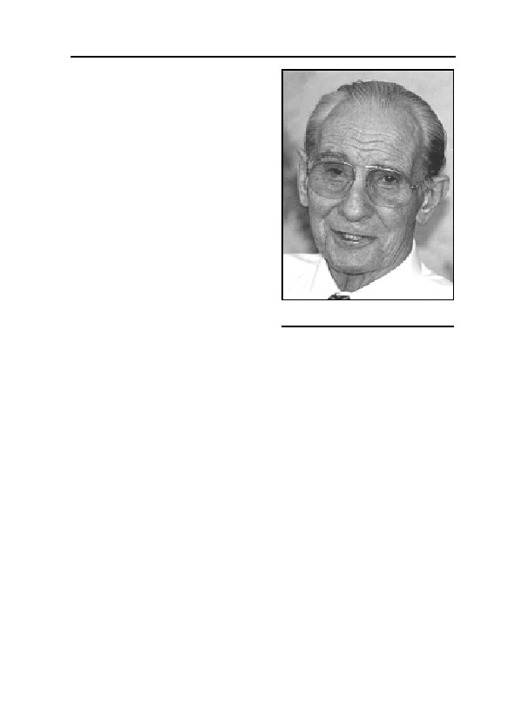
11. HUNTING GERMAR RUDOLF
Siebenbürger presiding, sentenced
me to 22 months prison without
probation. This is the equivalent of a
death sentence for me.
The trial against me was not a
real trial. The main session of the
trial ended in a deadlock. The sen-
tence was equivalent to the destruc-
tion of an 80-year old man. I was not
permitted to defend myself against
charges consisting of lies, harass-
ment, and attacks on my honor. The
court denied me the possibility of
defense by means of sec. 186 of the
German Penal Code. It refused to
put my assertions to the test of ex-
ret. Major General Otto Ernst
Remer in 1992
amination.
My defense attorney had asked the expert witness Rudolf to ap-
pear. This expert witness was in the courtroom, his expert report had
already been submitted along with other official records. However, the
expert witness was not allowed to speak and the expert report was not
allowed to be read. The expert report and irrefutable scientific facts
were denied by presiding judge Siebenbürger.
Earlier, Diplom-Chemist Rudolf had been assigned by my defense
attorney, retired Colonel Hajo Herrmann, as expert witness to investi-
gate testimony concerning alleged homicidal gassings at Auschwitz.
Rudolf used modern scientific, precise measurement techniques to es-
tablish the presence of cyanic residue.
No physical evidence has ever been presented in court to support
claims of homicidal gassings: no document, no photo, and no orders
from military or civil authorities. Can you imagine that a group of peo-
ple as large as the population of Munich could be annihilated without
leaving any traces of the crime? The only proofs of mass homicidal
gassings are absurd witness statements. In the great Frankfurt Ausch-
witz trial (50/4 Ks 2/63) the court ‘proved’ the existence of homicidal
gas chambers with the testimony of a single eye-witness, named Böck,
who reported having seen thousands of Jews killed with Zyklon B. He
testified that he “saw with my own eyes” how the prisoners’ commando
worked without any protective garment in the midst of this Zyklon B
353

GERMAR RUDOLF · THE RUDOLF REPORT
gas, still hovering in blue
clouds over the corpses, with-
out suffering ill effects. What
is the difference between
Böck’s testimony and that of
eye-witnesses who confirmed
under oath that they saw
The masonry samples taken by Rudolf
were analyzed by the renowned Institut
witches riding brooms on their
Fresenius.
way to the Blocksberg?
In a powerful and irrefutable scientific work, my expert witness
made a shattering discovery. The buildings in Auschwitz which are
pointed out to tourists as homicidal gas chambers, in which millions of
Jews were allegedly killed, never came in contact with Zyklon B. The
analyses were carried out by no less an organization than the renowned
Fresenius Institute. Notable historians agree that this research will revise
world history.
This expert report has been in the hands of the Federal Chancellor,
the Zentralrat der Juden in Deutschland (Central Council of Jews in
Germany), the Federal Attorney General, the Ministry of Justice, and
notable scientists and personalities for more than a year. Every one of
them remained as quiet as a mouse.
The condition under which my expert witness agreed to testify
was that his report should be presented only to the court. He specifi-
cally forbade me to make his report available to the public. However,
since the Auschwitz Lie has become an instrument which threatens the
existence of all Germans, I can no longer allow myself to be bound by
this condition.
I myself shall die in prison for publishing scientific facts. By
means of an unbelievably satanic twisting of history our people will be
held defenseless and “subject to extortion”, as the Association of Ger-
man Veterans wrote in its journal Soldat im Volk no. 7/8 in 1992. In
this condition of eternal abject surrender we shall be destroyed by
means of a horrifying ‘multiculturalism.’ This has forced me to a des-
perate defensive measure, which takes the form of unauthorized publi-
cation of Rudolf’s Expert Report on the alleged gas chambers of
Auschwitz.
Since 1945, generations of German politicians have not only ac-
quiesced in these ghastly lies against the German nation, they have
participated in manufacturing them. The same applies to the mass me-
354

11. HUNTING GERMAR RUDOLF
dia. These elements are doing everything they can to propagate the
most vicious lies in the history of mankind through the German crimi-
nal justice system. When the truth comes to light, these corrupt and
venal politicians know that they will be scorned by the public. The
media brotherhood know they will be reviled as liars and driven from
their posh editorial offices.
This whole pack of liars should be scorned and despised, deprived
of position and driven from their spoils fortresses for what they have
done to our people. I would like to contribute to this.
You too can help distribute this Expert Report. In the first phase of
this operation, I myself will send copies to 1,000 leading Germans.
Among them will be leaders of the military, business, scientific, and
university communities, in particular members of chemistry and his-
tory faculties. I shall send a copy to every representative in parliament
as well as media personalities.
In the second and third phases, I shall send another 1,000 copies of
this scientific report. No person of prominence will be able to say that
he did not know the truth.
These operations will be very expensive since postage alone costs
4 Marks per copy. Therefore I need your support. By ordering a copy
of the Expert Report, you will be helping help me to distribute this ir-
refutable scientific document. Additional contributions will enable ad-
ditional distribution. I am counting on your help.
Faithfully yours, Otto Ernst Remer
25th October 1992
I have added Sections I-V of the report of my trial in Schweinfurt.
After reading this report, you will understand the desperation of my
defense effort.
[Appendix]
Justice in Germany 1992:
“Death Sentence for General Remer”
This trial report by E. Haller is taken from REMER DEPESCHE no.
6/1992
355
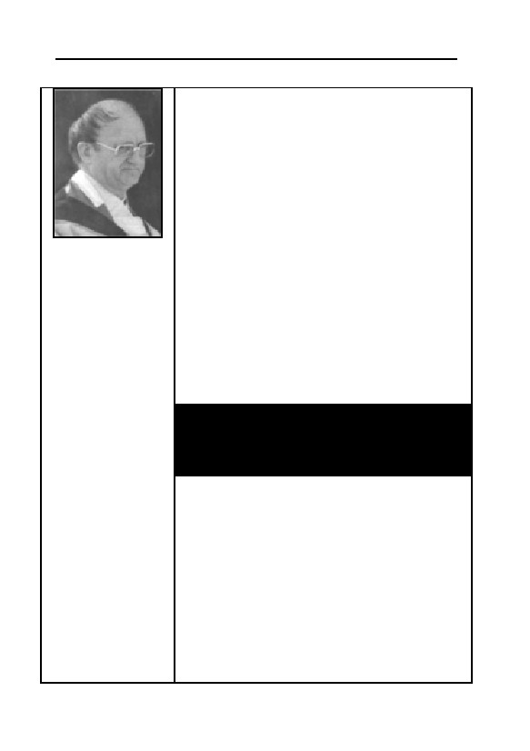
GERMAR RUDOLF · THE RUDOLF REPORT
Schweinfurt (EH) - On October 22, 1992, the First
Great Criminal Chamber of the District Court of
Schweinfurt, Judge Siebenbürger presiding, sen-
tenced General Remer for publication of a scientific
expert report. The main point of the expert report
Remer had published was: there were no mass kill-
ings in Auschwitz with Zyklon B. The court called this
publication ‘incitement to racial hatred,’ and Sieben-
bürger imposed on General Remer a sentence of 22
months imprisonment without probation. State Attor-
ney Baumann demanded a 30 months prison term
Kahlenbergerdorf
and moved for the immediate arrest of the 80-year
(Austria), the 2.6.1988,
old defendant in the courtroom. Observers of the trial
Source: Honsik, Acquittal
began to suspect that the sentence had been de-
for Hitler?
cided before the trial began. At 9:00 hours on Octo-
As a Roman Catholic
ber 20, 1992, the day the trial opened, radio
priest I say to you ... ques-
tion the existence of gas
BAYERN 1 had announced: “This time it will cost
chambers in the Third
Remer. […] this time the punishment will be harder.”
Reich. It is the right of
How did the announcer from B1 know that General
those who seek the truth
Remer would be punished more severely than in
to be allowed to doubt,
previous trials? Why was an acquittal not conceiv-
investigate and evaluate.
able?
Wherever this doubting
and evaluating is forbid-
den, wherever someone
This document is one of many that were pre-
demands that he must be
sented to the court as evidence.
believed, an arrogance
Answer: “Denied on grounds of common
arises that is a blasphemy
to God. This is why. If
knowledge.”
those whom you doubt
FOREIGN OFFICE
have the truth on their
side, they will accept any
214-E-Stuparek
questions gracefully and
answer them patiently.
Bonn , 8th Jan. 1979
They will no longer hide
Dear Mr. Stuparek!
their proofs and their re-
cords. If these are lying,
Federal Minister Genscher has asked me to respond to
they will cry for the judge.
your letter of December 21, 1978.
That is how you will recog-
nize them. The truth is
As far as I know, there were no gas chambers in the
always graceful, while lies
camp of Auschwitz ...
cry out for earthly judges.
Best regards,
Respectfully,
For the Federal Minister,
with best regards,
/s/ Dr. Scheel
/s/ Pastor Viktor Robert
Knirsch
356
11. HUNTING GERMAR RUDOLF
What had Remer done? As editor of the periodical Remer Depe-
sche, the highly-decorated front-line officer had published the results
of a number of scientific expert reports. One of them was the Leuchter
Report, which former Minister of Justice Engelhard described as “sci-
entific research”. Fred Leuchter is a constructor of execution gas
chambers that use hydrogen cyanide in the USA. Later, the Director of
the Auschwitz Museum, Dr. F. Piper, assigned the Jan Sehn Institut in
Cracow to make a similar expert report. A technical expert report in
German in conjunction with the renowned Institute Fresenius followed
in February 1992. The discussion that the General had opened up with
his publications was desired even by the Federal President. A letter
from the Presidential Office on October 23, 1989, states that von
Weizsäcker “will follow the discussion [on the Leuchter Report]
closely”. Had the Federal President lured General Remer into a trap
with this letter? Remer naturally felt that ex-Minister of Justice Engel-
hard and the Federal President had encouraged him to publish his facts.
Homicidal gas chambers that never came in contact with
gas
All three expert reports came to the same conclusion: The gas
chambers of Auschwitz and Birkenau testified to by witnesses never
came in contact with Zyklon B. In legal terms: the weapon was not
loaded. For better understanding: When hydrogen cyanide (Zyklon B)
comes into contact with concrete or stones, it forms permanent com-
pounds with traces of iron in such building material. The compound
that develops is blue (hence the German name Blue Acid (Blausäure)
for hydrogen cyanide, although the gas itself is colorless) and occurs
on the surface and within the walls exposed to gas. Today, one can eas-
ily see a massive blue dyeing on both inner and outer walls in the de-
lousing buildings. There is no such dyeing in the alleged homicidal gas
chambers. Chemical analyses of samples from the delousing buildings
show very high concentrations of cyanide, while no traces can be
found in samples from the alleged gas chambers. Scientific expert re-
ports were never produced for any of the numerous National Socialist
trials. No physical proof was ever offered.
357
GERMAR RUDOLF · THE RUDOLF REPORT
In Nuremberg, the propaganda lies of the victors were given
reference numbers. Since then they have become ‘facts.’
All courts have continually prevented all gas chamber skeptics
from use of any evidence for their scientific investigations. The courts
have taken the point of view that the homicidal gas chambers should be
regarded as commonly known ‘facts’. ‘Commonly known’ means that
the existence of homicidal gas chambers is as certain a fact as that the
day has 24 hours. The Nuremberg Military Tribunal introduced the use
of ‘common knowledge’ into judicial practice. Pure war horror propa-
ganda items from the Second World War were turned into ‘facts’
(IMT-Statutes 19 and 21) which had to be accepted without question
by the accused. Defense attorneys who attempted to prove the opposite
were threatened with the death penalty. The Stalinist massacre at Ka-
tyn was one of the charges, as well as homicidal gassings in the former
concentration camp Dachau (IMT Document 2430-PS). In Document
3311-PS, the Polish government “put the victors’ tribunal on notice”
that hundreds of thousands of Jews had been “steamed” at Treblinka.
Note: “steamed”, not ‘gassed’. Today, the Holocausters look down
shamefully when they are confronted with this nonsense. In the great
National Socialist trial before the District and Chamber Court of Berlin
(ref. PKs 3-50) it was determined: “There were no gas chamber struc-
tures in the concentration camp Majdanek”. But in Schweinfurt, Gen-
eral Remer was sentenced to imprisonment because he had published
in his Depeschen the court’s determination on the absence of gas
chambers in Majdanek.
To destroy the German people, only these words are necessary:
‘common knowledge.’
Concerning the alleged gas chambers, no one can speak of the
kind of common knowledge such as that which underlies the fact that
the day has 24 hours. Only such assertions, as that the day has 24
hours, require no proof. In all other cases there must be proof.
Remer’s proofs are new and far superior
The defense attorneys, Hajo Herrmann and Dr. Herbert Schaller,
had prepared comprehensive evidence. They prepared their evidence to
conform with a decision of the Upper District Court of Düsseldorf. In a
‘gas chamber denial’ case, this court held that evidence must be admit-
ted when it was superior to the ‘proofs’ in the former National Socialist
358

11. HUNTING GERMAR RUDOLF
Herr Judge Siebenbürger, Herr State Attorney Baumann, please
tell me which of the following figures is ‘common knowledge’.
Why have you not told the General during the trial which number
he should believe in? For which number should Remer now die in
prison?
Comparison of official figures on the number of those killed
in the gas chambers of Auschwitz:
Jul. 26, 1990: Allgemeine Jüdische Wo-
June 11, 1992: Allgemeine Jüdische
chenzeitung
Wochenzeitung
4,000,000
1,500,000
Apr. 20, 1978: French newspaper Le
Sept. 1., 1989: French newspaper Le Monde
1,472,000
Monde
5,000,000
1945: International Military Tribunal in
1985: Raul Hilberg: Die Vernichtung der eu-
Nuremberg
ropäischen Juden
4,000,000
1,250,000
1979: The Pope during his visit to
July 1990: The left-wing TAZ and other news-
Auschwitz
papers
4,000,000
960,000
April 1990: Chief State Attorney
1974: G. Reitlinger: Die Endlösung
Majorowsky/Wuppertal
850,000
4,000,000
1945: French War Crimes Investigations
1989: USSR releases death-books.
Office
Total deaths
8,000,000
66,000
1989: Eugen Kogon: Der SS-Staat
1965: Auschwitz decision 50/4 Ks 2/63.
4,500,000
including claimed gassing deaths
45,510
1989: Lie-memorial tablet in Birkenau
1965: Auschwitz decision 50/4 Ks 2/63,
removed, with number
without claimed gassing deaths
4,000,000
619
trials. New, superior evidence trumps ‘common knowledge’, according
to the Düsseldorf court. The evidence submitted by the defense is new
and far superior to that from the National Socialist trials, since there
was no physical evidence presented there.
Auschwitz: ‘Annihilation camp’ with a brothel, legal ad-
vice, sauna and soccer ...
Before the examination of the evidence that had been submitted,
attorney Herrmann addressed the State Attorney and judge: “It must be
proven, whether there were gas chambers or not, before there can be a
decision on common knowledge. The court must determine facts.” At-
torney Herrmann then presented evidence taken from anti-fascist litera-
ture and from court documents that showed that Auschwitz was no an-
359
GERMAR RUDOLF · THE RUDOLF REPORT
nihilation camp. The attorney read how there had been a brothel for
prisoners in Lager Auschwitz, that there had been weekly soccer
games between SS staff and camp inmates, that there was a central
sauna, that legal advice was available to the inmates, that in case of
non-natural death the camp administration had to notify the appropriate
State Attorney with over 30 signatures, that prisoners could be re-
leased, that SS-men were not allowed to hit prisoners, that 4,800 sick
persons were under medical care (although in the usual version, they
landed in the ‘gas chambers’ right away), and that, when the camp was
abandoned, the prisoners preferred evacuation by the SS over Soviet
‘liberation’…
The State Attorney roars
This piece of evidence made the State Attorney roar. “This piece
of evidence is an insult to the victims”, he yelled into the courtroom
with a red face. Herrmann replied, “Then your victims were insulted by
the decision in the Auschwitz trial in Frankfurt, Herr State Attorney.
Most of what I have just read are observations of the court in the great
Auschwitz trial in Frankfurt. You can read them in the decision.” At
this the State Attorney was speechless. It is peculiar, how a State At-
torney can free himself from almost any evidentiary difficulty with
only two magical words: ‘common knowledge’. He knew nothing
about the decision in the National Socialist trials and he knew next to
nothing about historical connections or physical facts. All a state attor-
ney needs in such a case is to be able to pronounce the words, “denied
on account of common knowledge.”
The court refused to accept this evidence. That is, it refused to ac-
cept whole passages from the decision in the Auschwitz trial in Frank-
furt as well as passages from the writings of ‘survivors’ such as Lang-
bein. Naturally, on account of “common knowledge”.
The English crown: no gassings
As part of the evidence he submitted, Dr. Schaller presented the
book of Jewish Princeton Professor Arno J. Mayer. In his book, Mayer
concludes that the majority of Auschwitz prisoners died of natural
causes and that there was no “Hitler order” for the ‘gassing’ of the
Jews. Mayer confirms that “proofs” for the gas chambers are “rare and
unreliable”. As evidence against the ‘common knowledge of gas
360

11. HUNTING GERMAR RUDOLF
chambers’, the attorney submitted a book by British history professor
F. H. Hinsley. Hinsley is the official historian of the English crown.
His book British Intelligence in the Second World War can be obtained
from the royal stationer’s office. There was a new edition in 1989. On
page 673, Hinsley states that from 1942 the English were able to break
the coded messages from the German concentration camps. The Eng-
lish found that the main cause of death in the camps was illness.
Hinsley reports that there were also shootings and hangings. The offi-
cial historical scientist of the English royal house states: “There was no
mention of gassings in the decoded messages.”
The State Attorney moved that this evidence, too, be refused on
account of ‘common knowledge’. One more time, the court agreed
with the State Attorney. At this point, the trial was suspended. It re-
sumed on October 22, 1992. Every time General Remer reentered the
courtroom after a pause in the proceedings, the public stood respect-
fully. Many remained sitting when the court entered, however.
An expert witness is kept out
The defense surprised the court with an evidence physically pre-
sent in the court room, the technical expert Diplom-Chemist G. Rudolf.
By the court’s rules of procedure, evidence that is physically present
can not be refused, even on account of ‘common knowledge’. The
technical expert sat in the courtroom. He had researched the alleged
gas chambers in Auschwitz from a physico-chemical point of view. He
had taken samples of mortar and had them analyzed by the Institute
Fresenius. Also he had conducted his own laboratory experiments in
which he had gassed masonry with hydrogen cyanide. The expert wit-
ness could present scientific proof that the alleged gas chambers never
came in contact with Zyklon B. The expert report prepared by the ex-
pert witness was submitted to the court with the rest of the evidence.
The expert witness could also prove that prisoner commandos could
not have “gone into blue clouds of Zyklon B still hovering over the
corpses”, without having been killed themselves. This nonsensical tes-
timony on work in the midst of clouds of Zyklon B had been given by
Richard Böck, the principal witness in the Auschwitz trial in Frankfurt.
Thus Böck was asserting that the commando had been immune to Zyk-
lon B. Yet the judge in the Auschwitz trial in Frankfurt believed that he
had proved the existence of gas chambers in Auschwitz with Böck’s
361
GERMAR RUDOLF · THE RUDOLF REPORT
statement. Böck had witnessed the gassings in two farm-houses which
never existed, according to a technical report of HANSA LUFTBILD,
which analyzed Allied air-reconnaissance photos. The expert witness
could also prove that hydrogen cyanide is a colorless poison. The ex-
pert witness was sitting in the courtroom. He could provide clarifica-
tion. What did the State Attorney have to say about that?
“I move that the expert witness be refused, since the gas chambers
are common knowledge fact”, was State Attorney’s monotonous re-
frain. He demanded that the expert witness be refused without his
technical qualifications having been examined. The court agreed with
the motion of the State Attorney and refused the expert witness, with-
out having heard a word he had to say, as “completely unsuitable evi-
dence”. In addition, the court refused to read the expert report, because
of ‘common knowledge.’
No one can see the Auschwitz death-books
Attorney Herrmann next submitted a large selection from the offi-
cial death books of Auschwitz. In 1989, these death books had been
released by the Soviet Union. These official papers documented 66,000
cases of death in minute detail. All of them are under seal at the special
effects office in Arolsen. No one is allowed to look at them. A ten
country commission, including Israel, prevents any inspection of these
documents. Recently, the journalist W. Kempkens succeeded in photo-
copying these documents in the Moscow archive. Herrmann submitted
a representative sample to the court. The defense attorney moved that
Kempkens be allowed to testify. The Holocausters keep talking about
how the old and unfit-for-work Jews were sorted out on the ‘ramp’ and
‘gassed’ immediately, so they could not have been entered in the camp
register. The death books prove the opposite. Most of the entries were
elderly men and most were Jews. The State Attorney moved that the
documents should not be admitted as evidence, since the gas chambers
are ‘common knowledge’ fact. The court agreed with the motion of the
State Attorney.
The State Attorney’s pleading
At that point, the taking of evidence was ended and the State At-
torney began his pleading. He did not need any evidence, since for him
the ‘gas chambers’ are ‘common knowledge.’ He described Remer as
362
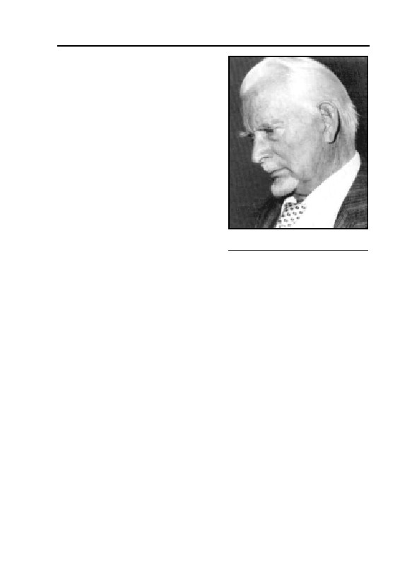
11. HUNTING GERMAR RUDOLF
Mephisto (the devil) for “denying”
what is “common knowledge.” For
such a “devil”, he argued, the abso-
lute minimum sentence should be
imprisonment for two years and six
months. He moved that the impris-
onment begin immediately.
Defense Attorney Herrmann’s
pleading
The attorney protested, “We
have submitted evidence in many
areas, but the court has never under-
taken to examine whether the ac-
Defense Attorney ret. Colonel
cused had a valid claim.” Once more
Hajo Herrmann
Herrmann discussed the denial of
evidence in connection with the ‘confession’ of the former camp com-
mander of Auschwitz, Rudolf Höß. “The court had refused to allow the
reading of Höß’s torture with the comment that it had not been proven
that Höß had made a false confession because of torture. But Höß’s
confession is false”, thundered the retired colonel, a former inspector
of Germany’s WWII night fighters, in the courtroom. “Höß confessed
3 million murdered Jews. Today Holocaust historians say the number
killed is 1.5 million”, he flung at the State Attorney and judge. Then
Herrmann read the record of the capture of Höß. It is described there
how the former commandant was thrown on a butcher bench and how
his face was smashed for hours. The Jewish sergeant shoved a guide-
lamp staff deep in his throat and dumped a whole bottle of whiskey
into his victim. His handcuffs were left on for three weeks. “That’s
what you don’t want to hear, Herr State Attorney”, the defense attor-
ney’s words rang out. Then Herrmann read relevant paragraphs from
the transfer treaty of the occupying powers. In these paragraphs, Ger-
many was forced to recognize forever the historical ‘facts’ that were
the basis of the Nuremberg trials. And so German courts still say
‘common knowledge’ to the four million Auschwitz lie, to the lie
about gassings in Dachau and the lie about “mass steamings” in Treb-
linka. Nonsense and oppression know no limit.
“I note”, said the attorney, “that the accused was denied his right.
363
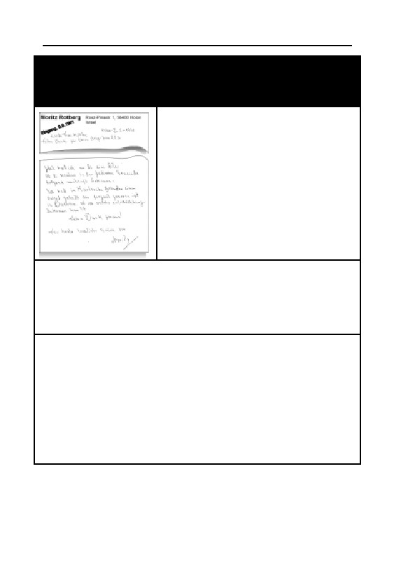
GERMAR RUDOLF · THE RUDOLF REPORT
Judge Siebenbürger and State Attorney Baumann justi-
fied themselves with this kind of witness when they yell,
“Evidence denied on account of common knowledge.”
Holon, Israel
I once had an uncle in Karlsruhe
B/Baden that was gast in Dchau. I
can get some damajes frm this??
Much thank in advans!
[misspellings in source]
This text is taken from a letter that was mailed on May 2, 1991, from
Holon/Israel to a German acquaintance with the request for help with an
application for compensation. The writer’s uncle was “gast” in Dachau
and he wanted “damajes”. For Judge Siebenbürger and State Attorney
Baumann, this served to prove that the gas chambers are ‘common
knowledge’.
Response of the City of Dachau:
City of
DACHAU
District capital
(coat of arms)
Artists' town for 1200 years
Our Ref.: 4.2/Ra/Sa
Date: 14.11.88
Dear Herr Geller!
With reference to your question, I must inform you that there were
no gassings in the former concentration camp Dachau ...
Best regards - Rahm; Director of Administration
Not only the State Attorney is bound politically. This is about an obli-
gation imposed on the state by the transfer treaty of the victorious
powers. But this treaty has no place in this court of law.”
Then he continued, “I have never before seen the public stand
when an accused enters the courtroom. Yes, the general is no turncoat,
364
11. HUNTING GERMAR RUDOLF
and that is basically what you are accusing him of.” Herrmann pin-
pointed the State Attorney’s error: “The State Attorney refuses to ac-
cept as evidence the decision of the Auschwitz trial in Frankfurt, which
counted 45,510 dead.” Herrmann hammered on the conscience of the
State Attorney, which does not exist. Then he continued, “But, accord-
ing to the State Attorney, the accused must know that 6 million Jews
were gassed.” Herrmann turned to the judge’s bench and shouts: “The
court intends to prove that the defendant acted with criminal intent,
that ‘he knows it.’”
The public realized that this great man had lived through times
where just dealing, dignity, honor, and decency were still common. A
trial like the present was very difficult for him. Once again, Herrmann
counted the denied pieces of evidence and asked, “Who in this court-
room was not well served by the defense?” Then he confronted the
State Attorney and said, “The State Attorney will try to convince the
accused that he knew that what he said was not true. Herr State Attor-
ney, you do not sit in the back of the accused’s head.”
Then the attorney said what he thought was behind the court’s—in
many people’s opinion—scandalous handling of the trial: “I believe
that there is another power that hangs over our legal system that gives
you your orders. I know that if you were to acquit, there would be a
great howling—not just here, but mostly in other countries. If you fear
this, you should decline to conduct the trial. How can you designate
even one piece of evidence as superfluous when the issue is life or
death, as it is here? You should recollect that the chief prosecutor at
Nuremberg described the victorious powers’ tribunal as a continuation
of the war against Germany. One cannot so totally destroy and plun-
der a civilized people such as the Germans without an ostensible rea-
son or pretext. Auschwitz was that pretext.
If ‘common knowledge’ does not endure forever, at what limit of
common knowledge do we find ourselves now? Yes, this ‘common
knowledge’ will collapse, but will the accused die in his prison cell
beforehand?” With that, Attorney Herrmann ended his pleading.
Dr. Schaller’s pleading
“This is a political trial of a very peculiar nature”, the courageous
Viennese attorney threw at the judge and State Attorney. “For the rea-
son that it deals with a crime of opinion, where there was no violence.
365
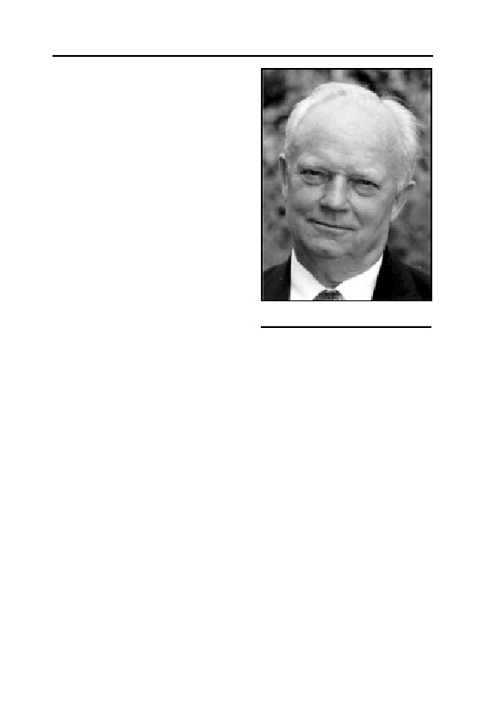
GERMAR RUDOLF · THE RUDOLF REPORT
The defenders of democracy sit on
the accuser’s bench. When a democ-
ratic state takes upon itself the
power to determine what the truth is,
it is no longer a democracy”, the
attorney admonished the State At-
torney and court.
Dr. Schaller told of a case in
Frankfurt of an African drug dealer
with a criminal history who stuck a
17 centimeter long knife into the
abdomen of a young German be-
cause the latter did not want to buy
drugs. The attorney quoted the
Frankfurter Allgemeine Zeitung
newspaper, as to how the judge in
Defense Attorney Dr. Herbert
this case would not regard the as-
Schaller
sault as attempted murder or even as
attempted manslaughter. She regarded it as a case of the African’s
merely wanting to “teach the German a lesson.” This example of jus-
tice in modern day Germany that Dr. Schaller so graphically portrayed
is reminiscent of the case of two Turks who stabbed an 18-year old
German in Berlin because the latter had blond hair. Both Turks had
already been convicted of manslaughter, yet they received probation.
For the 80-year old General Remer who published scientific papers,
the State Attorney wants the ‘death sentence’. In the waiting room,
people passed around articles from large German newspapers relating
how foreign murderers, robbers and mankillers are set free because
indictments cannot be prepared in time due to ‘shortage of staff’. Every
spectator was outraged that there was no shortage of judges to handle
the prosecution and indictment of an acknowledged national hero be-
cause of his publication of the truth. Dr. Schaller said further: “To
prosecute assertions of fact in the same way that murderers should be
prosecuted—but today no longer are—will lead to social collapse.
The state should take care that arguments are expressed in words.
The truth does not need criminal justice. The truth will prevail of its
own power”, the attorney scolded the State Attorney. The attorney fur-
ther said: “Doesn’t the State Attorney’s demand for a two and a half
year sentence for the publication of scientific knowledge smell of
366
11. HUNTING GERMAR RUDOLF
[communist east German] GDR justice? And such a thing for an 80-
year old man? Is this Bautzen? [a prison for political prisoners in for-
mer communist east Germany]” demanded Dr. Schaller. “This defense
team has introduced a plethora of evidence that supports the claims of
the accused. A plethora of proofs and expert reports that has never
been presented to any court of the victorious wartime Allies. And yet,
the Allies’ magic words from Nuremberg, ‘common knowledge’ should
still apply here?” Facing the State Attorney, Schaller asked, “Suppose
that we had a new government in Germany and this government were
to examine the manner in which you servants of the state are proceed-
ing, keeping in mind paragraphs 56 and 62 through 65 of the Basic
Law. Do you think you would escape harm from the hands of the Ger-
man people?” Then, facing the public: “Suppose the State Attorney had
to justify his charges against the General. Suppose a judge should ask
him, what proof do you have of the existence of homicidal gas cham-
bers? He would have nothing to show. But as of today, no state attor-
ney needs to produce evidence. We have not arrived at that point yet.”
Next he quoted the Jewish revisionist, Rabbi Immanuel Jakobo-
vits, who says: “Today, there is a whole spectrum of business relating
to the Holocaust Industry, with authors, researchers, museum curators
and politicians.” To the judges’ bench, Dr. Schaller hollered, “The real
threat to public order begins when one demands of the German people
that they should assume guilt for gas chamber murders.
These are dangerous perversions which construe publication of
scientific investigation of alleged gas chambers as defamation and in-
citement to racial hatred. How does the State Attorney dispute this sci-
entific evidence which the accused has published? He merely tells us
that we Germans should and must remain guilty as charged at the
Nuremberg trials following World War II. That is all.
On the other hand, defense counsel have an expert witness here in
the chamber who has produced an expert report that leaves no ques-
tion unanswered. The expert witness has come to the indisputable sci-
entific conclusion that the so-called gas chambers never came in con-
tact with Zyklon B gas. Never!”
Schaller continued, “There sits the technical expert, who is not al-
lowed to say a word. A scientist from the world renowned Max-Planck-
Institute is not allowed to testify in a German court! And you want to
send General Remer to prison? Are you willing to accept responsibility
for that?”
367
GERMAR RUDOLF · THE RUDOLF REPORT
Then, raising his voice: “The accused has the right to expect that
the court will fulfill its duty. that is, to inquire into the innocence of the
accused. This kowtowing to the victorious Allies of World War II can-
not go on forever!” With the following words tears came to his eyes:
“Why should a man be put to the sword to keep alive this mythology of
wartime propaganda? Mr. State Attorney, you should not continue be-
lieving novels that become ever more lurid with the passage of time. It
cannot go on like this, to leave one’s own people standing out in the
cold. Please allow the introduction of evidence once more.” Thus the
defense attorney closed his pleading.
The General’s closing words
“To this kangaroo court that has denied me the introduction of
scientific evidence I have only one thing to say.” General Remer
pointed at the state attorney and the judge. “Germany will one day hold
you responsible for what you have done in this courtroom.”
Resume
General Remer seems to be dangerous to the former victorious
powers because he has brought about a discussion of Auschwitz with
his scientific publications. If Remer can prove his case, the Allies will
lose their justification for having butchered and looted the German
people. The Jews will lose, as Prof. Wolffsohn says, “their only re-
maining identity-forming myth.” For these reasons, General Remer is
condemned to die in jail. This death sentence is reminiscent of other
cases of unsolved deaths such as those of Franz Josef Strauß and his
wife Marianne. First Marianne died of unexplained causes in a traffic
accident, then the fit, healthy former Minister President of Bavaria
passed away under unusual circumstances which are not medically ex-
plicable.
The Allgemeing Jüdische Wochenzeitung (German Jewish weekly
newspaper) of October 29, 1992, recalled Strauß’ goals: “The declara-
tion of Franz J. Strauß on February 1, 1987, that the Federal Republic
should come out from under the shadow of the Nazi past and begin a
new chapter in the book of history...”
The transfer treaty of the victorious powers forbids Germany to
“come out from under the shadow of the Nazi past and begin a new
chapter in the book of history”. The Allies would lose forever their
368

11. HUNTING GERMAR RUDOLF
justification for the horrendous crimes and ethnic cleansing which they
committed against Germany, and the Jews would lose their identity-
forming principle. This might endanger the existence of the state of
Israel. Are there parallels between Remer’s ‘death sentence’ and the
death of Marianne and F. J. Strauß?
11.4.2. The Second Crime: A Scientific Anthology
German Court Order: Scientific Work Must Burn!
Since the 7th of May 1995, Judge Burkhardt Stein of the County
Court of Tübingen held court on the fates of the publisher, editor, and
some of the authors of the fundamental revisionist work Grundlagen
zur Zeitgeschichte (ref. 4 Gs 173/95).570 First, the proceedings against
the authors were separated on various grounds. Next, the trial against
the editor Ernst Gauss alias Germar Rudolf was separated since the
accused was not present at the proceedings. For that reason, Judge
Stein issued an arrest warrant against Rudolf.
During the trial, the public attorney and the judge accused the pub-
lisher Wigbert Grabert that the incriminated book would meet the test
for the crime of inciting to racial hatred in that it used a number of
Holocaust denying adjectives such as “supposed”, “presumed” and
“so-called”. In order to show that the book had scientific merits, the
defense attorney insisted that while reading certain passages from the
book, one needed to consult the comprehensive and detailed footnotes
that it contained, which made reference mostly to books of establish-
ment sources. The judge merely turned toward Susanne Teschner, the
public attorney, and answered that the court would not think out loud
during the trial. The court denied numerous motions of the defense for
recourse to relevant expert reports or for access to court records that
might show that the words “supposed”, and so forth, did not per se
constitute an intentional denying.
The court also denied two motions of the defense to suspend the
trial on grounds that in this trial there was theoretically no possibility
that the judge would acquit the accused, because in such a case the
judge himself might encounter social harassment or even criminal re-
prisal from the judicial system, as the case of Judge Orlet in the trial
369
GERMAR RUDOLF · THE RUDOLF REPORT
against the revisionist Günter Deckert had shown.
Several days after the beginning of the trial, the expert witness Dr.
Joachim Hoffmann was interrogated as to whether the book Grundla-
gen zur Zeitgeschichte was scientific. Dr. Hoffmann, for decades a his-
torian in the Militärgeschichtliche Forschungsamt (Military History
Research Department) of the German Bundeswehr in Freiburg, wrote
an expert report on request of the defendant Germar Rudolf (see be-
low).
During his interrogation, the expert witness stated that terms such
as “presumed” or “supposed” did not please him, yet he did not con-
sider that they put the scientific merit of the book in question.
The public attorney’s pleading was next. The phrases in the book
that offended her most—“supposed annihilation camp”, “Auschwitz
bludgeon”, “Holocaust religion”, “identity-forming group fantasies”,
“supposed genocide”, “established Holocaust scene”, “lead ad absur-
dum”—although taken partly from established publications, deny the
National Socialist murder of Jews and therefore qualify as incitement
to racial hatred. According to the public attorney, the expert witness
Dr. Hoffmann was no more competent to judge whether the book was
scientific than a judge or a state attorney is, and his expert report
should therefore be disregarded. The publisher Grabert should be sen-
tenced to 9 months prison on probation.
On the last day of the trial, held on a Saturday(!),582 June 15, 1996,
in his pleading the defense attorney referred to the denunciations of the
public attorney, whereby the book was allegedly a pseudoscientific
hack-job of the vilest sort, saying that this sort of speech was “pseudo-
legal browbeating” without content or definition. The defense pointed
to the high degree of scientific expertise that had been necessary to
produce the book and also to the fact that the expert witness had unre-
servedly confirmed the book’s scientific quality. He also pointed out
that sec. 130 para. 3 of the German Penal Code (StGB, incitement to
racial hatred) was unconstitutional when it served to deliver proven
scientific publications up to book-burning.
The judge sentenced the publisher Grabert to pay a fine of DM
30,000 ($15,000) and ordered the seizure—in effect, the burning—of
all copies of Grundlagen zur Zeitgeschichte as well as all materials
needed to produce it. In the written verdict, he stated that although
582
In Germany, courts of law do not hold sessions on Saturdays—with this exeption.
370

11. HUNTING GERMAR RUDOLF
parts of the book had scientific merit, phrases such as “supposed”,
“presumed”, “burnt sacrifice of the Jews”, “imputed systematic na-
ture”, “furious fantasies”, although partly drawn from citations of es-
tablished personages, denied the Holocaust and therefore qualified as
the crime of incitement to racial hatred.
A Historian’s Expert Report
Joachim Hoffmann was born on December 1, 1930, in Königs-
berg, East Prussia. Since 1951, he initially studied natural sciences, but
later changed to study modern history, eastern European history, and
comparative ethnology at the University of Hamburg and the Free
University of Berlin. He ended his studies with a PhD degree in
1959/1960. In the same year, he became Academic Director at the
Militärgeschichtliche Forschungsamt, the official historical research
institute of the German Armed Forces. He stayed in this position until
he retired in 1995, more and more specializing on the German-Soviet
war of 1941-1945. He has published numerous articles and books and
won several cultural awards. Dr. Hoffmann died in February 2002. The
following is the text of his expert report written in defence of Germar
Rudolf and his anthology Grundlagen zur Zeitgeschichte (Dissecting
the Holocaust).583
Preamble
Accredited chemist Germar Rudolf has written me to request an
expert statement regarding an anthology titled Grundlagen zur Zeit-
geschichte: Ein Handbuch über strittige Fragen des 20. Jahrhunderts
(Foundations on Contemporary History. A Handbook of Points at Issue
of the 20th Century), edited by Ernst Gauss and published in 1994 by
Grabert-Verlag in Tübingen, Germany. The foremost issue was to be
the question of the work’s scientific, i.e., academic nature, rather than
the content per se.
As a historian specializing in recent and East European history, and
on the basis of my decades of professional experience and practice in the
academic service of the Federal Republic of Germany, I am qualified
and entitled to give an expert opinion on the matter in question.
583
Also published in E. Gauss (ed.), op. cit. (note 22), pp. 561-564.
371
GERMAR RUDOLF · THE RUDOLF REPORT
Regarding my personal qualifications, I wish to state that I was a
member of the Militärgeschichtliche Forschungsamt (Military History
Research Department) in Freiburg from 1960 to 1995. For almost three
decades, my work has focused exclusively on matters related to the
German-Soviet war. Through the publication of academic books and
periodical articles on this topic I am well established as an expert in
my field, both at home and abroad. Accredited chemist Rudolf and the
co-authors of the anthology at issue are not personally known to me.
The Formal Aspect
As pointed out in the anthology in question, the book does not of-
fer a comprehensive overview of the course of the National Socialist
persecution of the Jews during World War Two. Rather, the focus is on
specific individual topics regarding disputed and controversial aspects
of killings of the Jews. The various contributions to the book are ex-
pertly written in a predominantly investigative style. Where detail and
completeness are concerned, the body of supporting and documenting
references leaves little to be desired and is extremely helpful to a
reader seeking further information, not least of all since sources from
the opposing subject literature are also cited without reservation. It ap-
pears, therefore, that this anthology is part of the large-scale academic
dispute over a serious contemporary issue which reaches far beyond its
actual academic scope and into the political realm.
The individual contributions to this anthology are logically consis-
tent and objectively descriptive in structure, even though at times a
polemical note does become evident—as is perhaps inevitable in such
emotionally charged topics, and as is also quite common in political
and historical controversies. In any case, a striving for new understand-
ing is tangibly apparent throughout the book. From this perspective,
therefore, the anthology cannot be denied an academic character, par-
ticularly if one compares it with many a publication from its opposing
side, whose academic nature is also never questioned. There is much in
the various contributions that strikes one as thoroughly convincing.
Much else may be merely noted with objective interest. Elsewhere,
doubts and criticisms also come to mind. The issue may perhaps be
simplified by pointing out that what we are dealing with in this great
controversy is a rather more accusatory style of literature on the one
hand, and a rather more apologetic one on the other. This is to suggest
372
11. HUNTING GERMAR RUDOLF
that in the heat of controversy, both sides may be overly inclined to
overshoot the mark and to leave the solid ground of provable facts be-
hind. One might perhaps summarize by saying that the time for conclu-
sive declarations regarding the great persecution of the Jews has not
yet come.
The Problem of Self-Evidentness
There can be no doubt about the fact that genocide was committed
against the Jewish people by the Einsatzgruppen of the Security Police
and the SD and by the SS personnel in charge in the concentration
camps in the former General Government of Poland. Hitler, Himmler
and Dr. Goebbels clearly admitted these misdeeds on several occa-
sions. The anthology’s editor, Ernst Gauss, also considers this as given
in his chapter. And in fact, the genocide provides an unspoken back-
drop for the anthology at issue. To rule out any misunderstanding, it
would perhaps have been better to spell these things out unambigu-
ously and to clarify that an academic controversy today can no longer
dispute the mass killings per se, but rather only the numbers of victims
and the methods of murder. In this respect, we admittedly may expect
to see far-reaching modifications as yet. In this context as well, the
rather overused concept of self-evidentness is in need of limitation, or
at least of a more precise definition.
Two Important Examples
We shall give two especially significant examples of this.
1) From 1945 to 1990, the figure of 4 million victims in Ausch-
witz was considered self-evident and was accorded judicial notice in
the Federal German courts. But where did this figure come from? It
originated with Soviet war propaganda. On March 1, 1945, an official
Soviet announcement stated for the first time that “at least five million
people were exterminated” in Auschwitz. This figure was then reduced
to four million in the official Soviet communiqué of May 7, 1945. This
number of 4 million victims—put about by Soviet war propaganda, in
other words by the NKVD, and in no way proven by any evidence
whatsoever—was adopted by the public in western countries, and per-
sisted unchanged until 1990, when it was officially reduced to 1.5 mil-
lion virtually overnight. Currently the number of Auschwitz victims is
set at a remaining 631,000 to 711,000, and a further reduction has not
373
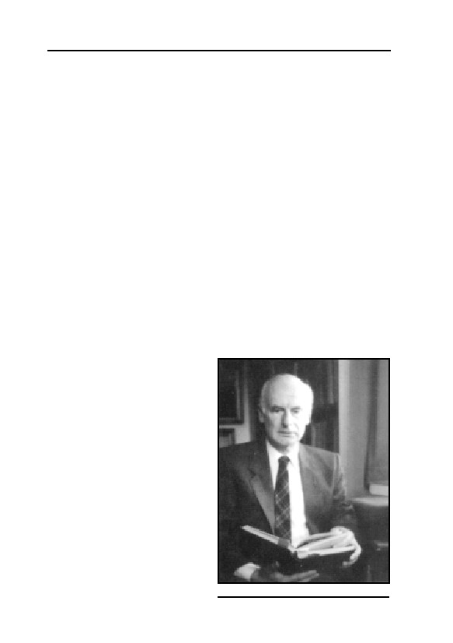
GERMAR RUDOLF · THE RUDOLF REPORT
been ruled out.
2) To this day the total number of Jewish victims is generally
given as 6 million. According to the current opinion of the German
experts on contemporary history, this figure was first provided to the
Americans by SS Sturmbannführer Dr. Hoettl in spring 1945, and re-
peated at the IMT in Nuremberg on November 26, 1945. It must be
noted, however, that this selfsame figure was demonstrably first put
forth in the foreign press as early as January 4, 1945, several weeks
prior to the January 27, 1945 liberation of the Auschwitz concentration
camp (with its alleged 4 million victims)—put about by none other
than the infamous Soviet Minister of Propaganda, Ilya Ehrenburg.
Thus it was Ehrenburg who came up with the figure of six million. [cf.
Joachim Hoffmann, Stalins Vernichtungskrieg 1941-1945, 5th ed., Her-
big, Munich 1999, pp. 182ff.; Engl.: Stalin’s War of Extermination
1941-1945, Theses & Dissertations Press, Capshaw, AL, 2001, pp.
189f.]
Regarding Ehrenburg himself, it must be mentioned that in 1941
Stalin had given him the general order to incite a boundless national
and racial hatred against all Germans. Ehrenburg’s years-long unbri-
dled frenzies of hatred culminated in his call to “put an end to Ger-
many” and in an effort which he described as “modest and honorable”,
namely “to reduce the popula-
tion of Germany”, towards which
end the only thing left to decide
was whether it would be better
“to kill the Germans with axes or
with clubs”.
Both examples show that
new evidence can immediately
overthrow something that is al-
legedly self-evident, and, accord-
ingly, it is the duty of any con-
temporary historian to call alleg-
edly conclusive findings into
question. Even in matters involv-
ing grave charges, the principle
of self-evidentness has been
known to become invalidated.
As an example one need only
Dr. Joachim Hoffmann
374
11. HUNTING GERMAR RUDOLF
consider the claim (widely accepted in Germany in particular, but now
denied by Yad Vashem itself) that the Germans had manufactured soap
from the bodies of murdered Jews—a fabrication that also goes back to
Soviet war propaganda. Therefore, the anthology at issue here does not
commit anything unlawful, but rather engages in a justified and neces-
sary pursuit in its attempt to critically examine allegedly self-evident
issues on the basis of new evidence or findings, as it is in fact the natu-
ral task of historiography to do.
The Problem of Eyewitness Testimony
Several contributions to this anthology point out, and rightly so,
that the testimony of eyewitnesses is unreliable; these contributions
back their claims with numerous examples, some of which are indeed
truly grotesque. Such experiences certainly agree with those of other
historians of the Second World War. This is not to say that eyewitness
statements are entirely superfluous, but practical experience definitely
has shown that they must always be examined and corroborated with
authentic documents. My personal experience has been that as early as
1970 eyewitness testimony about details of the events of the war was
so unreliable that it would have been a breach of professional duties to
base a historical treatise on them alone.
Benz’s Anthology
On the whole, the contributions to the anthology here at issue fre-
quently manifest a profound understanding of the subject and its asso-
ciated literature, even though some suggestions made do appear ques-
tionable at times. However, the Establishment literature about the
Holocaust also often contains factual errors. One example in this con-
text is Benz’s 1991 anthology Dimension des Völkermords, which dis-
plays a downright disarming ignorance of the state of affairs on the
Soviet side. The authors of the Gauss anthology object, and correctly
so, that Benz bases his studies uncritically on the announcements made
by Soviet war propaganda and on the publications about Soviet show
trials. The anthology edited by Benz attempts, by means of elaborate
statistical minutiae, to prove the correctness of the six-million figure.
Anyone who has worked with demographic statistics knows what seri-
ous errors can enter into such complex analyses even under a strictly
objective agenda. Benz is entirely unaware that Ehrenburg had already
375
GERMAR RUDOLF · THE RUDOLF REPORT
introduced the six-million figure into the annals of war propaganda on
January 4, 1945. Thus, he will have to accept the charge that, though
unwittingly, he has really only worked to confirm a propaganda figure
of Ehrenburg’s. From this perspective, his and his co-authors’ research
findings offer a foothold for fundamental criticism.
Babi Yar
The mass execution of Jewish inhabitants of Kyiv, known as the
massacre of Babi Yar, is also subjected to justified and necessary criti-
cism in the anthology here at issue. Over time, the actions of Einsatz-
kommando 4a of the Security Police and the SD under Blobel have
experienced propagandistic inflation to the point where restoring the
actual facts to their real dimensions is an obligation for anyone striving
for historical veracity. Of course this does not impinge on the fact that
thousands of Jews were killed in Kyiv.
Overall Impression
The overall impression evoked by this anthology edited by Gauss
is that its contents must be acknowledged—with critical common
sense, of course—no less than is always undisputedly and unrestrict-
edly done with the ‘official’ literature about the Holocaust. The princi-
ple of audiatur et altera pars [let the other side be heard] must apply in
this case as well! A suppression of this carefully documented work
would represent a forcible obstruction of the legitimate striving for
scientific and academic understanding. The state of knowledge is never
static. Experience has shown that exaggerations and errors always
grind themselves down in the course of a normal academic contro-
versy. One must not deny a mature and free researcher and reader his
ability to exercise his critical faculties. It would then be only a small
step from suppressing unpopular books, to burning them; and then,
though with different motivations, we would be right back where the
entire misfortune began.
Conclusion
As historian officially commissioned by the Militärgeschichtliche
Forschungsamt I have spent two-and-a-half decades studying the So-
viet military literature about the history of the Red Army and the Sec-
ond World War in its original documentary texts—an endless chain of
376

11. HUNTING GERMAR RUDOLF
misrepresentations, fabrications, distortions and slander. But even this
historical literature turned up the occasional truths. I could not have
carried out my academic duties if I had rejected the Soviet publications
out-of-hand as being unacademic. The same goes infinitely more for
the anthology here at issue, which is on a respectable academic level
and which doubtless contributes much to our understanding of aspects
of the war, despite any reservations one may have.
[sgd.] Dr. J. Hoffmann, Acad. Director (retired)
[written on September 28, 1995]
On June 15, 1996, judge Burkhardt Stein from Tübingen County
Court ordered the confiscation and incineration of all books Grundla-
gen zur Zeitgeschichte and all means for its manufacturing (Ref. 4 Gs
173/95). The expert reports presented by the defense were ignored.
11.4.3. More Thought Crimes…
Since I fled my home country in early 1996, many more criminal
prosecutions were started for publications I authored, edited, pub-
lished, or distributed, and keep authoring, editing, publishing, and dis-
tributing. The following list contains cases where such proceedings
came to my knowledge. Since distributing literature banned by the
German Federal Review Office for Youth-Endangering Publications
(Bundesprüfstelle für jugendgefährdende Schriften) is a criminal of-
fense in Germany, and each confiscation of literature by a German
court is accompanied automatically by criminal prosecution against
those who authored, edited, published, distributed, printed, imported,
exported, stored or otherwise made available the confiscated literature,
each of the following cases is considered to be a crime under the tough
German thought crime legislation. One must therefore assume that
each of the following cases may result in at least one criminal proceed-
ing against me. Finally, I have added a list of works published by me
for which it is unknown if any criminal proceedings were started. Since
the content of these publications is comparable to the other publica-
tions listed here, it must be expected that in any of these cases criminal
investigations have been or will be started.
377
GERMAR RUDOLF · THE RUDOLF REPORT
1.
In 1994, the State Prosecution Office of Böblingen confiscated the
following books written by Germar Rudolf. It is likely that Ru-
dolf’s ongoing distribution of these publications since 1994—both
in printed form as well as online—led to further criminal proceed-
ings against him (County Court Böblingen, 9 Gs 521/94):
– Rüdiger Kammerer, Armin Solms (ed.), Wissenschaftlicher Erd-
rutsch durch das Rudolf Gutachten, Cromwell Press, London
1993.
– Manfred Köhler, Prof. Dr. Ernst Nolte: Auch Holocaust-Lügen
haben kurze Beine, Cromwell Press, London 1994.584
– Wilhelm Schlesiger, Der Fall Rudolf, Cromwell Press, Brighton
1994.585
2.
In 1996, the County Court Munich ordered the confiscation and
destruction of the issue 6/1995 of the periodical Staatsbriefe, (Cas-
tel del Monte, Munich), because of an article authored by Germar
Rudolf (County Court Munich, 8440 Ds 112 Js 10161/96)586
3.
In 1996, the County Court Berlin Tiergarten ordered the confisca-
tion and destruction of the issues 2 and 3/1995 of the periodical
Sleipnir, (Castel del Monte, Munich), because of an article au-
thored by Germar Rudolf (County Court Berlin-Tiergarten, 271 Ds
155/96)587
4.
During a search of his property in March 1997, the Judge Dr.
Payer of County Court Böblingen orders the search of a German
PO Box used by Germar Rudolf, and its formal owner, because of
a prosecution launched against Germar Rudolf for disseminating
revisionist literature via the Internet address www.codoh.com,
where this PO Box is given as a contact address (County Court
Böblingen, ref. 9(8) Gs 228/97).
5.
In 1997, the County Court Weinheim ordered the confiscation and
584
Online: www.vho.org/D/Nolte; no Engl. version available.
585
Online: www.vho.org/D/dfr; Engl.: www.vho.org/GB/Books/trc
586
“Naht ein deutscher Bürgerkrieg?”, Staatsbriefe 6(6) (1995), pp. 6-8, online German only:
www.vho.org/D/Staatsbriefe/Rudolf6_6.html.
587
G. Rudolf and J. Markiewicz, W. Gubala, J. Labedz, “Briefwechsel”, Sleipnir, 1(3) (1995) pp.
29-33; online: www.vho.org/D/Kardinal/LeuchterR.html; Engl.:
www.vho.org/GB/Books/cq/leuchter.html; G. Rudolf, “Kein Brief ins Gefängnis?”, Sleipnir
1(2) (1995), not online. The criminal investigation against me in that case, Public Attorney’s
Office I in the District Court of Berlin, ref. 81 Js 1385/95, was dropped on March 21, 1996,
under sec. 154 German Penal Procedure Rules (StPO), because the expected punishment
“would not carry much weight” in comparison to the one expected from the District Court of
Stuttgart in my first “thought crime” trial.
378
11. HUNTING GERMAR RUDOLF
destruction of the book formally edited by Herbert Verbeke, but
factually written and published by Germar Rudolf, Kardinalfragen
zur Zeitgeschichte (Cardinal Questions of Contemporary History),
Vrij Historisch Onderzoek, Berchem 1996 (County Court Wein-
heim, ref. 2 Ds 11 Js 5428/97)588
6. In 1997, the County Court Böblingen ordered the confiscation and
destruction of the book edited by Rüdiger Kammerer, Armin
Solms, and authored by Germar Rudolf, Das Rudolf Gutachten,
Cromwell Press, London 1993 (County Court Böblingen, ref. 9(8)
Gs 228/97)589
7. In 1997, the County Court Böblingen ordered the confiscation and
destruction of the book formally edited by Herbert Verbeke, but
factually edited and co-authored by Germar Rudolf under the pen
names Ernst Gauss and Manfred Köhler, Auschwitz: Nackte Fak-
ten, Vrij Historisch Onderzoek, Berchem 1996 (County Court
Böblingen, ref. 9(8) Gs 228/97).590 On April 8, 1999, the German
Federal Review Office for Youth-Endangering Publications put
this book on its list of prohibited literature (Bundesanzeiger No.
81, April 30, 1999)
8. On December 2, 1997, the German Federal Review Office for
Youth-Endangering Publications informs the publisher of the
journal Vierteljahreshefte für freie Geschichtsforschung (Quarterly
for free Historical Research), formally Herbert Verbeke, but factu-
ally Germar Rudolf, that it is going to put the issues one and two
of the year 1997 on its list of prohibited literature.591
9. On May 12, 1998, the German Federal Review Office for Youth-
Endangering Publications informs the formally responsible per-
sons of the website www.vho.org, Herbert Verbeke, but factually
and since summer 1998 even formally Germar Rudolf, that it is
going to put the entire content of this website on its list of prohib-
ited literature. (Ref. No. BPjS, Pr. 273/98 UK/Schm)592
10. On August 25, 1998, the Office of State Prosecution in Munich I
informs the publisher of the journal Vierteljahreshefte für freie
588
Online: www.vho.org/D/Kardinal; Engl.: www.vho.org/GB/Books/cq
589
Online: www.vho.org/D/rga; Engl.: to be posted soon at www.vho.org/GB/Books/trr.
590
Online: www.vho.org/D/anf; Engl.: www.vho.org/GB/Books/anf
591
Online: www.vho.org/VffG/1997/1/1_97.html and www.vho.org/VffG/1997/2/2_97.html
(German).
592
See the transcript of this document at www.vho.org/censor/BPjS_vho.html (German).
379
GERMAR RUDOLF · THE RUDOLF REPORT
Geschichtsforschung (Quarterly for free Historical Research),
formally Herbert Verbeke, but factually Germar Rudolf, that
criminal proceedings have been started against them for an article
published in the issue 1/1998 of this journal, dealing with the
ground water table in the region of the former concentration camp
Auschwitz-Birkenau (Staatsanwaltschaft Munich I, ref. 112 Js
11282/98)593
11. On January 12, 1999, the German Federal Review Office for
Youth-Endangering Publications informs the publisher of the
journal Vierteljahreshefte für freie Geschichtsforschung (Quarterly
for free Historical Research), formally Herbert Verbeke, but factu-
ally Germar Rudolf, that it put the issues three and four of the year
1997 on its list of prohibited literature (Ref. No. 5490 (V)).594
12. On March 30, 1999, the County Court Munich ordered the confis-
cation and destruction of the issue 2/1998 of the journal Viertel-
jahreshefte für freie Geschichtsforschung (Quarterly for free His-
torical Research), published by Germar Rudolf, and informs him
that criminal proceedings were initiated against him.595 Reason for
this were mainly two articles dealing with the concentration camp
Majdanek596 and with microwave delousing facilities in the con-
centration camp Auschwitz597 (County Court Munich, ref. 812 Gs
16/98).
13. On January 5, 2000, the German Federal Review Office for
Youth-Endangering Publications informs the publisher of the book
KL Majdanek. Eine historische und technische Studie (Concentra-
tion Camp Majdanek. A Historical and Technical Study) , Germar
Rudolf, that it put this book on its list of prohibited literature.
(Ref. 5715(V), Bundesanzeiger No. 20, Jan. 29, 2000)598
593
Online: www.vho.org/VffG/1998/1/GaeRad1.html; Engl.: www.vho.org/GB/
c/WW/GroundWater.html.
594
Online: www.vho.org/VffG/1997/3/3_97.html and www.vho.org/VffG/1997/4/4_97.html
(German).
595
Online: www.vho.org/VffG/1998/2/2_98.html (German).
596
A review of the later confiscated book on the same topic, see next.
597
Hans Jürgen Nowak, “Kurzwellen-Entlausungsanlagen in Auschwitz”, Vierteljahreshefte für
freie Geschichtsforschung 2(2) (1998), pp. 87-105; online:
www.vho.org/VffG/1998/2/Nowak2.html; Engl.: in E. Gauss (ed.), Dissecting the Holocaust,
Theses & Dissertations Press, Capshaw, AL, 2000, pp. 331-324 (online:
www.codoh.com/found/found.html).
598
Authored by Jürgen Graf, Carlo Mattogno, Castle Hill Publishers, Hastings 1998; online:
www.vho.org/D/Majdanek; English to follow soon.
380
11. HUNTING GERMAR RUDOLF
14. On April 19, 2000, the police of Baden-Württemberg confiscated
and destroyed all copies available of the book Vorlesungen über
Zeitgeschichte (Lectures on Contemporary History), authored by
Germar Rudolf under the pen name Ernst Gauss, as ordered by the
County Court Tübingen (County Court Tübingen, ref. 4 Gs
312/2000).599
15. Criminal investigation so far unknown, but most likely: J. Graf, C.
Mattogno, Das Konzentrationslager Stutthof und seine Funktion in
der nationalsozialistischen Judenpolitik, Castle Hill Publishers,
Hastings 1999.600
16. Criminal investigation so far unknown, but most likely: J. Graf,
Riese auf tönernen Füßen. Raul Hilberg und sein Standardwerk
über den “Holocaust”, Castle Hill Publishers, Hastings 1999.601
17. Criminal investigation so far unknown, but most likely: Viertel-
jahreshefte für freie Geschichtsforschung (Quarterly for free His-
torical Research), all issues since 3/1998 (four each year).602
18. Criminal investigation so far unknown, but most likely: Ernst
Gauss (ed.) (i.e., Germar Rudolf), Dissecting the Holocaust. The
Growing Critique of ‘Truth’ and ‘Memory’, Theses & Disserta-
tions Press, Capshaw 2000.597
19. In August 2002, a customer of mine made me aware of the fact
that criminal proceedings were started against him because he had
ordered ten copies of the German version of this book, Das Rudolf
Gutachten, Castle Hill Publishers, Hastings 2001.603 This means
that distributing this book in Germany is considered a crime, so a
criminal investigation must have been started against me because
of this book.
20. Criminal investigation so far unknown, but most likely: C.
Mattogno, J. Graf, Treblinka. Durchgangslager oder
Vernichtungslager? (Treblinka. Transit Camp or Extermination
Camp?), Castle Hill Publishers, Hastings 2002.604
Each of these crimes, which are doubtlessly covered by the First
Amendment of the US Constitution, can be punished with up to five
599
Online: www.vho.org/D/vuez (German only).
600
Online: www.vho.org/D/Stutthof/index.html.
601
Online: www.vho.org/D/Riese/index.html.
602
Cf. online: www.vho.org/VffG/index.html.
603
Online: www.vho.org/D/rga2/index.html.
604
Online: www.vho.org/D/Treblinka/index.html.
381

GERMAR RUDOLF · THE RUDOLF REPORT
years in prison in Germany. Would I surrender to the German authori-
ties, I might well face some 10 years in prison for my entirely and ac-
knowledged scientific writings and for my internet fight against Ger-
man censorship, to which I have devoted parts of my website
www.vho.org, which offers all the literature banned and confiscated by
German authorities, as long as it does not promote pornography or vio-
lence.605
605
See online: www.vho.org/censor.
382
11. HUNTING GERMAR RUDOLF
11.5. The Media and the Case of Germar Rudolf
The Object of Zeal606
When in spring 1992 Germar Rudolf sent out the first draft of his
“Expert Report on the Formation and Detectability of Cyanide Com-
pounds in the ‘Gas Chambers’ of Auschwitz” to a narrow circle of re-
cipients in science and politics, several historians responded with inter-
est. The media, however, received no notice of the existence of the re-
port. Only in spring 1993, when retired Major General Otto Ernst
Remer took a later draft of the expert report, provided it with a peppery
political preface, and then sent some 1,000 to 2,000 copies to the me-
dia, public attorneys, politicians, and scientists, did a certain circle of
the Establishment learn of the existence of this report.
The press was quiet, except for two short articles that appeared on
May 8/9 and 13, 1993, in the Wiesbadener Kurier reporting on the em-
barrassment the expert report had caused to the chemical analysis Insti-
tute Fresenius hired by Rudolf, located in Taunusstein near Wiesbaden,
and an announcement in the Märkische Allgemeinen of May 14, 1993,
that a certain Prof. L. Bisky had filed a criminal complaint. Finally, in
spring 1994, when the Labor Court heard the case between Rudolf and
his former employer, the Max-Planck-Institute for Solid State Research
at Stuttgart, which ended with a compromise, the dpa (German Press
Agency) issued a press release that appeared in many newspapers and
even on the radio. That prompted the ARD (German Public Broadcast-
ing) television program Report to make a witch-hunt broadcast.
In the regional press of the Stuttgart area, where Rudolf resided at
that time, there appeared mostly factual police notices, reporting that
the State Security Department of the Criminal Police of Baden-
Württemberg607 for various reasons had ordered house-searches (Sep-
606
Appeared in Staatsbriefe 2-3/1996, Verlag Castel del Monte, Postfach 14 06 28, 80456 Mu-
nich, pp. 23-30.
607
The uninitiated reader may be unaware that in Germany there is a division of the Criminal
Police called the State Security Department which prosecutes politically motivated crimes.
This department, by far the largest of the criminal offices, has separate areas for right-wing
extremist, left-wing extremist, and foreign-influenced political crimes, respectively. Those
employed in one department tend to have a political opinion hostile to their target group. For
example, those in the right-wing extremist department tend to have left-wing, anti-fascist ori-
383
GERMAR RUDOLF · THE RUDOLF REPORT
tember 30, 1993,608 August 18, 1994,609 and March 27, 1995610). How-
ever, the headlines were occasionally ridiculous. For example, the
headline “Nazi book depot in Steinenbronn” appeared in the Böblinger
Boten of March 29, 1995. In fact, there were neither Nazis, Nazi mate-
rial nor a book depot in Rudolf’s home.
The authorized version of the expert report was published in
summer 1993 in Great Britain with the title Das Rudolf Gutachten and
has been distributed and sold in Germany since then.611 There has been
no echo about this version in the media.
The media showed increased interest, when the 17th State Security
Chamber of the Stuttgart District Court began the criminal investiga-
tion against me on account of suspicion of participation in the prepara-
tion and distribution of Remer’s commented version of my report.
However, they were not interested in the Expert Report nor in me, but
merely in the question, whether there should be made an example “to
punish the right-wing” for reasons of public instruction.
The trial proceedings did not center upon the actual contents of my
expert report, but on Remer’s political commentary and my (alleged)
political views. This was despite the fact that prosecutions for dissent-
ing political views are forbidden according to the German constitution
(cf. article 3.3. of the German Basic law). They have a strong tendency
to turn into show-trials, and this is exactly what happened in this case.
Later on, several of the media reports that were published in the
course of the hubbub over the Rudolf expert report and its author at-
tempted to critically evaluate how true—or rather how false—this ex-
pert report was.
On March 28, 1994, the Max-Planck-Gesellschaft (MPG, M.-P.-
Corporation), umbrella organization of some 200 Max-Planck-Insti-
tutes all over Germany and Austria—I had been a PhD student at one
entations. In addition, the German Federal court system includes State Security Chambers
whose only work is to punish politically motivated crimes. The prosecutors who work in these
courts were politically trained to deal with such crimes.
608
This house search concerned the commented version of my expert report distributed by
Remer.
609
This house search was due to suspicion of participation in the production and distribution of
the newsletters Remer Depesche and Deutschland Report. (See
http://www.nationaljournal.org)
610
This house search concerned the revisionist anthology edited by my under the pseudonym
Ernst Gauss entitled Grundlagen zur Zeitgeschichte. op. cit. (note 43); Engl.: Dissecting the
Holocaust, op. cit. (note 22).
611
R. Kammerer, A. Solms (ed.), op. cit. (note 43).
384
11. HUNTING GERMAR RUDOLF
of them—issued a press release on my expert report. They reported on
internal measures taken by my former employer, the Max-Planck-
Institute for Solid State Research in Stuttgart, against me. The MPG
made it clear that since they agreed with the German Federal Constitu-
tional Court and the Federal Supreme Court as to the commonly
known fact of the Holocaust, they would not involve themselves in the
discussion of the issues raised by my expert report.
The Expert Opinion of the dpa – Invented from Whole
Cloth
The news release of the dpa Press Bureau Stuttgart which ap-
peared the following day in almost all German newspapers and also on
the radio contained the following passage: 612
“According to their spokesman, the Max-Planck-Corporation has
no proof that the samples are really from Auschwitz. Even if they are
from there, according to expert opinion, it is certainly no wonder that no
traces of hydrogen cyanide were found, because cyanide compounds dis-
integrate quickly. In earth this takes six to eight weeks and in stone they
can only be preserved by “absolute conservation conditions, including
complete exclusion of air and bacteria”.
Of course, the Max-Planck-Corporation had no evidence about the
origin of the samples, since they did not ask me for any and I had no
reason to give them any without having been asked. This is nothing
else but a clumsy diversion from the main question. And by the way: if
this topic is important to anybody, no one is prevented from verifying
the results of my expert report and the test results of others as dis-
cussed in chapter 8.
On inquiry about the supposed expert opinion about the instability
of cyanide compounds, Albert Meinecke, the person at dpa apparently
responsible for the notice, referred first to the press statement from the
MPG.613 After it was shown to Meinecke that the statement contained
no comment on the factual content of the expert report, nor any com-
ment on the stability or presence of cyanide compounds,612 he made
various claims, depending on the caller and the time of the call:
612
Daily newspapers, such as Süddeutsche Zeitung, Stuttgarter Zeitung, Südwestpresse-Verbund
(March 29, 1994), taz, Frankfurter Rundschau (March 30, 1994).
613
Telephone conversation of K. Philipp, Frankfurt/Main, March 30, 1994.
385
GERMAR RUDOLF · THE RUDOLF REPORT
a) He did not have the source for the expert opinion at hand.612,614
b) He did not know who was responsible for the press notice.613
c) The person responsible for the notice was out of the office.613
d) The person responsible for the notice was possibly on vacation.613
e) Since Meinecke had said both b) and c) in the same conversation,
he was confronted with the fact that he had contradicted himself
and that he must know very well who the responsible party was if
he could say the person was not in the office. When asked if he
had not made a great pile of goat-dung with his press notice, he
opined that no one was without fault.613
f) He would call Rudolf when he knew more about who was respon-
sible and what the source was.613 As of January 2003, this has still
not happened.
The connection between the MPG and the unnamed expert opinion
created by the phraseology of the dpa notice would suggest to the
reader that the expert opinion was that of the MPG. The latter declared
by fax on April 12, 1994, that this was not the case and that the claim
in the dpa notice was mistaken.
After two weeks of silence, on April 13, 1994, dpa Editor-in-Chief
D. Ebeling of Hamburg, speaking for the agency, announced in a fax
message to me that the unnamed expert would remain unnamed to pro-
tect his privacy. Two days later, in an unsigned faxed notice, A.
Meinecke denied my accusation of falsehood615 and referred me to the
Editor-in-Chief in Hamburg.
The Technical Issues
Among others, the dpa notice contained the following assertion:
“Even if they [the samples] are from there [Auschwitz], according
to expert opinion, it is certainly no wonder that no traces of hydrogen
cyanide were found, because cyanide compounds disintegrate quickly.”
Evidently the writer of these lines does not know the difference
between hydrogen cyanide and cyanide compounds. If he should wish
to subsume cyanide compounds under hydrogen cyanide, which might
make it easier for the layman to understand, then it is clear: This sen-
tence and the following one discuss the stability of cyanide com-
614
Telephone conversation of G. Rudolf, Jettingen, March 30, 1994.
615
Press release, G. Rudolf on April 8, 1994.
386
11. HUNTING GERMAR RUDOLF
pounds, the only thing that makes sense with respect to the Rudolf Re-
port. The question as to the stability of hydrogen cyanide itself, as
raised by Ebeling in his fax to me, is of no concern to anyone616—the
question is a useless diversion from the subject.
The supposed statements of the unknown expert assert that cya-
nide compounds disintegrate quickly. This blanket claim is and will
always be untenable and shameful for any expert to make. As proof for
this, the reader may simply go back to chapter 6.6. of this book, and
there in particular to chapter 6.6.5. (page 177).
Ebeling’s assertions that stable compounds may form but do not
necessarily form615 needs no confirmation from competent authority,
since the fact that every acid in the world forms stable as well as un-
stable compounds is as trivial as an ‘Amen’ in church.
In the dpa notice it was stated that cyanide compounds will last in
stone only under “absolute conservation conditions”, but in contrast to
that, in the masonry of the cases of interest here and investigated in
detail in this report, the disinfestation chambers of Auschwitz, hydro-
gen cyanide formed extremely long-lasting iron cyanide compounds of
the Iron Blue type. See the arguments given above for proof of this.
Wrong is therefore not only the claim of the dpa press release that
this statement stemmed from an expert, but the actual content of this
release is absolutely untenable. No expert would have endorsed such a
embarrassingly absurd statement. It is not hard to see why the person
responsible for having released this article did not want to be named,
as Herr Ebeling said.
Report Portrait: Incitement to Hatred
One of the main incidents of the witch-hunt against Germar Ru-
dolf was the left-wing Report broadcast of the German public TV sta-
tion ARD on April 11, 1994. In the footage by Stefan Rocker, every-
one from Conservative to neo-Nazi personalities, including Germar
Rudolf, were thrown all together into one pot. By this sort of undiffer-
entiated reporting, one can produce in certain sectors of the German
population a pogrom mood against everything which is or might be
right-wing. Report showed pictures of a synagogue in Lübeck which
had been fire-bombed just a few months before, using the words, that
as soon as Auschwitz denial would boom again, synagogues would be
616
D. Ebeling’s response to numerous queries to the Stuttgarter dpa bureau, April 13, 1994.
387
GERMAR RUDOLF · THE RUDOLF REPORT
burning. The next picture shown in this footage was that of Germar
Rudolf on his way to the Labor Court in Stuttgart. Thereby, Herr Ru-
dolf was made into a sort of paper accomplice of the Lübeck arson.
This was strengthened by the commentator’s choice of words, when he
mentioned the title of the well-known play Biedermann und die Brand-
stifter (Everyman and the Arsonist).617
If that does not constitute criminal incitement of the German tele-
vision-viewing audience against Germar Rudolf, what would? It goes
without saying that reports of this kind are loaded with pictures of con-
centration camps, deported Jews, and a sea of corpses in order to ridi-
cule the supposed denial claim of a Germar Rudolf. This is the way the
left-wing Report works.
But which viewer would know that Rudolf had not only not de-
nied, but had actually denounced the frequent injustices that did oc-
curred at that time?618 And who would notice that the pictures proved
nothing except that thousands in the concentration camps died from
sickness and malnutrition? Who noticed that no TV program ever
showed a film or a picture of a ‘gas chamber’ either in operation or
capable of being put into operation—the only point in which Germar
Rudolf holds a different viewpoint from media outfits such as Report?
Report spewed falsehoods and lies into the world. One of them
was seized upon by Franziska Hundseder in her book Rechte machen
Kasse (Righ-wingers Cash In) and will be dealt with in the next sec-
tion. Here I will discuss another:619
In the appendix of his expert report under the heading Danksa-
gung (Acknowledgements), Rudolf had thanked a number of persons
and institutions who had helped him in many ways in the collection of
data or sources, the recovery and analysis of samples, or for any assis-
tance in the production of the report. Among these were the firms
DEGUSSA AG and Institute Fresenius, since the first had supplied
important technical data on the stability of Iron Blue and the second
had analyzed most of the samples in Rudolf’s presence and initially
with his help. Such acknowledgements are usual in scientific publica-
617
In the referenced book by Max Frisch, Herr Biedermann played just the opposite role of a
paper criminal, he was the victim of a criminal (and his own gullibility). But this fact was not
made clear to the viewer.
618
Cf. E. Gauss (ed.), Dissecting the Holocaust, op. cit.. (note 22), pp. 31-34.
619
There is a detailed discussion of this broadcast in: W. Schlesiger, Der Fall Rudolf, op. cit.
(note 91); there Rudolf disputes that he hid behind the pseudonym Ernst Gauss. He had admit-
ted that in the trial in the District Court of Stuttgart, ref. 17 KLs 83/94.
388
11. HUNTING GERMAR RUDOLF
tions—also they are polite.
In their commentary, Report reproached Rudolf that he had used
the names of well-known institutes and firms to give his report the ap-
pearance of competence. In view of the facts just given, this reproach
is both malevolent and ridiculous. Report’s additional assertion that a
criminal complaint for fraud had been filed against Rudolf due to this
misuse of well-known names, was pure invention. Up to today, Janu-
ary 2003, there have been no criminal complaints from any of the per-
sons or institutions directly or indirectly involved in the production of
the report. Report’s false accusation was a direct smear.
Stefan Rocker also participated in an ARD-Tagesthemen news
broadcast on June 6, 1996, covering the book-burning trial of the book
Grundlagen zur Zeitgeschichte,620 edited by Rudolf, then before the
County Court of Tübingen. A written version of this piece appeared in
FAZ (Frankfurter Allgemeine Zeitung) of June 10, 1996, p. 14. It be-
gan with the following sentence:
“Everyman and the Arsonist: diplom chemist German[621] Rudolf,
31, was sentenced to 14 months imprisonment by the Stuttgart District
Court a year ago for incitement to racial hatred and denial of the holo-
caust.”
Rudolf was also accused of having published a “pseudo-scientific”
“hack-job” titled Grundlagen zur Zeitgeschichte, whereby he had
proven himself a repetitious right-wing extremist offender. It was
stated he had left the country and was sought by the police.
The fact that 100 academics had placed an advertisement in the
Frankfurter Allgemeine Zeitung during the book-burning trial622 which
criticized the use of censorship and the violation of civil rights by
German courts was termed a “frontal assault on the Federal German
justice system” in this commentary. Throughout that piece, the authors
threw everyone who was politically right-of-center into one big brown
bucket.
Ripple Effects
In mid-May 1995, the left-wing political TV show Panorama
(again from the German public station ARD) reported on several me-
620
Cf. chapter 11.4.2. in this volume.
621
Should be: Germar. Error in Original.
622
Cf. “About true and false Perceptions” (www.vho.org/GB/Books/cq/percept.html).
389
GERMAR RUDOLF · THE RUDOLF REPORT
dium-size businesses that had become known as supporters of right-
wing circles.623 This broadcast was a cinematic presentation of the
book Rechte machen Kasse,624 (Right-Wingers Cash In) written by the
journalist who produced the broadcast, Franziska Hundseder. In the
book, the author discusses Germar Rudolf or his expert report twice.
Both times her discussion is full of errors and falsehoods.
For example, in referring to the invented dpa press release about
the alleged instability of cyanide compounds, Frau Hundseder con-
cludes:
“Therefore, this so-called expert report of Herr Rudolf—like the ex-
pert report of Frederick A. Leuchter, which similarly found no traces of
cyanide in the walls of Auschwitz-Birkenau crematoria 1 and 2—
contains no proof of anything other than the methods by which right-
wing extremists conduct historical research.”
Though notified in writing about the falsity of the dpa press re-
lease she was relying upon, Frau Hundseder never changed her posi-
tion on this. The same is true for a passage on page 212 of her book,
where she claims I had tried to collect several tens of thousands of
deutschmarks in order to buy copies of the death books of the Ausch-
witz camp. She gives the impression that I was trying to get the money.
But this is not true. The letter quoted by her had already been distort-
edly quoted by the above mentioned Report journalists who must have
illegally received a complete copy of this letter from the trial record.
However, if read completely, the letter reveals that I did not want any
money, but was asking several personalities to donate money to a third
person I had no personal connection with.
The Verdict a Foregone Conclusion
As the trial against Germar Rudolf in the State Security Chamber
of the District Court of Stuttgart began at the end of November 1994,
there were several media individuals who distinguished themselves by
their painful ignorance of the subject matter of the trial. The cause for
this seemed to be that no journalist deemed it necessary to ask for in-
623
Cf. Die Welt, May 15, 1995: “Unterstützen Unternehmer die rechtsextremen Szene?” (Do
Businesses Support the Right-wing Extremist Scene?). As a result of this broadcast, Germar
Rudolf’s employer was placed under such pressure from his customers, suppliers, competitors,
and employees that he terminated Herr Rudolf’s employment contract.
624
Knaur, Munich, May 1995.
390
11. HUNTING GERMAR RUDOLF
formation from anyone involved in the trial. So it happened that re-
peatedly items were misunderstood or misreported. One might not at-
tribute purposeful distortion to the journalists if it were not for the fact
that these misunderstandings were always decidedly unfavorable to
Rudolf.
The partisan orientation of the Süddeutscher Rundfunk, SDR, an-
other public broadcasting station (almost all German public broadcast-
ing stations are left-wing oriented) was exposed when it decided to
report only one side of the story, namely that of the investigating po-
lice officer.
Since his statements were apparently not critical enough for the
SDR, soon items were invented. The SDR took the only two statements
from the several hundred pages of correspondence in which Rudolf had
mentioned two Jewish personalities in a disapproving way, which were
cited by the police officer. SDR then asserted falsely, the officer had
characterized the rest of my correspondence “as the vilest incitement
and defamation”. The SDR also attributed to the police officer that he
had understood Rudolf to have said he wanted to “rewrite the history
of Germany from 1871 onward, without the Holocaust or World War
II”, which in view of the absurdity of the statement may cause doubt
about the sanity of the journalists involved. And of course, the SDR
was silent on the substantial mitigating evidence presented by the de-
fense in the following months.625
With a few exceptions, the entire media was silent until the end of
the trial. It could be seen from the behavior of the journalists present
that they were not looking for the real story, but were intent on bring-
ing in a sacrifice for the Zeitgeist: all but one of them—a new person
from Südwestfunk radio—resorted only to the prosecuting attorneys
and judges in their search for information.
The Stuttgarter Zeitung (StZ) provides a clear example of the ten-
dentious method of reporting used by the media. Since not enough in-
criminating material turned up in the several thousand pages of Ru-
dolf’s correspondence that were found in the first house search in Sep-
tember 1993, on January 27, 1995, the StZ conjured up “writing in the
hand of the accused with indisputable [...] xenophobic content”. How-
ever, in the whole trial there was never any talk of xenophobia or ra-
cism, because there was never any basis for same. At the end of a piece
625
Süddeutscher Rundfunk, in all four afternoon radio programs on Nov. 25, 1994.
391
GERMAR RUDOLF · THE RUDOLF REPORT
of the Landesschau of Südwest 3 TV station on December 27, 1994,
the Christian-Conservative Rudolf mutated into a neo-Nazi: the trial
against Rudolf was characterized as another case of a neo-Nazi in the
Stuttgart District Court, following a real trial against several National
Socialists that had taken place in the same court a short time before.626
That the verdict was assumed to have been decided before the fact
became more and more noticeable as the question was raised whether
there would be difficulties in convicting Rudolf of the crime he was
accused of, as if it were not the task of the court to determine the truth
without respect to party, but rather that it should find guilt whether or
not the crime had been committed.
The Böblinger Kreiszeitung reported in this vein on May 10, 1995,
as the trial was nearing its end. There, on page 13 under the headline
“Sentence Before Pentecost”, one found:
“He [the presiding judge] believes that the prosecuting attorney will
conclude her case at the next session on May 18 of this year, and that the
sentence against the chemist will be handed down before Pentecost
unless something unforeseen happens.”
How can it be that, according to this press report, the presiding
judge can announce before the end of the trial (it ended on June 23,
1995) that the expected judgment will be against the accused, that it
will be decided to his disadvantage? It would have made sense to state
that the judgment will be given in a case or about the accused. If the
journalist here reported the presiding judge’s words correctly, the
choice of words shows the partisanship of the judge; otherwise it
shows that of the journalist.
It is worthwhile to note the relative emphasis the media gave to
the pleadings of the prosecution as opposed to that of the defense. On
June 13, 1995, the StZ reported the arguments of the public attorney in
a detailed 3-column story on page 2, while the defense appearance was
covered the following day in a small single-column story which merely
recapitulated the events of the trial and did not report any of the argu-
ments of the accused.
To be fair, it should be mentioned that after the sentence came
down on June 24, 1995, Sonnhild Maier, the journalist for the StZ,
mentioned some of the defense arguments:
626
The video of this program distributed by the Süddeutscher Rundfunk was correspondingly
labeled with the caption “Neo-Nazi”.
392
11. HUNTING GERMAR RUDOLF
“The court ruled that the expert report and the preface were a sin-
gle work and were to be seen as a ‘common production’ of Rudolf and
Remer.
This is what the accused chemist vehemently disputed. He is a prac-
ticing Catholic, believes in the political order of the Federal Republic
and would never have entered into an association with Remer, whom he
took to be a ‘living political fossil’. In the chemist’s words: ‘I would not
have been so stupid—this would have undermined me in the final phase
of my doctoral program’.[627] At the time he was preparing his doctoral
thesis at the Max-Planck-Institute in Stuttgart. When his expert report
became publicly known, he lost his job.”
In a 3-column story on June 14, 1995, the Stuttgarter Nachrichten
summarized the prosecution case. The story gave the defense’s claims
responding to the prosecution’s points, but not a single argument sup-
porting these claims. Instead of this, the defense arguments were super-
ficially refuted by the journalist Frank Schwaibold using somewhat
erroneous counterarguments.
Against the assertion of the prosecution that Rudolf had revealed
himself as a politically motivated criminal by his work under the pseu-
donym Ernst Gauss and therefore deserved no probation, the defense
objected that the Gauss case could not be applied. It was hidden from
the reader that in a state under the rule of law an accused can not be
disadvantaged through a court case that had not even started. In re-
sponse to the defense counterargument to the prosecution charge that
Rudolf cooperated with Remer, journalist Frank Schwaibold asserted
falsely that Rudolf had met and talked with Remer three times. The
truth is that Rudolf and Remer met only by chance in the course of Ru-
dolf’s work as expert witness for Remer’s defense attorney. During
these accidental encounters, there was no conversation between them,
which even the court acknowledged.628
Against the defense assertion that the accused was no neo-Nazi,
the journalist cited a letter absurdly out of context in which Rudolf “re-
ferred to the ‘Jew Republic Germany’ in context with the person Ignatz
Bubis”. In that letter,629 Rudolf criticized a proposal made in spring
627
Because of the Remer’s commented version, the University of Stuttgart refused to give Rudolf
an appointment to take the rigorosum, the final examination for his PhD title.
628
Confidential letter of G. Rudolf to H. Herrmann, Dec. 20, 1992, Computer Data File 2, sheet
222, in records of the District Court Stuttgart, ref. 17 KLs 83/94, introduced Dec. 6, 1994.
629
Letter to K. Philipp on March 1, 1993, Investigation File 1, sheet 351, in records of the Dis-
393
GERMAR RUDOLF · THE RUDOLF REPORT
1993 that Ignatz Bubis be elected Federal German President. Taking
into consideration that Bubis had almost no political experience at that
time but had a criminal past, Rudolf commented that the proposal re-
flected the immense importance that was given to him as the leader of
a diminishing minority in the German state (the late Ignatz Bubis was
head of the Zentralrat der Juden in Deutschland, Central Council of
Jews in Germany, at that time). For that reason, Rudolf stated that it
was appropriate to rename the name of the German nation, using this
minority as a prefix: Judenrepublik Deutschland (Jew Republic of
Germany).630 The Jewish witness Horst Lummert, who testified on be-
half of Germar Rudolf, confirmed before the court on January 9, 1995,
that this reasoning was justified.631
Given these facts, it remains for Frank Schwaibold to explain to us
where neo-Nazism is hidden in Rudolf’s remarks.
Execution by Media
Naturally, after the announcement of the sentence of the District
Court of Stuttgart, according to which Rudolf was to be punished with
14 months imprisonment without probation, the media found it easy to
drag Germar Rudolf through the mud. The first was the Süddeutscher
Rundfunk. Following the imperative of the Zeitgeist, without making
use of the decision of the court or any other evidence, it labeled Rudolf
a “neo-Nazi”. It also attempted to make the Rudolf expert report ridicu-
lous by resurrecting the dpa notice from a year before. SDR 3 simply
claimed that it was known to competent chemists that cyanide com-
pounds disintegrate within a few weeks in rocks.632
The program Landesschau of the regional television station Süd-
west 3 made comments similar to those of SDR 3, but piled even fur-
ther on the defamation by misrepresenting an article that appeared in
the Stuttgarter Nachrichten the week before. This article of June 14,
trict Court Stuttgart, ref. 17 KLs 83/94, introduced on Dec. 17, 1994.
630
Response of G. Rudolf to accusation May 1994, introduced in trial before District Court Stutt-
gart, ref. 17 KLs 83/94, on March 17, 1995 in chambers, in records.
631
H. Lummert thinks that one should stay with the abbreviation for BRD: “Bubisrepublik
Deutschland” (Bubis Republic Germany). Approximately 30 witnesses testified that they had
never heard Germar Rudolf make anti-Semitic remarks and that he had even protested against
their use. There was no contrary testimony. The media likewise ignored a speech at an aca-
demic fraternity by Rudolf to students which was clearly pro-Jewish. On May 9, 1995, the
court verified that the speech had taken place.
632
SDR 3, June 23, 1995, 13:30 hours.
394
11. HUNTING GERMAR RUDOLF
1995, was entitled “Only a Victim of the ‘Father-figure of Neo-
Nazism’?”. Under the Word “Neo-Nazism,” a picture of the accused
was shown. The question raised by this newspaper headline was
whether Rudolf had been a victim of O. E. Remer, who was identified
as the “Father-figure of Neo-Nazism”.
In filming a copy of this article, the Südwestfunk bent the paper so
that the viewer would see only the words “Father-figure of Neo-
Nazism” over the photograph of Rudolf. The viewer would unavoid-
ably receive the impression that the harsh sentence on Rudolf was a
judicial determination that with Rudolf one was dealing with the fa-
ther-figure of Neo-Nazism. It is difficult to imagine how media distor-
tion could get any worse.
Many media sources considered the sentence handed down by the
court as an insufficient condemnation of Rudolf, as can be seen from
several examples. On June 24, 1995, the Böblinger Bote wrote that
Rudolf could be linked to National Socialist race doctrine. This com-
plete fabrication is so absurd and so far from any reality that it was
never an issue during the course of the trial, nor was it mentioned in
the court’s spoken opinion giving the basis for the written verdict. Un-
fortunately, this did not hinder the court from inserting this unfounded
assertion into the written verdict for the sentence.633
On the same day, and despite Rudolf’s personal appeal, Frank
Schwaibold of the Stuttgarter Nachrichten could not help but once
again misconstrue the contacts between Rudolf and Remer, in that he
wrote, Rudolf had been “provably in personal contact with Remer
three times”, where the word “personal” imputed a relationship be-
tween the two that had never existed.
On June 24, 1995, the Süddeutsche Zeitung outdid itself in ma-
nipulating the news. It wrote that Rudolf had occasionally been a
member of the right-wing extremist Republican Party. But, in fact, Ru-
dolf had been a member of the party at a time when it was not consid-
ered “right-wing extremist” and even important members of the semi-
conservative Christian Democrats (CDU/CSU) maintained contacts
with members of the party. Whatever opinion the media and the Ger-
633
Verdict of the District Court Stuttgart, ref. 17 KLs 83/94, pp. 15, 156ff. As evidence the court
used an unpublished writing of the accused. In it, Rudolf commented how the confirmation of
revisionist theses might embarrass Jews. Records of the District Court Stuttgart, ref. 17 KLs
83/94, Computer Data File 3, introduced on Jan. 26, 1995. Where there is racism in these
speculative remarks is unclear.
395
GERMAR RUDOLF · THE RUDOLF REPORT
man internal secret service, the Office for the Defense of the Constitu-
tion (Verfassungsschutz) had after Rudolf left the party in summer
1991 cannot be taken as a criterion for the evaluation of Rudolf’s po-
litical views. Also, Rudolf was not on trial for his political beliefs,
which, according to Article 3, Para. 3 of the German Basic Law can
never be cause for deprivation of rights. Finally, it is absurd to try to
associate the patriotic-conservative views of the Republicans with the
National Socialist views of Remer, which was clearly the intention of
the Süddeutsche Zeitung.
The Süddeutsche Zeitung also was the only one of Germany’s big-
ger daily newspapers that again trotted out the fable of the supposedly
long-ago refuted Rudolf expert report, based on the dpa notice:
“According to information from competent chemists, hydrogen cya-
nide compounds disintegrate within a few months from the effects of
weather and are no longer detectable.”
With this perpetual falsehood, the point was made to every unini-
tiated reader that the Rudolf expert report was the technically worthless
hack-job of an incompetent chemist. At the beginning of the trial on
November 23, 1994, the Böblinger Bote had spread the same nonsense:
“According to expert opinion, no traces of cyanide can be found af-
ter 50 years since they disintegrate quickly.”
In their report of 1997, p. 64, even the Bavarian Office for the Pro-
tection of the Constitution (Bayerisches Amt für Verfassungsschutz)
has the nerve to repeat that nonsense.
In view of the supposedly proven pseudo-science in the Rudolf
expert report, the newspapers avoided the words “expert report” or
printed them in quotation marks and also characterized it as a “hack-
job” (StZ, November 23, 1994). However, on that date, November 23,
1994, the court declared that it did not consider itself competent to de-
cide to what extent the expert report satisfied scientific criteria. It
avoided the issue of scientific evidence by attributing to Rudolf the
preface and epilogue written by Remer’s friend in Remer’s version and
sentenced Rudolf on that basis.
In a wider context, Hans Westra, Director of the Anne Frank
Foundation in the Netherlands, has commented on the technical cor-
rectness of the Rudolf expert report. The Anne Frank Foundation is
one of the most well-known of the institutions world-wide that occupy
themselves with uncovering and documenting proofs of the Holocaust.
396
11. HUNTING GERMAR RUDOLF
In response to the question of a journalist as to whether the scientific
conclusions of the Rudolf expert report were correct, Hans Westra re-
plied:634
“These scientific analyses are perfect. What one cannot determine is
how this Rudolf got them, how he obtained the samples.”
Certainly Mr. Westra could not restrain himself from casting
doubt on the authenticity of the samples, since established researchers
seem to be able to find no other loop-hole in the scheme of arguments
in the Rudolf expert report.
News for Public Instruction
The day of the announcement of the sentence in the case of Ger-
mar Rudolf may be the only one in which the media outside the local
region reported on it. As mentioned above, the Süddeutsche Zeitung
devoted an extensive story to the sentence.
Also, on June 23, 1995, the nationwide TV news show heute of
the ZDF (German public Television 2) felt called on to write a short
story reporting that the diplom chemist Germar Rudolf had been sen-
tenced to 14 months imprisonment without probation on account of an
expert report on the gas chambers of Auschwitz. Since as the media
outside the local region had reported almost nothing on the case previ-
ous to this, the normal television viewer would hardly know what to do
with this very brief piece of information. Therefore, the report can
have had only one purpose: It should be made clear to every potential
technical witness Republic-wide that those who voice views about the
Holocaust complex that deviate from those officially allowed—
however factually correct, reputable, scientific and perhaps even pro-
fessionally correct—will be thrown in jail without probation.
The news reports of the local press on May 6, 1996, ran in the
same direction after my application for a revision of the verdict was
turned down by the German Federal Supreme Court. They hinted to the
reader that the scientist Rudolf had been sentenced because of his ex-
pert report, which had come to an incorrect conclusion and thereby
denied the Holocaust. It apparently did not interest anyone that the ex-
pert report had not been an issue at the trial. Naturally, the Böblinger
634
BRT 1 (Belgian Television), Panorama, April 27, 1995.
397
GERMAR RUDOLF · THE RUDOLF REPORT
Bote could not restrain itself from digging up the dpa lie again:635
“In opposition to competent scientific authorities, the Jettingen
chemist asserted that mass-killing of humans with hydrogen cyanide
would leave traces of cyanide in the masonry of the remaining buildings
in the camp, but no such traces can be found.”
That the extremely harsh sentence against Rudolf was due to rea-
sons of public instruction, and thus for the purpose of frightening any
scientist who might play with the idea of publishing a deviating opin-
ion (general prevention), was also the opinion of the Böblinger Bote on
June 27, 1996:
“No probation was granted for the sentence of 14 months impris-
onment handed down in June last year on grounds of general preven-
tion.”
Hunted Abroad
In March of 1996, Germar Rudolf went into exile. The press ini-
tially lost track of him and for the time being, lost interest as well. This
changed in the fall of 1999, when British journalist Chris Hastings (34)
set about tracking him down in England. Since Rudolf had registered,
as required by law, and residency records are open to the public, it was
not difficult to establish that Rudolf was residing in England. In addi-
tion, Rudolf had listed his post office address on his website (PO Box
118, Hastings TN34 3ZQ.) Chris Hastings succeeded in locating the
apartment in which Rudolf was registered. He left a note requesting an
interview. Rudolf granted his request by allowing him a two hour in-
terview at Victoria station in London. The content of this interview
concerned primarily the present state of human rights in Germany as
well as the official persecution of Rudolf. But as Rudolf suspected,
Hastings was not interested in the present state of human rights in
Germany. In Hastings’ article in the Sunday Telegraph of Oct. 17,
1999, the subject was not even mentioned. Instead, under a subtitle
demagogically slandering Rudolf as a “neo-nazi”, Hastings wrote:636
“He [Rudolf] confirms that, during his stay in Britain, he has forged
links with far-Right extremists including members of the National Front
635
Kreiszeitung Böblinger Bote and Gäubote/Südwestpresse-Verbund, May 6, 1996.
636
Jessica Berry and Chris Hastings, “German neo-Nazi fugitive is found hiding in Britain”, The
Sunday Telegraph, Oct. 17, 1999; repeated on Oct. 18, 1999 in the Independent.
398
11. HUNTING GERMAR RUDOLF
and the British National Party.[...]
‘In Britain I work as an Holocaust revisionist 24 hours a day. My
work has brought me into contact with people on the far Right. I have
met leading members of the National Front and the British National
Party while I have been in England.’”
In the worst tradition of yellow journalism, Hastings took individ-
ual words and phrases totally out of context and rearranged them to
suit his sensationalistic purposes. Rudolf never uttered such sentences,
with the exception of the sentence about working 24 hours a day for
revisionism. It is a fact that, in the spring of 1999, Rudolf met with
Nick Griffin and discussed Griffin’s experiences with the British jus-
tice system. The year before, Griffin was, among other things, accused
of having published an article with revisionist statements in a small
right-wing periodical edited by himself, but he had been acquitted. Be-
cause of Rudolf’s own exposed position, and because he had exten-
sively reported on official censorship in his publication Viertel-
jahreshefte für freie Geschichtsforschung (VffG) before, Rudolf was
naturally very interested in Griffin’s story, but he was not interested in
Griffin’s organizational memberships or functions. Before this meet-
ing, Rudolf was not aware that Griffin held a leading position in the
nationalist British National Party. However, during the meeting, Grif-
fin informed him that he aspired to chairmanship of the party, to which
position he was subsequently elected. When asked by Hastings
whether he was in contact with members of the political right, Rudolf
straightforwardly told him of the conversation with Griffin. Hastings
used this to suggest to his readers that Rudolf had forged contacts with
the organizational leadership of the leading rightwing extremist parties
of England. But to the best of his knowledge, Rudolf has never made
contact with any member of the National Front.
Hastings went so far as to interview Rudolf’s former landlady,
whom he absurdly quoted as follows:
“Sheila Evans, Rudolf’s former landlady, said: ‘I remember he said
he was a writer working for journals in Germany. I was struck by how
clean he left the house when he left. He stripped it bare. I think he was
trying to cover his tracks.’”
In fact, when he negotiated the tenancy contract in July 1996, Ru-
dolf had told his landlady that he will write for a German periodical.
(VffG first appeared in spring of 1997, published by the Flemish or-
399
GERMAR RUDOLF · THE RUDOLF REPORT
ganization Vrij Historisch Onderzoek637). Mrs. Evans was the most
ferocious house-dragon that Rudolf ever met. When Rudolf moved out,
he had to repair and repaint every little scratch on the skirting boards,
every bit of chipped enamel on door frames and heaters, every tiny
dent in the walls before she would return his deposit. Surely it was
normal behavior for Rudolf to take his belongings with him when he
moved out. It seems that when people read about their neighbors in the
newspapers, they see ghosts and goblins everywhere.
Chris Hastings continued to make Rudolf’s presence and activities
known to a very large number of nosy and peculiar people. He
prompted them to agree that England needs a law to protect holocaust
lore against scientific examination. And he prompted them to agree
that Rudolf should be extradited to Germany immediately.
The results were not long in coming. The established media in
Germany ground out another sensationalistic story. “Indicted Neo-nazi
in Great Britain”, blared the dpa (German Press Agency) on October
18, 1999 (it was printed on the 19th in Rheinpfalz and other places.)
“Holocaust denier hiding out in England” announced the leftwing
Stuttgarter Nachrichten on October 21, page 4. On October 31, Chris
Hastings jubilantly announced in the Sunday Telegraph that Germany
would now seriously pursue Rudolf’s extradition. He predicted that
England would comply because Rudolf had not been convicted for
holocaust denial, but for incitement to racial hatred, which is a viola-
tion of English law, too.638 On October 22, the local press in Hastings,
where Rudolf resided, chimed in with “Fleeing neo-nazi uses base in
Hastings” (The Hastings and St. Leonards Observer). The monthly
English manhunter tabloid Searchlight joined the hunt in December
with “Auschwitz liar hides out in Britain” on page 13.639 Chris Hast-
ings added more wood to the flames in his update of January 16, 2000:
“Neo-nazi accused of ‘racial hatred’ goes on the run [...] Germany has
issued an international arrest warrant for Germar Rudolf, who fled to
England to escape a prison sentence for inciting racial hatred.”
The manhunt turned completely into hysteria with a BBC report
about Rudolf on March 28, 2000, which was repeated the day after by
637
Address: Castle Hill Publishers, PO Box 118, Hastings TN34 3ZQ, UK; online:
http://vho.org/VffG
638
This was echoed, e.g., by the Australian Jewish News, Nov. 5, 1999.
639
The German matching piece to this periodical, blick nach rechts, started its campaign as late
as June 2000 with a contribution by Thomas Pfeiffer in the same style, of course.
400
11. HUNTING GERMAR RUDOLF
the south English regional TV station ITV. Six or seven photographs
of Rudolf were shown during the report which had been taken from
Rudolf’s website www.vho.org. The public was warned to beware of
this “nazi sympathizer”. The audience must have gained the impression
that Rudolf was so dangerous that he was running around murdering
people. Mr. Michael Whine of the British Jewish Board of Deputies
was pleased to appear before the cameras and announce that regarding
Rudolf, England was dealing with a “new breed of dangerous nazis”.
The local press chimed in once more with “Escaped Neo-nazi still hid-
ing in Hastings [...] he [...] was still being hunted.” (The Hastings and
St. Leonards Observer, March 31, 2000). Obviously, the powers that
be are striving to familiarize the local populace with Rudolf’s likeness
and condition them to be afraid of him. It wants them to complain to
the police about the desperado in their midst.
On May 27, 2000, Günther Hoerbst of the Hamburger Abendblatt
reported on a report of the Israeli university of Tel Aviv entitled “Anti-
Semitism Worldwide 1998/99”:
“Twelve pages of the report are dedicated to Germany. The report
complains about the growing acceptance of the holocaust lie, primarily
by means of the internet and rightwing extremist groups. The report ac-
knowledges that present German legislation provides the most ‘advanced
and effective attempts at combating the holocaust lie’, but ‘it neverthe-
less is a growing phenomenon’. For instance, the leading German holo-
caust liar Rudolf continues to disseminate his writings over the internet
from foreign countries, even though he has been convicted and sentenced
in Germany.”
What a pity that is!
So far, the only more or less impartial article about Rudolf has ap-
peared on January 7, 2000, in the Los Angeles Times, in connection
with the Irving vs. Lipstadt trial. It was written by Kim Murphy.640
Freedom of the Press = A Truthful Press?
Against several of the above-mentioned media pieces, namely
those where the person of Germar Rudolf himself had been attacked, it
would have been possible to demand a right of reply in the press.
However, with respect to factually false assertions such as the fabri-
cated dpa notice which did not touch Rudolf personally, there can be
640
Online at: http://www.codoh.com/newsdesk/000107.html.
401
GERMAR RUDOLF · THE RUDOLF REPORT
no recourse under current law.
The District Court of Stuttgart sentenced Germar Rudolf to 14
months imprisonment without probation for the reasons that Rudolf
was deeply marked with anti-Semitism, that he was entangled in a re-
visionist and right-wing extremist environment, and that he was obvi-
ously a fanatical, politically motivated criminal. In that moment, the
court gave the media license to vilify and malign Germar Rudolf with-
out let or hindrance, since in the Federal Republic of Germany, anyone
labeled as an anti-Semite or right-wing extremist is a de facto outlaw.
That the court did not find that Rudolf was a right-wing extremist,
merely that he had had dealings with supposedly “right-wing extrem-
ist” persons, was of secondary importance and in view of the media
practice of imputing guilt by association no cause to hold back. Ru-
dolf’s applications for rebuttal in the press were denied out-of-hand,
since in the meantime the version of the story spread by the press had
been confirmed by the courts.
In a democracy, the people are the sovereign. Should the voice of
the people become the voice of God not only with respect to power,
but also partly with respect to infallibility, care must be taken that the
people are comprehensively and truthfully informed. In this modern
information age, the media play the central role in forming the public
will. For this reason, it must be guaranteed that the people are compre-
hensively and truthfully informed.
The intentional presentation of false and one-sided information to
the public must automatically lead to false conceptions of reality and
thence to unwise political decisions. The intentional presentation of
disinformation through suppression of news or spreading of false news
should be considered one of the most serious crimes of a political na-
ture that can be committed in a democracy.
The question of the executive and judicial means by which the
people can be guaranteed to be kept comprehensively and truthfully
informed is bound to be a difficult one in view of the fundamental
freedoms of press and speech. It would be necessary to require, for
example, that the media be subject to democratic control in that the
formation of political or economic monopolies would be prevented.
One proposal would be to allow access to the media in their area of
operations to political parties proportional to the vote they received or
to socially-concerned organizations (such as religions) proportional to
their membership, without a limiting minimum percent.
402

11. HUNTING GERMAR RUDOLF
Also the right of reply in the press should be expanded such that it
should apply not only when a person’s reputation is harmed, but also
when it can be shown that a news item is grossly one-sided or wrong,
and that the truth itself has been harmed.
The criminal prosecution of persons of whom it can be proven that
they deliberately composed and distributed false information is prob-
lematic, since the proof of the assertion that a journalist deliberately
spread false news—that he lied—could only rarely succeed. The sim-
ple assertion that the journalist must have known that his report was
not true since all others knew it should never suffice.641
After all, I think we do not need laws to censor liars, but laws that
punish censors. That alone can be a remedy for the escalating censor-
ship in modern Europe.
641
This is the trick used to send revisionists to jail: Since everyone knows that the Holocaust
happened, revisionists must know it also. When they still assert the opposite, they must do so
wittingly and therefore they lie. Whoever lies has evil intentions and therefore belongs behind
bars. Such is the logic of terror.
403
GERMAR RUDOLF · THE RUDOLF REPORT
“Thank heaven, we live under the rule of law. But
unfortunately, that does not apply to the territory of
the Federal Republic of Germany.”
Johannes Gross, Capital, Germany, Nov. 1994, p. 3
11.6. Outlawed in the Federal Republic of Germany
The Disfranchisement of Unwelcome Citizens642
In antiquity and in the Middle Ages, many European nations pos-
sessed the legal power to disfranchise citizens for gross misdeeds.
With the rise of secularized constitutional nations, the use of this
power disappeared until it resurfaced in the 3rd Reich as Thought-
crime Laws. In the Federal Republic of Germany, the possibility of far-
reaching revocations of civil rights was built right into the constitution
in Article 18 of the Basic Law, but until recently no use was made of
it. Jochen Lober has shown that the equivalent curtailment of the civil
rights of citizens has been achieved by extra-constitutional regula-
tion.643 We will examine here Lober’s question, whether a form of de
facto outlawry was introduced with the revision of section 130 of the
German Penal Code, which made any kind of Holocaust denial—or
revisionism—and opposition to multi-culturalism a potential criminal
offense punishable by up to five years in prison. This will be done by
studying the fate of Auschwitz researcher Diplom-Chemist Germar
Rudolf. What happened to him will be examined phenomenologically,
not chronologically, in order to focus on the effects of German crimi-
nal law on the civil rights of German citizens.
First Step: Denunciation
From September 20 to 22, 1991, a seminar took place in Nurem-
berg (Bavaria) on Holocaust revisionism, sponsored by the libertarian
Bavarian Thomas Dehler Foundation.
Among the participants, besides Germar Rudolf, there was a cer-
tain Diplom-Physicist Hermann Körber from Bünde. north Germany.
His behavior during the seminar was highly unpleasant. During a dis-
642
Written after reading the article by J. Lober in Staatsbriefe 7/95 mentioned in the beginning;
taken from Staatsbriefe 12/95, Verlag Castel del Monte, Postfach 14 06 28, 80456 Munich,
pp. 10-15.
643
Staatsbriefe 7/95
404
11. HUNTING GERMAR RUDOLF
cussion period, for example, he stated that the German people should
not only be considered as murderers, but as plunderers as well. He also
suggested that the Germans themselves were to blame for the many
deaths among old people, women and children that were caused by the
Allied aerial bombardment, because they had started the bombing
(which is not true) and had knowingly failed to evacuate the civil
population (which was also not true, since many children were sent to
the country). During the Sunday dinner, Körber threatened a fellow
participant sitting at his table with a dinner knife because the person
did not share his opinion on the Holocaust, and at the close on Sunday
afternoon, he loudly called the participants Germar Rudolf and Win-
fried Zwerenz pigs, because they had disagreed with him on scientific
grounds.
On November 5, 1992, this Hermann Körber filed a criminal com-
plaint with State Attorney Baumann in Schweinfurt against Germar
Rudolf for instigating Otto Ernst Remer to incitement to racial ha-
tred.644 He claimed that it was Rudolf and his expert report that had
caused Remer to begin publishing material on the Holocaust in his
Remer Depesche (Remer Dispatches).645 Subsequently, the state attor-
ney of Schweinfurt initiated a criminal investigation against Rudolf on
grounds of incitement to racial hatred, and others, in which O. E.
Remer was also named.646 Both accused denied the accusations.
Then, on April, 19, 1993, at the state attorney’s office in Bielefeld,
Körber filed a witness affidavit in which he stated:647
“As a Diplom Chemist, Rudolf knows and must know that his theses
are scientifically untenable.
It can be proven that that which Rudolf convinced Remer of is trick-
ery.”
On April 27, 1993, as proof of his assertion that Rudolf was know-
ingly deceitful, Körber filed another affidavit in which he interpreted
Rudolf’s technical arguments made in an exchange of correspondence
with Werner Wegner, as incitement to racial hatred, and characterized
644
Investigation File 1 in the trial against Germar Rudolf, District Court of Stuttgart, ref. 17 KLs
83/94, sheet 15.
645
The Remer Depesche had already appeared in Spring 1991, before Rudolf had begun his re-
search as expert witness.
646
Ref. 8 Js 13182/92, Investigation File 1 (District Court Stuttgart, ref. 17 KLs 83/94), sheet
17ff.
647
Ibid., sheet 58.
405
GERMAR RUDOLF · THE RUDOLF REPORT
Rudolf’s assertion that unambiguous technical evidence was superior
to ambiguous documentary evidence as “unscientific and unprofes-
sional procedure”.648
In another affidavit made on April 30, 1993, Körber asserted
falsely that Rudolf supported
“the Leuchter thesis that there was a danger of explosion through-
out the Auschwitz compound, at least for structures, whenever gassing
operations with Zyklon B were going on.”
Rudolf had in fact stated that the use of high concentrations of
Zyklon B to reduce execution periods to minutes or seconds, as the
witnesses had reported, would mean that there would be safety prob-
lems due to explosive concentrations of hydrogen cyanide.649 He had
never spoken nor written of a general danger of explosion.
The busy witness Körber was at it again on May 26, 1993, this
time to assert that the references to the Rudolf Report in various edi-
tions of the Remer Depesche proved that the author Rudolf was the
cause. Körber also claimed that Rudolf’s attempt to testify as an expert
witness, which was refused by the court, constituted conspiracy to
commit perjury.650 On June 7, 1993, he repeated his accusations that
Rudolf had instigated Remer to his misdeeds in the Remer Depesche,
and offered evidence that would defer the possible termination of the
investigation.651
It should be pointed out that there is no mention among Körber’s
statements of the fact that Germar Rudolf had written him a lengthy
letter in January 1993, in which Rudolf presented detailed arguments
supporting the conclusions of his report.652 Körber had never answered
the letter. His only response had been to make false accusations about
Rudolf to the police.
In mid-April 1993, the state attorney of Stuttgart set in motion an-
other prosecution against Germar Rudolf in addition to the ongoing
prosecution concerning incitement. This one was initiated by retired
Generalmajor O. E. Remer’s distribution of a commented version of
648
Ibid., sheet 63
649
See chapter 6.3. for this.
650
Investigation File 1 (District Court Stuttgart, ref. 17 KLs 83/94), sheet 84f.
651
Ibid., sheet 86.
652
In the exhibits of the trial against Rudolf (District Court Stuttgart, ref. 17 KLs 83/94), Corre-
spondence File K. Rudolf had added thanks for Körber’s Christmas present – his criminal
complaint.
406

11. HUNTING GERMAR RUDOLF
the Rudolf Report.
The first copies of Remer’s version were sent to various notable
personalities in politics, justice, and science on April 16, 1993.653 On
the same day, Prof. Dr. Hanns F. Zacher, President of the Max-Planck-
Corporation (MPG), received a call from the Chairman of the Direc-
torate of the Zentralrat der Juden in Deutschland (Central Council of
Jews in Germany), Ignatz Bubis, in which Herr Bubis told Prof. Zacher
of his concern about the effect of the Rudolf Report by Diplom-
Chemist Germar Rudolf, at that time an MPG employee.654 It is not
known what Prof. Zacher did in response to the call. In any case there
was no attempt by the MPG administration to terminate Rudolf’s em-
ployment at that time.
In mid-May 1993, Rudolf received at his office two calls from
journalists (the German weekly magazine stern and the private TV sta-
tion SAT 1) dealing with the distribution of the Remer version. During
one of these calls, a colleague of Rudolf was in the room. The col-
league later told another colleague, Jörg Sassmannshausen, who im-
mediately reported the event to the executive Director of the Max-
Planck-Institute, Prof. Arndt Simon.655 Subsequently, Germar Rudolf
was asked not to appear at the Institute anymore unless at the explicit
request of his doctoral supervisor, Prof. Dr. H. G. von Schnering, in
order to make sure that there might be no further contact with journal-
ists during work hours. His employment contract had not been men-
tioned.
This request was subsequently repeated in writing. Nine days af-
terwards, Rudolf entered the Max-Planck-Institute in order to copy
some documents and to discuss the reproduction of his doctoral thesis
with his doctoral supervisor. He deliberately avoided his office in order
653
Germar Rudolf’s doctoral supervisor, Prof. Dr. Dr. h. c. H. G. von Schnering, as well as sev-
eral other professors at the Max- Planck- Institute for Solid State Research received the pi-
rated version on this day: decision, District Court Stuttgart, ref. 17 KLs 83/94, p. 126.
654
A later letter of the Central Council of Jews to the President of the MPG on June 22, 1993,
refers to this telephone call. Facsimile published in Wilhelm Schlesiger, Der Fall Rudolf, op.
cit. (note 91); from the records of the Labor Court Stuttgart in the case Rudolf v. Max- Planck-
Institute for Solid State Research, ref. 14 Ca 6663/93.
655
According to information from his secretary, Prof. Simon knew what role he was being forced
to play, but for opportunistic reasons he put his career and the reputation of the Max-Planck-
Institute ahead of upholding the principles of scientific research; information received from
my former wife who still workes at this institute. On this affair, cf. also Prof. Simon’s reveal-
ing statements and the discussion on the social taboo that must be observed by German scien-
tists in: W. Schlesiger, Der Fall Rudolf, (note 91).
407
GERMAR RUDOLF · THE RUDOLF REPORT
to avoid being confronted with questions from the media. Rudolf was
seen by Institute workers, however, and they reported his presence to
the executive director.
Second Step: Professional Ruin
Rudolf had neglected to ask his doctoral supervisor for permission
to enter the Institute. The following day he was asked to accept termi-
nation of his employment contract without notice.656 The justification
for this was primarily that Rudolf had sent letters on stationary with
the Max-Planck-Institute letterhead while working on the Report. Ru-
dolf had privately engaged the Fresenius Institute to analyze the wall
samples from Auschwitz for traces of cyanide. But when the Fresenius
Institute was already working on his samples in Rudolf’s presence, he
handed in a letter typed on a letter head of his employer with a detailed
specification of the work to be conducted by the Fresenius Institute and
a detailed description of the samples. Though the unauthorized use of
official letterheads for private purposes was widespread at the Max-
Planck-Institute at the time, in Rudolf’s case it became a no-no. It was
this use of Institute letterhead, about which the management of the In-
stitute first became aware through news reports,657 that established the
connection of the Institute with the Rudolf Report.
Apparently because of the failure of the MPG to respond to the in-
tercession of I. Bubis (see above), on June 22, 1993, the Zentralrat der
Juden in Deutschland (Central Council of Jews in Germany) felt it
necessary to notify the President of the MPG that he was expected to
take appropriate measures to restrict the activities of Report researcher
Germar Rudolf. On July 14, 1993, the President of the MPG informed
the Central Council that the MPG had no further responsibility for the
activities of Herr Rudolf, since he had been fired.
The subsequent labor court proceeding instituted by Rudolf
against the Max-Planck-Institute with respect to his termination with-
out notice turned on the question, whether the generally-practiced and
in his case already known infraction “private use of official letterhead”
could be used as grounds for dismissal without notice when the
Auschwitz issue was mixed in. Labor court judge Stolz made it clear
656
This description is based on the transcript of Rudolf’s testimony from memory from this time,
Computer Data File 2, (District Court Stuttgart, ref. 17 KLs 83/94), 175-220.
657
Wiesbadener Kurier on 8./9. and 13. May 1993.
408
11. HUNTING GERMAR RUDOLF
that an employer could dismiss an employee anytime who held such
views as the plaintiff Germar Rudolf. This amounts to the principle
that Rudolf and others who think like him are outlaws with respect to
the labor law. For reasons of social concern, the Max-Planck-Institute
offered to make an agreement with the plaintiff out of court, by which
the termination without notice would be revoked and at the same time
replaced by a mutual agreement that the employment contract would
be terminated, barring further recourse.658
Despite this dispute between Rudolf and his now former em-
ployer, his doctoral supervisor Prof. H. G. von Schnering continued to
support his doctoral candidate and in July 1993 certified that Rudolf
possessed the necessary professional and ethical qualification to take
the next step, the final examination called the Rigorosum. In that
month, Rudolf submitted to the University of Stuttgart his doctoral the-
sis with all necessary supporting documents and applied for admission
to the Rigorosum. By fall 1993, however, permission for the promotion
had still not been granted. On inquiry at the University, Rudolf was
told that his application had been put on hold because of the criminal
investigation initiated against Rudolf for incitement to racial hatred as
well as that against O. E. Remer for distribution of Remer’s version of
the Rudolf Report. The University of Stuttgart maintained that it was
questionable whether the candidate possessed the necessary ethical
qualification.
The grounds for this decision was section 4 of the Law On Aca-
demic Degrees, enacted by Adolf Hitler in 1939 and still in force in
Germany today. By this provision, an academic degree can be revoked
or withheld, if one does not possess the necessary ethical qualification.
According to a decision of the Administrative Court of Baden-
Württemberg, an academic title can only be withheld when there has
been a judicial sentence for a serious crime that has been entered on
the person’s police record of conduct.659
658
Labor Court of Stuttgart, ref. 14 Ca 6663/93. A detailed description of the events in the Max-
Planck-Institute and elsewhere about the Rudolf report during the year 1993, with a series of
reproduced documents, can be found in the brochure W. Schlesiger, The Rudolf Case, op. cit.
(note 91).
659
Ref. IX 1496/79, decision on March 18, 1981. At that time, a person who had been convicted
to five years imprisonment for a drug offense which was entered in his police record, was cer-
tified as having the necessary ethical qualification, and the University was ordered to admit
him to the Rigorosum. In this decision, it was held that this Hitler law is still in effect because
it does not contain National Socialist thinking and should be considered as having been legally
409
GERMAR RUDOLF · THE RUDOLF REPORT
Since at the time of his application for admission to the Rigoro-
sum 1) Rudolf had not been judicially sentenced and 2) such a decision
was not expected by him, Rudolf filed a complaint against the Univer-
sity of Stuttgart in the County Court of Stuttgart for failure to act. At
the behest of the University of Stuttgart, the County Court Stuttgart
stalled on grounds that the ongoing criminal proceeding against Rudolf
would have to be concluded before it could be decided whether Rudolf
possessed the necessary qualifications for promotion.660
After the sentence against Rudolf was handed down in March
1996, the University of Stuttgart advised him that it was in his best
interest to withdraw his application for promotion, since otherwise the
University most likely would refuse his application because of Ru-
dolf’s conviction for a severe crime. Rudolf complied, because he
might otherwise have to reckon with the problem that his doctoral
work might be unacceptable everywhere else in the world.661
By good fortune, in fall 1994 Rudolf obtained a position as a field
representative with a firm dealing in corrosion inhibiting products.
During her research into ‘right-wing businesses’, left-wing journalist
F. Hundseder stumbled onto the fact that Rudolf was employed at one
of them. In the ARD broadcast Panorama in mid-May 1995, this dis-
covery was described as a scandal, and both the company and their
employee Rudolf as heinous Neo-Nazis. The company came immedi-
ately under such heavy pressure from customers, suppliers, employees
and competitors that by mutual agreement they and Rudolf terminated
his employment contract in order to prevent further loss to the com-
pany. Due to this denunciation by the media, Rudolf lost his job within
a few days.
In the current state of German labor law, if in future applications
for employment Rudolf were not to mention his revisionist activities
and this were to become known to his employer, it would be consid-
ered grounds for dismissal. If he duly mentioned these activities, how-
ever, he could expect not to find any ordinary employment anywhere
enacted.
660
Ref. 13 K 1329/94. After the prison sentence against Rudolf was announced, Rudolf’s doc-
toral supervisor commented that he would have to sit out his punishment before he could
complete his doctoral program. Prof. von Schnering was apparently always ready to stand be-
hind his candidate.
661
See the letter of the University as well as Rudolf’s reaction (in German only online:
vho.org/Authors/UniStgt.html and vho.org/Authors/RudolfUniStgt.html).
410
11. HUNTING GERMAR RUDOLF
in Germany.662
Third Step: Persecution through Prosecution
A more complete analysis of the prosecution against Rudolf will
be left to other works. Rudolf was accused not only because of
Remer’s political commentary, which was falsely attributed to Rudolf,
but also because of the purely technical conclusions in his Report.663 In
the principal hearing Presiding Judge Dr. Dietmar Mayer stated that
the competence of the court did not extend to the evaluation of the sci-
entific validity of the expert report. Because of this, the contents of the
expert report were not addressed in the proceeding, but only the ques-
tion whether the defendant was responsible for Remer’s commentary.
In its decision, the court made no secret of the fact that it held re-
visionist thinking itself to be reprehensible and punishable by increas-
ing the severity of the sentence.664 However, the sentence against Ru-
dolf to 14 months prison without probation was based on the false con-
tention that Rudolf had at least knowingly contributed to the political
commentary contained in Remer’s version of his expert report. The
court justified its sentence with a tiresomely assembled chain of proofs
amounting to 240 pages which in decisive points departed from the
actual evidence and which completely ignored the contradictory evi-
dence on the main point of the defense.
The chemical and construction problems of the buildings at
Auschwitz dealt with in the Rudolf Report were characterized by the
court as “hardly clarifiable details of the National Socialist mass-
crimes”, thus, under no circumstance a matter of ‘common knowl-
edge’.665
Rudolf’s trial on account of the business with Remer’s version
ended in summer 1995. Under which star this trial was held was made
blindingly clear by a document from the trial records: Rudolf’s judges
in the District Court of Stuttgart wanted to prevent that they them-
selves should come under the wheels of denunciation and inquisition,
as had the judges of the District Court of Mannheim in the Günter
Deckert Case, who were massively criticized by media and politicians,
662
There remained the non-ordinary way that he has followed successfully.
663
Criminal indictment by the States Attorney of Stuttgart on 19. April 1994, ref. 4 Js 34417/93.
664
Trial District Court Stuttgart, ref. 17 KLs 83/94, decision p. 239.
665
Trial District Court Stuttgart, ref. 17 KLs 83/94, decision p. 15.
411
GERMAR RUDOLF · THE RUDOLF REPORT
threatened with prosecution, and eventually send to early retirement
because they had dared to call a leading revisionist a man of good
character and sentence him only to one year imprisonment with proba-
tion. Before the opening of the trial against Rudolf, Rudolf’s judges
therefore carefully inquired with the German Federal Supreme Court
with respect to its decision against Günter Deckert and receive an im-
mediate reply.666 Since the German Federal Supreme Court revised the
Deckert decision so many times until a sentence of imprisonment
without probation was certain, it is obvious that in the Rudolf Case the
same sentence of imprisonment without probation was the only option
if the judges wanted to stay out of trouble.
At the same time as the above-mentioned prosecution, there were
three other prosecutions underway against Germar Rudolf. In the first
case, he was accused of being mainly or at least partially responsible
for the publication of the journals Remer Depesche and Deutschland
Report.667 The second involved his publication of the work Grundla-
gen zur Zeitgeschichte.668 The third was directed against an exchange
of correspondence between Rudolf and the Cracow Institute for Foren-
sic Research on chemical questions concerning the gas chambers of
Auschwitz that was published in Sleipnir, issue 3, 1995.587
It was clear already then that these would not be the last measures
taken against Rudolf, especially since he intended to defend himself in
print. In view of the fact that the District Court of Stuttgart was able to
find the defendant guilty contrary to the evidence, one could justifiably
fear that in each outstanding trial, the innocent defendant would be
found just as guilty, and that he would find himself incarcerated under
the terms of several sentences of increasing severity.
In the meantime, Rudolf’s home had been searched three times,
and each time books, archives, correspondence, technical data and his
computer equipment were seized. The principal loss was not that of
physical items, but the intellectual loss of data and archive material.
The result was that Rudolf could no longer work as a scientist and also
could not defend himself unrestrictedly in court, since his resources to
666
Trial District Court Stuttgart, ref. 17 KLs 83/94, Letter of the 17th Criminal Justice Chamber
of the District Court of Stuttgart to the Federal High Court (BGH) on April 21, 1994. Investi-
gation File 2, sheet 768. Answer of the Federal High Court on April 26, 1994 with enclosure:
decision on March 15, 1994 re: G. A. Deckert, ref. 1 StR 179/93.
667
County Court of Böblingen, ref. 9 Gs 521/94. This case was later dropped due to lack of evi-
dence.
668
See chapter 11.4.2.
412
11. HUNTING GERMAR RUDOLF
do so were continually taken away. Even the standard literature on the
Holocaust was confiscated.
Only those who have themselves undergone the same thing can
judge the psychological stress caused to an innocent person through
undergoing years-long criminal prosecutions. In addition to these psy-
chic burdens, there are the legal expenses to consider. Currently, they
can be calculated only with difficulty but, loosely estimated, they must
run into a few hundred thousand Dollars. It is clear that at the close of
the trial against him, Rudolf was financially ruined for the foreseeable
future—quite apart from the fact that for the foreseeable future he
would be given no chance to meet these burdens through employment
in his profession, at least not within Germany.
Fourth Step: Defamation
At the close of the labor court hearing of the case against the Max-
Planck-Institute, the Deutsche Presse-Agentur (dpa) published its al-
ready mentioned false announcement on the Rudolf Report.
Rudolf not only proved that the expert opinion cited in this an-
nouncement by the dpa was wholly fabricated – the MPG distanced
itself from the announcement – but also that the report based on the
phantom opinion is so false that no expert in the world would embrace
it. But this does not hinder the media to spread the announcement far
and wide and to use it as proof of the obvious falseness of the Rudolf
Report.669 In the meantime, this false press release even appeared in the
media in foreign countries.670 Since then, Rudolf has been defamed as
a right-wing radical,671 a right-wing extremist,672 a Neo-Nazi673 and a
brown doctoral candidate.674 His Report is always named in quotation-
marks, and characterized as hack-work675 or merely as a “false re-
port”.676 Unfounded accusations of xenophobia677 are accompanied by
669
See chapter 11.5.
Cf. also the article “The Role of the Press in the Case of Germar Rudolf” in this collection.
670
For example, in the South African newspaper The Citizen, June 24, 1995, p. 8.
671
dpa news release on March 28, 1994, published in the German daily newspapers on March 29,
30, 31, 1994.
672
Die Welt, April 5, 1995.
673
Landesschau, Südwest 3, Dec. 27, 1994; Kreiszeitung – Böblinger Bote, March 29, 1995.
674
Die Zeit, April 15, 1993, p. 44.
675
Stuttgarter Zeitung, Nov. 23, 1994
676
Die Welt, March 29, 1994.
677
Stuttgarter Zeitung, Jan. 27, 1995
413
GERMAR RUDOLF · THE RUDOLF REPORT
the false assertion of Judge Dr. Mayer that Rudolf was deeply marked
by anti-Semitism, which, since it is wrong, is all the more ferociously
maintained.
By 1994, Rudolf had had no success with his attempts to defend
himself against the effects of hostile descriptions, but this was due
more to financial difficulties than to judicial defeats.678 But once Ru-
dolf was sentenced for his supposed crime, the media declared open
season on him.
Fifth Step: Destruction of the Personal World
When the ARD smeared Rudolf in the most vicious way in its
spring 1994 broadcast Report,679 Rudolf’s parents distanced them-
selves from him and refused to come to his wedding, scheduled for
several weeks later. All his relatives joined them in this, except for his
siblings.680 His godmother Hannelore Dörschler distanced herself ex-
pressly from the views of the people with whom Rudolf surrounded
himself, without knowing with which persons Rudolf actually sur-
rounded himself or what views they held.681
Since November 2, 1983, Germar Rudolf had belonged to the
Catholic German Student Fraternity AV Tuisconia Königsberg in
Bonn. This fraternity is a member of an umbrella organization that
claims to be the largest academic organization of Europe, and to which
famous personalities belong(ed): Josef Cardinal Höffner, Joseph Car-
dinal Ratzinger, Friedrich Cardinal Wetter, Archbishop Johannes
Dyba, Franz-Josef Strauß (former Ministerpresident of Bavaria, Fed-
eral Defense Minister), Philipp Jenninger (former President of the
German Parliament), Matthias Wissmann (former Minister for Science
and Technology), Alexander von Stahl (former Federal General State
Attorney), Herbert Hupka, Rainer Barzel, Otto von Habsburg, Frie-
drich Wilhelm, Prince von Hohenzollern, Prof. Peter Berglar, Prof.
Josef Stingl, Thomas Gottschalk and others.682
678
A complaint against the Süddeutsche Zeitung was denied on account of errors of form, but the
fee of ca. DM 5,000 (ca. $2,500) had to be paid anyway.
679
A detailed critique of this broadcast can be found in: W. Schlesiger (note 91).
680
Statement of witness Ursula Rudolf on March 24, 1995 in Trial District Court Stuttgart, ref.
17 KLs 83/94.
681
Letter of the accused to his godmother on April 30, 1994, introduced in the main trial proceed-
ing on Feb. 23, 1995 in Trial District Court Stuttgart, ref. 17 KLs 83/94.
682
Cartell-Verband der katholischen deutschen Studentenverbindungen (Cartel-Union of Catholic
German Student Fraternities) (CV), with approximately 35,000 members.
414
11. HUNTING GERMAR RUDOLF
When Rudolf’s revisionist activity became known in spring 1994,
the umbrella organization exerted pressure on Rudolf’s organization to
expel him. Because of this, his organization convened a session of
various of its members that spring, without the knowledge or participa-
tion of Rudolf, at which his revisionist activity was discussed. An ex-
pulsion process followed that held a hearing on August 20, 1994, and
ended by expelling him in the fall.
This expulsion was by reason that:683
“The Holocaust and the acknowledgement thereof is the normative
foundation of our [German] Constitution. The legitimacy—in the sense of
worthiness of acceptance—of the Basic Law is based on the recognition
of the fact of National Socialist criminal measures by which Jews were
subject to a systematic technical mass murder. Inasmuch as Fraternity
Brother Rudolf raises doubts about the deliberate annihilation of the
Jews, he also raises doubts about the normative consensus on which the
Basic Law is based.
Content (normative consensus) and form (institutional order) of the
Basic Law are inextricably interwoven and their substance cannot be al-
tered.
Thereby, Fraternity Brother Rudolf violates our Patria Principle.”
The Patria Principle is one of the four principles of the semi-
conservative umbrella organization.684 Today, the principle is primarily
understood as meaning constitutional patriotism. It is left to the reader
to judge the mental health of the lawyers that composed these pro-
nouncements. The fact is that the decision to expel Rudolf because of
the pressure from the superior organization was inescapable, and it was
admitted that the decision would have been otherwise, had there been
no outside pressure.685
Sixth Step: Homelessness
When the police searched Rudolf’s home a second time on August
18, 1994, the local media described him as a well-known right-wing
extremist personality. In the small village of Jettingen, where Rudolf
lived at the time, it was thought necessary to do something to rid the
683
Written decision of the Conduct Court, e. v. AV Tuisconia Königsberg zu Bonn on Aug. 20,
1995, written by constitutional attorney Herbert Stomper. Rudolf’s appeal was rejected.
684
The other three are: religio, scientia, amicitia.
685
Testimony of union brother Dr. Markus Kiefer in the trial in the Conduct Court.
415

GERMAR RUDOLF · THE RUDOLF REPORT
town of this unwelcome citizen. It was made clear to Rudolf’s landlord
that the community did not wish him to lease a dwelling to Rudolf. It
was also made clear to Rudolf’s landlord that he should have an inter-
est in getting rid of his lessee, too, since otherwise he would have to
deal with such things as that his son could no longer bring his friends
home, because their parents would not allow them to enter a house in
which Neo-Nazis lived.686 Therefore, Rudolf’s occupancy of the dwell-
ing was terminated as soon as the lease allowed, at a time when his
wife expected the birth of their first child within four weeks.687
When the landlords of the dwelling that Rudolf had rented thereaf-
ter, the couple Sedlatschek of Steinenbronn, learned from the news on
June 23, 1995, about the fact that Rudolf had been sentenced to 14
months imprisonment, they had their lawyers communicate the follow-
ing to him:688
“In the name of and on behalf of our clients we hereby terminate
immediately the lease under the lease contract executed October 26,
1994, between you and them.
Our clients became aware through the press, by radio, and televi-
sion that you, Herr Rudolf, were sentenced to 14 months imprisonment
by the District Court of Stuttgart for the crime of incitement to racial ha-
tred. Our clients therefore no longer desire to continue the lease.
I am required to demand of you to depart from the dwelling no later
than
July 31, 1995
and to surrender the premises to our clients in the agreed-upon
condition.
If you fail to comply with this demand, we are authorized to file a
complaint without delay.”
When Rudolf requested his landlord to withdraw the termination,
threatening otherwise he would file a counter-complaint, the landlord
threatened eviction. For private reasons, among them that his wife was
expecting her second child, he submitted, found a new residence and
686
So the statement of the landlord at the time, Karlheinz Bühler, to G. Rudolf in later Summer
1994.
687
It was not necessary to give a reason, because by the German Civil Code (BGB) no reason for
termination is necessary with respect to a two-family house in which the landlord himself
lives.
688
Facsimile reproduction of this document in Sleipnir 4/95, insider back cover.
416
11. HUNTING GERMAR RUDOLF
settled with his landlord out of court.
Seventh Step: Special Treatment
On May 5, 1995, the GRÜNE/Alternative Liste (a radical-left en-
vironmental splinter party) of the parliament of Hamburg demanded
access to court records in the Rudolf case. Though denied at first, a
subsequent request for records access on July 3, 1995, apparently suc-
ceeded,689 although it is not legal to grant access to the court records to
outside persons who have no direct interest in a case. It is reasonable to
fear that the records may have come into the hands of radical anti-
fascist groups, where data on witnesses could be collected and com-
pared.
The dot on the ‘i’ was the request on October 16, 1994, of the Pro-
ject for Study of Anti-Semitism, Faculty of Humanities of the Univer-
sity of Tel Aviv, in which a certain Sarah Rembiszewski requested in-
formation on the state of Rudolf’s prosecution.690 The judges also were
aware of the world-wide attention on the case. Tel Aviv also pressed
for records access. Is it possible to hope that records access will remain
denied despite the ever more strident pleas out of Tel Aviv, inasmuch
as the research institute has no legal claim to such access? Under cur-
rent law, access to court records cannot normally be granted to outside
persons with no interest in a case. If it should turn out that Tel Aviv
got access to the records without legal ground, that therefore Jews in
Germany still receive Sonderbehandlung (special treatment),691 pre-
sumably a copy of the records will soon appear in the offices of a uni-
versity that probably would like to have intimate details of the revi-
sionist scene in Germany. It is even likely the records will find their
way to other offices where a more active use might be made of them.
Eighth Step: Destruction of the Family
After his 14 months prison sentence was confirmed in March 1996
by the German Federal Supreme Court, and considering the prospect of
perhaps even more severe convictions in several other pending crimi-
689
Sheet 1411 of the Records in Trial District Court Stuttgart, ref. 17 KLs 83/94, with the hand-
written note by Dr. Mayer that access to the records should be granted after records had been
returned by the defense.
690
Investigation File 2, Sheet 876, in trial of District Court Stuttgart, ref. 17 KLs 83/94.
691
From the letter of the defense attorney Dr. G. Herzogenrath-Amelung to the District Court of
Stuttgart on this subject on Nov. 16, 1995, in Trial District Court Stuttgart, ref. 17 KLs 83/94.
417
GERMAR RUDOLF · THE RUDOLF REPORT
nal investigations, probably ending with a summary sentence of up to
four years in prison, Rudolf decided to leave Germany with his family
and to settle in England, where he thought freedom of speech is more
then mere lip service. Having built up a revisionist publishing com-
pany abroad, his wife decided at the end of 1998 that she could not
bear the life in exile, permanently fearing the extradition of her hus-
band, being separated from all her old friends and relatives, having
difficulties to find new friends and acquaintances, and thus heavily
suffering from homesickness. Hence, in early 1999, she and their two
children returned to Germany and later started the divorce procedure
from her husband, leaving him alone in exile.
In fall 1999, when the British media started a smear campaign
against Rudolf, the nightmare of his wife became true: Rudolf became
fair game of British politics, media and the justice system.692 Had it
been possible for his wife and his children until then to visit Rudolf
frequently, this turned out to be extremely difficult ever after, since
Rudolf left Europe in late 1999 and entered the USA, where he applied
for Political Asylum in October 2000. Especially the abandoned father
and his two children suffer terribly under this situation of being almost
totally isolated from each other.
In February 2000, Rudolf’s father urged him to get sterilized,
since it would be irresponsible both for his first family as well as in
general—considering the conditions he has to live in—to father any
more children:693
“Hallo
Germar,
[...] If you want to avoid such difficulties in future [...], and you should do
this, regarding getting children, I mean, you should do something about
it. Don’t leave it up to the women. You surely know how easy vasoliga-
ture is for a man. Except you want to have more children. But to be hon-
est, you cannot do this to your first family. And especially not in your
situation. A chat with the urologist, and it already happened. You are up-
set about me? So be it. Just see it objectively. […]
Father””
Formerly, the persecution of the Jews by some Germans led to
consideration to get certain Jews sterilized. Today, the persecution of
Germans, mainly promoted by some Jewish lobbies, leads to consid-
692
See chapter 11.5.
693
Email from Georg Hermann Rudolf from February 19, 2000.
418
11. HUNTING GERMAR RUDOLF
erations to get Germans sterilized.
In August 2000, a week before he was legally divorced from his
wife, Germar Rudolf was told by his mother that his parents had disin-
herited him and entered his children in their last will instead.
419

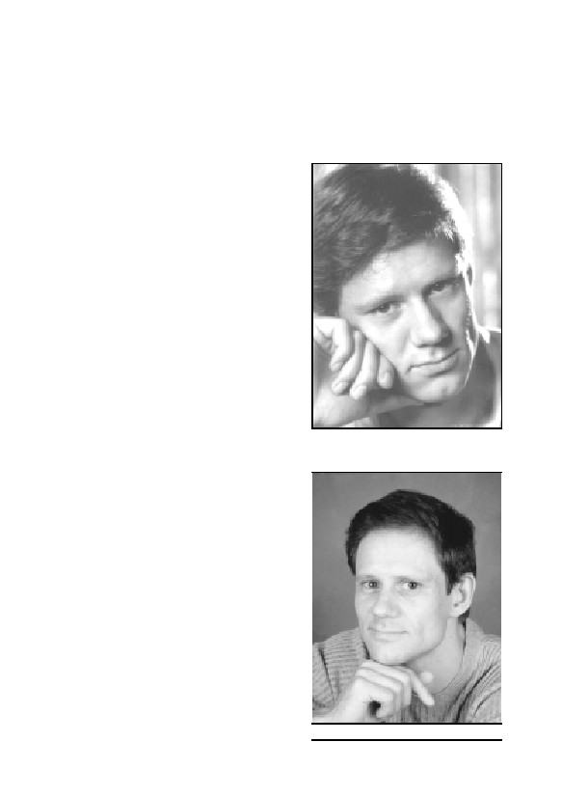
11.7. Biographical Notes on the Author
Germar Rudolf, a certified chemist, was born on October 29,
1964, in Limburg/Lahn, Germany. Elite High School Diploma (Gym-
nasium Abitur) in 1983 in Remscheid, followed by study for a certified
chemist’s degree at the University of
Bonn, graduation summa cum laude
in September 1989. Completion of
compulsory military service with the
German Luftwaffe (Air Force). Be-
tween October 1990 and June 1993,
Mr. Rudolf worked on the prepara-
tion of a doctoral thesis at the Max-
Planck-Institute for Solid State Re-
search in Stuttgart. Despite the high-
est recommendations, he was forced
to withdraw his dissertation, because
the University of Stuttgart threat-
ened to rejected it on political
grounds (due to his involvement in
revisionism).
Since early 1993, he has been
The Author in summer 1991,
while doing the main work
the defendant in several criminal
for this expert report
prosecutions resulting from the pub-
lication of scientific texts; in March
1996, he left his native Germany and
went into exile, first England, then,
in late 1999, the United States. In
late 1996, Mr. Rudolf founded the
publishing house Castle Hill Pub-
lishers and, simultaneously, a quar-
terly historical periodical of German
language, the aim of which is to deal
with critical aspects of contemporary
history currently suppressed in all
German speaking countries. In 2000,
he started publishing English lan-
guage books on revisionist topics
under the imprint of Theses & Dis-
The author in late 2002
421
GERMAR RUDOLF · THE RUDOLF REPORT
sertations Press, a firm originally established by Robert H. Countess
and purchased by Rudolf in summer 2002. Since 2003, he also pub-
lishes a quarterly historical language of English language, which fo-
cuses on the same topics as his the German periodical.
Books and brochures published: Vorlesungen über Zeitgeschichte
(1993, 2nd edition due for 2003), Das Rudolf Gutachten (1993, 2nd edi-
tion 2001; a Dutch translation was published in 1994, a French transla-
tion appeared in 1996, for an English translation see this work); Wis-
senschaftlicher Erdrutsch durch das Rudolf Gutachten, (brochure,
1993; an English translation appeared in 1994), Prof. Dr. Ernst Nolte:
Auch Holocaust-Lügen haben kurze Beine (brochure, 1994), Der Fall
Rudolf (brochure, 1994), Grundlagen zur Zeitgeschichte (1994; Eng-
lish under the title Dissecting the Holocaust 2000, 2nd edition due for
2003); Auschwitz: Nackte Fakten (1995); Kardinalfragen zur Zeit-
geschichte (1996).
Since early 1997, Mr. Rudolf is the publisher and responsible edi-
tor of the German quarterly journal Vierteljahreshefte für freie
Geschichtsforschung, and since early 2003, he is also the publisher and
responsible editor of the English quarterly journal The Revisionist.
Journal for Critical Historical Inquiry (UK address: Castle Hill Pub-
lishers, PO Box 118, Hastings TN34 3ZQ; US address: PO Box
257768, Chicago, IL 60625; email: chp@vho.org.), both including
many articles by Mr. Rudolf (see online: vho.org/i/a.html).
422
12. Bibliography
12.1. Monographs
– Hans G. Adler, Hermann Langbein, Ella Lingens-Reiner (ed.), Auschwitz, Europäische Verlag-
sanstalt, Cologne 31984
– Akademischer Verein Hütte (ed.), Hütte, Ernst und Sohn, Berlin 271942
– Günther Anntohn, Henri Roques, Der Fall Günter Deckert, DAGD/Germania Verlag, Wein-
heim 1995
– Rudolf Aschenauer, Macht gegen Recht, Arbeitsgemeinschaft für Recht und Wirtschaft, Mu-
nich 1952
– Enrique Aynat, Los protocolos de Auschwitz. i Una fuente historica? Verlag Garcia Hispan,
Alicante 1990
– Uwe Backes, Eckhart Jesse, Rainer Zitelmann (ed.), Die Schatten der Vergangenheit, Pro-
pyläen, Frankfurt 1990
– James Bacque, Crimes and Mercies, Little, Brown & Co., Toronto 1996.
– James Bacques, Other Losses, Stoddart, Toronto 1989
– John C. Bailar, Comprehensive Inorganic Chemistry, Vol. 3, Pergamon Press, Oxford 1973
– Brigitte Bailer-Galanda, W. Benz, W. Neugebauer (ed.), Wahrheit und Auschwitzlüge,
Deuticke, Vienna 1995
– John Clive Ball, Air Photo Evidence, Auschwitz, Treblinka, Majdanek, Sobibor, Bergen Belsen,
Belzec, Babi Yar, Katyn Forest, Ball Resource Service Ltd., Delta, B.C., Canada 1992
– John Clive Ball, The Ball Report, Ball Resource Services Ltd., Delta, BC, Canada, 1993
– Bayerischer Staatsminister des Inneren (ed.), Verfassungsschutzbericht 1997, Munich 1998
– Wolfgang Benz, Dimension des Völkermords, Oldenbourg, Munich 1991
– Michael Berenbaum, The World Must Know, Little, Brown & Co., Boston 1993
– Jadwiga Bezwinska, KL Auschwitz in den Augen der SS, Verlag des Staatlichen Auschwitz-
Museums, Auschwitz 1973
– Heinz Bobrach et al., Inventar archivalischer Quellen des NS-Staates, K. G. Saur, Munich
1995, volumes 3/1, 1991
– Hans-Kurt Boehlke, Friedhofsbauten, Callwey Verlag, Munich 1974
– Jean-Marie Boisdefeu, La controvers sur l’extermination des Juifs par les Allemands, volume
1, Vrij Historisch Onderzoek, Berchem 1994
– William Braker, Allen L. Mossman, Matheson Gas Data Book, Matheson Gas Products, East
Rutherford 1971
– Martin Broszat (ed.), Kommandant in Auschwitz, Deutsche Verlags-Anstalt, Stuttgart 1958
– Hans Buchheim, Martin Broszat, Hans-Adolf Jacobsen, Helmut Krausnick, Anatomie des SS-
Staates, Walter, Freiburg 1964
– Josef G. Burg, Schuld und Schicksal, Damm-Verlag, Munich 1962
– Josef G. Burg, Sündenböcke, Verlag G. Fischer, Munich 1967
– Josef G. Burg, NS-Verbrechen—Prozesse des schlechten Gewissens, ibid. 1968
– Josef G. Burg, Verschwörung des Verschweigens, Ederer, Munich 1979
– Josef G. Burg, Majdanek in alle Ewigkeit?, ibid. 1979
– Josef G. Burg, Zionazi-Zensur in der BRD, ibid. 1980.
– Jozef Buszko (ed.), Auschwitz, Nazi Extermination Camp, Interpress Publishers, Warschau
2
1985
– Rupert Butler, Legions of Death, Arrows Books Ltd., London 1986
– Arthur R. Butz, The Hoax of the Twentieth Century, Institute for Historical Review, Newport
423
GERMAR RUDOLF · THE RUDOLF REPORT
Beach, California, 71985
–
Alberto Cantagalli, Nozioni teorico-pratiche per i conduttori di caldaie e generatori di vapore,
G. Lavagnolo Editore, Turin 1940
–
Danuta Czech, Kalendarium der Ereignisse im Konzentrationslager Auschwitz-Birkenau 1939-
1945, Rowohlt Verlag GmbH, Reinbek bei Hamburg, 1989
–
Wolfgang Czernin, Zementchemie für Bauingenieure, Bauverlag, Wiesbaden 1977
Max Daunderer, Klinische Toxikologie, 30th suppl. delivery 10/87, ecomed, Landsberg 1987
–
–
Degussa AG (ed.), Im Zeichen von Sonne und Mond, Degussa AG, Frankfurt/Main 1993
–
Der praktische Desinfektor, Heft 2, Verlag Erich Deleiter, Berlin 1941
–
Der Prozeß gegen die Hauptkriegsverbrecher vor dem Internationalen Militärgerichtshof, Nur-
emberg 1949
–
Deutsche Chemische Gesellschaft (ed.), Gmelins Handbuch der Anorganischen Chemie, 59
(Fe), B4, Verlag Chemie, Weinheim 1932
–
Dokumentationszentrum des österreichischen Widerstandes, Bundesministerium für Unterricht
und Kultur (eds.), Amoklauf gegen die Wirklichkeit, Vienna 1991, pp. 47-52
–
W.H. Duda, Cement-Data-Book, Bauverlag, Wiesbaden 1976
–
C.T. Duffy, 88 Men and 2 Women, Doubleday, New York 1962
–
DuPont, Hydrogen Cyanide, Wilmington, Delaware 7/83
–
Ecole des hautes études en sciences socials (ed.), L’Allemagne nazie et le génocide juif, Galli-
mard/Le Seuil, Paris 1985
–
Encyclopedia Britannica, 1998 edition on CD-ROM
–
E. Emmerling, in: M. Petzet (ed.), Holzschädlingsbekämpfung durch Begasung, Arbeitshefte
des Bayerischen Landesamtes für Denkmalpflege, vol. 75, Lipp-Verlag, Munich 1995
–
Robert Faurisson, Mémoire en défense, La Vieille Taupe, Paris 1980
–
Robert Faurisson, Écrits révisionnistes, 4 vols., published by author, Vichy 1999.
–
Robert Faurisson, “Es gab keine Gaskammern”, Deutscher Arbeitskreis Witten, Witten 1978
–
H. Ferch, H. Schäfer, Schriftenreihe Pigmente Nr. 77, Degussa AG, Frankfurt 1990
–
Norman G. Finkelstein, Ruth Bettina Birn, A Nation on Trial: The Goldhagen Thesis and His-
torical Truth, Metropolitan Books, New York 1998
–
Ferdinand Flury, Franz Zernik, Schädliche Gase, Dämpfe, Nebel, Rauch- und Staubarten,
Berlin 1931
–
Wilhelm Foerst (ed.), Ullmanns Encyklopädie der technischen Chemie, vol. 5, Urban und
Schwarzenberg, Munich 31954; volume 13, ibid. 31962; volume 18, Verlag Chemie, Weinheim
1979.
–
Wolfgang Forth, Dietrich Henschler, Werner Rummel, Allgemeine und spezielle Pharmakolo-
gie und Toxikologie, Wissenschaftsverlag, Mannheim 1987
–
Henry Friedländer, The Holocaust, Vol. 12: “The ‘finale solution’ in the extermination camps
and the aftermath”, Garland, New York 1982
–
Ernst Gauss, Vorlesungen über Zeitgeschichte, Grabert, Tübingen 1993
–
Ernst Gauss (ed.), Dissecting the Holocaust, Theses & Dissertations Press, Capshaw, AL, 2000
–
Ernst Gauss (ed.), Grundlagen zur Zeitgeschichte, ibid. 1994
Ernst Gauss (ed.), Dissecting the Holocaust, 2nd edition, Theses & Dissertations Press, Cap-
–
shaw, AL, 2003
–
Martin Gilbert, Auschwitz and the Allies, Henry Holt & Co., New York 1981
–
Wigbert Grabert, Geschichtsbetrachtung als Wagnis, Grabert, Tübingen 1984
–
Helge Grabitz, NS-Prozesse – Psychogramme der Beteiligten, 2nd ed., C.F. Müller, Heidelberg
1986
–
Jürgen Graf, Der Holocaust auf dem Prüfstand, Guideon Burg, Basel 1992
–
Jürgen Graf, Der Holocaust-Schwindel, ibid. 1993
–
Jürgen Graf, Auschwitz. Tätergeständnisse und Augenzeugen des Holocaust, Verlag Neue
Visionen, Würenlos 1994
–
Jürgen Graf, Todesursache Zeitgeschichtsforschung, ibid. 1995
–
Jürgen Graf, Carlo Mattogno, KL Majdanek, Castle Hill Publishers, Hastings 1998
424
12. BIBLIOGRAPHY
–
Jürgen Graf, Mattogno, Das KL Stutthof, Castle Hill Publishers, Hastings 1999
–
Jürgen Graf, Riese auf tönernen Füßen, ibid. 1999
–
Jürgen Graf, The Giant With Feet of Clay, Theses & Dissertations Press, Capshaw, AL, 2001
–
Karl Greimer, Handbuch des praktischen Desinfektors, Th. Steinkopf, Dresden 1937
–
Pierre Guillaume, De la misère intellectuelle en milieu universitaire, B.P. 9805, 75224 Paris
cedex 05, 1995
–
Yisrael Gutman, Michael Berenbaum (ed.), Anatomy of the Auschwitz Death Camp, Indiana
University Press, Bloomington 1994
–
Friedrich E. Haag, Lagerhygiene, Taschenbuch des Truppenarztes, vol. VI, F. Lehmanns Ver-
lag, Munich 1943
–
David E. Hackett, (ed.), The Buchenwald Report, Beck, Munich 1997
–
O. Hähnle, Baustoff-Lexikon, Deutsche Verlagsanstalt, Stuttgart 1961
–
Joseph S. Haldane, J.G. Priestley, Respiration, Yale University Press, New Haven 1935
–
Hamburger Institut für Sozialforschung (ed.), Die Auschwitz-Hefte, vol. 1, Beltz Verlag, Wein-
heim 1987
Handbuch der Inneren Medizin, 2nd ed., 1925.
–
–
Wilhelm Heepke, Die Leichenverbrennungs-Anstalten, C. Marhold, Halle 1905
–
Yandell Henderson, Howard W. Haggard, Noxious Gases, Reinhold Publishing, New York
1943
–
Joachim Hoffmann, Stalins Vernichtungskrieg, Verlag für Wehrwissenschaften, Munich 1995
–
Joachim Hoffmann, Stalin’s War of Extermination 1941-1945, Theses & Dissertations Press,
Capshaw, AL, 2001
K.A. Hofmann, Anorganische Chemie, Vieweg, Braunschweig 211973
–
A.F. Holleman, N. Wiberg, Lehrbuch der Anorganischen Chemie, de Gruyter, Berlin 1001985
–
–
Gerd Honsik, Freispruch für Hitler, Burgenländischer Kulturverband, Vienna 1988
–
Gerd Honsik, Schelm und Scheusal, Bright Rainbow, Madrid n.d. [1994]
–
Franziska Hundseder, Rechte machen Kasse, Knaur, Munich, May 1995
–
Valérie Igounet, Histoire du négationnisme en France, Editions du Seuil, Paris 2000
–
David Irving, Nuremberg. The Last Battle, Focal Point, London 1996
–
Eberhard Jäckel, Jürgen Rohwer, Der Mord an den Juden im Zweiten Weltkrieg, Deutsche
Verlags-Anstalt, Stuttgart 1985
–
Franz Kadell, Die Katyn Lüge, Herbig, Munich 1991
–
Jürgen Kalthoff, Martin Werber, Die Händler des Zyklon B, VSA-Verlag, Hamburg 1998
–
Rüdiger Kammerer, Armin Solms (ed.), Das Rudolf-Gutachten, Cromwell, London 1993
–
Michael D. Kelleher, C. L. Kelleher, Murder Most Rare: The Female Serial Killer, Praeger,
Westport, Conn., 1998
Erich Kern, Meineid gegen Deutschland, Schütz, Pr. Oldendorf, 21971
–
–
R.E. Kirk, D.F. Othmer, Encyclopedia of Chemical Technology, Vol. 13, 3. ed., Wiley & Sons,
New York 1979
–
Serge Klarsfeld (ed.), The Auschwitz Album. Lilly Jacob’s Album, New York 1980
–
Ernst Klee, Willy Dreßen, Schöne Zeiten, S. Fischer, Frankfurt 1988
–
Ernst Klee, Willy Dreßen, The Good Old Days, Free Press, New York 1991
–
Heinrich Kliewe, Leitfaden der Entseuchung und Entwesung, F. Enke Verlag, Stuttgart 1951
–
Alexander von Knieriem, Nürnberg. Rechtliche und menschliche Probleme, Klett, Stuttgart
1953
–
Eugen Kogon, Hermann Langbein, Adalbert Rückerl et al. (eds.), Nationalsozialistische Mas-
sentötungen durch Giftgas, S. Fischer Verlag, Frankfurt 1983
–
Eugen Kogon, Hermann Langbein, Adalbert Rückerl et al. (eds.), Nazi Mass Murder, Yale
University Press, New Haven 1993
–
Herinrich Kruse, Leitfaden für die Ausbildung in der Desinfektion und Schädlingsbekämpfung,
Muster-Schmidt, Göttingen 1948
–
Barbara Kulaszka (ed.), Did Six Million Really Die? Report on the Evidence in the Canadian
“False News” Trial of Ernst Zündel—1988, Samisdat Publishers Ltd., Toronto 1992
425
GERMAR RUDOLF · THE RUDOLF REPORT
– Georg Kunike, Das ABC der Vorrats- und Hausschädlinge und ihre Bekämpfung, Theodor
Weicher, Berlin 1941
– Landolt-Börnstein, Eigenschaften der Materie in ihren Aggregatzuständen, part 2, volume b,
Lösungsmittelgleichgewichte I, Springer, Berlin 1962
– Landolt-Börnstein, Zahlen und Funktionen aus Physik, Chemie, Astronomie, Technik, volume
IV Technik, part 4b Wärmetechnik, Springer, Berlin 61972
– Hermann Langbein, Menschen in Auschwitz, Europaverlag, Vienna 1987
– Hermann Langbein, Der Auschwitz-Prozeß, Europäische Verlagsanstalt, Frankfurt/Main 1965
– Hans Laternser, Die andere Seite im Auschwitzprozeß 1963/65, Seewald, Stuttgart 1966
– Robert Lenski, The Holocaust on Trial, Reporter Press, Decatur, Alabama 1990
– Robert Lenski, Der Holocaust vor Gericht, Samisdat Publishers Ltd., Toronto 1996
– André Lettich, Trente-quatre mois dans les Camps de Concentration, Imprimerie Union
Coopérative, Tours, 1946
– Fredrick A. Leuchter, The Third Leuchter Report, Samisdat Publishers Ltd., Toronto 1989
– Fredrick A. Leuchter, An Engineering Report on the alleged Execution Gas Chambers at
Auschwitz, Birkenau and Majdanek, Poland, Samisdat Publishers Ltd., Toronto 1988
– Fredrick A. Leuchter, The Fourth Leuchter Report, Samisdat Publishers Ltd., Toronto 1991
– Salmen Lewenthal, Hefte von Auschwitz, Sonderheft 1, Handschriften von Mitgliedern des
Sonderkommandos, Verlag Staatliches Museum Auschwitz, 1972
– Peter A. Lewis (ed.), Pigment Handbook, Vol. 1, Wiley and Sons, New York 1974
– Carlo Mattogno, La soluzione finale. Problemi e polemiche, Edizioni di Ar, Padua 1991; Au-
schwitz. La prima gasazione, Edizioni di Ar, Padua 1992
– Carlo Mattogno, Auschwitz: The End of a Legend, Institute for Historical Review, Costa Mesa
1994
– Carlo Mattogno, „Sonderbehandlung“ ad Auschwitz. Genesi e Significato, Edizioni di Ar,
Padua 2001
– S. Moeschlin, Klinik und Therapie der Vergiftung, Georg Thieme Verlag, Stuttgart 1986
– Andreas Molau (ed.), Opposition für Deutschland, Druffel-Verlag, Berg am Starnberger See
1995
– Joachim Mrugowsky (ed.), Arbeitsanweisungen für Klinik und Laboratorium des Hygiene-
Instituts der Waffen-SS, 2nd ed., Urban & Schwarzenberg, Berlin and Vienna 1943.
– G.-O. Müller, Lehrbuch der angewandten Chemie, vol. I, Hirzel, Leipzig 1986
– Bernd Naumann, Auschwitz, Athenäum, Frankfurt/Main 1968
– Ernst Neufert, Bauentwurfslehre, Ullstein Fachverlag, Frankfurt 1962
– Ernst Nolte, in his book Streitpunkte, Propyläen, Berlin 1993
– Miklos Nyiszli, Auschwitz: A Doctor’s Eyewitness Account, Arcade Publishing, New York
1993
– Friedrich Oscar, Über Galgen wächst kein Gras, Erasmus-Verlag, Braunschweig 1950
– J. Oudar, Physics and Chemistry of Surfaces, Blackie & Son, Glasgow 1975
– Robert J. van Pelt, The Case for Auschwitz. Evidence from the Irving Trial, Indiana University
Press, Bloomington/Indianapolis 2002
– Robert van Pelt, Deborah Dwork, Auschwitz: 1270 to the Present, Yale University Press, New
Haven and London 1996
– J.H. Perry, Chemical Engineer’s Handbook, Wilmington Delaware 1949
– Gerhard Peters, Blausäure zur Schädlingsbekämpfung, Ferdinand Enke Verlag, Stuttgart 1933
– Gerhard Peters, Die hochwirksamen Gase und Dämpfe in der Schädlingsbekämpfung, F. Enke
Verlag, Stuttgart 1942
– Léon Poliakov, Auschwitz, René Julliard, 1964
– Léon Poliakov, Harvest of Hate, Greenwood Press, Westport, Conn., 1971
– Karl R. Popper, Objektive Erkenntnis, Hoffmann & Campe, Hamburg 41984
– Jean-Claude Pressac, Auschwitz: Technique and Operation of the Gaschambers, Beate-
Klarsfeld-Foundation, New York 1989
– Jean-Claude Pressac, Les crématoires d’Auschwitz. La machinerie du meurtre de masse,
426
12. BIBLIOGRAPHY
CNSR, Paris 1993
– Jean-Claude Pressac, Die Krematorien von Auschwitz. Die Technik des Massenmordes, Piper,
Munich 1994
– Proceedings of the Conference on Cyanide and the Environment, Colorado State University,
1984
– Franz Puntigam, Hermann Breymesser, Erich Bernfus, Blausäuregaskammern zur Fleckfie-
berabwehr, Sonderveröffentlichung des Reichsarbeitsblattes, Berlin 1943
– Paul Rassiner, Die Lüge des Odysseus, K.-H. Priester, Wiesbaden 1959
– Paul Rassiner, Was nun, Odysseus?, ibid. 1960
– Paul Rassiner, Das Drama der Juden Europas, H. Pfeiffer, Hannover 1965
– Paul Rassiner, Was ist Wahrheit?, Druffel, Leoni 81982
– Paul Rassiner, Debunking the Genocide Myth, The Noontide Press, Los Angeles, 1978
– Otto Ernst Remer (ed.), Die Zeit lügt!, Verlag Remer Heipke, Bad Kissingen 1992
– S. Röbert (ed.), Systematische Baustofflehre, volume 1, VEB Verlag für Bauwesen, Berlin
4
1983
– Henry Rollet, Les chambres à gaz secret d’Etat, Les Editions de Minuit, Paris 1984
– Henri Roques, Günter Annthon, Der Fall Günter Deckert, DAGD/Germania Verlag, Weinheim
1995
– Ludwig Rosenthal, “Endlösung der Judenfrage”, Massenmord oder “Gaskammerlüge”?,
Verlag Darmstädter Blätter, Darmstadt 1979
– Adalbert Rückerl, NS-Verbrechen vor Gericht, C. F. Müller, Heidelberg 1984, p. 249
– Adalbert Rückerl, Nationalsozialistische Vernichtungslager im Spiegel deutscher Strafpro-
zesse, dtv, Munich 1978
– Adalbert Rückerl, NS-Prozesse, C. F. Müller, Karlsruhe 1972
– Adalbert Rückerl, NS-Verbrechen vor Gericht, C.F. Müller, Heidelberg, 21984
– Colin Rushton, Spectator in Hell. A British Soldier’s Extraordinary Story, Pharaoh Press,
Springhill (Berkshire) 1998
– Ingrid Sagel-Grande, H. H. Fuchs, Christiaan F. Rüter (eds.), Justiz und NS-Verbrechen, vol.
21, University Press, Amsterdam 1979
– Walter N. Sanning, Die Auflösung des osteuropäischen Judentums, Grabert, Tübingen 1983
– Walter N. Sanning, The Dissolution of Eastern European Jewry, Institute for Historical Re-
view, Torrance, CA, 1983
– Otto von Schjerning, Handbuch der Ärztlichen Erfahrungen im Weltkrieg 1914/1918, volume
VII Hygiene, J. A. Barth Verlag, Leipzig 1922
– Wilhelm Schlesiger, Der Fall Rudolf, Cromwell, London 1994
– Robert F. Schmidt, Biomaschine Mensch, Piper, Munich 1979
– Gerhard Schoenberner (ed.), Wir haben es gesehen, Fourier, Wiesbaden 1981
– Shelly Shapiro (Ed.), Truth Prevails: Demolishing Holocaust Denial: The End of the Leuchter
Report, Beate Klarsfeld Foundation, New York 1990
– Yoram Sheftel, The Demjanjuk Affair. The Rise and Fall of the Show Trial, Victor Gollancz,
London 1994
– Wilhelm Stäglich, Der Auschwitz-Mythos, Grabert Verlag, Tübingen 1979
– Wilhelm Stäglich, The Auschwitz Myth, Institute for Historical Review, Torrance, CA, 1986
– Telford Taylor, The Anatomy of the Nuremberg Trials, Little, Boston 1992
– Serge Thion (ed.), Vérité historique ou vérité politique?; La Vielle Taupe, Paris 1980
– Ralf Tiemann, Der Malmedy-Prozeß, Munin, Osnabrück 1990
– Stephen Trombley, The Execution Protocol, Crown Publishers, New York 1992
– Freda Utley, Kostspielige Rache, H.H. Nölke-Verlag, Hamburg 71952
– Freda Utley, The High Cost of Vengeance, Regnery, Chicago 1949
– Herbert Verbeke (ed.), Auschwitz: Nackte Fakten, Vrij Historisch Onderzoek, Berchem 1995
– Herbert Verbeke (ed.), Kardinalfragen zur Zeitgeschichte, Vrij Historisch Onderzoek, Ber-
chem, 1996
– Verein Deutscher Zementwerke, Zement Taschenbuch 1972/73, Bauverlag, Wiesbaden 1972
427
GERMAR RUDOLF · THE RUDOLF REPORT
– Udo Walendy, Auschwitz im IG-Farben-Prozeß, Verlag für Volkstum und Zeitgeschichtsfor-
schung, Vlotho 1981
– N.V. Waubke, Transportphänomene in Betonporen, Dissertation, Braunschweig 1966
– R.C. Weast (ed.), Handbook of Chemistry and Physics, 66th Ed., CRC Press, Boca Raton,
Florida 1986
– Jürgen Weber, Peter Steinbach (eds.), Vergangenheitsbewältigung durch Strafverfahren?,
Olzog, Munich 1984
– H.-H. Wellhöner, Allgemeine und systematische Pharmakologie und Toxikologie, Springer
Verlag, Berlin 1988
– Karlhans Wesche, Baustoffe für tragende Bauteile, volume 1, Bauverlag, Wiesbaden 1977;
volume 2, Bauverlag, Wiesbaden 1981
– C. Wilson, Wilson & Wilson’s Comprehensive Inorganic Chemistry, Vol. 1B, Elsevier, Am-
sterdam 1960
– Winnacker-Küchler, Chemische Technologie, volume 2, Carl Hanser Verlag, Munich 1982
– Wolfgang Wirth, Christian Gloxhuber, Toxikologie, Georg Thieme Verlag, Stuttgart 1985
– David S. Wyman (ed.), America and the Holocaust, volume 12, Garland, New York/London
1990
– G. Zimmermann (ed.), Bauschäden Sammlung, volume 4, Forum-Verlag, Stuttgart 1981
12.2. Periodical Articles
–
Anal. Chem. 56 (14) (1984), pp. 2819-2822: T. Ozeki, K. Matsumoto, S. Hikime
–
Anal. Chim. Acta 3 (1949), pp. 558ff.
– 5 (1951), pp. 525-528
– 11 (1954), pp. 18-27: M. Kohn
–
Analusis, 13 (4) (1985), pp. 185-190: C. Lapp, C. Wehrer, P. Laugel
–
Ann. Chim. 50 (1960), pp. 782-789: V. Carassiti, V. Balzani
–
Annales d’Histoire Révisionniste 1 (1987) pp. 137-152: Robert Faurisson, “Comment les Bri-
tanniques ont obtenu les aveux de Rudolf Hoess”
– 7 (1989), pp. 212f.: Gérard Roubeix, Letter to the Editor
–
Anzeiger für Schädlingskunde, 14(8) (1938) pp. 98f.: Gerhard Peters, “Eine moderne Eisen-
bahn-Entwesungsanlage”
–
Arbeitsschutz, 5(III) (1942), pp. 167f.: Gerhard Peters, “Gefahrlose Anwendung der hochgifti-
gen Blausäure in Entlausungskammern”
–
Bild, Nov. 20, 2001; ; April 11, 2002, p. 2
–
blick nach rechts, June 2000: Thomas Pfeiffer
–
Cement and Concrete Research, 11 (1981), pp. 351-362: H.A. El-Sayed
–
Chicago Daily Tribune, Feb. 23-26, 28, 29, 1948; March 12; Sept. 13, 1949
–
Corriere della Sera, Nov. 21, 2001, p. 35.
–
Dachauer Hefte, 7(7) (November 1991), pp. 230-241: Georges Wellers, “Der Leuchter-Bericht
über die Gaskammern von Auschwitz”
–
Daily News, Washington, Jan. 9, 1949
–
Das Gas- und Wasserfach, in: Gas • Erdgas, 130 (1989), pp. 474-484: D. Maier, K. Czurda, G.
Gudehus
–
Der praktische Desinfektor, September 1941, pp. 93-96: Gerhard Peters and W. Rasch, “Die
Blausäure als Entlausungsmittel in Begasungskammern”
–
Deutsche Farben-Z. 5 (1951), pp. 419ff.: E. Elsermann
– 6 (1952), p. 231.: R. Beck
428
12. BIBLIOGRAPHY
–
Deutschland in Geschichte und Gegenwart 28(1-4) (1980), pp. 12-15; 17-21; 17-21; 25-31:
Walter N. Sanning, “Die europäischen Juden. Eine technische Studie zur zahlenmäßigen Ent-
wicklung im Zweiten Weltkrieg, Teil 1-4”
– 36(4) (1988), pp. 4-10: Robert Faurisson, “Zum Zündel-Prozeß in Toronto, Teil 2. Vor-
geschichte—Ablauf—Folgen”
– 39(2) (1991), pp. 13-17: Wolfgang Häberle, “Zu Wegners Kritik am Leuchter-Gutachten”
– 39(2) (1991), pp. 9-13: Wolfgang Schuster, “Technische Unmöglichkeiten bei Pressac”
– 41(2) (1993), pp. 16-24: Ernst Gauss, “Chemische Wissenschaft zur Gaskammerfrage”
– 42(2) (1994), pp. 25f.: Germar Rudolf, “Über die frei erfundene Expertenmeinung der
‘dpa’”
– 43(1) (1995) pp. 22-26: Germar Rudolf, “Leuchter-Gegengutachten: Ein Wissenschaftlicher
Betrug?”
– 44(2) (1996), pp. 24f.: Wilhelm Stromberger, “Was war die ‘Sonderbehandlung’ in Ausch-
witz?”
– 44(4) (1996), pp. 9f.: IDN, “‘Appell der 500’ vor Landtag”
–
Die Naturwissenschaften, 16(2) (1928), pp. 17-23: O. Hecht, “Blausäuredurchgasungen zur
Schädlingsbekämpfung”
–
Die Welt, March 29, 1994; April 5, 1995; May 15, 1995: “Unterstützen Unternehmer die recht-
sextremen Szene?”
–
Die Woche, Oct. 7, 1993, p. 8
–
Die Zeit, no. 39, Sept. 18, 1992, p. 104; no. 40, Sept. 25, 1992, p. 90: Till Bastian; April 15,
1993, p. 44; Dec. 31, 1993, p. 51
–
dpa news release on March 28, 1994, published in the German daily newspapers on March 29,
30, 31, 1994.
–
East European Sci. Abs. 5 (1969), pp. 84f.: E.F. Zhel’vis, Y.M. Glazman
–
Farbe und Lack, 64 (1958), pp. 130-135: E. Herrmann
–
Färg och Lack, 3 (1957), pp. 85-108: E. Gratzfeld
–
Focus no. 17/1994, pp. 118, 120
–
Frankfurter Allgemeine Zeitung, August 15, 1994, p. 21: Patrick Bahners, “Objektive Selbst-
zerstörung”; March 11, 1995, p. 8; May 6, 1995; June 10, 1996, p. 14; April 11, 2002, p. 2
–
Frankfurter Rundschau, March 30, 1994; April 11, 2002, p. 2
–
Gäubote/Südwestpresse-Verbund, May 6, 1996
–
Gesundheits-Ingenieur, July 19, 1941, pp. 399-404: Friedrich Konrich, “Über die Sanierung-
sanstalten der deutschen Kriegsgefangenenlager”
– 66(15) (1943), S. 174ff.: Ludwig Gaßner, “Verkehrshygiene und Schädlingsbekämpfung”
– 67(2) (1944), pp. 47-56: Franz Puntigam, “Die Durchgangslager der Arbeitseinsatzverwal-
tung als Einrichtungen der Gesundheitsvorsorge”
– 67(6) (1944), pp. 139-180: Franz Puntigam, “Raumlösungen von Entlausungsanlagen”
– 67(7) (1944), p. 179: Emil Wüstinger, “Vermehrter Einsatz von Blausäure-
Entlausungskammern”
–
Gesundheitswesen und Desinfektion, 65(8) (1973), pp. 115-127; 65(9) (1973), pp. 129-143: W.
Hagen, “Krieg, Hunger und Pestilenz in Warschau 1939-1943”
–
Glap. Hem. Tehnol. Bosne Hercegovine, 23-24 (1977, Vol. Date 1976), pp. 7-13: F. Krleza, M.
Avlijas, G. Dokovic
–
Hamburger Abendblatt, May 27, 2000: Günther Hoerbst “Anti-Semitism Worldwide 1998/99”
–
Hamburger Morgenpost, Nov. 14, 2000
–
Hazard. Ind. Waste 21 (1989), pp. 282-290: M.D. Gurol, J.H. Woodman
429
GERMAR RUDOLF · THE RUDOLF REPORT
–
Historische Tatsache no. 42, Verlag für Volkstum und Zeitgeschichtsforschung, Vlotho 1990:
U. Walendy
– no. 60, Verlag für Volkstum und Zeitgeschichtsforschung, Vlotho 1993: Udo Walendy
–
Holz als Roh- und Werkstoff, 32 (1974), pp. 108-114: D. Grosser, E. Roßmann, “Blausäuregas
als bekämpfendes Holzschutzmittel für Kunstobjekte”
–
Informationen der Gesellschaft für politische Aufklärung, Innsbruck, June 1991, no. 29: Brigit-
te Bailer-Galanda
–
Inorg. Chem. 1 (1962), pp. 337-342: M.B. Robin
– 1 (1962), pp. 587-591: J. Jordan, G.J. Ewing
– 9 (1970), pp. 2019ff.: R.M. Izatt, G.D. Watt, C.H. Bartholomew, J.J. Christensen
– 9 (1970), pp. 2512-2516: R.E. Wilde, S.N. Ghosh, B.J. Marshall
– 16 (1977), pp. 2704-2710: H.J. Buser, D. Schwarzenbach, W. Peter, A. Ludi
–
J. Appl. Chem. USSR, 74(1)(1974), pp. 139-142: N.G. Chen
–
J. Chem. Soc. 1963, pp. 1120-1125: J.F. Duncan
–
J. Ind. Chem. Soc. 28 (1951), pp. 221-224: A.K. Bhattacharya
– 28 (1951), pp. 703-709: R.S. Saxena
–
J. Inorg. Chem. USSR, 1 (1956), pp. 72ff.: I.V. Tananaev, M.A. Glushkova, G.B. Seifer
–
J. Inorg. Nucl. Chem. 28 (1966), pp. 2589-2598: L. Moggi, F. Bolletta, V. Balzani, F. Scandola
– 29 (1967), pp. 1637-1642: M. Andrew Alich, D.T. Haworth, M.F. Johnson
–
J. Jap. Soc. Col. Mat., 34 (1961), pp. 5-8; L. Müller-Focken, Farbe und Lack, 84 (1987), pp.
489-492: H. Watanabe
–
J. Réch. Cent. Nat. Réch. Sci. 4 (1952), pp. 184ff.: S. Barbezat
–
Jour J, December 12, 1988, pp. I-X: Jean-Claude Pressac
–
Jpn. Kokai Tokkyo Koho, 1990, 3 p.: H. Tada, M. Kunio, H. Kawahara
–
Killoy Sentinel (New South Wales, Australia), May 1, 1997
–
Kreiszeitung – Böblinger Bote, November 23, 1994; March 29, 1995; May 10, 1995; June 24,
1995; Nov. 16, 1995: dpa, “Dilettantische Kammerjäger”; May 6, 1996; June 27, 1996
–
Kurier, Aug. 30, 1992, p. 20: “Wenn Felsen fallen”
–
L’Express, 19.-25. January 1995: Eric Conan, “Auschwitz: la mémoire du mal”
–
Le Monde Juif, no. 97, January-March 1980, p. 2: Dino A. Brugioni, Robert G. Poirier; no.
107, Juli-September 1982, pp. 91-131: Jean-Claude Pressac
–
Le Monde, Dec. 29, 1978, p. 8: Robert Faurisson, “‘Le problème des chambres à gaz’ ou ‘la
rumeur d’Auschwitz’”; Feb 21, 1979: Robert Faurisson; Sept. 19, 1989; Nov. 20, 2001
–
Le Quotidien de la Réunion, June 25, 1998: “Un expert évoque la llustra de gaz mortel dans
la grotte”
–
Liberty Bell, 12/1994, pp. 36f.
–
Life, Dec. 22, 1947, p. 31: “How to get rid of termites”
–
Los Angeles Times, Jan. 7, 2000: Kim Murphy, “Danger in Denying Holocaust?”
–
Märkische Allgemeinen, May 14, 1993
–
Münchner Medizinische Wochenschrift, 89(22) (1942), pp. 483-488: R. Wohlrab, “Fleckty-
phusbekämpfung im Generalgouvernement”
–
Nation—The Orange County Register, Jan. 9, 2000, News 11
–
New Yorker Staats-Zeitung, March 13-19, 1999, p. 3: Bettina Freitag, “Henker warten nicht”,
–
Newsweek, November 8, 1993, p. 75
–
Osteuropa, 52(5) (2002), pp. 631-641: Fritjof Meyer, “Die Zahl der Opfer von Auschwitz”
–
Our Sunday Visitor, USA, June 14, 1959, 15
430
12. BIBLIOGRAPHY
–
Paint Ind. Mag. 69(11) (1954), pp. 33f.: H. Beakes
–
Polyhedron 4(11) (1985), pp. 1887-1890: G. Stochel, Z. Stasicka
–
Rheinpfalz Oct. 18, 1999: “Gesuchter deutscher Neonazi offenbar in Großbritannien”
–
Revue d’Histoire Révisionniste, 3 (1990/91), pp 65-154: Robert Faurisson, “Auschwitz : Tech-
nique and Operation of the Gas Chambers (1989) ou bricolage et ‘gazouillages’ à Auschwitz
et Birkenau selon J.-C. Pressac (1989)”
–
Rheinischer Merkur, April 16, 1999
–
Rivarol, March 22, 1996, p. 8; April 12, 1996, p. 4
–
Schriftenreihe Pigmente Nr. 50, Degussa AG, Frankfurt 1985
–
Searchlight, Dec. 1999, p. 13: Graeme Atkinson, “Auschwitz liar hides out in Britain”
–
Sleipnir 1(2) (1995): Germar Rudolf, “Kein Brief ins Gefängnis?”
– 1(3) (1995) pp. 29-33: Germar Rudolf and J. Markiewicz, W. Gubala, J. Labedz, “Brief-
wechsel”
– 4/95, insider back cover
–
Staatsbriefe, 6(6) (1995), pp. 6-8: Germar Rudolf, “Naht ein deutscher Bürgerkrieg?”
– 6(7) (1995): Jochen Lober
– 6(12) (1995), pp. 10-15: Germar Rudolf, “In der Bundesacht”
– 7(1) (1996), Verlag Castel del Monte, Munich, pp. 4-8: Germar Rudolf, “Webfehler im
Rechtsstaat”
– 7(2-3) (1996), pp. 23-30: Germar Rudolf, “Die Rolle der Presse im Fall Germar Rudolf”
–
Storia illustrata, 261 (1979), pp. 15-35: Robert Faurisson, “Le camere a gas non sono mai
esistite”
–
Stuttgarter Nachrichten, June 14, 1995; Oct. 21, 1999, p. 4: “Holocaust-Leugner im englischen
Versteck”
–
Stuttgarter Zeitung, March 29, 1994; Nov. 23, 1994; Jan. 27, 1995; June 13, 1995. p. 2; June
24, 1995: Sonnhild Maier; April 11, 2002, p. 2
–
Süddeutsche Zeitung, March 29, 1994; May 6, 1995; June 24, 1995
–
Südwestpresse-Verbund, March 29, 1994
–
Sunday Pictorial, Great Britain, Jan. 23, 1949.
–
Sunday Telegraph, Sept. 24, 1989; Oct. 17, 1999: Jessica Berry, Chris Hastings, “German neo-
Nazi fugitive is found hiding in Britain”; October 31, 1999: Berry, Hastings, “Germany pur-
sues Rudolf extradition”; Jan. 16, 2000: Berry, Hastings, “Neo-nazi accused of ‘racial hatred’
goes on the run
–
Sydney Jewish News, Nov. 5, 1999
–
tageszeitung, March 30, 1994; April 11, 2002, p. 2
–
The Atlantic Monthly, Feb. 1990
–
The Citizen, South Africa, June 24, 1995, p. 8
–
The Globe and Mail, Sept. 18, 1989
–
The Hastings and St. Leonards Observer, Oct. 22, 1999: James Clarke, “Fleeing neo-nazi uses
base in Hastings”; March 31, 2000: Clarke, “Escaped Neo-nazi still hiding in Hastings”
–
The Independent. Oct. 18, 1999: Jessica Berry and Chris Hastings, “German neo-Nazi fugitive
is found hiding in Britain”
–
The Jerusalem Post International Edition, May 5, 1990
–
The Journal of Historical Review 1(1) (1980) pp. 23ff.: Robert Faurisson, “The Mechanics of
Gassing”
– 1(2) (1980), pp. 103-114: Robert Faurisson, “The ‘problem of the gas chambers’”
431
GERMAR RUDOLF · THE RUDOLF REPORT
–
2(4) (1981), pp. 311ff.: Robert Faurisson, “The Gas Chambers of Auschwitz Appear to be
Physically Inconceivable”
– 2(4) (1981), pp. 319-373: Robert Faurisson, “The Gas Chambers: Truth or Lie?”
– 3(4) (1982), pp. 371-405: Arthur R. Butz, “Context and perspective in the ‘Holocaust’ con-
troversy”
– 7(1) (1986), pp. 73-94: Friedrich P. Berg, “The German Delousing Chambers”
– 7(4) (1986), pp. 389 ff.: Robert Faurisson, “How the British obtained the confessions of Ru-
dolf Hoess”
– 8(4) (1988), pp. 433-481: Friedrich Paul Berg, “Typhus and the Jews”
– 11(1) (1991), pp. 25ff.: Robert Faurisson, “Pressac, Jean-Claude. Auschwitz: Technique and
operation of the gas chambers. (part 1).”
– 11(2) (1991) pp. 217-227: Mark Weber, “‘Jewish soap’”
– 11(2) (1991), pp. 133ff.: Robert Faurisson, “Pressac, Jean-Claude. Auschwitz: Technique
and operation of the gas chambers. (part 2).”
– 11(2) (1991), pp. 207-216: “An official Polish report on the Auschwitz ‘gas chambers’”
– 12(2) (1992), pp. 248ff.: Paul Grubach, “The Leuchter Report Vindicated: A Response to
Jean-Claude Pressac’s Critique”
– 12(4) (1992), pp. 421-492 (various articles)
– 13(2) (1993), pp. 11-13: David Cole, “A Jewish Revisionist’s Visit to Auschwitz”
– 17(2) (1998), pp. 34ff.: Mark Weber, “Probing Look at ‘Capital Punishment Industry’ Af-
firms Expertise of Auschwitz Investigator Leuchter”
– 18(3) (1999), p. 4: Mark Weber, “High Frequency Delousing Facilities at Auschwitz”
– 19(6) (2000), pp. 12ff.: Arthur R. Butz, “Historical Past vs. Political Present”
–
The New York Times, Feb. 23, 25, 29; March 6; July 30; Oct. 7, 1948; Jan. 7, March 2, 5; May
5, 1949; Oct, 13, 1990; June 16, 1994, p. A23; October 6, 1994, p. A20
–
The News & Observer, Raleigh, North Carolina, June 11, 1994, p. 14A; June 19, 1994, p. A1:
Bill Krueger, “Lawson’s Final Moments”
–
The Plain Dealer, Dec. 19, 1999, p. 30A
–
The Revisionist, 1(1) (2003), pp. 3-12: Michael Gärtner, Werner Rademacher, “Ground Water
in the Area of the POW camp Birkenau”
– 1(1) (2003), pp. 13-16: Carlo Mattogno: “‘Incineration Pits’ and Ground Water Level in
Birkenau”
– 1(1) (2003), pp. 17-23: Robert Faurisson, “How many deaths at Auschwitz?”
– 1(1) (2003), pp. 23-30: Germar Rudolf, “Cautious Mainstream Revisionism”
– 1(1) (2003), pp. 30-37: Carlo Mattogno, “Auschwitz. The new Revisions by Fritjof Meyer”
–
The Sunday Telegraph, Oct. 17, 1999: Jessica Berry and Chris Hastings, “German neo-Nazi
fugitive is found hiding in Britain”
–
Tranp. Inst. Met. Finish., 35 (1958), pp. 353-384; 59 (1981), pp. 35-39: J.M. Kape, E.C. Mills
–
Trans. Far. Soc. 53 (1957), pp. 1659-1661: B.N. Gosh, K.C. Ray
–
Ukrainskii Khim. Zh. 35 (1969), pp. 766ff.: E.F. Zhel’vis, Y.M. Glazman
–
Vierteljahreshefte für freie Geschichtsforschung 1(1) (1997), pp. 2-5: Wolfgang Lambrecht,
“Zyklon B – eine Ergänzung”
– 1(1) (1997), pp. 34-37: VHO, “Zur Wissenschaftsfreiheit in Deutschland”
– 1(1) (1997), pp. 6ff.: Conrad Grieb, “Der selbstassistierte Holocaust-Schwindel”
– 1(1) (1997), pp. 24f.: Michael Gärtner, “Vor 25 Jahren: Ein anderer Auschwitzprozess”
– 1(2) (1997), pp. 102-104: Bertrand Clair, “Revisionistische Gutachten”
432
12. BIBLIOGRAPHY
–
1(2) (1997), pp. 104-108: Germar Rudolf, “Zur Kritik am Rudolf Gutachten”
–
1(3) (1997), pp. 139-190: Germar Rudolf, “Auschwitz-Kronzeuge Dr. Hans Münch im Ge-
spräch”
–
1(4) (1997), p. 226-243: Samuel Crowell, “Technik und Arbeitsweise deutscher Gasschutz-
bunker im Zweiten Weltkrieg”
–
1(4) (1997), pp. 224f.: La Vielle Taupe/Pierre Guillaume, “Rudolf Gutachten: ‘psychopa-
thologisch und gefährlich’. Über die Psychopathologie einer Erklärung”
–
2(1) (1998), pp. 2-12: Michael Gärtner, Werner Rademacher, “Grundwasser im Gelände des
KGL Birkenau (Auschwitz)”
–
2(1) (1998), pp. 13-22: Carlo Mattogno, “Die ‘Gasprüfer’ von Auschwitz”
–
2(2) (1998), pp. 87-105: Hans Jürgen Nowak, “Kurzwellen-Entlausungsanlagen in Ausch-
witz”
–
2(3) (1998), pp. 226ff.: Mark Weber, “Ein prüfender Blick in Amerikas ‘Todesstrafen-
Industrie’ bestätigt das Leuchter-Gutachten”
–
2(4) (1998), pp. 311ff.: Richard Widmann, “Holocaust-Literatur versus Holocaust-
Wissenschaft”
–
2(4) (1998), pp. 261-272: Hans Lamker, “Die Kurzwellen-Entlausungsanlagen in Auschwitz,
Teil 2”
–
2(4) (1998), pp. 248-261: Hans Jürgen Nowak, W. Rademacher, “‘Gasdichte’ Türen in Au-
schwitz”
–
3(1) (1999), pp. 77-82: Germar Rudolf, “Das Rudolf Gutachten in der Kritik, Teil 2”
–
3(2) (1999), p. 208: Rudi Zornig, “Rechtsanwalt wegen Stellung von Beweisantrag verur-
teilt”
–
3(3) (1999), pp. 256-267: Werner Rademacher, “Die Wandlungen der Totenzahl von Au-
schwitz”
–
3(3) (1999), pp. 268-272: Robert Faurisson: “Wieviele Tote gab es in Auschwitz?
–
4(1) (2000), pp. 104f.: Werner Rademacher, “In memoriam Dipl.-Ing. Dr. techn. Walter
Schreiber”
–
4(1) (2000), pp. 33-50: Germar Rudolf, “Gutachter und Urteilsschelte”
–
4(1) (2000), pp. 25-33: Carlo Mattogno, “Architektonische Stümpereien zweier Plagiatoren”
–
4(2) (2000), pp. 152-158: Carlo Mattogno, “Leichenkeller von Birkenau: Luftschutzräume
oder Entwesungskammern?
–
4(3&4) (2000), pp. 284-330: Samuel Crowell, “Bombenschutzeinrichtungen in Birkenau:
Eine Neubewertung”
–
4(3&4) (2000), pp. 410-415: Vincent Reynouard, “Deutsch-Französische Völker-
Freundschaft”
–
4(3&4) (2000), p. 457: “Verteidiger Rieger siegt in Verfahren wegen ‘unzulässiger Verteidi-
gung’”
–
5(4) (2001), pp. 446-449: Reinhold Schwertfeger, “Gab es Gaskammern im Altreich?”
–
6(2) (2002), pp. 139-145: Carlo Mattogno, “Die ‘Entdeckung’ des ‘Bunkers 1’ von Birke-
nau:alte und neue Betrügereien”
–
6(2) (2002), pp. 146-158; Manfred Gerner, Michael Gärtner, Hans Jürgen Nowak, “Die Kos-
ten von Auschwitz
–
6(2) (2002), pp. 176-190: Günther Herzogenrath-Amelung: “Gutachten im Asylverfahren
von Germar Rudolf”
–
6(3) (2002), pp. 284-304: Carlo Mattogno, “Keine Löcher, keine Gaskammer(n)”
–
6(3) 2002), pp. 349-354: Robert H. Countess, “Van Pelts Plädoyer gegen den gesunden
Menschenverstand”
433
GERMAR RUDOLF · THE RUDOLF REPORT
–
6(3) 2002), pp. 354-359: Paul Grubach, “Greuelpropaganda des Ersten Weltkriegs und der
Holocaust”
– 6(4) (2002), pp. 421-424: Carlo Mattogno, “‘Verbrennungsgruben’ und Grundwasserstand
in Birkenau”
–
Wiesbadener Kurier, 8./9. and 13. May 1993
–
Z Zagadnien Nauk Sadowych, Z XXX (1994), pp. 17-27: Jan Markiewicz, Wojciech Gubala,
Jerzy Labedz
–
Z. anorg. allg. Chem. 333 (1964), pp. 235-247: E. Fluck, W. Kerler, W. Neuwirth
–
Z. Hygiene und Infektionskrankheiten, 107 (1927), pp. 798-813; ibid., 109 (1929), pp. 201-212:
L. Schwarz, Walter Deckert
– 108 (1928), pp. 108-123: W.A. Uglow
–
Zeitschrift für angewandte Entomologie, 21(4) (1935), pp. 547-559: Gerhard Peters, W. Gan-
ter, “Zur Frage der Abtötung des Kornkäfers mit Blausäure”
–
Zeitschrift für hygienische Zoologie und Schädlingsbekämpfung, 10/11 (1940), pp. 191-196:
Gerhard Peters, Emil Wüstinger, “Entlausung mit Zyklon-Blausäure in Kreislauf-
Begasungskammern. Sach-Entlausung in Blausäure-Kammern”
– (1941), pp. 36-45: K. Naumann: “Die Blausäurevergiftung bei der Schädlingsbekämpfung”
– 33 (1941), p. 126.
– (1942), pp. 35f.: Richard Irmscher, “Nochmals: ‘Die Einsatzfähigkeit der Blausäure bei
tiefen Temperaturen’”
– (1943), pp. 190-194: R. Queisner, “Erfahrungen mit Filtereinsätzen und Gasmasken für
hochgiftige Gase zur Schädlingsbekämpfung”
12.3. Archival Documents
–
Alliied aerial photographs, National Archives Air Photo Library, Washington, D.C., RG 373
Can F 5367, exp. 3185; RG 373 Can B 8413, exp. 6V2
–
APMO, BW 30/34, p. 40, 47, 78, 105; D-Z/Bau, nr. inw. 1967, pp. 231f., 246f.; Standort-
Befehl, D-AuI-1, p. 46
–
Tsentr Chranenija Istoriko-dokumental’nich Kollektsii (TCIDK, recently renamed to Rossiskii
Gosudarstvennii Vojennii Archiv, RGVA): 502-1: 26-117; 332-46/46a; 332-9/10; 333-145;
336-94; 332-37; 332-86/90; 332-117/119; 332-219; 233-33/38; 322-219; 322-31; 332-175;
332-28; 332-212; 149-135; 401; 336; 312-8; 316-431; 323-137; 335-3; 316-430; 26-21; 327-
25/25a; 24-77; 24-33; 1-332-46a; 1-26-66; 238-10; 214; 22-19; 24
12.4. Internet Documents
–
APBnews.com, April 29, 2000
(www.apbnews.com/safetycenter/business/2000/04/29/safetycrime0429_01.html;
www.apbnews.com/safetycenter/business/2000/04/29/safetycrime0429_doc.html
–
Codoh, “Revisionist Historian Suffers Savage Beating”
(www.codoh.com/thoughtcrimes/8909FAUR.HTML)
–
Samuel Crowell, “Technique and Operation of German Anti-Gas Shelters in WWII: A Refuta-
tion of J.C. Pressac’s Criminal Traces” (www.codoh.com/incon/inconpressac.html)
–
Samuel Crowell, “Defending Against the Allied Bombing Campaign: Air Raid Shelters and
Gas Protection in Germany, 1939-1945” (www.codoh.com/incon/inconabr.html)
434
12. BIBLIOGRAPHY
–
Samuel Crowell, “The Gas Chamber of Sherlock Holmes: An Attempt at a Literary Analysis of
the Holocaust Gassing Claim” (www.codoh.com/incon/inconshr123.html)
–
Samuel Crowell, “New Documents on Air Raid Shelters at Auschwitz Camp”
(www.fpp.co.uk/Auschwitz/documents/LSKeller/MoscowDocs.html)
–
Samuel Crowell, “Comments on Mattogno’s critique of the bomb shelter thesis”
(www.codoh.com/incon/inconscrmtgno.html)
–
Samuel Crowell, “Bomb Shelters in Birkenau: A Reappraisal”,
(www.codoh.com/incon/inconbsinbirk.html)
–
Davis Colors (www.coloredconcrete.com/davis/Tech/03470.html)
–
D.D. Desjardin: “Kenneth Stern’s Critique of The Leuchter Report: A Critical Analysis”
(www.codoh.com/newrevoices/nddd/ndddstern.html)
–
D.D. Desjardin, “My Visit to Auschwitz-Birkenau, May 30-31, 1996”, Interview mit F. Piper
(www.codoh.com/newrevoices/nddd/ndddausch.html)
–
Department of Justice National News Release, May 10, 1999
(www.osha.gov/media/oshnews/may99/national-19990510.html)
–
Robert Faurisson, “Sur Auschwitz, lentement, la vérité reprend ses droits”
(www.abbc.com/aaargh/fran/archFaur/RF950204.html)
–
Michael Gärtner, Werner Rademacher, “Ground Water in the Area of the POW camp Birke-
nau” (www.vho.org/GB/c/WW/GroundWater.html)
–
Richard J. Green, “The Chemistry of Auschwitz”, May 10, 1998 (www.holocaust-
history.org/auschwitz/chemistry)
–
Richard J. Green, “Leuchter, Rudolf and the Iron Blues”, March 25, 1998 (www.holocaust-
history.org/auschwitz/chemistry/blue)
–
Richard J. Green, Jamie McCarthy, “Chemistry is Not the Science”, May 2, 1999
(www.holocaust-history.org/auschwitz/chemistry/not-the-science)
–
Conrad Grieb, “The Self-assisted Holocaust Hoax” (www.codoh.com/gcgv/gcgvself.html)
–
Manfred Köhler, “Pressac and the German Public”
(www.vho.org/GB/Books/anf/Koehler.html)
–
Carlo Mattogno, “Auschwitz 1270 to the Present” (www.codoh.com/granata/irving-eng.html)
–
Carlo Mattogno, “Morgue Cellars of Birkenau: Gas Shelters or Disinfesting Chambers?”
(www.codoh.com/granata/leichen.html)
–
Merck, “The Merck Manual of Diagnosis and Therapy. Section 13. Infectious Diseases. Chapter
159. Rickettsial Diseases” (www.merck.com/pubs/mmanual/section13/chapter159/159a.htm)
–
Nizkor (www2.ca.nizkor.org/features/qar/qar29.html)
–
Charles Provan, “No Holes? No Holocaust? A Study of the Holes in the Roof of Leichenkeller 1
of Krematorium II at Birkenau” (www.revisingrevisionism.com)
–
Report, Minnesota State University, “Suicide fumes sicken nine Iowa students”, Oct. 10, 1998
(www.mankato.msus.edu/depts/reporter/reparchive/10_15_98/campuscope.html)
–
Germar Rudolf, “A Fraudulent Attempt to Refute Mr. Death”
(www.vho.org/GB/c/GR/Fraudulent.html)
–
Germar Rudolf, “About true and false Perceptions” (www.vho.org/GB/Books/cq/percept.html)
–
Germar Rudolf, “Cardinal Questions about Contemporary History”
(www.vho.org/GB/Books/cq)
–
Germar Rudolf, “Character Assassins” (www.vho.org/GB/c/GR/CharacterAssassins.html)
–
Germar Rudolf, “Counter-Leuchter Expert Report: Scientific Trickery?”
(www.vho.org/GB/Books/cq/leuchter.html)
–
Germar Rudolf, “Critique of Claims Made by Robert Jan Van Pelt”
(www.vho.org/GB/c/GR/RudolfOnVanPelt.html)
435
GERMAR RUDOLF · THE RUDOLF REPORT
–
Germar Rudolf, “Critique of the ‘Findings on Justification’ by Judge Gray”
(www.vho.org/GB/c/GR/CritiqueGray.html)
–
Germar Rudolf, “Critique of Truth and the Auschwitz-Lie”
(www.vho.org/GB/Books/cq/critique.html)
–
Germar Rudolf, “Some considerations about the ‘Gas Chambers’ of Auschwitz and Birkenau”
(www.vho.org/GB/c/GR/Green.html)
–
Germar Rudolf, The Rudolf Case (www.vho.org/GB/Books/trc)
–
Herbert Verbeke (ed.), “Auschwitz: Plain Facts” (www.vho.org/GB/Books/anf)
12.5. Courts Files, Governmental Documents
–
Baden-Württemberg, Administrative Court, ref. IX 1496/79, decision on March 18, 1981
–
Berlin, Public Attorney’s Office I in the District Court, ref. 81 Js 1385/95
–
Böblingen, County Court, ref. 9 Gs 521/94; ref. 9(8) Gs 228/97
–
Bonn, Bundesprüfstelle, letter to Vrij Historisch Onderzoek, May 12, 1998, ref. Pr. 273/98
UK/Schm (www.vho.org/censor/BPjS_vho.html); ref. No. 5490 (V); Ref. 5715(V
– Cracow, The Trial of Höß, volume 11a.
– Federal Constitutional Court, Germany, ref. 1 BvR 408f./83
– Federal Supreme Court, Germany, ref. 1 StR 18/96; ref. 5 StR 485/01
– Frankfurt (Main), Public Prosecutor at the District Court, “Strafsache beim Schwurgericht
Frankfurt (Main) gegen Baer und Andere wegen Mordes”, ref. 4 Js 444/59
– Frankfurt, Jury Court, ref. 50/4 Ks 2/63 (Auschwitz trial)
– Frankfurt, City of, Letter to the Bundesprüfstelle, April 27, 1998, ref. 51.16 schu
– Hagen, Jury Court, verdict from July 24, 1970, ref. 11 Ks 1/70, p. 97
– London, Queen’s Bench Division, Royal Courts of Justice, Strand, David John Cawdell Irving
vs. (1) Penguin Books Limited, (2) Deborah E. Lipstadt, ref. 1996 I. No. 113: Robert Jan van
Pelt, Pelt Report, introduced as evidence; Judgment of Judge Gray
– Mannheim, District Court, ref. (13) 5 Ns 67/96
– Munich, County Court, ref. 451 Cs 112 Js 3326/90; ref. 432 Cs 113 Js 3619/90; ref. 812 Gs
16/98
– Munich, Public Prosecution I, ref. 112 Js 11282/98
– Nuremberg Documents: NI-9098 (DEGESCH, Acht Vorträge aus dem Arbeitsgebiet der
DEGESCH, 1942); 511-USSR; NI-9912(1) (Richtlinien für die Anwendung von Blausäure (Zy-
klon) zur Ungeziefervertilgung (Entwesung), Gesundheitsanstalt des Protektorats Böhmen und
Mähren, Prag o.J.); NI-11 396; 3868-PS (IMT volume 33, pp. 275ff.)
– Stuttgart, County Court, ref. 13 K 1329/94
– Stuttgart, District Court, ref. 17 KLs 83/94, Verdict and investigative files
– Stuttgart, Labor Court, Rudolf v. Max- Planck- Institute for Solid State Research, ref. 14 Ca
6663/93
– Stuttgart, Public Prosecutor, Criminal indictment, 19. April 1994, ref. 4 Js 34417/93
– Tübingen, County Court, ref. 4 Gs 173/95; ref. 4 Ls 15 Js 1535/95; ref. 4 Gs 312/2000
– U.S. Senate, Congressional Record-Senate No. 134, Sept. 26, 1949, pp. 10397ff.
– Vienna, District Court, trial against Gerd Honsik, April 4., April 30, May 4, 1992, ref. 20e Vr
14184 and Hv 5720/90; transcript of the expert opinion of Prof. Dr. G. Jagschitz, 3.-5. hearing
days
– Vienna, District Court, trial against Walter Dejaco and Fritz Ertl, ref. 20 Vr 6575/72 (Hv56/72)
436
12. BIBLIOGRAPHY
–
Weinheim, County Court, ref. 2 Ds 11 Js 5428/97
–
Deutsches Reich, “Anwendung von hochgiftigen Stoffen zur Schädlingsbekämpfung durch die
Waffen-SS”, Rund-Erlaß des Reichsministers für Ernährung und Landwirtschaft vom April 3,
1941
–
Deutsche Reichsbahn Eisenbahnverkehrsordnung (EVO, German Reich railway regulations),
annex C to §54 EVO, Vorschriften über die nur bedingt zur Beförderung zugelassenen Gegen-
stände vom 1. Okt. 1938
–
DIN: 3181 part 1 (draft); DIN 4108, part 3 to 5; 38 405, section D 13 & 14; 55,943, 55,945
–
Entseuchungs- und Entwesungsvorschrift für die Wehrmacht, H. Dv. 194, M. Dv. Nr. 277, L.
Dv. 416, Reichsdruckerei, Berlin 1939.
–
Hauptverband der gewerblichen Berufsgenossenschaften, Atemschutz-Merkblatt, Carl Hey-
manns Verlag, Cologne Oct. 1981
–
Robert Kühn, Karl Birett, Merkblätter Gefährlicher Arbeitsstoffe, ecomed, Landsberg 1990:
Technische Regeln für Gefahrstoffe, TRGS 512, Begasungen, BArbBl. Nr. 10/1989
–
Franz Puntigam, Hermann Breymesser, Erich Bernfus, Blausäuregaskammern zur Fleckfie-
berabwehr, Sonderveröffentlichung des Reichsarbeitsblattes, Berlin 1943
–
Willibald Schütz, “Explosionsgefährlichkeit gasförmiger Entwesungsmittel”, Reichsarbeits-
blatt, Teil III (Arbeitsschutz no. 6), no. 17/18 (1943), pp. 198-207
–
War Department, Hydrocyanic-Acid-Gas Mask, US Government Printing Office, Washington
1932
–
War Department, Technical Manual No. 3-205, US Government Printing Office, Washington
1941
12.6. Video, Audio, and Unpublished Documents
–
Amnesty International, Botched Executions, Fact Sheet December 1996, Amnesty International
USA, 322 Eighth Avenue, New York, NY 10001-4808.
–
Hellmuth Auerbach, Institut für Zeitgeschichte, letter to Bundesprüfstelle, Munich, Oct. 10,
1989
–
Hellmuth Auerbach, Institut für Zeitgeschichte, letter to Bundesprüfstelle, Munich, November
1989
–
Hellmuth Auerbach, Institut für Zeitgeschichte, letter, Munich, March 20, 1992
–
Auschwitz State Museum, letter to Joel P. Hayward, ref. I-8523/26/2120/ 91, dated May 7,
1991
–
Willy Dreßen, Zentrale Stelle der Landesjustizverwaltung Baden-Württemberg, Ludwigsburg,
letters to Karl Philipp, ref. 110 AR 916/89, July 26, 1989, and Oct. 11, 1989
–
Dieter Ebeling’s response to numerous queries to the Stuttgarter dpa bureau, April 13, 1994
–
Dr. Ulrich Goll, Ministry of Justice of Baden-Württemberg, letter to Parliament Baden-
Württemberg, ref. 4104—III/185, Sept. 23, 1996
–
IHR, 66 Questions and Answers on the Holocaust, flyer, Institute for Historical Review, Costa
Mesa, undated.
–
Jan Konieczny, The Soviets, But Not the Western Allies, Should Have Bombed the Auschwitz
Camp, Polish Historical Society, unpublished paper.
–
Wolfgang Lambrecht, Otto Karl, Das Handelsprodukt Zyklon B, unpublished manuscript
–
Fredrick A. Leuchter, Boston, FAX to H. Herrmann dated April, 20, 1992
–
Jan Markiewicz, Wojciech Gubala, Jerzy Labedz, B. Trzcinska, Expert Opinion, Prof. Dr. Jan
437
GERMAR RUDOLF · THE RUDOLF REPORT
Sehn Institute for Forensic Reserach, department for toxicology, Cracow, Sept. 24, 1990
–
Errol Morris “Mr. Death: The Rise and Fall of Fred A. Leuchter, Jr.” documentary, VHS
video.
–
Pfeiffer, Hansa Luftbild GmbH, aerial photographic analysis of Allied photograph dated Aug.
25, 1944, letter dated July 17, 1991
–
Germar Rudolf, press release, April 8, 1994
–
Dr. Scheel, Bonn, German Foreign Office, letter to Mr. Stuparek, Jan. 8, 1979, ref. 214-E-
Stuparek
–
Prof. Dr. Jan Sehn Institute for Forensic Expert Opinions, Department for Forensic Toxicol-
ogy, Cracow, letter to W. Wegner, undated (winter 91/92)
–
AV Tuisconia Königsberg zu Bonn, written decision of the Conduct Court against Germar
Rudolf, Aug. 20, 1995
–
University of Stuttgart, letter exchange between with Germar Rudolf
(vho.org/Authors/UniStgt.html and vho.org/Authors/RudolfUniStgt.html)
–
Dr. Weber of the Bavarian State Ministry of the Interior, Letter to Hans-Jürgen Witzsch, Oct.
13, 1998, ref. IF1-1335.31-1
–
H. Winkler, Degussa AG, letter to this author, June 18, 1991.
–
ARD Panorama, May 1995
–
ARD Report, April 11, 1994
–
ARD Tagesthemen, June 6, 1996
–
BBC, March 28, 2000, news report about G. Rudolf
–
BRT 1 (Belgian Television), Panorama, April 27, 1995
–
David Cole, “David Cole Interviews Dr. Franciszek Piper, Director, Auschwitz State Museum”
, VHS Video, distributed by CODOH, P.O. Box 439016, San Diego, CA 92143, USA
–
ITV (southeast England), March 29, 2000, news report about G. Rudolf
–
Süddeutscher Rundfunk, news reports on G. Rudolf in all four afternoon radio programs on
Nov. 25, 1994
–
Süddeutscher Rundfunk 3, June 23, 1995, 13:30 hours
–
Südwest 3 TV station, Landesschau, December 27, 1994, report on Germar Rudolf, available
as VHS entitled “Neo-Nazi” distributed by the Süddeutscher Rundfunk
–
ZDF heute, June 23, 1995
438
13. Lists
13.1. List of Tables
Page
Table 1: Arguments relating to the Zyklon B introduction col-
umns................................................................................... 134
Table 2: Equipment and suitability of actual or alleged ‘gas
chambers’........................................................................... 146
Table 3: Physical Properties of HCN ............................................... 156
Table 4: Formation of Iron Blue ...................................................... 169
Table 5: Dissociation constants and solubility products of iron
compounds ......................................................................... 175
Table 6: Composition of Portland cement ....................................... 183
Table 7: Absorption of hydrogen cyanide by various building
materials............................................................................. 187
Table 8: Effect of various concentrations of hydrogen cyanide
in air upon human beings................................................... 192
Table 9: Reduction of O2 content in air-tight morgue 1 as a
function of time.................................................................. 214
Table 10: Amount of hydrogen cyanide as a function of execu-
tion time ............................................................................. 215
Table 11: Some values of the ventilation efficiency of a hypo-
thetical homicidal ‘gas chamber’, with Zyklon B re-
maining in the chamber...................................................... 226
Table 12: Some values of the ventilation efficiency of a
hypothetical homicidal ‘gas chamber’, with Zyklon B
removed from chamber ...................................................... 226
Table 13: Quasi-stationary concentrations of HCN in masonry in
percent of saturation, as a function of daily exposure
time to HCN....................................................................... 229
Table 14: Maximally admissible concentration of harmful com-
pound for protection filters ................................................ 230
Table 15: Minimum break through times for filters........................... 231
Table 16: Evaluation of eyewitnesses ................................................ 236
Table 17: Cyanide concentrations in the masonry of ‘gas cham-
439
GERMAR RUDOLF · THE RUDOLF REPORT
bers’/disinfestation chambers according to F.A.
Leuchter ............................................................................. 249
Table 18: Cyanide concentrations in the masonry of ‘gas cham-
bers’/disinfestation chambers according to the Jan
Sehn Institute for Forensic Research.................................. 251
Table 19: Cyanide concentrations in the masonry of ‘gas cham-
bers’/disinfestation chambers according to G. Rudolf ....... 254
Table 20: Analysis results from the Institut Fresenius and the
Institut für Umweltanalytik ................................................ 258
Table 21: Test sample preparation and fumigation ............................ 267
Table 22: Cyanide concentrations in the masonry of ‘gas cham-
bers’/ disinfestation chambers according to J.C. Ball ........ 268
Table 23: Orders of magnitude of analytical results
of various samples.............................................................. 272
Table 24: Comparison between cases of building damage,
morgue and disinfestation chamber ................................... 281
13.2. List of Illustrations
Page
Figure 1:
Schematic drawing of the US execution gas cham-
ber in North Carolina ....................................................... 11
Figure 2: How to get rid of termites ................................................ 15
Figure 3: Inky blue stains on the plaster of a church fumigated
with hydrogen cyanide..................................................... 20
Figure 4: The Protestant church at Meeder-Wiesenfeld .................. 21
Figure 5: Single door to an execution gas chamber for one
single person per gassing procedure (Baltimore,
USA) ................................................................................ 24
Figure 6: Door of an alleged National Socialist gas chamber
for the execution of hundreds of persons simultane-
ously (crematorium I, Auschwitz) ................................... 24
Figure 7: Frederick A. Leuchter ...................................................... 25
Figure 8: Prof. Dr. Robert Faurisson ............................................... 29
Figure 9: Prof. Faurisson after an attack by Jewish thugs ............... 37
Figure 10: Map of the surrounding vicinity of Auschwitz dur-
ing the Second World War............................................... 56
Figure 11: Map of Auschwitz I/Main Camp (concentration
440
13. LISTS
camp) ............................................................................... 57
Figure 12: Map of POW camp Auschwitz II/Birkenau..................... 58
Figure 13: A lice-ridden train enters a railway gassing tunnel in
Budapest .......................................................................... 62
Figure 14: DEGESCH delousing chamber with circulation fea-
ture ................................................................................... 64
Figure 15: Schematic organization of a hygiene complex ................ 65
Figure 16: Typical advertisement of the firm DEGESCH ................ 66
Figure 17: Ground plan of the HCN disinfestation wing of
building 5a before building alterations (mirror im-
age) and BW 5b today ..................................................... 74
Figure 18: Ground plan of the hot air disinfestation wing of
building 5a after building alterations in 1943 .................. 75
Figure 19: Ventilation outlets from the disinfestation wing of
building BW 5b................................................................ 76
Figure 20: Water pipe system with shower heads in the disin-
festation wing of building BW 5b.................................... 78
Figure 21: Ground plan of crematorium I in Auschwitz I/main
camp in its original planning condition ........................... 80
Figure 22: Ground plan of crematorium I Auschwitz I Main
Camp after conversion to air raid shelter......................... 81
Figure 23: Ground plan of crematorium I in Auschwitz I/Main
Camp today...................................................................... 82
Figure 24f.: Symptoms of decay visible on the interior ceiling of
the morgue of crematorium I in Auschwitz Main
Camp................................................................................ 86
Figure 26: Ground plan of morgue 1 (alleged ‘gas chamber’) of
Crematoria II and III (mirror symmetrical) in
Auschwitz II/Birkenau..................................................... 92
Figure 27: Cross-section of morgue 1 (alleged ‘gas chamber’)
of crematoria II and III (mirror symmetrical) in
Auschwitz II/Birkenau..................................................... 92
Figure 28: Schematic location of the new crematorium as
originally planned for the Auschwitz main camp ............ 95
Figure 29: Schematic location of crematorium II, altered plan
for Birkenau ..................................................................... 95
Figure 30: “Re.: Auschwitz crematorium […] Caulking work
performed for the disinfestation installation” ................ 100
Figure 31: “Re: BW: 32 = Disinfestation installation […]
441
GERMAR RUDOLF · THE RUDOLF REPORT
Caulking work performed for the disinfestation in-
stallation” ....................................................................... 101
Figure 32: “2 Topf disinfestation ovens for crematorium II in
the Prisoner of War Camp, Auschwitz.”........................ 102
Figure 33: Wooden disinfestation chamber door at Auschwitz....... 103
Figure 34: German air-raid shelter door.......................................... 104
Figure 35: Photograph of two indicator devices from the Sie-
mens; component of a gas tester .................................... 112
Figure 36: Photograph of crematorium II of Birkenau taken in
February 1943 ................................................................ 114
Figure 37: Magnification of detail from Fig. 36 with outlines of
the morgue and scale of measurements drawn in .......... 115
Figure 38: Schematic drawing of a view onto morgue 1 of cre-
matorium II .................................................................... 115
Figure 39: Photograph of crematorium II from Jan. 20, 1943......... 116
Figure 40: Enlargement of Allied air photo RG 373 Can F
5367, exp. 3185 of Birkenau camp, taken on August
25, 1944 ......................................................................... 117
Figure 41: Schematic drawing of the air photo in Fig. 40............... 117
Figure 42: Schematic drawing of the location and size of the
spots on the roof of morgue 1 (the ‘gas chamber’) of
crematorium II ............................................................... 118
Figure 43: Interior photograph taken from the ruins of morgue
1 (‘gas chamber’) of crematorium II.............................. 119
Figure 44: Alleged Zyklon B introduction hole in the ceiling of
morgue 1 (‘gas chamber’) of crematorium II, entry
to the still passable part of the cellar.............................. 120
Figure 45: Ceiling of morgue 1 (‘gas chamber’) of crematorium II ... 121
Figure 46: Alleged Zyklon B introduction hole in the roof of
morgue 1 (‘gas chamber’) of crematorium II in De-
cember 1991................................................................... 122
Figure 47: Hoop iron with dovetail, cast in cement in a hole in
concrete .......................................................................... 123
Figure 48: Notch (fatigue) effect resulting at inserted openings
from the application of force.......................................... 124
Figs. 49-53: The five properly constructed ventilation holes in
the ceiling of the oven room to the upper story, cre-
matorium III ................................................................... 126
Figure 54: J.-C. Pressac’s drawing of the legendary “Zyklon B
442
13. LISTS
introduction columns”.................................................... 130
Figure 55:
Handwritten entries in an inventory list of cremato-
rium II for morgue 2 ...................................................... 130
Figure 56:
North view and ground plan of crematorium IV
and/or V (mirror image) in Auschwitz II/Birkenau ....... 135
Figure 57:
Then and today—the unchanged ground water state
in the Birkenau camp, here in midsummer 1991 ........... 142
Figure 58:
White circles: possible sites of old mass graves of
typhus victims in Auschwitz.......................................... 144
Figure 59:
Interior room in the Zyklon B disinfestation wing of
BW 5a in the Birkenau camp...................color section, 153
Figure 60:
Exterior wall of the Zyklon B disinfestation wing of
BW 5b in the Birkenau camp...................color section, 153
Figure 61:
Zyklon B disinfestation installation, chamber III of
barrack 41 in Majdanek camp .................color section, 153
Figure 62:
Zyklon B disinfestation installation, east wall of
chamber III, barrack 41, Majdanek..........color section, 153
Figure 63:
Large Zyklon B disinfestation chamber, ceiling, bar-
rack 41 in Majdanek camp.......................color section, 153
Figure 64:
Zyklon B disinfestation installation, exterior wall of
barrack 41 in Majdanek camp..................color section, 153
Figure 65:
Zyklon B disinfestation chamber in Stutthof camp,
interior......................................................color section, 154
Figure 66:
Zyklon B disinfestation chamber in Stutthof camp,
east side, exterior .....................................color section, 154
Figure 67:
Sketch of morgue 1 (‘gas chamber’) of crematorium
II in Birkenau with test sample taking locations by
F.A. Leuchter ................................................................. 248
Figure 68:
The outside of the external wall of hydrogen cya-
nide delousing wing of building 5a in August 1991 ...... 259
Figure 69:
Interior room in the Zyklon B disinfestation wing of
BW 5a in the Birkenau camp (same as Fig. 59) ............ 260
Figure 70:
Picture of the door frame in disinfestation wing of
building 5a ..................................................................... 261
Figure 71:
Exterior wall of the Zyklon B disinfestation wing of
BW 5b in the Birkenau camp (same as Fig. 60) ............ 262
Figure 72:
Construction drawing of the experimental container
for the fumigation of material samples with hydro-
gen cyanide .................................................................... 266
443
GERMAR RUDOLF · THE RUDOLF REPORT
Unnumbered:
Letter by Michel Adam Nov. 2, 1997................................................ 240
Results of analyses by Institut Fresenius........................................... 256
Otto Ernst Remer............................................................................... 353
Building of Institut Fresenius ............................................................ 354
Viktor Robert Knirsch ....................................................................... 356
Hajo Herrmann .................................................................................. 363
Letter Moritz Rotberg, Holon, Israel ................................................. 364
Dr. Herbert Schaller .......................................................................... 366
Dr. Joachim Hoffmann ...................................................................... 374
Germar Rudolf................................................................................... 421
13.3. List of Graphs
Page
Graph 1: Vapor pressure of hydrogen cyanide in percentage of
air pressure as a function of temperature ......................... 157
Graph 2: Saturation concentration of hydrogen cyanide in wa-
ter as a function of temperature at 1 mol% HCN in
the air ............................................................................... 165
Graph 3: Degree of coverage of the surface of a solid material
with an adsorbed gas as a function of temperature .......... 167
Graph 4: Degree of disassociation of hydrogen cyanide as a
function of the pH value at room temperature ................. 168
Graph 5: Cyanide equilibrium concentration in water as a func-
tion of the temperature and pH value............................... 169
Graph 6: Free Fe³+ concentration as a function of pH value and
the resulting minimal pKS value of Iron Blue ................. 174
Graph 7: Accumulated pore volume distribution of concrete
and of wall mortar ............................................................ 183
Graph 8: Drop in the hydrogen cyanide concentration in old,
dry, cement blocks, after 24-hour fumigation.................. 189
Graph 9: Evaporation rate of hydrogen cyanide from the Ercco
carrier material ................................................................. 195
Graph 10: Schematic representation of the breathing volume
behavior relative to time in case of suffoca-
tion/poisoning .................................................................. 213
444
13. LISTS
Graph 11: Incorporated amount of HCN as function of time un-
til respiratory arrest.......................................................... 214
Graph 12: Hydrogen cyanide concentration behavior in delous-
ing chamber with and without circulating air systems..... 216
Graph 13: Hydrogen cyanide concentration behavior in
disinfestation chamber with and without clothes............. 217
Graph 14: Relation between hydrogen cyanide adsorption on
clothing and temperature in a delousing chamber ........... 217
Graph 15: Simulation of the concentration of hydrogen cyanide
in a hypothetical homicidal ‘gas chamber’ ...................... 224
13.4. List of Abbreviations
APMO
Archiwum Panstwowego Muzeum w Oswiecimiu
DIN
Deutsches Institut für Normung
DGG
Deutschland in Geschichte und Gegenwart
IMT
International Military Tribunal/Internationaler
Militärgerichtshof
JHR
The Journal of Historical Review
TCIDK Tsentr Chranenija Istoriko-dokumental’nich Kollektsii
(recently renamed to Rossiskii Gosudarstvennii Vojennii
Archiv)
VffG
Vierteljahreshefte für freie Geschichtsforschung
445

14. INDEX
14. Index
Names, locations, topics. Entries in footnotes in italics. Topics
covered by certain chapters are not included. Names and locations in
source references, in the bibliography and in lists are not included.
—A—
—B—
absorption: 151
Babi Yar: 376
Academy of Sciences, French: 35
Bad Kissingen, Germany: 316, 337, 352
Adam, Michel: 238
Bahners, Patrick: 325, 326, 327
Administrative Court, Baden-
Bailer, Josef: 33, 34, 211, 212, 248, 252,
Württemberg: 409
269, 270
adsorption: 151
Balkan: 60
Afghanistan: 297
Ball, John Clive: 119, 145, 246, 268, 272,
Allègre, Claude: 239
294
Allgemeine Jüdische Wochenzeitung:
Baltimore: 24
359, 368
Barford, engineer: 129
Alpha Analytic Laboratories: 246, 247,
Barzel, Rainer: 414
249, 273
Bastian, Till: 338
Amnesty International: 12
Baumann, prosecutor: 356, 359, 364, 405
Andres, Bernhard: 304
Bautzen: 367
ANEC: 238
Bavarian Ministry of the Interior: 180
ARD
Bayern 1 radio: 356
Panorama: 389, 410
Beethoven, Ludwig van: 50
Report: 383, 387, 388, 389, 390
Belgium: 32
Tagesthemen: 389
Bendel, Charles S.: 203, 206
ARED GmbH: 293
Benroubi, Maurice: 139
Armontrout, Bill: 14, 26
Benz, Wolfgang: 375
Arolsen: 362
Berg, Friedrich Paul: 128, 242, 294
Ashland, MA: 246, 249, 273
Berglar, Peter: 414
Asia Minor: 60
Berlin: 66, 67, 138, 304, 307, 366
Auschwitz: passim.
Olypmics: 73
Auschwitz State Museum: 34, 46, 53, 57,
Wall: 306
58, 94, 121, 127, 129, 136, 152, 245,
Berlin Blue: 158, 251
357
Besnard, Marie: 40
Auschwitz Trial
BET: 181
Cracow: 42
Bielefeld: 405
Frankfurt: 44, 45, 46, 139, 317, 346,
Birkenau: passim.
353, 359, 360, 361, 365
family camp: 50, 58
Vienna: 45, 89
gypsy camp: 58
Australia: 32, 332
Hungarian camp: 58
Austria: 32, 33, 45, 299, 319, 332, 356,
pond: 142
384
Bischoff, Karl: 98, 110
Austro-Hungarian Monarchy: 53, 79
Blobel, Paul: 376
blue cloud in 'gas chamber': 203, 204, 236
447
GERMAR RUDOLF · THE RUDOLF REPORT
Blüm, Norbert: 306
concentration: 155
Bock, Ludwig: 331
Countess, Elda: 294
Böck, Richard: 139, 197, 199, 203, 204,
Countess, Robert H.: 294, 422
205, 353, 354, 361, 362
County Court
bones: 46, 145
Berlin Tiergarten: 295, 378
Boston, MA: 23, 245
Böblingen: 295, 378, 379
Brauner, Aze: 349
Munich: 295, 338, 378, 380
British National Party: 399
Stuttgart: 410
Broad, Pery S.: 79, 86, 139, 346
Tübingen: 295, 324, 325, 369, 377,
Broszat, Martin: 199, 201
381, 389
Bubis, Ignatz: 393, 394, 407, 408
Weinheim: 295, 378
Buchenwald: 29
Court Toronto: 25, 26
Buchy, France: 20
Cracow, Poland: 34, 46
Bühler, Karlheinz: 416
crematoria II/III: chapter 5.4.1., and
Buki, Milton: 139
passim.
Bulgaria: 201
crematoria IV/V: chapter 5.4.2., and
Bünde, north Germany: 404
passim.
Bundesarchiv-Militärarchiv: 293
crematorium I: chapter 5.3., and passim.
Bundesprüfstelle für jugendgefährdende
Croatia: 16
Schriften: 295, 377, 379, 380
Crowell, Samuel: 106
Bundeswehr: 307, 370
CSU: 297, 298, 301, 395
Buser, H.J.: 159, 164
Czech, Danuta: 51, 68, 114
Butz, Arthur R.: 29, 31, 278
Czechoslovakia: 298, 299
—C—
—D—
Canada: 23, 32, 119, 332
Dachau: 65, 152, 347, 348, 358, 363, 364
Canada I: 68
Damon, James M.: 294
capillary condensation: 157
Deana, Franco: 244
carbon monoxide: 20, 241, 243
Deckert, Günter: 326, 330, 370, 411, 412
Cartell-Verband der katholischen
Degesch: 24, 61, 63, 64, 65, 66, 74, 194,
deutschen Studentenverbindungen:
195, 216, 244
414
Kreislaufverfahren: 63, 64, 65, 70, 72,
CDU: 297, 305, 306, 307, 395
108, 132, 137, 152, 216, 217, 218
Charbonnages de France: 238
Degussa AG: 171, 293, 388
chemisorption: 151
Dejaco, Walter: 45, 89
Christmann, Carl Hermann: 22, 123, 275,
Delta, B.C.: 246
294
Demjanjuk, John: 348
Church of the Holy Juraj, Croatia: 17
Der Spiegel: 148, 206, 352
CIA: 119
Detia Freyberg GmbH: 293
city gas: 179, 241, 242, 243
Detscher: 338
Clarke, Bernard: 197
Deutsche Ausrüstungs-Werke: 68, 110
coke gas: 241
Deutsche Presseagentur: 17, 179, 180,
Cole, David: 49, 51
273, 383, 385, 386, 387, 390, 394,
common knowledge: 197, 199, 202, 331,
396, 398, 400, 401, 413
347, 348, 356, 358, 359, 360, 361,
Deutschland Report: 384, 412
362, 363, 364, 365, 367, 411
Diesel engine exhaust: 241, 242
Conan, Eric: 84
dispersion: 159
448
14. INDEX
dissociation: 160
fat, human
District and Chamber Court of Berlin: 358
for cremation: 199, 200, 201, 202, 237
District Court
for soap: 349
Bielefeld: 338
Faurisson, Robert: 23, 25, 26, 29, 30, 31,
Hamburg: 331
37, 42, 46, 84, 88, 104, 129, 133, 149,
Mannheim: 411
293, 336, 339, 340
Munich: 338
FDP: 305, 306, 307, 308
Schweinfurt: 334, 352, 356
Federal Constitutional Court, German:
Stuttgart: 295, 306, 316, 324, 332,
326, 327, 328, 385
340, 345, 346, 349, 384, 389, 390,
Federal Supreme Court, German: 324,
392, 394, 402, 411, 412, 416
331, 333, 334, 341, 345, 385, 397, 412
Diwald, Hellmut: 294
Fick’s law of diffusion: 228
Dominguez, Scott: 18
Filbinger, Hans: 309
doors, gas-tight: 24, 63, 82, 83, 103, 104,
Fischer, Konrad: 21, 280, 294
105, 137, 263
flames
Dora-Mittelbau: 29
cremation pits: 145, 204, 234, 287
Dragan, Myroslaw: 143, 294
crematorium chimney: 202, 203, 237
Dragon, Szlama: 139
Fleckfieber: 59
Drahtnetzeinschubvorrichtungen = wire
Fleißner, Herbert: 318
mesh push-in devices: 114, 131
Florence, AZ: 12
Dreßen, Willy: 204
Flury, Ferdinand: 192
Dwork, Deborah: 52, 85
Forschungs- und Materialprüfungsanstalt,
Dyba, Archbishop Johannes: 414
Stuttgart: 183, 293
dynamite: 157
Forschungsinstitut für Pigmente und
Lacke e.V.: 293
—E—
Förster, Gerhard: 294
France: 238
East Prussia: 272, 298, 371
Franciszek Piper: 49, 81, 136, 357
Ebeling, Dieter: 386, 387
Frankfurt Auschwitz Trial: 197
Ehrenburg, Ilya: 349, 374, 375, 376
Frankfurt, Germany: 302, 307, 366
Eichmann, Adolf: 242
Free University of Berlin: 371
Einsatzgruppen: 40, 373
Freiburg, Germany: 293, 370, 372
Einsatzkommando: 376
Friedmann, Bernhard: 306
Elias, Allan: 18
Friedrich Wilhelm, Prince von
Engelhard, Hans. A: 300, 357
Hohenzollern: 414
England: 398, 399, 400, 401, 418, 421
Fuetterer, Andrew: 294
Ercco, Zyklon B: 194, 195
Ertl, Fritz: 45, 89
—G—
Evans, Sheila: 399, 400
Evergreen Resources: 18
Garbarz, Moshe Maurice: 139
experimental gas chamber: 265, 266
Gärtner, Michael: 142, 144, 294
gas chamber: passim.
—F—
Gassing Cellar: 96, 97
Gauss, Ernst: 369, 371, 373, 375, 376,
Fabius-Gayssot, law: 32
379, 381, 393
Faith, Linda M.: 294
Geißler, Heiner: 306
farmhouses: 1, 55, 137, 139, 140, 141,
Genscher, Hans-Dietrich: 299, 356
146, 204, 208, 227, 232, 234, 287, 290
German Democratic Republic: 367
Faßbender, R.: 123, 294
449
GERMAR RUDOLF · THE RUDOLF REPORT
Germany: 32
Pursuit of Justice: 27
Ginsburg, Josef: 29
Holon, Israel: 364
Glücks, Richard: 110
Honsik, Gerd: 338, 356
Göbel, Klaus: 294
Höß, Rudolf: 79, 86, 139, 197, 199, 200,
Goebbels, Joseph: 373
201, 206, 346, 363
Gottschalk, Thomas: 414
Höttl, Wilhelm: 374
Grabert Verlag: 327, 371
Humphrey, Michael: 294
Grabert, Wigbert: 369, 370
Hundseder, Franziska: 388, 390, 410
Graf, Jürgen: 381
Hungarian Jews: 140
Green, Richard J.: 276, 277, 278, 279
Hungary: 32, 201
Griffin, Nick: 399
Hupka, Herbert: 414
Grimm, Carl T.: 17
Huta: 89, 90, 91, 96
Grinnell College: 17
Hydrokop: 46
Grinnell Regional Medical Center: 17
Hygieneinstitut der Waffen-SS: 66
Gross, Johannes: 404
—I—
GRÜNE: 305, 417
Guarantee Fumigation Company: 15
I.G. Farbenindustrie AG: 53, 56, 154, 242,
243
—H—
Institut Fresenius: 246, 247, 252, 254,
Habsburg, Otto von: 414
255, 258, 293, 320, 354, 357, 361,
hair: 41, 42, 43, 46, 274
383, 388, 408
hair clasps: 42, 43
Institut für Umweltanalytik: 293
hair cut: 54, 64, 207
Institut für Zeitgeschichte: 33, 44, 121,
Haller, E.: 355
313, 317
Hamburg: 386, 417
Institute for Historical Review: 25
Hansa Luftbild: 362
Irmscher, Richard: 194, 195, 196, 224
Hastings, Chris: 398, 399, 400
Iron Blue: passim
Hastings, East Sussex: 398, 400, 401
Irving, David: 36, 129, 273, 274, 338, 401
hatches, gas-tight: 136
Israel: 50, 347, 348, 362, 364, 369
Haverbeck, Werner Georg: 294, 338
—J—
Heepke, Wilhem: 108
Hepp, Robert: 294
Jährling, Rudolf: 72, 113
Herrmann, Hajo: 294, 313, 333, 334, 337,
Jail fever: 59
353, 358, 359, 360, 362, 363, 365
Jakobovits, Immanuel: 367
Herzogenrath-Amelung, Günther: 294,
Jan Sehn Institute, Cracow: 34, 42, 43, 44,
417
46, 245, 246, 250, 251, 270, 277, 279,
Hilberg, Raul: 359, 381
357, 412
Himmler, Heinrich: 373
Jefferson City: 14, 26
Hinsley, Francis H.: 361
Jenninger, Philipp: 309, 414
Hitler, Adolf: 30, 37, 271, 278, 300, 303,
Jerusalem: 348, 349
304, 312, 316, 360, 373, 409
Jerusalem Post: 49
Hoerbst, Günther: 401
Jettingen: 398, 415
Höfer, Werner: 309
Junge Union: 306
Hoffmann, Joachim: 294, 370, 371, 374,
Jungen Freiheit: 310, 313
377
Jury Court, Frankfurt: see
Höffner, Josef Cardinal: 414
Holocaust Survivors and Friends in
450
14. INDEX
330, 338, 357, 390, 406
—K—
ligand: 164
Kahlenbergerdorf, Autria: 356
Limburg, Germany: 421
Kammerer, Rüdiger: 379
Lipstadt, Deborah E.: 36, 129, 273, 401
Kammler, Hans: 71
Lober, Jochen: 404
Karl, Otto: 294
London Agreement: 198
Karlsruhe: 104
London, England: 178, 398
Katyn: 41, 42, 358
Los Angeles: 15
Kelkheim, Germany: 181, 293
Lovran, Croatia: 17
Khan, Genghis: 37
Lübeck, Germany: 387, 388
Kiefer, Markus: 415
Lublin: see Majdanek
Klarsfeld, Beate: 26
Lüftl, Walter: 21, 294
Knirsch, Viktor Robert: 356
Luftwaffe: 313, 421
Knödler, Heinz: 294
Lummert, Horst: 394
Kogon, Eugen: 312, 359
Kohl, Helmut: 306
—M—
Köhler, Manfred: 379
Maier, Sonnhild: 392
Kohn, M.: 176
Majdanek: 23, 25, 99, 153, 274, 358, 380
Königsberg, East Prussia: 298, 371
Markiewicz, Jan: 34, 245, 246, 250, 251,
Konrad, Christian: 338
270, 271, 272, 273, 278, 279, 294
Konrich, Friedrich: 60
Mattogno, Carlo: 95, 97, 110, 113, 125,
Körber, Hermann: 404, 405, 406
130, 140, 143, 144, 153, 154, 244,
Kosovo: 40, 41
245, 294, 381
Kremer, Johann Paul: 139
Max-Planck-Corporation, Munich: 384,
Kretschmer, Werner: 338
385, 386, 407, 408, 413
Krleza, F.: 173, 175
Max-Planck-Institute for Solid State
Kula, Michal: 130, 131, 133, 192, 196
Research, Stuttgart: 39, 46, 295, 321,
Kulaszka, Barbara: 26
322, 367, 383, 385, 393, 407, 408,
Kyiv, Ukrain: 376
409, 413, 421
Mayer, Arno J.: 360
—L—
Mayer, Dietmar: 411, 414, 417
Labor Court Stuttgart: 388
Meinecke, Albert: 180, 273, 385, 386
Lachout, Emil: 294
Mexico: 60
LaGrand, Walter: 12
Meyer, Fritjof: 148, 352
lampshades made of human skin: 349
Militärgeschichtliche Forschungsamt: 370,
Langbein, Hermann: 360
371, 372, 376
Langmuire: 167
Ministry of Justice, Baden-Württemberg:
Lawson, David: 11
327
LD100: 193
Mohler, Armin: 308, 309, 310
Le Monde: 30, 359
mol: 165
Leipprand, Horst: 294
Monowitz: 53, 243
Lettich, André: 139
Montérolier: 20
Leuchter Report: 26, 29, 31, 32, 33, 34,
Mösbauer, Rudolf: 158
36, 310, 312, 357
Moscow: 53, 94, 362
Leuchter, Frederick A.: 13, 14, 23, 25, 26,
Munich: 44, 353, 379
27, 34, 46, 91, 141, 149, 154, 193,
Murphy, Kim: 401
245, 247, 248, 249, 250, 252, 253,
258, 272, 273, 274, 276, 288, 312,
451
GERMAR RUDOLF · THE RUDOLF REPORT
97, 99, 105, 108, 114, 116, 122, 124,
—N—
127, 130, 133, 135, 136, 137, 138,
Nantes: 238
139, 141, 201, 203, 205, 206, 207,
National Front: 398, 399
208, 211, 212, 226, 232, 233, 234,
Neumaier, Arnulf: 294
245, 249, 287, 346, 350
New South Wales, Australia: 50
process gas: 241, 242, 243
Niyszli, Milkos: 203, 206
producer gas: 241, 242
NKVD: 373
protolysis: 168
Nolte, Ernst: 294
Provan, Charles D.: 129, 130, 294
northern Africa: 60
Prowazek, scientist: 59
Nowak, Hans Jürgen: 105
Prüfer, Kurt: 98
NPD: 302, 303, 330
Prussian Blue: 152, 178. = Iron Blue
nucleophilic: 161
Nuremberg: 404
—Q—
Nuremberg Tribunal: 40, 198, 199, 211,
quantum efficiency: 177
212, 358, 359, 363, 365, 367, 374
—R—
—O—
Rademacher, Werner: 105, 113, 138, 143,
ÖDP: 307
144
Orlet, Rainer: 330, 369
Rahm, Director: 364
Rajsko: 66
—P—
Raleigh, NC: 11, 194
Paris: 31
Ranke, Leopold: 37
partial pressure: 165
Rassinier, Paul: 29, 308
Payer, judge Dr.: 378
Ratzinger, Joseph Cardinal: 414
Pechiney-Ugine-Kuhlmann: 238
Ravensbrück: 238
Pelt, Robert Jan van: 35, 36, 46, 52, 85,
Reich. Harald: 294
91, 99, 110, 127, 128, 129, 130, 226,
Reitlinger, Gerald: 359
274, 278
Rembiszewski, Sarah: 417
Peters, Gerhard: 62
Remer Depesche: 355, 357, 358, 384, 405,
pH: 162
406, 412
Philipp, Karl: 153, 293, 316, 337, 338
Remer, Anneliese: 316, 322
phosgene: 241
Remer, Otto Ernst: 246, 293, 313, 316,
photolysis: 177
317, 319, 320, 321, 322, 323, 324,
physisorption: 151
333, 334, 335, 336, 337, 338, 339,
Pilsen: 299
341, 342, 345, 346, 347, 348, 349,
pKS: 172
351, 352, 353, 355, 356, 357, 358,
Placentia, CA: 17
359, 361, 362, 366, 367, 368, 369,
Pocatello, ID: 18
383, 384, 393, 395, 396, 405, 406,
Poland: 23, 32, 34, 42, 49, 53, 79, 243,
407, 409, 411
246, 272, 273, 298, 299, 373
Republikaner: 301, 302, 304, 305, 306,
Political Asylum: 418
307, 308, 313
Pomerania: 272
Resistance, French: 29, 308
Porter, Carlos: 294
Reynouard, Vincent: 239
Post, Walter: 294
Ricketts, scientist: 59
Prague, Czechia: 53
Rickettsia: 59
Pressac, Jean-Claude: 33, 36, 46, 51, 52,
Rieger, Jürgen: 294, 331
53, 68, 69, 78, 79, 81, 82, 83, 93, 94,
452
14. INDEX
Rijeka, Croatia: 17
192, 236
Rocker, Stefan: 387, 389
lampshades made of human: 349
Roding, Germany: 336, 337
poisoning through: 14, 20, 191, 192,
Romania: 201
218, 232, 233, 236
Roth, James: 246, 247, 273, 274, 275, 276
Sleipnir: 378, 412
Roubeix, Gérard: 238, 239
Slough, England: 178
Rückerl, Adalbert: 44
smoke
Rudolf, Georg Hermann: 418
from cremation pits: 140, 145, 204,
Rudolf, Germar: 46, 245, 247, 252, 254,
234, 287
255, 272, 276, 279, 290, 371, 372.
from crematorium chimney: 237
chapter 11
smoking in ‘gas chamber’: 199
Rudolf, Ursula: 414
soap
Russia: 60
from Jewish fat: 349, 375
campaign WWI: 59
in ‘gas chamber’: 220
campaign WWII: 53
Sobibor: 242
government: 41
Sola river: 141
Soldat im Volk: 354
—S—
Solms, Armin: 379
solubility product: 172
Sachsenhausen: 88
Sonderbehandlung: 109, 110, 417
Sarin: 241
Sonderkommando: 98, 199, 201, 202, 208,
Sassmannshausen, Jörg: 407
232, 234, 236, 287, 290
SAT 1 TV: 407
Sorbonne: 31
Saxony: 305
Soulié, Louis: 20
Schaller, Herbert: 294, 319, 358, 360, 365,
Spain: 32, 316
366, 367
SPD: 305, 306, 307
Scheel, Dr.: 346, 356
Special Treatment: 109, 110, 417
Schlee, Emil: 294
Spotted Fever: 59
Schmidt, Robert F.: 232
St. Avold: 238
Schnering, Hans Georg von: 318, 407,
Stäglich, Wilhelm: 312, 328, 336
409, 410
Stahl, Alexander von: 414
Scholz, Rainer: 338
Stalin, Joseph: 42, 349, 358, 374
Schreiber, Walter: 89, 106
Stalingrad: 93
Schwaibold, Frank: 393, 394, 395
State Security Department, German: 383
Schweinfurt, Germany: 358, 405
Stein, Burkhardt: 369, 377
Sedlatschek: 416
Steinenbronn, Germany: 384, 416
Seine-Maritime: 20
stern magazine: 407
Self-Evidentness: 373, 374, 375
Stingl, Josef: 414
Serbia: 297
Stomper, Herbert: 415
Shapiro, Shelly: 26
Strauß, Franz-Josef: 297, 298, 301, 368,
shower heads: 97, 235
369, 414
showers: 96, 97, 98, 99, 219, 220, 235
Strauß, Marianne: 368
Siebenbürger, judge: 353, 356, 359, 364
Stromberger, Wilhelm: 110
Siemens: 112
Stuparek: 356
Silesia: 272, 299
Stuttgart: 31, 39, 180, 183, 245, 247, 258,
Simon, Arndt: 407
293, 325, 383, 385
skin
Süddeutscher Rundfunk: 391, 394
green/blue of gassing victims: 131,
453
GERMAR RUDOLF · THE RUDOLF REPORT
Sudeten: 298, 299, 316
Upper District Court
Südwestfunk: 391, 392, 394, 395
Düsseldorf: 358, 359
suspension: 159
Munich: 338
Süssmuth, Rita: 306
Upper Silesia: 51, 53, 177, 243, 244
Switzerland: 32
USSR: 40, 299, 359, 362
synagogue: 387
—V—
—T—
VARTA Batterie AG: 181, 293
Tabun: 241
Vecernji List: 17
tageszeitung: 359
VEDAG Vereinigte Dachpappen-
Tananaev, I.V.: 172, 173, 174, 175
Fabriken Aktiengesellschaft: 98, 99
Tarrassevich: 60
Ventilation: 107, 145, 146, 221, 222, 223,
tartrate: 175
234, 237, 294
Tauber, Henryk: 122, 199, 201, 202, 203
accident: 17
Taunusstein: 246, 254, 293, 383
crematorium I: 80, 82, 83, 86, 200
Tel Aviv: 323, 401, 417
crematorium II/III: 92, 106, 107, 108,
Tesch und Stabenow: 113
110, 111, 214, 223, 224, 225, 226,
Teschner, Susanne: 369
227, 234, 276, 287, 290
Thomas Dehler Stiftung: 404
crematorium IV/V: 136, 137, 232,
thought criminal: 351
287, 290
Töben, Fredrick: 125, 294, 331
disinfestation: 63, 78, 112, 145, 227,
Topf & Söhne: 97, 98, 99, 102, 107, 111,
235
112, 113, 133
farmhouses: 232, 287, 290
Toronto: 23, 245, 274
homicidal chamber: 145, 211, 227,
towels
228, 230, 236, 237, 244
in ‘gas chamber’: 220
homicidal chambers: 220
Treblinka: 358, 363, 381
short circuit: 223, 234
Trombley, Stephen: 14
US execution chamber: 13
Tübingen, Germany: 325, 340, 371
Verbeke, Herbert: 379, 380
Tuisconia Königsberg, fraternity: 414
Verein Deutscher Studenten: 302
Turnbull’s Blue: 152, 178. = Iron Blue
Verlag der Freunde: 344
typhus: 24, 54, 59, 60, 70, 74, 77, 110,
Vidal Naquet, Pierre: 30
144, 241, 243
Vienna: 45
epidemic: 59
Vincennite: 20
louse-borne: 59
Vistula river: 141
vol.%: 156
—U—
von Hase & Köhler: 318
Vrij Historisch Onderzoek: 400
Uglow, W.A.: 188
Ullstein-Langen Müller: 318
—W—
Undressing Room: 64, 65, 96
University of Bonn: 297, 421
Wahl, Max: 338
University of Cologne: 320
Walendy, Udo: 338
University of Hamburg: 371
Weber, Mark: 26, 342
University of Lyon II: 23, 30
Wegner, Werner: 33, 211, 212, 251, 294,
University of Stuttgart: 295, 393, 409,
405
410, 421
Weizsäcker, Richard von: 357
University of Tel Aviv: 417
Wellers, Georges: 34, 211, 212
454
14. INDEX
Westphal, Hans Karl: 338
—Z—
Wetter, Friedrich Cardinal: 414
Zacher, Hanns F.: 407
Wiesbaden, Germany: 383
ZDF, heute: 397
Wiesenfeld, Bavaria: 20, 21
Zentralbauleitung der Waffen SS und
windows, gas-tight: 137
Polizei, Auschwitz: 52, 72, 89, 94, 96,
wire mesh push-in devices: see
97, 98, 99, 107, 109, 113
Drahtnetzeinschubvorrichtungen
Zentralrat der Juden in Deutschland: 295,
Wirths, Eduard: 70, 71, 72
354, 394, 407, 408
Wissmann, Matthias: 414
Zentralsauna: 58, 98, 99, 138, 141, 142,
Witzsch, Hans-Jürgen: 180
147
Wolffsohn, Michael: 368
Zernik, Franz: 192
Zitelmann, Rainer: 33, 294
—Y—
Zündel, Ernst: 245, 274, 275, 312, 318
Yugoslavia: 299
Zwerenz, Winfried: 293, 405
Zyklon B: chapter 7.2., and passim.
455

