**ARC Processor; Israel's Omnipresent Backdoor**

[**pynchon**(34)](https://steemit.com/@pynchon)in [**#technology**](https://steemit.com/trending/technology) • 2 years ago

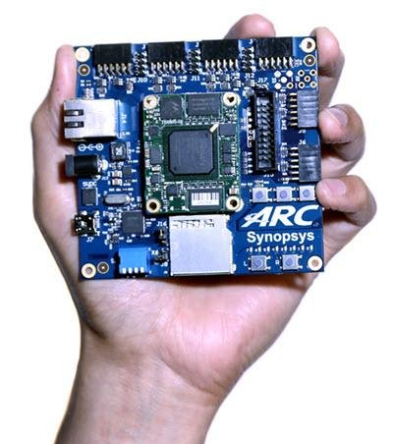

*A tiny "Arc Processor" sitting within the Intel CPU with it's own custom version of Linux (Minix) operating beyond the software level - completely transparent to the end user. Does not matter if your using Windows, Linux or Apple iOS...you are toast and THIS is how Israel does it. All part of The Talpiot Program.*

*No one is safe - no one. AMD has the exact same system - Platform Security System - and that is now totally owned and run by China. The ENTIRE worlds "Cloud Based" Internet system is backdoored by Israel. THIS is a national security disaster. Disaster is spelt D-I-S-A-S-T-E-R. I have copped endless shit for 9 years exposing this.*

*I have been jailed, beaten, bashed, vilified and threatened with the dreaded "Wood Shed" by Ry Ry Dawson [shivers], but I am still here. And so are you. I have been greeted by high level players. Everyone HATES Israel. Everyone. They just have the key staff in key positions bribed and blackmailed. They have "kill switched" the world's infrastructure. This is why Netanyahu is soooooooooo cocky and why we never seem to get anywhere. - Brendon O'Connell*

I would recommend watching the video, it is densely packed full of content.

Credit goes to [@blondenfun1](https://steemit.com/@blondenfun1) as referenced here: <https://steemit.com/anonymous/@blondenfun1/operation-talpiot-how-israel-backdoored-everything-here-s-the-hardware>

[#security](https://steemit.com/trending/security)[#nwo](https://steemit.com/trending/nwo)[#nsa](https://steemit.com/trending/nsa)[#israel](https://steemit.com/trending/israel)

2 years ago in [#technology](https://steemit.com/trending/technology) by **[pynchon](https://steemit.com/@pynchon)**[(34)](https://steemit.com/@pynchon)

$0.00

Reply [0](https://steemit.com/technology/@pynchon/the-arc-processor-israel-s-omnipresent-backdoor)

Sort:

• [Trending](https://steemit.com/technology/@pynchon/the-arc-processor-israel-s-omnipresent-backdoor?fbclid=IwAR1iaROZNpVHHYC7x1I19PR5DmZtoUMlMcaJN-gtvdzS95E_6udXY0NedO0)

[-]

[**egodust**(41)](https://steemit.com/@egodust) [2 years ago](https://steemit.com/technology/@egodust/re-pynchon-the-arc-processor-israel-s-omnipresent-backdoor-20180616t084646062z#@egodust/re-pynchon-the-arc-processor-israel-s-omnipresent-backdoor-20180616t084646062z)

Good info thanks for sharing - now we just need to develop some Minix killing firmware so we can completely disable this backdoor. (I know there is some Intel Management patches out there but could make the system unstable I'm told) It's well understood that this type of attack against Intel CPU's makes computers less secure for everyone and can't be tolerated for security's sake.

$0.00

[1 vote](https://steemit.com/technology/@pynchon/the-arc-processor-israel-s-omnipresent-backdoor?fbclid=IwAR1iaROZNpVHHYC7x1I19PR5DmZtoUMlMcaJN-gtvdzS95E_6udXY0NedO0)

Reply

[-]

[**pynchon**(34)](https://steemit.com/@pynchon) [2 years ago](https://steemit.com/technology/@egodust/re-pynchon-the-arc-processor-israel-s-omnipresent-backdoor-20180616t084646062z#@pynchon/re-egodust-re-pynchon-the-arc-processor-israel-s-omnipresent-backdoor-20180616t143439057z)

easier said than done..we need someone on the inside at Intel--lol!

$0.00

Reply

[-]

[**egodust**(41)](https://steemit.com/@egodust) [2 years ago](https://steemit.com/technology/@egodust/re-pynchon-the-arc-processor-israel-s-omnipresent-backdoor-20180616t084646062z#@egodust/re-pynchon-re-egodust-re-pynchon-the-arc-processor-israel-s-omnipresent-backdoor-20180617t185405694z)

disclosure is the first step of fixing this - maybe some Intel users or corporations should sue for breach of privacy and installing spy craft on their CPU's. I'm sure this will create quite a spectacle on the news and Intel shares would plummet...