**Israeli Zionism**

**It’s entirely true that: *“Each of the above-listed cataclysms was stealthily carried out to create the modern State of Israel and/or to greatly advance the clandestine Greater Israel project.”*(Source:**[**The Secret Agenda Behind the Trump Mideast Peace Plan**](http://stateofthenation.co/?p=5830)**)**

**Huawei**

When you follow the BIG money behind Huawei, it becomes clear that the largest Chinese multinational technology company is really owned and operated by the [***International Banking Cartel***](http://themillenniumreport.com/?s=international+banking+cartel).

It’s crucial to understand that *“Huawei has deployed its products and services in more than 170 countries. Huawei overtook Ericsson in 2012 as the largest telecommunications equipment manufacturer in the world, and overtook Apple in 2018 as the second-largest manufacturer of smartphones in the world, behind Samsung Electronics”*.[1]

Publicly-traded corporations the size of Huawei are only permitted to acquire so much market share with the blessing of the *International Banking Cartel*(IBC).  The IBC is in turn overseen by the **Khazarian Mafia** whose headquarters happens to be in Tel Aviv.  This is precisely why China was awarded Israel’s Port of Haifa contract in 2019 which will actually force the U.S. Sixth Fleet to dock elsewhere. See: [**How did China ever win Israel’s Port of Haifa contract over the US?**](http://stateofthenation.co/?p=6928)

The relatively hidden state of affairs between China and Israel has obscured the profound influence that Tel Aviv exerts over Beijing.  That well-concealed relationship developed as a result of China being released from the throes of the Cultural Revolution that ended in 1976 when it was permitted to transition to a market-oriented economy by the *International Banking Cartel*.

*“Since the introduction of*[***economic reforms in 1978***](https://en.wikipedia.org/wiki/Chinese_economic_reform)*,*[***China’s economy***](https://en.wikipedia.org/wiki/Economy_of_China)*has been one of the world’s*[***fastest-growing***](https://en.wikipedia.org/wiki/List_of_countries_by_real_GDP_growth_rate)*with annual growth rates consistently above 6 percent.”[2]*

The deal that China made with its secret masters in London and New York City is quite similar to the one that President Boris Yeltsin made with the very same banksters (IBC) which covertly approved the Fall of the Berlin Wall.  Both Presidents Gorbachev and Yeltsin were only able to facilitate the liberation of Russia from the Western-installed communist regime that ruled the Soviet Union by agreeing to a new form of “Rule by Oligarchs”—Western controlled oligarchs.  Except that Vladimir Putin patriotically reneged on those plunderous agreements in the interest of *“protecting Russia”*. See: [**Secret History Revealed — Putin Played Critical Role After The Pre-Planned Collapse Of The USSR**](http://stateofthenation2012.com/?p=8159)

However, in the case of China, what was imposed by the Western banksters was a novel form of predatory capitalist-imposed slavery after the yoke of communism was removed by the IBC.  That’s why there are so many sweat shops all over China today.  That’s also why 5G has been rolled out in some of the largest Chinese cities without even an iota of safety testing.  Powerful transnational corporations (like Huawei) have been granted slaveowner power by the IBC to run corporate plantations all over China.

[**COMMUNISM: A Jewish Creation for World Takeover**](http://stateofthenation.co/?p=6971)

The essential point here is that communism was first used by the banksters in China (and Russia) to establish an enormous archipelago of concentration camps for slave-workers nationwide, which were then converted into corporate plantations after the entirely staged ‘fall’ of communism.  For example, Apple, Inc has been frequently blasted for running inhumane factory operations (aka sweatshops) which depict the corporate plantation conditions.

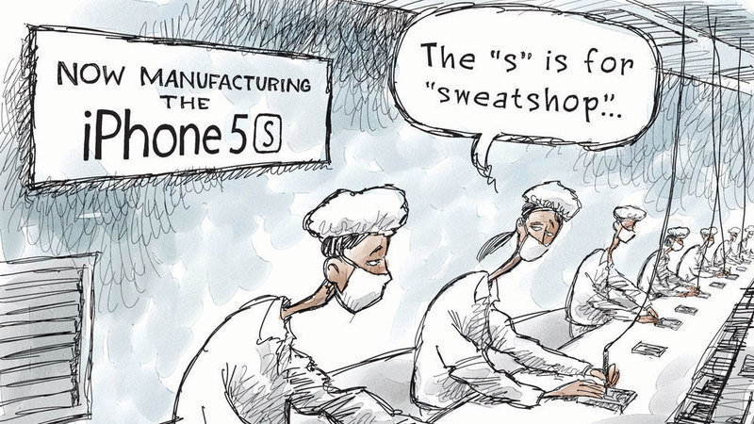

**Why China?**

Who can debate that the Trump administration has harassed China as much as they have tormented Iran?  What follows is the short list of some of the worst transgressions the Neocon Zionists in the White House have committed against China.

***In light of the US-staged Hong Kong protests, U.S. tariff regime against China, threat of economic sanctions against nations working with Huawei, CIA-inflamed Xinjiang conflict involving the Muslim Uyghurs, provocative sailing of US Navy warships through the Taiwan Strait, transparent political prosecution of Huawei’s CFO, ravaging of China’s pig farms by another DARPA-bioengineered animal virus, FedEx thwarted multiple sensitive deliveries to China in 2019, etc. the Chinese government has been under withering attack since 2018.****(Source:*[***OPERATION CORONA BIOTERROR***](http://stateofthenation.co/?p=5231)*)*

All of this bellicose behavior was directed toward softening up the Chinese government.  Not only does the Zio-Anglo-American Axis demand that Beijing submit to its will, they will not stop their provocations until they do.  The West has always treated the great nations of the East worst than stepchildren, and that will likely never change.  Which is precisely why everything points to China being used as the primary NWO laboratory for the furtive totalitarian technocracy before the new lab procedures are exported to California and elsewhere around the globe.

**\*The Chinese people are exceptionally computer literate, digitally connected and hooked into the wireless paradigm—to their great detriment.  Many years of exposure to these destructive energies have addicted them to their various information technologies and devices.  It has also rewired their brains in ways they are totally unaware and quite damaging. The same is true in every other nation on Earth where technology rules, but the Chinese are extreme in this regard.**

The most precarious aspect about the smartphone culture is that many Chinese are susceptible to psychogenic disease and illness, injuries and imbalances.  Of course, these are not limited to physical conditions; they are also being subjected to directed frequencies which will cause serious psychological disorders.  This may be exactly what’s going on right now in Wuhan where many folks might be triggered via their smartphones, particularly after the city-wide PTSD resulting from so much coronavirus uncertainty and inevitable mass anxiety.

It should also be noted that the countless techies in this type of IT society have never lost control like this.  In view of the double whammy of the coronavirus scare and 5G activation, many have been through an unparalleled “shock and awe” experience.  The resulting trauma has put many on edge—LITERALLY.  Hence, it now appears that many folks in places such as Wuhan can be triggered quite easily via their smartphones without even knowing what’s happening.  They can be walking along and suddenly just hit the ground; some even dying on the spot.

The upshot of this discussion is that the NWO controllers are pushing the edge of the envelope with regard to experimenting with sophisticated psychotronic weaponry that is both harmful and deadly.  In the present case, Wuhan is their laboratory and the Wuhanese are the lab rats.  There are other cities in China which are also being exposed to their own unique set of laboratory conditions.

China is also the premier national testing site for the infamous social credit score system– yet another oppressive control mechanism that the globalists will roll out worldwide when it has been perfected there.  The fact that the Chinese government has colluded with the globalist cabal and permitted the citizenry to be abused in this way greatly contributes to the notion that Israel owns China — lock stock and barrel — just as the Zionist banksters did during the days of Red China.

[**COMMUNIST CHINA: Established by Jewish Revolutionaries and Banksters**](http://stateofthenation.co/?p=6975)

**Wuhan: Ground Zero**

Wuhan, China was specifically chosen to be ground zero for both the 5G roll-out and the coronavirus pandemic.  No one can dispute that Wuhan City has been transformed into a desolate, dystopian 5G demonstration zone where the citizens are literally being used as guinea pigs.  As far as the 5G scientists in Israel are concerned, all Chinese citizens are nothing but chattel and, therefore, usable (and expendable) in any 5G experiment they set up there.

[**Why is Huawei setting up 5G base stations all over Wuhan to help fight the coronavirus?**](http://stateofthenation.co/?p=6921)

However, these cruel human experiments involve much more than 5G and the coronavirus; they also make use of chemtrails and specific types of industrial pollution generated throughout Hubei Province.  China has a well established reputation for wanton environmental degradation, and Wuhan will surely become a post-apocalyptic wasteland when they are finished with it. See: [**What in the world are they spraying all over Wuhan City?**](http://stateofthenation.co/?p=6932)

Known as “China’s Thoroughfare”, Wuhan occupies a very special place in Chinese history as well as in regard to the astonishing economic boom occurring since the mid-1970s.  Whatever happens in Wuhan can deeply affect the rest of the nation as the coronavirus panic has graphically demonstrated.  It’s as though the producers of this ‘disaster movie’ quite intentionally chose the capital of Hubei Province to be the epicenter of their NWO horror flick so that all of China would tune in.  And so they have!

*Wuhan today is considered the political, economic, financial, commercial, cultural and educational center of*[***Central China***](https://en.wikipedia.org/wiki/Central_China)*.*[***[17]***](https://en.wikipedia.org/wiki/Wuhan#cite_note-Focus_on_Wuhan,_China-17)*It is a major transportation hub, with dozens of railways, roads and expressways passing through the city and connecting to other major cities.*[***[23]***](https://en.wikipedia.org/wiki/Wuhan#cite_note-23)*Because of its key role in domestic transportation, Wuhan is sometimes referred to as “the*[***Chicago***](https://en.wikipedia.org/wiki/Chicago)*of China” by foreign sources.*[***[3]***](https://en.wikipedia.org/wiki/Wuhan#cite_note-timemagazine-3)[***[4]***](https://en.wikipedia.org/wiki/Wuhan#cite_note-Chicago_is_all_over_the_place-4)[***[5]***](https://en.wikipedia.org/wiki/Wuhan#cite_note-%E6%B0%B4%E9%87%8E%E5%B9%B8%E5%90%89_Mizuno_Kokichi_2014_3-5)*The “Golden Waterway” of the*[***Yangtze River***](https://en.wikipedia.org/wiki/Yangtze)*and its largest tributary, the*[***Han River***](https://en.wikipedia.org/wiki/Han_River_(Hubei))*, traverse the urban area and divides Wuhan into the three districts of****[Wuchang](https://en.wikipedia.org/wiki/Wuchang_District" \o "Wuchang District)****,****[Hankou](https://en.wikipedia.org/wiki/Hankou" \o "Hankou)****and****[Hanyang](https://en.wikipedia.org/wiki/Hanyang_District" \o "Hanyang District)****. The*[***Wuhan Yangtze River Bridge***](https://en.wikipedia.org/wiki/Wuhan_Yangtze_River_Bridge)*crosses the Yangtze in the city. The*[***Three Gorges Dam***](https://en.wikipedia.org/wiki/Three_Gorges_Dam)*, the*[***world’s largest power station***](https://en.wikipedia.org/wiki/List_of_largest_power_stations_in_the_world)*in terms of*[***installed capacity***](https://en.wikipedia.org/wiki/Installed_capacity)*, is located nearby.*

*While Wuhan has been a traditional manufacturing hub for decades, it is also one of the areas promoting modern industrial changes in China. Wuhan consists of three national development zones, four scientific and technological development parks, over 350 research institutes, 1,656 hi-tech enterprises, numerous enterprise incubators, and investments from 230 Fortune Global 500 firms.*[***[24]***](https://en.wikipedia.org/wiki/Wuhan#cite_note-24)*It produced GDP of US$224 billion in 2018. The****[Dongfeng Motor Corporation](https://en.wikipedia.org/wiki/Dongfeng_Motor_Corporation" \o "Dongfeng Motor Corporation)****, an automobile manufacturer, is headquartered in Wuhan. Wuhan is home to multiple notable institutes of higher education, including*[***Wuhan University***](https://en.wikipedia.org/wiki/Wuhan_University)*, which was ranked third nationwide in 2017,*[***[25]***](https://en.wikipedia.org/wiki/Wuhan#cite_note-25)*and the****[Huazhong University of Science and Technology](https://en.wikipedia.org/wiki/Huazhong_University_of_Science_and_Technology" \o "Huazhong University of Science and Technology)****.[3]*

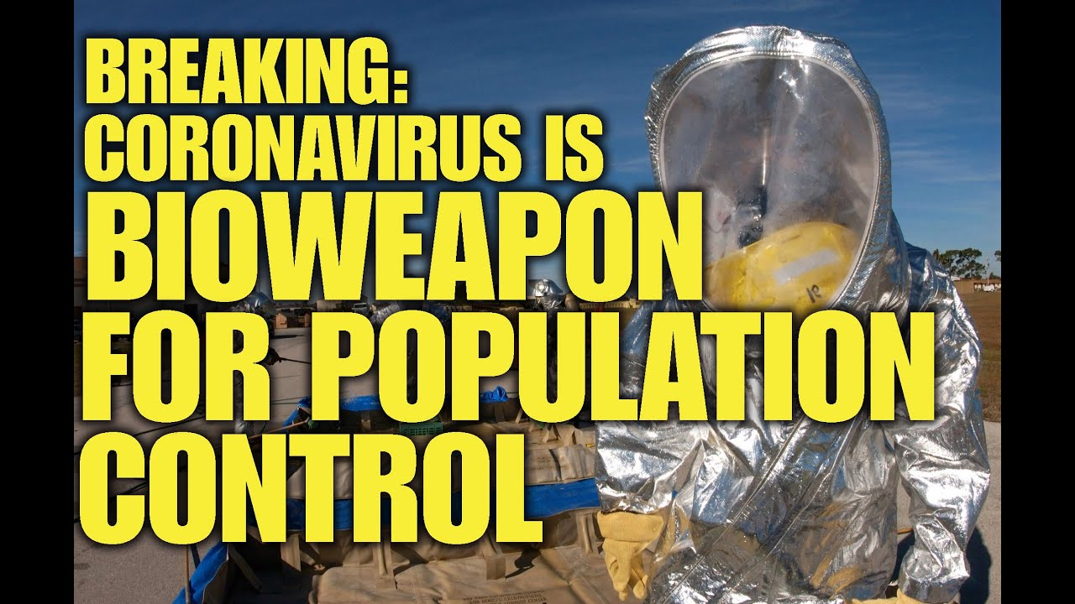

**Coronavirus**

Into this Kafkaesque context, enter the fastidiously bioengineered Wuhan coronavirus.  There are several high-integrity authorities, as well as scientific research studies, which have described what makes this unusually fatal virus a lab-produced bioweapon.  As follows:

[**CORONAVIRUS BIOWEAPON UPDATE: Unique HIV-1 Signatures Confirmed by Team of Indian Scientists**](http://stateofthenation.co/?p=6150)

[**WUHAN CORONAVIRUS BIOWEAPON: Bioengineered with Virulence Associated Protein (Video)**](http://stateofthenation.co/?p=6844)

There’s no question that this bioweapon was purposefully bioengineered to target the indigenous Chinese people.  In particular, individuals born from that traditional Asian gene pool and bloodline are affected much more profoundly by coronavirus infections. See: [**BIOWARFARE: Wuhan Coronavirus is likely another race-targeting bioweapon strategically unleashed throughout China by U.S. military labs**](http://stateofthenation.co/?p=5005)

This deliberate racial targeting by the Zionist perps in Israel is being conducted with certain objectives which are well beyond the scope of this exposé.  Suffice it to say that what the whole world is now witnessing in Wuhan is yet another depopulation event and citizen relocation exercise.  Just like the Northern Levant, Israel’s preferred method of waging war is first, genocide, and secondly, forced removal or a coerced exodus.

The same Zionist warmongers will also not hesitate to use any type of terrorism necessary to get the job done.  Just look at what [**they did on 9/11**](http://themillenniumreport.com/2019/02/hard-evidence-confirms-9-11-was-both-an-inside-job-and-mossad-job/) in order to stampede the whole world into the utterly fake *War on Terror*.  There is perhaps no act of terrorism or violent attack the Neocon Zionists would not carry out in order to advance their devastating *Greater Israel* project as delineated here: [**Nothing changes until those who secretly rule US are prosecuted for 9/11, JFK, OK City, 5G, Chemtrails, Vaccines….**](http://stateofthenation.co/?p=5363)

Should the unparalleled crisis in the greater Wuhan area continue to deteriorate at the current alarming rate, there’s no telling what the government in Beijing will resort to.  Of course, the current government will obey the dictates of their Zionist overlords, even if it means warehousing the citizenry, enforcing vaccinations, pervasive 5G activations, nonstop chemtrailing, etc.  Therefore, how this situation develops over the course of the Winter and Spring of 2020 will reveal both the true purpose and perpetrators of this twisted plot.

[**Wuhan Coronavirus Bioterrorist Attack Is China’s 9/11, Same Perps**](http://themillenniumreport.com/2020/02/wuhan-coronavirus-bio-attack-is-chinas-9-11-same-perps/)

**The International Criminal Conspiracy**

No one can argue that China has been a world leader of the global 5G roll-out.  Huawei has aggressively sold their 5G program to every country in the world that will listen… or is not intimidated by Trump’s threat of sanctions should they sign on.  In light of this single stark reality, who can argue that China seems clueless to the inherent dangers of 5G … unless they have been paid to be clueless.

The Asians are by their very nature quite vulnerable to the allurements of the latest and greatest IT devices and advancements.  This weakness of national character made China the perfect pitchman for 5G worldwide; little do they know that they are working on behalf of the *International Banking Cartel*.

Not only do the 5G roll-out and IoT build-out represent the most lucrative business opportunities of all time, they promise an IT paradise for any nation that goes for the bait.  Far from effectuating an improvement in one’s life, these two major developments are essentially the most important pieces of the quickly materializing *Global Control Matrix*.  Those who opt in to this next generation of the global IT society will not only bask in a field of perilous energies 24/7, they will also be subjected to the highest degree of life-monitoring on the planet today.  And, it’s the 5 EYES + ISRAEL who will be running that most invasive spying and surveillance regime ever.

Now, to pull this off successfully, there was a deal made among all the involved state actors and other corporate and institutional co-conspirators.  All the usual suspects showed up at the table to include the UN, US, UK, France, Germany, Italy, Australia, Japan, Canada, Israel, *Big Tech*, *Big Social Media*, *Big Pharma*, etc.  While that deal was being hammered out, China was working its own deal — on the sly — with Israel—the 5G kingmaker.

What now appears to be the case is that the Chinese government sold its soul to grab all the Eurasian biz.  Once that deal with the devil was made, China has gone full-bore with 5G development and deployment via Huawei, Samsung and other corporate titans to lock down the IT marketplace.  The real problem with this highly dynamic situation is that no one really knew how much China gave up … until now.

The deteriorating plight of Wuhan is a clear illustration of what can and will happen when any nation signs such a malevolent contract with Israel.  Whether the deal unraveled because China balked at the one-sided terms of the contract — after the fact — or whether Israel grossly violated the terms of the contract as they ALWAYS do, remains to be seen.

[**China Slams Israeli Claim That Coronavirus Came From Bioweapon Lab**](http://stateofthenation.co/?p=6761)

Nevertheless, both the United States and United Kingdom were enlisted as always as the contract enforcement muscle.  Just as the Brits still control Hong Kong and the Yanks wield much influence inside China through so many corporate spies and Christian missionaries, the Chinese government failed to realize their nation could be turned inside out and upside down with the flip of a switch—a 5G switch by Israel, a coronavirus switch by the US/UK, as well as a Hong Kong protest switch by the UK/US.

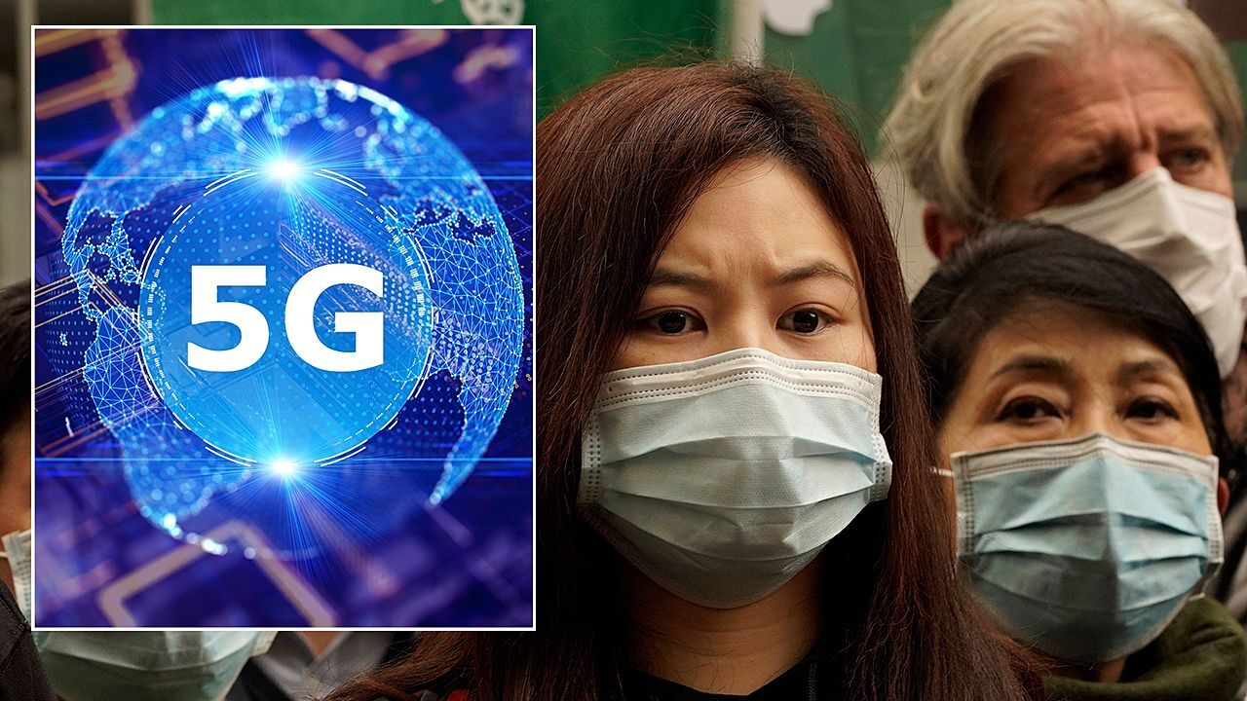

**5G + Coronavirus + Vaccinations + Chemtrails = Depopulation Event**

Let’s face it: it didn’t take a rocket scientist to figure out that the very day 5G was activated in Wuhan along side a recently release virulent flu strain targeting racially susceptible individuals, that people would start dropping like flies.  Such an assault on the immune system is guaranteed to take out a big number of city dwellers in a day and a night.  And drop on the spot they have done, perhaps many more than the world will ever know.

What has really put the coronavirus outbreak on super-steroids is the ongoing chemtrail operations that put the whole province under a dark noxious cloud.  Chemtrails are commonly used to soften up the residents below by introducing various toxic chemicals and pathogenic biologicals into the ambient atmosphere.  Once the bioterrain of any individual has been sufficiently cultivated with triggering toxins and pathogenic micro-organisms, the individual is easily preyed on by highly contagious diseases like the Wuhan coronavirus. See: [**CHEMTRAIL SYNDROME & FLU: A Global Pandemic Of Epic Proportions**](http://thehealthcoach1.com/?p=3403)

Few are aware but Wuhan, in particular, is notorious for its year-long episodes of debilitating industrial pollution.  Some of this atmospheric engineering is undertaken with purposeful design via specific chemical releases from industrial smokestacks.  Exactly what toxic brews and waste products these discharges are composed of is anyone’s guess.  Nonetheless, industrial airborne effluents in China have reached a whole new plateau of pollution that is also affecting nations near and far. See: [**Is the Wuhan coronavirus a cover story for this, too?**](http://stateofthenation.co/?p=6951)

***\*When toxic chemtrail aerosols are sprayed on the residents below, who are already exposed to a highly infectious coronavirus while glued to a powerful 5G device after receiving their exceedingly toxic annual flu vaccination, what could possibly go wrong?!***

Let’s not forget that the Chinese people have been conditioned (read: socially engineered to get their annual flu shots) to VACCINATE, INOCULATE & IMMUNIZE themselves over many years by the regular serious flu outbreaks which have started in some of the largest metro areas, especially Hong Kong, Shanghai and Guangzhou.  With each successive influenza panic, the populace is corralled into the pen of flu vaccine compliance as a means of ‘preventing a mass epidemic’.  It is their civic duty, they are told, to vaccinate the whole family so as to not spread the latest flu bug to the rest of the neighborhood or to larger community.

[**5G is a kill grid that will lead to forced vaccinations! (Video)**](http://stateofthenation.co/?p=7072)

Undoubtedly, this Wuhan epidemic was set up for years just waiting for the perfect moment for the Zio-Anglo-American Axis powers to press the button.  Now that both the USA and Great Britain have been heavily implicated in this criminal conspiracy, all Israel has to do is avoid having their Mossad fingerprints appearing anywhere near the crime scene.  Even if Zionists do somehow get caught, [**like they did with 9/11**](http://themillenniumreport.com/2019/02/hard-evidence-confirms-9-11-was-both-an-inside-job-and-mossad-job/), they are the world’s best at shamelessly blaming their victims as they have already done about the origin of the coronavirus.

These Zionist master of illusion will employ every trick of the trade they can muster, especially powerful psychological ploys such as predictive programming.  Otherwise, how, pray tell, did this ever happen nearly 40 years ago: [**PREDICTION OF THE WUHAN CORONOVIRUS IN 1981**](http://stateofthenation.co/?p=7022)

[**More Predictive Programming About ‘A virus called Wuhan-400’**](http://stateofthenation.co/?p=7120)

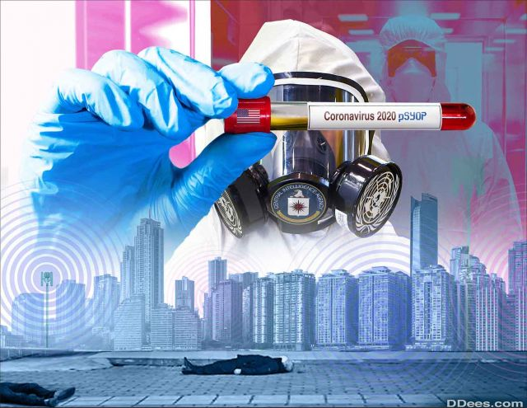

**PSYOP**

Undoubtedly, the single most important piece of this captivating psyop is the worldwide initiative to develop a vaccine that will supposedly serve as a prophylactic measure to contracting the coronavirus.  Never has there been such a highly coordinated international effort to produce a vaccine in the wake of any previous epidemic or pandemic.

As always, the dangerously untrustworthy World Health Organization (WHO) is leading the global charge to develop a vaccine that is likely impossible to create within the stated time frames.  What this really means is that *Big Pharma* has already secretly manufactured massive amounts of a so-called ‘Wuhan coronavirus vaccine’ (which treats the WHO-named COVID-19) that is ready to be injected worldwide, especially wherever the World Health Organization and Bill Gates have set up their countless vaccination centers in Third World countries. See: [**Bill Gates Accused Of Starting Ebola Outbreak In African Village By Putin**](http://themillenniumreport.com/2017/05/bill-gates-accused-of-starting-ebola-outbreak-in-african-village-by-putin/)

As always, the poorest and least educated nations will be victimized by this meticulously designed psyop.  Something so HUGE as this Westerrn-manufactured coronavirus pandemic provides a unique opportunity for the reptiles at the very top of the food chain to conduct a mass casualty depopulation event the likes of which the world has never seen.

Every person on the planet needs to be aware that this represents only one component of this swiftly manifesting psyop.  Surely, this NWO psychological operation will morph and mutate according to the reactions of each national populace on all 7 continents.  Then, each [HARDWIRED] locale will be responded to by the authorities in a manner so that sufficient consent is manufactured in order to lock each place down … **until the whole place is locked down**.

Such draconian measures are already being taken in the rich, industrialized nations such as the United Kingdom. See: [**Look at how they’re locking down the UK because of the coronavirus!**](http://stateofthenation.co/?p=6964)

Given these draconian developments worldwide, particularly with respect to unprecedented police powers being given to law enforcement everywhere, this staged pandemic has all the hallmarks of a classic “Problem~Reaction~Solution” black operation being run by the global intelligence community with the C.I.A., MOSSAD and MI6 taking their usual lead.

There is perhaps no more effective way to foist a totalitarian **One World Government** upon the world community of nations than to scare every inhabitant of planet Earth into demanding it.  Of course, coronavirus fearmongering appears to be the path forward for the perps at peak of the world power pyramid, and now that they have started the giant snowball rolling down the hill toward global depop, there may be no stopping it.  But, we wait and see how “deus ex machina” might prevail in this Shakespearean tragedy.  Perhaps the perps will be found out and taken out.

**Donald Trump | Xi Jinping | Vladimir Putin**

There’s a very curious connection (and disconnection) between the three most prominent leaders on the world stage today regarding this pandemic which demands further treatment if this important analysis is to withstand legitimate scrutiny.

**First, there is President Donald Trump.**

It’s quite unlikely that Trump knows anything of substance about the real pandemic plot.  He simply could not be trusted by the real perps.  However, that does not mean Trump is not being used all day long to send messages and make pronouncements that serve the various Zionist agendas, and there are several.  What follows is an illustration of his being used as a transparent tool in this way.

[**CORONAVIRUSgate: The only way Trump could ever make such a ridiculous prediction about April is because he was ordered to by the real perps!**](http://stateofthenation.co/?p=6914)

Both Father Trump and Daughter Ivanka have already demonstrated their zeal for all things 5G, and especially how important it is for the U.S. to stay way ahead of the Chinese in this regard.  Why it’s so urgent for the US government to fry its citizens before the Chinese government does the same has never been adequately addressed by Trump … or anyone else in his administration.

[**Contrary to so much false reporting, 5G has NOT been canceled by Trump nor has its harmful effects been eliminated because it’s impossible……5G is currently undergoing a large-scale military deployment nationwide.**](http://stateofthenation2012.com/?p=122954)

The key point here is that Trump has always placed MIGA over MAGA. He has done the bidding of Israel as no other POTUS in American history.  Toward that end, Trump has made the 5G roll-out a major priority throughout his term in office **because it’s Israel’s top priority**.  Not only will Israel gain considerably from the 5G and IoT economic boom, it will provide them with financial independence, which they have been desperately seeking for decades, from every country they routinely fleece and swindle.  See: Germans swindled yet again

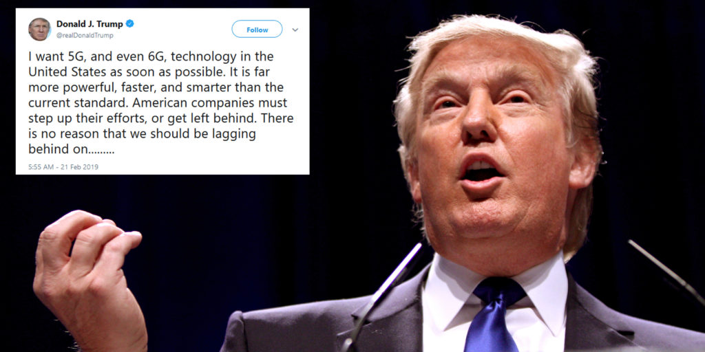

Trump’s main thrust (and complaint to his antagonists) is that he wants the USA to lead the worldwide 5G revolution, not China.  He has taken his vicious 5G war against Huawei to Europe and beyond, even threatening every national Huawei customer with economic and/or financial sanctions.  Trump has quite recklessly done all of this after coercing Canada to arrest Huawei’s CFO in order to extradite her to the U.S. to face prosecution for violating the his illegal sanctions against Iran—WOW! ! !

[**Here’s Why Canada Arrested Chinese CFO for Trump Admin**](http://themillenniumreport.com/2018/12/canadas-shocking-arrest-of-chinese-cfo-for-u-s-has-highly-radioactive-back-story/)

**Then, there is President Xi Jinping.**

If ever there was a prez sitting in a roiling stew pot, Jinping is it.  While the Chinese president’s story is way too complicated to understand in any meaningful way in this short assessment, an accurate understanding of his true predicament will reveal the most radioactive back story of all.

What can be said about Jinping is that he seems to be a typical Chinaman who places the advancements of information technology over the good health of the citizenry.  Just as Beijing has always put China’s industrial prowess even over the well-being of the residents living in the capital itself, so, too, is the military deployment of 5G more sacred than the safety of the populace.  That the air quality in Beijing is consistently rated one of the worst in the entire world stands as a smoggy testament to this fact.

That Jinping has even been put in this extremely challenging predicament by his masters in Israel can indicate different things.  But, maybe Jinping had enough of Trump’s intimidation and bullying?  Or, did Trump become impatient with Jinping’s justifiable recalcitrance?  Did Xi attempt to leave the Zionist reservation, which then predicated the rapid explosion of the Wuhan coronavirus?  Or, is Jinping just a powerless figurehead playing his part perfectly in this coronavirus pandemic melodrama?

Clearly, it’s way too early to form firm conclusions about Xi Jinping; but how this tragic drama unfolds will certainly reveal the main plot in Beijing, as well as several Chinese sub-plots.  In the meantime, the whole world is held captive by the Wuhan coronavirus pandemic which has all the elements necessary to collapse the *Global Economic & Financial System*.  That, too, may be one of the primary objectives of this diligently staged horror show.

**Lastly, there is President Vladimir Putin**

Putin has made no bones about the fact that 5G and IoT will be fully integrated within the Russian military to whatever extent necessary to stay ahead of the rest of the world, especially the U.S. military.  This stated intention appears to be quite true as Putin knows that existential threats lurk around every corner, and the Russian Motherland has a lot of corners to protect and boundaries to defend.

Putin has not made 5G such a priority for Russian civil society, however.  The corporate sector may be developing 5G networks and IoT infrastructure to gain advantage in the global marketplace, but Moscow seems to be relatively uninvolved.  The Kremlin is well aware of the deleterious effect of the 5G paradigm and only appears to promote it when absolutely required—as a defensive psyop tool.

Putin has been on the forefront of so many vital issues where it concerns human health and environmental protection that it would only make sense that he would not endanger the Russian people with a nationwide 5G roll-out; besides, it’s impossible to do with any level of integrity in a vast country the size of Russia.

**Let’s not forget the Brits.**

As always, the US-UK Empire stands together when the West takes on the East.  However, the very nature of the so-called special relationship is that London uses Washington, D.C. to do all of its dirty work.  The British are always very careful to elude blame, especially for matters of such great import as they did with the creation of the coronavirus.  While there were several parties involved in that genocidal enterprise, the prime mover was most definitely “The Crown” as seen by the very name — **“Coronavirus”** — ***where corona literally means crown***.  They did not even try to hide it, did those bloody Brits?!  As follows:

[**CORONAVIRUS was funded and patented by Wellcome Trust (UK, fake sold to GlaxoSmithKline), Bill & Melinda Gates Foundation, DARPA, DEFRA (UK), World Health Organization, European Commission (EU) via THE PINBRIGHT INSTUTUTE (UK)**](http://stateofthenation.co/?p=5884)

**Bottom Line**: The unintended benefit of all this manufactured chaos by the highest level of the *World Shadow Government* regarding 5G is that it has brought a LOT of awareness — GLOBALLY — to what is now the single greatest threat to humanity and the biosphere.  Truly, the exceedingly dangerous military deployment of 5G represents an ongoing event with worldwide apocalyptic consequences.  In point of fact, the far-reaching health repercussions and unavoidable environmental ramifications will be so profound and pervasive that this depop event will likely evolve into a full-blown ELE if left unchecked by competent authorities.**\***

**\*ELE = Extinction Level Event**



**Coronavirus Distraction**

As always, the NWO cabal looks for ways to distract the entire planetary civilization.  Really, is there any better way to do this than with a VERY scary coronavirus pandemic?

Whether this pandemic is being completely staged, or is totally real, or is hoax blended with reality cannot yet be determined with any certainty.

At the end of the day, it may not really matter since the end result will be the same.  *We the People* will be deceived into believing that only global governance can solve this ‘dire matter’.  And, that only a [**One World Government**](http://themillenniumreport.com/?s=one+world+government) can prevent such plagues and pandemics from ravaging humankind in the future.

In this way, the 5G roll-out will proceed forthwith.  Even though the 5G energy platform represents the worst and biggest part of the problem, it’s being slyly covered up by coronavirus hysteria.  The Chinese government is even singing the praises of the now accelerated 5G roll-out in Wuhan and other major cities as a means of battling the coronavirus! See: [**Why is Huawei setting up 5G base stations all over Wuhan to help fight the coronavirus?**](http://stateofthenation.co/?p=6921)

Really, is there a more efficacious strategy for the perfidious perps to execute their diabolical plan toward total world domination?  What better way to accomplish their ultimate objective of global population lockdown via the dictates of a tyrannical technocracy?

**KEY POINT:** What this depop event really is thus far is nothing short of attempted genocide.  Hence, the $64,000 question is “Cui bono?”  There is only one tribe behind all the major genocides since 1900. See: [**GENOCIDE ALERT: Shooting Down Families & Journalist In Wuhan China!!! (Video)**](http://stateofthenation.co/?p=7067)

***Deep State’s* Kill Switch**

There’s no quicker to collapse the *Global Economic & Financial System* than to purposely propagate a highly contagious virus with an alarmingly high mortality rate.  The daily  headlines have already prove that business and commerce — EVERWHERE — is being radically affected by this intensifying pandemic. See: [**BLACK SWAN EVENT = WUHAN CORONAVIRUS PANDEMIC**](http://stateofthenation.co/?p=7176)

*Deep State*, not only in the United States and United Kingdom, but within every nation aligned with the Zio-Anglo-American Axis, has an overriding need to arrest the numerous national movements which are enjoying unparalleled popular and political success.  Hence, there’s no question that what we are seeing is either a threat to pull the “Kill Switch” on the *Global Economic & Financial System*; or that *Deep State* is holding this threat over the head of every nationalist leader to include President Donald Trump, Prime Minister Boris Johnson and every other head of state who is fighting globalism.

What is indisputable is that the Wuhan coronavirus bioweapon has all the necessary elements to effectuate of a truly devastating pandemic that can penetrate every sphere of life throughout the entire planetary civilization.  Clearly, ***it was designed this way***.  Now we wait and see if the *Deep State* perps will actually pull that “Kill Switch” as a means of carrying out [**THEIR FINAL SOLUTION: Market Crash, Dollar Collapse & World War 3**](http://stateofthenation2012.com/?p=98787).

**“Staged Coronavirus Pandemic”**

***How is this pandemic being staged, yet at the same time very real?***

**Here’s how:**

**SPECIAL NOTE: The Wuhan bio-attack appears to be  
just one in a series of ongoing biological attacks being  
conducted throughout mainland China.  This Zio-Anglo-  
American bioterrorist operation is being stealthily  
perpetrated to give the appearance that the national  
epidemic started with a single case in Wuhan City, when  
it’s still being surreptitiously spread in other Chinese  
cities via similar modes of propagation. Because the  
vectors of dissemination of this weaponized coronavirus  
are mapping worldwide at rapidly expanding rates, there  
are quite likely multiple methods of proliferation which  
are being cunningly implemented to confuse the medical  
investigators as well as to avoid detection.  
(Source:**[**A Strong Case for Premeditated Act(s) of Bioterrorism in Wuhan City, China Carried Out by Paid Agents of the Zio-Anglo-American Axis**](http://stateofthenation.co/?p=6689)**)**

**Conclusion**

The preceding narrative is long and complicated, we know.  The distillation of this very real multi-decade conspiracy as well as the unending associated scandals is this: that the **military deployment of 5G worldwide** is the central pillar of the NWO agenda which the globalists will not allow to be put in jeopardy or slowed down by popular protests.  Hence, the globalists have conducted the **Wuhan coronavirus pandemic** scare as a means of misdirecting the medical investigators so that the coronavirus symptoms will instead be blamed for all 5G-induced medical ailments and health conditions. See [**CRITICAL DATA POINT: Wuhan established as Hubei’s first 5G demonstration zone**](http://stateofthenation.co/?p=6061)

The worsening plight of the Chinese people has predictably created the context for yet another **racially targeted vaccine** to be administered first, to the Wuhan control group, and secondly, to the rest of China, and then, throughout the world-at-large.  Not only are the medical authorities closely monitoring those who have submitted themselves to past vaccination schedules, they will soon be experimenting with the new series of coronavirus vaccines that specifically address 2019-nCoV.

The other two pillars of this complex depopulation event are **chemcial geoengineering** and **industrial pollution**.  Not only has Wuhan suffered from a tremendous amount of air pollution due to the extraordinary concentration of industries in the greater metro area, the local population has been subjected to various formulations of chemtrail aerosols, each being sprayed with purposeful design.

While this broad analysis of the Wuhan coronavirus pandemic psyop does not offer the detailed breakdown of the undeniable connections between the various aforementioned assaults on the citizenry, all of which mutually support the outworking of this odious black operation, those vital connections — between 5G, Coronavirus, Vaccines, Chemtrails & Pollution — ought to be obvious by now.

**CAVEAT: Look out, folks, wherever and whenever they are rolling out 5G locally, spraying chemtrails regularly, fervently pushing vaccines right after the latest frankenvirus or exotic disease outbreak, and relentlessly fearmongering in the midst of it all.**

Clearly, the most significant objectives of the coronavirus outbreak are to cover up the Chinese genocide and ensuing global depop, as well as to hide the pivotal link to 5G.  Therefore, it’s imperative that all truth-seekers and patriots read the following exposé; our lives and the welfare of our families and friends greatly depend upon it.  Also, circulating the many links in this analysis will serve considerably the enlightenment of the greater community around these life-threatening matters.

[**The Hidden Link Between the Coronavirus and 5G Testing**](http://stateofthenation.co/?p=6986)

Until the next installment in this series on the Wuhan coronavirus pandemic, stay safe, stay sober, stay sane, and be sure to follow the coronavirus recommendations of *The Health Coach*as follows: [**Here’s How Everyone Can Avoid Getting The Coronavirus**](http://stateofthenation.co/?p=6220)**.**

[**State of the Nation**](http://stateofthenation.co/?p=6898)  
February 13, 2020

Author’s Note

Part I of this Wuhan coronavirus series is a vital prerequisite if one is to properly grasp the many angles on this ***“elaborately staged, global, false-flag, bioterror operation using real bioweapons aimed at multiple national and racial targets in order to accomplish numerous NWO objectives”***.  Read: [**WUHAN CORONAVIRUS PANDEMIC BIOENGINEERED: Who’s behind it, why now and why China? – Part 1?**](http://themillenniumreport.com/2020/01/wuhan-coronavirus-pandemic-bioengineered-whos-behind-it-why-now-and-why-china/)

Editor’s Note

For years this *Alt Media* platform has studied the correlation between the different influenza symptoms and *Hyper-electrosensitivity syndrome*—a very real medical ailment that even medical doctors are now diagnosing.  Since the 5G roll-outs in the big cities, the  flu bug seasons are getting worse and longer.  Quite coincidentally, many of the flu symptoms are similar to many those directly associated with *Hyper-electrosensitivity syndrome*.  Surely this is no accident of fate; rather, these two medical phenomena are mutually feeding each other and contributing to the severity of each disease process both individually and jointly. See: [**Exposure to 5G millimeter waves leads to ……..“flu-like symptoms”.**](http://stateofthenation.co/?p=5700)