The RAND Corporation and the New Manhattan Project
TOPICS:ChemtrailsGeoengineeringMilitaryPeter KirbyScienceWeather Modification
JULY 19, 2020
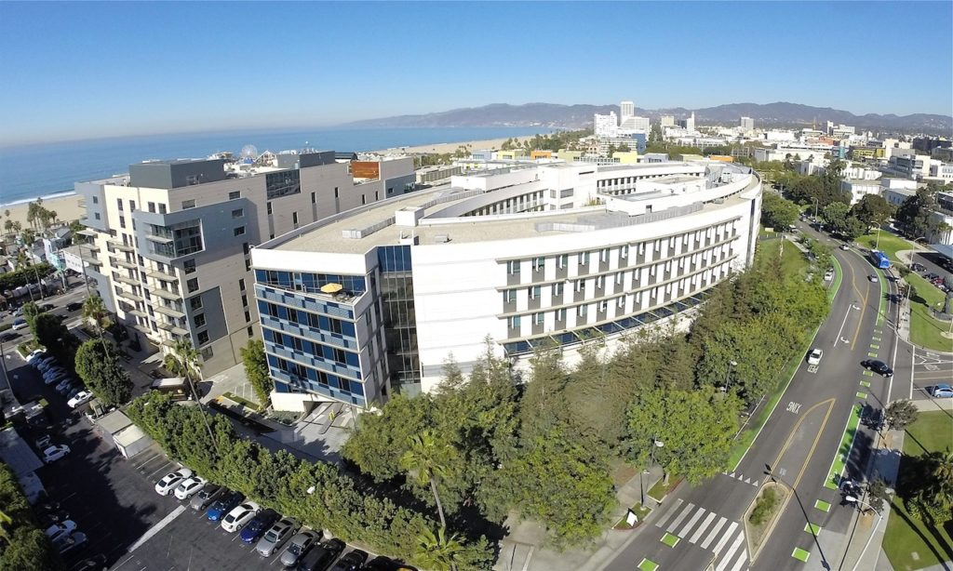By Peter A. Kirby
The RAND Corporation appears to have been central to the development of today’s New Manhattan Project. Their founding and evolution involves many organizations and individuals associated with the project and they have been involved in many areas of research germane to the New Manhattan Project. To learn all about today’s New Manhattan Project, please refer to the new, greatly revised and expanded second edition of the author’s book Chemtrails Exposed: A New Manhattan Project available exclusively at Amazon.

The story of the RAND Corporation
During World War II, the importance of air war capabilities became apparent. The Japanese attack on Pearl Harbor, Nazi Germany’s superior aerospace capabilities, and other developments impressed upon American military leadership the need for a tremendous expansion of the Army Air Forces. An Army Air Force general by the name of Henry ‘Hap’ Arnold (1886-1950) took up these challenges by the horns.
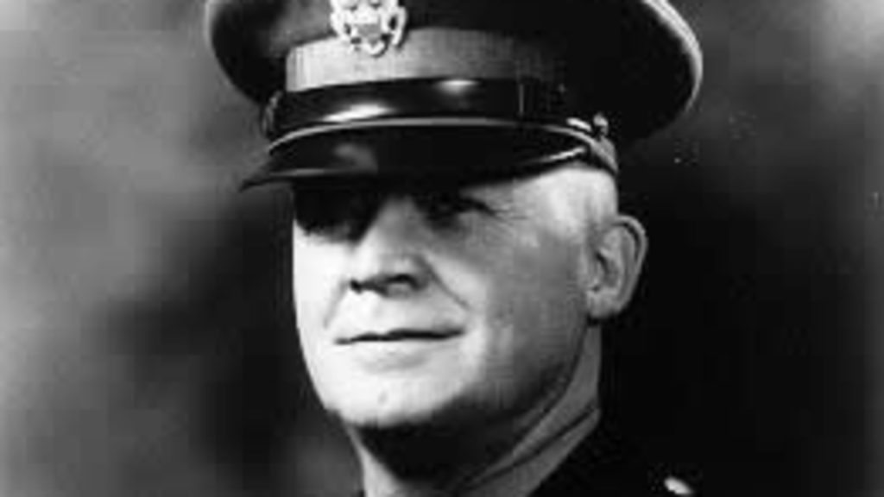
General Henry ‘Hap’ Arnold
General Hap Arnold is already familiar to readers of this work. He was responsible for the post-war series of reports titled Toward New Horizons, also known as the von Kármán Reports. Toward New Horizons laid out a path for this desired expansion of aerospace capabilities and resulted in the creation of something called the Air Force Scientific Advisory Board, which was tasked with carrying out the dictums of Toward New Horizons. The RAND Corporation was formed as a sort of sister organization to the Air Force Scientific Advisory Board. In this relationship, the RAND Corporation handled research and development of new technologies, while the Scientific Advisory Board evaluated RAND’s work and advocated for further production and implementation.
Arnold got the idea for the RAND Corporation in September of 1945 from an Army Air Force test pilot by the name of Franklin R. Collbohm (1907-1990). Arnold and Collbohm had first met during the war when Collbohm furnished Arnold with radar technology from the Massachusetts Institute of Technology (MIT). With the end of hostilities and the impending dissolution of military science, Collbohm suggested to Arnold that an organization be created in order to retain and utilize scientists for military purposes as well as bypass a lot of bureaucratic red tape that had previously hindered the development of new military technologies. Shortly thereafter, a meeting at Hamilton Air Force Base in Marin County, California was convened in order to initiate the creation of such an organization. Attending this meeting were: Arnold, Collbohm, the head of Douglas Aircraft, Donald Douglas (1892-1981), the Vice President and Head of Engineering of Douglas Aircraft, Arthur E. Raymond (1899-1999), and scientist Edward Bowles (1898-1990) of MIT. At this meeting Arnold pledged to allocate $10M of unspent wartime funds to the Douglas Aircraft Corporation for a study about future warfare called Project RAND. RAND was short for ‘research and development.’ Collbohm was appointed as RAND’s first director. RAND’s first headquarters were at the main Douglas Aircraft plant in Santa Monica, California. Today their world headquarters are still located in Santa Monica, California.
RAND world headquarters, Santa Monica, CA
In late December of 1945, Air Force Deputy Chief of Staff for Research and Development General Curtis LeMay (1906-1990) began supervising the development of RAND. LeMay, Collbohm, Raymond, and Bowles had all previously worked together during WWII in the Mariana Islands.
Questions about conflicts of interest between the Douglas Aircraft Corporation and the Air Force soon arose. So in May of 1948, Collbohm called in San Francisco attorney Rowan Gaither (1909-1961) as a consultant. It was Gaither’s job to advise the RAND Corporation’s administrators as to exactly how RAND should establish their independence from Douglas Aircraft. Collbohm knew Gaither from the war when Gaither worked as the associate director in charge of administration at the MIT Radiation Laboratory and as a consultant to the National Defense Research Committee. Gaither’s job at the MIT Rad Lab was to coordinate the work of the staff and serve as a liaison between the Rad Lab and the military.
Gaither drew up a memorandum offering RAND’s administrators a range of options. From all of the options presented, it was decided that RAND would break away from Douglas Aircraft as a nonprofit corporation, the first of its kind in America. Air Force Chief of Staff Carl Spaatz (1891-1974), who had previously served under General Arnold, signed off on the plan. Gaither then drafted RAND’s articles of incorporation and helped enlist men for RAND’s board of trustees. Using his connections, Gaither also helped raise RAND’s original working capital from the Ford Foundation as well as the Wells Fargo Bank. Gaither later went on to become the head of the Ford Foundation. Gaither served as RAND’s chairman of the board until his death in 1961.
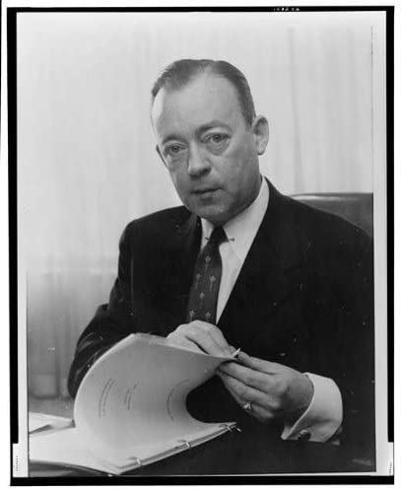
Horace Rowan Gaither
Being that Gaither was so key to the founding of the RAND Corporation, it is interesting to note that he was also one of the original trustees of the later MITRE Corporation. As regular readers of this work already know, the MITRE Corporation is the most probable executor of all of the scientific aspects of today’s New Manhattan Project. In fact, the MITRE Corporation’s structure was modeled after the RAND Corporation’s and 5 out of the 10 members of MITRE’s first board of trustees were also executives at the RAND Corporation.
The RAND Corporation originally did work exclusively for the Air Force. But as the years went by, RAND began fulfilling contracts for many other organizations. In fact, the RAND Corporation went on to fulfill contracts for just about every major organization implicated in the development of the New Manhattan Project. RAND went on to do work for: Boeing, the Department of Defense, the Navy, the Atomic Energy Commission, the National Aeronautics and Space Administration, the Advanced Research Projects Agency (ARPA/DARPA), the National Science Foundation, the Department of State, the Electric Power Research Institute, the Office of Water Resources Research, the Department of the Interior, the Travelers Companies, the Environmental Protection Agency, the CalTech Jet Propulsion Laboratory, the Central Intelligence Agency, the Carnegie Foundation, the Ford Foundation, and the Rockefeller Foundation.
RAND has also employed a plethora of individuals implicated in the New Manhattan Project. These individuals include: Edward Teller (1908-2003), Luis Alvarez (1911-1988), George Kistiakowsky (1900-1982), Samuel Cohen (1921-2010), Charles Allen Thomas (1900-1982), Lee A. DuBridge (1901-1994), Julius A. Stratton (1901-1994), Ernest O. Lawrence (1901-1958), John von Neumann (1903-1957), Donald Rumsfeld, and Alfred Lee Loomis (1887-1975). Many of these individuals served on RAND’s board of trustees and most of them were involved in the original Manhattan Project.

RAND weather and climate
In the decades since their founding, the RAND Corporation has issued many reports concerning weather modification. Being that today’s New Manhattan Project is, in its essence, a global weather modification project, these reports are of particular interest to our discussion. RAND began work on weather modification studies in 1962.
In October of 1968 their Weather-Modification Research Project released a report titled “Weather-Modification Progress and the Need for Interactive Research.” The most important contributor to this report was a man by the name of R.E. Huschke. Shortly after asserting the catastrophic theory of man-made global warming, this report states that the exhaust from jet airplanes at altitude produces ‘cirrus cloudiness’ which can have an effect upon the earth’s temperature. This is an example of both the essence of the SRM geoengineering thesis as well as an argument in favor of chemtrails.
After writing about how unadulterated jet airplane exhaust creates atmospheric cloudiness (it doesn’t, but let us continue), the authors of this report go further into the SRM geoengineering thesis by writing about actively seeding clouds in order to create cloudiness that can affect earth’s temperature. In fact, the authors go so far as to sketch out the details of a program of large-scale SRM geoengineering. The authors write, “For example, it has already been noted that the creation or dissipation of high cloudiness has an enormous influence on the heat budget of the atmosphere and of the surface. Moreover, under certain conditions, only one kilogram of reagent can seed several square kilometers. It is estimated that sixty C-5 aircraft could deliver one kg per km squared per day over the entire Arctic basin. Thus, it is a large but not impossible task to seed such enormous areas. Assuming that such seeding were effective in creating or dissipating clouds, it is of interest to estimate the effect of such cloudiness on the heat budget of the surface/atmosphere system.” The authors then go on to give more detail as to the technical aspects of such a program.
The authors of this report then call for action writing, “The inadvertent influences of man’s activity will lead eventually to catastrophic effects on global climate unless ways can be developed to compensate for these undesired effects.” As we know, they just laid out ways to compensate for these undesired effects. They are calling for SRM geoengineering. They are calling for chemtrails.
They make their point more explicitly as they write, “The diversity of thermal processes that can be influenced in the atmosphere, and between the atmosphere and ocean, offers promise that if global climate is adequately understood it can be influenced for the purpose of either maximizing climatic resources or avoiding unwanted changes. For example, to avoid undesired planetary warming, ways might be found to drain additional heat to space. Regulating cloud cover, as suggested in an example above, is one possible way of approaching such a problem.”
Under their Dynamics of Climate Project, sponsored by the Defense Advanced Research Projects Agency (DARPA), the RAND Corporation studied climate from 1969-1975. RAND’s Dynamics of Climate Project involved the study of: atmospheric modeling, climatic experimentation and analysis, the gathering of climatic data, programming and use of the Illiac-IV ( a supercomputer of the time), assessment of international capacity for climate change research, and designing actions that might be taken to mitigate any future deleterious climatic changes. The UCLA Department of Meteorology worked with RAND on the atmospheric modeling part of this project.
In the waning years of the Dynamics of Climate Project, the RAND Corporation established their RAND Climate Project in 1974. The RAND Climate Project went on to study computerized atmospheric models using the Iliac-IV supercomputer as well as ARPANET (a precursor of today’s Internet). The RAND Corporation was an early and extensive user of ARPANET.
The authors of a 1977 RAND report characterize variations in climate as, “one of the outstanding unsolved problems in geophysics.” They go on to write that a solution to the climate problem, “could be immensely valuable to man’s agricultural and commercial activities.”
RAND’s earliest investigations into satellites showed that they could be used as weather observation platforms. They published a report about it in 1951. Tiros, the first dedicated weather satellite, came about in 1958. The RAND Corporation has also historically maintained a large bank of weather data known as the RAND Weather Data Bank.
The RAND Corporation published a 2011 report titled “Governing Geoengineering Research: A Political and Technical Vulnerability Analysis of Potential Near-term Options” in which they advocate for SRM geoengineering and its regulation. On their website, one may browse from a large collection of RAND Corporation reports pertaining to climate.
The RAND Corporation has done work in just about every area of scientific study pertinent to the New Manhattan Project. During RAND’s early years, a variety of subjects germane to the NMP were studied including: atmospheric physics, optimal design of structures for military aircraft, air-traffic control, and high-energy radiation. Some of RAND’s departments have direct relevance to the NMP, such as: Aero-Astronautics, Computer Sciences, Electronics, Physics, Planetary Sciences, and System Operations.
RAND’s System Development Division provided computer programs for the SAGE system and developed training methods for SAGE crews. This System Development Division became twice the size of the rest of RAND, so it was spun off in 1957 as the System Development Corporation, an independent, nonprofit corporate entity. The SAGE system is of particular relevance to the New Manhattan Project as it is most probably the ancestor of today’s NMP aircraft command and control systems.
A man by the name of Vernon L. Smith was a RAND consultant in 1959. Smith laid the theoretical foundations for the deregulation of energy markets in the United States as well as in Australia and New Zealand. This is of note to our discussion because it was this deregulation of energy markets that allowed for the emergence of Enron. Enron founded the weather derivatives market which has profound implications for today’s New Manhattan Project. Smith was a co-recipient of the 2002 Nobel Prize for economics.

RAND’s Institute for Civil Justice
The RAND Corporation’s Institute for Civil Justice is very interesting. The RAND Corporation Institute for Civil Justice (ICJ) was founded in 1979 and conducts policy analysis of the civil justice system. Its studies have looked at the justice system as a whole as well as particular types of litigation such as litigation pertaining to asbestos and professional malpractice. In these matters, the ICJ has looked at alternative dispute resolution. More than 50 RAND staffers and consultants from a broad range of disciplines work on ICJ projects. The ICJ receives funding for general support as well as for specific projects from a broad base of contributors in the public and private sectors. With funding from the Ford Foundation as well as the John D. and Catherine T. MacArthur Foundation, the ICJ has established a $3.5M endowment. By the end of 1988, the ICJ had received more than $20M and had spent almost all of that amount.
The director of the ICJ, Kevin F. McCarthy (1945-2015) authored or co-authored many papers published by RAND about Hurricane Katrina and its aftermath. The research director of the ICJ, Deborah R. Hensler is a renowned authority on class action lawsuits who has co-authored papers published by the RAND Corporation about asbestos litigation, mass personal injury litigation in general, as well as papers about alternative dispute resolution.
The types of litigation studied by RAND Corporation’s Institute for Civil Justice noted here have direct relevance to future litigation that might be filed pertaining to mass injuries inflicted upon the general public from the spraying of particulate matter from aircraft as well as those that might be caused by weather disasters; such as those which are part, or potentially part, of today’s New Manhattan Project. Might the RAND Corporation’s Institute for Civil Justice be looking into the details of potential class action lawsuits arising from the New Manhattan Project?
Quite a few individuals from organizations with potential ties to the New Manhattan Project have sat on the ICJ’s executive committee known as the ICJ Board of Overseers. These individuals include: the chairman and CEO of the Travelers Companies, Edward H. Budd; the president of Marsh & McLennan, Robert Clements; the president of the Alliance of American Insurers, Frank Nutter; and the chairman of the board of the Dow Chemical Company, Paul Oreffice.
References
Soldiers of Reason: The RAND Corporation and the Rise of the American Empire a book by Alex Abella, published by Harcourt, 2008
Architects of American Air Supremacy: General Hap Arnold and Dr. Theodore von Karman – Conceptualizing the Future Air Force, Covering Rockets, Missiles, Jet Airplanes, Atomic Warfare, Propulsion a book by Dik A. Daso, published by Progressive Management Publications, 1997
The Gaither Committee, Eisenhower, and the Cold War a book by David L. Snead, published by Ohio State University Press, 1999
Mitre: The First Twenty Years: A History of the MITRE Corporation (1958-1978) a book by the MITRE Corporation, published by the MITRE Corporation, 1979
“The RAND Corporation: The First Fifteen Years” a report by the RAND Corporation, published by the RAND Corporation, 1963
“RAND 25th Anniversary Volume” a report by the RAND Corporation, published by the RAND Corporation


Brave - The Browser Built for Privacy
“40th Year: The RAND Corporation” a report by the RAND Corporation, published by the RAND Corporation, 1988
The World as a Mathematical Game: John von Neumann and 20th Century Science a book by Giorgio Israel and Ana Millán Gasca, published by Birkhäuser, 2009
“Weather-Modification Progress and the Need for Interactive Research” a report by the RAND Corporation, published by the RAND Corporation, 1968
“RAND/ARPA Climate Dynamics Research: Executive Summary and Final Report” a report by W.L. Gates and the RAND Corporation for the Defense Advanced Research Projects Agency, published by the RAND Corporation, 1977
“Governing Geoengineering Research: A Political and Technical Vulnerability Analysis of Potential Near-term Options” a report by Robert J. Lempert and Don Prosnitz, published by the RAND Corporation, 2011
“The RAND Weather Data Bank (RAWDAB): An Evolving Base of Accessible Weather Data” a report prepared for the United States Air Force Project RAND by Esperanza Rodriguez and Ralph E. Huschke, published by the RAND Corporation, March 1974

