**Jack Herer 1939-2010**

http://en.wikipedia.org/wiki/Jack_Herer

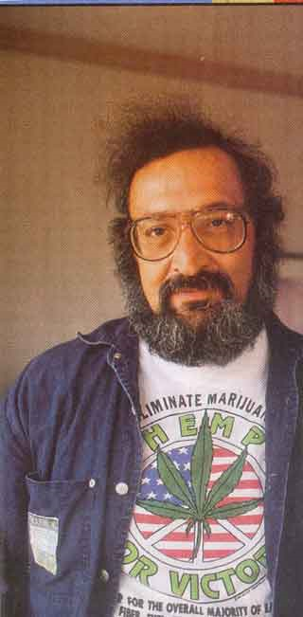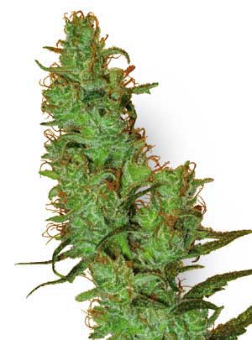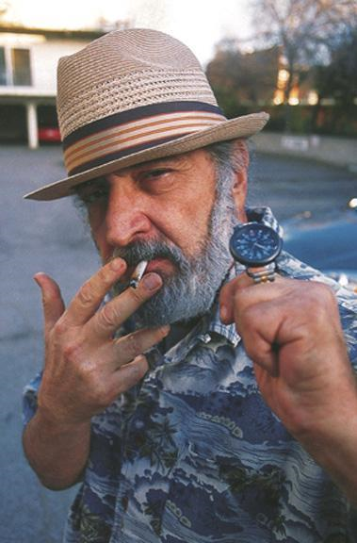

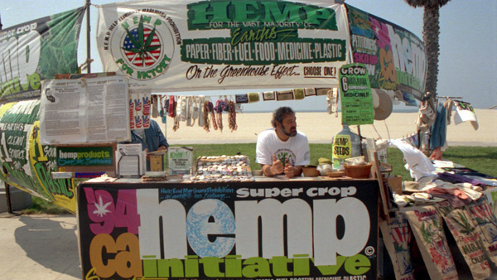

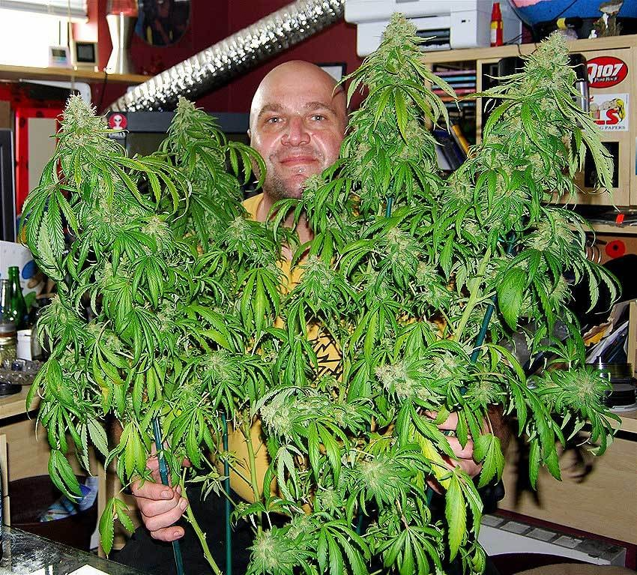

**Jack Herer** (June 18, 1939 – April 15, 2010) was an American [cannabis](http://en.wikipedia.org/wiki/Cannabis) [activist](http://en.wikipedia.org/wiki/Activist) and the [author](http://en.wikipedia.org/wiki/Author) of [*The Emperor Wears No Clothes*](http://en.wikipedia.org/wiki/The_Emperor_Wears_No_Clothes), a book which has been used in efforts to [decriminalize cannabis](http://en.wikipedia.org/wiki/Legality_of_cannabis).

A former [Goldwater](http://en.wikipedia.org/wiki/Barry_Goldwater) [Republican](http://en.wikipedia.org/wiki/United_States_Republican_Party), Herer was a pro-cannabis ([marijuana](http://en.wikipedia.org/wiki/Cannabis_%28drug%29)) and [hemp](http://en.wikipedia.org/wiki/Hemp) activist. He wrote two books, the aforementioned *The Emperor Wears No Clothes* and *Grass*. There has also been a [documentary](http://en.wikipedia.org/wiki/Documentary_film) made about his life called, *The Emperor of Hemp*. He believed that the [cannabis sativa](http://en.wikipedia.org/wiki/Cannabis_sativa) plant should be decriminalized because it has been shown to be a renewable source of [fuel](http://en.wikipedia.org/wiki/Fuel), [food](http://en.wikipedia.org/wiki/Cannabis_foods), and [medicine](http://en.wikipedia.org/wiki/Medical_cannabis), and can be grown in virtually any part of the world, and that the [U.S. government](http://en.wikipedia.org/wiki/U.S._government) deliberately hides the proof of this.

A specific [strain of cannabis](http://en.wikipedia.org/wiki/Jack_Herer_%28cannabis%29)[[1]](http://en.wikipedia.org/wiki/Jack_Herer#cite_note-0) has been named after Jack Herer in honor of his work. This strain has won several awards, including the 7th High Times Cannabis Cup. Jack Herer was also inducted into the [Counterculture Hall of Fame](http://en.wikipedia.org/wiki/Counterculture_Hall_of_Fame) at the 16th Cannabis Cup in recognition of his first book.[[2]](http://en.wikipedia.org/wiki/Jack_Herer#cite_note-1)

Herer ran for [United States President](http://en.wikipedia.org/wiki/United_States_President) twice, in [1988](http://en.wikipedia.org/wiki/United_States_presidential_election,_1988) (1,949 votes) and [1992](http://en.wikipedia.org/wiki/United_States_presidential_election,_1992) (3,875 votes) as the [Grassroots Party](http://en.wikipedia.org/wiki/Grassroots_Party) candidate.

In July 2000, Herer suffered a minor [heart attack](http://en.wikipedia.org/wiki/Heart_attack) and a major [stroke](http://en.wikipedia.org/wiki/Stroke), resulting in difficulties speaking and moving the right side of his body.[[3]](http://en.wikipedia.org/wiki/Jack_Herer#cite_note-2) Herer mostly recovered, and claimed in May 2004 that treatment with the [amanita muscaria](http://en.wikipedia.org/wiki/Amanita_muscaria), a [psychoactive mushroom](http://en.wikipedia.org/wiki/Mushroom#Psychoactive_mushrooms) was the "secret".[[4]](http://en.wikipedia.org/wiki/Jack_Herer#cite_note-3)

On September 12, 2009 Herer suffered another heart attack while backstage at the [Hempstalk Festival](http://en.wikipedia.org/wiki/Portland_Hempstalk_Festival) in [Portland, Oregon](http://en.wikipedia.org/wiki/Portland,_Oregon).[[5]](http://en.wikipedia.org/wiki/Jack_Herer#cite_note-4) He spent nearly a month in critical condition in a Portland hospital, including several days in a medically induced coma. He was discharged to another facility on October 13, 2009. Paul Stanford of The Hemp and Cannabis Foundation said "He is waking up and gazing appropriately when someone is talking... but he is not really communicating in any way."[[6]](http://en.wikipedia.org/wiki/Jack_Herer#cite_note-5) He died aged 70 on April 15, 2010 in [Eugene, Oregon](http://en.wikipedia.org/wiki/Eugene,_Oregon), from complications related to the September 2009 heart attack.[[7]](http://en.wikipedia.org/wiki/Jack_Herer#cite_note-6)[[8]](http://en.wikipedia.org/wiki/Jack_Herer#cite_note-7) Herer was buried at the [Eden Memorial Park Cemetery](http://en.wikipedia.org/wiki/Eden_Memorial_Park_Cemetery) in [Mission Hills, California](http://en.wikipedia.org/wiki/Mission_Hills,_California).

**References**

1. [**^**](http://en.wikipedia.org/wiki/Jack_Herer#cite_ref-0) ["Jack Herer"](http://www.sensiseeds.com/jackherer/1p2310.html), Sensi Seeds
2. [**^**](http://en.wikipedia.org/wiki/Jack_Herer#cite_ref-1) ["History of the Cup"](http://hightimes.com/cancup/hager/29), Steven Hager, High Times Cannabis Cup, 23 September 2004.
3. [**^**](http://en.wikipedia.org/wiki/Jack_Herer#cite_ref-2) ["Jack Herer suffers heart attack"](http://www.cannabisculture.com/articles/1620.html), Pete Brady, Cannabis Culture Magazine , 20 July 2000
4. [**^**](http://en.wikipedia.org/wiki/Jack_Herer#cite_ref-3) ["An Afternoon With Jack Herer"](http://freepress.org/journal.php?strFunc=display&strID=229&strJournal=27), Sean Luse, The Free Press, 23 May 2004
5. [**^**](http://en.wikipedia.org/wiki/Jack_Herer#cite_ref-4) <http://www.cannabisculture.com/v2/content/emperor-wears-no-clothes-marijuana-author-jack-herer-collapses-after-stage-appearance-portla>
6. [**^**](http://en.wikipedia.org/wiki/Jack_Herer#cite_ref-5) ["Jack Herer Strives To Recover As The Fight For Hemp Goes On"](http://www.salem-news.com/articles/october132009/jackherer_101309.php), Bonnie King, Salem-news.com , 13 October 2009
7. [**^**](http://en.wikipedia.org/wiki/Jack_Herer#cite_ref-6) ["The Hemperor, Jack Herer has Died"](http://www.salem-news.com/articles/april152010/jack_herer_died.php), Bonnie King, Salem-news.com , 15 April 2010
8. [**^**](http://en.wikipedia.org/wiki/Jack_Herer#cite_ref-7) Saker, Anne (2010-04-15). ["Jack Herer, father of marijuana legalization movement, dies at age 70 in Eugene"](http://www.oregonlive.com/portland/index.ssf/2010/04/jack_herer_fatherof_marijuana.html). [*The Oregonian*](http://en.wikipedia.org/wiki/The_Oregonian). <http://www.oregonlive.com/portland/index.ssf/2010/04/jack_herer_fatherof_marijuana.html>. Retrieved 16 April 2010.

**External links**

* [Official site](http://www.jackherer.com)
* [Erowid Jack Herer Vault](http://www.erowid.org/culture/characters/herer_jack/herer_jack.shtml)
* [Blog in Swedish about the death and Jack Herer](http://blog.obesm.se/2010/04/jack-herer-dod/)

=============================================================================================================================================

http://latimesblogs.latimes.com/jacketcopy/2010/04/author-and-hemp-activist-jack-herer-has-died.html



# [Author and hemp activist Jack Herer has died](http://latimesblogs.latimes.com/jacketcopy/2010/04/author-and-hemp-activist-jack-herer-has-died.html)

April 16, 2010 |  2:05 pm

Author and activist [Jack Herer died Thursday](http://www.oregonlive.com/portland/index.ssf/2010/04/jack_herer_fatherof_marijuana.html) in Eugene, Ore. The 70-year-old activist was in ill health following a heart attack he experienced after leaving the [Hempstalk](http://www.hempstalk.org/) festival stage in Portland last fall.

Herer, pictured in 1996, was a longtime marijuana activist and the author of the landmark book "The Emperor Wears No Clothes: The Authoritative Historical Record of Cannabis and the Conspiracy Against Marijuana." By 2004, it had been through 16 printings and published more than 600,000 copies. In 2004, [the L.A. Times wrote](http://www.latimes.com/search/la-tm-hemp03jan18,0,572346.story):

Today, Herer is widely credited with launching the modern hemp movement, a persistent campaign by an eclectic coalition of environmentalists, legislators, rights activists, farmers, scientists, entrepreneurs and others to end the maligned plant's banishment and tap its potential as a natural resource. ...

When Jack Herer began his quest to emancipate hemp, he just assumed that everyone would find the essential facts about the plant's qualities so compelling that the battle would be won in six months -- two years, tops. That was 29 years ago.

One of the many people intrigued by Herer's book was Dave West, a Midwest plant breeder with a doctorate in breeding and genetics. His curiosity about hemp had already been piqued by something he witnessed in the mid-1980s as he toiled one sweltering day in a Wisconsin cornfield. A helicopter suddenly appeared low in the sky, then hovered over an adjacent field while several men rappelled to the ground. It was a drug-enforcement operation going after wild marijuana. "Which, as a plant breeder and as somebody who grew up in Wisconsin, I knew was preposterous," West recalls. "I knew this was feral hemp and nobody wanted it, and that's why it was growing as a weed out there and nobody was picking it."

Herer, known to some as "[the Hemperor](http://www.salem-news.com/articles/april152010/jack_herer_died.php)," posted half of "[The Emperor Wears No Clothes](http://www.jackherer.com/chapters.html)" online. Though he used to sell copies of the book from his website, sales have been suspended since September; now it is listed [from Amazon resellers](http://www.amazon.com/gp/offer-listing/1878125028/ref=sr_1_1_olp?ie=UTF8&s=books&qid=1271450964&sr=1-1&condition=new) for $33-$93.

-- Carolyn Kellogg

Photo: Jack Herer in Venice Beach in 1996. Credit: Steve Dykes

==============================================================================================================================================