A secret pact between the Dept. of Justice and the CIA
The CIA was released from the requirement to
report suspected drug trafficking by
CIA agents and operatives.
In March, 1998, the CIA Inspector General testified that there had existed a secret agreement between CIA and the Justice Department, wherein "during the years 1982 to 1995, CIA did not have to report the drug trafficking by its assets to the Justice Department."
As Michael Levine commented, "..[to] a trained DEA agent this literally means that the CIA had been granted a license to obstruct justice in our so-called war on drugs; a license that lasted, so the CIA claims, from 1982 to 1995."
Firstly, the actual request from Central Intelligence Agency Director William Casey to then-Attorney General William French Smith still isn't in the public domain. But two letters, one from Smith thanking Casey for his request, and a follow-up by Casey, are both available. They were released as part of a internal CIA report that explored allegations of CIA involvement in drug trafficking. In the first document, Smith thanks Casey for his letter (the one that isn't public) and says:
"...in view of the fine cooperation the Drug Enforcement Administration has received from CIA, no formal requirement regarding the reporting of narcotics violations has been included in these procedures." --William French Smith, Attorney General.
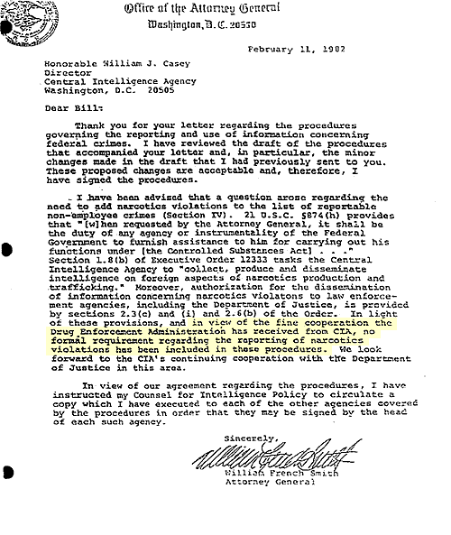

Casey in return thanks the Attorney General for his understanding:
"I am pleased that these procedures, which I believe strike the proper balance between enforcement of the law and protection of intelligence sources and methods, will now be forwarded to other agencies..." --William J. Casey, Director, Central Intelligence Agency
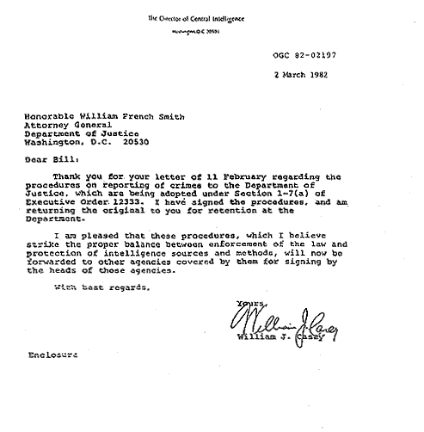

The two men then codified their agreement in a Memorandum of Understanding. According to the agreement, intelligence agencies would not have to report if any of their agents were involved in drug running. (By agents, the agreement meant CIA sources and informants. Full-time employees still couldn't deal drugs.) That understanding remained in effect until August of 1995, when current Attorney General Janet Reno rescinded the agreement.
It's reasonable that the CIA be allowed to keep its mouth shut if it knows that some of its agents are involved in minor illegal affairs. Presumably some of the value of informants comes from the fact that they keep company with shady characters who engage in unlawful activities.
But why would the CIA ask to be exempt specifically from drug enforcement laws? According to Congresswoman Maxine Waters (D-Calif.), who is calling for full disclosure of the facts, "The CIA knew that the Contras were dealing drugs. They made this deal with the Attorney General to protect themselves from having to report it."

Subj: US: Don't Ask, Don't Tell
Source: In These Times
Contact: itt@inthesetimes.com
Website: http://www.inthesetimes.com/
Pubdate: May 1998
Author: Martha Honey
DON'T ASK, DON'T TELL
In testimony before the House Select Committee on Intelligence on March 16, the Central Intelligence Agency once again suffered a blow to its reputation. This time the injury was self-inflicted. The CIA's own top watchdog, Inspector General Frederick P. Hitz, admitted that although "dozens of individuals and a number of companies" involved in the agency's covert war against Nicaragua during the '80s were suspected drug traffickers, the CIA had legal authority to ignore their crimes as long as they were helping contra rebels fight the left-wing Sandinista government.
Hitz revealed that between 1982 and 1995 the spy agency had an agreement with the Justice Department, allowing it to ignore drug trafficking by its "agents, assets and non-staff employees." The directive, known as a "Memorandum of Understanding" (MOU), did not exempt the agency's full-time, career employees, who are known as CIA "officials." However, the agency did not have to tell the Justice Department about the criminal activities of "agents" or "assets" -- terms used interchangeably to refer to its paid and unpaid spies. Also exempt were CIA contractors, such as pilots, accountants and military trainers, who supplied the agency with specific goods and services rather than intelligence. "There was no official requirement to report on allegations of drug trafficking with respect to non-employees of the agency," Hitz told the committee.
Hitz said this agreement, which he termed "a rather odd history," has since been changed. But it was not until 1995 -- five years after the end of the war in Nicaragua and three years into Clinton's first term -- that the agreement was revised to include agents, assets and contractors as "employees" whose suspected criminal activities, such as drug trafficking, must be reported to the Justice Department.
Disclosure of this agreement is another black eye for the CIA at a time when the agency is trying to distance itself from persistent allegations of drug trafficking, including the provocative August 1996 "Dark Alliance" series in the San Jose Mercury News. Veteran journalists, investigators, policy analysts and members of Congress interviewed by In These Times all say they were unaware of the directive. "This previously unknown agreement enabled the CIA to keep known drug smugglers out of jail and on the payroll of the American taxpayer," says Peter Kornbluh, a senior analyst with the National Security Archive, who has written extensively on the CIA and the war in Nicaragua. "CIA officials realized collaborating with pro-contra drug smugglers was important to the goal of overthrowing the Sandinistas and it sought protection from the Justice Department."
In 1982, when the MOU was implemented, the United States was gearing up for a covert war in Central America aimed at toppling the Sandinistas. Over the next eight years, the CIA hired scores of Latin American, Cuban and American spies, as well as dozens of aviation, fishing and real estate companies, to support the contras. Simultaneously, cocaine began flooding into the United States, fueling the crack epidemic that has devastated Los Angeles, Baltimore and other cities.
David MacMichael, who was a senior CIA officer in the early '80s, says that while he was not aware of this MOU, he does recall that "in 1981, [CIA Director William] Casey went to attorney general [William French] Smith looking for a blanket exemption from prosecution for CIA officers for crimes committed in the line of duty." Smith demurred, he says.
Since the mid-'80s, a spate of media reports, congressional inquiries, and court cases in the United States and Central America have linked contra officials and collaborators with cocaine traffickers, money launderers and various front companies. Many of those implicated also claimed or were alleged to be working for the CIA. In 1996, the accusations erupted anew with the publication of Gary Webb's Mercury News series, which detailed how a Nicaraguan drug ring used black street gangs to sell crack cocaine in Los Angeles. Over the years, the CIA has repeatedly denied allegations that it dealt with drug dealers.
Those denials have been championed by Washington Post reporter Walter Pincus, a specialist in national security affairs and a leading critic of the Mercury News series. Pincus, who has yet to report on Hitz's testimony, says he had not been previously aware the directive. "I am still trying to get a clarification of it," he says, adding that it may not be very significant. "All it admits is that what they were doing was legal. On occasion they were dealing with people who may or may not have been dealing in drugs."
In December 1985, reporters Robert Parry and Brian Barger wrote the first story tying the CIA's contra operation to cocaine smuggling. The piece for The Associated Press angered Reagan administration officials, who tried unsuccessfully to block its publication. During the contra war, most of the media either ignored or discredited the drug trafficking reports. Parry maintains that his pursuit of this story helped cost him jobs at AP and Newsweek. "Historically we were correct," Parry says. "We pointed to a serious problem in a timely fashion, and we were all punished and ridiculed. The reporters who put this story down have gone on to fame and fortune."
Parry calls Hitz's disclosure "extremely significant." "It amounts to a blank check for dealing with drug traffickers," he says. "The agency is admitting that it engaged in covering up drug crimes by the contras and that this was legal."
Major media also ignored the 1989 findings of Sen. John Kerry's (D-Mass.) Subcommittee on Terrorism, Narcotics and International Operations. The Kerry committee's two-year investigation turned up substantial evidence of cocaine smuggling and money laundering by persons connected to the contras and the CIA. Among the conclusions of its 1,166-page report:
*"Drug traffickers used the contra war and their ties to the contras as a cover for their criminal enterprises in Honduras and Costa Rica. Assistance from the drug lords was crucial to the contras, and the traffickers in turn promoted and protected their operations by associating with the contra movement."
*"Drug traffickers provided support to the contras and used the supply network of the contras. Contras knowingly received both financial and material assistance from the drug traffickers."
*"Drug traffickers contributed cash, weapons, planes, pilots, air supply services and other materials to the contras."
*"In each case, one or another U.S. government agency had information regarding these matters either while they were occurring, or immediately thereafter."
The report was all but ignored by the three major networks and buried in the back pages of the major newspapers. Combined, the stories in the Washington Post, New York Times and Los Angeles Times totalled less than 2,000 words.
At the March congressional hearing, Hitz explained that the MOU between the agency and the Justice Department was modified slightly in 1986, prohibiting the CIA from paying those suspected of involvement in drug trafficking. The CIA, however, could legally continue to use suspected drug smugglers and not report their activities, as long as they received no money from the agency.
But for major drug traffickers, being allowed to operate under the CIA's umbrella was payment enough. The Kerry committee's report, along with most press accounts of the CIA-cocaine connection, alleges that the contras accepted money and supplies from drug smugglers and money launderers -- not the other way around.
John Mattes, a young public defender in Miami in the mid-80s, stumbled upon the allegations of drug trafficking by Cuban-Americans working with the contras. Mattes, who represented several cocaine traffickers and soldiers-of-fortune who testified before the Kerry committee, says traffickers were seeking protection, not money, from the CIA. "There was a marriage of convenience between the contras and the coke smugglers," he says. The smugglers had cash, planes and pilots, while the Contras had intelligence, airstrips and, most importantly, unimpeded access to the United States. "And that, to a drug smuggler," he says, "is worth all the tea in China."
During the '80s, the CIA conducted several internal inquiries and announced it found no substantial evidence that contra leaders and other persons working for the CIA had connections to cocaine traffickers. Then, the "Dark Alliance" series touched off a volatile, nationwide controversy over the agency's role in introducing crack to Southern California street gangs. To help quell public and congressional anger, both the CIA and Justice Department launched separate internal investigations. Both reports were scheduled to be released last December, but were withheld at the last minute without explanation.
Attorney General Janet Reno subsequently announced that she had blocked the release of the Justice Department report (rumored to be the more substantial and significant of the two) for unspecified "law enforcement reasons." Justice Department sources told in These Times that one of the people named in the report is a government witness in an ongoing criminal case, whose identity must be protected. However, Jack Blum, a Washington attorney and investigator for the Kerry committee, doubts that the Justice Department will ever release its report. Blum says law enforcement officials often claim disclosures will jeopardize ongoing cases, and he wonders why the report was not simply edited to protect the informant's identity.
In late January, the CIA released a declassified version of volume one of its two-part report. Entitled "The California Story," this 149-page report focuses on the cocaine network described in the "Dark Alliance" series, which detailed the activities of two Nicaraguan drug smugglers, Danilo Blandon and Juan Norwin Meneses. In the early '80s, Meneses and Blandon supplied large quantities of powder cocaine to Ricky Ross, an African-American drug dealer, who then turned it into crack for sale to two Los Angeles gangs. Webb alleges that the Nicaraguans gave some of their drug profits to top contra officials who were working with the CIA.
Hitz called the CIA's 18-month investigation "the most comprehensive and exhaustive ever conducted" by the agency. He told the congressional committee: "We found absolutely no evidence to indicate that the CIA as an organization or its employees were involved in any conspiracy to bring drugs into the United States," But, taken in conjunction with what Hitz said about the MOU, "employees" here may pertain only to CIA career officials -- not agents, assets or contractors.
Webb, whose reporting touched off the controversy, describes the report as "schizophrenic." "The Executive Summary says there's no CIA involvement," says Webb. "The actual report shows there are CIA fingerprints all over this drug operation."
For example, upon the release of volume one, CIA Director George Tenet proclaimed that the Agency "left no stone unturned" in reaching its conclusion that the CIA had "no direct or indirect" ties to Blandon and Meneses. Yet, the report contains a compendium of indirect links between the CIA's contra army and drug traffickers. The most obvious admissions contained in the report include:
- --An October 22, 1982, cable from the CIA's Directorate of Operations that reports, "There are indications of links between (a U.S. religious organization) and two Nicaraguan counter-revolutionary groups...These links involve an exchange in (the United States) of narcotics for arms." The report goes on to say that there was to be a meeting in Costa Rica of contras, several U.S. citizens and Renato Pena, a convicted drug dealer who was part of Meneses' operation. Astonishingly, a November 3, 1982, cable from CIA headquarters says that the agency decided "not to pursue the matter further" because of "the apparent participation of U.S. persons throughout."
- --The CIA directly intervened in the 1983 "Frogman Case," in which San Francisco police seized 430 pounds of cocaine and arrested 50 individuals, including a number of Nicaraguans. Because the CIA feared the agency's connections to some of the contras involved had "potential for disaster," an unidentified CIA lawyer convinced the U.S. Attorney in San Francisco and Justice Department officials to cancel plans to take depositions from contra leaders in Costa Rica and to return $36,800 seized in the drug raid to one of the contra factions. "There are sufficient factual details which would cause certain damage to our image and program in Central America," CIA assistant general counsel Lee Strickland wrote in a August 22, 1984, memo quoted in the report.
- --Blandon and Meneses met on various occasions with the contras' military commander, Enrique Bermudez, who worked for the CIA. At one meeting in Honduras in 1982, Bermudez, arguing that "the ends justify the means," asked the pair for help "in raising funds and obtaining equipment" and arms for the contras. After the meeting, a group of contras escorted Blandon and Meneses to the Tegucigalpa airport, where the pair was arrested by Honduran authorities because they were carrying $100,000 in cash, profits from a Bolivian drug deal. The contras intervened and the money was returned to Blandon and Meneses. The report inexplicably concludes that there is no evidence that Bermudez knew the duo were drug traffickers, even though CIA cables show the agency was aware that Meneses had been a "drug king-pin" since the '70s.
At the congressional hearings, lawmakers cited these and other portions of the report, questioning the agency's capacity to investigate itself. Among the most vocal critics were Los Angeles Democratic Reps. Maxine Waters and Juanita Millender-McDonald, whose districts have been the epicenter of the crack epidemic. Waters charged that the report was "fraught with contradictions and illogical conclusions," saying that the CIA's cleverly worded denials of links to drug traffickers in Southern California "defies the evidence."
Volume two of the report, which covers the entire Nicaraguan war, was scheduled to be turned over to the House and Senate intelligence committees in late March. But, as of mid-April, CIA officials told In These Times, the report had not been released to Congress. In his congressional testimony, Hitz said that volume two will contain "a detailed treatment of what was known to CIA regarding dozens of people and a number of companies connected in some fashion to the contra program or the contra movement, that were the subject of any sort of drug trafficking allegations."
Previewing the report, Hitz admitted: "There are instances where the CIA did not, in an expeditious or consistent fashion, cut off relationships with individuals supporting the contra program, who are alleged to have engaged in drug trafficking activity or take action to resolve the allegation." Several congressional sources say that they suspect the report will never be released.While the precise wording of the MOU has not been made public, some say the directive may be considerably broader than implied at the hearing. At one point in his testimony, Hitz said the MOU applied to "intelligence agencies," indicating that it also may include the dozen or so U.S. agencies involved in intelligence work, not just the CIA. Hitz declined requests for an interview.
But the CIA may not be able to get away without further disclosures. The National Security Archive and other public interest groups, as well as Reps. John Conyers (D-Mich.) and Waters, are mounting a campaign for the declassification and release of the text of the MOU, the Justice Department report, volume two of the CIA report, tens of thousands of pages of documents and hundreds of interviews compiled by the two agencies in the course of their internal investigations. Attorney Blum warns that CIA officials who testified before the Kerry committee may have perjured themselves in denying they knew of any links between the CIA, the contras and cocaine traffickers. And investigative journalists Parry and Webb, among others, say Hitz's admission may be the smoking gun that conclusively proves that the CIA colluded with and then concealed its involvement with cocaine traffickers.
Martha Honey is director of the Peace and Security program at the Institute for Policy Studies in Washington, D.C. During the '80s, she covered the war in Nicaragua as a journalist in Costa Rica
====================================================================================================================================
END

