**[The “Black Eye” Club](https://thephoenixenigma.com/the-black-eye-club/)**

**Enlighten the massess..**

* ***28***

*Shares*

[**ALL ARTICLES**](https://thephoenixenigma.com/category/uncategorized/)

[#Black eye club#Illuminati#soul scalping](https://thephoenixenigma.com/the-black-eye-club/?fbclid=IwAR3_CHEGVVpVZCpAZro2_a8m5PbsAiTR-_HUvsusuLwylVcb1YSk66kYa0U)

May 9, 2018

[**Cory Daniel**](https://thephoenixenigma.com/author/brujo2u/)

[[](https://thephoenixenigma.com/the-black-eye-club/)](https://thephoenixenigma.com/the-black-eye-club/)

Although not officially an organization, the “Black Eye” club refers to a growing number of politicians, celebrities, business elites, and heads of State who have suddenly and mysteriously wound up with black eyes. Although a few of them have sustained injuries to their right eye, the majority occur on the left. Among those who have succumbed to this affliction are George Bush, Kanye West, and the Pope.

But why this current and periodic rash of Black Eyes? And why has this phenomenon disproportionately afflicted people of considerable power and influence?  Even allowing for our modern 24-hour news cycle and tabloid cellphone camera culture, up until the year 2000 I can’t recall any publically recognizable figures having black eyes.

It would appear that there are two main categories within the “Black Eye” Club.  Those seated firmly into positions of government/politics and those in the entertainment/Hollywood. Are there others in the fields of science, and military? I’m sure there are.

Theories as to this strange phenomenon are abuzz on the internet and range from a secret society ritual which involves striking the participant in the head, to alien abduction and **“Soul Scalping”** in order to replace our world leaders with alien consciousness. (More on Soul Scalping at the bottom of this page.) Another theory holds that it is a form of punishment used to as a sort of check and balance within secret societies. And still, other theories lean towards the implementation of life extension technologies or preparatory surgeries for off-world travel.

A less extreme theory holds that the phenomenon is nothing more than the entertainment industry capitalizing on the public’s recent enlightenment of the existence of the Illuminati. But let’s assume for a moment this is only media marketing. This would mean that the entertainment industry is using occult ritual to manipulate people into certain behavior and consciousness. The end result is the same. And the fact that most every successful pop and rap artist use Illuminati symbology in their act openly telegraphs the ritual. People can pretend like it’s a game, but if you’re acting out a ritual you are very much indeed participating in a ritual. A ritual which permeates the hierarchical tiers of the entertainment industry and obviously defines success.

**Bernie Sanders**

March 2019



Claims to have sustained a black eye and stitches from cutting his head on the edge of a glass shower door.

**George Bush**

January 2002



Official Explanation – Choked on a pretzel, fainted and fell off the couch and hit the floor.  According to Dr. Abdul Giwa, an emergency room doctor at St. Lutes=Roosevelt Hospital, the President likely fell victim to “vasovagal syndrome, “a rare occurrence in which the vagus nerve, which regulates heart rate, is stimulated and the signal slows the heart. Victims can pass out, and they often look pale afterward.

“It can be brought on by a number of causes, usually stress, but also swallowing something,” Giwa said. “As food goes down through the esophagus, it passes by the vagus nerve.”

The event happened at 5:35 p.m. Note. that 5:35 reduces to the number 13.

**Harry Reid**

2011

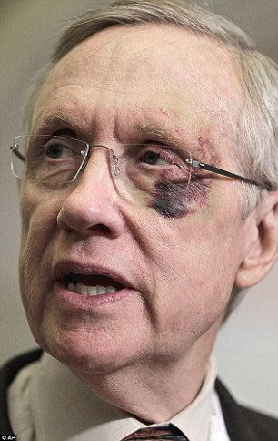

Official Explanation- Slipped and fell while running in the rain. Also suffered a dislocated shoulder.

January 1 2015

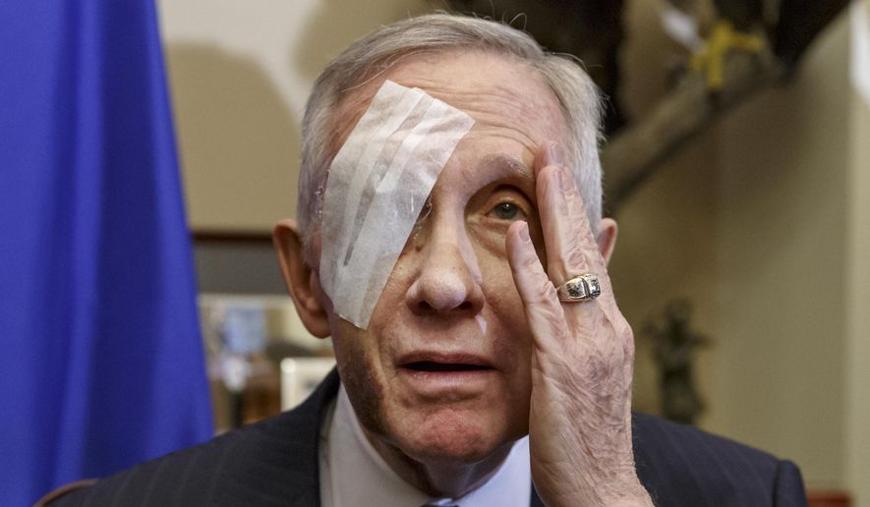

Harry Reid’s second eye injury in 4 years.

Right eye, multiple bones around the eye, loss of eyesight, broken ribs, concussion.

Official Explanation – I know there are a lot of rumors as to what happened, but that’s very simple. My wife and I were in our new home. I was doing exercises that I’ve been doing for many years with those large rubber bands and, uh, one of them broke and spun me around and I crashed into these cabinets and injured my eye.

**John Kerry**

January 2012



Official Explanation – Black eyes received from sustaining a broken nose while playing Ice hockey.

**Prince Andrew**

June 2017



Official Explanation – Palace refused to comment.

**John McCain**

July 2017

Official Explanation – Mayo Clinic surgeons took out the 5-centimeter blood clot during “a minimally invasive craniotomy with an eyebrow incision,” according to a Mayo Clinic Hospital statement released by McCain’s office.

Michael Noonan

February 2015

Official Explanation – The Department of finance stated that Noonan underwent eye surgery but refused to elaborate further. A Dr. Gray diagnosed he had a unilateral exophthalmos or proptosis, otherwise known as bulging of the eye.  This was supposedly his **second surgery** on his eye in a couple years.

**Prince Philip**

April 2013

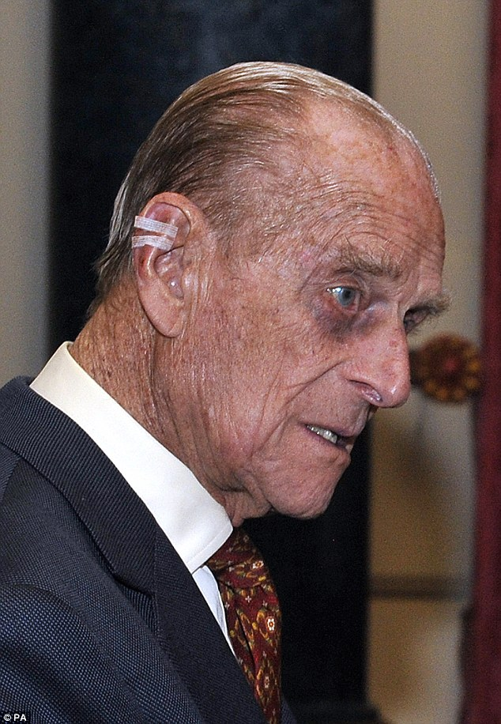Official Explanation – the Palace gave a press release that he just woke up with the black eye.

February 2015

Official Explanation – NO OFFICIAL EXPLANATION GIVEN.

**Pope Francis**

September 2017



Official Explanation – Hit his face on the Pope Mobile

Pope Benedict XVI

October 2017



Official Explanation – The Pope fell

**Madonna**

April 1998

Madona’s publicist Liz Rosenberg said.  “She was playing peekaboo with her baby, I’m almost embarrassed to tell you about it because it sounds so cute. But that’s what happened.” She went on to explain that she was bouncing her 18-month-old daughter Lourdes on her lap when the child’s head smacked into the bone under her eye.

**Kanye West**

April 2014

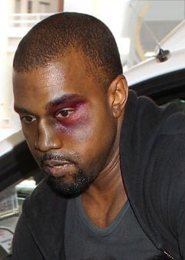Official explanation – Got punched in a random game of knockout after leaving a nightclub.

**Kelly Osbourne**

August 2008

Official Explanation – The contents of her cupboard fell out and on top of her head.

**Robert Downey Jr.**

December 2012

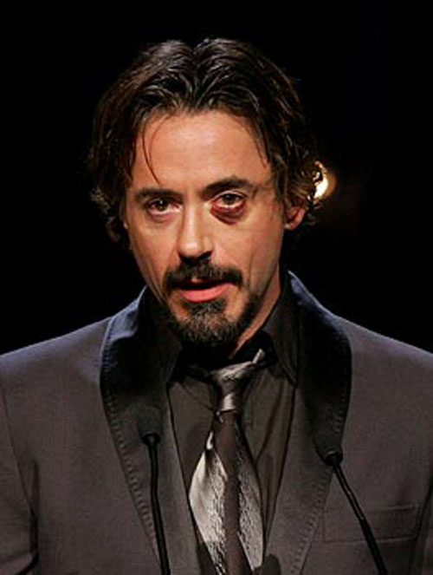

Official explanation – No explanation was given.

**Ryan Gosling**

May 2009



Official explanation – Make-up. However, he sustained another black eye when hit by Harrison Ford in a “stunt gone wrong” while filming Blade Runner years later.

**Richard Branson**



Official Explanation – The entrepreneur was cycling in the dark on Virgin Gorda, one of the British Virgin Islands, with his children, when he hit a bump in the road, causing him to be flung over his handlebars.

**Lady Gaga**

June 2012



Official Explanation – Got hit in the face with a pole during a performance.

**John Stamos**

May 2008



Official Explanation – Kickboxing accident

**Justin Bieber**

January 2011

Official Explanation – Fighting

**Steve Buscemi**

2001



Official Explanation – Bar room brawl

**Reece Witherspoon**

September 2011



Official Explanation – Involved in a car accident.

**Jamie Oliver**

February 2012

Official Explanation – Fell down the stairs at his home.

Ritual?

The idea that these people are all taking part in a ritual is not at all far-fetched. Cults and societies exist and have existed since the dawn of time and are still very much alive. If you not aware that this is happening, simply go to Catholic mass and watch it unfold. In our modern culture, we’ve been desensitized to them in since childhood when we were first put in front of a Television. We’ve seen them portrayed in cartoons and movies, and every once in a while it makes the news. Recently the leaked video footage or the “Cremation of Care” ceremony at the Bohemian Grove. Before this, there was the Skull and Bones ritual which took place in the courtyard filmed from the vantage point of the wall surrounding the compound.

I think it hilarious that it’s not even a secret that elites from all over the world have been engaging in rituals and ceremonies since the beginning of nation-states throughout all of history, yet we believe that in today’s world they have somehow grown out of this practice and it has been replaced by Oaths of Office, and public ceremonies.  While these things do occur and have become part of the public show during the peaceable transition of power, there are pipers to be paid beneath the public sphere of awareness. Those pipers being the organizations responsible for the assent of these candidates in the first place. If you still believe that presidents are elected and not chosen I urge you to do your research.

Checks and Balances

We are aware of the checks and balances designed into the three branches of government here in the United States of America. Other countries too have systems in place which prevent tyranny. When first implemented these governments worked quite well, however, as time marched on and the those within secret societies learned how to game the system the checks and balances have all but failed in any practical sense of their intended purpose.

It has been theorized that the black eyes are a result of an internal power structure. Checks and balances. Warnings or perhaps even rites of passage within what is generally referred to as the Illuminati. One could use the term globalists as well I would think. Is there an organization so powerful that even the Pope and heads of monarchy are subject to its law? Some think so. And have we not been desensitized to this idea already? Think of the evil Empire in Star Wars. The vast organization of Sauron and the Lord of the rings, etc. of course this is fiction but it forms the foundational reality for our subconscious, and whether or not we realize it we pull from this foundation and use it in contrast to process and evaluate current events and information.

Soul Scalping

The term soul scalping was coined by Sherry Shriner, although the idea had been around since the 1940s and portrayed in sci-fi classics such as the invasion of the body snatchers. The famous miniseries from the 1980s “V” also ran with this theme. Probably the most recent and accurate depiction of this theory, however, can be seen in the Stargate series. In the series, the Goa’uld are a parasitic race of ancient astronauts which integrate with their host. The resulting creature is a powerful race been on galactic conquest and domination largely without pity compassion or remorse.

Sherry’s belief is that heads-of-state and Hollywood elites are abducted and a surgery is performed on their eye. This is a segment from her website.

“They take a slimy skinny snake, about 6-8 inches long, greyish in color…it looks more like a long slimy worm, and open the person’s mouth and stick it down their throat…These reptile aliens work in groups. In true form most of them are over 6′ 4″ tall. They watch and study the targeted person so they know all about them, and when they take over their brains and bodies they literally can act and become that person. They even do this to their kids so the kids don’t make a fuss that something’s wrong with mommy or daddy because something’s just not right about them. They don’t care about destroying the lives of children. They’re all cold and heartless, unemotional reptiles with no thought of love, compassion or human emotions and sentiment. Those are emotions they have to learn to fake when they take over a human’s body so they can blend in with society as a human.”

“What they do is transform their entire being or conscious self into this proboscis and eject it off their head and then wiggle into the host, such as a human and they enter into a person’s eye. If they have help the host’s eyeball can be pulled out and this proboscis can be put into the back of the eye where it will then wiggle and spiral itself around the person’s optical nerve and it also takes control of the person’s brain as well. Donald Marshall talks about this. He’s part of Lucifer’s Disclosure Project where they are revealing all their methods, technology, and nefarious agendas to mankind.

Wow…That’s some pretty heavy stuff. How she knows this I’m not exactly sure, but there are quite a few people out there who are behind this theory. If I were making an argument for this theory I would point to the Web-Slinging Wasp, the Jewel Wasp, the Lancet Liver Fluke, the Euhaplorchis californiensis, and Hairworms. Then there is Toxoplasma gondii which is found aplenty in cats and already transfers to humans. All these parasites actively affect the behavior of its host in order to complete its reproductive cycle. Over 50% of people in developed nations believe an extraterrestrials. And if there are extraterrestrials we have to assume that some of them may not be benevolent and themselves. Of course, I’m just brainstorming here. But it really isn’t that big of a leap if one runs the numbers.

Does the Black Eye Club have anything to do with the all-seeing eye of the Illuminati?

The British magazine ID famously adorns each one of their covers with a facial portrait of someone either covering their right eye or obscuring their left.  This bimonthly magazine is dedicated to fashion, music, art and youth culture. What point are they trying to make? Is it just fun, fashion, and modern youth culture?



What about all the other hands covering one eye found all over entertainment and media?



From fashion to art, to music, to design, clothing, and business. The covering of one eye has infiltrated nearly EVERY nitch of marketing in the world, and the target is always, the next generation.



Why now?

But here’s the important question. Why now? What changed in the late 90s that brought on this rash of black eyes in conjunction with the rise of the all-seeing eye of the Illuminati? We didn’t have this in the 80s or the 70s or the 60s. No, this is a new phenomenon.

ANSWER: THE INTERNET

My guess is that the global elite had to step up their timeline. The Internet simply got away from them. As of 2017, they began reeling it back in through censorship of YouTube, Facebook, Twitter, and Google. The four primary platforms on the Internet today. The Internet was supposed to replace the television, just as television followed the radio and radio followed the newspaper in the newspaper followed the town halls. Only they lost control of it early.

Ask any YouTube content creator about censorship and unless they’re making cat videos or cooking tutorials they will fill you in about shadow banning, subscription blackouts, and demonetization. The elite realized they could not control the flow of ideas but they could control the exposure those ideas received and who ultimately came in contact with them. THIS IS THE CURRENT BATTLEGROUND.

As the plans of the elite were brought to light they were no longer permitted to operate in the shadows, so they simply changed tactics. I believe they began openly embracing their religion. Throwing it back in the face of those who have been outing them. Making a mockery of the whole thing while continuing to operate at full speed.

It’s obvious to me that the rise of the all-seeing eye of the Illuminati and the black eyes we’ve been seeing since the mid-90s is simply the conscious and unconscious programming of the society to desensitize them to what is coming. In fact, I would go so far as to say that it is part of the ritual and draws in energy which they harness and use for their own ends. Whatever is causing these black eyes, one thing is a fact. They are not hiding them but are instead flaunting them.

If this seems far out there to you, it may be because you never been exposed to this material. It may be that you live in a world of football, office parties, and barbecues. It may be that you are one of the many hundreds of millions who been successfully kept from this ancient occultic science and believe it is fantasy. It is hard to see your prison walls when your prison is 1000 miles across. There are many prisons. Mental prison, spiritual prisons, the prison of fear, and the prison of a reality which has been constructed for you since birth.

Sources

http://www.sherryshriner.com/sherry/scalping.htm

**Make this make sense…**

[[en](https://thephoenixenigma.com/the-black-eye-club/?fbclid=IwAR3_CHEGVVpVZCpAZro2_a8m5PbsAiTR-_HUvsusuLwylVcb1YSk66kYa0U) English](https://thephoenixenigma.com/the-black-eye-club/?fbclid=IwAR3_CHEGVVpVZCpAZro2_a8m5PbsAiTR-_HUvsusuLwylVcb1YSk66kYa0U)

**About**

Welcome to the Phoenix Enigma. You have stumbled upon the only website devoted to decoding and reverse-engineering the esoteric symbolism embedded within the city of Phoenix, Arizona. Here you will find articles examining a myriad of esoteric topics including physics, sacred geometry, politics, architecture and ancient religions; science and which form the foundations of the institutions of civilization.  These sciences are well known by many, however, most fail to understand how they have been used by esoteric organizations throughout the ages for the control and manipulation of others.  Here at The Phoenix Enigma we shed light on these topics and attempt to make the intangible, tangible.

**Sponsor**

**Recent Posts**

* [Wikipedia: Soft Propaganda and A modern-day grimoire.](https://thephoenixenigma.com/wikipedia-soft-propaganda-and-a-modern-day-grimoire/)
* [Thailand’s King Coronation: The Physics of Astrology](https://thephoenixenigma.com/thailands-king-coronation-the-physics-of-astrology/)
* [Superstition Mountains Discussion with “The Paranormal Files”](https://thephoenixenigma.com/superstition-mountains-discussion-with-the-paranormal-files/)
* [Netflix Induced Suicides: Sympathetic Magic 101](https://thephoenixenigma.com/netflix-induced-suicides-sympathetic-magic-101/)
* [Senator Cohen Performs Ancient JEWISH RITUAL on the Senate Floor](https://thephoenixenigma.com/senator-cohen-performs-ancient-jewish-ritual-on-the-senate-floor/)

**Recent Comments**

* bay on [The Doorknob Sacrifices; A Black-Sun Ritual: 12 Celebrity “Suicides” related to Pedophilia Cover-up.](https://thephoenixenigma.com/the-doorknob-sacrifices-a-black-sun-ritual-12-celebrity-suicides-related-to-pedophilia-cover-up/#comment-8129)
* joe richardson on [D.U.M.B.s](https://thephoenixenigma.com/d-u-m-b-s/#comment-7380)
* Ryen McFarlane on [April 28th, 2019 – The Paranormal Files Hosted by Colin](https://thephoenixenigma.com/april-28th-2019-the-paranormal-files-hosted-by-colin/#comment-7332)
* Wanda on [De-Occulting the Nipsey Hu$$le Masonic Memorial Ritual](https://thephoenixenigma.com/de-occulting-the-nipsey-hule-masonic-memorial-ritual/#comment-7306)
* Greg Carlson on [The Number 9](https://thephoenixenigma.com/the-number-9/#comment-7295)

Please Consider SUPPORTING ThePhoenixEnigma

[*******PATREON*******](https://www.patreon.com/Thephoenixenigma)

[The Number 1](https://thephoenixenigma.com/the-number-1/)



**Cory Daniel**

Cory Daniel is a professional certified interpretive guide and writer/researcher who currently lives in the Valley of the Sun.

[The Number 42](https://thephoenixenigma.com/the-number-42/)



[Chris calo](https://thephoenixenigma.com/the-black-eye-club/?fbclid=IwAR3_CHEGVVpVZCpAZro2_a8m5PbsAiTR-_HUvsusuLwylVcb1YSk66kYa0U)

21st July 2018, [11:23 pm](https://thephoenixenigma.com/the-black-eye-club/?fbclid=IwAR3_CHEGVVpVZCpAZro2_a8m5PbsAiTR-_HUvsusuLwylVcb1YSk66kYa0U#comment-3162)

These people are fucked up they should be burnt at the stake

[Reply](https://thephoenixenigma.com/the-black-eye-club/?fbclid=IwAR3_CHEGVVpVZCpAZro2_a8m5PbsAiTR-_HUvsusuLwylVcb1YSk66kYa0U&replytocom=3162#respond)



[shakey](https://thephoenixenigma.com/the-black-eye-club/?fbclid=IwAR3_CHEGVVpVZCpAZro2_a8m5PbsAiTR-_HUvsusuLwylVcb1YSk66kYa0U)

7th August 2018, [1:11 pm](https://thephoenixenigma.com/the-black-eye-club/?fbclid=IwAR3_CHEGVVpVZCpAZro2_a8m5PbsAiTR-_HUvsusuLwylVcb1YSk66kYa0U#comment-3329)

Ryan Gosling was filming Blade Runner 2049 in 2009? Don’t think so.

[Reply](https://thephoenixenigma.com/the-black-eye-club/?fbclid=IwAR3_CHEGVVpVZCpAZro2_a8m5PbsAiTR-_HUvsusuLwylVcb1YSk66kYa0U&replytocom=3329#respond)



[Cory Daniel](https://thephoenixenigma.com/the-black-eye-club/?fbclid=IwAR3_CHEGVVpVZCpAZro2_a8m5PbsAiTR-_HUvsusuLwylVcb1YSk66kYa0U)

7th August 2018, [2:08 pm](https://thephoenixenigma.com/the-black-eye-club/?fbclid=IwAR3_CHEGVVpVZCpAZro2_a8m5PbsAiTR-_HUvsusuLwylVcb1YSk66kYa0U#comment-3330)

Thank you for bringing that to my attention. There were a couple of black eye scenarios concerning Gosling. I got the first mixed with the second while writing this piece. I meant to put them both down….Good catch.

[Reply](https://thephoenixenigma.com/the-black-eye-club/?fbclid=IwAR3_CHEGVVpVZCpAZro2_a8m5PbsAiTR-_HUvsusuLwylVcb1YSk66kYa0U&replytocom=3330#respond)



[Aylah Lateralus](https://thephoenixenigma.com/the-black-eye-club/?fbclid=IwAR3_CHEGVVpVZCpAZro2_a8m5PbsAiTR-_HUvsusuLwylVcb1YSk66kYa0U)

15th August 2018, [3:21 am](https://thephoenixenigma.com/the-black-eye-club/?fbclid=IwAR3_CHEGVVpVZCpAZro2_a8m5PbsAiTR-_HUvsusuLwylVcb1YSk66kYa0U#comment-3404)

Also…..Pope Francis…..?! ……I think it was?…..just….just go re read the text under his photo…..I was veryyyy confused until I scrolled down a little.

[Reply](https://thephoenixenigma.com/the-black-eye-club/?fbclid=IwAR3_CHEGVVpVZCpAZro2_a8m5PbsAiTR-_HUvsusuLwylVcb1YSk66kYa0U&replytocom=3404#respond)



[Cory Daniel](https://thephoenixenigma.com/the-black-eye-club/?fbclid=IwAR3_CHEGVVpVZCpAZro2_a8m5PbsAiTR-_HUvsusuLwylVcb1YSk66kYa0U)

23rd August 2018, [6:57 pm](https://thephoenixenigma.com/the-black-eye-club/?fbclid=IwAR3_CHEGVVpVZCpAZro2_a8m5PbsAiTR-_HUvsusuLwylVcb1YSk66kYa0U#comment-3486)

Fixed it…Apparently, I goofed when posting. Thanks for the heads up….

[Reply](https://thephoenixenigma.com/the-black-eye-club/?fbclid=IwAR3_CHEGVVpVZCpAZro2_a8m5PbsAiTR-_HUvsusuLwylVcb1YSk66kYa0U&replytocom=3486#respond)



[Dave](https://thephoenixenigma.com/the-black-eye-club/?fbclid=IwAR3_CHEGVVpVZCpAZro2_a8m5PbsAiTR-_HUvsusuLwylVcb1YSk66kYa0U)

23rd August 2018, [1:31 pm](https://thephoenixenigma.com/the-black-eye-club/?fbclid=IwAR3_CHEGVVpVZCpAZro2_a8m5PbsAiTR-_HUvsusuLwylVcb1YSk66kYa0U#comment-3484)

Joan of Arc was burnt at the stake.

[Reply](https://thephoenixenigma.com/the-black-eye-club/?fbclid=IwAR3_CHEGVVpVZCpAZro2_a8m5PbsAiTR-_HUvsusuLwylVcb1YSk66kYa0U&replytocom=3484#respond)



[Meeks](https://thephoenixenigma.com/the-black-eye-club/?fbclid=IwAR3_CHEGVVpVZCpAZro2_a8m5PbsAiTR-_HUvsusuLwylVcb1YSk66kYa0U)

12th September 2018, [7:34 am](https://thephoenixenigma.com/the-black-eye-club/?fbclid=IwAR3_CHEGVVpVZCpAZro2_a8m5PbsAiTR-_HUvsusuLwylVcb1YSk66kYa0U#comment-3628)

The black eyes are a common side effect of a ingesting an adrenal hormone secreted when one is in fear. These hormones are especially found in children

[Reply](https://thephoenixenigma.com/the-black-eye-club/?fbclid=IwAR3_CHEGVVpVZCpAZro2_a8m5PbsAiTR-_HUvsusuLwylVcb1YSk66kYa0U&replytocom=3628#respond)



[Cory Daniel](https://thephoenixenigma.com/the-black-eye-club/?fbclid=IwAR3_CHEGVVpVZCpAZro2_a8m5PbsAiTR-_HUvsusuLwylVcb1YSk66kYa0U)

12th September 2018, [7:55 am](https://thephoenixenigma.com/the-black-eye-club/?fbclid=IwAR3_CHEGVVpVZCpAZro2_a8m5PbsAiTR-_HUvsusuLwylVcb1YSk66kYa0U#comment-3629)

Do you have any more information on this? Is this your research or do you have a source? Thank you.

[Reply](https://thephoenixenigma.com/the-black-eye-club/?fbclid=IwAR3_CHEGVVpVZCpAZro2_a8m5PbsAiTR-_HUvsusuLwylVcb1YSk66kYa0U&replytocom=3629#respond)



[Lisa](https://thephoenixenigma.com/the-black-eye-club/?fbclid=IwAR3_CHEGVVpVZCpAZro2_a8m5PbsAiTR-_HUvsusuLwylVcb1YSk66kYa0U)

20th March 2019, [12:26 pm](https://thephoenixenigma.com/the-black-eye-club/?fbclid=IwAR3_CHEGVVpVZCpAZro2_a8m5PbsAiTR-_HUvsusuLwylVcb1YSk66kYa0U#comment-6027)

“Over the years many testimonies of people who have survived “illuminati” sacrificial rituals, high ranking government officials and people who have witnessed their kids being subjected to high level pedophilia and satanism have all came forward to share their experiences. Most of those who have been involved in the illuminati have shared the same story over and over again, they say the “cabal” or the “illuminati’, these high-ranked politicians, bankers., businessmen…they all take part in satanist rituals in wich they subject a person or even many Individuals to unbelievable levels of torture and trauma, in most cases they prefer torturing children as they consider them to be more “pure” and to produce high -potency ADRENOCHROME which they harvest and either inject or drink”

[Reply](https://thephoenixenigma.com/the-black-eye-club/?fbclid=IwAR3_CHEGVVpVZCpAZro2_a8m5PbsAiTR-_HUvsusuLwylVcb1YSk66kYa0U&replytocom=6027#respond)



[j](https://thephoenixenigma.com/the-black-eye-club/?fbclid=IwAR3_CHEGVVpVZCpAZro2_a8m5PbsAiTR-_HUvsusuLwylVcb1YSk66kYa0U)

1st October 2018, [10:23 pm](https://thephoenixenigma.com/the-black-eye-club/?fbclid=IwAR3_CHEGVVpVZCpAZro2_a8m5PbsAiTR-_HUvsusuLwylVcb1YSk66kYa0U#comment-3779)

Please claify what you typed here?: Most of them are over 6 “4”??? What am I reading this wrong?

” They take a slimy skinny snake, about 6-8 inches long, greyish in color…it looks more like a long slimy worm, and open the person’s mouth and stick it down their throat…These reptile aliens work in groups. In true form most of them are over 6 “4”. “

[Reply](https://thephoenixenigma.com/the-black-eye-club/?fbclid=IwAR3_CHEGVVpVZCpAZro2_a8m5PbsAiTR-_HUvsusuLwylVcb1YSk66kYa0U&replytocom=3779#respond)



[Cory Daniel](https://thephoenixenigma.com/the-black-eye-club/?fbclid=IwAR3_CHEGVVpVZCpAZro2_a8m5PbsAiTR-_HUvsusuLwylVcb1YSk66kYa0U)

2nd October 2018, [8:54 am](https://thephoenixenigma.com/the-black-eye-club/?fbclid=IwAR3_CHEGVVpVZCpAZro2_a8m5PbsAiTR-_HUvsusuLwylVcb1YSk66kYa0U#comment-3780)

That quoted paragraph was copied and pasted into the article. Looks like the original writer made a typo (6″ 4″) when it should have read (6′ 4″)…… She is referring to their height.

[Reply](https://thephoenixenigma.com/the-black-eye-club/?fbclid=IwAR3_CHEGVVpVZCpAZro2_a8m5PbsAiTR-_HUvsusuLwylVcb1YSk66kYa0U&replytocom=3780#respond)



[That Mfsyy](https://thephoenixenigma.com/the-black-eye-club/?fbclid=IwAR3_CHEGVVpVZCpAZro2_a8m5PbsAiTR-_HUvsusuLwylVcb1YSk66kYa0U)

15th October 2018, [9:21 am](https://thephoenixenigma.com/the-black-eye-club/?fbclid=IwAR3_CHEGVVpVZCpAZro2_a8m5PbsAiTR-_HUvsusuLwylVcb1YSk66kYa0U#comment-3866)

Very interesting post! Three more that might qualify: 1) Kathleen Sebelius — former HHS Secretary who (supposedly) “had skin cancer cells removed” … just as she was going to testify before Congress about the disastrous rollout of Obamacare … <http://voices.washingtonpost.com/federal-eye/2009/10/whats_up_with_kathleen_sebeliu.html>  
2) Hillary Clinton — during her Congressional testimony about the Benghazi incident, she was wearing “special prism glasses” … purportedly to correct double vision caused by a concussion &/or blood clot near the brain, which resulted from a fall … <https://nypost.com/2013/01/25/hillary-clintons-special-eyeglasses-to-stop-double-vision/>  
3) Rand Paul (Ky senator) — reportedly attacked & beaten by a “crazed” neighbor around 11/3/17 … pics of his swollen eye(s) are suddenly harder to find …

Many of these Eye Events seem to occur during a time of greater public scrutiny for the celeb — perhaps indicative of ritual & initiation. Aside from some covered-up DWI’s & beatings, perhaps some of these “injuries” are resulting from a surgical procedure … a procedure that “regular folks” aren’t privy too … maybe one that enhances in some way (can you say Transhumanist?).  
What we DO know is this — they are Not trying to hide it … in fact, they seem proud to show their shiners off. Which again comes back to ritual & initiation.

Re the “Soul Scalpers” … umm … that is an exact description of the Go’auld in the Stargate TV series. Snake-like aliens (about 6-8 inches in length) enter the “host” (human) body either through the mouth or spinal cord, & take complete control over the host’s mind & body. Again … the descriptions are Exactly Alike … hmm.

Just discovered your work after hearing you on a recent THC podcast. Loved It! Looking forward to your videos & reading through your posts … hope to hear you do more interviews. You are a very interesting person, & it was refreshing to hear a speaker capable of keeping the pace moving forward — with intriguing insights throughout.  
Thank you for (accurately) referring to the “War Of Northern Aggression” … lol … it’s the hallmark of a legitimate researcher — one no longer bound to the propaganda shackles of the Court Historians. As a southerner whose familial oral histories never jived with the Traditional Narrative, I can’t thank you enough. We’ve been unjustly maligned for so long (with no end in sight), & a simple statement such as that reminds us that the Truth is not completely buried.

One more thing — in the podcast you mentioned ancient beads with micro-carving inside them. Here in Ky I have found rocks with that as well … just “plain old rocks” like you find in a gravel pit. Which raises questions about how “gravel pits” really came to be. Could they perhaps be ruins from an ancient time … & might that be why powerful entities have consistently regarded them almost like a “trash resource” — dispersing the contents far & wide, & burying it inside concrete & under asphalt … with never any scrutiny given to the rocks themselves? I know this sounds “out there”, but years of observation have produced consistent results.

Keep up the great work … you’ve got a (new) real fan here!!  ;D

[Reply](https://thephoenixenigma.com/the-black-eye-club/?fbclid=IwAR3_CHEGVVpVZCpAZro2_a8m5PbsAiTR-_HUvsusuLwylVcb1YSk66kYa0U&replytocom=3866#respond)