Who's The Enemy: The "End of Days" Begun? 911
http://www.enterprisemission.com/tower2.htm
Copyright © 1996 - 2013 Richard C. Hoagland

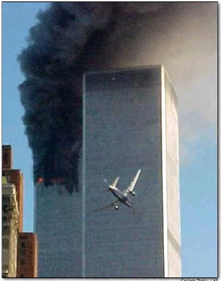

As we first reported to you last year in our (admittedly unfinished) “End of Days” series, we believe that the world has crossed a Rubicon into a new and extremely dangerous phase. The portent of this new period was defined by the passing of Sirius across the Giza meridian at precisely 12:00 midnight on January 1, 2000, an event which we have shown could NOT have been “coincidental.” At that time, we asserted that this singular event, dictated by a series of deft manipulations of the western Gregorian calendar, had been planned and worked towards for perhaps more than two millennia. The authors of this extraordinary and meticulously planned celestial event were a series of groups which have come to be loosely known as “secret societies” -- semi-hidden bands of hand picked and self-appointed “leaders” who frequently attempt to manipulate secular political events.
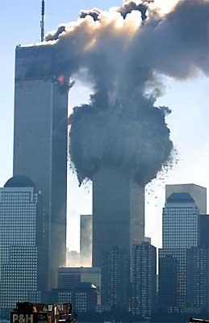
Yet still, when we first witnessed the horrific acts of terror and cowardice that brought down New York's twin World Trade Center
towers, it simply did not occur to us that we might be witnessing such a “manipulated” event. Random acts happen. Violent, murderous thugs commit unspeakable acts of murder against innocent people everyday. The world is full of religious and political zealots who seek to either convert or kill those that refuse to bend to their will. This, in our initial reaction to the horror, most likely was the case with this worst single attack on American soil in our history.

Then the numbers began to come in.

It became obvious fairly early that there were some strange coincidences surrounding these events. As was quickly reported throughout the Internet, there were a whole bunch of odd "9-1-1" and "11" coincidences that linked to these horrific attacks.

For instance:
- The attacks took place on 9/11
- 9+1+1 = 11
- Each WTC Tower had 110 floors, which is a multiple of 11
- The aircraft which ultimately hit the Pentagon was American Airlines Flight 77. 77 is another multiple of 11
- American Airlines Flight 11, the first plane flown into World Trade Tower2, had 11 crewmembers. A total of 65 people were on Flight 11. 6+5 = 11
- The second plane, United Airlines Flight 175, hit the World Trade Tower 1 at 9:02 AM. 9+2 = 11
- 9/11 is the 254th day of the year. 2+5+4 = 11
- After 9/11, there are 111 days left in the year
- New York City (where the major attack occurred) consists of 11 letters
- New York was the 11th state admitted into the Union
- President Bush ordered flags to fly at half mast until 9/22, making an 11 day period of mourning
And so on. At this point, our interest had been piqued, but little else. We had no way of knowing, or certainly proving, whether all these resonances were simply true coincidence or part of some other larger pattern. But given our previous research into such recurring symbolism, we felt impelled to at least look.

The first place we started was with the date itself.

As many news agencies immediately pointed out, the week of 9/11 is the week of the Camp David Accords -- which made peace between Israel and Egypt in 1978 (with an official signing on March 26, 1979). But that seemed a bit too simplistic, so we kept digging. As it turns out, 9/11 is also an ancient date of special Middle Eastern significance. September the 11th is New Years Day in the ancient Egyptian Coptic Christian calendar. That the day must still hold special significance to the people of Egypt is reflected by the fact that Egypt ratified its current constitution on that same day in 1971.

But what immediately bothered us was this question: why would a terrorist pick this day -- a day of unique significance to Christians in Egypt -- against targets in a primarily ‘Judeo-Christian” country like the United States? And why these particular targets?

As we demonstrated in “End of Days,” the US was founded essentially as a great “Masonic experiment.” Most of the driving forces and compelling personalities behind the American Revolution originated in the Masonic lodges of the time. The evidence of a pervasive Masonic influence is present throughout our culture, then … and now: in our symbols (looked at a dollar bill lately?); architecture (how about the Washington Monument?); and traditions (what is the real reason July 4th is celebrated as Independence Day?).

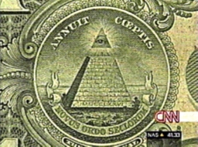

What is not commonly known is that the roots of modern Freemasonry extend far beyond the mid-eighteenth Century, all the way back to ancient Egypt, and more importantly; through a Middle Ages movement commonly known as the "Knight's Templar."

It is, we now suspect, the remnants of this Templar/Masonic/American axis that were the true target of these attacks -- in other words, September 11th was a direct thrust at the heart of the American Revolutionary Experiment … in the critical year (see below) of 2001.

As we did in “End of Days,” before we lay out the remarkable evidence we have now found that makes this conclusion inescapable, we must take you through something of a history lesson. Let us quote again from that previous research:

In 1095 AD (note the decimal recursion of the critical “19.5” symbolism!), Pope Urban II declared a “holy war” against the Muslim invaders of the Holy Land, and launched an effort to retake the “sacred” city of Jerusalem; the infamous “Crusades” had thus begun .…
By 1099, this was accomplished. Then, in 1113, a new order was formed within the Catholic Church that came to be known as the “Knights Hospitalers.” One of the original members of this Order, St. Bernard of Clairvaux, also created a monastery in Seborga in northern Italy in 1113. Documents found in this ancient monastery state that it was built to protect a “great secret.”
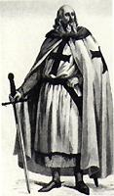
Later, nine Knights (this number will become important later) split off from the original Knights Hospitalers and, all dependent on one another through a complex series of family relationships, presented themselves to King Baudoin I of Jerusalem in 1118 -- requesting the duty of keeping Christian pilgrims safe on the roads and highways leading to the holy city from the port of Jaffa. Obviously, such a task was far beyond the capabilities of a mere nine men, and the entire “protection gambit” was a ruse concealing another agenda for public consumption. Upon arrival in Jerusalem, the Knights (under the patronage of this Vatican appointed Monarch of Jerusalem) proceeded directly to the Temple Mount, the ancient site of the Temple of Solomon, and immediately began excavating the (even then) ancient ruin. It is for this work that they received their name, the “Knights of the Temple” (Knights Templar).
According to Knight and Lomas in “The Hiram Key,” the Temple of Solomon was a structure designed under the precepts of "sacred" geometry by the earliest progenitors of Freemasonry, and was laid out in such a way as to invoke the essence of the Egyptian myths of Isis and Osiris. According to the Royal (British) engineers who later examined the excavations of the Templars (in 1867), the Knights in 1118 found a secret room beneath the Temple Mount, apparently knowing exactly what they were looking for and where to find it. Just “what” they found is the subject of legend, but it has gained scholarly support recently. According to the European Templar Heritage Research Network:
“On the exterior of Chartres Cathedral, by the north door, there is a carving on a pillar, which gives us an indication of the object sought by the burrowing Templars, representing the Ark of the Covenant, but in a rather strange context. The Ark is depicted as being transported on a wheeled vehicle. Legend recounts that the Ark of the Covenant had been secreted deep beneath the Temple in Jerusalem centuries before the fall of the city to the Romans. It had been hidden there to protect it from yet another invading army who had laid the city to waste. Hugh de Payen, one of the original nine Templar Knights, had been chosen to lead the expedition mounted to locate the Ark and bring it back to Europe. Persistent legends recount that the Ark was then hidden for a considerable time deep beneath the crypt of Chartres Cathedral. The same legends also claim that the Templars found many other sacred artifacts from the old Jewish temple in the course of their investigations and that a considerable quantity of documentation was also located during the dig. While there has been much speculation as to the exact nature of these documents, a reasonable consensus is emerging that they contained scriptural scrolls, treatises on sacred geometry, and details of certain knowledge, art and science -- the hidden wisdom of the ancient initiates of the Judaic/Egyptian tradition. Until very recently these legends received short shrift from academic historians, but that situation is undergoing considerable change. One modern archeological discovery tends to support the speculative scenario that the Templars knew where to look and precisely what they were seeking.. The Copper Scroll, one of the Dead Sea Scrolls discovered at Quamran, tends to confirm not only the objective of the Templar excavations but also, albeit indirectly, gives some credence to the bizarre concept of the transmission of knowledge through the generations that led to the original Templar discoveries underneath the Temple Mount in Jerusalem.
“The Copper Scroll, which was unrolled and deciphered at Manchester University under the guidance of John Allegro, was a list of all the burial sites used to hide the various items both sacred and profane described as the treasure of the Temple of Jerusalem. Many of these sites have been re-excavated since the discovery of the Copper Scroll, and several of them have disclosed not Temple treasure but evidence of Templar excavation made in the twelfth century.”
After their excavations were completed at the Temple Mount, the Knights returned to their native lands. Two of them ventured to Rosslyn, Scotland, where they set up their headquarters. Shortly afterwards, the Knights were given the official seal of the Roman Catholic Church, and their numbers swelled as wealthy landowners and aristocrats joined their ranks. The Templars went on a binge of Temple construction and brought back many sciences, such as astronomy, from the holy land. Their order grew in stature, wealth and power quickly, and they won battle after battle against the Muslims during the various crusades. Their secret power was supposedly that they held possession of a piece of the true cross of the crucifixion of Christ (probably found in the Temple Mount excavations). This gave them powers over their enemies in battle and they were said to have never lost a battle while in possession of the Cross.
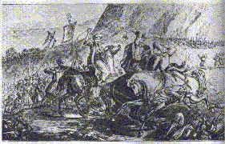
They eventually lost the Cross in the battle of Hattin in 1187 to the Muslim Saladin. After marching on July 2nd, the Templars were surrounded and cut off from water supplies. On July 4th, they broke ranks in thirst and panic, abandoned the encampment and the Cross, and were wiped out by Muslim forces. (These two dates later would become crucial -- not only in the Templar-inspired formation of the United States of America (as we shall see), but in the continuing "hidden ritual history" of NASA as well.)
Ultimately, despite the loss of the Cross, the Templars apparently became a threat to the Church itself. The Pope and the nearly broke King of France, Philip le Bel (1268-1314), plotted to undermine the Order and seize their considerable treasures in France. On Friday, October 13th, 1307, the King's men moved against the Knights and arrested many of them. (This is also why “Friday the 13th” is now considered ‘unlucky”).
Although the Papal conspiracy with King Philip succeeded in obtaining various "confessions" under torture and a considerable sum of Templar wealth, the conspirators never found the ultimate “Templar treasure” itself -- which by now had been secreted away to Scotland. Even so, most of the Order was wiped out in the “10/13” raid (the leader, Jaques de Molay, was burned at the stake), and its members scattered across Europe ... and beyond. On March 22, 1312, the Church officially dissolved the Order by Papal Bull (this date also subsequently became significant, in not only the Nazi movement in Germany but also was another recurring NASA “ritual date”). Surviving German members formed the Teutonic Knights, and the Scottish members went underground ... only to eventually re-emerge as “the Freemasons.”
Whatever ancient relics and treasures the Templars held from their Jerusalem (and other Holy Land) excavations, they were from this moment on secreted away beneath Rosslyn Chapel in Scotland, in much the same way these same artifacts were once buried under the Temple Mount itself. The “Chapel” itself bears no resemblance to a Christian structure, as many experts who have surveyed it have verified; remarkably, it is laid out along the same architectural lines as the Biblical dimensions given for the original “Solomon's Temple.”
What this brief history documents is that the Founders of our Nation – Washington … Franklin … Hancock, to name but just a few -- were intimately connected with, and philosophically descended from, these original Knights who fought against the Islamic forces in “the Crusades” over half a century before, across the Middle East. They were in fact so enamored with Templar rites and traditions that they made sure that our own Declaration of Independence was ratified (July 2nd, 1776) and signed (July 4th, 1776) on dates of overwhelming significance to this older Templar Order.

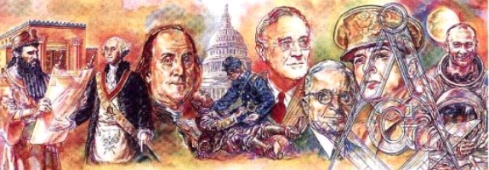
In other words, for some, America could easily be viewed (especially by any fanatic followers of Islam) as the literal embodiment of their oldest enemy of Allah … a literal, infidel “Knights Templar State.”
In light of this little-known history, there were other unusual “numeric coincidences” surrounding the New York and Washington attacks which now seem highly relevant.
How about the Templar Order’s date of official recognition by the Vatican: 1118 AD.
Which, when added (1+1+1+8) equals another 11!

Now, do you remember (as we asked earlier) that there were 9 Templar original Knights involved in the founding of the Order? Which, when added to the previous Templar founding date, equals--

911.
Which brings us to this crucial year of the “911 Attack” -– 2001.
There are exactly 883 years between 1118 and 2001.

And these, when added (8+8+3) equal 19 -- which was the exact number of hijackers on the aircraft.

The reason this latter number is important, and was quite obviously also carefully planned by the architects of this terrorist assault, is to be found in several scholars’ recent discovery of a remarkable pattern of “19s” throughout the Koran. In the view of many modern Islamics, the scientific discovery of the “code of the 19s” provides the final proof of Allah’s direct Revelation of the Koran:
THE CODE - SIMPLE FACTS
Though the code was initially discovered by examining the occurrences of Quranic initials in the initialed chapters of Quran, there is a large number of much less complex parameters to the code. Here is a brief listing of some of them:
1.There are 114 chapters in the Quran, or 19 x 6.
2.The total number of verses in the Quran is 6346, or 19 x 334.
3.Then you add the 30 different numbers which are mentioned in the Quran's text (i.e. one God, two brothers, etc.), the total is 162146 or 19 x 8534.
4.The first statement in Quran, "In the name of God, Most Gracious, Most Merciful" consists of 19 Arabic letters. Known as the `Basmalah', it prefaces every chapter except Chapter 9.
5.Though missing from Chapter 9, exactly 19 chapters later the Basmalah occurs twice. Chapter 27 has this statement at its beginning and in verse 30. This makes the total number of times the Basmalah occurs in the Quran 114, or 19 x 6.
6.Since there are 19 chapters between the missing Basmalah and the extra one, the sum of those chapter numbers is a multiple of 19. (The sum of any 19 consecutive numbers is a multiple of 19.) But the total, 342, is also the exact number of words between the two occurrences of the Basmalah in Chapter 27. This number, 342, is 19 x 18.
7.Every word in the Basmalah occurs throughout the Quran a number of times which is a multiple of 19.
8.The very first revelation that was given to the prophet of Islam, Mohammed, came as 19 words.
9.The total number of letters making up the 19 words of the first revelation is 76, 19 x 4.
10.Though they were the first revelation, these verses are placed at the beginning of Chapter 96. This chapter is atop the last 19 chapters.
11.Chapter 96 consists of 304 Arabic letters, or 19 x 16.
12.The last chapter revealed (Chapter 110) has 19 words, and its first verse is 19 letters.
13.God's name in Arabic, `Allah,' occurs in the Quran 2698 times, or 19 x 142.
14.If you add the numbers of the verses where `Allah' occurs, the total is 118123 or 19 x 6217.
15.The main message in the Quran is that there is only One God. The number of times that the word `one' is used to refer to this concept of One God is 19.
16.The word `Quran' occurs in 38 different chapters, or 19 x 2.
17.The total number of times `the Quran' is mentioned is 57, 19 x 3.
18.Within the 114 chapters of the Quran, 29 of them begin with the Quranic initials discussed earlier. Intermixed between the first initialed chapter (Chapter 2) and the last initialed chapter (Chapter 68) are 38 non-initialed chapters, or 19 x 2.
19.In that same group of chapters, from Chapter 2 to Chapter 68, there are 19 alternating sets of initialed and non-initialed chapters.
20.The total number of verses making up this group of chapters is 5263, 19 x 277.
21.Within this group of chapters there are also 2641 occurrences of the word `Allah', or 19 x 139. Of course, that leaves 57, or 19 x 4, occurrences of that word outside of this group.
22.If you add the chapter and verse numbers of the 57 occurrences of `Allah' outside the initialed section, the total is 2432 or 19 x 128.
23.There are a large number of discoveries having to do with the numbers of the chapters and verses. Many of them are very complex and interrelated. Here is a simple one to give you a feel for these discoveries: If you add the numbers assigned to all the chapters, plus the numbers assigned to all of the verses, plus the number of verses in the Quran, the total is 346199 or 19 x 19 x 959.
24.If you look at the initialed chapters separately and add the chapter numbers, verse numbers and number of verses, the total is 190133, 19 x 10007. Of course it follows that the total for the uninitialed chapters, 156066, is also divisible by 19.
At this point, we were beginning to see a serious pattern -– a highly disturbing pattern, with a unique Templar/Islamic signature -– indicating that this striking series of “coincidences” –- the symbology surrounding the “911 Attack” -- in fact, may have been as meticulously planned as the attacks themselves.

Since the Freemasons are now considered by most scholars (if not by Masons themselves) the Templars’ direct lineal descendants, it only makes sense that the perpetrators of this crime – in their apparent hatred of America -- would choose a target (or targets) that had some symbolic link -- through the Masons -- to the original Knights Templar Order.

In fact they did.

But before we get to that, it is necessary to study and understand just who “the adversary” truly was that fateful September day.

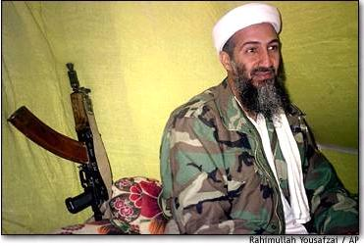

Osama bin Laden, widely believed to have been the mastermind (with possible help from the Iraqi's) of this vicious surprise attack, is a well-established figure in the radical Islamic terrorist community. The son of a wealthy Saudi oil and construction magnate, bin Laden has forsaken all the privileges his family's wealth and stature have provided him in favor of his escalating anti-US campaign. In news coverage of these events, bin Laden has frequently been described as a modern day Saladin -- yes, the same great Islamic general who defeated the Templars at Hattin -- a modern recreation of that general in his current “Holy War” against the United States. However, Bin Laden is far from a military commander or general. His methods are not those of an honorable warrior, but of a cowardly and murderous assassin.

With all due respect to the producers of “The West Wing,” there’s far more to this story than they had time to tell.

The original “Assassins” were a quasi-religious sect of murderous “defenders of Islam” formed in 1090 by “al-Hasan ibn-al-Sabbah” -– the same period that the Templars and the Catholic Church began their ill-fated attempt to “retake” the Holy Land in the Crusades. According to Islamic scholar Edward Burman, author of The Assassins - Holy Killers of Islam, though founded in Egypt, the Order soon moved to a mountainous region of Persia (modern-day Iran), organizing their campaigns against the invading knights from a well defended castle called “Alamut.” According to Berman, the cult was a ruthless, closed, secretive –- even occult –- society, one that used murder, guerrilla warfare, and (at times) overt military conquest to achieve its aims. The Assassins were much feared (and, paradoxically, simultaneously admired) by the Templars during the Crusades, for their almost mystical ability to strike at any time and without warning -- and against any target. Their almost inhuman willingness to sacrifice their own lives for the cause they were fighting (sound familiar ..?) made them a fearsome enemy.

According to the famed explorer, Marco Polo, who visited Alamut in 1273, the Assassins used a variety of techniques that we today would call “mind-control” to obtain and indoctrinate new members. These reportedly involved the use of drugs like hashish, and the transfer of the recruit to “a sumptuous garden filled with beauty, feasts and women.” In this drug-induced state, the recruit on waking was convinced that he had literally gone to Paradise. Upon his return to the "real" world, over time and at the hands of artful teachers, the recruit’s original beliefs in Islam were replaced with a perverted version called the “Nizari Ismailis” -- which ultimately convinced him he could return to this Paradise by means of sacrificing himself for the Cause and its leaders. Internally, the leaders of this sect referred to it as the ‘New Propaganda.”

Readers who have studied bin Laden should now recognize many echoes of this 12th Century Islmailis cult in bin Laden’s fanatic 21st Century followers, who apparently carried out the fatal September suicide missions holding similar bizarre “Islamic” beliefs. Clearly, according to a document discovered by the FBI in one of the hijackers’ bags, the hijackers were convinced that the simple act of carrying out their mission would get them “back to Paradise,” a striking parallel to the Assassin’s original beliefs. This, of course, is in stark contrast to traditional Islam -- which teaches that suicide is a sin against Allah, and that one must live an exemplary life to return to Heaven.

This underscores one of the many puzzles of this increasingly paradoxical event: how supposedly “devout Muslims” –- some of the suicide pilots and their henchmen -- were seen drinking and carousing at strip clubs the night before the attacks! The answer: like the brainwashed members of the original 12th Century Assassins, the suicide hijackers also did not believe that they needed to follow the traditional external teachings of Islam to get to Heaven ... They had a “shortcut.”

Eventually, the Assassins were driven out of the Holy land, only to retreat to Afghanistan and Pakistan –- precisely where bin Laden now has his base (in fact, perhaps subtly referring to this ancient heritage, bin Laden calls his current world-wide assassination network “Al Qaeda” -– “the Base”).
Modern Afghanistan, after they finally defeated the invading Soviet Union in the 1980’s, was taken over by a fanatic religious revolutionary government called the “Taliban,” which translates from Arabic as “students of God” (Allah). This revolution, which began as a religious weapon -- a “jihad” -- against the Soviets (with the direction and encouragement of both the CIA and the Pakistani intelligence service, ISI), was subsequently taken up and is now quietly being continued by a series of Islamic madrasas (Muslim religious seminaries) in both countries. It is here, according to New York Times reporter Jeffrey Goldberg, writing in the summer of 2000, that the next generation of bin Laden’s brand of “Assassins” is even now being quietly trained.
“… the secret of the Taliban -- the secret of Talibanism -- is not found inside the Shrine of the Cloak of Muhammad. The secret is embodied in the two 11-year-olds cocking their fingers at me, and in the taunts of the students in the mosque who raised their hands for Osama bin Laden, and in the person of Mullah Haji Muhammad, my 17-year-old minder in Kandahar who has no interest in any book but the Koran, and in the hundreds of thousands of young men like him at madrasas across Pakistan and Afghanistan. These are poor and impressionable boys kept entirely ignorant of the world and, for that matter, largely ignorant of all but one interpretation of Islam [emphasis added].
“They are the perfect jihad machines.”

Protected by Afghanistan’s Taliban, it is apparent that bin Laden sees himself as leading a new generation of Islamic fanatics –- to be molded into modern descendants of the ancient Assassins -- in a continuation of the “900-year-old holy war” against the hated infidels of the Crusades, almost a thousand years ago: the Templars, and their ultimate creation … the United States.

A war to be prosecuted this time using, among many weapons, naked fear and terror against innocent civilians; the slitting of the flight crew and passengers throats aboard those aircraft, and the allowing of last-minute terrified cell phone calls from the hijacked planes, was obviously designed to be an unmistakable reminder to those “in the know” of the fearsome “signature of the Assassins.” Other weapons in this “new” (actually, very old) war: subterfuge, disinformation, the planting of “sleepers” in the enemy camp years before, etc. A campaign of escalating terror clearly now being planned … with a final, global outcome in mind.

In this role as a modern “al-Hasan ibn-al-Sabbah,” in addition to using his great inherited wealth to underwrite this now literally global network, bin Laden is recognized even by his enemies as a devious and highly educated mastermind –- and one with a determined long-term plan. But recent evidence has surfaced that a major part of that “plan” may not be the sole creation of bin Laden, but a shadowy figure known as Ayman al Zawahiri –- a highly educated medical doctor, and bin Laden’s right hand man.

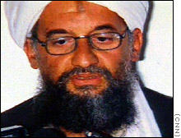

Al Zawahiri also began his terrorist career in Egypt, being a young medical student when he first became involved in a plot called “the Muslim Brotherhood” to kill then President Nasser in the 1960’s. Later, he was put on trail and jailed for three years for being part of Islamic Jihad’s successful plot to kill Nasser’s successor, Anwar Sadat, in October 1981. Surfacing in Pakistan in 1987, where his medical training was used to aid Afghani resistance fighters to the Soviet invasion, that’s where he first met bin Laden.

According to CNN terrorism expert, Peter Bergen:

“Ayman al-Zawahiri's influence on bin Laden has been profound. According to a number of people who know both men, he helped him become more radical, more anti-American and more violent.”

According to Bergen’s sources, this is because al-Zawahiri has a vision of “an apocalyptic conflict between Islam and the West ….”
In other words, an Armageddon War –- the Last Jihad.

Mustaf al-Amin, a contemporary authority on Freemasonry, in his book Al-Islam, Christianity & Freemasonry notes:

“During the period of the Crusades, many of the ideas and practices of the Muslim groups were adopted by the European Christian warriors. More specifically, it was through the Knights Templar that most of the Eastern secret societies’ methods were introduced to Europe. The Templars were influenced by the Order of the Assassins ...”

Al-Amin goes on to observe that the Assassins, when carrying out their missions, took great pleasure in the actual killing -– believing that the victims, in dying, gave up their gnosis (life force) to their assassins ...

Given this background, it was still astonishing for us to discover an unmistakable “signature” … unequivocally linking the millennial-old Order of the Assassins to the horrific events of September 11, 2001. Because --

If you take the current year, 2001, and subtract the year al-Hasan ibn-al-Sabbah founded the Assassins, 1090, you get --

911!

Obviously, whoever was behind this modern horror wanted us to specifically and unmistakably connect the unique and ancient Middle Eastern “secret and warrior society” –- the Order of the Assassins –- with this specific 9/11 event. Further, as previously noted, they also wanted us to realize that this is also the only year, 2001, that the addition of the numbers in the year of the founding of the Knights Templar –- 1118 (1+1+1+8 = 11) -– plus the number of founding Knights in the Templar Order (9), gives the same identifying number --
911.
It should now also be obvious that the same “someone” who meticulously planned these attacks, also wanted it known that there was a major nexus between their planning and the Templars -– between the date of the Templars formation in 1118 (and that first Crusade, which brought them to their secret excavations on the Temple Mount) -- and this one date: September 11, 2001. And … an equally fundamental connection between the Templars and the Assassins themselves …

There is historical evidence pointing to the Order of the Assassins being present at the seminal battle of Hattin, in 1187, where the Knights Templar were resoundingly defeated. Is it coincidence that the term “Assasseen” in Arabic signifies “guardians”, and that some commentators have considered this to be the true origin of the word? But -- “guardians” of what? How about: whatever the Templar Knights defiled through their non-Islamic excavations under Solomon’s Temple in Jerusalem in 1118, and brought first to Europe … then to Scotland … then West?

As we dug deeper, it became apparent that many additional layers of sophisticated Assassin/Templar symbolic “fingerprints” had been deliberately encoded in this tragedy (see below). The real mystery: to what end?

Even conventional news organizations have noted some of the more superficially “symbolic” aspects of these strikes -- calling the twin WTC towers and the Pentagon “symbols of America.” They are, of course, correct. But it is clear that, beyond the now much-used cliché “they’re the heart of the financial and military power of the United States,” these media pundits simply do not understand what these objects -- especially the Twin Towers -- are truly symbols “of” … at a far more fundamental level.

Yes, it is also true that the Pentagon is the heart of American military prowess and pride. It makes sense as a target, if the aim of the Assassins was to put doubt into the minds of the enemy, just as their ruthless predecessors did with the Templars so many centuries ago. But, again, why the twin WTC towers? Why not, if your aim is to strike at the financial center of America, take out the entire New York Stock Exchange ..?]

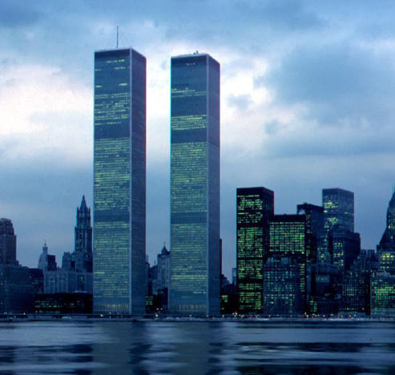
The reason the twin towers were such inviting targets to radical Islamic fundamentalists (like Bin Laden), was that they were symbols, first and foremost, of America's Masonic/Templar roots. It was no accident that these particular buildings housed the financial center of the Free World; they represented the Templar’s little-known invention of the very international financial system that has enabled the United States to become the global superpower that it is now.

This legacy, again, stemmed from whatever the Knights succeeded in retrieving from the Temple Mount in 1127; that it was “something of enormous value” -– both financially and culturally -- seems apparent in their subsequent reception across Europe. When news spread of the Templars' success in their “retrieval operation,” history records that the Knights became revered by one and all. And, in spite of their newly-acquired Jerusalem wealth, major donations also began flowing in from all other quarters. Suddenly, no price seemed too high to secure identification with the Templars.

According to one writer:

“Within a decade of their return, the Templars were probably the most influential body the world has ever known. Nonetheless, despite the prodigious holdings of the Order, the individual Knights were still bound to a vow of poverty. Whatever his station in life, every Templar was obliged to sign over title to his possessions. Even the Grand Master, Hugues de Payens, had done so. Yet still the sons of nobility flocked to join the Order, either as warriors in the Crusades or as travelling ambassadors and political consultants. Being so well funded, the Templars established the first international banking network, becoming financiers for the Levant and for practically every throne in Europe [emphasis added].

Thus, in striking at the World Trade Center, whoever carried out the attack was striking not just at the political concept of “America” -- but at the underlying financial aspect of the Templar legacy. A legacy overtly symbolized by the very nature of the twin World Trade Center Towers themselves …

In the Mythology of the Freemasons/Templars, one of the core legends is that of Jachin and Boaz … the “Twin Pillars” of Atlantis.

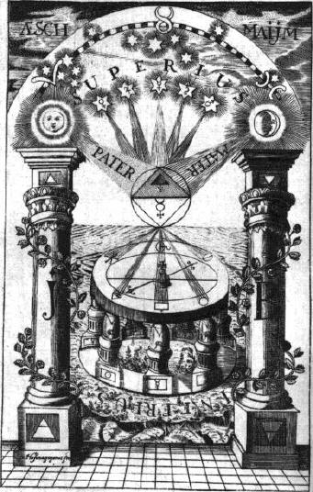

All Masonic lodges have these two pillars at some location in their architecture. In the earliest Lodges, they were said to represent far more ancient pillars, supposedly erected by “the children of Lamech.” On those ancient pillars -- one of brick, one of stone -- were said to be engraved all the then known sciences to preserve them from destruction “by fire or inundation.” As such, they symbolized the esoteric importance of the knowledge of the builder's (mason’s) art, to be guarded and preserved by future faithful craftsmen. Simply put, according to Masonic legend, “the children of Lamech” were the inhabitants of Atlantis. This information, passed down from that prior highly advanced civilization, is supposed to form the basis of the Masonic secrets “from the ancient times.”

Hundreds of years later, shortly before the American Revolution, these original representations of “ancient, preserved knowledge” were replaced in Masonic lodges with two brass pillars, representing two similar pillars originally erected at the entrance to King Solomon's Temple in Jerusalem -- the Pillars of Jachin and Boaz. The new Masonic pillars took on the symbolic attributes of “establishment” and “strength,” cleverly concealing their continuing representation of the great catastrophe which had destroyed a previous epoch of “high civilization,” beneath additional layers of almost impenetrable (for most non-members) new symbolic interpretation.

These same two pillars also make their appearance in non-Masonic religious works, like the Bible.

“And he set up the pillars in the porch of the temple: and he set up the
right pillar, and called the name thereof Jachin: and he set up the left
pillar, and called the name thereof Boaz. (1 Kings 7:21)

“And he reared up the pillars before the temple, one on the right hand, and
the other on the left; and called the name of that on the right hand Jachin,
and the name of that on the left Boaz. (2 Chronicles 3:17)”

As the root source of the deepest Masonic secrets –- the literal “end of days,” and the Masonic role in the subsequent “preservation and carefully timed re-dissemination of the sacred knowledge of Mankind” -- these twin pillars, “Jachin” and “Boaz,” represent the most sacred objects in contemporary Templar/Masonic rituals. Because of this, their symbolic incorporation into the towering 110-story twin World Trade Center Towers made those “pillars” -- not the New York Stock Exchange -- the prime targets of the Islmailis “Assassins” still waging their millennia-long “holy war” ….

If we could tie the actual architects of the WTC towers directly to Freemasonry, we would have strong support for this aspect of our theory. To this point however, we have not been able to do so. We do, however, have some fascinating circumstantial evidence -– both from the architecture of the Trade Towers themselves … and from their world-class architect, Minoru Yamasaki.

“There are a few very influential architects who sincerely believe that all buildings must be 'strong'. The word 'strong' in this context seems to connote 'powerful' — that is, each building should be a monument to the virility of our society. These architects look with derision upon attempts to build a friendly, more gentle kind of building. The basis for their belief is that our culture is derived primarily from Europe, and that most of the important traditional examples of European architecture are monumental, reflecting the need of the state, church, or the feudal families — the primary patrons of these buildings — to awe and impress the masses. This is incongruous today. Although it is inevitable for architects who admire these great monumental buildings of Europe to strive for the quality most evident in them — grandeur, the elements of mysticism and power, basic to cathedrals and palaces, are also incongruous today, because the buildings we build for our times are for a totally different purpose.”
-- Minoru Yamasaki, in Paul Heyer, Architects on Architecture: New Directions in America, p186.
Yamasaki’s discussion of incorporating qualities of “grandeur” … “mysticism” … “power,” as in the great cathedrals, into contemporary architecture is provocative. And his specific reiteration of the term “strong,” remarkably echoes the very meaning of one of the pillars of Solomon’s Temple -– “Boaz” … “strength.” Even more intriguing, in the Temple “Boaz” was the left hand (northern) pillar; in the September 11th attack, Flight 11 hit the northern Tower first -– thereby attacking the “strength of America” first …

However, without an internal memo from Yamasaki’s architectural firm directly admitting this intended symbolism in the choice of “two twin towers,” we readily admit that some will not see this crucial connection to the events of September 11th. So, how about some direct architectural evidence?

Yamasaki, again the chief architect of the Towers, once described his search for architectural inspiration thus:

“… I decided that I wanted to go back and find out what happened in the older buildings, you see. And once I got started on this idea of looking at older buildings to try to gain from them the qualities that we might instill in our architecture then I got very excited, you see. And so I started with the cathedrals …”

In a direct comparison, the Gothic cathedral-like architecture Yamasaki designed into the World Trade Towers becomes startling and unmistakable in hindsight. The question is: was he trying to communicate something deeper than a mere physical resemblance …?

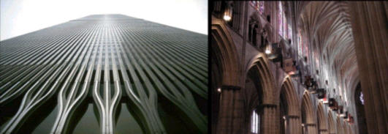

The great Gothic cathedrals of Europe were constructed over a period of about two hundreds years –- from approximately 1134 to 1350 -- by masons … ostensibly the same guild that would go on to become the foundation of Freemasonry today. And it was these same Templar masons who were supposed have incorporated esoteric and secret geometric knowledge into the cathedrals basic construction. Notes writer Graham Hancock:

“St. Bernard, the patron of the Templars, played a formative role in the evolution and dissemination of the Gothic architectural formula in its early days (he had been at the height of his powers in 1134 when the soaring north tower of Chartres cathedral had been built), and he had constantly stressed the principles of sacred geometry that had been put into practice in that tower and throughout the whole wonderful building.

“… Soaring roofs and arches had … been the distinguishing features of the Gothic architectural formula as expressed at Chartres and other French cathedrals in the twelfth century -- cathedrals that ... were regarded by some observers as 'scientifically ... far beyond what can be allowed for in the knowledge of the epoch' [Louis Charpentier, The Mysteries of Chartres Cathedral.]”
Hancock goes on to speculate:

“... What if, in their excavations on the Temple Mount, they [the Knights Templar] had unearthed scrolls, manuscripts, theorems or blueprints relating to Solomon's Temple itself? What if these discoveries had included the lost architectural secrets of geometry, proportion, balance and harmony that had been known to the builders of the pyramids and other great monuments of antiquity [emphasis added]?”
In addition to their obvious resemblance to the soaring Gothic cathedrals that so obviously impressed Yamasaki decades before, what else was he trying to communicate through his choice of this particular design? Did he, like the Templar architects and Masons who built the astonishing cathedrals a thousand years before, also encode ultimate “Masonic secrets” in the Towers’ very forms …?

Paul Heyer’s Architects on Architecture: New Directions in America (p. 194-195) contains the following description of Yamasaki’s actual design of the twin towers:

“The structural system, deriving from the I.B.M. Building in Seattle, is impressively simple. The 208-foot wide facade is, in effect, a prefabricated steel lattice, with columns on 39-inch centers acting as wind bracing to resist all overturning forces; the central core takes only the gravity loads of the building. A very light, economical structure results by keeping the wind bracing in the most efficient place, the outside surface of the building, thus not transferring the forces through the floor membrane to the core, as in most curtain-wall structures. Office spaces will have no interior columns. In the upper floors there is as much as 40,000 square feet of office space per floor. The floor construction is of prefabricated trussed steel, only 33 inches in depth, that spans the full 60 feet to the core, and also acts as a diaphragm to stiffen the outside wall against lateral buckling forces from wind-load pressures."

“... a prefabricated steel lattice, with columns on 39-inch centers …”

As everyone who has followed our research should instantly recognize by now, 39 is none other than --

Twice 19.5!

Two towers … twice 19.5 … creating a 39-inch separation of the steel.
“ … The floor construction is of prefabricated trussed steel, only 33 inches in depth, that spans the full 60 feet to the core .…”
And, again, those of you have followed our research will instantly recognize that --

“33” is not only the highest attainable Degree in Masonry in the Scottish Rite … it is also (and more fundamentally) the sin of 19.5 degrees.

“60” of course is the critical angle in both equilateral triangles and the tetrahedra of which they are comprised -- the latter incorporating those same critical circumscribed 19.5-degree angles …

In other words, it is overwhelmingly obvious that Yamasaki went out of his way to quietly, secretly, incorporate key Templar/Masonic geometric information in the most fundamental dimensions of the World Trade Center Towers themselves. By using these specific units [which are NOT metric, and certainly not part of any Imperial (English) measurement system], there can be no other logical explanation for Yamasaki’s bizarre choices of those specific numbers … other than to enshrine Masonic secrets in his masterpieces … and thus provide convincing proof of the Trade Towers ultimate symbolic role as “the twin pillars of Solomon.”

And on September 11th, 2001, these 110-story representations of Jachin and Boaz –- incorporating, through Minoru Yamasaki’s quiet genius, elements of Templar knowledge extending back at least a thousand years -- were finally, deliberately, and totally … destroyed.
The only surviving clue as to the hidden knowledge once incorporated in their towering construction, being haunting portions of “… the prefabricated steel lattice, with columns on 39-inch centers .…”

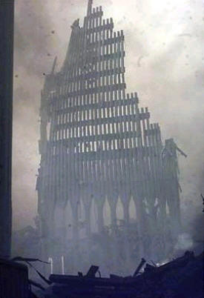

Another way to look at this extraordinarily well-planned and overwhelmingly successful terrorist attack against these major Templar symbols, is in the context of the “ritual alignment pattern” we have been documenting for so long.

As we have shown many times before, years ago we discovered that certain key events in our National space program have been repeatedly and consistently timed to occur around the placement of certain stars at “key ritual positions” in the heavens. Presumably, if Bin Laden, Ayman al-Zawahiri, or whoever planned these intricate assaults, understood this ancient “ritual language” of their enemies, or -- were part of an equally ancient tradition which made use of similar knowledge for their own well-being -- the September 11th events would have also been devised to incorporate those critical celestial elements in the attacks -- if for no other reason than to confer a “celestial advantage” on their operations.

And, if this was indeed the case, then a carefully orchestrated –- and precisely timed -- sequence of events in the hijackings, routings, and eventual collisions of each aircraft with each target, would have been required -- to successfully pull off such a multi-leveled, interlocking Plan. Such additional elements -– because they all would have depended on precise timing with the rotation of the Earth -- would easily and unmistakably show up in any post analysis of the attacks.

Another quick review is in order here. According to our system, the only stars of significance for the fulfillment of these rituals are Sirius, which represented the goddess Isis in the ancient Egyptian stellar religion; the three belt stars of Orion, which represented Osiris, her brother and husband; and Regulus, the "heart of the lion" of the constellation Leo. Leo is representative of Horus (the son of Isis and Osiris), who ultimately vanquished his father’s murderer, Set. The only ritual positions for these stars considered significant are: 33° above or below the horizon (representative of the highest degree of enlightenment in the Templar/Masonic rites); 19.5° above or below the horizon (taken from the Hyperdimensional physics of Cydonia, and the intimate geometric relationship of 19.5 to 33); and the horizon and meridian themselves (considered markers of the passage between life and death).

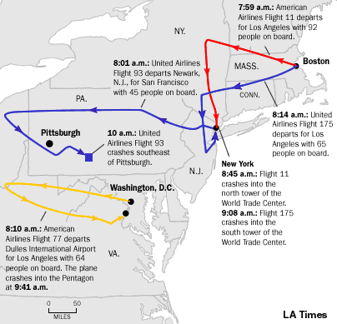

According to well-published timelines of the events from various media sources, the first plane (American Airlines Flight 11) struck the first tower at 8:45 EDT. In checking the alignments for New York at that time, we found only one “hit” of possible significance. Sirius, the representation of the goddess Isis in the ancient Egyptian (and as we have asserted, Templar/Masonic) stellar religion, was just slightly above 32° over the horizon. Now, 33° is the position we normally consider a “hit,” and we normally only allow a 1/2 degree margin for error, so this was a case of “close but no cigar.” Still, it was close enough (a 1-degree error, plus or minus, is still “one chance in 180”) to be intriguing, since Sirius never really got as high as 33° the entire morning. In checking the 9:03 impact of United Airlines Flight 175 with the second Tower, we found that Sirius was slightly further out of range, though still very close.

In quickly checking Washington DC at the times of the Tower impacts, we also found that neither Sirius nor Orion (as Osiris), the two primary players in this sacramental dance we have seen so many times, were close enough to any of the usual “ritual positions.” So in neither of the targeted cities did there seem to be any irrefutable evidence that bin Laden “the Assassin,” at the times of the New York attacks, was trying to use the Templars own “magic” against them.

However, a cursory check of Giza, Egypt -- the home of not only the Assassins (and Al Zawahiri) but also the Templar/Masonic religion itself -- showed the belt stars of Orion well within the half degree margin of 33° at the time of the first attack! And in Kabul, capitol of Afghanistan (and bin Laden's Al-Quada “base”), Regulus -- the heart of the lion -- was dead on the horizon ... the Western “death” horizon
…

The significance of Regulus on the western horizon at Kabul might be especially meaningful. Leo represents Horus, who was a figure of vengeance in ancient Egyptian tradition. If bin Laden saw himself as a “vengeful assassin,” then having Horus, the instrument of traditional Templar vengeance, on the death horizon of his adopted capitol, could be not only an ironic affront to the enemy -- but a powerful source of magical power as well.

Still, without the usual “suspects” in proper ritual positions over the targeted cities, we did not feel we could “call” these events as part of the normal ritual pattern we have come to recognize so well. Nor, could we use such a pattern (if it was absent) to ferret out precisely “who” was behind these despicable acts of September 11th. We needed more.

Then we looked closely at the actual flight numbers. The four planes involved were, in sequence, American Airlines Flight 11, United Airlines Flight 175, American Airlines Flight 77, and United Airlines Flight 93. As we looked at each of these, a disturbing and faintly familiar pattern began to emerge. Besides all the nines and elevens, it did not escape our notice that the flight which crashed into the Pentagon, in the only successful attack on Washington D.C., was “Flight 77.” As we looked in the skies above the Pentagon at the exact moment of impact, 9:39 AM (according to NBC’s Dateline –- and yes, we noticed), we saw something extraordinary.

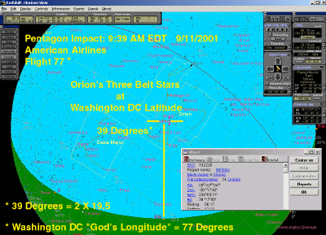

There, at precisely 39°, literally in a row parallel to the horizon, were the three belt stars of Orion.

Ok, so what?

Well .…
Orion, as we have said, represents the god Osiris, overseer of the dead, judge of the underworld and resurrection, the literal “god of the dead” and highest deity in the Egyptian pantheon of gods so sacred to the Masonic/Templar religion we’ve been tracking. To find Osiris, lord of the dead, at such a point overlooking this scene of death and destruction –- the assault on the Pentagon -- was surprising if not disturbing. But again, it is at 39°, so it doesn’t quite fit our pattern of “19.5's and 33's.” Or … does it?
Readers will recall that in one of the earlier chapters of “End of Days,” we laid out our case that the location of Washington D.C. at 77° longitude was definitely no “accident.” What we did not discuss (yet) was that the latitude of the Capitol city was of equal symbolic significance to its longitude. That latitude?

39°.

That key multiple again of 19.5 (which, we now know, was also clandestinely embedded in the architecture of the World Trade Towers). The key code to figuring out the ultimate secret of the “Templar Magic.”

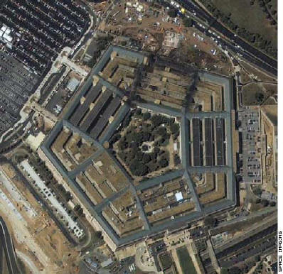

So this specific act, the crashing of Flight 77 into the Pentagon in Washington D.C. with “Osiris” at 39° above the site, was draped in the symbolism of bin Laden's Templar enemies. It literally encoded “death to those at 77° by 39°” -- ergo “death to the Templar State of America!”

If you need any more evidence that our Masonic founding fathers understood the significance of not only Cassidy and Steele's 77° “God's Longitude” but also our own Hyperdimensional Physics, you need look no further than the architecture of our Nation's Capitol for it.
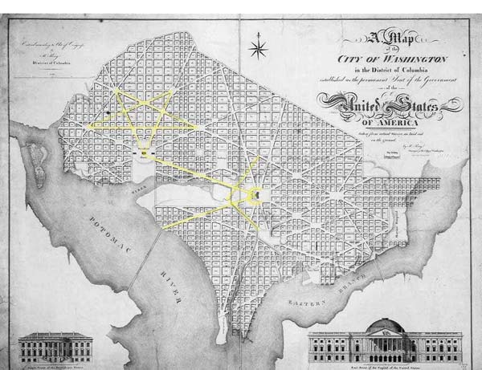
The architect of Washington DC, Pierre Charles L'Enfante, was a French Freemason who was well acquainted with Benjamin Franklin from the latter's time in France. L'Enfante cleverly encoded not only the Masonic symbol of the Compass and Square into his design for our capitol city, but also apparently an inverted pentagram, commonly considered an occult/Satanic symbol. The association of the pentagram with Satan is a fairly recent development, however, and the geometric symbol would have had a completely different meaning to a Scottish Rite Freemason like L'Enfante.
In Freemasonry, the Pentagram is found commonly in the inner chambers the lodges. Its ancient origins are as a symbol for the star Sirius, inextricably linked through the Masonic lore to the Egyptian goddess Isis. As such, it has become the symbol for the Order of the Eastern Star, the female counterpart to the exclusively male brotherhood of Freemasonry.
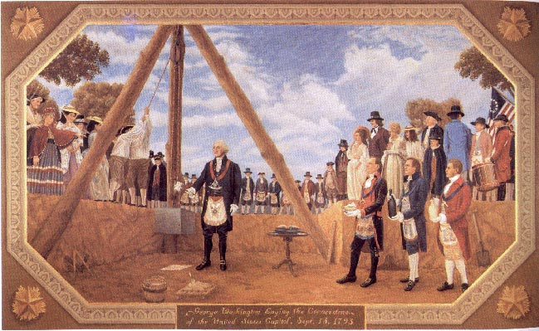
It should be fairly clear at this point that the sacred “33-year” cycle calendrical longitude -– 77° -- was picked as the site for our Nations Capitol for a major reason. It should also be evident that the Masonic order had full knowledge of this longitude's mathematical significance when they chose to place “2’s District of Columb(i)a” dead on it. But what evidence do we have (beyond the fact that the cycle itself is “coincidentally” 33 years) that any of this was based on some secret knowledge of a physics that has its modern roots in the ruins of Cydonia?
It's all in that 39° latitude.
Certainly, architects of a grand and covert Plan such as this one would have carefully considered the site of their most crucial shrine -- the very Capitol of the “New Atlantis” -- based on more than just the longitude. Wouldn't the latitude of this all- important linch-pin site reveal something about the “selectors” as well?
Indeed it does. If there were in fact some Hyperdimensional connection to the placement of our Nations Capitol, we would expect to see it revealed in its location in a significant way. And we do.
Let's consider this for a moment. The most obvious way to encode such a message would be to place the City on an obvious “tetrahedral” latitude. But “19.5° N by 77° W” would have placed the Capitol City off land and into the ocean off Mexico (to say nothing of the fact that this was territory that the English/Masonic colonists did not control). Similarly, placing it at a latitude of 33° N would have left them trying to build their city in the Atlantic off the coast of Georgia. So the only logical place George Washington could choose for this new Atlantean Capitol in North America -– even if it was in the middle of a literal swamp when Washington selected the site! -- was where he eventually did place it -- 39° N.
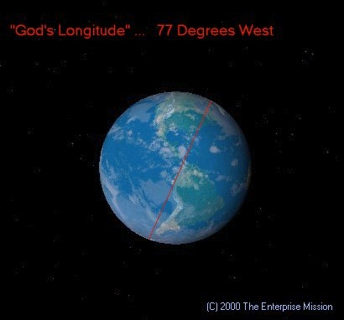
Huh? Just how is 39°, not 19.5° or 33°, "tetrahedral" or "Hyperdimensional?"; Well, if you remember from the preceding Trade Towers example, you simply divide 39 by 2, to derive ... 19.5. So, since it was impractical for the Founders to place their city where they clearly wanted to -- at one of these prime Hyperdimensional latitudes -- they settled for the next best thing. A "multiplicative harmonic" of 19.5° -- 39°!
But, they went further. The two main thoroughfares in Washington -– Pennsylvania and Maryland Avenues -- connecting the Capitol Building with two other major landmarks –- the White House and the Jefferson Memorial –- depart the Capitol at exactly the key Templar/Masonic angle of 19.5°. And twice that angle of course equals 39° … again, the “encoded latitude” of Washington DC.
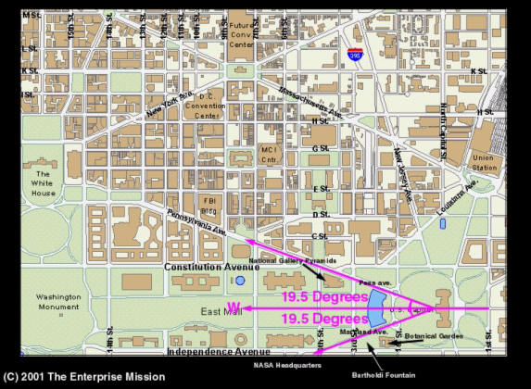
There is other American precedent in our investigation for this kind of geodetic “Templar encoding.”
At the Kennedy Space Center in Florida, there are two launch pads from which all of the Apollo and Space Shuttle missions have been launched. They are certainly the best known launch sites in the world to any space exploration buff. Pads 39a and 39b.
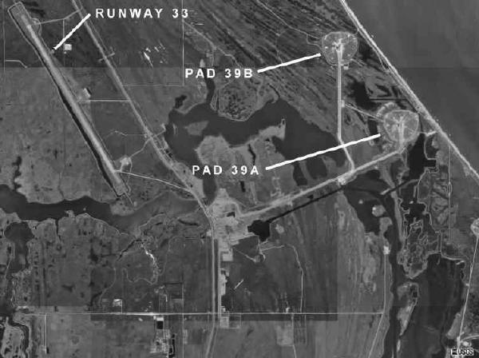
Now, it has always bugged us -- why “39a and b,” instead of … “39 and 40” … or, “38 and 39?” The answer is that neither of those combinations is tetrahedral! As if to reinforce the point, the two pads are adjacent to a runway -- the only runway at the Cape --
Runway 33.
And lest you forget, the sine of 19.471° (the un-rounded 19.5) is … 0.3333.
And the Cape itself, “Cape Canaveral” translates in English as the “Cape of Reeds.” And what ancient Egyptian god was associated specifically with reeds?
Osiris, of course. They may have just as well called it “the Cape of Osiris.”
Starting to notice a trend here?
Now, our critics will say that all of this is just a “lucky coincidence” -- that we are applying “magical thinking” to pull connections “out of thin air” … But that’s exactly the point: this is all about somebody’s warped idea of “magic!”
Is it really so hard to believe that the choice of locales for Washington DC was based not on some “random affinity for good swampland,” but instead on the ancient and esoteric teachings to which all of these Founders were demonstrably students? That this same sort of mathematical/religious symbolism has simply continued another 225 years beyond the Founding of this Nation to the present day, just as it has for the many thousands of years of human history leading up to 1776? Why would 2,000 (plus!) years of devotion to this kind of symbolic thinking simply stop at the doorstep of the 20th century, and not find its way into many current branches of government -- such as NASA, demonstrably dominated (how many top NASA officials and astronauts are Masons?!) by modern devotees of these same ancestral organizations?
Who really is “reaching” for an explanation here?
Obviously, they are.
But there is still one task ahead of us. One final point that has to be made to tie all this ritual history together, and explain why it is intricately … inextricably … connected to the horrifying political events of today.
What's it all about? Why has all this been done? To what Ultimate Purpose, in the eyes of its Founders, was this Nation -- called by Lincoln “... the Last Best Hope of Mankind” -- truly born?
We think the specific numerology of these attacks –- the date, their timing, the flight numbers of the planes chosen, even the number of passengers and crew aboard each flight -- was an encoded message … and a warning from bin Laden to his Templar opponents. “I understand your magic … and I can make use of it myself.”

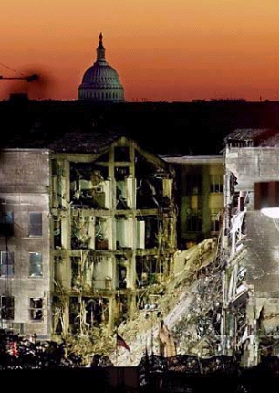

But our theory would only apply if there were equal symbolism in the other doomed flights.
We quickly turned our attention to Flight 93: the flight that crashed in the fields of Pennsylvania after an heroic effort on the part of the passengers to overcome the terrorists and keep the plane from being flown into the White House. “93,” of course, is an anagram for “39. The number also made us curious, because 1993 was the year of the first attempt -- apparently also by bin Laden (although Saddam Hussein’s fingerprints were also left on the scene) -- to bring down the WTC towers. So, of course, we went back to that initial event to see if it fit the symbolic pattern we’ve been tracking.
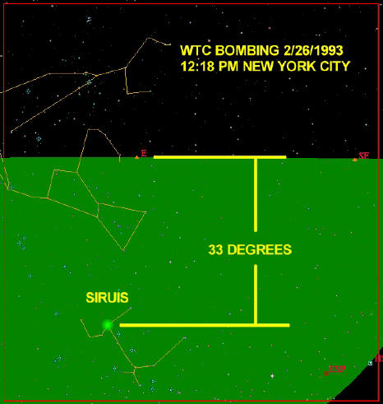
And once again -- the pattern was confirmed.
“93” is also a significant number in “magic” (and remember what Sir Arthur has always said: “Any sufficiently advanced technology [or physics] is indistinguishable from magic”), the so-called “thelemic practices” of yet another modern day descendant of an ancient secret society -- the “Magi.” 93 was considered the literal number of “magic” itself; and the “holy’ significance of this number was repeatedly espoused by Aleister Crowley, an early 20th century practitioner of magical rites -- through which he hoped to bring about Armageddon. Crowley is usually seen as a marginal figure in history, but more recently he has been discovered to have had a significant (if unsuspected) role in the development of our own space program.
But Flight 93 was important for an even deeper, and in retrospect, more obvious reason.
For a moment, put yourself in the mind of the terrorists. If you have been given the task of destroying a specific target -- like the WTC Towers or the White House -- why wouldn't you try to quickly gain control of the aircraft? In the case of the two WTC aircraft, this was in fact done. But Flight 77, which crashed into the Pentagon, was not commandeered for at least 45 minutes after take-off. Flight 93, which was headed either for the White House or the Capitol Building itself, was all the way to Cleveland before being taken and turned around. It crashed around 10 AM, more than an hour after the first plane hit the WTC tower. So the question is, if you are looking to hit a key target, why wait? Why give the enemy the chance to figure out what is going on, scramble his fighters, and possibly knock you out of the sky before you reach your target?
You don't. You get the jet as soon as you can and you head directly for oblivion. The only reason to wait, is if you’re waiting --
For a specific time!

Like say … when a certain star is in a certain position over your intended targets.

And even more to the point, why hijack just 767s or 757s? They’re big planes, yes. And they got the job done. But why not grab 747s? They have much larger fuel capacities and would do a lot more damage, just because of their sheer size. Unless ... they didn't have the right Flight Numbers that fateful morning?
So, if Flight 93 had not been taken out by the passengers, when would it have arrived in Washington DC, its presumptive target? Using a maximum speed of around 500 mph, probably around 10:20 AM. And what did the sky over Washington look like at that moment?
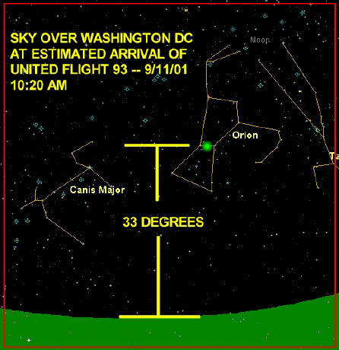

Orion/Osiris, at the Masonic altitude of 33°.
The ritual pattern continued …
It is perhaps not surprising that bin Laden would understand how to use these particular magical moments to plan his attack; these same “rules of engagement” had been used before -- by none other than President Bill Clinton, then representing the United States -- on bin Laden.

Some of you will remember the August 7th, 1998 terrorist attacks on US embassies in Tanzania and Kenya. These atrocities, clearly proven to have been planned and carried out by bin Laden's Al Qaeda network, killed 224 innocent civilians and wounded thousands more. From the beginning, what was curious to terrorism experts in America was why there were two attacks simultaneously. In this case, it seems to be linked to the Longitude of the targets -- 39° E in the case of the embassy in Tanzania, and just a shade off that for the embassy in Nairobi. And of course 39° divided by two-- is 19.5°! So even then, bin Laden was telegraphing his coming attacks on Washington -- at 77° x 39°

In response, the US launched a (mostly ineffectual) cruise missile attack on bin Laden's base camps in Afghanistan, and simultaneously, on the Sudan, on August 20th. The location of the Afghanistan attack was fascinating: bin Laden’s terrorist training camps, near the town of Khost … at 33.3° N.

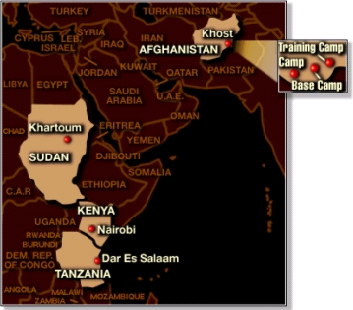

The target in the Sudan was a supposed “bin Laden nerve gas factory” in the Capitol itself, Khartoum -- a former bin Laden sanctuary. Later investigation revealed that the “nerve gas factory” was actually only making aspirin, and in no way connected with bin Laden or terrorist activity. So, why did Clinton give the order (secretly -– without even the input of the Joint Chiefs!) to take it out? Because—
It was located at 33° E.

And, the precise timing of the attacks was at 13:30 EDT (military time) or 19:30 in Khartoum.
That's 19.5 … in case you're interested.
A few months later, after he had kicked out the UN weapons inspectors and evidence began to mount that Iraqi leader Saddam Hussein was secretly stockpiling chemical weapons, the US launched a similar attack on Baghdad. At first, this held little interest for us, but US officials kept repeating over and over, clearly using a preplanned talking point, that Clinton had ordered the attack at “precisely 8:00 AM EST on December 16th, 1998.” They kept repeating this, even when not asked, ad-nauseum. Obviously, there was a message here, and it did not take us long (after we “got the message”) to figure it out.
When we checked the stars, we again found this same, all-too-familiar magical pattern.
What this told us was that Clinton certainly understood the importance of acting with “the grace of the gods” in mind. The Templar gods, that is. And –- like bin Laden now -- he certainly seemed to want “somebody,” presumably Saddam, to know about it.
While we did not yet know if the current occupants of the White House are as up on all aspects of this “magical symbolism,” we are unquestionably sure that the previous occupants were …
So what of yesterdays US response to the attacks of 9-11? Did Bush follow the pattern we have so carefully tracked in his first response of this new "crusade" against terrorism?
Of course he did.
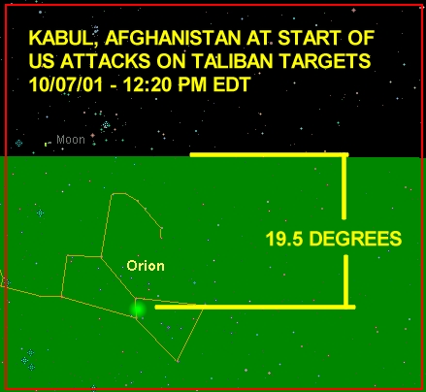

One of the questions we’ve had to deal with over the years around this recurrent symbolism is the argument “even if you’re right, it’s meaningless; even if the alignments are real -- so what?! What use are they, other than to ‘predict’ or expose ostensibly linked events … post posteri … after the fact?”

We have always held that the alignment patterns are, at their core, “Hyper-dimensional” -- inextricably linked to the ruins at Cydonia as a shadowy reflection of “a higher knowledge of arts, sciences and physics” that we (as humans!) once commanded, of the “Magic” that we once wielded. But we have not been entirely positive in some instances whether “the planning,” or “the incident” comes first.

These September 11th events may have finally brought us to an appreciation of what these alignments really mean.

A little reported story surfaced after the attacks, of some astonishing electronic data collected by a research team at Princeton University
on something called the “Global Consciousness Project.” In short, this is a project consisting of 38 random number generators (RNGs) located around the world, communicating their second-by-second random number data via the Internet back to a central computer located at Princeton University. The team discovered, on checking their data for September 11th, that there was a stunning decrease in randomness –- a literal non-random “spike” in their previously random numbers -- beginning a few hours before the tragic events at the WTC and extending several hours after. This completely world-wide occurrence showed unequivocally that there was indeed a “confluence of events,” or some sort of “spike,” in the background entropic noise of “reality” … a dramatic change that remarkably occurred precisely around the attacks. The phenomenon is flatly inexplicable by any “conventional” science.
By stark contrast, this extraordinary effect on the RNGs is easily explainable -- if not inherent in -- the Hyperdimensional Physics Model.
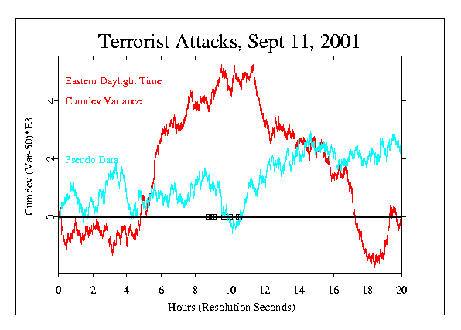
This startling September 11th data is supported by a completely independent set of Russian experiments, conducted over the past 40 years, which have found equally non-random, repeating cycles in such supposedly “random” processes as radioactive decay. These two studies, taken together, all but destroy the notion that physical and biochemical processes are simply “probabilistic.” In fact, the mere existence of such data is a flat refutation of the current reigning view of quantum physics as a strictly “probabilistic, random process.” It does, however, provide startling explanation for a looming problem underlying all of quantum physics -– the baffling violation of the so-called “Bell Inequalities …”

These are the experimentally observed violations of the normal set of quantum mathematical relations that would rule out the ability of distant quantum particles to exert influences on each other at seemingly instantaneous (faster-than-light) rates …”. The Hyperdimensional Model not only provides an elegant explanation (via a literal higher dimension of space-time) for such otherwise inexplicable faster-than-light communications between fundamental particles -- called “quantum entanglement” -- it demands that time “windows” exist (for less-susceptible masses above the quantum level) within which this same “hyperspatial communication” also can occur … in cycles-–

When the hyperspatial geometries -- dictated by the positions, rotations and momenta of the solar system’s planets -- create increasing and decreasing “gating” opportunities on Earth for this instantaneous information transfer of increased coherence between dimensions.

The working model of the Princeton experimenters is that the shocking events of September 11th triggered a massive “tremor in the Force” -– that the major decrease in “randomness” of their random number generators placed around the planet was a direct result of the linked consciousness of billions of people all over the world, reacting to that horror seen on television. We respectfully disagree.

In our model, the dramatic change in the random numbers coning in to Princeton -– beginning four hours ahead of the “event” -- was a direct result of a change in spatial parameters around those far-flung generators. These changing parameters, in turn, were caused by an increase in the “information transfer rate” between dimensions -- caused by a particular spatial geometry between Earth and key celestial objects.

It was into this precise “hyperspatial window” that the modern Assassins methodically drove their aircraft –- attempting with military precision (as we have seen) to use the horror and revulsion of the literally billions watching live on television to effect a direct change in the consciousness of humanity around the world … directly assisted by the “Physics.” Remember what Mustaf al-Amin said about the Assassins: “they take pleasure in stealing the gnosis (life force) from their victims ….” In other words, they use conscious application -– via these critical celestial alignments -– of a “practical Hyperdimensional Magic” literally thousands of years old …

Support for this “Hyperdimensional” interpretation of the Princeton results comes not only from their own long-term RNG data (which reveal many similar “spikes,” going back years -– with NO globally-riveting events entraining a “mass consciousness” within those “windows”), but also from a detailed analysis of the September 11th events themselves, carried out by Dean Radin of the Noetic Sciences Institute.
Radin did a detailed instrument by instrument analysis of all the 38 random number generators deployed by Princeton around the world, seeking to discover if there was any “distance dependence” from New York and Washington in the observed “non-random instrument effects.” What he discovered was absolutely fascinating –- and totally supportive of the Hyperdimensional “celestial window model,” but NOT of a “mass consciousness effect.”
Radin discovered that the effect on the 38 RNGs was NOT uniform around the planet: those generators specifically located in the Western Hemisphere exhibited increased “non-randomness” within the “window,” compared to others in the Eastern Hemisphere; and of those, the ones in North America exhibited still more divergence from strictly random behavior; and of those, the instruments on the East Coast exhibited the most divergence from their expected random behavior.

These effects are NOT characteristic of any other “consciousness experiments” that have been conducted over the last 70 years -- ranging from early examinations of precognition, clairvoyance and telepathy in the classic Rhine Experiments at Duke University in the 1930’s, to the remote viewing experiments carried out at SRI for the CIA decades later, to astronaut Edgar Mitchell’s famous clandestine ESP experiment conducted literally half way to the Moon! Uniformly, all positive “consciousness effects” from these experiments have seemed completely unaffected by simple distance factors. Noted one recent review of the field.
“No known energy seems to fit the facts of clairvoyance and telepathy. Radiant energy appears to be the necessary stimulus. X-rays, radio waves, gamma rays, etc., have been advanced as a possible cause for the phenomena in question. However, all these types energy lose efficiency through distance and are affected by intervening objects, conditions which seem to have no appreciable influence on extrasensory perception … To say that these minds are ‘attuned’ to each other [the ‘mass consciousness effect’], is a facile phrase, but it is merely an analogy and explains nothing. We may as well face the fact that the science of physics at the present time has contributed little to an adequate understanding of the nature of extrasensory perception …. [emphasis added].”
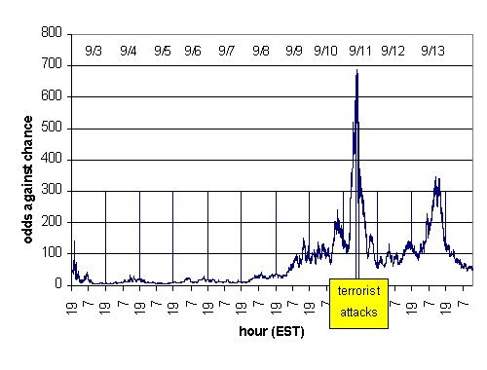
These and the Princeton RNG results ARE, however, totally consistent with a geometric “celestial alignment effect,” peaking on September 11th -- just as Flight 11 was precisely timed to hit World Trade Tower2 at the height of the “geometric window.” Note the slow build-up of “non-randomness,” beginning days earlier (highly indicative of a slowly changing astronomical “window” effect), and the additional, statistically significant “non-random second peak” two days later -- when there were NO major new terrorist events … or, obvious reasons for a resulting “mass consciousness effect.”
This data, however, is remarkably supportive of an enhanced “Hyperdimensional transfer rate,” decreasing the normally random Princeton’s RNGs through temporary increased coherence in the machines.
If we now used a combination of the “alignment model,” and the data depicted in the Princeton graphs, it is entirely feasible that a calamity like what took place at the WTC and in Washington, might be predicted, or even prevented in advance -- if only we knew where to look, and what to look for. Such new studies at Enterprise are on-going, even as we write.
How's that for a “practical” use of the Alignment Model?

Ultimately, this led us to look at the symbolism around the last (in terms of our recounting, not in terms of the actual impact times) of the four flights.
On the surface, United Flight 175, other than having 65 people on board (6+5=11), didn't seem to fit this numerological pattern (1+7+5=13). But, as we have seen, since all the previous flights contained deep symbolic significance (obviously now, carefully planned by the Assassins for their maximum “magical” effect), we intuitively felt that “175” somehow had to share in this common crucial pattern.

Then it struck us:

What if the redundant “11's” all throughout this process also referred to an arrogant prediction (in keeping with the ancient “rules of engagement” of such secret societies) of the next attack … like the eleventh month? And what if “175” was really “17.5,” like noon on the 17th of November? Which we subsequently discovered, just “happens” to be noon on the first full day of Ramadan -- the holiest period of the year for Muslim's around the world. What if we were supposed to look to Mecca, the Holy City of Islam, where at least a million pilgrims would be gathered (in the “Haj”) at noon on that specific day?
The more we though about it, the more this scenario began to worry us –- a LOT.
From a variety of reports, bin Laden is thought to possess at least one “suitcase nuke” (purchased after the break up of the former Soviet Union): a small tactical device that can devastate a major city. We had a stunning thought: what if, as his “next act,” bin Laden used such a device in Mecca -- at the height of Ramadan … on his own people? Who in the Muslim world -- especially if there is a highly visible military “response” to September 11th from the United States in Afghanistan on CNN between now and then, which unfortunately kills Afghani civilians -- would believe that anyone other than “the Great Satan,” the United States was responsible for such a heinous act?

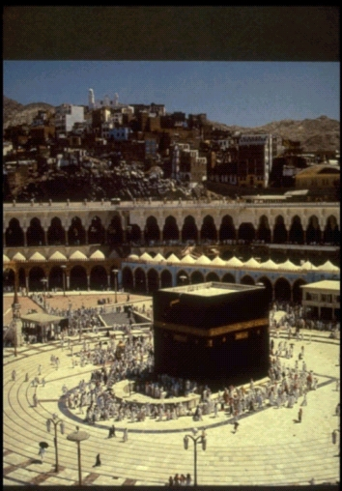

What Arab state would (or could!) deny bin Laden at that point his world-wide jihad -- the Holy War with the West that he (and Ayman al Zawahiri) so fervently desires? What would the Muslin-dominated southern “republics” of the former Soviet Union do -- armed with thousands of nuclear –tipped ballistic missiles, that they could vengefully turn against the United States in retaliation for the unspeakable crime against all Islam? What would the Muslim-dominated government of Pakistan do, armed with their newly-developed (thought more limited) arsenal of equally dangerous rocket born nuclear weapons …?

So we looked.

And found … absolutely nothing.

But what if Mecca wasn't the target on that date? What if the target was somewhere back in the United States … like Washington again?
So again, we looked. Noon in Mecca on the 17th is 4:00 AM in Washington DC. At precisely that moment, Sirius, the goddess Isis -- the most important single star in this Templar/Masonic religion –- will be at EXACTLY 33° elevation … with an azimuth of EXACTLY 195° (a decimal “harmonic” of 19.5).
A celestial alignment which, eerily, will be an exact duplicate of Sirius’ alignment for Washington DC at the height of the September 11th attack … and Princeton’s “peak!”

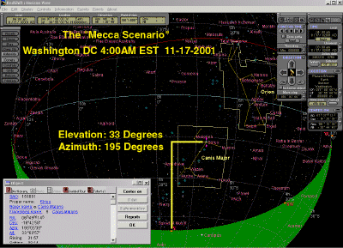

According to this striking “window” in November, whatever is being planned for the 17th (if anything), will either come from Washington … or be aimed at Washington in this time period. And, it will NOT be “trivial.” Neither scenario is very pleasant to consider.

From previous pieces of this pattern, which now assume a striking new importance (just keep thinking “Princeton”), we must also not forget that there is a small but powerful lobby in our own government that wouldn't mind such a literal "Armageddon Script" playing itself out. And we know that bin Laden and his cohorts want (and need) something equally devastating -- to inflame the entire Muslim world into jihad. We hope that by publicizing this potential set of scenarios NOW, we can foil whatever secret plans there are, if any, to escalate this “war on terrorism” into total, global devastation. And even if the 17th comes and goes … and nothing happens … there will still be other “windows” coming.
We must seriously start looking NOW … if we are to evade what “someone’s” obviously designed by launching September 11th … the Final War for all Mankind.
And, we must not forget that the President sees himself as something of a “Horus-avenger.” By all press accounts, George Walker Bush had no great passion for being President prior to his election (and some say, even after) -- other than fulfilling a sense of duty to avenge his fathers political “death” at the hands of Bill Clinton in 1992, by vanquishing Clinton's hand picked successor, Al Gore.
In light of the Middle Eastern history we’ve laid out here, and his being sworn in on the same Templar/Masonic Bible used by George Washington over two centuries before, George Bush’s use of the word “Crusade” repeatedly in the days and weeks following the September 11th attacks could only have been deliberate and intentional -- and aimed directly at bin Laden and his Assassin band of cutthroats (we now know where that term came from, don’t we?). What we all must hope, in the weeks and months ahead, is that Mr. Bush does not become so blinded by his new-found “sense of destiny” -– the belief that he has been literally chosen by God to lead the Nation in this hour of crisis, according to some close advisors and friends, “informed and shaped by the President's own strain of Christianity ...” -- that he falls into bin Laden’s carefully laid assassins’ trap of escalation to the ultimate Final War.

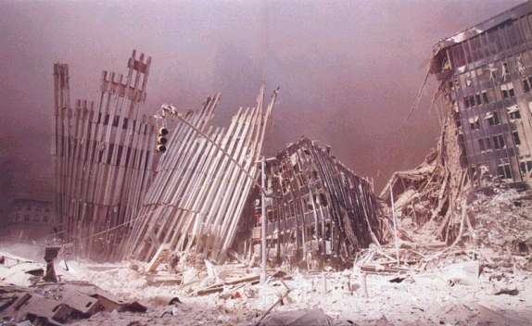

Take care, Mr. President. The game’s afoot, and you may not know as yet all the rules of this “new” (but, in fact, very ancient) war ….
But it’s obvious you’re learning.
==========================================================================================================================

