Snowden claims bin Laden is still alive under CIA control

The former leader of a global terrorist network, Osama Bin Laden, is still on the CIA's payroll and living in a quite villa in Bahama, a former CIA agent claims

Editor / Internet 18:11 February 07, 2016 Yeni Şafak

258 [*258*](javascript:;)

[[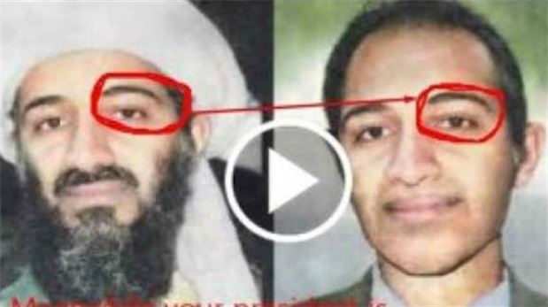](http://www.yenisafak.com/en/world/snowden-claims-bin-laden-is-still-alive-under-cia-control-2406043?p=1)](http://www.yenisafak.com/en/world/snowden-claims-bin-laden-is-still-alive-under-cia-control-2406043?p=1" \o ")

Edward Snowden, a former CIA employee, said that he has evidence proving that Osama bin Laden, who was supposedly killed in 2011, is still alive and well.  
  
According to a report published by USA Politics Today, Snowden claimed in an interview with the Moscow Tribune that Laden, the former leader of the al-Qaida global terrorist network, is living in the Bahamas on CIA payroll.  
  
“I have documents showing that Bin Laden is still on the CIA's payroll. He is still receiving more than $100,000 a month, which is being transferred through some front businesses and organizations, directly to his Nassau bank account. I am not certain where he is now, but in 2013, he was living quietly in his villa with five of his wives and many children,” the newspaper quoted Snowden as saying.  
  
Snowden, who now lives as a fugitive in Russia, fled the U.S. after leaking documents about the NSA's mass surveillance programs to the media in 2013.  
  
The report also said that Snowden previously too made some unreported allegations about Osama bin Laden.  
  
Snowden goes on to say that the CIA orchestrated the fake death of the former al-Qaida leader.  
  
He claims that Osama was transported with his family to an undisclosed location in the Bahamas.  
  
The report further quotes him as follows – “Osama bin Laden was one of the CIA's most efficient operatives for a long time. What kind of message would it send their other operatives if they were to let the SEALs kill him? They organized his fake death with the collaboration of the Pakistani Secret Services, and he simply abandoned his cover. Since everyone believes he is dead, nobody's looking for him, so it was pretty easy to disappear. Without the beard and the military jacket, nobody recognizes him.”  
  
Not only this, Snowden categorically states that he will talk about the documents which prove Bin Laden is alive in his soon-to-be-released book.  
  
However, Snowden's claims have not been substantiated or confirmed by any other source.  
  
The U.S. government has filed espionage charges against Snowden for revealing classified NSA documents to journalists.