SHANKSVILLE MYSTERY SOLVED?

### Uncovering Flight 93

It is hard to believe it has been almost six years since I released, “How the Shanksville Crater Was Made.” In that eight minute video I tried to explain what I see in the photos of that odd-shaped crater in Shanksville, and tried to articulate how those clues translate into the real world.  I remember  I had naively hoped to take the truther world by storm with the concept that the most likely explanation for the “evidence at the scene of the crime” was that the U.S. Military launched a couple missiles into the ground.  I was just a babe in the woods.

[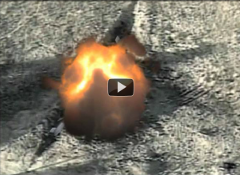](http://yankee451.com/wp-content/uploads/2012/03/3-27-2012-9-41-49-AM1.png)

***Two missiles striking from opposite directions, with one of them detonating a split second later.***

My Shanksville video was published shortly after the[9/11 Crash Test project](http://911crashtest.org/) was introduced, and I braced myself for the attention that was sure to come from my intended audience, truth-seekers of all stripes. I thought there was no way I could be right; I say that because I’m a slow-learner and I started late, many years behind virtually everyone else I know in “9/11 Truth,” so it was with some trepidation that I waited to be peer reviewed, but it never happened.

I am alone with the cruise missile conclusion but in my defense I didn’t wake up one morning and say, “Hey, maybe I can find evidence that the U.S. Military used cruise missiles to dupe the world into supporting their wars of aggression!”  The progression of events was that I started in the same place most everyone else did. I believed in the “Scary Box-Cutter-wielding- A-Rabs” meme and I swallowed the “the steel-slicing-planes-cuz-we-saw-it-on-TV” story and I was hooked by the ”bin-Laden-in-a-cave-in-Pipelinistan” canard. I bought it all. The only reason I began to research any of it was because as a Democrat I had a deep dislike for both George Bushes, and I thought I could use 9/11 as ammunition in my ongoing online feud with Republicans. But it didn’t take long before I realized both parties are just two sides of the same ‘divide and rule’ coin and that if I was going to learn the truth I would have to do the work myself.

At first I was disappointed at the lack of attention my research was receiving from my alleged peers, but I realize now that was because I had stumbled on the truth. Six years later nothing has changed. It is nearly impossible to find any leaders of the movement that will discuss the evidence of the impact holes at any site, but especially Shanksville.  If I’m wrong, then there is a better explanation, but after a while I started seeing their silence as confirmation that I’m not wrong. The way I look at it is if they were interested in the truth they would be very interested in this evidence, but if they have ulterior motives such as leading the opposition away from the truth, then when confronted with evidence that can lead to the truth they will be forced to ignore it.  If they are controlled then they are painted into a corner; they can’t talk about it because it exposes what happened, but by not talking about it they are exposed as complicit.

You might wonder who the hell am I to think that I’m right where all the Movement’s scientists, engineers and architects are wrong, which is a question I have often asked of myself, but I’m not so much claiming to be right as much as asking to be shown where I’m wrong. I am not a scientist; I don’t even have a college degree and like a lot of people I learned physics by falling out of trees. My only ballistics experience was gained by growing up in Alaska surrounded by firearms, and then later, after model rockets, black powder and fireworks were added to the mix, I learned that if shot a roll of caps with a BB, it burst into flame, thereby discovering a way to ignite my explosives from afar.  We sent black powder rockets into the Alaska sky, shot anything that moved and if it didn’t move we shot it twice, and were responsible for more than one good-sized fire.  Not exactly genius material and I am not unique in these things by any means; all my friends were similarly armed to the teeth, but somehow in my generation we avoided mass shootings. But I digress.

Maybe it’s because I had less indoctrination than my fellow truthers that I recognized the Shanksville crater from the smoking holes in the ground I once made as a kid, but in retrospect the flight 93 crash site is the weakest link in the chain of events that was 9/11; so weak that it needs the most protection, which is why I assume Christopher Bollyn was deployed, to get out ahead of the opposition and lead it into a rabbit hole of bigoted inanity. As I look back sometimes I wonder if they were deliberately leaving us easily-exposed and moronic clues hoping to be found-out and relieved from their ludicrous charade, or sometimes I wonder if they were just taunting us with the proof, knowing full well there’s nothing we can do about it because they control all the media, mainstream and alternative. I think a lot of things out here on the fringe, but in my more lucid moments I notice that some of these clues are so “right in your face!” that they can’t be denied, therefore they must be ignored. Obviously the spooks are nowhere near as all powerful as they’d like us to believe, but apparently they don’t worry about their incompetent and stupid mistakes being noticed because we are incompetent and stupid too, and they know we’ll believe authority by virtue of their authority and nothing else.

But we’re not all stupid, at least until we’re educated, just ask the children. Even my grandson knows the Shanksville story is a joke, and he’s eleven; the literal child in the proverbial tale, “The Emperor’s New Clothes.” He laughed out loud when I told him the Shanksville crater was a plane crash, but that’s because he knows what happens to the ground when you hit it with a stick, or shoot it with a slingshot, or a BB. He hasn’t been tainted by his education yet so he is able to think with his head, and he can tell just by looking at the pictures that it wasn’t a plane crash, although he was confused as to why anyone would make such a claim, but I left that discussion for another time.

Flight 93’s story of the brave passengers who chose certain death rather than to allow their plane to be used as a guided missile digs right into our emotions, just like all good propaganda does. It is a compelling tale that places the average American in extraordinary conditions where they demonstrated the true grit that makes America great. When I first heard it I immediately put myself in the shoes of the stereotypical Todd Beamer who traded his life for protection of the White House (which everyone knows was the target,) a narrative that could only be written by Hollywood. Flight 93 transported me, albeit for only a short time, to a place of heroism where I knew I would have acted in the same way if I was put in the same position, this despite the fact that in real life I am an abject coward, but that’s what a good movie does; it takes you to an imaginary place where anything is possible, which is of course complete bullshit.

In my Shanksville video [I made the mistake to include a photo which I thought was captured from the crash site, but which was really from the “Flight 93” movie.](http://www.visioninconsciousness.org/Conspiracies_A05/CT%20-%20051001.jpg) I also mistakenly said the passengers took control of the plane when the official story is they fought the hijackers who in the confusion lost control of the plane.

As I look back I see how easily it was for me to become confused; there is a lot of misdirection and disinformation in the truth movement. When taken together the task of unraveling it all can become too daunting and overwhelming to consider, which I believe is the point. I also believe that it is important to split us into different myopic categories because we’ve been divided and conquered. As the perpetrators they know there is evidence in the public domain that can expose them, so they’re sure to keep the distractions coming.

Looking for the truth, the actual truth, about what happened that day is almost impossible by following the work of the truth movement. For example Simon Shack represents the, ‘it’s all fake, so nothing is real and we might as well go home!’ crowd, and Judy Wood represents the, ‘our masters have godlike prowess and can’t be fucked with, so just pay your taxes and go back to work!’ crowd, Richard Gage represents the, ‘the planes were real and we need to turn to the most likely suspects for redress’ crowd, and Veterans Today represents the, ‘Israel nuked the USA, thereby undermining 9/11 Truthers as Anti-Semitic’ crowd. They then publicly argue among themselves, as if only their hypotheses carry any weight, while pointing the hypocritical finger at each other and everyone else as being a spy.

And truthers eat it with a spoon. It is an amazing thing to see when confronted with evidence we all have access to, but to which truthers have never been exposed, the programmed and predictable reaction is to accuse me of being “disinfo!” as if I’m the one that took the photos that burst their bubbles. If anyone needed proof that propaganda works, look no further than the ironically-named 9/11 Truth Movement! What these impostors are doing is providing busy-work for the next dozen or so years while we scurry around trying to verify their claims, but in the meantime those claims discredit anyone who repeats them. But that’s the point of the whole exercise; to give us a playground where we can fight over which of our toys are better until our moms call us in for dinner.

If as I suspect the truth movement’s raison d’etre is to direct truthers away from the truth, then logically the truth will be found where truthers fear to tread. From the very beginning the truth movement’s approved lines of investigation were drawn out, and to this day those are the lines toed by the average truther; thermite, modified planes, and Israeli involvement are some of their hallmarks. But a quick investigation shows that most of them sprang from the same source. In my Shanksville video I included some footage from an Interview with Susan McElwain, a witness who described a “small white plane” no wider than her van that flew so low over her van that she instinctively ducked, in her van. In that clip the interviewer mentioned that it was “American Free Press” that [published an article](http://www.americanfreepress.net/html/flight_93.html) stating that the plane she described was an A-10 Thunderbolt, AKA a “Warthog,” a claim Susan denied. That claim comes from a trailblazer for truth (kinda-sorta) since the beginning, Christopher Bollyn. Bollyn has been the truth movement’s pied piper [since 2002, when he burst onto the scene with fraudulent stories that eventually got him fired from American Free Press](http://www.sott.net/signs/editorials/signs20061010_AmericanFreePressFiresChristopherBollyn.php), but which are still repeated today.

[It was Bollyn who gave us molten steel at the WTC](http://www.rense.com/general73/bollyn.htm), something that was [parroted by alleged members of the FDNY](https://youtu.be/-C0xztnYJj4). These statements taken together are evidence of collusion, not evidence of super-hot fires; on the one hand we have a so-called journalist breathlessly reporting about molten steel, and on the other we see what looks like firefighters corroborating that tale, which puts the firefighters and Bollyn on the same side, allegedly fighting the “Man” that is supposedly suppressing this information. But apparently they are working together with the Man to spread confusion; ***it takes two minutes to verify there are no photographs or videos of any molten metal whatsoever, cooled or hot, from 9/11.***

The videos you’ve seen of the sparks pouring out of the towers were just that, sparks, not waterfalls of molten steel:

[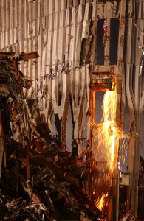](http://yankee451.com/wp-content/uploads/2015/07/FEMA-0059.jpg)

[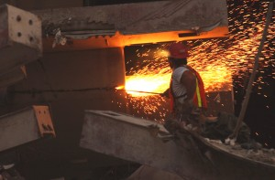](http://yankee451.com/wp-content/uploads/2015/07/snapped-bolts-torn-spandrel.jpg)Acetylene torches can do the same thing, so why aren’t truthers investigating why there would be a clearly visible shower of sparks from an acetylene torch pouring out of an office building that would soon collapse into a cloud of dust? My guess is because Christopher Bollyn, Stephen Jones, the NYPD and the FDNY led them to molten metal and such is the power of suggestion, illustrating the importance of leading the opposition.

[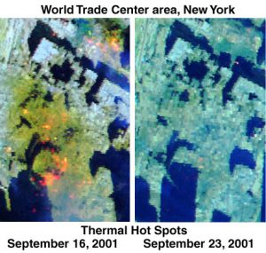](http://yankee451.com/wp-content/uploads/2018/02/hotspots-compare.jpg)

The molten metal myth is accompanied by “fuming from fires so hot that they could be seen from space” myth, but the hot spots and ‘smoke for months’ have a very simple explanation; they lied. Truthers could benefit from considering that the whole movement has always been part and parcel to the cover up and that to give their controlled movement ammunition they weaved certain threads into the fabric of the story.  From this perspective, Building 7 being reported by the BBC as collapsed before it actually did so was not a gaffe, it was planned as a platform upon which to build the Architects and Engineers for 9/11 Truth. Similarly that would mean FEMA’s hotspot photos were fabricated to give the Bollyns of the world a voice, and because no one doubts a man in uniform, the claims of Bollyn, the police and firefighters are recorded into the annals of history as fact, despite there being no other evidence to support them.  If this was a real investigation they would all be suspect as accomplices.

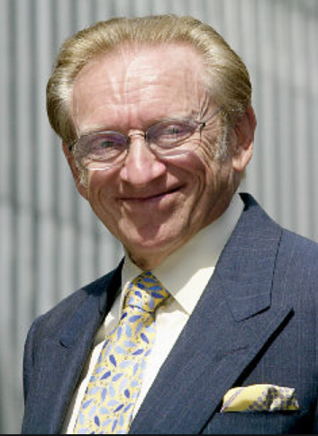

***Lucky Larry***

The same can be said about the cornucopia of low hanging 9/11 fruit; the Zionists, Silverstein, the [PNAC](https://en.wikipedia.org/wiki/Project_for_the_New_American_Century) and the [dancing Israelis](http://www.911myths.com/html/dancing_israelis.html)are exposed as planted breadcrumbs designed to discredit anyone who swallows them.  Jews are dangled in our faces as a “slide” which in hypnosis and brainwashing terms refers to a word or phrase that will shut-down critical thinking, thereby ending a conversation. We in the West have been brainwashed since the ‘70s to equate criticism of Israel with Anti-Semitism (whatever that is) therefore the fastest way to turn-off our Western neighbors is by sliding into the conversation a complaint about Jews. If this was my operation I’d make sure to put Jews and Zionists in positions of prominence to act as Jewish lightning rods to attract attention and to discredit anyone who notices. Since our only hope of stopping the wars is by exposing the lies that started them, Bollyn is out there taking the lead saying “Solving 9/11 Stops the Wars,” which sounds great and ought to be the theme of the whole truth movement if he wasn’t wrong about just about everything and if the truth movement wasn’t actively covering up the truth. **If you really want to solve 9/11, Mr. Bollyn, then consider this a formal challenge to debate the evidence and “win or lose,” we’ll do just that, solve it.**

### Methinks he complains too loudly.

[It was in 2002 that Bollyn started screaming about the PNAC,](http://www.bollyn.com/911/) the Zionists, and[Israeli Art Students.](http://www.bollyn.com/911/#article_11826) I don’t have a problem blaming Israel if that’s where the evidence leads, but like I said, we all have access to the same information, and from what I’ve found it leads a whole lot closer to a shitty British Colony in North America than it does to some shitty British Colony in the Middle East. Bollyn heralded the rumors that built the truth movement but those rumors aren’t true, and instead of his being laughed off stage he is lauded as one of the world’s premier 9/11 researchers. You can’t make this stuff up. When it comes to 9/11 everyone’s claims should be considered suspect, including mine, but especially those of the leaders!

[It was Bollyn who gave us the disinformation that the Shanksville crater was there in 1994, an easily exposed falsehood that lies bare the fact that he is either too incompetent to be called a journalist or he is deliberately obfuscating.](https://youtu.be/5NcFEADuObE) If this was a court trial after he was exposed for lying, his credibility would be in doubt and all of his testimony would be discredited, but truthers just shrug it off as a mistake. When confronted with proof of his mistake, instead of correcting the record like any good journalist would do, [Bollyn’s response was to “out” my family and accuse me of being a Jew](http://yankee451.com/?p=3858) which is odd, because I don’t understand how being a Jew is synonymous with being a liar, but apparently that is what Bollyn thinks. However aside from my being circumcised, by every other definition of a Jew I am not one, so does that mean I’m telling the truth? Bollyn is obviously fixated with Jews in the way a child is fixated with the bogey man, or in the way an operative is fixated with distracting and discrediting the opposition. But now that we’re all one big happy spook-family, since he was kind enough to bring up my background I decided to return the favor and all I can say is, glass houses, Christopher!

Christopher Bollyn:

* is the son of a woman who worked [as governess for the Farish family](http://www.iamthewitness.com/Bollyn/AboutBollyn.html) and took care of the young William S. Farish III, a [Pilgrims Society](http://www.nndb.com/org/207/000134802) member and friend of the [Bush family](http://articles.latimes.com/1989-12-29/news/mn-1125_1_south-texas/2) and the [British royal family](http://www.telegraph.co.uk/news/worldnews/northamerica/usa/1322587/Racing-friend-of-the-Queen-to-be-US-ambassador.html) with [a host of exotic intelligence contacts](http://www.kmf.org/williams/bushbook/bush3.html) was an altar boy in the Episcopal Church, and went [to the Middle East in 1975](http://www.rumormillnews.com/cgi-bin/archive.cgi/noframes/read/104676), including living in a kibbutz in Israel around the time of the [1976 restructuring](http://www.anglicancommunion.org/tour/province.cfm?ID=J2) of the Episcopal Church in Jerusalem
* married an [Israeli military intelligence officer](http://i218.photobucket.com/albums/cc56/poseidon888/BollynIsraeliWife.png) in an arrangement that [provided her with US citizenship](http://web.archive.org/web/20080102082801/http:/www.wakeupfromyourslumber.com/node/2623#comment-11104) in 1983, when she wanted to live in Santa Monica within three  miles of the Rand Corporation, within a year of Israel lobbyist [Steven J. Rosen](http://www.newyorker.com/archive/2005/07/04/050704fa_fact?currentPage=all) having had [secret industrial security clearance](http://fl1.findlaw.com/news.findlaw.com/nytimes/docs/dod/usfrnklin80205ind.pdf) to CIA contracts at the Rand Corporation, and thereby probably at a time when other agents of Israel had access to classified material there or were attempting to gain access met [billionaire](http://www.forbes.com/lists/2007/10/07billionaires_Rupert-Murdoch_639W.html) Zionist media mogul Rupert Murdoch and his family[around 1988](http://i218.photobucket.com/albums/cc56/poseidon888/BollynMurdochCoincidence.png), skiing with them for half an hour, when Murdoch’s second wife (from [1967-1999](http://en.wikipedia.org/wiki/Rupert_Murdoch)), the mother of James Murdoch, was Anna Torv from Estonia [married again in 1995](http://i218.photobucket.com/albums/cc56/poseidon888/BollynMarriages.png) following the marriage of convenience that lasted for two years, this time to Helje Kaskel who was born and educated in Estonia tracked anti-Zionist, nationalist author and writer for [*The Spotlight*](http://en.wikipedia.org/wiki/The_Spotlight)Michael Piper [in 1994 and 1997](http://www.takeourworldback.com/911perpstimeline.htm) whilst working together with Helje Kaskel worked for IBM Global Network Services, [IBM and the Watson family](http://web.archive.org/web/20080725024003/http:/www.isgp.eu/organisations/Pilgrims_Society02.htm) being heavily represented in the Pilgrims Society
* was [brought to](http://mikepiperreport.com/Talk_Show_Archive/Audio_Speakers/Piper,%20Michael%20Collins/RBN%20Shows2006/Piper200605-May/Piper20060523Bollyn,Christopher.html) *The Spotlight* in 2000 by Jerry Myers, a [self-described Khazar](http://ziofascism.net/blog/?p=869&cpage=1#comment-1894) (the

[Neanderthal-Caucasoid](http://www.michaelbradley.info/books/iceman/iceman_promo.html) tribe from which Ashkenazi [so-called](http://www.biblestudysite.com/factsarefacts.htm) “Jews” are descended)

* was [in New York City on 9/11](http://www.iamthewitness.com/Bollyn/Bollyn_intro-to-911.html), one year into his new career as a “journalist” collaborated for years – from [2002](http://i218.photobucket.com/albums/cc56/poseidon888/BollynHufschmid2002Collaborate.png) to [2007](http://www.rumormillnews.com/cgi-bin/archive.cgi/noframes/read/108221) – with [Eric Hufschmid](http://www.takeourworldback.com/short/hufschmid.htm),[whose](http://www.erichufschmid.net/HufschmidMurdochCoincidence.html) half-sister [Kathryn](http://www.politico.com/blogs/bensmith/0107/A_Murdoch_in_Clintonworld.html), a [public relations executive](http://www.nytimes.com/2000/06/20/nyregion/public-lives.html), is[Director of Strategy & Communications](http://www.kew.org/about-kew/press-media/press-releases-kew/kew-foundation-appoints-new-trustees/index.htm) at the Clinton Foundation’s [Clinton Climate Initiative](http://www.guardian.co.uk/media/2007/dec/09/bskyb.newscorporation), and in 2000 married James Murdoch, Rupert Murdoch’s son and[heir apparent](http://www.welt.de/english-news/article2633435/James-Murdoch-The-Heir-Apparent.html) who joined News Corporation [in 1996](http://moreintelligentlife.com/story/invisible-mogul) and was placed [in charge](http://news.bbc.co.uk/1/hi/business/3132678.stm) of its[internet operations](http://www.thisislondon.co.uk/standard-business/article-23845548-sky-is-not-the-limit-for-ambitions-of-james-murdoch.do) is evidently “[protected at the highest levels](http://purpleliquor.blogspot.com/2009/06/shills-and-disinfo-in-911-truth.html)” and was “visited regularly by an individual or individuals [bearing license plates that cannot be traced](http://www.takeourworldback.com/mp3/Piper08March2007clip.mp3)“
* [dialled 911](http://infowars.net/articles/August2006/170806Bollyn.htm) to call the police out to his home on some pretext about a “suspicious” car and then [became belligerent](http://www.takeourworldback.com/short/cache/bollynconvicted2.htm) in order to get himself arrested and Tasered in August 2006, serving to present himself as a “target” of the crooked elite who evidently promote and protect him
* frequently lies, e.g. alleges he was told to “[drink from the toilet](http://www.cassiopaea.org/forum/index.php?topic=2887.msg18103#msg18103)” after he got himself arrested, “the Liberty Lobby” (publisher of *The Spotlight* and forerunner of American Free Press) “is actually [owned and controlled by a Zionist Jew](http://www.takeourworldback.com/bollynhender.htm) named Mark Lane”, and [Michael Piper](http://216.240.133.177/Piper/06/index.php) has been [“attacking” him “since December 2001”](http://i218.photobucket.com/albums/cc56/poseidon888/BollynClaimPiperAttackSince2001.png)
* makes allegations and conducts a fear and smear campaign against anti-Zionists based

on demonstrably deliberate lies (see above link about Mark Lane, who was described as “[anti-Zionist](http://i218.photobucket.com/albums/cc56/poseidon888/MarkLaneAntiZionistJew.png)” in a 1983 book co-authored by Zionist Jew Steven J. Rosen)

* [has a reputation for](http://i218.photobucket.com/albums/cc56/poseidon888/BollynTurkeys.png) writing 9/11 stories that often [turn out to be turkeys](http://forums.randi.org/showpost.php?p=2203160&postcount=77)
* has a tendency to [visit Switzerland](http://www.rumormillnews.com/cgi-bin/archive.cgi/noframes/read/109301) that is more consistent with a courier for clients of Swiss banks than a researcher, e.g. when travelling from [Brussels to West / Central France](http://www.bollyn.com/bollyn-responds-to-malicious-slander-of-daryl-b-smith), and when writing about “[chemtrails over Switzerland](http://www.rumormillnews.com/cgi-bin/archive.cgi?read=27708)“
* was financed by [a front](http://www.holysmoke.org/cos/cult-front-groups-latest.htm) for [Scientology](http://www.topix.com/forum/health/TJQ48F6T4S6RSETR0#c18) who paid him for “[editing](http://www.rumormillnews.com/cgi-bin/archive.cgi?read=103030)” her book

<http://www.takeourworldback.com/short/bollyn.htm#liar>

### Recreating the Scene of the Crime

All of this ugly background was necessary to set the context and to illustrate that because Shanksville brings cruise missiles into the frame it is critical that truth seekers are directed away from it. I once asked Christopher Bollyn to explain how Israel created the gash in Shanksville, but he refused to answer because the most likely suspect is of course the U.S. Military. Covering up this evidence is so important that it all but vanished from the radar of the intrepid 9/11 Truth Movement, and when it is discussed it is as an inconsequential side show.

[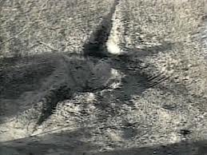](http://yankee451.com/wp-content/uploads/2018/02/images.jpg)The fact is anyone with two projectiles and an explosive can reproduce the Shanksville crater on a smaller scale anytime they wish. The same crater will be produced regardless of the size of the projectile. When I first began this experiment I used a slingshot and some sand and kitty litter (per NASA’s recommendation,) then a BB gun, then a more powerful air rifle with pellets and darts, and then bullets. It is easier to reproduce with the projectile striking in the center and then ricocheting out, rather than it is with the projectile striking from the outside and burrowing into the middle, but it works either way, outside-in or inside-out. The gash created by the projectiles striking at trajectories of less than ten degrees from horizontal is predictable using NASA’s own meteorite trajectory calculations, not to mention any police ballistics department, and it is reproducible by anyone who cares to give it a try. Reproducible and predictable are hallmarks of the scientific method, so you tell me why truthers won’t touch Shanksville.

Below are some photos I captured during my rather clumsy experiment. I used a cheap gun vise and a digital level to verify the trajectory of the projectile, in this case .22 caliber pellets, lead balls and darts fired into dampened sand that I had spray-painted white for contrast. At trajectories of less than ten degrees from horizontal the gash created by the projectile was pretty consistent. Add a firecracker and you get the picture. If the [9/11 Crash Test](http://911crashtest.org/) project ever gets any rocket-sled test center time, we will conduct a full scale test of this hypothesis.

These are the gashes created by the impact of meteorites at oblique trajectories of less than degrees from horizontal.

[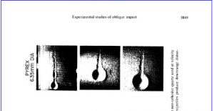](http://yankee451.com/wp-content/uploads/2018/02/oblique.jpg)

By mirroring the images it can be seen what a crater might look like if two meteorites struck at 10 degree trajectories from opposite directions.

[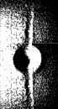](http://yankee451.com/wp-content/uploads/2018/02/mirrored-oblique.jpg)

Looks familiar, doesn’t it?

[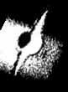](http://yankee451.com/wp-content/uploads/2018/02/mirrored-oblique2.jpg)

Less than ten degrees from horizontal from opposite directions:

[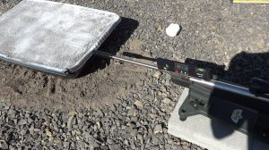](http://yankee451.com/wp-content/uploads/2018/02/experiment1.jpg)[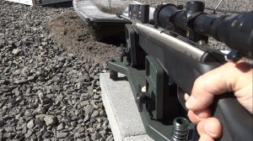](http://yankee451.com/wp-content/uploads/2018/02/experiment2.jpg)

[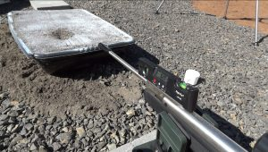](http://yankee451.com/wp-content/uploads/2018/02/experiment3.jpg)[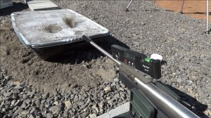](http://yankee451.com/wp-content/uploads/2018/02/experiment4.jpg)

[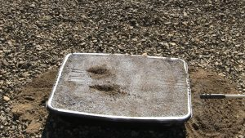](http://yankee451.com/wp-content/uploads/2018/02/experiment5.5.jpg) [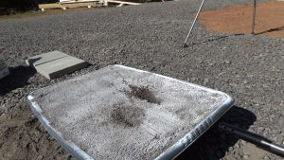](http://yankee451.com/wp-content/uploads/2018/02/experiment5.jpg) [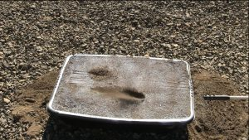](http://yankee451.com/wp-content/uploads/2018/02/experiment6.jpg)

Add a firecracker, and voila.

[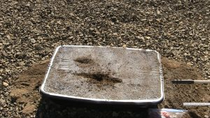](http://yankee451.com/wp-content/uploads/2018/02/experiment8.jpg)

Smaller air gun without the power of the rifle:

[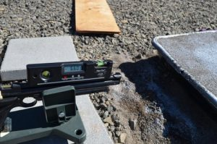](http://yankee451.com/wp-content/uploads/2018/02/6.6.jpg)[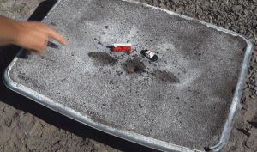](http://yankee451.com/wp-content/uploads/2014/01/Shanksville-crater-experiment-1.png)

So far the evidence I have seen for Shanksville, like the WTC, is that multiple cruise missiles were launched in broad daylight, but truthers would rather not talk about it. If I am incorrect then please contact me at [steve@911crashtest.org](mailto:steve@911crashtest.org) to show me how the Shanksville Crater is better explained with a different conclusion.

Thanks for reading,

Steve De’ak