Pilots for 9/11 Truth: The Missing Memorandum

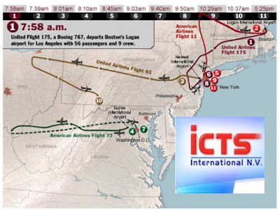
The official flight trajectories for the 9/11 airliners

Jim Fetzer

As an advisor to Robert David Steele in the production of his series, "Memorandums for the President on 9/11", I have made quite a few recommendations of experts who could make their own important contributions. Among those I have suggested was Rob Balamo, Co-Founder of Pilots for 9/11 Truth, which has made highly significant discoveries that never received the recognition that they deserve.

Rob, however, was ambivalent about contributing, emphasizing that Pilots wants nothing to do with (what has been called) "no planes theory", in spite of the fact that Pilots have adduced proof that two of the planes, Flight 93 (Shanksville) Flight 175 (South Tower) were still in the air after they had "officially" crashed in Pennsylvania and New York. "No planes" theory is defined by four theses:

(T1) that Flight 11 did not hit the North Tower;
(T2) that Flight 77 did not hit the Pentagon;
(T3) that Flight 93 did not crash at Shanksville;
(T4) that Flight 175 did not hit the South Tower.

We already have memoranda from Aeronautical Engineer, "Memorandum for the President: No Boeing 757 Hit the Pentagon", and from John Lear, "Memorandum for the President: 9/11 Twin Towers were Not hit by Nor destroyed by two Boeing 767s", which establish theses (T1), (T2) and (T4). My belief was that Pilots could confirm (T3) and (T4) as a valuable contribution to the series.

Because Rob was reluctant, I suggested I could draft a memorandum for his consideration, but after a few days deliberation, he decided against it. Since my draft was based upon and simply paraphrased the content of three of Pilots' previously publish studies, I was rather taken aback. Here is the draft memorandum. I would welcome comments or speculation as to why Rob refused to endorse it.

Rob Balsamo, Memorandum for the President: We Have Not Been Told the Truth About 9/11 Attack Airplanes

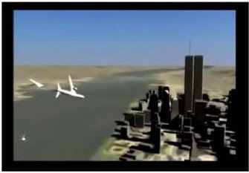
From Pilots for 9/11 Truth, "9/11 Intercepted"
​
Dear Mr. President,

Pilots for 9/11 Truth, an organization of aviation professionals and pilots through the globe, was founded in 2006 to seek the truth surrounding the events of 9/11. While we do not offer a theory or assign blame for the atrocities that occurred on that occasion, we have discovered a number of anomalies of which we believe you ought to be made aware. Here, I mention three.

Impossible Speed

Much controversy has surrounded the videos of (what purports to be) Flight 175, a Boeing 767, approaching the South Tower. We have analyzed data provided by the National Transportation Safety Board (NTSB) in terms of a “Radar Data Impact Speed Study” in which the NTSB found 510 knots for Flight 175 (South Tower) and 430 knots for Flight 11 (North Tower). Relying upon a bench mark set by the crash in October 1999 of another 767, Egypt Air 900. It had exceeded its maximum operating limits causing in-flight structural failure, which would also have been the case for the WTC aircraft, as we have illustrated in our documentary, “9/11 Intercepted”.

Flight 93 Airborne After Crash

Air Traffic Control (ATC) transcripts reveal United 93 as being airborne after its alleged crash in Shanksville, PA. Similar scenarios have been offered with regard to American 11 and American 77, showing an aircraft target continuing past its alleged crash point in the case of American 11 or past its turn-around point in the case of American 77. Both of those cases can be explained by “Coast Mode” radar tacking. That is not the case with United 93, where tracking data shows it was over Champaign-Urbana, IL, after its reported crash in Pennsylvania. FAA Registration Records further show that it was not formally taken out of service until 28 September 2005.

Flight 175 Airborne Long After Crash

Aircraft Communications Addressing and Reporting System (ACARS) is used to send messages to and from aircraft. Similar to text messaging and email systems used today, developed in 1978 and still in use today, it allows airplanes to communicate with one another. ACARS messages obtained through FOIA requests demonstrate that Flight 175 was over Harrisburg, PA, and then over Pittsburgh, PA 20 minutes after allegedly having hit the South Tower. FAA Registration data, once again, show that the plane was not taken out of service until 28 September 2005.

Pilots does not take a position on the explanation for the data other than to conclude that we have determined the actual positions of Flights 93 and 175 are inconsistent with The Report of the 9/11 Commission (2004) and believe we are professionally obligated to so inform you.

Very respectfully,

DECLINED

References:

“Speeds Reported for World Trade Center Attack Aircraft Analyzed”, http://pilotsfor911truth.org/WTC2.html

“United 93 Still Airborne After Alleged Crash – According to ATC/Radar”, http://pilotsfor911truth.org/UAL93.html

“ACARS Confirmed: 9/11 Aircraft Airborne Long After Crash”, http://pilotsfor911truth.org/WTC2.html

