**[Man who grounded 4,000 planes on 9/11 was on first day of his job](https://jalopnik.com/5838772/man-who-grounded-4000-planes-on-911-was-on-first-day-of-his-job)**

[](https://kinja.com/raywert)

[Ray Wert](https://kinja.com/raywert)

[9/09/11 12:30pm](https://jalopnik.com/5838772/man-who-grounded-4000-planes-on-911-was-on-first-day-of-his-job)

[Filed to: 9/11](https://jalopnik.com/tag/911)

306.6K

[99](https://jalopnik.com/5838772/man-who-grounded-4000-planes-on-911-was-on-first-day-of-his-job#replies)[3](https://jalopnik.com/5838772/man-who-grounded-4000-planes-on-911-was-on-first-day-of-his-job)

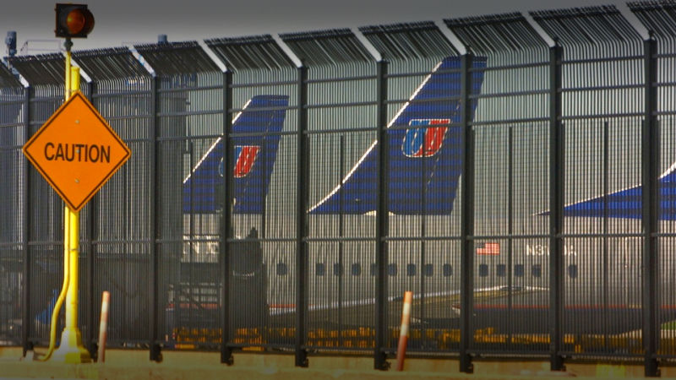

As terrorists seized control of four airplanes on Sept. 11th, 2001, Ben Sliney, chief of air-traffic-control operations at the FAA's command center in Herndon, Va., gave the unprecedented order to ground 4,000-plus planes across the nation and redirect any in the sky to the nearest airport. It was his first day on the job.

**Outstream Video**

On Sept. 11th, 2001, terrorists hijacked four American commercial jets with the intention of crashing them into the twin towers of the World Trade Center in New York City, and the Pentagon and U.S. Capitol in Washington, D.C. The terrorists were successful in three of their four targets with the fourth plane's assault on the Capitol building was thwarted by heroic passengers on board. While we now know no other planes were hijacked, at the time, each of the 4,000-plus flights in American air space were potential risks.

But [due to Ben Sliney](http://www.usatoday.com/life/movies/news/2006-04-23-united93-main_x.htm), the Federal Aviation Administration's National Operations Manager on duty that fateful morning, possible harm, at least by the thinking at the time, was averted. Sliney made the gutsy — and completely unprecedented — call to ground every single commercial airplane in the country.

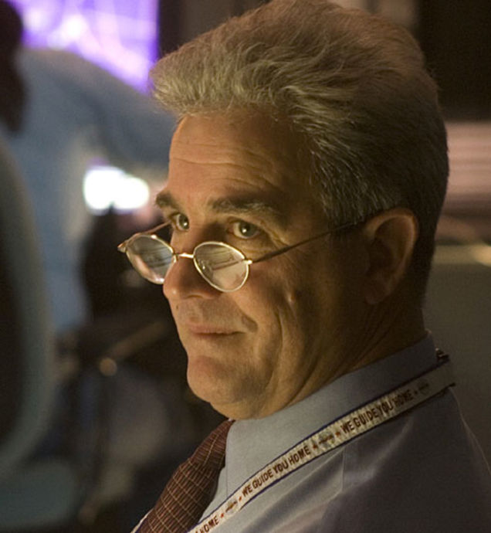

What makes the call — which, without direct order from the President and the bureaucracy above him, was his and his alone to make — all the more gutsy is that Sept. 11th, 2001, was Ben Sliney's first day on the job as an FAA National Operations Manager.

Although that's not to say Sliney was some neophyte making a cowboy-like call. He had 25 years of experience in air traffic control as part of FAA management, including a leadership position at New York TRACON, which has responsibility over all air traffic for New York City's three major airports and the smaller, regional airports in the New York City area. But the decision to ground the planes — that was entirely Sliney's.

In fact, it's such a great story that when Universal Pictures decided to turn [the heroism of the passengers of United Flight 93 into a movie](http://www.imdb.com/title/tt0475276/), they not only didn't overlook Sliney's role — they asked him [to play himself in the movie](http://www.metro.co.uk/showbiz/interviews/20603-60-seconds-ben-sliney). Which he did.

Sliney's decision is a great testament to the belief that doing the right thing sometimes requires a risky choice. Sliney made the right one.

**Discussion**

Reply

* Staff (2)
* Community (97)
* Pending
* [](https://kinja.com/manny-e-lopez-old)[**manny.e.lopez**](https://kinja.com/manny-e-lopez-old)Ray Wert

[9/09/11 1:55pm](http://jalopnik.com/5838772/man-who-grounded-4000-planes-on-911-was-on-first-day-of-his-job?comment=42562499#comments)

Looks like every one wants to be hero. Norman Mineta, then Secretary of Transportation, is also cited as giving the order to "ground all civilian aircraft traffic for the first time in U.S. history."

[[en.wikipedia.org]](http://en.wikipedia.org/wiki/Norman_Mineta)

[Reply](https://jalopnik.com/5838772/man-who-grounded-4000-planes-on-911-was-on-first-day-of-his-job)

* + [](https://kinja.com/raywert)[**Ray Wert**](https://kinja.com/raywert)manny.e.lopez

[9/09/11 2:32pm](http://jalopnik.com/5838772/man-who-grounded-4000-planes-on-911-was-on-first-day-of-his-job?comment=42564106#comments)

Direct quote from the 9/11 Commission report timeline:

"At 9:42, the Command Center learned from news reports that a plane had struck the Pentagon. The Command Center’s national operations manager, Ben Sliney, ordered all FAA facilities to instruct all aircraft to land at the nearest airport."

Likely, any order Mineta gave, if it was before that time, reached the FAA command center after Sliney gave his order. Mineta's not even entirely sure when he gave that order — it may have been at 9:26, or it may have been later.