***Jeb Bush’s 9/11 problem***

By

[**Daniel Hopsicker**](https://www.madcowprod.com/author/dhopsicker/)

 -

September 4, 2015

[31](https://www.madcowprod.com/2015/09/04/jeb-bushs-911-problem/#comments)

66

On the campaign trail in New Hampshire two weeks ago, Jeb Bush was asked a question for which he clearly wasn’t prepared, which hearkened back to Bush’s time as Florida Governor.[You can see the question here.](https://www.facebook.com/sharer/sharer.php?u=https%3A%2F%2Fwww.facebook.com%2Fmike.jackman.77%2Fvideos%2F10100469291692807%2F&display=popup&ref=plugin)[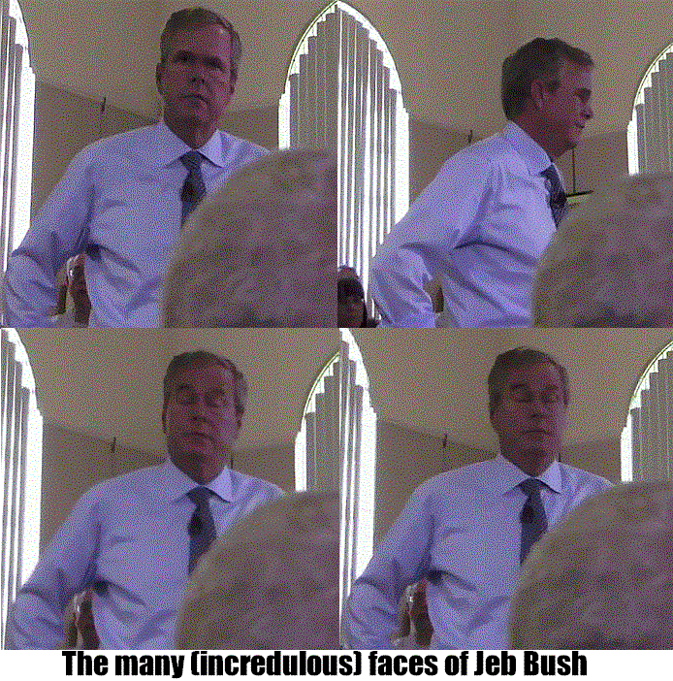](https://www.madcowprod.com/wp-content/uploads/2015/09/jeb10.gif)

“According to Sergeant Marty (Mike) Treanor and other law enforcement officials in Sarasota Florida, the files pertaining to 9/11 hijacker pilots Marwan Al-Shehhi and Mohamed Atta from Huffman Aviation Flight School in Venice Florida were loaded onto two Ryder trucks and driven onto a C-130 cargo plane which left Sarasota the day after 9/11,” began newly-minted radio talk show host Mike Jackman, who with his brother comprise a media outlet pols this election season can ill afford to miss appearing on called [Jackman Radio.](http://jackmanradio.podbean.com/)

“Is it true that you were onboard the C-130? And, if so, can you tell us what became of the files?”

According to those who were there, a certain amount of discomfort ensued. Bush, who has appeared as limp as overcooked spaghetti on the campaign trail, visibly stiffened.

**“How weird”**

[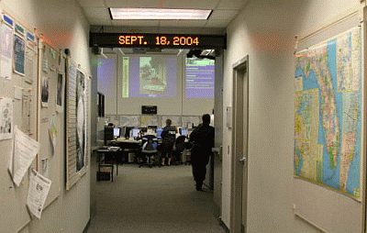](https://www.madcowprod.com/wp-content/uploads/2015/09/UrgentEmergency.gif)“No. Not true,” he replied. Then, as an aside to those sitting in front row of his town hall meeting, he said, “How weird.”

Bush began taking another question, then stopped. His voice rising slightly to convey indignation, he said, “I was in the Emergency Operations Center trying to make sure the state of Florida was safe… trying to work with local officials to figure out how to make sure another attack wouldn’t hit and devastate our economy…That’s what I did.”

“So, that was kind of a weird… (question.)”

[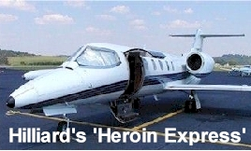](https://www.madcowprod.com/wp-content/uploads/2015/09/222dd.jpg)No, Governor, not really. What would be “weird” would be if you could back up your off-the-cuff and very startled assertion that on the day after 9/11 you were in the Florida Emergency Center with anything like proof. Because there are a number of people who know you can’t.

Jackman’s question refers to evidence uncovered during my investigation into the activities of the 9/11 hijackers in Venice.  And somewhere in there Jackman had also referenced Wally Hilliard and Rudi Dekkers, the principals in Hoffman Aviation. When he did, one observer noted, Bush seemed to freeze slightly.

Perhaps that has something to do with the little-known fact that a Learjet belonging to Hilliard, who owned the Venice flight school that trained both pilots who flew planes into the World Trade Center Towers, had been caught carrying 43 pounds of heroin by DEA agents in July of 2000.

Just weeks earlier, Jeb Bush’s Secretary of State, the infamous Katherine Harris, had heaped praise on Hilliard’s start-up commuter airline, Florida Air.

**Requiem for an honest cop**

[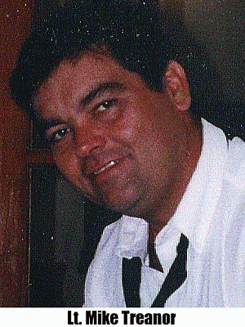](https://www.madcowprod.com/wp-content/uploads/2015/09/treanor.gif)What follows is a re-cap from primary sources who were there —including local official and aviation observers—about what took place on the day after 9/11.

And, after that, one final astonishing disclosure, a world exclusive, revealed here for the first time.

But first, a word about the sources of the information about Bush, who it came from, and how I learned of it. In his question, Jackman references Mike (Marty) Treanor from the Venice Police Department.

Treanor was the first person to tell me of Jeb Bush’s flight to Washington with the files from Huffman Aviation and the Venice Police Department. But not the last.

“The FBI took all our files, everything,” Treanor told me. “They loaded the files right outside this window into two Ryder trucks, then drove them right onto a C-130 military cargo plane at the Sarasota Airport, which took off for Washington with Jeb Bush aboard.”

Treanor wasn’t a flake, or a name I made up. He’d been quoted in [national news reports right after 9/11.](http://articles.latimes.com/2001/sep/13/news/mn-45262/2)

[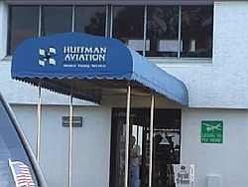](https://www.madcowprod.com/wp-content/uploads/2015/09/huffman-aviation.jpg)“Det. Sgt. Mike Treanor of the Venice Police Department said that FBI agents had obtained the two suspects’ school records from the Huffman school and the Voss home and identified them as two of the men who agents believe flew the hijacked jets,” reported the LA Times on Sept 13 2001.

“Treanor said FBI agents were drawn to Venice after finding Arabic language flight manuals in a car at the Boston airport.”

“’This one man, Atta,” said Treanor, “was confirmed on one of the planes that hit the towers.’”

**“Like Leisure World…without the bright lights”**

[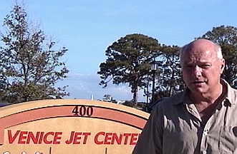](https://www.madcowprod.com/wp-content/uploads/2015/09/JETS.jpg)My personal involvement began the day after 9/11, with the news that three of the four terrorist pilots had learned to fly in tiny Venice Florida, a sleepy retirement community on Florida’s Gulf Coast. And immediately—there’s no other way to say this—I smelled a rat. For two reasons:

First, I knew Venice. My parents retired there in the early 80’s. And being a (semi)-dutiful son, I’d visit them regularly, flying in from California, where I lived. And if by the third or fourth night I was there I was restless enough to feel the need to go out and have a beer, I knew from personal experience that there was no place to go, and nothing to do… because Venice, Florida has the second oldest population in the entire United States. Picture Sun City, or Leisure World… only without the bright lights.

So what were young men with no known fetishes for blue-haired widows doing in Venice? Especially considering there are 220 other flight schools in Florida alone?

It didn’t make sense.

**Things that don’t make sense for $200, please**

And second, the way the news quietly dribbled out didn’t make sense, either. That three of the four terrorist pilots—including both pilots who slammed planes in the World Trade Center Towers—had learned to fly in Venice instantly made Venice Florida the biggest September 11th crime scene that wasn’t reduced to rubble.

But when I rolled into Venice Florida three months after 9/11, there hadn’t been any spotting of Bob Woodward or Seymour Hersh or Michael Isikoff at any local watering holes.

The town seemed eerily quiet. Quiet but jittery, I discovered.  In 25 years of visiting the parents I hadn’t remembered ever even seeing a cop, but on my first day in town, I was pulled over twice by local police.

Neither traffic stop resulted in a ticket. But when I wondered aloud if it might be prudent to pay a courtesy call on the Police Chief, the courteous officer allowed that it might.

**Paying a courtesy call on the Chief**

So I slid on by the new Police Headquarters to say hello. The Chief wasn’t in, or if he was, wasn’t receiving. And that’s how I met the Sergeant on duty, Mike Treanor, who proved congenial enough for me to ask the burning question I had about Huffman’s manager Rudi Dekkers, who had been everywhere on television during the days after the attack.

My strong suspicion was that every word out of his mouth had been a lie. So I asked my question. “Does Rudi Dekkers’ have any local priors (prior arrests)?”

Sergeant Treanor sighed. He started to say something. He thought better of it. And then he sighed again.

**“Trust local before state. And never trust the Feds”**

When Treanor died of cancer in 2008, [his obituary](http://www.heraldtribune.com/article/20080326/NEWS/803260396?Title=22-year-veteran-officer-was-the-voice-of-the-Venice-police)in the Sarasota Herald Tribune called him the “voice of the Venice Police Department.”

“His professionalism, compassion and occasional humor had earned him the respect of his colleagues in law enforcement,” said a fellow officer. “He was gregarious, friendly and had a big heart.”

Moreover, he wasn’t afraid of speaking his mind. He was openly critical of a Venice Chief of Police— even filing a complaint against him for improperly handling a criminal investigation—for more than a year before the Chief was forced out.

And that’s why I think, when I spoke with him, in 2002, he told the truth. Because that’s who he was. He was an honest local cop.

Treanor said he couldn’t tell us if Dekkers had been in any trouble in Venice. All of his files were gone.

I asked, “Gone?”

**Gone and never to return**

“The FBI took all our files, everything. They loaded the files right outside this window,” Treanor said, indicating the parking lot outside the station, ‘into two Ryder trucks, then drove them onto a C-130 military cargo plane at the Sarasota airport, which took off for Washington with Jeb Bush aboard”

At the time, I was unaware of the Governor of Florida’s national security responsibilities. The important point seemed to be that taking all the Venice Police Department’s files was a lot different than merely copying them.

Much later, I received confirmation that Jeb Bush was aboard the C-130 that took off from Sarasota Airport. It came from the man who had been in charge of the flight crew. That’s usually the pilot. But when this man asked to remain anonymous, I completely understood, as will anyone who remembers what happened to CIA pilot Richard Brenneke.

Brenneke piloted a flight carrying CIA Director Bill Casey and then-Vice-President George H.W. Bush aboard on their way to a meeting in Europe where they conspired with Iranian officials to keep 53 American hostages in captivity until Ronald Reagan took office.

It was called the “October Surprise.”

**Can you handle the truth?**

[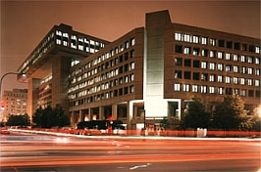](https://www.madcowprod.com/wp-content/uploads/2015/09/fbi-building-at-night.jpg)

The man who confirmed that Jeb Bush was aboard the C-130 was, I knew for a fact, also a CIA pilot, with experience flying Lockheed C-5 Galaxy military cargo planes, among the largest military aircraft in the world.

In addition to confirming Jeb Bush’s presence on the plane, he had one other piece of startling, and dispiriting, news. Everyone I’d spoken to with knowledge of the flight had assumed the files from Huffman Aviation, and the criminal records of the Venice Police Department, were being flown to FBI Headquarters in Washington, D.C.

The FBI never got them. The files never got there. They were diverted to McLean Virginia. If memory serves, that’s the home of the CIA. Repeated phone calls to the Venice Police Department on whether the files were ever returned received no response. It doesn’t take a psychic to figure out that means they were never returned.

Somebody should ask Jeb Bush what he knows about that.