[← Why Was Jackie On The Trunk?](https://johnkimber.wordpress.com/2013/02/14/why-was-jackie-on-the-trunk/)

[Jackie Shot JFK QED (revised) →](https://johnkimber.wordpress.com/2013/02/14/jackie-shot-jfk-qed-v2/)

[**9/11 Logic – Drones, Missiles, And Nukes**](https://johnkimber.wordpress.com/2013/02/14/911-logic-drones-missiles-and-nukes/)

Posted on [February 14, 2013](https://johnkimber.wordpress.com/2013/02/14/911-logic-drones-missiles-and-nukes/) by [John Kimber](https://johnkimber.wordpress.com/author/johnkimber2/)

Can 9/11 be explained logically, without recourse to unknown “Directed Energy Weapons” (DEWs), mountains of thermite, “widespread video fakery”, and “holographic planes”? Also, was 9/11 largely carried out by and for Israel, or was a larger group with a broader agenda involved?

The widely accepted basics of the operation, are that the transponders of Flights 11, 175, 77, and 93, were switched off, and these planes were then replaced by remote controlled drone planes.

Many believe that these drones and/or missiles were then flown into the three targets, plus the Shanksville “crash site”.

Does the video and photographic evidence from the day, support this outline? The clearest images, from the WTC 2/South Tower attack, reveal a drone with a pod and connected tubing etc, attached to its underside.

[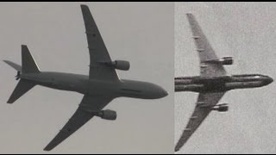](http://911logic.files.wordpress.com/2012/11/1-9l-wtc-2-drone.jpg)

[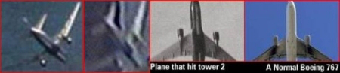](http://911logic.files.wordpress.com/2012/11/2-9l-wtc-2-pod-composite1.jpg)

[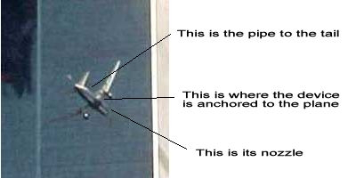](http://911logic.files.wordpress.com/2012/11/9-9l-wtc-2-flight175-pod-explained.jpg)

[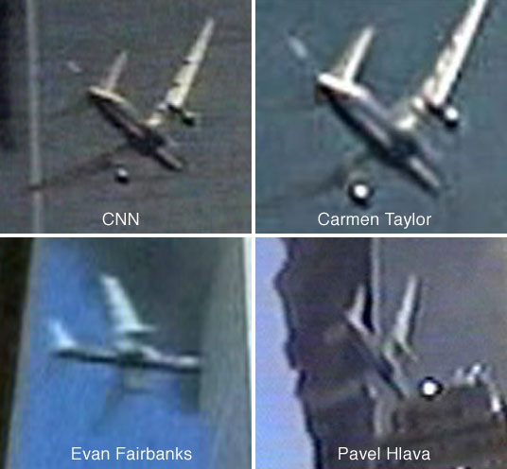](http://911logic.files.wordpress.com/2012/11/5-9l-wtc-2-4-pods1.jpg)

[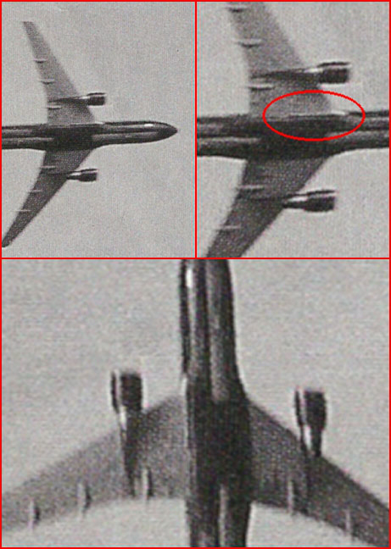](http://911logic.files.wordpress.com/2012/11/6-9l-175_pod_photo-3.jpg)

Whilst some 9/11 footage does look fake, the case for video fakery seems to have been overstated. Why, for example, would a pod etc, have been added to “fake images” of “Flight 175”?

<http://www.youtube.com/watch?v=gV4rvTxcMSY> 9/11 No Planes Absurdity

What could these strange additions be for? The pod may have held a depleted uranium (DU) tipped missile – note the “flash” images below. The “tube” (pipe, pod, and nozzle), may have hidden this missile, and most of its launch flash.

[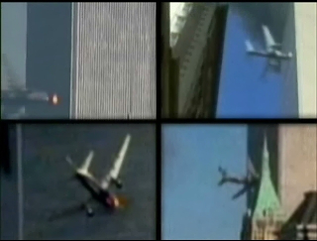](http://911logic.files.wordpress.com/2012/11/8-wtc-2-pod-flash-2-9l.jpg)

[](http://911logic.files.wordpress.com/2012/11/3-9l-wtc-2-flight175-pod-explained1.jpg)

<http://www.bollyn.com/were-du-missiles-used-on-9-11-2><http://www.bollyn.com/the-missile-pod-of-911-and-the-cover-up/><http://www.bollyn.com/the-huge-bullet-hole-in-the-south-tower-and-analysis-of-missile-evidence>

In short, a DU missile would have enabled a KC-767 drone’s fuselage to enter WTC 2, the engines would enter naturally (strong/dense). Vulnerable parts, such as the wings, would get shredded on impact.

<http://www.youtube.com/watch?v=RZjhxuhTmGk> F4 versus wall at 500mph

The missile may have also ignited pre-planted explosives in WTC 2, and/or have been “thermobaric” (fireball producing) itself. If its entry angle caused the missile to avoid the “core columns”, debris pushed out by its exiting uranium tip, may have even produced the (multiple angle/footage) “nose out” images.

<http://www.youtube.com/watch?v=aHekCOlLilE> WTC 2 thermobaric missile  
<http://en.wikipedia.org/wiki/Thermobaric_weapon>  
<http://www.911myths.com/index.php/Nose_out>

The “missile pod”, appears to have a smaller (targeting?) pod, on top of it. Laser spot targeting, perhaps via a Predator-B 002 UAV, may have assisted the final approaches of Flights “11” and “175”.

<http://www.youtube.com/watch?v=dr4BJ89Df5Q> 9/11 UAV laser targeting?  
<http://letsrollforums.com/targeting-laser-light-spot-t1715.html> 9/11  
<http://www.ask.com/wiki/Lockheed_Martin_Sniper_XR> The targeting pod?

[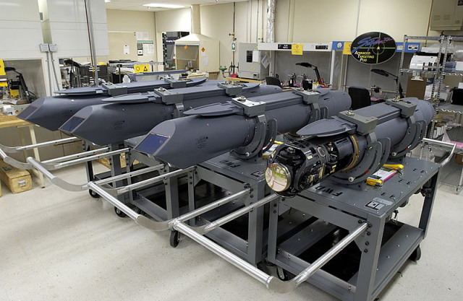](http://911logic.files.wordpress.com/2012/11/10-b-9l-pod-1409.jpg)

There are also two other “open ended tubes” at the rear of the fuselage (glass fronted camera pods?). A thinner white tube, extends from the base of one wing, to the tail (second photo below). It may have been used to drain surplus fuel, to prevent explosions on impact.

[](http://911logic.files.wordpress.com/2012/11/11-9l-175_pod_photo-3.jpg)

[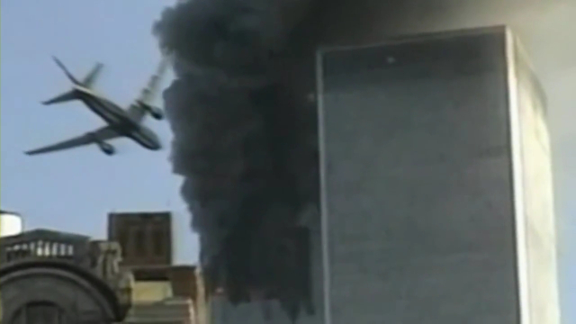](http://911logic.files.wordpress.com/2012/11/9_11-drone-screen-capture-a.jpg)

<http://www.youtube.com/watch?v=AwhCKGjnf-w> Standard 45m Fuel Dump

You may have heard “no-planers” claim that wing-tip vortices are not present in the “Flight 175” footage. Wing and wake vortices both appear to develop:-

<http://www.youtube.com/watch?v=0YVNBycaNXE> note CALEB0302 comments  
<http://www.youtube.com/watch?v=SceLjWa3hqA> Wing-tip vortex WTC 2

“No-Planers DEBUNKED!” “Huge vertical WAKE vortex splits in two”:-

<http://www.youtube.com/watch?v=1HwmPlgepOw> note description

The same dual WAKE vortices (?):-

<http://hereisnewyork.org/gallery/showbig.asp?photoid=0879>  
<http://www.youtube.com/results?search_query=9-11+vortex>

“Flight 175’s vanishing holographic wing”, was simply obscured by smoke from the North Tower:-

<http://www.youtube.com/watch?v=gbWD_dGBIm8> DEBUNKED 9/11 Wing

What of WTC 1? The video footage is much less clear. However, according to the impressive research that follows, the drone was large, with no wing mounted engines.  
Also, its wings were far closer to its tail than with a 767, and a lot of extra equipment  
surrounded the base of its tail:-

<http://x11drone.0catch.com/>   X11/C-22

The Boeing 727/C-22 (and Vickers VC10) fit the above description, and surely, “faked footage” would include a 767 shaped object? The WTC 1 drone also produces a clear pre-entry (missile?) flash. This is followed by an unnatural “z shaped” string of explosions.

[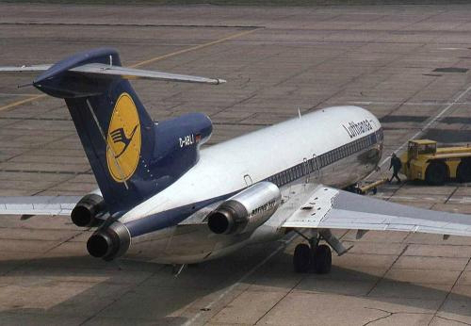](http://911logic.files.wordpress.com/2012/11/11-b-9l-boeing-727-031_rear.jpg)

[](http://911logic.files.wordpress.com/2012/11/11-c-9l-boeing-727-033_front.jpg)

<http://www.youtube.com/watch?v=jDJ4nuI3na8> VC10 Coningsby 28/08/12  
<http://www.youtube.com/watch?v=PwXuFeJ3M0c> WTC 1 Hit – Slowmotion

[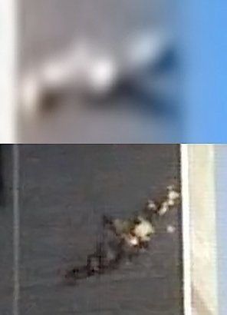](http://911logic.files.wordpress.com/2012/11/12-9l-wtc-1-2-impacts-compared1.jpg)

At the Pentagon, there was a clear missile vapour trail, but scant evidence of a crashed Boeing 757 or drone:-

<http://www.youtube.com/watch?v=vwzT0QnwtTE> 9/11 Pentagon Video

[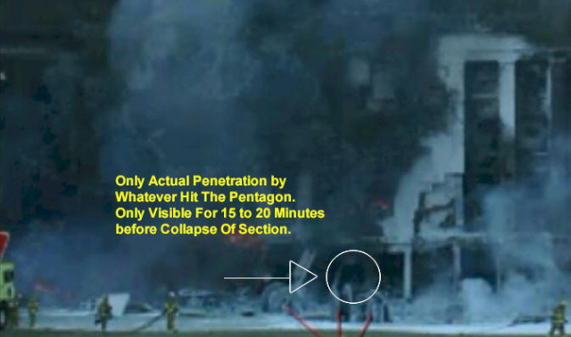](http://911logic.files.wordpress.com/2012/11/12b-9l-pentagon-hole1.jpg)

[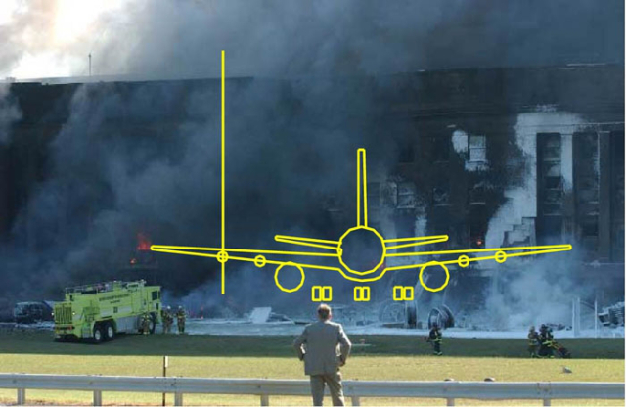](http://911logic.files.wordpress.com/2012/11/14-9l-pentagon-hole-2.jpg)

[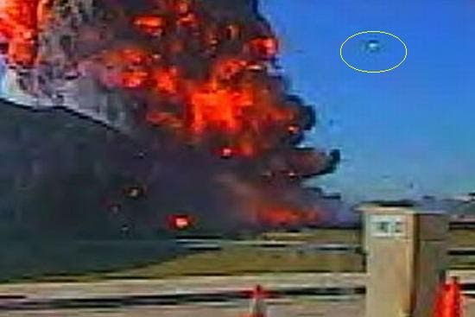](http://911logic.files.wordpress.com/2012/11/14b-9l-helicopter-pentagon-helicopter.jpg)

<http://jamesfetzer.blogspot.co.uk/2010/01/what-didnt-happen-at-pentagon.html>

At Shanksville, a cruise missile may have created the modest hole, an eyewitness description of the object at seven minutes into this video:-

<http://www.youtube.com/watch?v=ycTPeIa9DdA> Shanksville McElwain

[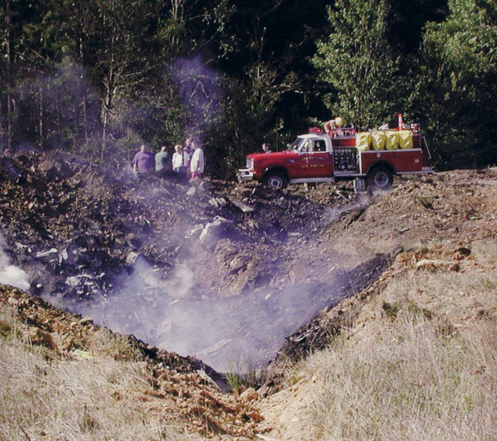](http://911logic.files.wordpress.com/2012/11/15-9l-shanksville-hole.jpg)

[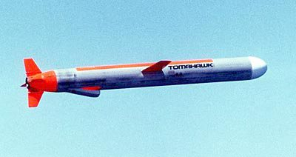](http://911logic.files.wordpress.com/2012/11/tomahawk-cruise-missile-intro.jpg)

Drones and missiles were certainly incapable of demolishing WTC 1 and 2, which were specifically designed to withstand such impacts. Nano-thermite is a very weak explosive – astronomical amounts would have been required to turn WTC 1 and 2 into dust.

<http://www.veteranstoday.com/2011/07/17/is-911-truth-based-upon-a-false-theory/>

What of DEWs, and the mysterious “Hutchison Effect”? John Hutchison has admitted faking videos, and being unable to successfully duplicate his bizarre experiments for over twenty years.

<http://www.damninteresting.com/the-hutchison-effect/> Hoaxer Hutch  
<http://www.youtube.com/watch?v=yABGpiYONmo> Hutchison fake levitation

Many of his 9/11 “toasted cars” look remarkably similar to normal burnt out cars. The “selective molecular dissociation of door handles and engine parts”, via the “Hutchison Effect”, seems unlikely. Plastic car door handles etc melting in a burning car, is more logical.

[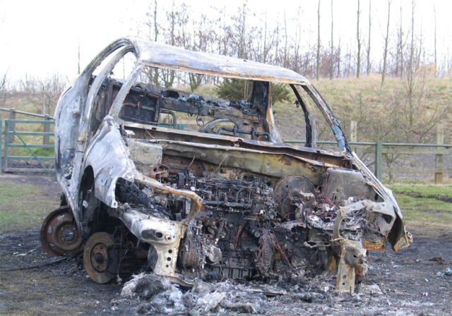](http://911logic.files.wordpress.com/2012/11/16-9l-burntoutcar_clockface.jpg)

<http://bit.ly/Burnt-Out-Cars> Google Images  
<http://bit.ly/9-11_Toasted_Cars> Google Images – spot the difference  
<http://www.ask.com/web?q=plastic+car+door+handles>  
[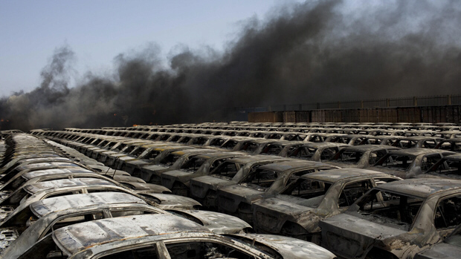](http://911logic.files.wordpress.com/2012/11/17-9l-burned_cars_seen_near_plume_of_black_smoke_in_misrata.jpg)

<http://ny.curbed.com/tags/toasted-cars> NY “toasted cars” 2008/9 (DEW free)  
<http://www.abovetopsecret.com/forum/thread699127/pg2> Hot embers etc

Is there a more logical, and scientifically proven way, to turn huge towers into dust? Nuclear demolition fits the evidence extremely well.

A tremendous variety of mini and micro nukes have been produced, and the blast can be directed upwards, to pulverize say, ten floors at a time. Visible cutter charges (thermite?) were used to ensure a vertical collapse. Seismic records indicate that the foundations were destroyed first, followed seconds later, by the top down nuclear pulverization.

<http://www.ask.com/web?q=tactical+nuclear>  
<http://whatreallyhappened.com/WRHARTICLES/shake.html> seismic records  
<http://whatreallyhappened.com/WRHARTICLES/9-11_wtc_videos.html>

Supporting nuclear demolition, is the high level of radioactive isotopes found near the WTC, shortly after 9/11. Tritium, for example, was 55 times higher than expected. The intense heat sustained in the ruins, long after 9/11, also points to nuclear reactions. The phrase “Ground Zero” is often associated with nuclear detonations.

<http://www.ask.com/web?q=WTC+isotopes>

[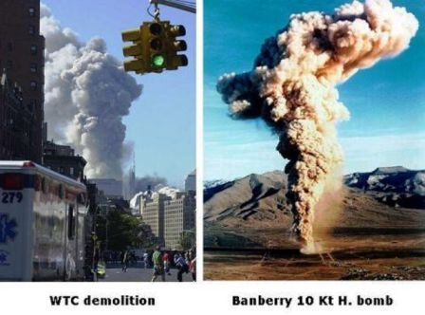](http://911logic.files.wordpress.com/2012/11/18-9l-wtc-vs-nuke.jpg)

<http://www.serendipity.li/wot/nuclear_bombs_demolished_the_wtc.htm>

I heard recently that Bill Cooper knew that Mossad/Israel had used nuclear demolition on 9/11, in 2001. Was Bill Cooper killed/silenced to make way for Alex “Israel” Jones, and a decade of planted theories/“cognitive infiltration”?

<http://bit.ly/Ott_Fetzer_Cooper_9-11> The Real Deal – 9/11 11 years later.

Most major terror attacks, across the Western World since 1990, have been Mossad led,  
in an apparent attempt to remove regimes hostile to Israel. Israeli leaders may have exaggerated the threats to Israel’s survival, to encourage Israeli agents to take part in these murderous attacks.

<http://wikispooks.com/wiki/9/11:Israel_did_it><http://bit.ly/Oslo_Mossad_Madsen> Mossad False Flag Attacks  
<http://hobeika.blogspot.co.uk/2009/03/oklahoma-city-bombing-was-mossad-german.html><http://www.ask.com/web?q=Mossad+Terrorism>

However, with a lavish military, and hundreds of nuclear weapons, Israel was not seriously threatened by its enemies and opponents. Psychopathic political leaders have no loyalty to tribes or countries, in any case.

<http://www.sott.net/article/210473-Ponerology-101-The-Political-Psychopath>

Therefore, the main objectives of false flag terror attacks in recent years, were to take control of valuable resources (oil, opium, etc), and to introduce police state powers in many countries.

<http://whatreallyhappened.com/WRHARTICLES/oil.html> Afghan oil pipeline  
<http://www.youtube.com/watch?v=xorR2Yo84Jo> Nick Rockefeller explains 9/11 (5m)

Plundering the whole world, whilst slowly enslaving mankind, is the so-called “Great Work”, or “New World Order” plan, of Freemasonry. Freemasons control Israel, Britain, America, and many other nations. They also dominate the “Truth Movement”.

<http://newworldordersummary.wordpress.com/>  
<http://bit.ly/SPA8DC>  Famous Freemasons  
<http://bit.ly/Freemason_Prime_Ministers_Israel>  
<http://bit.ly/Top_Masons_Praise_Lucifer>

[[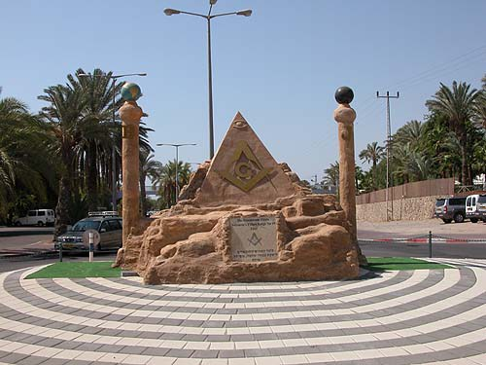](http://911logic.files.wordpress.com/2012/11/welcome-to-masonic-israel-eilat-2.jpg)](http://911logic.files.wordpress.com/2012/11/welcome-to-masonic-israel-eilat-2.jpg)

[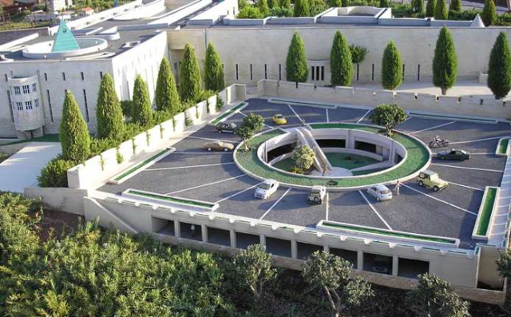](http://911logic.files.wordpress.com/2012/11/israeli-masonic-supreme-court-2.jpg)

Many of history’s worst mass murderers, including Napoleon, Stalin, and Hitler, were self-confessed Masons (via handsigns). 9/11 and 7/7 are amongst the big brotherhood’s more recent crimes.

<http://www.whale.to/b/hand_sign.html> The Hidden Hand of History (War)  
<http://bit.ly/SPA8DC>   Jackie Shot JFK QED David Icke, Alex Jones, Webster Tarpley, Hitler – Masons  
<http://www.scribd.com/doc/3289775/Famous-Freemasons-Exposed> (huge page)  
<http://911logic.wordpress.com/2012/11/05/masons/>  More Freemason links.

Occult numerology is their calling card: 9 = end (of the era), 11 = sacrifice to Satan, e.g. Remembrance/Armistice Day (11 am on 11/11).  The Knights Templar, who took over Freemasonry in the 14th century, were founded by **9** knights in **1111**AD. The London Bombings of 7/7/2005 = [777](http://www.ask.com/web?q=777+numerology+Crowley).

<http://tiny.cc/Gary-Bell-numerology> Occult numerology guide

What is endgame for the Masons in heavily armed America? The OKC Bombing,  
9/11,  
and 7/7, were all described beforehand within so-called fiction:-

<http://uk.ask.com/web?q=final+jihad+OKC> OKC Bombing and 9/11  
<http://www.youtube.com/watch?v=z3WW6eoLcLI> 9/11 Lone Gunmen HQ  
<http://uk.ask.com/web?q=9-11+predictive> 9/11 in prior movies  
<http://uk.ask.com/web?q=7-7+panorama> BBC “predicts” 7/7

Operation Blackjack, and the TV series Jericho, describe nuclear false flag attacks, to be blamed Syria, Iran, and “home grown extremists”. Was this plan postponed in June, after being raised on Coast To Coast AM (15 million listeners) on 6/8/2012?

<http://beforeitsnews.com/story/1752/187/Nuclear_9_11_Planned_For_6_22_2012.html>  
<http://beforeitsnews.com/story/2210/045/More_6_22_2012_Terror_Attack_Programming.html>  
<http://beforeitsnews.com/stories/by/35310> All Kimber articles  
<http://www.youtube.com/watch?v=1aj0gxuSW9E> C2C AM 6/8/12 (29m in)

[](http://911logic.files.wordpress.com/2012/11/jericho-s3-civil-war-s.jpg)

A lethal virus may be sent to known resistors, via America’s secret dual water pipeline system. Billions of hollow point bullets have been stockpiled recently for others, along with many plastic coffins.

[](http://911logic.files.wordpress.com/2012/11/nwoi-plasticcoffins_1116155i.jpg)

<http://www.youtube.com/results?search_query=Ventura+Police+State+full> Pandemic 1st 2m  
<http://neworleans.indymedia.org/news/2007/05/10214.php> dual water pipelines  
<http://radiofetzer.blogspot.co.uk/2012/06/janet-phelan.html> ditto, from 1h:10m  
<http://www.who.int/water_sanitation_health/emerging/h5n1background.pdf>  
<http://www.youtube.com/watch?v=flBpsyFbEOs> Prothero Vendetta War Virus  
<http://www.naturalnews.com/036847_ammo_purchases_government_stockpiling_media_lies.html>

So, there you have it, a logical explanation of 9/11, involving only technology that was known and reliable in 2001 – drones, missiles, and nukes. It was a spectacular attack, to promote needless foreign wars and creeping domestic fascism, but no “voodoo science” was required.

Further information:-

<http://www.bollyn.com/the-shanksville-deception-of-9-11-2>  
<http://www.serendipity.li/leonard_spencer_articles.htm> 9/11  
<http://enki.hubpages.com/hub/911-Misdirection> 9/11  
<http://911anomalies.wordpress.com/> 9/11