9/11 - "3,000 DEAD AND 6,000 INJURED" A LIE

It took me four years of study to wake up to this lie because of the truther-targeted propaganda campaign (H1b below) ... but I got there in the end.  
  
According to [**Wikipedia**](https://en.wikipedia.org/wiki/Casualties_of_the_September_11_attacks), deaths on 9/11 included 265 on the four planes (including the terrorists), 2,606 in the World Trade Center and in the surrounding area, and 125 at the Pentagon. More than 6,000 others were injured.  
  
**Hypothesis 1a (H1a)** - The claim 3,000 people died and 6,000 people were injured on 9/11 is a fabrication. This fabrication has been achieved by: conducting an evacuation/anti-terror drill and pushing out photos of the "drill injured" as real, faking photos of dead people, making up dead people's names or otherwise faking them and paying people to act as loved ones of the dead and injured.  
Note: I do not claim no one died on 9/11 as people may have died accidentally or been specific targets or died for some other reason but the evidence shows that the statement in general is a lie.  
  
**Hypothesis 1b (H1b)** - The power elite have a special propaganda campaign targeted at truthers to ensure that while they may recognise controlled demolition and faked plane crashes, they believe the 3,000-dead-6,000-injured lie along with those who believe the 19-terrorists-armed-with-boxcutters story. That truthers and believers alike believe this lie is extremely important to the power elite because when we don't have a significant part of the truth we are stymied in getting it out. Cleverly, they transform the seeming truth liability of controlled demolition into a magical propaganda asset as part of this campaign.  
  
**Hypothesis 1c (H1c)**- The power elite let us know what they're up to with obvious signs. False-flag analyst, Ole Dammegard, was given information by an insider that the power elite justify their hoaxing of us by signalling it through clues, implausibilities, ridiculousness, things that don’t add up, contradictions, constant and strange changes in the story, smiling grievers, obviously doctored imagery, the actual truth and on and on. Their reasoning is that if we’re too stupid to pick up the obvious problems with their stories, the fault’s on us, not them and this will protect them from karmic repercussions. Of course, the story of 19 barely-trained terrorists armed with boxcutters hijacking four planes, navigating them through the most highly-defended airspace in the world to crash them into high-rise steel frame buildings causing them to crash to the ground in a matter of seconds is utterly ludicrous in the first place ... but they lay it on at every turn.  
Note: I think this applies regardless of whether they're hoaxing us with fake dead people or actually killing people. In the JFK assassination, an example is that the rifle allegedly used by Lee Harvey Oswald was very clearly not up to the task. They enjoy mashing their crimes right in our faces like cream pie and daring us to do anything about it.  
  
  
**Hypothesis 2** - 3,000 people died and 6,000 people were injured on 9/11  
  
We start with the premise that 9/11 was an inside conspiracy using the facts that [**WTC-7 came down by controlled demolition**](http://occamsrazorterrorevents.weebly.com/911.html) and the plane crashes were faked (Occam's Razor on this to come).  
  
  
**​All 10 points below** favour H1 over H2.  
  
1.  **No obvious motive**- There is no evidence to suggest reasons for the power elite to kill the 3,000 or injure the 6,000 people in either the buildings or the planes. There are appearances on the internet of intimations that this or that group was a likely target because they were doing sensitive audits or investigations of fraudulent activity but there is no compelling evidence of anything. These intimations favour H1b (truther-targeted propaganda). Even if there were evidence, many more people than targeted groups would have been killed. One might suggest they simply took a "collateral damage" approach but Point 2 disfavours it. In the case of the 265 passengers on the planes whose crashes were faked, "collateral damage" could not be applied, they would have had to deliberately kill the passengers. I must say, I'm most intrigued about what happened to Barbara Olson, media personality and wife of former Solicitor General, Ted Olson, who allegedly died on Flight 77. Did she elect to live the rest of her life on a Greek island or something similar?  
  
2.  **Anti-motive** - There was an extremely strong anti-motive for killing and injuring people in the buildings and the planes. Dealing with the loved ones of 3,000 dead and 6,000 injured and the injured themselves would be an absolute nightmare for the perpetrators when the collapse of WTC-7 is such an obvious controlled demolition not to mention the vast number of other problems with the official story. While people may tend to accept, if reluctantly, what the media/government tells them in normal circumstances, when loved ones are killed they become much more alert to anomalies in the media/government story and more strident and less inhibited in demanding answers.  
  
3. **Very few loved ones** - As we might expect if 3.000 people were not killed and 6,000 were not injured, there are very few loved ones or injured themselves kicking up hell and the ones who are all seem to have a kind of profile - these people fit perfectly with H1b (truther-targeted propaganda). You don't find odd ones with their own web pages demanding justice. It all feels very controlled. We are told that others have been "paid off" but that fits perfectly with H1b too. Surely, the power elite would have anticipated that the controlled demolitions would be recognised by some and would not simply rely on "paying off" all the loved ones demanding justice. Some people will not be bought off and the power elite could not rely on being able to do that.  
  
4. **Not a single loved one of a passenger on the planes** - To my knowledge, there is not a single loved one of one of the 265 passengers who has been agitating against the government. The only people are those whose loved ones or colleagues were in the buildings but the loved ones of those on the planes would also have suspicions. Even loved ones of victims who tended to believe the 19-terrorists-armed-with-boxcutters story would surely be making a lot of noise about puzzling aspects. Former Democratic congresswoman and presidential candidate for the Greens party, Cynthia McKinney, has never received an answer to her extremely pertinent (especially to US taxpayers) question: “How did a multi-trillion dollar military and intelligence complex fail four times on one day?”  
  
5. **Anomalies with key figures whom we might consider to be disinformation agents used in the propaganda campaign aimed at the truthers,**that is, they push the double "suspicions of government/controlled demolition" // "my loved one died/people were rescued" line.  
  
**Bob McIlvaine**  
Bob McIlvaine is the father of Bobby McIlvaine who died in the lobby of one of the twin towers from an explosion before it came down. Bob appears to be an extremely vocal fighter for 9/11 truth and has joined forces with [**Architects & Engineers for 9/11 Truth**](https://www.ae911truth.org/) which I believe has many genuine members but is obviously infiltrated.  
  
Below is a photo of Bobby with his mother and father. Notice how the hand around his mother has red on the fingernails and a thumb ring. This seems inconsistent with Bobby’s image. Also notice that his arm across his father’s back extends into the air rather strangely and tapers to his wrist prematurely. Obvious and sloppy doctoring of photos is one of the power elite "signs". This photo supports H1a (fabrication), H1b (truther-targeted propaganda) and H1c (they tell us) - the photo doctoring could suggest that Bobby is not Bob's son; it also fits into the propaganda campaign aimed at truthers (died before the building came down) and the sloppiness of the doctoring is a "sign" from the power elite.

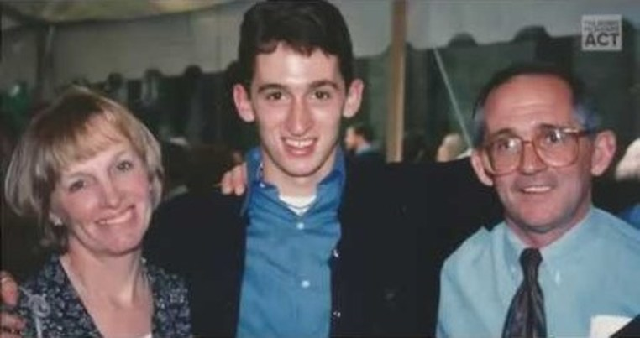

​Below is a photo of Bobby with his parents and brother. Notice the position of his hand on top of his father's and seemingly against his brother’s cheek, with thumb ring and bracelet. He also seems to have an earring but it looks a little strange. These elements are inconsistent with the trouser, tie and shirt outfit. There is a straight line formed between his mother’s dress and his trousers which is not consistent with the line formed when a person is leaning against another. The background is very dim while the people are brightly lit, suggesting a fake background.

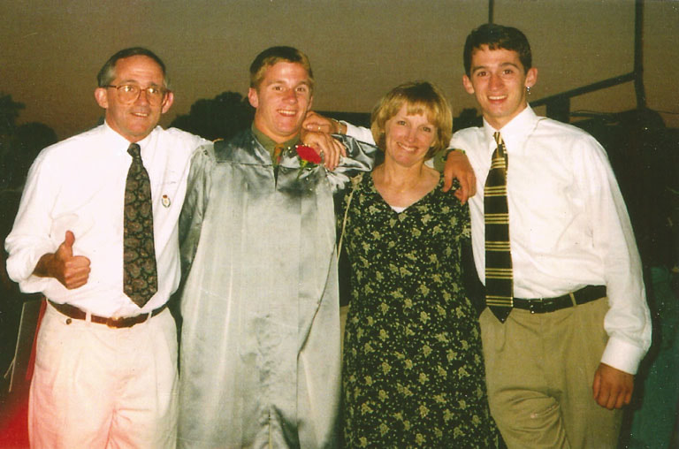

**William Rodriguez**  
It was while half-watching an autoplay YouTube video about William Rodriguez that I had an epiphany about the false claim of deaths. Rodriguez testified that he experienced explosions before the North tower fell which would suggest controlled demolition but he was also hailed as a hero who’d helped “hundreds” evacuate from the building. It suddenly struck me as anomalous that someone saying things that incriminated the government would be awarded for heroism by it. On this webpage, Mark Roberts, who, ironically, is a believer of the official story, has problems with Rodriguez's timeline and [**points out the anomalies**](https://sites.google.com/site/911stories/rodriguez%27stimelinewayoff%3F). The page starts with a quote from William:  
  
*"Once my story came out, some people even joked, they say “Oh, this is Superman. This is a false story because the guy did incredible things on that day."*  
  
Telling the actual truth is another sign from the power elite ([**Larry Silverstein's "pull it"**](https://www.youtube.com/watch?v=p34XrI2Fm6I) is another infamous example).  
  
William Rodriguez and his anomalous story support all three parts of H1. The anomalous story shows he is lying and means we have no reason to believe in the injured he alludes to (H1a - fabrication); the fact that he says he experienced explosions supports (H1b - truther-targeted propaganda) and his stating of the truth and the very obvious anomalies in his timeline support H1c (they tell us).  
​  
6. **Eminently fakable**- Faking the 3,000 dead and 6,000 injured may seem a daunting task but it isn't really all that difficult. Here's how they could have easily done it. They evacuated ALL the people from the buildings rather than just some before they came down and, as the plane crashes were faked, the damage done before the buildings came down could have been small and restricted to empty floors meaning no injuries. We don't expect to see many images of the dead so not a great deal of work to do there. The few that there are are not particularly convincing - they could easily be fake. This is [**a particularly gruesome one**](https://www.google.com.au/search?q=images+of+dead+9/11&rls=com.microsoft:en-GB&source=lnms&tbm=isch&sa=X&ved=0ahUKEwjTzc-qn5fdAhUaUd4KHe1lAawQ_AUICigB&biw=1920&bih=894#imgrc=wVTfLHoOMhFXZM:) of a jumper who has hit the pavement (which I do not necessarily advise looking at) that looks fake to me. There is only the tiniest fraction of the 6,000 injured shown. The trickiest part, I'd imagine, is the names and photos of all the dead and what to do about the some, at least, still-alive people but that can be managed too - it is hard to determine which people were still alive and which were already dead, completely made up or whatever. But we have intelligence agencies on the job here - they know how to do these things.  
  
As it was so eminently fakable and as actually killing and injuring the people would have had very problematic consequences, faking it can only be seen as the preferred option. H1a very much over H2 here.  
  
7. **No convincing signs of injury** - There are no convincing signs of injury in a single photo that can be found on the internet - grimaces but no convincing signs of injury. The photos fit "drill" better than they fit "real".   
Note: While you might argue that this is only a small number of photos, you simply won't find very many more which, of itself, is anomalous for 6,000 injured. Where are all the photos? Wouldn't they surely have shown us one person, at least, recovering in hospital? Comments on the first four photos:

* 1 and 2: In the first two photos all people have their eyes closed. This seems to produce a particular effect and supports the idea that the alleged victims are acting for effect. The girl seems to have burn scars or similar on her arm but these look old.
* 3: In drills, agency staff tend to outnumber the injured. In the photo on the Pentagon lawn we see only suggestions of injured but lots of other people. Where are all the injured and what are all these people doing?
* 4: The light and shadows look wrong to me for the time of day. The background is dark while the people look artificially lit. I think we can assume that these photos were not all taken on 9/11 if indeed any were. I think that it's very possible that they were taken at different times and photoshopped onto backgrounds. Apart from the buildings actually coming down, I think 9/11 was a massively staged event.

**[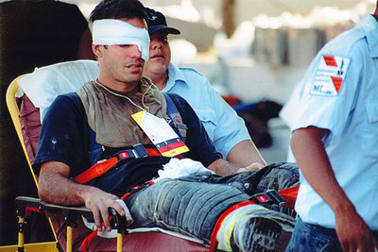](http://occamsrazorterrorevents.weebly.com/uploads/2/4/8/7/2487397/rescueworkeronstretcher_orig.jpg)**

**[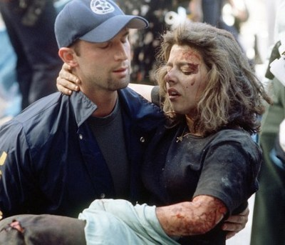](http://occamsrazorterrorevents.weebly.com/uploads/2/4/8/7/2487397/girl-with-burns_orig.jpg)**

**[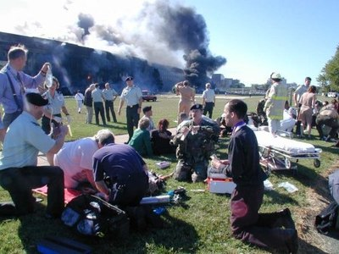](http://occamsrazorterrorevents.weebly.com/uploads/2/4/8/7/2487397/pentagon_orig.jpg)**

**[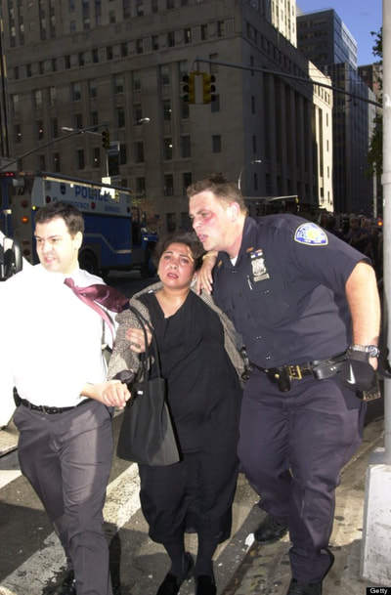](http://occamsrazorterrorevents.weebly.com/uploads/2/4/8/7/2487397/womanbeingwalkedbyrescuerandtieman_1_orig.jpg)**

**[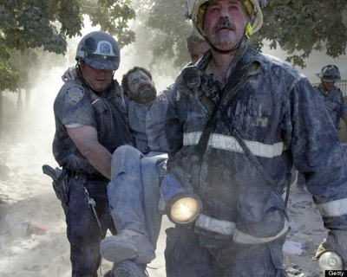](http://occamsrazorterrorevents.weebly.com/uploads/2/4/8/7/2487397/twin-towers-man-being-carried_orig.jpg)**

**[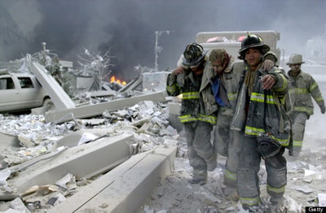](http://occamsrazorterrorevents.weebly.com/uploads/2/4/8/7/2487397/anotherrescuerbeingwalked_orig.jpg)**

**[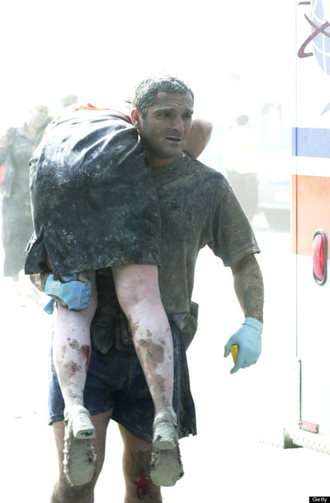](http://occamsrazorterrorevents.weebly.com/uploads/2/4/8/7/2487397/woman-over-rescuers-shoulder_orig.jpg)**

**[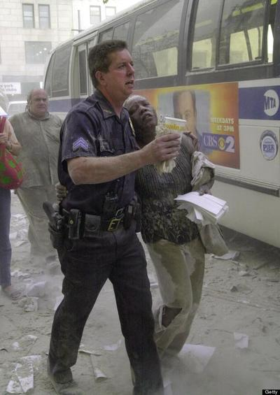](http://occamsrazorterrorevents.weebly.com/uploads/2/4/8/7/2487397/woman-walking-with-rescuer_orig.jpg)**

**[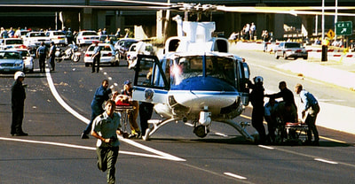](http://occamsrazorterrorevents.weebly.com/uploads/2/4/8/7/2487397/rescure-helicopter-evacuates-wounded-p_orig.jpeg)**

**[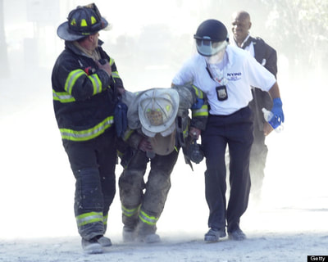](http://occamsrazorterrorevents.weebly.com/uploads/2/4/8/7/2487397/firstresponderbeingwalked_orig.jpg)**

**[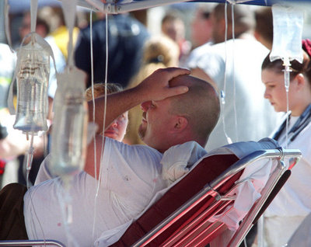](http://occamsrazorterrorevents.weebly.com/uploads/2/4/8/7/2487397/drip_orig.jpg)**

**[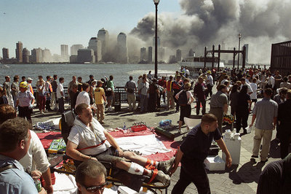](http://occamsrazorterrorevents.weebly.com/uploads/2/4/8/7/2487397/bloodlowerleg_orig.jpg)**

**[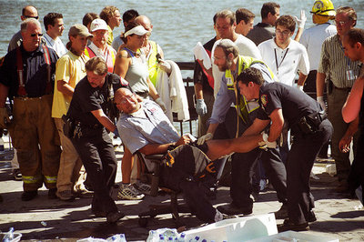](http://occamsrazorterrorevents.weebly.com/uploads/2/4/8/7/2487397/wheelchair_orig.jpg)**

**[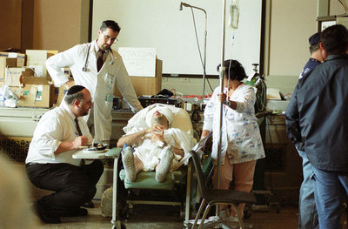](http://occamsrazorterrorevents.weebly.com/uploads/2/4/8/7/2487397/bandaged-face_orig.jpg)**

8. **Memorial anomalies** - There are many anomalous aspects to the names of the alleged dead. On this webpage dated January 2010, [**Simon Shack, points out**](http://www.septemberclues.info/deconstructing.shtml)a number of discrepancies:

* Nine years after the event the memorials are all showing different numbers, and names on one memorial do not appear on others.
* The first two names on the Wall of Americans memorial are Diana Aaliyah and Justin Aaliyah but these are not on the other memorials. Simon asks, "Wouldn't the loved ones make contact and point out that these names are not on the other memorials?" He also questions the names themselves. If we say them, they can sound like "Die in a lie" and "Just in a lie".

The anomalies support both H1a (fabrication) and H1c (they tell us)  
For more on these anomalies go to [**the webpage**](http://www.septemberclues.info/deconstructing.shtml).  
  
9. **Ridiculous survivor stories of the 12-second collapses of the 500,000 ton twin towers**- We are told that 16 people survived the 12-second total collapse of the North Tower, including Pasquale Buzzelli, as explained in this article, [**Miracle Survivors**](http://nymag.com/nymetro/news/sept11/2003/n_9189/).

I felt the walls next to me crack and buckle on top of me,” he says. Suddenly, he seemed to be in free fall, and the walls seemed to separate and move away from him.  
  
Maybe two hours later, he regained consciousness on a slab of concrete 180 feet below the 22nd floor. (He may be the source of the rumor that someone surfed the collapse and lived.)

When you [**watch the tower collapse**](https://www.youtube.com/watch?v=kMTFVeRbpC4) this simply isn't credible.  
  
Nor is this story.

The wind lifted Komorowski off his feet. “I was taking a staircase at a time,” he says, “It was a combination of me running and getting blown down.” Lim says Komorowski flew over him. Eight seconds later—that’s how long it took the building to come down—Komorowski landed three floors lower, in standing position, buried to his knees in pulverized Sheetrock and cement.  
  
Lim landed near Harris. “If Josephine doesn’t slow me down, I’m dead,” he’d later say. “I figured this out.” That captain who’d urged Lim to go ahead didn’t make it. “Josephine Harris saved my life,” he says definitively. Harris landed on her side, clinging to the boot of Billy Butler.​

The unbelievable miracle survivor stories support H1c (they tell us). I mean, they really do make you chortle, they're so ridiculous.  
  
10. **No firefighters convincingly agitating for justice** - We have to wonder at the number of firefighters who died: 343, of a total victim count of 3,000 - more than 10%. Surely, firefighters who were involved in the alleged rescues would recognise that the buildings came down by controlled demolition and would be agitating about the number of their colleagues who died and the reason for their deaths. Their website, [**Firefighters for 9/11 Truth and Unity**](https://www.ff911truthandunity.org/) is very muted – compare it to that of [**Architects & Engineers for 9/11 Truth**](https://www.ae911truth.org/). This makes sense, of course, if the evacuations of the buildings were a drill (pushed out as real) just like [**all the other exercises**](https://en.wikipedia.org/wiki/United_States_government_operations_and_exercises_on_September_11,_2001) going on that day. ​