[The Pure EVIL of 911 & Yes They DID BET ON IT (Part 1)](https://theyig.ning.com/front-page-news/the-pure-evil-of-911-yes-they-did-bet-on-it-part-1)

Posted by **[Yig Wilson](https://theyig.ning.com/members/YigWilson)** on September 12, 2018 at 4:41pm in [**Daily Articles**](https://theyig.ning.com/front-page-news/Daily+Articles)

<https://theyig.ning.com/front-page-news/the-pure-evil-of-911-yes-they-did-bet-on-it-part-7>

This is going to be a pretty big post and graphic heavy, but I promise you that you may have to look for your jaw on the floor before you are finished. This is jam packed with solid information and some of it is going to be painful to read. Yes, people really are just this EVIL. Whats worse? To know we as a people voted for many of them. I hope this is a good lesson going forward to make sure you look into who you decide to give your votes too going into the future and not just blindly following the parties.

This information is from a drop on FaceBook, but dont let this detour you from reading it. Like I said, It is SOLID. You will recognize many connections as you read through it. I will be copying it over to here so that it is an easier read for you to follow since it is spread out through comments. Sometimes through, he does respond to peoples comments. In this case I will use **FB** for the commenter and**JJ** for his response.Sometimes he responds but Im not quite sure to whom he is responding too. If I think something he says may be relevant I will add it in for digs. One last NOTE, I will add the links to the graphics above them so you can go see them larger if you wish to.

**THIS IS**[**Jason Q Janiszewski**](https://www.facebook.com/jay.jan.3766/posts/232757464251975)**STORY:**

The Main reason why i had to start with the FBCAN is because it was developed so that Blackmailers could track users, Pedophiles and Victims with a Specific Facial recognition software. It’s called Demon Face Recognition Software. It was Developed in 1978 when a company named Starnet Communications in Vancouver, Canada and one of the first SES (Senior Executive Service) members......Stephen Paddock, yes....same one.... so they could track all these people that were to be blackmailed on a system called Oath Inc. to have them available for long range logistics for Murder for Hire schemes.

This will probably take me til sunrise to get out. But the 17th anniversary of the largest live snuff film ever recorded deserves it. The truth.

There are 2 Brothers in the UK named Nicholas and Rupert Soames. They are Winston Churchill’s grandsons. They were in charge of SERCO.... that is one of the largest corporations that you probably have never heard of. They had to find a way to blackmail members of the US Government to maintain some control on their golden goose so they went right to the head of the SES, Kristine Marcy.

They used a pedophile oath ritual known as “Mendenhall’s baby” to lure her and other higher up pedophiles in and they filmed them using the Demon Face Recognition Software so that whenever SERCO decided to launch what’s known as a ‘Red Team’ against the US, that they would give the US Military and officials the order to Stand Down.  
Remember when Q was going on about RED RED......remember one of them above.

Now what these teams consisted of were the worst of the worst. Mercenaries....SuperMax Prisoners.... anyone that is ruthless to be on a big hit squad

SERCO controls a lot of US Interests.  
One for instance is the US Passport and Visa Office. This is how they are able to get perfectly illegal ‘legal’ visas for anyone willing to commit crimes against Americans on foreign and domestic soil. Kristine Marcy, being the head of the SES, had control of the prisoners at the SuperMax Prisons. So anyone and everyone was in play.  
SERCO issued these visas to these ConAir Swat teams that had embedded themselves in the US Defense Threat Reduction Agency so they could execute asymmetrical missions. Terrorism. For short

**FB: Kristine Marcy is Abel Danger’s sister. He hasn’t talked to her in years and he’s a patriot trying to help POTUS.**

**JJ: they were the ONLY ones to ever mention the FBCAN. And once you go down that rabbit hole. You gone**

Another US Interest that SERCO has control of is the US Patent and Trademark Office. In the previous 9/11 post, i had posted some patents and just by typing in the patent number in a search engine...the patent appears....what’s one thing that everyone has been so curious about?  
Servers right?  
Oh i know what’s on em. And now you do too.

**JJ: Yale should be the tell tale. That’s 322 territory**

**FB: Isn’t Prince William involved in SERCO, Jason?**

**JJ: He currently owns them**

**JJ: But theres no sense in Owning SERCO when you aren’t in any power. Trump looked SOOOOOO Good in Churchill’s Chair didnt he???? Lmao**

**JJ: But we own them. To hell with the Crown**

[**https://www.facebook.com/photo.php?fbid=232786964249025&set=p.232786964249025&type=3&theater**](https://www.facebook.com/photo.php?fbid=232786964249025&set=p.232786964249025&type=3&theater)

**[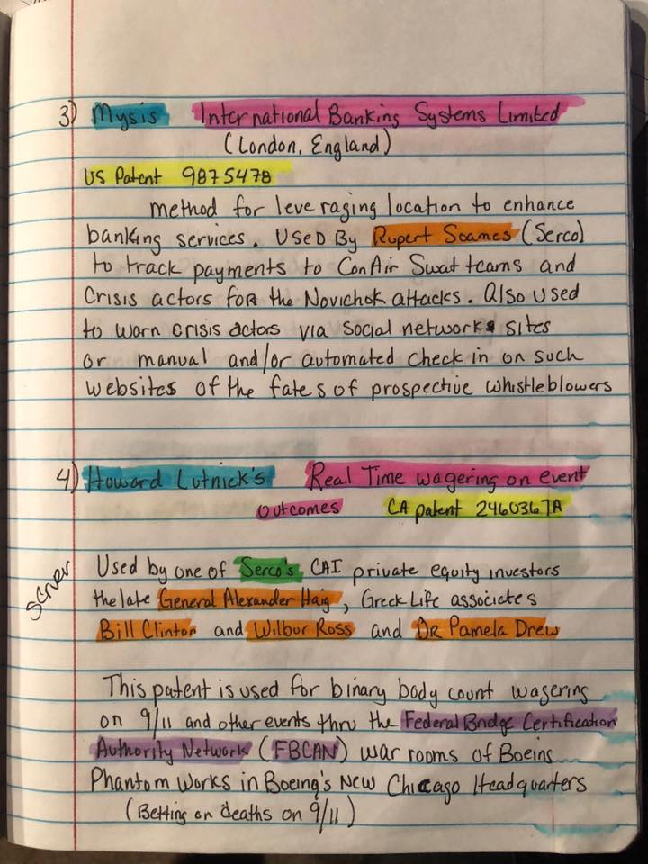](https://scontent-mia3-1.xx.fbcdn.net/v/t1.0-9/41540284_232786967582358_6613470223829827584_n.jpg?_nc_cat=0&oh=4fb45a87974e33ae06737c4c096338ea&oe=5C2522D2)**

**FB: Is this the same system that they use for betting on the manufactures storms too?**

**JJ: Yes #4 is what I’m gonna explain and show you how it works**

[**https://www.facebook.com/photo.php?fbid=232787334248988&set=p.232787334248988&type=3&theater**](https://www.facebook.com/photo.php?fbid=232787334248988&set=p.232787334248988&type=3&theater)

**[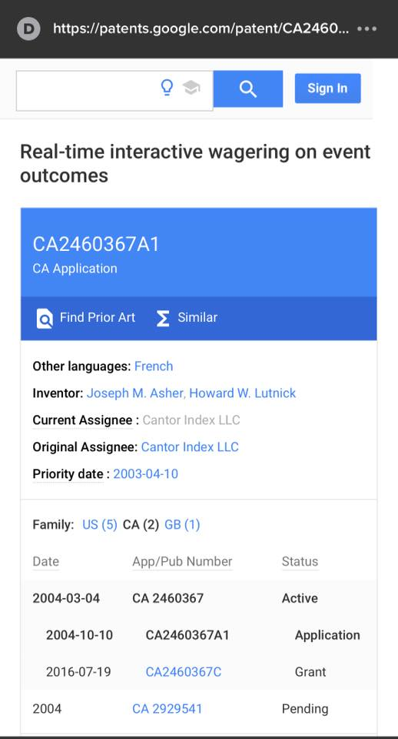](https://scontent-mia3-1.xx.fbcdn.net/v/t1.0-9/41585431_232787337582321_4566252080548806656_n.jpg?_nc_cat=0&oh=c7da6d92f80a0392f18b80edc304d0ed&oe=5C2555FA)**[**https://www.facebook.com/photo.php?fbid=232787400915648&set=p.232787400915648&type=3&theater**](https://www.facebook.com/photo.php?fbid=232787400915648&set=p.232787400915648&type=3&theater)

**[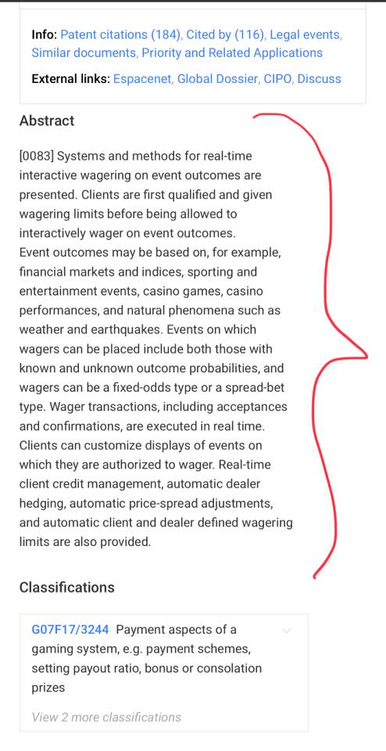](https://scontent-mia3-1.xx.fbcdn.net/v/t1.0-9/41487148_232787404248981_3537310609441816576_n.jpg?_nc_cat=0&oh=bb4e9535e3b94c3fc4417b2574a74640&oe=5BF05B51)FB: Is this why CRYPTO currency is being pushed?**

**JJ: It’s actually because Obama took a template of a 100 dollar bill and had 3 TRILLION dollars printed. In Bangkok Thailand. Centennial Energy. But our new money should be done by the 18th. They have been working on it 24/7**

**FB: Was noticing the changes a few weeks ago. Took a pic**

**[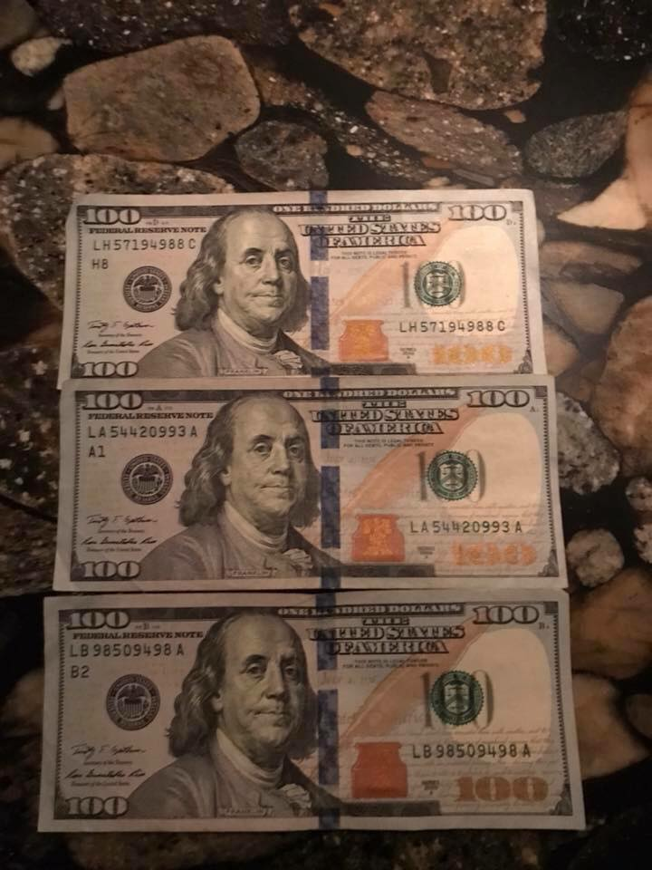](https://scontent-mia3-1.xx.fbcdn.net/v/t1.0-9/41675192_10215762013937163_3603833330664996864_n.jpg?_nc_cat=0&oh=cacd2f5b6c3ca89cd4436d7eecabd212&oe=5C2AE45D)FB: Half new money half old?**

**JJ: Once the switch happens. You tear the left side off. That’s the bad side**

**JJ: They seriously love using confusing verbiage for anyone else looking into this.....**

[**https://www.facebook.com/photo.php?fbid=232787614248960&set=p.232787614248960&type=3&theater**](https://www.facebook.com/photo.php?fbid=232787614248960&set=p.232787614248960&type=3&theater)

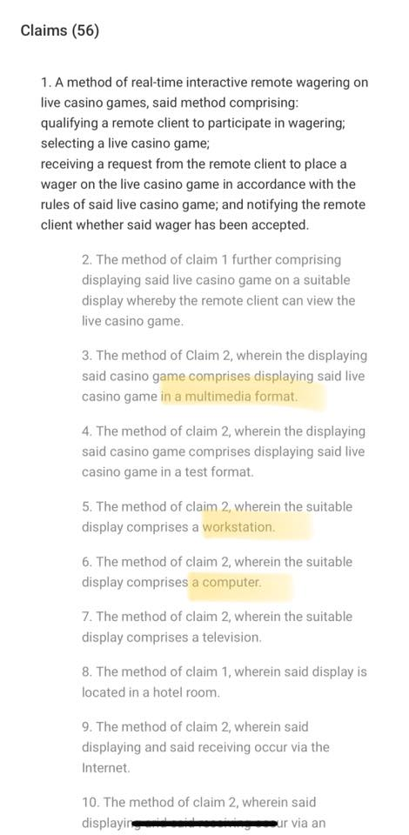

**FB: Does this also tie into Las Vegas? Were they wagering there also?**

**JJ: They have Junket Rooms in Vegas. Well. Had**

[**https://www.facebook.com/photo.php?fbid=232787660915622&set=p.232787660915622&type=3&theater**](https://www.facebook.com/photo.php?fbid=232787660915622&set=p.232787660915622&type=3&theater)

**[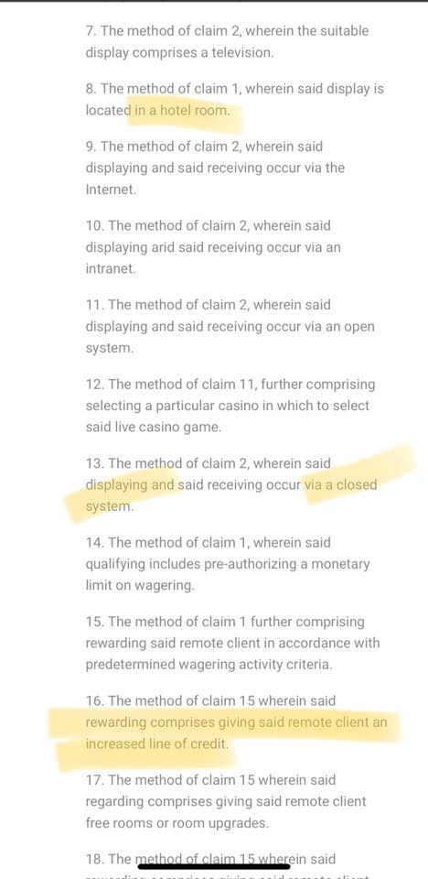](https://www.facebook.com/photo.php?fbid=232787660915622&set=p.232787660915622&type=3&theater)**

[**https://www.facebook.com/photo.php?fbid=232787697582285&set=p.232787697582285&type=3&theater**](https://www.facebook.com/photo.php?fbid=232787697582285&set=p.232787697582285&type=3&theater)

**[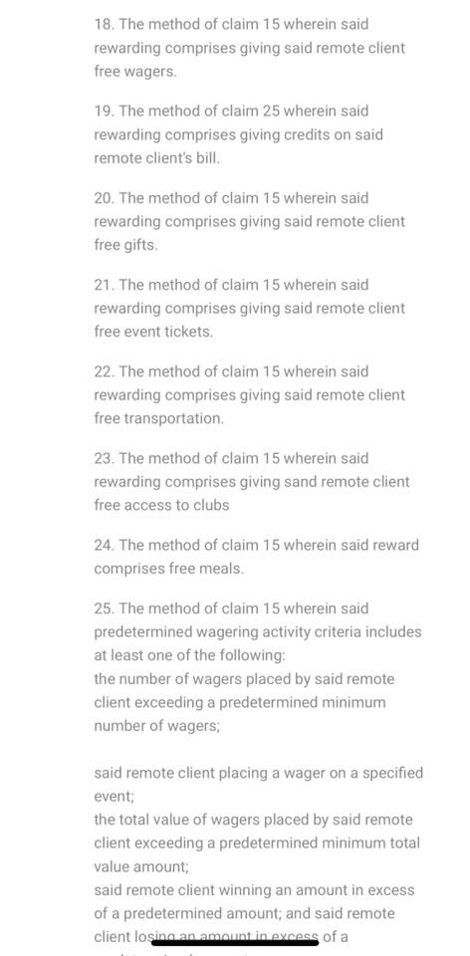](https://www.facebook.com/photo.php?fbid=232787697582285&set=p.232787697582285&type=3&theater)**

**JJ: Whoops! What do we have here?  
Server? Ill finish posting the rest of the patent now and then explain the patent**

[**https://www.facebook.com/photo.php?fbid=232787910915597&set=p.232787910915597&type=3&theater**](https://www.facebook.com/photo.php?fbid=232787910915597&set=p.232787910915597&type=3&theater)

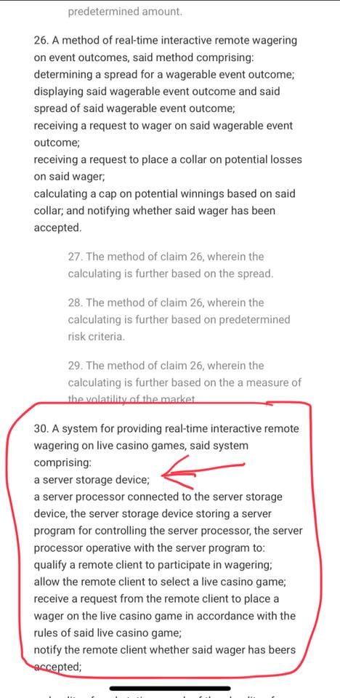

[**https://www.facebook.com/photo.php?fbid=232787947582260&set=p.232787947582260&type=3&theater**](https://www.facebook.com/photo.php?fbid=232787947582260&set=p.232787947582260&type=3&theater)

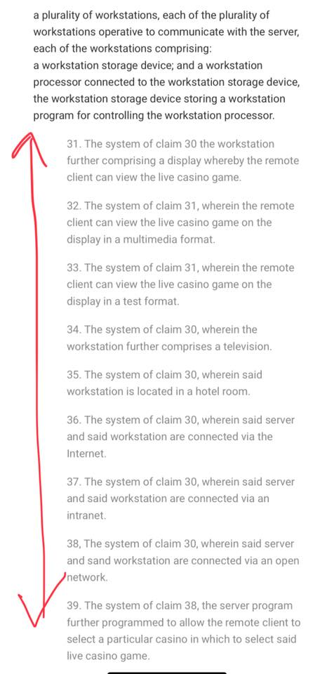

[**https://www.facebook.com/photo.php?fbid=232787984248923&set=p.232787984248923&type=3&theater**](https://www.facebook.com/photo.php?fbid=232787984248923&set=p.232787984248923&type=3&theater)

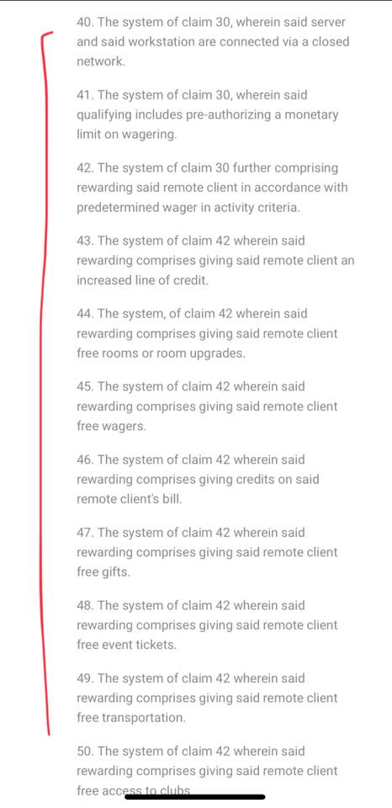

[**https://www.facebook.com/photo.php?fbid=232788094248912&set=p.232788094248912&type=3&theater**](https://www.facebook.com/photo.php?fbid=232788094248912&set=p.232788094248912&type=3&theater)

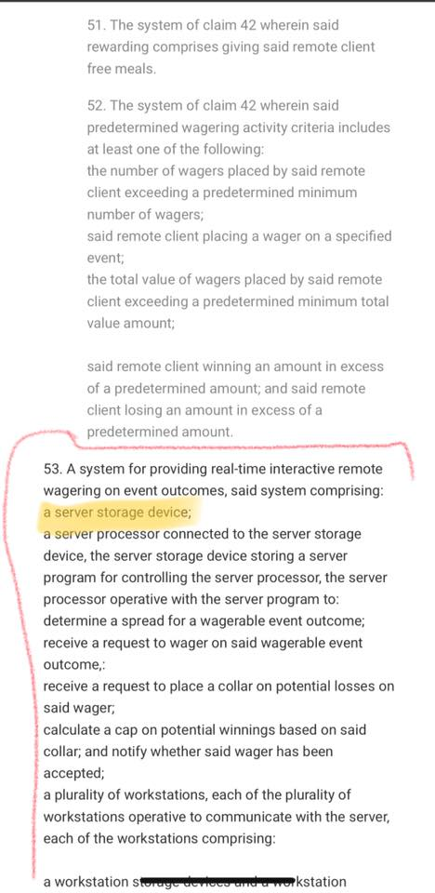

[**https://www.facebook.com/photo.php?fbid=232788147582240&set=p.232788147582240&type=3&theater**](https://www.facebook.com/photo.php?fbid=232788147582240&set=p.232788147582240&type=3&theater)

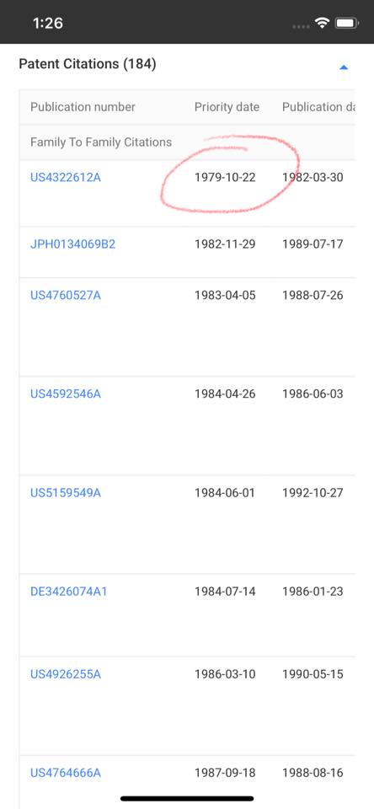

**JJ: So this Patent has been around since 1979**

[**https://www.facebook.com/photo.php?fbid=232788494248872&set=p.232788494248872&type=3&theater**](https://www.facebook.com/photo.php?fbid=232788494248872&set=p.232788494248872&type=3&theater)

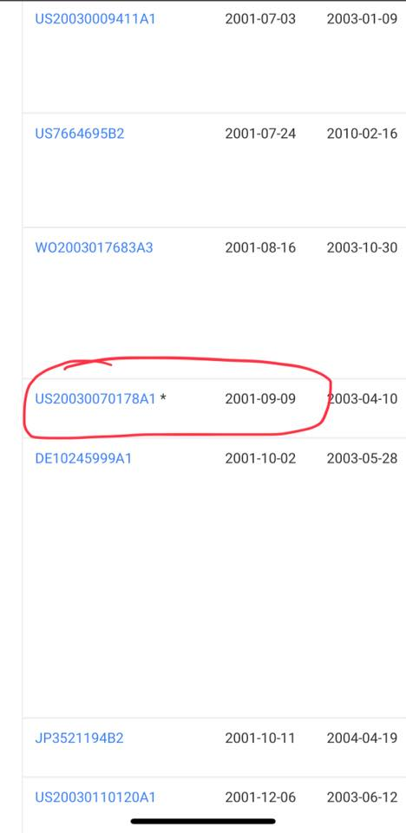

**FB: 2 days before the event**

Yig: As I mentioned earlier this is going to be a huge thread so I will continue with his explanation in part 2. Part 2 is much more information heavy.

This is now continued from Part 1

**JJ: A poker tournament.... with multiple servers being used......**

[**https://www.facebook.com/photo.php?fbid=232789047582150&set=p.232789047582150&type=3&theater**](https://www.facebook.com/photo.php?fbid=232789047582150&set=p.232789047582150&type=3&theater)

**[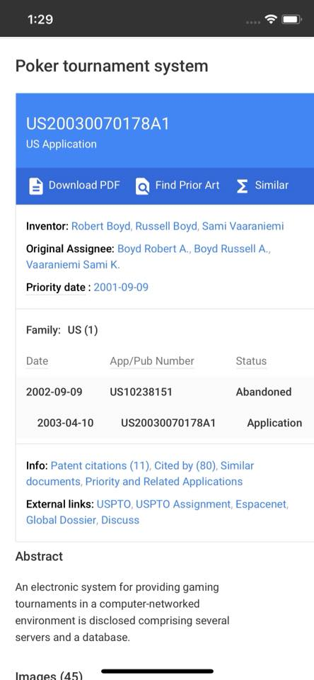](https://scontent-mia3-1.xx.fbcdn.net/v/t1.0-9/41496144_232789050915483_3536747135502385152_n.jpg?_nc_cat=0&oh=7a8e2836ee43de8f5ddca5cb614fe8fa&oe=5C1A2A11)**

[**https://www.facebook.com/photo.php?fbid=232789137582141&set=p.232789137582141&type=3&theater**](https://www.facebook.com/photo.php?fbid=232789137582141&set=p.232789137582141&type=3&theater)

**[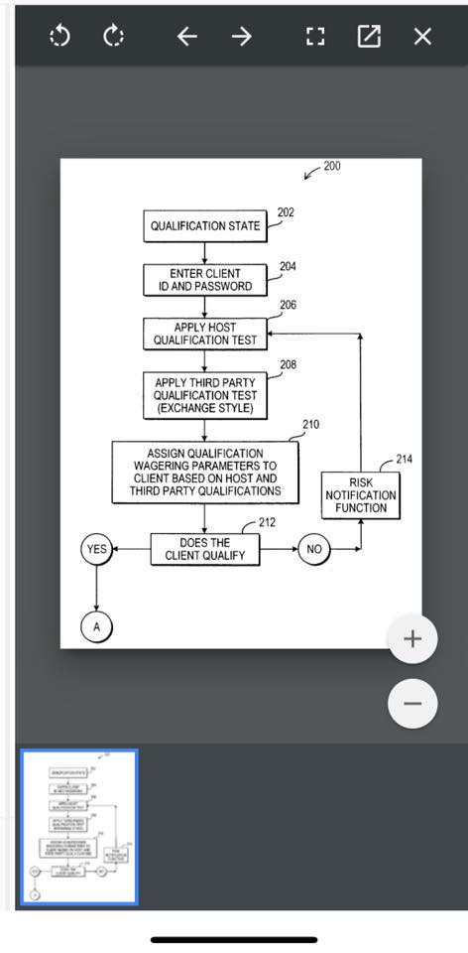](https://scontent-mia3-1.xx.fbcdn.net/v/t1.0-9/41412353_232789140915474_1733227322087047168_n.jpg?_nc_cat=0&oh=7c3724aa429a34a946dedb79e5307745&oe=5BEE44B0)**

**JJ: The beauty part is that you get to see diagrams as well on these. Now on the left hand side, bottom pic.....looks like a radio. Or a Camera.**

[**https://www.facebook.com/photo.php?fbid=232789590915429&set=p.232789590915429&type=3&theater**](https://www.facebook.com/photo.php?fbid=232789590915429&set=p.232789590915429&type=3&theater)

**[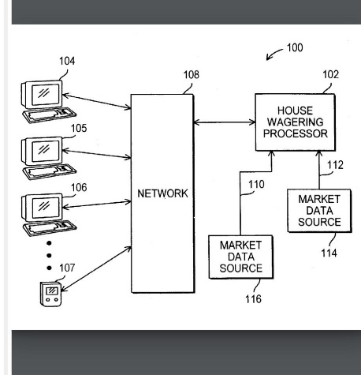](https://scontent-mia3-1.xx.fbcdn.net/v/t1.0-9/41442042_232789594248762_2600934621390569472_n.jpg?_nc_cat=0&oh=e9eb861ddaaa20afbc607654c5e7e031&oe=5C31B350)**

**FB: Those bastards placed bets on deaths, jumpers, time of impact, time of destruction??? Didn’t they??? I bet they also watch kids being tormented and bet on that shit too!!!**

**JJ: Couldn’t be any more spot on. And it gets worse**

**JJ: The Camera is used exclusively to give an accurate time of death for the target and also there are “High Value Targets” as well.  
There’s a lot of info. Not gonna lie**

**JJ: If anyone needs the link again that has patents, definitions etc..here it is. Definitely save it to fb. It’s a nice research point**

**JJ:**[**https://americandigitalnews.com/2018/08/18/from-titanic-to-twin-towers-serco-fbcan-ses-power-elite-jabs/**](https://americandigitalnews.com/2018/08/18/from-titanic-to-twin-towers-serco-fbcan-ses-power-elite-jabs/)

If theres that much betting on the time of death....you would think they need a base clock to go off of. They used the National Physical Laboratory Clock to base all the times of death to keep it “clean”

 To pull off this kind of betting...it has to be pretty secretive. They devised these Betting areas as ‘Junket Rooms’ These were mainly promoted by the CAI Equity Group that was run by the late General Alexander Haim and the late Brigadier General James Ritchie.  
Ritchie was a member of Bohemian Grove and an ex Executive at the Mirage resorts so he knew his way around the betting world.

Now when it came to the high value Targets, SERCO would use the US Defense Red Switch Network to alert guests in the elite hotels and Casinos (Even at their homes when it came to the Rothschilds) once they get this notification, they are given the opportunity to put in their real time bets on the time that the high value target will be killed or if available they could predict body counts in real time mass causality events.

And yes i do have some names of High Value Targets that ill post later. 90% of people will be pretty irritated by one name in general.

Notice. Another Red. Keep tabs

Now in order to be accepted into these Junket Rooms, you first have to go thru a series of initiation tests and if you pass those, your facial features are captured because now, theres no way out. Your facial features are taken while performing sexual deviant acts (mostly pedo) and they save it in order to add your face onto a virtual likeness of you and have you committing even more heinous crimes.

SERCO was literally running a live Death Pool online for all the Junket Rooms in 69 countries

During GHWB’s term in office, he noticed his Drug trafficking partner, Bill Clinton, was catching on a lot faster than expected so he only had to serve one term. They had lots of planing to get done. So post Bush Sr, Clinton was placed in as POTUS ( yeah. We never had a choice) and it worked great because with Hillary in the White House, it gave the Chicago Mob another leg up into the game. Her dad, Hugh Rodham, ran the chicago mob after Capone went to Prison. These rats are all over  
So Clinton was put in office to get the Child trafficking more profitable and there were other plans he had so that once his 8 years were done, then GWB could come in and finish the Snitch Saddam Hussein off finally for his pappy

Clinton and Bush Sr......BIG into Trafficking kids and drugs

See Saddam had a secret about Sr. He knew about the child trafficking and that they were keeping the kids in Iran. When he found out, he wanted a cut to stay quiet. Sr was way too greedy and instead took our troops over there to try to overthrow him. Didn’t work this time.

In 1993, Wilbur Ross (Greek Life Associate and current Commerce Secretary under Trump) got a few buddies together and financed the creation of the Federal Bridge Certification Authority Network. Now at the time, Ross was a Rothschild Banker. He’s the one that bailed Trump out in 1989 by being the only one that would loan him the 1.5 Billion dollars he needed in order to stay afloat. If he didnt... he would never become POTUS. He knew that. He had to make a deal with the devil but also make sure that Karma played out and he helped Ross as well. Everything has to be in a complete harmonious circle.

Funny thing about the Greek Life Associates is that its a much better term than what they are REALLY known as.  
322. Skull and Bones.

Ross and his friends financed the creation of the FBCAN so that aides to Senator Obama could hack into the US Defense Red Switch Network and allow SERCO to stand down US military response to “Man in the middle” attacks on the US National Command Authority. ALSO Ross and the 322 offer RICO investment banking services to SERCO

SERCO is the UK outsourcer of all the attacks. They had a BIGGER plan for the FBCAN. They began an internal Blackmail system where companies (Lockheed Martin for example) will “employ higher people in power in Government” pay them and they will find out shortly that they are owned. By creating the FBCAN.....they literally created the LARGEST Pedophile Blackmail network EVER

**FB: Comey worked for Lockheed Martin.**

**JJ: They seem to all take a turn with Lockheed. It’s the main blackmail corporation**

Because who also did they have added to the FBCAN? The UK Ministry of Defence. Which by the way is another name for “Churchill’s Toyshop” that had Rupert as the CEO and he was the former CEP of Mysis Banking and Securities Division.  
Nicholas was the former Minister of State for the UK Armed Forces from 1994-1997

The Soames Bros. Established an online register for  
“Churchill’s Toyshop” at the offices of Northern Trust (which is SERCO’s alien property custodian in Chicago) where the insiders of the SES ( Marcy) can identify published patents or submarine devices needed by these privately financed ConAir Swat Teams to execute their missions

So they Transferred the custody of the Toyshop (which also goes back to WW2 They were the UK Weapon Research and development organization) onto the FBCAN so that key holders with access to Boeing’s ‘Encryption for asymmetric Data Lines’ Patent ,that was actually developed by a former Boeing Phantom Works director and current SERCO Director Dr Pamela Drew, to conceal warfare attacks on the US or its Allies. They would even use it on their innocent enemies. The UK is THAT dirty!

One of the real main reasons for the transfer was that SERCO could threaten targets in the US for terrorism such as Trump Tower, or even transportation systems. The Brothers have been deploying pedophile and other criminal groups with the ConAir Prisoner tracking patent activated to extort and blackmail Trump and the French President Macron(who was a Rothschild banker himself).

On those mystical Servers of Hillary’s, there was some software loaded on in order to have home based access to the JABS (Joint Automated Booking System) so that she could deploy ConAir Swat teams herself in a robe and slippers

Posted by **[Yig Wilson](https://theyig.ning.com/members/YigWilson)** on September 12, 2018 at 4:36pm in [**Daily Articles**](https://theyig.ning.com/front-page-news/Daily+Articles)

Continued from Part 2

In October of 1996, some DOJ insiders along with the SES began a program to “Reinvent Government”. What they did was they would sell Root Key access to the FBCAN and JABS to Clinton Donors(Including convicted felon Charles Kushner) Citibank, Saudi Arabia so that they could conceal their acts of Murder For Hire

Welcome to Pay to Play. Clinton Foundation Style.

SERCO embedded Virtual Command Centers in the Disaster Mortuary Operational Response Team (DMORT) and FBI Law Enforcement Online Networks to direct Patentee Swat teams at Mass causality events with the Tencent patent “Instant Messaging [IM] System and Method” and it allowed all Clinton Foundation Pay to Play donors to bet on the body counts using the Howard Lutnicks “Real Time wagering on Event Outcomes” patent.  
As they saw it....you pay us.....you can bet on others losing their lives by our own choice of mass causality event.

SES and ConAir embedded the same 2 patents as above, in the Boeing flight management system which allowed CF donors and Skull and Bones to bet on the body counts and or times of High Value target deaths during 9/11. Not only did they do that but the SES and Dr. Drew equipped Skull and bones Clinton and Ross, the keys to the ConAir patent vault on the FBCAN gaining them even MORE access to betting and getting others to wager as well.

In 1996-7, Chip Bernan with the USN wrote the Global Guardian War Game of September 10-12,2001 as a simulation on HIS end because he thought he was helping out by better defending the country by showing different ways and weaknesses that can be exposed. Well once it was done....he ended up becoming a High Value target and was killed.

In 1998, SERCO Shareholders (the UK and Saudi Arabian Governments) gave Generals Haig and Shalikashivili the keys to the FBCAN and Red Switch Networks and ordered them to prepare Boeing’s HQ in Chicago for the Stand Down of 9/11.  
(Makes me sick because i was working down the street)

SERCO patentee Swat Teams used images of the Jon Benet Ramsey murder in 1996 to extort the former director of Lockheed Martin, Lynne Cheney (Dick’s wife) into transferring digital custody of various patented devices including Lockheed Martin’s “Rocket Boosted Guided hard Target Penetrator”to be used in the drones that would hit WTC Tower’s 1 and 2 and ignite explosives on board after target penetration. Both drones were loaded with explosives.

There was also a Bunker Buster in the drone that hit tower 1 on the North face

**FB 1: Lynn Cheney was also in the Pentagon bunker with her husband, Dick. Usually the position Dick was Manning was held by military personnel. Dick changed that a few months earlier and became the first civilian to hold that position.**

**FB 2: So you're saying Dick and Lynne Cheney were the ones that murdered Jonbenet Ramsey?**

**JJ: Lynne Cheney wrote the note. The rest will be in a drop**

Now that they were getting it all lined up to go down on Sept 11th because NESARA was going to take effect and there were going to be mass arrests and what we will be celebrating shortly....was to happen back then.

Now that the prepping is taking shape, they are gonna start getting the Junket Rooms ready and get everyone involved in it

Kristine Marcy of the SES used **Stephen Paddock** to promote Junket Rooms for the FBCAN which would allow CAI group w/David Johnson(Patron of SOS Canada) and General Haig to stage the first ever live broadcast of a mass snuff film in human history on 9/11

All of the Junket Rooms were betting on the outcome of a war game designed to decapitate America thru a SES coup d’etas.

General Haig used the Red Switch and the FBCAN to order SERCO swat teams that were all assembled in the Sheraton Pentagon City Hotel by the former DoD contract auditor and Junket Promoter Stephen Paddock, to hack the 67th cyberspace wing on 9/11...initiate decoy and drone maneuvers during a Red team Wargame attack on the Pentagon’s US Navy Command Center and Identify the bettor entitled to “Scoop the Pot” after Captain DeConto was shown to have died by the impact images which were dated and time stamped September 12,2001. 17:37:19

SERCO uses Buck revelli’s version of facial recognition called Imagis to track actors and victims thru the FBCAN because even though the Clinton insiders write the ConAir Swat team scripts that SERCO controls special weapons thru the US Patent and Trademark Office. Serco Controls the US.

**[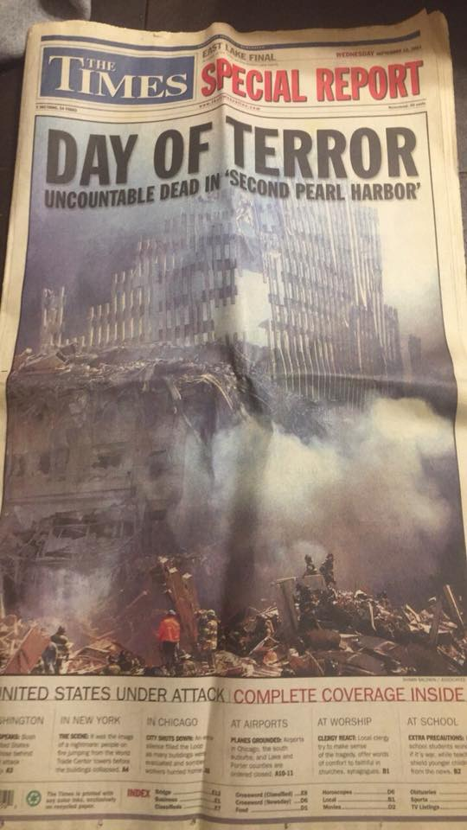](https://scontent-mia3-1.xx.fbcdn.net/v/t1.0-9/41502716_232850017576053_3878825509508874240_n.jpg?_nc_cat=0&oh=ceea22241ac4024e2b4031a3a90fcb86&oe=5BEDF200)**

**[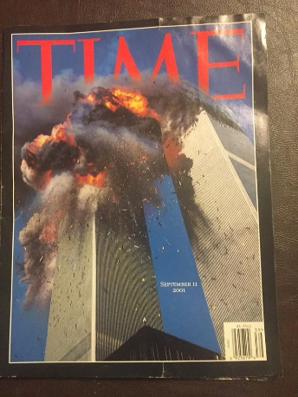](https://scontent-mia3-1.xx.fbcdn.net/v/t1.0-9/41500191_232849967576058_8012375225716965376_n.jpg?_nc_cat=0&oh=b2a27cf39a244b18d54ac5a5494a39c2&oe=5C344E42)**

**[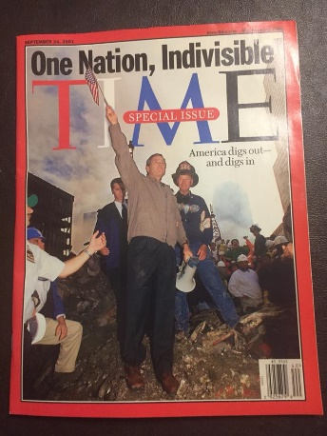](https://scontent-mia3-1.xx.fbcdn.net/v/t1.0-9/41483974_232850097576045_232331570067800064_n.jpg?_nc_cat=0&oh=7e7c73fb05fa6af6798f00b7f0dd5734&oe=5C2AE46B)**

General Haig equipped Chinese junket investors and Greek Life Clinton and Ross with Law Enforcement Online Virtual Command canters so they could deploy swat teams wit nortel JABS to trigger 9/11 bets on body counts for target entities such as FDNY (343 died) and “drift” the money into private accounts thru “Coordinated rebalancing by money manager portfolio management system and a master overlay manager portfolio management system “  
US Patent 7729969B1

Now when it comes to “What happened to the planes”.

The 4 Boeing planes were all equipped with an Uninterruptible Auto Pilot switch that was manufactured by GE

What this does is it takes the controls out of the pilots hands once the auto pilot switch is activated. They made it in case a plane had no one to land it that it could be Controlled from the ground. Seems like it worked these 4 times perfectly.

 The CEO of GE was Jeffrey Immelt. Not only was Larry Silverstein worried about himself.... but Immelt took out a corporate life insurance policy in case he didn’t live past 9/12/2001.  
Winner winner treason dinner. He made it. In fact he has the LARGEST corporate paid out life insurance policy for a single person EVER. $274 MILLION.... Cash.

The 4 planes were all navigated up into Northern Canadian Airspace and were shot down

A cruise missile hit the Pentagon. I know. I was soooooo shocked as well.

See General Haig was also working with NATO. Does ANYONE wanna guess what he bought?

He had 18 AMRAAM’s just kinda “appear”

He technically didn’t BUY them

They are the same exact missiles that we used to take out the Trident II that was launched out of Washington State not so long ago

Oh and the Man in the Middle Of 9/11 ......  
The UK ministry of defence. It’s actually quite coincidental that the World Bank would be located in the WTC and on 9/12/2001.....it’s opened right back in London.

The Brits as far as people I’m good with. The Royals. They can all go eat a cold blooded member

Even Trudy. But he’s gonna be dealt with shortly.

Oh and speaking of getting dealt with. When everyone is all about doom and gloom. When I saw GE taken out of the Dow Jones and replaced with Walgreens...... I knew something was up. Then that takes us back to the Q post where they have the United Flight and Gina Haspel is in the front seat. Wintertime.

[I]?

With him committing crimes against humanity as listed in the EO, ALL his shit is now ours. Trump will have the Omnibus paid back 500 times over.

They planted mini Nukes in the elevator shaft. Both towers HAD to fall in order for their Satanic Zionist bullshit to work. They did the same to us in WW2. We agreed. One bomb. That’s it. They sent 2.

**FB: "The 4 planes were all navigated up into Northern Canadian Airspace and were shot down.". Why were there reports on Cincinnati Radio that two of the planes .... the real flights 175 and 11, landed and offloaded at back hangars?**

**JJ: THAT would be a really good question right there. 2 of my sources said the same thing. Wonder if that was the “shut the fuck up about the planes” message.  
Where’s Operation Mockingbird when ya need em.**

It takes us RIGHT back to the game. Symbolism.  
2 columns of smoke is a Satanic Zionist Masonic symbol of the 2 columns in the 3rd temple they want to build in which to crown their “King Of the World”.  
  
It’s Lucifer.

And it wouldn’t be a decent post without more goodies

[**https://www.facebook.com/photo.php?fbid=232895017571553&set=p.232895017571553&type=3&theater**](https://www.facebook.com/photo.php?fbid=232895017571553&set=p.232895017571553&type=3&theater)

**[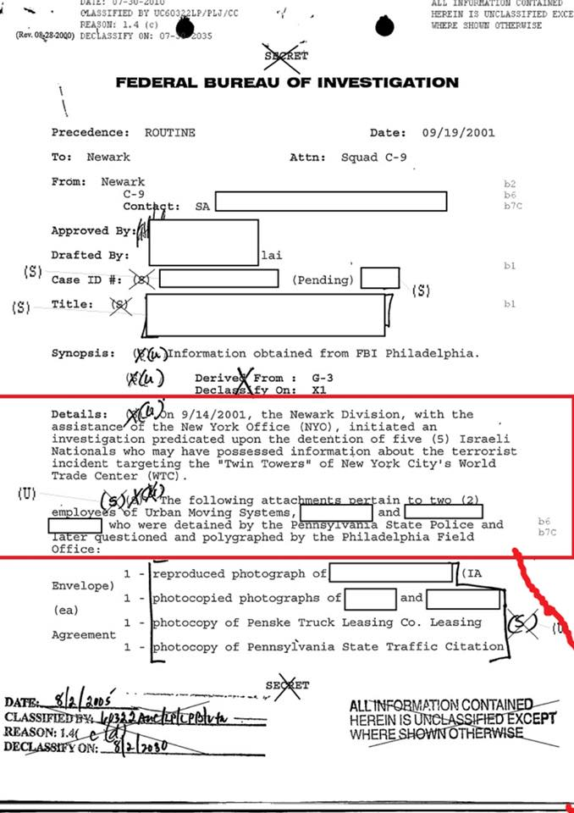](https://scontent-mia3-1.xx.fbcdn.net/v/t1.0-9/41477461_232895020904886_3173257473352007680_n.jpg?_nc_cat=0&oh=bdc0bf449d8607ffcd6c9290c6aaf32b&oe=5BEEF9AF)**

[**https://www.facebook.com/photo.php?fbid=232895110904877&set=p.232895110904877&type=3&theater**](https://www.facebook.com/photo.php?fbid=232895110904877&set=p.232895110904877&type=3&theater)

**[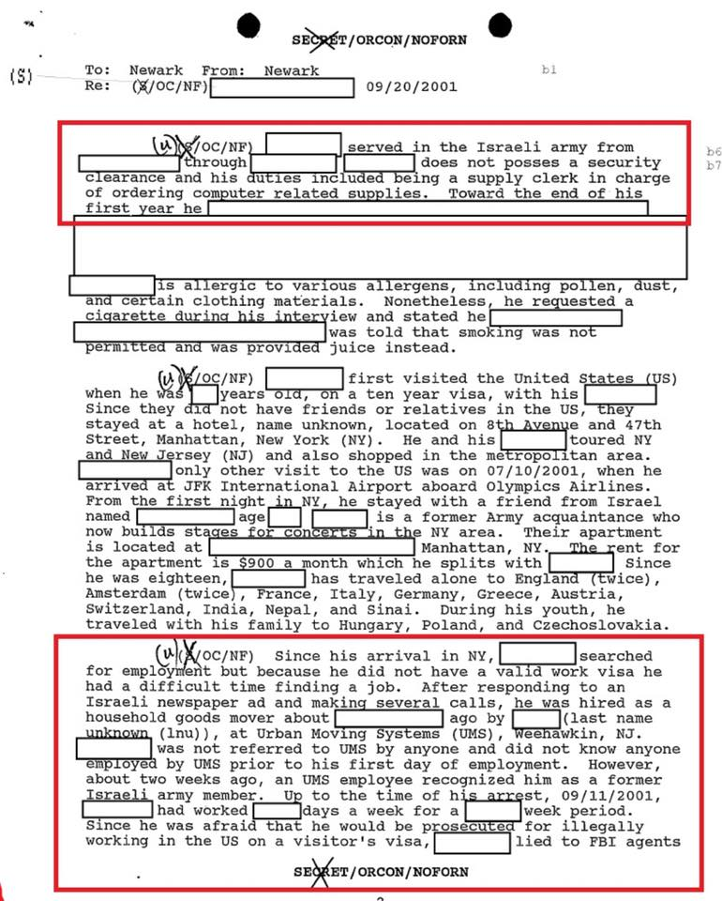](https://scontent-mia3-1.xx.fbcdn.net/v/t1.0-9/41575425_232895114238210_8322601280442728448_n.jpg?_nc_cat=0&oh=a0c443cb1ad0d24bd785f9db22425357&oe=5BEFB537)**

[**https://www.facebook.com/photo.php?fbid=232895147571540&set=p.232895147571540&type=3&theater**](https://www.facebook.com/photo.php?fbid=232895147571540&set=p.232895147571540&type=3&theater)

**[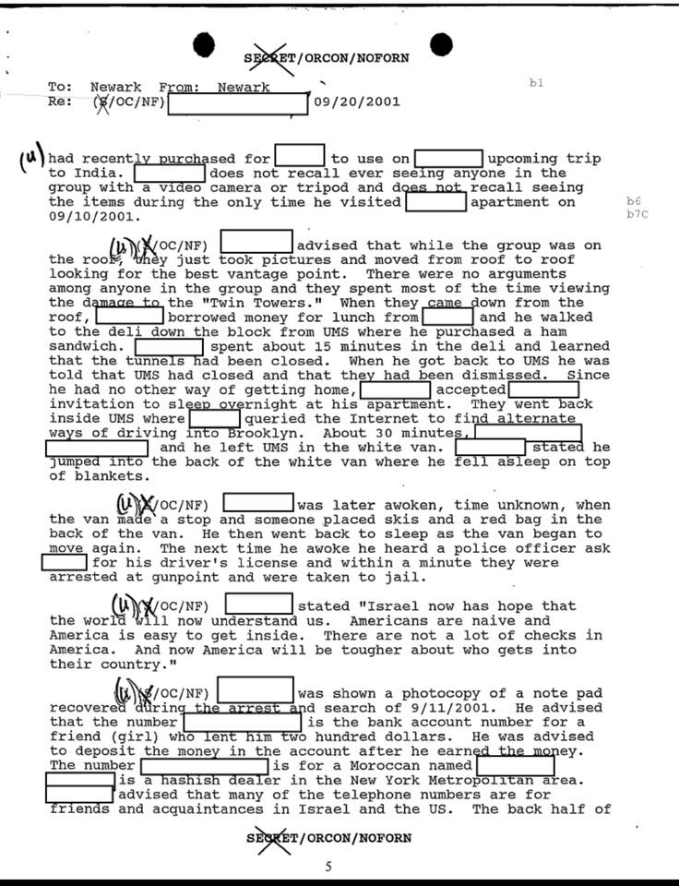](https://scontent-mia3-1.xx.fbcdn.net/v/t1.0-9/41585112_232895150904873_6414109524260552704_n.jpg?_nc_cat=0&oh=65b8a1955b8b10d57b5ed5c4d3fe99a9&oe=5C2CBEA2)**

[**https://www.facebook.com/photo.php?fbid=232895217571533&set=p.232895217571533&type=3&theater**](https://www.facebook.com/photo.php?fbid=232895217571533&set=p.232895217571533&type=3&theater)

**[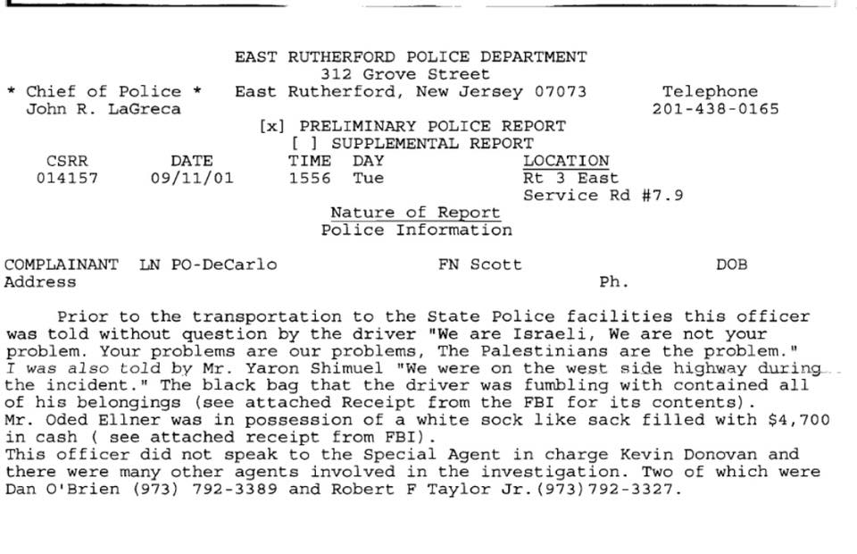](https://scontent-mia3-1.xx.fbcdn.net/v/t1.0-9/41556926_232895220904866_350630719044714496_n.jpg?_nc_cat=0&oh=3ae99602f8ef705a7bb8af3dd35d848c&oe=5C2A6CE2)**

[**https://www.facebook.com/photo.php?fbid=232895274238194&set=p.232895274238194&type=3&theater**](https://www.facebook.com/photo.php?fbid=232895274238194&set=p.232895274238194&type=3&theater)

**[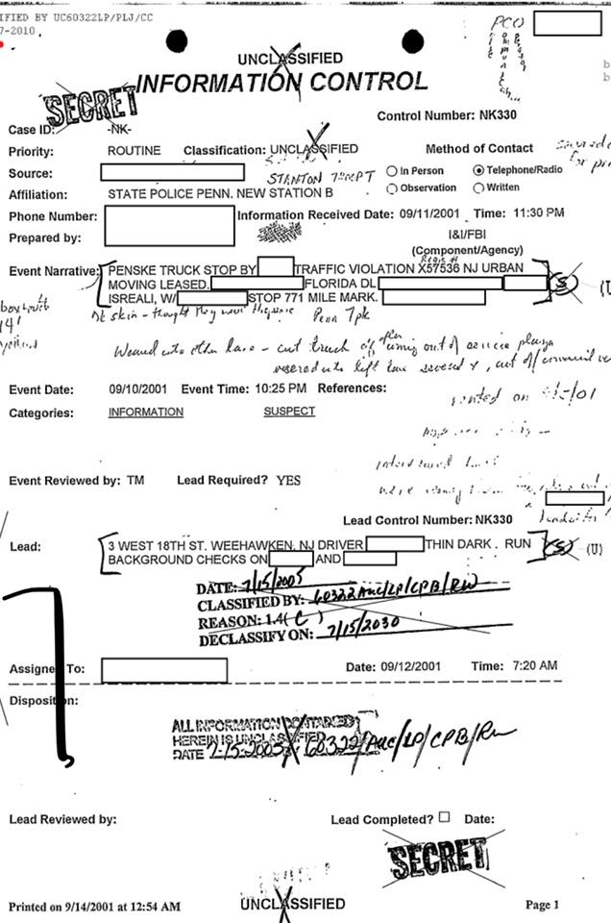](https://scontent-mia3-1.xx.fbcdn.net/v/t1.0-9/41482779_232895280904860_2123702757679431680_n.jpg?_nc_cat=0&oh=dc44e7af82a39b872a0b2ad091adc2fe&oe=5C2F0777)**

[**https://www.facebook.com/photo.php?fbid=232895317571523&set=p.232895317571523&type=3&theater**](https://www.facebook.com/photo.php?fbid=232895317571523&set=p.232895317571523&type=3&theater)

**[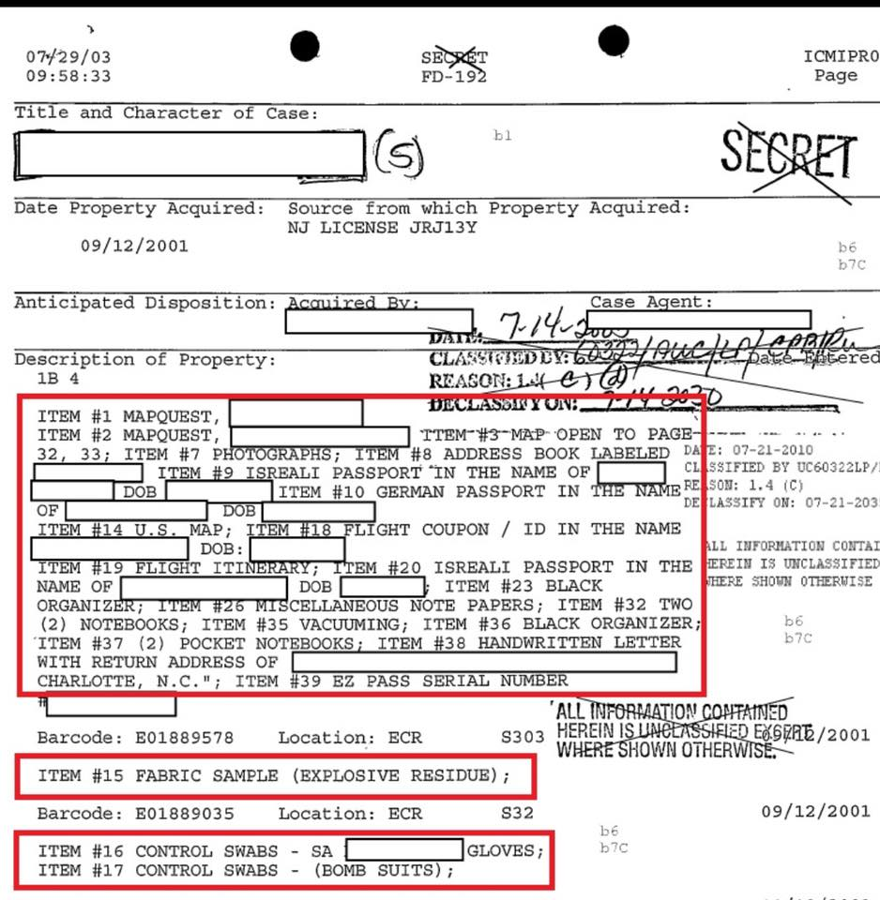](https://scontent-mia3-1.xx.fbcdn.net/v/t1.0-9/41646998_232895320904856_2200031022383366144_n.jpg?_nc_cat=0&oh=c562d1a7123d886d8b10d23e81a9912c&oe=5BEEC89A)**

THERES the Israeli/Mossad/Nazi connection. The Dancing Israelis.

**FB: Israeli nukes to trigger Fukushima, Israeli nukes installed as 'security cameras' the week before, to blow the reactors.**

**JJ: France actually pulled off Fukushima! All my years growing up.... their national flag was just solid white. NOW they gotta start shit.**

Continued from Part 5

**You would be wise to start at**[**PART 1 FOUND HERE**](https://theyig.ning.com/front-page-news/the-pure-evil-of-911-yes-they-did-bet-on-it-part-1)

**[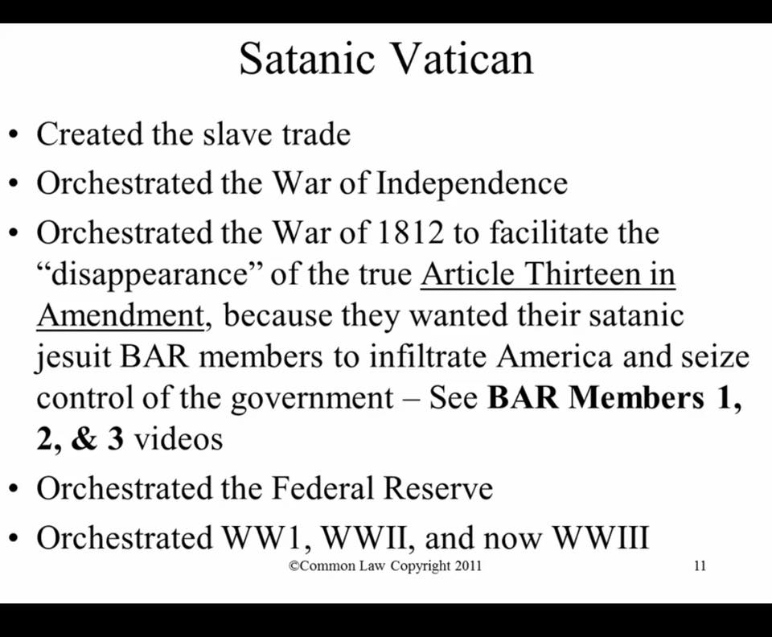](https://scontent-mia3-1.xx.fbcdn.net/v/t1.0-9/41550894_232978244229897_3731768500763492352_n.jpg?_nc_cat=0&oh=21d2ded319c34be3bb5f54e2019ab2c3&oe=5C2ACA97)**

**[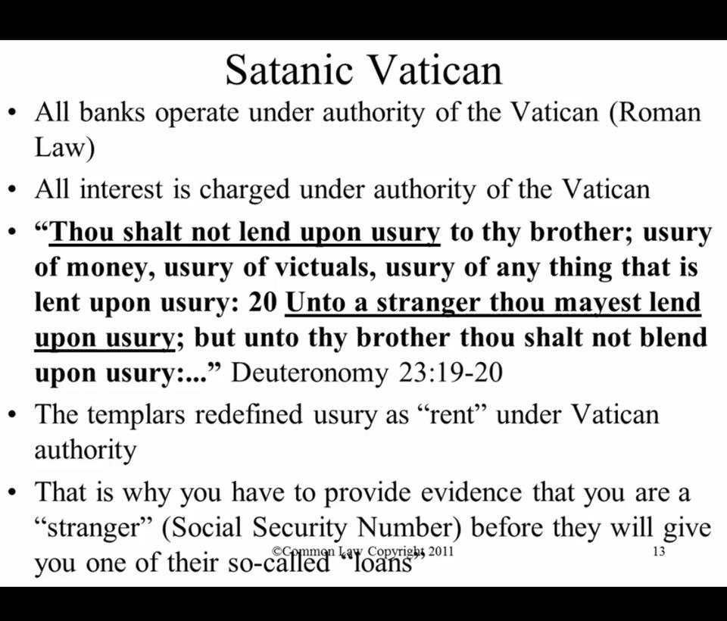](https://scontent-mia3-1.xx.fbcdn.net/v/t1.0-9/41477355_232978294229892_8255453869111246848_n.jpg?_nc_cat=0&oh=c02ffcb3644030bd96af549d4748abf7&oe=5C193F05)**

**[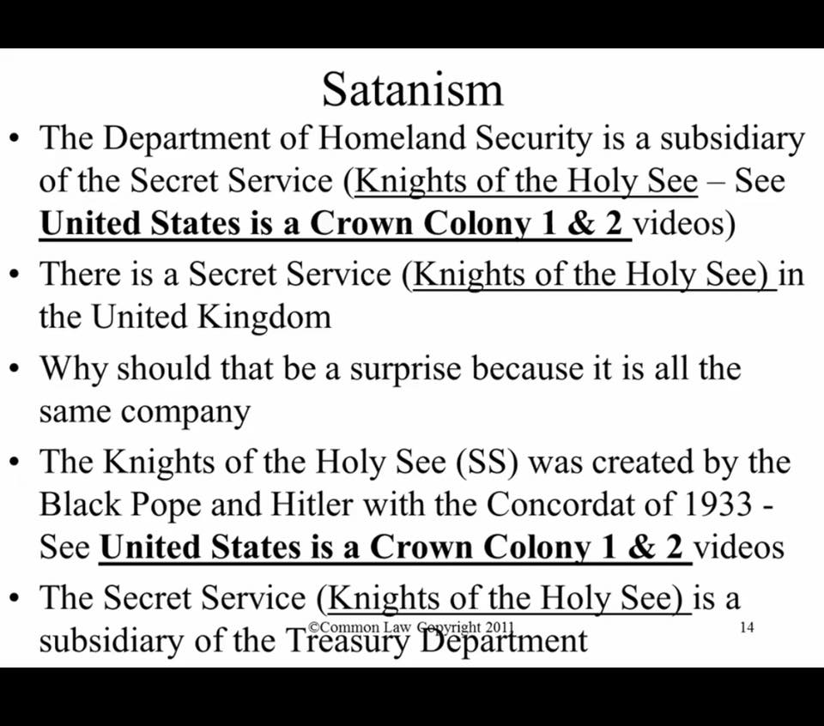](https://scontent-mia3-1.xx.fbcdn.net/v/t1.0-9/41495227_232978344229887_8882851352997265408_n.jpg?_nc_cat=0&oh=83be7d2ef22b695b3e6d069b11d40b56&oe=5C1CA777)**

**[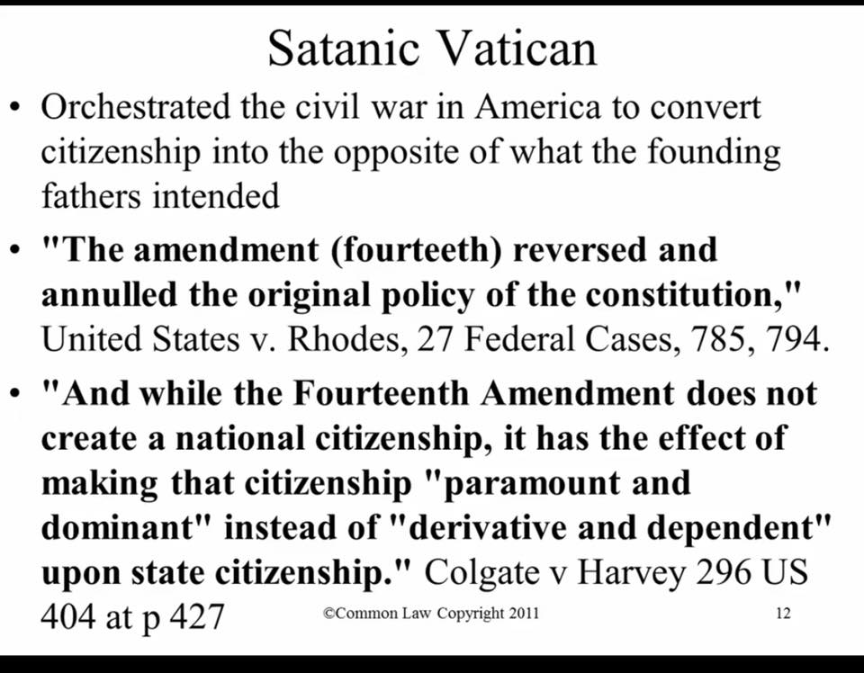](https://scontent-mia3-1.xx.fbcdn.net/v/t1.0-9/41661475_232978400896548_4571668953432064000_n.jpg?_nc_cat=0&oh=b30837327324b3255fc611334613c0fd&oe=5C22AF7A)**

**[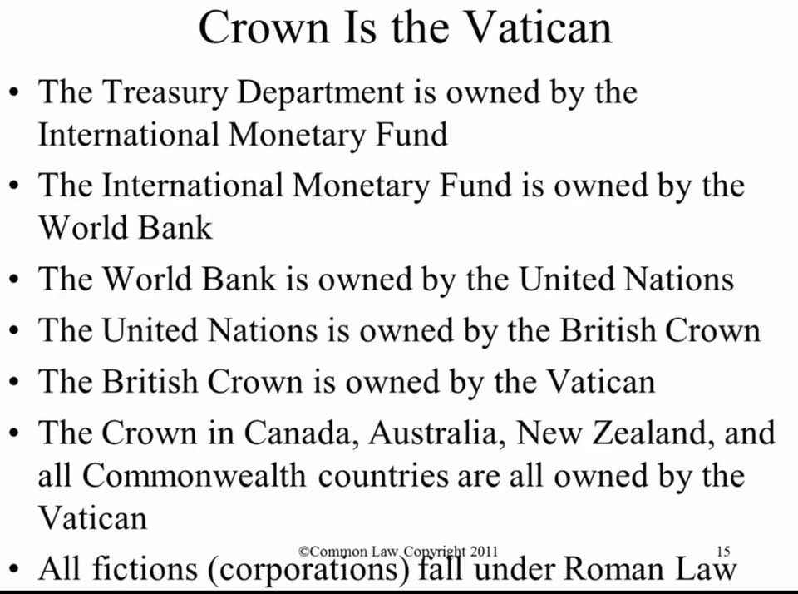](https://scontent-mia3-1.xx.fbcdn.net/v/t1.0-9/41498812_232978447563210_7315376735942344704_n.jpg?_nc_cat=0&oh=675afb5be650db628c25358462ac378b&oe=5C2EE9F1)**

Rome never fell. It moved is all. Israel being Gods chosen ones. WRONG.  
In Israel’s case.... God is in fact an Acronym.  
For Greenland Of Denmark. Home of the Greco Roman Empire AND the Black Pope

~~~

This is where it hit a HUGE nerve with me. The one High Value Target that i mentioned earlier that would piss many off  
  
Pat Tillman.  
They thought that it was cute to bet on killing our Hero and it wouldn’t get back to us.  
Wrong thought process assholes.

Now we are gonna get into some good stuff

If I didnt go back and explain the backstory about the FBCAN and notice that when Q mentions BRIDGE_1 and BRIDGE_2.....why this would seriously make every bell and whistle go off.

SERCO had a board meeting on 9/11 on the 47th floor first thing in the morning. One of the American CEO’s was Chris Hyman. He had breakfast at the top of WTC 1 real early and went down to the 47th floor for the meeting. He addressed the shareholders ( which was a Saudi Sheik, reps from the US and UK Teachers Pension Fund and others). Once he was done addressing them. He got back in the elevator.....the only people that lived were the ones in his elevator car.....

There were also Agents for Northern Trust present. Nothing like eating your own....

So if they are all dead....and you know WHO was there and what shares they owned....you just pulled off an even BIGGER Dick move

Because after that....they used a Patent made by Renaissance Technologies called “System and Method for Executing Synchronized Trades in Multiple Exchanges”. US patent 20160035027A1  
They were pulling off a MASSIVE High Frequency insider Trading scam all while people were jumping to their death.

Before the planes even hit.....the War Game was given a green light by the UK Ministry of Defence to Serco shareholders and good ole Wilbur Ross to give the Stand Down Order to Rudy Giuliani aides and his office of Emergency Management in WTC 7 and allow the Red Team to engage in attacks to get the ball rolling.

**FB: so why is Giuliani on Team Trump?**

**JJ: Giuliani and Trump OWNED New York. There aren’t 2 men that loved that city more. Well wait. The 3rd one is making a special comeback. His aides all most likely had guns at their heads. When i heard that Rudy was meeting with Mueller.....**

**[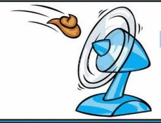](https://scontent-mia3-1.xx.fbcdn.net/v/t1.0-9/41661471_233015267559528_5261196905941041152_n.jpg?_nc_cat=0&oh=2f7338d11aea2ba9caf7c2b34db392ab&oe=5C1CE034)**

One of Rudy’s best buddies, John O’Neill just started working at WTC 7 as the Security head a few days prior. Now if you go back and read the SES Con Air Prisoner Tracking Patent.....you are going to see why an earlier meeting of these 2 REALLY was HUGE  
Bob Mueller Coordinated the swat team attacks on WTC 7 and they made John O’Neill a High Value Target. Nothing like killing your buddy to just get the blood boiling.

Now the Churchill’s Toyshop actually has one place in the US they they do their Biologial testing in for nerve gas agents. It’s in Chicago. At Northwestern University.  
How do i know.....  
  
I was on the job......

**[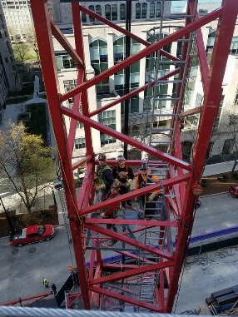](https://scontent-mia3-1.xx.fbcdn.net/v/t1.0-9/41564794_233007860893602_7015871542357655552_n.jpg?_nc_cat=0&oh=7dc2bfc4e12c7d6b72544b3e4f7dc042&oe=5C36135D)**

**[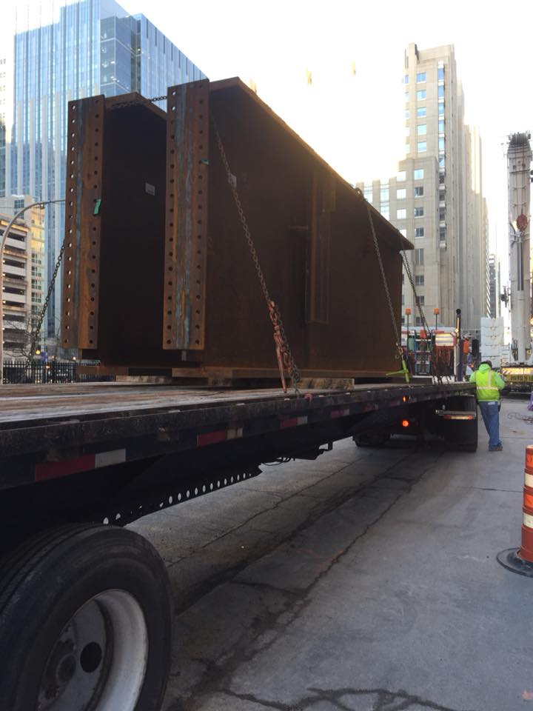](https://scontent-mia3-1.xx.fbcdn.net/v/t1.0-9/41505181_233010580893330_5354707874507390976_n.jpg?_nc_cat=0&oh=c8daf980cbe3659d400aa99d5bde485c&oe=5C3349B6)**

**FB: What is that Jason?**

**JJ: those are floor headers. Crane brings em in. Toss a few bolts in it. Cut it loose and detail gang stuffs the rest and impacts and wash, lather, repeat.**

**[](https://scontent-mia3-1.xx.fbcdn.net/v/t1.0-9/41500294_233010654226656_3891961409285652480_n.jpg?_nc_cat=0&oh=8423540108c605efb77eedff1c7939e9&oe=5C2814CA)**From a couple years ago. They built a Brand new facility. NOW it makes sense why the Iron was so massive.

Want to be COMPLETELY MIND BLOWN.  
The Matrix came out in 1999. Look at the date on Neo’s passport.....cant even make this shit up anymore

**[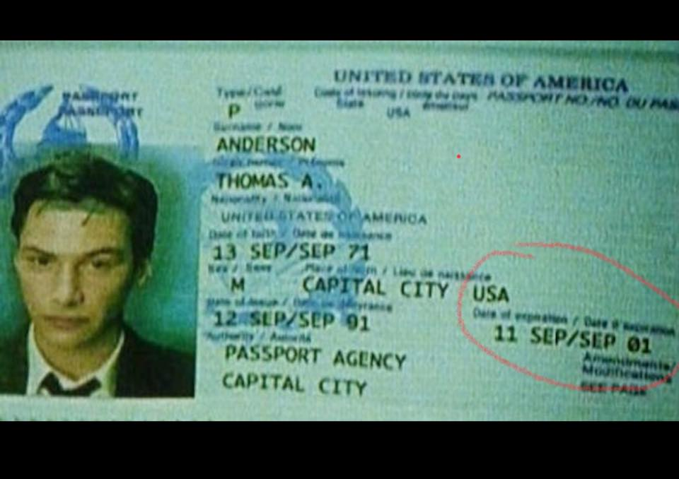](https://scontent-mia3-1.xx.fbcdn.net/v/t1.0-9/41519867_233015810892807_6349826753036288000_n.jpg?_nc_cat=0&oh=ca32205eeaa7ebaf7f4805aa755cd381&oe=5C26A835)**

**FB: Who is that?**

**JJ: That’s Keanu Reeves’s character in the Matrix. PLEASE tell me you have seen them.  
ITS OUR DOCUMENTARY......**

When people realize HOW BIG this truly is and was....and what we finally receive for the big Win...... most wont believe me. But thats ok. Future proves past. But we are about to make the change for ALL Human Kind

**[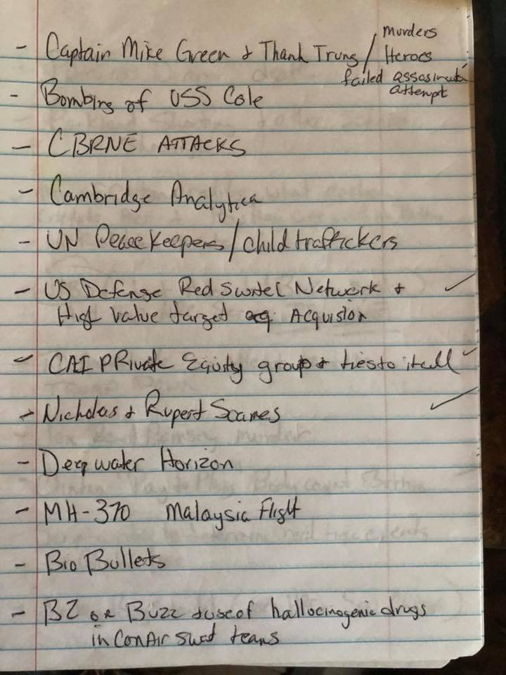](https://scontent-mia3-1.xx.fbcdn.net/v/t1.0-9/41575463_233049124222809_8726562440898150400_n.jpg?_nc_cat=0&oh=0238b7c44b280df4ae92ecaa08f16c98&oe=5C1ED99D)**

**[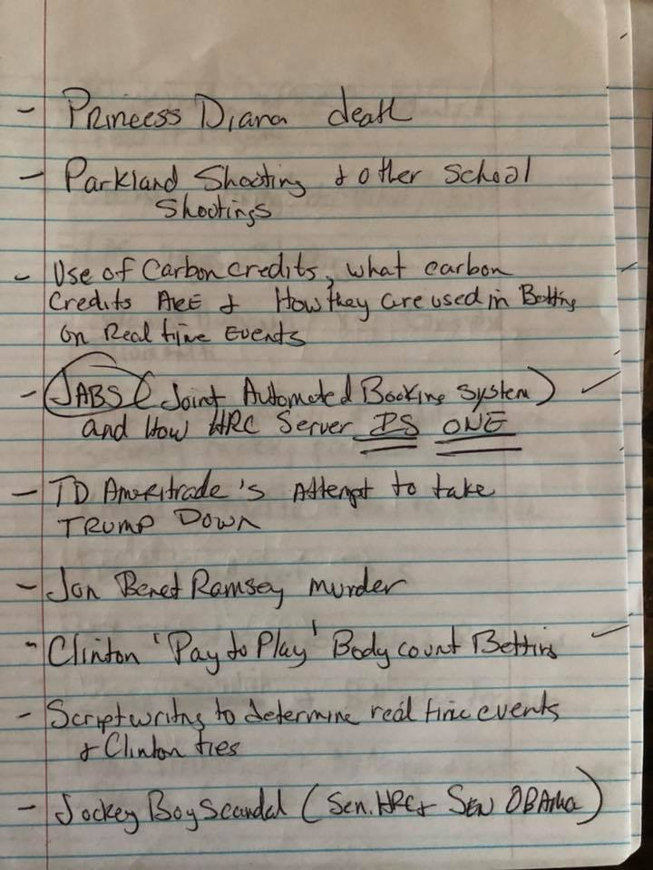](https://scontent-mia3-1.xx.fbcdn.net/v/t1.0-9/41661518_233049157556139_8871609327639592960_n.jpg?_nc_cat=0&oh=b7e0a09257e812174485e4c6b8359103&oe=5C1C63A2)**

**[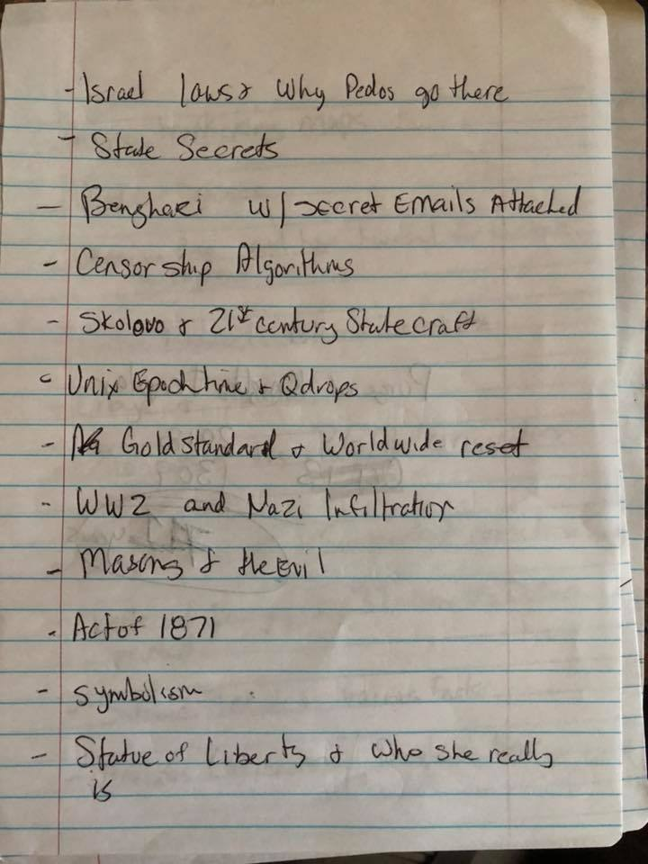](https://scontent-mia3-1.xx.fbcdn.net/v/t1.0-9/41538344_233049254222796_5476781062786908160_n.jpg?_nc_cat=0&oh=7323206bc4cac16a3350468120d25d18&oe=5C267A54)**

**FB:  statue of liberty: we'll take your poor etc...**

**JJ: She wasn’t given to us by the Satanic Illuminati. We were actually gifted her by the Gnostic Illuminati. The Light beings**

**JJ: Her name is Goddess LuSophia Gaia Saraswati Amunet. In case it EVER comes up in a trivia night**

**JJ: Remember. We have been fed lies our whole lives**

**[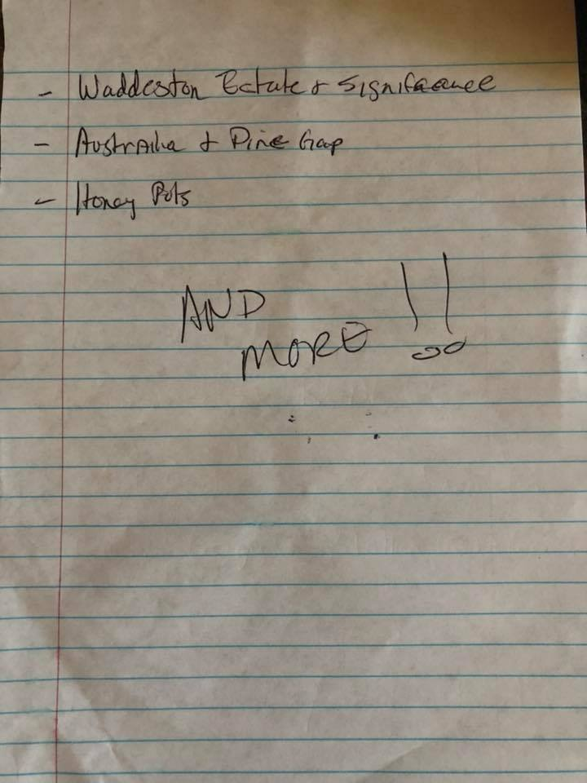](https://scontent-mia3-1.xx.fbcdn.net/v/t1.0-9/41542216_233049310889457_4442975738785693696_n.jpg?_nc_cat=0&oh=60ff014c8fd33c0d8b600561e367f1e0&oe=5C1A4B4B)**GHWB made 1 Trillion dollars off betting on 9/11.

Obama and his Kenyan kickstand Michelle are both involved in 9/11 as well. They were both working for Sidney Austin....a law firm in NYC.

Warren Buffet is 100% linked to 9/11. He was in a bunker in Nebraska with 300 Goldman Sachs bankers on 9/11. Doesn’t sound like a sleepover or anything.

Dick Cheney was the mastermind behind it all

There are well over 100 people directly tied to 9/11. Then you have Governments, Banks, the Mossad. It was literally “Whoever wanted to get a free shot in to destroying America...the line forms to the Right.”  
People complained about the omnibus bill. He’s already paid that back and working on a nice kitty that he will most likely give to the families.  
That’s full circle.