10 Life Quotes from Dr. Seuss

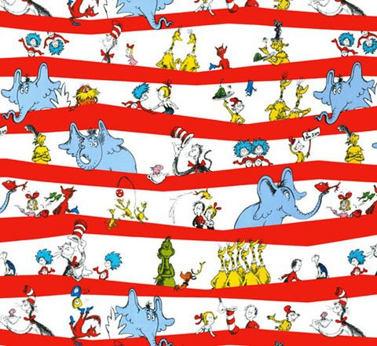

Dr. Seuss on…

http://www.elephantjournal.com/2012/08/10-life-quotes-from-dr-seuss/

1. being yourself:

“Be who you are and say what you feel, because those who mind don’t matter and those who matter don’t mind.”
2. freedom and choice:

“You have brains in your head. You have feet in your shoes. You can steer yourself, any direction you choose.”
3. no regrets:

“Don’t cry because it’s over, smile because it happened.”
4. clarity:

“Sometimes the questions are complicated and the answers are simple.”
5. creativity:

“I like nonsense, it wakes up the brain cells. Fantasy is a necessary ingredient in living, it’s a way of looking at life through the wrong end of a telescope. Which is what I do, and that enables you to laugh at life’s realities.”
6. love:

“You know you’re in love when you can’t fall asleep because reality is finally better than your dreams. “
7. activism:

“Unless someone like you cares a whole awful lot, nothing is going to get better. It’s not.”
8. brain power:

“Think left and think right and think low and think high. Oh, the thinks you can think up if only you try!”
9. looking after Earth:

“I speak for the trees, for the trees have no tongues.”
10. process and patience:

“If things start happening, don’t worry, don’t stew, just go right along and you’ll start happening too.”
=========================================================================================================

