Dan Millman 1946 –
http://en.wikipedia.org/wiki/Dan_Millman
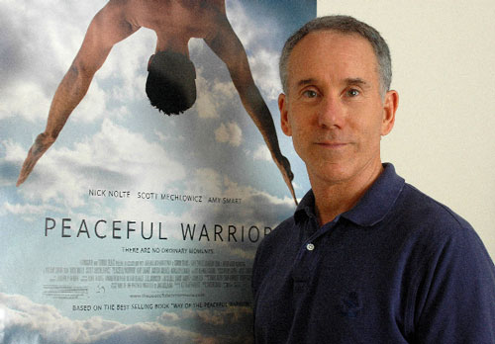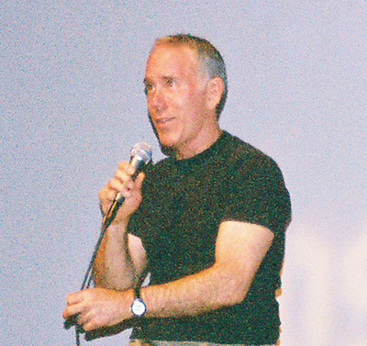
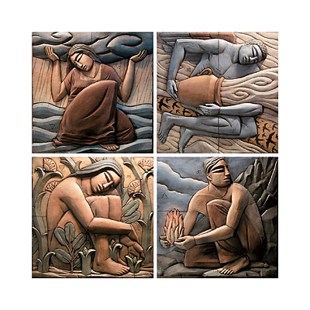
Dan Millman (born Feb 22, 1946) is an author of thirteen self-help books, the most famous of which is the semi-autobiographical novel, Way of the Peaceful Warrior (1980). As the winner of the 1964 World Trampoline Championship in London, he co-captained the 1968 NCAA University of California gymnastics team and has also worked as a gymnastics instructor at Stanford University and a professor of physical education at Oberlin College. He is connected to the human potential movement along with Anthony Robbins. His early background includes modern dance and Aikido. Later he studied various yogas and martial arts while he travelled around the world, which resulted in his new calling as spiritual and motivational speaker and author.

Contents

1 Way of the Peaceful Warrior (1980)
  - 1.1 Summary
- 2 Chronological list of books by Dan Millman
- 3 Books grouped by topic
- 4 External links

Way of the Peaceful Warrior (1980)

Way of the Peaceful Warrior, Millman's first book, is a work of autobiographical fiction set mostly during his college years. Initially, the book had only modest sales, until Hal Kramer reportedly came out of retirement to republish the book and help make it a best seller.
In the summer of 2006, Lions Gate Films released a film version, Peaceful Warrior, starring Scott Mechlowicz and Nick Nolte.

[] Summary
The story tells of a chance meeting with a gas station attendant who becomes a mentor to the young gymnast, Dan Millman, who names the attendant "Socrates". When Millman's right leg is shattered in a motorcycle accident, Socrates becomes Millman's spiritual teacher and shows Millman how to become a Peaceful Warrior.

[] Chronological list of books by Dan Millman
- Whole body fitness: mind, body, and spirit (1979). ISBN 0-517-53853-9
- Way of the Peaceful Warrior: A Book That Changes Lives (1980). Fictionalized autobiography. ISBN 0-915811-89-8
- Sacred Journey of the Peaceful Warrior (1991). Details the world travels of the character in the above book. ISBN 0-915811-33-2
- Secret of the Peaceful Warrior: A Story About Courage and Love (1991). Children's book. ISBN 0-915811-23-5
- No Ordinary Moments: A Peaceful Warrior's Guide to Daily Life ISBN 0-915811-40-5
- Quest for the Crystal Castle: A Peaceful Warrior Children's Book (1992). ISBN 0-915811-41-3
- The Life You Were Born to Live: A Guide to Finding Your Life Purpose (1995). ISBN-10: 0-915811-60-X
- The Laws of Spirit: A Tale of Transformation (1995) ISBN 0-915811-93-6
- Everyday Enlightenment: The Twelve Gateways to Personal Growth (1998). ISBN 0-446-67497-4
- Body Mind Mastery: Creating Success in Sport and Life (1999). ISBN 1-57731-094-2
Previous versions of same book:
- The Warrior Athlete: Body, Mind & Spirit (1985). ISBN 0-913299-22-7
- The Inner Athlete (1994). ISBN 0-913229-70-9
- Divine Interventions: True Stories of Mysteries and Miracles That Change Lives (with Doug Childers, 2000) ISBN 1-57954-338-3
- Living on Purpose: Straight Answers to Life's Tough Questions (2000) ISBN 1-57731-132-9
- Way of the Peaceful Warrior: A Book That Changes Lives, H J Kramer, 20th Anniversary ion, (2000) ISBN 0-915811-89-8
- The Journeys of Socrates (April 1, 2005) Prequel to first book. ISBN 0-06-083302-5
- Wisdom of the Peaceful Warrior: A Companion to the Book That Changes Lives (January 2007)

[] Books grouped by topic
Dan Millman groups his books into three major categories: [1]
- Novels for inspiration and to provide the big picture:
  - Way of the Peaceful Warrior
  - Sacred Journey
  - The Journeys of Socrates
- Non-fiction
  - Core teaching and practical guide books:
    - Wisdom Of The Peaceful Warrior
    - Living on Purpose
    - No Ordinary Moment
    - The Life You Were Born to Live
    - Everyday Enlightenment
    - The Laws of Spirit
  - Specialty and Inspiration:
    - Body Mind Mastery
    - Divine Interventions
- Children's books:
  - Secret of the Peaceful Warrior
  - Quest for the Crystal Castle

[] External links
- The Peaceful Warriors Way - Dan Millman's personal website.
- peacefulwarrior.com - Main promotional website
- Interview with Spiritual Endeavors discusses training philosophy, fiction in book
- Peaceful warrior (2006) - The movie directed by Victor Salva and starring Nick Nolte, based on the book Way of the Peaceful Warrior
- Dan Millman - Brief bio and motivational speaking topics
- iFilm.com movie preview and interviews
- Working and Living Life Smarter Conference - keynoted by Dan Millman (November 2006)
- West View Trampoline Community - Trampoline History, about Dan Millman
- U.S. Gymnastics and honored guests Hall of Fame website - Dr. Larry Banner's page on Dan Millman
Retrieved from "http://en.wikipedia.org/wiki/Dan_Millman"
Categories: College gymnasts | College gymnastics coaches | American motivational speakers | American motivational writers | American self-help writers | American spiritual writers | New Age authors | Personal development | American trampolinists | People associated with the Human Potential Movement

