Henry Steel Olcott 1832-1907
http://en.wikipedia.org/wiki/Henry_Steel_Olcott
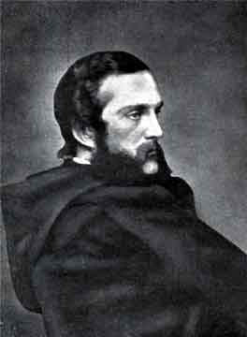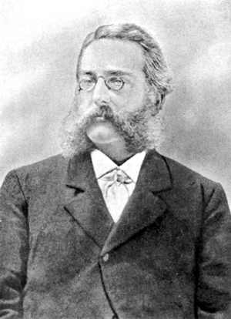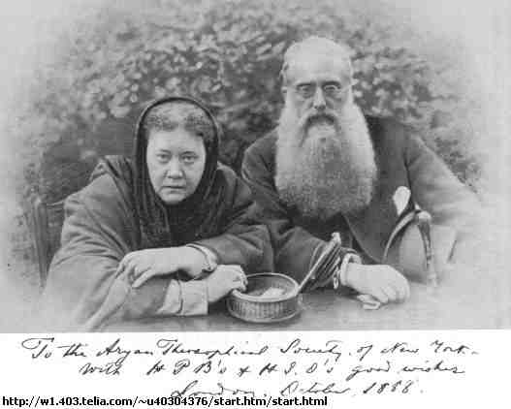
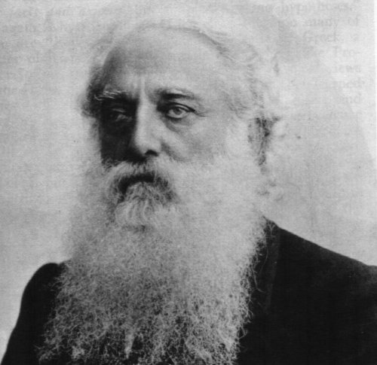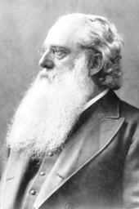
Colonel Henry Steel Olcott (1832-1907), founder and first president of the Theosophical Society, is well-known as the first prominent person of Western descent to make a formal conversion to Buddhism. His subsequent actions as president of the Theosophical Society helped Buddhism into a new renaissance. He is still honoured in Sri Lanka for these efforts.

Contents
- 1 Overview
- 2 Notes
- 3 Works
- 4 References
- 5 External links

Overview
Olcott grew up on his father's New Jersey farm. In 1860 he married Mary Epplee Morgan daughter of the rector of Trinity parish, New Rochelle; they had three sons. Olcott was agricultural editor of the New York Tribune (1858–60), and sometimes submitted newspaper articles on various other subjects. He served in the Civil War and afterward was admitted to the bar in New York City. With the rank of Colonel, he was special commissioner in the U.S. War and Navy departments (1863–66). He published a genealogy of his family that traced him back to Thomas Olcott, one of the founders of Hartford, Connecticut in 1636.
Some of his newspaper articles covered the Spiritualist movement. In 1874 while writing a series of articles on the seances of the Eddy brothers of Chittenden, Vermont he met Helena Blavatsky when both visited the Eddy farm. In early 1875 Olcott was called upon by prominent Spiritualists to investigate the charge of fraud against the mediums Jenny and Nelson Holmes, who had claimed to materialize the famous spirit control Katie King (Doyle 1926: volume 1, 269-277).
In September of 1875, Henry, Helena and others, notably William Quan Judge formed the Theosophical Society. In December 1878 they left New York in order to move the headquarters of the Society to India, where it later was established at Adyar. They landed at Bombey Feb 16 1879.^{[1]} Olcott acted as adviser to the committee appointed to design a Buddhist flag. Blavatsky eventually went to live in London where she died, but Henry stayed in India and pursued the work of the society there. The Theosophical society built several Buddhist schools in Sri Lanka, most notably Ananda College, Nalanda College, Dharmaraja College and Visakha Vidyalaya. After his death, the leadership of the society devolved onto the shoulders of Blavatsky's protege Annie Besant.
Olcott Road, a major street in Colombo, has been named after him. A statue of him has been built in Maradana. He is still fondly remembered by many Sri Lankans and especially the students of these schools who have gone on to become Prime Ministers and industry leaders of the country.

Notes
- ^ http://www.theosociety.org/pasadena/mahatma/ml-ccpre.htm

Works
- Theosophy, Religion, and Occult Science, 1885
- Old Diary Leaves (6 volumes)
- Descendents of Thomas Olcott, 1872
- A Buddhist catechism; Madras 1881
- Human Spirits and Elementaries; 1875
- Old diary leaves, Inside the occult, the true story of Madame H. P. Blavatsky; Running Press, Philadelphia 1975; ISBN 0-914294-31-8
- Outlines of the first course of Yale agricultural lectures; C. M. Saxton, Barker & Co., New York 1860
- People from the other world; American Publishing Co., Hartford 1875
- Sorgho and Imphee, the Chinese and African sugar canes; A. O. Moore, New York 1857
- The Golden Rules of Buddhism; 1887
- The Hindu Dwaita Catechism; 1886
- The kinship between Hinduism and Buddhism; The Maha-Bodhi society, Calcutta 1893
- The Life of the Budha and its Lessons; 1912
- The poor pariah; Addison & Co., Madras 1902

Theosophy, Religion, and Occult Science; New York 1885

References
- Doyle, Arthur Conan. The History of Spiritualism. New York: G.H. Doran, Co. Volume 1: 1926 Volume 2: 1926
- Motwani, Kewal: Colonel H. S. Olcott, a forgotten page in American history; Ganesh, Madras 1955 (englisch)
- Murphet, Howard: Hammer on the mountain, life of Henry Steel Olcott (1832-1907); Theosophical Publishing House, Wheaton 1972; ISBN 0-8356-0210-9
- Prothero, Stephen R.: The white Buddhist, the Asian odyssey of Henry Steel Olcott; Indiana University Press, Bloomington 1996; ISBN 0-253-33014-9
- Williams, Gertrude Marvin. Priestess of the Occult, Madame Blavatsky. New York : A. A. Knopf, 1946.

External links
- Theosophy Library Online
- Articles by and relating to H.S. Olcott
- Articles on Olcott
- Some articles by Olcott
- Works by Henry Steel Olcott at Project Gutenberg
=============================================================================================

