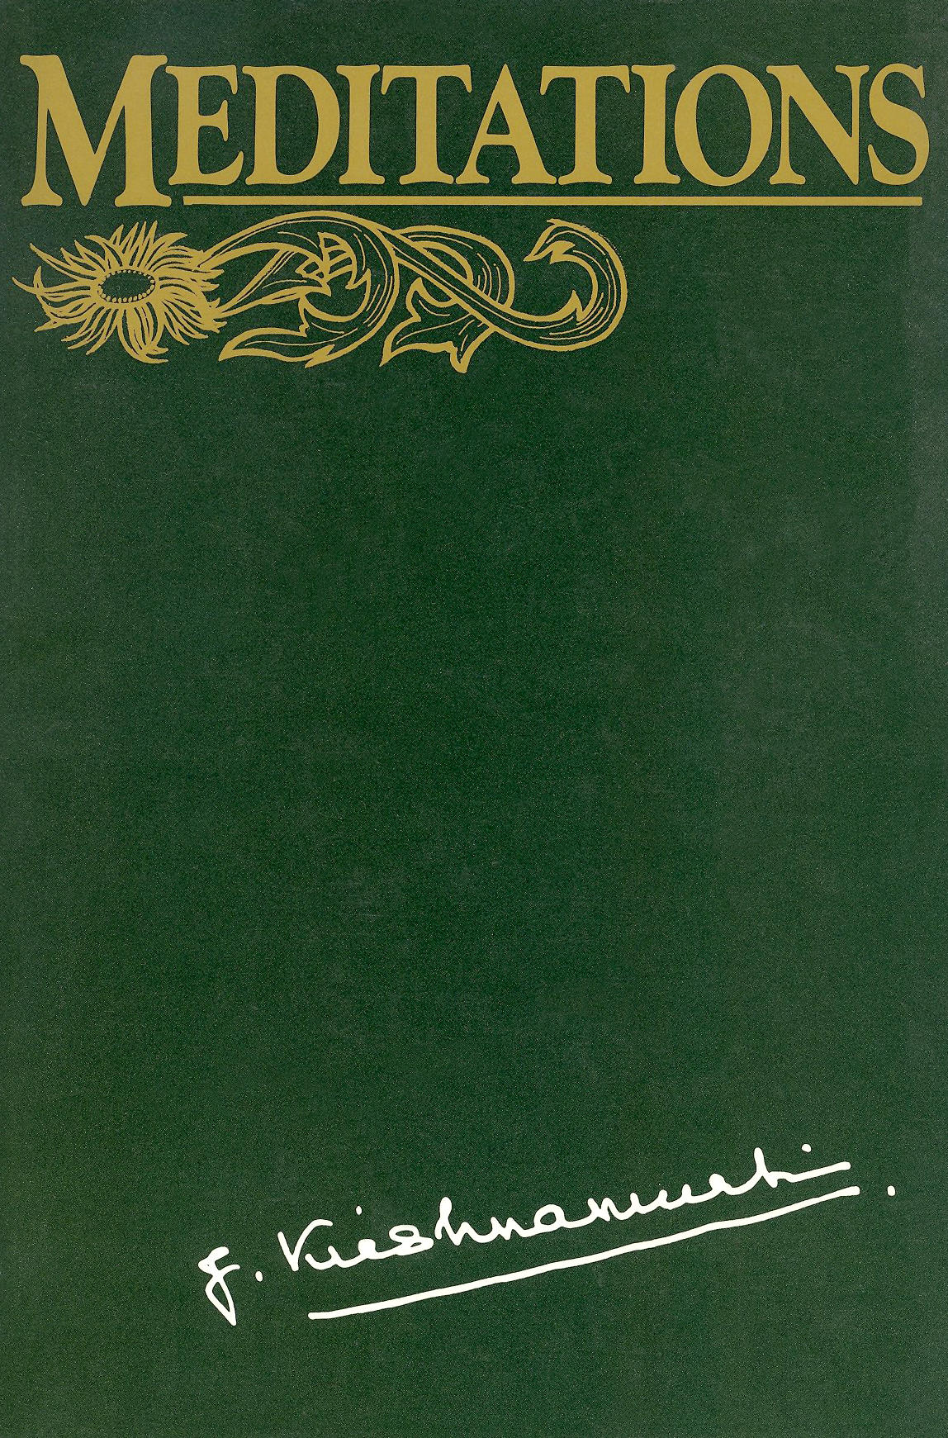

Meditations
Copyright © 1979 Krishnamurti Foundation Trust Ltd.

J. KRISHNAMURTI

MEDITATIONS
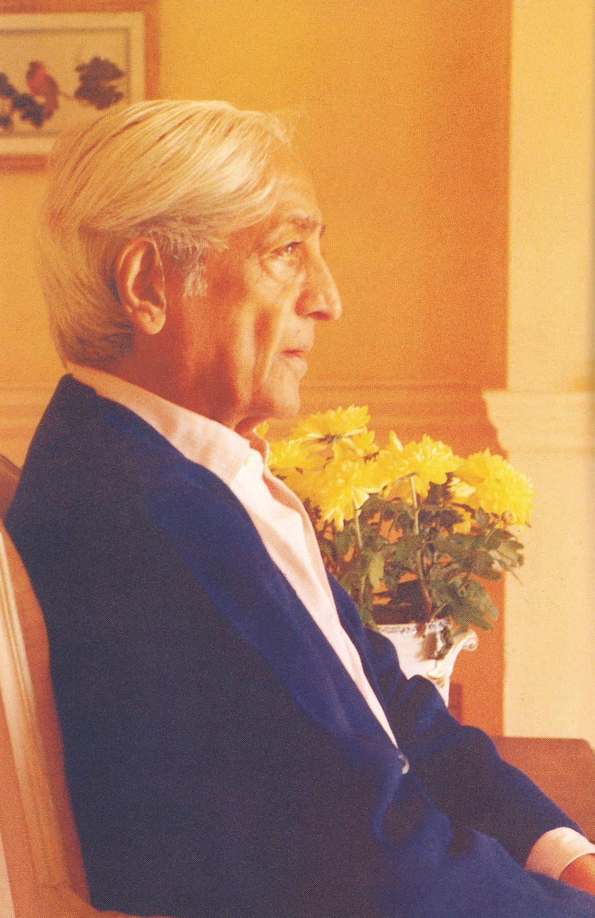
FOREWORD

Man, in order to escape his conflicts, has invented many forms of meditation. These have been based on desire, will and the urge for achievement and imply conflict and a struggle to arrive. This conscious, deliberate striving is always within the limits of a conditioned mind and in this there is no freedom. All effort to meditate is the denial of meditation.
Meditation is the ending of thought. It is only then that there is a different dimension which is beyond time.

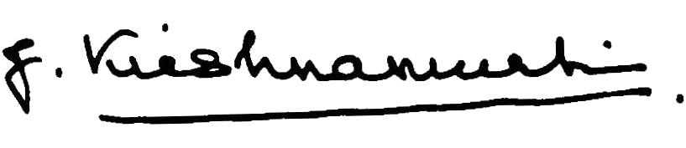
March, 1979
A meditative mind is silent. It is not the silence which thought can conceive of; it is not the silence of a still evening; it is the silence when thought—with all its images, its words and perceptions—has entirely ceased. This meditative mind is the religious mind—the religion that is not touched by the church, the temples or by chants.
The religious mind is the explosion of love. It is this love that knows no separation. To it, far is near. It is not the one or the many, but rather that state of love in which all division ceases. Like beauty, it is not of the measure of words. From this silence alone the meditative mind acts.
Meditation is one of the greatest arts in life—perhaps the greatest, and one cannot possibly learn it from anybody. That is the beauty of it. It has no technique and therefore no authority. When you learn about yourself, watch yourself, watch the way you walk, how you eat, what you say, the gossip, the hate, the jealousy—if you are aware of all that in yourself, without any choice, that is part of meditation.
So meditation can take place when you are sitting in a bus or walking in the woods full of light and shadows, or listening to the singing of birds or looking at the face of your wife or child.
It’s curious how all-important meditation becomes; there’s no end to it nor is there a beginning to it. It’s like a raindrop: in that drop are all the streams, the great rivers, the seas and the waterfalls; that drop nourishes the earth and man; without it, the earth would be a desert. Without meditation the heart becomes a desert, a wasteland.
Meditation is to find out whether the brain, with all its activities, all its experiences, can be absolutely quiet. Not forced, because the moment you force, there is duality. The entity that says, “I would like to have marvelous experiences, therefore I must force my brain to be quiet”—will never do it. But if you begin to enquire, observe, listen to all the movements of thought, its conditioning, its pursuits, its fears, its pleasures, watch how the brain operates, then you will see that the brain becomes extraordinarily quiet; that quietness is not sleep but is tremendously active and therefore quiet. A big dynamo that is working perfectly hardly makes a sound; it is only when there is friction that there is noise.
Silence and spaciousness go together. The immensity of silence is the immensity of the mind in which a center does not exist.
Meditation is hard work. It demands the highest form of discipline—not conformity, not imitation, not obedience —but a discipline which comes through constant awareness, not only of the things about you outwardly, but also inwardly. So meditation is not an activity of isolation but is action in everyday life which demands cooperation, sensitivity and intelligence. Without laying the foundation of a righteous life, meditation becomes an escape and therefore has no value whatsoever. A righteous life is not the following of social morality, but the freedom from envy, greed and the search for power—which all breed enmity. The freedom from these does not come through the activity of will but by being aware of them through self-knowing. Without knowing the activities of the self, meditation becomes sensuous excitement and therefore of very little significance.
Always to seek for wider, deeper, transcendental experiences is a form of escape from the actual reality of “what is,” which is ourselves, our own conditioned mind. A mind that is awake, intelligent, free, why should it need, why should it have, any “experience” at all? Light is light; it does not ask for more light.
Meditation is one of the most extraordinary things, and if you do not know what it is you are like the blind man in a world of bright color, shadows and moving light. It is not an intellectual affair, but when the heart enters into the mind, the mind has quite a different quality; it is really, then, limitless, not only in its capacity to think, to act efficiently, but also in its sense of living in a vast space where you are part of everything.
Meditation is the movement of love. It isn’t the love of the one or of the many. It is like water that anyone can drink out of any jar, whether golden or earthenware: it is inexhaustible. And a peculiar thing takes place which no drug or self-hypnosis can bring about: it is as though the mind enters into itself, beginning at the surface and penetrating ever more deeply, until depth and height have lost their meaning and every form of measurement ceases. In this state there is complete peace—not contentment which has come about through gratification—but a peace that has order, beauty and intensity. It can all be destroyed, as you can destroy a flower, and yet because of its very vulnerability it is indestructible. This meditation cannot be learned from another. You must begin without knowing anything about it, and move from innocence to innocence.
The soil in which the meditative mind can begin is the soil of everyday life, the strife, the pain and the fleeting joy. It must begin there, and bring order, and from there move endlessly. But if you are concerned only with making order, then that very order will bring about its own limitation, and the mind will be its prisoner. In all this movement you must somehow begin from the other end, from the other shore, and not always be concerned with this shore or how to cross the river. You must take a plunge into the water, not knowing how to swim. And the beauty of meditation is that you never know where you are, where you are going, what the end is.
Meditation is not something different from daily life; do not go off into the corner of a room and meditate for ten minutes, then come out of it and be a butcher—both metaphorically and actually.
Meditation is one of the most serious things. You can do it all day, in the office, with the family, when you say to somebody, “I love you,” when you are considering your children. But then you educate them to become soldiers, to kill, to be nationalized, to worship the flag, educating them to enter into this trap of the modern world.
Watching all that, realizing your part in it, all that is part of meditation. And when you so meditate you will find in it an extraordinary beauty; you will act rightly at every moment; and if you do not act rightly at a given moment it does not matter, you will pick it up again—you will not waste time in regret. Meditation is part of life, not something different from life.
If you set out to meditate, it will not be meditation. If you set out to be good, goodness will never flower. If you cultivate humility, it ceases to be. Meditation is the breeze that comes in when you leave the window open; but if you deliberately keep it open, deliberately invite it to come, it will never appear.
Meditation is not a means to an end. It is both the means and the end.
What an extraordinary thing meditation is. If there is any kind of compulsion, effort to make thought conform, imitate, then it becomes a wearisome burden. The silence which is desired ceases to be illuminating; if it is the pursuit of visions and experiences, then it leads to illusions and self-hypnosis. Only in the flowering of thought and so ending thought does meditation have significance; thought can only flower in freedom, not in ever-widening patterns of knowledge. Knowledge may give newer experiences of greater sensation but a mind that is seeking experiences of any kind is immature. Maturity is the freedom from all experience; it is no longer under any influence to be or not to be.
Maturity in meditation is the freeing of the mind from knowledge, for it shapes and controls all experience. A mind which is a light to itself needs no experience. Immaturity is the craving for greater and wider experience. Meditation is the wandering through the world of knowledge and being free of it to enter into the unknown.
One has to find out for oneself, not through anybody. We have had the authority of teachers, saviors and masters. If you really want to find out what meditation is, you have to set aside all authority completely and totally.
Happiness and pleasure you can buy in any market at a price. But bliss you cannot buy—either for yourself or for another. Happiness and pleasure are time-binding. Only in total freedom does bliss exist. Pleasure, like happiness, you can seek, and find, in many ways. But they come and go. Bliss—that strange sense of joy—has no motive. You cannot possibly seek it. Once it is there, depending on the quality of your mind, it remains—timeless, causeless, a thing that is not measurable by time. Meditation is not the pursuit of pleasure or the search for happiness. Meditation, on the contrary, is a state of mind in which there is no concept or formula, and therefore total freedom. It is only to such a mind that this bliss comes—unsought and uninvited. Once it is there, though you may live in the world with all its noise, pleasure and brutality, they will not touch that mind. Once it is there, conflict has ceased. But the ending of conflict is not necessarily the total freedom. Meditation is the movement of the mind in this freedom. In this explosion of bliss the eyes are made innocent, and love is then benediction.
I do not know if you have ever noticed that when you give total attention there is complete silence. And in that attention there is no frontier, there is no center, as the “me” who is aware or attentive. That attention, that silence, is a state of meditation.
We hardly ever listen to the sound of a dog’s bark, or to the cry of a child or the laughter of a man as he passes by. We separate ourselves from everything, and then from this isolation look and listen to all things. It is this separation that is so destructive, for in that lies all conflict and confusion. If you listened to the sound of those bells with complete silence you would be riding on it—or, rather, the sound would carry you across the valley and over the hill. The beauty of it is felt only when you and the sound are not separate, when you are part of it. Meditation is the ending of the separation not by any action of will or desire.
Meditation is not a separate thing from life; it is the very essence of life, the very essence of daily living. To listen to those bells, to hear the laughter of that peasant as he walks by with his wife, to listen to the sound of the bell on the bicycle of the little girl as she passes by: it is the whole of life, and not just a fragment of it, that meditation opens.
Meditation is the seeing of what is and going beyond it.
Perception without the word, that is, without thought, is one of the strangest phenomena. Then the perception is much more acute, not only with the brain, but also with all the senses. Such perception is not the fragmentary perception of the intellect nor the affair of the emotions. It can be called a total perception, and it is part of meditation. Perception without the perceiver in meditation is to commune with the height and depth of the immense. This perception is entirely different from seeing an object without an observer, because in the perception of meditation there is no object and therefore no experience. Meditation can, however, take place when the eyes are open and one is surrounded by objects of every kind. But then these objects have no importance at all. One sees them but there is no process of recognition, which means there is no experiencing.
What meaning has such meditation? There is no meaning; there is no utility. But in that meditation there is a movement of great ecstasy which is not to be confounded with pleasure. It is the ecstasy which gives to the eye, to the brain and to the heart the quality of innocency. Without seeing life as something totally new, it is a routine, a boredom, a meaningless affair. So meditation is of the greatest importance. It opens the door to the incalculable, to the measureless.
Meditation is never in time; time cannot bring about mutation; it can bring about change which needs to be changed again, like all reforms. Meditation that springs out of time is always binding, there is no freedom in it and without freedom there is always choice and conflict.
We have to alter the structure of our society, its injustice, its appalling morality, the divisions it has created between man and man, the wars, the utter lack of affection and love that is destroying the world. If your meditation is only a personal matter, a thing which you personally enjoy, then it is not meditation. Meditation implies a complete radical change of the mind and the heart. This is only possible when there is this extraordinary sense of inward silence, and that alone brings about the religious mind. That mind knows what is sacred.
Beauty means sensitivity—a body that is sensitive, which means the right diet, the right way of living. Then the mind will inevitably and naturally, unknowingly, become quiet. You can’t make the mind quiet, because you are the mischief-maker, you are yourself disturbed, anxious, confused—how can you make the mind quiet? But when you understand what quietness is, when you understand what confusion is, what sorrow is and whether sorrow can ever end, and when you understand pleasure, then out of that comes an extraordinarily quiet mind; you don’t have to seek it. You must begin at the beginning and the first step is the last step, and this is meditation.
To meditate is to be innocent of time.
Meditation is not an escape from the world; it is not an isolating, self-enclosing activity, but rather the comprehension of the world and its ways. The world has little to offer apart from food, clothes and shelter, and pleasure with its great sorrows.
Meditation is wandering away from this world; one has to be a total outsider. Then the world has a meaning, and the beauty of the heavens and the earth is constant. Then love is not pleasure. From this all action begins that is not the outcome of tension, contradiction, the search for self-fulfillment or the conceit of power.
If you deliberately take an attitude, a posture, in order to meditate, then it becomes a plaything, a toy of the mind. If you determine to extricate yourself from the confusion and the misery of life, then it becomes an experience of imagination—and this is not meditation. The conscious mind or the unconscious mind must have no part in it; they must not even be aware of the extent and beauty of meditation—if they are, then you might just as well go and buy a romantic novel.
In the total attention of meditation there is no knowing, no recognition, nor the remembrance of something that has happened. Time and thought have entirely come to an end, for they are the center which limits its own vision.
At the moment of light, thought withers away, and the conscious effort to experience and the remembrance of it is the word that has been. And the word is never the actual. At that moment—which is not of time—the ultimate is the immediate, but that ultimate has no symbol, is of no person, of no god.
Meditation is to find out if there is a field which is not already contaminated by the known.
Meditation is the flowering of understanding. Understanding is not within the borders of time; time never brings understanding. Understanding is not a gradual process to be gathered little by little, with care and patience. Understanding is now or never; it is a destructive flash, not a tame affair; it is this shattering that one is afraid of and so one avoids it, knowingly or unknowingly. Understanding may alter the course of one’s life, the way of thought and action; it may be pleasant or not but understanding is a danger to all relationship. But without understanding, sorrow will continue. Sorrow ends only through self-knowing, the awareness of every thought and feeling, every movement of the conscious and that which is hidden. Meditation is the understanding of consciousness, the hidden and the open, and of the movement that lies beyond all thought and feeling.
It was one of those lovely mornings that have never been before. The sun was just coming up and you saw it between the eucalyptus and the pine. It was over the waters, golden, burnished—such light that exists only between the mountains and the sea. It was such a clear morning, breathless, full of that strange light that one sees not only with one’s eyes but with one’s heart. And when you see it the heavens are very close to earth, and you are lost in the beauty. You know, you should never meditate in public, or with another, or in a group: you should meditate only in solitude, in the quiet of the night or in the still, early morning. When you meditate in solitude, it must be solitude. You must be completely alone, not following a system, a method, repeating words, pursuing a thought, or shaping a thought according to your desire.
This solitude comes when the mind is freed from thought. When there are influences of desire or of the things that the mind is pursuing, either in the future or in the past, there is no solitude. Only in the immensity of the present this aloneness comes. And then, in quiet secrecy in which all communication has come to an end, in which there is no observer with his anxieties, with his stupid appetites and problems—only then, in that quiet aloneness, meditation becomes something that cannot be put into words. Then meditation is an eternal movement.
I don’t know if you have ever meditated, if you have ever been alone, by yourself, far away from everything, from every person, from every thought and pursuit, if you have ever been completely alone, not isolated, not withdrawn into some fanciful dream or vision, but far away, so that in yourself there is nothing recognizable, nothing that you touch by thought or feeling, so far away that in this full solitude the very silence becomes the only flower, the only light, and the timeless quality that is not measurable by thought. Only in such meditation love has its being. Don’t bother to express it: it will express itself. Don’t use it. Don’t try to put it into action: it will act, and when it acts, in that action will be no regret, no contradiction, none of the misery and travail of man.
So meditate alone. Get lost. And don’t try to remember where you have been. If you try to remember it, then it will be something that is dead. And if you hold on to the memory of it, then you will never be alone again. So meditate in that endless solitude, in the beauty of that love, in that innocency, in the new—then there is the bliss that is imperishable.
The sky is very blue, the blue that comes after the rain, and these rains have come after many months of drought. After the rain the skies are washed clean and the hills are rejoicing, and the earth is still. And every leaf has the light of the sun on it, and the feeling of the earth is very close to you. So meditate in the very secret recesses of your heart and mind, where you have never been before.
Meditation is not a means to an end; there is no end, no arrival; it is a movement in time and out of time. Every system, method, binds thought to time, but choiceless awareness of every thought and feeling, understanding of their motives, their mechanism, allowing them to blossom, is the beginning of meditation. When thought and feeling flourish and die, meditation is the movement beyond time. In this movement there is ecstasy; in complete emptiness there is love, and with love there is destruction and creation.
Meditation is that light in the mind which lights the way for action; and without that light there is no love.
Meditation is never prayer. Prayer, supplication, is born of self-pity. You pray when you are in difficulty, when there is sorrow; but when there is happiness, joy, there is no supplication. This self-pity, so deeply embedded in man, is the root of separation. That which is separate, or thinks itself separate, ever seeking identification with something that is not separate, brings only more division and pain. Out of this confusion one cries to heaven, or to one’s husband, or to some deity of the mind. This cry may find an answer, but the answer is the echo of self-pity, in its separation.
The repetition of words, of prayers, is self-hypnotic, self-enclosing and destructive. The isolation of thought is always within the field of the known, and the answer to prayer is the response of the known.
Meditation is far from this. In this field, thought cannot enter; there is no separation, and so no identity. Meditation is in the open; secrecy has no place in it. Everything is exposed, clear; then the beauty of love is.
On this morning the quality of meditation was nothingness, the total emptiness of time and space. It is a fact and not an idea or the paradox of opposing speculations. One finds this strange emptiness when the root of all problems withers away. This root is thought, the thought that divides and holds. In meditation the mind actually becomes empty of the past, though it can use the past as thought. This goes on throughout the day and at night sleep is the emptiness of yesterday and therefore the mind touches that which is timeless.
Meditation is not the mere control of body and thought, nor is it a system of breathing in and breathing out. The body must be still, healthy and without strain; sensitivity of feeling must be sharpened and sustained; and the mind with all its chattering, disturbances and gropings must come to an end. It is not the organism that one must begin with, but rather it is the mind with its opinions, prejudices and self-interest that must be seen to. When the mind is healthy, vital and vigorous, then feeling will be heightened and will be extremely sensitive. Then the body, with its own natural intelligence which hasn’t been spoiled by habit and taste, will function as it should.
So one must begin with the mind and not with the body, the mind being thought and the varieties of expressions of thought. Mere concentration makes thought narrow, limited and brittle, but concentration comes as a natural thing when there is an awareness of the ways of thought. This awareness does not come from the thinker who chooses and discards, who holds on to and rejects. This awareness is without choice and is both the outer and the inner; it is an interflow between the two, so the division between the outer and the inner comes to an end.
Thought destroys feeling—feeling being love. Thought can offer only pleasure, and in the pursuit of pleasure love is pushed aside. The pleasure of eating, of drinking, has its continuity in thought, and merely to control or suppress this pleasure which thought has brought about has no meaning; it creates only various forms of conflict and compulsion.
Thought, which is matter, cannot seek that which is beyond time, for thought is memory, and the experience in that memory is as dead as the leaf of last autumn.
In awareness of all this comes attention, which is not the product of inattention. It is inattention which has dictated the pleasurable habits of the body and diluted the intensity of feeling. Inattention cannot be made into attention. The awareness of inattention is attention.
The seeing of this whole complex process is meditation from which alone comes order in this confusion. This order is as absolute as is the order in mathematics, and from this there is action—the immediate doing. Order is not arrangement, design and proportion: these come much later. Order comes out of a mind that is not cluttered up by the things of thought. When thought is silent there is emptiness, which is order.
It was really a marvelous river, wide, deep, with so many cities on its banks, so carelessly free and yet never abandoning itself. All life was there upon its banks, green fields, forests, solitary houses, death, love and destruction; there were long, wide bridges over it, graceful and well-used. Other streams and rivers joined it but she was the mother of all rivers, the little ones and the big ones. She was always full, ever purifying herself, and of an evening it was a blessing to watch her, with deepening color in the clouds and her waters golden. But the little trickle so far away, amongst those gigantic rocks which seemed so concentrated in producing it, was the beginning of life and its ending was beyond its banks and the seas.
Meditation was like that river, only it had no beginning and no ending; it began and its ending was its beginning. There was no cause and its movement was its renewal. It was always new, it never gathered to become old; it never got sullied for it had no roots in time. It is good to meditate, not forcing it, not making any effort, beginning with a trickle and going beyond time and space, where thought and feeling cannot enter, where experience is not.
Meditation is the total release of energy.
In the space which thought creates around itself there is no love. This space divides man from man, and in it is all the becoming, the battle of life, the agony and fear. Meditation is the ending of this space, the ending of the “me.” Then relationship has quite a different meaning, for in that space which is not made by thought, the other does not exist, for you do not exist.
Meditation, then, is not the pursuit of some vision, however sanctified by tradition. Rather it is the endless space where thought cannot enter. To us, the little space made by thought around itself, which is the “me,” is extremely important, for this is all the mind knows, identifying itself with everything that is in that space. And the fear of not being is born in that space. But in meditation, when this is understood, the mind can enter into a dimension of space where action is inaction.
We do not know what love is, for in the space made by thought around itself as the “me,” love is the conflict of the “me” and the “not-me.” This conflict, this torture, is not love.
Thought is the very denial of love, and it cannot enter into that space where the “me” is not. In that space is the benediction which man seeks and cannot find. He seeks it within the frontiers of thought, and thought destroys the ecstasy of this benediction.
Belief is so unnecessary, as are ideals. Both dissipate energy which is needed to follow the unfolding of the fact, the “what is.” Beliefs like ideals are escapes from the fact and in escape there is no end to sorrow. The ending of sorrow is the understanding of the fact from moment to moment. There is no system or method which will give understanding; only a choiceless awareness of a fact will do that. Meditation according to a system is the avoidance of the fact of what you are; it is far more important to understand yourself, the constant changing of the facts about yourself, than to meditate in order to find god or have visions, sensations and other forms of entertainment.
Meditation at that hour was freedom and it was like entering into an unknown world of beauty and quietness; it was a world without image, symbol or word, without waves of memory. Love was the death of every minute and each death was the renewing of love. It was not attachment, it had no roots; it flowered without cause and it was a flame that burned away the borders, the carefully built fences of consciousness. It was beauty beyond thought and feeling; it was not put together on canvas, in words or in marble. Meditation was joy and with it came a benediction.
The flowering of love is meditation.
In meditation one has to find out whether there is an end to knowledge and so freedom from the known.
It had rained heavily during the night and the day, and down the gullies the muddy stream poured into the sea, making it chocolate-brown. As you walked on the beach the waves were enormous and they were breaking with magnificent curve and force. You walked against the wind, and suddenly you felt there was nothing between you and the sky, and this openness was heaven. To be so completely open, vulnerable—to the hills, to the sea and to man—is the very essence of meditation.
To have no resistance, to have no barriers inwardly towards anything, to be really free, completely, from all the minor urges, compulsions and demands, with all their little conflicts and hypocrisies, is to walk in life with open arms. And that evening, walking there on that wet sand, with the seagulls around you, you felt the extraordinary sense of open freedom and the great beauty of love which was not in you or outside you—but everywhere.
We don’t realize how important it is to be free of the nagging pleasures and their pains, so that the mind remains alone. It is only the mind that is wholly alone that is open. You felt all this suddenly, like a great wind that swept over the land and through you. There you were—denuded of everything, empty—and therefore utterly open. The beauty of it was not in the word or in the feeling, but seemed to be everywhere—about you, inside you, over the waters and in the hills. Meditation is this.
Meditation is not concentration, which is exclusion, a cutting off, a resistance and so a conflict. A meditative mind can concentrate, which then is not an exclusion, a resistance, but a concentrated mind cannot meditate.
In the understanding of meditation there is love, and love is not the product of systems, of habits, of following a method. Love cannot be cultivated by thought. Love can perhaps come into being when there is complete silence, a silence in which the meditator is entirely absent; and the mind can be silent only when it understands its own movement as thought and feeling. To understand this movement of thought and feeling there can be no condemnation in observing it. To observe in such a way is a discipline, and that kind of discipline is fluid, free, not the discipline of conformity.
That morning the sea was like a lake or an enormous river—without a ripple, and so calm that you could see the reflections of the stars so early in the morning. The dawn had not yet come, so the stars, the reflection of the cliff and the distant lights of the town were there on the water. And as the sun came up over the horizon in a cloudless sky it made a golden path, and it was extraordinary to see that light of California filling the earth and every leaf and blade of grass.
As you watched, a great stillness came into you. The brain itself became very quiet, without any reaction, without a movement, and it was strange to feel this immense stillness. “Feel” isn’t the word. The quality of that silence, that stillness, is not felt by the brain; it is beyond the brain. The brain can conceive, formulate or make a design for the future, but this stillness is beyond its range, beyond all imagination, beyond all desire. You are so still that your body becomes completely part of the earth, part of everything that is still.
And as the slight breeze came from the hills, stirring the leaves, this stillness, this extraordinary quality of silence, was not disturbed. The house was between the hills and the sea, overlooking the sea. And as you watched the sea, so very still, you really became part of everything. You were everything. You were the light, and the beauty of love. Again, to say “you were a part of everything” is also wrong: the word “you” is not adequate because you really weren’t there. You didn’t exist. There was only that stillness, the beauty, the extraordinary sense of love.
The words “you” and “I” separate things. This division in this strange silence and stillness doesn’t exist. And as you watched out of the window, space and time seemed to have come to an end, and the space that divides had no reality. That leaf and that eucalyptus and the blue shining water were not different from you.
Meditation is really very simple. We complicate it. We weave a web of ideas around it—what it is and what it is not. But it is none of these things. Because it is so very simple it escapes us, because our minds are so complicated, so time-worn and time-based. And this mind dictates the activity of the heart, and then the trouble begins. But meditation comes naturally, with extraordinary ease, when you walk on the sand or look out of your window or see those marvelous hills burnt by last summer’s sun. Why are we such tortured human beings, with tears in our eyes and false laughter on our lips? If you could walk alone among those hills or in the woods or along the long, white, bleached sands, in that solitude you would know what meditation is.
The ecstasy of solitude comes when you are not frightened to be alone—no longer belonging to the world or attached to anything. Then, like that dawn that came up this morning, it comes silently, and makes a golden path in the very stillness, which was at the beginning, which is now, and which will be always there.
Meditation is a movement in and of the unknown. You are not there, only the movement. You are too petty or too great for this movement. It has nothing behind it or in front of it. It is that energy which thought-matter cannot touch. Thought is perversion, for it is the product of yesterday; it is caught in the toils of centuries and so is confused, unclear. Do what you will, the known cannot reach out for the unknown. Meditation is the dying to the known.
The meditation of a mind that is utterly silent is the benediction that man is ever seeking. In this silence every quality of silence is.
Once you have laid the foundation of virtue, which is order in relationship, there comes into being this quality of love and of dying, which is all of life; then the mind becomes extraordinarily quiet, naturally silent, not made silent through suppression, discipline and control, and that silence is immensely rich.
Beyond that, no word, no description is of any avail. Then the mind does not enquire into the absolute because it has no need, for in that silence there is that which is. And the whole of this is the benediction of meditation.
After the rains the hills were splendid. They were still brown from the summer sun, and soon all the green things would come out. It had rained quite heavily, and the beauty of those hills was indescribable. The sky was still clouded and in the air there was the smell of sumac, sage and eucalyptus. It was splendid to be among them, and a strange stillness possessed you. Unlike the sea which lay far down below you, those hills were completely still. As you watched and looked about you, you had left everything down below in that little house—your clothes, your thoughts and the odd ways of life. Here you were traveling very lightly, without any thoughts, without any burden, and with a feeling of complete emptiness and beauty. The little green bushes would soon be still greener, and in a few weeks’ time they would have a stronger smell. The quails were calling and a few of them flew over. Without knowing it, the mind was in a state of meditation in which love was flowering. After all, only in the soil of meditation can this flower bloom. It was really quite marvelous and, strangely, all through the night it pursued you, and when you woke, long before the sun was up, it was still there in your heart with its incredible joy, for no reason whatsoever. It was there, causeless, and quite intoxicating. It would be there all through the day without your ever asking or inviting it to stay with you.
There on the perfumed verandah, when dawn is still far away and the trees are still silent, what is essence is beauty. But this essence is not experienceable; experiencing must cease, for experience only strengthens the known. The known is never the essence.
Meditation is never the further experiencing; it is not only the ending of experience, which is the response to challenge, great or small, but it is the opening of the door to essence, opening the door of a furnace whose fire utterly destroys, without leaving any ashes; there are no remains. We are the remains, the yes-sayers of many thousand yesterdays, a continuous series of endless memories, of choice and despair. The big self and the little self are the pattern of existence and existence is thought and thought is existence, with never-ending sorrow.
In the flame of meditation thought ends and with it feeling, for neither is love. Without love, there is no essence; without it there are only ashes on which is based our existence. Out of the emptiness love is.
Meditation is the action of silence.
Meditation has no beginning and no end; in it there is no achievement and no failure, no gathering and no renunciation; it is a movement without finality and so beyond and above time and space. The experiencing of it is the denying of it, for the experiencer is bound to time and space, memory and recognition. The foundation for true meditation is that passive awareness which is the total freedom from authority and ambition, envy and fear. Meditation has no meaning, no significance whatsoever without this freedom, without self-knowing; as long as there’s choice there’s no self-knowing. Choice implies conflict which prevents the understanding of what is. Wandering off into some fancy, into some romantic beliefs, is not meditation; the brain must strip itself of every myth, illusion and security and face the reality of their falseness. There’s no distraction; everything is in the movement of meditation. The flower is the form, the scent, the color and the beauty that is the whole of it. Tear it to pieces actually or verbally, then there is no flower, only a remembrance of what was, which is never the flower. Meditation is the whole flower in its beauty, withering and living.
Meditation is the freedom from thought, and a movement in the ecstasy of truth.
It was very quiet so early in the morning and not a bird or leaf was stirring. Meditation which began at unknown depths, and went on with increasing intensity and sweep, carved the brain into total silence, scooping out the depths of thought, uprooting feeling, emptying the brain of the known and its shadow. It was an operation and there was no operator, no surgeon; it was going on, as a surgeon operates for cancer, cutting out every tissue which has been contaminated, lest the contamination should again spread. It was going on, this meditation, for an hour by the watch. And it was meditation without the meditator. The meditator interferes with his stupidities and vanities, ambitions and greed. The meditator is thought, nurtured in these conflicts and injuries, and thought in meditation must totally cease. This is the foundation for meditation.
To meditate is to transcend time. Time is the distance that thought travels in its achievements. The traveling is always along the old path covered over with a new coating, new sights, but always the same road, leading nowhere—except to pain and sorrow.
It is only when the mind transcends time that truth ceases to be an abstraction. Then bliss is not an idea derived from pleasure but an actuality that is not verbal.
The emptying of the mind of time is the silence of truth, and the seeing of this is the doing; so there is no division between the seeing and the doing. In the interval between seeing and doing is born conflict, misery and confusion. That which has no time is the everlasting.
Dawn was slow in coming; the stars were still brilliant and the trees were still withdrawn; no bird was calling, not even the small owls that rattled through the night from tree to tree. It was strangely quiet except for the roar of the sea. There was that smell of many flowers, rotting leaves and damp ground; the air was very, very still and the smell was everywhere. The earth was waiting for the dawn and the coming day; there was expectation, patience and a strange stillness. Meditation went on with that stillness and that stillness was love; it was not the love of something or of someone, the image and the symbol, the word and the pictures. It was simply love, without sentiment, without feeling. It was something complete in itself, naked, intense, without root and direction. The sound of that faraway bird was that love; it was the direction and distance; it was there without time and word. It wasn’t an emotion that fades and is cruel; the symbol, the word can be substituted but not the thing. Being naked, it was utterly vulnerable and so indestructible. It had the unapproachable strength of that otherness, the unknowable, which was coming through the trees and beyond the sea. Meditation was the sound of that bird calling out of the emptiness and the roar of the sea, thundering against the beach. Love can only be in utter emptiness. The greying dawn was there far away on the horizon and the dark trees were even more dark and intense. In meditation there is no repetition, a continuity of habit; there is death of everything known and the flowering of the unknown. The stars had faded and the clouds were awake with the coming sun.
Meditation is a state of mind which looks at everything with complete attention, totally, not just parts of it.
Meditation is destruction to security, and there is great beauty in meditation, not the beauty of the things that have been put together by man or by nature but of silence. This silence is emptiness in which and from which all things flow and have their being. It is unknowable; intellect and feeling cannot make their way to it; there is no way to it and a method to it is the invention of a greedy brain. All the ways and means of the calculating self must be destroyed wholly; all going forward or backward, the way of time, must come to an end, without tomorrow. Meditation is destruction; it’s a danger to those who wish to lead a superficial life and a life of fancy and myth.
The death that meditation brings about is the immortality of the new.
This is something most marvelous if you come upon it. I can go into it, but the description is not the described. It’s for you to learn all this by looking at yourself—no book, no teacher can teach you about this. Don’t depend on anyone, don’t join spiritual organizations; one has to learn all this out of oneself. And there the mind will discover things that are incredible. But for that, there must be no fragmentation and therefore immense stability, swiftness, mobility. To such a mind there is no time and therefore living has quite a different meaning.
These writings have been drawn from the following sources:

A meditative mind is silent... The Only Revolution
Meditation is one of the greatest... Freedom from the Known
It’s curious how all important... Krishnamurti’s Notebook
Meditation is to find out whether... The Impossible Question
Silence and spaciousness go... The Only Revolution
Meditation is hard work... The Only Revolution
Always to seek for wider, deeper... The Flight of the Eagle
Meditation is one of the most extraordinary... Meditations 1969
Meditation is not something different... The Flight of the Eagle
If you set out to meditate... The Only Revolution
Meditation is not a means to an end... The Only Revolution
What an extraordinary thing... Krishnamurti’s Notebook
One has to find out... The Awakening of Intelligence
Happiness and pleasure you can buy... Meditations 1969
I do not know if you have ever noticed... You Are the World
We hardly ever listen... The Only Revolution
Meditation is the seeing of... The Awakening of Intelligence
Perception without the word... Meditations 1969
Meditation is never in time... Krishnamurti’s Notebook
We have to alter the structure... Beyond Violence
Beauty means sensitivity... The Awakening of Intelligence
To meditate is to be innocent of time... The Only Revolution
Meditation is not an escape... The Only Revolution
If you deliberately take an attitude... The Only Revolution
Meditation is to find out if there is... The Awakening of Intelligence
Meditation is the flowering... Krishnamurti’s Notebook
It was one of those lovely mornings... Meditations 1969
Meditation is not a means to... Krishnamurti’s Notebook
Meditation is that light... The Only Revolution
Meditation is never prayer... The Only Revolution
On this morning the quality... Beginnings of Learning
Meditation is not the mere... Meditations 1969
It was really a marvelous... Krishnamurti’s Notebook
Meditation is the total release of energy... The Awakening of Intelligence
In the space which thought... Meditations 1969
Belief is so unnecessary... Krishnamurti’s Notebook
Meditation at that hour was... Krishnamurti’s Notebook
The flowering of love is meditation... The Only Revolution
In meditation one has to find out... The Awakening of Intelligence
It had rained heavily during... Meditations 1969
Meditation is not concentration... Krishnamurti’s Notebook
In the understanding of... Freedom from the Known
That morning the sea was... Meditations 1969
Meditation is a movement... Krishnamurti Foundation of America Bulletin No. 4
The meditation of a mind that... The Only Revolution
Once you have laid the foundation... Talks to American Students
After the rains the hills... Meditations 1969
There on the perfumed verandah... Krishnamurti’s Notebook
Meditation is the action of silence... The Only Revolution
Meditation has no beginning... Krishnamurti’s Notebook
Meditation is the freedom from thought... The Only Revolution
It was very quiet... Krishnamurti’s Notebook
To meditate is to transcend time... The Only Revolution
Dawn was slow in coming... Krishnamurti’s Notebook
Meditation is a state of mind... Freedom from the Known
Meditation is destruction to... Krishnamurti’s Notebook
The death that meditation... The Only Revolution
This is something most marvelous... The Impossible Question

