GEOFFREY HODSON 1886-1983

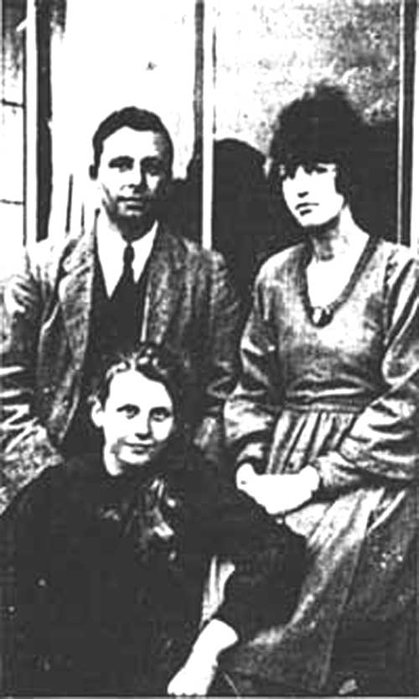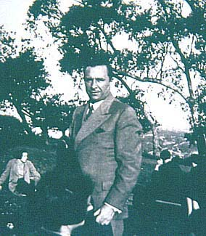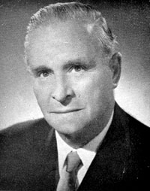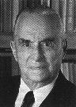

The Rev. Geoffrey Hodson is probably - next to Bishop Charles Webster Leadbeater - the most well-known clairvoyant among Liberal Catholics.
Living in New Zaland, Geoffrey Hodson traveled extensively in Europe, North and South America, India, and Australia.
Most of his work is dedicated to the Kingdom of the Angels, and all his lectures and books bear the stamp of the utter sincerity and devotion typical of the Author.

Brotherhood of Angels and of Men
Clairvoyant Investigations of Christian Origins and Ceremonial
Fairies at Work and Play
Hidden Wisdom in the Holy Bible
Kingdom of the Gods
Man, the Triune God
Man’s Supersensory and Spiritual Powers
Meditation on the Occult Life
Miracle of Birth
Occult Powers in Nature and Man
Priestly Ideal
Reincarnation: Fact or Fallacy
Seven Human Temperaments
Soul’s Awakening
Supreme Splendour
The Inner Side of Church Worship
Through the Gateway of Death
La Fraternité des Anges et des Hommes

============================================================================================================================
END

