Annie Wood Besant 1847-1933
http://en.wikipedia.org/wiki/Annie_Besant
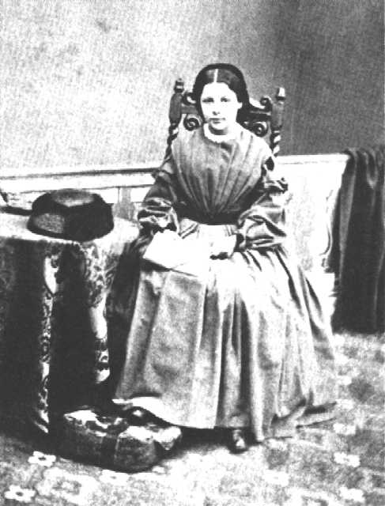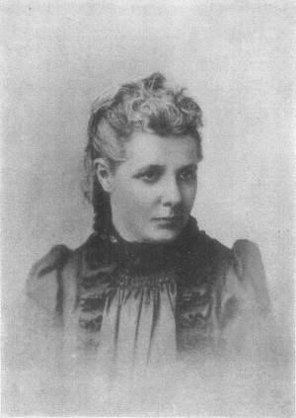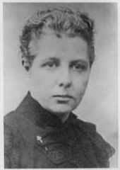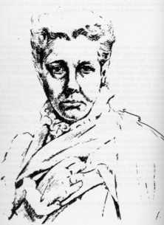
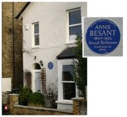
Plaque on house in Colby Road, London SE19 where Annie Besant lived in 1874.

Annie Wood Besant (Clapham, London October 1, 1847 – Adyar, India September 20, 1933) was a prominent Theosophist, women's rights activist, writer and orator.

Contents
[hide]
- 1 Early life
- 2 Birkbeck
- 3 Reformer and Secularist
- 4 Socialist
- 5 Marxist
- 6 Theosophist
- 7 President
- 8 Krishnamurti
- 9 The Home Rule Movement
- 10 Later years
- 11 Trivia
- 12 Selected works
- 13 Further reading
- 14 See also
- 15 References
- 16 External links

[] Early life
Annie Wood was born in 1847 in London into a middle-class family of Irish origin. Annie was always proud of being Irish and supported the cause of Irish self-rule throughout her adult life.
Her father died when she was young and left the family almost penniless. Annie's mother was forced to support the family by running a boarding house for boys at Harrow. She raised the money for a private tutor for Annie in this way.
Annie was educated privately by a female tutor as an Evangelical Christian. She was given a strong sense of duty to society and an equally strong sense of what independent women could achieve.
As a young woman, Annie was also able to travel widely in Europe. There she acquired a taste for Catholic colour and ceremony that never left her.
She was married in 1867 in Hastings, Sussex, to 26-year-old clergyman Frank Besant, younger brother of Walter Besant. He was an Evangelical Anglican clergyman who seemed to share many of her concerns.
Soon Frank became vicar of Sibsey in Lincolnshire. Annie moved to Sibsey with him, and within a few years they had two children: Digby and Mabel.
The marriage was, however, a disaster. The first conflict came over money and Annie's independence. Annie wrote short stories, books for children and articles. Frank took all the money she made: married women did not have the right to own property. Politics further divided the couple. Annie began to support farm workers who were fighting to unionise and to win better conditions. Frank was a Tory and sided with the landlords and farmers. The tension came to a head when Frank struck Annie. She left him and returned to London.
Annie began to question her own faith. She turned to leading churchmen for advice. She even went to see Edward Bouverie Pusey, leader of the Catholic wing of the Church of England. He simply told her she had read too many books. Annie returned to Frank to make one last effort to repair the marriage. It proved useless. She finally left for London. Divorce was unthinkable for Frank, and was not really within the reach of even middle-class people. Annie was to remain Mrs Besant for the rest of her life. At first, she was able to keep contact with both children and to have Mabel live with her. She got a small allowance from Frank.
Her husband was given sole custody of their two children.

[] Birkbeck
For a time she undertook part-time study at the Birkbeck Literary and Scientific Institution, where her religious and political acitivities were to cause alarm. At one point the Institution's governors sought to withold the publication of her exam results.^{[1]}

[] Reformer and Secularist
She fought for the causes she thought were right, starting with freedom of thought, women's rights, secularism (she was a leading member of the National Secular Society alongside Charles Bradlaugh), birth control, Fabian socialism and workers' rights.
Once free of Frank Besant and exposed to new currents of thought, Annie began to question not only her long-held religious beliefs but also the whole of conventional thinking. She began to write attacks on the Churches and the way they controlled people's lives. In particular she attacked the status of the Church of England as a state-sponsored faith.
Soon she was earning a small weekly wage by writing a column for the National Reformer, the newspaper of the National Secular Society. The Society stood for a secular state: an end to the special status of Christianity. The Society allowed her to act as one of its public speakers. Public lectures were very popular entertainment in Victorian times. Annie was a brilliant speaker, and was soon in great demand. Using the railway, she criss-crossed the country, speaking on all of the most important issues of the day, always demanding improvement, reform and freedom.
For many years Annie was a friend of the Society's leader, Charles Bradlaugh. It seems that they were never lovers, but their friendship was very close indeed. Bradlaugh, a former seaman, had long been separated from his wife. Annie lived with Bradlaugh and his daughters, and they worked together on many issues.
Bradlaugh was an atheist and a republican. He was working to get himself elected as MP for Northampton to gain a better platform for his ideas.
Besant and Bradlaugh became household names in 1877 when they published a book by the American birth-control campaigner Charles Knowlton. It claimed that working-class families could never be happy until they were able to decide how many children they wanted. It suggested ways to limit the size of their families. The Knowlton book caused great offence to the Churches, but Annie and Bradlaugh proclaimed in the National Reformer: "We intend to publish nothing we do not think we can morally defend. All that we publish we shall defend."
The couple were arrested and put on trial for publishing the Knowlton book. They were found guilty, but released pending appeal. As well as great opposition, Annie and Bradlaugh also received a great deal of support in the Liberal press. Arguments raged back and forth in the letters and comment columns as well as in the courtroom. For a time, it looked as though they would be sent to prison. The case was thrown out finally only on a technical point: the charges had not been properly drawn up.
The scandal lost Annie her children. Frank was able to persuade the court that she was unfit to look after them, and they were handed over to him permanently.
Bradlaugh's political prospects were not damaged by the Knowlton scandal. He got himself into Parliament at last in 1881. Because of his atheism, he refused to swear the oath of loyalty. Although many Christians were shocked by Bradlaugh, others (like the Liberal leader Gladstone) spoke up for freedom of belief. It took more than six years before the whole issue was sorted out (in Bradlaugh's favour) after a series of by-elections and court appearances.
Meanwhile Besant built close contacts with the Irish Home Rulers and gave them support in her newspaper columns. These were crucial years, in which the Irish nationalists were forming an alliance with Liberals and Radicals. Annie met the leaders of the movement. In particular, she got to know Michael Davitt, who wanted to mobilise the Irish peasantry through a Land War: a direct struggle against the landowners. She spoke and wrote in favour of Davitt and his Land League many times over the coming decades.
However, Bradlaugh's parliamentary work gradually alienated Annie. Women had no part in parliamentary politics. Annie was searching for a real political outlet: politics where her skills as a speaker, writer and organiser could do some real good.

[] Socialist
For Annie, politics, friendship and love were always closely intertwined. Her decision in favour of Socialism came about through a close relationship with George Bernard Shaw, a struggling young Irish author living in London, and a leading light of the Fabian Society. Annie was impressed by his work and grew very close to him too in the early 1880s. It was Annie who made the first move, by inviting Shaw to live with her. This he refused, but it was Shaw who sponsored Annie to join the Fabian Society. In its early days, the Society was a gathering of people exploring spiritual, rather than political, alternatives to the capitalist system.
Annie now began to write for the Fabians. This new commitment - and her relationship with Shaw - deepened the split between Annie and Bradlaugh, who was an individualist and opposed to Socialism of any sort. While he would defend free speech at any cost, he was very cautious about encouraging working-class militancy.
Unemployment was a central issue of the time, and in 1887 some of the London unemployed started to hold protests in Trafalgar Square. Annie agreed to appear as a speaker at a meeting on 13 November. The police tried to stop the assembly. Fighting broke out, and troops were called. Many were hurt, one man died, and hundreds were arrested. Annie offered herself for arrest, but the police refused to take the bait.
The events created a great sensation, and became known as Bloody Sunday. Annie was widely blamed - or cred - for it. She threw herself into organising legal aid for the jailed workers and support for their families. Bradlaugh finally broke with her because he felt she should have asked his advice before going ahead with the meeting.
Socialists saw the trade unions as the first real signs of working people's ability to organise and fight for themselves. Until now, trade unions had been for skilled workers - men with a craft that might take years to acquire and which gave them at least a little security. The Socialists wanted to bring both unskilled men and women into unions to fight for better pay and conditions.
Her most notable victory in this period was perhaps her involvement in the London matchgirls strike of 1888. Annie was drawn into this first really important battle of the "New Unionism" by Herbert Burrows, a young socialist with whom she was for a time in love. He had made contact with workers at Bryant and May's match factory in Bow, London, who were mainly young women. They were very poorly paid. They were also prey to horrendous industrial illnesses, like the bone-rotting Phossy jaw, which were caused by the chemicals used in match manufacture. Some of the match workers asked for help from Burrows and Annie in setting up a union.
Annie met the women and set up a committee, which led the women into a strike for better pay and conditions. The action won enormous public support. Annie led demonstrations by "match-girls". They were cheered in the streets, and prominent churchmen wrote in their support. In just over a week they forced the firm to improve pay and conditions. Annie then helped them to set up a proper union and a social centre.
At the time, the matchstick industry was an immensely powerful lobby, since electric light was not yet widely available, and matches were essential for lighting candles, oil lamps, gas lights and so on. (Only a few years earlier in 1872, lobbyists from the match industry had persuaded the British government to change its planned tax policy.) Besant's campaign was the first time anyone had successfully challenged the match manufacturers on a major issue, and was seen as a landmark victory of the early years of British Socialism.

[] Marxist
During 1884, Annie had developed a very close friendship with Edward Aveling, a young socialist teacher, who lived in her house for a time. Aveling was a scholarly figure and it was he who translated the important works of Marx into English for the first time. Annie seems to have fallen in love with Aveling, but it is not clear that he felt the same way. He was certainly a great influence on her thinking, and she was a great support to his work. However, Aveling left Annie to live with Eleanor Marx, daughter of Karl Marx. This led to permanent ill-feeling between Annie and Eleanor and probably pushed Annie towards the rival Fabians at that time. Aveling and Eleanor joined the Marxist SDF but they distrusted its leader, Henry Hyndman. Soon they left the SDF to join the Socialist League, a small Marxist splinter group which formed around the artist William Morris.
It seems that Morris played a large part in converting Annie to Marxism, but it was to the SDF, not his Socialist League, that she turned in 1888. She remained a member for a number of years and became one of its best speakers. Strangely, she was still a member of the Fabian Society. Neither she nor anyone else seemed to think the two movements completely incompatible at the time.
Soon after joining the Marxists, Annie stood for election to the London School Board. Because women were not able to take part in parliamentary politics, it is often thought that they did not have the vote until 1918. In fact, women householders had been brought into the local electorate in 1881, and soon began to make a mark in local politics.
Annie drove about with a red ribbon in her hair, speaking at noisy meetings. "No more hungry children," her manifesto proclaimed. She made clear that her Socialism had a feminist side too: "I ask the electors to vote for me, and the non-electors to work for me because women are wanted on the Board and there are too few women candidates." Astonishingly, Annie came out on top of the poll in Tower Hamlets, with over 15,000 votes. Annie wrote in the National Reformer: "Ten years ago, under a cruel law, Christian bigotry robbed me of my little child. Now the care of the 763,680 children of London is placed partly in my hands." Annie was also closely involved in the struggle for the "Dockers' Tanner". The dockers were poorly paid for hard and dangerous work. They were casual labourers, only taken on for one day at a time. Ben Tillett set up a union for dockers. Annie was crucial in this. She helped Tillett to draw up the union's rules and played an important part in the meetings and agitation which built up the organisation. Tillett led the dockers in a fight for better wages: sixpence (2½p.) an hour. Annie spoke for the dockers at public meetings and on street corners. Like the match-girls, the dockers won a lot of public support for their struggle. Even Cardinal Manning, the head of the Roman Catholic Church in England, came out on their side. After a bitter strike, the "dockers' tanner" was won.

[] Theosophist
Besant was a prolific writer and a powerful orator. In 1889, she was asked to write a review for the Pall Mall Gazette^{[2]} on The Secret Doctrine, a book by H.P. Blavatsky. After reading it, she sought an interview with its author, meeting Blavatsky in Paris. In this way she was converted to Theosophy. Annie's intellectual journey had always involved a spiritual dimension, a quest for transformation of the whole person. As her interest in Theosophy deepened, she allowed her membership of the Fabian Society to lapse (1890) and broke her links with the Marxists. When Blavatsky died in 1891, Annie was left as one of the leading figures in Theosophy. Her most important public commitment to the faith came in 1893, when she went to present it at the Chicago World Fair.
Soon after becoming a member of the Theosophical Society she went to India for the first time (in 1893). After a dispute, where William Quan Judge, leader of the American section was accused of falsifying letters from the Masters, the American section split away. The remainder of the Society was then led by Henry Steel Olcott and Besant and is today based in Chennai, India and is known as the Theosophical Society Adyar. Thereafter she devoted much of her energy not only to the Society, but also to India's freedom and progress. Besant Nagar, a neighborhood (near the Theosophical Society) in Chennai is named in her honor.

[] President
Together with Charles Webster Leadbeater, whom she had first met in London in Apr 1894^{[3]}, she investigated the universe, matter and the history of mankind through clairvoyance. The two became embroiled over Leadbeater's advice to young boys to masturbate. At the time such advice was highly controversial. He had to leave the Theosophical Society over this in 1906. In 1908 he was taken back into the fold through the agency of Besant, who had been elected president of the Theosophical Society in 1907 upon the death of the previous president Henry Steel Olcott.
Up until Besant's presidency, the society had as one of its foci Theravada Buddhism and the island of Ceylon, where Henry Olcott did the majority of his useful work. Under Besant's leadership there was a decisive turn away from this and a refocusing of their activities on "The Aryavarta", as she called central India. Besant actively courted Hindu opinion more than former Theosophical leaders. This was a clear reversal of policy from Blavatsky and Olcott's very public conversion to Buddhism in Ceylon, and their promotion of Buddhist revival activities on the subcontinent (see also: Maha Bodhi Society).
Annie set up a new school for boys at Varanasi: the Central Hindu College. Its aim was to build a new leadership for India. The boys lived like monks. They spent 90 minutes a day in prayer and studied the Hindu scriptures, but they also studied modern science. It took 3 years to raise the money for the CHC. Most of the money came from Indian princes.
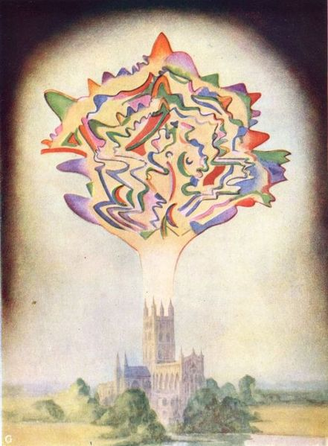
The Music of Gounod - a Thought Form from Thought-Forms, by Annie Besant & C.W. Leadbeater.
Project Gutenberg eText 16269

Krishnamurti
Soon after Besant's inheritance of the presidency, in 1909, Leadbeater discovered Jiddu Krishnamurti on the private beach that was attached to the societies headquarters at Adyar. Krishnamurti had been living there with his father and brother for a few months prior to this. This discovery started years of upheaval in the Theosophical Society in Adyar, as the boy was proposed as the incarnate vessel for the Christ. Jiddu Krishnamurti and his brother Nitya were brought up by Theosophists from that moment on, with a subsequent lawsuit filed by his father.
Eventually, in 1929, Krishnamurti ended up disbanding the Order of the Star of the East, which had been founded to support him and of which he had been made the leader. [1] This destroyed Besant's spirit, as it went against her ideals.

[] The Home Rule Movement
As well as her religious activities, Annie continued to participate in concrete political struggles. She had joined the Indian National Congress. As the name suggested, this was originally a debating body, which met each year to consider resolutions on political issues. Mostly it demanded more of a say for middle-class Indians in their own government. It had not yet developed into a permanent mass movement with local organisation.
In 1914 war broke out in Europe. Britain needed the support of its Empire in the fight against Germany. Annie said: "England's need is India's opportunity," a clear echo of an Irish nationalist slogan. As or of a newspaper called New India, she attacked the (British) government of India and called for clear and decisive moves towards self-rule. As with Ireland, the government refused to discuss any changes while the war lasted.
In 1916 Annie launched the Home Rule League, once again modelling demands for India on Irish models. For the first time India had a political party to fight for change. Unlike the Congress itself, the League worked all year round. It built a strong structure of local branches, enabling it to mobilise demonstrations, public meetings and agitations. In June 1917 Annie was arrested and interned at a hill station. She flew a red and green flag in the garden to show her defiance. Congress and the Muslim League together threatened to launch protests if she were not set free. Annie's arrest had created a focus for protest, giving those who wanted long-term independence for India a chance to work together for a simple, achievable goal.
The government was forced to give way and to make vague but significant concessions. It was announced that the ultimate aim of British rule was Indian self-government, and moves in that direction were promised. Annie was freed in September to a tremendous welcome from crowds all over India. In December she took over as President of Congress for a year. It was perhaps the greatest honour she received in her lifetime.
After the war, there could be no going back. A new leadership emerged around Mohandas K. Gandhi - one of those who had written to demand Annie's release. He was a lawyer who had returned from leading Asians in a peaceful struggle against racism in South Africa. It was Annie who first called him Mahatma (Great Soul), using the vocabulary of Theosophy. Nehru, Gandhi's closest collaborator, had been educated by a Theosphist tutor.
The new leadership too was committed to action that was both militant and non-violent, but there were differences between them and Annie. Despite her past, she was not happy with their socialist leanings. Until the end of her life, however, she continued to campaign for India's independence, not only in India but also on speaking tours of Britain. In her own version of Indian dress, Mrs Besant remained a striking presence on speakers' platforms. She produced a torrent of letters and articles demanding independence.

[] Later years
She tried to accommodate Krishnamurti's views into her life, but never really succeeded. The two remained friends, however, until the end of her life. Annie Besant died in 1933 and was survived by her daughter, Mabel.

[] Trivia
She is the great-grandmother of Andrew Castle, a television presenter and former professional tennis player.

[] Selected works
- The Political Status of Women (1874)
- Marriage, As It Was, As It Is, And As It Should Be: A Plea For Reform (1878)
- The Law Of Population (1877)
- Autobiographical Sketches (1885)
- "Why I became a Theosophist" (1889)
- An Autobiography (1893)
- The Ancient Wisdom (1898)
- Thought Forms (1901) ISBN 0-8356-0008-4
- Bhagavad Gita (Translation) (1905)
- Introduction to Yoga (1908) [2]
- Occult Chemistry
- The Doctrine of the Heart (1920)
- Esoteric Christianity
- The Case for India The Presidential Address Delivered by Annie Besant at the Thirty-Second Indian National Congress Held at Calcutta 26th December 1917
- Besant, Annie. The Devachanic Plane. Theosophical Publishing House, London, ca 1895.
- Besant, Annie. Man and his bodies. Theosophical Publishing House, London, 1911.
- Besant, Annie. Man's life in this and other worlds. Theosophical Publishing House, Adyar, 1913.
- Besant, Annie. Study in Consciousness - A contribution to the science of psychology. Theosophical Publishing House, Madras, ca 1907.

[] Further reading
- Chandrasekhar, S. "A Dirty, Filthy Book": The Writing of Charles Knowlton and Annie Besant on Reproductive Physiology and British Control and an Account of the Bradlaugh-Besant Trial. University of California Berkeley 1981
- Grover, Verinder and Ranjana Arora (eds.) Annie Besant: Great Women of Modern India – 1 : Published by Deep of Deep Publications, New Delhi, India, 1993
- Kumar, Raj Rameshwari Devi and Romila Pruthi. Annie Besant: Founder of Home Rule Movement, Pointer Publishers, 2003 ISBN 81-7132-321-9
- Manvell, Roger. The trial of Annie Besant and Charles Bradlaugh. Elek, London 1976
- Nethercot, Arthur H. The first five lives of Annie Besant Hart-Davis: London, 1961
- Nethercot, Arthur H. The last four lives of Annie Besant Hart-Davis: London (also University of Chicago Press 1963) ISBN 0-226-57317-6
- Taylor, Anne. Annie Besant: A Biography, Oxford University Press, 1991 (also US ion 1992) ISBN 0-19-211796-3

[] See also
- Theosophical Society
- Order of the Temple of the Rosy Cross
- History of feminism

[] References
- ^ The History of Birkbeck. Birkbeck, University of London. Retrieved on 2006-11-26.
- ^ Lutyens, Krishnamurti: The Years of Awakening, Avon/Discus. 1983. p 13
- ^ http://www.tphta.ws/TPH_OCIV.HTM

[] External links
- AnandGholap.net - Online Books by Annie Besant
- Links to books by Annie Besant
- Theosophical.ca On-Line Documents Some works of Annie Besant and other theosophists
- Works by Annie Wood Besant at Project Gutenberg
- Books by Annie Besant and other authors
- Annie Wood Besant: Orator, Activist, Mystic, Rhetorician By Susan Dobra
- Confounding or Amazing? The Multiple Deconversions of Annie Wood Besant By Carol Hanbery MacKay
- Biography
- Biography (BBC)
- biography
- Annie Besant: A Tribute
- Annie Besant's Quest for Truth: Christianity, Secularism, and New Age Thought
- Biography and links
- Biography, quotes and links
- Annie Besant Memorial from the Indian Post
- History of Theosophical Society Adyar and Besant
- Articles by and about Annie Besant
===============================================================================================================================
END

