A MIND TO EMBRACE THE UNIVERSE

BY

E. L. Gardner

from The Theosophist - December 1960- Reprinted in 1965

http://www.theosophical.ca/MindEmbrace.htm

In view of the obvious fact that the “lesser” can never contain the “greater”, the statement in the Stanzas that the Breath (Man) needs a Mind that can embrace the Universe demands some analysis to be understood. A familiar optical experiment, in physical terms, may assist. A concave mirror, accurately curved, will reflect and reduce a widespread landscape to the scale of a small garden: every vista and detail is reproduced—but is presented to the eye as a beautiful miniature of the whole scene. Another analogy, and a still closer one, is that of a crystal ball, for such a transparent sphere will reproduce, within itself, every object around. With the crystal sphere, however, one should be, apparently, inside the crystal to see all that is reflected. So closely does the human mind resemble such a sphere in its reproductive ability that Patanjali actually used this very illustration:

The mind may be compared to a lens in the form of a sphere, so constructed as to be capable of giving a three-dimensional image inside itself of every external object. §1. 41. (Stephen’s translation)
... it [the mind] is as colourless as a piece of pure rock-crystal... (Divedi's translation)

We can take a step further if we couple these descriptions of the human mind with a precept from The Voice of the Silence (T. P. H., London, 1900; p.32):

“But Breath needs a mind to embrace the Universe”: The Stanzas of Dzyan, II, iv, 17.

Merge into one sense thy senses ... that sense alone which lies concealed within the hollow of thy brain...

A familiar living analogy of such an inclusive “one sense” is available: it will enable us also to picture the relationship of the higher and lower mind.

The Amoeba

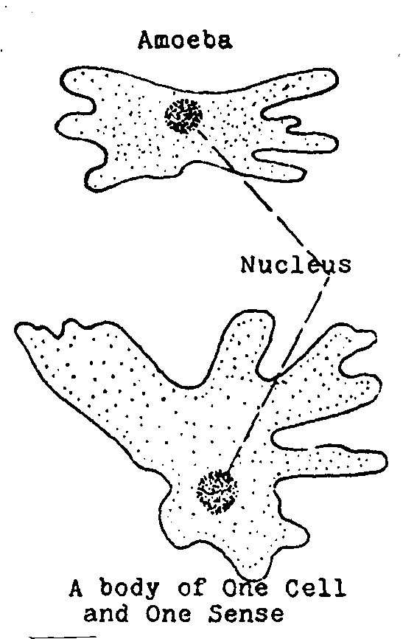
It is the amoeba that provides the closest correspondence, in form, to the human mind. It is one of the simplest forms of the animal kingdom, a single cell only yet a very capable living creature

This minute single cell, itself the whole body of the amoeba, appears under the microscope as a mere droplet of plasm. Its only differentiation is a tiny nucleus with a still smaller “point”, within it, of bubbling activity, called the nucleolus. The surface skin of the plasm is the creature’s one sense-organ. Though quite unspecialized the skin is responsive enough to enable the amoeba to hear, feel, see, taste and smell sufficiently for its own practical welfare. This active living cell represents a very early stage in the structure of the physical forms; for the cell is the unit brick of which all are built. An important fact to note here is that our own physical sense-organs, precise and efficient as they are, are all modifications of the skin of the physical body. The single cell of the amoeba possesses the five senses in one general over-all sense—unextended. And the mental body of a human being—the lower-mind—has but one general over-all sense which, however, is undergoing vigorous training during our many incarnations. The human mental body appears indeed to be of the same form as that of a single physical cell—similar to the free-swimming amoeba.

The Mind and the Body

A well-known principle in manifestation—the One and Many—is to be noted in the relationship of the human mind and the physical body. Examples of this principle are abundant: Sun and planets; Monad and its vehicles; King and subjects; Commander and army; Captain and crew; in short, a Leader and followers or a Composite and extensions. The human mind of One Cell and the physical body of Many Cells is in accord with this familiar principle.

In the light of Patanjali’s description of the mind and the precept quoted above, we can picture the relationship of mind and body and the “one-sense” that links the Monadic Ray to both. The correspondence with the initial cell of physical bodies, as illustrated by the amoeba, is illuminating.

The mental body of a human being is in the form of one large cell. Within its periphery is the physical body. The only differentiation in the “plasmic” mental body (at the beginning of an incarnation) is a nucleus and, within this again, a nucleolus.

The plasmic body is the lower mind. Clear at physical birth, it becomes filled later with thought-forms and minute memory records.

The mental nucleus—the higher mind—is a sphere of brilliant clarity. It appears aglow with the “astral-light” of the higher mental plane. The mental nucleus, during waking consciousness, coincides with the central ventricle of the brain, the “hollow” of the precept.

The nucleolus of the mind—within the nucleus—resembles the iris of the eye. It appears to be an infinitesimal entrance portal through which the Monadic Ray flashes in alternations like the flickering tongue of a serpent.

The spherical lens of the nucleus evidently provides the means whereby the light of the Ray is focussed. As the physical sense-organs register images on the membrane of the nucleus, the Ray “sees” them there as in a mirror. Their comparative precision and clarity make the mirror images objective and long experience projects them accurately into an exterior physical world—itself a real world of forms on its own plane.

The reversal of technique, as between physical and mental sight, explains the statement that “a physical basis is necessary to focus a ray”. In physical vision, light passes through a flattened lens and builds a flat picture on the retina. Thence it is conveyed to the “hollow” in the brain and registers on the membrane of the nucleus.

This retinal membrane or mirror, corresponding to the surface of a crystal sphere, builds a three-dimensional reproduction within the glowing “hollow”. The Monadic Ray—the spiritual eye—sees the interiorly projected sense-impression as an object, that is, separate from itself. This reversal of technique is typical of the higher-mind. Indeed, our apprehension of three-dimensional space seems to be due to this faculty. The frequency speed of the Monadic Ray is so high that it appears to “observe” instantaneously the build-up, whatever the sense-impression may be. The television camera, with its multitude of “eyes” (photocells), seem to be the nearest physical approach to the flashing speed of the single eye of the Ray.
The need for closing down sense-impressions entirely in order to see that which may be registered from “above” is obvious.

The Mind and the Universe

Our objective physical plane—a triumph of Spirit-Matter—gives us a world in slow-motion; steady and stable enough to enable consciousness to get a grip. Physical objects are photographed, so to speak, by the sense-organs and conveyed to the brain, to its “hollow”, the third ventricle, to which the crystal sphere of the mental nucleus (the higher-mind) is magnetically held. As in a mirror, the objective world is reproduced, and gradually the Monad realizes that it is itself separate from the mirrored objects. Thence the Monad begins to “know itself” and, later, may realize in a deep yet true sense that the objective world, the universe, is its own creation! Monad and Plenum are One and that which is seen objectively has been created by “Itself” while veiled in other and earlier forms.

While the first steps towards Self-discovery are thus taken, necessarily, during physical incarnations, the major task lies directly ahead, namely, the control and mastery of the lower-mind—the “plasm” body—for this is in direct contact with the mental plane or world. The contact is made through its outer membrane or skin—its own one-sense. This boundary membrane of the lower-mind is a veritable ring-pass-not dividing the personal mind from the world-mind just as the boundary skin of the physical body is a ring-pass-not for its own plane. In other words, everything we contact in the physical world must be reproduced by the skin (through the specialized sense-organs) for our consciousness to “know”. Similarly, the mental plane or world must be reproduced by the mirror-like mental membrane (its skin), and accurately, if we are to “know”. The mental membrane appears to respond to the mental world very much as the retina of the physical eye responds to light and shade.

The word “Universe”—often used in the literature and rituals of occultism—denotes all that which is external to oneself. It is an inclusive term meaning, strictly speaking, everything that is apart from, is objective to, the human mind. As the mental mirror reproduces the external “universe” and thereby “becomes” it and consciously understands it, the controlled mind may be said to “embrace the universe”.

The Higher Mind

The duality of the human mind has presented a problem to every student of occultism. Higher and lower, formless planes and planes of form, spiritual spheres of Light above and personal world of Life below—what do all these mean for us? In other words, what is implied in the classification “higher” and “lower” mind? The mental body’s correspondence with a single physical cell goes far to clarify the problem.

It is stated earlier that the mental nucleus, a brilliant sphere of astral-light, coincides during waking consciousness with the brain. This link appears indeed to be the first mark of a truly human incarnation. A coincidence of the nucleus and the third ventricle—the “hollow”—of the brain may be frequent after the seventh year though seldom maintained till later. Learning by repetition, by rote, is a purely lower-mental practice and perfectly natural during early years of physical life (it is a recapitulation of the past) but the link with the higher-mind opens up new vistas. Philosophy, the higher arts and sciences, abstract thinking, creative activities, are then all within reach. The many lapses that occur—inattention in study, lack of concentration, idle reverie—are merely a temporary withdrawal of coincidence, a mind-wandering, and indicate the comparative novelty of the link. Sleep, literal slipping-out, is due evidently to the withdrawal of the mental nucleus. Sleep is deep or fitful according to whether the withdrawal is complete or partial.

The light of the nucleus is due to the golden glow of the higher mental plane—also synonymous with the first elemental kingdom. The astral light (its technical term) is the universal medium for creation of forms—in much the same sense that paint is the medium for creating pictures. The higher mind of man is of this Light. Whence it comes is disclosed in an illuminating hint in The Secret Doctrine (III, 90).

What is the human mind in its higher aspects, . . . if it be not a portion of the essence . . . of a higher Being; one from a higher and divine plane?

It is easy to identify the “higher being” to whom this refers. The many allusions in The Secret Doctrine to two great Orders of Devas—the Dhyâni-Buddhas and the Dhyân Chohans—are unmistakable.

The God in man . . . [is] a highly Spiritual Dhyân Chohan . . . besides the presence of his own Seventh Principle. (I, 334)
. . . the . . .Dhyân Chohans—are evolving, pari passu with it [the Monad] . . . (I. 292)
The Dhyân Chohans are made to pass through the School of Life. (V. 532)

The two Orders are of the life and form aspects of the same high level and become more or less distinctively dual on their descent to contact and union with the human personality. At the physical level the Two may be said to be represented in the pineal and pituitary centres of the brain’s third ventricle. To many students of Theosophy this view will provoke surprise, both startling and thrilling. It must be added at once, however, that conscious companionship depends on the prescience and understanding—and humility—of the personality.

The significance of the phrase that the higher mind of man is a “portion of the essence of a higher being” must also be noted. The word “portion” implies that a similar division and subdivision takes place as with the group-soul of the plant and animal kingdoms. In the human individual the “group” is reduced to a concentrated unit. A similar unit of the higher-mental plane, derived from the Dhyânis, constitutes the higher-mental plane, and the link with the divine being, notwithstanding the subdivisions of the “essence,” is maintained and may be strengthened.

When our familiar five senses—all really subdivisions of one original sense—are merged in the subtle mental membrane (begun even now) two further senses dawn. Little has been told of these because of their dependence on our relationship with the Devas—for the sixth and seventh senses are their endowment. Though sometimes referred to as a higher clairvoyance and clairaudience, the terms are inadequate. On the one hand, the minutely infinitesimal may be shared by human consciousness and, on the other hand, the vastly great. Some correspondence with the Shaktis (Powers, Ministers) of the Most High, seems to be as much as can be imaged.

The vision unfolded in the statement quoted from The Secret Doctrine concerning the relationship of the Dhyâni-Buddhas and Dhyân Chohans and mankind awakens a view of immeasurable promise and splendour.

The Monad and Two Companions

All trinities appear to be divisible into a Pair and One. Though equal in value, as no one of the Three can manifest without the other two, they vary in dominance. A typical example is that of parents and child—a pair and one: the parents precede the child and are dominant till the child matures; thence the child may lead if adult and able. In like manner the two Orders of the Devas (1) precede the Monad and prepare the way; (2) work together with the Monad, training and being trained; (3) may be led by the Monad to a consummation. During the vast cycles of the fourth (the present) Round and the fifth, we begin to achieve a conscious introduction to the Angelic hosts— and co-operate together with understanding. The human mind is the meeting place, though for long, unconsciously so.

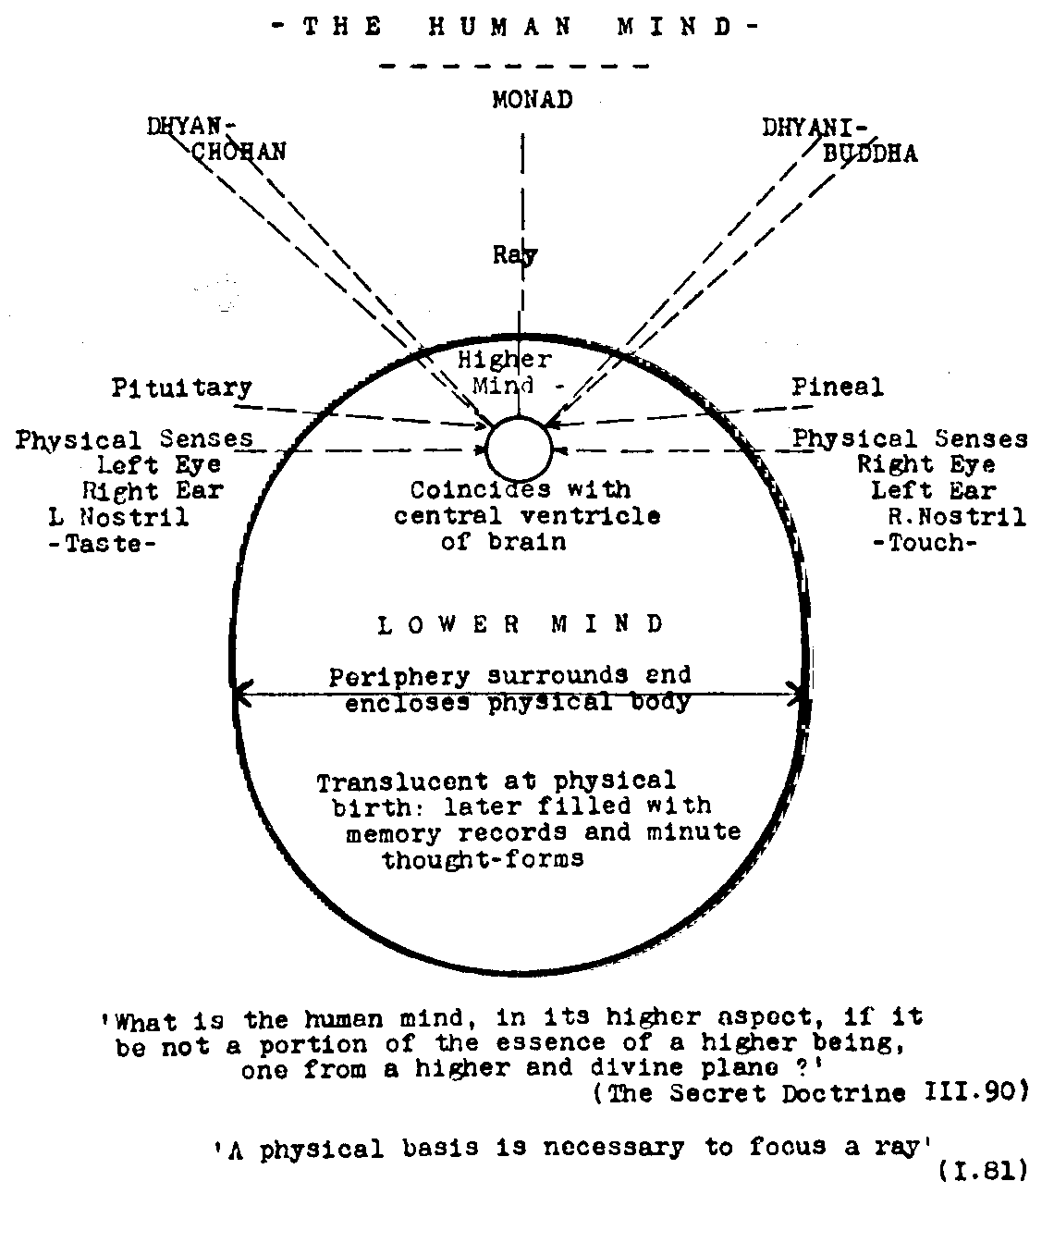

The relationship of the Monad and the two Orders of Devas is indicated best in the above diagram.
The human mind, including higher and lower, has a definite periphery, an enclosing membrane or skin—its ring-pass-not. In correspondence with a single cell, the human mind has a plasmic body (lower-mind), a nucleus (higher-mind), and nucleolus within the latter. The nucleus of the mind coincides with the third ventricle of the physical brain during clear–cut waking consciousness: it constitutes the higher-mind of man and is a concentrated “portion of the essence” of the two Orders of Devas.

The smaller membrane, enclosing the nucleus, is the mirror to which the physical sense vibrations are conveyed—and may be “seen” there by the Monadic Ray, at will. The two-lobed chakram surrounding the nucleus is the transformer. Thus does the innermost, the Monad, meet the outermost, the physical basis on which the Ray can focus consciousness.

. . . only through a vehicle . . . of matter [does] . . . consciousness . . .[arise], a physical basis being necessary to focus a Ray . . . (The Secret Doctrine, I, 81)

Our Devas and the Mind

The membrane of the nucleus, in contact itself also with the plasmic lower-mind, serves as a mirror in which the two Devas contact the thought-built elementals of the emotional and lower-mental plane, their own opposites and complements—just as the physical contact is the Monad’s opposite and complement. Our many dreams, haphazard and inconsequent, are often the temporarily focussed attention of the Devas flitting about the many memory records and thought-forms in the lower-mental body. Maybe they provide for the Arûpa Devas [A-rûpa = No form.] their first contact with definite forms—the toys of a kindergarten on the mental plane.

Although the lower-mind of man may thus serve as a nursery for the Gods and as a preparatory school for the focussing of consciousness for them, their contribution to the Monad’s education is via the higher mind. Buddhi is the vehicle of Âtma and the archetypes of all that which is due to manifest are carried by the Dhyâni-Buddhas’ line and focussed by the Dhyân Chohans’ line— both “lines” terminating in the human mind, its higher aspect. Thereby they can be interpreted in definite terms and appear in our outer world as spiritual inspiration, pictorial art of the highest, in poetry and music that elevates and enthrals. These for our human consciousness, so much concerned with the concrete and formal, introduce us to the flowing rhythms of the formless. The archetypal “patterns in the heavens” seem to be conveyed by the Dhyânis unknowingly, until recorded in the human mind. An analogy may be found in the sound figures formed in fine sand by the human voice on a sensitive vibrating disc—of which the singer is unaware till they are seen. Interpretations of the “patterns” depend of course on the responsiveness and quality of the mind’s vibrating disc, the mental membrane. The mutual assistance rendered by the Devas to the Monad and by the Monad to the Devas, though potent and essential, is for long unconscious. In our familiar physical world too, the similar assistance that is being rendered mutually by our development of plant and animal forms and their services to ourselves is also mostly unconscious. The consciousness of the Monad and the Devas, however, slowly but continuously tend to blend.

Human awareness, strictly speaking that of the Monadic Ray, is vividly clear and understanding in physical terms because of the clear-cut objective world of the physical in which it first arises. But in the mental sphere we are at school with the Devas, very much so apparently until, by the exercise of the Will, the lower-mental field is cleared and its own outer membrane becomes the mirror, described by Patanjali, accurately reproducing the mental world within the Mind.

Will: The Power Controller

The seventh principle, in man, is the Monadic Ray itself, moving through Âtma, and its awakening in consciousness means the birth of the Will. We appear, at the present time, to be only at the very fringe of this awakening. The Will is not, of course, power itself but may direct and control power. The existence of illimitable force all around us, in the midst of which we live, has been amply demonstrated recently by the release of the locked-up energy in hydrogen gas. A comparatively minute amount, released suddenly, is of terrifying violence. The exceeding delicacy and risk involved in the manipulation of such power through the human constitution may now be really appreciated. Normally the power that may be released through the human frame is infinitesimal in amount—yet is strong and can be destructive. That which is implied by this principle as a destroyer (as in SIVA, Destroyer, of the Hindu Trinity), is that the Will can clear away obstacles, can dissolve the outmoded and outworn, and thus make way for new creation to emerge. The Mind creates the new—the Will dissolves the old and outgrown. A very simple but telling illustration of the relationship of Mind and Will is a sharply pointed pencil with an eraser at the other end! The pencil point is formless itself but can create form: it symbolizes the higher-mind, the creator. The eraser clears away the unneeded.

The Will alone—no other—can clear the mind, the lower-mind, of its limited personal interests and thoughts, and allow the Dhyânis to register their contribution. Reference has already been made to the iris-portal (the nucleolus) through which the Monadic Ray enters. Its similarity in function to the iris of the physical eye enables us to understand, in some measure, its control of the issue of “power”. The iris of the eye responds automatically to light: if this is strong the iris closes down somewhat, if the light be weak the iris opens. The iris of the eye allows as much light to enter as is useful and no more; it is not under normal human control, but is entirely automatic. The iris-portal of the mental nucleolus seems always to operate similarly: it allows power to emerge but no more or less than is needed. This means in effect that the issue of power into the mental sphere is, normally, safely automatic. If we couple all this with the fact that the early and natural condition of the human mind is of crystal clarity, [“The Auric Egg [of the child] is quite pure at birth, but it is a question whether the higher or lower Manas will colour it at the seventh year.” The Secret Doctrine, V. 511.] the solution of a very difficult mental problem is in view, at least intellectually. How does one clear the mind of one’s personal worries and anxieties, of regrets of the “might have been”, of remorse? The answer is, first to resolve to rectify all that is within one’s personal ability and then “inhibit the modifications of the thinking principle”. [Patanjali’s Aphorisms I, 13 and I, 41]

It is of course this latter instruction of Patanjali’s that appears so impossible. The lower-mind itself, its elemental life, delights in repetition, even a catchy tune in the mind may become a nuisance because of this repetitive trait. Yet, immediately one withdraws attention from the busy lower-mind, the natural tendency is for a cleansing power to sweep through. The withdrawal of attention might be likened to rolling up a blind and allowing sunlight to enter: the sun is not induced nor even invited to enter, it automatically does so. The “withdrawal of attention” like the removal of a blind is an act of Willpower. But it must be noted that this is not a “willing” of power to enter. One needs merely to be willing to make way, willing to allow power to enter. An obstruction is thus removed, the mind is cleared and its function as a mirror is restored. Then, in an “overhead” attitude of poise and watchfulness, the higher mind can register. That is neither concentration nor contemplation, but the quiet ‘middle way’ of Meditation.

Note

This study should be taken as exploratory and somewhat tentative because, apart from the quotations cited, descriptive analyses are the writer’s own. These are, however, mostly inferential, but partly from observation and experience. The conclusions may be summarized:

Conclusions

(1) The Human Mind, in its formation, resembles a single large cell. Like the one-celled animalcule of protoplasm with its one sense, the Mind’s only natural properties are: Surface membrane or skin. Translucent body—that constitutes the lower-mind. A glowing nucleus, in its own membrane, “the higher aspect of the human mind”. A minute orifice, the nucleolus, within the nucleus.
(2) During physical life, the nucleus of the mind coincides with the third ventricle of the brain—when awake.
(3) The mental nucleus, the higher-mind of man, is itself of the essence of two Orders of Devas, the Dhyâni-Buddhas and Dhyân Chohans.
(4) The membrane of the nucleus is its “one sense”. It receives and records, as in a mirror, the vibrations conveyed to it from the physical sense-organs.
The Monadic Ray, through the iris portal of the nucleolus, sees them there objectively.
The membrane of the lower-mind (the periphery of the mental body), again, its “one sense,” responds to the mental plane, usually imperfectly.
(5) The Devas convey to the human mind “the patterns of the heavens” (the archetypes for our Planetary Chain) the source of divine inspiration and enlightenment.
Though division and subdivision follows their descent from the loftiest to the lowliest, a “vertical” link appears always to be maintained. The link stimulates and enhances the activities of the form-building Rûpa-devas, astral and mental.
(6) The Monad and the Two Devas meet—at present more or less consciously—and may become a Creative Trinity

The Fifth Round of the future appears to be the cycle during which this union is effected—but the beginnings of this acquaintance and co-operation are made in this the fifth Root-race of the present.

