Theosophy

http://en.wikipedia.org/wiki/Theosophy

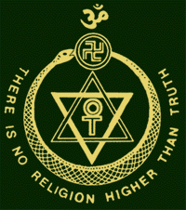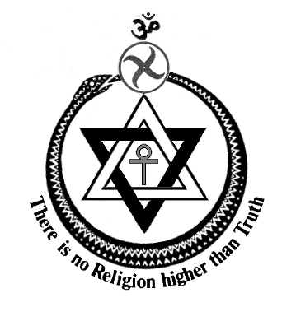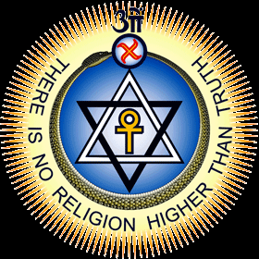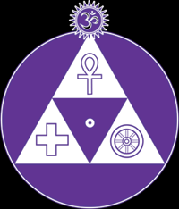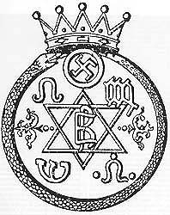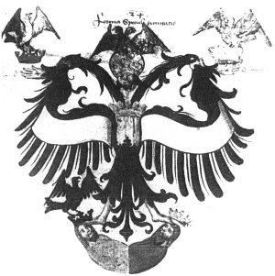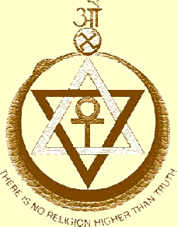

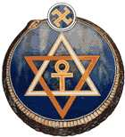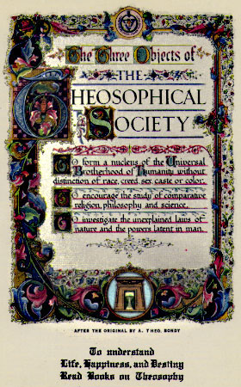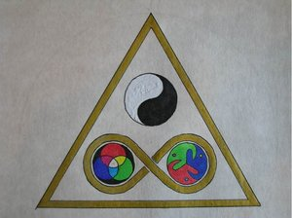

Theosophy, literally "wisdom of the divine" (in the Greek language), designates several bodies of ideas. Philosophers such as Emanuel Swedenborg and Jacob Boehme are commonly called theosophists. The word was revived in the nineteenth century by Helena Petrovna Blavatsky to designate her religious philosophy which holds that all religions are attempts by humanity to approach the absolute, and that each religion therefore has a portion of the truth. Together with Henry Steel Olcott, William Quan Judge, and others, Blavatsky founded the Theosophical Society in 1875. This society has since split into a number of organizations, some of which no longer use the term "theosophy".
A formal definition from the Concise Oxford Dictionary describes Theosophy as "any of various philosophies professing to achieve a knowledge of God by spiritual ecstasy, direct intuition, or special individual revelation; esp. a modern movement following Hindu and Buddhist teachings, and seeking universal brotherhood." Madame Blavatsky's theosophy would, however, not fall under this definiton, as it is non-theistic.
Adherents of Theosophy maintain that it is a "body of truth" that forms the basis of all religions. Theosophy, they claim, represents a modern face of Sanatana Dharma, "the eternal truth," as the proper religion.
The motto of the parent society is : "There is no religion higher than Truth."

Contents
- 1 The three objects
- 2 Basic Theosophical beliefs
  - 2.1 Consciousness is universal and individual
  - 2.2 Man is "provisionally" immortal
  - 2.3 Reincarnation is universal
  - 2.4 Karma
  - 2.5 Universal brotherhood
  - 2.6 Evolution
  - 2.7 The Septenary
- 3 A brief history of Theosophy
  - 3.1 Background
  - 3.2 The Theosophical Society
  - 3.3 Influence
  - 3.4 Music
  - 3.5 20th-century literary references to Theosophy
- 4 Notes
- 5 See also
- 6 External links
- 7 References

The three objects
There are three objects to which one must assent in order to join the Theosophical Society (Adyar). They are:
- To form a nucleus of the universal brotherhood of humanity without distinction of race, creed, sex, caste, or color.
- To encourage the comparative study of religion, philosophy and science.
- To investigate the unexplained laws of nature and the powers latent in humanity.

Basic Theosophical beliefs

[] Consciousness is universal and individual
According to Theosophy, nature does not operate by chance. Every event, past or present, happens because of laws which are part of a universal paradigm. Theosophists hold that everything, living or not, is put together from basic building blocks evolving towards consciousness. H.P. Blavatsky's Theosophy is non-theistic, however some of her followers seem closer to theistic attitudes.

[] Man is "provisionally" immortal
Theosophists believe that all human beings in their "higher selves" are immortal, but their lower personalities are unconscious of the link with their eternal spiritual nature and will perish.

[] Reincarnation is universal
Like esoteric Buddhism, from which much of Theosophical thought springs, Theosophy teaches that beings have attained the human state through myriad reincarnations, passing through the mineral, plant and animal stages since before the birth of life on earth. However, Theosophy differs from the exoteric belief that regression is possible. Humans cannot reincarnate as animals or plants again except in the rare cases of disintegrating "lost souls." Conversely, humans are considered only the epitome of physical life on Earth and not the end stage of evolution, which continues for further stages, including the form of the Dhyani Chohans or Buddhic beings.

[] Karma
Theosophy is similar to the beliefs of the Hindu Arya Samaj sect concerning karma, dharma, and cosmogony. Theosophy teaches that evil and good are the result of differentiation of spirit/matter in a cycle of becoming. There is a natural involution of spirit into matter followed by an evolution of matter back into spirit. The purpose of the Universe is for spirit to manifest itself self-consciously through seven stages.

[] Universal brotherhood
Theosophy teaches that every thing of whatever kind is from one divine source. All things are "monads" in reality. All monads potentially possess the same principles and their forms and natures are an expression of their present consciousness level.

[] Evolution
Theosophists believe that religion, philosophy, science, the arts, commerce, and philanthropy, among other "virtues," lead humans ever closer to "the Absolute."
Planets, solar systems and even galaxies are seen as conscious beings, fulfilling their own evolutionary paths.
The spiritual units of the universe are the monads, which at different times may manifest as planets, angels, human beings or in various other forms.
Theosophists also believe that human civilization, like all other parts of the universe, develops through cycles of seven stages. Thus, in the first age, humans were pure spirit; in the second age, they are known as Hyperboreans; in the third as Lemurians; and in the fourth, Atlanteans. Since Atlantis was the nadir of the cycle, the present fifth age is a time of reawakening humanity's psychic gifts.

[] The Septenary
Theosophy, as well as many other esoteric groups and occult societies, claims that the universe is ordered by the number seven. The reincarnating unit, the monad, consists of the two spiritual constituents of a sum of seven human bodies:
- The first body is called sthula-sarira (Sanskrit, from sthula meaning coarse, gross, not refined, heavy, bulky, fat in the sense of bigness, conditioned and differentiated matter + sarira to molder, waste away). A gross body, impermanent because of its wholly compounded character. The physical body is usually considered as the lowest substance-principle. The physical form is the result of the harmonious coworking on the physical plane of forces and faculties streaming through their astral vehicle or linga-sarira, the pattern or model of the physical body.
- The second body is called Linga-Sarira, (Sanskrit, from linga meaning characteristic mark, model, pattern + sarira, from the verbal root sri to moulder, waste away). A pattern or model that is impermanent; the model-body or astral body, only slightly more ethereal than the physical body. It is the astral model around which the physical body is built, and from which the physical body flows or develops as growth proceeds.
- The third body is prana (Sanskrit, from pra before + the verbal root an to breathe, to live). In theosophy, the breath of life. This life or prana works on, in, and around us, pulsating unceasingly during the term of physical existence. Prana is "the radiating force or Energy of Atma -- as the Universal Life and the One Self, -- its lower or rather (in its effects) more physical, because manifesting, aspect. Prana or Life permeates the whole being of the objective Universe; and is called a 'principle' only because it is an indispensable factor and the deus ex machina of the living man.
- The fourth principle is kama (Sanskrit, from the verbal root kam meaning to desire). Desire; the desire principle is the driving, impelling force. Born from the interaction of atman, buddhi, and manas, kama per se is a colorless force, good or bad according to the way the mind and soul use it. It is the seat of the living electric impulses, desires, aspirations, considered in their energic aspect.
- The fifth principle is manas (Sanskrit, from the verbal root man meaning to think). The seat of mentation and egoic consciousness; in humanity Manas is the human person, the reincarnating ego, immortal in essence, enduring in its higher aspects through the entire manvantara. When imbodied, manas is dual, gravitating toward buddhi in its higher aspects and in its lower aspects toward kama. The first is intuitive mind, the second the animal, ratiocinative consciousness, the lower mentality and passions of the personality.
- The sixth principle or vehicle is Buddhi (Sanskrit, from the verbal root budh to awaken, enlighten, know). The vehicle of pure, universal spirit, hence an inseparable garment or vehicle of atman. In its essence of the highest plane of akasa or alaya. In man buddhi is the spiritual soul, the faculty of discriminating, the channel through which streams divine inspiration from the atman to the ego, and therefore that faculty which enables us to discern between good and evil -- spiritual conscience. The qualities of the buddhic principle when awakened are higher judgment, instant understanding, discrimination, intuition, love that has no bounds, and consequent universal forgiveness.
- The seventh is called Atman (Sanskrit). Self; pure consciousness, that cosmic self which is the same in every dweller on this globe and on every one of the planetary or stellar bodies in space. It is the feeling and knowledge of "I am," pure cognition, the abstract idea of self. It does not differ at all throughout the cosmos except in degree of self-recognition. It may also be considered as the First Logos in the human microcosm. During incarnation the lowest aspects of atman take on attributes, because it is linked with buddhi, as the buddhi is linked with manas, as the manas is linked with kama, etc.
See: Encyclopedic Theosophic Glossary

[] A brief history of Theosophy

[] Background
Theosophists trace the origin of Theosophy to the universal striving for spiritual knowledge that existed in all cultures. It is found in an unbroken chain in India but existed in ancient Greece and also in the writings of Plato (427-347 BCE), Plotinus (204-270) and other neo-Platonists, as well as Jakob Boehme (1575-1624). Some relevant quotations:
...we are imprisoned in the body, like an oyster in his shell.
— The Socrates of Plato, Phaedrus
To the philosopher, the body is "a disturbing element, hindering the soul from the acquisition of knowledge..."
...what is purification but...the release of the soul from the chains of the body?
— The Socrates of Plato, Phaedo

[] The Theosophical Society
Modern Theosophical esotericism, however, begins with Madame Helena Petrovna Blavatsky (1831-1891) usually known as Madame Blavatsky. In 1875 she founded the Theosophical Society in New York City together with Henry Steel Olcott, who was a government investigator, lawyer and writer. Madame Blavatsky was a world traveller who eventually settled in India where, with Olcott, she established the headquarters of the Society. She claimed numerous psychic and spiritualist powers. Her first major book Isis Unveiled (1877) presented elements mainly from the Western wisdom tradition based on her extensive travels in Asia, Europe and the Middle East. Her second major work The Secret Doctrine (1888), a commentary on The Book of Dzyan, is based on esoteric Buddhism and also Hinduism. These writings became the basic pillars of the Theosophical movement, together with The Mahatma Letters, purported to originate with highly evolved humans directing HPB and the Theosophical Society
Upon Blavatsky's death in 1891, several Theosophical societies emerged following a series of schisms. Annie Besant became leader of the society based in Adyar India, while William Quan Judge split off the American Section of the Theosophical Society in New York which later moved to Point Loma, Covina, and Pasadena, California under a series of leaders: Katherine Tingley, Gottfried de Purucker, Colonel Arthur L. Conger, James A. Long, Grace F. Knoche, and in March 2006 Randell C. Grubb. The great pulp fiction writer Talbot Mundy was a member of the Point Loma group, and wrote many articles for its newsletter. Yet another international theosophical organization, the United Lodge of Theosophists, was formed by Robert Crosbie. He went to Point Loma in 1900 to help Katherine Tingley, left in 1904, and founded his society in 1909.
Rudolf Steiner created a successful branch of the Theosophical Society Adyar in Germany. He focused on a Western esoteric path that incorporated the influences of Christianity and natural science, resulting in tensions with Annie Besant. (cf. Rudolf Steiner and the Theosophical Society) — having already founded his own Anthroposophical Society a month earlier — after he refused members of the Order of the Star of the East membership in the German Section, opposing the theosophical principle of admitting members from all religious persuasions. The great majority of German-speaking theosophists, as well as several others, joined Steiner's new society. (Steiner later became famous for his ideas about education, resulting in an international network of "Steiner Schools.")
In North London, another splinter group split off to form the Palmers Green Lodge under the leadership of the occultist and colonial adventurer, Thomas Neumark-Jones. The Palmers Green Lodge published the journal Kayfabe which published, among others, Rainbow Circle writers like Hobhouse and Chiozza Money. After the death of William Quan Judge, another society, the United Lodge of Theosophists, emerged, recognizing no leader after Judge; it is now based in Los Angeles, California.
Other organizations based on the theosophical teachings include The Lucis Trust, Share International, Agni Yoga, The Bridge to Freedom, The Summit Lighthouse / Church Universal and Triumphant, and The Temple of The Presence.

[] Influence
At its strongest in membership and intensity during the 1920s the parent Theosophical Society (or Theosophical Society Adyar) had around 7,000 members in the United States. [2] The largest section of The Theosophical Society , the Indian section, at one time had more than 20 000 members, now reduced to around 10 000.
Theosophy was closely linked to the Indian independence movement; The Indian National Congress being founded during a Theosophical conference, and many of its leaders, including M. K. Gandhi being associated with theosophy.
The present-day New Age movement is to a considerable extent based on the teachings originating with H. P. Blavstky.
Artists who investigated Theosophy, aside from the musicians listed below, include Wassily Kandinsky, Piet Mondrian, Franz Kafka, W. B. Yeats, Owen Barfield, and T. S. Eliot, in Europe, and Arthur Dove, Robert Duncan, Marsden Hartley, Wallace Stevens, and James Jones^{[1]} in America. [3]

[] Music
Composers such as Ruth Crawford-Seeger, Dane Rudhyar, and most famously Alexander Scriabin were Theosophists whose beliefs influenced their music, especially by providing a justification or rationale for their dissonant counterpoint. According to Rudhyar, Scriabin was "the one great pioneer of the new music of a reborn Western civilization, the father of the future musician." (Rudhyar 1926b, 899) and an antidote to "the Latin reactionaries and their apostle, Stravinsky" and the "rule-ordained" music of "Schoenberg's group." (Ibid., 900-901) Scriabin devised a quartal synthetic chord, often called his "mystic" chord, and before his death Scriabin planned a multimedia work, to be performed in the Himalayas, that would bring about the armageddon, "a grandiose religious synthesis of all arts which would herald the birth of a new world." (AMG [4]). This piece, Mysterium, was never realized.

[] 20th-century literary references to Theosophy
- In E.M. Forster's novel, Howard's End (1910), there are several references to the Schlegel siblings' study and participation in Theosophy, as well as a mention of Madame Blavatsky. The characterization serves to highlight the Schlegel's (who were German) non-conformist, liberal and artistic pursuits - considered radical and inappropriate by the upper-class Edwardian society into which Margaret Schlegel was to marry.
- In Hermann Hesse's novel, Demian, Knauer asks Emil if Emil is a theosophist.
- Theosophy is mocked in several episodes of James Joyce's Ulysses (1922).
- In the play Juno and the Paycock (1924) by Sean O'Casey, which is set in pre-independence Dublin, one of the secondary characters is a Theosophist. This character is quite shallow, and through him O'Casey parodies theosophy as an intellectual fad.
- H. P. Lovecraft read W. Scott-Elliot's The Story of Atlantis & Lost Lemuria and altered Theosophical ideas in his short story, "The Call of Cthulhu (1928)."
- Mahatma Gandhi met Madame Blavatsky and Annie Besant in India in about 1893, shortly after Besant had joined the Society. He declined invitations to join, but said the meeting induced him to study his own background in Hinduism. He mentions this, and his further study of Theosophy during 1903 as published in his autobiography, The Story of My Experiments with Truth (1927–29).
- Mark Frost utilizes Theosophy as a plot point in his novel The List of 7 (1993) and features Madame Blavatsky as a minor character.
- The novel Little, Big by John Crowley includes a minor character who is a Theosophist.
- A 1997 film called FairyTale: A True Story includes a Theosophist as a main character.

[] Notes
- ^ Carter, Steven R. James Jones: An American Literary Orientalist Master. Urbana and Chicago: U of Illinois P, 1998, ISBN 0-252-02371-4

[] See also
- Annie Besant
- Ascended master
- C.W. Leadbeater
- Raghavan Iyer
- Buddhism
- Esoteric cosmology
- Gnosticism
- Hinduism
- Liberal Catholic Church
- Manly Palmer Hall
- Occult
- Spiritualist Church
- Sufism
- Theosophical Society
- Yoga
- Warren Prall Watters
- Free Church of Antioch
- Bahá'í
- Will Levington Comfort
- Terry Bergeson, Washington State Superintendent of Public Instruction

[] External links
- AnandGholap.Net - Online Books on Theosophy
- Theosophy Library Online
- Theosophical History
- Blavatsky Archives
- Theosophical Society - Adyar
- Theosophical Society (Pasadena)
- United Lodge of Theosophists
- Theosophical Society in America
- New York Theosophical Society
- Theosophy and the Theosophical Society
- Modern Theosophy
- Blavatsky.net
- Canadian Theosophical Association
- Theosophy World, online e-zine
- Mysticism, Theosophy & the Occult - Anna Kingsford
- Anthroposophical Society in America

[] References
- Blavatsky, Helena: The Key to Theosophy, ISBN 0-911500-07-3
- René Guénon. Theosophy: History of a Pseudo-Religion (2004), Sophia Perennis. ISBN 0-900588-79-9
- Roth, Christopher F., "Ufology as Anthropology: Race, Extraterrestrials, and the Occult." In E.T. Culture: Anthropology in Outerspaces, ed. by Debbora Battaglia. Durham, N.C.: Duke University Press, 2005.
- Washington, Peter Madame Blavatsky's Baboon: Theosophy and the Emergence of the Western Guru (1993), London: Secker & Warburg. ISBN 0-436-56418-1 Review
- Influence of the Theosophical Society and Theosophists
The Theosophy Series of Articles
Founders of the T.S. | Helena Blavatsky - William Quan Judge - Henry Steel Olcott
People | George Arundale - Alice Bailey - Annie Besant - Radha Burnier - John Coats - Arthur L. Conger - Robert Crosbie - Abner Doubleday - C. Jinarajadasa - Grace F. Knoche - Jiddu Krishnamurti - C.W. Leadbeater - James A. Long - G.R.S. Mead - Gottfried de Purucker - Nilakanta Sri Ram - Helena Roerich - Nicholas Roerich - Katherine Tingley - B.P. Wadia
Theosophical texts | Isis Unveiled - The Key to Theosophy - Mahatma Letters - The Secret Doctrine - The Voice of the Silence - More...
Theosphical philosophical concepts | Etheric body - Etheric plane - Mental body - Mental plane - Round (Theosophy) - Septenary (Theosophy) - Universal Brotherhood - More...
Institutions, publications | Theosophical Society - Theosophical Society Adyar - Theosophical Society Pasadena - United Lodge of Theosophists - Sunrise - The Theosophist - More...
Related articles | Agni Yoga - Esotericism - Maitreya - Plane (cosmology) - Spiritual evolution
Retrieved from "http://en.wikipedia.org/wiki/Theosophy"
Categories: Esoteric schools of thought | Religious philosophy and doctrine | Theosophy
============================================================================================================
END

