THE PATTERN ON THE TRESTLEBOARD

by Paul Foster Case

------This is truth about the Self:-----
------------------------------------------------------------------------------------

All the power that ever was or will be is here now.

I am a center of expression for the Primal Will-to-good which
eternally creates and sustains the universe.

Through me its unfailing Wisdom takes form in thought and
word.

Filled with Understanding of its perfect law, I am guided, moment
by moment, along the path of liberation.

From the exhaustless riches of it limitless Substance I draw
all things needful, both spiritual and material.

I recognize the manifestation of the undeviating Justice in all
the circumstances of my life.

In all things, great and small, I see the Beauty of the divine
expression.

Living from that Will, supported by its unfailing Wisdom and
Understanding, mine is the Victorious Life.

I look forward with confidence to the perfect realization of the
Eternal Splendor of the Limitless light.

In thought and word and deed, I rest my life, from day to day,
upon the sure Foundation of Eternal Being.

The Kingdom of Spirit is embodied in my flesh.

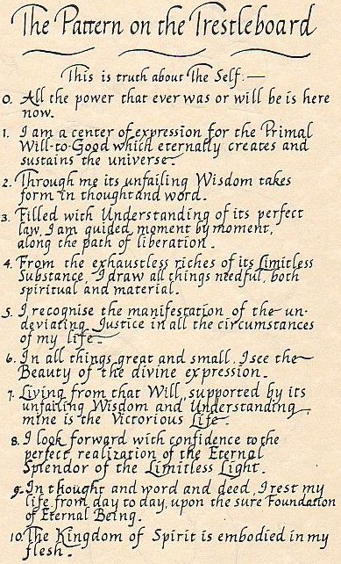

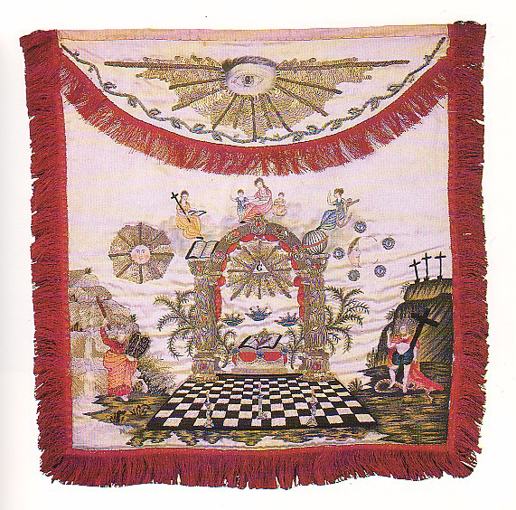
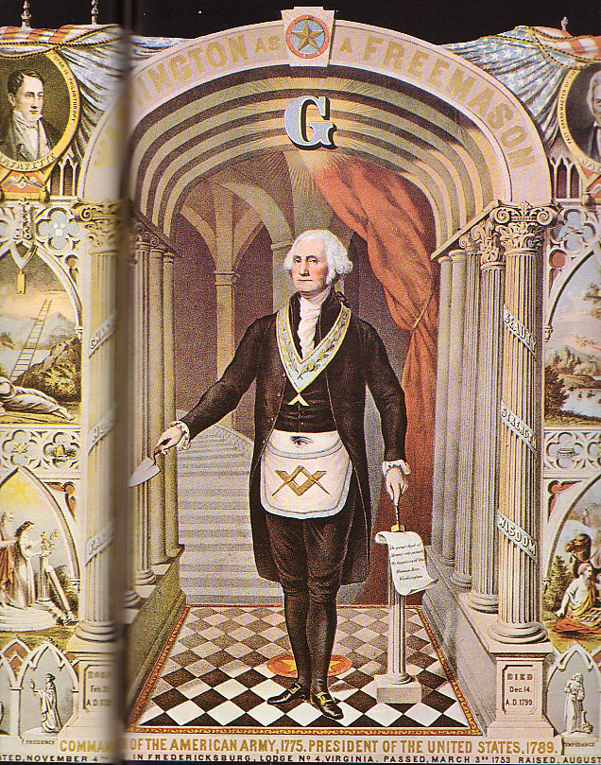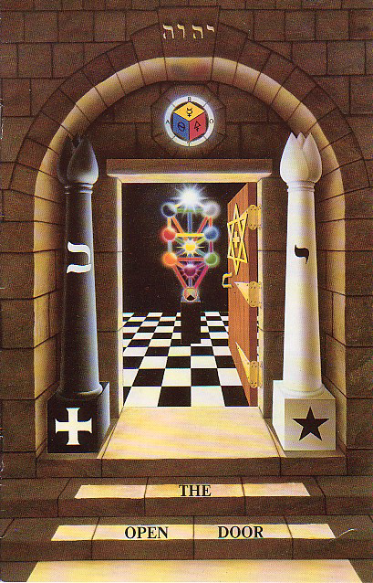



END

