An Hermetic Origin of the Tarot Cards?
A Consideration of the Tarocchi of Mantegna

Adam McLean
First published in the Hermetic Journal 1983.
http://www.levity.com/alchemy/mantegna.html

It has become almost universally accepted as the received wisdom of the Western esoteric tradition that the tarot card images embody a system derived from the Jewish Kabbalah. This view seems to derive from the mid-nineteenth century French Occult revival, and particularly was promulgated by Eliphas Levi and later incorporated through Westcott, Mathers and Waite in the teachings of the Hermetic Order of the Golden Dawn from which our twentieth century tradition of occultism has been derived. Other esotericists have even tried to link the tarot images back further into Egyptian iconography and suggest that the Jews may have received this esoteric system during the time of their stay in Egypt. In part this association of the tarot with Jewish esotericism lies in the fact that there are 22 major arcana cards in the modern tarot pack and this parallels the number of letters in the Hebrew alphabet, which lies at the heart of the Kabbalistic system.
I would, however, like us to pause and consider for a moment, before we return to the established view, the implications of the regrettably neglected early tarot pack, the Tarocchi of Mantegna. This is one of the earliest known tarot or Tarocchi packs, being dated to c.1465, contemporary with the Visconti-Sforza deck of the mid-fifteenth century which is recognised as the earliest tarot. (Some authorities suggest that the Tarocchi of Mantegna may be earlier than the Visconti-Sforza.)
Little is known of the Tarocchi of Mantegna and what we do know entirely contradicts it name. Most scholars are of the opinion that this Tarocchi has been wrongly attributed to Andreas Mantegna (1431-1506) the painter and printmaker of the School of Padua, and rather are to be seen as emanating from the School of Ferrara. They are not a 'Tarocchi' pack in the true sense of that technical term, and they are not cards but a set of prints. Kenneth Clark, the well known art historian of the Renaissance, attributes them to a Parrasio Michele, Master of the School of Ferrara. They consist of a set of 50 finely executed engravings divided into five decades, which could be characterised as:-
1 The archetypal social stations of humanity;
2 The nine Muses and Apollo;
3 The Liberal Arts;
4 The Cardinal Virtues;
5 The Heavenly Spheres.
The symbolism of these cards, or perhaps we should say 'emblematic figures', would seem to derive from the Hermetic tradition which is now recognised as underlying the Italian Renaissance of the mid-fifteenth century. It was during this period that the Platonic Academies of the Medici's were set up and Ficino and other scholars began translating texts such as the Corpus Hermeticum and the works of Plato, some of which were brought to the Court of Florence from Constantinople by Gemistus Plethon (c.1355-1450), a Greek scholar who was probably an initiate of a 'Platonic' Mystery School in the East. This reconstruction of hermetic and neoplatonic esotericism is reflected in such ideas as the Muses, the Liberal Arts, the Cardinal Virtues, and the Heavenly Spheres, and it is my view that the Tarocchi of Mantegna should be seen as an 'emblem book' of this hermetic current. The fact that its designs show parallels with the later tarot decks should therefore be of the greatest interest both to students of tarot and of Hermeticism.
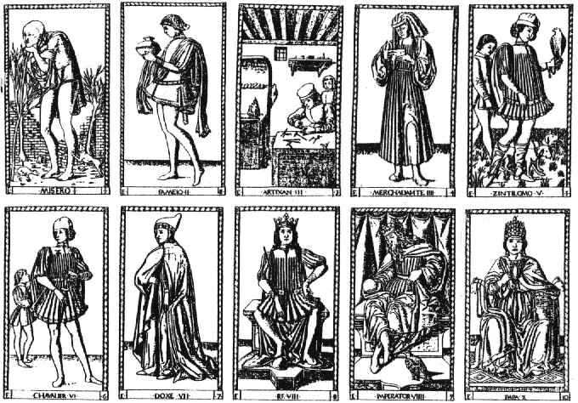
The first decade shows us a sequence reflecting the state or condition of humankind, from the lowly beggar to the Pope. These are :-
1 Beggar 6 Knight
2 Servant 7 Duke
3 Artisan or Craftsman 8 King
4 Merchant 9 Emperor
5 Gentleman or Squire 10 Pope
There is in this sequence both a reflection of the social conditions of humankind and also the stages of an inner development, from the lowly 'beggar' state of soul, to the fully spiritualised 'Pope' facet of the soul.
Interestingly, these fit well onto the tree of life diagram corresponding to the sephiroth quite tightly, but can also equally well be tied symbolically to the Pythagorean 'Tetractys' or pyramid.
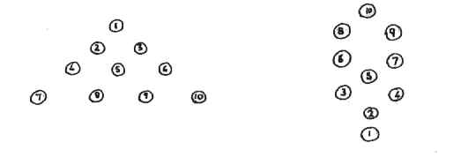
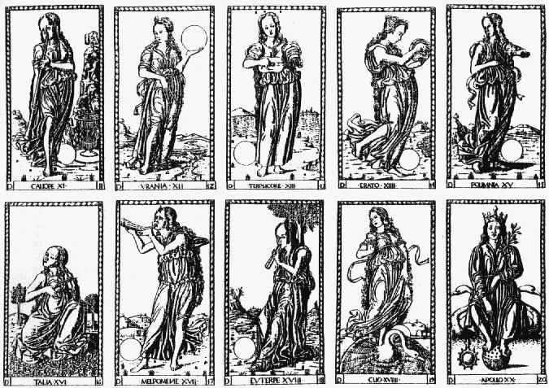
The second decade consists of images of the nine muses and Apollo. These muses preside over certain arts and instruments of these arts.
Calliope 'Beautiful voiced' epic poetry Trumpet
and eloquence stylus

Urania 'Heavenly' astrology compass and
celestial globe

Terpsichore 'she who loves lyric poetry lyre or cithera
dancing' and dance

Erato 'arouser of desire' erotic or tambourine
love poetry

Polihymnia 'many hymns' heroic hymns lyre or
mimic art portative organ

Thelia 'the festive' comedy and violin
pastoral poetry mask of comedy

Melpomene 'the singer' tragedy horn
mask of tragedy

Euterpe 'giver of joy' music and double flute
lyric poetry

Clio 'giver of fame' history scroll

Apollo
This group represents the archetypal sources of creative inspiration for the soul, and these muses work in the realm of the imagination. The soul can draw upon these ten different inner spiritual resources for its inspiration and transmutation.
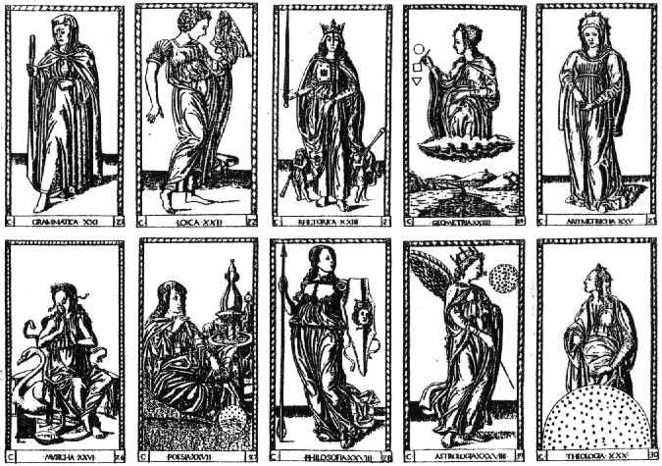
The third group consist of the Seven Liberal Arts with the addition of Poetry, Philosophy and Theology to bring the number up to ten. The Liberal Arts lay at the basis of scholasticism and consist of the Trivium of Grammar, Rhetoric and Dialectic, which trained the mind in the use of language, and the Quadrivium of Geometry, Arithmetic, Music and Astronomy, which four constituted the domain of medieval science. Each of these bear a symbol
Grammar File and Vase
Logic Veiled Dragon
Rhetoric Sword
Geometry Circle, Square, Triangle
Arithmetic Coins or counters
Music Flute
Poetry Flute and a Vase
Philosophy Arrow and Shield (Athene figure)
Astrology Sphere of Stars and pointer (Angelic figure)
Theology Sphere of Heaven and Earth (Androgyne figure)
This group are the archetypes that work behind human thinking.
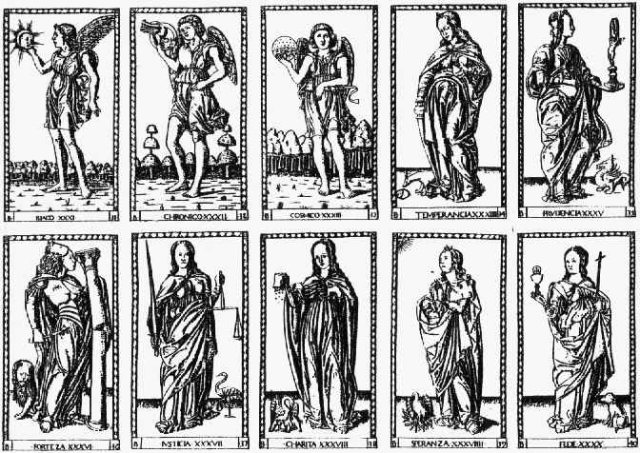
The fourth decade consist of the seven Cardinal Virtues appearing as female figures together with three Spirits (or Genius') of Life (or the Sun), Time and the Cosmos, these being shown as male Angels, each carrying a symbol. The seven Cardinal Virtues also have animal figures beside them.
Iliaco Sun disc
Chronico Ouroboros Dragon
Cosmico Heavenly Globe
Temperance Two vases Dog, Cat, weasel, or stoat/ermine
Prudence Mirror Dragon
Strength Sceptre Lion
Justice Sword and scales Crane
Charity Wallet, offering charity Pelican
Hope in attitude of prayer phoenix
Faith Chalice and Host Dog
These represent that which works in the higher soul of humanity as the virtues dwelling in the conscience. As the aspiring soul develops towards inward perfection, rising to an awareness of the spiritual genius behind the life force (the Sun), Time and Space, then there will inwardly develop from the seed of conscience rooted in the soul, the Virtues, which will unfold and grow from within to express themselves in ones outer actions.
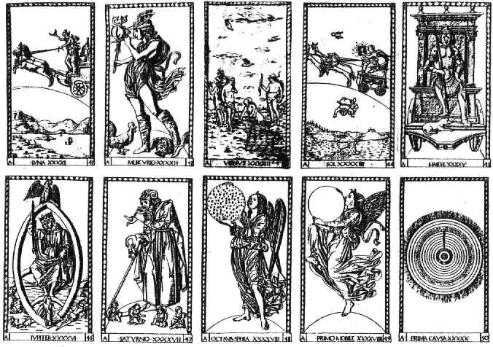
The final decanate is that of the heavenly spheres - the seven planets and the three higher spheres each having a symbol.
Luna Moon disc
Mercury Flute Caduceus with two
intertwined dragons Cock
Venus Seashell Ducks
Sun Sun disc Scorpion Crabs
Mars Sword Dogs (hunting)
Jupiter Arrow (thunderbolt) Eagle
Saturn Scythe Ouroboros
Eighth Sphere Starry Disc
Prime Mover Empty Sphere
First Cause Cosmos
This represents the highest spiritual principles working as the planetary forces behind all the aspects of the world.
To summarise:-
The First Decade Stations of Archetypal powers in the outer
Humanity world of humanity externalised in
social forms
The Second Decade Muses Archetypal powers of in the imagination
of humanity, expressing themselves
in artistic creation
The Third Decade Liberal Arts Archetypal powers in human thinking
expressing themselves in the patterns
of human thought
The Fourth Decade Cardinal Virtues Archetypal patterns in the conscience
of humanity expressing themselves in
the inner development and spiritual
refinement of the soul
The Fifth Decade Cosmic Spheres Archetypal patterns in the Cosmic
order expressing themselves in all
facets of the universe
So we have here the cosmic spheres of the fifth decade representing the Macrocosm and the first decade being a kind of reflection of this in the Microcosm, while between these two polarities are found the Muses, Liberal Arts and Cardinal Virtues, the channels through which the soul experiences the archetypal powers lying behind its feeling, thinking and willing, and can thereby develop its imaginative, intellectual and spiritual gifts. This reflects the Renaissance ideal propounded in the Neoplatonic academies which inspired artists, writers and musicians, and brought great works of the creative human spirit into being which transformed the outer restrictive social forms of the medieval period and gave a new impulse of freedom to the spiritual seeking of humanity.
So it should be obvious that these cards and their symbolism arise out of a Neoplatonic and hermetic current, but they should not be seen as entirely limited symbolically to this period or set of ideas. For this very early Tarocchi of Mantegna designs, through reflecting this hermetic system of ideas also may have provided the archetypal forms for some of the later and more familiar tarot packs. We note certain obvious parallels.
Mantegna Modern tarot Mantegna Modern tarot

1 BEGGAR FOOL 36 FORTEZA STRENGTH
3 ARTISAN MAGUS 37 IUSTICIA JUSTICE
B KING HIEROPHANT 43 VENUS THE LOVERS
9 EMPEROR EMPEROR 44 THE SUN THE SUN
10 POPE PRIESTESS 45 MARTE THE CHARIOT
(N.B.the Pope here 46 JUPITER THE WORLD
appears female) 47 SATURNO DEATH
27 POESIO THE STAR
34 TEMPERANCE TEMPERANCE

So could it not be that our present day tarot cards should perhaps be seen as arising out of the hermetic ideas at the foundation of the Renaissance, rather then from the Jewish Kaballah? I believe this view requires, indeed demands, some attention, even though it might upset the established and ingrained ideas of twentieth century occultism. An Hermetic Origin of the Tarot Cards?
A Consideration of the Tarocchi of Mantegna

Adam McLean
First published in the Hermetic Journal 1983.

It has become almost universally accepted as the received wisdom of the Western esoteric tradition that the tarot card images embody a system derived from the Jewish Kabbalah. This view seems to derive from the mid-nineteenth century French Occult revival, and particularly was promulgated by Eliphas Levi and later incorporated through Westcott, Mathers and Waite in the teachings of the Hermetic Order of the Golden Dawn from which our twentieth century tradition of occultism has been derived. Other esotericists have even tried to link the tarot images back further into Egyptian iconography and suggest that the Jews may have received this esoteric system during the time of their stay in Egypt. In part this association of the tarot with Jewish esotericism lies in the fact that there are 22 major arcana cards in the modern tarot pack and this parallels the number of letters in the Hebrew alphabet, which lies at the heart of the Kabbalistic system.
I would, however, like us to pause and consider for a moment, before we return to the established view, the implications of the regrettably neglected early tarot pack, the Tarocchi of Mantegna. This is one of the earliest known tarot or Tarocchi packs, being dated to c.1465, contemporary with the Visconti-Sforza deck of the mid-fifteenth century which is recognised as the earliest tarot. (Some authorities suggest that the Tarocchi of Mantegna may be earlier than the Visconti-Sforza.)
Little is known of the Tarocchi of Mantegna and what we do know entirely contradicts it name. Most scholars are of the opinion that this Tarocchi has been wrongly attributed to Andreas Mantegna (1431-1506) the painter and printmaker of the School of Padua, and rather are to be seen as emanating from the School of Ferrara. They are not a 'Tarocchi' pack in the true sense of that technical term, and they are not cards but a set of prints. Kenneth Clark, the well known art historian of the Renaissance, attributes them to a Parrasio Michele, Master of the School of Ferrara. They consist of a set of 50 finely executed engravings divided into five decades, which could be characterised as:-
1 The archetypal social stations of humanity;
2 The nine Muses and Apollo;
3 The Liberal Arts;
4 The Cardinal Virtues;
5 The Heavenly Spheres.
The symbolism of these cards, or perhaps we should say 'emblematic figures', would seem to derive from the Hermetic tradition which is now recognised as underlying the Italian Renaissance of the mid-fifteenth century. It was during this period that the Platonic Academies of the Medici's were set up and Ficino and other scholars began translating texts such as the Corpus Hermeticum and the works of Plato, some of which were brought to the Court of Florence from Constantinople by Gemistus Plethon (c.1355-1450), a Greek scholar who was probably an initiate of a 'Platonic' Mystery School in the East. This reconstruction of hermetic and neoplatonic esotericism is reflected in such ideas as the Muses, the Liberal Arts, the Cardinal Virtues, and the Heavenly Spheres, and it is my view that the Tarocchi of Mantegna should be seen as an 'emblem book' of this hermetic current. The fact that its designs show parallels with the later tarot decks should therefore be of the greatest interest both to students of tarot and of Hermeticism.
The first decade shows us a sequence reflecting the state or condition of humankind, from the lowly beggar to the Pope. These are :-
1 Beggar 6 Knight
2 Servant 7 Duke
3 Artisan or Craftsman 8 King
4 Merchant 9 Emperor
5 Gentleman or Squire 10 Pope
There is in this sequence both a reflection of the social conditions of humankind and also the stages of an inner development, from the lowly 'beggar' state of soul, to the fully spiritualised 'Pope' facet of the soul.
Interestingly, these fit well onto the tree of life diagram corresponding to the sephiroth quite tightly, but can also equally well be tied symbolically to the Pythagorean 'Tetractys' or pyramid.
The second decade consists of images of the nine muses and Apollo. These muses preside over certain arts and instruments of these arts.
Calliope 'Beautiful voiced' epic poetry Trumpet
and eloquence stylus

Urania 'Heavenly' astrology compass and
celestial globe

Terpsichore 'she who loves lyric poetry lyre or cithera
dancing' and dance

Erato 'arouser of desire' erotic or tambourine
love poetry

Polihymnia 'many hymns' heroic hymns lyre or
mimic art portative organ

Thelia 'the festive' comedy and violin
pastoral poetry mask of comedy

Melpomene 'the singer' tragedy horn
mask of tragedy

Euterpe 'giver of joy' music and double flute
lyric poetry

Clio 'giver of fame' history scroll

Apollo
This group represents the archetypal sources of creative inspiration for the soul, and these muses work in the realm of the imagination. The soul can draw upon these ten different inner spiritual resources for its inspiration and transmutation.
The third group consist of the Seven Liberal Arts with the addition of Poetry, Philosophy and Theology to bring the number up to ten. The Liberal Arts lay at the basis of scholasticism and consist of the Trivium of Grammar, Rhetoric and Dialectic, which trained the mind in the use of language, and the Quadrivium of Geometry, Arithmetic, Music and Astronomy, which four constituted the domain of medieval science. Each of these bear a symbol
Grammar File and Vase
Logic Veiled Dragon
Rhetoric Sword
Geometry Circle, Square, Triangle
Arithmetic Coins or counters
Music Flute
Poetry Flute and a Vase
Philosophy Arrow and Shield (Athene figure)
Astrology Sphere of Stars and pointer (Angelic figure)
Theology Sphere of Heaven and Earth (Androgyne figure)
This group are the archetypes that work behind human thinking.
The fourth decade consist of the seven Cardinal Virtues appearing as female figures together with three Spirits (or Genius') of Life (or the Sun), Time and the Cosmos, these being shown as male Angels, each carrying a symbol. The seven Cardinal Virtues also have animal figures beside them.
Iliaco Sun disc
Chronico Ouroboros Dragon
Cosmico Heavenly Globe
Temperance Two vases Dog, Cat, weasel, or stoat/ermine
Prudence Mirror Dragon
Strength Sceptre Lion
Justice Sword and scales Crane
Charity Wallet, offering charity Pelican
Hope in attitude of prayer phoenix
Faith Chalice and Host Dog
These represent that which works in the higher soul of humanity as the virtues dwelling in the conscience. As the aspiring soul develops towards inward perfection, rising to an awareness of the spiritual genius behind the life force (the Sun), Time and Space, then there will inwardly develop from the seed of conscience rooted in the soul, the Virtues, which will unfold and grow from within to express themselves in ones outer actions.
The final decanate is that of the heavenly spheres - the seven planets and the three higher spheres each having a symbol.
Luna Moon disc
Mercury Flute Caduceus with two
intertwined dragons Cock
Venus Seashell Ducks
Sun Sun disc Scorpion Crabs
Mars Sword Dogs (hunting)
Jupiter Arrow (thunderbolt) Eagle
Saturn Scythe Ouroboros
Eighth Sphere Starry Disc
Prime Mover Empty Sphere
First Cause Cosmos
This represents the highest spiritual principles working as the planetary forces behind all the aspects of the world.
To summarise:-
The First Decade Stations of Archetypal powers in the outer
Humanity world of humanity externalised in
social forms
The Second Decade Muses Archetypal powers of in the imagination
of humanity, expressing themselves
in artistic creation
The Third Decade Liberal Arts Archetypal powers in human thinking
expressing themselves in the patterns
of human thought
The Fourth Decade Cardinal Virtues Archetypal patterns in the conscience
of humanity expressing themselves in
the inner development and spiritual
refinement of the soul
The Fifth Decade Cosmic Spheres Archetypal patterns in the Cosmic
order expressing themselves in all
facets of the universe
So we have here the cosmic spheres of the fifth decade representing the Macrocosm and the first decade being a kind of reflection of this in the Microcosm, while between these two polarities are found the Muses, Liberal Arts and Cardinal Virtues, the channels through which the soul experiences the archetypal powers lying behind its feeling, thinking and willing, and can thereby develop its imaginative, intellectual and spiritual gifts. This reflects the Renaissance ideal propounded in the Neoplatonic academies which inspired artists, writers and musicians, and brought great works of the creative human spirit into being which transformed the outer restrictive social forms of the medieval period and gave a new impulse of freedom to the spiritual seeking of humanity.
So it should be obvious that these cards and their symbolism arise out of a Neoplatonic and hermetic current, but they should not be seen as entirely limited symbolically to this period or set of ideas. For this very early Tarocchi of Mantegna designs, through reflecting this hermetic system of ideas also may have provided the archetypal forms for some of the later and more familiar tarot packs. We note certain obvious parallels.
Mantegna Modern tarot Mantegna Modern tarot

1 BEGGAR FOOL 36 FORTEZA STRENGTH
3 ARTISAN MAGUS 37 IUSTICIA JUSTICE
B KING HIEROPHANT 43 VENUS THE LOVERS
9 EMPEROR EMPEROR 44 THE SUN THE SUN
10 POPE PRIESTESS 45 MARTE THE CHARIOT
(N.B.the Pope here 46 JUPITER THE WORLD
appears female) 47 SATURNO DEATH
27 POESIO THE STAR
34 TEMPERANCE TEMPERANCE
So could it not be that our present day tarot cards should perhaps be seen as arising out of the hermetic ideas at the foundation of the Renaissance, rather then from the Jewish Kaballah? I believe this view requires, indeed demands, some attention, even though it might upset the established and ingrained ideas of twentieth century occultism.

