Tarot
http://en.wikipedia.org/wiki/Tarot
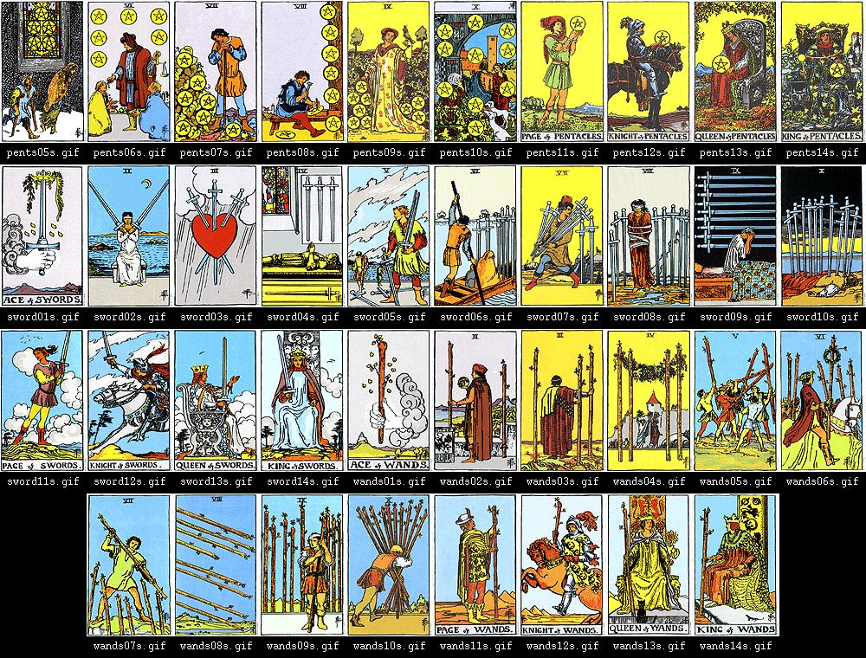
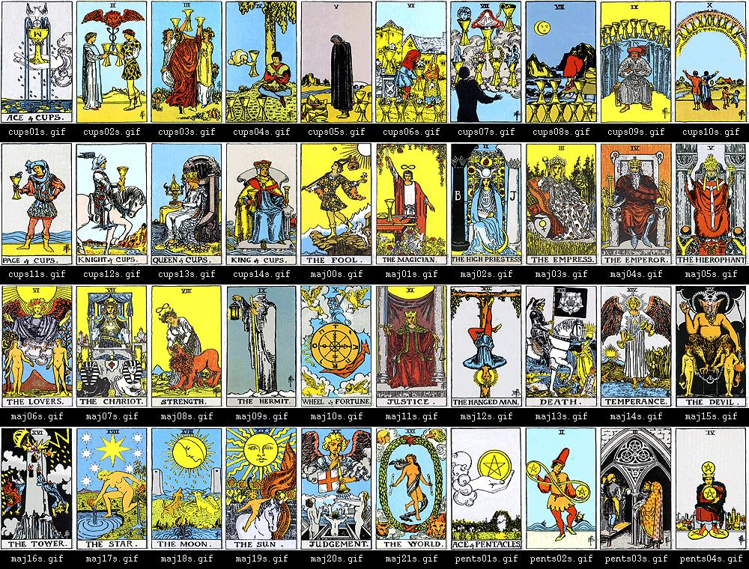
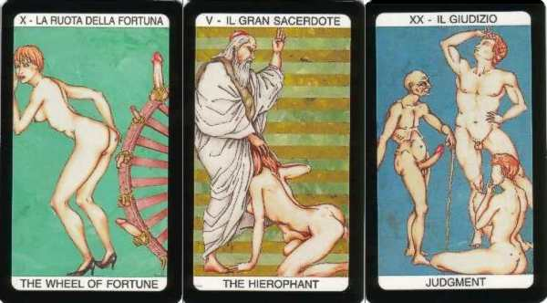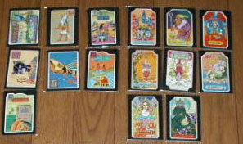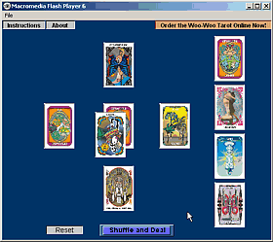
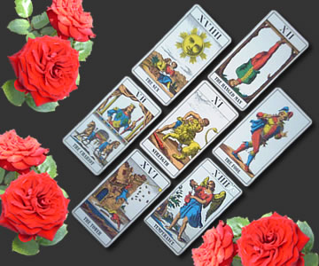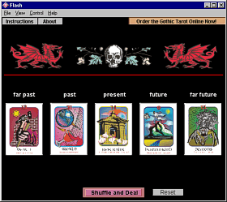

The tarot is a set of cards displaying allegorical representations. Originally used as playing cards, they later came to be used for divination.

Contents
[hide]
- 1 Composition
- 2 Origins
- 3 The tarot deck
  - 3.1 Uses of tarot cards
    - 3.1.1 Divination
    - 3.1.2 Communication
- 4 History
  - 4.1 Early tarot decks
  - 4.2 Later tarot decks
- 5 Esoteric views on the history of tarot
- 6 Use of tarot cards in divination
  - 6.1 Differences among decks
- 7 Symbolism
- 8 Psychology
- 9 Critics
- 10 Storytelling and art
- 11 External links

[] Composition
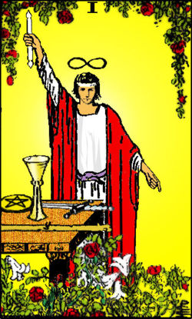
The Magician, card one in the major arcana. This particular card is from the Rider-Waite tarot deck.

The typical 78-card tarot deck has two distinct parts.
The first part, known as the trump cards, consists of 21 cards without suits, plus a 22nd card, The Fool, which is often given the value of zero. These cards are known as the major arcana, or "greater secrets."
The second part consists of 56 cards divided into four suits of 14 cards each, ten numbered cards and four court cards (the page, the knight, the queen and the king). The traditional Italian suits are swords, batons, coins and cups; in modern tarot decks, however, the batons suit is often called wands, rods or staves, while the coins suit is often called pentacles or disks. These cards are known as the minor arcana, or "lesser secrets."

[] Origins
Whilst the exact origins of tarot are not entirely known, the earliest reliable information suggests that tarot originated as a game in 15th century Italy by the addition of 21 trump cards, a fool and four queens to a normal deck of cards. Some early tarot decks of Northern Italian origin, which date from the early to mid-15th century, have survived. These were called carte da trionfi, or "triumph cards." About a century later, the cards came to be known as tarocchi.
When the tarot was first used for divination is not known, but no documented examples exist of tarot cards being used for divination prior to the 18th century; all available evidence indicates that cartomancy with more conventional playing cards predates tarot cartomancy. As early as 1540, for example, a book entitled The Oracles of Francesco Marcolino da Forli shows a simple method of divination using the coin suit of a regular playing card deck. It was not until the 1700s, with manuscripts from 1735 (The Square of Sevens) and 1750 (Pratesi Cartomancer), that rudimentary divinatory meanings for the cards of the tarot, as well as a system for laying out the cards, were documented. and in 1765 Giacomo Casanova wrote in his diary that his Russian mistress frequently used a deck of playing cards for divination^{[citation needed]}.
In 1781 Antoine Court de Gébelin wrote a speculative history and a detailed system for the use of tarot to foretell the future and, since the publication of this history, various explanations have been given for the origins of tarot, most of them of doubtful veracity. There is no evidence for any tarot cards prior to the hand-painted ones that were used by Italian nobles, but some esoteric schools believe its origins could be in Ancient Egypt, Ancient India or even the lost continent of Atlantis^{[citation needed]}. Such beliefs in non-Italian origins, however, are speculative.

[] The tarot deck
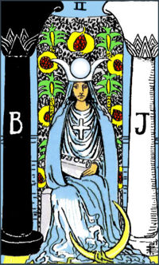
The High Priestess, card number 2 in the major arcana.

Modern tarot decks are typically split into two major groups:
- The major arcana, consisting of 22 trump cards (sometimes referred to as keys): The Fool, The Magician, The High Priestess. The Empress, The Emperor, The Hierophant, The Lovers, The Chariot, Strength, The Hermit, Wheel of Fortune, Justice, The Hanged Man, Death, Temperance, The Devil, The Tower, The Star, The Moon, The Sun, Judgement, and The World.
- The minor arcana, consisting of 56 cards (sometimes referred to as pips): four suits — traditionally batons, cups, swords and coins — of ten numbered cards, plus four court cards per suit

[] Uses of tarot cards

[] Divination
Some traditions in mysticism and parapsychology hold that tarot cards can be used for divination or for accessing the unconscious. The cards are typically shuffled as a deck and laid out in one of a variety of patterns, often called "spreads", and then interpreted as a way of revealing facts about the subject of the reading. These might include the subject's thoughts and desires (known or unknown), or events that have taken place in their past or present or might take place in their future. Sometimes the subject must personally shuffle or deal the cards in order to affect the ordering.
Each card in the tarot deck has a variety of symbolic meanings that have evolved over the years, and many custom or themed tarot decks exist, especially in the United States, which have even more specific symbolism. The minor arcana cards have astrological attributions that can be used as general indicators of timing in the year, based on the Octavian calendar, and the court cards may signify different people in a tarot reading, with each suit's "nature" providing hints about that person's attitudes and physical and emotional characteristics.

[] Communication
Some schools of occult thought or symbolic study, such as the Hermetic Order of the Golden Dawn, consider the tarot to function as a textbook and mnemonic device for their teachings. This may be one cause of the word arcana being used to describe the two sections of the tarot deck: arcana is the plural form of the Latin word arcanum, meaning "closed" or "secret."

[] History

[] Early tarot decks
The relationship between tarot cards and playing cards is well documented. Playing cards appeared quite suddenly in Christian Europe during the period 1375–1380, following several decades of use in Islamic Spain (see playing card history for discussion of its origins). Early European sources describe a deck with typically 52 cards, like a modern deck with no jokers [1]. The 78-card tarot resulted from adding 21 trumps and The Fool — analogous to the modern joker — to an early 56-card variant (14 cards per suit).
A greater distribution of playing cards in Europe can, with some certainty, be given from 1377 onwards. Tarot cards appear to have been developed some 40 years later and they are mentioned, possibly for the first time, in the surviving text of Martiano da Tortona [2]. Da Tortona's text is likely to have been written between 1418 and 1425, since in 1418 the confirmed painter Michelino da Besozzo returned to Milan, and Martiano da Tortona died in 1425. It cannot be proven that tarot cards did not exist earlier than this date, but it seems improbable as the Martiano da Tortona text was written at least 15 years earlier than other corroborating documents.
Da Tortona describes a deck similar to tarot cards in many specific ways, but quite different in others. What he describes is more a precursor to tarot than what we might think of as "real" tarot cards. For instance, his deck has only 16 trumps, its motifs are not comparable to common tarot cards (they are Greek gods) and the suits are four kinds of birds, not the common Italian suits.
What makes da Tortona's deck similar to tarot cards is that these 16 cards are obviously regarded as trump cards in a card game; about 25 years later, a near-contemporary speaker, Jacopo Antonio Marcello, called them a ludus triumphorum, or "game winner". The letter in which Marcello uses this term has been documented and translated on the Internet [3].
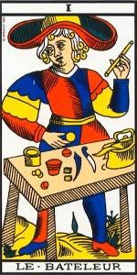
Le Bateleur from the Tarot of Marseilles

The next documents that seem to confirm the existence of objects similar to tarot cards are two playing card decks from Milan (Brera-Brambrilla and Cary-Yale-Tarocchi) — extant, but fragmentary — and three documents, all from the court of Ferrara, Italy. It is not possible to put a precise date on the cards, but it is estimated that they were made circa 1440. The three documents date from 1 January 1441 to July 1442, with the term trionfi first documented in February 1442. The document from January 1441, which used the term trionfi, is regarded as unreliable; however, the fact that the same painter, Sagramoro, was commissioned by the same patron, Leonello d'Este, as in the February 1442 document, indicates that it is at least plausibly an example of the same type. After 1442 there is some seven years without any examples of similar material, which gives no reason to conclude a greater distribution of the game during these years. The game seemed to gain in importance in the year 1450, though, a Jubilee year in Italy, which saw many festivities and movement of pilgrims.
Until this time all relevant early documents point to the origin of the trionfi cards as being in the upper class of Italian society, specifically to the courts of Milan and Ferrara. At the time, these were the most exclusive courts in Europe.
In the given context, it seems apparent that the special motifs on the trumps, which were added to regular playing cards with a "four suits of 14 cards" structure, were ideologically determined. They are thought to show a specific system of transporting messages of different content; known early examples show philosophical, social, poetical, astronomical, and heraldic ideas, for instance, as well as a group of old Roman/Greek/Babylonian heroes, as in the case of the Sola-Busca-Tarocchi (1491)[4] and the Boiardo Tarocchi poem [5] (produced at an unknown date between 1461 and 1494). For example, the earliest-known deck, extant only in its description in Martiano's short book, was produced to show the system of Greek gods, a theme that was very fashionable in Italy at the time. Its production may well have accompanied a triumphal celebration of the commissioner Filippo Maria Visconti, ruler of Milan, meaning that the purpose of the deck was to express and consolidate the political power in Milan (as was common for other artworks of the time). The four suits showed birds, motifs that appeared regularly in Visconti heraldry, and the specific order of the gods gives reason to assume that the deck was intended to imply that the Visconti identified themselves as descendants from Jupiter and Venus (which were seen not as gods but deified mortal heroes).
This first known deck seems to have had the standard ten numbered cards, but kings as the only court card, and only 16 trumps. The later standard (four suits of 14 plus 22) took time to settle; trionfi decks with 70 cards only are still spoken of in 1457[6]. No corroborating evidence for the final standard 78-card format exists prior to the Boiardo Tarocchi poem and the Sola Busca Tarocchi.
Individual researchers' opinions are that the trionfi decks of the early time primarily had five suits of fourteen cards [7] only; the trumps and the fool were simply considered as a fifth suit with predefined trump function.
The oldest surviving tarot cards are three early to mid-15th century sets, all made for members of the Visconti family. The oldest of these existing tarot decks was perhaps painted to celebrate a mid-15th century wedding joining the Visconti and Sforza families of Milan, probably painted by Bonifacio Bembo and other miniaturists of the Ferrara school. Of the original cards, 35 are in the Pierpont Morgan Library, 26 are at the Accademia Carrara, 13 are at the Casa Colleoni and four — the Devil, the Tower, the Three of Swords and the Knight of Coins — are lost, or possibly were never made. This "Visconti-Sforza" deck, which has been widely reproduced, combines the suits of swords, batons, coins and cups and the court cards king, queen, knight and page with trumps that reflect conventional iconography of the time to a significant degree.
For a long time tarot cards remained a privilege for the upper class of society, and, although some sermons inveighing against the evil inherent in cards can be traced to the 14th century, the Roman Catholic Church and most civil governments did not routinely condemn tarot cards during tarot's early history. In fact, in some jurisdictions, tarot cards were specifically exempted from laws otherwise prohibiting the playing of cards.

[] Later tarot decks
As the earliest tarot cards were hand-painted, the number of the decks produced is thought to have been rather small, and it was only after the invention of the printing press that mass production of cards became possible. Decks survive from this era from various cities in France (the best known being a deck from the southern city of Marseilles). At around the same time, the name tarocchi appeared.
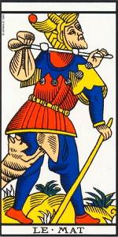
Le Mat (The Fool) from the Tarot of Marseilles.

A widespread and now traditional hypothesis states that the final form of the tarot (with its "four suits of 14 plus 22" structure) was settled on in around 1450. This opinion is based on the suggestion that the surviving 68 Bonifacio Bembo cards had the "6 added trumps" as replacements for earlier "lost cards" (an alternative view, however, states that early tarot decks would usually have 70 cards, and that the Bembo deck only has two cards missing).

[] Esoteric views on the history of tarot
Since 1781, when Antoine Court de Gebelin published his "Le Monde Primatif", in which he claimed Tarot cards held the "secrets of the Egyptians", without producing any evidence to sustain his claims, Tarot cards have been written about by many esoterians who have advanced speculative views on the history of Tarot cards. From this mystical vantage-point, the origin and history of the Tarot is unclear and often idealized.
Many Hermetic traditions, such as the Hermetic Order of the Golden Dawn, which have made claims that the Tarot system was derived from ancient mystery religions as a visually encoded framework of the archetypal concepts seminal to the journey of enlightenment, have blossomed after the Freemasonic writer (Court de Gebelin([8] - with link to the online text in French) published his text about the Tarot, in which he incorporated some writing of the Comte de Mellet, in the year 1781. Naturally the playing card research conditions of the year 1781 were not remotely comparable to the much better research situation of today, Gebelin's errors and partly wild speculations, which proved nonetheless of some importance for the development of Western Esotericism, were natural in his time because of missing information. A good and informative timeline of the development short before and after Gebelin is given by the book author Mary Greer [9].
The Hermetics were quick to point out that in a qabalistic analysis, Tarot is equivalent to Rota (Wheel) or Torah (Law) indicating they were a representation of the 'Wheel of the Law'. (Note that this theory, which tries to explain the name "Tarot", loses its value when one considers that "Tarot" is only the French variant on the original Italian name "tarocchi".) In less obtuse terms, the Tarot would then be a series of metaphysical 'facts' after the manner of the Zen Ox Paintings. From the first to the last of the Major Arcana ("Big Secrets") they are arranged as a series of lessons, or a parable of the passage of the soul. From the "Fool" 0, the tabula rasa, naive and artless child-mind, a quest is laid out which is meant for the spiritual edification of the student.
A number of scholars of the western Hermetic or Magical traditions have made such claims of the Tarot having ancient roots and lessons. Look to the works of Robert Fludd or Albertus Magnus for deeper inspections. Another school of thought believes that the Roma people, travelling through many cultures, picked up this pictorial wisdom, and being inventive by nature, created a form of divination (and perhaps of card games) from it. The idea is that they understood and kept the knowledge of the mystery-lessons of the picture-cards in private, while in public they used the cards for profit through divination and card games.

[] Use of tarot cards in divination
Since the Egyptianizing ruminations in Le Monde primitif by Antoine Court de Gébelin (1781) which soon inspired the occultism of "Etteilla" (Jean-Babtiste Alliette), it has been believed by many that the Tarot is far older than this. Based on purported similarities of imagery and reinforced by the added numbering, some claim that Tarot originated in ancient Egypt, the Hebrew mystic tradition of the Kabbalah, or a wide variety of other exotic places and times. Such ideas, however, are speculative.
In fact, although much of Tarot imagery looks mysterious or exotic to modern users, nearly all of it reflects conventional symbolism popular in the late Middle Ages and early Renaissance. Nearly all of it may easily be interpreted as a reflection of the dominant Christian values of the times. Thus, the earliest Tarots may have been depictions of the carnival parades that ushered in the Christian season of Lent or the related motif of hierarchical powers found in Petrarch's poem I Trionfi. These trionfi or triumphs were elaborate productions which layered then-fashionable Graeco-Roman symbolism over a Christian allegory of sin, grace, and redemption. Notably, the earliest versions of the World card show a conventional image known from period religious art to represent St. Augustine's "Heavenly City", and it is not coincidence that it often closely follows the Judgement card.
Several other early Tarot-like sequences of portable art survive to place the Visconti deck in context. Later confusion about the symbolism stems, in part, from the occult decks, which began a process of steadily paganizing and universalizing the symbolism to the point where the underlying Christian allegory has been somewhat obscured (as, for example, when the Rider-Waite deck of the early Twentieth Century changed "The Pope" to "The Hierophant" and "The Popess" to "The High Priestess"). It is notable that between 1450 and 1500 the Tarot was actually recommended for the instruction of the young by Church moralists. Not until fifty years after the Visconti deck did it become associated with gambling, and not until the 18th century and Gébelin and Etteilla with occultism.
The Tarot cards eventually came to be associated with mysticism and magic. This was actually a late rather than early development, as we can tell from period sources on card divination and magic. The Tarot was not widely adopted by mystics, occultists and secret societies until the 18th and 19th century. The tradition began in 1781, when Antoine Court de Gébelin, a Swiss clergyman and Freemason, published Le Monde Primitif, a speculative study which included religious symbolism and its survivals in the modern world. De Gébelin first asserted that symbolism of the Tarot de Marseille represented the mysteries of Isis and Thoth. Gébelin further claimed that the name "tarot" came from the Egyptian words tar, meaning "royal", and ro, meaning "road", and that the Tarot therefore represented a "royal road" to wisdom. Gébelin asserted these and similar views dogmatically; he presented no clear factual evidence to substantiate his claims. In addition, Gébelin wrote before Champollion had deciphered Egyptian hieroglyphs. Later Egyptologists found nothing in the Egyptian language that supports de Gébelin's fanciful etymologies, but these findings came too late; by the time authentic Egyptian texts were available, the identification of the Tarot cards with the Egyptian "Book of Thoth" was already firmly established in occult practice.
Although tarot cards were used for fortune-telling in Bologna, Italy in the 1700s, they were first widely publicized as a divination method by Alliette, also called "Etteilla", a French occultist who reversed the letters of his name and worked as a seer and card diviner shortly before the French Revolution. Etteilla designed the first esoteric Tarot deck, adding astrological attributions and "Egyptian" motifs to various cards, altering many of them from the Marseille designs, and adding divinatory meanings in text on the cards. Etteilla decks, although now eclipsed by Smith and Waite's fully-illustrated deck and Aleister Crowley's "Thoth" deck, remain available. Later, Mademoiselle Marie-Anne Le Normand popularized divination and prophecy during the reign of Napoleon I. This was due, in part, to the influence she wielded over Joséphine de Beauharnais, Napoleon's first wife. However, she did not typically use Tarot.
Interest in Tarot by other occultists came later, during the Hermetic Revival of the 1840s in which (among others) Victor Hugo was involved. The idea of the cards as a mystical key was further developed by Eliphas Levi and passed to the English-speaking world by The Hermetic Order of the Golden Dawn. Lévi, not Etteilla, is considered by some to be the true founder of most contemporary schools of Tarot; his 1854 Dogme et Rituel de la Haute Magie (English title: Transcendental Magic) introduced an interpretation of the cards which related them to Cabala. While Levi accepted Court de Gébelin's claims about an Egyptian origin of the deck symbols, he rejected Etteilla's innovations and his altered deck, and devised instead a system which related the Tarot, especially the Tarot de Marseille, to the Kabbalah and the four elements of alchemy. On the other hand, to this day some of Etteilla's divinatory meanings for Tarot are still used by some Tarot practitioners.
Tarot became increasingly popular beginning in 1910, with the publication of the Rider-Waite-Smith Tarot, which took the step of including symbolic images related to divinatory meanings on the numeric cards. (Arthur Edward Waite had been an early member of the Hermetic Order of the Golden Dawn). In the 20th century, a huge number of different decks were created, some traditional, some vastly different. Thanks, in part, to marketing by the publisher U.S. Games Systems Inc., the Rider-Waite-Smith deck has been extremely popular in the English-speaking world beginning in the 1970s.
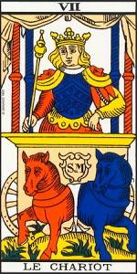
Le Chariot, from the Tarot of Marseille, ion 1930

[] Differences among decks

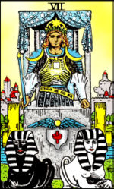
The Chariot from the Rider-Waite Tarot deck

Tarot cards serve many purposes, and this leads to a variety of Tarot deck styles. Traditionally, a variety of styles of Tarot decks and designs have existed. A number of typical regional patterns emerged. Historically, one of the most important designs is now usually known as the Tarot de Marseilles. This standard pattern was the one studied by Court de Gébelin, and cards based on this style illustrate his Le Monde primitif. The Tarot de Marseilles was also popularized in the 20th century by Paul Marteau. Some current ions of cards based on the Marseilles design go back to a deck of a particular Marseilles design that was printed by Nicolas Conver in 1760. Other regional styles include the "Swiss" Tarot; this one substitutes Juno and Jupiter for the Papess, or High Priestess and the Pope, or Heirophant. In Florence an expanded deck called Minchiate was used; this deck of 96 cards includes astrological symbols and the four elements, as well as traditional Tarot cards.
Interestingly, some people view the older decks such as the Visconti-Sforza and Marseilles as crude and limited when compared to some modern ones. This may reflect their belief that Tarot symbolism has evolved, especially since the early 20th century, so that it has become increasingly universal. A Marseilles-type deck is usually distinguished by having repetitive motifs on the pip cards as opposed to full scenes found on "Rider-Waite" style decks.
Some decks exist primarily as artwork; and such "art decks" sometimes contain only the 22 cards of the Major Arcana. Esoteric decks are often used in conjunction with the study of the Hermetic Qabala; in these decks the Major Arcana are illustrated in accordance with Qabalistic principles while the numbered suit cards (2 through 10) sometimes bear only stylized renderings of the suit symbol. However, under the influence of the Rider-Waite-Smith deck, decks used in the English-speaking world for divination often bear illustrated scenes on the numeric cards to facilitate divination. The more simply illustrated "Marseilles" style decks are nevertheless used esoterically, for divination, and previously for game play. (Note that the French card game of tarot is now generally played using a relatively modern 19th-century design of German origin. Such Tarot decks generally have 21 trumps with genre scenes from 19th-century life, a Fool, and have court and pip cards that closely resemble today's French playing cards.)
An influential deck in English-speaking countries is the Rider-Waite deck (sometimes called simply the Rider deck). (See also discussion of the general expression "Rider-Waite-Smith" below, to indicate a category of decks that includes the "Rider-Waite" deck as well as decks which use the line drawings of the Rider-Waite deck, such as the Universal Waite deck, or decks using scenes on the pip cards as opposed to simple motif repetition.) (In contrast, in French-speaking countries, the Marseilles deck enjoys the equivalent popularity.) The images were drawn by artist Pamela Colman-Smith, to the instructions of Christian mystic and occultist Arthur Edward Waite, and originally published by the Rider Company in 1910. While the deck is sometimes known as a simple, user-friendly one, its imagery, especially in the Trumps, is complex and replete with occult symbolism. The subjects of the trumps are based on those of the earliest decks, but have been significantly modified to reflect Waite and Smith's view of Tarot. An important difference from Marseilles-style decks is that Smith drew scenes on the numeric cards to depict divinatory meanings; those divinatory meanings derive, in great part, from traditional cartomantic divinatory meanings (e.g., Etteilla and others) and from divinatory meanings first espoused by The Hermetic Order of the Golden Dawn, of which both Waite and Smith were members. However, it isn't the first deck to include completely illustrated numeric cards. The first to do so was the 15th-century Sola-Busca deck; however, in this case, the illustrations apparently were not made to facilitate divination.
Some individuals object to the Rider-Waite deck due to its relatively small selection of colors and "flat" appearance. However, several decks, such as the Universal Waite, copy the Smith's line drawings, but add more subtle coloring and three dimensional modeling. The limited number of colors and "flat" appearance in the original Rider-Waite-Smith decks were virtually unavoidable due to the limits of printing technology in the early 20th century.
In Internet tarot discussion groups, the Rider-Waite deck and very similar decks, e.g., the Universal Waite, are sometimes referred to by the collective term "Rider-Waite-Smith", "RWS" or "Waite-Colman-Smith" (or similar expressions). Numerous other decks that are loosely based on Rider-Waite (as noted below) have been published from the mid-20th century through today. They are sometimes called Rider-Waite-Smith clones; however, the term is misleading. They are not exact copies as the term clone would imply. Instead, they are variations.
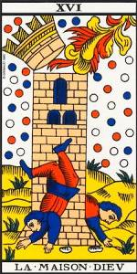
The Tower from the Tarot of Marseilles

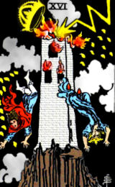
The Tower from the Rider-Waite Tarot deck

A widely-used esoteric Tarot deck is Aleister Crowley's Thoth Tarot (pronounced /təʊt/ or /θɒθ/). The often controversial Crowley engaged the artist Lady Frieda Harris to paint the cards for the deck. The Thoth deck is distinctly different from the Rider-Waite deck, and some find it to have much darker symbology. That said, many consider the Rider-Waite deck and the Tarot de Marseilles also to be 'esoteric' decks.
In contrast to the Thoth deck's colourfulness, the illustrations on Paul Foster Case's B.O.T.A. Tarot deck are black line drawings on white cards; this is an unlaminated deck intended to be coloured by its owner. Other esoteric decks include the Golden Dawn Tarot, which is apparently based on a deck by SL MacGregor Mathers and clearly based on the teachings of the Golden Dawn. Numerous other decks exist, including the Tree of Life Tarot whose cards are stark symbolic catalogs, and the Cosmic Tarot.
The Marseilles-style Tarot decks generally feature numbered minor arcana cards that look very much like the pip cards of modern playing card decks. The Marseilles' numbered minor arcana cards do not have scenes depicted on them; rather, they sport a geometric arrangement of the number of suit symbols (e.g., swords, rods, cups, coins) corresponding to the number of the card (accompanied by botanical and other non-scenic flourishes), while the court cards are often illustrated with flat, two-dimensional drawings.
Other modern decks created since the time of the first publishing of the Rider-Waite deck in 1909 vary in their card imagery. The variety is almost endless, and grows yearly. For instance, cat-lovers may have the Tarot of the Cat People, a deck complete with cats in every picture. The Tarot of the Witches and the Aquarian Tarot retain the conventional cards with varying designs. The Tarot of the Witches deck became famous/notorious in the 1970s for its use in the James Bond movie Live and Let Die.
These modern decks change the cards to varying degrees. For example, the Motherpeace Tarot is notable for its circular cards and feminist angle: the mainly male characters have been replaced by females. The Tarot of Baseball has suits of bats, mitts, balls and bases; "coaches" and "MVPs" instead of Queens and Kings; and major arcana cards like "The Catcher", "The Rule Book" and "Batting a Thousand". In the Silicon Valley Tarot, major arcana cards include The Hacker, Flame War, The Layoff and The Garage; the suits are Networks, Cubicles, Disks and Hosts; the court cards CIO, Salesman, Marketeer and New Hire. Another very popular tarot in recent years has been the Robin Wood Tarot. This deck retains the Rider-Waite theme while adding some very soft and colorful Pagan symbolism. As with other decks, the cards are available with a companion book written by Ms. Wood which details all of the symbolism and colors utilized in the Major and Minor Arcana.

[] Symbolism
The Tarot has a complex and rich symbolism with a long history. In the past, many occult- or divination-oriented authors claimed that the symbolism's origins are lost in time and/or postulated or claimed as fact non-historical theories. More recently, however, authors such as Michael Dummett, Robert O'Neill and Robert Place have written historically accurate books. At the same time, some authors such as Rachel Pollack feel that tarot origin myths have their own significance and value and that the reader can find a study of such myths enriching while at the same time being aware that they aren't factually true.
Some people find that modern Tarot decks are more interesting, expressive, and psychologically resonant than their ancestors. Interpretations have evolved together with the cards over the centuries: later decks have "clarified" the pictures in accordance with meanings assigned to the cards by their creators. In turn, the meanings come to be modified by the new pictures. Images and interpretations have been continually reshaped, in part, to help the Tarot live up to its mythic role as a powerful occult instrument and to respond to modern needs.
See, for example, the Rider-Waite-Smith Strength card. We can know more about the symbolic intentions of the designer here, since he conveniently wrote many books on the subject on occultism and symbolism and a handbook specifically for this deck titled The Pictorial Key to the Tarot (1910). As with its ancestor in the Tarot de Marseilles, the Strength trump shows a woman holding the jaws of a lion, but this picture is far more elaborate. The woman's hat of the Marseilles card has frequently been interpreted as a lemniscate: the sideways-figure-eight representing infinity, or, according to Waite, the Spirit of Life. In the newer card, this symbol appears explicitly. Other symbols are included: a chain of roses symbolizing desire or passion, against a white robe symbolizing purity. The mountains in the background demonstrate another kind of strength. Even here there is room for interpretation: the card is sometimes considered as showing intellect triumphing over desire, sometimes as the equal union of intellect and passion, sometimes just as a symbol of mental strength or endurance.
Another example of the preservation of designs from one deck to another can be seen via the incorporation of the ribbon design found on the Deux de Deniéres in a Swiss-style deck originally published by Müller & Cie. of Schaffhouse into the of The Book of Thoth Tarot's Two of Disks.
The twenty-two cards in the major arcana are: Fool, Magician, High Priestess [or La Papessa/Popess], Empress, Emperor, Hierophant [or Pope], Lovers, Chariot, Strength, Hermit, Wheel of Fortune, Justice, Hanged Man, Death, Temperance, Devil, Tower, Star, Moon, Sun, Judgement, World. Each card has its own large, complicated and disputed set of meanings. Altogether the major arcana are frequently said to represent The Fool's Journey, a symbolic journey through life in which the Fool overcomes obstacles and gains wisdom. This idea was apparently first suggested by tarot author Eden Gray in the mid-20th century.
There is a vast body of writing on the significance of the Tarot. In many systems of interpretation based on that of the Golden Dawn, the four suits are associated with the four elements: Swords with air, Wands with fire, Cups with water and Pentacles with earth. The numerology is usually thought to be significant. The tarot is often considered to correspond to various systems such as astrology, Pythagorean numerology, the Kabalah, the I Ching, Christianity [10], Aura-Soma and others.

[] Psychology
Carl Jung was the first psychologist to attach importance to tarot symbolism. He may have regarded the tarot cards as representing archetypes: fundamental types of person or situation embedded in the subconscious of all human beings. The Emperor, for instance, represents the ultimate patriarch or father figure.
The theory of archetypes gives rise to several psychological uses. Some psychologists use tarot cards to identify how a client views himself or herself, by asking the patient to select a card that he or she identifies with. Some try to get the client to clarify his ideas by imagining his situation or relationship in terms of tarot images: Is someone rushing in heedlessly like the Knight of Swords perhaps, or blindly keeping the world at bay as in the Rider-Waite-Smith Two of Swords? The Tarot has been said to be a kind of language of the "subconscious" , allowing it to be analysed at the conscious level. Like most "New Age" therapies, however, tarot cards are not widely used by mainstream psychologists. Although Jung along with Sigmund Freud are still seen as important innovators, the majority of psychologists today are quite critical of many aspects of their theories. Moreover, there are no known university programs that teach this practice and there is no empirical evidence of therapeutic benefit. There are also no scientific papers published on their use in any professional journals. More likely, individuals who practice these "techniques" can be seen as being on the fringes of the field.

[] Critics
Because of the association of tarot cards with fortune telling, some religious groups oppose the use of tarot cards. In some societies and religious belief systems, divination is forbidden based on religious or traditional teachings. As with many similar debates regarding lifestyles or religious practices, plenty of people can be found on both sides of the debate, supporting or condemning the reading of Tarot cards.
Skeptics of the paranormal also express objections to "tarot card readings" along with objections to psychics, astrology, and other claims of the supernatural, or claim tarot readers mislead clients by solely using cold reading techniques or, more disconcertingly, exploiting vulnerable people by grooming them to rely on the counsel of the cards, at frequent and disproportionate expense, over even the most trivial issues in a manner calculated to engender a state analogous to addiction or reliance.
As the jury is still out over what various metaphysical insights and psychic abilities or intuitions people may possess it is not just skeptics who have reservations over some of the sharp practices for which Tarot can be employed as a prop and the subsequent bad name with which the genre can be associated in the public mind.
Many enthusiasts of tarot card games have objected to the widespread promotion of tarot cards primarily for divination or fortune-telling. They maintain that the more genuine purpose of the tarot is for the playing of card games. Similarly, many who appreciate tarot as a cultural artifact or as an iconisation of popular themes during Renaissance era, consider divination and fortune telling to be a lower use of the cards.
To this, the card readers would stress that the benefits they claim to derive from divination are what is genuine regardless of the Tarot's origins or original purpose.

[] Storytelling and art
The Tarot has inspired writers as well as visual artists. For examples, see tarot cards in popular culture.

[] External links
- Tarot FAQ
- Trionfi.com
==================================================================================================================================
END

